

# Task card – how to create session reports in the Provider Entry Point (child overview)

How to create session reports in the Provider Entry Point using the child overview

Overview 1

Logging in 3

Creating a new session report 3

Reporting Absences 8

Reporting discounts and third-party payments 9

Prescribed third-party payments and discounts 9

Non-prescribed third-party payments and discounts 10

Both prescribed and non-prescribed third-party payments and discounts 11

Transport only and changing the location for care 11

## Overview

This task card outlines how to:

* create a new session report
* report absences
* report discounts and third-party payments
* Update care address details

This task card is for providers that use the Provider Entry Point (PEP). If you use third-party software, contact your software provider for help.

Find more [task cards](https://www.education.gov.au/child-care-package/provider-tool-kit#toc-task-cards) for the PEP on our website.

If you need further assistance, contact the Child Care Subsidy Provider Helpdesk on 1300 667 276 9am to 5pm AEST or [via email](mailto:CCSHelpdesk@education.gov.au) anytime.

**Note:** Only certain special characters can be used in the PEP:

* full stop (.)
* comma (,)
* hyphen (-)
* slashes (/, \)
* apostrophe (‘).

All other special characters will cause an error in the system.

## Logging in

Step 1

Log in to the [Provider Entry Point (PEP)](https://proda.humanservices.gov.au/prodalogin/pages/public/login.jsf?TAM_OP=login&ERROR_CODE=0x00000000&URL=%2Fmga%2Fsps%2Foauth%2Foauth20%2Fauthorize%3Fscope%3Dopenid%26state%3DalN0hw9ovD%26client_id%3DGTzCa6CRNfBsRTdfljBa%26redirect_uri%3Dhttps%253A%252F%252Fbusinessonline.humanservices.gov.au%252Fmga%252Fsps%252Foidc%252Frp%252Fchildcaresubsidy%252Fredirect%252Fproda%26response_type%3Dcode&OLDSESSION=).

## Creating a new session report

Step 1

From the PEP landing page, select **More details** in the **Sessions** tile.

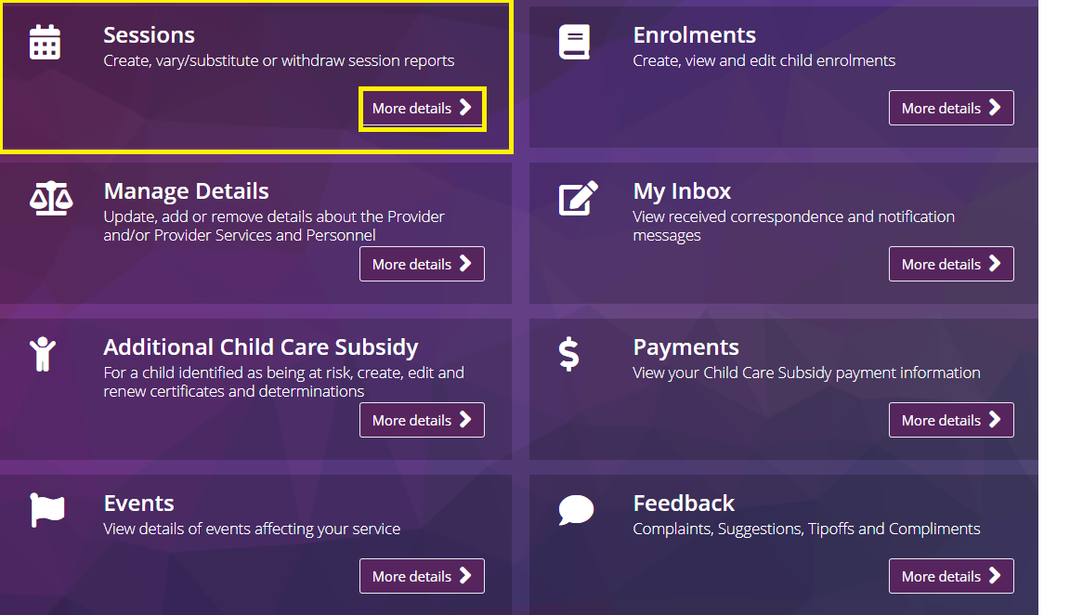

Step 2

The **Sessions of Care Reporting (child overview)** screen will display the following fields:

* **Reporting Period:** use this field to select the relevant week
* **Child Name:** use this filed to search for a specific child by name
* **Enrolment ID:** use this field to search for a specific child by enrolment ID
* **Age:** use this field to filter by a specific age
* **Claimant Name:** Use this field to search for a specific child by claimant
* **Status:** use this field to filter by session status
* **Actions**: select the view button to select the period you want to view

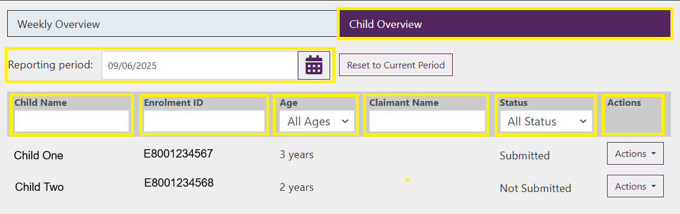

Step 3

Once you have selected the relevant week and located the relevant child select **Actions** and select **Create Report**

**Screenshot of the child overview page with reporting period and child name search options highlighted. 
Actions and create report options highlighted**

Step 4

Here you will be able to complete all sessions for the week for the child, or select **No sessions to report,** if care did not occur in this week.

Populate the following fields:

* **Session:** start and end times for the session. This will be pre-filled for routine sessions. Fields can be edited if needed, for example to change the session length.
* **Attendance:** Enter the accurate sign in and sign out times for the session
* **Fee details:** total fee by either session or hour. This will be pre-filled for routine sessions. Fields can be edited if needed, for example to reduce the fee due to a non-prescribed discount.
* **Is preschool:** select this field if the session is a pre-school session. This is mandatory for Centre-Based Day Care (children aged 3-5 inclusive)
* **Absent:** Select this field if the child was absent from care. Additional information will be required.

*Note: All times must be entered in 24-hour time. Attendance times details are not required for absences*

Screenshot of the session submission page with days of the week, session, attendance, fee details, preschool and absence options highlighted. 
No sessions to report option also highlighted. 

Step 5

To include additional session information such as absence details or third-party payments or discounts, select **Actions** and select **Show Advanced.**

*Note: Information on these additional options are located further below*

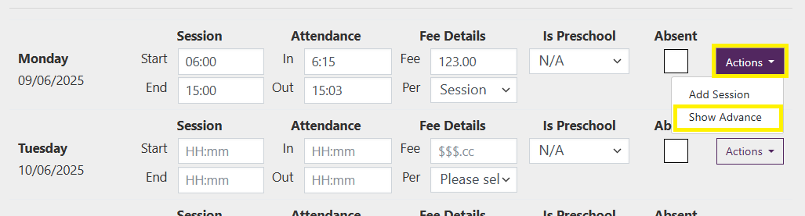

Step 6

If you have multiple sessions in a single day these can be submitted by selecting **Actions** and selecting **Add Session.**

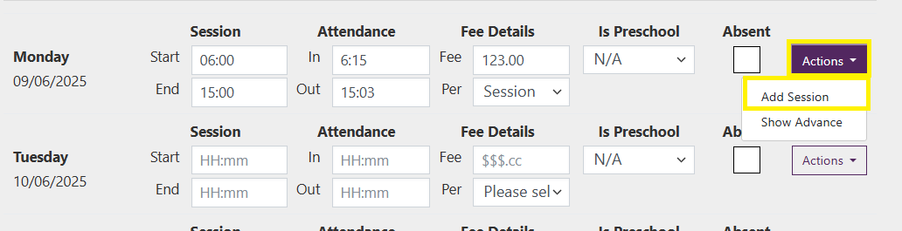

Step 7

Additional session fields will generate, complete these as required.

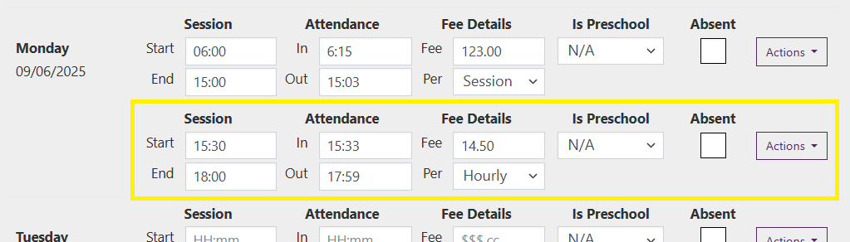

Step 8

If a session is incorrectly added it can be removed by selecting **Actions** then selecting **remove Session.**

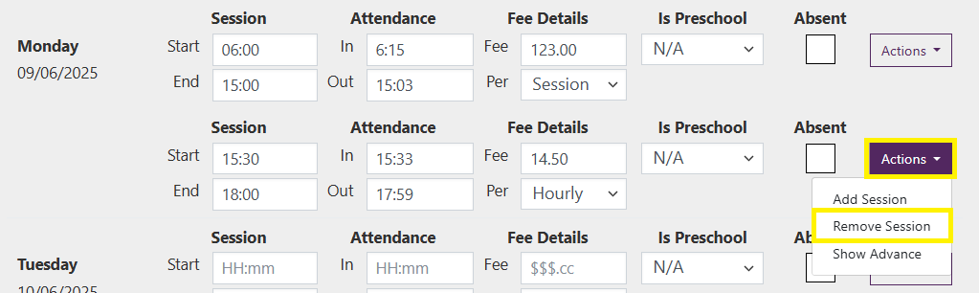

Step 9

Once all sessions have been completed select **Submit.**

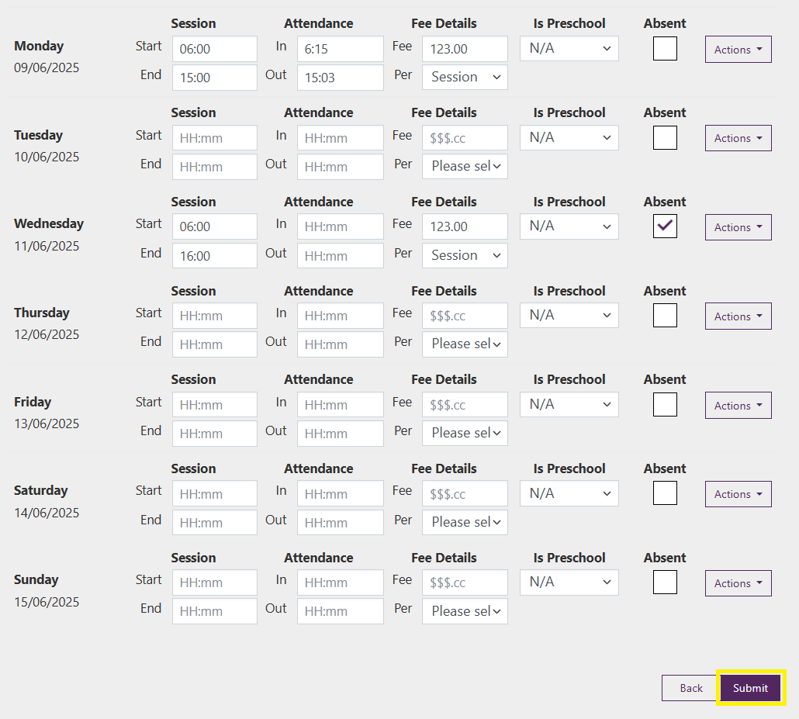

Step 10

A receipt will be generated confirming the submission of sessions. Select **Return Home** to return to the homepage.

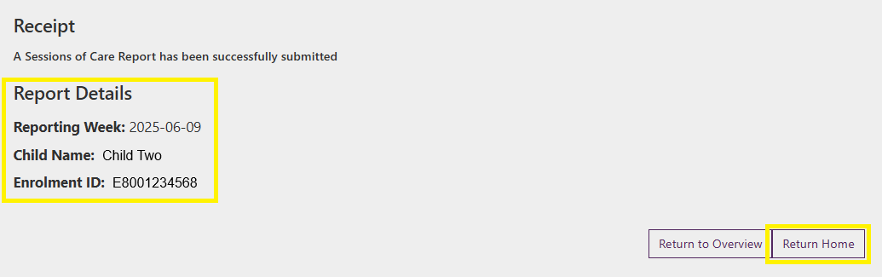

## Reporting Absences

Step 1

Where you have reported a session as absent you will be prompted to provide the absence reason and, if required, confirm that evidence is held.

Select the **Absence Reason** from the drop down

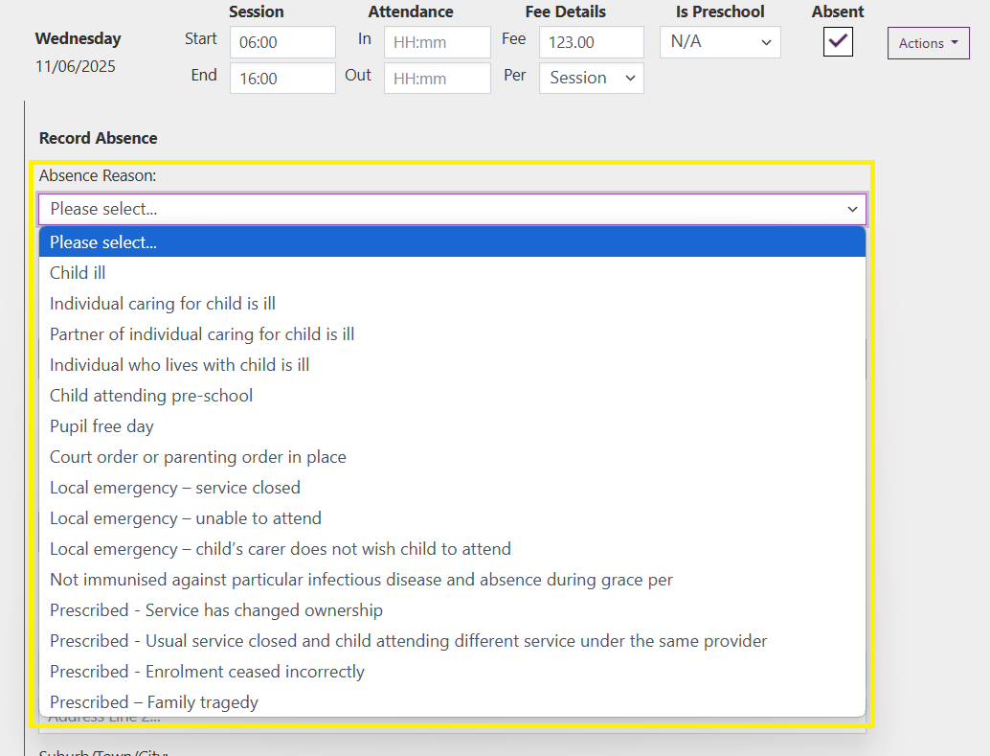

Step 2

Select either **Yes** or **No** depending on if evidence is held.

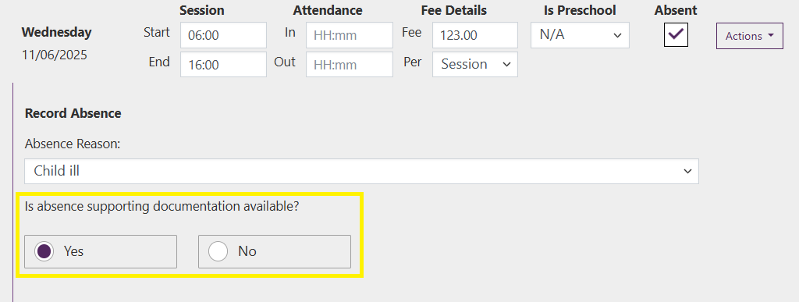

*Note: Some absences require evidence for CCS/ACCS to apply. If you are unsure if evidence is required for the absence, please check evidence requirements on the Departments website* [*How to manage absences - Department of Education, Australian Government*](https://www.education.gov.au/early-childhood/providers/howto/manage-absences)*.*

## Reporting discounts and third-party payments

If the session fee has been reduced by a prescribed or non-prescribed payment or discount you can report this as part of the session submission. How this is submitted will depend on if the payment/discount is prescribed under FAL or not.

### Prescribed third-party payments and discounts

Step 1

Select **Yes.** Select the relevant third-party payment or discount category from the options and enter the estimated payment/discount amount.

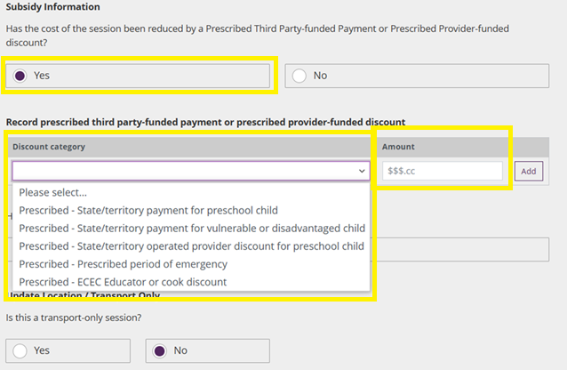

Step 2

If there are multiple prescribed third-party payments or discounts, select the **Add** option, select the relevant category and enter the estimated payment/discount amount.

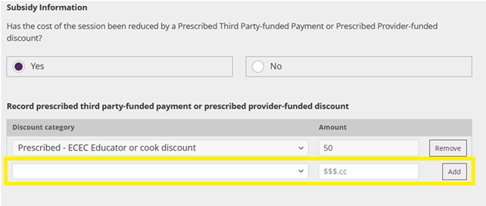

### Non-prescribed third-party payments and discounts

Step 1

It is not a requirement to report non-prescribed third-party payments or discounts; however, you are able to do so if you chose to.

Select **Yes.** Select the relevant third-party payment or discount category from the options, enter the name and details of the discount and enter the estimated payment/discount amount.

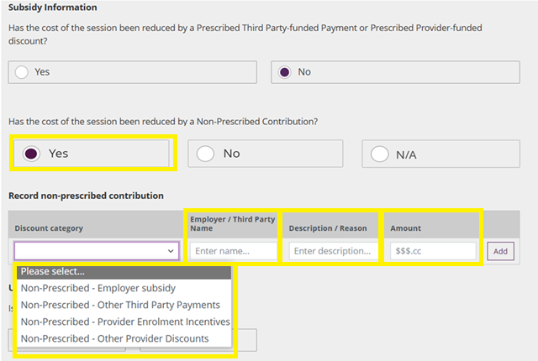

Step 2

If there are multiple third-party payments or discounts, select the **Add** option, select the relevant category, enter the name and details of the discount and enter the estimated payment/discount amount.

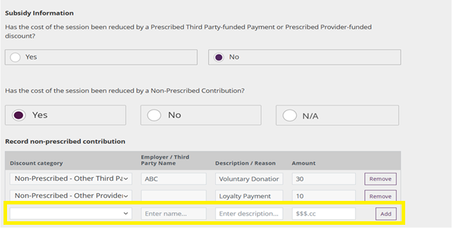

### Both prescribed and non-prescribed third-party payments and discounts

Step 1

Where both a prescribed and non-prescribed third-party payment or discount applies you can report both in the session.

Select **Yes** to both options and complete the fields.

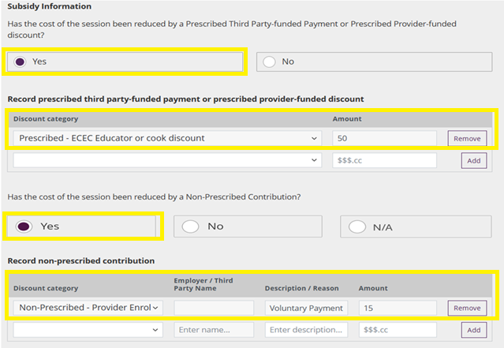

## Transport only and changing the location for care

Step 1

If a session is transport only select **Yes**. This will remove the address details as they are not relevant to the session.

If you select **No,** the address details will remain and will be pre-filled with the regular care address. If the address has changed you are able to manually

