

# Task card – how to create session reports in the Provider Entry Point (weekly overview)

How to create session reports in the Provider Entry Point using the weekly overview

Overview 1

Logging in 3

Creating a new session report 3

Reporting Absences 8

Reporting discounts and third-party payments 9

Prescribed third-party payments and discounts 10

Non-prescribed third-party payments and discounts 10

Both prescribed and non-prescribed third-party payments and discounts 11

Transport only and changing the location for care 12

## Overview

This task card outlines how to:

* create a new session report
* report absences
* report discounts and third-party payments
* Update care address details

This task card is for providers that use the Provider Entry Point (PEP). If you use third-party software, contact your software provider for help.

Find more [task cards](https://www.education.gov.au/child-care-package/provider-tool-kit#toc-task-cards) for the PEP on our website.

If you need further assistance, contact the Child Care Subsidy Provider Helpdesk on 1300 667 276 9am to 5pm AEST or [via email](mailto:CCSHelpdesk@education.gov.au) anytime.

**Note:** Only certain special characters can be used in the PEP:

* full stop (.)
* comma (,)
* hyphen (-)
* slashes (/, \)
* apostrophe (‘).

All other special characters will cause an error in the system.

## Logging in

Step 1

Log in to the [Provider Entry Point (PEP)](https://proda.humanservices.gov.au/prodalogin/pages/public/login.jsf?TAM_OP=login&ERROR_CODE=0x00000000&URL=%2Fmga%2Fsps%2Foauth%2Foauth20%2Fauthorize%3Fscope%3Dopenid%26state%3DalN0hw9ovD%26client_id%3DGTzCa6CRNfBsRTdfljBa%26redirect_uri%3Dhttps%253A%252F%252Fbusinessonline.humanservices.gov.au%252Fmga%252Fsps%252Foidc%252Frp%252Fchildcaresubsidy%252Fredirect%252Fproda%26response_type%3Dcode&OLDSESSION=).

## Creating a new session report

Step 1

From the PEP landing page, select **More details** in the **Sessions** tile.

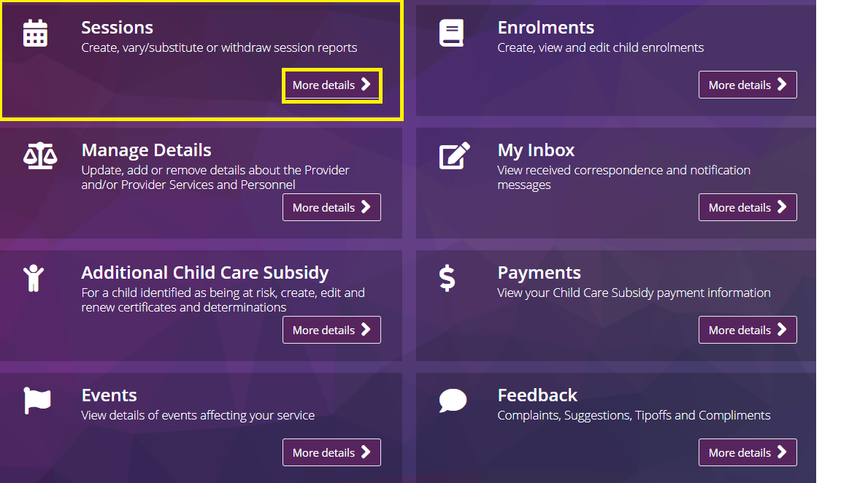

Step 2

The **Sessions of Care Reporting (weekly overview)** screenwill display the following fields:

* **Week Beginning**: this is the week beginning date that sessions relate to.
* **Total Enrolments for this Period**: this number is based on enrolments with at least one routine session in this week.
* **Reports Requiring Submission**: total number of outstanding reports requiring submission.
* **Actions**: select the view button to select the period you want to view.

*Note: Session reports for each child can be submitted on the day that the last session of care for the week occurs.*

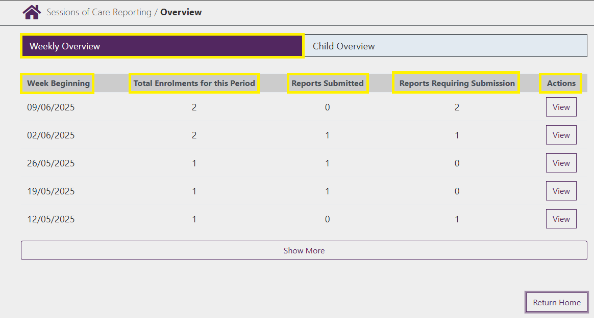

Step 3

Locate the relevant week and select **View**

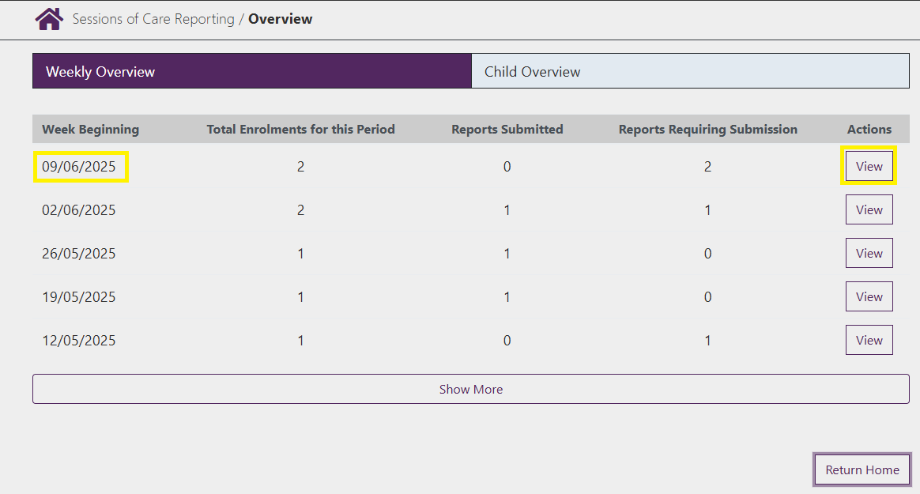

Step 4

From the **Update Session Report** screen, you can search for the child’s name via the **Name** field or locate the child’s details from the list provided.

Populate the following fields:

* **Session:** start and end times for the session. This will be pre-filled for routine sessions. Fields can be edited if needed, for example to change the session length.
* **Attendance:** Enter the accurate sign in and sign out times for the session
* **Fee details:** total fee by either session or hour. This will be pre-filled for routine sessions. Fields can be edited if needed, for example to reduce the fee due to a non-prescribed discount.
* **Is preschool:** select this field if the session is a pre-school session. This is mandatory for Centre-Based Day Care (children aged 3-5 inclusive)
* **Absent:** Select this field if the child was absent from care. Additional information will be required.

*Note: All times must be entered in 24-hour time. Accurate attendance data is not required for absent sessions.*

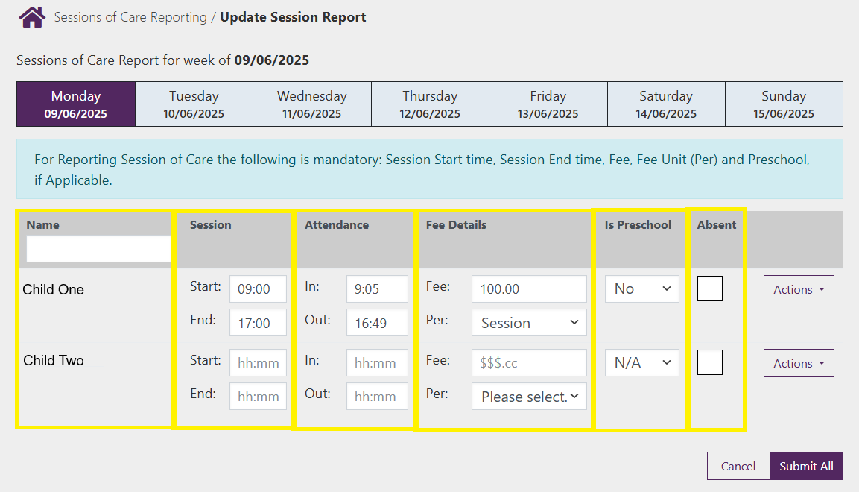

Step 5

To include additional session information such as absence details or reporting discounts or third-party payments, select **Actions** and select **Show Advanced.**

*Note: Information on these additional options are located further below*

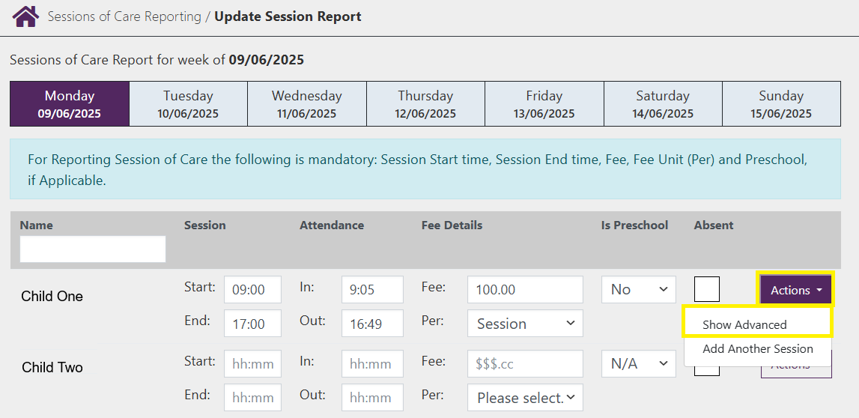

Step 6

If you have multiple sessions in a single day these can be submitted by selecting **Actions** and selecting **Add Another Session**

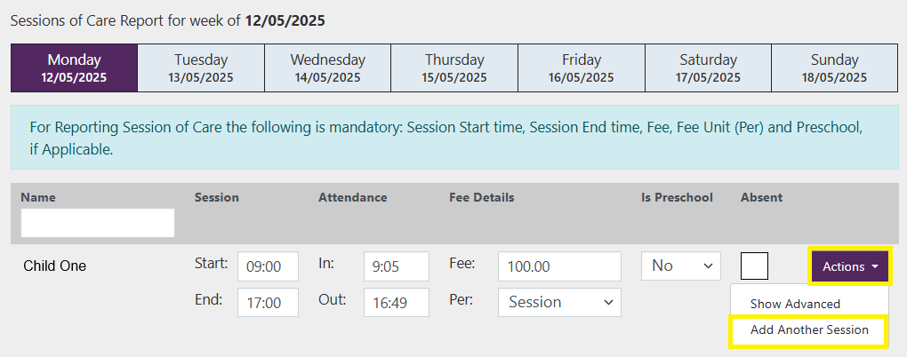

Step 7

Additional session fields will generate, complete these as required.

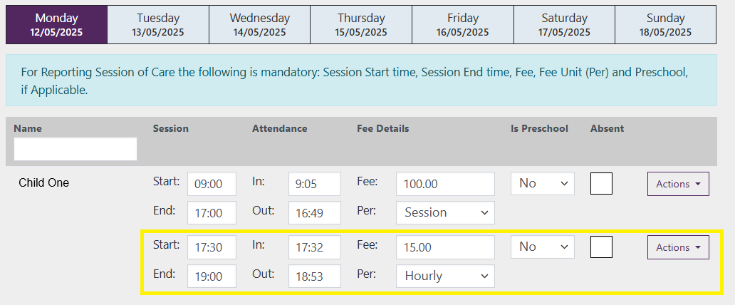

Step 8

If a session is incorrectly added it can be removed by selecting **Actions** then selecting **remove Session.**

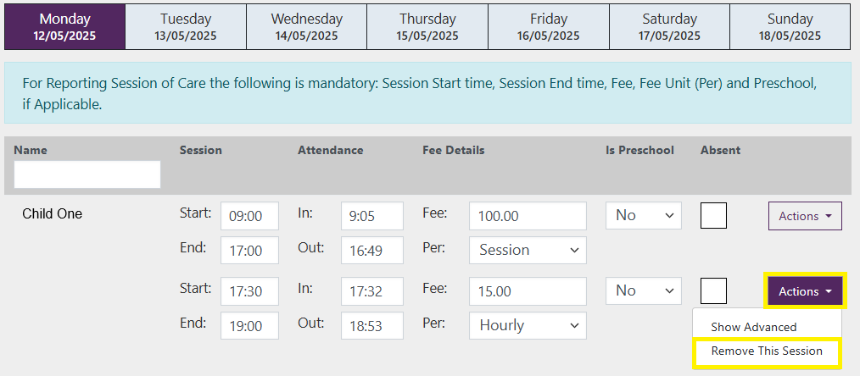

Step 9

Navigate through the remaining days using the tabs, completing the sessions as required.

*Note: Enrolments with routine sessions must be completed with either attendance or absence information.*

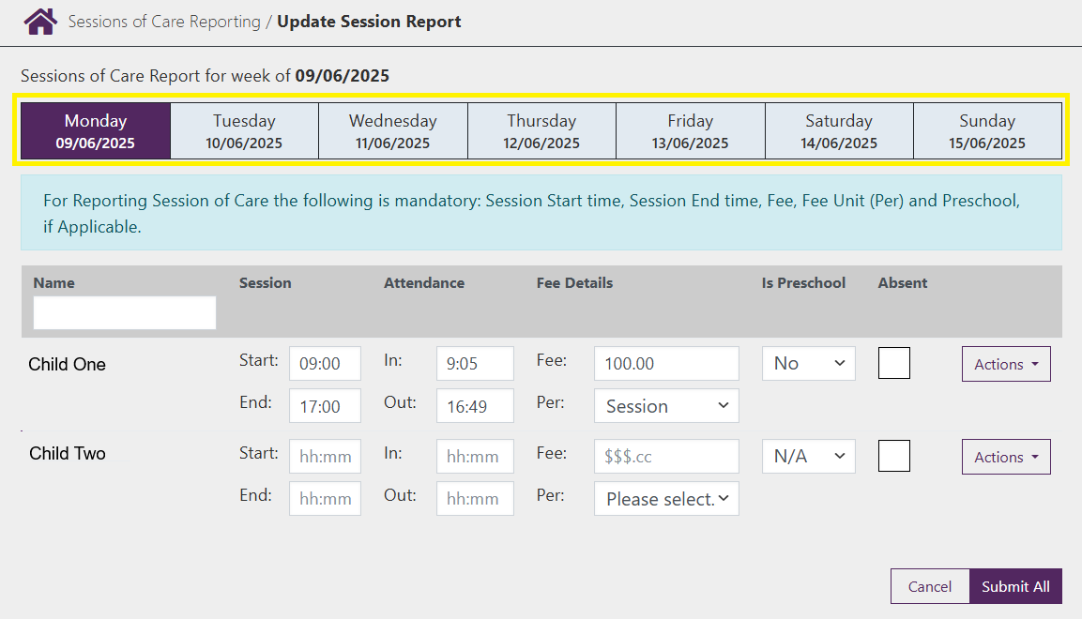

Step 10

Once all session reports have been completed. Select **Submit All.**

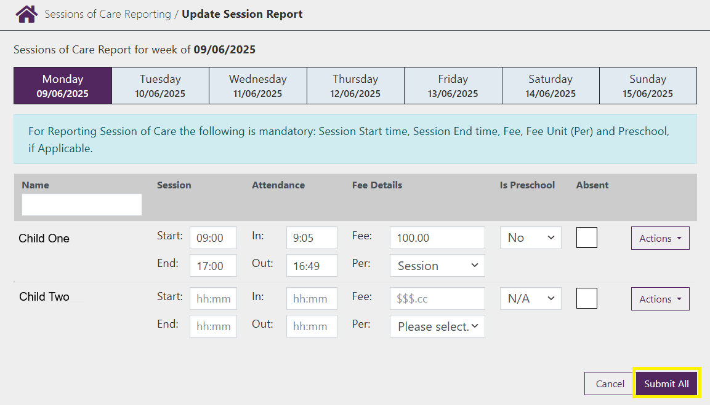

Step 11

You will be prompted to confirm the submission, select **Yes**

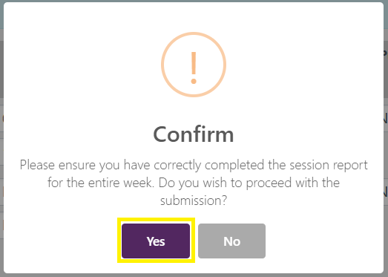

Step 12

A receipt will be generated confirming the submission of sessions. If there are any errors identified in the submission it will also be flagged here.

Once you have reviewed the results, select **Return Home** to return to the homepage.

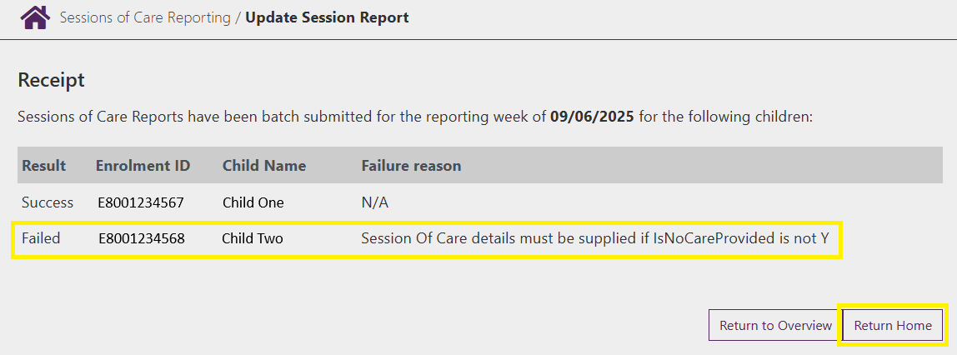

## Reporting Absences

Step 1

Where you have reported a session as absent you will be prompted to provide the absence reason and, if required, confirm that evidence is held.

Select the **Absence Reason** from the drop down

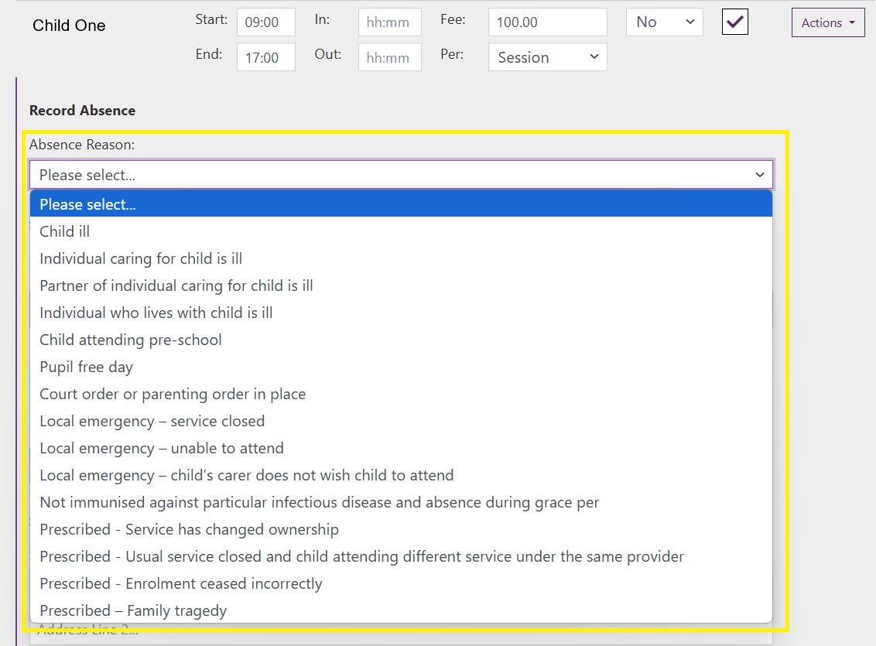

Step 2

Select either **Yes** or **No** depending on if evidence is held.

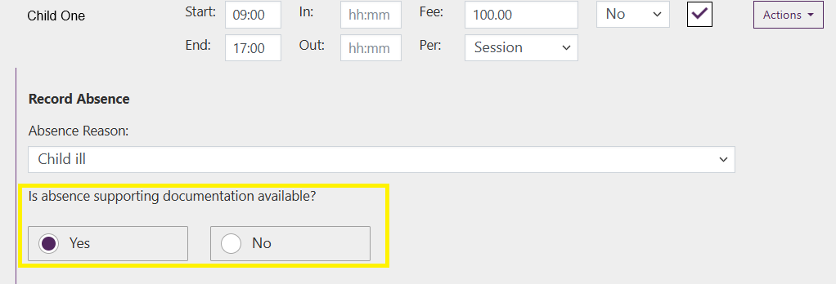

*Note: Some absences require evidence for CCS/ACCS to apply. If you are unsure if evidence is required for the absence, please check evidence requirements on the Departments website;* [*How to manage absences - Department of Education, Australian Government*](https://www.education.gov.au/early-childhood/providers/howto/manage-absences)*.*

## Reporting discounts and third-party payments

If the session fee has been reduced by a prescribed or non-prescribed payment or discount you can report this as part of the session submission. How this is submitted will depend on if the payment/discount is prescribed under FAL or not.

### Prescribed third-party payments and discounts

Step 1

Select **Yes.** Select the relevant prescribed third-party payment or discount category from the options and enter the payment/discount amount.

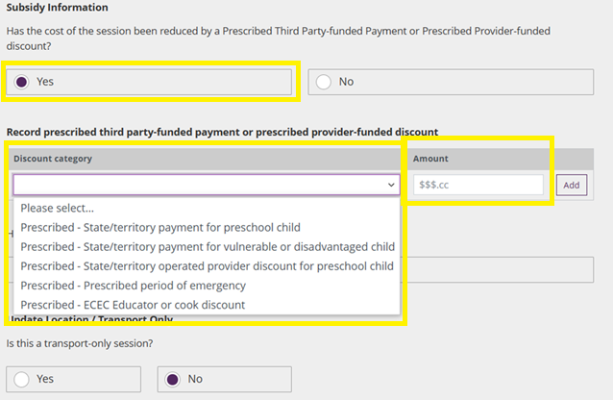

Step 2

If there are multiple prescribed third-party payments or discounts, select the **Add** option, select the relevant category and enter the estimated payment/discount amount.

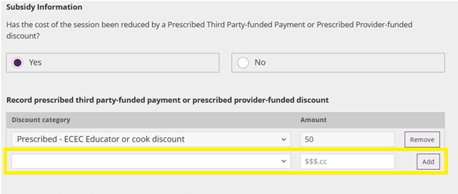

### Non-prescribed third-party payments and discounts

Step 1

It is not a requirement to report non-prescribed third-party payments or discounts; however, you are able to do so if you chose to.

Select **Yes.** Select the relevant third-party payment or discount category from the options, enter the name and details of the discount and enter the estimated payment/discount amount.

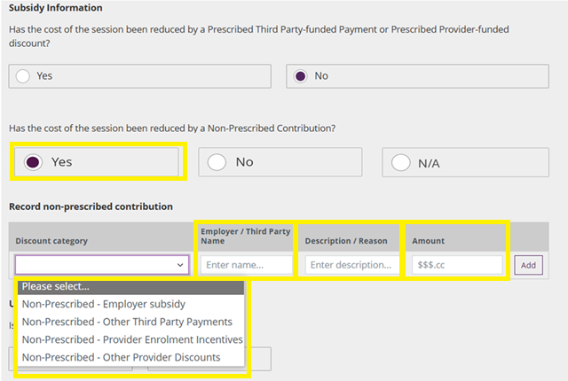

Step 2

If there are multiple third-party payments or discounts, select the **Add** option, select the relevant category, enter the name and details of the discount and enter the estimated payment/discount amount.

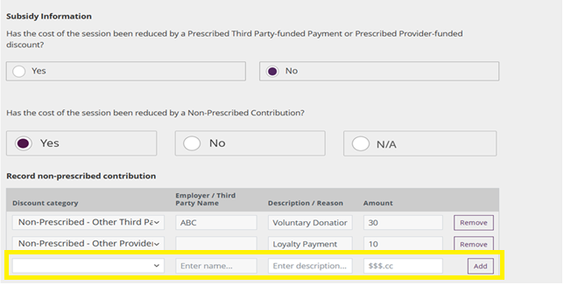

### Both prescribed and non-prescribed third-party payments and discounts

Step 1

Where both a prescribed and non-prescribed third-party payment or discount applies you can report both in the session.

Select **Yes** to both options and complete the fields.

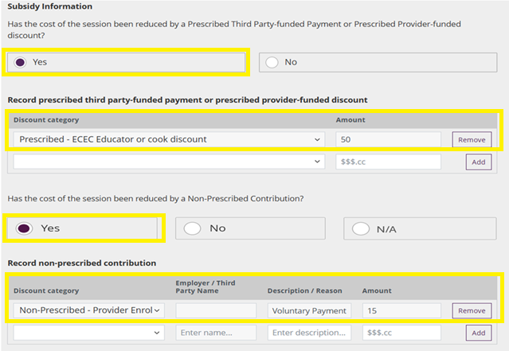

## Transport only and changing the location for care

Step 1

If a session is transport only select **Yes**. This will remove the address details as they are not relevant to the session.

If you select **No,** the address details will remain and will be pre-filled with the regular care address. If the address has changed you are able to manually

