19-20 March 2025
Early Childhood Care and Development Policy Partnership
Meeting Nine Outcomes
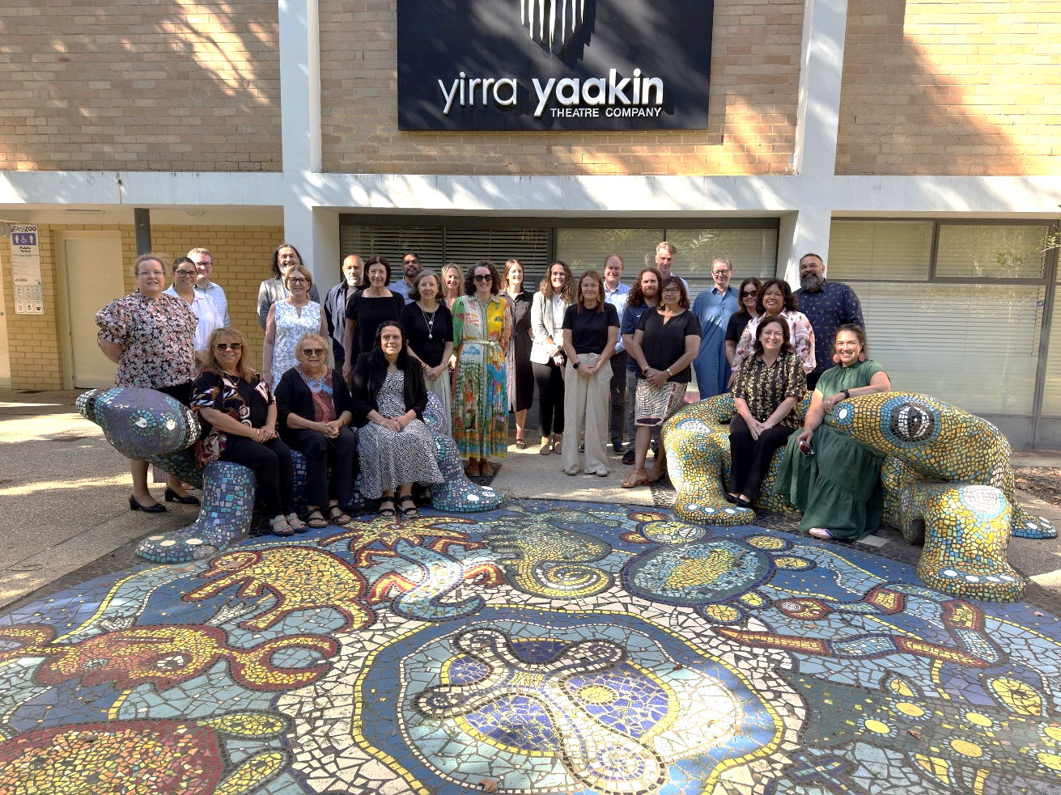
Members of the Early Childhood Care and Development Policy Partnership on Noongar Boodja Country
The Early Childhood Care and Development Policy Partnership (the ECCDPP or Partnership) held its ninth meeting in Boorloo/Perth. The meeting was on Whadjuk Noongar Boodja (Country). The meeting opened with a Welcome to Country by Joanne Della Bonna, who reflected on the importance of the Partnership’s work for improving outcomes for Aboriginal and Torres Strait Islander children.
The meeting was co-chaired by Catherine Liddle, CEO, SNAICC – National Voice for our Children (SNAICC) and Kylie Crane, Deputy Secretary, Early Childhood and Youth Group. In December 2024, the Australian Government announced $11.4 million to extend the ECCDPP for a further three years until 30 June 2028.
The meeting was attended by Aboriginal and Torres Strait Islander independent and peak body representatives and representatives from Australian State, Territory and Commonwealth governments. A full list of attendees is located on page 5.
Presentation on Early Childhood Care and Development policy landscape in Western Australia
Western Australia (WA) representatives provided an overview of the local early childhood care and development operating context. Ali Meehan from the Council of Aboriginal Services Western Australia (CASWA), the peak body for Aboriginal Community Controlled Organisations (ACCO) in WA, presented on CASWA’s key priorities for the early years. These include improving representation for ACCOs in early childhood care and development policy and working with the WA Government to overcome blockages to releasing the 10 Year Roadmap for Reducing the Overrepresentation of Aboriginal Children in Care in WA. Independent Aboriginal and Torres Strait Islander members Joanne Della Bonna and Elizabeth Cox then presented on the work their ACCOs are doing to support children and families. Joanne provided an overview of the work of Coolabaroo. She emphasised that Aboriginal children had a right to access culturally supportive early childhood education and it was critical for governments to support ACCOs to deliver these vital services for children. She also emphasised the cultural responsibility staff took on and the urgent need for ACCOs to be adequately funded to support their staff. Elizabeth provided an overview of Wunan’s work, which includes providing holistic, wrap around supports for families in Kununurra.
Melanie Samuels from the WA Department of Communities noted that key child protection priorities in WA included implementing Safe and Supported: National Framework for Protecting Australia’s Children 2021-2031 and reducing the over-representation of Aboriginal children in out of home care, including via the Building Safe and Strong Families initiative and Earlier Intervention and Family Support Strategy. Early evaluation findings from these programs showed positive results when ACCOs were supported to work with families. Raechelle Lee from the WA Department of Education noted that their focus was building a culturally responsive education system, in alignment with the State’s Aboriginal Empowerment Strategy and Closing the Gap Implementation Plan. The Department of Education’s Aboriginal Cultural Standards Framework supports this work. The Department is also working closely with CASWA on an ACCO Sector Strengthening Stakeholder Engagement Plan. Members discussed how important it was that government departments work together across silos, as well as with ACCOs, to provide joined-up support for families.
The ECCDPP members welcomed representatives from Binarri-binyja yarrawoo (BBY) Aboriginal Corporation (Empowered Communities East Kimberley) and the WA Department of the Premier and Cabinet to talk about their work on the East Kimberley Place-Based Partnership (EK PBP). The EK PBP was established under the National Agreement on Closing the Gap to build partnership and shared decision-making between East Kimberley Aboriginal organisations and governments to facilitate community-led outcomes at the local level. The EK PBP chose early childhood as the focus based on priorities identified by local communities, guided by BBY’s Regional Development Agenda for Growing Up Strong Kids. The Partnership will focus on the Closing the Gap Priority Reforms and targets 2, 3, 4, 9, 13 and 16, providing critical early supports for families to support child health and wellbeing. The BBY governance structure prioritises the voices of communities to directly feed into decision-making and priority setting for the EK PBP. Governments in turn are committed to working with communities to direct funding to align with the priorities of local communities. Insights from the EK PBP’s progress include the value of coordinating services at a local level to support families and the importance of transforming government funding practices to enable community-led decision-making regarding priorities, service design and delivery approaches. Members also discussed the future of the EK PBP’s work and opportunities for future collaboration.
Progressing the Partnership’s Priorities
The Partnership's priorities focus on advancing the safety, development, and well-being of children, as well as addressing the cross-cutting area of disability. A full list of priorities can be found here.
Priorities 2A and 2B – access to Early Childhood Education and Care (ECEC) for Aboriginal and Torres Strait Islander children and funding models for ACCO Integrated Early Years Services
The Partnership welcomed members of the Early Childhood Policy Group (ECPG) for a workshop for priorities 2A and 2B. These priorities relate to developing implementation advice in response to two research reports commissioned by the ECCDPP: The Systematic Evidence Review into Optimal Hours of ECEC for Aboriginal and Torres Strait Islander children, and The Funding Model Options for ACCO Integrated Early Years Services Report. This collaboration between ECPG and ECCDPP members is a new way of working that aligns with governments’ commitments to strong partnership and shared decision-making under Priority Reform One of the National Agreement on Closing the Gap (National Agreement).
Members noted that the Australian Government is replacing the Child Care Subsidy (CCS) activity test from January 2026 with at least 3 days of subsidised early education and care for all children. Families caring for Aboriginal and Torres Strait Islander children will now have access to 100 hours of subsidised care per fortnight. Members discussed how this reform closely aligns to the ECCDPP research outcomes and priorities progressed by the Partnership. The Aboriginal and Torres Strait Islander Caucus provided feedback on a range of considerations for governments to improve access to ECEC. This included: investment in workforce and infrastructure for ACCO services, transport for children to access ECEC services, investment in cultural competency of non-Indigenous services and acknowledging that ACCOs deliver a broad range of services beyond ECEC. Aboriginal and Torres Strait Islander members also raised key considerations for governments when developing implementation advice regarding the ACCO Integrated Early Years Funding Model, including considering workforce and infrastructure needs and the broad range of services delivered by ACCOs. They reflected children grow strong in their cultural identity and sense of belonging when attending ACCO early years services, setting them up for success in school and in life.
ECPG members will continue to progress the development of implementation advice and engage ECCDPP members throughout the process.
Priority 1A – transitioning child and family services funding to ACCOs
The National Agreement recognises that Aboriginal community-controlled services deliver better outcomes for Aboriginal and Torres Strait Islander children. Members held a workshop to identify high-impact actions governments could take in partnership with Aboriginal and Torres Strait Islander communities to direct increased funding to ACCOs delivering child and family services, so that funding to these services is proportionate to the needs of Aboriginal and Torres Strait Islander families. Funding ACCOs to deliver these services is an act of self-determination and aligns with government commitments under the National Agreement. Members also discussed the Families and Children Activity Funding Review being undertaken by the Commonwealth Department of Social Services and how this presented a significant opportunity for the Commonwealth to transfer family services funding to ACCOs in line with the National Agreement and the ECCDPP’s priorities. Following the workshop, members will have a list of high impact initiatives to explore in their jurisdiction to progress the transition of funding to ACCOs.
Priority 5A – Evidence Guidance Framework
Members heard an update on work to develop a framework to guide a shared understanding between governments and ACCOs of how Aboriginal and Torres Strait Islander communities, researchers and organisations define, use and understand evidence regarding child and family support services (Framework). The project team has conducted an evidence scan and identified existing Indigenous-led research, evidence and evaluation frameworks that will inform the future direction of this work.
Members noted that the Framework will be valuable for both governments and the ACCO sector, and will inform the development and use of evidence to improve impact and accountability across the child and family sector.
Priority 4B – supporting Aboriginal and Torres Strait Islander children and families with disability
Members discussed the importance of providing appropriate supports for Aboriginal and Torres Strait Islander children and families with disability. Members agreed to take this priority forward via a research project to improve the availability and accuracy of data regarding children and parents with disability in contact with child protection systems. This research will allow governments and Aboriginal and Torres Strait Islander communities and organisations to better understand how Aboriginal and Torres Strait Islander children and parents with disability are coming into contact with child protection systems, which will provide evidence to better support children and parents with disability so more children are able to stay safely with their families. Members also noted the importance of adequate disability assessments in the early years, which could be a focus area for future work.
Priority 1B – improved funding models for ACCOs delivering child and family services
Members agreed to a way forward for a research project exploring ways to improve funding models for ACCOs delivering child and family services. ACCOs deliver critical services to strengthen families, support parents and help children grow up safe and strong in their culture. This research will contribute to the Partnership's understanding of the ACCO funding environment, and complement, but not duplicate, existing research on ACCO funding models by examining the child and family services sector.
Other ECCDPP priorities
The Partnership noted progress updates on the other ECCDPP priorities.
Forward planning and other items
Members discussed opportunities and focus areas for the year ahead and provided an overview of work relevant to the ECCDPP that would be underway in their jurisdictions this year. The First Nations members reflected the need to support Aboriginal and Torres Strait Islander communities to develop their own responses to improve outcomes, in line with commitments under the National Agreement and principles of self-determination, rather than initiatives being driven by governments.
Members noted the finalisation of the ECCDPP Probity Framework, which provides independent advice on how to manage probity matters in a shared decision-making environment. The Framework is important because it supports Aboriginal and Torres Strait Islander organisations to participate in shared decision-making, while also supporting Aboriginal and Torres Strait Islander-led research and ensuring public resources are used responsibly.
Next meeting
The Partnership will meet again in July to continue progressing the Partnership’s priorities.

Attendees
Name | Representing
Coalition of Peaks representatives
Catherine Liddle | SNAICC – National Voice for our Children (SNAICC)
Monica Barolits-McCabe (proxy for Donnella Mills) | National Aboriginal Community Controlled Health Organisation (NACCHO)
Neville Atkinson | Victorian Aboriginal Education Association Incorporated
Lisa Coulson | Tasmanian Aboriginal Centre
Tennille Lamb (proxy for Damian Griffis) | First Peoples Disability Network
Kylie Degenhardt (proxy for Sharron Williams) | South Australian Aboriginal Community Controlled Organisation (SAACCON)
Independent Aboriginal and Torres Strait Islander representatives
Darcy Cavanagh | Independent representative
Paul Gray | Independent representative
Apologies from Garth Morgan | Independent representative
Joanne Della Bona | Independent representative
Government representatives
Kylie Crane | Commonwealth Government, Department of Education
Mark Barraket | New South Wales Government
Mathew Lundgren | Victorian Government
Tania Porter | Queensland Government
Caron Irwin and Melanie Samuels | Western Australia Government
Natalie Atkinson (proxy for Kim Little) | South Australia Government
Peter Whitcombe | Tasmania Government
Nicole Moore (online) | Australian Capital Territory Government
Gabrielle Brown | Northern Territory Government
Partners
Muriel Bamblett | SNAICC – National Voice for our Children (SNAICC)
John Leha (Day 1) | CEO of AbSec – NSW Child, Family and Community Peak Aboriginal Corporation
Tarja Saastamoinen (proxy for Letitia Hope) | Commonwealth Government, Department of Social Services
Julie-Ann Guivarra (online) | Commonwealth Government, National Indigenous Australians Agency
Stuart Malcher (online) | New South Wales Government
Simone Corin | Victorian Government
Fiona Ward | Queensland Government
Raechelle Lee | Western Australia Government
Jackie Bray (online) | South Australian Government
Vidhya Chelliah (Day 1 only, online. Proxy for Jodee Wilson) | Tasmania Government
Chris Simpson (online) | Australian Capital Territory Government
Aderyn Chatterton | Northern Territory Government
Early Childhood Policy Group representatives
Jessamin Clissold | New South Wales
Bec Curtin | South Australia
Lauren Kaerger | Victoria
Sean Moysey | Australian Capital Territory
Angelo Barbaro | Western Australia

On 13 February 2025, the Early Childhood Education and Care (Three Day Guarantee) Bill 2025 was passed by Parliament and is awaiting royal assent.

