****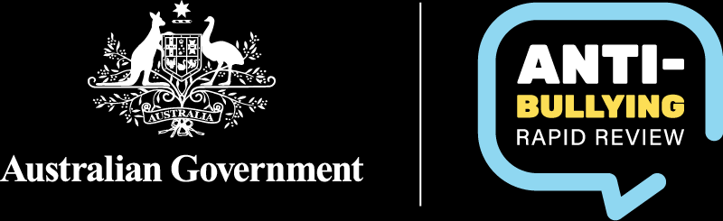

# Student/young person information sheet

Online submissions for the Anti-Bullying Rapid Review

#### Hi there

Thank you for your interest in the Anti-Bullying Rapid Review (the Review). This information sheet outlines:

* what the Review is about and
* how you can be involved in the **online submission** process.

#### What is the Review about?

The Review will look at what Australian schools are currently doing about bullying and the main causes of bullying. In your submission, we will ask you about what is working in your school and what can be done better to address bullying. We will also seek submissions from parents and school staff.

At the end of the Review, we will give recommendations to government on how schools in Australia can handle bullying so everyone can feel safe at school.

#### How can I be involved?

We are interested in your views about what **programs and supports** are offered to stop and respond to bullying in schools. If you would like to participate in the Review, follow these steps:

**Step 1:** Visit the Anti-Bullying Rapid Review webpage at <https://www.education.gov.au/antibullying-rapid-review> to access the online submission form. If you haven’t already, check out the helpful resources and support on the webpage.

**Step 2:** While you’re there, follow the link to the [students and young people online submission form](https://submit.dese.gov.au/jfe/form/SV_8B2mS36MSLsJUQm). This is where you will make your submission to the Review.

**Step 3:** If you are under the age of 15, ask your parent/legal guardian for permission to participate.

**Step 4:** Participation is **voluntary**. You do **not** need to answer all the questions. If you feel overwhelmed or uncomfortable at any point in time, you can come back to the submission at another time or stop taking part completely.

Information on the support available is at <https://www.education.gov.au/antibullying-rapid-review>.

#### Why we’d like you to participate

Your insights about your experiences with bullying are important to the Review. By completing a submission, you will help us understand and inform advice on:

* The best ways to stop and deal with bullying in schools.
* What actions work to stop bullying in your school.
* Possible ways to create the same rules to stop and deal with bullying in all Australian schools.

#### Will making a submission make me feel uncomfortable in any way?

We know that talking about a bullying experience can be hard. If you start to feel uncomfortable for any reason, you can exit the submission or take a break. We encourage you to speak to a trusted adult and seek support using the resources below if you feel you need it.

* Lifeline - [https://www.lifeline.org.au](https://www.lifeline.org.au/) or phone [13 11 14](tel:131114)
* 13YARN – [https://www.13yarn.org.au](https://www.13yarn.org.au/) or phone [13 92 76](tel:139276)
* Beyond Blue - [https://www.beyondblue.org.au](https://www.beyondblue.org.au/)
* headspace - [https://headspace.org.au](https://headspace.org.au/)
* Kids Helpline - [https://kidshelpline.com.au](https://kidshelpline.com.au/) or phone [1800 55 1800](tel:1800551800)
* Dolly's Dream Support Line - <https://www.dollysdream.org.au/what-we-do/support-line>  
  or phone [0488 881 033](tel:0488881033)

#### Can I stop taking part?

Yes, you can. You don’t need to tell us why. If you start to feel uncomfortable while you are completing your submission, you do not need to finish it.

When you complete your submission, make sure you are happy with what you have written. Once you have submitted it you will not be able to withdraw it. If you have any concerns you can email us at [ABRRConsultations@education.gov.au](mailto:ABRRConsultations@education.gov.au?subject=ABRR%20Submission%20-%20student%20consent)

#### What happens to my personal information e.g. my name, email address, responses?

At the end of the online submission, you will be able to choose one of three options regarding your submission and your personal details:

* You can consent to your name and submission being published on the Review’s webpage or
* You can ask for your personal details to be removed, and your submission will be published anonymously on the Review’s webpage or
* You can ask for your personal details to be removed, and your submission will **not be** published on the Review’s website.

If you choose to provide your personal details, we may contact you to discuss your submission further.

For more information on the Terms and Conditions for public submissions, visit: <https://www.education.gov.au/about-us/corporate-reporting/information-publication-scheme-ips/public-reviews-and-consultations/terms-and-conditions-public-submissions>

#### How can I contact you?

If you have any questions or want to know more, you or your parent/legal guardian can email [ABRRConsultations@education.gov.au](mailto:ABRRConsultations@education.gov.au?subject=ABRR%20Submission%20-%20student%20consent).

#### What if I have a complaint?

The department’s [Privacy Policy](https://www.education.gov.au/privacy) explains how to make a complaint. This is also explained in the Review’s [Privacy Statement](https://www.education.gov.au/antibullying-rapid-review/resources/antibullying-rapid-review-consultations-privacy-statement).

If you or your parent/legal guardian have any concerns about your personal information, email [privacy@education.gov.au](mailto:privacy@education.gov.au).

If you or your parent/legal guardian have any concerns about the Review or your submission, email [ABRRConsultations@education.gov.au](mailto:ABRRConsultations@education.gov.au) and the team will be able to help you.

#### Thank you!

Your experiences and views are critical to this Review. We thank you for taking the time to learn more about the online submission process.

We hope to hear from you soon.

**Dr Charlotte Keating and Dr Jo Robinson AM**

**Anti-Bullying Rapid Review co-chairs**