****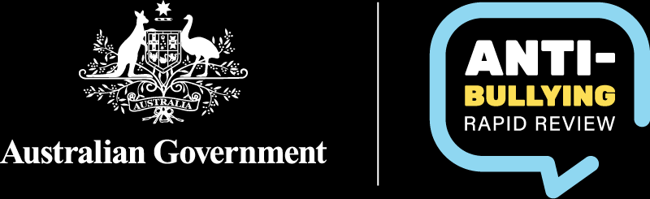

# Parent/caregiver information sheet

Online submissions for the Anti-Bullying Rapid Review

Thank you for your interest in the Anti-Bullying Rapid Review (the Review). This information sheet outlines for parents/caregivers:

* what the Review is about and
* how you or your child can make an **online submission** to the Review.

### Anti-Bullying Rapid Review

The Review will look at what schools are currently doing to address bullying in Australian schools. It will look at what is working and what needs strengthening. At the conclusion of the Review, a report will be provided to all Education Ministers, providing recommendations for the development of a consistent national standard for responding to bullying in schools.

How can I or my child get involved?

We are interested in hearing from parents and young people about:

* what schools are doing to prevent and respond to bullying in schools and
* what programs and supports may have been offered to improve the situation.

To help you get a better understanding of what information you or your child will be asked to provide we have created a [Consultation Paper](https://www.education.gov.au/antibullying-rapid-review/resources/consultation-paper-antibullying-rapid-review).

Parents and young people can be involved by completing the relevant online submission. Taking part is **voluntary**.

To access the online submissions, visit the Anti-Bullying Rapid Review webpage at <https://www.education.gov.au/antibullying-rapid-review>.

Will my or my child’s participation in the Review be made public? Can my or my child’s submission be withdrawn?

Submissions will be used to inform the findings and recommendations of the Anti-Bullying Rapid Review. The Review report will be published on the Australian Government Department of Education website.

At the end of the online submission, you or your child will be able to choose one of three options regarding you or your child’s submission and personal details:

* You/your child can consent to you/your child’s name and submission being published on the Review’s webpage or
* You/your child can ask for your/your child’s personal details to be removed, and your/your child’s submission will be published anonymously on the Review’s webpage or
* You can ask for you/your child’s personal details to be removed, and your/your child’s submission will **not** bepublished on the Review’s website.

Once submitted, your submission or your child’s submission **cannot be withdrawn**. However, if you have any concerns, you can email us at [ABRRConsultations@education.gov.au](mailto:ABBRConsultations@education.gov.au).

Why should I or my child participate?

By providing a submission to the Review, you or your child will help inform advice on:

* Best practice in relation to preventing and responding to bullying in schools.
* Types of actions, resources and supports that are working to address or prevent bullying in Australian schools.
* Possible models and content for a consistent national standard for responding to bullying in schools and its underlying causes in school contexts.

Will this involve any risk or discomfort to me or my child?

We understand that some young people may find re-living a bullying experience difficult. Taking part in the online submissions is **voluntary**. If at any time during the submission process, you or your child does not want to continue, you are under no obligation to finish.

We encourage people to seek help if they need it. We have provided links to available support on the Anti-Bullying Rapid Review webpage at <https://www.education.gov.au/antibullying-rapid-review>.

Young people under the age of 15 will be asked to get their parent’s consent to take part in the online submission.

We encourage you to have a conversation with your child about their intention to provide a submission and what is involved. You may also want to consider any risk factors that may be unique to their situation prior to starting the submission process.

How do you intend to publish or disseminate the results?

Information that is collected may be disclosed to third parties, including but not limited to:

* the Review co-chairs
* the Department of Employment and Workplace Relations for the purpose of IT support
* any contracted service provider engaged by the department in connection with the Review.

Submissions will be used to inform the findings and recommendations of the Review. The Review report will be published on the Australian Government Department of Education website.

For the purposes of the Review and any reporting, personal information that has been provided will be de-identified.

For more information on the Terms and Conditions for public submissions, visit: <https://www.education.gov.au/about-us/corporate-reporting/information-publication-scheme-ips/public-reviews-and-consultations/terms-and-conditions-public-submissions>

How will the data and information that me or my child provides be disposed of?

Storage of personal information (and the disposal of information when no longer required) is managed in accordance with the [Australian Government’s records management regime](https://www.naa.gov.au/information-management/information-management-policies/building-trust-public-record/integrity-and-information-management-guidance-australian-public-service).

The department takes all reasonable steps to protect the personal information held in our possession against loss, unauthorised access, use, modification, disclosure of misuse.

For more information, read the department’s [Privacy Policy](https://www.education.gov.au/using-site/privacy).

Where can I find further information?

For more information on the Review, contact the Anti-Bullying Rapid Review Taskforce at the Australian Government Department of Education at:

Email – [ABRRConsultations@education.gov.au](mailto:ABRRConsultations@education.gov.au)

Website – <https://www.education.gov.au/antibullying-rapid-review>

What if I have a complaint?

The department’s [Privacy Policy](https://www.education.gov.au/privacy) contains more information about how the department will manage your personal information, including information about how to make a complaint and seek access to and correction of your personal information. This is also outlined in the Review’s [Privacy Statement](https://www.education.gov.au/antibullying-rapid-review/resources/antibullying-rapid-review-consultations-privacy-statement).

To contact the department about your personal information, email [privacy@education.gov.au](mailto:privacy@education.gov.au).

To contact the department about the Review, email: [ABRRConsultations@education.gov.au](mailto:ABBRConsultations@education.gov.au).

#### Thank you!

Your experiences and views are critical to this Review. We thank you for taking the time to learn more about the online submission process.

We hope to hear from you soon.

**Dr Charlotte Keating and Dr Jo Robinson AM**

**Anti-Bullying Rapid Review co-chairs**