May 2024
Report to
Department of Education

Evaluation of PACER and CCE programs
Final Report

About ACIL Allen
ACIL Allen is a leading independent economics, policy and strategy advisory firm, dedicated to helping clients solve complex issues.
Our purpose is to help clients make informed decisions about complex economic and public policy issues.
Our vision is to be Australia's most trusted economics, policy and strategy advisory firm. We are committed and passionate about providing rigorous independent advice that contributes to a better world.
© ACIL Allen 2023
ACIL Allen acknowledges Aboriginal and Torres Strait Islander peoples as the Traditional Custodians of the land and its waters. We pay our respects to Elders, past and present, and to the youth, for the future. We extend this to all Aboriginal and Torres Strait Islander peoples reading this report.

Goomup, by Jarni McGuire

Contents
Executive summary i
1 Introduction 1
1.1 Background 1
1.2 This evaluation 2
1.3 Methodology 2
1.4 This report 3
2 Policy context 4
2.1 Civics and citizenship education in Australia 4
2.2 Australian and State and Territory Government responsibilities 5
2.3 Commonwealth policy and strategic priorities 6
2.4 Need for civics and citizenship programs 7
2.5 Effective practice in CCE 9
The PACER program 15
3 Appropriateness 16
3.1 Design 16
3.2 Alignment with effective practice 20
3.3 Alignment with key policy considerations 20
3.4 Alignment with Commonwealth policy and strategic priorities 22
3.5 Fitness for purpose 23
3.6 Governance arrangements 24
4 Fidelity 26
4.1 Reach of PACER 26
4.2 Reach of the PACER pilot 30
4.3 Rebates 33
4.4 Awareness and accessibility 40
4.5 Level of satisfaction 42
4.6 Administration processes and communication processes 43
4.7 Enablers 44
4.8 Barriers 45
5 Effectiveness 48
5.1 Overview 48
5.2 Engagement with civics and citizenship 48
5.3 Student outcomes 51
6 Efficiency 54
6.1 Value for money 54
6.2 Alternative funding models 56
6.3 Future funding needs 57
7 Opportunities 58
The Civics and Citizenship Education Program 60
8 Appropriateness 61
8.1 Design 61
8.2 Alignment with effective practice 65
8.3 Alignment with key policy considerations 66
8.4 Alignment with education priorities 67
8.5 Fitness for purpose 68
8.6 Governance arrangements 69
9 Fidelity 71
9.1 Reach of the CCE program 71
9.2 Awareness of the CCE program 73
9.3 Administration 74
9.4 Enablers 75
9.5 Barriers 75
10 Effectiveness and efficiency 77
10.1 Overview 77
10.2 Student outcomes 78
10.3 Effectiveness measures and their adequacy 79
10.4 Efficiency 80
11 Opportunities 81
Strategic performance 83
12 Key findings 84
Appendices 86
A Evaluation framework B-1
B Additional data and information B-1
B.1 Curriculum alignment analysis B-1
C Additional methodology and data sources C-1
C.1 Stakeholder consultation C-1
C.2 Stakeholder submissions C-1
C.3 Survey administration and response rates C-1
D Australian Constitutional Centre at the High Court D-1
D.1 Overview D-1
D.2 Appropriateness D-3
D.3 Fidelity D-4
D.4 Effectiveness D-5
D.5 Efficiency D-5
D.6 Key insights D-5
E CCE teacher resources package E-1
E.1 Overview E-1
F International Geography Olympiad and Geography Big Week Out F-1
F.1 Overview F-1
F.2 Appropriateness F-1
F.3 Fidelity F-2
F.4 Effectiveness F-4
F.5 Key insights F-4
G National History Challenge G-1
G.1 Overview G-1
G.2 Appropriateness G-1
G.3 Fidelity G-2
G.4 Effectiveness G-4
G.5 Key insights G-4
H National Schools Constitutional Convention H-1
H.1 Overview H-1
H.2 Appropriateness H-1
H.3 Fidelity H-2
H.4 Effectiveness H-6
I The Simpson Prize I-1
I.1 Overview I-1
I.2 Appropriateness I-1
I.3 Fidelity I-2
I.4 Effectiveness I-5
I.5 Key insights I-5
J World Schools Debating Championships and affiliate equity programs J-1
J.1 Overview J-1
J.2 Appropriateness J-1
J.3 Fidelity J-2
J.4 Effectiveness J-4
J.5 Key insights J-5

- Executive summary

Project context
The Australian Government funds a range of programs that support the Humanities and Social Sciences (HASS) learning area. This learning area comprises 5 subjects: F-6/7 HASS, Years 7-10 History, Geography, Civics and Citizenship and Economics and Business. The HASS learning area involves the study of human behaviour and interaction in social, cultural, environmental, economic, and political contexts. HASS has a historical and contemporary focus, from personal to global contexts, and considers challenges for the future. Through studying HASS in the Australian Curriculum, students develop the ability to question, think critically, solve problems, communicate effectively, make decisions, and adapt to change. HASS subjects provide a broad understanding of the world in which we live, and how people can participate as active and informed citizens with high-level skills needed for the 21st century.
The Australian Government Department of Education commissioned ACIL Allen to evaluate the Parliament and Civics Education Rebate (PACER) program, the 2023 PACER pilot, and the 7 Civics and Citizenship Education (CCE) programs, those being The Simpson Prize, Australian Constitutional Centre at the High Court, CCE teacher resources package, International Geography Olympiad and Geography Big Week Out, National History Challenge, National Schools Constitutional Convention, World Schools Debating Championships and affiliate equity programs.
The evaluation examines effectiveness, reach, and impact, and how well the programs support teaching and learning in the Australian Curriculum.
The evaluation covers 3 key policy considerations:
- the extent to which the programs support equitable and inclusive participation
- alignment with, and extent to which the programs support the Australian Curriculum
- extent to which the programs complement what is being provided by state and territory governments and organisations.
The evaluation findings will be used to inform ongoing program design, delivery decisions and future policy directions.
PACER and the CCE programs collectively encourage students to take part and be involved in the democratic system in Australia by providing them with the knowledge, skills, values and dispositions of active and informed citizenship. The programs vary in implementation date, funding arrangement, duration, and scale.
The CCE programs are funded under the Civics and Citizenship Education element of the Quality Outcomes sub-program within Outcome 1 Schools, Program 1.5. PACER is funded under Quality Outcomes, however, is separate to the CCE funding line.
A note on data informing the evaluation of the PACER pilot:
Program data for the 2023 PACER pilot spans 1 January 2023 to 31 October 2023. The evaluation notes that the department saw an upwards trend in participation continue in November and December 2023 against previous years.

Key findings

A. Delivery on key policy considerations
The design of the PACER and CCE programs support the key policy considerations of equitable and inclusive participation. A key challenge for the evaluation was assessing the extent to which equitable and inclusive participation has been supported. There are important dimensions of inclusivity relating to disability inclusion, culturally and linguistically diverse communities and First Nations peoples. The suite of initiatives has no clear focus on addressing these dimensions which may impact on the extent to which the key policy considerations are achieved.
PACER and the 7 CCE programs are aligned with the Australian Curriculum. However, visibility of the alignment could be improved for school staff. Collectively, the programs address key HASS and civics and citizenship curriculum areas, but the coverage is not consistent across age groups and subjects – meaning a student would potentially need to participate in multiple programs to cover all relevant content. This aligns with the intent of the programs to complement classroom-based activity, rather than servicing all learning areas.
The Commonwealth funded programs complement other CCE programs at a state and territory level, but there are opportunities to strengthen scaffolding. The suite of programs are seen as a disparate group of activities. Strengthening the connections between the programs would maximise the impact for students by building exposure, knowledge and skill over time. This will likely require a collective assessment of the suite to identify where there are relevant touch points between programs and gaps against the Australian Curriculum to build coherence and integration. Mapping the interface with state and territories would improve these connections.

B. Design
Principles of effective practice are clear in the design of PACER and the CCE funded programs. Where there are gaps in relation to effective practice, this is largely due to the short-term nature of the intervention and challenges for providers in implementing action-oriented programs in the period available. Innovative approaches could be used to improve the alignment with contemporary practice at the local level.
Governance arrangements vary across the suite of initiatives. The PACER Advisory Committee provides a positive mechanism for operational governance and for discussing program enhancements but has had a limited strategic focus. The CCE programs are largely limited to contract management, which is appropriate given the size and scale of the initiatives but may present a missed opportunity to bring providers together to support practice improvement.

C. Implementation
Overall, PACER and the CCE funded programs have been delivered on time and on budget. The COVID-19 pandemic led to underspends and lower reach as activities had to be placed on hold while restrictions were in place. Collectively the programs are reaching an estimated 30% of Australian schools, noting that the participation of students is likely much lower. This reflects positive coverage of school locations, types, year levels and cohorts.
There are clear opportunities to improve the exposure of PACER and the CCE programs to encourage students to engage with civics and citizenship education. There are some limitations here, in that PACER and some CCE initiatives have limited funding envelopes. Other CCE initiatives have no restrictions on student numbers and more could be done to engage young people, provided sufficient administrative support is available.

D. Impact
Observed impacts on students, as reported by school staff and program providers, are positive. These largely relate to immediate outcomes in terms of quality educational experiences and improvements in knowledge or understanding.
There is limited evidence on the longer-term outcomes for students, nor capturing of student voice. Anecdotal information from teachers indicates that there are flow-on effects to the classroom and future aspirations of students, but these are not captured systematically. Student voice is an essential component of effective practice and a gap in the historical design, implementation and monitoring of the PACER and CCE programs.

Opportunities

Strategic directions for PACER and CCE funded programs

S1. Awareness raising
Reach of PACER and the CCE programs could be expanded through increased awareness raising and active promotion through the contracted service provider, the department and state and territory channels. This would assist in delivering on the key policy considerations of increased equity and inclusion.
There is an inherent tension between awareness raising, increased participation and funding needs. Awareness raising in the current climate would likely increase participation but would require monitoring to ensure that sufficient funding was available to support school participation through the calendar year.

S2. Interface with states and territories
Alignment of PACER and the CCE programs with state and territory programs could be strengthened by improving connectivity between the department and state and territory counterparts. This would enhance the key policy considerations relating to the complementary nature of programs.
This approach would need to start with establishing communication lines to build awareness, before moving into more strategic conversations on the scaffolding of programs, the potential for cross-promotion and other opportunities to enhance participation.

S3. Measurement of effectiveness
Understanding of impact could be improved by embedding data collection requirements into contractual arrangements. This data is essential to understanding what is working and what could be improved. This should capture both school staff and student perspectives.

S4. Embedded student voice
Student voice should play a more active role in program design. This aligns with effective program management for young people and with best practice civics and citizenship education. The department or administrative service provider could integrate student surveys into post-trip administration or consult with students around future program changes or reviews.

PACER

P1. Defining equity and inclusion
There is no current definition of equity and inclusion under the key policy considerations. Equity and inclusion are focus areas for the department, evidenced within their Corporate Plan, however the absence of a clear criteria makes it difficult to determine whether PACER is delivering on the priority needs. A definition for equity and inclusion could be developed by the department and shared with the administrative service provider. This could assist with any future adjustments to the rebate structure.

P2. Improving PACER rebate structure
Retaining the current increases to the base PACER or ensuring inflationary costs are considered in future funding model planning will improve equity and inclusivity and respond to financial barriers emerging from cost-of-living pressures. Further investigation of the most appropriate loadings or funding model mix for schools facing additional disadvantage could be considered, noting that the ICSEA loading was highly utilised among new PACER participants that accessed the Pilot in 2023. The calculation of ICSEA scores by ACARA considers student socio educational advantage, Remoteness and Indigenous student enrolment and therefore stands as a holistic measure to recognise equity and inclusion.

P3. Disability inclusion
More funding for students with disability would improve equitable and inclusivity considerations for the program. PACER participation from specialist schools is low, as is engagement from mainstream schools with students with disability. Consideration of funding increases should take into account such costs to schools and should also ensure that institutions can cater to all student needs.

CCE program

C1. Strategic positioning
The department could consider whether there is value in considering the initiatives as a collective CCE program, as referred to in this evaluation, and promoting them accordingly. This would assist in providing an overarching logic, identifying program gaps in relation to priorities and curriculum, and ensuring coherence of implementation.

C2. Curriculum alignment
The CCE programs could work more closely with ACARA and state curriculum bodies to improve alignment to the curriculum. This would improve the ease of implementation in classrooms for teachers and expand and enhance their delivery of curriculum. Promotion of curriculum alignment would help bring new schools and teachers into the programs, moving away from the reliance on individual teachers championing their programs in schools.

C3. Community of Practice
The suite of initiatives could strategically benefit from a Community of Practice (CoP) for program providers or staff as appropriate. Such an engagement platform could also assist with identifying gaps in content or skill areas and open opportunities for new programs to enter the suite. A CoP could also assist in response to changes to curriculum or state and territory-based programs that may create new opportunities for program delivery.

Introduction
This chapter outlines the background, scope of the evaluation and methodology for the evaluation.

Background
The Australian Government funds a range of programs that support the Humanities and Social Sciences (HASS) learning area. This learning area comprises 5 subjects: F-6/7 HASS, Years 7-10 History, Geography, Civics and Citizenship, and Economics and Business.
The HASS learning area involves the study of human behaviour and interaction in social, cultural, environmental, economic, and political contexts. HASS has a historical and contemporary focus, from personal to global contexts, and considers challenges for the future. Through studying HASS in the Australian Curriculum, students develop the ability to question, think critically, solve problems, communicate effectively, make decisions, and adapt to change.
HASS subjects provide a broad understanding of the world in which we live, and how people can participate as active and informed citizens with high-level skills needed for the 21st century.
From a Civics and citizenship education focus, this subject area lays the foundation of knowledge for students to enhance their understanding of democratic societies and improve their capacity for active and informed civic participation.
Alongside high-quality teaching and learning within schools, experiential learning opportunities outside of the classroom allow students to see democratic processes in action and to consider the history from which civic processes and institutions have been formed. Students can be supported to understand their position as the contributors to Australia’s local, state and territory, federal and global democracies at large.
The Parliament and Civics Education Rebate (PACER) and Civics and Citizenship Education (CCE) programs, funded by the Department of Education (the department) provide learning opportunities nationwide. These programs are the:
- PACER – a travel rebate program, paid to schools on a per student basis for students to undertake excursions to visit national institutions in Canberra.
- CCE programs – funding to support 7 civics and citizenship and humanities education initiatives in schools that help young Australians become active and informed citizens and/or provide Australian Curriculum aligned resources to support teaching in schools.

This evaluation
The department engaged ACIL Allen to undertake an evaluation of the PACER and CCE programs. The evaluation examines effectiveness, reach, and impact, and how well the programs support teaching and learning in the Australian curriculum. The evaluation findings will be used to inform ongoing program design, delivery decisions and future policy directions.
Key policy considerations for the evaluation of the PACER and CCE programs include:
- the extent to which the programs support equitable and inclusive participation
- the extent to which the programs align with and support the Australian Curriculum
- the extent to which the programs complement what is being provided by state and territory governments and non-government organisations.

Methodology
This evaluation uses a mixed-methods approach, drawing on qualitative and quantitative data to address the evaluation framework. An overview of the methodology is provided in Figure 1.1.
Figure 1.1 Overview of methodology
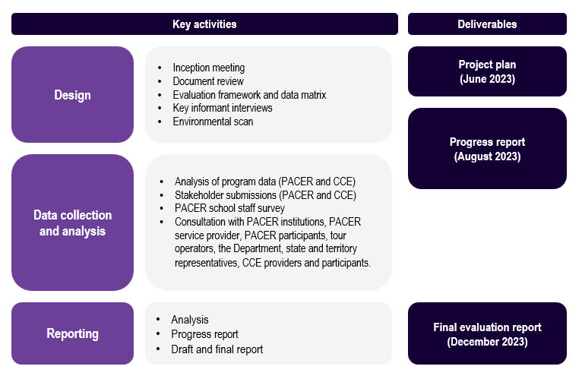
Source: ACIL Allen, Evaluation of PACER and CCE programs Progress Report, 2023

This report
This Final Report is structured as follows:
- Chapter 2: Policy context provides an overview of the policy considerations.
Part 1: PACER
- Chapter 3: Appropriateness examines the alignment of the PACER design with effective practices, key policy considerations and contemporary educational priorities.
- Chapter 4: Fidelity examines the alignment between design and implementation.
- Chapter 5: Effectiveness examines the outcomes achieved by PACER and the Pilot.
- Chapter 6: Efficiency examines the administration and delivery of PACER.
- Chapter 7: Opportunities outlines the opportunities for the future of PACER and the Pilot.
Part 2: CCE Programs
- Chapter 8: Appropriateness outlines the design of the CCE programs and examines alignment with key policy considerations and good practice.
- Chapter 9: Fidelity examines the implementation of the CCE programs.
- Chapter 10: Effectiveness and efficiency examines outcomes and funding.
- Chapter 11: Opportunities outlines the key findings and possible future directions.
Part 3: Strategic performance
- Chapter 12: Key findings outlines the key findings for the delivery of the suite of civics and citizenship education programs and opportunities for further integration and expansion.

Policy context
This chapter provides an overview of the policy context of the PACER and the CCE programs.

Civics and citizenship education in Australia
Civics and citizenship education is a common feature of the education system in modern democracies, delivered through curriculum-based learning, educational programs, and school student governance processes or structures.
Civics education builds knowledge, skills and understanding of society. In the Australian context, this addresses Australia’s federal system of government, democratic processes, public administration, the judiciary, political and social heritage and features local, state, national, regional, and global perspectives. Citizenship education relates to civil rights and responsibilities, political participation and representation, social values, identity, and involvement in the community.
Civics and citizenship education can take different forms, including but not limited to:
- formal learning (curriculum-based lessons or opportunities occurring as part of a student’s ordinary school education)
- participatory learning (non-mandatory participation opportunities within individual school governance structures such as student councils, debating societies and mock elections)
- political contact opportunities (interactive opportunities between students and political actors e.g., politicians and or institutions).
Delivery of civics and citizenship education is supported through the open classroom climate, or the learning culture in a classroom where opportunities are provided which encourage students to debate, express or develop opinions and introduce class discussion.

Australian and State and Territory Government responsibilities
Education is a shared responsibility of the Australian Government and the states and territories. Under the Constitution, the delivery of education in Australia is primarily the responsibility of the state and territory governments.

Curriculum
The Australian Curriculum is developed by the Australian Curriculum, Assessment and Reporting Authority (ACARA). ACARA is also responsible for a national assessment program, and a national data collection and reporting program that supports learning for Australian students.
The Australian Curriculum is endorsed by state and territory education ministers and sets the expectation for what students are taught in schools across the country.
Civics and citizenship content is introduced to the national curriculum throughout compulsory schooling years as a sub strand of HASS and becomes a standalone subject from Year 6-10. As a sub strand of HASS, or as its own subject, civics and citizenship achievement standards include ‘Knowledge and Understanding’ as well as ‘Skills and Inquiry’. More specialised civics and citizenship related subjects such as Legal Studies or Australian Global Politics are also taught at a state and territory level in Year 11 and 12.
At the state and territory level, curriculum and school authorities have responsibility to implement the Australian Curriculum in their schools. This occurs in line with system and jurisdictional policies.11 States and territories make decisions regarding the extent and timing of the intended Australian Curriculum into the local education system.11

Education programs
Alongside curriculum-based teaching and learning, civics and citizenship education programs are funded at a federal, state and territory level. These programs provide additional opportunities for students to experience civics and citizenship content, processes, and scenarios to build knowledge, skills, interest, passion, and confidence. Furthermore, the programs provide broader support to teaching the Australian Curriculum.
At the Commonwealth level, current programs are those in scope for this evaluation – namely, PACER and the suite of CCE initiatives.
At a state and territory level, there are a variety of civics and citizenship education programs which supplement curriculum-based learning. These programs occur within or outside of schools and can involve school or individual student participation.

Commonwealth policy and strategic priorities

Quality Outcomes Program
The PACER and CCE programs are funded under the Quality Outcomes sub-program (QOP) within Outcome 1 Schools, Program 1.5, Early Learning and Schools Support which funds projects of a strategic nature that support improved student learning outcomes in schools and Australia’s national leadership role in school education. The QOP has policy objectives to:
- improve the quality of teaching and learning
- promote national collaboration on curriculum and assessment and reporting outcomes
- enhance the professional role of principals and teachers to support national initiatives
- promote good practice in school organisation and leadership
- promote greater national consistency in schooling.

Strengthening Democracy Taskforce (2023)
The Strengthening Democracy Taskforce (the Taskforce) was established by the Department of Home Affairs in recognition that Australia’s democracy is a national asset that requires protection. The Taskforce is responsible for exploring threats to:
- trusted institutions: the security, integrity, legitimacy, responsiveness, and performance of democratic institutions
- credible information: the accuracy, relevance, responsibility, accessibility, and civility of information flows within a deliberative public sphere
- social inclusion: a society that is connected, cohesive, participatory, engaged, and respectful, reinforcing and reflecting a sense of common purpose and shared identity.
The Taskforce is exploring the role of education, including civics and citizenship education, in supporting Australia’s democracy.

The National School Reform Agreement
The National School Reform Agreement (the Agreement) reflects the Australian and State and Territory Governments’ shared priority to lift student outcomes across Australian schools. The Agreement outlines a set of strategic reforms in areas where national collaboration will have the greatest impact on driving improved outcomes. The reform directions in the Agreement include:
- supporting students, student learning and achievement
- supporting teaching, school leadership and school improvement
- enhancing the national evidence base.

Need for civics and citizenship programs

Student outcomes
While civics and citizenship education is a mandatory component of the Australian Curriculum, student achievement standards are low.
The National Assessment Program-Civics and Citizenship (NAP-CC) data shows that 53% of Year 6 students and 38% of Year 10 students were at or above the proficient standard for civics and citizenship in 2019 (Figure 2.1). Achievement standards have not gone beyond 55% for Year 6 students or beyond 49% for Year 10 students over the 2004-2019 period.
Figure 2.1 Civics and citizenship national achievement data – Year 6 and 10
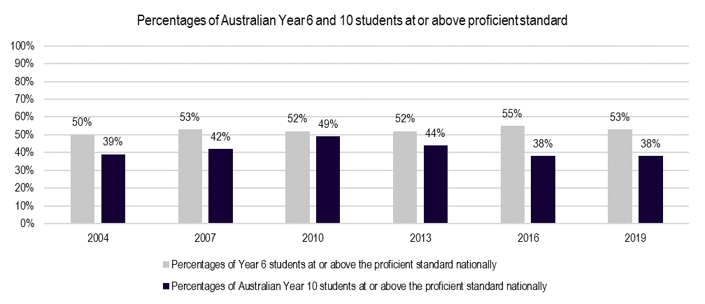
Source: National Assessment Program Civics and Citizenship, 2019

Challenges to democracy
In addition to educational outcomes, there are broader issues regarding trust and confidence in Australia’s democracy that highlight the need for effective civics and citizenship education and engagement of young people in civic affairs.
Challenges for Australia’s democracy are both acute and chronic. They impact upon key strengths of a democratic system including trust in institutions, the availability and access to credible information and social inclusion. Recent inquiries have identified the need for civics and citizenship education programs. These have included:
- Telling Australia’s story – and why it’s important (2019) – report tabled by the Joint Standing Committee on the National Capital and External Territories via their inquiry into Canberra’s national institutions which investigated Australia’s national institutions including but not limited to their:
  - strategies in creating strong brand and presence online
  - experimentation with new forms of public engagement and audience participation
  - outreach activities
  - governance structures.
- Nationhood, National Identity and Democracy: Australia in the wider world (2021) – inquiry undertaken by the Legal and Constitutional Affairs References Committee that investigated issues including but not limited to:
  - changing notions of nationhood and citizenship
  - citizenship rights and obligations
  - social cohesion and cultural identity in the nation state.

Availability of alternative initiatives
There are a range of civics and citizenship education related programs offered at national, state and territory levels, which is likely necessary to meet the diversity of need and capacity to access education.
An environmental scan identified upward of 46 civics and citizenship education-related programs delivered at the state and territory level. There is an even spread across the states and territories, with Victoria and the Commonwealth delivering the highest number of programs. Common approaches include tours, role play/simulation-based experiences, youth parliaments, teacher resources and professional development opportunities for school staff.
Some programs include social equity-based access elements in their design including:
- Distance based travel rebates (for schools to visit State/Territory parliaments or parliament sittings) – these rebates are often limited in number per year and available to eligible schools once per year.
- Regional/rural school specific programs, for example regional sittings of parliament or education outreach programs – some of these programs are run as incursions within school communities and others are held in regional centres.

Effective practice in CCE

Educational design
Experience-based educational opportunities support effective and meaningful engagement for school students. For example, student participation in school governance, extracurricular activities and access to local government has been shown to have positive impacts on the propensity for civic action in students.
Key elements of effective educational design include:
- simulations
- discussion of controversial and current issues, open exchange of ideas, encouragement of independent thinking and expression of opinions
- exposure to civic role models
- service learning
- programs that give students opportunity to discuss issues relevant to their own lives.

Box 2.1 Project Soapbox, Chicago
Project Soapbox was established by a Chicago-based, nonprofit and nonpartisan organisation Mikva Challenge and involves a public speaking curriculum with 5 detailed lessons.
Project Soapbox is aligned with best practice elements of civic education with respect to the opportunities it provides for open idea exchange, public speaking skill development and developing the role of authentic youth voice.
Within the program curriculum, students choose an issue of importance to them which they will structure a speech around. A key feature of this program implementation is in establishing clear expectations for students in listening, peer feedback and encouragement.
At the end of the preparation work, students deliver their speech to their peers with adult community judges in attendance – judges include a broad spectrum of community members including lawyers, parents, clergy, city residents, parents and public officials.
Project Soapbox has been found to increase student confidence in their rhetorical skills and their expectations for future political engagement and in cultivating empathy and connectivity to others in the community.
Source: Andolina, M. & Conklin, H. (2019). Fostering Democratic and Social-Emotional Learning in Action Civics Programming: Factors That Shape Students’ Learning From Project Soapbox. American Educational Research Journal. XX(X). 1-37. DOI: 10.3102/0002831219869599

Student engagement
To be effective, civics and citizenship education needs to extend beyond the ‘what’ and into the ‘how’. Students should be viewed as active citizens in the present and agents in democracy. Student voice and opportunities for students to express their points of view on issues that affect them is crucial.
Two of the recent trends in ‘effective’ modes of civics and citizenship education include positive youth development (PYD) and youth participatory action research (YPAR).
- PYD programs are intentional and pro-social – engaging students within their communities, organisations, schools, peer groups and families in productive and constructive formats.36 When students are offered opportunities to engage in authentic, self-generated meaningful activities, civic competence and commitment can be fostered and the space between civic learning and community involvement can be bridged.
- YPAR offers opportunities for students to learn how to investigate and develop solutions into problems and obstacles that prevent their growth and wellbeing.36 YPAR projects help students who may experience marginalisation or are risk to engage in educational opportunities that can increase student consciousness about their ability to promote and enact social justice in their communities.
YPAR approaches have been associated with improvements in health and wellbeing, agency and leadership, social-emotional, interpersonal, and cognitive development, academic or career outcomes and connectivity and critical consciousness.
With PYD and YPAR roots, ‘action civics’ is also emergent in the best practice civics and citizenship education approaches with key elements including opportunities for:
- students to engage in civic activities within and outside the classroom
- students to choose an issue that is important to them to work out a path to make a difference
- students to reflect on their actions, successes, and challenges throughout the project
- student voices, decisions, and experiences to be valued.
In the context of YPAR, key success factors associated with effectiveness relate to:
- emphasising the sense of ownership and control over the process in youth involved
- promoting youth social and political engagement and their allies with the aim to help address problems identified in research.

Safe and supported discourse
The discussion of controversial issues is an increasingly important element of effective teaching and learning in civics and citizenship education. Discussion is widely viewed as the most appropriate pedagogical tool in the exploration of controversial issues in the classroom – many of which issues land in the context of civics and citizenship. There is a growing evidence base describing learning strategies that result in long-term commitment to civic participation, of which classroom discussion is highlighted to be essential.
Effective discussion for teaching and learning in civics and citizenship entails:
- open, conversational, and non-biased tone in the teaching environment42
- welcoming disagreement, diversity, and deliberation42
- allowing space for civic and political issues and problems in the community42
- providing opportunities for students to analyse issues that matter to them.42
Some of the key success factors to this context relate to what is referred to as a ‘good classroom environment’ encompassing:
- social relationships – the sense of safety and trust between peers and students and staff in classroom environments, including the feeling of safety toward expressing disagreement
- social interaction norms – principles of respect and tolerance among peers and staff
- facilitation – the 3 core aspects to effective facilitation of discussion including:
  - appropriate background knowledge
  - creating interest and engagement
  - locating and defining the issue.
Other effective approaches in civics and citizenship education include educational programs addressing critical thinking, fact checking and analysis in the online and media landscape of civic engagement – where improvements have been found in students online reasoning and other online games, simulations and technology-based programs and/or interventions that can bolster student knowledge and efficacy to engage in online discourse around policy issues of a controversial nature.
Box 2.2 iEngage Summer Civics Institute, Baylor University Texas
The iEngage Summer Civics Institute was established by Baylor University, Texas and funded via grant funding from Hatton W. Sumners Foundation. iEngage was free and available to students entering their fifth through to ninth grade of schooling.
The institute has been analysed in literature as a contemporary example of ‘action civics’ which aims to empower students through a 6-stage process including:
- Examination of their community
- Selection of their issue
- Researching an issue and goal setting
- The analysis of power
- Strategy development
- Taking action to impact policy
The institute was designed to support students to engage in civic action and engaged preservice and in service teachers as leaders on the camp – first engaged in a 3-day professional development workshop on best practices in civics education.
During the camp, youth civic agency was the focus where students were exposed to and interacted with:
- processes and powers of local government, including how these processes and representatives relate to their issues or concerns
- meeting civic leaders
- mock trials and judgments
- primary source materials, artefacts and archival materials related to local community action
- digital games
- community issue fair
- blogs, advocacy campaigns and awareness raising.
The iEngage Summer Civics Institute has been subject to a mixed methods research study into its outcomes finding that the institute successfully incorporated its 4 key competencies including:
- producing 21st century positive youth leaders
- producing active and informed citizens
- increasing youth civic participation
- encouraging youth civic creation.
Source: Blevins, B., LeCompte, K. & Wells, S. (2016). Innovations in Civic Education: Developing Civic Agency Through Action Civics. Theory & Research in Social Education, 44. 344-384. DOI: 10.1080/00933104.2016.1203853

Other success factors
To be successful, civic and citizenship education must:
- Be attentive to the needs of communities – including in relation to political, economic, social, and political dimensions of the student and family communities.
- Contextually go beyond the surface level of a school community (e.g., analysing and debating school rules and projects) and support students to engage in critical thinking and assessment of controversial issues.
- Provide the appropriate academic and emotional supports for students when investigating civics and citizenship issues that may present personal challenges or issues.
- Provide participating students with a hope of civic improvement.
- Provide appropriate scaffolding that supports students in their understanding and skills of how to make a difference.
- Value student experiences.
- Encourage student voice in the investigation of issues of importance to them.

Barriers to success
Challenges in teaching, learning and achievement in civics and citizenship education are not limited to the Australian context and can be seen in many other developed counties such as the United States (US), United Kingdom (UK) and throughout Europe. Key challenges and/or barriers in providing quality, relevant and actionable civics and citizenship education can relate to:
- prioritisation (what priority the subject area is given)
- expertise and specialisation (knowledge, skills and understanding of teaching staff)
- level of support in the community (student or parent / school community generated political or religious sensitivities within the subject area)
- social norms, avoidance and/or self-censorship (the level to which political and social issues of a given school community, individual views or broader national consciousness prevent the discussion of controversial issues within the subject area).

The PACER program

Appropriateness
This chapter examines the alignment of the PACER design with effective practice, key policy considerations and contemporary educational priorities.
Box 3.1 Appropriateness – Key findings
- The design of PACER and the PACER pilot is effective in delivering against the key policy considerations, but there are some limitations in terms of equity and inclusion.
- The PACER and the PACER pilot are consistent with current education policy priorities, including addressing threats to democracy and strengthening young people to be active citizens.
- PACER and the PACER pilot are fit for purpose and educationally valid, but there are opportunities to improve alignment with the principles of contemporary best practices, including strengthening student voice and problem-based learning.
- Governance arrangements are designed appropriately to enable effective administration and issue management but have a limited focus on strategic directions and future planning, which provides an opportunity for future improvement.

Design
PACER was first established in 2006. PACER supports students in Years 4 to 12 to participate in learning experiences in the Nation’s Capital which complement civics and citizenship education delivered in classrooms.
PACER is a travel subsidy program. Financial assistance is paid to schools in the form of a rebate on a per student basis. Rebate rates are determined based on student numbers and the applicant school’s distance from Canberra. To receive the rebate, students must participate in programs delivered by at least 3 mandatory PACER institutions, noting students can also participate in programs at alternative PACER approved institutions should mandatory institutions be fully booked.
Table 3.1 PACER institutions
Mandatory institutions | Alternate institutions
Parliament House  National Electoral Education Centre (NEEC)  Museum of Australian Democracy  Australian War Memorial | Government House  High Court of Australia  National Archives of Australia  National Portrait Gallery  National Museum of Australia  National Capital Authority  National Gallery of Australia  National Film and Sound Archive

Figure 3.1 PACER – Program Logic
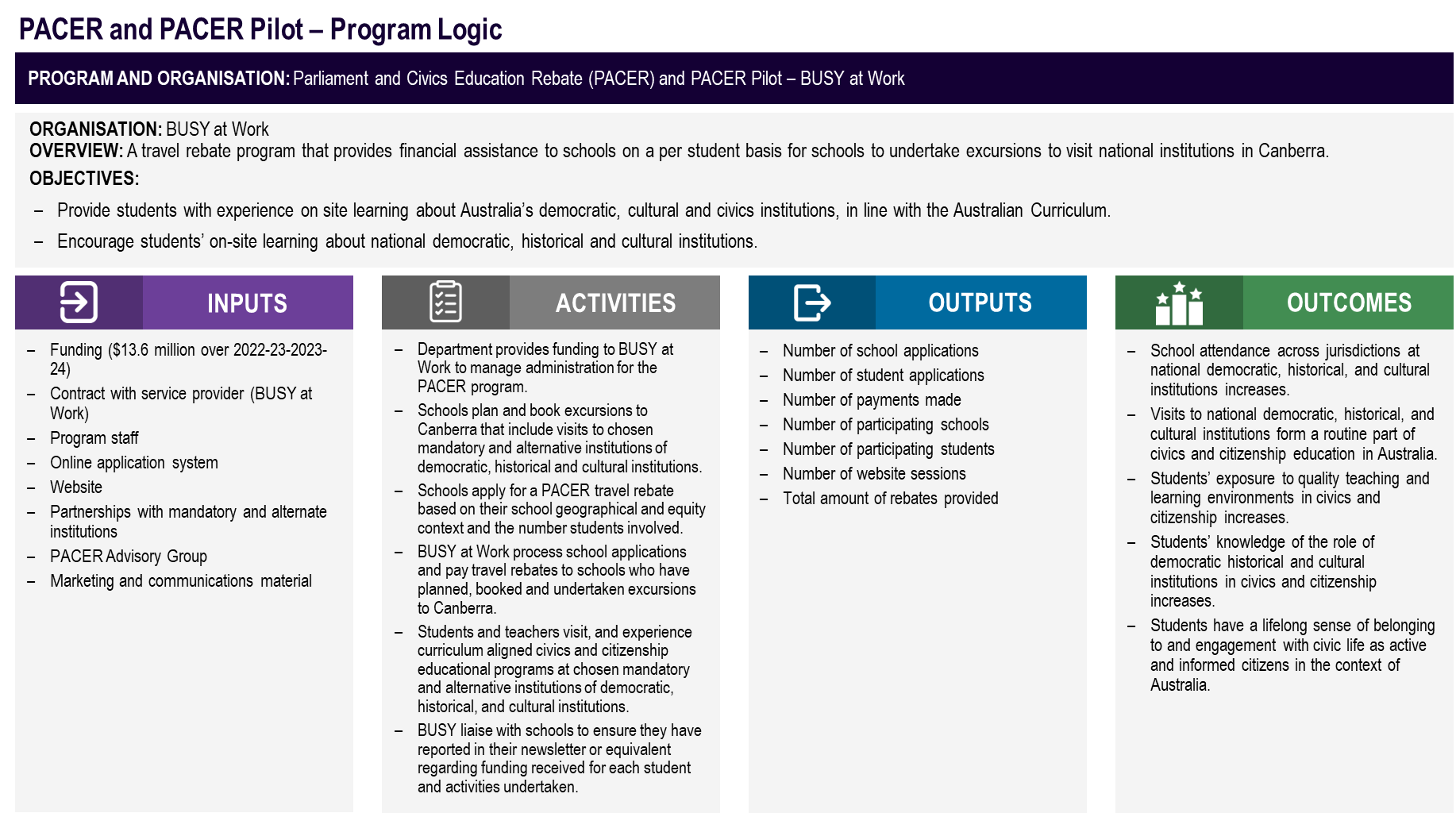
Source: ACIL Allen, 2023.

Roles and responsibilities

Department of Education
The department is responsible for the design, implementation, and oversight of PACER. This includes policy settings, contractual arrangements, and coordination of the PACER Advisory Committee.

BUSY at Work
BUSY at Work is the administrative service provider contracted by the department to provide the administration activities for PACER, including processing rebate applications and ensuring program eligibility is met. BUSY at Work also disburses rebates to schools.

Schools
Schools are responsible for planning and booking their civics and citizenship education excursions to Canberra. Schools may choose to utilise tour operator services to assist their planning and booking activities. Schools make applications for PACER and ensure they meet eligibility criteria by providing evidence including their attendance at the required number of mandatory institutions and excerpts from their school newsletter.

Institutions
PACER institutions facilitate visits and deliver civics and citizenship educational experiences to schools and students.

PACER Advisory Committee
The PACER Advisory Committee (the Committee) is managed by the department and provides governance for PACER. The Committee’s role is to facilitate communication between key stakeholders of the program, including the institutions and provide advice to the department on PACER implementation including:
- effective administration and promotion
- strategies to manage rebate take up
- issues that may impact upon student educational visits to Canberra and national institutions
- other matters arising from relevance.
Members of the Committee include:
- Australian Government Department of Education (Chair & Secretariat)
- the Department of the House of Representatives
- the Parliamentary Education Office, Parliament House
- the Australian War Memorial
- the Museum of Australian Democracy
- the National Electoral Education Centre.
The Committee meetings are also attended by BUSY at Work in an ex officio capacity.

Rebate levels
Zoning and rebate amounts have changed over time. These changes have aimed to address increasing travel costs for schools, especially for those furthest from Canberra.
On 27 March 2023, the PACER Pilot was announced by the Minister for Education. The Pilot includes additional rebate loadings to support schools in outer regional, remote, and very remote locations and schools with an Index of Community and Socio-Economic Advantage (ICSEA) score of 1000 or below (excluding schools at or under 149km from Canberra, which get a flat rate). The Pilot will run for the 2023 school year through to 31 December 2023.
The one-year Pilot was made possible due to unspent PACER funds emerging out of the COVID-19 pandemic and associated school travel restrictions.
These changes have translated into the rebate structure outlined at Table 3.2, including the base PACER and PACER Pilot inclusions.
Table 3.2 PACER structure 2023
Zone |  | Distance from Canberra | Current rates | 50% additional rebate | 50%  ICSEA of 1000 or below | 150%  Outer Regional | 200%  Remote | 250%  Very Remote
 | Zone 0 | 0-149 kilometres | $5 (new) | n/a | $0.00 | $0.00 | $0.00 | $0.00
 | Zone 1 | 150-499 kilometres | $20 | $30 | $15.00 | $45.00 | $60.00 | $75.00
 | Zone 2 | 500-999 kilometres | $30 | $45 | $22.50 | $67.50 | $90.00 | $112.50
 | Zone 3 | 1,000-1,499 kilometres | $60 | $90 | $45.00 | $135.00 | $180.00 | $225.00
 | Zone 4 | 1,500-1,999 kilometres | $100 | $150 | $75.00 | $225.00 | $300.00 | $375.00
 | New Zone 5* | 2,000-2,999 kilometres | n/a | $300 | $150.00 | $450.00 | $600.00 | $750.00
 | New Zone 6 | 3,000 kilometres and over | n/a | $510 | $255.00 | $765.00 | $1,020.00 | $1,275.00
*Includes students from Tasmania due to air/sea travel expenses
Notes: Remote islands receive an extra $120 recognising additional flight costs.
Source: BUSY at Work, 2023, https://www.pacer.org.au/apply/rebate-rates-2/

Alignment with effective practice
There are some elements of PACER that align with contemporary best practice and provide educational validity.
PACER’s immersive learning experiences delivered by the institutions align with two key elements of high-quality civics and citizenship education – simulation (e.g., via the National Electoral Education Centre – voting and the Parliamentary Education Office – parliamentary role play) and exposure to civic role models (e.g., via visits to the Parliament or Australian War Memorial).
PACER supports the provision of scaffolded learning supports. By taking students out of their school and classroom environments, the educational experiences involved in PACER go beyond the local context to expose students to functioning and active elements of Australia’s democracy.
Student voice plays an active role in educational programs provided in PACER institutions. Students are provided some opportunities to consider issues important to them through the design of the educational programs at the institutions.
“From the moment they step in the door we ask them what democracy means to you.” – PACER mandatory institution.
“We try to have open ended opportunities. What are students interested in and how can we bring contemporary learning with historical trends.” – PACER mandatory institution.
PACER institutions provide opportunities for interactions that promote listening, respect and diverse discussion. Students are exposed to challenging content such as political differences and past conflicts. Through this learning experience, students interpret information, reflect, and learn skills in safe and respectful lines of questioning.
While the above elements align, not all PACER activities support project and issue based ‘action civics’ style teaching and learning principles. This may be due, in part, to the short nature of the interactions between institutions and students which may require institutions to focus on more traditional exposure.

Alignment with key policy considerations

Inclusive and equitable participation
The design of the PACER rebate structure supports inclusive and equitable participation through the consideration of both socio-economic and geographic factors.
The core rebate addresses geographical factors by reducing financial barriers to participation for schools further away from Canberra. PACER is also open to all Australian schools and is inclusive of the Australian schooling system. These features provide an opportunity for all Australian schools to participate in the program.
The rebates under the PACER Pilot address socio-economic factors by embedding the ICSEA loading and remoteness loadings. This supports students who face disadvantage which may further limit their ability to participate.
However, while PACER is open to all Australian schools, distribution of funds is led by school applications and is thus ‘first in, first served’. This may lead to some cohorts having a higher level of participation that is not relative to a higher level of need (e.g. schools in NSW and Victoria participating repeatedly vs. low ICSEA schools not participating or participating sparingly).

Alignment with the Australian Curriculum
The design of PACER is highly aligned with the Australian Curriculum.
Almost all survey respondents indicated that the student experiences were aligned with the Australian Curriculum (95%, Figure 3.2). In addition, independent mapping undertaken by this evaluation determine the extent of curriculum alignment for PACER to the Civics and Citizenship subject area in Year 4-10 (years eligible for PACER) showed strong alignment for both Knowledge and Understanding and Skills and Inquiry. An overview of the technique applied, and the overall results is provided in the appendix.
On an aggregate year level basis PACER is more aligned to the Knowledge and Understanding strand than the ‘Skills and Inquiry’ strand achievement standards, alignment also decreases in both areas after Year 6. This may indicate one reason for why PACER is more frequently used by primary school than secondary schools as teachers may see greater value in curriculum alignment and in finding opportunities to link with and supplement classroom learning.
Figure 3.2 PACER participant survey – Curriculum alignment
Source: Survey of PACER program participants, administered by ACIL Allen, 2023. Analysis by ACIL Allen, 2023.

Complimenting other programs
PACER complements programs provided by state and territory governments and other non-government organisations in schools, but there are opportunities to strengthen linkages.
PACER is a unique civics and citizenship school education program offering with a design that is not replicated elsewhere in Australia. The focus on Commonwealth institutions differs from state and territory activities, which focus on the local context. This supports a scaffolded series of educational experiences that can improve student understanding of Australia’s civics and citizenship related systems and structures.
Ninety-six per cent of survey respondents indicated the learning opportunities complemented the civics and citizenship education being provided in their school through (Figure 3.3).
Figure 3.3 PACER participant survey – Complementing state and territory government activity
Source: Survey of PACER program participants, administered by ACIL Allen, 2023. Analysis by ACIL Allen, 2023.

However, the design of PACER operates in isolation from state and territory processes. Consultations indicated that there are no formal mechanisms for the department to connect with state and territory counterparts to ensure the alignment of the design of PACER and local programs. This impacts the level to which departments can cross promote programs and link teaching and learning opportunities.

Alignment with Commonwealth policy and strategic priorities
PACER is aligned to Australian Government strategic priorities.

Quality Outcomes Program
PACER aligns with the QOP by improving the quality of teaching and learning through providing increased exposure to high quality educational experiences at institutions. It also promotes greater national consistency in schooling by providing equal opportunity to schools across the country to engage in relevant civics and citizenship education.

Strengthening Democracy Taskforce (2023)
PACER aligns with the objectives of the Strengthening Democracy Taskforce by delivering civics and citizenship education experiences that promote Australian institutions as trusted pillars of Australian society, by supporting the provision of credible information on government and democracy, and promoting social inclusion by encouraging wide-ranging school participation.

The National School Reform Agreement
The National School Reform Agreement (the Agreement) reflects the Australian and State and Territory governments’ shared responsibility in supporting students, student learning and achievement.
In offering rebates for trips to Canberra, PACER is designed to subsidise immersive in-person civics and citizenship educational opportunities that complement and extend on teaching and learning in classroom environments. Therefore, the program is supporting students and their learning in the Australian Curriculum. The extent to which PACER supports student achievement is harder to determine as the program does not include measurement, monitoring or data related to this domain.
PACER supports teaching through subsidising facilitated, learning programs and experiences that are often delivered by educational and institutional specialists. The role of teachers is supported on the excursions through exposure to:
- new learning styles and content
- indirect professional development
- follow up resources availed through the institutions.
Furthermore, education programs provided by institutions are informed and reviewed in relation to the Australian Curriculum. The programs are therefore in line with teaching requirements for classroom environments.

Fitness for purpose
PACER is underpinned by 3 objectives to increase student’s knowledge and understanding of Australia’s:
- democratic heritage and traditions
- political and legal institutions
- shared values of freedom, tolerance, respect, responsibility and inclusion.
Considering the above objectives, the design of PACER has some mechanisms to ensure the program remains fit-for-purpose, but there are opportunities for improvement.

Democratic heritage and traditions
Students involved in PACER learn about the history of Australia’s democracy via experiential and role play teaching practice. This assist students to see the value of democratic processes and traditions, building their understanding of their individual role in Australian society.

Political and legal institutions
PACER tailors educational programs around students’ presence at institutions to build understanding of the role of political and legal institutions and their own accessibility within their functionality.

Shared values of freedom, tolerance, respect, responsibility and inclusion
The diverse range of institutions through PACER communicate values from the perspective of formal political and legal structures and processes. Students are exposed to patterns of shared civics and citizenship values from multiple angles.
The mandatory institution list has not changed over time. This may result in the PACER program being unable to meet contemporary needs of school students and the Australian Curriculum. However, institutions highlighted their processes to ensure alignment with the curriculum and educational relevance and currency.
“The list of institutions designated as mandatory attractions has not changed for close to 20 years. There should be a broader-based system that enables teachers to choose the attractions that best meet the educational needs of their students as judged by them at the time… This restriction should not limit a school’s potential to undertake a Civics & Citizenship excursion approved by PACER.” – Not-for-profit organisation
The governance structures, discussed below, provide an embedded mechanism that can help program monitoring to ensure that PACER remains fit-for-purpose.

Governance arrangements

PACER Advisory Committee
The PACER Advisory Committee is well-structured to provide effective governance over the mandatory institutions, but there a limited strategic focus.
The design of the Terms of Reference (ToR), frequency of meetings and structure support information sharing, collaboration and identification of delivery risks. The department manages the PACER Advisory Committee and the terms of reference.
The structures are appropriate for the management of potential issues and continuous improvement to enhance the accessibility and quality of programming. Revised reporting requirements, implemented by the department, have assisted in a structured approach to practice – understanding what works and where improvement is needed.
“It’s interesting to hear about what other mandatories are doing. It’s a good place to talk about our challenges/ bookings.” – PACER Advisory Committee member
“I feel light bulb moment when we had our advisory meeting – seeing how they’re updating information and the interactive nature of their programs.” – PACER Advisory Committee member
While the Committee is designed to support operational matters, there is limited focus on the strategic context through the ToR and meeting structure. For example, there is no link in the ToR to alignment between the activities of institutions and key policy considerations or current educational priorities. There are also no embedded mechanisms to drive alignment with evidence-based practices. This has the potential to limit the impact and effectiveness of PACER.
Membership of the Committee is also limited to mandatory institutions. While this helps to provide a manageable focus on core institutions, it limits the potential information sharing and collaborative practice across non-mandatory institutions.

Management of Service Provider (currently BUSY at Work)
The governance provided by the department in managing the PACER contracted service provider BUSY at Work appears to function well for administration, communication and issue management purposes.
BUSY at Work and the department have worked collectively to manage the impacts such as the COVID-19 pandemic. However, there are opportunities to strengthen reporting requirements to monitor program effectiveness and to drive future improvements.
The frequency of contractual meetings and reporting requirements support information sharing, collaboration and identification of delivery risks.
Reporting requirements under current contractual arrangements are largely output based and don’t include outcome or effectiveness indicators. This presents an opportunity to include outcome and effectiveness indicators in future contractual arrangements, and to provide greater potential for continuous improvement or strategic delivery.

Fidelity
This chapter examines the alignment between design and implementation, identifying enablers and barriers.
Box 4.1 Fidelity – Key findings
- The implementation of PACER and the PACER pilot aligns with design, with little variation from the original intent and implementation. However, the original program design did not embed targets for activities or outputs which limits the extent to which fidelity can be quantified.
- The reach of PACER and the PACER pilot is limited, representing approximately 15% and 1.4% of the total school and student population respectively in 2023. Reach is not representative of the distribution of schools and students across Government, Independent and Catholic sectors.
- The implementation of the PACER pilot is shifting rebate patterns with the top 10 Pilot payments accounting for 12% of all rebates (i.e., 0.7% of schools received 12% of total rebates).
- The Pilot (additional loadings attached to ICSEA, remoteness and Zone 0) supported 20,096 students across 459 schools in Australia. Of these schools, 88 (19%) had not accessed PACER before.
- Awareness of PACER and the PACER pilot is limited, as evidenced by the low number of new schools participating year-on-year and the proportion of schools reached. This is related to the passive nature of promotion of the PACER program and limited active outreach to schools.
- Participating schools, institutions and partners are highly satisfied with PACER. Key success factors are simplicity of the administrative application, efficiency of the distribution of funds, clarity of communications and the opportunity to embed curriculum.
- Key barriers for schools in accessing PACER include the lack of active promotion, financial barriers, distance from Canberra, mandatory institution capacity and school staffing and resources.

Reach of PACER

Total reach
The reach of PACER has increased between 2020 and 2023 but has not yet returned to pre COVID-19 levels.
A total of 404,684 students from 3,143 unique schools accessed PACER between 2018 and October 2023. In 2022, there were a total 9,709 schools and 4.1 million students in Australia. Adopting a per-year average of 60,000 students using PACER, 1.4% of Australian students are accessing PACER each year.
While the total number of students accessing PACER has increased, the growth is not relative to increased funding. Where funding delivered and promised for 2023 has increased by approximately 450% from 2022, student numbers rose by only 53%.
This indicates that barriers to schools travelling to Canberra are not limited to financial considerations. Post COVID19, schools are facing other challenges such as time and planning constraints, staffing pressures, the national teacher shortage, increasing up front travel costs, and competing priorities which may be impacting school decisions to undertake an excursion to Canberra.
Figure 4.1 Number of students accessing PACER
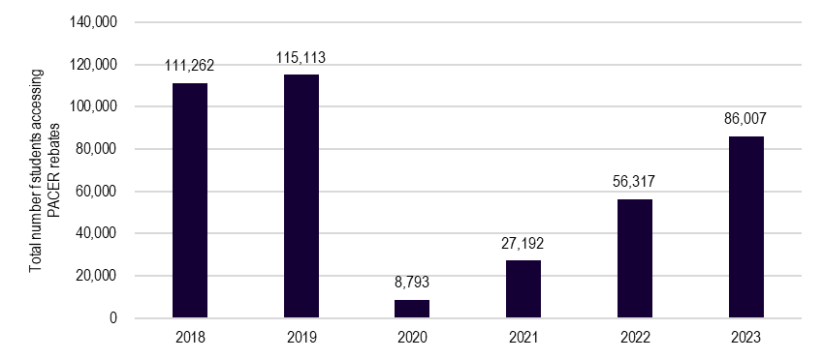
Source: BUSY at Work, program data, 2018-31 October 2023
Note: 2023 figures include the status of schools listed as “Eligible” and “Paid and closed”

Representation across the school system

School sector
The reach of PACER by school sector is not reflective of the demographics of the Australian school system.
Most students and schools accessing PACER are from the government sector, with relative proportions remaining stable year to year. However, these figures are not representative of the Australian school population more broadly, where government schools comprise approximately 70% of schools, independent schools 13%, and Catholic schools 18%. The higher proportion of independent schools is likely influenced by the fact that families at these schools generally have higher socioeconomic advantage and therefore have greater capacity to pay for school trips to Canberra.
Figure 4.2 Distribution of PACER schools by school sector
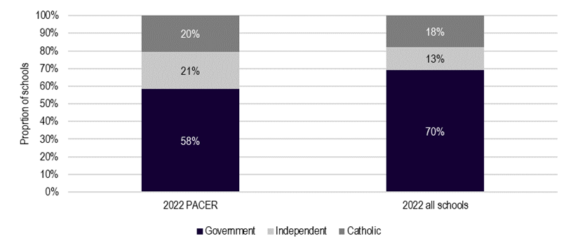
Source: BUSY at Work, program data

Figure 4.3 Percentage of PACER schools by school sector
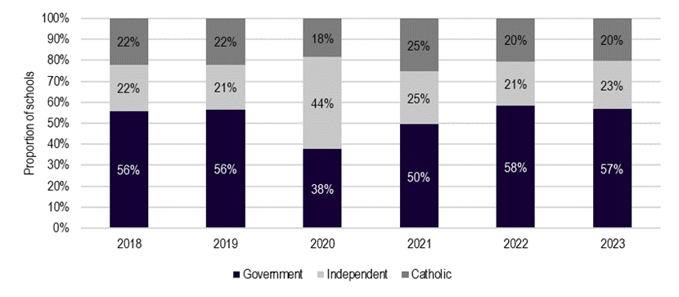
Source: BUSY at Work, program data, 2018-31 October 2023
Note: 2023 figures include the status of schools listed as “Eligible” and “Paid and closed”

School type
Primary schools are slightly overrepresented in PACER schools.
Each year, primary schools tend to make up approximately 67% of PACER schools, slightly more than their Australia-wide proportion of 64%. Only 4 specialist schools accessed PACER in 2023, down from a maximum of 16 in 2019. This indicates there are additional barriers for the participation of these schools.
Figure 4.4 Percentage of PACER schools by type
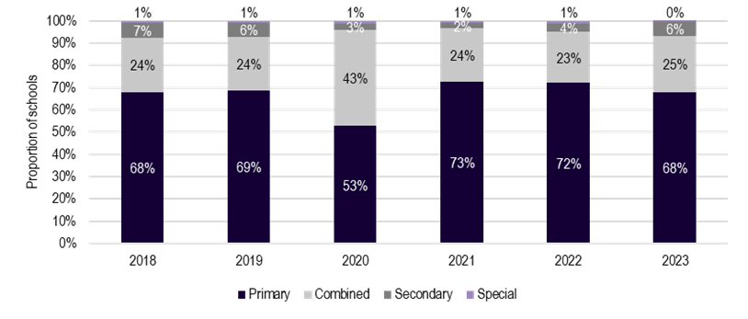
Source: BUSY at Work, program data, 2018-31 October 2023
Note: 2023 figures include the status of schools listed as “Eligible” and “Paid and closed”

By state and territory
Distribution of schools is not evenly spread across states and territories, nor representative of the demographics.
Schools from NSW are overrepresented in PACER, accounting for approximately 56% of schools on average over the 6-year period (compared to comprising 33% of all schools). The next largest is Victoria, with an annual average of approximately 23%, then Queensland with 10%.
Figure 4.5 Proportion of PACER schools by state
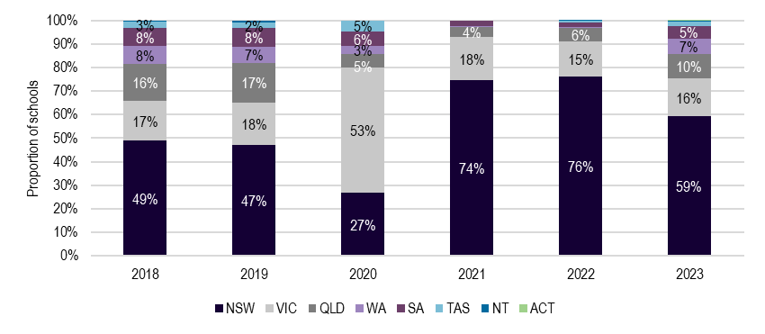
Source: BUSY at Work, program data, 2018-31 October 2023
Note: 2023 figures include the status of schools listed as “Eligible” and “Paid and closed”

Table 4.1 Proportion of PACER schools by state
State | 2018 | 2019 | 2020 | 2021 | 2022 | 2023
NSW | 49% | 47% | 27% | 74% | 76% | 59%
VIC | 17% | 18% | 53% | 18% | 15% | 16%
QLD | 16% | 17% | 5% | 4% | 6% | 10%
WA | 8% | 7% | 3% | 0% | 0% | 7%
SA | 8% | 8% | 6% | 2% | 2% | 5%
TAS | 3% | 2% | 5% | 0% | 1% | 2%
NT | 1% | 1% | 0% | 0% | 0% | 1%
ACT | 0% | 0% | 0% | 0% | 0% | 0%
Source: BUSY at Work, program data, 2018-31 October 2023

By geography
While PACER intends to support schools Australia-wide, participation is skewed to schools that are closer to Canberra.
Zones 1 and 2, being the closest, make up most of the students and schools who accessed the PACER rebates. Zone 6 accounts for more students and schools than zones 3, 4, and 5, but this is representative of the number of schools in those regions. Zones further away tend to bring fewer students than those closer to Canberra.
Figure 4.6 Number of PACER students by Zone
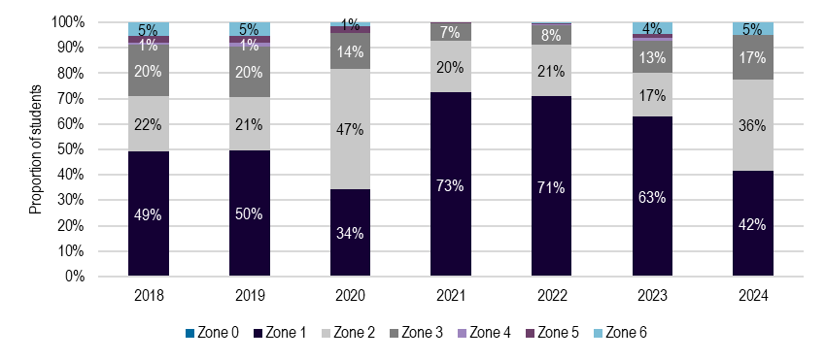
Source: BUSY at Work, program data, 2018-31 October 2023
Note: 2023 figures include the status of schools listed as “Eligible” and “Paid and closed”

Reach of the PACER pilot
Data informing reach of the PACER pilot for 2023 is up to 31 October 2023. This evaluation notes that department has seen a trend of higher monthly participation against previous years continue through November and December 2023.
The PACER pilot is reaching a relatively small number of eligible school cohorts in each category.

Overall
As of October 2023, the Pilot (additional loadings attached to ICSEA, remoteness and Zone 0) supported 20,096 students across 459 schools in Australia. Funding has been delivered via the ICSEA and level of remoteness additional loading categories. 459 schools have received, or are eligible to receive, Pilot rebates. Of these schools, 88 (19%) had not accessed PACER before.
Qualitative feedback indicated that the PACER Pilot has improved program participation and reach. Stakeholders indicated that the additional loadings were essential to improving school participation in the program.
“If not for PACER (additional loading) teachers said they wouldn’t be able to come, especially where from far away or even in Sydney in low socioeconomic east cost areas.” – PACER mandatory institution
Introduction of socio-educational advantage and accessibility/remoteness indexes were considered to be a more effective measure to determine PACER funding to schools that the previously used ‘distance from Canberra’ measure.
“The implementation of additional rebates in March 2023 (in combination with the refining of distance zones) has significantly improved the ability of schools to engage with the Civics & Citizenship programs that NCIs offer.” – Not-for-profit organisation

By category
Across all the Pilot categories, there has been no more than 12.6% of eligible schools accessing the loadings.
Table 4.2 analyses the reach of the Pilot in terms of eligible cohorts. It considers the number of schools that were eligible for the Pilot’s additional rebates of ICSEA, Zone 0 and remote loading (based on their demographics in relation to Zone 0, ICSEA and level of remoteness) as well as those eligible for the standard PACER (based on distance only).
Table 4.2 Reach of the Pilot (number of schools)
Status | Zone 0 | ICSEA | Outer Regional | Remote Area | Very Remote Area | Base rebate only
Didn’t access PACER in 2023 | 327 | 4,121 | 1,271 | 264 | 280 | 3,411
Accessed PACER | 2 | 401 | 144 | 38 | 18 | 1,008
Rate of access | 0.6% | 8.9% | 10.2% | 12.6% | 6.0% | 22.8%
Source: BUSY at Work, program data, 2023 (up until 31 October)
Note: Schools considered as having accessed PACER include the status of schools listed as “Eligible” and “Paid and closed”

By sector
Independent schools in Outer Regional areas are accessing the Pilot at a higher rate than government and Catholic schools, as well as accessing the program at a greater rate more broadly (Figure 4.7).

Figure 4.7 Reach of the Pilot by school sector
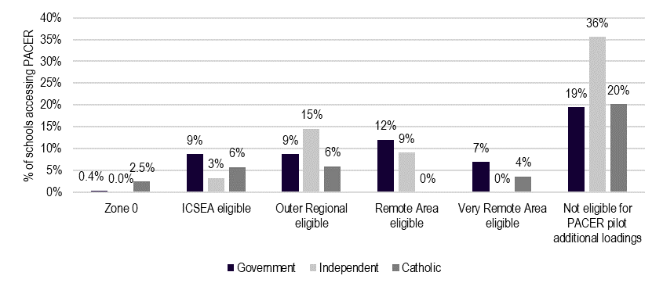
Source: BUSY at Work, program data, 2023 (up until 31 October)
Note: Schools considered as having accessed PACER include the status of schools listed as “Eligible” and “Paid and closed”

Rebates
PACER program rebates are at their highest level financially since 2019. Schools have also accessed the highest per student rebates since this time.

Overall
The total rebates that have been paid to schools has increased year-on-year since 2020, following the impact of the COVID-19 pandemic (Figure 4.8).
The total rebates paid and promised to schools in 2023 is $8.06 million.
Schools in 2023 received or have been promised an average rebate of $5,466, approximately $94 per student. However, the median payment per school is $2,640, with several large rebates skewing the average payment. The top 10 payments in 2023 account for 12% of all rebates (i.e., 0.7% of schools received 12% of total rebates).
Figure 4.8 Total PACER rebate
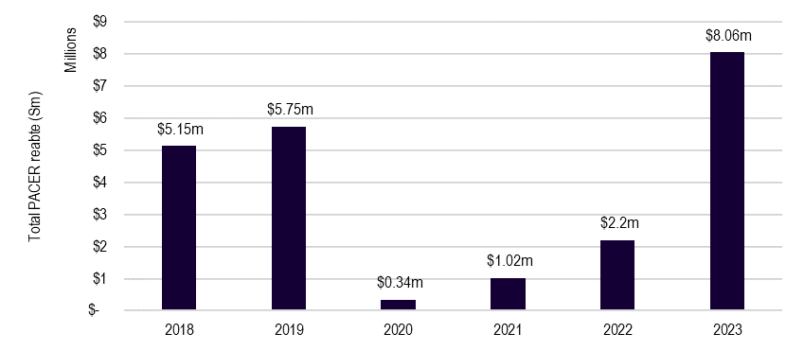
Source: BUSY at Work, program data, 2018-31 October 2023
Note: 2023 figures include the status of schools listed as “Eligible” and “Paid and closed”

By sector
Independent schools are receiving significantly higher rebates per student than their Government and Catholic school counterparts.
In previous years, the average rebate per student across the 3 school sectors was approximately $45 per student. In 2023, independent schools received approximately 50% and 34% more than government and Catholic counterparts (Figure 4.9). This has primarily been driven by several large payments to independent schools in the Northern Territory and Western Australia who have been eligible for Outer Regional additional loadings as well as the larger Zone 6 rebates.
Figure 4.9 Average PACER rebate per student by school sector
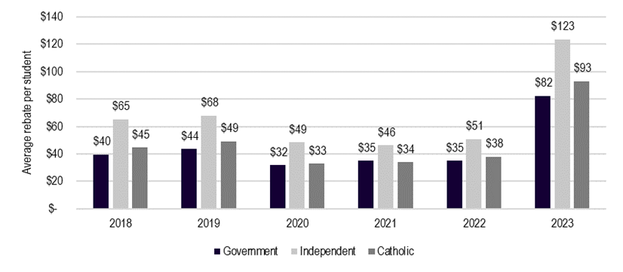
Source: BUSY at Work, program data, 2018-31 October 2023
Note: 2023 figures include the status of schools listed as “Eligible” and “Paid and closed”

Pilot rebates
The Pilot rebates paid and promised to schools totalled $2.2 million, accounting for 27% of all PACER rebates for the year.
Table 4.3 outlines the spread of the ‘paid and closed’ and ‘eligible’ rebates across the additional loading categories with the largest proportion of Pilot rebates provided via the Outer Regional category.
Table 4.3 PACER Pilot rebates
Rebate status | Zone 0 | ICSEA | Outer Regional | Remote Area | Very Remote Area | Total Pilot rebate | Total PACER
Paid and closed | $625 | $420,338 | $782,430 | $378,690 | $128,475 | $1,710,558 | $6,391,508
Eligible | $- | $195,353 | $168,098 | $104,880 | $36,600 | $504,930 | $1,665,235
Total | $625 | $615,690 | $950,528 | $483,570 | $165,075 | $2,215,488 | $8,056,743
Source: BUSY at Work, program data 2023 (up until 31 October)

ICSEA additional loadings are achieving their design to reach schools with an ICSEA below 1000 with the average recipient ICSEA being 947. However, Table 4.4 shows that the ICSEA loadings have not reached the whole spectrum of ICSEA scores and are largely reaching schools at the upper end of the target school cohorts.
Table 4.4 PACER ICSEA loading distribution
ICSEA range | Pilot schools who received ICSEA rebate | Number of schools in ICSEA range | Access rate
500-599 | 1 | 20 | 4.8%
600-699 | 5 | 133 | 3.6%
700-799 | 4 | 148 | 2.6%
800-899 | 48 | 714 | 6.3%
900-999 | 309 | 3330 | 8.5%
1000-1100 | 20 | 3483 | 0.6%
1100-1199 | 12 | 1392 | 0.9%
Source: BUSY at Work, program data, 2023 (up until 31 October)
Note: 2022 ICSEA figures were used, which is why there are some schools with apparent ICSEA scores above 1000. These figures are likely out of date but are used here to show a general distribution.

Table 4.5 compares previous years of the PACER program to 2023 and the introduction of the Pilot loadings. There is an increase in the number of schools within each category who are accessing the program between 2022 and 2023, but it is unclear whether this is due to the lifting of travel restrictions / shifting travel behaviour post COVID-19, or the availability of the additional Pilot loadings. What is clear, however, is that the Pilot has not restored the rate of access to the program from pre-COVID levels. Across all states and territories, and across nearly all Pilot eligibilities, more schools were accessing PACER prior to 2020 than in 2023.
Table 4.5 Pilot eligibility by state and year
State |  | Year | ICSEA <1000 | Outer regional | Remote | Very remote
 | New South Wales | 2018 | 374 | 106 | 11 | 3
 | New South Wales | 2019 | 354 | 85 | 8 | 3
 | New South Wales | 2020 | 7 | 0 | 0 | 1
 | New South Wales | 2021 | 82 | 26 | 1 | 3
 | New South Wales | 2022 | 289 | 83 | 10 | 1
 | New South Wales | 2023 | 269 | 69 | 7 | 5
 | Victoria | 2018 | 66 | 36 | 0 | 0
 | Victoria | 2019 | 77 | 35 | 0 | 0
 | Victoria | 2020 | 13 | 1 | 0 | 0
 | Victoria | 2021 | 11 | 5 | 0 | 0
 | Victoria | 2022 | 27 | 18 | 0 | 0
 | Victoria | 2023 | 40 | 20 | 0 | 0
 | Western Australia | 2018 | 52 | 17 | 13 | 9
 | Western Australia | 2019 | 45 | 23 | 10 | 3
 | Western Australia | 2020 | 2 | 1 | 0 | 0
 | Western Australia | 2021 | 1 | 0 | 1 | 0
 | Western Australia | 2022 | 1 | 0 | 0 | 0
 | Western Australia | 2023 | 26 | 16 | 14 | 4
 | South Australia | 2018 | 42 | 22 | 6 | 2
 | South Australia | 2019 | 42 | 20 | 10 | 2
 | South Australia | 2020 | 1 | 0 | 0 | 0
 | South Australia | 2021 | 1 | 1 | 0 | 0
 | South Australia | 2022 | 3 | 1 | 0 | 1
 | South Australia | 2023 | 14 | 8 | 4 | 1
 | Queensland | 2018 | 86 | 34 | 9 | 3
 | Queensland | 2019 | 111 | 58 | 9 | 8
 | Queensland | 2020 | 0 | 1 | 0 | 0
 | Queensland | 2021 | 2 | 1 | 2 | 0
 | Queensland | 2022 | 17 | 11 | 2 | 2
 | Queensland | 2023 | 40 | 24 | 9 | 5
 | Tasmania | 2018 | 19 | 17 | 0 | 0
 | Tasmania | 2019 | 21 | 13 | 1 | 2
 | Tasmania | 2020 | 3 | 3 | 0 | 0
 | Tasmania | 2021 | 0 | 0 | 0 | 0
 | Tasmania | 2022 | 3 | 2 | 0 | 0
 | Tasmania | 2023 | 6 | 2 | 1 | 1
 | Northern Territory | 2018 | 6 | 8 | 1 | 1
 | Northern Territory | 2019 | 11 | 10 | 4 | 1
 | Northern Territory | 2020 | 0 | 0 | 0 | 0
 | Northern Territory | 2021 | 0 | 0 | 0 | 0
 | Northern Territory | 2022 | 1 | 0 | 1 | 0
 | Northern Territory | 2023 | 6 | 5 | 3 | 2
 | ACT | 2018 | 0 | 0 | 0 | 0
 | ACT | 2019 | 0 | 0 | 0 | 0
 | ACT | 2020 | 0 | 0 | 0 | 0
 | ACT | 2021 | 0 | 0 | 0 | 0
 | ACT | 2022 | 0 | 0 | 0 | 0
 | ACT | 2023 | 0 | 0 | 0 | 0
 | National | 2018 | 645 | 240 | 40 | 18
 | National | 2019 | 661 | 244 | 42 | 19
 | National | 2020 | 26 | 6 | 0 | 1
 | National | 2021 | 97 | 33 | 4 | 3
 | National | 2022 | 341 | 115 | 13 | 4
 | National | 2023 | 401 | 144 | 38 | 18
 | Source: BUSY at Work, Program data 2018-31 October 2023
Table 4.6 provides a summary of the top 10 highest rebates paid in 2023. All but one of 10 of these rebates included Pilot additional loadings, with Good Shepherd Lutheran College in Howard Springs NT accessing the highest rebate at $91,800, equivalent to $1,275 per student. Of the top 10, there is an even spread of Independent (4), Government (5) and Catholic (1) schools. Western Australia has attracted the highest proportion of the top 10 rebates.

Table 4.6 Top 10 highest PACERs in 2023
School name | Sector | State | Location | Distance | ICSEA | No. Students | Base rebate | Island rebate | Total ICSEA | Total Outer Regional | Total Remote | Total Very Remote | Total PACER rebate | Rebate per student
Good Shepherd Lutheran College - Howard Springs | Independent | NT | Outer Regional | 3,000 kilometres and over (Zone 6) | 1042 | 72 | 36,720 |  |  | $55,080 |  |  | $91,800 | $1,275
St Mary's Anglican Girls' School - Karrinyup | Independent | WA | Major Cities | 3,000 kilometres and over (Zone 6) | 1155 | 169 | $86,190 |  |  |  |  |  | $86,190 | $510
Northern Territory Christian College | Independent | NT | Outer Regional | 3,000 kilometres and over (Zone 6) | 971 | 54 | $27,540 |  | $13,770 | $41,310 |  |  | $82,620 | $1,530
Hedland Senior High School | Government | WA | Remote | 3,000 kilometres and over (Zone 6) | 913 | 42 | $21,420 |  | $10,710 |  | $42,840 |  | $74,970 | $1,785
Mount Barker Community College | Government | WA | Outer Regional | 3,000 kilometres and over (Zone 6) | 933 | 48 | $24,480 |  | $12,240 | $36,720 |  |  | $73,440 | $1,530
Esperance Anglican Community School | Independent | WA | Remote | 3,000 kilometres and over (Zone 6) | 1007 | 48 | $24,480 |  |  |  | $48,960 |  | $73,440 | $1,530
Humpty Doo Primary School | Government | NT | Outer Regional | 3,000 kilometres and over (Zone 6) | 920 | 47 | $23,970 |  | $11,985 | $35,955 |  |  | $71,910 | $1,530
St Joseph's Catholic College - Katherine | Catholic | NT | Remote | 3,000 kilometres and over (Zone 6) | 969 | 40 | $20,400 |  | $10,200 |  | $40,800 |  | $71,400 | $1,785
Christmas Island District High School | Government | Christmas Island | Very Remote | 3,000 kilometres and over (Zone 6) | 1001 | 32 | 16,320 | $3,840 |  |  |  | $40,800 | $60,960 | $1,905
Baynton West Primary School | Government | WA | Remote | 3,000 kilometres and over (Zone 6) | 1003 | 33 | 16,830 |  | $8,415 |  | $33,660 |  | $58,905 | $1,785

Source: BUSY at Work. 2023 (up until 31 October)

Awareness and accessibility
Awareness of PACER is limited as a result of the constrained promotion and communication channels.
State and territory representatives reported that there was limited awareness of PACER in their jurisdictions. Some states and territory representatives consulted were not aware of PACER until being consulted as part of this evaluation. As discussed in relation to governance, there are no formal connections to build awareness of PACER through the existing departmental approach.
Alternative and mandatory institutions agreed with state and territory feedback, noting that schools were generally repeat participants in PACER. Institutions noted that awareness was often person-dependent, with individual school staff or school leaders familiar with PACER.
“No one knows about the program, or improvements to program for additional money, because PACER providers do not promote it.” – PACER alternative institution
Table 4.7 shows the number of new schools to PACER in each year, which provides some indication of whether awareness is growing. The number of new schools applying to the program has been rising since 2020, which indicates that familiarity may be growing, or that schools who accessed the program prior to 2019 are returning to PACER. There were no clear data on why this change has occurred, with the exception of the introduction of the Pilot.
Table 4.7 Number of new PACER schools year on year
Year | Number of new schools | Percentage of new schools
2020 | 54 | 9%
2021 | 65 | 8%
2022 | 169 | 15%
2023 | 235 | 16%
Source: BUSY at Work, Program data 2018-2023

Table 4.8 compares the location and ICSEA eligibility of schools who are new to PACER and schools who have accessed the PACER rebate before 2023. In almost all Pilot categories, and across all states, of the schools who received a Pilot rebate, more schools had accessed PACER before the introduction of the Pilot program than were new to the program.
Table 4.8 New and old PACER schools by 2023 Pilot loading
State | ICSEA New to PACER | ICSEA Accessed prior  (2018-22) | Outer regional New to PACER | Outer regional Accessed prior (2018-22) | Remote New to PACER | Remote Accessed prior (2018-22) | Very remote New to PACER | Very remote Accessed prior (2018-22)
VIC | 12 | 27 | 8 | 15 | 0 | 1 | 0 | 0
NSW | 32 | 234 | 10 | 56 | 0 | 4 | 0 | 5
TAS | 2 | 4 | 0 | 3 | 1 | 0 | 0 | 1
SA | 6 | 8 | 5 | 5 | 1 | 6 | 1 | 0
QLD | 15 | 25 | 7 | 15 | 4 | 6 | 4 | 1
WA | 4 | 22 | 3 | 10 | 0 | 16 | 1 | 3
NT | 4 | 2 | 1 | 2 | 2 | 0 | 2 | 0
ACT | 0 | 0 | 0 | 0 | 0 | 0 | 0 | 0
Total | 75 | 322 | 34 | 106 | 8 | 33 | 8 | 10
Source: BUSY at Work, program data, 2018-31 October 2023

Table 4.9 examines how the additional loadings were combined / not combined amongst the new schools that received Pilot rebates. Along the diagonal is the new schools who received that specific Pilot loading in isolation. In the first column, the number of schools who received the location-based loadings on top of the ICSEA rebate are split out by outer regional, remote, and very remote.
Almost half of those who received an ICSEA rebate also received a location-based rebate. For instance, of the 8 new schools who received the “Very remote” additional rebate, all received the ICSEA rebate (Table 4.9). This data shows that the current funding model is enabling loading categories to be accessed simultaneously. This is potentially linked to the fact that the ICSEA modelling (calculated by ACARA) includes remoteness in its formula, therefore schools are eligible for both.
Table 4.9 Interaction between Pilot additional loadings
Loading | ICSEA | Outer regional | Remote | Very remote
ICSEA | 38
Outer regional | 22 | 12
Remote | 7 | 0 | 1
Very remote | 8 | 0 | 0 | 0
Source: BUSY at Work, program data, 2023
Table 4.9 also shows that the ICSEA loading was the most commonly received/promised category among new schools who accessed the Pilot. Of the 88 new schools to PACER via the Pilot, 75 accessed the ICSEA loading. This could mean that of the Pilot loading categories, ICSEA has been the most enticing in shaping new PACER participation. However, it cannot be confirmed whether it is the availability of this loading that has solely driven new PACER participation.
Communication approaches for promotion are limited. School staff who had participated in PACER indicated that they were generally made aware of PACER through word of mouth (36%, Figure 4.10) or the PACER website (27%). The remainder of staff learned about the program through travel agents or tour companies, or via communications from program providers. A significant proportion (23% of respondents who identified ‘other’ as their mode of awareness) of schools identified that their school had historically and repeatedly implemented in their school.
Figure 4.10 PACER participant survey – Mode of finding out about PACER
Source: Survey of PACER program participants, administered by ACIL Allen, 2023. Analysis by ACIL Allen, 2023.

Level of satisfaction
Stakeholders across the education sector who are aware of PACER are broadly satisfied with the design and implementation.
Over half of surveyed school staff indicated that they were significantly satisfied with the program (59%, Figure 4.11), and almost all were at least moderately satisfied (89%). Less than half of respondents found that the program met their needs significantly (43%), with just over three-quarters indicating that the program met their needs at least moderately (77%).
Those receiving the 50% additional rebate, ICSEA rebate, outer region and very remote rebates indicated a high level of satisfaction (average of 78% significantly satisfied). Similarly, those receiving the 50% additional rebate and ICSEA rebate indicated that the program significantly met their needs at higher rates (average of 57% significantly med needs). Respondents indicated that, whilst appreciative of the rebate, additional financial supports would enable the program to better meet their needs in addressing the increased cost of living.
Figure 4.11 PACER participant survey – Satisfaction
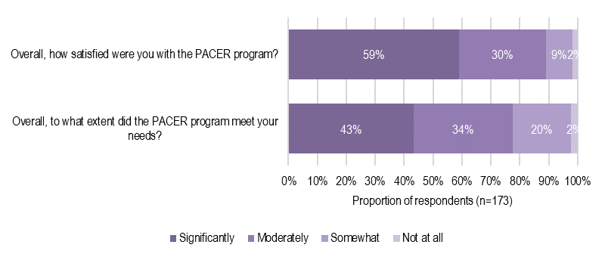
Source: Survey of PACER program participants, administered by ACIL Allen, 2023. Analysis by ACIL Allen, 2023.

Perspectives of institutions and state and territory representatives were also highly positive. Stakeholders referenced the positive experiences of students and staff regarding the learning activities received and the immersive and real-life nature of the excursions as contributing to their level of satisfaction.
“Students rave about their experience, they come back on such a high.” – PACER school staff participant
“Our feedback is overwhelmingly positive about the journey they’ve been on, and the stories they’ve learned.” – PACER mandatory institution

Administration processes and communication processes
Administrative arrangements are operating effectively and supporting efficient delivery of PACER.
Schools who have previously participated found the administrative and communication processes sufficient to their needs and user friendly, particularly the current online approach. Most surveyed school staff reported that information on the PACER website was helpful (84%, Figure 4.12), and that the application process was easy to navigate, with assistance available when needed (81%). This was consistent across respondent characteristics.
“It [process to access rebate] was easy.” – PACER school staff participant
“[The PACER website] was straightforward and simple to use.” – PACER school staff participant
Figure 4.12 PACER participant survey – Administration and information
Source: Survey of PACER program participants, administered by ACIL Allen, 2023. Analysis by ACIL Allen, 2023.

Schools and tour operators highlighted that while the process was sufficient, the administrative burden was high. This was a result of the level of documentation required to evidence excursion bookings and receive the rebate, compounded if itineraries needed to change.
“The only issue was the documentation required for the application, I didn’t receive a lot of the booking confirmations from attractions because it was organised by the tour company, so I had to cobble together screen shots of emails and receipts provided by the tour company as evidence of bookings.” – PACER school staff participant
“Last year we just had to write down the days we were going to certain attractions/exhibits, this year they wanted a full schedule, which we don’t actually finalise until we’re about to go on the trip, but Busy at Work ask for it way earlier.” – PACER school staff participant
“Participating services should be able to send in evidence of schools attending programs and reduce administrative burden on schools.” – PACER school staff participant

Enablers

Clear guidelines
Accessible communications and easily understandable guidelines are assisting schools to participate in PACER. Schools highlighted the benefit of understanding requirements in supporting planning and risk management associated with excursions. Clear program information has allowed schools to communicate to families about rebates and costs, supporting engagement.
“Knowing that a rebate is available helps us sell it to parents and engage families early and get their buy-in for the trip. Knowing the exact rebate amounts means we can communicate it to families with advance notice and the timeframe of when the rebate will come through, which is valuable.” – PACER school staff participant
Tour operators are playing a key role in effective communication. Their awareness of institution requirements and evidence requirements of PACER has improved the efficiency for schools in planning trips to Canberra and reduced the planning burden.
“[Tour operators] are on top of PACER, the first thing they do is send me a timeline of due dates, PACER is included in the checklist they provide, despite it not being something that matters to them.” – PACER school staff participant

Simple application
The application process is user-friendly and digitised. This has been a key enabler for schools in submitting applications and accessing rebates. The new online application system has been well received by schools and institutions alike for its simplicity and ease of access. Schools highlighted the benefit of simple processes in minimising the administrative burden on them.
“Ease of access to information for the application and the actual application process itself. It only took me 15 minutes to complete it, I just had to fill in the gaps with the information I had.” – PACER school staff participant
Institutions have greatly appreciated the removal of the hard copy stamping or check off processes previously required for each school group visiting. The removal of these processes allowed institutions to focus on program delivery rather than administrative burden.

Opportunity to embed curriculum
Schools who participate regularly in PACER have been able to embed the delivery of the HASS curriculum for certain year levels, with the program providing a milestone in teaching, learning and reflection opportunities. PACER trips are often cemented into the school schedule or form a ‘rite-of-passage’ for certain grade levels (often Grade 6). This has additional benefits of reducing the planning burden on teachers for teaching and learning activities.
“I’ve been here for 10 years, every second year since I’ve joined, we’ve taken students from years 10 and 11 to Canberra and we’ve applied for the PACER rebate each time…We facilitate the trip through the humanities faculty, we’ve integrated a course based on the SACE for democracy and civic engagement.” – PACER school staff participant

Barriers

Lack of active promotion
There is limited awareness across Australian schools of PACER and the Pilot. The current program design operates under a passive communication approach through the website and broad-based email campaign, which relies on schools seeking out information or reaching the right person via the email distribution. This limits the extent to which new schools are attracted to the program and able to travel to the relevant institutions. Feedback indicates that this is particularly relevant for the Pilot, with a need for promotion to ensure schools are aware of the increased support available.
“The biggest barrier is lack of awareness, which stems from a lack of promotion.” – State or territory representative.

Financial barriers
Increasing travel costs and cost of living pressures present significant barriers for schools considering travel under PACER. Financial barriers are reflected in the rising costs of accommodation, flights and coaches, tour operators and food. While the Pilot provided additional funding support for schools most in need, the current rebates do not significantly reduce the cost of travel for schools. As a partial rebate program, the most disadvantaged schools will likely continue to face financial barriers when considering their participation.
“Everything is going up in price and while we very much appreciate the $30.00 everyone gets back; this excursion is pricing itself out of business.” – PACER school staff participant

Distance from Canberra
Schools further away experience greater logistical barriers in travelling to Canberra. The Pilot rebates are designed to address the increased cost associated with distance but often don’t account for the modes of transport required – for example, taking a bus to a regional airport as opposed to being closely located to a major airport.
“For very remote students, barriers are not only distance and financials costs, but it’s also the logistical costs as well. A student in remote areas might need to catch a mail-run flight, then get another connecting flight to Canberra, it results in large time out of school for students and teachers.” – State or territory representative

Institution capacity
The capacity of PACER institutions creates administrative barriers for schools. Mandatory institutions may not be able to support PACER schools at peak periods if they are already fully booked. Institutions have noted bookings often fill up to 2 years in advance, creating additional complexities for schools in planning and scheduling their arrangements.
“We need to hit the mandatory institutions on the itinerary to ensure schools are approved for PACER. This can be hard to juggle at times, particularly as some of these institutions have limited capacity and availability.” – Tour operator
Alternative institutions highlighted capacity to cater for more schools and students than currently accessed. This shows that the barrier of over-subscription faced by the mandatory institutions has potential to be offset by increased use of the alternative institutions.
“I’m willing to open the building early and close later to get more kids to see us.” – PACER alternative institution
However, the program data does not support these conclusions. BUSY at Work program reporting, shows that 94% of trips planned/visited the minimum 3-4 mandatory institutions. Six per cent of trips filled a minimum mandatory institution spot with an alternative institution visit. While these numbers may have been impacted by booking changes post data reporting, there is only a small percentage of schools that are unable to access mandatory institutions.
This data does not capture schools who may have initially engaged with the PACER application platform, attempted to book into mandatory institutions and felt the administration required too burdensome to continue.

School staffing and resourcing
Nation-wide teacher shortages are impacting the ability for schools to participate in excursions and trips. Schools reported that it was difficult to provide the required staff to student ratios and maintain staffing back in the classroom.
“Pressures around workload and workforce shortages are hard. The big picture workload is that teachers are doing 2000 hours in preparation each year, then they do the normal teaching hours on top of that, it’s almost like having 2 full-time jobs, and pressure builds on the workforce.” – State or territory representative.
Changed Enterprise Bargaining Agreements (EBAs) around time-in-lieu for staff on camps at the state and territory level may exacerbate these pressures into the future, making it more difficult for schools to financially support excursions and trips. For instance, the Victorian Government Schools Agreement 2022 Time-in-Lieu provisions mean that work required of teachers that exceeds their 38-hour full time or pro rata employment will be granted time-in-lieu.
“Schools don’t do anything outside of the 8:30 to 4:30 timeslot. Given how the system is working currently [interstate travel] would result in significant time in lieu. This is already impacting subject camps (like outdoor education) and school camps.” – State or territory representative

Effectiveness
This chapter examines the outcomes achieved by the PACER program and Pilot.
Box 5.1 Effectiveness – Key findings
- PACER is having a positive impact on increasing visits to national institutions, driving participation in civics and citizenship education.
- PACER is effective in increasing student knowledge about the role of institutions in civics and citizenship at the content and practical level.
- PACER is impacting students’ and schools’ lifelong sense of belonging and engagement in civic life through driving student and school active community participation beyond the life of the excursion.

Overview
PACER aims to provide students with experiences of on site learning about Australia’s democratic, cultural and civics institutions, in line with the Australian Curriculum and to encourage students on site learning about these institutions.
The PACER program logic outlines 5 key outcomes relating to increased school attendance across jurisdictions at institutions, visits to institutions forming a routine part of CCE, students increasing exposure to quality teaching and learning, and improved student knowledge. The assessment of effectiveness is structured under the domains of:
- engagement with civics and citizenship
- student outcomes.
There are no formal measures of effectiveness embedded within PACER.
The assessment in this chapter relies upon survey data, stakeholder consultations and stakeholder submissions to measure impact. There is no direct feedback from students, which limits the ability to comment on their perspectives of change.

Engagement with civics and citizenship

Increased attendance across jurisdictions

Outcome 1: School attendance across jurisdictions at national democratic, historical and cultural institutions increases.
School staff reported that PACER had a positive influence on their decision to undertake an excursion to Canberra.
Most surveyed staff indicated that the rebate positively influenced their decision to visit the institutions (72%, Figure 5.1), particularly those in their first year of participation and in zones 4, 5 and 6. However, fewer than half of respondents indicated that they would not have travelled without PACER (38%). This was consistent across zones, participating years and rebate types. This indicates that PACER has largely supported schools that were already intending to undertake excursions to Canberra. PACER has been less effective in influencing schools not already intending to undertake excursions.
Figure 5.1 PACER participant survey – Impact on participation
Source: Survey of PACER program participants, administered by ACIL Allen, 2023. Analysis by ACIL Allen, 2023.

Mandatory institutions indicated that because of PACER they are at capacity for school visits and in some cases book out up to 2 years in advance. This indicates that the number school visits have increased to their capacity ceilings.
“We book out 2 years in advance, particularly in winter periods.” – PACER mandatory institution.
PACER has particularly impacted school attendance at national institutions for regional locations. These schools are less exposed to these sorts of institutions in their every day and have benefitted from an incentive that can bring these experiences to their teaching and learning journey.
“It’s [PACER] a good program to help schools such as ours which is 1,600km from Brisbane, kids don’t often go to capital cities, and they’re so excited to go to Canberra, they find it amazing.” – PACER school staff participant.
However, PACER institutions have communicated that NSW and Victoria make up most school visitors. While it is noted within NSW and Victoria there have been some new schools to PACER via the Pilot that are representing low ICSEA and Outer Regional cohorts, attendance has not increased across all jurisdictions to their full proportions (Table 4.8).
“…the majority of visiting schools are from NSW and Vic.” – PACER mandatory institution.

Routine part of CCE

Outcome 2: Visits to national democratic, historical and cultural institutions form a routine part of civics and citizenship education in Australia.
School staff indicated that the PACER rebates had increased their school participation in civics and citizenship. Most survey respondents indicated that the rebate had increased their school’s participation in national democratic, historical and cultural institutions (81%, Figure 5.2).
Figure 5.2 PACER participant survey – School participation
Source: Survey of PACER program participants, administered by ACIL Allen, 2023. Analysis by ACIL Allen, 2023.

PACER is forming a routine part of civics and citizenship curriculum delivery for schools who have embedded the program into their schedules as repeat users of the program. Participation data shows that there is a significant proportion of schools who utilise PACER frequently, often yearly. These schools incorporate the excursion to Canberra as an element of knowledge delivery and/or reflection and assessment. This shows that for repeat users of the program, visits to institutions are being integrated into existing learning schedules to complement classroom learning. The visits become an expected offering for staff, students, and families alike.
“Prior to going [on the PACER excursion], usually around week 7 of term 1, we do a unit on humanities and social sciences, this includes looking at governments and how they operate.” – PACER school staff participant.
“The voting simulation at Parliament House helps bring the things they’ve [students] learned in the classroom together and shows students the responsibilities they have as citizens and what the involvement in the democratic process means.” – PACER school staff participant.
PACER improves family buy-in, particularly for those with financial struggles. Regional, rural, and remote schools and disadvantaged schools benefit from PACER in terms of driving their visits to national institutions.
Such schools cannot as readily and routinely access Canberra as their metropolitan counterparts and therefore PACER has likely had a greater impact on driving their decisions to participate.
“Recent changes following the impact of COVID, plus the addition of the PACER Pilot program, are significant and positive steps in the right direction to increase equitable and inclusive participation, particularly for students in rural, regional and remote locations and students from low SES schools.” – Peak body organisation.
“Given we [school community] live in a regional centre, it’s really important that there is an incentive for schools to take their students to Canberra.” – PACER school staff participant.

Student outcomes

Student exposure

Outcome 3: Students’ exposure to quality teaching and learning environments in civics and citizenship increases.
School staff reported that the opportunities provided through PACER were highly impactful teaching and learning opportunities. Almost all survey respondents reported that the Canberra excursion provided positive learning opportunities for their students (95%, Figure 5.3).
Figure 5.3 PACER participant survey – Educational opportunities
Source: Survey of PACER program participants, administered by ACIL Allen, 2023. Analysis by ACIL Allen, 2023.

PACER programs enable direct engagement opportunities with democratic institutions and provide vital learning and insight into Australia’s history.
“A lot of [PACER] builds on their learning in years 8 and 9. There isn’t a requirement to continue civics education as much, this program helps explain why these things exist and why are they important.” – PACER school staff participant.
Exposure to PACER institutions has also increased student knowledge from a content to a practice base via role plays, simulations and viewing real life legal and parliamentary proceedings. These immersive experiences supplement and extend classroom learning and enable student knowledge to be enhanced through utilising multiple sensory modes.
“…our boys are visual learners; they want to get in there and touch and see things in person.” – PACER school staff participant.
“We have really interesting conversations arising from being in Canberra with the students which can help hook kid’s interest when they’re back in the classroom as well.” – PACER school staff participant.

Student knowledge

Outcome 4: Students’ knowledge of the role of democratic, historical and cultural institutions in civics and citizenship increases.
School staff view PACER’s impact on student educational outcomes positively. Most survey respondents indicated that student knowledge regarding the role of democratic, historical and cultural institutions in civics and citizenship had increased (88%, Figure 5.4) and that student exposure to quality teaching and learning environments in this area had increased (85%). This was consistent across survey respondent characteristics.
Figure 5.4 PACER participant survey – Educational impact
Source: Survey of PACER program participants, administered by ACIL Allen, 2023. Analysis by ACIL Allen, 2023.

PACER has provided vital educational and engagement opportunities for students. Impacts are most notably observed in areas of improving literacy in HASS areas, critical thinking, problem solving and development of analytical skills.
“By examining real-world issues and engaging in discussions and debates, students learn critical thinking, communication, and problem-solving skills that are transferable to various aspects of their lives.” – Peak body organisation.
PACER is also seen as a positive professional development opportunity for teachers accompanying students in the excursions. Visits to institutions were seen as viable platforms to embed and build subject matter knowledge and improve skills, which could be transferred into classroom settings.
“On average, 4 teachers accompany an excursion, meaning over 12,000 Teacher also receive Civics & Citizenship education each year – this cannot be underestimated and should be considered as high-quality Professional Development (there is no national Civics & Citizenship professional development program.” – Not-for-profit organisation.

Student belonging

Outcome 5: Students have a lifelong sense of belonging to and engagement with civic life as active and informed citizens in the context of Australia.
It is difficult to assess whether the impacts of PACER on student belonging are lifelong due to a lack of longer-term student engagement tracking.
Anecdotally, schools reported that students remember and value their excursion to Canberra well beyond their school education journey. School staff reported that PACER excursions are impacting students’ and schools’ sense of civic engagement and a drive for active community participation beyond the life of the excursion.
“Following the Canberra trip, we come back and students will write an essay. We also have interest-based projects later in the year and we find a lot of students draw inspiration and passion from their Canberra experience for these projects.” – PACER school staff participant.
Stakeholders highlighted that there have been a range of benefits to students and school communities because of PACER. These benefits help to instil an ongoing engagement with civic participation and engagement for students involved. Some benefits have included:
- schools taking up opportunities to build connections with local Federal members of Parliament
- new opportunities to inform and involve parents in student classroom learning and discussions – offering the potential for these conversations to continue in homes
- students becoming more involved in local community projects or advocacy efforts, leading to positive community development.
“Primary schools who plan valuable visits for students to the National capital, using the support of the PACER program, build a culture of growing awareness both amongst students, staff and school community members around the value of Civics and Citizenship. Schools invariably strengthen connections with their local Federal representatives (MPs and Senators).” – Peak body organisation.
“CCE programs supported by PACER are important because they empower individuals to actively participate in their communities and democratic processes by understanding how government works, the rights and responsibilities of citizens, and how to engage in civic activities. This equips individuals with the knowledge and skills to advocate for their needs, make informed decisions, and contribute positively to society.” – Peak body organisation.

Efficiency
This chapter examines the administration and delivery of PACER, including the funding model.
Box 6.1 Efficiency – Key findings
- PACER provides value for money for the Australian Government when considering the reach across the education system and low level of administrative costs.
- Total rebate spending since 2020-21 has been substantially below budget. This has been significantly impacted by COVID-19 and resultant travel restrictions preventing PACER excursions however underspend continued in 2022-23.
- PACER administrative costs have remained stable between 2018 and 2023 at 10% of overall budget.
- Alternative funding models for PACER may include a full cost recovery model or a grant based model however the partial rebate model still appears the most appropriate model for program reach, administrative efficiency and available funds.

Value for money

Expenditure over time
Total rebate spending for all financial years since 2020-21 has been substantially below budget.
Before COVID, PACER funding was being expended within the anticipated budget envelope. COVID-19 resulted in a significant underspend for 2020-21 and 2021-22, which led to the establishment of the Pilot. While expenditure is more closely aligned with budget in recent years, rebate expenditure was still approximately 40% below budgeted for 2022-23.
Figure 6.1 PACER rebate budget and spend comparison
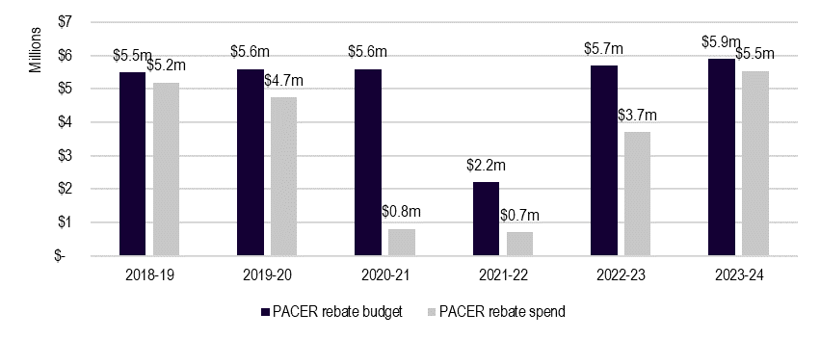
Source: BUSY at Work, program data, 2023 and Department of Education, PACER contracts 2018-2023
Note: ‘Rebate spend’ considers the status of schools listed as “Eligible” and “Paid and closed” therefore some rebates are approved to schools rather than paid and closed and therefore extend beyond the evaluation period of 2018-June 2023.

Administrative costs
For all financial years between 2018 and 2023, administrative costs as a percentage of overall budget remained stable at approximately 10%.
Administrative costs for PACER for the financial year 2022-23 were approximately $11.16 per student and have increased since 2018-19. As an absolute figure, it has remained stable since 2018-19 (with a slight reduction in costs following COVID travel restrictions). Administrative costs include BUSY at Work administrative costs, Department of Education staffing costs, and Department of Education on costs and overheads.
Figure 6.2 PACER administrative costs
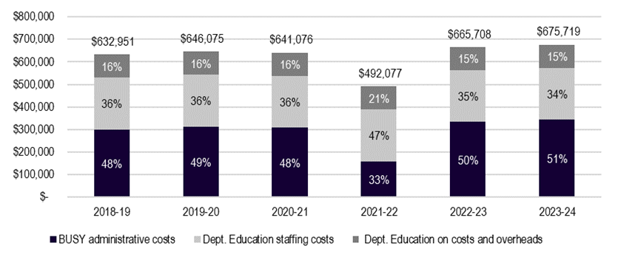
Source: Department of Education, PACER contracts 2018-2023
Note: Department staffing, overheads and on costs were provided by the department as an estimate only and should not be viewed as the actual spend.

Alternative funding models

Rebate approach
The PACER rebate has been established as a partial rebate. The rebate amounts are not intended to cover the entire cost of a student’s visit to Canberra. Alternative models of funding include:
- Full cost recovery model: schools would need to submit the full cost of the trip which would be covered by rebate.
- Grant model: partial funds would be paid without the need for schools to acquit their actual spend.
Table 6.1 Possible implications for alternative funding model design
Factor | Partial rebate | Full cost recovery | Grant
Improvement of reach (assuming current budget) | Moderate impact | Low impact | Moderate-High impact
Cost for government (assuming current student numbers) | Moderate cost | High cost | Moderate cost
Administrative burden | Moderate impact | High impact | Low impact
Ease of auditability/transparency | Moderate | Low | High
Source: ACIL Allen, 2023

A full cost recovery model would likely attract many more schools to the PACER program. However, if the budget was to remain the same as in previous years, the number of schools who could access the program would be substantially lowered.
Costs for schools in undertaking trips to Canberra vary based on factors such as trip length, distance from Canberra, student numbers and the need for air or sea travel. One PACER school staff participant advised their per student costs travelling from Tasmania equated to $1,900.
“…it costs us $1,900 per student for the trip [to Canberra] and we receive $300 [per student] from PACER.” – PACER school staff participant.
While the above is just one example, it provides an indication of the upper end of costs faced by schools at a further distance. Covering such costs in full would limit potential participation within the current funding envelope considerably.
A grants model may encourage more schools to engage with the PACER program, as the administrative burden of collating costs has been removed.

Rebate amount
Incorporating the Consumer Price Index (CPI) into rebate structure design could address cost barriers reported by schools.
Examining a situation in which the base rebates had increased in line with CPI increases gives an insight into the potential costs of making such an adjustment to the PACER rebates. Using the March 2021 CPI (approximately the time when the additional 50% base rebate was implemented) and December 2022 CPI would give an increase of 10.94%. Applying this increase to the base rebate only, and assuming that the additional loadings remained in place, would have cost approximately $6.3m ($518,305 more than the $5.8m paid and promised for the calendar year of 2023).

Future funding needs
Ongoing demand for PACER is difficult to forecast, which impacts the ability to estimate required funding.
While the number of schools and students accessing the rebate has grown since the end of COVID travel restrictions, they have not yet reached pre-pandemic levels. Survey responses indicated that 92% of schools would apply for the PACER program again.
The diagram below shows the assumed growth in student numbers back to pre-COVID levels. It assumed that the rate of growth from 2020 to 2023 will continue, ultimately reaching pre-COVID levels in 2026. Many factors are weighted by schools and teachers when considering participation in PACER. These include the financial burden for students, the coordination effort, time away from the classroom, and the costs of covering for the teachers who travel with the students. Some stakeholders indicated that these factors and their respective costs have been exacerbated post-COVID, and this may deter the growth of demand for PACER. It is unlikely that the growth in student numbers will continue in line with growth in previous years.
Assuming an average rebate of $90 per student (as was the average in 2023), and assuming the growth of student numbers in Figure 6.3, future rebate funding would require approximately $9.0m in 2024, $11.2m in 2025, and $13.4m in 2026.
Figure 6.3 Assumed growth of PACER demand
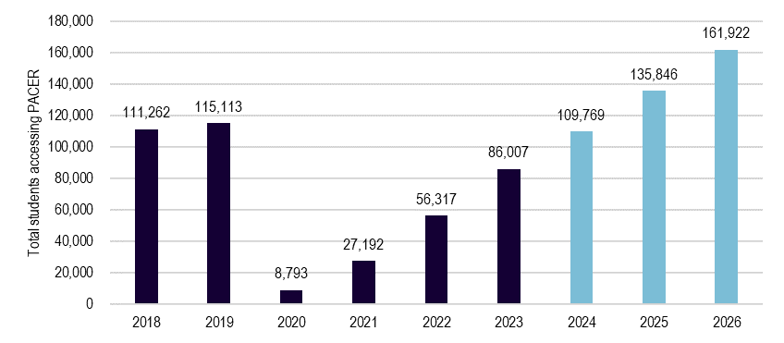
Source: BUSY at Work, program data, 2018-31 October 2023 and ACIL Allen

Opportunities
This chapter outlines the opportunities for the future of PACER and the Pilot.

P1 Defining equity and inclusion
While the department has a strategic focus on equity and inclusion (evidenced in statements included in their Corporate Plan), this focus has not extended to a clear definition or criteria of this priority in program contexts such as PACER and the Pilot.
The lack of equity and inclusion criteria under the key policy considerations makes it difficult to determine whether PACER is delivering on the priority needs.
A definition for equity and inclusion, for example, “participation from proportionate representation of sectors, states and territories, school types or year levels” could be developed by the department and shared with the administrative service provider. This could assist with targeting any future adjustments to the rebate structure.

P2 Improving the PACER rebate structure
Retaining the current increases to the base PACER or ensuring inflationary costs are considered in future funding model planning will improve equity and inclusivity and respond to clear financial barriers emerging from cost-of-living pressures. Further investigation of the most appropriate loadings or funding model mix for schools facing additional disadvantage could also be considered, noting that the ICSEA loading was highly utilised among new PACER participants that accessed the Pilot in 2023. The calculation of ICSEA scores by ACARA considers student socio educational advantage, Remoteness and Indigenous student enrolment and therefore stands as a holistic measure to recognise equity and inclusion.

P3 Disability inclusion
More funding for students with disability would improve equitable and inclusivity considerations for the program. PACER participation from specialist schools is extremely low, as are mainstream schools with students with disability. These schools face increased costs of participation given the needs of their student cohort. Consideration of funding increases should take into account such costs to schools and should also ensure that institutions can cater to all student needs.

P4 Awareness raising
Reach of PACER could be expanded through increased awareness raising and active promotion through BUSY at Work, the department and state and territory channels. This would assist in delivering on the key policy considerations of increased equity and inclusion.
There is an inherent tension between awareness raising, increased participation and funding needs. Awareness raising in the current climate would likely address the underspend within PACER but would require careful monitoring into the future to ensure that sufficient funding was available to support school participation.

P5 Interface with states and territories
Alignment of PACER with state and territory programs could be strengthened by improved connectivity between the department and state and territory counterparts. This would enhance the key policy considerations relating to the complementary nature of programs.
This approach would need to start with establishing communication lines to build awareness, before moving into more strategic conversations on the scaffolding of programs, the potential for cross-promotion and other opportunities to enhance participation.

P6 Measurement of effectiveness
Understanding of impact could be improved by embedding data collection requirements into contractual arrangements with BUSY at Work or the expectations of participating institutions. This data is essential to understanding what is working and what could be improved.
One avenue to do this would be to develop a simple survey, administered via BUSY at Work, to be distributed to schools following their participation in PACER. Questions could target short-term outcomes if administered in the immediate term or could capture data on the longer-term impact if undertaken at a 6- or 12-month delay.

P7 Encouraging student voice
Student voice could play a more active role in program design. This aligns with effective program management for young people and with best practice civics and citizenship education. Program administration occurs through school staff so there is limited data on student perspectives.
The department or administrative service provider could integrate student surveys into post-trip administration or the program could more broadly consult with students around future program changes or reviews. The department should consider whether this is best serviced through processes at the institutional level or through the Advisory Committee.

The Civics and Citizenship Education Program

Appropriateness
This chapter outlines the design of the CCE program and examines alignment with key policy considerations and good practice.
Box 8.1 Key findings – CCE program appropriateness
- The design of the CCE program is aligned to effective practice and is educationally valid, especially in terms of the encouragement of student voice in activities and discussion of controversial issues. However, initiatives lack a clear issue-based project element in design.
- The individual CCE initiatives are highly aligned with key policy considerations but there are some limitations in terms of equity and inclusion and complementing state and territory programs.
- The CCE program is broadly aligned with current education policy priorities however could benefit from greater data and evidence of achievement and outcomes in design.
- Governance arrangements are well structured to provide effective governance, but there are opportunities to strengthen monitoring, continuous improvement and knowledge sharing.

Design
The CCE program supports civics and citizenship education in schools by funding programs that:
- aim to help young Australians become active and informed citizens through an understanding of Australia’s system of government, history, and culture
- provide resources aligned to the Australian Curriculum to aid the teaching of civics and citizenship education in schools respectively.
The CCE program currently funds 7 separate programs delivered by service providers and grantees, as outlined in the table below.

Table 8.1 CCE program overview
Title | Responsible body | Description | Target audience
The National Schools Constitutional Convention | National Curriculum Services (NCS) | An annual peak event exploring the Australian Constitution | Students in Year 11 and 12
The Australian Constitution Centre (ACC) at the High Court | Constitutional Education Fund Australia (CEFA) | A one-off grant payment that supported a centre located at the High Court of Australia in Canberra that helps young Australians learn about Australia’s constitutional arrangements and our system of government | All students
The National History Challenge (NHC) | History Teachers Association of Australia (HTAA) | A free research-based competition that gives Australian students a chance to be historians, researching world history, examining Australia’s past, investigating their community, or exploring their own roots | All students
The Simpson Prize | History Teachers Association of Australia (HTAA) | A national competition that focuses on the service of Australians in World War I | Students in Year 9 and 10
World Schools Debating Championships (WSDC) | Australian Debating Federation (ADF) | Supports Australia’s participation in an English-language World Debating Championships and the development of debating in schools across Australia through teaching coaching and development programs | Students in Year 7-12
International Geography Olympiad (iGEO) and Geography Big Week Out (GBWO) | Royal Geographic Society of Queensland (RGSQ) | Supports Australia’s participation in the iGEO and Geography Big Week Out (GBWO), providing students with an opportunity to achieve higher level analytical and decision-making skills in geography and raise the standard of geographical knowledge | Students in Year 11
Civics and Citizenship Education (CCE) Teacher Resources Package | Education Services Australia (ESA) | When published, this will provide an online hub of approximately 200 resources for civics and citizenship educators. | All students
Source: Department of Education, 2018-2023, various program overviews and grant agreements.

The key activities vary for each CCE program, however broadly involve:
- competitions and prizes
- educational challenges and activities
- domestic or international study tours
- domestic and international events and conventions
- teaching and learning resources.

History
The CCE programs are funded via grant agreements or procurements with service providers, and each has its own implementation history. Figure 8.1 outlines the year in which the department first funded the programs, their current funding timeframe and total funding for this timeframe. Of the 7 programs, the NSCC and the CCE teacher resource package are procurements, the remainder are grant agreements.
Over COVID-19, many of the activities involved in these programs were cancelled or put on hold due to travel and social restrictions. Several funding variations were put in place and service providers have also managed underspends over this time.
Figure 8.1 CCE program funding and implementation timeline
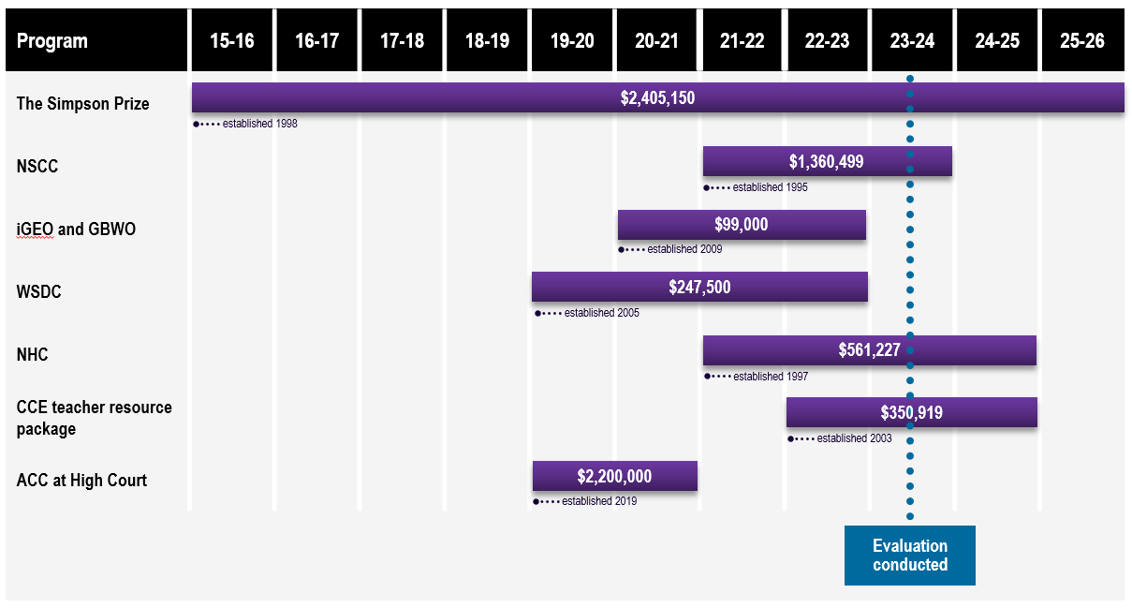
Note – The ACC at High Court was first funded by Dept of Education in 2019 but was established by Attorney-General’s Department prior to that date. The CCE teacher resource package is distinct from the now lapsed Discovering Democracy website.
Source: Department of Education, 2023, various sources

Governance
The department manages the contracts and grant agreements, and the various grantees and service providers manage the programs. There are no mandated governance requirements outside of contractual requirements.
As grant agreements and procurements, these programs are time limited to such funding arrangements and require regular re-consideration and review by the department and the Minister for Education on this basis.

Alignment with effective practice
The design of the CCE program is highly aligned with effective practice; however, the provision of ‘action civics’ style student engagement opportunities are limited.
Table 8.2 has been prepared utilising the analysis of the CCE program information and consultations to identify in which areas the individual initiatives align with effective civics and citizenship education approaches identified in the literature.
Table 8.2 CCE program – Alignment with best practice
Program | Alignment with best practice
The Simpson Prize | - Providing scaffolding and learning supports for student capability and understanding.  - Discussion of controversial and/or difficult issues  - Open exchange of ideas  - Student voice, interest, and agency  - Exposure to civic role models
NSCC | - Discussion of controversial and/or difficult issues  - Open exchange of ideas  - Simulation  - Exposure to civic role models  - Student voice and agency  - Providing scaffolding and learning supports for student capability and understanding
iGEO and GBWO | - Student voice, interest, and agency  - Discussion of controversial and/or difficult issues
WSDC | - Discussion of controversial and/or difficult issues  - Open exchange of ideas  - Encouragement of independent thinking and expression of opinions  - Simulation  - Student voice, interest, and agency  - Opportunities for discussion of issues relevant to student’s own lives
NHC | - Discussion of controversial and/or difficult issues  - Student voice, interest, and agency  - Encouragement of independent thinking and expression of opinions  - Opportunities for discussion of issues relevant to student’s own lives
CCE Teacher Resource Package | Information on resources not yet available.
ACC at High Court | - Providing scaffolding and learning supports for student capability and understanding.  - Exposure to civic role models
Sources: Andolina et.al. (2019), Blevins et.al. (2016), Blevins et.al (2021), Briole et.al. (2023), Cohen et.al. (2021), Prati et.al (2020) and Wineburg et.al (2022).

Currently no CCE initiative reflects an ‘action civics’-based model of project engagement with civics and citizenship. Participants are not provided an active and student-led experience of civic action and problem solving in their community. This may place limitations on the level to which students can be further connected to issues relevant to them and the extent to which they can build their confidence and belief in undertaking civic action beyond the bounds of program activities.

Alignment with key policy considerations

Inclusive and equitable participation
The CCE program is broadly designed to ensure equity of access.
The design of the initiatives reduces the impact of geography on participation. For initiatives with travel requirements, geographical barriers are diminished through the provision of funding for travel and accommodation, though some logistical challenges associated with travel remain. Other initiatives are designed to be delivered in any classroom regardless of location, supporting broad access.
The CCE programs do not have consistent school and student participation data collection processes in place. This limits the extent to which inclusivity and demographics can be accurately assessed. Some CCE providers communicated high level assessments on the breakdown of some demographics, however equity and inclusion does not appear to be routinely monitored, assessed, or targeted. Providers also indicated the flexibility that programs offer to enable participation, e.g., allowing for a variety of competition entries, however a clear and tailored focus on engaging students with a disability is not seen in program delivery.
“There is good metro and regional representation and gender representation.” – CCE program provider.
“[Managing influx from certain demographic groups is] something we could be better at. Where aren’t the entries coming from?” – CCE program provider.

Alignment with the Australian Curriculum
The CCE program is well aligned with the Australian Curriculum, though there are some opportunities for improvement.
Teachers reported that the CCE initiatives were aligned to the curriculum. The extent of agreement between teachers was dependent on certain variables, including the initiative they were involved in, the topic for that initiative, and the year level of students targeted. Some initiatives target Year 11 and 12 students and therefore were seen to align with state and territory curriculums more directly.
“[To what extent did the teaching and learning activities/task within the CCE program align with the Australian Curriculum?] Very well. Students from my school have participated in the NSCC for the last 2 years, and it has extended their knowledge and understanding of the VCE Legal Studies curriculum significantly.” – CCE program school staff participant.

Complementing other programs
The suite of Commonwealth funded CCE initiatives broadly complement those offered by the states and territories, however there are some competitions that would benefit from improved linkages between the jurisdictions.
Providers and state and territory representatives noted that there was limited overlap between state-based programs/competitions and the suite of CCE initiatives funded by the department, and that for the most part, the 2 streams of programs complemented one another. In some instances, as with the NSCC, the state-based programs feed into the federal programs broadening the reach at no additional cost to the federal provider.
While limited, there is some overlap with prizes in other states. Improved communication between federal and state programs could align their resources and reduce content duplication. Improved alignment in design would also allow for greater content coverage across the competitions.

Alignment with education priorities
The CCE program is broadly aligned with Australian Government strategic priorities.

Quality Outcomes Program
The CCE Program aligns with the QOP by improving the quality of teaching and learning through providing increased supports for the delivery of interactive educational and student-led processes. It also promotes greater national consistency in schooling by providing equal opportunity to schools across the country to engage in relevant civics and citizenship initiatives.

Strengthening Democracy Taskforce (2023)
The CCE program aligns with the objectives of the Strengthening Democracy Taskforce by delivering civics and citizenship education activities that build knowledge and understanding of Australian institutions and by supporting the provision of credible information.

The National School Reform Agreement

Supporting students, student learning and student achievement
The CCE program is supporting students to expand their learnings through experiences beyond the classroom. Initiatives have allowed students to engage in their interests beyond what’s typically covered in the classroom and have rewarded them for this, either at a participation level or for high achievement.
“The biggest impact is on knowledge, because it’s theme based, students/teachers can pick the theme, they can pick something of interest that they have an affinity for and can go further than the curriculum prescribes.” – CCE program provider

Supporting teaching, school leadership and school improvement
The CCE program is providing teachers with professional development opportunities through resource provision, event attendance, or collaboration with other teachers when judging prizes. Many providers also promote the benchmarking opportunities their programs provide, to allow schools and teachers to compare performance with similar schools.
“We try and advertise to teachers that it’s an opportunity to get benchmarking against other schools. There are also professional development opportunities for teachers because they engage in judging you’re seeing work from other schools and getting to talk to other teachers about what they see as a good or bad work as they are working on a panel to judge.” – CCE program provider

Enhancing the national evidence base
The CCE program is limited in the alignment to this goal. There has been an inconsistency in data collection across providers and in reporting requirements from the department. These limitations impact the ability to assess effectiveness for the programs as a suite.

Fitness for purpose
The CCE program is underpinned by 3 objectives, including to increase student’s knowledge and understanding of Australia’s:
- democratic heritage and traditions
- political and legal institutions
- shared values of freedom, tolerance, respect, responsibility and inclusion.
Considering the above objectives, the design of the CCE program embeds some mechanisms to ensure the programs remain fit-for-purpose, but there are opportunities for improvement.

Democratic heritage and traditions
Students involved in the CCE program are learning about and conceptualising the history of Australia’s democracy through content and activities related to the Constitution. This assists students to understand the role and impact of Australia’s historic governance structures and the role of democratic participation in making change to these structures and traditions. However democratic heritage and traditions are heavily covered in relation to the Constitution rather than engaging with First Nations history. This means that students are likely being exposed to an Anglo centric approach to content and activity design that could better integrate Aboriginal and Torres Strait Islander perspectives.
“There is a lack of First Nations culture in the programs offered.” – Peak body organisation.
“Programs are very white, there are other stores that can be told, Australian of Year awards is now a multicultural event. We don’t want kids to come away with just information on the Constitution.” – Peak body organisation.

Political and legal institutions
The CCE program is providing opportunities for students to understand political and legal institutions through tailoring programs around student’s presence at institutions such as the Parliament, War Memorials and commemoration activities. In some initiatives, students engage with Parliamentarians and Ministers providing first-hand perspectives on their role as political representatives of these institutions and communities.
“Students are blown away by the Canberra experience, they get to meet their local MP, the Governor General and sometimes the Prime Minister.” – CCE program provider.

Shared values of freedom, tolerance, respect, responsibility and inclusion
The CCE program is providing opportunities for students to build knowledge about shared values of freedom, tolerance, respect, responsibility and inclusion via their content, activities and social and networking opportunities.
Freedom, tolerance and respect and inclusion are being promoted through programs such as WSDC, the NHC and NSCC via discussion, exchange of ideas and encouragement of independent thinking and expression of opinion. In peer-to-peer forums such as the NSCC, students have opportunity to interact with students from different schools, sectors, states, and territories, opening avenues for diverse demographics and opinions to be represented.
The CCE program exposes students to civic responsibilities in Australian governance structures and democratic processes.

Governance arrangements
Grant agreements between the department and the various program providers are well structured to provide effective governance, but there are opportunities to strengthen monitoring, continuous improvement in program outcomes and knowledge sharing.
The design of the individual grant agreements, the frequency of department meetings and communications support information sharing and identification of delivery risks, including COVID-19 impacts. All CCE program providers indicated that their relationship with the department has been positive and clear, noting they felt confident to manage underspends resulting from event cancellations or adjustments.
“I’ve always found the Australian Department of Education fantastic to deal with, they know when to step in and speak to states. This was tested during COVID but they acted promptly to work with the states to come to a sensible solution.” – CCE program provider.
While the grant agreements are designed to support administrative and operational effectiveness, they lack consistent reporting and impact measurement requirements. There is potential for duplication or inaccuracy in student and school participation reporting and a limited understanding of program impacts and outcomes. Governance arrangements do not formalise data collection against effectiveness outcomes, impacting the capacity of CCE program providers to drive continuous improvement.
The CCE initiatives are not governed together as a suite of programs. Governance occurs at the individual level. This is unsurprising given the initiatives are unique in scope and delivery, have been established at different times and involve various providers. However, there may be missed opportunities from the lack of a shared governance structure between program providers. Currently providers don’t have a channel to connect and share successes and improvements for their programs. This means that evidence-based knowledge sharing cannot readily occur, and potential strategic linkages and cross promotion opportunities may be missed.

Fidelity
This chapter examines the implementation of the CCE program, including enablers and barriers.
Box 9.1 Key findings – CCE program fidelity
- The implementation of the CCE program has aligned with design, with little variation from the original intent and implementation aside from the impacts of COVID-19 on delivery.
- The collective reach of the CCE program between 2018 and 2023 captures an estimated of 1,485 schools Australia wide.
- Awareness of the CCE program is somewhat limited due to the ad hoc nature of communications and person-dependent approaches. Awareness of the programs as a suite is not evidenced beyond the department.
- Administrative arrangements for the CCE program support delivery of the individual initiatives, but do not promote a collective approach.
- Key enablers for schools accessing CCE programs include dedicated staff, personal passion and partnerships with states and territories.
- Key barriers include the reliance on program volunteers, competing priorities for school staff and financial impacts.

Reach of the CCE program

Aggregate reach
Between 2018 and 2023 the programs have collectively engaged an average of 1,485 schools Australia wide per year (approximately 15% of all schools).
The aggregate reach of CCE programs has remained relatively stable since 2018, with only an anomaly reduction in 2022. The decline in engagement in 2022 was due to a lower-than-average participation rate in the National History Challenge, which had only a third of its usual level of engagement in that year. Numbers appear to have stabilised in 2023. It is noted that the programs have been able to maintain some form of engagement or participation over the COVID-19 pandemic despite adjustments to event dates, locations and delivery platforms.
Figure 9.1 Total school reach of the CCE programs
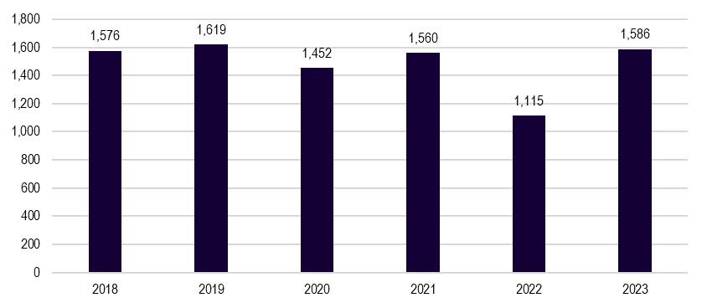
Source: Various CCE program providers
Note: Due to data limitations, schools who participated in multiple CCE programs may be double counted.

Program reach
Reach across the initiatives varies in line with the scale of the individual activity.
Broad reaching competitions including the NHC and the Australian Geography Competition (AGC) (the feed in to iGEO and GBWO) have contributed the highest number of participants to the overall engagement in the CCE program. These initiatives accounted for a yearly average of 539 (36%) and 731 (50%) of participating schools respectively.
Figure 9.2 Contribution of CCE programs to total schools’ engagement
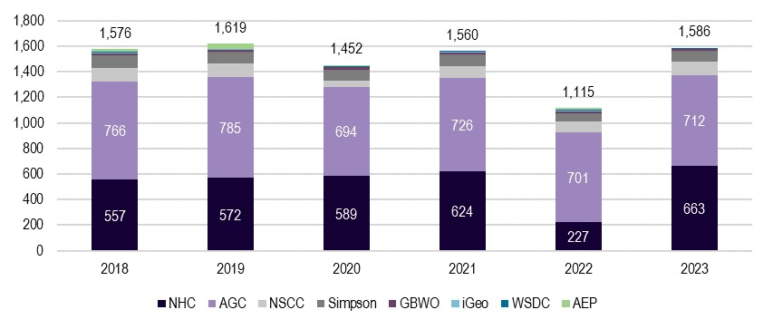
Source: Various CCE program providers
Note: Due to data limitations, schools who participated in multiple CCE programs may be double counted.

State and territory reach
New South Wales makes up the greatest proportion of CCE program engagement when disaggregated by state and territory, followed by Victoria and Queensland. These proportions are approximately relative to the distribution of schools Australia-wide. Patterns of participation are similar to PACER, which indicates that barriers such as distance, logistics and resource availability likely impact engagement in similar ways for CCE programs.
Figure 9.3 State distribution of CCE schools
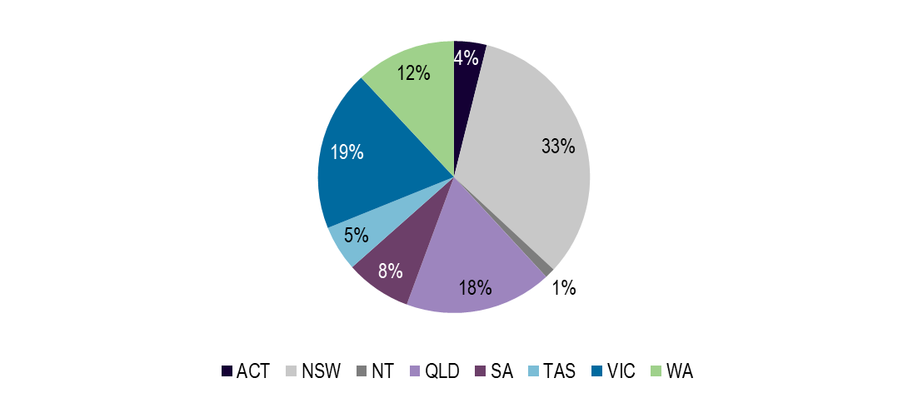
Source: Various CCE program providers

Awareness of the CCE program
Awareness of CCE programs is somewhat limited due to the ad hoc nature of communications and person-dependent approaches.
Stakeholders have been generally aware of one or more, but not all, of the initiatives based on their own areas of interest. Many of the initiatives have had a consistent base of participating teachers or schools that have promoted the respective activities. This has meant that the schools participating in the CCE program have been relatively stagnant, with little growth in awareness or changes in the profile of participants. When new schools join, this is often a result of state and territory-based advertising.
“When I worked in schools wasn’t a great deal of general awareness across the community. School engagement is driven by a particular teacher with an interest in a school. So, you often see the same school names with winners.” – State or territory representative.
CCE program providers noted that they have been reliant on internal methods of communication as funding arrangements did not support additional advertisement or promotion. This feedback was consistent across all initiatives, who reported leveraging in-kind contributions and low-cost avenues to promote the availability and benefit of participation.
There is no awareness of the programs as a suite, or as the ‘CCE program’ beyond the department. While the department has a dedicated website that lists the individual initiatives, stakeholders were not familiar with the website, nor did they perceive the initiatives as a coherent collection of activities. There is limited visibility of the connections between the initiatives and the curriculum.
“At a state and territory level, they know some of the programs like the National History Challenge, but they don’t understand the overall connection to the curriculum or understand what else is out there and how they all tie together.” – State or territory representative.
“There is a communication and awareness issue, it’s great that these opportunities exist for schools, but schools aren’t aware of them.” – State or territory representative.
State and territory representatives have promoted the initiatives in some jurisdictions. While this has helped to build awareness, staff turnover has meant mailing lists become outdated, and emails are often sent to administrative inboxes, rather than lead humanities teachers. This limits the effectiveness of awareness raising activities.
“There are still gaps in awareness, part of my role is listing the events and deadlines, but there is such high turnover in school you don’t know if the right people are getting the communication.” – State or territory representative.

Administration
Administrative arrangements for the CCE program support delivery of the individual initiatives, but do not promote a collective approach.
Providers overwhelmingly feel that the department have been easy to deal with, and while COVID-19 created several difficulties for providers, the department responded promptly to find suitable solutions. Grant agreements were perceived as non-prescriptive by providers, allowing them to tailor their programs to deliver additional deliverables beyond those listed in the grant agreement.
The quality of the information provided varies across the initiatives. As the initiatives have been run independently of one another, different information has been communicated, captured and reported. Individual program websites have contained key information, but accessibility has relied on individual awareness of the initiatives themselves. Information provided to schools often has not reached the desired recipient due to poor targeting and staff turnover.
“Before students got in, our school didn’t know about the it. When you receive information about the competition its very limited, we don’t know what it looks like.” – CCE teacher program participant.
“Generally, this material goes straight to the principal, depending on who the gatekeeper is for the principal, material for the programs may not end up on the desk of the person who is responsible for the program in the school.” – Peak body organisation.
Teachers who’ve engaged in the initiatives reported guidelines for participation were clear and that information regarding their role, be it supervising an assessment piece or volunteering as a chaperone, has been appropriate and adequate. While most of the feedback in terms of event organisation was positive, some teachers highlighted a need for improved timeliness of communication around flights and event timing for particular initiatives.
“There were no surprises, I felt well briefed, and it was all very well organised.” – CCE teacher program participant.
“Guidelines are very clear, the website is clear, communication is excellent.” – CCE teacher program participant.

Enablers

Dedicated staff
CCE initiatives are staffed by an enthusiastic and dedicated workforce within individual providers. The providers have demonstrated their passion for their subject areas and have often been teachers who have moved into their role following positive interactions with the programs.

Personal passion
School participation is being driven by a dedicated teacher base, without whom engagement would be significantly lower. The loyalty of these teachers to the program has often stemmed from personal engagement in a particular prize, and the professional development opportunities offered by certain programs.
“Offering teachers the same opportunities as the students. Being a chaperone one year for the QLD Premiers ANZAC Prize is why I’ve become such a big advocate of the Premiers ANZAC Prize. Obviously, this can’t be offered to all teachers though.” – State or territory representatives.
“Because we have stakeholders that believe the [the initiative] is good quality and so they’re willing to put in the yards to get people to attend.” – CCE program provider.

Partnerships
Implementation for initiatives has been improved by partnerships between the Commonwealth funded CCE program and state and territory programs that feed into the Commonwealth programs. These partnerships greatly enhanced the reach of initiatives, such as the NSCC and WSDC.
“Students become aware of the NSCC through advertisements run by the [local] program, and you can’t go to nationals unless you’ve completed the [local program]. We share information with all schools (state, independent and catholic).” – State or territory representative.

Barriers

Reliance on volunteers
The implementation of CCE initiatives is heavily reliant on a volunteer workforce, which creates sustainability risks due to staff turnover and lack of availability. Staff turnover reduced the overall quality of the program delivered. Without volunteers, many initiatives would be unable to deliver in full.
“Need to acknowledge the level of volunteering taking pace to deliver these programs. We pay the expenses for the competition, but we don’t pay for people’s time. Even in my office our pay doesn’t work out to a living wage. We do a lot of volunteering and don’t get paid for the work we do on weekends.” – CCE program provider.

Competing priorities
Teachers are time poor, and the additional work required by teachers to facilitate participation has been a key barrier to participation. Many of the initiatives rely on teachers to organise and facilitate participation. This has included aligning the initiative with classroom work plans and curriculum or devoting additional hours to run the initiative as an extracurricular activity.
“The time commitment required by both students, who are asked to do an extra thing which is always a challenge regardless of the prize, and teachers who have to make time to provide guidance when they may have another 20 pieces of work to mark.” – State or territory representative.
“Staff must have the time available to take time away from the school and ensure that someone can cover for them, a staff member probably needs to be in attendance to ensure the students and their families feel safe. It can be difficult for schools to release staff members for these activities, particularly smaller schools.” – CCE program school staff participant.

Financial impact
Schools have absorbed some administration costs in running these initiatives. Relatively new changes to Enterprise Bargaining Agreements mean schools in some jurisdictions are now liable to pay staff time in lieu for the additional time required to coordinate the program in their school and any volunteering they may undertake as part of the program. Some schools have to pay for relief staff when teachers volunteer as chaperones, which have added to the financial costs’ schools must consider when making their decisions on whether to participate and volunteer staff for more time intensive roles, such as teacher chaperones.
“There’s no money for replacement teachers, schools must be willing to volunteer a teacher’s time. So, the first issue is funding but then it’s also about finding someone to replace you.” – CCE program provider.

Effectiveness and efficiency
This chapter examines the effectiveness and efficiency of the CCE program.
Box 10.1 Key findings – CCE program effectiveness and efficiency
- The CCE program is broadly effective in achieving the variety of desired outcomes such as in building student interest in civics and citizenship and in improving leadership and communication skills.
- The individual initiatives are highly valued by students and staff, evidenced by repeat involvement and the embedding of programs into curriculum delivery at schools.
- The CCE program is operating efficiently especially considering the relatively low cost of grant agreements, comparative to wide reach. However, sustainability is a risk to ongoing efficiency.

Overview
There is no single program logic for the delivery of the suite of CCE initiatives.
Anticipated outcomes for the individual initiatives typically include a strengthened understanding of, and engagement with the programs specific subject area. Most competitions, tours and conventions are required to report on prize winners, attendees, and international placings though the detail varies dependent on the grant agreement. The emphasis of reporting requirements is focused on outputs rather than outcomes.
As a suite, the CCE initiatives aim to promote civics and citizenship education in schools by:
- helping young Australians become active and informed citizens through an understanding of Australia’s system of government, history, and culture
- providing resources aligned to the Australian curriculum to aid the teaching of civics and citizenship education in schools respectively.
The assessment in this chapter relies upon stakeholder consultations and stakeholder submissions to measure impact. There is no direct feedback from students, which limits the ability to comment on their perspectives of change.

Student outcomes
The CCE program has had a range of diverse, but related, positive impacts for students.

Interest in CCE topics at school/further education
School staff and CCE providers noted that participation in the initiatives had increased student awareness of the career pathways in the civics and citizenship sector. In some instances, the CCE initiative had helped to develop a student’s desire to pursue a related subject in the future, both at university and as a career.
“She’s [student involved in NSCC] only built her skills since attending the NSCC and has told me she is keen to study law next year, it’s lit a fire for a career in law.” – CCE program school staff participant.
“One student who won the Simpson Prize went to Canberra for university and got a job at the War Memorial. I met her when I went there and she loves it there. It really inspired her to find work in the history field.” – CCE program school staff participant.
“Some have gone on to study geography and environmental science and sustainability because of their interest. It starts here and moves on into university.” – CCE program school staff participant.
“They enjoyed it because it broadened their horizons and they got to see how much bigger the world is outside the Northern Territory and they could see how many weird and niche jobs there are out there.” – CCE program school staff participant.

Improved leadership and communication skills
Funded competitions and trips are helping participating students to practise, and develop, skills in leadership and communication, be it through the opportunity to express their ideas, public speaking, or from working in a team environment. Teachers described their students coming away from these initiatives with improved self-confidence and self-assurance.
“[Through participation in the NSCC] Student’s self-confidence has improved. They get to practice working in a team, you see them start to become more self-assured and gain confidence in public speaking.” – CCE program school staff participant.
“There are many benefits for students – increased curriculum knowledge, public speaking skills, networking with other like minded students, increased confidence and independence.” – CCE program school staff participant.

Interpersonal skills
The competitions with travel and group activities provide opportunities for students to interact with their peers from across the country. Teachers expressed the benefits and improvements to their students’ interpersonal skills following exposure to students from vastly different backgrounds, who held differing points of view on issues.
“It was great for the kids to have experience and exposure to other kids from around the country, they get exposed to all these different points of view and backgrounds.” – CCE program school staff participant.
“Pastoral care growth is huge, it’s not just academic growth from attendance. Our student numbers are on the decline, without these trips kids don’t get to engage with many other students. These prizes help them to see the east coast, meet people from WA, it boosts their academic performance too.” – State or territory representative.

Analytical and problem-solving skills
Across the suite of CCE initiatives there is a consistent effort to develop students’ analytical and problem-solving skills, and to create a spark for continual learning. Be it through a prize such as the National History Challenge, or the Simpson Prize which emphasises research and the development of constructive arguments, or debating which gives students an unimpeded platform to discuss and debate non-conformant issues.
“It hooks them into some really good practices in terms of their learning, they learn how to make good arguments and reference correctly. The prizes help sharpen their skills.” – CCE program school staff participant.
“They (students) get a chance to express ideas, think about non-dominant ideas, and develop empathy to give credence to the other side of the argument.” – CCE program school staff participant.

Effectiveness measures and their adequacy
There is a lack of emphasis on student outcomes which limits the extent to which the impact of the CCE program can be quantified.
The stipulated reporting requirements of CCE initiatives vary depending on the program being delivered. There is no consistency in how the providers report outcomes. Some are required to identify if and how outcomes are achieved in a final report, as a part of their agreement, while others report on an annual basis.
The grant agreements lack clarity around how these outcomes should be reported, often leaving this to the interpretation of the provider. The outcomes subsequently reported more on outputs rather than outcomes. These outputs include the number of participants, programs run and their challenges, and program materials. This may point to a capability gap in program providers, in terms of the ability to design, implement and report on program evaluation.
Some providers survey students and teachers that have participated in their programs and report these survey results to the department. These surveys focus on the program outputs and the perceived quality of the program. The value of these surveys could be enhanced by creating a lag between the event and the survey being administered. This would allow students and teachers to reflect on outcomes which may require some time to manifest, such as increased engagement with the CCE content covered in the program, skills developed from participation and other perceived benefits from participation.

Efficiency
CCE programs are operating efficiently, considering low-cost grant agreements comparative to wide reach. Sustainability is a risk to ongoing efficiency.
At the time of evaluation, grant agreements for the suite of CCE initiatives provide funding of $7.2 million. The amount of funding and duration of each individual grant varies across the initiatives, as evident in Table 10.1.
On an annualised basis, to account for the variance in grant agreement lengths, grant funding is $2.1 million. More than 50% of this is attributable to the ACC at the High Court agreement. Where information was provided, many of the initiatives fully expend their funding from the department, though there were some underspends due to the COVID-19 pandemic.
In addition to grant funding, the department incurs yearly CCE staffing costs of around $286,000 and, on costs and overheads of around $128,000.
Table 10.1 CCE current grant funding – By program
CCE program | Total grant funding | Duration of grant funding
The Simpson Prize | $2,405,150 | 11 years
The NSCC | $1,360,499 | 3 years
iGeo and GBWO | $99,000 | 3 years
WSDC | $247,500 | 4 years
NHC | $561,227 | 4 years
CCE teacher resources package | $350,919 | 3 years
ACC at the High Court | $2,200,000 | 2 years
Total | $7,224,295
Note: All figures are GST inclusive
Source: Department of Education, 2023, various grant agreements with CCE program providers.

The CCE programs are efficient in delivering quality educational resources and competitions with broad reach at a relatively low cost. Efficiency is heavily reliant on the volunteer workforce and goodwill of passionate teachers, who expend significant time and effort to deliver the programs within their allocated budgets. CCE program providers also communicated that they do significant unpaid work outside of the coverage of grant agreements which currently feeds into efficiency gains. Without passionate volunteers and teachers, the efficiency and viability would be greatly diminished.
“Need to acknowledge the level of volunteering taking place to deliver these programs. We pay the expenses for the competition, but we don’t pay for people’s time. Even in my office our pay doesn’t work out to a living wage. We do a lot of volunteering and don’t get paid for the work we do on weekends.” – CCE program provider
“…there are a core list of deliverables [in the grant agreement] but we also do a lot more outside of those.” – CCE program provider.

Opportunities
This chapter outlines the key findings for the CCE programs and possible future directions.

C1. Strategic positioning
The evaluation identified that the current initiatives are seen as a disparate set of programs that deliver on individual priorities. This impacts on awareness, cross-referral and cross-promotion.
The department could consider whether there is value in considering the initiatives as a collective CCE program, as referred to in this evaluation, and promoting them accordingly. This would assist in providing an overarching logic, identifying program gaps in relation to priorities and curriculum, and ensuring coherence of implementation.

C2. Curriculum alignment
The CCE program could work more closely with ACARA and state curriculum bodies to improve alignment to the curriculum. This would improve the ease of implementation in classrooms for teachers and expand and enhance their delivery of curriculum.
Promotion of curriculum alignment would help bring new schools and teachers into the programs, moving away from the reliance on individual teachers championing their programs in schools.

C3. CCE Community of Practice
The suite of initiatives could strategically benefit from a Community of Practice (CoP) for program providers or staff as appropriate. While CCE initiatives exist as a suite, there is currently no formal mechanism to share learnings, outcomes, or ideas.
While it is noted that such an engagement platform may increase governance burden slightly, it could assist with identifying gaps in content or skill areas and open opportunities for new programs to enter the suite. A CoP could also assist in response to changes to curriculum or state and territory-based programs that may create new opportunities for program delivery.

C4. Awareness raising
Reach of the CCE program could be expanded through increasing awareness raising and active promotion by the department and state and territory channels, particularly for cross-promotion between local and Commonwealth initiatives. This would assist in complementing existing promotion by CCE program providers.
Awareness raising efforts may increase department expenditure however could provide value in reach and reception. It is acknowledged that the department actively promotes some programs via social media such as The Simpson Prize and the National History Challenge. Further increases to active promotion for CCE programs with no limitations on participation numbers would likely result in greater administrative burden from increased engagement and this would have to be closely monitored to ensure sufficient funding is provided for staffing and program management.

C5. Measurement of effectiveness
Understanding of the impact of CCE program could be provided through embedding data collection requirements within grant agreements. This data is essential to understanding what is working and for driving continual positive changes across programs via best practice.
Consistent data reporting requirements stipulated in the grant agreements would enable comparable data across programs. This would in turn enable the department to measure the impacts and reach of the programs, demographic data could also provide further insights into the equitability of the suite of programs to locate gaps and targeting needs.

C6. Encouraging student voice
Student voice could play a more active role in CCE program design. This would align with effective principles for young people and with best practice civics and citizenship education. Currently there are inconsistencies with the level to which program providers collect student input on their experiences or level of satisfaction.

Strategic performance

Key findings
This chapter outlines the key findings for the delivery of the suite of civics and citizenship education programs and opportunities for further integration and expansion.

Design is appropriate
The design of PACER and the CCE program is aligned with the Australian curriculum. Collectively, the programs address key civics and citizenship curriculum areas, but the coverage is not consistent across age groups and subjects – meaning a student would potentially need to participate in multiple programs to cover all relevant content. This aligns with the intent of the programs to complement classroom-based activity, rather than servicing all learning areas.
Principles of effective practice are clear in the design of PACER and the CCE program. Where there are gaps in relation to effective practice, this is largely due to the short-term nature of the intervention and challenges for providers in implementing action-oriented programs in the period available. Innovative approaches could be used to improve the alignment with contemporary practice at the local level.

Reach is positive, but could be strengthened
The suite of civics and citizenship programs are reaching an estimated 30% of Australian schools, noting that the participation of students is likely much lower. This reflects positive coverage of school locations, types, year levels and cohorts.
There are clear opportunities to improve the exposure of PACER and the CCE program to encourage students to engage with civics and citizenship education. There are some limitations here, in that PACER and some CCE initiatives have limited funding envelopes. Other CCE initiatives have no restrictions on student numbers and more could be done to engage young people, providing sufficient administrative support is available.

Impact is positive, but short-term
Observed impacts on students, as reported by school staff and program providers, are positive. These largely related to immediate outcomes in terms of quality educational experiences and improvements in knowledge or understanding.
There is limited evidence on the longer-term outcomes for students, nor capturing of student voice. Anecdotal information from teachers indicates that there are flow-on effects to the classroom and future aspirations of students, but these are not captured systematically. Student voice is an essential component of effective practice and a key gap in the design, implementation and monitoring of the PACER and CCE programs.

Equity and inclusion need to be defined
The design of the PACER and CCE program support the key policy considerations of equitable and inclusive participation, alignment with the Australian curriculum and complementary programs for states and territories.
A key challenge for the evaluation was assessing the extent to which equitable and inclusive participation has been supported as there is no definition and/or criteria of what this means. For example, PACER participation is not representative of the student population but does reach both advantaged and disadvantaged schools.
There are important dimensions of inclusion relating to disability inclusion, culturally and linguistically diverse communities and First Nations peoples. The suite of initiatives has no clear focus on addressing these dimensions which may impact on the extent to which the key policy considerations are achieved.
Moving forward, it will be important for the department to establish a definition in order to prioritise the allocation of funds and effectively assess program success.

Integration to maximise impact
PACER and the CCE program service a range of areas of the Australian curriculum and different year levels within the schooling system. However, the suite of programs are seen as a disparate group of activities that are not well connected or well scaffolded.
Strengthening the connections between the programs would maximise the impact for students by building exposure, knowledge and skill over time. This will likely require a collective assessment of the suite to identify where there are relevant touch points between programs and gaps against the Australian curriculum to build coherence and integration. Mapping the interface with state and territories would improve these connections.

Appendices

Evaluation framework
Table A.1 Evaluation framework
Evaluation focus areas and questions |  | Data sources
 |  | Prog data | Scan | Submissions | Interviews | Survey
Appropriateness (Design) | How appropriate are PACER, the PACER pilot, and CCE programs in delivering against the Key Policy Considerations? | ü | ü | ü | ü
Appropriateness (Design) | To what extent are PACER, the PACER pilot, and CCE programs consistent with current education policy priorities? | ü | ü | ü | ü
Appropriateness (Design) | Do PACER, the PACER pilot and CCE programs continue to be fit for purpose and educationally valid? |  | ü | ü | ü | ü
Appropriateness (Design) | What opportunities exist to improve the appropriateness of PACER, the PACER pilot and CCE programs? | ü | ü | ü | ü | ü
Appropriateness (Design) | Are governance arrangements appropriate for PACER, the PACER pilot, and CCE programs? | ü |  |  | ü
Fidelity (Implementation) | To what extent has the implementation of the PACER, the PACER pilot, and CCE programs aligned with design? | ü |  | ü | ü | ü
Fidelity (Implementation) | What has been the reach of the PACER, the PACER pilot, and CCE programs, disaggregated by demographics? | ü |  |  |  | ü
Fidelity (Implementation) | Do stakeholders and schools know about PACER, the PACER pilot and CCE programs and how to access them? | ü |  | ü | ü | ü
Fidelity (Implementation) | Are the PACER rebate zones appropriate? Are schools in each zone participating? Does the PACER rebate affect whether schools visit Canberra as part of students’ civics and citizenship education? | ü |  | ü | ü | ü
Fidelity (Implementation) | What is the level of satisfaction from schools with the delivery of the PACER program? | ü |  | ü | ü | ü
Fidelity (Implementation) | Are service PACER and CCE program delivery components such as the websites, communication activities and application assistance service sufficient? | ü |  | ü | ü | ü
Fidelity (Implementation) | What have been the enablers and barriers to implementation of PACER, the PACER Pilot and CCE programs? How could implementation of each be improved? | ü |  | ü | ü | ü
Effectiveness | How effective are PACER, the PACER pilot, and CCE programs in delivering against the Key Policy Considerations? | ü |  | ü | ü | ü
Effectiveness | What effectiveness measures are currently used for PACER, the PACER pilot and CCE programs and how adequate are they to determine impact? | ü |  |  | ü
Effectiveness | What is the impact of the PACER 2023 pilot and to what extent have the changes in the pilot broadened program reach? | ü |  | ü | ü | ü
Effectiveness | What does ongoing demand for PACER look like? | ü |  | ü | ü | ü
Effectiveness | Are there alternative models of PACER funding which should be considered? | ü | ü
Effectiveness | How could PACER better support equity and inclusivity? | ü | ü | ü | ü | ü
Effectiveness | What opportunities exist to improve effectiveness of PACER, the PACER pilot and CCE programs? | ü | ü | ü | ü | ü
Efficiency | How efficient are the PACER, the PACER pilot, and CCE programs in delivering against the Key Policy Considerations? | ü |  |  | ü
Efficiency | Do the PACER, the PACER pilot, and CCE programs represent good value for money? | ü |  |  | ü
Efficiency | Could the process of administering PACER be improved? | ü | ü | ü | ü | ü
Efficiency | What opportunities exist to improve efficiency of PACER the PACER Pilot and CCE programs? | ü | ü | ü | ü | ü
Strategic performance | How well do the suite of PACER and CCE programs collectively deliver Civics and Citizenship education opportunities? | ü |  | ü | ü | ü
Strategic performance | Can CCE program initiatives be integrated further to expand their capacity to achieve desired outcomes? | ü |  | ü | ü | ü

Additional data and information
This appendix provides additional information on the mapping processes undertaken for the analysis of Australian Curriculum alignment for PACER and CCE.
  - Curriculum alignment analysis
The evaluation undertook independent mapping techniques to determine the extent of curriculum alignment for PACER and CCE programs to the Civics and Citizenship subject area in Year 4-10 (years eligible for PACER) and for various year levels in CCE programs (due to different target audiences).
The mapping technique analysed the PACER and CCE programs against different achievement standards within the strands of ‘Skills and Inquiry’ and ‘Knowledge and Understanding’. The technique provided alignment scores as per Table B.1.
Table B.1 Overview of alignment scoring approach.
Score | Extent of alignment
1 | Program is neither relevant to, nor connected with, the content item
2 | Program has a tangential connection or some relevance to the content item
3 | Program is relevant to, but does not deliver, the content item
4 | Program is aligned to, with minor omissions in relation to, a content item
5 | Program is fully aligned with, and provides resource to, a content item
Source: ACIL Allen, Curriculum mapping analysis, 2023

    - PACER
Table B.2 shows the results of curriculum mapping analysis for PACER. PACER strongly supports student learning in Knowledge and Understanding achievement standards from Years 4 to 6, with alignment decreasing after Year 6. On an aggregate year level basis PACER is more aligned to the Knowledge and Understanding strand than the Skills and Inquiry strand achievement standards, alignment also decreases in both areas after Year 6. It is noted that Year 11 and 12 students are not covered by the Australian Curriculum, however state and territory curriculum alignment is likely.

Table B.2 PACER Australian Curriculum alignment
Year level | Alignment (Skills and Inquiry) | Alignment (Knowledge and Understanding) | Total alignment
4 | 3.8 | 4.0 | 3.9
5 | 3.8 | 4.3 | 4.0
6 | 3.8 | 4.2 | 4.0
7 | 3.1 | 3.0 | 3.1
8 | 3.0 | 3.9 | 3.4
9 | 2.9 | 3.6 | 3.3
10 | 2.9 | 3.4 | 3.1
Source: ACIL Allen, Curriculum mapping analysis, 2023

    - CCE programs
Table B.3 shows the results of curriculum mapping analysis for the CCE programs. It is noted that some programs are history or geography based and therefore will by nature not align as strongly to Civics and Citizenship. Despite this, these programs have shown some alignment in Knowledge and Skills and significant alignment to Skills and Inquiry. Programs may also target year 11 and 12 students engaged in subjects set by state and territory curriculums. In these cases, analysis has focussed on the next closest year levels within Civics and Citizenship in the Australian Curriculum.
While curriculum alignment varies at the program level, at the aggregate level CCE programs align most closely with Skills and Inquiry strands.
Table B.3 CCE programs Australian Curriculum alignment
Program | Year levels | Alignment (Skills and Inquiry) | Alignment (Knowledge and Understanding) | Total alignment
ACC at High Court | Year 3-10 | 2.63 | 2.13 | 2.50
CCE Teacher resource package | N/A | N/A | N/A | N/A
iGEO/GBWO | Year 9-10 | 1.75 | 1.06 | 1.45
NHC | Year 3-10 | 3.63 | 1.26 | 2.57
NSCC | Year 9-10 | 4.50 | 1.78 | 3.16
The Simpson Prize | Year 9-10 | 3.75 | 1.59 | 2.78
WSDC | Year 7-10 | 3.79 | 1.04 | 2.53
Source: ACIL Allen, Curriculum mapping analysis, 2023
Note: The CCE Teacher resource package was not yet designed at the time mapping analysis occurred and could therefore not be assessed.

Additional methodology and data sources
  - Stakeholder consultation
A total of 61 stakeholders were consulted in 64 interviews. Notes were recorded during interviews to enable qualitative thematic analysis. Interviewees were provided with a discussion guide.
Table C.1 Stakeholders consulted
Stakeholder group | Number of interviewees
Department of Education | 6
PACER service provider | 2
PACER mandatory institutions | 4
PACER alternative institutions | 8
Tour operators | 4
PACER school staff participants | 5
CCE program providers | 6
CCE program school or program staff participants | 25
State and territory representatives | 15
Total | 75
Source: Interviews with PACER and CCE program stakeholders, administered by ACIL Allen, 2023. Analysis by ACIL Allen, 2023.

  - Stakeholder submissions
The stakeholder submissions process was opened via direct email approach between 24 July and 18 August 2023. The total number of submissions received was 7.
  - Survey administration and response rates
A survey was administered via Web Survey Creator to gather insights school staff from a large number of schools who have participated in PACER. This provided a breadth of data collection that could not be obtained through consultation alone. The survey was tailored to address gaps identified in the desktop review of PACER data and information. Survey respondents were required to agree to the Privacy Collection Statement/Notice before completing the survey.
This survey received a total of 184 responses (Table C.2). The number of responses and response rates from school staff in each rebate zone are detailed in Table C.3.
Table C.2 Survey responses and response rates
Number of potential respondents | Number of responses | Response rate
School staff from 2810 Australian schools | 184 | 6.5%
Source: Survey of PACER program participants, administered by ACIL Allen, 2023. Analysis by ACIL Allen, 2023.

Table C.3 Survey of PACER program participants total responses by PACER zone
PACER zone | Number of responses
Zone 0 | 3
Zone 1 | 132
Zone 2 | 28
Zone 3 | 0
Zone 4 | 2
Zone 5 | 5
Zone 6 | 13
Total | 184
Source: Survey of PACER program participants, administered by ACIL Allen, 2023. Analysis by ACIL Allen, 2023.

Australian Constitutional Centre at the High Court
This appendix provides an assessment of the Australian Constitutional Centre (ACC) at the High Court.
  - Overview
This program emerged from a one-off grant payment provided by the Australian Government for online civics and citizenship education resources and interactive displays developed by the Constitution Education Fund Australia (CEFA) for the Australian Constitutional Centre (ACC) at the High Court.
The Australian Government provided funding of $2 million to the ACC in the 2019 Budget, across 2019−20 and 2020−21 to:
- design and install an interactive display in the education room at the High Court, and
- support the development of 15 new online educational resources.
The Department of Education was not responsible for any approval of resources under the grant, and as such there is no Department badging on the resources.
The ACC, located at the High Court of Australia in Canberra, aims to help young Australians experience, and learn about Constitutional arrangements and our system of government.
The ACC involves a physical centre that students visit at the High Court and supporting resources. The aim of the AAC is to improve teaching and learning outcomes of the Australian Curriculum HASS, Civics and Citizenship for years 5 to 10 in areas of constitutional history and processes of government.
Construction of the interactive display was completed on 31 March 2023. The display was approved by the Communications Committee of the High Court and is currently being used.
The ACC is supported by a teaching and learning website offering pre and post exhibition resources on topics such as:
- the Australian Constitution
- 6 foundational Constitutional principles
- processes of the Australian system of parliamentary democratic government
- values underlying the Constitution
- history of the High Court of Australia
- people and institutions of Australia’s Constitutional story.
The website also provides resources on contemporary core cross-curriculum topics such as Aboriginal and Torres Strait Islander Peoples studies, sustainability, and Australia’s role in Asia, while providing links to resources from other relevant organisations and institutions.
The ACC opened at the High Court, Canberra on April 9, 2018. The ACC at High Court was first funded by the department in 2019 but was established by Attorney-General’s Department prior to that date. The ACC and website have been created in collaboration with CEFA and the High Court of Australia.
    - Data sources used for this assessment
This assessment draws from:
- qualitative analysis of interviews with service provider
- qualitative analysis of interviews with representatives from the department
- qualitative analysis of program data provided by service provider.

  - Appropriateness
    - Key policy considerations
The ACC is appropriately designed to align with key policy considerations.
- Online website resources enable equitable and inclusive participation.
- Online resources and program visits to the Exhibit align with the Australian Curriculum.
    - Consistency with current educational priorities
The ACC has been designed to align with current education priorities particularly around Australia’s Constitutional history and democratic processes. Website resources and student visitor programs at the ACC exhibit have been developed in alignment with 6 principles considered central to teaching CCE education, namely:
- democracy
- the rule of law
- separation of powers
- federalism
- nationhood
- rights.
“CEFA’s resources are year-level topic based, sequenced and are clear and easy to teach. Utilising them, students increase their learning and understanding of Australia’s constitutional arrangements, the workings of government and the history and story of Australian nationhood and democracy.” – CCE program provider.
    - Educational validity
The design of ACC programs and resources aligned with contemporary education standards. At the time of consultation on the evaluation, the Department of Education had provided advice to CEFA noting some areas of the resource images and other items that should be updated prior to publication.
The ACC provides teaching and learning resources covering court-systems which do not receive as much coverage in similar CCE-related educational programs.
“We are in the High Court and there is a focus on judiciary and courts system. There is a big gap in that. There are lots of resources for PEO and MOAD and AAC on the parliament but very little on Courts. If you don’t know about Courts system – you have one arm missing.” – CCE program provider.
CEFA consulted practicing teachers who provide input into Australian Curriculum lesson design to inform the development of ACC resources.
Materials containing information on indigenous perspectives have been developed through consultation with indigenous experts.
    - Governance
The ACC program is jointly developed and administered by the High Court and CEFA, however there is a separation in administrative responsibilities.
Program visits to the ACC are administered by the High Court separately from CEFA. The High Court also has a sub-committee that reviews materials to be displayed at the High Court. CEFA is responsible for maintaining the ACC-Australian-Curriculum aligned website.
Governance arrangements are sufficient for effective program delivery. However, feedback received suggests potential barriers to effective delivery and information sharing due to the separation of providers.
  - Fidelity
    - Alignment with design
The ACC at High Court resources have been developed to meet intended objectives of improving understanding and reach of constitutional history and democratic processes within school environments. All CEFA teacher and learning resources are free and available online, rendering access pathways to these resources easy and equitable.
A separate index for Teacher Reference Documents is provided for each topic covered in the resources. Teachers have the option of accessing and embedding these CCE resources into standard curriculum delivery at no extra costs. Teacher Reference Documents also provide guidelines on setting up and running hands-on practical education activities such as classroom courts to improve classroom engagement with the subject matter.
    - Reach of the program
All CEFA teacher and learning resources are free and available online, rendering access pathways to these resources easy and equitable. However, service providers have indicated challenges with accessing. Stakeholders consulted indicated they were unable to comment on the Exhibit’s reach within schools owing to separate governance arrangements between CEFA and the High Court.
    - Awareness and accessibility of the program
There is limited evidence from data gathered to analyse awareness of the program. Website resources are yet to be released, hence evidence gathered to date is insufficient to address awareness and accessibility of the online resources.
Stakeholders consulted as part of this evaluation did not have sufficient information to comment on awareness and accessibility of the Exhibit program visits by schools.
    - Sufficiency of program administration and communication
Data collected is inconclusive to analyse sufficiency of program administration and communication.
    - Enablers
The key enablers identified are:
- ACC at High Court Website Resources are free and available online.
- Year specific resources are provided for Years 5–10.
- Supplementary Teacher Reference Documents are available for teachers that can be embedded into curriculum.
    - Barriers
The key barriers identified are:
- lack of collaboration between state and territory and commonwealth governments in promoting the program
- sensitivity of topics being covered in resources results in limited uptake from teachers in classrooms
- COVID-19 significantly delayed release of online resources.
  - Effectiveness
Give the relative immaturity of the ACC, it is not possible to comment on impact.
  - Efficiency
    - Efficiency in delivering against key policy considerations
The online resources meet the inclusive and equitable aims of the Key Policy Considerations. The Resources have been developed in collaboration with teachers involved in Australian Curriculum lesson design.
    - Value for money
Cannot be determined with data available and implementation to date.
    - Opportunities to improve efficiency
A key opportunity to improve efficiency noted was provision of a small portion of recurring funding to update and maintain resources. The conditions under which ACC resources are published requires regular updating to ensure materials are in line with contemporary events and responsive to changing contexts and emergent events.
Feedback received indicated that the evolving nature of the subject matter has required scrapping and reproducing new materials, resulting in publishing delays of materials to the website. Consistency in funding would ensure capacity to update rather than reproduce materials in an ongoing manner, leading to improved efficiency on the side of the service provider whilst offering consistency in access for schools.
  - Key insights
The key opportunities for improvement are:
- High Court to be recognised a mandatory institution under the PACER program
- online resources must meet disability standards, such as integrating adaptive technology
- recurring funding.

CCE teacher resources package
This appendix provides an assessment of the CCE teacher resources package.
  - Overview
The CCE teacher resource package is an online CCE Hub with approximately 200 resources for civics and citizenship educators. Education Services Australia (ESA) was initially contracted by the Department of Education to scope, design and build stages of the CCE Hub. A further contract has been established between the department and ESA to support a set of activities that ESA will perform in relation to the CCE Hub. These include:
- hosting and maintenance of the CCE Hub until 30 June 2025
- ensuring all necessary requirements are met for information security and web content accessibility guidelines
- publishing the CCE Hub to a live status
- creation, uploading and publication of new content onto the CCE Hub
- promotion of the CCE Hub to raise teacher awareness of it as a resource to teaching and learning under the Australian Curriculum.
Total funding provided by the department to support the development and administration of the CCE Hub is $1,123,350.48 GST exclusive.
The CCE teacher resources package has not yet been released and is thus too early in its design to be assessed as part of this evaluation.

International Geography Olympiad and Geography Big Week Out
This appendix provides an assessment of the International Geography Olympiad (iGEO) and Geography Big Week Out (GBWO).
  - Overview
The International Geography Olympiad (iGEO) and Geography Big Week Out (GBWO) recognises and rewards high achieving students in the field of geography.
Students in secondary school are invited to participate in the Australian Geography Competition. This incurs a cost of $4 per student entry. The highest achieving students in year 11 in each state and the combined territories are invited to participate in the GBWO.
The GBWO occurs annually and is a 5-day event where students participate in fieldwork, spatial technologies and analytical skills. At the end of the event, these students complete an assessment. This assessment is used to determine the 4 highest achieving students, who are selected to represent Australia at the iGEO.
The iGEO is an international geography competition, also held annually. The iGEO consists of a written test, multimedia test and substantial fieldwork, and is held in an international location. It also includes presentations by the Australian team, cultural exchanges and additional time.
Costs for the GBWO and iGEO are covered by a co-contribution funding model between the Department of Education and the Royal Geographical Society of Queensland, including travel, accommodation, and meals.
    - Data sources used for this assessment
- Quantitative and qualitative analysis of program data, program reporting and reporting from associated organisations
- Qualitative analysis of interviews with participants
- Qualitative analysis of interview with program provider
  - Appropriateness
    - Key policy considerations
The GBWO and iGEO are appropriately designed to address key policy considerations.
- The Australian Geography Competition enables participation from a range of students, varying in ability and need. The cost is generally considered not prohibitive.
- The program is specifically designed to align to the Australian Curriculum, including questions in the Australian Geography Competition and the GBWO content and assessment.
    - Consistency with current educational priorities
The competition at all 3 levels is strongly linked to the Australian Curriculum. Competition questions are designed to centre on curriculum content, which feeds into the content at the GBWO, where teaching partners undertake testing and marking, again aligned with the curriculum.
“It starts at the competition itself. All those questions are linked back to the curriculum. Our question writers are asked to base their questions from that area of learning. Once they are written, they must be linked back to the content descriptors and areas. We have question writers from all over Australia.” – CCE program provider.
Activities undertaken at the iGEO are set by the international committee, and as such may deviate marginally from the Australian curriculum.
    - Governance
The GBWO and iGEO are operated by the Royal Geographic Society of Queensland (RGSQ), reporting to the Department of Education. Governance arrangements are appropriate and sufficient for effective program delivery. This is exemplified in the cancellation of GBWO and rescheduling of GBWO from 2020 to 2021, due to COVID-19 restrictions.
    - Educational validity
All phases of the GBWO and iGEO were of high educational quality. Teaching partners valued the emphasis on skill application rather than content knowledge. This was seen to align strongly with the competition design, whilst enabling students of different abilities to participate.
“It’s a different form of experience, a multiple-choice test [with] a lot of stimuli, which we deal with a lot in geography. Critical thinking, thinking outside the box. It caters for different needs of students, its skills driven not content driven. A wholistic approach. They might get 3-4 pieces of stimulus to answer questions, that requires higher order thinking. It gives opportunities for students who may not have that in the classroom setting.” – CCE program school staff participant.
  - Fidelity
    - Alignment with design
The GBWO and iGEO are delivered in accordance with their program design, except for COVID-related disruptions. Outside of this, the program has been effectively delivered, both in activities relating to the GBWO and iGEO and in administration of these events.
    - Reach of the program
The Australian Geography Competition has a broad and expansive reach. On average since 2014, over 70,000 students per year participate in the competition. The number of schools participating is unclear, but in 2021 it was reported that 728 individual schools participated reaching a total of over 73,000 students. This estimates that approximately 100 students participate per year for each participating school.
Two to 3 students are selected from each state and at least one territory to participate in the GBWO. This amounts to a total of between 16 and 17 students. Considering that 4 students each year are drawn from the GBWO cohort, 24 students had been involved since 2018. Of those, almost half were from New South Wales (42%), with a quarter from South Australia (25%). Seventeen per cent were from Victoria, with only a small number of students each from Western Australia and the ACT (8% each). No students had been selected in this time from Queensland, the Northern Territory or Tasmania.
    - Awareness and accessibility of the program
Awareness of the Australian Geography Competition was significant, with some level of awareness of the GBWO and iGEO. School staff were highly aware of the programs, with some community awareness.
“Mainly staff [drive the program]. I have had parents in the past who have been keen, [who have] heard about it externally, [and] contacted the school to make sure we are running it.” – CCE program school staff participant.
The RGSQ is linked with the AGTA, whose membership includes all state and territory associations. The program is represented at the annual AGTA conference.
    - Sufficiency of program administration and communication
The program was considered by teachers to be sufficiently and appropriately administered and communicated. Materials were provided in a timely manner and effectively communicated.
“Guidelines are very clear, the website is clear, communication is excellent.” – CCE program school staff participant.
“The front cover of the information packs is a poster for them to have around the school. We find that one of the big things to help promotion is to have our dates ready as early as possible. They can include that in their calendar, planning of events.” – CCE program provider.
    - Enablers
Enablers for the implementation of the initiative include:
- Where a student is successful in attending either the GBWO or the iGEO, their involvement generates further interest and promotion for the competition trips, as well as the Australian Geography Competition. This fosters continued participation.
- Effective promotional activities within the school support greater involvement from the student cohort in the competitions.
    - Barriers
Barriers for the implementation of the program include:
- Technical issues associated with the transfer to an electronic platform. This created complications in the administration of the National Competition that were overly burdensome on teachers and support staff, including training with software and registration of individual students.
  - Effectiveness
    - Effectiveness in delivering against key policy considerations
The GBWO and iGEO programs are equitable and inclusive through the design of the Australian Geography Competition. There is seen to be some advantage to schools with appropriate resources to support and enable student participation.
“It gives everyone an opportunity to show what they know. The high achievers will achieve the best in this circumstance. I have a year 12 who is not getting an ATAR, on the NCCD scheme. He is excited every year to do the competition, whether he gets a participation or not, he is excited to finish it and be part of the team. They all get a certificate, participation to high accomplish. It is quite challenging and will extent high achievers, but everyone gets a go.” – CCE program school staff participant.
The Competition, and subsequently the GBWO and iGEO are strongly linked to the Australian Secondary curriculum. This alignment both encourages participation from schools and supports teachers in their delivery of geography education through the provision of assessment and performance data.
“Each question is linked somewhere in the 7-12 Australian curriculum… It links to what we do in the Australian Curriculum, but part of it is the geographical skills… I don’t’ think it works for year 7, they don’t have enough background.” – CCE program school staff participant.
“The data we get is good... You get a big spreadsheet tracking how they are thinking in different areas. Having an external assessment to see where they are sitting is beneficial.” – CCE program school staff participant.
    - Adequacy of effectiveness measures
Data on student performance in the Australian Geography Competition is collected and distributed to schools. Data on student impact is not collected for the GBWO or iGEO. Here, a set number of competition winners transition from the GBWO to the iGEO Performance in the iGEO is noted as the placing or ranking achieved by the Australian team.
  - Key insights
Opportunities for design improvement include:
- Streamlining the electronic delivery of the Australian Geography Competition, to support teachers to deliver the assessment efficiently and effectively by reducing the administrative burden.

National History Challenge
This appendix provides an assessment of the National History Challenge (the Challenge).
  - Overview
The National History Challenge (the Challenge) is a research-based competition open to Australian students at all year levels. With a new theme every year, the challenge encourages students to explore various topics in history. It fosters critical thinking and research skills by prompting students to conduct independent research, relying on both primary and secondary sources.
The Challenge encourages students to develop a deeper understanding of history and present their findings in creative and compelling ways, with students being able to submit their research in almost any format, including as an essay, 3D mode, multimedia display or performance.
Prizes are awarded to the National Young Historian of the Year, State and Territory Young Historians, 6 year-level winners and winners in sponsored categories. The History Teachers’ Association of Australia (HTAA) is funded to support the delivery of the Challenge.
    - Data sources used for this assessment
Participation data, stakeholder consultation, and program documentation.
  - Appropriateness
    - Key policy considerations
The Challenge is open to all ages and all schools across the country. Allowing submissions in a variety of forms encourages equitable and inclusive participation for all students.
    - Consistency with current educational priorities
A great deal of effort is taken by the HTAA in aligning the theme and operation of the Challenge with the Australian Curriculum. Stakeholders reported that the Challenge worked well as a ready-made educational tool that could be slotted into a school curriculum.
    - Governance
State/territory coordinators oversee the rollout of the Challenge in their respective jurisdictions, responsible for promotion and teacher liaison. All coordinators consulted felt they were receiving adequate support to meet the requirements of their role.

    - Educational validity
The Challenge encourages students to undertake prolonged research and deep learning into a historical question. The yearly themes and questions are broad enough to allow students to pursue research in areas they are passionate about. Teachers implementing the Challenge believed it was an important educational tool that differed from standard classroom activities, allowing for substantive and rich student learning.
  - Fidelity
    - Alignment with design
The Challenge is delivered in accordance with its program design. The program has been effectively delivered, both in activities relating to the Challenge, award ceremonies, and in administration of these events.
    - Reach of the program
Despite a drop in participating schools in 2022, the number of schools involved in the Challenge has grown year on year from 2018 (Figure G.1). New South Wales (30%) and Queensland (20%) had the most schools involved in 2023, but the Northern Territory, ACT, Tasmania and South Australia traditionally make up single digit percentages respectively of the total number of schools with submissions.
Figure G.1 Growth and reach of the National History Challenge
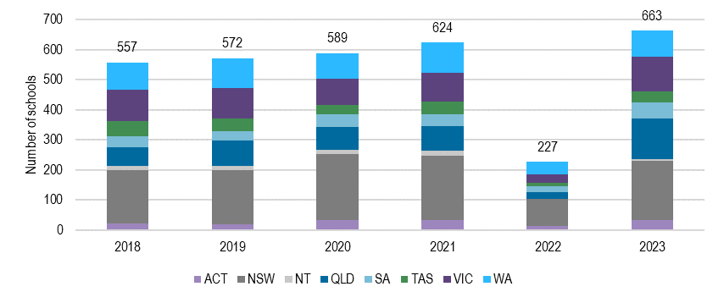
Source: HTAA program data 2018-2023.

While government schools make up the majority of those making submissions (Figure G.2), these figures are not reflective of the schools Australia-wide (where Government schools account for approximately 70% of all schools). In recent years, the number of schools from Metropolitan areas has increased from 67% to 73% of all schools.

Figure G.2 National History Challenge
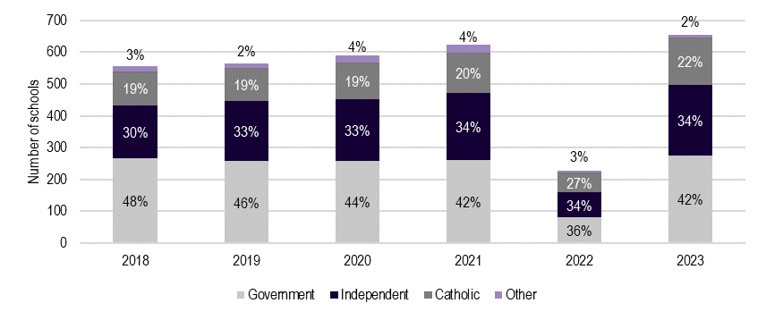
Source: HTAA program data 2018-2023

    - Awareness and accessibility of the program
The Challenge is promoted through conferences, social media, brochures and welcome kits, and general mailouts; however, stakeholders reported that awareness of the Challenge is limited. Anecdotally, in-person discussion and promotion of the Challenge has been the most successful mechanism to increase participation. Schools who have entered the Challenge in the past are more likely to continue to make submissions.
Given that the Challenge is open to all ages, and that there is no entry fee, the Challenge is seen as being broadly accessible.
    - Sufficiency of program administration and communication
The Challenge website is good for information and resource gathering, and those involved in running the program at their schools found the resources provided adequate for their classroom needs. Several stakeholders commented that more could be done to promote the challenge through different mediums such as radio or television.
    - Enablers
The introduction and continuation of the Challenge at a school is primarily driven by a single passionate teacher at that school. If the Challenge is implemented outside of a school’s Humanities curriculum, teachers are often running information sessions after school and on weekends.
The resources that are provided for Challenge are widely seen as enabling uptake. Many stakeholders commented on the opportunity for travel and ceremonial presentations as being influential factors for encouraging student participation.
    - Barriers
One notable challenge to broader participation in more schools is the time constraints that teachers already grapple with due to already busy curriculums. The Challenge, though valuable, is often perceived as an additional demand on their limited time and resources. Furthermore, reaching the appropriate person within a school who can champion and integrate the program can be difficult, as awareness of the Challenge might be limited among staff and administration.
A general lack of enthusiasm towards humanities subjects, when compared to the interest in STEM disciplines, can also impact the uptake of the Challenge.
The roles of state coordinators, essential for organising and promoting the Challenge at regional levels, are voluntary positions. This can lead to inconsistencies in outreach and support, as the coordinators' time and commitment may vary due to their other responsibilities.
  - Effectiveness
    - Effectiveness in delivering against key policy considerations
The Challenge appears to meet the inclusive and equitable aims of the Key Policy Considerations. The annual themes of the Challenge allow for integration within the Australian Curriculum at all student levels.
    - Adequacy of effectiveness measures
Data provided to ACIL Allen shows that the HTAA record the number of schools and students who register and participate in the challenge. Schools are disaggregated by state and sector, and entrants are disaggregated by year level, format, and category of submission (Wartime Experience, Democracy, etc.). The HTAA monitor submissions by state and year level carefully and are a cognisant of developing trends against these indicators. Monitoring of longer term outcomes, e.g. on student achievement, does not currently occur.
  - Key insights
- The program is seen by teachers as being well-aligned with the Australian Curriculum, as valuable for participants, and broadly complementary with the skills students should be developing. Awareness of the Challenge is limited, and more could be done to broaden the participation rates for all students.
- Releasing each year’s theme earlier would allow teachers to integrate the Challenge into their curriculum planning for the upcoming year. This will provide teachers with ample time to brainstorm creative approaches and tailor their lesson plans accordingly.
- Highlighting the correlation between the Challenge and assessment tasks could foster increased engagement from both teachers and students. By demonstrating how participation aligns with educational objectives and assessment criteria, the Challenge can be positioned as an engaging means of reinforcing historical research and analytical skills, thus boosting involvement levels.
- School participation data is not linked to any measures of regionality or ICSEA level, and the collection/linking of this information with submission data would improve understanding of evolving trends against the effectiveness of the Challenge’s reach and participation.

National Schools Constitutional Convention
  - Overview
The National Schools Constitutional Convention (NSCC) is an annual event organised by the National Curriculum Services (NSC) for senior school students in Years 11 and 12, which explores the Australian Constitution.
Each year, 120 students from across Australia are selected to attend the NSCC in Canberra, in addition to around 19 teacher chaperones. The numbers of student representatives from each state and territory is dependent on state ratios and a minimum of 2 teacher chaperones are required from each state and territory. In larger states, there are state conventions held for selected students, states select students to attend the National Convention from the pool.
    - Data sources used for this assessment
Qualitative data from stakeholder consultation and program reporting.
  - Appropriateness
    - Key policy considerations
Key policy considerations of the NSCC include:
- the extent to which the programs support equitable and inclusive participation
- the extent to which the programs align with and support the Australian Curriculum
- the extent to which the programs complement what is being provided by state and territory governments and non-government organisations.
Key policy aims of the NSCC are:
- to help young Australians to become active and informed citizens through an understanding of Australia’s system of government, history, and culture
- to provide resources aligned to the Australian curriculum to aid the teaching of civics and citizenship education in schools respectively.
    - Consistency with current educational priorities
The NSCC is designed for students in Years 11 and 12, who are not covered by the Australian Curriculum. Despite this, stakeholders indicated that the NSCC aligned with what students in these year levels were learning and provided a practical application for the topics covered in the classroom.
“The NSCC builds upon what students are already learning in civics and citizenship, it provides a practical application for what they’re learning in the classroom.” – CCE program staff participant.
“It was very clearly aligned, I wished I could have had the whole year 12 legal studies cohort rather than just the one student. The information they covered was so powerful for a legal studies student.” – CCE program school staff participant.
“Students from my school have participated in the NSCC for the last 2 years, and it has extended their knowledge and understanding of the VCE Legal Studies curriculum significantly.” – CCE program school staff participant.
    - Governance
The Department of Education procures services from the NCS to facilitate and run the NSCC. Stakeholders from the NCS noted the ease of working with the department and valued the assistance provided by the department when dealing with states and territories, particularly during COVID-19.
While the NCS runs the national event and has contractual obligations around equity, diversity and fairness, the decision of which students attend the NCSS falls to states and territories. This blurs the lines of governance as the NCS have contractual KPIs that they cannot directly impact and must assume states are choosing representatives equitably. This complicates the NCS’s tender application as travel costs and accommodation are expenses covered by the NCS with department funding but are a relative unknown at the time of application as the regions students travel from change every year and can vary significantly within states.
“States and territories decide who comes, we must presume they ensure equitable representation. Important to make sure kids aren’t excluded because of where they live, there have been more remote students attending the convention over time.” – CCE program provider.
“I’ve always found the Australian Department of Education fantastic to deal with, they know when to step in and speak to the states. This was tested during COVID, but they acted promptly to work with the states to come to a sensible solution.” – CCE program provider.
    - Educational validity
Participation in the NSCC has enabled students to strengthen and build a range of important skills that enhance their education. Teachers reported observing improved skills in public speaking, leadership, networking and perspective taking when students returned to school following the convention.
  - Fidelity
    - Alignment with design
The program aligns with its design and helps students engage in topics of civics and citizenship. The only area where the program was not aligned was the number of students engaged. The NSCC is supposed to have 120 students in attendance, however, over the last 3 years, attendance has averaged 107 students.
    - Reach of the program
State and Territory based conventions and professional development for teacher chaperones extends the reach of the NSCC far beyond the 120 students who travel to Canberra.
In 2023, 115 students attended the NSCC in Canberra, slightly above the average of 103 students from the 2 preceding years. Of the students who travelled to Canberra, 73% were from schools in metro areas, which is equivalent to the proportion of all FTE students in Australia attending schools in major cities (ABS 2022 Schools Survey). Since 2021, around 50% of students who attended the NSCC were from Government schools, around 26% were from Catholic schools and 23% were from Independent schools. Compared to 2022 ABS Schools data, students from government schools are under-represented at the NSCC, while students from both Catholic and Independent schools are over-represented.
“Should ensure it’s a merit based, I noticed that students from some states were all from private schools, I did wonder if there was diversity in selection there. I like the way NSW does it, it brings in a degree of merit.” – CCE program school staff participant.
Many states and territories hold state-based conventions as pre-cursors to the NSCC, increasing the number of students actively engaging in a convention. For instance, at the Queensland Schools Constitutional Convention there were 50 schools in attendance and 315 students.
“We attempt to make sure that all regions and schools are catered for. Years 7-11 can attend, what we see is that some schools bring students along on an interest base, while others involve their whole legal studies program.” – State or territory representative.
The reach of the program is also extended by professional development opportunities for the teachers in attendance at the NSCC. Stakeholders referred to learnings they had taken away from the convention and later applied to the classroom.
Figure H.1 NSCC – Student demographics
Source: NSCC program data

    - Awareness and accessibility of the program
Awareness of the NSCC within schools stems from advertisements for state-based conventions and information provided to schools by state and territory departments. The NCS noted that while most schools are aware of the NSCC many teachers don’t engage with it due to their already busy schedule, they reflected that it was often not until a teacher had experienced the NSCC themselves as a chaperone that they began to engage more actively. This perception was confirmed by teachers during consultation.
“Getting teachers to realise that this is a good program, there’s a little bit of work required from teachers to help students get their application completed. Now having experienced how good the program is I might do a bit more coaching to help get more students to Canberra.” – CCE program school staff participant.
A key enabler for student accessibility to the NSCC is having all associated costs covered, which provides more equitable access for students from regional and remote areas, and from families that would otherwise be unable to afford to send their child to Canberra to attend. However, time is a non-monetized cost that these students are unable to recover. Students from regional and remote areas were reportedly spending an additional day or 2 travelling to and from the event compared to their peers in major cities.
Regionality is an even larger barrier for state-based conventions. In states where events are held face-to-face students are having to travel in their own time and at their family’s expense to attend. If the monetary costs and time taken to travel are too high, regional and remote students are less likely to attend, and the pool of regional students that can attend the NSCC falls. Since COVID-19, to enable more equitable access some states, such as Queensland, have moved to an online convention for their state.
“There are extra challenges for regional NSW students. There is the NSW parliament constitutional convention (the steppingstone in NSW) is easy for suburban NSW students to attend because it’s just a day out of school. But for students from country NSW who don’t get funding to attend the state convention are reliant on their parents bringing them to Sydney to get that opportunity to go on to the NSCC.” – CCE program school staff participant.
    - Sufficiency of program administration and communication
Administration of the NSCC and communication regarding the program was lauded by stakeholders. Teachers felt well supported by state officials when assisting students with their applications and reported the application process as being relatively straightforward. Communication and information provision for teachers attending as chaperones was comprehensive and delivered in a timely manner.
“The process was incredibly straight forward, we received information from the NT government, the kids filled out the forms and within a couple of weeks we had confirmation that they had been accepted. I couldn’t believe how much information was provided by the National Curriculum Service; they were amazing.” – CCE program school staff participant.
“[Communication and the information provided] was excellent, everything about it was good. … It was a little scary looking after 40 students you’ve never taught or met before. They (the NCS) sent a lot of information through; I had all the medical information in relation to the students attending a good 2 weeks before the trip. It meant I could prepare in advance for the medical and emotional needs of students.” – CCE program school staff participant.
    - Enablers
In addition to financial costs of attending the NSCC being covered, buy-in from teachers and school executives was identified as another key enabler for the NSCC in schools.
Buy-in stems from having stakeholders that believe in the quality of the NSCC and the programs alignment with the curriculum. This was supported by teacher’s, those that attended the NSCC as chaperones were more likely to engage with it again and assist more students from their school to attend in the future. Additionally, buy-in from school executives is important as principals must be willing to sign off on a relief teacher to cover a teacher who attends as a chaperone.
“[The program is successful] because we have stakeholders that believe the NSCC is good quality and so they’re willing to put in the yards to get people to attend.” – CCE program provider.
    - Barriers
Travel time for regional and remote students, and difficulties replacing teachers with relief staff when they attend the NSCC were the 2 main barriers identified through consultation.
Students from some state and territories, and regional areas are having to take multiple flights to attend the NSCC, this increases the logistical difficulties of getting students to the event and can drastically extend the amount of time away from school a student must take to attend, particularly if flights are delayed or cancelled.
“The amount of time students have to spend travelling from remote and regional areas to attend, kids have to take a week off school to allow for travel time. We chaperone the kids down to Brisbane and then supervisors take them to Canberra. It takes a lot of effort to get students from across the state.” – State or territory representative.
The program relies on teacher chaperones volunteering to supervise students, and their schools allowing them to do so. Schools are struggling to find and organise relief staff, particularly in regional schools with smaller relief workforces to draw from. The added financial costs of relief teachers and paying staff attending the NSCC time in lieu is a disincentive to school leadership when determining whether to allow a teacher to attend as a chaperone.
“There’s no money for replacement teachers, schools must be willing to volunteer a teacher’s time. So, the first issue is funding but then it’s also about finding someone to replace you. Teachers attending the event is an expense to schools due to the time-in-lieu provision.” – CCE program provider.
Additional challenges included a lack of awareness of the NSCC among teaching staff and the timing of the event resulting in some schools not sending their students due to assessment conflicts.
  - Effectiveness
    - Effectiveness in delivering against key policy considerations
The NSCC has several benefits which align closely with the key policy considerations. The NSCC has helped develop awareness of the constitution and has cultivated political interest among participating students. The program is effective in broadening participants knowledge in related course work such as legal studies. By participating in the NSCC, teachers reported that students also gain key skills in leadership, communication and networking.
“[Participation in the NCSS has] Improved awareness of the constitution, greater political awareness and political interest, students also feel like their voices are being heard.” – CCE program provider.
“There are many benefits for students – increased curriculum knowledge, public speaking skills, networking with other like-minded students, increased confidence and independence.” – CCE program school staff participant.
Teachers reported that the NSCC had widened the career horizons of the students in attendance, particularly for students who were from regional and remote areas that otherwise don’t have visibility of many professions in the public sector.
“It was great for the kids to have experience and exposure to other kids from around the country, they get exposed to all these different points of view and backgrounds. They enjoyed it because it broadened their horizons and they got to see how much bigger the world is outside the NT, and they could see how many weird and niche jobs there are out there.” – CCE program school staff participant.
“The event has seemed to be a pathway to politics, anecdotally, we’ve had members of parliament who said they had engaged in the convention as students.” – CCE program provider.
    - Adequacy of effectiveness measures
The NCS does an excellent job in reporting against the NSCC’s effectiveness measures. A comprehensive list of participants and supervisors, and their demographics are provided by the NCS, in addition to a survey of participant feedback. A limitation of this survey is its focus on participants perceived quality of the programs outputs, as opposed to the outcomes for participants resulting from participation.
    - Key insights
- The program aligns with the curriculum and has tangible impacts on student outcomes in line with the objectives of CCE. The NSCC itself has limited reach beyond the 120 students in attendance and the teacher chaperones. The reach is broadened by some states running their own state-based conventions, which enable greater student attendance and can cater for non-Year 11 and 12 students.
- While the NCS cover travel and accommodation costs for attendees, regional students face additional challenges to attend the NSCC and state conventions. Some states have moved to online conventions which has reduced some of these accessibility issues, though, stakeholders asked that the NSCC remain face-to-face due to their experience during COVID-19 and the benefits of being there in-person.
- Increasing awareness among schools and teachers of the benefits that come from involvement in the NSCC and the experiences of previous participants would be valuable. It is clear staff that attend the NSCC find real benefits from the convention’s professional development activities and their student’s participation. These experiences could be leveraged through promotional material and activities to better communicate the benefits to other schools that may not have previously engaged with the program, thereby expand its reach.
- Broadening the suite of resources and offerings available to schools is an additional opportunity to improve program effectiveness. Attendance to the national event is limited to 120 students. State-conventions and application processes do a lot of the heavy lifting to expand the reach of the NSCC. The provision of resources and training material to school staff on how to run a classroom-based activity that mimics the national convention would drastically increase the reach of the program.

The Simpson Prize
This appendix provides an assessment of The Simpson Prize.
  - Overview
The Simpson Prize is a national competition for Year 9 and 10 students in Australia. It focuses on the service of Australians in World War I. Under the competition, a question is posed to students with simple instructions to complete an essay or audiovisual entry. These entries are judged by a state panel appointed by the state History Teachers Association, according to a set marking guideline for each format. Students are provided with multiple sources, including written, visual and video content, from which to inform their research and viewpoint.
Schools are permitted to submit up to 3 student entries per year. These entries are judged, and the winner and runner-up in each state and territory is invited to participate in a 2- or 3-day program in Canberra. On this trip, students and their teacher chaperones attend several museums and institutions, including a presentation ceremony at Parliament House.
The 8 state and territory winners, along with 2 teacher chaperones and a historian from the Australian War Memorial, then travel overseas to relevant battlefields and attend and participate in ANZAC Day commemorations.
    - Data sources used for this assessment
- Quantitative and qualitative analysis of program data and program reporting.
- Qualitative analysis of interviews with participants.
  - Appropriateness
    - Key policy considerations
The Simpson Prize is somewhat appropriately designed to meet the key policy considerations.
- The Simpson Prize is freely available to all students to participate, supporting equity. However, the rigid entry requirements may restrict the extent to which the program is considered inclusive.
- The program is aligned with content in the Australian Curriculum and with the skills required for an entry. However, as it is spread across multiple year levels, these area alignments may not occur simultaneously.
    - Consistency with current educational priorities
The Australian Curriculum includes World War I history in year 9. Hence, the Simpson Prize aligns strongly with the year 9 curriculum in terms of content. However, as the competition is open to Year 9 and 10, the competition does not align with the year 10 curriculum in terms of content but is more strongly aligned regarding student skills.
While the competition covers both Year 9 and 10 in terms of skills and content, some teachers felt that year 10 students held a significant advantage in the competition due to their advanced skills.
    - Governance
The Simpson Prize is operated by the History Teachers’ Association of Australia (HTAA) who develops program materials. Each State and Territory has a coordinator/affiliate. Reporting indicates consistency in budget allocation and expenditure.
    - Educational validity
The Simpson Prize was widely viewed to be a strong educational tool.
The data sources provided where considered to be of high quality and appropriately developed relevant skills in research, analysis and communication.
“We do it as a major project for all our students in year 10. That’s not just because of the competition, but developing the skills, researching, data sources, extrapolating data. It’s always great if a student can win, but the process is very valuable. Especially before they go into year 11.” – CCE program school staff participant.
  - Fidelity
    - Alignment with design
The Simpson Prize effectively delivers a national competition to Year 9 and 10 students across Australia. The competition is appropriately managed, administered and resourced, with sufficient promotion and awareness raising activities undertaken.
Domestic and international study trips have been delivered as prescribed. This has been interrupted by the COVID-19 pandemic, wherein some activities were conducted virtually, and additional funding of $20,000 was delivered to HTAA to support the rescheduling of these study trips.
    - Reach of the program
The program has a strong reach. Since 2005, 19,503 students have submitted entries to the competition. This notes that schools are limited in the number of entries they may submit, indicating that the number of students participating in the activity is likely to be significantly higher.
Over time, the number of participating students has varied considerably. Since 2005, on average, over 1,000 entries are made per year. Since 2020, this average has dropped to 730.5 entries per year. This may be indicative of a reduced participation and reach and may be influenced by factors such as COVID-19 restrictions.
Figure I.1 Number of student entries per year
Source: Simpson Prize participation data, 2023.

Since 2005, 100 schools per year submit entries to the competition. This average has declined since 2016 to 86.5 schools submitting entries per year.
Figure I.2 Number of schools with a student entry per year
Source: Simpson Prize participation data, 2023.

Teacher chaperones noted that the reach of the program extends beyond the competition. In some cases, examples were provided of a successful student raising awareness of the program within their community. However, it was also noted that the limited number of prize winner and runner up places restricted the influence of the program.
“It is [about] bringing history to life and making those experiences accessible. Its only few students. So, they can’t bring much of that back either.” – CCE program school staff participant.
    - Awareness and accessibility of the program
Awareness of the Simpson Prize appears to be moderate to high. Participation is free, with resources highly accessible, and no mandated additional costs to the school.
Teacher chaperones did note that the production of a high-quality entry did require additional time for both the students and the teachers supporting them. As such, this may require additional personnel or time, which may not be available to schools with limited resourcing and heavy time constraints. This does not impact on the accessibility of base participation but does influence the accessibility of a competitive entry.
“Anything like this relies on teacher’s will and commitment to have student engagement… If I didn’t do it as a class requirement, it would be extra work in my own time.” – CCE program school staff participant.
    - Sufficiency of program administration and communication
The Simpson Prize was viewed to be well administered and communicated. The resources were provided in a timely manner and communicated effectively to the appropriate coordinators.
    - Enablers
Key enablers raised by teacher chaperones included:
- That the resources were easily accessible and of high quality. This facilitated greater participation, as teachers could access readily available materials that were trusted to be of high quality and appropriate.
- The program was generally viewed to align closely to the Australian curriculum. This again encourages teachers to incorporate some or all the program into their teaching plans, facilitating further participation.
“It’s extremely well aligned to curriculum. Fits in perfectly with NSW and Australian curriculum. I am the history coordinator, so we tailored it to that. The resources they provide with the question are superb. So not only the content but skills outcomes.” – CCE program school staff participant.
    - Barriers
Key barriers raised by teacher chaperones included:
- That the program in each school often relies on an individual teacher to lead and drive the program. This creates a person dependency that creates a risk of continued program implementation should that staff member leave, or where staffing resources are limited.
- That the competition winners are subject to different travel arrangements that are not always accounted for. For example, individual students may have extensively more travel time than other students, which adversely impacted their ability to participate in the winners and runners up programs.
- That the competition is slightly misaligned across the curriculum of Year 9 and 10, whereby a Year 10 with additional supports may gain an advantage in the competition.
“A limitation now is that it’s a year 9/10 competition, but WWI is taught in year 9. Year 10 students are stronger writers and better researchers, but it is hard to get year 10 to partake. In private school, it may be possible to mentor and teach students individually, but for public school getting year 10 to do an extracurricular competition in the teachers own time and in students’ own time.” – CCE program school staff participant.
  - Effectiveness
    - Effectiveness in delivering against key policy considerations
Evidence suggests that the Simpson Prize has contributed to achieving the key policy considerations.
The Simpson Prize has support young Australians to develop a complex understanding of and interest in Australian history and culture and build relevant research skills. This impact is limited only by the reach of the program.
“I remember quite a powerful full school assembly when Sasha had been to Europe and on ANZAC she spoke to the assembly about the experience. And it was so powerful. And students hearing that will get inspired in history – where we come from where we are going and what it all means, that’s what the program captures.” – CCE program school staff participant.
“It is important to recognise that History and Social Sciences (HASS) has career paths, and the value HASS can take them to. Students often want to take subjects that will help them and take them into a career and know about job opportunities.” – CCE program school staff participant.
The Simpson Prize is also considered to align strongly with the Australian curriculum in terms of content and skills. However, there is a disconnect regarding the timing of the competition with this alignment, in that the skills and content do not align simultaneously.
The program is sufficiently designed to support equitable participation. However, the rigidity of program design may impact the ability for certain student cohorts, such as Aboriginal and Torres Strait Islander students, to participate.
    - Adequacy of effectiveness measures
Effectiveness measures are limited largely to the scale of entries, schools participating, and the activities of program winners and runner’s up. This measure does not capture the quality of the entries being submitted, nor the scale of content that is not submitted.
“How many students you have entering the program is a measure of success. We had such success at [our] school [that] it built [more]. Our kids did the Europe trip and spoke about their experience in the assembly. Now new head of HASS is not promoting SP. There was one entry last year, haven’t heard anything this year.” – CCE program school staff participant.
  - Key insights
Opportunities to improve the design include:
- Increased promotion of the program to schools and teachers. This would facilitate greater reach and participation in the program.
- Including activities that support the participation of different cohorts of students. This could include activities that foster greater engagement with Aboriginal and Torres Strait Islander students, or students where an essay format may not be the most appropriate accessible.
Opportunities to improve the effectiveness of the Simpson Prize include:
- Incorporating additional effectiveness measures to capture the quality of entries, and to report on the number of students preparing entries that may not be submitted.
- Adapting the activities involved in the competition to allow more inclusive participation. This may incorporate alternative options to essay writing and videography that enable broader accessibility.

World Schools Debating Championships and affiliate equity programs
This appendix provides an assessment of the World Schools Debating Championships (WSDC) and affiliate equity programs.
  - Overview
The World Schools Debating Championships (WSDC) and affiliate equity programs support Australia’s participation in an English-language WSDC and the development of debating in schools across Australia through teaching coaching and development programs.
    - Data sources used for this assessment
Qualitative data from stakeholder consultation and program reporting.
  - Appropriateness
    - Key policy considerations
Key policy considerations of the WSDC and affiliate equity programs include:
- the extent to which the programs support equitable and inclusive participation
- the extent to which the programs align with and support the Australian Curriculum
- the extent to which the programs complement what is being provided by state and territory governments and non-government organisations.
Key policy aims of the WSDC affiliate equity programs are:
- to help young Australians to become active and informed citizens through an understanding of Australia’s system of government, history, and culture
- to provide resources aligned to the Australian curriculum to aid the teaching of civics and citizenship education in schools respectively.
    - Consistency with current educational priorities
While not explicitly fitting into the Australian Curriculum, teachers considered debating to be complementary to many learning areas covered within it, including civics and citizenship. One teacher discussed how the topics covered in debating competitions were usually of relevance to their community, and thereby lend themselves to issues of civics and citizenship.
The Australian Debating Federation (ADF) similarly noted that debating’s focus on developing spoken and critical thinking skills meet aspects of the Australian Curriculum but does not directly address it.
    - Governance
The ADF hosts the National Schools Debating Competition each year, from this they select a national representative team for the WSDC. The ADF receives funding from the Department of Education to train and send the selected team to the WSDC. Additionally, the ADF works with state affiliates who run state-based competitions and affiliate equity training programs, except for NSW. These programs are funded through the provision of grants from the ADF.
Around three-quarters of funding provided by the department is allocated to the WSDC, the remainder is spent on affiliate equity programs.
    - Educational validity
The skills acquired from participation in debating are of high educational relevance, these include critical thinking, communication, teamwork and leadership skills.
Some schools in regional areas also noted that debating was the only available academic extra-curricular activity available to their students, so it had significant value add for their community.
  - Fidelity
    - Alignment with design
For the WSDC aspect of the program, there is close alignment with the program design. Australian teams have a record of high performance at the WSDC, which is a credit to the training they receive within schools and after selection for the national team.
Alignment with design is poorer for the affiliate equity programs, limited funding means that most state affiliates are only covering one or 2 of the prescribed activities in the contract with the ADF. There is variability in the effectiveness of these activities due to consistent turnover of state affiliate staff.
    - Reach of the program
Between 2018 and 2023, 30 students attended the WSDC from 19 schools, only Tasmania and the Northern Territory had not sent students to the WSDC. While selection is merit based, access to be selected is not equitable. Of the 29 students who have attended the WSDC since 2018, only 6 students (20%) were from public schools and of those 6, 2 were from non-selective government schools.
Additionally, all students selected were from schools in their state’s capital city, indicating non-existent regional representation. Through consultation it was evident that regional and remote schools face significant barriers to attend debates in their own regions let alone at a state level which was reducing participation and diminishing the reach of the program.
At a state level it was anecdotally reported that there are typically 200-300 students to choose from in each of NSW and Victoria, while in smaller states such as Tasmania and the Northern Territory there are between 15 and 20 students. Each state selects a squad to participate in the National Schools Debating Competition, from which the ADF then selects the national team.
For the affiliate equity programs, the number of students engaged in 2018 (the only year with complete reporting) was around 580 according to affiliate reports, though nearly 3 quarters were from Queensland and Western Australia. 2019 reports were available for all affiliate programs except for Tasmania and the ACT, in this year the number of students participating was much lower with around 180 students participating in affiliate equity programs.
    - Awareness and accessibility of the program
A school’s participation in debating was regularly the result of one passionate or dedicated teacher who pushed the debating agenda in their school, rather than explicit advertisements from state affiliates.
Student interest was reportedly lacking in some schools, including those with long-standing participation in debating events. This was attributed to the extra-curricular nature of the activity, travel times to participate, and a general lack of awareness of what debating is. Teachers are combatting this with different promotional activities, but in regional areas the lack of interest has reportedly led to the dissolution of some school debating teams.
    - Sufficiency of program administration and communication
The ADF noted that communication with the department was sufficient and there were appropriate ‘guard rails’ in place with the funding arrangement.
At a school level, communication regarding the timing of state-competitions and regional equity-based training sessions caused some issues. Delayed communication on event timing meant school staff were unable to appropriately plan, prepare and set aside time in the school calendar for the event, which sometimes led to unavoidable clashes and schools withdrawing teams.
    - Enablers
The teaching, coaching and development programs run in schools to foster an understanding of debating techniques for students and teachers, provided by affiliate debating programs, was highlighted as a key enabler for debating in schools. These sessions not only taught students key debating skills, but also increased attendance as they were held during normal school hours.
“The training day has broken down the barrier of students not wanting to commit time to anything for school outside of normal school hours. We hold training days at the start of the year. This year we had over 100 students attend from across the 11 schools, it was a highly successful day, it provides them with an insight into how debates are run and how to put together a speech.” – CCE program staff or school staff participant.
The passionate and dedicated teacher base and volunteers were also highlighted as an enabler. Teachers are spending a lot of time outside their normal hours to deliver debating programs and facilitate competitions, while the affiliate workforce is volunteer based. Without these 2 groups state championships would not occur.
    - Barriers
The main barrier identified to student engagement in debating was the extra-curricular nature of the activity. Teachers reported that students weren’t willing to commit time outside of school to attend sessions and that debating was having to compete with other extra-curriculars such as sport.
“One of the biggest barriers to attendance and participation has been getting kids to attend outside of normal school hours.” – CCE program staff or school staff participant.
Another challenge was the inconsistent timing of affiliate led debating training sessions and competitions, which reduced attendance and prevented necessary planning from taking place. Schools struggled with funding for debating programs, teachers reported having to fight for funding at their schools.
Regional schools noted how they were isolated in terms of other schools to work and compete with and were struggling for interest. Travel times to compete and attend trainings were a strong disincentive to student participation. While online debates had been explored, regional schools cited connectivity issues which significantly diminished their experiences, this was compounded by a lack of interest from schools in metro areas to participate in online debates.
  - Effectiveness
    - Effectiveness in delivering against key policy considerations
The size of the national team that is selected to attend the WSDC limits the reach of the program. The team size is governed by the WSDC Tournament Committee and Debate Rules. The merit-based selection process, while allowing the highest performing team to be chosen, is not equitable in terms of accessibility. The National Schools Debating Competition, and state competitions run by affiliates broaden the reach of debating. Though, there are still some equity issues in terms of accessibility to these events, particularly for schools in regional areas.
Affiliate equity programs similarly broaden the reach of the program to schools that are otherwise unable to participate in debating due to their resources and location. Inconsistent interest from students, staff turnover in schools and a need for affiliates to support schools in other regions, has meant that schools that engage in the equity programs regularly don’t continue participation after the initial treatment for reasons outside of the affiliates control. The effectiveness of affiliate programs is further inhibited by the small proportion of funding they receive relative to the World Schools Debating Championships.
“We haven’t entered a team this year or attended the affiliate led training sessions due to low interest from students, low skills, and students not wanting to engaged with the program and have to travel for 2 days to attend.” – CCE program staff or school staff participant.
Debating programs complement many learning areas within the curriculum and allow students to grow skills in areas that lend themselves to students being more active and informed citizens.
“[Through debating] They [students] get a chance to express ideas, think about non-dominant ideas, and develop empathy to give credence to the other side of the argument.” – CCE program staff or school staff participant.
“Students self-confidence has improved. They get to practice working in a team, you see them start to become more self-assured and gain confidence in public speaking.” – CCE program staff or school staff participant.
    - Adequacy of effectiveness measures
Reporting by the ADF itself focuses on the WSDC and emphasises the results and composition of the team as the primary outcomes of the program. State affiliates provide more detailed information through their annual reporting on the equity programs they facilitate. The affiliates report on the outcomes, reception and participation figures for their state-based equity programs. These reports are adequate in measuring the effectiveness of the programs and are uniform across the states and territories.
  - Key insights
- Debating is a highly valuable program, with a passionate teacher and volunteer base that push the debating agenda within schools. Debating can have a large positive impact on students in terms of their education, skill development, and ability to critically engage with matters of civics and citizenship.
- The current emphasis of funding on the WSDC is preferencing a select group of students and schools over everyone else, the emphasis should increase on affiliate training programs which are doing the leg work to extend the reach of debating and increase participation numbers in areas that would otherwise not participate.
- To improve program effectiveness the emphasis of the program should move away from the WSDC, which takes up around 75% of funding and impacts a handful of students, to national and state competitions, and affiliate equity programs. These activities engage the most students and provide more equitable opportunities. When consulted, schools focused on the benefits of the affiliate equity programs, professional development opportunities, training and regional competitions. Indicative of the importance they place on these initiatives, and the need for greater service provision in these areas.

Melbourne  Suite 4, Level 19, North Tower  80 Collins Street Melbourne VIC 3000 Australia  +61 3 8650 6000  Canberra  Level 6, 54 Marcus Clarke Street Canberra ACT 2601 Australia  +61 2 6103 8200 | Sydney  Suite 603, Level 6  309 Kent Street  Sydney NSW 2000 Australia  +61 2 8272 5100  Perth  Level 12, 28 The Esplanade  Perth WA 6000 Australia  +61 8 9449 9600 | Brisbane  Level 15, 127 Creek Street  Brisbane QLD 4000 Australia  +61 7 3009 8700  Adelaide  167 Flinders Street  Adelaide SA 5000 Australia  +61 8 8122 4965
ACIL Allen Pty Ltd
ABN 68 102 652 148
acilallen.com.au

Programs in the Economics and Business area are out of scope for this evaluation.
2 Programs in the Economics and Business area are out of scope for this evaluation.
The Department’s Corporate plan specifically includes statements on inclusion and equity as central pillars of government. For example: Schools - Support children through a positive school experience with equity and wellbeing outcomes for all learners. Education systems vary in terms of defining and conceptualising diversity, equity, and inclusion in education. Equity and inclusion in education systems are approached holistically, building on their interdependencies to generate complementarities and prevent inconsistent objectives.
Australian Curriculum and Assessment Authority ACARA. (2012). The Shape of the Australian Curriculum: Civics and Citizenship. https://docs.acara.edu.au/resources/Shape_of_the_Australian_Curriculum__Civics_and_Citizenship_251012.pdf
ACARA. (2012).
ACARA. (2012).
Weinberg, J. (2022). Civic education as an antidote to inequalities in political participation? New evidence from English secondary Education British Politics 17:185–209 https://doi.org/10.1057/s41293-021-00186-4
Weinberg. (2022).
Parliament of Australia. (2023). https://www.aph.gov.au/About_Parliament/Parliamentary_departments/Parliamentary_Library/FlagPost/2023/June/Civics_and_Citizenship
ACARA. (2023). Senior Secondary. https://www.australiancurriculum.edu.au/senior-secondary-curriculum/
ACARA. (2023). Implementation of the Australian Curriculum. https://www.australiancurriculum.edu.au/f-10-curriculum/implementation-of-the-australian-curriculum/
Australian Government Department of Education. (2023). Department of Education Skills and Employment Portfolio Guide. https://www.education.gov.au/download/14669/department-education-skills-and-employment-portfolio-guide/30399/department-education-skills-and-employment-portfolio-guide/pdf
Australian Government Department of Education. (2023).
Australian Government Department of Home Affairs. (2023). Strengthening Democracy Taskforce. https://www.homeaffairs.gov.au/about-us/taskforces/strengthening-democracy-taskforce
Australian Government: Department of Home Affairs. (2023)
Australian Government Department of Education. (2023). The National School Reform Agreement. https://www.education.gov.au/recurrent-funding-schools/fact-sheets/national-school-reform-agreement
Australian Government Department of Education. (2023)
Australian Government Department of Education. (2023)
Parliament of Australia. (2023)
ACARA. (2019). NAP Civics and Citizenship 2019 National Report. https://nap.edu.au/docs/default-source/default-document-library/20210121-nap-cc-2019-public-report.pdf
ACARA. (2019).
Australian Government Department of Home Affairs. (2023).
Parliament of Australia. (2019). Terms of Reference: Joint Standing Committee on the National Capital and External Territories. https://www.aph.gov.au/Parliamentary_Business/Committees/Joint/National_Capital_and_External_Territories/NationalCapital/Terms_of_Reference
Parliament of Australia. (2020). Terms of Reference. https://www.aph.gov.au/Parliamentary_Business/Committees/Senate/Legal_and_Constitutional_Affairs/Nationhood/Terms_of_Reference
Cohen, A., Fitzgerald, J., Ridley-Kerr, A., Maker Castro, E. & Ballard, P. (2021). Investigating the Impact of Generation Citizen’s Action Civics Education Program on Student Academic Engagement. The Clearing House: A Journal of Educational Strategies, Issues and Ideas. 94(4). 168-180. DOI: 10.1080/00098655.2021.1927942
Cohen et.al. (2021)
Blevins, B., LeCompte, K. & Wells, S. (2016). Innovations in Civic Education: Developing Civic Agency Through Action Civics. Theory & Research in Social Education, 44. 344-384. DOI: 10.1080/00933104.2016.1203853
Blevins et.al. (2016)
Sætra, E. (2020). Discussing Controversial Issues in the Classroom: Elements of Good Practice, Scandinavian Journal of Educational Research, 1470-2270. DOI: 10.1080/00313831.2019.1705897
Blevins et.al (2016)
Blevins et.al (2016)
Blevins et.al (2016)
Blevins et.al (2016)
Blevins et.al (2016)
Cohen et.al (2021)
Blevins et.al. (2016)
Blevins et.al. (2016)
Blevins et.al. (2016)
Prati, G., Mazzoni, D., Guarino, A., Albanesi, C & Cicognani, E. (2020). Evaluation of an Active Citizenship Intervention Based on Youth-Led Participatory Action Research. Health Education & Behaviour. 47(6).894–904. DOI: 10.1177/1090198120948788
Blevins et.al. (2016)
Prati et.al (2020)
Sætra (2020).
Blevins, B, LeCompte, K, Riggers-Piehl, T, Scholten, N & Magill, K. (2021). The Impact of an Action Civics Program on the Community & Political Engagement of Youth. The Social Studies. 112(3). 146-160. https://doi.org/10.1080/00377996.2020.1854163
Sætra (2020)
Bevins et.al (2016).
Blevins et.al (2021).
Sætra (2020).
Briole, S., Gurgand, M., Maurin, E., McNally, S., Ruiz-Valenzuela, J & Santín, D. (2023). The making of civic virtues: a school-based experiment in 3 countries. Centre for Economic Performance: The London School of Economics and Political Science, 1830, 2-51.
Wineburg, S., Breakstone, J., McGew, S., Smith, M & Ortega, T. (2022). Lateral Reading on the Open Internet: A District-Wide Field Study in High School Government Classes. Journal of Educational Psychology. 114(5). 893-909. https://doi.org/10.1037/edu0000740
Chen, J., & Stoddard, J. (2020). A Virtual Internship to Prepare High School Students for Civic and Political Action. Education Tech Research Dev. 9847. https://doi.org/10.1007/s11423-020-09847-5
Blevins et.al (2016).
Briole et.al (2023).
Australian Government Ministers’ Media Centre. Making it easier for students from across the country to visit Parliament House and the Australian War Memorial. https://ministers.education.gov.au/clare/making-it-easier-students-across-country-visit-parliament-house-and-australian-war-memorial
Blevins et.al. (2016)
Blevins et.al (2016)
Blevins et.al (2016)
Sætra (2020)
Blevins et.al. (2016)
Blevins et.al (2021)
This includes the number of students and schools in PACER applications that have been deemed eligible for the rebate by BUSY at Work but have not yet travelled as well as paid and closed rebates. It is noted that these figures have been impacted by travel restrictions related to the COVID-19 pandemic occurring within this time.
Data were not available on the distribution of students across year levels within primary or secondary schools.
ACARA. 2020. Guide to understanding the Index of Community Socio educational Advantage (ICSEA) https://www.myschool.edu.au/media/1820/guide-to-understanding-icsea-values.pdf
An example of an ‘action civics’ case study is provided on p.11 of this report at Box 3.2. This case study describes the iEngage Summer Civics Institute, Baylor University, Texas.
ACIL Allen linked postcodes of participating schools to measures of the Modified Monash Model. For information, see https://www.health.gov.au/sites/default/files/documents/2020/07/modified-monash-model-fact-sheet.pdf

