

# **Trailblazers quarterly newsletter**

May 2025 update

Welcome to the second edition of the Trailblazer Universities Program newsletter showcasing the real-world impacts of research commercialisation. Our Trailblazer university partners are accelerating Australia’s innovation agenda at speed and at scale, building on the Australian Government’s initial $370 million investment. The total value of investment in the program from the Australian Government, universities and their industry partners has grown to more than $1 billion, including more than $500 million in co-investment from industry, driving the translation of ideas into new products and forging new career pathways.

One of the many recent highlights comes from the Resources Technology and Critical Minerals Trailblazer establishing an [Industry Exchange](https://www.curtin.edu.au/engage/partnerships/industry-exchange/) internship program, connecting industry partners with students – undergraduate through to PhD – to apply skills they have developed in their studies and research to rapidly solve industry problems. The program will be a legacy of the Trailblazer program for years to come and is a great example of how industry and academia can converge. Industry partners interested in the program can connect with the team at [industryexchange@curtin.edu.au](mailto:industryexchange@curtin.edu.au).

A key feature of the Trailblazer program, industry collaboration, is being highlighted by UNSW researchers at the Trailblazer for Recycling and Clean Energy’s [SMART Hydrogen Tank initiative.](https://trace.org.au/the-smart-hydrogen-tank/) Researchers are contributing their expertise in advanced materials and monitoring technology, while their industry partner Quickstep contributes the engineering know-how to ensure designs align with scalable manufacturing and real-world aerospace applications. You can learn more about this initiative in this [video from TRACE](https://youtu.be/5QMinGOWF80?si=_YHesS9NmMbTwaK7).

Finally, congratulations to the Food and Beverage Accelerator [on their successful release of the 2025 Sustainable Packaging Trends Report](https://faba.au/news/packaging-up-a-sustainable-future-for-australian-business/). The [report](https://faba.au/wp-content/uploads/2025/04/FaBA-Sustainable-Packaging-Trends-Report_Final-Formatted.pdf) provides a roadmap to help Australian food and beverage businesses shift towards more eco-friendly packaging.

Keep reading below for updates from all our Trailblazer universities.

All the best,  
  
Anthony Millgate  
Assistant Secretary  
Australian Government Department of Education

## Recycling and Clean Energy Commercialisation Hub (REACH)

**REACH empowering the green workforce of tomorrow**

Deakin University is helping grow the green workforce of tomorrow through a series of innovative courses focussed on industries that are driving a cleaner, greener future. Delivered by Deakin’s Lifelong Learning teams and supported by REACH, the short courses are designed for everyone from school leavers, TAFE graduates and career changers to professionals seeking to step into emerging industries. Topics include hydrogen, energy storage and sustainable resource management, ensuring learners gain job-ready skills for Australia’s low-emission economy transition. Find out more about these courses in this [REACH news update](https://reach.deakin.edu.au/2025/05/deakin-short-courses-power-up-clean-energy-careers/).

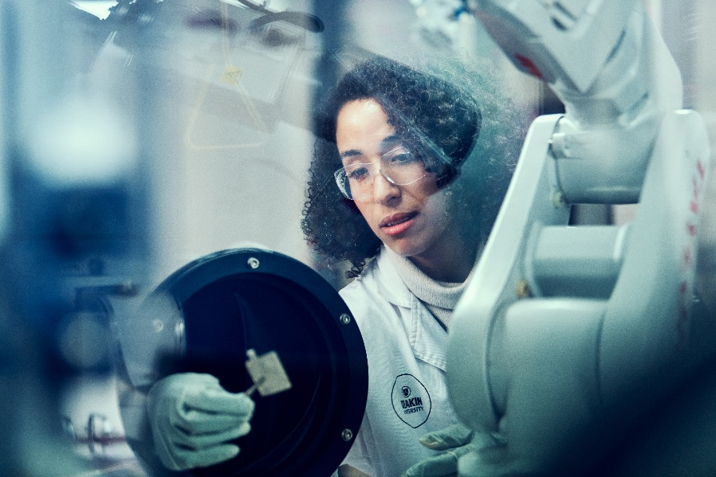

REACH is led by Deakin University. Follow [REACH on LinkedIn](https://www.linkedin.com/company/deakin-research/).

[More about REACH](https://reach.deakin.edu.au/)

## The Innovative Launch, Automation, Novel Materials, Communications, and Hypersonics Hub (iLAuNCH)

**Growing the Future: Aussie tech takes plant monitoring to space**

The iLauNCH Trailblazer is heading back to space to demonstrate a key technology capability for sustainable plant-based food production. Space crops are expected to be an important food source in long-term space missions and may also have significant commercial applications here on Earth. The University of Southern Queensland is working with Axiom Space and other research and industry partners to address food security challenges posed by limited land availability and a growing global population. [Read the full story](https://ilaunch.space/media-release/growing-the-future-aussie-tech-takes-plant-monitoring-to-space/).

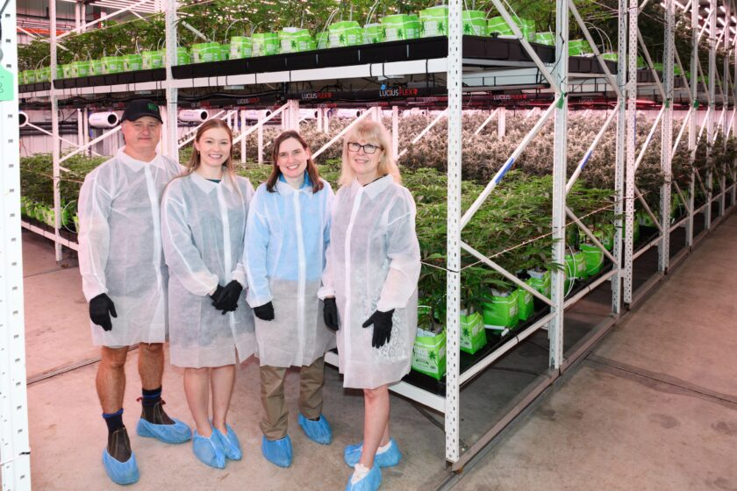

*Pictured: The University of Southern Queensland is working with Axiom Space to develop space crops.*

iLAuNCH is led by the University of Southern Queensland. Follow [iLAuNCH on LinkedIn](https://www.linkedin.com/authwall?trk=bf&trkInfo=AQHCJoaSHT6O9AAAAYhQVcPQrle_TN0Hr1S2Fx1eNTQKQQRHMgAyTrPJXaJaIbx4dz8PdwobsjH8iZbqtu_w-VZI5Ur73FmP0VRf-FBKFUi-9fE_oQs_bbvLzV4fBbKQ6TBTxYU=&original_referer=&sessionRedirect=https%3A%2F%2Fwww.linkedin.com%2Fcompany%2Filaunchspace%2Fposts%2F%3FfeedView%3Dall).

[More about iLAuNCH](https://ilaunch.space/)

## Australia’s Food and Beverage Accelerator (FaBA)

**Texture toolkit is a recipe for food success**

Researchers at FaBA have developed a toolkit to help manufacturers make the texture of products more appealing to consumers. The toolkit allows companies to better understand a food or beverage product’s textural attributes and how it could be re-formulated to make it more appealing. The FaBA Texture Library Toolkit can be used on any food product, while flavour and aroma toolkits can be developed for specific clients. [Read the full story](https://faba.au/news/texture-toolkit/).

FaBA is led by the University of Queensland in partnership with the University of Southern Queensland and Queensland University of Technology. Follow [FaBA on LinkedIn](https://msg.dese.gov.au/link/id/zzzz6792be3f636b8724Pzzzz678d971d81d2c710/page.html).

[More about FaBA](https://faba.au/)

## Resources Technology and Critical Minerals Trailblazer

**UQ copper processing start-up to help unlock global resources**

University of Queensland researchers have developed a technology that can extract copper from previously unviable low-quality resources. The technology provides a cleaner and more efficient method for processing copper concentrate, an element that helps run everything from smartphones to electric vehicles. The research is being translated into a commercial opportunity by new start-up company Banksia Minerals Processing, with the support of the RTCM Trailblazer and other backers. [Read the full story](https://rtcm-trailblazer.au/uq-copper-processing-start-up-to-help-unlock-global-resources/).

*Pictured: Associate Professor James Vaughan from UQ and Banksia Minerals Managing Director Leigh Staines.*

The RTCM Trailblazer is led by Curtin University. Follow the [Resources Technology and Critical Minerals Trailblazer on LinkedIn](https://www.linkedin.com/company/resources-technology-and-critical-minerals-trailblazer/).

[More about RTCM Trailblazer](https://rtcm-trailblazer.au/)

## Defence Trailblazer for Concept to Sovereign Capability

**Australian SMEs lead the way**

The Defence Trailblazer has had a strong start to 2025, with a total of $135 million worth of industry-led research and development projects now underway. This includes 35 industry-led projects with both Defence and cross-sector applications and 19 further projects in the pipeline. Many of these projects are led by Australian small-medium enterprises, reflecting strong support for Australia’s innovation ecosystem. [Read more about the Defence Trailblazer projects](https://dtb.solutions/news/media-release/funding-injection-worth-135m-underway-for-defence-research-development-activities/).

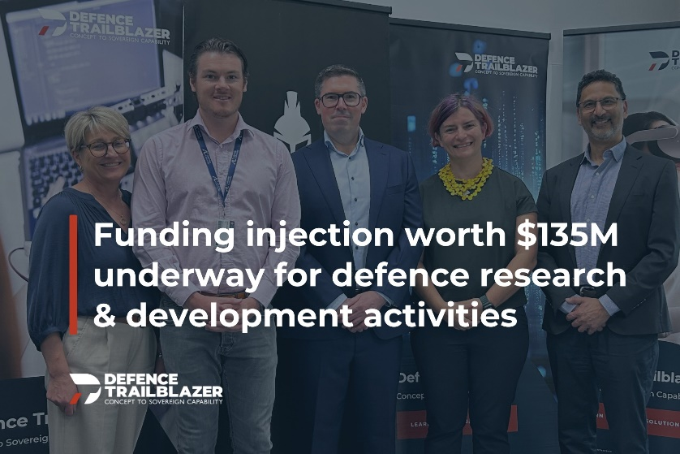

*Pictured: The Defence Trailblazer team.*

The Defence Trailblazer is led by the University of Adelaide. Follow [Defence Trailblazer on LinkedIn](https://www.linkedin.com/company/defence-trailblazer/).

[More about Defence Trailblazer](https://dtb.solutions/)

## Trailblazer for Recycling and Clean Energy (TRaCE)

**Next-generation energy management system to drive net-zero buildings**

UNSW researchers and Dubbo Regional Council are working together to transform how buildings consume, store and distribute energy to improve efficiency and sustainability while lowering costs. They have developed an innovative next-generation hybrid energy management system that will be installed in a Dubbo Regional Council building, serving as a living lab to showcase its functionality in real-world conditions. The system automatically dims or turns off lights and reduces heating or cooling, pre-cooling buildings using solar energy generated earlier in the day to alleviate strain on the grid when demand peaks in the evening. [Read the full story](https://trace.org.au/energy-management-system-to-drive-net-zero-buildings/).

*Pictured: The UNSW research team and Dubbo Regional Council project team*

TRaCE is delivered in partnership between the University of New South Wales and the University of Newcastle. Follow [TRaCE on LinkedIn](https://www.linkedin.com/company/trace/).

[More about TRaCE](https://trace.org.au/)

## Stay informed

Subscribe to the Department of Education’s Trailblazer newsletter – delivered every quarter to your mailbox and on the department's [Trailblazer website](https://www.education.gov.au/trailblazer-universities-program).

](https://msg.dese.gov.au/link/id/zzzz6786f72ae5ffb618/page.html)Find out more about the great work happening in the Australian Government's Trailblazer Universities Program through our social media channels and websites.

[Department of Education](http://www.education.gov.au/trailblazer-universities-program) | [LinkedIn](http://au.linkedin.com/company/australias-economic-accelerator?trk=public_post_feed-actor-name)

## Acknowledgement of Country

**The Department of Education acknowledges the Traditional Owners and Custodians of Country throughout Australia and their continuing connection to land, waters and community. We pay our respects to the people, the cultures and the Elders past and present.**

[Privacy](http://www.education.gov.au/using-site/privacy) | [Disclaimer](http://www.education.gov.au/using-site/disclaimer) | [Unsubscribe](https://msg.dese.gov.au/trailblazer-unsubscribe)

