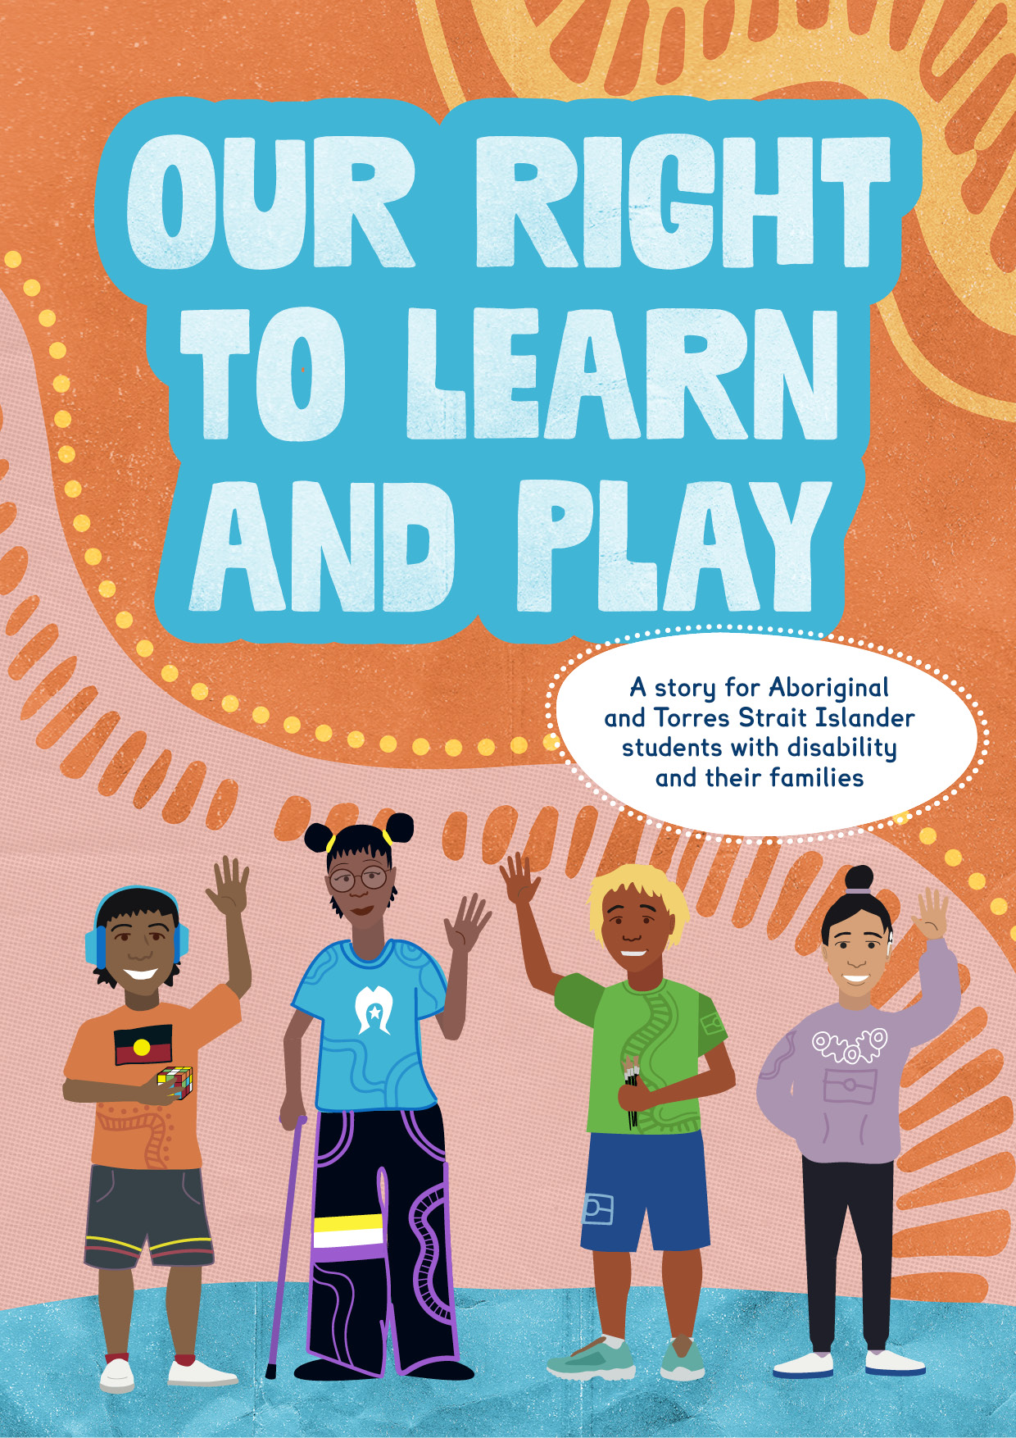

Our Right to Learn and Play

  - A story for Aboriginal and Torres Strait Islander
  - students with disability and their families

Acknowledgements

The Australian Government acknowledges the Traditional Owners and Custodians of Country throughout Australia. We acknowledge their continuing connection to land, water and Community.

We pay our respects to Elders past and present. We pay our respects to the continuing cultural, spiritual and educational practices of Aboriginal and Torres Strait Islander peoples.

This resource was funded by the Australian Government. It was designed by and for young First Nations people with disability, with the help of First Peoples Disability Network Australia and Children and Young People with Disability Australia.

We would like to thank the voices of young people living with disability and their open contributions to this story.

Content warning:
This story shows examples of ableism and discrimination.

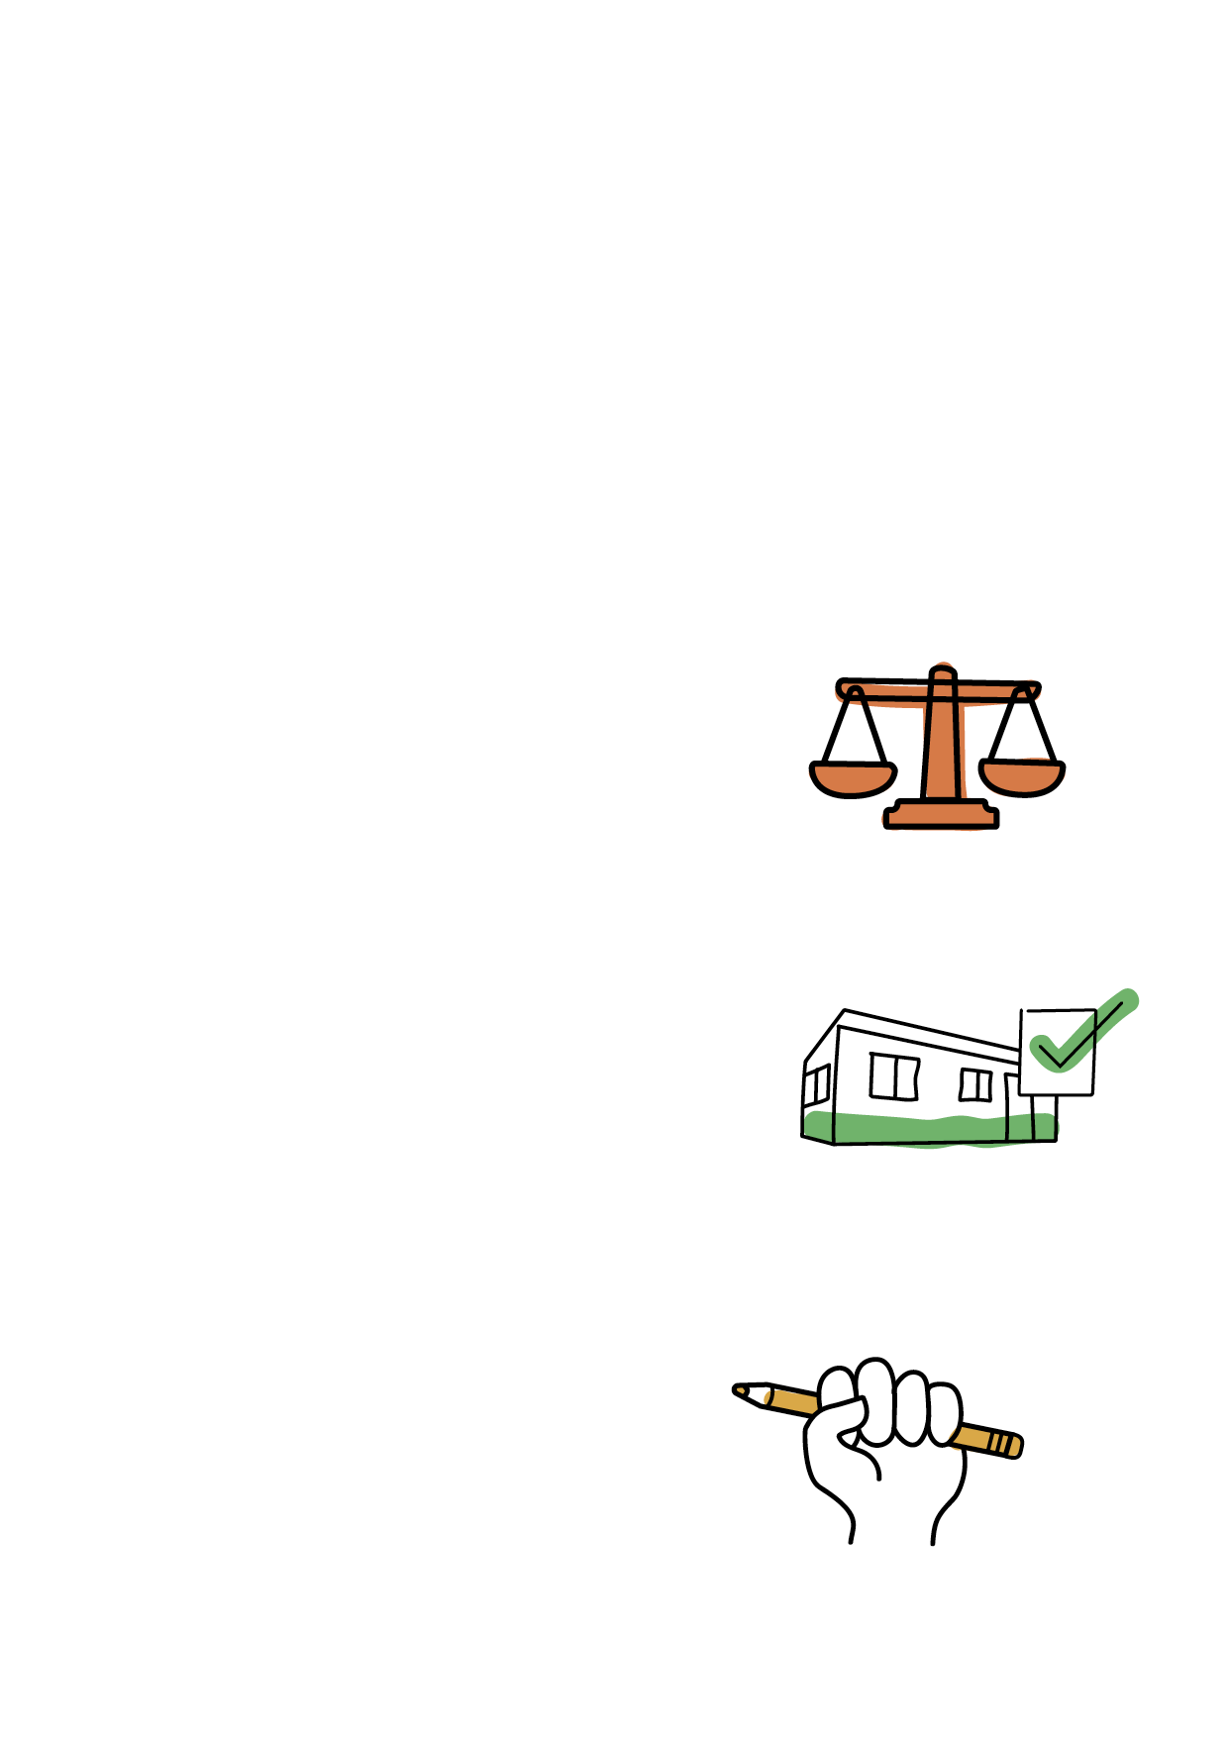
In this story

You’ll learn how Australian law protects students with disability.

We’ll explain:

What the law is called (page 6)

What schools have to do (page 7)

Your rights (page 13).

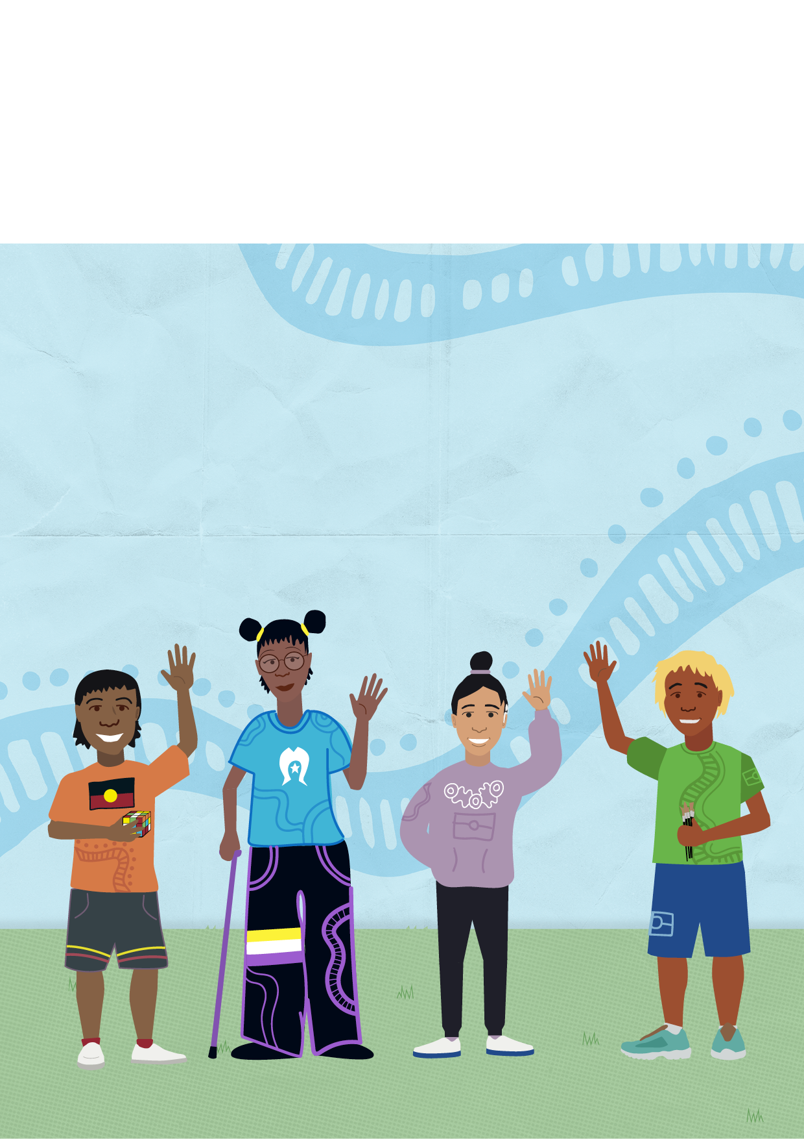
Hi, I’m Jarrod! These are my friends, Janaya, Louisa and Tyson.
We’re going to tell you how we stand up for our rights at school.

I’m in Grade 7. I love nature and hanging out with my friends and family. And I am autistic.

My favourite thing to do is explore my Country with my grandad. Grandad is a ranger. He teaches me about different plants and animals.

Sometimes Nan comes with us and shows me how to make bread and tea on the fire.
Nan doesn’t hear so well now, so we’re also learning how to use sign language together.

I like being on Country because it’s peaceful and quiet, there’s so much to learn and there’s always something to do. Also, Grandad brings great food!

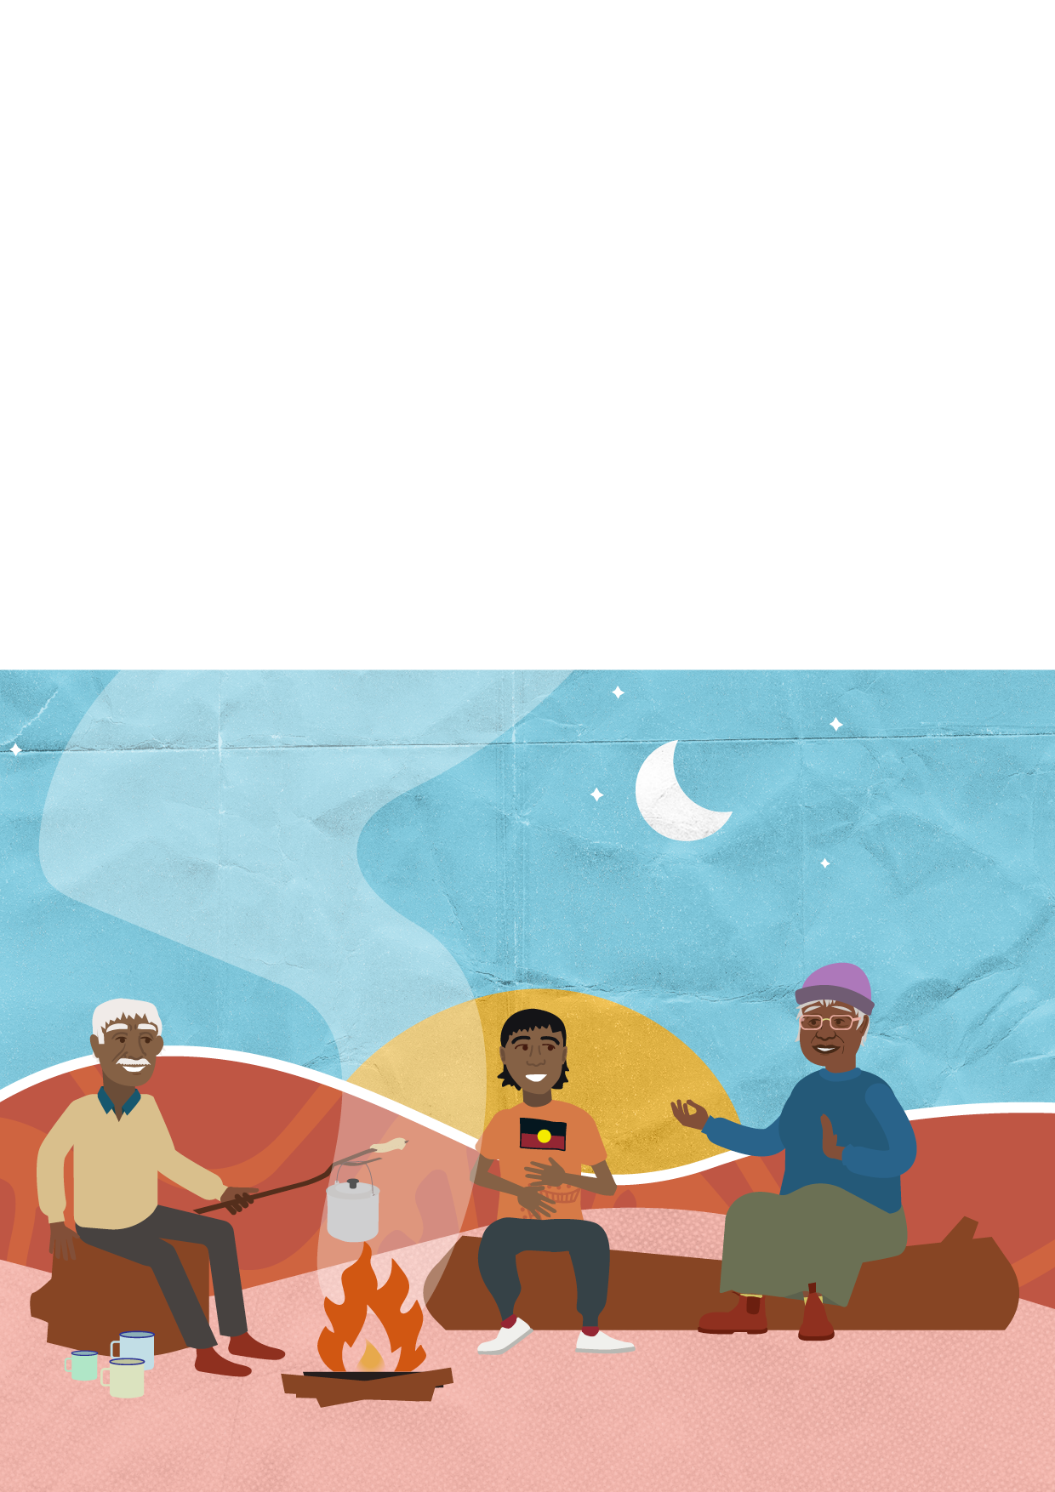
Last year, I had a hard time at school. There were too many people around and the classroom was too loud. Sometimes I got into trouble and I didn’t know why.

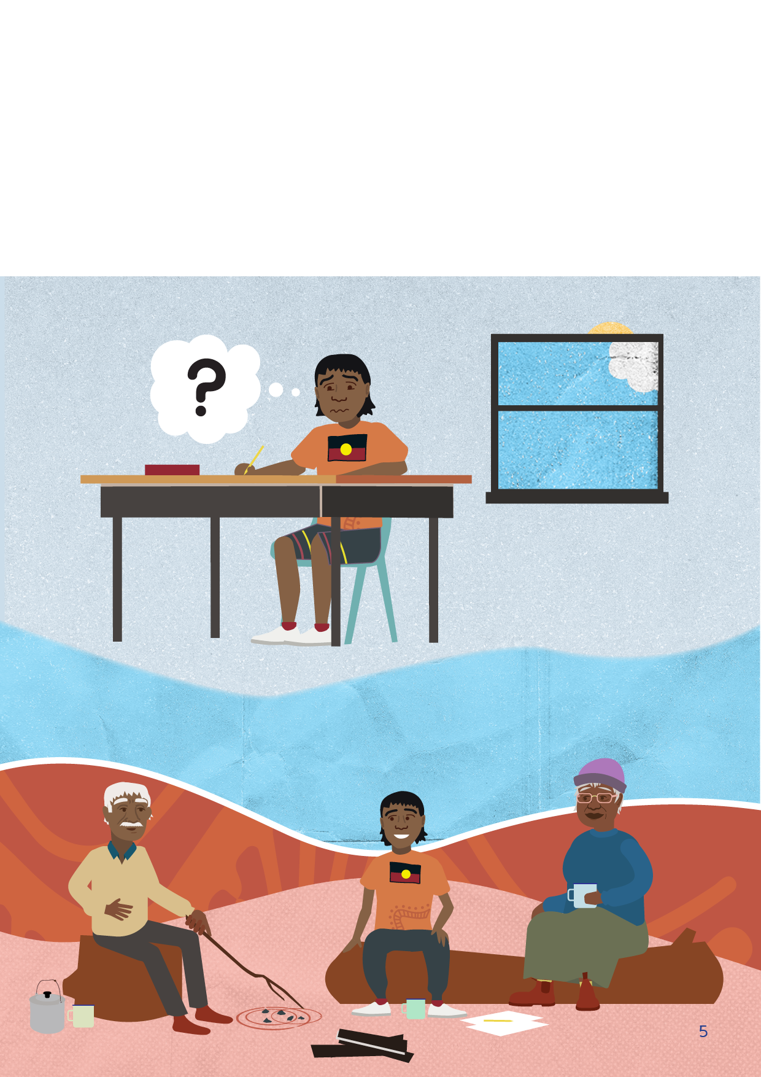
School would be easier if I could have class outside. On Country, Grandad teaches me maths using rocks to count and Nan helps me write stories about my adventures.

When I’m old enough, I want to work on my Country. I want to take care of the land like Grandad, Nan and my family before me.

Over the holidays, my grandparents and I learnt about the Disability
Standards for Education 2005 (DSE). The DSE is part of Australian law.

The DSE talks about:
• What schools must do to support students with disability
• The rights of students with disability.
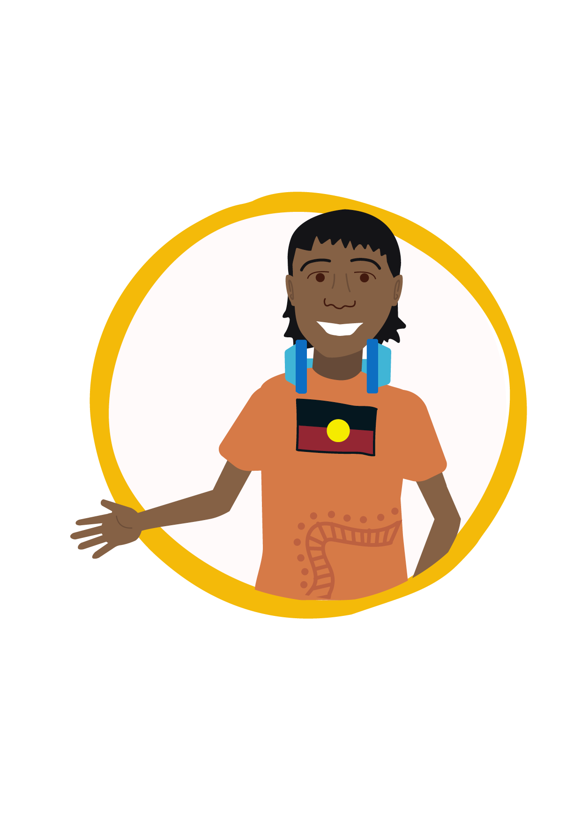
These are big ideas.
Don’t worry, keep reading and I’ll explain it all! You might also find the word list on page 19 helpful.

Pssst… you can learn more about the DSE by going to

www.education.gov.au/disability-standards-education-2005

What schools have to do

1. Talk with us
The DSE says schools must
do three things for students
with disability:

2. Make changes so we can join in
and learn with our classmates

3. Take steps to stop us from
being treated badly.

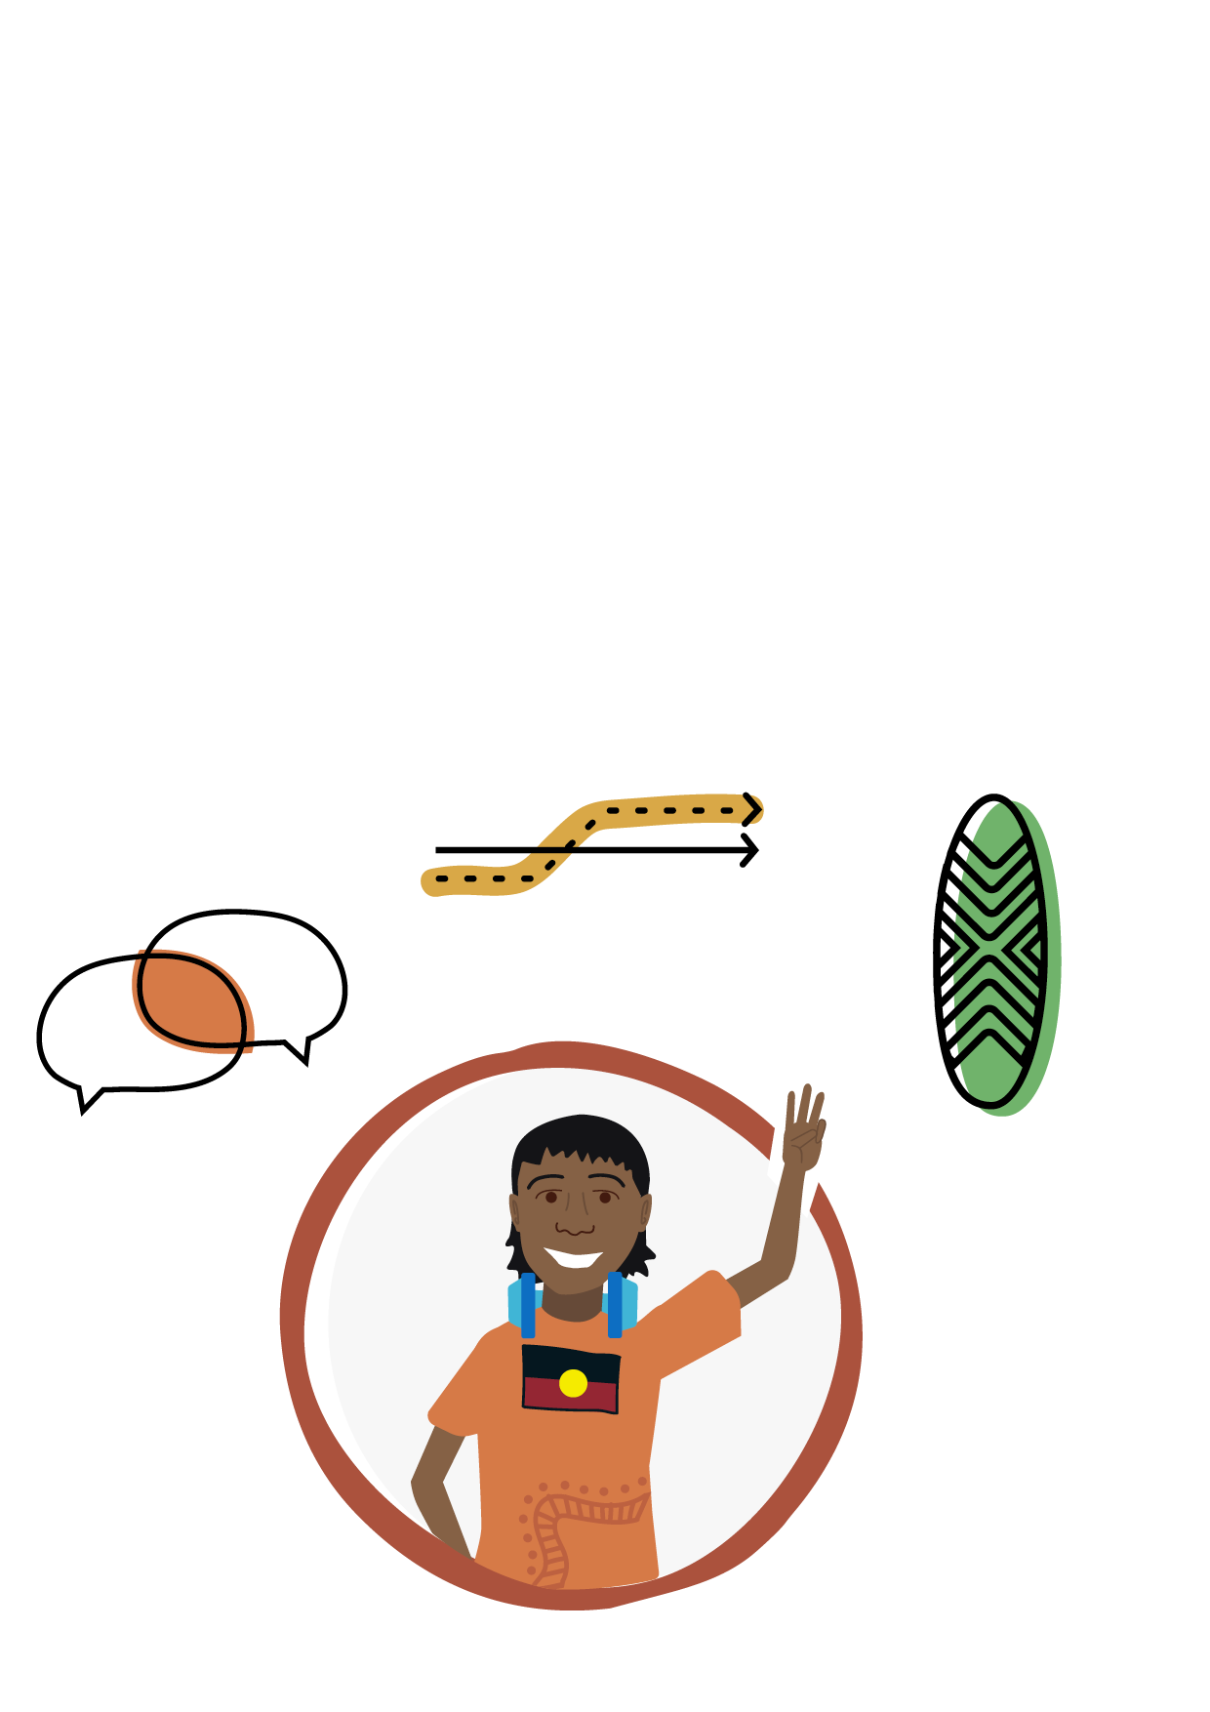

Talk with us

My grandparents and I met with my school. We talked about how my school could make changes to support me.
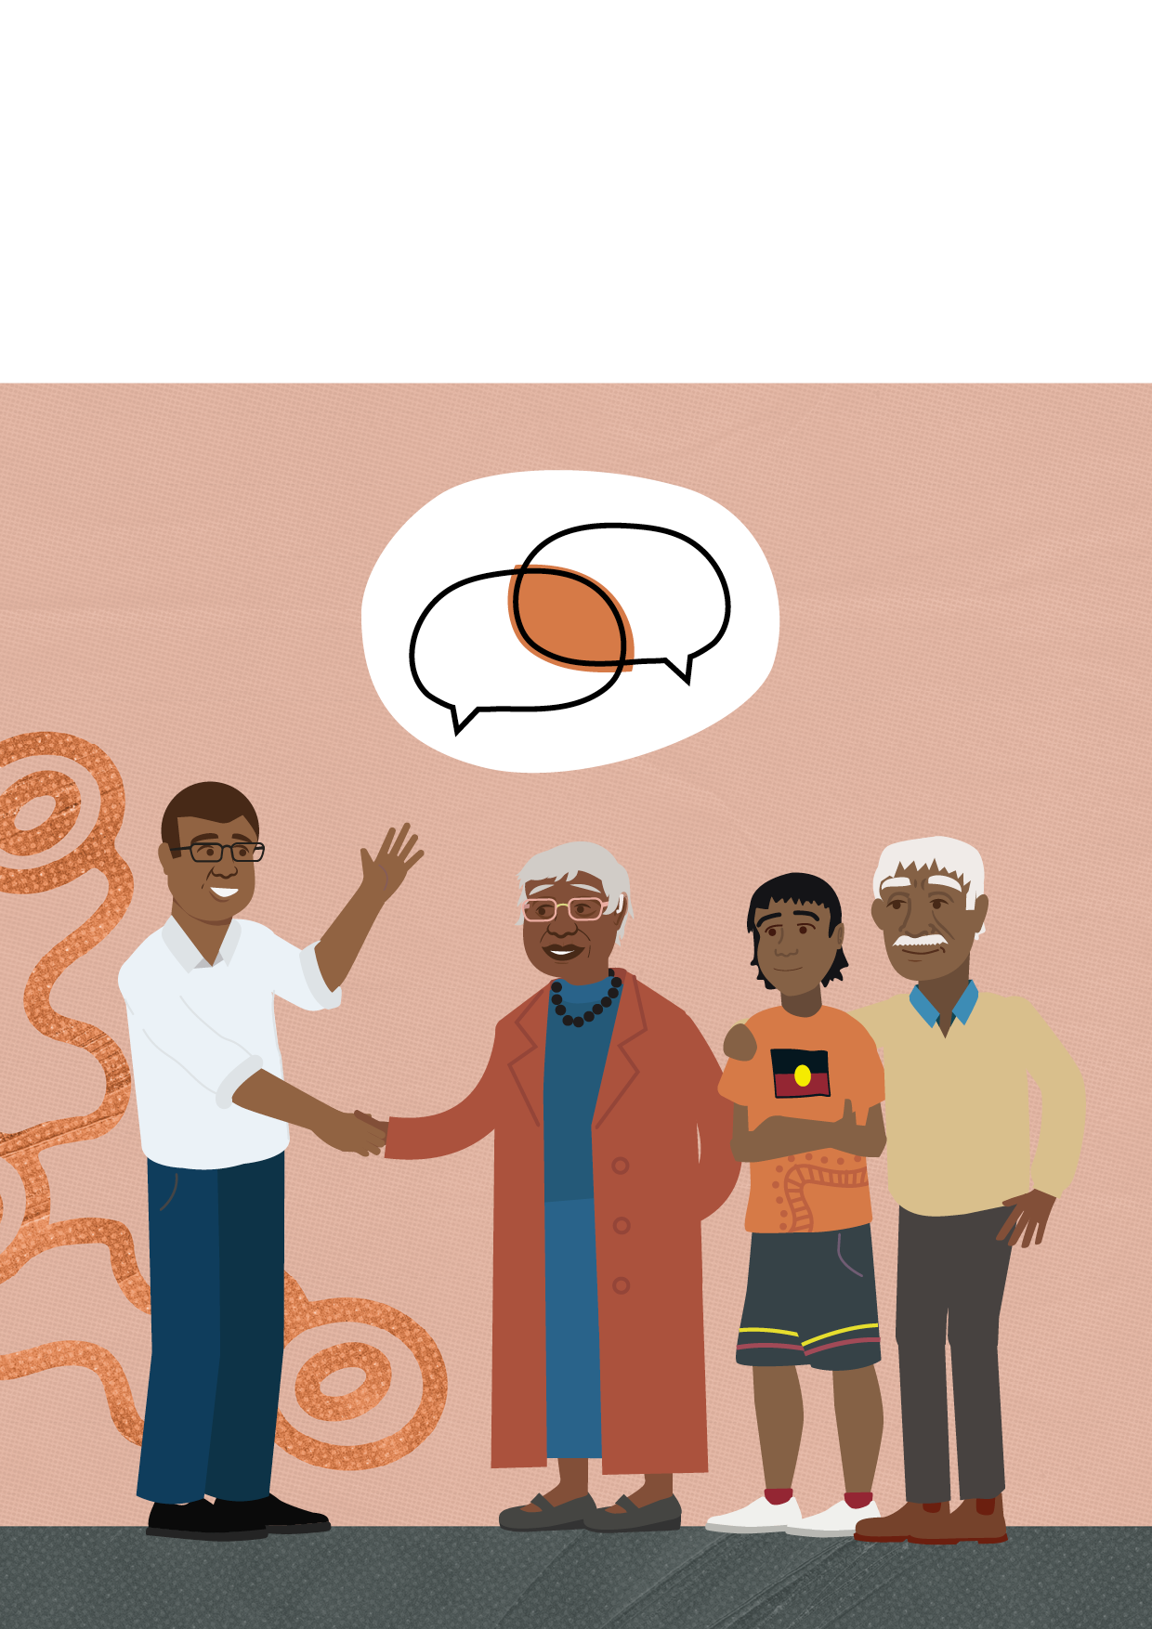

The school asked:
• What it’s like for me at school
• How my disability affects the
way I join in and learn at school
• What support I might need.

We came up with a plan to make some changes to the classroom, so I could join in and learn with everyone else.

2. Make changes so we can join in and learn with our classmates

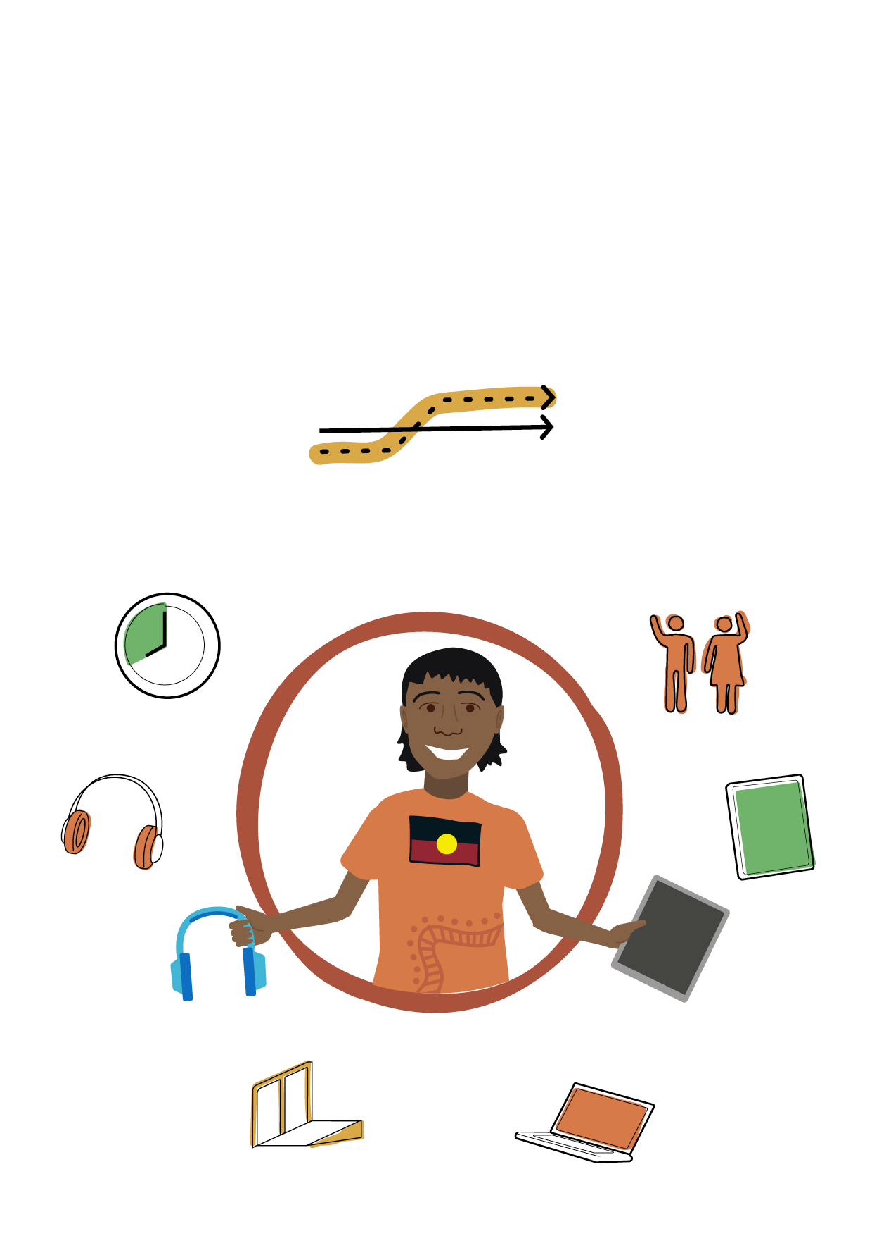
Schools have to make changes to support
students with disability. These changes are
sometimes called ‘reasonable adjustments’
or ‘accommodations’.

These changes can come in many forms, like:
• People - e.g., support staff
• Materials - e.g., equipment, laptops and tablets
• Changes in how things are done - e.g., rest breaks

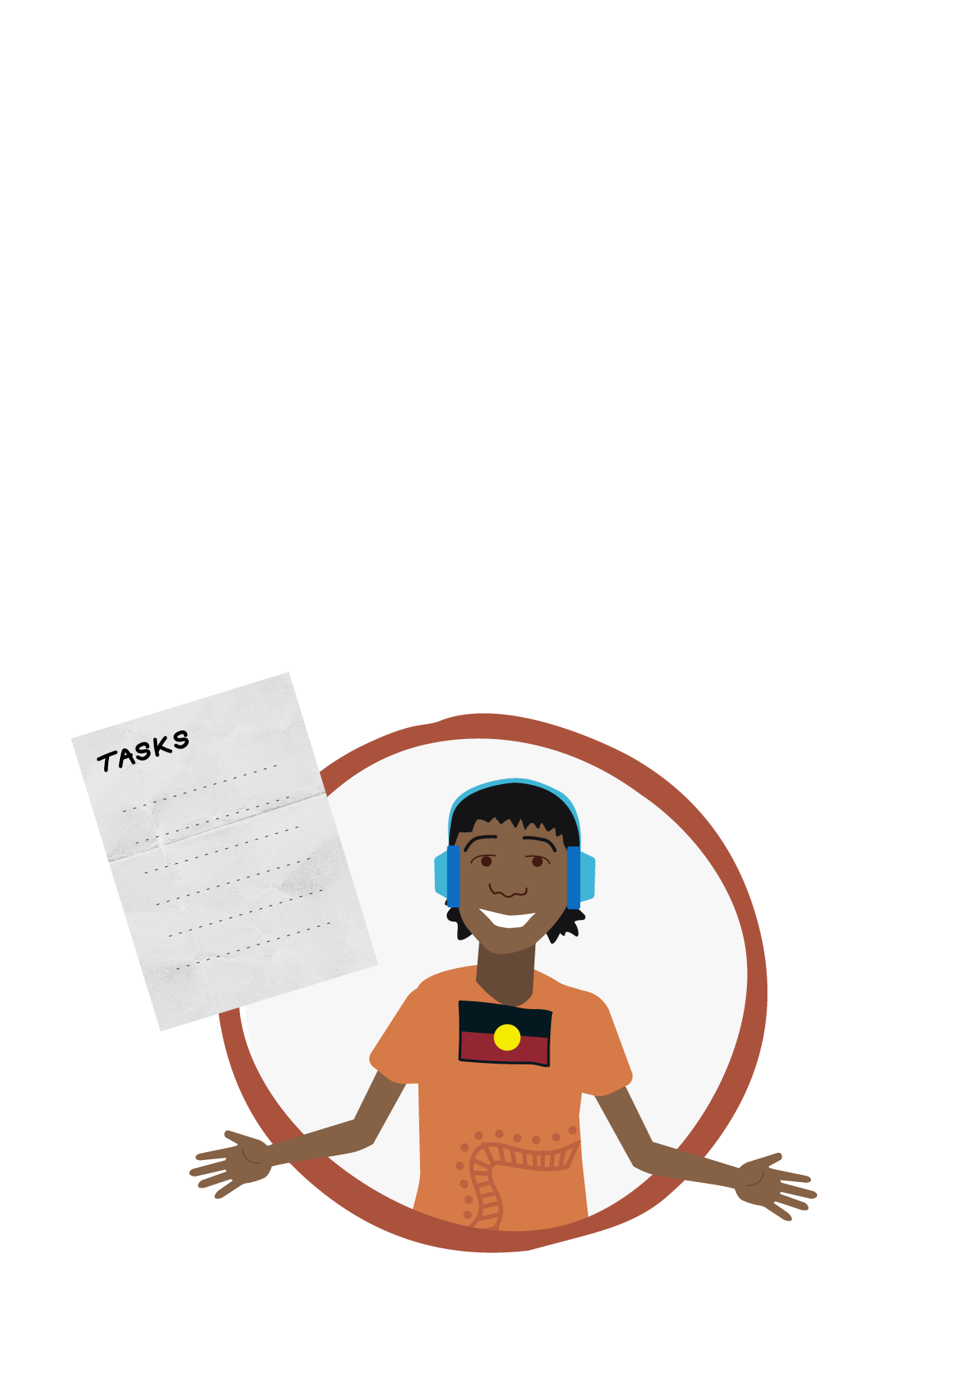
I needed some one-on-one support in class, so my school organised a teacher’s assistant who works with me sometimes to break down tasks.

Sometimes when the classroom gets very noisy and confusing, I use noise-cancelling headphones. I also take breaks when I need them.

My teacher gives instructions out loud to my class, but sometimes this is hard for
me to follow. Now she writes them down for me as well.

I’m excited that next week my class is going onto Country to learn from Elders.

Now my school has made these changes, I feel more included. These changes helped me, but you might need different changes to support you. Every student’s needs are different.

Did you know, you don’t need to be diagnosed with a disability to be protected

by the DSE?

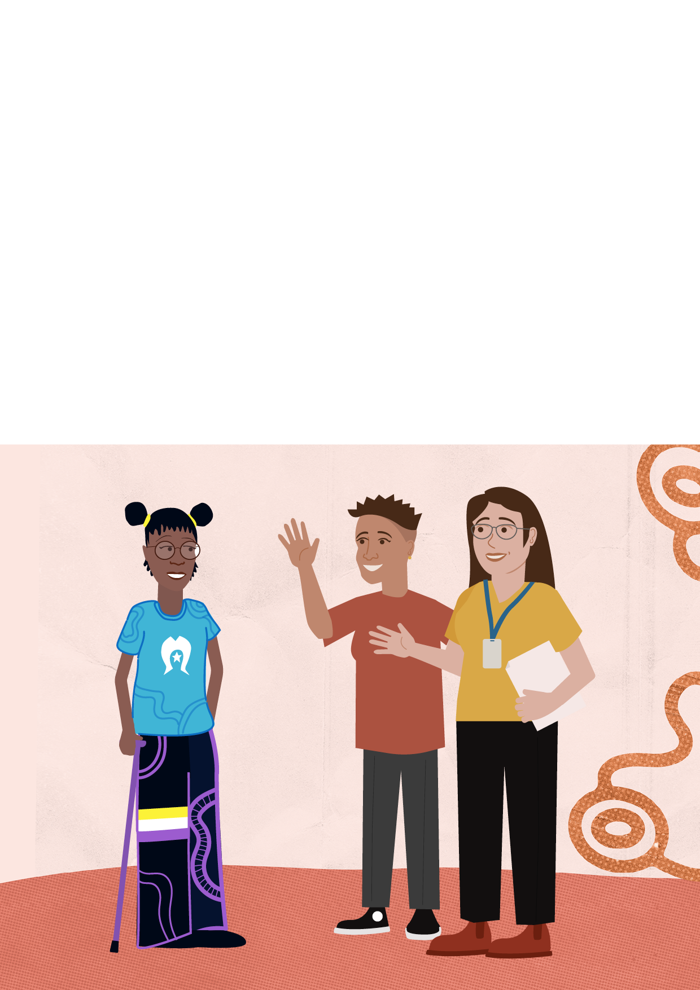
This is my friend, Janaya.
Janaya loves to write stories in their free time and at school. But Janaya has noticed that when they write they often feel tired and sick and have lots of pain in their body. They are
working with a local Aboriginal health service to find a supportive doctor to help with a diagnosis. Just like me, Janaya met with their school. Janaya explained that they need to take rest breaks in class and extra time during tests. The school agreed that Janaya knows their body best and was happy to make changes.

3. Take steps to stop us from being treated badly

Along with making changes to let students with disability
join in and learn, schools must do their best to stop:
• Harassment
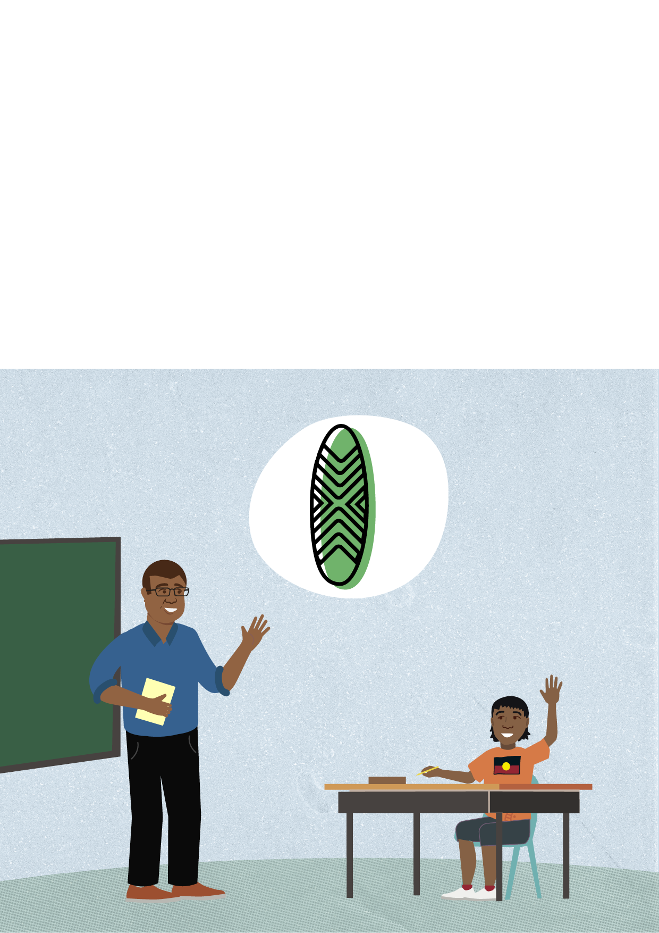
• Unfair treatment
• Discrimination.

This includes making sure our cultural values are understood,
respected and part of our life at school.

We should not be treated unfairly because of our disability.

We should not be treated worse than we would be if we didn’t have a disability.

We should not be punished for complaining or saying that something is wrong.

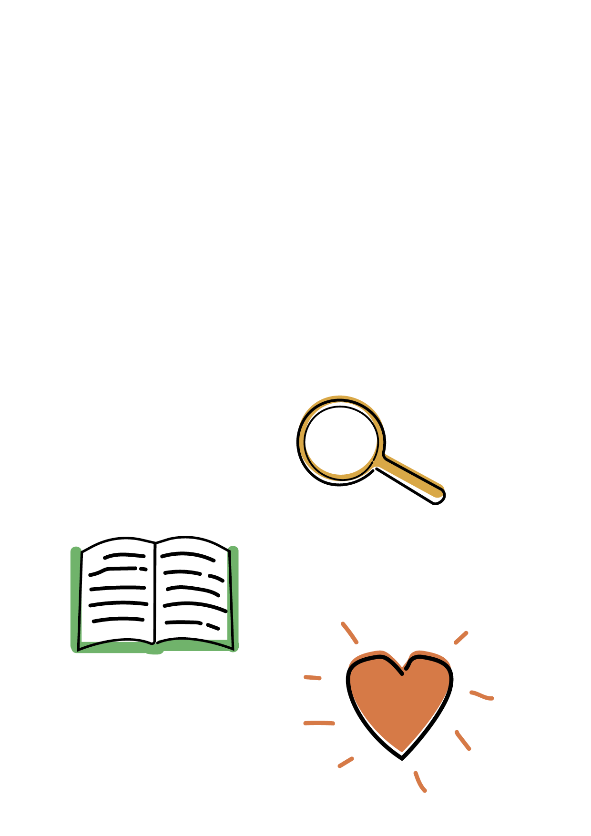
Your rights

You have the same right to education as
your classmates. You should be treated the
same way as your classmates.
This means you should have the same
– or very similar – choices and opportunities.

You have the same right to:
- Enrol to study
- Take part in learning experiences and school activities
- Use support services.

This is my friend, Louisa. She’s deaf and about to start high school. Louisa loves sports and plays all-abilities rugby.

Louisa tried to enrol in a high school with a sports program, but the school said no. They said they didn’t know how to teach a deaf student.

They said as a school that has a special sports program, they don’t follow the same DSE rules. Louisa’s dad knew this wasn’t true.

So, he talked to a local Aboriginal community centre. He asked for help from the Disability Liaison Officer.

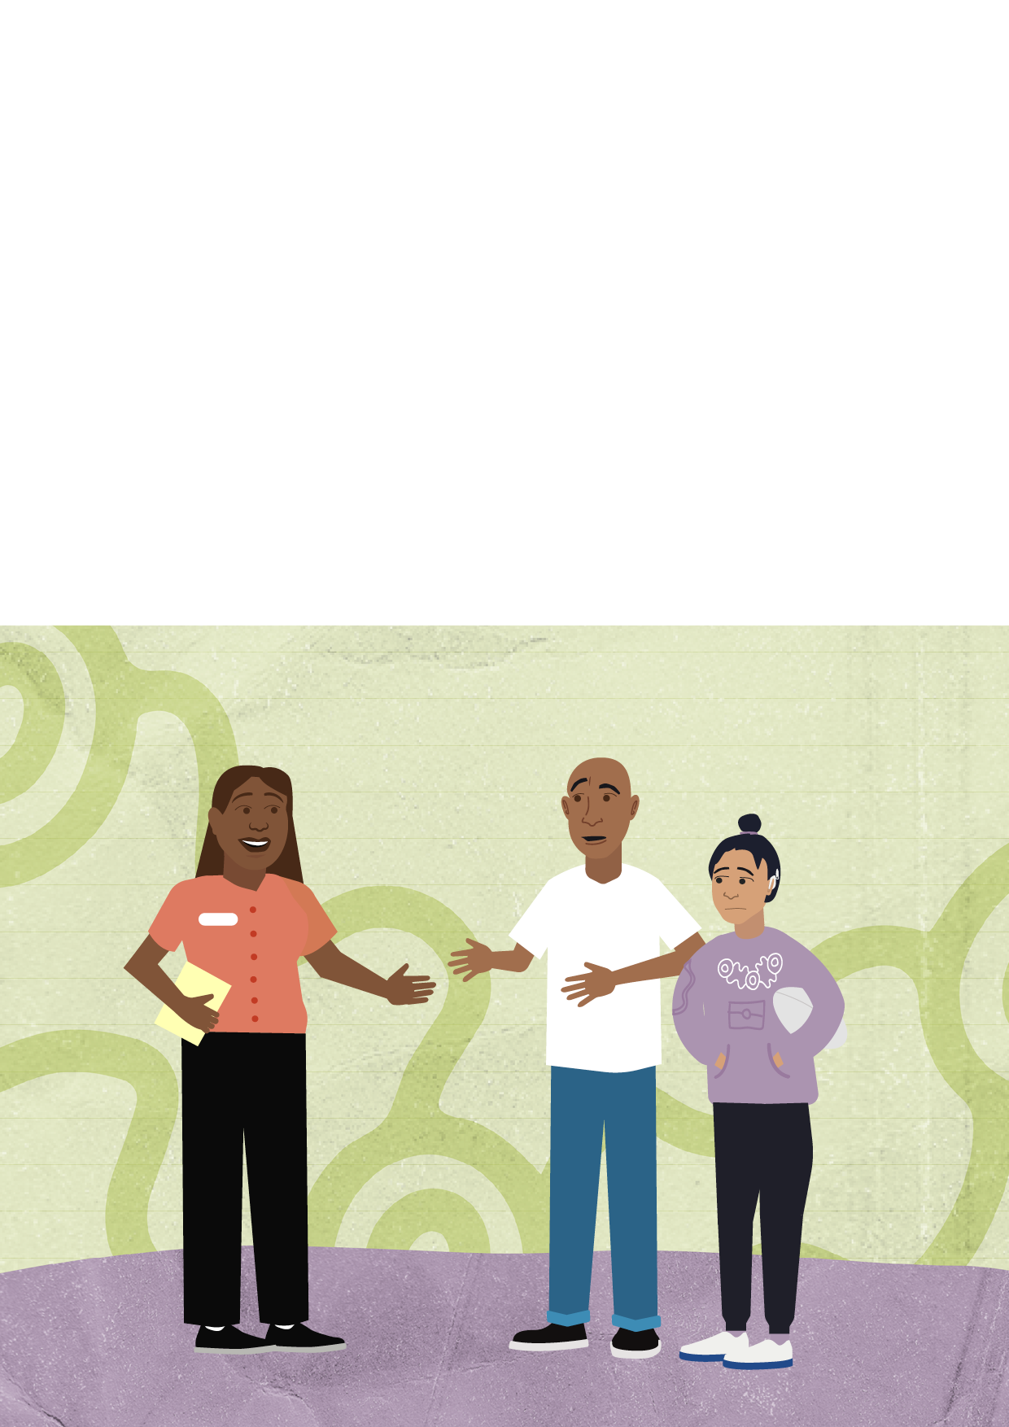
The Disability Liaison Officer got to know Louisa. Once everyone felt confident, they met with the school to talk about the school’s obligations and Louisa’s rights.

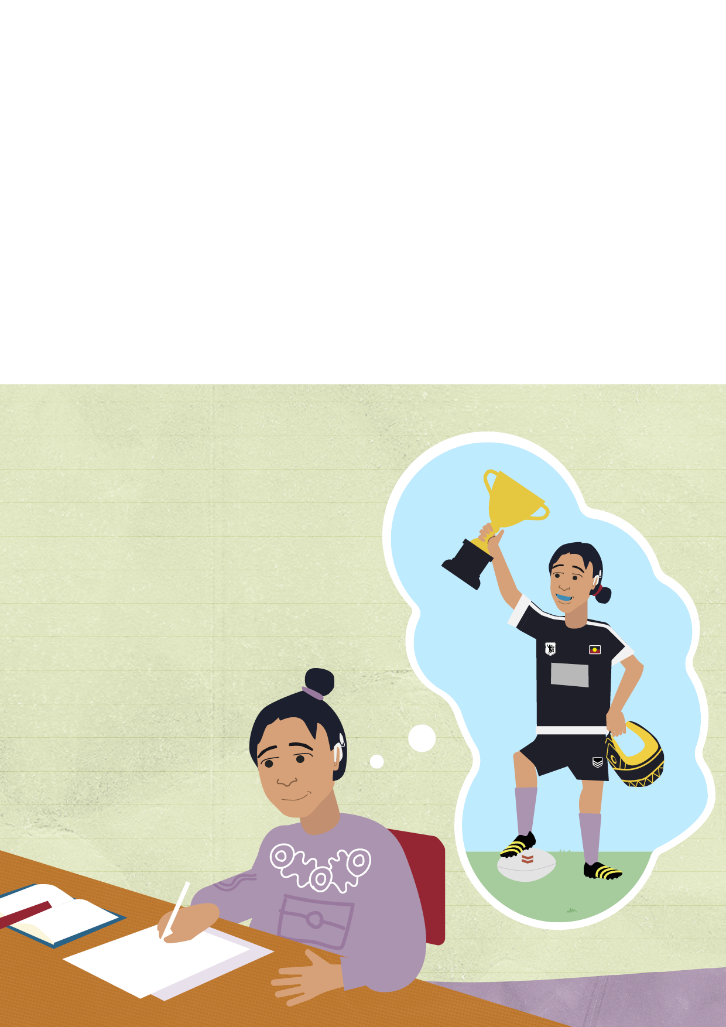
After the meeting, the school understood that what they had done was unfair. So, the school agreed to let Louisa enrol. Louisa and the school came up with lots of ideas and a plan for how to support Louisa. This included teachers using microphone and voice-to-text technologies.

One day, Louisa wants to become the school’s rugby captain. Then, play in the Koori
Knockout and travel the world as a professional athlete!

This is my cousin, Tyson.

He has a cognitive disability and is in high school. Tyson loves to make art.

He does paintings of Country with his mum. He’s taking a Vocational Education and Training (VET) art course at the local TAFE.

At first, Tyson’s school tried to talk him out of taking the VET course.
They thought it would be too hard for Tyson and didn’t know how to
support him.

Tyson and his mum didn’t agree – they told the school that Tyson has the right to choose his own path and use school support services to fit VET into his timetable.

Tyson and his mum wrote a list of things that help Tyson to
succeed at school and home.

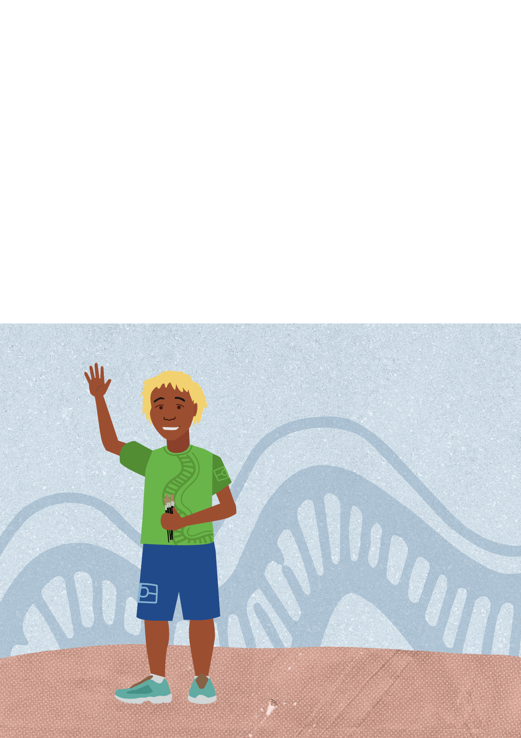

Tyson and his mum told the school about the things that already work for him.

Tyson showed them his picture timetable as an example. After a few meetings, the school understood Tyson’s needs better and looked at ways to support him.

Together, they all came up with a plan. It covered breaking down big tasks into smaller steps. It also included lots of group tasks and checking in with Tyson.

The TAFE also used the plan to support Tyson. Now Tyson is studying art at TAFE twice a week. He’s proud he stood up for himself.

One day, Tyson wants to live independently in his own house, with a studio and gallery out the back.

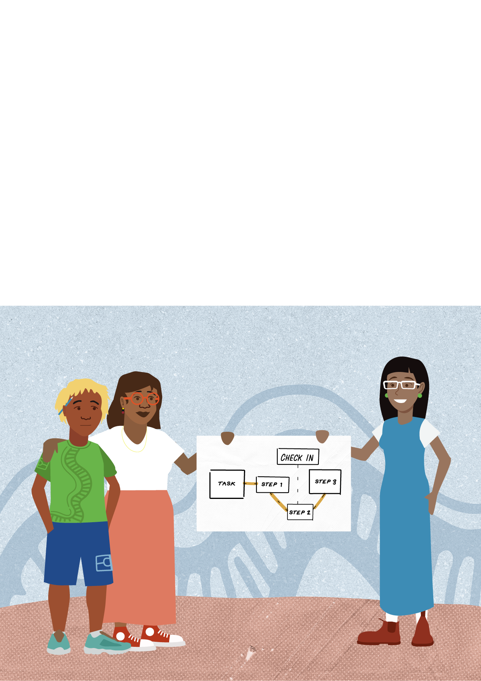
Remember, all students have the right to join in and learn in a safe environment
at school.

Thanks for learning about the Disability Standards for Education 2005 with us.

I hope you found something in these stories that you can use – now, or if you ever need it!

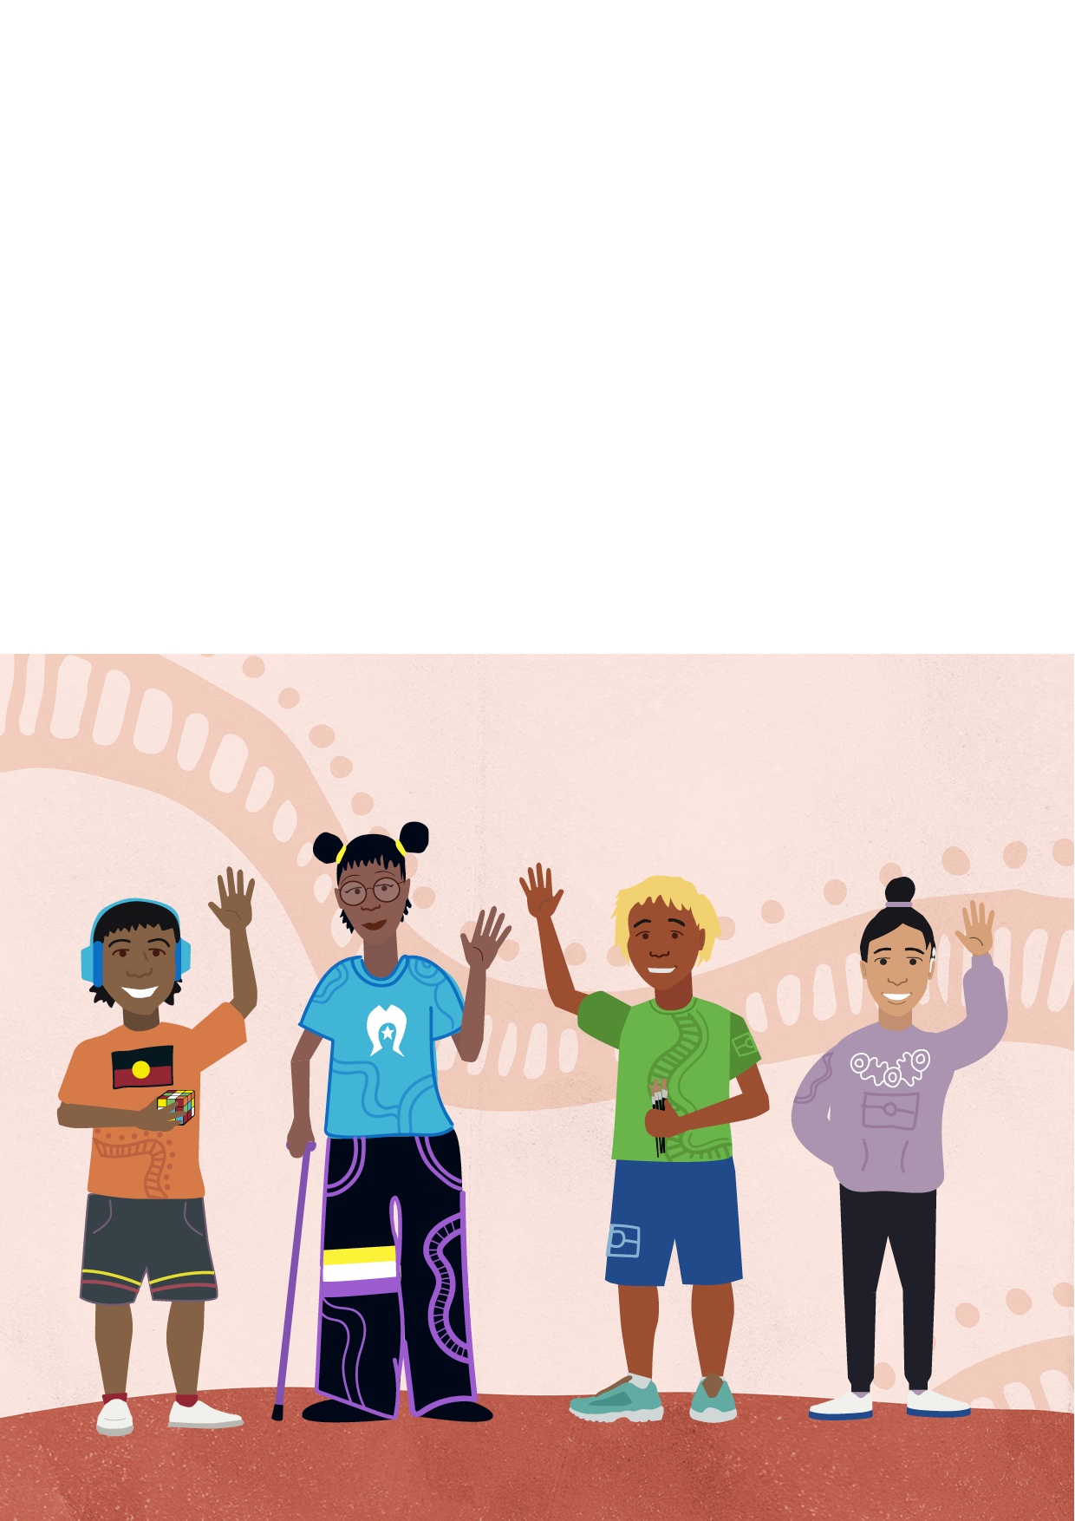

Word list

Ableism
The discrimination of people with disability. Ableism means
unfairly putting the needs of people without disability first.

Cognitive disability
Where a person has more than the usual trouble thinking,
learning, remembering, concentrating or making decisions.

Cultural values
Ideas and beliefs about what’s good or right that are passed
down from one generation to another, e.g., connection to land
and Country, the importance of family and community.

Diagnosis
Finding out and naming an illness, injury or disability.

Disability Liaison Officer
A person who helps people with disability to access
disability information, support, education and resources.

Discrimination
Where someone is being treated worse than they
would be if they were not disabled.

Harassment
Where a person feels threatened, distressed, offended or humiliated by something that someone does because of their disability.

Obligation
An obligation is something that a person or organisation must do. It is a legal responsibility.
You can expect people to carry out their obligations and ask them to do this.

Find support

National Aboriginal Community Controlled Health Organisation (NACCHO)
www.naccho.org.au

Children and Young People with Disability Australia (CYDA)
www.cyda.org.au

Positive Partnerships
www.positivepartnerships.com.au/resources/first-nations

Hearing Health
www.health.gov.au/hearing-health/first-nations

First Peoples Disability Network Australia (FPDN)
www.fpdn.org.au

Yarning SafeNStrong
www.vahs.org.au/yarning-safenstrong

Disability Advocacy Network
www.dana.org.au/find-an-advocate

Disability Australia Hub
www.disabilityaustraliahub.com.au

Disability Gateway
www.disabilitygateway.gov.au

Wellmob
www.wellmob.org.au

SNAICC
www.snaicc.org.au

