24-25 July 2024
Early Childhood Care and Development Policy Partnership
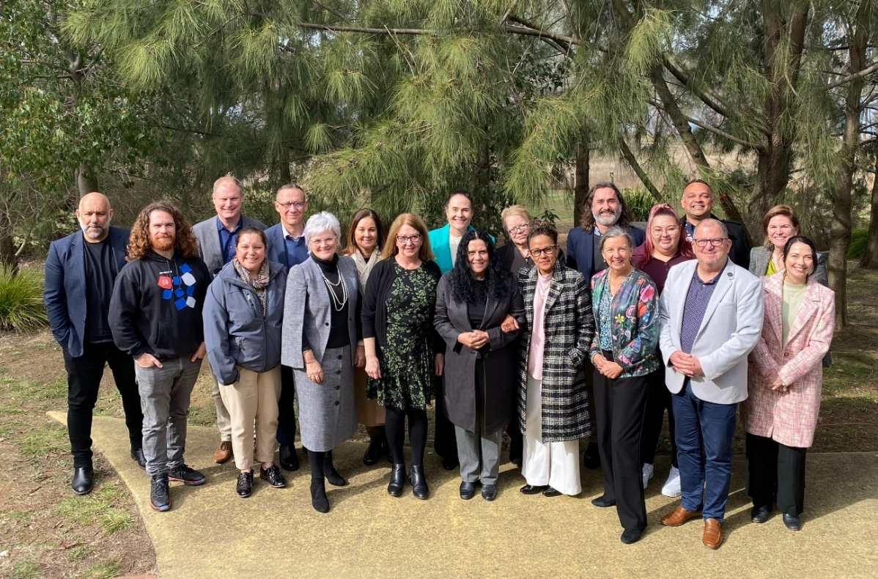
Members of the Early Childhood Care and Development Policy Partnership on Ngunnawal Country
Meeting Seven Outcomes
The Early Childhood Care and Development Policy Partnership (the Partnership) held its seventh meeting in Canberra on the lands of the Ngunnawal and Ngambri people. Yerrabi Yurwang Child and Family Aboriginal Corporation hosted the meeting. Yerrabi means ‘Walk Strong’ in Ngunnawal language.
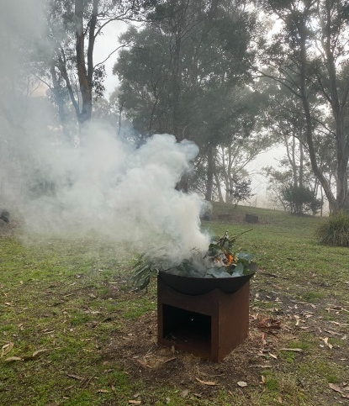
The meeting opened with a Welcome to Country by Selina Walker. Selina recognised her Ngunnawal Ancestors and Elders. She spoke about the history of Canberra as a meeting place for Aboriginal and Torres Strait Islander people and emphasised the importance of an ongoing focus on reconciliation. Mitch Daley welcomed members with a smoking ceremony.
The meeting was co-chaired by Kylie Crane, Deputy Secretary, Early Childhood and Youth Group, Commonwealth Department of Education and Aunty Muriel Bamblett, Chair, SNAICC – National Voice for our Children (SNAICC). Aunty Muriel Bamblett co-chaired on behalf of Catherine Liddle, CEO of SNAICC. The meeting was attended by Aboriginal and Torres Strait Islander independent and peak body representatives and representatives from all Australian governments. A full list of attendees is located on page 5.
Photo of the smoking ceremony
Members of the Partnership expressed their acknowledgement of the work of The Hon. Linda Burney MP, Minister for Indigenous Australians, who publicly announced her retirement during the time of the meeting. Members wished to express their thanks to the Minister for her tireless work on Closing the Gap and her support for the Policy Partnership.
Presentation on ECCD policy landscape in the Australian Capital Territory (ACT)
Representatives from the ACT provided information on the local early childhood care and development (ECCD) operating context in their jurisdiction.
Deputy Director-General Jo Wood spoke to the ACT government’s aim to transition Aboriginal and Torres Strait Islander children to the care of Aboriginal Community Controlled Organisations (ACCOs) rather than child protection, and the ACT government’s progress to provide proportional funding to ACCOs to support this change. The Our Booris, Our Way Review provides the blueprint for this work. The ACT government members acknowledged that significant work was needed to transform government ways of working to centre self-determination and implement the ambition and intention of the Review’s recommendations. ACT members also shared an update on Koori Preschool and Aboriginal and Torres Strait Islander 3- and 4-year-old children having access to 30 hours per week of early childhood education in the ACT. Members noted the appointment of Vanessa Turnbull-Roberts, the Aboriginal and Torres Strait Islander Children and Young People Commissioner for the ACT, in line with recommendation seven of the Our Booris, Our Way Review.
Professor Dea Delaney, CEO of Yerrabi Yurwang, also presented on the history and work of Yerrabi Yurwang Child & Family Aboriginal Corporation (Yerrabi) located at Yarramundi Reach. She provided information on the holistic early intervention services offered by Yerrabi, which include weekly Women’s Yarning Circles, the Yawarj Mara Youth program, playgroups, culturally informed healing programs and supports for families and new parents. The centre is expanding into new areas, including early childhood education and care, allied health and housing supports.
Agreeing to the Partnership’s priorities
The Aboriginal and Torres Strait Islander Member Caucus noted the importance of the priorities, which are the agreed policy areas that the Partnership will focus on in its work. The priorities aim to drive concrete action to meet Closing the Gap targets 2, 3, 4, 12 and 13 and the cross-cutting area of disability. Members considered the priorities at Meeting Six, provided feedback out of session.
Members agreed to the ECCDPP priorities (full list at Attachment A) which build on the Partnership’s Year 1 Priorities and existing strategies, including the Early Childhood Care and Development Sector Strengthening Plan. The Partnership will work collectively to progress the priorities.
Members agreed to consider an additional priority focused on addressing family violence experienced by Aboriginal and Torres Strait Islander people, including the impacts on children, which will be drafted and added to the list after the meeting.
Members agreed on a process to plan how these priorities would be taken forward and to track progress. The tracking process will provide the Partnership with visibility on how each priority is progressing and provide an opportunity to share best practice and address any issues. The Aboriginal and Torres Strait Islander Member Caucus noted the importance of delivering the Priorities in line with the Priority Reforms under the National Agreement on Closing the Gap.
Joint Council Engagement
Members reflected on the Partnership’s achievement to make its first set of recommendations to Joint Council on Closing the Gap including the establishment of a National Aboriginal and Torres Strait Islander Children and Young People’s Commissioner, along with tabling the Partnerships' inaugural annual report and 3-year strategic plan.
Responding to the Productivity Commission Review of the National Agreement on Closing the Gap
Members discussed governments’ responses to the Productivity Commission Review, and government members agreed to provide the Partnership with further information on how their governments were responding to the Review report at Meeting Eight.
Partnership strategic collaboration
Part 1 – Collaborating with shared decision-making bodies
Members discussed how the Partnership can more effectively approach collaboration with other shared decision-making bodies. This item followed on from discussions at the Policy Partnerships co-chairs forum earlier this year, where co-chairs of different policy partnerships discussed collaboration needs.
Co-chairs emphasised the need for strong relationships with other Policy Partnerships, Place-based Partnerships and Safe and Supported governance bodies. This helps to avoid the risk of siloed policy development that doesn’t appropriately consider the holistic needs of families. Members agreed to focus on greater collaboration with these other shared decision-making bodies and to focus on cross cutting issues, including workforce, disability and social and emotional wellbeing.
Part 2 – Engagement across jurisdictions
Members discussed how government members are currently progressing the work of the Partnership through the different Ministerial fora and governance bodies in their jurisdictions. Members discussed examples of what was working well and how they can align processes for a co-ordinated approach. Members noted that Aboriginal and Torres Strait Islander representatives were involved in several governance forums which involved a significant workload that is often not appropriately resourced. Members of the Aboriginal and Torres Strait Islander Caucus take on this workload because of their commitment to children but noted their frustrations when these processes do not result in meaningful reforms.
Communications and engagement planning
The Partnership was updated on SNAICC’s planned communications and engagement to promote the Partnership and engage with Aboriginal and Torres Strait Islander communities, peak bodies and ACCOs. SNAICC is producing communications materials and an artwork to support this engagement.
Languages Policy Partnership
The Partnership welcomed representatives from the Languages Policy Partnership (LPP) to talk about their work and opportunities for collaboration between the two Policy Partnerships. The LPP works to make Aboriginal and Torres Strait Islander languages strong, supported and flourishing under Target 16 of Closing the Gap.
Members reflected on the importance of language for both children and adults, and ways to build languages by deliberately incorporating them into every aspect of life. Members also reflected on how languages need to be centred in place and the need to consider the inclusion of non-verbal languages, and the importance of growing the number of language practitioners. The LPP representatives noted the opportunity for the Partnership to promote languages learning in the early years and how strong languages are an indicator of wellbeing for children.
Next meeting
The Partnership will meet again in October 2024 to discuss the approach to taking forward each Partnership priority and provide updates on progress.

Attendees
Name | Representing
Coalition of Peaks representatives
Apology from Catherine Liddle | SNAICC – National Voice for our Children (SNAICC)
Donnella Mills | National Aboriginal Community Controlled Health Organisation (NACCHO)
Neville Atkinson | Victorian Aboriginal Education Association Incorporated
Lisa Coulson | Tasmanian Aboriginal Centre
Tahlia-Rose Vanissum (representing Damian Griffis) | First Peoples Disability Network
Dan Mitchell (representing Sharron Williams) | Aboriginal Family Support Services
Independent Aboriginal and Torres Strait Islander representatives
Darcy Cavanagh | Independent representative
Paul Gray | Independent representative
Garth Morgan (online, Day 1 only) | Independent representative
Apology from Joanne Della Bona | Independent representative
Apology from Keara Baker-Storey | Independent representative
Government representatives
Kylie Crane | Commonwealth Government, Department of Education
Mark Barraket | New South Wales Government
Mathew Lundgren | Victoria Government
Tania Porter | Queensland Government
Caron Irwin | Western Australia Government
Kim Little | South Australia Government
Jodee Wilson | Tasmania Government
Nicole Moore | Australian Capital Territory Government
Gabrielle Brown | Northern Territory Government
Partners
Muriel Bamblett | SNAICC – National Voice for our Children (SNAICC)
Apology from John Leha | CEO of AbSec – NSW Child, Family and Community Peak Aboriginal Corporation
Tarja Saastamoinen (proxy for Letitia Hope) | Commonwealth Government, Department of Social Services
Julie-Ann Guivarra (online until 11am)  Ali Jenkins (online as a proxy from 11 am) | Commonwealth Government, National Indigenous Australians Agency
Stuart Malcher (online, Day 2 only) | New South Wales Government
Nathan Chapman (online) | Victoria Government
Juliet Edeson (proxy for Helen Missen) | Queensland Government
Lisa Criddle (online) | Western Australia Government
Sally Wellington (online Day 1 only, proxy for Shirley Smith) | South Australian Government
Apology from Vidhya Chelliah | Tasmania Government
Brooke Rigney (proxy) | Australian Capital Territory Government
Agnes McGrath (online, Day 2 only) | Northern Territory Government
Attachment A – Partnership Priorities
The Partnership priorities are the areas that the Partnership will focus on in its work for the next year and they build on the Partnership’s Year 1 priorities.
The priorities were proposed by the Aboriginal and Torres Strait Islander Member Caucus of the Partnership and developed with input from government members. The priorities will be progressed by the Co-chairs, co-Secretariat and Partnership members and updates on progress will be provided in future meetings.
Members agreed to the priorities at Meeting Seven, noting that agreement does not consist of a formal government commitment to implement the policy positions outlined in the priorities. Any formal government commitments would be sought through normal processes, including via Joint Council.
The priorities were separated into:
- Partnership priorities, which the co-secretariat and co-chairs will lead on with input from the Partnership members;
- Collaboration priorities, which involve collaborating with other shared decision-making governance bodies, such as Safe and Supported; and
- Government and community-led priorities, where government members are responsible for leading action within their own jurisdictions, in partnership with communities and peak bodies.
Government and community-led priority | Partnership priority | Collaboration priority
Key:

# | Priority
Theme 1: Child and family services funding and workforce reform
1A | Increase the proportion of child and family services funding to ACCOs with consideration to the proportion of Aboriginal and Torres Strait Islander children involved in child protection systems, across Commonwealth and jurisdictions in line with the recommendations of the Stronger ACCOs, Stronger Families Report (SASF) and Family Matters Report.
1B | Develop models for adequate and coordinated funding of ACCOs that deliver child and family services, in consideration of the real cost of service delivery, including core functions, capital infrastructure, wage parity and other workforce costs.
1C | Monitor and engage with reform agendas that are central to responding to the needs and priorities of the ACCO early years and child and family services workforce, including particularly: (a) The National Skills Agreement (NSA)  (b) The Australian Government’s response to the Australian Universities Accord Final Report.
1D | Collaborate with Safe and Supported and other Policy Partnerships on delivering Aboriginal and Torres Strait Islander community-led, place-based commissioning models in each jurisdiction to address child and family needs.  This priority will be placed on hold pending the initial scoping and design.
Theme 2: Early years funding reform
2A | Coordinate and guide the development, in partnership with peaks, ACCO sector and communities, of jurisdictional and cross-jurisdictional implementation advice in relation to a dedicated, needs-based, sustainable funding model for ACCOs delivering early years services, including integrated early years services, in response to the findings of the ECCDPP Year 1 Priority research project.
2B | Coordinate and guide the development of jurisdictional implementation advice in relation to increasing the hours of free early childhood education and care available for Aboriginal and Torres Strait Islander children, in response to the findings of the ECCDPP Year 1 Priority research project.
Theme 3: Strong Aboriginal and Torres Strait Islander leadership and accountability for governments
3A | Support and resource communities and ACCO sector to establish and operate peak bodies for Aboriginal and Torres Strait Islander early childhood education, care and development, and child safety sectors across each jurisdiction, noting the design of the peak would vary depending on community needs and priorities in each jurisdiction.
3B | Support and provide advice on the establishment and process for the appointment of a legislated, independent, and empowered National Commissioner for Aboriginal and Torres Strait Islander Children and Young People, in line with the principles of shared decision-making, and in collaboration with Safe and Supported governance.
Theme 4: Breaking down government silos to deliver integrated support for families
4A | The ECCDPP, building on the existing workstreams of the HPP where possible, will identify initiatives relevant to supporting the provision and prioritisation of stable and appropriate housing for Aboriginal and Torres Strait Islander families where children are at risk of or are in contact with child protection. This is as part of broader work by the ECCDPP to break down silos to address the social and economic determinants of child protection involvement and provide holistic support for families.
4B | Oversee and support joined-up responses to reviews and inquiries relevant to Aboriginal and Torres Strait Islander children and families with disability in partnership with Aboriginal and Torres Strait Islander stakeholders, in line with the Partnership’s cross-cutting remit and with reference to the Disability Sector Strengthening Plan. This work should have a focus on culturally safe services to Aboriginal and Torres Strait Islander children with developmental delay and disability, and their families, including integrated health and allied health assessments and evidence-based supports.
4C | Identify, promote, and research options to expand existing successful community-led models of care to support the perinatal health and wellbeing of Aboriginal and Torres Strait Islander babies and families and prevent infant removals by child protection authorities.
Theme 5: Commission research and evidence development on Aboriginal and Torres Strait Islander-led models of family support to prevent entry into out-of-home care
5A | Commission research that is grounded in Aboriginal and Torres Strait Islander knowledges, practices and theoretical frameworks to develop an Aboriginal and Torres Strait Islander-led Evidence Guidance Framework to build a shared understanding between Aboriginal and Torres Strait Islander-led services, communities and governments on what is understood as ‘evidence’ in the context of Aboriginal and Torres Strait Islander-led child and family support services. Once the Framework is complete, ensure that it is used to promote a better understanding of the value of community-led approaches to child and family support, to support government decision-making, and implement the Framework across jurisdictions.
5B | Collaborate with Safe and Supported on any shared opportunities to progress research priorities, working with the National Aboriginal and Torres Strait Islander Centre for Excellence in Child and Family Support once it is established.
Theme 6: Connection and collaboration
6A | Work with the Justice Policy Partnership and Safe and Supported governance to identify opportunities to increase the capacity of specialist ACCO legal services to provide support for children and families, including children in contact with both the justice and child protection systems. This will include consideration of any findings and recommendations from the SNAICC and NATSILS ACCO Legal Supports Scoping Study and the National Aboriginal and Torres Strait Islander Family Safety Plan.
6B | Work with the Languages Policy Partnership to develop a shared Priority to identify opportunities to promote traditional and local languages in early years education for children, including local sign languages.

