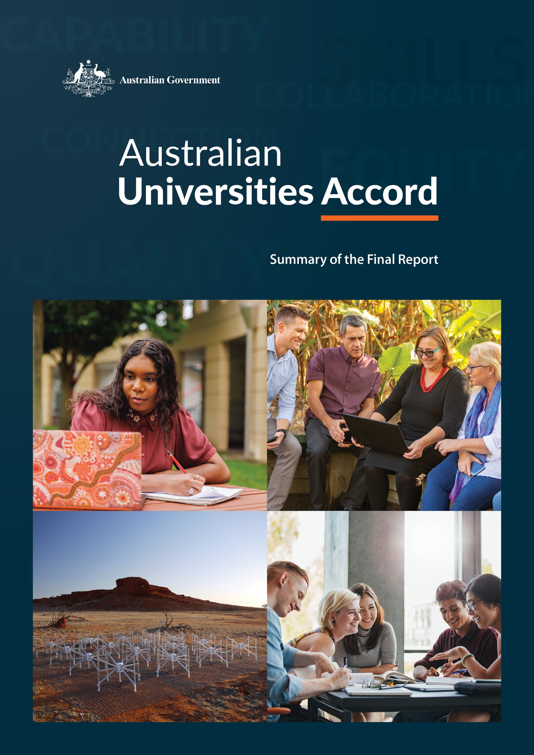Australian Universities Accord

Summary of the Final Report

The Department of Education acknowledges the Traditional Owners of the lands and waters on which Australians live, work and study, and pays respects to their Elders, past and present. Australia’s First Nations peoples are the custodians of the world’s oldest continuous cultures of learning and the passing down of knowledge. The Department of Education also acknowledges the determination of First Nations leaders over generations to ensure that higher education is accessible to First Nations people, reflects knowledges and law, and supports research led by First Nations people about their community, land and culture.



With the exception of the Commonwealth Coat of Arms, the Department’s logo, any material protected by a trade mark and where otherwise noted all material presented in this document is provided under a Creative Commons Attribution 4.0 International (https://creativecommons.org/licenses/by/4.0/) licence.

The details of the relevant licence conditions are available on the Creative Commons website (accessible using the links provided) as is the full legal code for the CC BY 4.0 International (https://creativecommons.org/licenses/by/4.0/legalcode)

**Disclaimer**

This summary report has been prepared by the Department of Education as a summary of the Australian Universities Accord Final Report. For the full report see: [www.education.gov.au](http://www.education.gov.au).

The document must be attributed as Australian Universities Accord: Summary of the Final Report.

Contents

**Overview: equity and innovation for higher education 4**

**A new vision for tertiary education 5**

**Ambitious targets 5**

**Skills through equity 8**

**Real equity funding 10**

**New qualifications and better pathways 12**

**Putting students at the centre 13**

**A stronger research system 16**

**New leadership and stewardship 19**

**A better funding model 21**

**Let’s get started 22**

**Summary of recommendations 22**

Overview: equity and innovation for higher education

This Review was asked to examine Australia’s higher education system and create a long-term plan for reform. Its message is simple and direct: if Australia is to prosper in the years ahead, Australian participation, performance and investment in tertiary education needs to improve in order to generate the knowledge, skills and research our nation needs.

Australia needs a more equitable and innovative higher education system.

The Review found that significant changes are needed in Australian tertiary education to produce the skills, knowledge and intellectual ambition needed to meet the nation’s current and emerging social, economic and environmental challenges. Pressure on the tertiary education system is already being felt every day through chronic shortages of skilled professionals, including early childhood educators, teachers, aged care workers, nurses, doctors, and more. And increasingly, Australia is going to need greater numbers of engineers and others to transform our energy grid, advance our manufacturing, drive new discoveries and innovations, make our agriculture more sustainable, and build new public infrastructure for our growing cities and regions. Australia’s tertiary education system must be strong and agile enough to provide the answers. The Review proposed large and significant changes to the tertiary education system to ensure that the system delivers for the nation.

Figure 1:Projected growth in employment by industry (thousands of positions), May 2023 to May 2033.

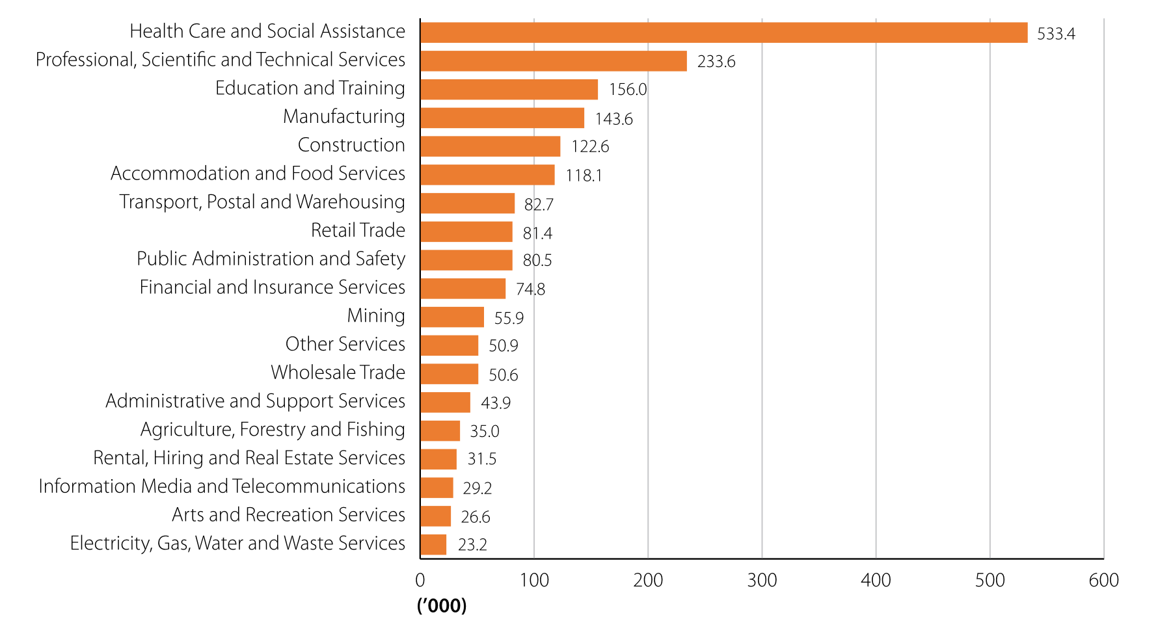

Source: Jobs and Skills Australia, *Employment Projections*, Canberra, 2023 <https://www.jobsandskills.gov.au/data/employment-projections>, accessed 20 November 2023.

The Review found that significant change is needed – small reforms to programs and funding won’t be enough.

Higher education provides many other essential benefits to Australian society beyond increasing the number of skilled workers. By encouraging intellectual endeavour, creativity and personal accomplishment, higher education adds to the quality of our lives. By pursuing truth through free discussion, higher education promotes democracy and civic values. Those communities fortunate enough to host a university benefit directly from the employment, higher incomes, sporting facilities, cultural and intellectual richness, and other opportunities they bring.

To ensure we are up to this challenge, our higher education system needs a fresh start, with new ideas, investment and an openness to change.

To renew itself, as well as to encourage innovation elsewhere, Australian higher education must embrace major innovation. The Review therefore recommended big changes in crucial areas:

* higher education attainment and participation targets
* the relationships between vocational education and training (VET) and universities
* the types of qualifications offered
* the current university funding model
* student contributions, repayments, and support
* the way industry and government use university research
* tertiary education policy making at the national level

A new vision for tertiary education

The Review’s vision is to grow and strengthen tertiary education in Australia over the next two decades so that all Australians have the opportunity to obtain the knowledge, skills and understanding to create and thrive in the jobs of the future.

Australia should grow the tertiary education system and improve skills through attainment targets and increased equity, meeting student needs and enabling fit-for-purpose research to meet the challenges facing our nation, region and world. Education, research and innovation are vital for Australia’s economic prosperity, democratic cohesion and environmental sustainability.

Ambitious targets

The Review makes it clear it is critical to increase participation in and successful completion of tertiary education. Australia is not meeting our current skills needs and will not meet them in the future unless we produce far greater numbers of higher education and VET graduates.

Jobs and Skills Australia (JSA) anticipates that over the next decade more than 90% of new jobs will require post-school qualifications. This includes around 50% requiring bachelor degree or higher qualifications and 44% requiring VET qualifications.[1] Further, evidence prepared for the Review by Oxford Economics Australia suggests that 90% of 25 to 34-year-olds will require a tertiary education by 2050.[2]

Failure to increase student numbers to meet these needs could do lasting damage to Australia’s prospects of national economic success. While our tertiary attainment rates are reasonably strong by world standards, other comparable nations are doing considerably better.

Figure 2: Tertiary attainment by OECD country, proportion of 25 to 34-year-olds (%), 2022.

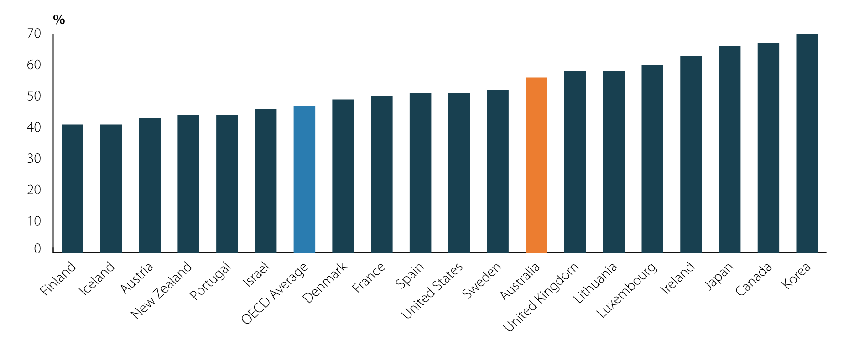

Source: OECD, *Education at glance: Educational attainment and outcomes*, OECD Publishing: Pairs, 2023, , <https://doi.org/10.1787/e13bef63-en>.

Note: Tertiary education as defined by the OECD includes diploma or above degrees (diploma, advanced diploma, bachelor, graduate certificate, graduate diploma and postgraduate degree).

The Review recommends a tertiary attainment target of at least 80% by 2050.

The Review proposed ambitious targets to increase the number of places in the tertiary education system to meet Australia’s skills needs. This includes:

* lifting the tertiary attainment rate all working age people (with at least one Certificate III qualification or higher) from 60% currently to at least 80% by 2050
* increasing the proportion of university educated Australians aged 25 to 34 from 45% currently to 55% by 2050
* to achieve this increase, the system will need to more than double the number of Commonwealth supported students in universities from 860,000 currently to 1.8 million by 2050.

Figure 3: VET and higher education graduates share of all employed people (%), current figures and projected future demand, 2010 to 2050.

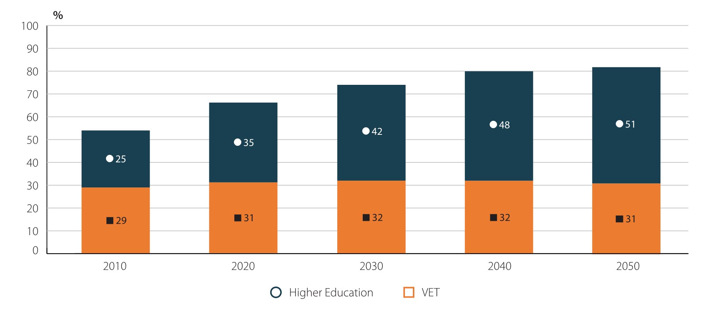

Source: Oxford Economics Australia, *Tertiary Education Qualification Demand: Preliminary Report*, produced for the Department of Education [unpublished report], OE, Sydney, November 2023.

Figure 4: Total Commonwealth supported student projection (headcount, thousands of students) under current policy settings and to achieve 55% attainment by 2050.

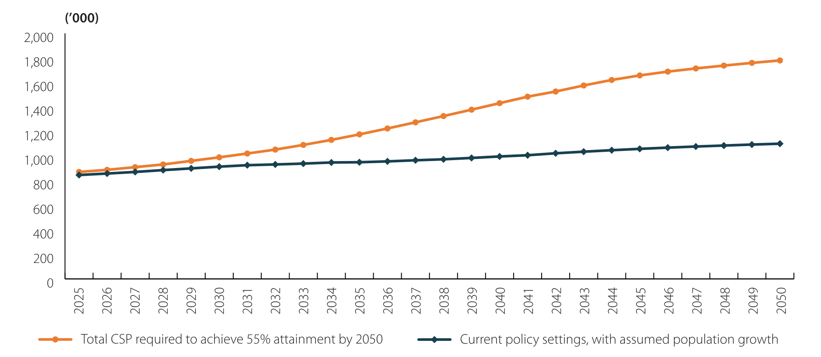

Source: Department of Education internal analysis based on ABS, *Population: Census 2021*, (Canberra: ABS, 2022), accessed 6 June 2023, <https://www.abs.gov.au/statistics/people/population/population-census/latest-release>; ABS, *Population Projections, Australia* [data sets], (Canberra: ABS, 2021),, accessed 6 June 2023,<https://www.abs.gov.au/statistics/people/population/population-projections-australia/latest-release>; Centre for Population, *Budget 2023–24, population projections, Australia, 2022–23 to 2033–34* [data set], (Canberra: Centre for Population, 2023), accessed 6 June 2023<https://population.gov.au/data-and-forecasts/projections/budget-2023-24-population-projections-australia-2022-23-2033-34>; and *Department of Education, Higher Education Statistics – Student Data* [unpublished data], (Canberra, n.d.).

Note: Assumptions based on current completion profiles.

Achieving new higher education and broader tertiary attainment targets will require concerted effort to bring those who are not currently participating in tertiary education into the system, rather than simply shifting existing students between the higher education and VET sectors. The school system, and even early childhood education, have a significant role to play in driving an uplift in preparedness for post-school education. The Department of Education projections show modest growth over the next 5 years, increasing to stronger growth from 2030 to 2050.

Skills through equity

Australia will be unable to meet its skills needs without increasing attainment of historically under-represented cohorts in tertiary education. Increasing the number of people undertaking tertiary education through a more inclusive approach will have significant benefits. Australia needs to not only increase the number of skilled workers but also ensure that they have access to lifelong learning. This will require much higher participation among groups historically under-represented in higher education, and students from these groups will need adequate support to succeed throughout their learning journeys.

The current under-representation of people from disadvantaged groups is stark. Australians from low socio-economic status (SES) backgrounds make up 25% of the population, but only 17% of undergraduate enrolments in higher education.[3] Australians from regional backgrounds have far lower educational attainment than those from the major cities.

Figure 5: Target cohorts share of Australian population, higher education participation (domestic undergraduate Table A) and higher education completions (domestic undergraduate Table A) (%), 2022.

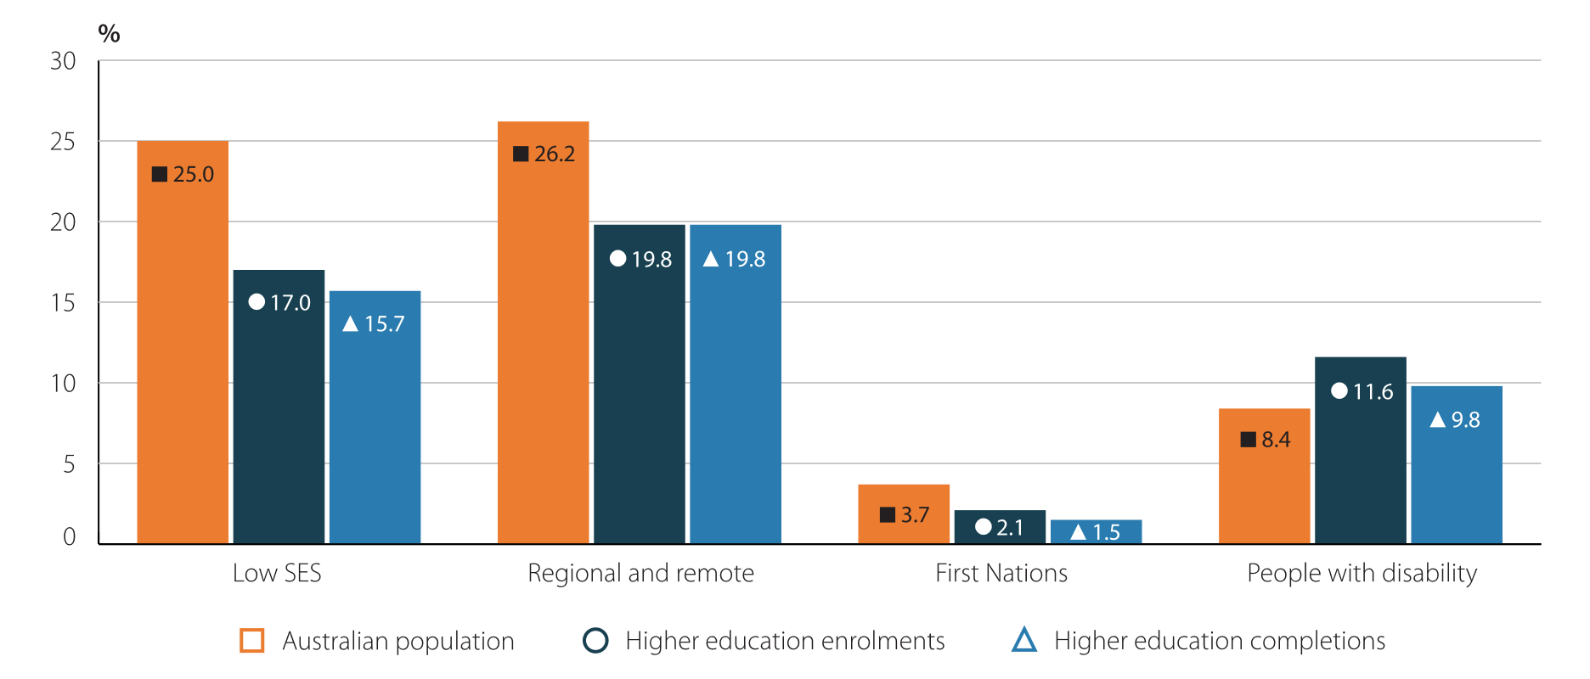

Source: Department of Education, *Higher Education Statistics – Section 16* Equity Performance Data [data set], (Canberra: 2023), accessed 19 December 2023, <https://www.education.gov.au/higher-education-statistics/resources/2022-section-16-equity-performance-data>; Australian Bureau of Statistics, *2021* *Census TableBuilder*, *Indigenous Status and level of highest qualification*, (Canberra, 2023), accessed 19 December 2023; Australian Bureau of Statistics, *2021* *Census TableBuilder*, *Remoteness Areas and level of highest qualification*, (Canberra, 2023), published 18 December 2023.

Note: Share of the Australian population for people with disability is an expected enrolment share estimated by the Department of Education, based on the proportion of the 15 to 64-year-old population with disability, adjusted for age profile and profound disability.

Figure 6: Educational attainment by geographical remoteness, 2021.

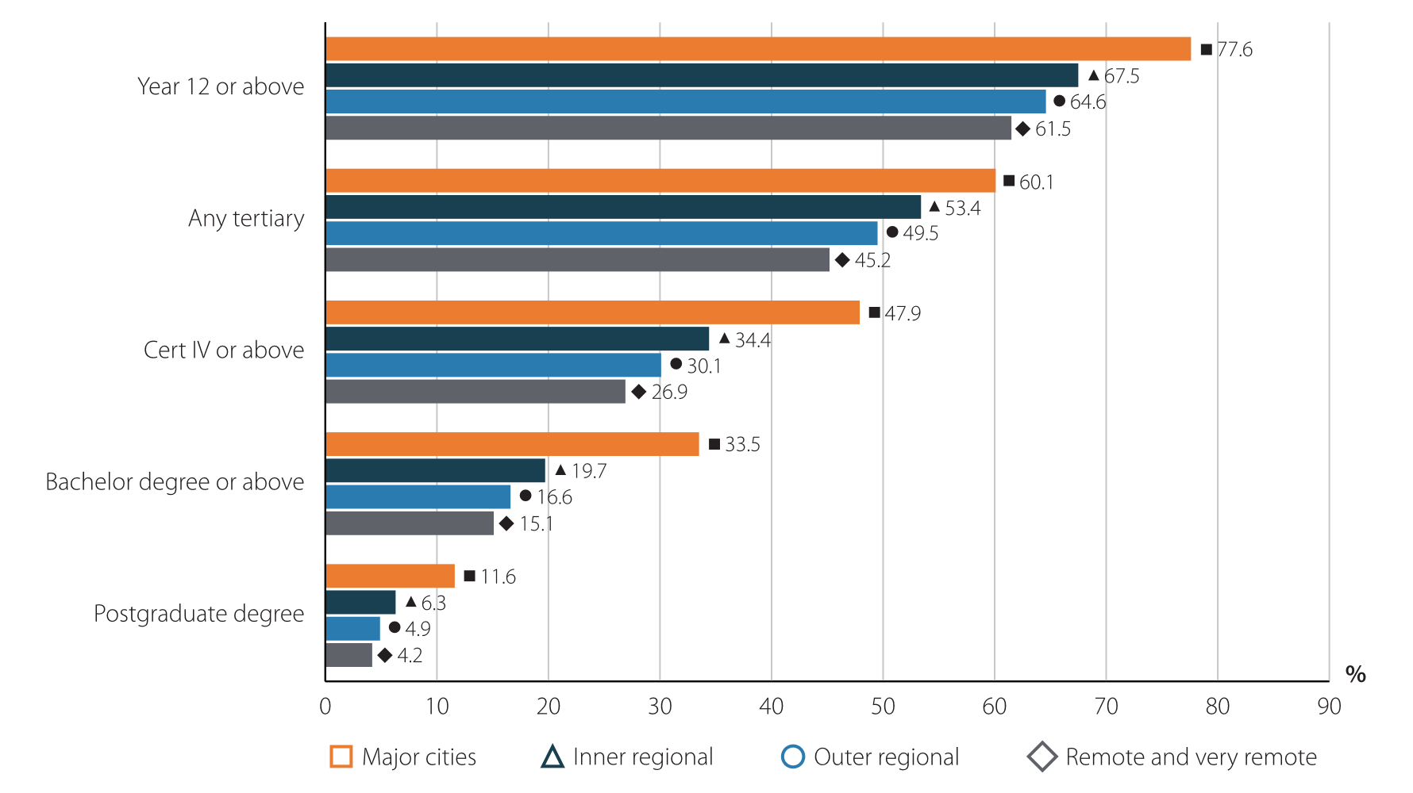

Source: Australian Bureau of Statistics, *Level of highest educational attainment (HEAP)*, (Census of Population and Housing: Census Dictionary, 2021), <https://www.abs.gov.au/census/guide-census-data/census-dictionary/2021/variables-topic/education-and-training/level-highest-educational-attainment-heap>.

All Australians must be encouraged and assisted to obtain the life-changing benefits of higher education. The Review recommended participation targets for groups historically under-represented in higher education (First Nations people, people from low SES backgrounds, people with disability, and people from regional, rural and remote communities) so that, by 2050, these groups are able to participate in higher education at a rate consistent with their proportion of the Australian population. The Review considered that urgent action to establish the right trajectory should start today and requires ‘whole of student’ focus – on learning and teaching, affordable student housing, assistance with finding employment, and income support where needed – as opposed to simply enrolling disadvantaged students into a course and hoping they succeed.

By 2050, those groups most under-represented in higher education should increase to achieve parity across the Australian population.

Real equity funding

**Needs-based funding.** Australia should recognise the need to not just improve access to higher education, but also to ensure that people from groups historically under-represented in higher education receive the support they need to succeed. The Review recommended the introduction of a needs-based funding model that acknowledges the cost of providing additional academic and other support, the locality of the institution they attend, and including bonuses to providers for student completions.

The Review recommended the delivery of places for students in higher education that ensures greater access, participation and success for historically underrepresented cohorts – effectively ‘demand driven for equity’ but with planned allocation of places to universities.

**Improving regional tertiary education.** Regional tertiary education delivers significant benefits to Australia’s regions. Regional tertiary education providers deliver local jobs, make significant social and economic contributions to their local communities, provide relevant research and many other tangible benefits. Because they educate a higher proportion of historically under-represented students, regional universities will play an essential role in achieving population parity of higher education participation.

Figure 7: Share of target cohort student participation at metropolitan and regional universities, 2022.

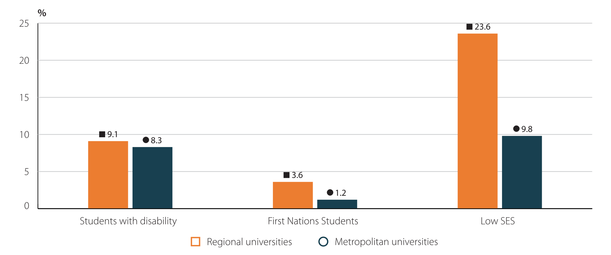

Source: Department of Education, Selected Higher Education Statistics – 2022 Student data, (Canberra: 2023), published 18 December 2023, https://www.education.gov.au/higher-education-statistics/student-data/selected-higher-education-statistics-2022-student-data

Note: Low SES is defined by first address.

The needs-based funding model proposed by the Review would be a game-changer for regional higher education providers, better reflecting the increased costs of educating students in the regions.

The Review recommended several additional measures to deliver for the regions, including:

* significantly increasing the number of Commonwealth supported medical places allocated to regionally based end-to-end medical schools
* expanding the successful University Regional Study Hubs program to increase participation, retention and completion rates for university and VET students
* examining further opportunities to strengthen regional tertiary education, including the potential creation of a National Regional University and a more integrated tertiary education system in regional Australia.

New qualifications and better pathways

**Providing the qualifications people want and need.** Meeting our equity and skills needs will require fresh ways of thinking. The Review considered how to provide the knowledge, skills and qualifications people want and employers need, and do so faster, more efficiently and more cost-effectively. Their answer lies in removing many of the unnecessary barriers people face when searching for education and skills and creating more flexible pathways that enable more people to achieve success.

**A more seamless tertiary education system.** To make qualification attainment faster and easier, Australia should ensure students can more seamlessly navigate between VET and higher education. Misalignment between and within these sectors currently makes navigation more difficult than it should be. The Review recommended the continued development of a National Skills Passport to help people to demonstrate the skills they have obtained to employers, supported by improvements to credit transfer and recognition of prior learning (RPL).

**Modular, stackable skills.** Australia should develop new and more flexible and efficient ways for individuals to attain the skills they need across their working life. This would require more modular, stackable and transferable qualifications that address Australia’s emerging skill needs. This should include microcredentials that are funded, accredited and recognised by the Australian Government and new combinations of earning and learning, such as Degree Apprenticeships.

**Fee-free preparatory courses.** The Review found that an important way of increasing enrolments, particularly from under-represented groups, will be through enabling or ‘preparatory’ courses. Currently 25,000 students undertake preparatory courses each year.[4] These courses prepare those with interrupted educational journeys to qualify for higher education entry without having to return to school. The Review recommended an increase in quality preparatory courses that are fee-free and funded at a level that reflects the full cost of delivery.

**Encouraging aspiration.** Decisions about attending tertiary education are often formed early in life, affected by numerous factors, including students’ background and where they live.Surveys show that 16-year-olds from the highest SES quartile are significantly more likely as those from the lowest quartile to plan to attend university immediately after leaving school.[5] The Review found that increasing equity in tertiary education requires raising aspiration levels among currently under-represented groups through outreach programs to develop familiarity with higher education. The Review also recommended a nationally consistent framework for careers advice for all stages of life, better career pathways advice in secondary schools, and high-quality communications campaigns about the benefits of tertiary education.

**Size and shape of the tertiary education sector.** The Review found that institutions need to innovate and evolve in type, diversity, size and number over the coming decades to meet the changing needs of our students and economy. Achieving this greater level of institutional innovation and diversity would require long-term planning, system-wide collaboration and proactive intervention by governments to reduce barriers to evolution and change, and to unlock the innovation potential within the sector.

Putting students at the centre

**Time to listen to students.** We want them to study hard, gain skills and do the research that will set our nation up for the future. Tertiary education is a valuable investment for individuals that supports personal growth. However, many students are having to carefully balance further study with opportunities to work and commitments to look after family.

The Review listened with empathy and concern as students told of their financial and personal struggles to keep studying in sometimes difficult circumstances. The Review concluded that students deserve greater assistance with their cost of living while studying, and that the cost of degrees should align with prospective future earnings.

The Review recommended a range of measures to ensure students are financially supported to study.

It is time to listen to what students are saying and to respond genuinely to their calls for change. This is extremely important for the wider reputation of Australian universities. The views of students influence the public sentiment towards tertiary education, particularly universities, and there is evidence that positive sentiment towards universities has declined. The proportion of Australians who thought universities were ‘doing a good job’ fell from 78.9% in 2008 to 70.6% in 2023.[6] This worrying decline must be turned around if Australia is to meet its skills needs for the future.

After hearing from students, the Review recommended a number of changes that address their major concerns. These changes will not only improve students’ experience of university, but also unlock the growth necessary to meet Australia’s future skills needs.

**Replacing the Job-ready Graduates (JRG) package.** The Review found the JRG package should be replaced. Its purpose of providing price signals to influence student subject choices has failed. Only 1.5% of students applied to enrol in courses they would not have applied for under the pre-JRG student contribution arrangements.[7] It has left some students facing extremely high student contributions and large HELP debts that do not reflect their future earning potential, and it has tilted the overall cost burden of higher education further onto students and away from the Australian Government.

The JRG reforms included a 113% rise in student contributions for students studying communications, humanities, other society and culture, and human movement. By cutting student and Commonwealth contributions in other disciplines, the JRG package also reduced the amount of funding available to higher education providers to deliver subjects that are critical to future jobs and innovation like science, engineering and mathematics. The Review recommended that the Australian Government reduce student contributions for those affected by JRG and move towards a student contribution system based on potential lifetime earnings.

The Review recommended moving to a student contribution scheme based on lifetime earnings.

**Modernising HELP.** If the nation’s goal is to expand tertiary education, the Higher Education Loan Program (HELP) system needs to continue to operate well and respond to changing circumstances. The core principles of HELP remain sound – asking students to contribute to the costs of their education later in life through an income contingent loan. HELP has served Australia well by sustainably expanding university access to many more students.

Figure 8: Proportion of commencing university students from a low SES background as a share of all commencing students (%), 1989 to 2022.

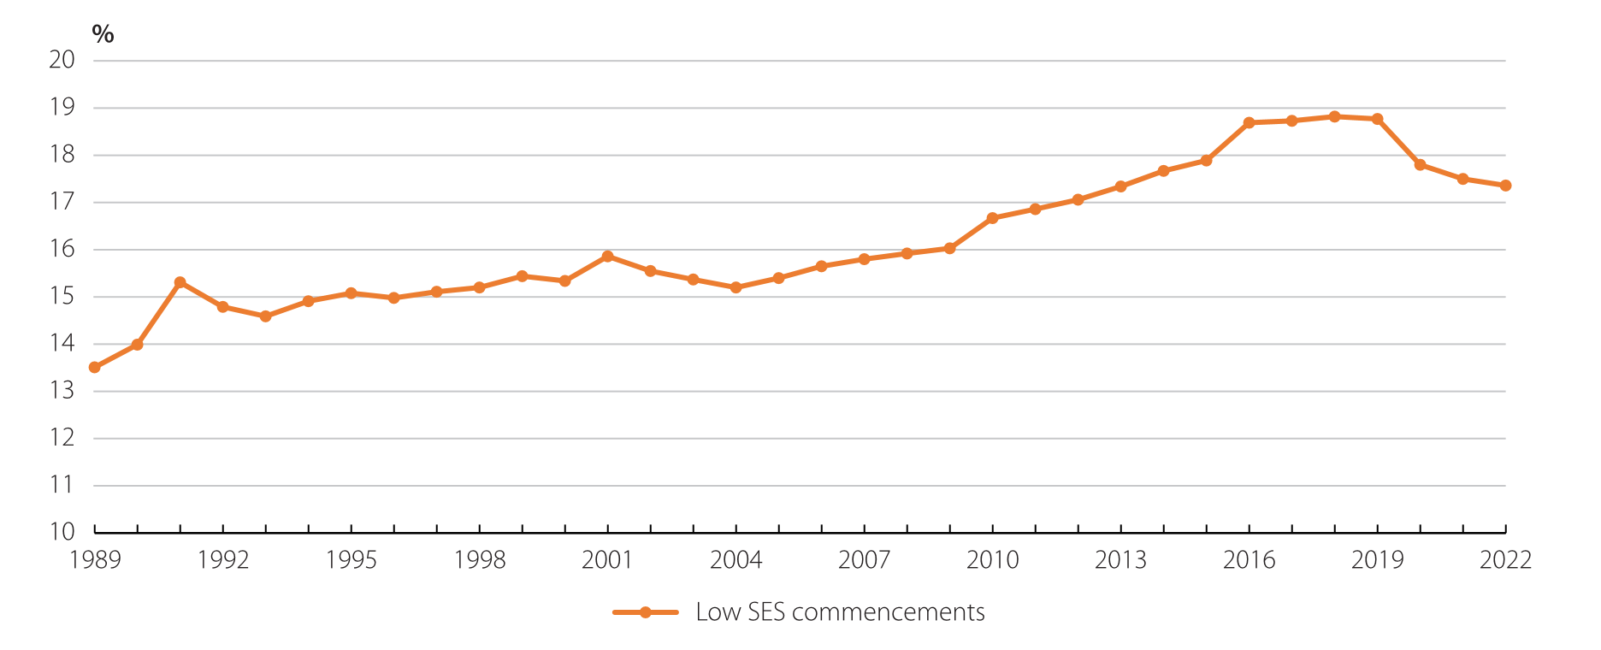

Source: Department of Education, *Selected Higher Education Statistics – 2022 Student data, Student Enrolment Time Series* [unpublished data], (Canberra: 2023).

Note: SES in this figure is determined by postcode to maintain a consistent measurement.

However, the Review found that some features of HELP are now outdated. Higher student contribution amounts, particularly those imposed through the JRG package, have significantly and unfairly increased what students repay. While the HELP system protects students by ensuring that repayments scale with their income, cost of living pressures and higher than usual inflation rates have increased concerns about the HELP system. Higher levels of HELP indebtedness, and the public debate about these developments, risk deterring some people from seeking higher education at exactly the time we need growth in participation.

The Review therefore considered the HELP system needs to be modernised to make it fairer and simpler. Changes have been recommended by the Review to:

* reduce the financial burden of repayment on lower-income earners, particularly women and those just starting out in their careers
* limit disincentives to do additional work
* change the timing of indexation to deduct compulsory repayments first
* ensure that people’s HELP loans do not grow faster than wages.

The Review found that modernisation of the HELP system will support increased participation.

**Improved income support.** Income support payments for students have not kept pace with wages or the needs of students – resulting in a smaller proportion of students now receiving income support. The Review recommended adjusting current arrangements to prevent cost-of-living pressures deterring people from studying. In particular, the Review highlighted that First Nations students, students from low socio-economic backgrounds and regional, rural and remote students are more likely to report financial difficulties as a reason they consider leaving university early.[8]

The proportion of students receiving income support has fallen.

**Recognising the reality and importance of student part-time work.** The proportion of students studying part-time is increasing. Students are on average taking on lower loads – most likely to accommodate extra work – and are taking longer to complete their degrees. The Review recognised that this is the new reality, that it is popular, that it has a positive side, and that tertiary education providers need to make it work for their students. The Review found that much can be done and should be done, to support students to earn and learn successfully at the same time, because Australia needs more people to upskill and reskill in the decades to come.

For some students, finding appropriate work can be tough, and in response the Review recommended establishing a Jobs Broker to help students find part-time employment in areas close to their field of study. For those in need of additional support while studying, the Review is also recommending that the Government increase the Parental Income Free Area for Youth Allowance and index it more appropriately, extend pro rata student payments to students who study part-time, and adjust the criteria for the Tertiary Access Payment, an important youth payment for regional students, to reflect and better cover relocation costs. Recognising that Australia’s social security system is complex, the Review recommended the Government commission further technical analysis to address the problems it has identified.

Part-time work is the reality for many students.

**Tackling ‘placement poverty’.** The Review received strong feedback from students about the burdens imposed by mandatory unpaid work placements. To ensure ‘placement poverty’ does not deter tertiary participation and successful completion, the Review recommended that the Australian Government work with higher education providers and employers to introduce payment for unpaid placements, including government financial support for placements in the areas of nursing, care and teaching.

The Review found there is a need to pay students for mandatory placement work.

**Quality learning and teaching.** Institutions and course sizes are increasing and technologies like the virtual classroom and artificial intelligence are becoming even more widespread. The Review found that, as students look to more accessible means of studying, there is a need to improve the quality of learning and teaching.

The Review called upon the Australian Government and universities to use the full potential of new teaching technologies, encourage minimum teaching qualifications for higher education teaching roles and ensure professional development opportunities for staff.

Students pay considerable fees and the Review found there is a need to ensure they receive good teaching in return.

**Student safety.** The Review heard from students about the serious wellbeing problems they face, ranging from sexual harm and sexual violence to lack of mental health support and housing shortages. It is important that students and staff alike feel safe and healthy when on campus or online. The Review proposed the establishment of a national student charter covering student welfare, safety and wellbeing, along with a National Student Ombudsman to address student complaints.

It is important that students and staff alike feel safe and healthy when on campus or online.

A stronger research system

**Untapped potential.** Gross Research and Development (R&D) expenditure in Australia is low for an advanced economy.

As a result, Australia’s university research is uniquely important to Australia. In few other countries does university research comprise such a large proportion of overall national research.

Figure 9: Gross Expenditure on R&D as a Percentage of GDP, OECD country comparisons, 1992 to 2021.

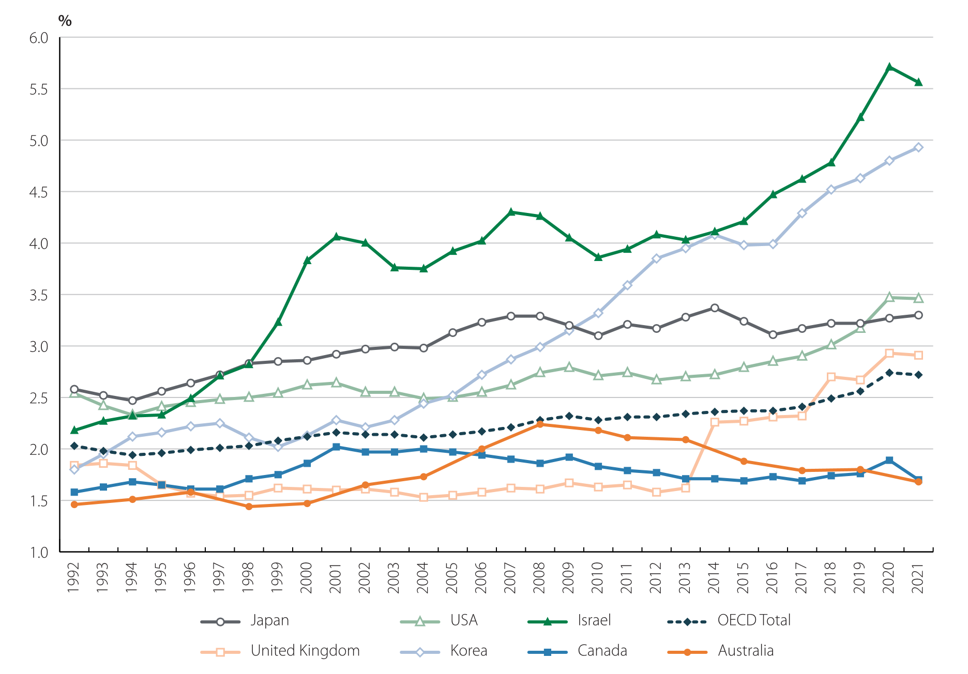

Source: OECD, OECD Main Science and Technology Indicators [data set], 2023, <https://stats.oecd.org/Index.aspx‌?DataSetCode=MSTI_PUB>.

Figure 10: Higher Education Expenditure on R&D (HERD) as a percentage of Gross Domestic Expenditure on R&D (GERD) (%), OECD country comparisons, 1992 to 2021.

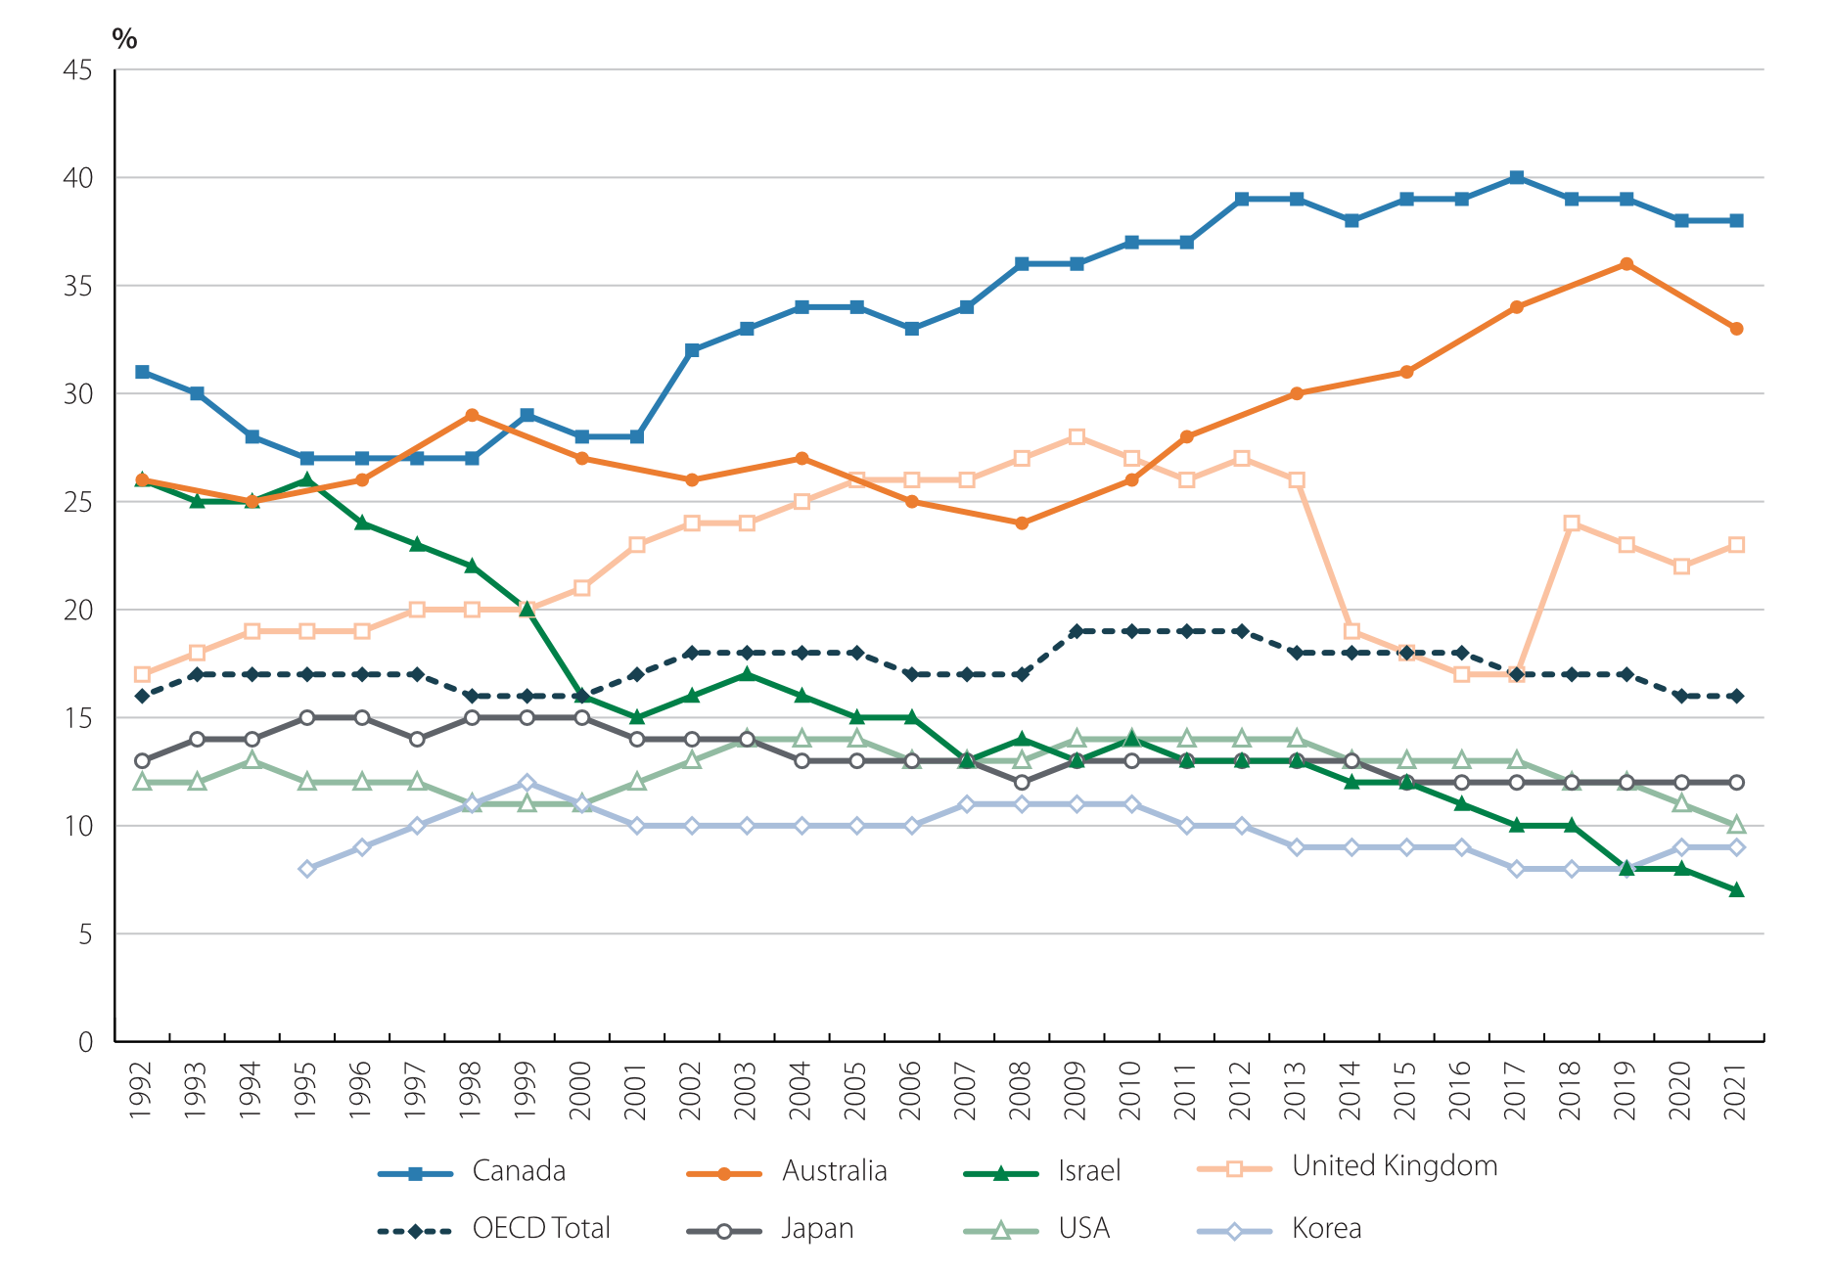

Source: OECD, *OECD* [*Main Science and Technology Indicators*](https://www.oecd.org/sti/msti.htm)[data set],2023*.* Percentage of GERD performed by the Higher Education sector HERD as a percentage of GDP.

Australian university research is highly regarded and globally connected. Over half of Australian university research output, as assessed by the Australian Research Council (ARC), is above or well above world standard. Its notable achievements – from solar cells to fully automated mines to COVID-19 virus sequencing – are popularly known, and rightly so.

Despite the high quality of Australia’s university R&D, the nation does not currently utilise its full potential as a source of innovation. Our rankings on innovation indices are poor. Australia’s governments and industries are not making enough use of university research capability and capacity.Recognising its importance, the Review devoted considerable time to the question of how to increase the amount and quality of university R&D and its uptake by government, business and industry.

The Review found Australia doesn’t fully utilise the full potential of its university research as a source of innovation.

**Targets for more research.** The Review also recommended that, as part of a strategic examination of national research funding, there should be a multi-agency government strategy containing targets to significantly increase national R&D spending as a proportion of Gross Domestic Product. The Review also recommended that ARC be given increased funding to invest in fundamental research.

**A new strategic research fund.** The Review recommended a new Solving Australia’s Challenges Fund should be established to reward universities that demonstrate effective use of their research expertise and capability and application of their research findings to big national challenges by governments, business and industry.

**A pathway to fully funding university research.** The Review considered that fully funded university research is a crucial objective for Australia’s universities. This is not just to allow more and better research, but to free up funding so that universities can invest in other priorities like learning and teaching and infrastructure, to support growth. Fully funding research would also reduce the currently excessive pressure on universities to secure international student revenue. To achieve this, the Review recommended that, over time, universities charge and government and industry pay at least the full economic cost for the university research they commission and university consulting they purchase. In addition, the Review recommended that the Australian Government should establish a higher and fixed base funding level through the Research Support Program for the indirect costs associated with Australian competitive grants.

The Review recommended that Governments should use more university research to address the big issues we face.

**Government leading by example.** The Review recommended that all Australian governments should lead by example by increasing their use of university research and by calling on the capacity of Australia’s universities to address the nation’s pressing economic, social, health and environmental problems.

**More opportunities and increased reward for early career researchers.** The Review recommended that governments, industry bodies and employers should establish targets to increase the number of doctoral candidates employed in industry undertaking a PhD relevant to their company. The Review also recommended raising the minimum stipend for Higher Degree by Research candidates under the Research Training Program and making part-time scholarships tax free.

New leadership and stewardship

The changes proposed by the Review are broad and ambitious. Australian tertiary education needs a step change in participation, performance and investment to generate the knowledge, skills and research needed to prosper in the contemporary world. Increasing the number of students in tertiary education to the required levels while improving the equity and quality of the entire system is a challenging goal, which the Review found would require new institutions, more diverse operating models and more cross-provision between VET and higher education providers, including opportunities to expand the role of TAFEs.

If the reforms recommended are to be successful, the Review found that stronger leadership, planning and collaboration than is possible under current system arrangements. This would include a far greater understanding of policy and reform priorities, and evidence about the state of the system.

The Review calls for big changes, and Australia should meet them head on.

**Leadership and stewardship.** To implement change, the Review recommended that the Australian Government establish an Australian Tertiary Education Commission (the Commission). Its task would be to provide the leadership and stewardship necessary to transform the tertiary education system to achieve an agreed objective for Australian tertiary education. Its initial remit would extend to policy development for higher education and research, future planning, making mission-based compacts, pricing, funding allocation, accountability, data collection and transparency, quality and performance. Reporting to both the Minister for Education and the Minister for Skills and Training, the Commission would play an important role in driving stronger alignment between VET and higher education, in pursuit of a stronger skills system.

The Commission would aim for a stronger, more diverse, innovative, mission-driven system, likely with more public providers and greater differentiation between those providers. It will draw advice widely from across the system. To ensure the Australian Tertiary Education Commission has a comprehensive view of the whole tertiary education system, the Tertiary Education Quality and Standards Agency (TEQSA) and the Australian Research Council should form part of the Commission, as independent statutory bodies under its umbrella, with each Chair becoming an ex-officio Commissioner and retaining their legislated roles.

The Review found that improving tertiary education is too important a task to be left to uncoordinated action.

**First Nations self-determination.** The Review adopted the principle that First Nations should be at the heart of the tertiary education system.To ensure self-determination for First Nations peoples within a reformed and improved tertiary education system, the Review recommended establishing a First Nations Council to advise ministers and the Commission, stronger obligations on universities to demonstrate self-determination within their operations, and a First Nations-led review of tertiary education to improve First Nations participation and workforce and to strengthen First Nations knowledge and research in higher education.

**Quality international education.** The Review found that international education makes an enormous contribution to Australian tertiary education by enabling Australian learning and teaching to have wider impact, helping universities to invest in important research, adding to diversity, and being an important avenue for soft diplomacy and international linkages.

In 2022, Australian higher education providers enrolled almost 450,000 international fee-paying students (more than a quarter of total enrolments), with around 120,000 of these studying Australian higher education courses from outside Australia.[9] International student fees contributed more than a fifth of overall university funding.[10] Now Australia’s fourth largest export, international education is a fixture of the economy.[11]

The Review considered that a strong and sustainable footing is therefore important. On the demand side, fluctuations in enrolments risk the stability and viability of institutions. On the supply side,there have been failures in quality and integrity in some parts of the market, and these must be addressed.

The Review considered that the financial stability and integrity of Australia’s international education system should be addressed.

The Review recommended that the Australian Government, higher education providers and the Commission work together to manage volatility in demand where possible, including by diversifying markets to avoid overreliance on a small number of countries.

Some international students seek a migration pathway. In line with the Australian Government’s Migration Strategy goal for a better targeted system,[12] the Review recommended that the tertiary education sector should encourage these students to study courses linked to Australian skill shortages and to study in regional locations. Finally, the Review considered that the sector should protect its reputation and ranking as a study destination by lifting course quality and improving the overall student experience. The Review recommended TEQSA take an evidence-based approach to ensure that providers have appropriate risk management strategies for international education to issues including managing demand volatility, course concentrations and the quality of the student experience, and access and availability of affordable housing.

**A better funding model**

The Review has found that the current funding model does not provide for sufficient growth in enrolments to meet the nation’s skills needs, with growth occurring in unplanned, unmanaged and under-funded ways that can have unintended consequences for the breadth and quality of courses. The Review recommends that, for the first time, core funding include needs-based funding for preparatory courses and undergraduate courses to support equity and access.

To address this, the Review recommended the introduction of a new needs-based funding model, planned and managed by the Commission. It would deliver managed – effectively introducing ‘demand driven places for equity students’.

The model proposed by the Review would include a needs-based system that covers the costs of providing courses, taking into account the higher costs of educating equity groups and providing regional education. The new funding model would include a significant increase to fee-free preparatory places and publicly funded higher education places, including at TAFEs. The new system would appropriately price the cost of teaching in different disciplines, increasing where necessary government contributions for disciplines in science, technology, engineering and mathematics, and, when student contributions are included, fully fund the cost of teaching. It would end the process of universities enrolling students over their funding cap and only receiving partial funding for additional students.

**A future fund.** Since the closure of the Education Infrastructure Fund, there has been no dedicated government funding for higher education infrastructure. To provide such a source of funding, and funding for other significant sector needs such as student housing, the Review recommended the creation of a Higher Education Future Fund (HEFF). It would be managed by the Future Fund Board of Guardians and funded by co-contributions from universities and the Australian Government, with the aim of reaching $10 billion in assets. Distribution of returns would be invested in projects informed by advice of an independent board.

Let’s get started

Change should get underway as soon as possible with emphasis on building skills through equity, developing the new stewardship role and managing the transition to the proposed new funding model.

First steps should include establishing an Implementation Advisory Committee that brings together higher education stakeholders and those from across the tertiary education system. In addition, the Australian Government should outline a staged approach to recommendations to provide transparency and predictability for the sector and in recognition of the Review’s ambition for lasting reform.

Improving the higher education system requires foundational changes and a staged approach to implementation.

Summary of recommendations

The Final Report includes 47 recommendations. Below is a snapshot summary of the Review’s recommendations.

A new objective

* A national tertiary education system with an objective of: *underpinning a strong, equitable and resilient democracy, and driving national economic and social development and environmental sustainability* (Recommendation 1).

Meeting our current and future skills needs

* Ambitious targets to drive improvements to national workforce participation and productivity, including a tertiary education attainment target of at least 80% of the working age population, achieved by more than doubling the number of Commonwealth supported places from around 860,000 today to 1.8 million in 2050(Recommendation 2).
* Additional Commonwealth supported medical places in regional universities and for all First Nations students(Recommendation 3).
* A more flexible and responsive skills system, achieved through initiatives including a National Skills Passport to give all Australians a record of their formal qualifications, skills, prior learning and work experience(Recommendation 4).
* A comprehensive system of modular, stackable and transferable qualifications (Recommendation 5).
* New accreditation arrangements for microcredentials in the higher education sector, setting conditions so these microcredentials are funded as Commonwealth supported places (Recommendation 6).
* Increased opportunities for tertiary students to find part-time work and placements relevant to their fields of study, including througha ‘Jobs Broker’ (Recommendation 7).
* Supporting methods of ramping up skills delivery, including through collaborative infrastructure such as TAFE Centres of Excellence (Recommendation 8).
* Work with professional accreditation bodies on placement requirements to ensure they match industry and skills needs (Recommendation 9).

Expanding opportunity to all

* Participation targets for students from underrepresented backgrounds to achieve participation parity by 2050, including linking these new attainment targets with Closing the Gap targets(Recommendation 10).
* Outreach programs to build the aspiration and capacity of students from underrepresented groups to participate in tertiary education, including a consistent national framework for career advice across all life stages and a national communications campaign to build aspiration for tertiary education(Recommendation 11).
* Increase the availability of fee-free preparatory courses and fund these places to match the cost of delivery (Recommendation 12).
* Adopt a needs-based funding model, including a per-student funding amount for under-represented students that recognises the cost of additional support to succeed and a completion bonus for higher education providers who meet agreed completion targets (Recommendation 13).
* Introduce financial support for unpaid work placements (Recommendation 14).
* Recognise the benefits of tertiary education in regional, rural and remote areas through an expanded Regional University Study Hubs Program, consideration of establishing a National Regional University and adjusted eligibility requirements and timing of payments for the Tertiary Access Payment (Recommendation 39).

Delivering for students

* Higher and more accessible income support for students who need it most (Recommendation 15).
* Student contributions that are fairer and better reflect the lifetime benefits that students will gain from studying and HELP loans with fairer and simpler indexation and repayment arrangements(Recommendation 16).
* More Commonwealth supported places available for postgraduate study in areas of national priority and skills shortage (Recommendation 17).
* Develop a national student charter setting out a shared, national commitment to the welfare, safety and wellbeing of all students and establish a National Student Ombudsman to respond to student complaints (Recommendation 18).
* Ensure a proportion of the Student Services and Amenities Fee received by each higher education provider be directed to student-led organisations (Recommendation 19).
* Agree through the Education Ministers Meeting to not issue early at-school offers for 2025 and 2026 before September in the relevant year. Stakeholders should develop a national, cross-jurisdictional approach to at-school offers by 2027 (Recommendation 20).
* Best practice on-campus, online and hybrid teaching practices and professional development for teaching staff to improve the quality of teaching and learning offered to Australian tertiary students(Recommendation 21).
* A strengthened international education system, with higher quality courses that are better aligned with Australia’s skill and migration needs, more diversified international student source markets, more international students studying in regional campuses, and improved alumni engagement programs and research networks(Recommendation 22).
* Ensure trust and integrity within the Australian student visa system is maintained and ensure providers have appropriate risk management strategies for international education including managing demand volatility and access and availability of affordable student housing (Recommendation 23).

Producing and using new knowledge

* Set medium and long-term targets for Australia's overall national spending on R&D as a percentage of GDP (Recommendation 24).
* Ensure Australia’s research capacity and capability has a high impact through ‘Solving Australian Challenges Strategic Fund’ to reward universities that work successfully to solve the acute and stubborn economic, social, health, climate and environmental challenges facing Australia (Recommendation 25).
* Australian businesses and governments drawing more heavily on the research and consultancy capacity of Australian universities, governments working closely with business and industry peak bodies to establish a Research Investor Forum, and firms investing in upskilling staff to PhD level at scale (Recommendation 25).
* Strengthen the fundamentals of the Australian research system, including additional investment in the ARC’s programs, setting a minimum percentage of national competitive grants that run for 5 years or longer and providing stable and ongoing funding for the National Collaborative Research Infrastructure Strategy (NCRIS) (Recommendation 26).
* The Australian Government should substantially increase investment in the Research Training Program, including providing dedicated PhD scholarships and postdoctoral fellowships for First Nations researchers, ensuring that training in entrepreneurial, business, teaching and leadership skills is offered in parallel to research training (Recommendation 26).
* The Australian Tertiary Education Commission should develop a National Research Workforce Development Program by the end of 2026 (Recommendation 26).
* Elevating ‘First Nations knowledge’, First Nations knowledge systems’, and ‘Closing the Gap through First Nations Leadership’ to the list of National Science and Research Priorities (Recommendation 27).
* Develop a pathway to fund the full economic cost of university research through universities charging full market rates for commissioned and contract research and consulting and Australian Government providing transparency and significant material support for national competitive schemes and provide explicit indirect cost support. (Recommendation 28).
* Create a National Research Evaluation and Impact Framework that strengthens the capacity of Australian universities and researchers and is less burdensome for universities to measure and report research quality and impact (Recommendation 29).
* Make changes to the university research funding model by establishing a Solving Australian Challenges Strategic Fund, increasing funding to the ARC, creating a pathway towards funding more of the full economic cost of research, and substantially increasing investment in the Research Training Program and raising the minimum stipend rate (Recommendation 42).

A dynamic, collaborative and responsive system that serves the national interest

* An Australian Tertiary Education Commission as a statutory, national body to plan and oversee the creation of a high quality and cohesive tertiary education system to meet Australia’s future needs. Functions would include policy coordination and development, system planning, pricing authority, funding allocation and negotiation of mission-based compacts for universities (Recommendation 30).
* Improve workforce capability and capacity, through professional learning and teaching standards for academics and minimum teaching qualifications for higher education teaching roles (Recommendation 31).
* Establish a Centre of Excellence in Higher Education and Research (Recommendation 32).
* Conduct a survey into the prevalence and impact of racism across the tertiary education system (Recommendation 33).
* Commission a First Nations-led review of higher education in consultation with relevant First Nations stakeholder groups (Recommendation 34).
* Increase the representation of suitably qualified First Nations people in university governance and leadership positions (Recommendation 35).
* Develop a fit for purpose, integrated and timely tertiary education data capability, with the Australian Tertiary Education Commission to produce an annual State of the Tertiary Education System Report (Recommendation 36).
* The Australian Tertiary Education Commission address the appropriate diversity of tertiary education providers of varying size and shape, including exploring the establishment of new public universities and encouraging and incentivising new models of delivery and collaboration (Recommendation 37).
* A pathway for TAFEs to become self-accrediting in VET at the Australian Qualification Framework (AQF) Level 5 and above in areas of national priority (Recommendation 38).
* A new needs-based funding model for tertiary education that recognises the additional costs involved in successfully educating students from equity groups and from regional and remote Australia. This will include the creation of higher-funded, demand driven places for equity students (Recommendation 40).
* A new funding model which see places funded by both government and the student; delivers growth ensuring places for undergraduate students who meet entry requirements in publicly funded higher education courses; increasing funding to STEM courses; expanding the number of publicly funded higher education places; and continuing to provide the Indigenous Student Support Program (Recommendation 41).
* The establishment of a Higher Education Future Fund, with co-contributions from public universities and the Commonwealth, to fund future built and digital infrastructure (Recommendation 43).

Transition

* The establishment of an Implementation Advisory Committee to provide advice on the implementation of the recommendations from this review (Recommendation 44).
* A staged and managed approach to updating legislation that governs the sector, starting with those measures with most urgent impact that arise from the Review’s recommendations (Recommendation 45).
* A ‘glidepath’ to implementation to support universities as they transition from the current funding system based on a fixed dollar amount to the new funding model built on EFTSL, disciplined-based and needs-based funding (Recommendation 46).
* The Australian Government outline a staged approach to implementation of the Review’s recommendations (Recommendation 47).

1. JSA, *Towards a National Jobs and Skills Roadmap: Annual Jobs and Skills Report 2023* (October 2023), 18, [www.jobsandskills.gov.au/publications/towards-national-jobs-and-skills-roadmap](https://www.jobsandskills.gov.au/publications/towards-national-jobs-and-skills-roadmap).
2. Oxford Economics Australia, *Tertiary Education Qualification Demand* [unpublished report],(Sydney: Department of Education, November 2023).
3. First Address Low SES SA1. Domestic undergraduate Table A student population; Department of Education, *Higher Education Statistics – Student Data – 2022 Section 11 Equity groups* [data set], (Canberra: 2023), accessed 18 December 2023, <https://www.education.gov.au/higher-education-statistics/resources/2022-section-11-equity-groups>.
4. Department of Education*, Higher Education Statistics – Student Data – 2022 Section 5 Liability Status*[data set], (Canberra: 2023), accessed 18 December 2023,<https://www.education.gov.au/higher-education-statistics/resources/2022-section-5-liability-status-categories>.
5. Department of Education, *Quality Indicators for Learning and Teaching (QILT) LSAY Y15 cohort data* [unpublished data], (Canberra: 2016).
6. Nicholas Biddle, *Attitudes towards education in Australia*, (Canberra: ANU Centre for Social Research and Methods, 2023), 13, [https://csrm.cass.anu.edu.au/sites/default/files/docs/2023/8/Attitudes_towards_  
   education_in_Australia_-_For_web.pdf](https://csrm.cass.anu.edu.au/sites/default/files/docs/2023/8/Attitudes_towards_education_in_Australia_-_For_web.pdf).
7. Maxwell Yong, Michael Coelli and Jan Kabatek, *University fees, subsidies and field of study,* Working Paper No. 11, 23, (Melbourne: Melbourne Institute of Applied Economic and Social Research, September 2023), 4, <https://melbourneinstitute.unimelb.edu.au/__data/assets/pdf_file/0011/4751741/wp2023n11.pdf>.
8. Quality Indicators for Learning and Teaching (QILT), *2022 Student Experience Survey* [data set], (Canberra: 2022), accessed 5 December 2023, <https://www.qilt.edu.au/surveys/student-experience-survey-(ses)>.
9. Department of Education, *Higher Education Statistics – Student data – 2022 Section 2 All students* [data set], (Canberra: 2023), accessed 18 December 2023, <https://www.education.gov.au/higher-education-statistics/resources/2022-section-2-all-students>.  
10. Department of Education, *Higher Education Providers Finance Tables 2004*–*2021* [data set], (Canberra, March 2023) accessed 8 June 2023, <https://www.education.gov.au/higher-education-publications/resources/2021-higher-education-providers-finance-tables>.
11. Australian Bureau of Statistics, *Balance of Payments and International Investment Position* [data set], (Canberra: September 2023), accessed 12 December 2023, <https://www.abs.gov.au/statistics/economy/international-trade/balance-payments-and-international-investment-position-australia/latest-release>.
12. Martin Parkinson, Joanna Howe and John Azarias, *Review of the Migration System*, (Canberra: Department of Home Affairs, March 2023), <https://www.homeaffairs.gov.au/reports-and-pubs/files/review-migration-system-final-report.pdf>.