


Task card – How to log into the Provider Entry Point (PEP)

Overview
This task card outlines how to log into the Provider Entry Point (PEP) through PRODA.
In the PEP you can:
- apply to become an approved provider
- view, add or remove a service
- view and update staff and organisation details
- create session reports and enrolments
- view entitlements and payments
- make an ACCS claim
- update the Family Day Care Exceptions Register.
Find more task cards for the PEP on our website.
If you need further assistance, contact the Child Care Subsidy Provider Helpdesk on 1300 667 276 9 am to 5 pm AEST or via email anytime.

Step 1
Log in to PRODA. If you do not yet have a PRODA log in you will need to register your details.
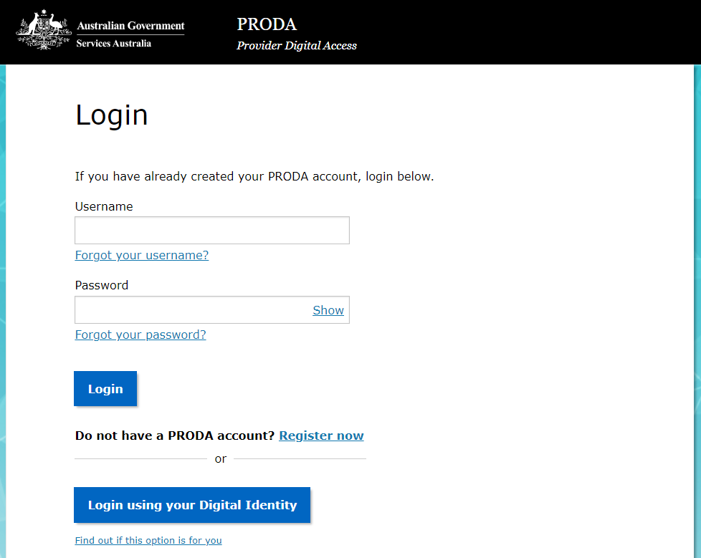

Step 2
From the PRODA homepage select the Child Care Provider Entry Point tile to enter the PEP.
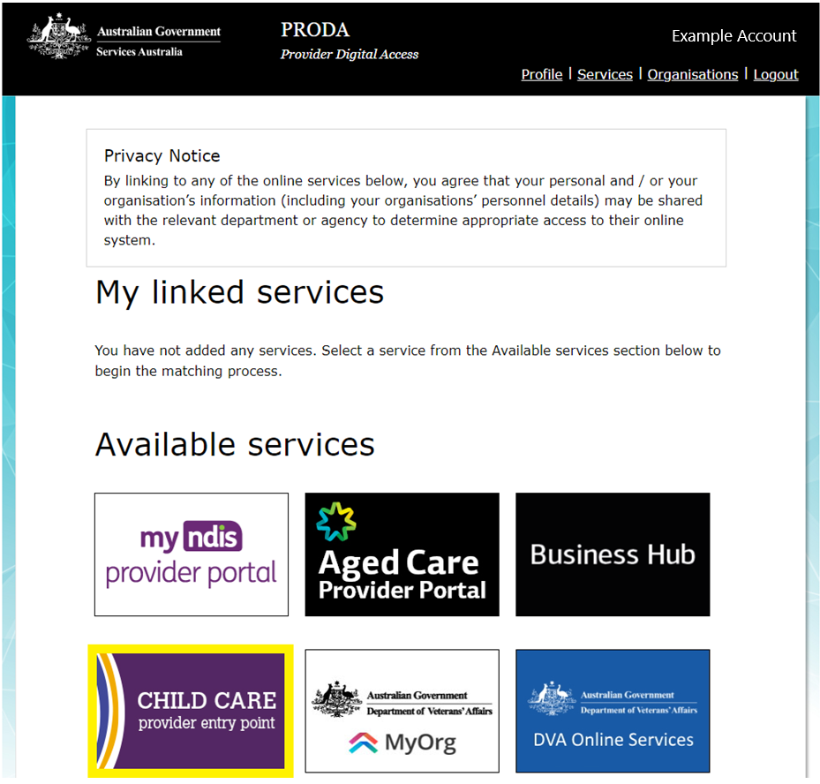

Step 3
You will be presented with an online Declaration.
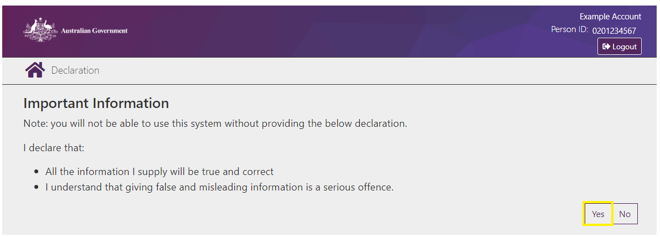

Step 4
Here you will be presented with all of the child care providers and services that you are authorised to act for.
You can search a provider/service by the CRN (1900XXXXXX), name or address.
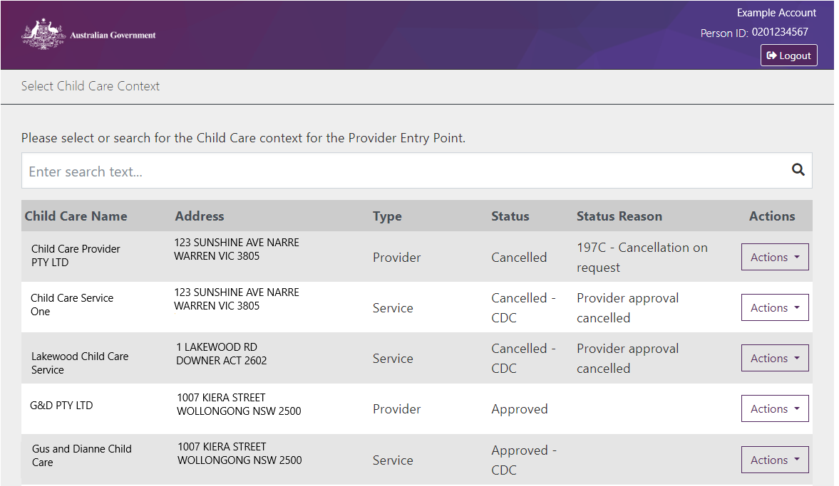

Step 5
Once you have found the relevant provider/service, select Actions, then Select to access the provider/service.
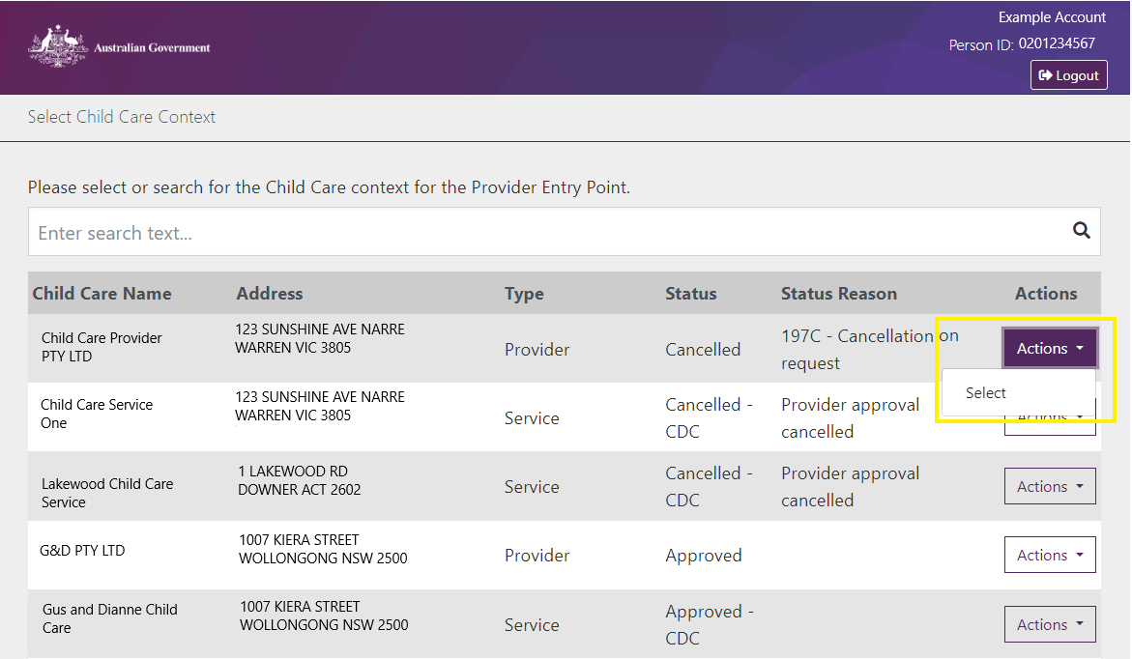

Step 6
You can now navigate the provider/service.
