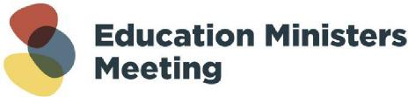
21 November 2023
Communiqué
Addressing gender-based violence in Higher Education
Ministers were briefed on the Commonwealth-led Universities Accord governance Working Group’s draft Action Plan, Addressing gender-based violence in higher education.
Ministers were briefed by victim-survivor advocates on the draft Action Plan.
Ministers agreed to release the draft Action Plan for further consultation and detailed design work.
Enquiries: emmsupport@education.gov.au

