

Assessment and Selection Policy

Purpose
The Commonwealth Teaching Scholarships (CTS) Program Assessment and Selection Policy articulates the policy defining the criteria and process for the assessment and selection of individuals to receive a Commonwealth Teaching Scholarship.
This policy should be considered in conjunction with the CTS Grant Opportunity Guidelines (Scholarship Guidelines) available on the Scholarships website. The Scholarship Guidelines will prevail over this policy to the extent of any inconsistency.

Background
Section 8 of the Scholarship Guidelines outlines the scholarship selection process.
5,000 scholarships will be made available over 5 years to new Initial Teacher Education (ITE) students intending to start a full time, accredited ITE program in the first study period or semester of the year they apply for.
The scholarship application process is outlined in Section 7 of the Scholarship Guidelines.

Eligible applications criteria
To be considered for a Commonwealth Teaching Scholarship applicants must complete an online scholarship application form and provide all requested supporting evidence.
The Department of Education (the Department) can only consider applications that satisfy all of the eligibility criteria as outlined in Section 6 of the Scholarship Guidelines.
Funding allows for up to 1,000 scholarships each year over five rounds (2024-2028). Scholarship applicants should follow the application process as outlined in Section 7 of the Scholarship Guidelines. Submitting an application does not guarantee a scholarship and applicants should not commit funds until signing their Scholarship Agreement, should they be successful.

Eligibility criteria
Eligibility Criteria are set out in Section 6 of the Scholarship Guidelines.

Target cohorts
Applicants are requested to identify if they belong to one or more of the following cohorts:
- high achieving students with an ATAR of 80 or above (undergraduate applicants only)
- First Nations peoples
- people from regional, rural and remote areas
- mid-career professionals
- people for whom English is an Additional Language or Dialect (EAL/D)
- people from low socio-economic backgrounds
- people with disability.

Previous ITE enrolment
Applicants who are part-way through an ITE program or commenced an ITE program in the two years prior to the year they are applying for a scholarship are not eligible to apply under the eligibility criteria set out in the Scholarship Guidelines.
Applicants who have previously enrolled in an ITE program more than two years prior to the year they are applying but withdrew their enrolment and failed to complete the course, may have their application considered.
Applicants will need to provide official evidence from the higher education provider of the withdrawal of enrolment to support the claim of eligibility.

Application
To apply, applicants must:
- complete the online CTS application form available on the Scholarships website;
- provide all the information requested;
- meet all eligibility criteria; and,
- include all necessary copies of supporting evidence (refer to section 7.3 of the Scholarship Guidelines).
If the Department receives more than one application from the same Scholarship Applicant, only the last (most recent) application received will be assessed.
Advice on making an application is published on the Department’s website. Applicants must submit an application between the published opening and closing dates. The Department is unable to accept late applications.
Applicants will receive lodgement advice via email once the application is submitted. Applicants should check their junk/spam folders if the advice is not received in their primary email inbox. If an applicant does not receive this advice, the application may not have been fully submitted. An application must be completed and fully submitted before the published closing date. Downloaded copies of applications not fully submitted cannot be accepted.

Application evidence requirements
Applicants must provide official academic evidence of their highest level of prior academic achievement to demonstrate their eligibility for a scholarship.
Evidence must be in the format indicated in the application form and legible in order to be accepted.
Evidence submitted must be an official statement of a completed qualification that demonstrates academic achievement and must include:
- full name of the applicant
- official branding that clearly identifies the issuer/educational provider
- relevant completion or result dates
- an overall academic result.
An application will be deemed ineligible if official evidence meeting the above criteria is not provided.

Undergraduate applicants
Undergraduate applicants need to provide ONE of the following ranks, scores or grades and upload the official evidence that matches the academic result provided:
- an ATAR (predicted or adjusted ATARs will not be accepted); or
- a pre-ATAR statement (e.g. Tertiary Entrance Rank (TER), Universities Admissions Index (UAI), Equivalent National Tertiary Entrance Rank (ENTER)); or
- a Skills for Tertiary Admissions Test (STAT) (formerly known as the Special Tertiary Admissions Test) result; or
- an International Baccalaureate score; or
- an Overall Position (OP); or
- a Grade Point Average (GPA) or Weighted Average Mark (WAM) (for applicants who have completed a Bachelor degree but intend to enrol in an undergraduate ITE Program). Please refer to section 4.1.2 for GPA and WAM evidence requirements
- Note, applicants who are intending to transfer from an incomplete Bachelor degree to an ITE Program must provide their academic transcript from the partially completed degree; or
- Grade or score for a qualification awarded by an international school or institution.
Applicants with Vocational Education and Training (VET) qualifications (e.g. Diploma, Certificate IV, Certificate III) must provide a competency transcript for the completed qualification.

Postgraduate applicants
Postgraduate applicants need to provide:
- a Grade Point Average (GPA); or
- a Weighted Average Mark (WAM); or
- grade or score for a qualification awarded by an international institution.
Postgraduate applicants must provide an official academic statement to substantiate the GPA or WAM result. If the academic evidence (e.g. official transcript) does not contain an overall GPA or WAM, the department will calculate this for you based on the calculation used by the awarding institution. An application will be deemed ineligible if the correct evidence is not provided.
Applicants with a Doctor of Philosophy (PhD) must provide their next highest completed qualification (e.g. Masters or Honours degree).
Applicants deemed ineligible will be notified by the Department via email.

Unacceptable evidence
It is the responsibility of the applicant to provide correct evidence to fully support the information provided in the application. Submitted evidence that does not meet the required standards will result in an application being deemed ineligible. Unacceptable evidence may include, but is not limited to:
- Evidence does not include the full name of the applicant
- Evidence does not include the name of the issuer/higher education provider
- Evidence does not include the name (or code) of the course (for higher education qualifications)
- Corrupted/unreadable files
- Cropped screenshot/half-scanned pages/blurry files
- Links to external online storage locations (e.g. cloud-based storage).

Assessment and selection overview
Assessment of eligible applications will be undertaken by the Department’s CTS Assessment Team (the assessors). Eligibility checks may commence prior to the closing date.
Assessment officers will ensure the application is complete and the required supporting evidence has been provided. If an application is incomplete it will be deemed ineligible and will not move to the assessment stage.
Where an applicant identifies errors in their application, they should lodge a new application prior to the closing date via the scholarships website. For this reason, applicants must review their application responses prior to submission and retain a copy of their application. The Department will not accept any additional information nor requests to correct an application after the closing date.
The assessors will rank eligible applications. Prior to assessment, all information will be de-identified and only the academic ranking and target cohort identification will be provided to assessors. Assessors will allocate a ‘recommendation for scholarship’ until available scholarships are exhausted.
The recommendation for CTS recipients will be provided to the Senior Responsible Officer (SRO) for decision and approval to issue conditional offers.

Assessment and selection process
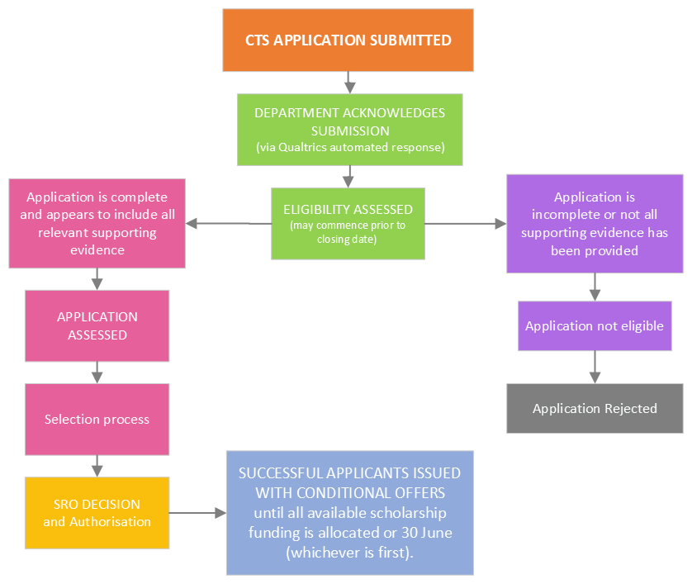

Eligibility and assessment checklist
The following will be assessed by the assessors during eligibility check and assessment process.
- Does the applicant meet the citizenship requirements?
  - Australian citizen; OR
  - Permanent resident; OR
  - Holder of a permanent humanitarian visa; OR
  - New Zealand citizen living in Australia
Please note, applicants who proceed to the conditional offer phase will be required to provide certified official evidence to demonstrate they meet the citizenship requirements.

- Has the applicant identified one or more target cohorts?
  - High-achieving student with an ATAR of 80 or more or equivalent (undergraduate applicants only)
  - First Nations person
  - Mid-career professional
  - Person from a rural, regional or remote area
  - Person with disability
  - Person from a low-socio economic background
  - Person for whom English is an additional language/dialect

- Has the applicant provided ONE highest prior academic achievement:
Undergraduates:
  - ATAR
  - STAT
  - IB
  - OP
  - pre-ATAR (TER, UAI, ENTER)
  - GPA or WAM
  - VET qualification
  - Academic transcript from an incomplete degree (if transferring to an ITE program)
  - qualification awarded from an international school or institution
Postgraduates:
  - GPA or WAM from a completed degree
  - academic transcript without an overall GPA or WAM, with numeric or letter grades, if unable to request GPA or WAM from the awarding institution.
  - Qualification awarded from an international institution.

- Has the applicant provided official evidence of prior academic result?
See evidence requirements at section 4.1 for further information.

- Has the applicant identified their intention to enrol in a full time accredited ITE program?
  - Enrolling (or recently enrolled) in an accredited teaching program.
  - Not currently studying an accredited ITE program.
  - Not withdrawn from an accredited ITE program in the two years prior to the application.

Selection process
Following the eligibility check, eligible applications will be distributed into relevant states and territories according to the permanent address provided by the applicant.

State and territory distribution
To ensure equity across states and territories, a notional distribution of available scholarships will be used to allocate scholarships in each state and territory with allowable variations (e.g. where a particular state or territory is undersubscribed). This notional distribution is based on the national distribution of eligible schools, located in each state and territory.

Target cohorts
To ensure an equitable distribution of target cohorts across each state and territory, a notional equal distribution will be applied to the target cohorts, with allowable variations where target cohorts are undersubscribed.

Assessment process
- All eligible applications will be ranked according to academic result and relevant target cohort(s) identified.
- Applications for each jurisdiction will then be assigned, from highest to lowest academic achievement, to a relevant target cohort on an even basis across the relevant target cohorts (where applicable).
- If the applications assigned to a target cohort exceed the number of scholarships available for that target cohort then successful applications for a target cohort will be determined on the basis of higher academic result.
- If any target cohorts in a jurisdiction are undersubscribed, then the allowable number of eligible applications for other target cohorts in that jurisdiction may be increased by an equivalent number or distributed to oversubscribed jurisdictions.
For eligible applications identifying multiple cohorts, the assessors have the autonomy to move successful applications to another identified target cohort during the assignment process to ensure representation across target cohorts. This recommendation has no bearing on the funding available to that recipient nor the nature of the scholarship.
If the process above is followed and there are still scholarships available then scholarships will be awarded to eligible applications who do not identify as belonging to a target cohort.
If the scholarships are undersubscribed, no further applications will be sought past the closing date of the relevant round.
Recommendations will be provided to the SRO for decision and approval to issue the CTS conditional offers. The SROs decision is final and there is no mechanism to appeal this decision.
No feedback will be given to applicants who are not successful in being awarded a scholarship.

Conditional offer

Receipt of a conditional offer
Successful applicants will receive a conditional offer from the Department. The conditional offer will confirm the applicant has been successful, pending submission of evidence of citizenship and enrolment in an accredited ITE program. The conditional offer will also include the sample Scholarship Agreement website link (see section 9) and advise successful applicants to seek professional advice in relation to their obligations and payments.
The conditional offer (the offer) will include advice to the applicant on how to accept the offer, including the 14-day timeframe for providing the required evidence. Any successful applicant who has not received enrolment confirmation from their ITE provider within 13 days of the offer must seek an extension by emailing the Department. If the successful applicant fails to accept the offer, or has not applied for an extension, within the 14-day timeframe the offer will be withdrawn. This scholarship place will be offered to another applicant. If an applicant misses their conditional offer deadline, and considers they have a case for being considered for extenuating circumstances (as set out in section 9.2 of the Scholarship Guidelines), the applicant must contact the Department within seven days of the missed deadline. No requests for consideration of extenuating circumstances will be considered after seven days.
Acceptance of a conditional offer does not guarantee that a scholarship will be awarded.

Reserve offers
Following the initial conditional offer round, additional conditional offers may be made to fill available scholarship places. Eligible applicants who do not receive an initial offer will be placed on a reserve list. Applicants will be informed if they have been placed on the reserve list.
If an applicant is no longer interested in being considered for a scholarship, they can decline the conditional Offer. Subsequent conditional offer rounds will be made until scholarship places are exhausted.

Conditional offer evidence requirements
To accept a conditional offer applicants must provide official ITE program enrolment evidence and certified citizenship evidence to demonstrate eligibility for a formal scholarship offer. A conditional offer will be withdrawn if the evidence provided does not meet the requirements and the applicant will no longer be eligible for a scholarship.
Evidence must be in the format indicated in the application form and legible in order to be accepted.

Enrolment evidence
Evidence of full-time enrolment in an accredited ITE program must be:
- an official academic statement confirming enrolment; or
- an official letter of enrolment from a higher education provider.

Official evidence to demonstrate full-time enrolment in an accredited ITE program must include:
- full name of the applicant
- name of the higher education provider (e.g. university)
- name of the ITE program
- equivalent full-time study load (EFTSL)
- commencement date of the course
- expected completion date
- details of any Recognition of Prior Learning granted.

Citizenship evidence
Official evidence to demonstrate an applicant meets the citizenship eligibility criteria must be:
- evidence of Australian citizenship, permanent residency, permanent humanitarian visa or a New Zealand citizen living in Australia. This may include:
  - Passport
  - Birth certificate
  - Australian citizenship certificate
  - VEVO/visa documents
- CERTIFIED as a true copy by an authorised individual within six months prior to the conditional offer.
if an applicant has legally changed their name, they must provide CERTIFIED evidence of the name change.
New Zealand citizens living in Australia must also provide evidence of residency in Australia. This may include:
- drivers licence
- rental/lease agreement
- rates notice
- electricity/gas/water bill.

Unacceptable evidence
It is the responsibility of the applicant to provide correct evidence to fully support the information provided in the conditional offer. Submitted evidence that does not meet the required standards will result in a conditional offer response being deemed ineligible. Unacceptable evidence may include, but is not limited to:
- Evidence does not include the full name of the applicant
- Citizenship and name change evidence is not CERTIFIED as a true copy by a relevant official within the last 6 months
- ITE enrolment evidence does not include the name of the issuer/higher education provider
- ITE enrolment evidence does not include the name (or code) of the course
- ITE enrolment evidence does not include the study load
- ITE enrolment evidence does not include the commencement date
- ITE enrolment evidence does not include the completion date
- Corrupted/unreadable files
- Cropped screenshot/half-scanned pages/blurry files
- Links to external online storage locations (e.g. cloud-based storage).

Assessment of conditional offer
Conditional offer responses will be assessed to determine eligibility for a formal scholarship offer. If an applicant’s response is deemed eligible and all supporting evidence is provided (as prescribed above) a scholarship agreement will be issued to the applicant.
The Department may seek further information from an applicant to clarify information provided in the conditional offer response. Applicants will have seven (7) days to provide the requested information. If an applicant is not able to meet the deadline, they must contact the Department before the deadline to request an extension.

Scholarship agreement
Successful applicants will be issued an individual legally binding Scholarship Agreement (the agreement) outlining the obligations of the CTS recipient. The successful applicant must ensure they review the agreement and provide a signed agreement to the Department within 14 days of receiving the agreement.

Complaints
Any complaint about a decision made by the Department will be handled in accordance with the Department’s Complaints Procedure outlined in the Complaints Handling Policy.

