****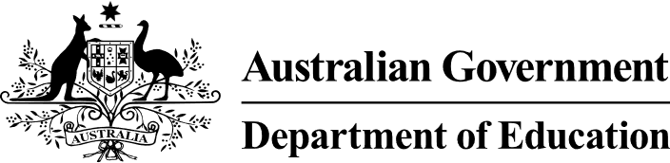

# 2024 Review of the Australian Framework for Generative Artificial Intelligence in Schools

In October 2023, Education Ministers published the *Australian Framework for Generative Artificial Intelligence in Schools* (the Framework) to address the opportunities and challenges presented by generative artificial intelligence (GenAI). States, territories, and non-government schooling sectors began work to implement the Framework into their own education systems from Term 1, 2024.

Education Ministers agreed that a review of the Framework should take place annually to keep up with the rapidly evolving nature of GenAI. In June 2025, Education Ministers endorsed the 2024 Framework Review, undertaken by the National AI in Schools Taskforce (the Taskforce) in consultation with representatives of all jurisdictions, school sectors and national agencies.

The 2024 Framework Review found that the Framework not only correctly identified and made provision for existing challenges but also effectively predicted emerging and current risks, such as the increased use of AI deep fakes, highlighting its relevance and foresight in addressing contemporary challenges. The Taskforce is satisfied that the Framework provides an evidence-informed, best practice framework for the use of GenAI in Australian schools.

Work in the AI in schools space is occurring through various jurisdictional projects and initiatives, as well as nationally-funded programs in 2024-25. The Taskforce’s two working groups *(AI in Practice* and *AI Compliance and Standards)* deliver and oversee national work in six focus areas to enhance teaching and learning: workload, data security and privacy, equity, market power, research, and copyright.

The *AI in Practice* working group, co-led by the Australian Institute for Teaching and School Leadership (AITSL) and the Australian Education Research Organisation (AERO) has three nationally-funded projects and initiatives in the Taskforce’s 2024-25 Workplan. The first two projects were led by Australian Curriculum, Assessment and Reporting Authority (ACARA)—also featured in ACARA’s 2023-2024 Workplan—and published on the Australian Curriculum Version 9.0 website:

1. *Curriculum connections: Artificial Intelligence:* Supports whole school planning for AI by helping teachers and schools to see the interrelationships across the dimensions of the Australian Curriculum.
2. *Artificial intelligence content elaborations:* Clearly positions AI within the Australian Curriculum and provides teachers with optional content elaborations about AI that can be used to enhance learning.
3. *Scoping of potential research into Generative AI:* Scoping potential research into the use of GenAI in education and its impact on learning outcomes (particularly for students from historically disadvantaged cohorts).

The *AI Compliance and Standards* working group, led by Education Services Australia (ESA) is overseeing one key project in the Taskforce’s 2024-25 Workplan*: National Product Expectations*. This project aims to communicate to Edtech developers, adaptors and deployers of AI consistent national expectations for AI products developed for school use.

National and jurisdictional work in the AI in schools space will continue as a national priority throughout 2025. These efforts will continue to be developed and refined by Taskforce members to align with emerging GenAI technologies, educational priorities and regulatory considerations, and will be assessed through the 2025 Framework Review.