
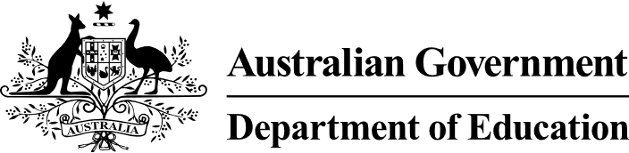

Preschool Outcomes Measure
  - Factsheet for parents and carers
The Preschool Outcomes Measure is a nation-wide teaching tool for teachers and educators. It helps them teach your child in preschool. The Preschool Outcomes Measure will be trialled in selected services in 2025.

What will it do?
The Preschool Outcomes Measure will help teachers and educators:
- understand your child’s strengths and capabilities
- plan the next steps in your child’s learning and development.
It will support teachers and educators to teach all children, including:
- First Nations children
- children from culturally and linguistically diverse backgrounds
- children of varying abilities.

Who will use it?
The Preschool Outcomes Measure will be designed for use by teachers and educators who work with children in preschool. Preschool is the year before children start full time school.
It will be voluntary to use.

Will it suit my child?
In 2024, we will consult with teachers, educators and education experts to develop the Preschool Outcomes Measure. This will ensure it is appropriate for all children, including:
- children of varying abilities
- children with disability
- children who experience varied development trajectories or experiences.
The Preschool Outcomes Measure is a joint initiative of the Australian, state and territory governments.

National trial in 2025
State education departments will invite services to participate in a national trial in 2025. The trial will focus on two age-appropriate areas, called domains:
- executive function
- oral language and literacy.
Executive function is about your child's ability to plan, focus and pay attention, remember instructions, and juggle multiple tasks.
Oral language and literacy is about your child's ability to speak, listen, read, view, write and create.
Supporting children to build these skills is critical to supporting child development. By using the tool teachers and educators can identify:
- what children already know
- what they are ready to learn next.

How will it work?
The Preschool Outcomes Measure is not a test. Teachers and educators will be able to use it through play-based learning. It will be designed to complement teachers’ and educators’ existing knowledge of your child's learning and development.

Want more information?
To find out more about the Preschool Outcomes Measure you can:
- visit www.education.gov.au/preschool
- contact your state or territory department of education
- contact your local preschool. n

