

# Task Card

Requesting access to the Inclusion Support Portal in the role of Authorised Access Delegate

**Who will need this task card?**

This task card is intended to support a service provider representative to gain access to the Inclusion Support Portal (IS Portal) as an Authorised Access Delegate.

**What is this task card for?**

This Task Card provides information and a step-by-step guide to support Authorised Access Delegates to request access to the Inclusion Support Portal.

Contents

About the Role 2

Flow chart – How to Request IS Portal Access as an Additional Authorised Access Delegate 3

Flow chart – How to Request IS Portal Access as an Authorised Access Delegate when a service is unable to identify who their Authorised Access Delegate is, or they do not have one. 4

PRODA Requirements 5

Once a user has a PRODA account they can login and lodge a user access request 5

Child Care Subsidy System (CCSS) Requirements 5

Provider Entry Point (PEP) 5

Approved Third Party Software 5

Requesting Access 5

Portal Entry Point 5

Logging in to PRODA 6

Requesting IS Portal Access 8

Finalising Your Request 12

Inclusion Support Portal Helpdesk Form 12

Logging into the IS Portal 13

## About the Role

Authorised Access Delegates are responsible for reviewing and approving new users access, updating users access, removing access if a user leaves the service and suspending access if a user goes on long term leave.

Authorised Access Delegates are encouraged to regularly review who has access to the Inclusion Support Portal on behalf of the service and remove access for users who have left the service.

The department recommends that Authorised Access Delegates are people in management control of the service (specified personnel), such as Service Directors, service managers/administrators, educational leaders, and area managers.

All services should have more than one Authorised Access Delegate to ensure access to the Inclusion Support Portal can be managed when staff are on holiday or leave the service.

**Gaining IS Portal Access**

Anyone seeking access to the Inclusion Support Portal (IS Portal) is referred to as a user.

The requirements for gaining access to the Inclusion Support Portal in the role of Authorised Access Delegate are influenced by the current circumstances of the service.

When a **service already has an Authorised Access Delegate** and are wanting to add an additional person in this role, the user is required to:

1. Have a PRODA account; and
2. Request access as an Authorised Access Delegate via the Portal Entry Point.

**Note:** It is essential that the first and last name of the user are recorded exactly the same in PRODA and the Portal Entry Point.

When a **service is unable to identify who their Authorised Access Delegate is or they do not have one**, the user is required to:

1. Have a PRODA account;
2. Be linked to the services Child Care Subsidy System (CCSS) as a Person with Management or Control of the Provider or as or as a Persons Responsible for the Day-to-Day Operation of the Service;
3. Request access as an Authorised Access Delegate via the Portal Entry Point; and
4. Request approval for IS Portal access (Delegate Only) by submitting an [online Inclusion Support Portal Helpdesk form](https://submit.dese.gov.au/jfe/form/SV_54IWuOmN6Gd7jwi)

**Note:** It is essential that the first and last name of the user are recorded exactly the same in PRODA, CCSS and the IS Portal Entry Point.

### Flow chart – How to Request IS Portal Access as an Additional Authorised Access Delegate

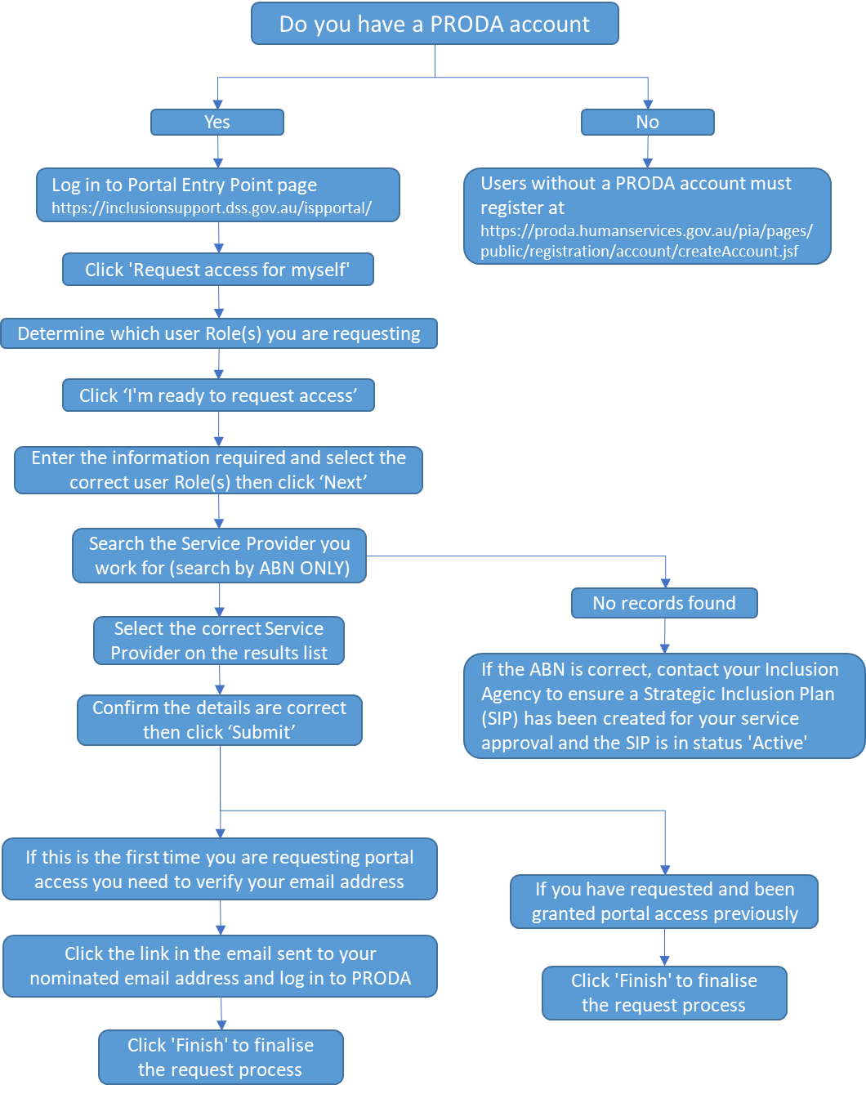

### Flow chart – How to Request IS Portal Access as an Authorised Access Delegate when a service is unable to identify who their Authorised Access Delegate is, or they do not have one.

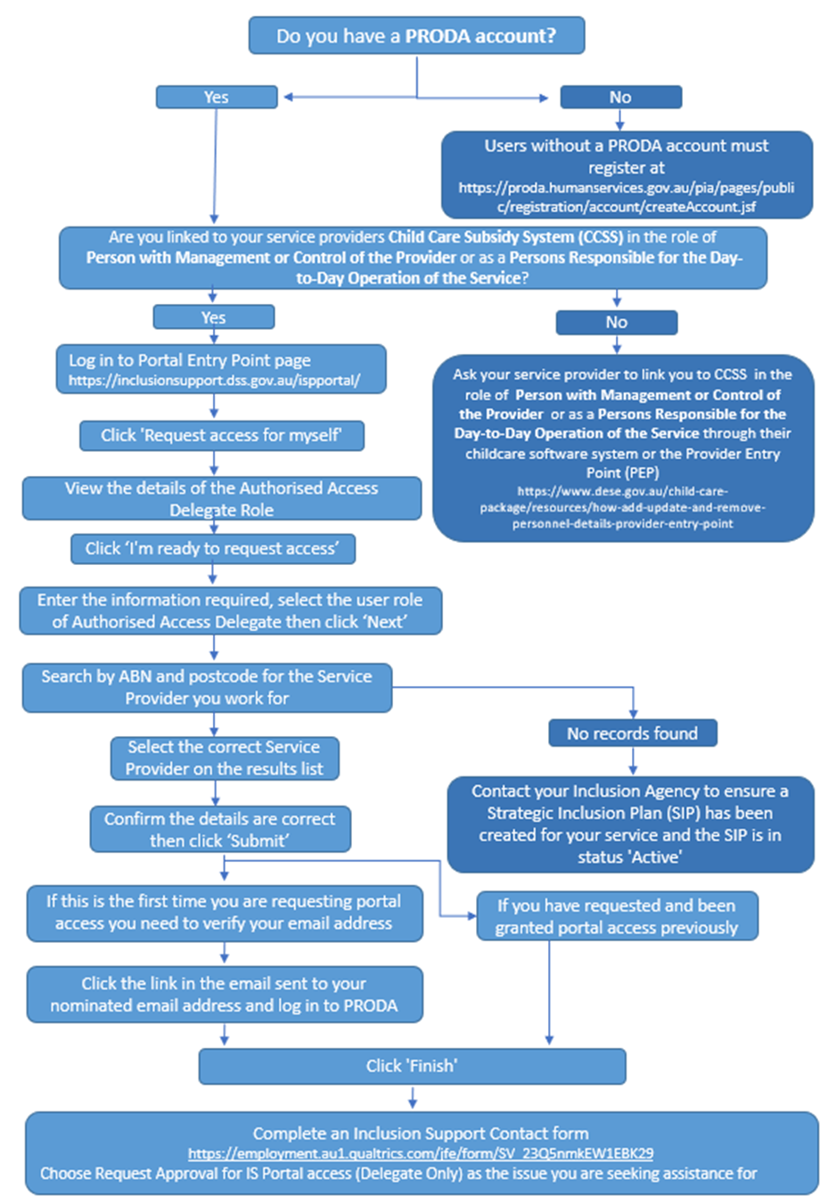

### 

### PRODA Requirements

PRODA is an online identity verification and authentication system that provides secure access a range of Australian Government online services, including the Inclusion Support Portal (IS Portal).

Users from ECEC services who already have a PRODA account, for accessing the Child Care Subsidy System (CCSS) or other government online services, will use the same PRODA account to request access and login to the IS Portal.

Users without a PRODA account must first register for an account through [Services Australia](https://proda.humanservices.gov.au/pia/pages/public/registration/account/createAccount.jsf).

### Once a user has a PRODA account they can login and lodge a user access request

### Child Care Subsidy System (CCSS) Requirements

The Child Care Subsidy System (CCSS) is the online system used to administer the Child Care Subsidy (CCS).

Users requesting access to the Inclusion Support Portal as an Authorised Access Delegate when a service is unable to identify who their Authorised Access Delegate is or they do not have one, need to be linked to their service provider via the Child Care Subsidy System (CCSS) in the role of *Persons with Management or Control of the Provider* or withor as a *Persons Responsible for the Day-to-Day Operation of the Service.*

A user can be added to the CCSS system and linked to a service provider through the Provider Entry Point (PEP) or through the service providers approved third party software system.

### Provider Entry Point (PEP)

A task card to assist service providers to add, update and remove personnel details through the Provider Entry Point is available on the [Department of Education’s website](https://www.education.gov.au/child-care-package/resources/how-add-update-and-remove-personnel-details-provider-entry-point).

### Approved Third Party Software

To access assistance adding, updating or removing personnel details through an approved third party software system refer to the software user guide or link with the system provider directly.

## Requesting Access

### Portal Entry Point

Once you have a PRODA account and, if required, are linked to your service provider via the Child Care Subsidy System (CCSS) in the role of *Persons with Management or Control of the Provider* or as a *Persons Responsible for the Day-to-Day Operation of the Service* (required when a service does not have an Authorised Access Delegate or is unable to identify who they are), you can request access as to the IS Portal as an Authorised Access Delegate via the Portal Entry Point.

### Logging in to PRODA

1. **Access** the ***PRODA login*** ***page***. [https://PRODA.humanservices.gov.au](https://proda.humanservices.gov.au/)

1.1 If you have a PRODA account – refer to image 1 below.

**Enter** your ***PRODA username and password*** and **click *Login*** then proceed to step 2.

1.2 If you have connected your Digital Identity to your PRODA account – refer to image 2 below.

**Click** ***Login using your Digital Identity*** then proceed to step 4.

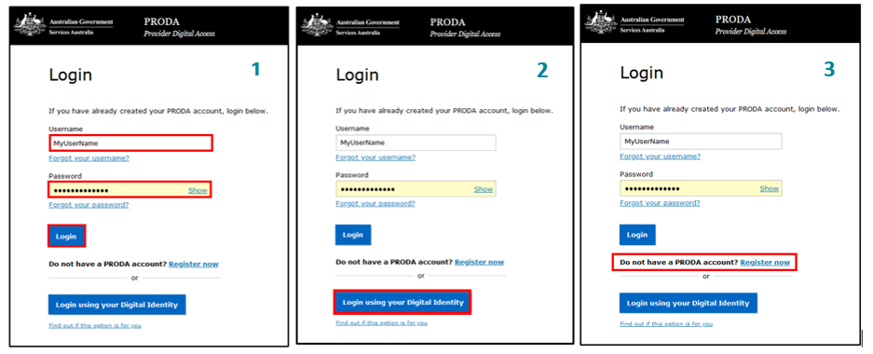

1. A passcode will be sent to the email account or mobile phone number you provided when setting up your PRODA account.

On the ‘2-step verification’ page, enter the passcode and **click** ***Next.***

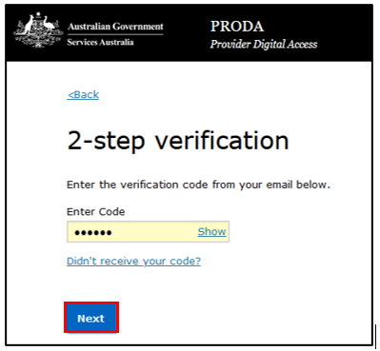

1. If you are a new PRODA user, you must first consent to PRODA’s terms and conditions before progressing.

On the ‘Terms and Conditions’ page, **read** the ***terms*** and **click** ***I agree*** to consent. Refer to the image on the next page.

Image of the terms and conditions screen when logging into PRODA. The button titled 'I agree'  is highlighted 

After successfully logging in to PRODA, a page of available services is displayed.

1. **Select** the ***Child Care Inclusion Support Portal*** button.

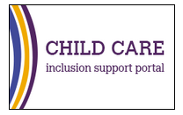

The 'Portal entry point' page will be displayed.

If you are a new user who has not yet been granted access to the IS Portal, only the ‘My portal access’ section of this page will be visible.

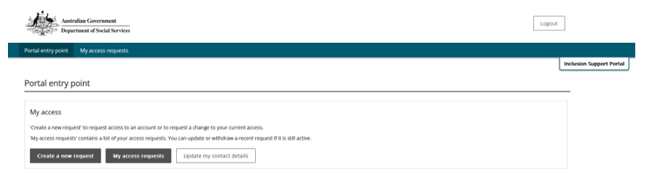

If you are a user who has previously been granted IS Portal access, the page will display as seen below.

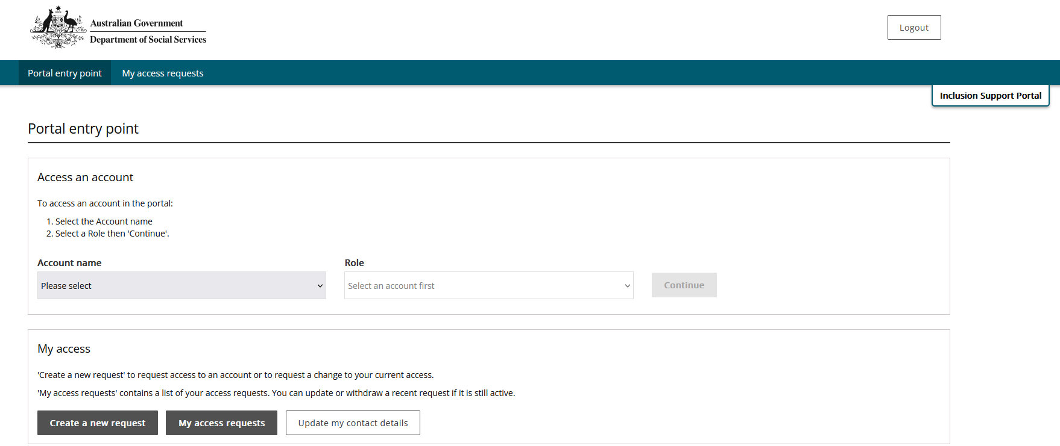

### Requesting IS Portal Access

1. To request user access, login to *PRODA* and access the *Child Care Inclusion Support Portal*



1. **On the Portal entry Point page, select *Create a new request*.**

Image of the Create a new request button.

The ‘Request to create/update my access’ page is displayed.

1. Read over the information on the page and **select** ‘I am ready to request access’.

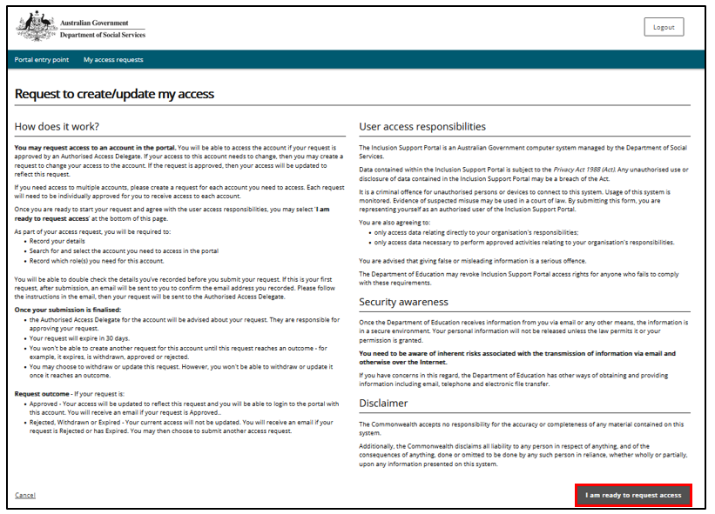

The ‘Record your details’ page will open.

1. **Review** the details and, if not already listed, **add** your ***Phone number.*** **Select** ***next****.*

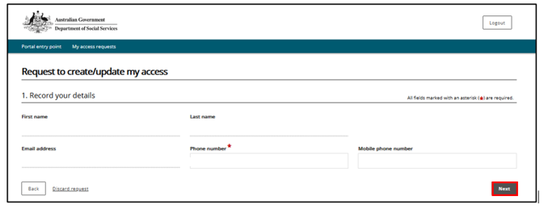

The ‘Search for and select the organisation’s account’ page will open.

To find the service provider you work for, it is recommended to search by ABN only.

For larger service providers it can be helpful to search by ABN and Postcode.

**Note:** If you work for more than one employer, or at different service locations for the same employer, you must complete a separate access request for each situation.

1. Enter details and **Click *Run search***.

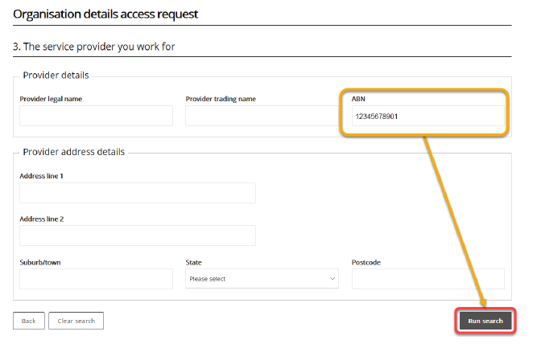

1. **Select** ***your service*** provider from the list of results.

The ‘Access to roles’ page will open.

1. **Select** the ***Authorised Access Delegate role*** and **click *Next***.

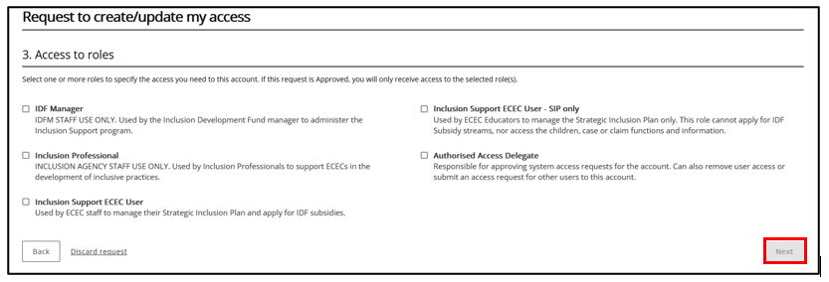

1. On the ‘Request summary access request page’, **review** your entries. **Click *Submit*** to continue or **Click *Back***to edit. Refer to the image on the next page.

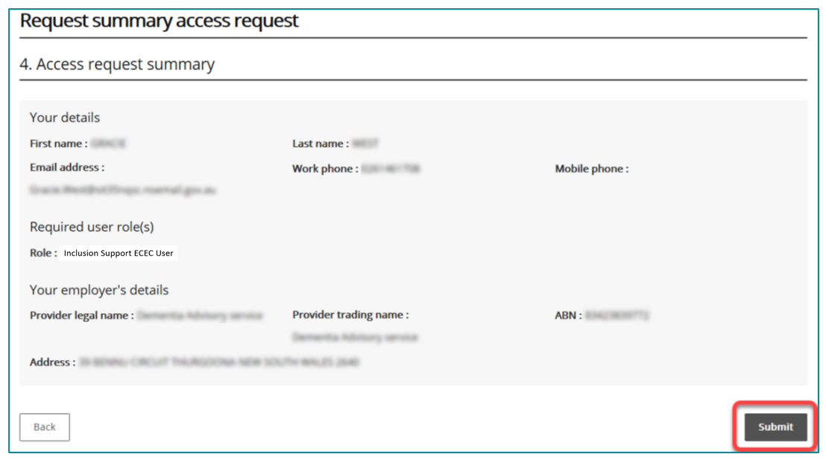

If you have previously accessed the IS Portal in a different user role, you will not need to verify your email address. Finish your access request by **following *step 13*** below.

If you are a new user, your email address must be verified before your request can proceed. **Continue *with step 10*.**

1. **Access** your nominated ***email account*** and **locate** the ***verification email*** sent to you.

**IMPORTANT:** This email contains a ‘token’ associating your request with your email address and your PRODA ID. If you do not click the link provided in the email and log into PRODA, your email address will not be verified, and the request cannot be processed.

1. From the opened email (refer to the image below), **click** ***Confirm my email address*.**

Clicking the link opens a browser and takes you to ‘*Department of Social Services (DSS) account selection page.*’

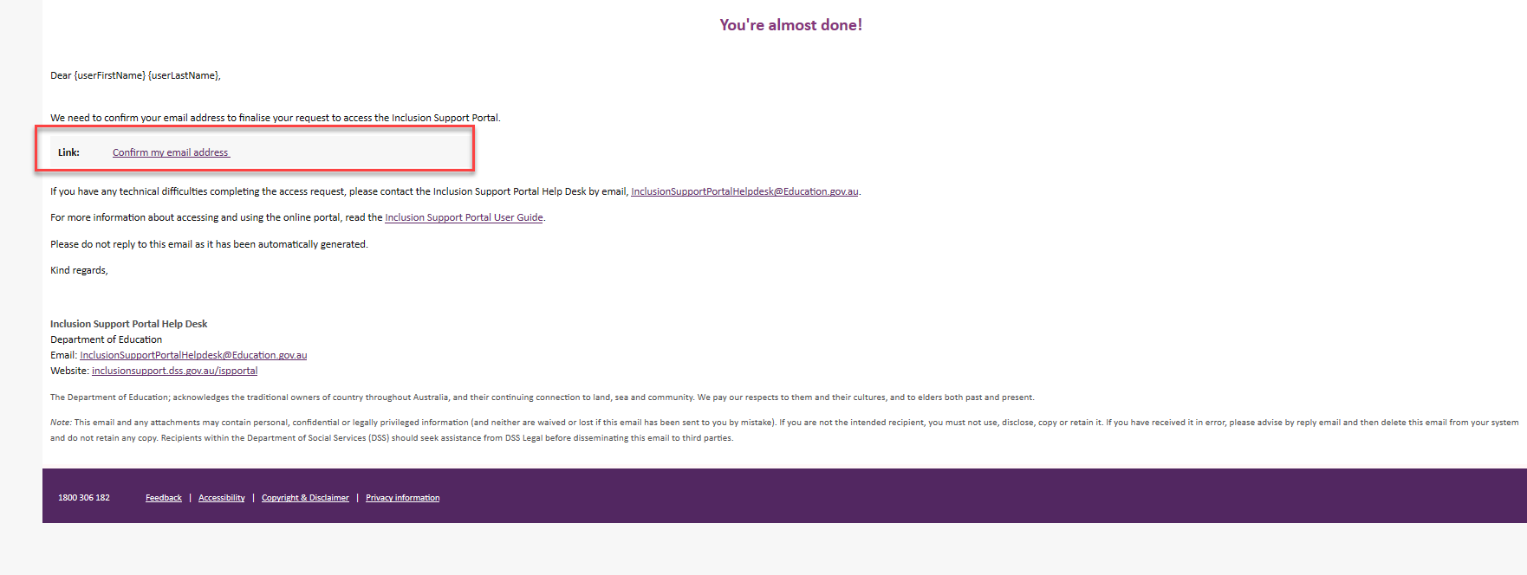

1. **Select *PRODA*.**

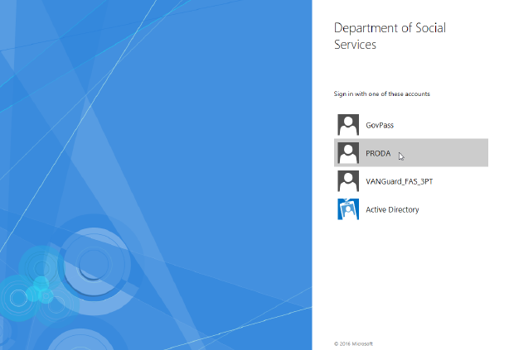

1. **Log into *PRODA*** as described in steps 1 – 4 of Logging into PRODA located on pages 4-5 of this task card.

When you have successfully logged in, you are taken to the ‘Finish access request’ page.

1. **Read *Next Steps*** and **click *Finish.***

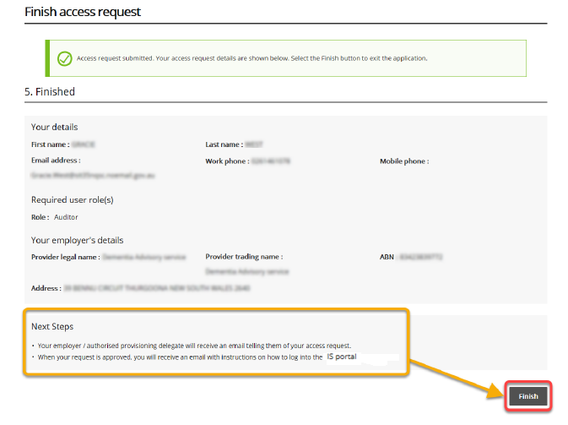

After clicking Finish, you will automatically leave the portal and an email notification will be sent to your service provider’s existing Authorised Access Delegate.

After your request has been reviewed by your service provider’s existing Authorised Access Delegate, you will receive another email indicating if your request was approved or denied.

* If approved, you may log into the Inclusion Support Portal in your approved role.
* If access has been denied, speak with your services Authorised Access Delegate.
* If you do not receive a confirmation email, contact your provider’s Authorised Access Delegate or the [Inclusion Support Portal Help Desk](mailto:inclusionsupportportalhelpdesk@education.gov.au.).

## Finalising Your Request

**Note:** This step is only required if you are requesting access as an Authorised Access Delegate because your service does not have anyone in this role, or they have been unable to identify who the services Authorised Access Delegate is.

### Inclusion Support Portal Helpdesk Form

1. Complete an  [Inclusion Support Contact Form](https://submit.dese.gov.au/jfe/form/SV_54IWuOmN6Gd7jwi)
2. In the select the issue you are seeking assistance for field, **Choose Request Approval for IS Portal access (Delegate Only)**.

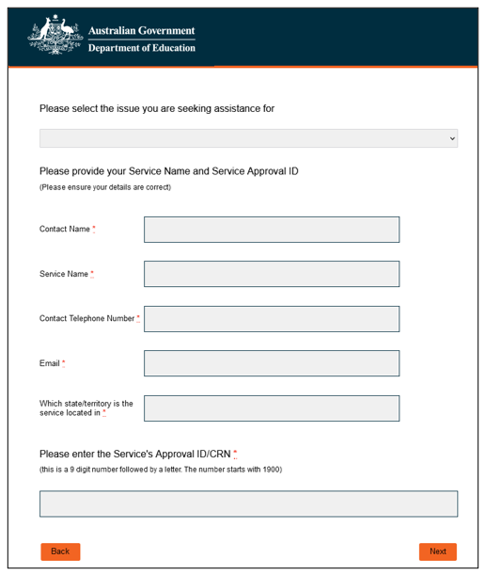

1. After submitting the Inclusion Support Contact Form, a reference number will be sent to your nominated email address.

The IS Portal helpdesk will review your access request and communicate the outcome with you via email.

It can take a few days for the department to review and process the access request. Please **DO NOT** repeat the access request process. This will duplicate your request in the system and slow down the approval process.

#### Activating your access

After your access request has been approved, you may begin using the IS Portal.

1. **Open** your ***approval email.***
2. **Click *activate your access.***

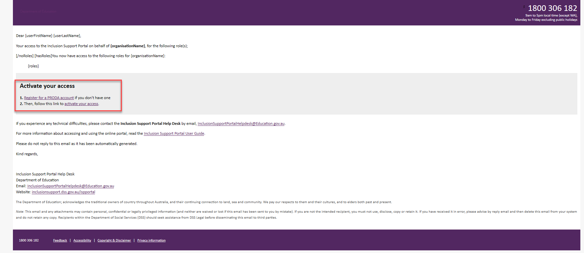

Clicking the link opens a browser and takes you to the Inclusion Support Portal

### Logging into the IS Portal

After initially activating you access, the IS Portal can then be accessed via

[Login | PRODA](https://proda.humanservices.gov.au/prodalogin/pages/public/login.jsf) - <https://proda.humanservices.gov.au/prodalogin/pages/public/login.jsf>

Login to your PRODA account and select the Inclusion Support Portal tile.

Refer to pages 6-8  for support to login to PRODA.



When your identity is verified, the ‘Portal entry point’ page is displayed.



1. **Select** your employer from the **Provider name** dropdown list.

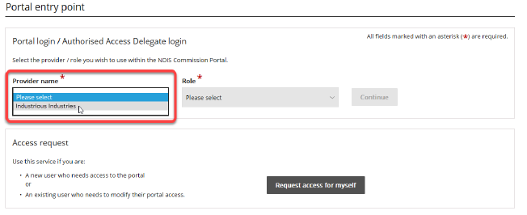

1. Using the Role dropdown option, **Select** the role of ***Inclusion Support User*** and **click *Continue.***

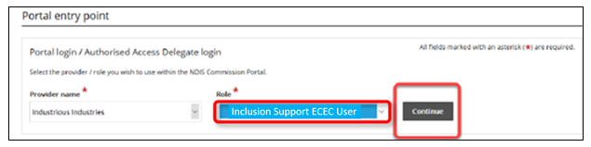

The *Inclusion Support Portal entry* page will open.

1. **Read** ***User Agreement*** then **click** ***I agree,*** to proceed to the IS Portal.

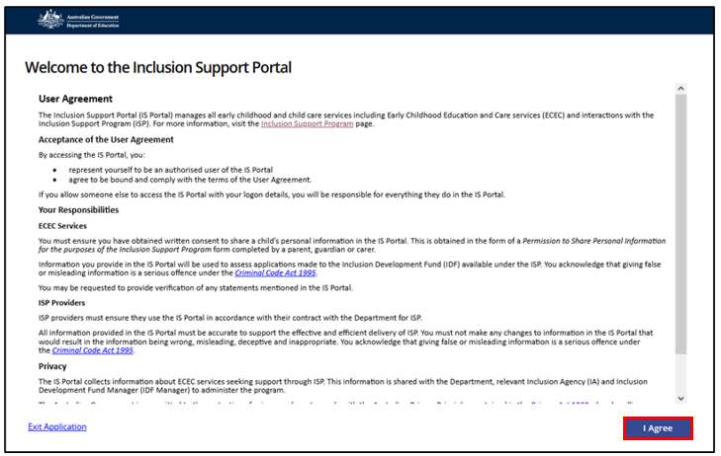

The Inclusion Support Portal Welcome page is displayed.

**Note:** You can return to the *Portal Entry Point page* to log in with a different user role or for a different service provider by **clicking *Change role/Manage access*** at the top of any Provider Portal screen.

Image of the CBDC & OSHC homepage dashboard

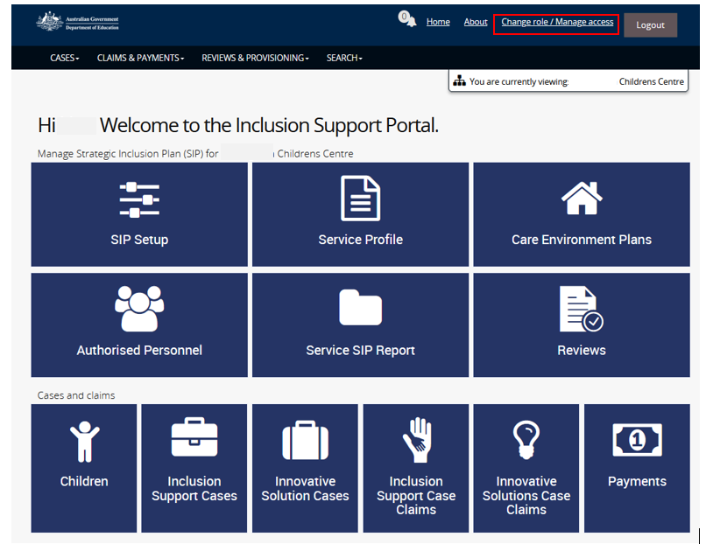­­­­

Image of the FDC homepage dashboard

