

# Task Card

Accessing the Inclusion Support Portal as an Inclusion Agency Representative

**Who will need this task card?**

The Inclusion Support Portal (IS Portal) is a web-based application that manages all Early Childhood Education and Care services’ (ECEC) interactions with the Inclusion Support Program (ISP).

This task card is intended for Inclusion Agency representatives who are supporting ECEC services in the development of inclusive practices.

**What is this task card for?**

This Task Card provides information and a step by step guide to support Inclusion Agency representatives to request access to the Inclusion Support Portal.

Contents

User Options 3

Gaining IS Portal Access 4

PRODA 4

Logging into PRODA 4

Requesting Access 6

Activating your access 10

Logging into the IS Portal 11

## User Options

Anyone seeking access to the Inclusion Support Portal (IS Portal) is referred to as a user.

There are two accredited user roles available to Inclusion Support Program representative’s

**IDF Manager**

This role is for users who work for the Inclusion Development Fund Manager only.

**Inclusion Professional**

This role is for users who work for Inclusion Agencies only.

There are three user roles available to service provider representatives

**Authorised Access Delegate**

This role is for ECEC service representatives who are required to manage access to the Inclusion Support Portal for other users in the service.

Services are encouraged to have more than one Authorised Access Delegate.

**Note:** To develop and manage their services Strategic Inclusion Plan (SIP) and to apply for IDF subsidies, an Authorised Access Delegate will also need to have access to the IS Portal in the role of Inclusion Support ECEC User.

**Inclusion Support ECEC User**

This role is for ECEC service representatives who need to access to the Inclusion Support Portal to be able to develop and manage their services Strategic Inclusion Plan (SIP), including Care Environment Plans, and apply for IDF.

**Inclusion Support ECEC User – SIP Only**

This role is for ECEC Educators who need to access to the Inclusion Support Portal to be able to develop and manage the services SIP, including Care Environment Plans.

This role does not allow the user to apply for IDF streams, to access information about children, IDF cases or claims information.

Note: A service provider representative can hold the roles of both Authorised Access Delegate and Inclusion Support ECEC User.

Task cards to support service provider representatives to access the Inclusion Support Portal are available on the Department of Education website [Inclusion Support Program - Department of Education, Australian Government](https://www.education.gov.au/early-childhood/providers/extra-support/inclusion-support-program)

## Gaining IS Portal Access

Inclusion Support Agency representatives will access the IS Portal in the user role of Inclusion Professional.

Gaining access to the Inclusion Support Portal requires each user to:

1. Have a Provider Digital Access (PRODA) account; and
2. Gain permission to act on behalf of the service provider.

### PRODA

PRODA is an online identity verification and authentication system that provides secure access a range of Australian Government online services, including the Inclusion Support Portal (IS Portal).

Users who already have a PRODA account for accessing other Australian Government online services will use the same PRODA account to request access and login to the IS Portal.

Users without a PRODA account must first register for an account through [Services Australia](https://proda.humanservices.gov.au/pia/pages/public/registration/account/createAccount.jsf).

Once a user has a PRODA account they can login and lodge a user access request.

#### Logging into PRODA

1. **Access** the ***PRODA login*** ***page***. [https://PRODA.humanservices.gov.au](https://proda.humanservices.gov.au/)
   1. If you have a PRODA account – refer to image 1 below.

**Enter** your ***PRODA username and password*** and **click *Login*** then proceed to step 2.

* 1. If you have connected your Digital Identity to your PRODA account – refer to image 2 below. **Click** ***Login using your Digital Identity*** then proceed to step 4.

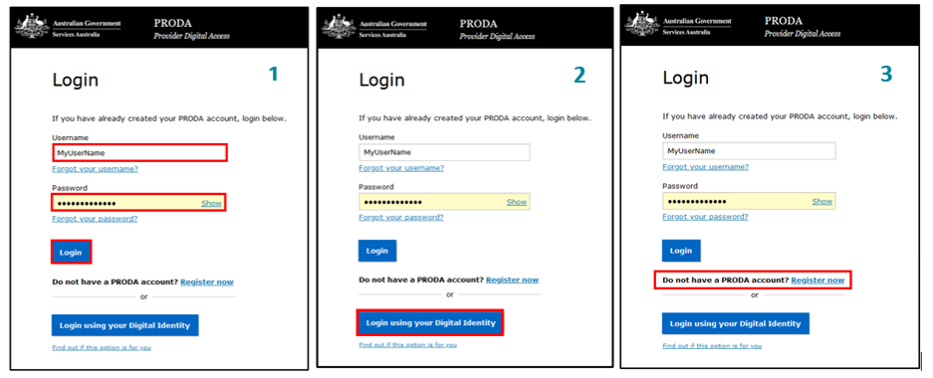

1. A passcode will be sent to the email account or mobile phone number you provided when setting up your PRODA account.

On the ‘2-step verification’ page, enter the passcode and **click** ***Next.***

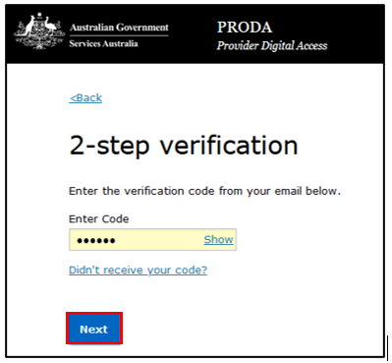

1. If you are a new PRODA user, you must first consent to PRODA’s terms and conditions before progressing.

On the ‘Terms and Conditions’ page, **read** the ***terms*** and **click** ***I agree*** to consent.

Image of the terms and conditions screen when logging into PRODA. The button titled 'I agree'  is highlighted 

After successfully logging in to PRODA, a page of available services is displayed.

1. **Select** the ***Child Care Inclusion Support Portal*** tile.

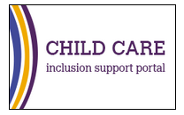

The 'Portal entry point' page will be displayed.

If you are a new user who has not yet been granted access to the IS Portal, only the ‘My access’ section of this page will be visible.

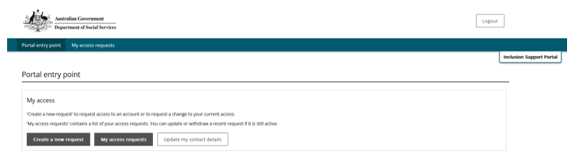

If you are a user who has previously been granted IS Portal access, the page will display as seen below.

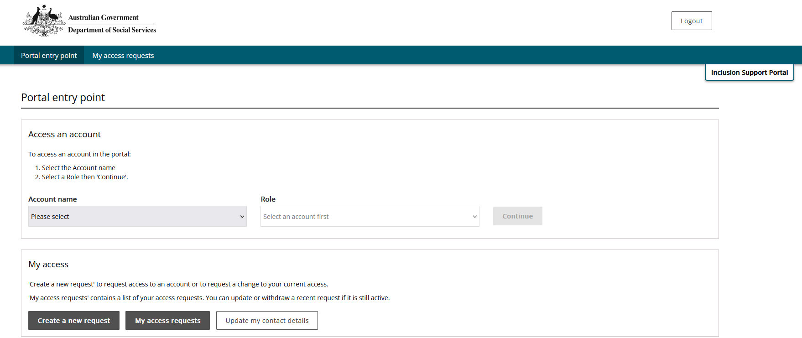

#### Requesting Access

The Inclusion Support Portal Help Desk manages the approval of access requests for both IDFM and IA representatives.

If you have not previously accessed the IS Portal or you if need to add or change your user access, an access request must be submitted.

1. To request user access, login to *PRODA* and access the *Child Care Inclusion Support Portal.*
2. **On the Portal entry Point page, select *Create a new request*.**

Image of the Create a new request button.

The ‘Request to create/update my access’ page is displayed.

1. Read over the information on the page and **select** ‘I am ready to request access’.

Image of the create/update my access page. The ' I am ready to request access' button is highlighted.


The ‘Record your details’ page will open.

1. **Review** the details and, if not already listed, **add** your ***Phone number.***
2. **Select** ***Next****.*

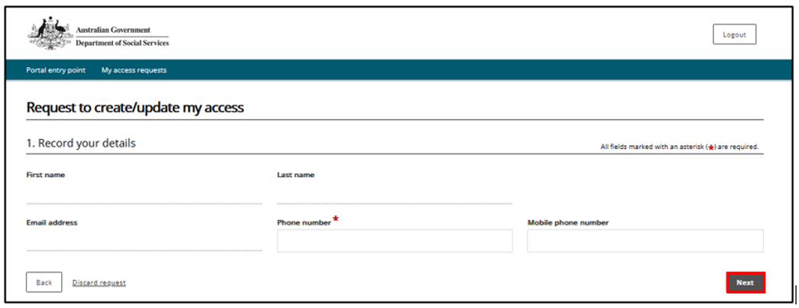

The ‘Search for and select the organisation’s account’ page will open.

To find the organisation you work for, it is recommended to search by ABN only.

1. Enter details and **Click *Run search***.

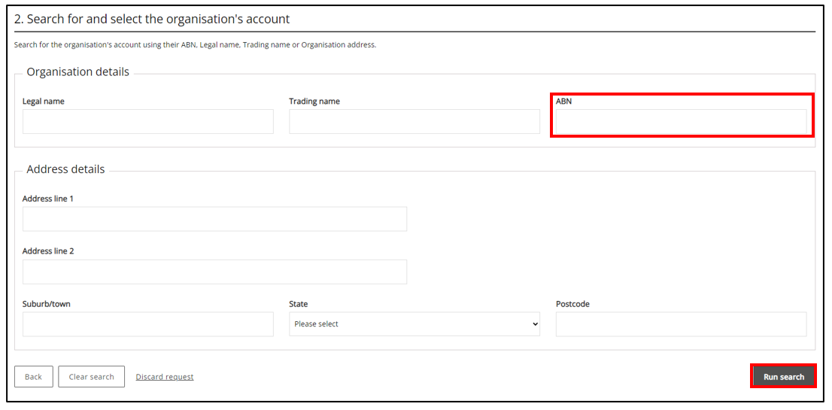

1. **Select** ***your organisation*** from the list of results.

The ‘Access to roles’ page will open. Please refer to the image on the next page.

1. **Select** the role of ***Inclusion Professional*** and **click *Next***.

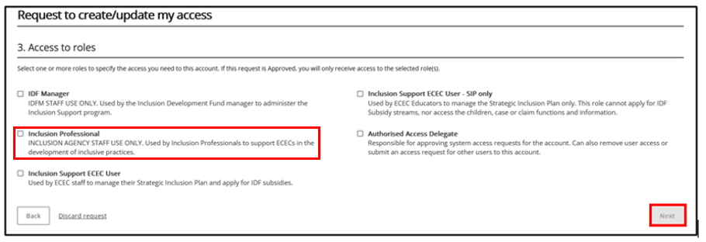

1. On the ‘Request summary access request page’, **review** your entries. **Click *Submit*** to continue or **Click *Back***to edit.

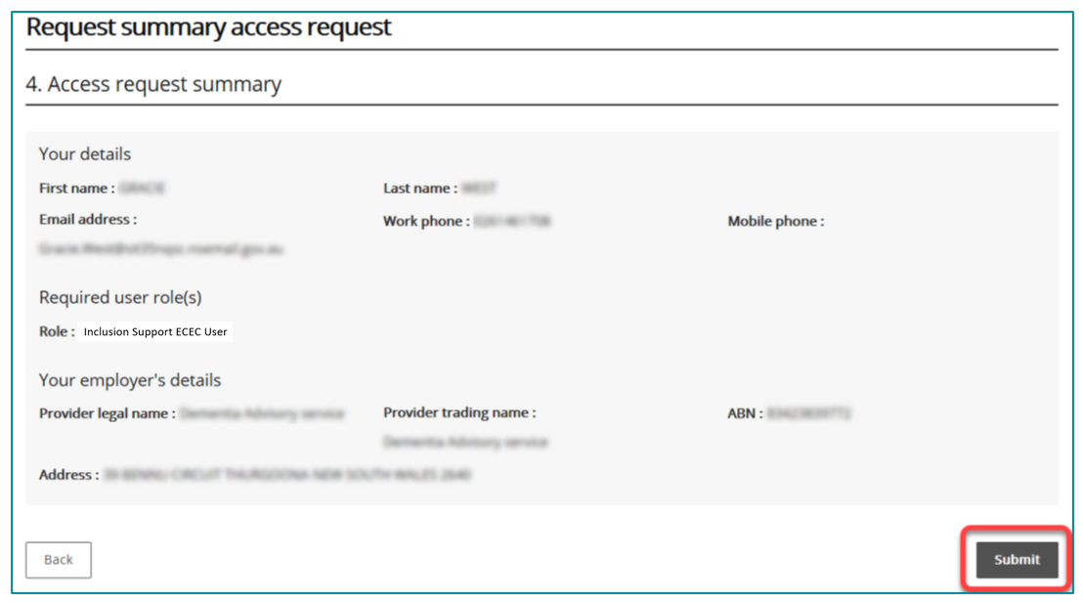

If you have previously accessed the IS Portal in a different user role, you will not need to verify your email address. Finish your access request by **following *step 13*** below.

If you are a new user, your email address must be verified before your request can proceed. **Continue *with step 10*.**

1. **Access** your nominated ***email account*** and **locate** the ***verification email*** sent to you.

**IMPORTANT:** This email contains a ‘token’ associating your request with your email address and your PRODA ID. If you do not click the link provided in the email and log into PRODA, your email address will not be verified, and the request cannot be processed.

1. From the opened email (refer to the image below), **click** ***Confirm my email address*.**

Clicking the link opens a browser and takes you to ‘*Department of Social Services (DSS) account selection page.*’

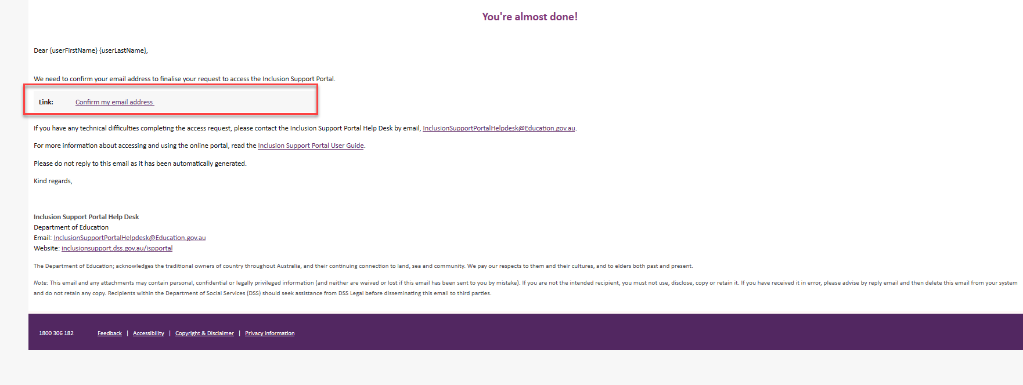

1. **Select *PRODA*.**

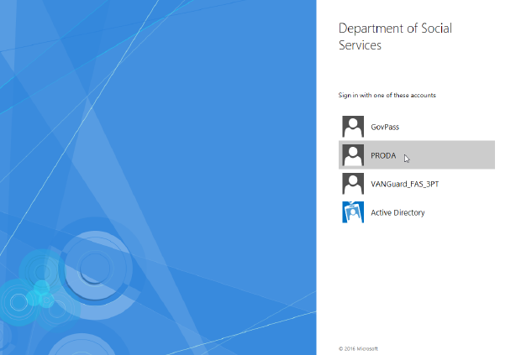

1. **Log into *PRODA*** as described in steps 1 – 4 of Logging into PRODA located on pages 4-6 of this task card.

When you have successfully logged in, you are taken to the ‘Finish access request’ page.

1. **Read *Next Steps*** and **click *Finish****.*

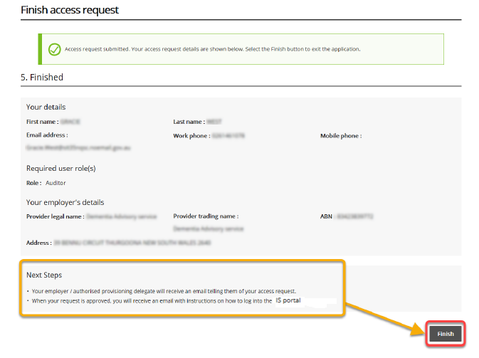

After clicking Finish, you will automatically leave the portal and an email notification will be sent to Inclusion Support Portal Help Desk.

After your request is reviewed by the Inclusion Support Portal Help Desk, you will receive another email telling you whether your request was approved or denied.

If you do not receive a confirmation email or your request was denied, contact your Inclusion Agency Manager or the [Inclusion Support Portal Help Desk](mailto:inclusionsupportportalhelpdesk@education.gov.au).

**Note:** Individual Inclusion Agencies may have additional processes that need to be followed when requesting access to the IS Portal. Please check in with your Inclusion Agency Manager to confirm their requirements.

#### Activating your access

After your access request has been approved by the Inclusion Support Portal Help Desk, you may

begin using the IS Portal.

1. **Open** your ***approval email.***
2. **Click *activate your access.***

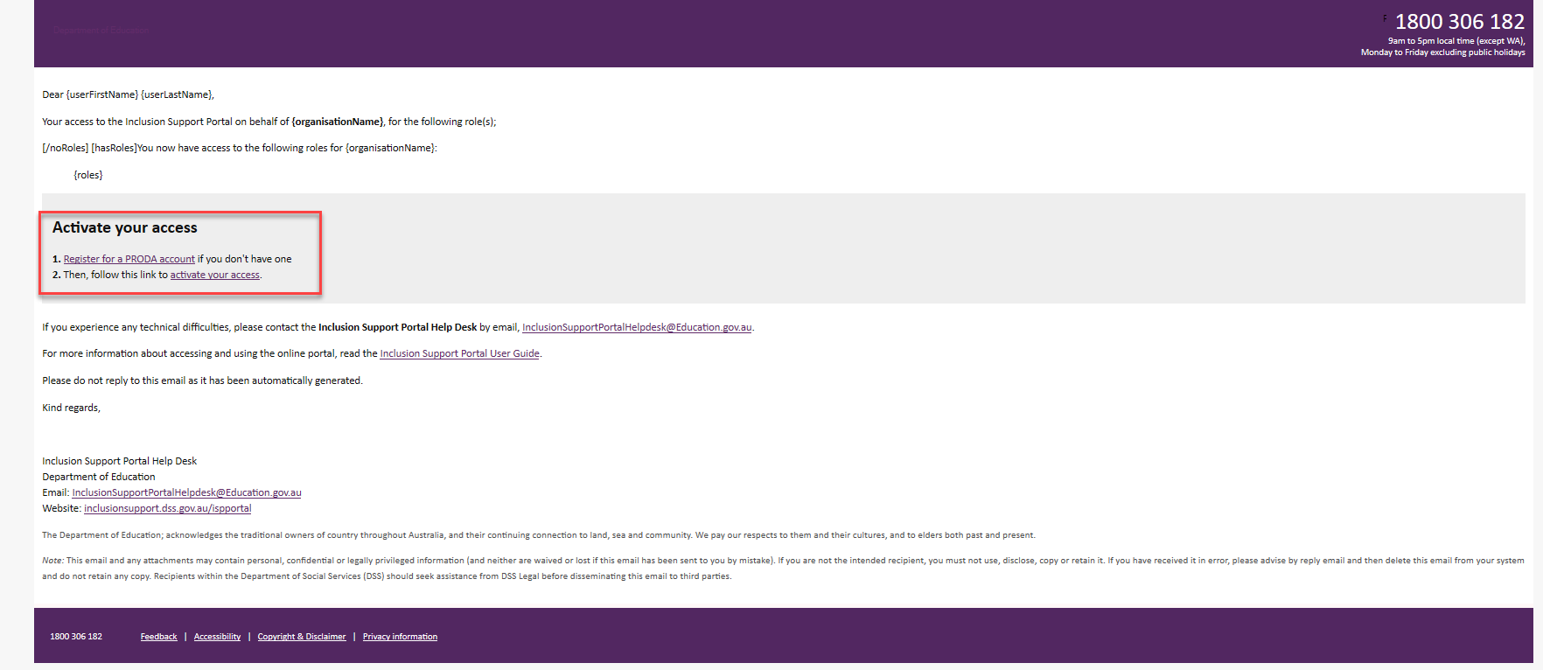

Clicking the link opens a browser and takes you to the Inclusion Support Portal. Follow the steps below to login to the IS Portal.

### Logging into the IS Portal

After initially activating you access (refer to page 10), the IS Portal can then be accessed via

[Login | PRODA](https://proda.humanservices.gov.au/prodalogin/pages/public/login.jsf) - https://proda.humanservices.gov.au/prodalogin/pages/public/login.jsf

Login to your PRODA account and select the Inclusion Support Portal tile. Refer to pages 4-5 for support to login to PRODA.



When your identity is verified, the ‘Portal entry point’ page is displayed.



1. **Select** your employer from the **Provider name** dropdown list.

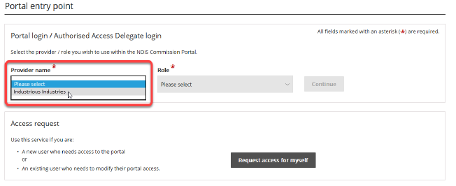

1. Using the Role dropdown option, **Select** the role of ***Inclusion Professional*** and **click *Continue.***

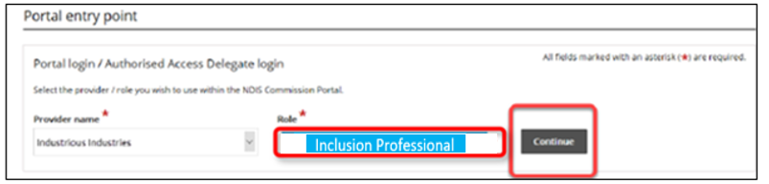

The *Inclusion Support Portal entry* page will open.

1. **Read** ***User Agreement*** then **click** ***I agree,*** to proceed to the IS Portal.

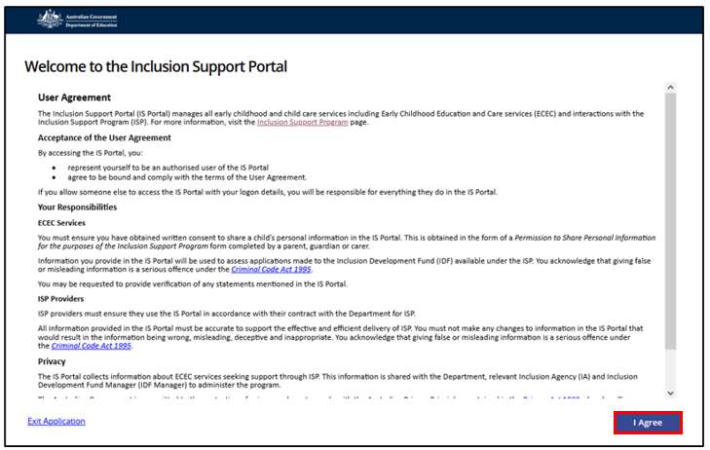

The Inclusion Support Portal homepage dashboard page will be displayed.

**Note:** You can return to the *Portal Entry Point page* to log in with a different user role or for a different organisation by **clicking *Change role/Manage access*** at the top of the screen. Refer to the image on the next page.

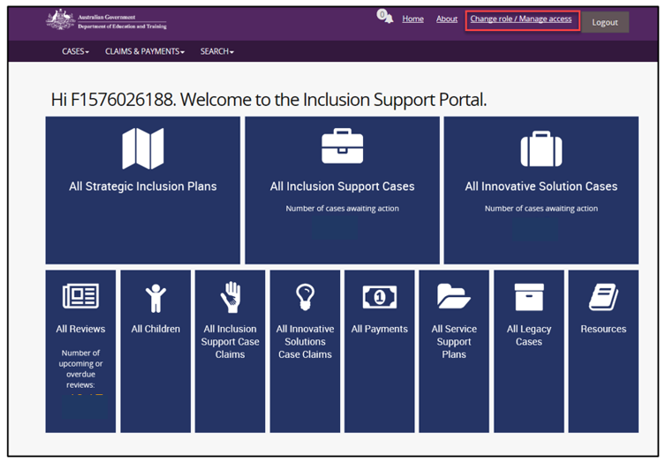

For additional support or assistance with trouble shooting any technical issues please contact please contact the [Inclusion Support Portal helpdesk](mailto:inclusionsupportportalhelpdesk@education.gov.au) or call the Inclusion Development Fund Manager (IDFM) on 1800 824 955.