VET Delivered to Secondary Students
Investigating the provision of VET to secondary students in regional, rural, and remote areas
2023




Disclaimer
This report is not intended to be read or used by anyone other than the Department of Education (formerly Department of Education, Skills and Employment).
We prepared this report solely for the Department of Education’s use and benefit in accordance with and for the purpose set out in our engagement letter with the Department of Education (formerly Department of Education, Skills and Employment) dated 4 May 2021, and the contract variation dated 19 November 2021. In doing so, we acted exclusively for the Department of Education and considered no-one else’s interests.
We accept no responsibility, duty or liability:
- to anyone other than the Department of Education in connection with this report
- to the Department of Education for the consequences of using or relying on it for a purpose other than that referred to above.
We make no representation concerning the appropriateness of this report for anyone other than the Department of Education. If anyone other than the Department Education chooses to use or rely on it they do so at their own risk.
This disclaimer applies:
- to the maximum extent permitted by law and, without limitation, to liability arising in negligence or under statute; and
- even if we consent to anyone other than the Department of Education receiving or using this report.
Liability limited by a scheme approved under Professional Standards legislation.

Contents
1 Executive summary 1
2 Objectives and purpose 3
3 Methodology 5
4 Literature review 8
5 Findings and analysis 9
6 Appendix A Detailed literature review 28
7 Appendix B Stakeholder register 32

Executive summary
Vocational Education and Training (VET) is an integral part of the secondary education system, with VET Delivered to Secondary Student (VETDSS) programs providing school students with the opportunity to engage in vocational learning and work towards attaining a nationally recognised VET qualification. However, access to high quality VETDSS programs can vary depending on where a student is located, and students in regional, rural, and remote (RRR) areas are often identified as having more limited opportunities than their metropolitan counterparts.
As noted in the Napthine Review, there is strong engagement with VET programs in many RRR areas. In fact, attainment rates up to and including Certificate III level qualifications in these areas often surpass those in metropolitan locations. For school students, VETDSS programs with a strong link to local industry can provide a clear pathway into further education, training and/or employment. Ensuring high quality and appropriate scope of VETDSS opportunities in these areas is critical.
This report builds an understanding of the current landscape for VETDSS in RRR areas and seeks to develop an evidence base of the delivery models, challenges, and strengths of these programs. It is intended that this evidence base provides a starting point to address Recommendation 4 of the Napthine Review: “Build aspiration, improve career advice and strengthen RRR schools to better prepare RRR students for success by: expanding access to high quality VET programs in RRR schools.” In seeking to do this, the report addresses the following areas:
The current state of VETDSS in RRR areas: The report summarises the current arrangements for VET programs in these areas, including the different delivery models and analysis of the similarities and differences across jurisdictions and school sectors. Analysis of current arrangements led to the following findings:
- According to the National Centre for Vocational Education Research (NCVER), approximately 30% of students completing VET in Schools programs are located in RRR Australia.
- There is no one dominant delivery model for VETDSS in RRR areas. Rather, the delivery model used within a particular state or territory is driven by their local circumstances.
- Some jurisdictions have policies relating to the delivery of VET in RRR areas, including South Australia and Tasmania.
- Stakeholders highlighted the differences between jurisdictions regarding RRR status. In some states, a regional city is 115 kilometres from a metropolitan city (e.g. Ballarat in Victoria) and in other states, a regional city could be as far as 415 kilometres from a metropolitan city (e.g. Geraldton in Western Australia).
- In some jurisdictions, including Queensland and Victoria, schools in RRR areas reported collaboration across the three school sectors.
- Schools in RRR areas may use online learning for some components of their VETDSS program, as they may be too geographically distant to access face-to-face learning opportunities.
The challenges of delivery of high quality VETDSS in RRR areas: Through extensive stakeholder consultation across the jurisdictions and school sectors, an evidence base of the key challenges and barriers facing those in RRR areas was built. This section details the following findings:
- The challenges experienced by all stakeholders in delivering high quality VETDSS are amplified in RRR settings.
- Access to qualified trainers and assessors was reported by most stakeholders as a significant challenge.
- Stakeholders consistently raised lack of funding as a challenge of VETDSS in RRR areas.
- Because of their locations, some stakeholders reported challenges with geographical access to VET programs.
- In some areas, there are insufficient student numbers to form classes.
- Stakeholders suggested that some delivery arrangements, for example, solely online learning, may restrict the delivery of high quality VETDSS in RRR settings as students lack the face-to-face connection.
- Stakeholders noted challenges with equipment and resources, including internet access in RRR settings.
- Some stakeholders suggested that gaining industry experience can be challenging in RRR settings, due to the limited number of work placement opportunities.
The strengths and enablers of good practice of VETDSS in RRR areas: In addition to understanding the key barriers, this report seeks to highlight the strengths of RRR VETDSS programs and identify examples of good practice that could be replicated. This section details the following findings:
- Stakeholders agreed that VETDSS programs work well in RRR areas, as there are typically stronger post-school pathways, given the links to the local economy, compared to metropolitan areas.
- Generally, stakeholders commented that the perception of VETDSS is positive in RRR areas.
- Stakeholders noted that the ability to build strong relationships is essential to high quality VETDSS programs, especially in RRR areas.
- Some innovative delivery models have been employed to overcome barriers to quality delivery in RRR areas.
Options for improving access to high quality VETDSS programs in RRR areas: Based on the above analysis and findings, this report identifies options to improve and expand access to high quality VET programs in RRR schools. These options include:
- Review minimum class number requirements and funding per student in RRR areas.
- Incentivise VET teachers to work in RRR areas to promote greater course options for students.
- Implement virtual work placements to allow students in RRR areas to obtain work experience, even when geographically isolated.
- Encourage collaboration to create economies of scale and communities of practice.
- Promote access to stable internet connections.
Please note, this report forms part 6 of a larger piece of work that seeks to improve the evidence base and understanding of VETDSS across Australia and school sectors. There are six streams of work within the broader project, outlined in the Objectives and purpose section below, and an individual report has been produced for each.

Objectives and purpose
PwC was engaged by the Department of Education (formerly the Department of Education, Skills and Employment) to improve the VET Delivered to Secondary Students (VETDSS) evidence base and build support for quality reforms by gathering and analysing information on current approaches to VETDSS funding, delivery, data collection and policy.
The project has been divided into six key streams of work:
- Stream 1(a): Reviewing VETDSS data collection and reporting workflows across all states and territories and providing advice on merging the VET in Schools Collection and the National Provider Collection.
- Stream 1(b): Reviewing data policies and processes governing submission to the National VET in Schools Collection and considering any technical and procedural barriers to the integration of the National VET in Schools Collection with the National VET Provider Collection.
- Stream 2: Gathering insights on jurisdictional funding and delivery approaches.
- Stream 3: Reviewing the currency and relevance of the Preparing Secondary Students for Work (PSSfW) framework.
- Stream 4: Collating evidence to support the development of guiding principles to promote the quality delivery of VETDSS programs.
- Stream 5: Exploring ways in which schools can employ qualified VET teachers to deliver VET on an ongoing basis across the respective jurisdictions and school sectors.
- Stream 6: Investigating the provision of VETDSS in regional, rural, and remote (RRR) areas.
A separate report has been produced for each stream of work, with this report relating to stream 6.
The objective of this report is to outline a summary of key findings from stakeholder consultation and research relating to stream 6, with the report segmented into an exploration of:
- The current state of VETDSS in RRR areas.
- The challenges of delivery of high quality VETDSS in RRR areas.
- The strengths and enablers of good practice of VETDSS in RRR areas.
- Options for improving access to high quality VETDSS programs in RRR areas.
The report is structured around these four topics, with an individual section on each discussing the key findings and insights from consultation and research.
Definition of regional, rural, and remote
For the purposes of this stream of work, definitions of RRR follow those outlined in the Napthine Review. The term RRR is used to characterise non-metropolitan areas across Australia. Where the terms “regional” or “remote” are used, they are referring to the Australian Statistical Geography Standard’s (ASGS) classes of remoteness. As seen in Figure 1, there are five classes which are based on relative access to services: major cities, inner regional, outer regional, remote, and very remote. For this stream of work, as in the Napthine Review, the term “remote” will generally include “remote” and “very remote” unless otherwise specified. Additionally, it should be noted that, whilst communities or individuals may identify themselves as “rural,” this term is not clearly defined and does not correspond to any of the ASGS classes. It is noted that there are limitations with using the ASGS framework, namely that it was not designed specifically for education purposes. Because of this, the Napthine Review recommends the development of an improved geographical classification tool specifically designed for education purposes. As this tool has not yet been developed, for the purposes of this stream of work, the ASGS framework has been used to categorise remoteness across Australia.
Figure 1 - Map of remoteness categories from the Napthine Review
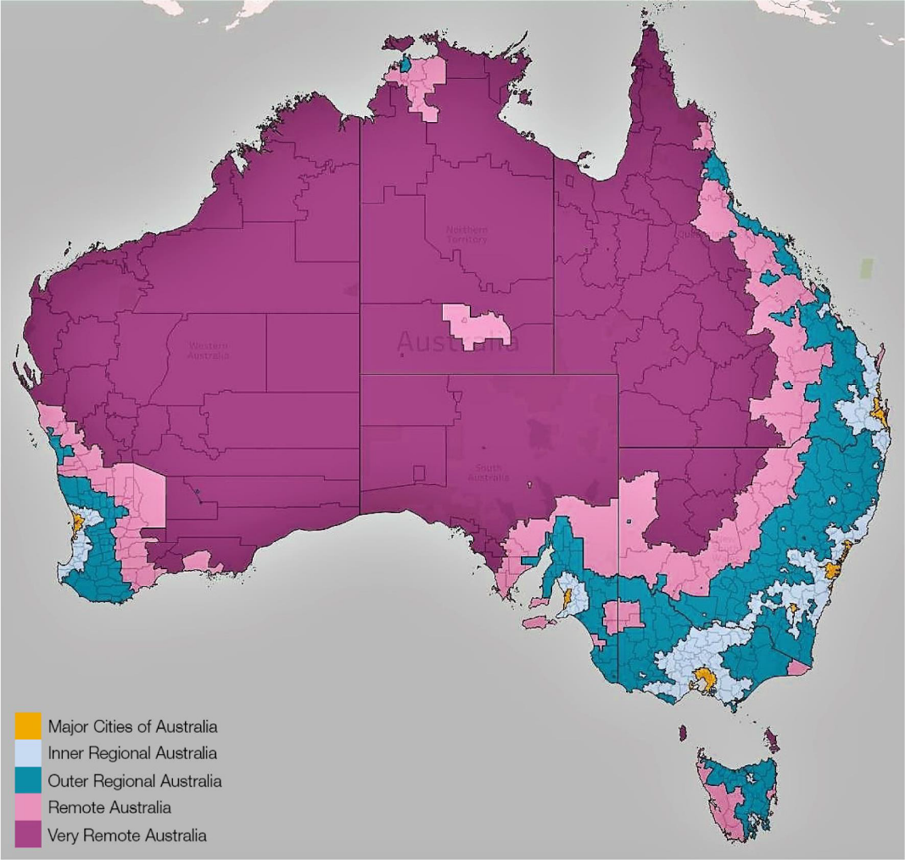

Methodology
The research methodology included both primary and secondary research.
Literature review
Desktop research was undertaken to gather insights on the current arrangements and landscape for VETDSS in RRR areas. Sources relied upon included the Education in Remote and Complex Environments Report, the National Regional, Rural and Remote Tertiary Education Strategy (Napthine Review) and the Independent Review into Regional, Rural and Remote Education (Halsey Review). These reports provided a valuable overview of core issues impacting secondary students in RRR settings. A list of sources relied upon can be found in the Literature review section, and an overview of the findings and analysis of the literature review can be found in Appendix A.
Stakeholder consultation
Consultations were used to build on the desktop research and gather stakeholder insights into the following topics as they relate to VETDSS in RRR areas:
- Current arrangements for the delivery of VET to secondary students in RRR areas, and drivers for these arrangements.
- Barriers and challenges in the delivery of VET to secondary students in RRR areas.
- Examples of excellence and innovation in the delivery of VET programs in RRR areas.
- Recommendations for addressing the challenges of delivering VET to secondary students in RRR areas.
It is important to note that, during consultation, stakeholders did not differentiate between students undertaking VETDSS as part of their Senior Secondary Certificate of Education (SSCE) and those who complete a VETDSS program without contribution to their SSCE. For the purposes of this report, any reference to VETDSS covers both types of programs.
To gather insights, two methods of consultation were adopted: a survey, and targeted one-on-one consultations and focus groups. Over 80 stakeholders were consulted, and the full list of the stakeholders consulted as part of this stream of work can be found in Appendix B.
Survey
The survey was adopted to provide a broad cohort of stakeholders the opportunity to participate and share their insights on key topics. The key stakeholder groups engaged included representatives from:
- Government Schools
- Non-Government Schools (Independent and Catholic)
- State Government Departments and bodies (e.g. Departments of Education)
- Registered Training Organisations (RTOs) and RTO peak bodies (e.g. TAFE Directors Australia and Independent Tertiary Education Council Australia)
- Education peak bodies (e.g. Australian Secondary Principals’ Association)
- Regional peak bodies (e.g. Isolated Children's Parents' Association and Regional Australia Institute).
The survey opened on Monday 21 February 2022 and closed Monday 28 March 2022. A total of 680 responses were received, however, it is noted that respondents were not required to answer all questions and a number of incomplete responses were received. The number of respondents for a particular survey question have been referenced throughout the report to allow appropriate interpretation of the results.
As seen in Figure 2, responses were received from stakeholders across all jurisdictions, with particularly strong representation from stakeholders in Queensland (QLD) and New South Wales (NSW), accounting for 25.8% (n=134) and 19.6% (n=102) of responses respectively.
It is noted that some states experienced adverse weather events (e.g. flooding, especially in RRR areas) throughout the survey period, and this may have impacted the response rate. In addition, several state Departments noted that there were a range of other reviews occurring at the same time and that this may have impacted the response rate in their jurisdiction.
Figure 2 - Survey question: Which State or Territory are you based in? (n=520)
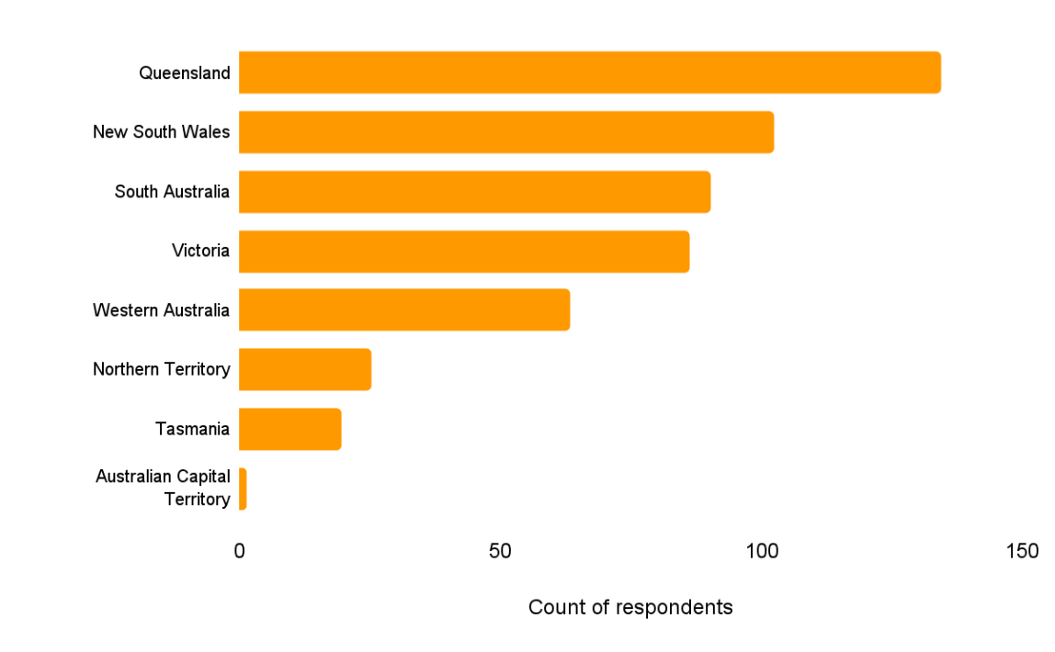
As seen in Figure 3, there was a strong response from all three school sectors, with school stakeholders accounting for 72.7% (n=376) of respondents.
Figure 3 - Survey question: Please describe the organisation that you work for? (n=517)
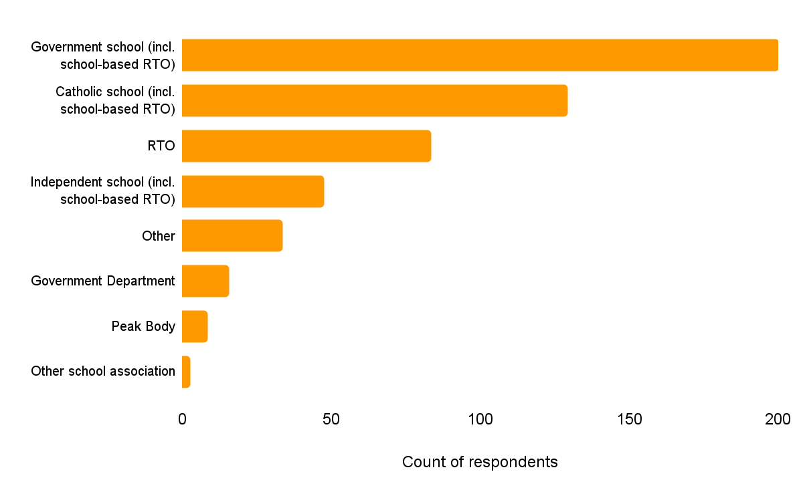
One-on-one consultations and focus groups
One-on-one consultations and focus groups were also held to gather insights and feedback on specific lines of inquiry. Stakeholders engaged in these sessions included representatives from:
- Departments of Education across jurisdictions
- Independent and Catholic school associations across jurisdictions
- Independent Tertiary Education Council Australia (ITECA)
- Australasian Curriculum, Assessment and Certification Authorities (ACACA) sub-group
- TAFE Directors Australia (TDA)
- Regional Australia Institute
- Isolated Children’s Parents’ Association (ICPA)
- Other peak bodies.
Stakeholder consultations ran from 3 March 2022 until 6 April, 2022. A full list of stakeholders consulted can be found in Appendix B.

Literature review
There have been multiple initiatives that have focused on examining the educational opportunities for students in regional areas - see Table 1 for a summary. This section includes a discussion of how the findings from the relevant initiatives and reports informed the development of hypotheses that were used as the basis for ongoing stakeholder consultation. The full literature review has been included in Appendix A.
Table 1 - Summary of reports analysed as part of the literature review
# | Report | Author | Focus area | Year of report release
1 | Education in Remote and Complex Environments | The Parliament of the Commonwealth of Australia: Standing Committee on Employment, Education and Training | Learning needs of RRR students | 2020
2 | Looking to the Future - Report of the review of senior secondary pathways into work, further education and training (Shergold Review) | Education Council | Senior secondary school pathways | 2020
3 | Strengthening skills: Expert review of Australia’s VET system (Joyce Review) | Steven Joyce | Whole of VET system | 2019
4 | National Regional, Rural and Remote Tertiary Education Strategy (Napthine Review) | The Regional Education Expert Advisory Group | Tertiary education in RRR areas | 2019
5 | Through Growth to Achievement  Report of the Review to Achieve Educational Excellence  in Australian Schools | Department of Education, Skills and Employment | Senior secondary school excellence | 2018
6 | Independent Review into Regional, Rural and Remote Education (Halsey Review) | Dr John Halsey | Learning needs of RRR students | 2018
Hypotheses for consultation
Analysis of the literature outlined in Table 1 informed the hypotheses that were tested in consultation and explored in further detail with stakeholders. In particular, based on the above, the following key hypotheses were tested:
- VETDSS programs are recognised as a valuable pathway from school to further education, training and/or employment in RRR areas.
- Diversity of VETDSS program options is limited in RRR areas due to student numbers and required economies of scale.
- There are challenges for RRR students in accessing VET programs, including geographical distance and limited resources.
- For students and their families, there can be significant costs in accessing VET programs.
- VETDSS programs thrive in RRR communities where there is a strong link and relevance with the local economy, and students are given practical work placement opportunities.
- Limited availability of qualified VET teachers is an issue that impacts those in RRR areas disproportionately to metropolitan areas.

Findings and analysis
Part 1: The current state of VETDSS in RRR areas
This section provides an evidence base for the current arrangements for VETDSS in RRR areas across the different jurisdictions and explores the key drivers for these arrangements. This section also analyses the commonalities and differences that may exist across jurisdictions with regards to VETDSS in regional settings.
Figure 4 - Key findings for Part 1
A | According to the National Centre for Vocational Education Research (NCVER), approximately 30% of students completing VET in Schools programs are in RRR Australia.
B | There is no one dominant delivery model for VETDSS in RRR areas. Rather, the delivery model used within a particular state or territory is driven by their local circumstances.
C | Some jurisdictions have policies relating to the delivery of VET in RRR areas, including South Australia and Tasmania.
D | Stakeholders highlighted the differences between jurisdictions regarding RRR status. In some states, a regional city is 115 kilometres from a metropolitan city (e.g. Ballarat in Victoria) and in other states, a regional city could be as far as 415 kilometres from a metropolitan city (e.g. Geraldton in Western Australia).
E | In some jurisdictions, including Queensland and Victoria, schools in RRR areas reported collaboration across the three school sectors.
F | Schools in RRR areas may use online learning for some components of their VETDSS program, as they may be too geographically distant to access face-to-face learning opportunities.

A. According to the National Centre for Vocational Education Research (NCVER), approximately 30% of students completing VET in Schools programs are located in RRR Australia.
Each year, the NCVER’s VET in Schools collection provides data for VET undertaken by school students as part of their Senior Secondary Certificate of Education (SSCE), where the training is nationally recognised or delivered by schools or other training providers. The collection provides information about students enrolled in a VET in Schools program, including their gender, country of birth, Indigenous status, disability status and, importantly for this Stream of work, their remoteness status. According to the 2020 Collection, 240,770 students were enrolled in a VET in Schools program in Australia, with 122,305 (50.7%) of them from major cities and 72,090 of them (29.9%) from RRR areas. It is noted that 46,375 (19.3%) students have an unknown or unreported location, and an additional 400 students are offshore. As seen in Table 2, the NCVER’s data indicates that the proportion of VET in Schools students located in RRR areas varies between jurisdictions. For example, approximately 43% of VET in Schools students in South Australia are from RRR areas, whereas 30% of these students in NSW are from RRR areas.
Please note, when interpreting this data from the NCVER, it is important to recognise that there are known challenges with the VET in Schools Collection. Specifically, there are differences in definitional and compilation practices across jurisdictions
Table 2 - Breakdown of VET in Schools students by students’ jurisdiction and remoteness region (VET in Schools 2020 Collection)
 | Major city | RRR area | Not known | Total
ACT | 2,275 (99.8%) | 5 (0.2%) | - | 2,280
NSW | 28,125 (69.7%) | 12,215 (30.3%) | - | 40,340
NT | - | 2,405 (100%) | - | 2,405
Qld | 53,130 (61.3%) | 33,595 (38.7%) | - | 86,725
SA | 5,525 (57.2%) | 4,135 (42.8%) | - | 9,660
Tasmania | - | 2,560 (100%) | - | 2,560
Victoria | 33,240 (65.9%) | 17,150 (34.0%) | - | 50,390
WA | 10 (50%) | 10 (50%) | - | 20
Not known | - | - | 46,375 | 46,375
Total | 122,305 (50.7%) | 72,090 (29.9%) | 46,375 (19.3%) | 240,770

The VET in Schools Collection also collects information on students who identify as Indigenous or as having a disability - see Table 3 for a summary of this information.
Table 3 - Breakdown of VET in Schools students by Indigenous status, disability status and remoteness region (VET in Schools 2020 Collection)
Disability status | Major city | RRR area | Not known | Total
With a disability | 3,695 | 2,145 | 5 | 5,845
Without a disability | 53,625 | 38,270 | 280 | 92,175
Not known | 64,985 | 31,675 | 46,090 | 142,750
Total | 122,305 | 72,090 | 46,375 | 240,770
Indigenous status | Major city | RRR area | Not known | Total
Indigenous | 4,040 | 7,390 | 1,045 | 12,475
Non-Indigenous | 112,870 | 61,710 | 8,755 | 183,335
Not known | 5,395 | 2,990 | 36,575 | 4,4960
Total | 122,305 | 72,090 | 46,375 | 240,770

B. There is no one dominant delivery model for VETDSS in RRR areas. Rather, the delivery model used within a particular state or territory is driven by their local circumstances.
For example, as shown in Figure 5, survey respondents from RRR areas identified a variety of methods by which their students engage in VET, including through school-based RTOs, system RTOs and third-party arrangements.
Figure 5 - Survey question: Which of the following statements best describes how you deliver or offer VET to secondary students? Please select the option that characterises how the majority of students engage in VET (n=350).
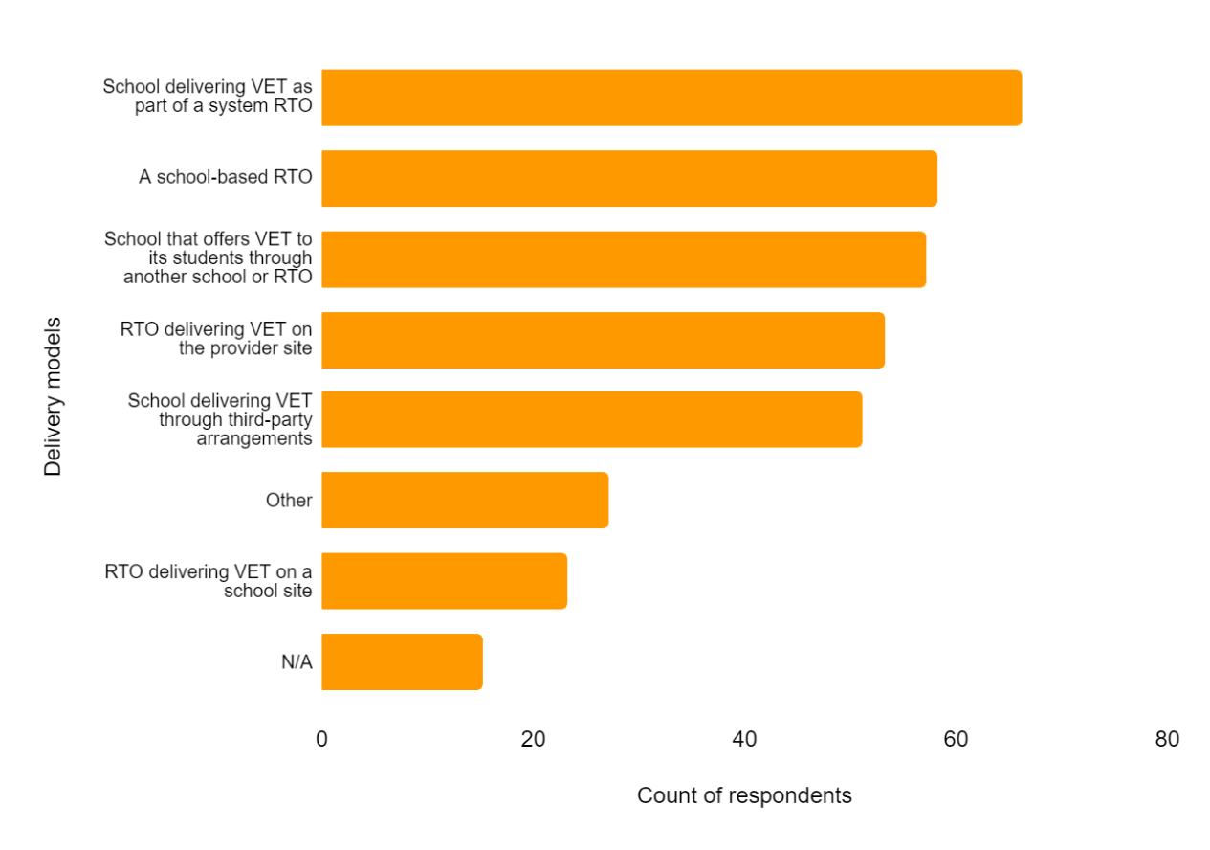
The factors commonly cited as drivers for a particular delivery model include funding, staff availability, class sizes, existing relationships, and location. In the Northern Territory, for example, some very remote communities are inaccessible by road for up to six months of the year. In these communities, a full-time VET trainer and assessor is ‘embedded’ at the school to live onsite and deliver training, as travelling in and out of the community is not feasible. Conversely, in South Australia, VET is delivered to secondary students in RRR areas through six regional hubs across the state. Each of the hubs is centred around a TAFE or a trade training centre, with varying degrees of accessibility. Some of the hubs (e.g. Mt Gambier), are well supported by public transport, allowing students to commute as needed to access the training. Other hubs (e.g. Whyalla) are less central and deliver VET in block training, allowing students to board at the nearby University of South Australia accommodation for the duration of the block period.
C. Some jurisdictions have policies relating to the delivery of VET in RRR areas, including South Australia and Tasmania.
For example, the South Australian Group Training Program (SAGTP) Funding Guidelines describe how training organisations can employ school-based apprentices and trainees in regional areas and outlines the different regional loading that applies for different geographical areas. Remote and very remote areas attract a 200% adjustment value, whereas moderately accessible areas attract only a 70% adjustment value. In New South Wales, whilst there is no specific policy for VETDSS in RRR areas, the Rural and Remote Education Strategy references VET, career learning and pathways. A key vision outlined in this strategy is the enabling of “stronger partnerships with higher education providers, vocational education suppliers and local industry.” In Tasmania, the overarching policy that guides VETDSS is the Vocational Learning and VET to 2030. Interestingly, the state has also implemented the Tasmanian Agriculture Education Framework (the Framework) to guide learning about agriculture in RRR areas, beginning from primary school and continuing through to completion of senior secondary school. The Framework helps to ensure that by the time the student is enrolling in VETDSS, they have a sound understanding of the industry, and have had opportunities to explore career options through work-based learning. Other industries are following this approach and starting to implement exposure programs in the years leading up to senior secondary school.
Additionally, some jurisdictions may also have specific advisory councils for RRR areas. For example, the Rural and Remote Education Advisory Council (RREAC), who seek to support educational initiatives that promote strong outcomes for regional Western Australian students. The RREAC reports to the Minister for Education on advice for the ongoing provision of quality education and training to rural and remote Western Australians.
D. Stakeholders highlighted the differences between jurisdictions regarding RRR status. In some states, a regional city is 115 kilometres from a metropolitan city (e.g. Ballarat in Victoria) and in other states, a regional city could be as far as 415 kilometres from a metropolitan city (e.g. Geraldton in Western Australia).
These differences in distance can drive the types of delivery models used for VETDSS. For example, in Victoria, a ‘hub’ model is feasible because schools are situated close enough to co-locate for VET programs. However, in jurisdictions where regional towns are further apart, including Queensland and WA, ‘hub’ models may not always be appropriate. The vast distances between schools and RTOs may make this model impractical, and schools may be more reliant on auspicing arrangements or purchase models.
E. In some jurisdictions, including Queensland and Victoria, schools in RRR areas reported collaboration across the three school sectors.
Stakeholders highlighted the value of collaboration and cluster arrangements between schools to increase VETDSS opportunities, however, it was noted that cross-sector collaboration is not maximised. Clusters are an effective way in which schools can share resources to optimise outcomes for students, as they allow for schools to increase class sizes, improve the diversity of offerings, address trainer shortages and share resources. For example, a stakeholder noted that Longreach State High School (a school-based RTO) has started a cluster model which enables students in smaller surrounding schools to participate in VETDSS programs. Another stakeholder cited the Lower Hume VET Cluster as a strong example of collaboration, stating that relationships between schools in the cluster are strong and outcomes are optimised for students. The schools involved in the cluster have worked to build relationships within the region and support each other as required.
Cross-sector collaboration, however, is not widespread, and some stakeholders noted that, whilst there are increasing opportunities for collaboration, it remains limited across school sectors. A stakeholder noted that a possible reason for this could be difficulties in coordinating schools across sectors. For example, it can be challenging logistically to coordinate clustering arrangements, including transporting students to different locations and identifying a location that is central for all parties. Case Study 1 below, focused on the Drones in Schools Project led by Marist College, is one example of strong cross-sector collaboration. This project involves Twelve State, Catholic and Independent schools across the Central Highlands and Isaac regions in Queensland, who collaborate to deliver training to students. Another example of cross-sector collaboration highlighted by stakeholders is the Bunbury Regional Trade Training Centre in WA, as outlined in Case Study 3 in Part 2 of this report.

Case Study 1 – Cross-sector collaboration with the Drones in Schools Project
Twelve State, Catholic and Independent schools across the Isaac, Central Highlands and Woorabinda Aboriginal Shire regions in Queensland collaborate on the Drones in Schools Project, led by Marist College in Emerald. Participating schools have combined to deliver a Certificate III in Aviation and collaborate with local partners to provide students with strong industry experience. One representative from the Drones in Schools Project noted that it seeks “...to build graduate capability, enhance community capacity and develop a self-sustaining training model that can be replicated across the country.” Members of the Project work together to achieve:
- A broadening of educational opportunities for regional/remote students
- The development of vocational STEM skills for the future of work in a global economy
- A commitment to community engagement and exposure to local enterprise
- Addressing skills shortages and emerging economic opportunities within industry
- Preparing students with the enterprise skills needed for workforce participation.
There are five key phases to the project:
- The VET in Schools Phase: delivering nationally recognised training in schools
- Imagine Innovation Phase: engaging students in industry opportunities and events at a local, state, and international level
- Developing Communities Phase: building local capacity through the development of educator skills
- Advanced Drone Training Phase: specialised industry skills development (for selected students)
- Industry Pathways Phase: path to industry mentoring program, including work experience and internship support.
F. Schools in RRR areas may use online learning for some components of their VETDSS program, as they may be too geographically distant to access face-to-face learning opportunities.
Stakeholders frequently highlighted an increase in the use of online learning, noting that it can be an effective way to increase VET offerings for students at schools in RRR areas. Most commonly stakeholders noted the use of online learning as part of a hybrid model of VET delivery, which incorporates online theory with blocks of practical study. For example, an RTO stakeholder noted that they are currently delivering a Certificate II in Electrotechnology in RRR areas, with the majority of learning taking place online each week and a three-day practical face-to-face block of delivery timetabled for each term. This stakeholder noted that online delivery can increase opportunities for students in RRR areas. Further, stakeholders noted that the types of online learning opportunities are also expanding. For example, a stakeholder cited that they “have a wider range of delivery options for students in RRR areas including mobile training units and digitally-enabled spaces, where students can tap into practical training, online learning and simulations and access our teachers and support services without leaving their local community.”
However, there are challenges with online delivery. It was noted that online learning can be a “black hole” for students who require more support, and that online learning can create a greater divide between the “high performing” and “low performing” students. Consultation highlighted that online learning is particularly challenging for students with disability, as they may require more individualised support. Further, stakeholders frequently noted that online delivery can be difficult to access in some RRR areas where there is not a stable internet connection. For example, one stakeholder from a remote RTO noted they deliver “online and virtually to students in RRR areas where computers and internet capacity or satellite connectivity permit, but different locations may still experience significant communication or technology barriers to engaging in VETDSS.” This stakeholder further noted that their RTO delivered VET to a secondary school class in a remote location, and the class had to share one computer as others were not available at school or home.
Stakeholders suggested that online learning is effective when it utilises technology in an innovative way and engages students in RRR areas. One example of this is the School of Isolated and Distance Education (SIDE) RTO - see Case Study 2 below. Based in WA, SIDE RTO delivers training for students in RRR areas. Stakeholders noted that the SIDE RTO began with 50 students and has now increased to 250, showing that there is an appetite for access to this type of VET program. These stakeholders noted that SIDE RTO continues to look to expand its scope by considering needs and workforce shortages, ensuring that the VET qualifications being delivered are relevant to the region.
Case Study 2 – Online learning with the School of Isolated and Distance Education (SIDE) RTO
SIDE RTO is a Department of Education (WA) funded RTO that uses digital technology to deliver VET classes for Government school students in regional, rural, and remote areas. When establishing a partnership with a school, a SIDE member will communicate with the school and discuss needs and challenges with VET staff. The communication ensures that SIDE has an understanding of what is happening on the ground and a school's individual needs. Depending on the school and their needs, SIDE offers one of three models:
- A fee-for-service delivery (SIDE RTO delivers training online through Webex)
- An auspicing arrangement (where a local trainer delivers on-site)
- A blended model of delivery (training is carried out locally by a trainer and assessor but assessment is carried out by SIDE RTO). This blended model may also include instances where the delivery is mainly carried out online, but particular assessments are done in person, and may require the SIDE RTO trainer to visit the school and do a block of training.
SIDE RTO has a small range of qualifications on scope selected through previous research and discussion prior to the RTO being established. SIDE RTO’s online delivery through the Webex platform works well in regional areas, catering for smaller cohorts and a range of qualifications. In particular, SIDE members noted in consultation that delivery works best when there is also a dedicated supervisor in the classroom to ensure that students are engaged. However, this supervisor does not need to be qualified as a teacher or trainer and assessor, which makes this option more viable for RRR schools to engage students and encourage ongoing participation.

Part 2: The challenges of delivery of high quality VETDSS in RRR areas
As shown in Figure 6, 89.8% of survey respondents (n=415) agreed that the experiences of delivering VET to secondary students in RRR areas are different from those in metropolitan areas. This section explores some of the challenges and barriers faced by stakeholders when delivering VET to students in these settings.
Figure 6 - Survey question: Do you believe the experiences of delivering VET to secondary students in RRR areas are different from those in metropolitan areas? (n=462)
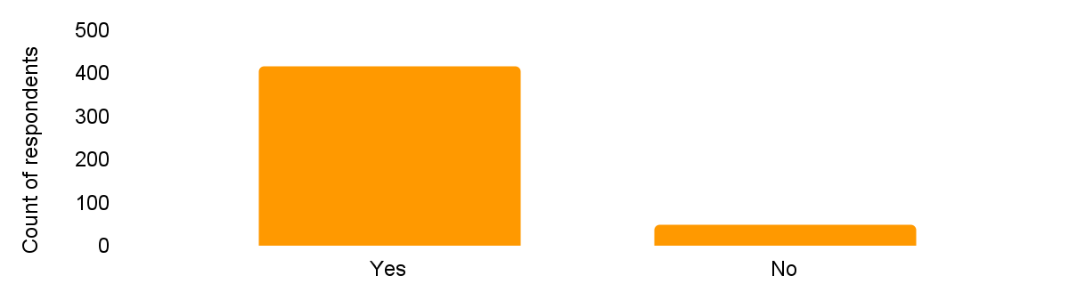
Figure 7 - Key findings for Part 2
A | The challenges experienced by all stakeholders in delivering high quality VETDSS are amplified in RRR settings.
B | Access to qualified trainers and assessors was reported by most stakeholders as a significant challenge.
C | Stakeholders consistently raised lack of funding as a challenge of VETDSS in RRR areas.
D | Because of their locations, some stakeholders reported challenges with geographical access to VET programs.
E | In some areas, there are insufficient student numbers to form classes.
F | Stakeholders suggested that some delivery arrangements, for example, solely online learning, may restrict the delivery of high quality VETDSS in RRR settings as students lack the face-to-face connection.
G | Stakeholders noted challenges with equipment and resources, including internet access in RRR settings.
H | Some stakeholders suggested that gaining industry experience can be challenging in RRR settings, due to the limited number of work placement opportunities.

A. The challenges experienced by all stakeholders in delivering high quality VETDSS are amplified in RRR settings.
Our analysis indicates that the challenges and barriers to delivering high quality VETDSS are consistent across all locations. However, these challenges can be amplified in RRR areas, and some challenges may be experienced to a higher degree. As one survey respondent from an RTO suggested, “the content and service we provide is the same, but there are additional costs (both time and dollars) involved in regional delivery.”
B. Access to qualified trainers and assessors was reported by most stakeholders as a significant challenge.
In fact, 21.79% of survey respondents (n=90) indicated that the availability of qualified trainers and assessors was the most significant challenge of VETDSS in RRR areas, more than any other challenge - see Figure 8.
Figure 8 - Survey question: Rank the following challenges in the delivery of VET to secondary students in RRR areas, in order of most significant challenge to least significant challenge (n=413). Note - this graph shows the count of survey respondents who ranked each option #1.
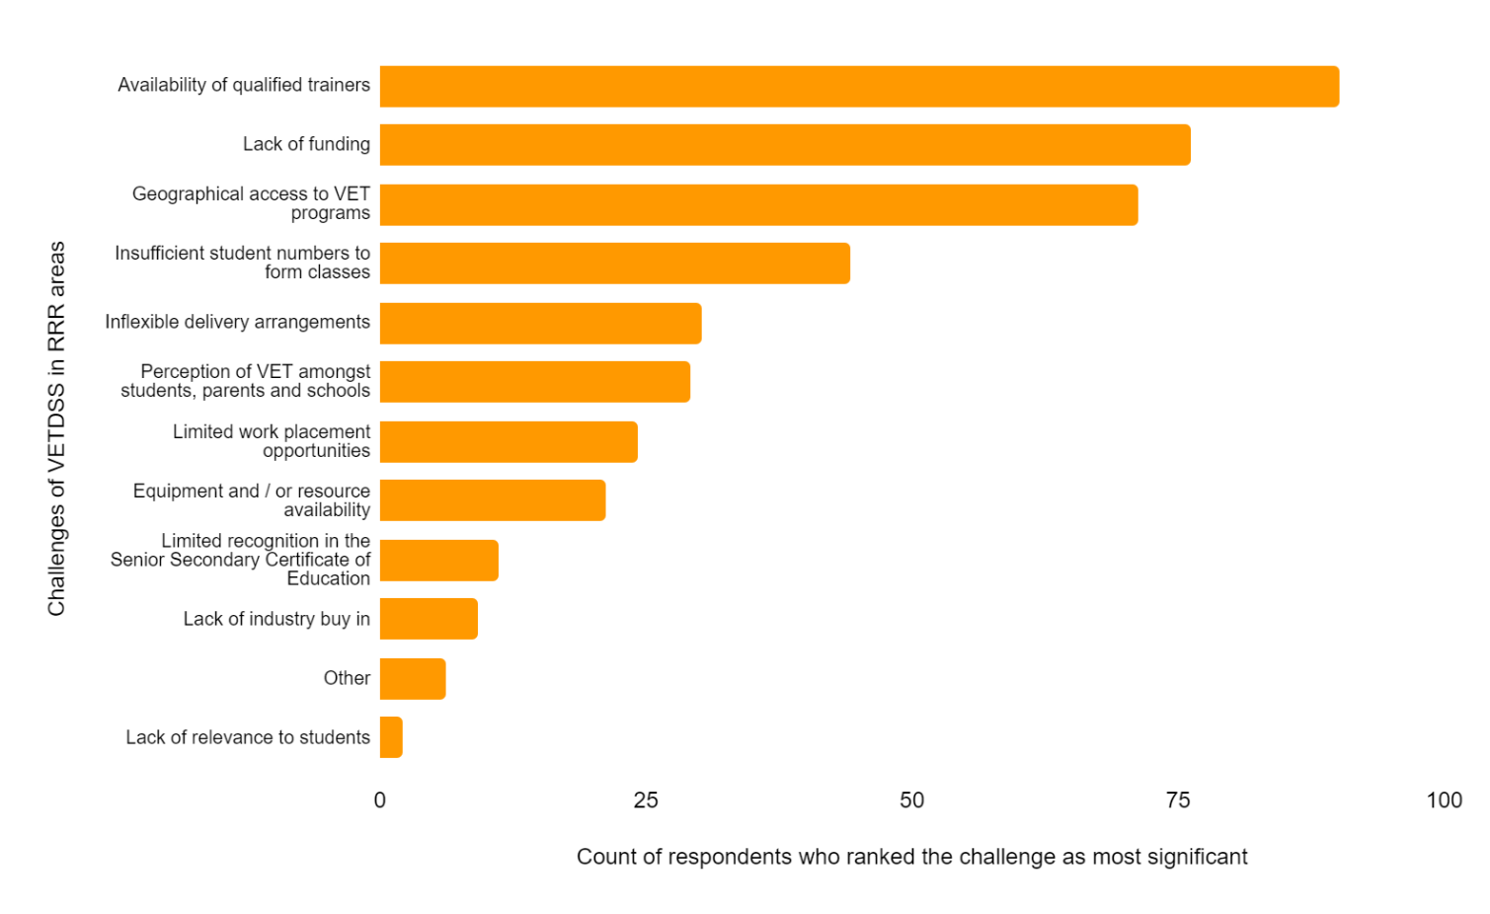
As summarised by stakeholders, the availability of qualified trainers and assessors is a challenge being faced across the VET sector. However, for those delivering VETDSS in RRR areas, this challenge is especially pertinent. It can be difficult to attract trainers and assessors to these areas, particularly the more remote communities. Stakeholders explained that some communities may have trainer and assessor roles vacant for up to two years.
Results from the survey indicate that the limited access to qualified trainers and assessors can lead to an ongoing shortage of staff in an area which impacts the quality, volume, and flexibility of course delivery. One respondent from a remote school explained that having “qualified staff to deliver programs is the main barrier as it greatly limits what can be offered at either a TAFE or school level.”
Stakeholders also noted that it can be challenging to retain trainers and assessors in these areas. If the individual is not local, they may not stay in their role long-term as it can be an isolating experience to be based in a remote community. Stakeholders also suggested that VET trainers and assessors often leave their roles at schools/RTOs to seek opportunities for greater remuneration in their qualified trade, e.g. mining or electrical roles. Once there is a staff vacancy, it is challenging to find an appropriate replacement, even as a short-term solution. As one survey respondent from a remote school noted, “we don't have relief teachers nor qualified VET teachers with the necessary training qualification.” To overcome this issue, some stakeholders offer employed VET trainers and assessors flexible working arrangements as an incentive to stay in the RRR area. For example, they may offer the individual a 4-day working week or provide an allowance for living in the region.
Additionally, stakeholders suggested that meeting the requirements of the Standards for RTOs and/or the teacher registration requirements can be more burdensome in RRR areas. This is because there may be limited access to face-to-face professional development opportunities to ensure staff are adequately trained to deliver programs and to remain industry current and competent. If a VET teacher is required to travel to access professional development opportunities, because of their unique skill set, there is often no qualified replacement teacher to cover the classes.
Some of these workforce challenges are not unique to RRR areas, though they may be exacerbated by the geographic distance or limited number of available staff.
C. Stakeholders consistently raised lack of funding as a challenge of VETDSS in RRR areas.
18.4% of survey respondents (n=76) cited lack of funding as the most significant challenge in the delivery of VET in RRR settings. This is consistent with the findings of the Education in Remote and Complex Environments report, which found that “funding issues limit the provision of VETDSS” and that accessing VET can often be “too expensive for many students from less financially secure families.” Stakeholders commented that lack of funding limits some VET courses more than others. They noted that courses such as Building or Engineering need constant funding to enable them to keep equipment industry relevant and to a standard that is safe.
Stakeholders generally agree that greater funding is required for VETDSS in RRR areas than in metropolitan areas. In recognition of this, some states, including Queensland and WA, have increased subsidy loadings for areas that are more geographically isolated. Even so, one survey respondent from a regional RTO noted that the “funding received for the little amount of students attending does not allow for the training to be financially viable.” Additionally, stakeholders note that distance is an issue in RRR areas and makes accessing VET more costly. One survey respondent from a regional school explained that their students access VET courses that are 50 kilometres away and relying on parents to transport the students is problematic as some are unable to drive and others are unable to afford petrol. The school does not have a minibus to help transport the students, nor the funds to pay for a bus service. They note that without additional funding provided to help transport students, they are limited in their ability to access VET programs.
D. Because of their locations, some stakeholders reported challenges with geographical access to VET programs.
As noted in the Education in Remote and Complex Environments report, “students who are located vast distances from major regional centres have limited access or no access to… opportunities for VET pathways while remaining within their communities.” In fact, 17.2% of survey respondents (n=71) noted that geographic access was the most significant barrier to these programs - see Figure 8.
As one survey respondent from a remote school noted, students have to travel large distances (i.e. over 100km) to attend classes either weekly or via block release. As most VETDSS students are not able to drive yet, they may access these programs via public transport, however options for public transport are generally limited in RRR areas and it may not be an appropriate option depending on the time of classes. Alternatively, students may rely on schools or family members to transport them. However, stakeholders raised concerns about student safety and duty of care when young people are travelling large distances and sometimes staying in accommodation overnight.
Additionally, there are some unique access challenges that exist for very remote communities. For example, stakeholders from the Northern Territory explained that some remote communities are inaccessible by road for six months of the year. One survey respondent from an RTO that delivers in remote communities also suggested that “doing practical components is often difficult due to the heat.”
E. In some areas, there are insufficient student numbers to form classes.
Stakeholders consistently noted that a key barrier of VETDSS in RRR areas is the thin markets. 10.65% of survey respondents (n=44) noted that having insufficient student numbers to form classes was the most significant challenge of VET delivery in these areas - see Figure 8. As one survey respondent from a regional RTO explained, because “there are a lower number of students who are spread out across a wider geographic area, there may not always be enough enrolments for a course to go ahead.” For private RTOs and TAFEs, it may not make economic sense to deliver to students in remote areas, particularly if there are only a few students interested in the course.
This is consistent with the findings of the Education in Remote and Complex Environments report, which noted that as students are looking for a wider range of courses, this “leads to smaller and less economically sustainable group sizes in regional areas.” Stakeholders cautioned that student number benchmarks are problematic, with the minimum number of students to deliver a course too large for the population size of an RRR area.
One way to overcome this issue is through cross-sector collaboration. Consultation with Central Regional TAFE stakeholders identified that their Geraldton campus draws on students from the multiple nearby schools (including Independent, Catholic and Government schools) to make up class sizes. Another example is the Bunbury Regional Trade Training Centre in WA, which involves 16 schools across the Independent, Catholic and Government school sectors. Over 300 students from these schools are able to access up to 17 courses, offered through RTOs – see Case Study 3 below for more detail.
Case Study 3 – Cross-sector collaboration at Bunbury Regional Trade Training Centre in WA
Multiple stakeholders noted the Bunbury Regional Trade Training Centre (BRTTC) as an example of strong cross-sector collaboration involving 16 schools across the Independent, Catholic and Public sector and over 300 students. Three training sites are operated across three different schools, with approximately 17 courses being delivered by 8 different RTO’s.
These courses can be accessed by any student at one of the 16 schools and are mostly offered via a fee-for-service model through private RTOs. Some course fees are subsidised by the schools, as state funding follows a student to their chosen course, or by agencies like the Building and Construction Training Fund which currently funds a Certificate II in Construction Pathways and Department of Training and Workforce Development who funds the Certificate II in Plumbing and Certificate II in Electrotechnology.
An Advisory Board made up of representatives from peak industry bodies in the region provides strategic advice to the Alliance. This group is tasked with providing information on emerging local training needs and possible funding sources. South West VETlink (a not-for-profit organisation) manages the operations of the BRTTC on behalf of the Alliance Schools.
The BRTTC collaborates with South Regional TAFE to offer students the ability to access a complimentary range of qualifications from Certificate II level to Certificate IV level that may not be offered through other providers. The courses offered provide pathways into employment, apprenticeships and traineeships, and further education and training, including university pathways.
F. Stakeholders suggested that some delivery arrangements, for example, solely online learning, may restrict the delivery of high quality VETDSS in RRR settings as students lack the face-to-face connection.
Students in geographically isolated areas may be required to access VETDSS programs through online classes, offered by a private RTO or TAFE. Many stakeholders agree that while providing the online classes is helpful, face-to-face learning is still the preferred delivery model. As one survey respondent from a regional RTO explained, “it is a shame these students do not always get the opportunity to learn face-to-face as generally this has better learning outcomes and a better chance of course completion.” Stakeholders from the SIDE RTO, who offer virtual VET programs to students in WA, agreed, noting that their online classes work best when there is a teacher on site with students supporting them to engage with the content.
Additionally, stakeholders commented that different delivery models can create challenges with student attendance. For example, for VET delivery with block arrangements (i.e. a two-week block of classes and practical work learning), student participation for the full block can be challenging as they may miss out on content in their other subjects. Distributed delivery models, for example where a student is required to attend a practical component daily, can also be challenging as it may put a burden on the family to transport the student to the site daily.
G. Stakeholders noted challenges with equipment and resources, including internet access in RRR areas.
In RRR settings, there may be limited access to appropriate infrastructure that supports VETDSS programs. As one survey respondent from an RTO noted, “we often do not have the variety of equipment or testing facilities to support the training experience.” Another survey respondent from a remote school noted the difference between RRR areas and metropolitan areas, where students from the latter may have the choice between many RTOs with facilities to support courses, such as commercial kitchens or mechanic garages. They commented that for remote schools, there is limited choice based on local facilities. One way that this issue is being overcome is through initiatives such as the Big Red Truck, which provides a mobile way for students to complete the practical components to work towards their Certificate II in Kitchen Operations - see Case Study 6 for more details.
Additionally, reliable internet access was highlighted as an issue for stakeholders in rural areas, especially those relying on online delivery models. As one stakeholder noted, without reliable internet access, teachers have difficulty engaging students in the content and they may have to rely on work-around solutions, such as downloading materials to give to the students. Stakeholders noted that some schools in regional areas only have dial-up internet. Some State Departments provided students with laptops during the COVID-19 pandemic, which helped with access to hardware, but accessing reliable internet connections is an ongoing problem. In recognition of this issue, a key recommendation in the Education in Remote and Complex Environments report was to improve access and affordability in RRR communities to broadband and mobile phone reception.
H. Some stakeholders suggested that gaining industry experience can be challenging in RRR settings, due to the limited number of work placement opportunities.
A component of VET that makes it unique is the practical learning gained through industry experience and work placements. Some stakeholders in RRR areas noted work placement opportunities can be challenging as there may be a limited range of businesses in the local community to host the work placement hours for the student. This could mean that students are not motivated to follow their interests because the opportunities to pursue the job in their local area are not visible, or the student may need to relocate to get the necessary experience. One survey respondent from a school noted that they currently have too many students for the limited number of local small businesses able to host the work experience. When this happens, some students either miss out, do unrelated workplace hours, or are required to travel to another town for the opportunity.

Part 3: The strengths and enablers of good practice VETDSS in RRR areas
Stakeholders consistently commented on the value of VETDSS programs in RRR areas, particularly in providing strong post-school pathways into further education, training and/or employment. 23.62% of survey respondents (n=90) ranked the ability of VET programs to provide post-school pathways as the number one strength of these courses, more than any other strength - see Figure 9.
Figure 9 - Survey question: Rank the following strengths in the delivery of VET to secondary students in RRR areas, in order of most significant strength to least significant strength (n=381). Note - this graph shows the count of survey respondents who ranked each option #1.
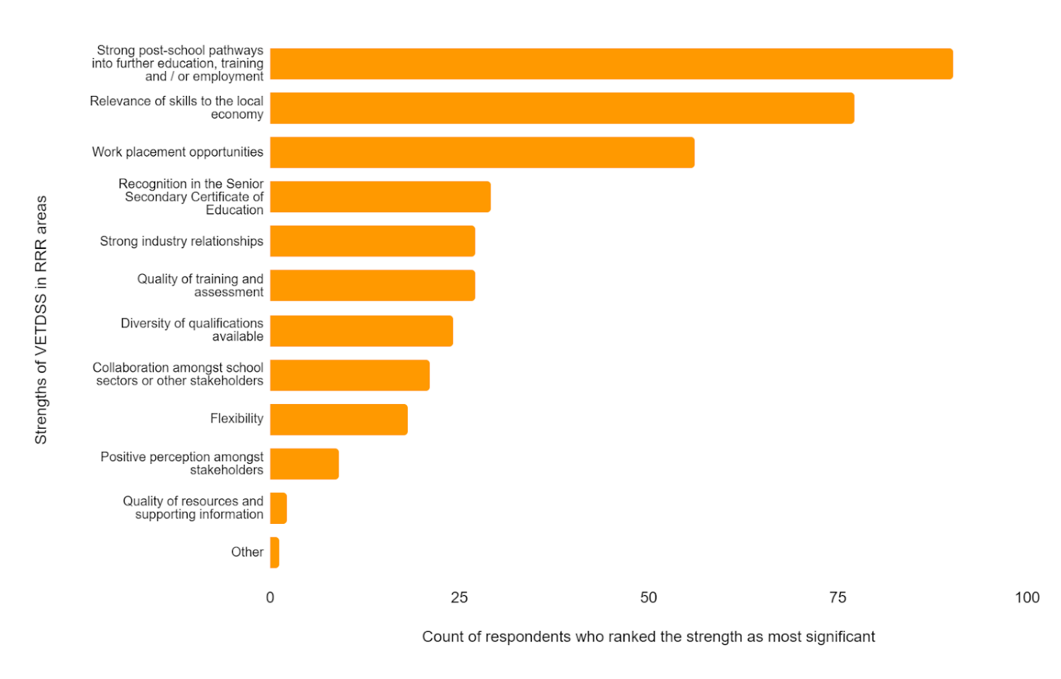
Figure 10 - Key findings for Part 3
A | Stakeholders agreed that VETDSS programs work well in RRR areas, as there are typically stronger post-school pathways, given the links to the local economy, compared to metropolitan areas.
B | Generally, stakeholders commented that the perception of VETDSS is positive in RRR areas.
C | Stakeholders noted the ability to build strong relationships is essential to high quality VETDSS programs, especially in RRR areas.
D | Some innovative delivery models have been employed to overcome barriers to quality delivery in RRR areas.

A. Stakeholders agreed that VETDSS programs work well in RRR areas, as there are typically stronger post-school pathways, given the links to the local economy, compared to metropolitan areas.
This was a consistent theme in the responses from the survey, with stakeholders indicating that, typically, the courses with the largest enrolment numbers relate to the main industries which operate in the relevant RRR area, such as engineering courses in towns with large mining industries. Another example is in the East Arnhem Land region of the Northern Territory, where there is a strong fishing industry. Schools in this area have established a Maritime Program partnership that provides students with real-world post-school pathways with the community and local fishing industry - see Case Study 4 for more detail on this.
Case Study 4 – Links with local industry through the Northern Territory Maritime Program
The Maritime Program was established in 2016 as an innovative partnership between four very remote schools in the East Arnhem Land region of the Northern Territory. The program equips students from remote, regional, and urban NT schools with the skills, knowledge and experience required for employment within the maritime industry. The program provides real-world job pathways through engagement with the community and local industry. This program offers a range of employment pathways and is heavily aligned with industry, such as community ranger groups and other maritime related areas such as barge companies, water police, surf lifesaving and fisheries.
The program involves students participating in accredited training such as the Elements of Shipboard Safety Skill Set, Certificate I in Maritime Operations (Coxswain Grade 2) and/or Certificate II in Maritime Operations (Coxswain Grade 1).
Because the VETDSS courses often align with local needs, students can gather on-the-ground, real-world experience from local workplaces. As one survey respondent from regional Queensland noted, this helps students see themselves in the role and better prepares them for their post-school pathway. Through local work experience opportunities, students can develop a better understanding of the industry and understand more about the world of work as it relates to their specific region. The survey responses suggest that employers within RRR communities are keen to offer training and employment opportunities to local students, as it can help with skills shortages and improve connections between industry and schools. Indeed, once students engage with local employers through VETDSS, they are more likely to envision themselves in a post-school pathway in the relevant sector. This may help keep young people working in local industries and further develop sustainable communities. As one survey respondent from a regional RTO summarised, a key strength of VETDSS in RRR areas is “being able to deliver industry needs within the regions that are relevant.” Another respondent commented that “providing skills to regional students that benefit the community” is a core strength of VETDSS.
B. Generally, stakeholders commented that the perception of VETDSS is positive in RRR areas.
Stakeholders suggested that strong links with the local industry and community mean that the perception of VETDSS in RRR areas is largely positive. It was noted by some that the perception of VETDSS in RRR areas is “leaps and bounds ahead” of those in metropolitan areas. As one survey respondent from a remote school in WA highlighted, VETDSS is a “great opportunity” for students wishing to stay local and complete a trade, resulting in employment. Stakeholders from RRR areas also frequently commented on the benefits of VETDSS, including developing “real life skills” and gaining exposure to the workplace. Knowledge of these benefits amongst stakeholders in local communities can help to create a positive branding of VETDSS, as it creates certainty around a student’s skills, establishes trust in the quality of training received and boosts potential employment outcomes.
When VETDSS programs have direct engagement with the community, it can improve its positive perception. For example, Scone Grammar School in rural NSW has an on-site café known as Grammar Grind. Grammar Grind is a commercial business for year 11 and 12 students to gain practical experience towards their qualifications in Hospitality. It services real customers from within the school and wider community, and provides students with valuable industry experience, strengthens their employability skills, and promotes VETDSS.
During consultation, stakeholders also suggested that supportive school leadership is essential in driving the positive perception of VET in the community. For example, stakeholders commented that some school principals see the success of VETDSS as a personal responsibility. This leads to a greater focus on VET pathways as a viable post-school option and leads to a greater understanding of the value of VET across the school community.
C. Stakeholders noted that the ability to build strong relationships is essential to high quality VETDSS programs, especially in RRR areas.
During consultations, stakeholders suggested that schools in metropolitan areas have more freedom to select RTOs, industries, and local businesses to partner with, due to the magnitude of options available in large cities. However, in RRR areas, there are more limited opportunities, meaning that strong relationships are essential to creating valuable partnerships with these groups. 27 survey respondents (7.09%) noted that strong industry relationships are the most significant strength of VETDSS in RRR areas. As one survey respondent from a regional RTO explained, when alliances are created between schools, RTOs/TAFEs and employers in RRR areas, VET offerings can be tailored to the needs of the local community and economy.
Throughout consultation, stakeholders highlighted the different ways in which quality relationships can be built in the VETDSS sector. One stakeholder noted that when they visit regional schools, they make an effort to attend the local shire and resource centres, as this is one way to understand the work experience and employment opportunities in the local community. Another noted that they engage with a career advisors network group, designed for the career advisors in the local area to provide advice to one another, share learnings and identify VETDSS opportunities. Stakeholders noted that some schools utilise their local Chamber of Commerce to identify industry needs, encouraging connections between the classroom, workplace, and industry requirements. An example of this type of connection between the classroom and workplace can be seen at Spinifex State College, where students have the opportunity to make connections with local industry because of the strong relationships the school has with Mt Isa’s largest employer, Glencore Mt Isa Mines. Further detail is included in Case Study 5 below.
Case Study 5 – Building strong partnerships at Spinifex State College, Mt Isa
The College has built a number of partnerships to ensure that students are work-ready, including with the largest employer in Mt Isa, Glencore Mt Isa Mines. Erin Johnson, Glencore Mt Isa Mines’ Capability Development Advisor, recognises the benefits in working collaboratively with local schools, highlighting key programs available to students, for example the Work Experience program, the Girls for Mining Program and the School Leavers Program. Each program allows students to see what it is like to work as a trade and/or engineering professional in the workplace, understand what their chosen discipline entails, and make an informed decision about their chosen career pathway. Further, Johnson notes that there is mutual benefit in these programs and partnerships as they “future proof” business by providing local school students with employment.
D. Some innovative delivery models have been employed to overcome barriers to quality delivery in RRR areas.
Survey respondents indicated that VETDSS delivery models should aim to be geographically tailored and flexible for them to be successful. Stakeholders highlighted a number of innovative VET programs in RRR schools, for example the Outback College of Hospitality Trade Training Centre (Big Red Truck) in Queensland - a mobile training facility for five regional schools - see Case Study 6.
Additionally, a survey respondent from an RTO highlighted their innovative delivery model, which features block delivery of training for regional areas. Students are transported via bus to the TAFE campus and can participate in a range of courses. Relevant trainers and assessors are flown in for the duration of the block training. Stakeholders noted that the benefits of this model include the larger class sizes, as school students from multiple schools attend the block training. This allows for greater collaboration, relationship building and the ability to easily schedule in the training, as it is a regular and known arrangement.
Case Study 6 – Innovative delivery models through the Outback College of Hospitality Trade Training Centre (Big Red Truck) in Queensland
The Outback College of Hospitality Trade Training Centre (Big Red Truck) is funded by the QLD Department of Education and provides Years 10 - 12 students with the opportunity to work toward their Certificate II in Kitchen Operations. The mobile truck is purpose built to train up to 20 students at a time, with a commercial kitchen, seating, and marquee. Operating in Longreach, Winton, Barcaldine, Blackall and Aramac, the truck has seen a 15% increase in students’ achieving their Senior Secondary Certificate of Education.
The Big Red Truck has proven effective in increasing workplace learning opportunities for students, who complete catering jobs at events within the community for work experience. Interviewed for the Courier Mail, Brendan Krueger, Principal at Longreach State High School noted that the truck is an Australian first, providing pathways into tourism jobs for local students. The Big Red Truck has seen a 57% increase in the number of students completing the course leading to jobs in the local tourism sector.

Stakeholders also noted that some RRR students may require additional support in accessing VET programs, with an RTO noting that the establishment of alternative learning settings has been a key achievement. For example, stakeholders from TAFE NSW highlighted the establishment of Connected Learning Centres (CLCs) as a successful way of increasing access to VET programs for students in RRR areas - see Case Study 7 for more detail.
Case Study 7 – Increasing access to learning opportunities through TAFE NSW’s Connected Learning Centres
TAFE NSW has established 20 multi-purpose Connected Learning Centres (CLC), with two additional centres under construction, to increase access to learning opportunities and high-quality training for students in regional areas. CLCs have been designed with digitally enabled technologies, providing students with increased course choice, flexible learning options using online and hybrid delivery and access to practical training without leaving the region.
CLCs are supported by mobile training units to provide the practical equipment and experience beyond the classroom environment of the CLC itself. For example, students in a CLC may be able to dial in and watch a live demonstration of a practical task from a chef wearing a body camera. TAFE NSW note that CLCs are an effective way to enhance capability to deliver practical learning and increase students’ access to teachers on and off site, promoting strong education opportunities for regional students.

Part 4: Options for improving access to VET programs in RRR areas
Based on the insights, findings, and discussions above, this section presents an overview of some of the key options that could be implemented to address the barriers that exist for school students pursuing vocational pathways in RRR areas and support these students to access a broad range of high quality VETDSS programs.
Figure 11 - Key options for improving access to VETDSS in RRR areas
1 | Review minimum class number requirements and funding per student in RRR areas.
2 | Incentivise VET teachers to work in RRR areas to promote greater course options for students.
3 | Implement virtual work placements to allow students in RRR areas to obtain work experience, even when geographically isolated.
4 | Encourage collaboration to create economies of scale and communities of practice.
5 | Promote access to stable internet connections.
Please note, these options are not mutually exclusive and multiple options could be selected.
Option 1: Review minimum class number requirements and funding per student in RRR areas
Stakeholder feedback frequently identified that the minimum viable class numbers used in metropolitan areas to determine whether a VETDSS program can run are not appropriate in RRR settings. It was noted that most classes require 14-15 students for an RTO/school to run the program, however, in RRR areas, student numbers are lower and more dispersed, so reaching economies of scale is not always feasible. As one stakeholder noted in a consultation, this can mean that ten interested students miss the opportunity to undertake their chosen course because the ‘magic number’ has not been met and RTOs will operate at a loss if they run a course with a smaller cohort.
To prevent economies of scale impacting VETDSS opportunities for RRR students, guidance for minimum class numbers should be reviewed. This would need to be supported by changes to funding allowances for students in RRR areas in order to be effective. For example, if students in RRR areas received a higher funding weighting, this would allow smaller class sizes to operate without causing a loss to the RTO.
Option 2: Incentivise VET teachers to work in RRR areas to promote greater course options for students
Stakeholders frequently noted in consultation that one of the key issues impacting the delivery of VETDSS in RRR areas is the availability of appropriately qualified VET teachers. This challenge occurs because the supply of VET teachers with the appropriate qualifications and industry experience in RRR areas is limited. As discussed in Part 2 of this report, the limited supply of VET teachers in RRR areas is caused by a number of factors, including an insufficient number of people with the appropriate skills and qualifications to deliver VETDSS (Certificate IV in Training and Assessment, Initial Teacher Education qualification and industry qualification) and opportunities for greater remuneration in other industries (for example, construction and mining). The primary impact of this VET teacher supply challenge on school students is that it results in fewer VETDSS courses being available to interested students. This can hinder student engagement as the course they want to pursue is not on offer and/or they cannot get a place in a class as it reaches capacity due to limited availability.
To support students to have access to a range of relevant and high quality VETDSS courses, incentives could be implemented to increase the supply of VET teachers. This supply can be achieved by (1) encouraging VET teachers to move and work in RRR areas, and/or (2) supporting locals in RRR areas to become VET teachers. Options for incentivisation in these two categories have been included below:
(1) Encouraging VET teachers to move to RRR areas:
- Financial incentives. This could include upfront payments, as well as subsidised housing, childcare costs, and relocation payments. Yearly financial payments could be offered to encourage the retention of VET teachers in RRR areas. This style of incentive subsidy for teachers operating in RRR areas is common at the state and territory level, and existing programs could be built upon to incorporate specific VET teacher funding. For example, the ‘Rural Teacher Incentive’ in NSW provides incentives to teachers that work in rural and remote public schools, including financial incentives, rental subsidies, climatic allowances, and additional personal leave.
- Career progression opportunities. This could take a number of formats, including the provision of additional training and development days, fast tracking the transition from temporary to permanent staff member and/or prioritising subsequent transfer requests of staff that have worked in RRR areas. Priority transfer points are an element of the NSW Rural Teacher Incentive program, with teachers that work in RRR schools awarded higher transfer points for every year they are a permanent staff member. Accumulated points are used to prioritise applications for transfer.
(2) Supporting locals in RRR areas to become VET teachers:
- Subsidised Certificate IV in Training and Assessment (Cert IV TAE) programs. Given that feedback indicates that most VET teachers operating in RRR areas are employed by RTOs, not schools, they are typically not required to have an Initial Teacher Education qualification. Rather, they only need their Certificate IV in Training and Assessment (TAE) and industry qualification in order to comply with the Standards for RTOs 2015. Encouraging industry professionals in RRR areas to undertake their TAE and participate in delivery to school students would significantly support the supply of VET teachers, and subsidisation of the course costs may provide individuals an incentive to do so.
- Financial incentives for industry participants to become trainers and assessors. In conjunction with the option above, industry professionals that undertake their Certificate IV TAE could receive financial incentives to encourage them to upskill and become trainers and assessors. There are already examples of this style of incentive structure across states and territories to encourage stakeholders to undertake the Certificate IV. For example, in Victoria, experienced professionals in demand industry areas can receive incentive payments up to $10,000.
It is noted that when considering which options are most appropriate for implementation, the core issue will be balancing an appropriate supply of VET teachers whilst maintaining the quality and integrity of VETDSS in RRR areas.
Option 3: Implement virtual work placements to allow students in RRR areas to obtain work experience, even when geographically isolated
Whilst stakeholders identified that connections between VETDSS and industry/employers are typically strong in RRR areas, the availability of relevant and appropriate opportunities for work placements can be limited. This can stem from:
- A smaller pool of potential employers;
- Employers/businesses being a smaller size and unable to take on large numbers of students;
- Decreased scope of industries available to suit student needs;
- Distances between students and employers; and
- Limited public transport to connect students and employers.
To ensure that students in RRR areas have the opportunity to participate in work placement programs and gain real workplace experience, virtual work placement programs could be established. This would allow students to undertake work placements unrestricted by their physical location.
Virtual work placements are not a new phenomenon in Australia, with a number of programs established by large organisations:
- CSIRO: The Virtual Work Experience Program provides an opportunity to experience the work of a CSIRO scientist from home, especially for students who face geographic or other barriers to participating in a traditional work experience. Students undertake collaborative group projects in the science, technology, engineering, and mathematics (STEM) fields, supervised by CSIRO staff or STEM industry professionals.
- Amazon Web Services (AWS): In partnership with the Workplace Learning Network, AWS have delivered a virtual work placement with 275 Information and Digital Technology students in NSW. Students worked in teams with AWS mentors and were introduced to a range of IT skills. They note that the program provided an opportunity for regional students to have access to a global business.
A range of initiatives could be led by the Department to encourage the establishment of virtual work placement programs, including:
- Developing guidelines outlining how organisations could implement such programs and the benefits of doing so. This additional layer of support may provide a catalyst for organisations that are unsure how to go about setting up a program.
- Funding a third party to work with organisations to develop and run virtual work placement programs. This would remove the need for organisations themselves to develop the programs and provide an additional layer of support. Relevant third parties might include Work Placement Service Providers.
- Raising awareness about virtual work placement programs through case studies and other promotional materials.
Option 4: Encourage collaboration to create economies of scale and communities of practice
As noted in Parts 2 and 3 of this report, a key challenge of VETDSS in RRR areas are the thin markets and challenges in reaching economies of scale. Additionally, because schools and RTOs are often geographically isolated from one another, it may not be common for these organisations to share learnings. There is an opportunity to encourage better collaboration between school sectors, and between schools and RTOs who may be from similar areas or have similar interests. One way this is currently being achieved is through career advisors network groups. Identified through consultation, these groups enable career advisors from a particular region to share learnings and experiences, including VETDSS opportunities.
Some ways that greater collaboration could be achieved is through:
- Developing guidelines outlining how organisations, schools and RTOs could collaborate to create economies of scale, and the benefits of doing so. This additional layer of support may provide a catalyst for some schools and RTOs that may be unsure where to begin.
- Engaging with school sector associations in each jurisdiction to test their appetite for greater collaboration with other school sectors, specifically in RRR areas. If there is interest, it could be worthwhile introducing the representatives from specific regions to one another.
- Raising awareness about best practice and opportunities for improving collaboration.
- Raising awareness of VETDSS among regional councils, local governments, and community organisations, as they may be large employers in a specific RRR area.
Option 5: Promote access to stable internet connections
As noted in Part 2 of this report, students in RRR areas are more likely to access at least some component of their education online. However, there are challenges with stable internet connections in these areas, which limits a student’s ability to access online learning. In recognition of this issue, the Education in Remote and Complex Environments report recommended “improving access and affordability in RRR communities to broadband and mobile phone reception.” In particular, the report referenced extending the Sky Muster Education data offering to vocational students in RRR areas. This is a service that allows students who study via distance education to request a separate internet service port, enabling them to have access to data plans that are allocated for educational purposes. Currently, only school-aged students who are enrolled in a recognised distance education program are eligible to access this service. Some students completing a VET course may miss out on the service, based on the eligibility criteria.
Some ways in which stable internet connections for VETDSS students in RRR areas could be promoted include:
- Extending the current eligibility criteria for Sky Muster Education data, enabling students from certain RRR who engage in VETDSS to access the data offering.
- Funding a program directly for VETDSS students in need to bolster or improve their internet connections.
- Increasing the infrastructure to support stable internet connections, particularly in facilities that engage in block training for students (e.g. some RTOs).

Appendix A: Detailed literature review
Education in Remote and Complex Environments
The Education in Remote and Complex Environments report, released by the Standing Committee on Employment, Education and Training, examined how education meets the learning needs of students in RRR communities and how barriers in education can be overcome. Overall, the report aligns with findings presented in the Halsey Review and the Napthine Review. With regards to VETDSS, the report found that “students who are located vast distances from major regional centres have limited or no access to VET pathways while remaining in their communities,” and that “the financial and emotional costs of relocating can be significant.” The report also highlighted some of the barriers to VET in RRR areas, namely geographical remoteness, capacity of RTOs to service remote communities, transport, licensing, and thin markets.
While the report acknowledges that some work is being undertaken to address these barriers, it makes 14 recommendations to improve access to quality education and outcomes for RRR students. The recommendations most relevant to this stream of work are:
- Improving access and affordability in RRR communities to services, including public transport, broadband and mobile phone reception; and
- Introducing new proposals in the National School Reform Agreement commencing in 2023, including a needs-based school funding model.
These challenges and recommendations were explored through consultation with stakeholders from RRR areas of multiple jurisdictions and school sectors.
Looking to the Future - Report of the review of senior secondary pathways into work, further education and training (Shergold Review)
Released in 2020, the Shergold Review examines the most appropriate way to support secondary students during their transition to work, further education, or training. The report acknowledges the high emphasis on ATARs and recommends a broader framework for secondary school students. Regarding RRR students, the report suggests the establishment of a network of career hubs, with an initial focus on regional areas. This initiative would provide schools and students with the opportunity to connect with employers, information on the labour market, education and training information and independent career advice. These hubs would also become a single point for industry to connect with local schools and therefore streamline the industry engagement process. The report suggests that this network of career hubs would be particularly valuable in communities that lack networks, connections, or infrastructure - including some RRR communities.
Other key findings from this report that are relevant to this stream of work include:
- Only 70% of RRR students accept their university offer, compared to 77% of metropolitan students. RRR students are also more likely to defer offers and less likely to complete tertiary education. Tertiary completion rates are 65.5% in metropolitan areas, 61.4% in inner regional areas, 58.5% in outer regional areas and 48.7% in remote areas.
- Consultations with students in RRR areas highlighted their sentiments that they are prevented from pursuing their ambitions as they are unable to undertake electives they are passionate about, due to the lack of resources, teachers or fellow students who were also interested.
- RRR students, students with disabilities, students from low socioeconomic backgrounds and Indigenous students are more likely to engage with VET than higher education. For this reason, it is crucial that there is well-informed career advice readily available for parents and students from these backgrounds.
The challenges and opportunities discussed in the Shergold Review were tested in consultation with stakeholders.
Strengthening Skills: Expert review of Australia’s VET system (Joyce Review)
Published in 2019 and commissioned by the Commonwealth Government, the Joyce Review presents an overview of the current VET system and determines how the VET system can better service the current and future needs of jobseekers and employers. In total, the Review makes 71 separate recommendations around the six key areas, including clearer secondary school pathways and greater access for disadvantaged Australians.
Specific recommendations which address the needs of RRR students include:
- Recommendation 5.13: Adapting the university-based regional study hub model for the VET sector. Regional study hubs would provide infrastructure and academic support for students studying via distance at partner universities or RTOs. Additionally, dedicated funding grants could be provided to encourage RTOs to offer training through the regional study hubs.
- Recommendation 5.5: Creating a new architecture in which the National Skills Commission would be responsible for, inter alia, determining nationally consistent subsidy loadings for rural and remote learners, Indigenous Australians and disadvantaged groups.
- Recommendation 5.6: Creating a list of nationally consistent percentage loadings to account for differences in cost of delivery. As the Review notes, there is a higher cost of delivering VET in RRR areas. This needs to be recognised and accounted for to ensure that there continues to be high-quality and diverse training options offered in these markets. The Review suggests that for RRR areas, a percentage national loading on top of the national subsidy amount should be paid on a per-student or enrolment basis.
The challenges of the VET sector more broadly that were raised in the Joyce Review were tested with stakeholders throughout consultation, and in particular the relevance of these challenges to the VETDSS context was discussed.
National Regional, Rural and Remote Tertiary Education Strategy (Napthine Review)
Released in 2019, the Napthine Review explores the need for a national strategy for RRR tertiary education and presents key findings on this topic, along with a plan for change and implementation strategy. The report sheds light on five key issues, namely:
- The lack of access, opportunity and choice in RRR areas due to the lack of tertiary education options.
- The insufficient levels of support for RRR students who want to participate in tertiary education including, but not limited to, financial support.
- RRR students being hampered by additional challenges and receiving insufficient preparation for tertiary education, which strongly impacts their aspirations.
- The inadequate targeted support for underrepresented groups, for example, low socioeconomic status students, Indigenous Australians, students with disability and remote students. These students experience the compounding of multiple challenges, which strongly impacts their learning.
- The contribution of RRR areas is not being maximised, including the capacity of education institutions.
The report details seven recommendations and 33 related actions, which together aim to reduce the additional barriers faced by students in RRR areas. The Napthine Review cautions that no single action can solve the education challenge in RRR areas on its own. Rather, a combination of actions taken together will “shift the tide.” The recommendations most relevant to this stream of work are listed below:
- Recommendation one: Improve access to tertiary study options for students in RRR areas by:
  - Expanding access to Regional Study Hubs
  - Addressing problems with student access to affordable, reliable, high speed internet services
  - Improving access to high quality VET programs
- Recommendation four: Build aspiration, improve career advice and strengthen RRR schools to better prepare RRR students for success by:
  - Implementing a regionally based model for independent, professional career advice
  - Improving online career related information and advice
  - Establishing aspiration-raising initiatives for VET
  - Expanding access to high quality VET programs in RRR schools
  - Undertaking further work to improve RRR schools and Year 12 completion rates
  - Improving support available to teachers, principals and school leaders
- Recommendation five: Improve participation and outcomes for RRR students from equity groups including Indigenous students, students with disability and remote students by:
  - Modifying the Higher Education Participation and Partnerships Program (HEPPP) to better target funding to cost effective RRR programs
  - Establishing tailored initiatives for equity groups and those experiencing hardship
These recommendations, as well as the five key issues identified in the Napthine Review, were tested throughout consultation.
Through Growth to Achievement: Report of the Review to Achieve Educational Excellence in Australian Schools
The Through Growth to Achievement report is a Commonwealth publication and review, designed to provide advice on how to improve student achievement and school performance. One of the key acknowledgements in the review is that academic performance has declined when compared to other Organisation for Economic Co-operation and Development (OECD) countries, suggesting that Australian students and schools are not improving at the same rate and are falling short of achieving their full learning potential.
With regards to students in RRR areas, the report found the following:
- Staff shortages in RRR schools: Schools in rural, remote and low socio-economic status areas have reported difficulties in filling vacancies and attracting high-quality teachers. It is important that teacher shortages are addressed to ensure all classrooms are fronted by teachers with the skills and knowledge required to promote student growth. Some jurisdictions have created targeted programs in an attempt to attract new teachers to work in schools with persistent vacancies, including those in RRR areas. For example, the NSW Teach Rural Scholarship offers university students in teacher education courses a subsidy to study and a full-time job after graduation on the condition they teach in a public school in rural or remote part of NSW for at least 3 years.
- Quality partnerships to deepen community engagement: School-community engagement to improve student learning is ad hoc across Australia and there are limitations with regard to a lack of resources and risks associated with off-site learning. The report suggests that the uptake of school-community engagement can be encouraged through the use of brokers. Brokers can provide support in making connections, building networks, developing partnering skills and providing tailored support. The report suggests that brokers can play a valuable role in communities that lack the networks and connections to support young people, including those in RRR areas.
Commentary and feedback regarding both staff shortages and school-community partnerships was sought from stakeholders, particularly those with on-the-ground experience in RRR areas.
Independent Review into Regional, Rural and Remote Education (Halsey Review)
Published in 2018, the Halsey Review considers the key issues that impact the learning outcomes of RRR students and identifies innovative approaches to support improved access to and achievement of these students in school and in their transition to further study, training and employment.
With regards to VETDSS, the Review highlighted the challenges of RRR delivery including “distance, low numbers, thin markets, availability, access and costs.” The Review suggests that there are values-based issues that limit the availability and uptake of VET programs in schools, including the perceived dominance of and preference for a university pathway.
The Review made eleven recommendations, with those of particular relevance to this stream of work listed below:
- Expand the availability, affordability and accessibility of high-quality work experience placements, VET and dual VET/university options for RRR students.
- Support RRR students to make successful transitions from school to university, training, employment or a combination thereof.
- Improve the availability, accessibility and affordability of ICT for RRR schools, teachers, students, parents and communities.
- Support RRR communities to implement innovative approaches to education delivery design to improve education access and outcomes for students living in remote communities.
These challenges and recommendations were tested with stakeholders throughout consultation.

Appendix B: Stakeholder register

We would like to thank the following stakeholders for their contributions to this report.
Table 4 - Stakeholder register
Name | Organisation
Abby Duruz | TAFE NSW
Adam Gowen | Society for the Provision of Education in Rural Australia
Adam Todorovski | Melbourne Polytechnic
Adam Walker | Department of Training and Workforce Development
Adele Broster | SACE Board of SA
Alana Moller | Isolated Children's Parents' Association
Alison Noble | Central Regional TAFE (WA)
Amanda Walker | TAFE NSW
Andrew Long | National Catholic Education Commission
Andrew Pierpoint | Australian Secondary Principals Association
Anna McCorkle | Isolated Children's Parents' Association
Anne-Maree Butt | Australian Skills Quality Authority
Anthony Doyle | Association of Independent Schools South Australia
Arti Dogra | School Curriculum and Standards Authority (WA)
Australian Special Education Principals Association Representatives | Australian Special Education Principals Association
Catherine Sip | Association of Independent Schools NSW
Catholic Secondary Principals Australia Representatives | Catholic Secondary Principals Australia
Chris Ronan | Society for the Provision of Education in Rural Australia
Christine Rynne | St Laurence's College
Claire Hearn | School of Isolated and Distance Education
Daniel McCarthy | Department for Innovation and Skills SA
Danielle Keenan | Society for the Provision of Education in Rural Australia
Darryl Buchanan | Association of Independent Schools NSW
Daryl Sutton | Victorian Curriculum and Assessment Authority
Dianne Campbell | Department of Industry, Tourism and Trade, Northern Territory Government of Australia
Diwa Hopkins | Regional Australia Institute
Donna Bucher | Catholic Schools Tasmania
Ellen Lintjens | NSW Department of Education
Emily Wilson | Queensland Catholic Education Commission
Emma Handford | Department of Education SA
Genevie Baker | Catholic Education WA
Gerard Delany | Catholic Schools NSW
ITECA | Independent Tertiary Education Council Australia
James Hayres | Department of Education WA
Jenni Butler | TAFE Queensland
Jenny Dodd | TAFE Directors Australia
Jenny WIlson | Melbourne Archdiocese Catholic Schools
Jessica Jackson | Skills Tasmania
Joanne Gooden | School of Isolated and Distance Education
Joanne Perry | Central Queensland University
Julia Anderson | Catholic Schools NT
Karen Ruppert | Catholic Schools ACT
Karen Watts | Central Regional TAFE (WA)
Kate Thompson | Isolated Children's Parents' Association
Katherine Bassett | Regional Australia Institute
Kim Houghton | Regional Australia Institute
Kristen Nyholt | TAFE SA
Krystal Morrison | Department of Education Northern Territory Government
Kym Turner | Department of Education (QLD)
Linda Johnston | TAFE NSW
Dr Lizzie Knight | Career Industry Council of Australia
Louise Murphy | Catholic Education South Australia
Marie Previte | Edmund Rice Education Australia
Mark Maddox | Queensland Curriculum and Standards Authority
Mark Sivills | Department of Education Tasmania
Matthew Dixon | School of Isolated and Distance Education
Maureen Chapman | TAFE NSW
Melanie Alexandra | Independent Schools QLD
Melissa Pinney | Education Directorate, ACT Government
Mike Frost | Independent Schools of Tasmania
Monique Evans | Marist Regional College
Pam Hargreaves | Independent Schools Victoria
Peter Devery | Melbourne Archdiocese Catholic Schools
Peter Helibuth | Central Queensland University
Peter Teo | Education Directorate, ACT Government
Rachel Holland | TasTAFE
Rob Hill | Department of Education Tasmania
Robert Spencer | Central Queensland University
Robyn Kleinhans | Central Queensland University
Robyn Pemberton | NSW Department of Education
Robyn Rosengrave | Department of Education (QLD)
Ros Raimond | NSW Education Authority
Ross Manford | TAFE NSW
Samantha Avitaia | Society for the Provision of Education in Rural Australia
Sandra Christians | Australian Skills Quality Authority
Sandra Marshall | Department of Education (Tasmania)
Sarah Lance | TAFE SA
Shannon Laidler | School of Isolated and Distance Education
Shanti Philpott | School of Isolated and Distance Education
Steven Atkins | TAFE NSW
Susan Coffey | Society for the Provision of Education in Rural Australia
Tom Rowe | TAFE Queensland South West
Trent Engel | Townsville Catholic Education
Wade McLeod | Association of Independent Schools WA
Wayne Wilson | School of Isolated and Distance Education
Wendi Masters | Department of Employment, Small Business and Training
Wes Heberlein | Central Queensland University
Wes McGrath | Catholic Education WA

Australian Government: Department of Education, Skills and Employment, ‘National Regional, Rural and Remote Education Strategy’ accessed at https://www.dese.gov.au/reviews-and-consultations/national-regional-rural-and-remote-education-strategy.
Australian Bureau of Statistics: ‘The Australian Statistical Geography Standard (ASGS) Remoteness Structure’ accessed at https://www.abs.gov.au/websitedbs/d3310114.nsf/home/remoteness+structure.
National Centre for Vocational Education Research (NCVER), ‘About the VET in Schools Collection’ accessed at https://www.ncver.edu.au/research-and-statistics/collections/vet-in-schools.
NCVER, ‘VET in Schools 2020’ accessed at https://www.ncver.edu.au/research-and-statistics/publications/all-publications/ vet-in-schools-2020.
NCVER 2021, VET in Schools 2020: students DataBuilder, Total, State/territory of residence, Remoteness region by Year. Numbers are rounded to the nearest 5. Note: For the purposes of Table 2, offshore students (400 students) have been omitted.
According to the NCVER, Western Australia reports a relatively high proportion of unknown demographic data due to limitations on the information that can be disclosed. For more information, please see NCVER 2021, ‘VET in Schools 2020’ accessed at https://www.ncver.edu.au/__data/assets/pdf_file/0038/9667271/VET_in_Schools_2020.pdf.
NCVER 2021, VET in Schools 2020: students DataBuilder, Total, Indigenous status, Disability status, Remoteness region by Year. Numbers are rounded to the nearest 5. Note: For the purposes of Table 3, offshore students (400 students) have been omitted.
Please note: This question has been filtered only for respondents who identified as being from RRR areas.
Government of South Australia: Department for Innovation and Skills, ‘South Australian Group Training Program (SAGTP) Funding Guidelines 2021-2022’ accessed at https://providers.skills.sa.gov.au/DesktopModules/Bring2mind/DMX/API/Entries/Download? Command=Core_Download&EntryId=1358&language=en-US&PortalId=1&TabId=911.
NSW Government: Department of Education, ‘Rural and Remote Education Strategy’ accessed at https://education.nsw.gov.au/about-us/strategies-and-reports/rural-and-remote-education-strategy-2021-24.
Tasmanian Government: Department of Education, ‘Vision for Vocational Learning and VET to 2030’ accessed at https://www.education.tas.gov.au/about-us/projects/years-9-12-project/project-overview/.
Tasmanian Government: Department of Education, ‘Tasmanian Agricultural Education Framework’ accessed at https://publicdocumentcentre.education.tas.gov.au/library/Shared%20Documents/Tasmanian-Agricultural-Education-Framework.pdf.
Government of Western Australia: Rural and Remote Education Advisory Council, ‘Welcome to RREAC’ accessed at https://www.education.wa.edu.au/web/rreac.
Association of Independent Schools NSW, ‘VET’s ‘Time to Shine’’ accessed at https://www.aisnsw.edu.au/newsroom?ArticleId=898d4451-69d7-46b9-8904-851554b6d129.
Queensland Department of Education, ‘Pathways & Partnerships: Connecting and collaborating with industry to improve student outcomes’ accessed at https://www.youtube.com/watch?v=S-8C9PAArWY.
Queensland Department of Education, ‘Pathways & Partnerships: Connecting and collaborating with industry to improve student outcomes’ accessed at https://www.youtube.com/watch?v=S-8C9PAArWY.
Courier Mail, ‘Big Red Truck puts students on road to brighter future’ accessed at https://www.couriermail.com.au/news/queensland/big-red-truck-puts-students-on-road-to-brighter-future/news-story/a57de5e71b20311aa52882a5f2057902?from=htc_rss.
Courier Mail, ‘Big Red Truck puts students on road to brighter future’ accessed at https://www.couriermail.com.au/news/queensland/big-red-truck-puts-students-on-road-to-brighter-future/news-story/a57de5e71b20311aa52882a5f2057902?from=htc_rss.
NSW Government: Department of Education, ‘Benefits and incentives’ accessed at https://education.nsw.gov.au/teach-nsw/find-teaching-jobs/choose-rural/benefits-and-incentives#Be3.
NSW Government: Department of Education, ‘Benefits and incentives’ accessed at https://education.nsw.gov.au/teach-nsw/find-teaching-jobs/choose-rural/benefits-and-incentives#Be3.
GOTAFE, ‘Know how, show how’ accessed at https://www.gotafe.vic.edu.au/know-how-show-how.
CSIRO, ‘Virtual Work Experience Program’ accessed at https://www.csiro.au/en/careers/scholarships-student-opportunities/work-experience.
Workplace Learning, ‘Amazon Web Services - Innovators in Virtual Work Placement’ accessed at https://www.iswlp.org.au/amazon-web-services-innovators-in-virtual-work-placement/.
Parliament of Australia: Standing Committee on Employment, Education and Training, ‘Education in Remote and Complex Environments’ accessed at https://www.aph.gov.au/Parliamentary_Business/Committees/House/Employment_Education_and_Training/ RemoteEducation/Report.
Education Council, ‘Looking to the future: Report of the review of senior secondary pathways into work, further education and training’ accessed at https://cica.org.au/wp-content/uploads/Looking-to-the-Future-Report-June-2020.pdf.
Australian Government: Department of Prime Minister and Cabinet, ‘Strengthening Skills: Expert Review of Australia’s Vocational Education and Training System’ accessed at https://www.pmc.gov.au/sites/default/files/publications/strengthening-skills- independent-review-australia-vets.pdf.
Australian Government: Department of Education, Skills and Employment, ‘National Regional, Rural and Remote Education Strategy’ accessed at https://www.dese.gov.au/reviews-and-consultations/national-regional-rural-and-remote-education-strategy.
Australian Government: Department of Education, Skills and Employment, ‘Through Growth to Achievement: Report of the Review to Achieve Educational Excellence in Australian Schools’ accessed at https://www.dese.gov.au/quality-schools-package/resources /through-growth-achievement-report-review-achieve-educational-excellence-australian-schools.
Australian Government: Department of Education, Skills and Employment, ‘Independent Review into Regional, Rural and Remote Education’ accessed at https://www.dese.gov.au/quality-schools-package/independent-review-regional-rural-and-remote-education.

