

# Australian Universities Accord

Update from Mary O’Kane – 20 June 2023

In my last update I called for bold ideas to position the Australian higher education system for the future.

On behalf of the Australian Universities Accord Panel, I thank stakeholders for answering the call with enthusiasm. The recently completed Discussion Paper drew out many different ideas from many different voices. It is this diversity that makes the higher education system such a rich and complex community.

We have published the submissions (for which we have author permission) sent in response to the Discussion Paper on the [Accord website](https://www.education.gov.au/australian-universities-accord/consultations/consultation-discussion-paper) so that everyone can have the opportunity to consider the matters raised.

In addition, the Accord Panel has continued to engage in extensive consultation and visits. The Minister has hosted two very helpful Ministerial Reference Group meetings – these are a source of key advice to the Panel. The Business Council of Australia hosted two roundtables for us (one on skills, one on the use of higher education research capability), bringing together industry peak bodies with university representatives.

We have also spent time with students, employers, private providers, universities, peak bodies and government agencies. A few weeks ago, we met with representatives of the regional universities in Armidale. We have also had two very productive meetings with TAFE Directors Australia as part of a range of discussions about closer links between vocational and higher education. In this regard, I also addressed the Skills Ministers meeting in Darwin.

And now we are busy finalising our Interim Report where we reflect on all we have heard.

Mary O’Kane, Chair

*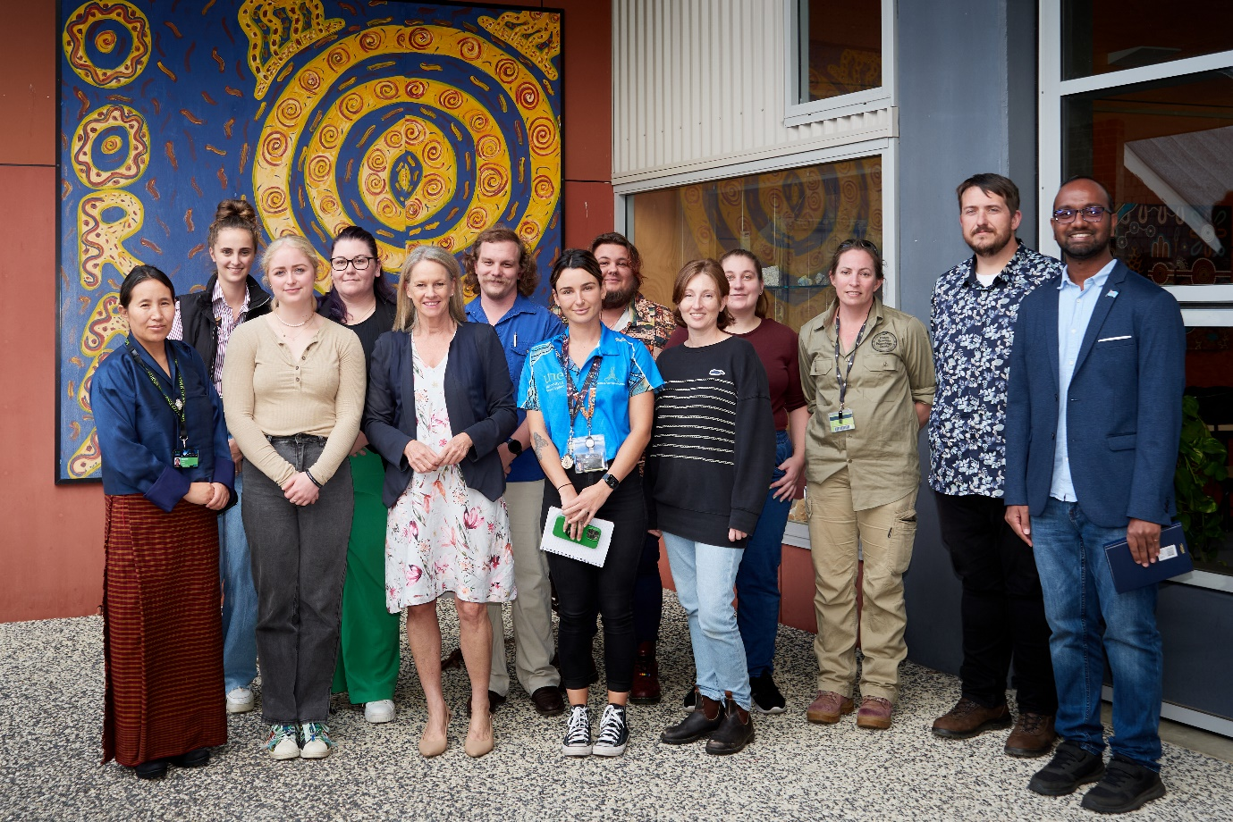  
Accord Panel member the Hon Fiona Nash with student representatives at University of New England*

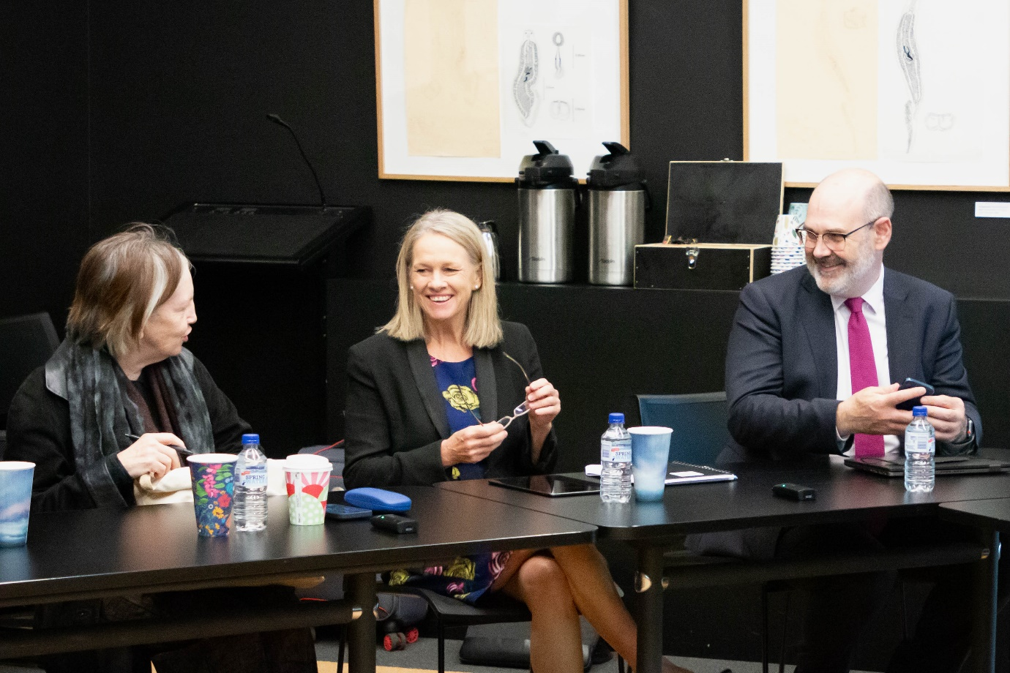*Professor Mary O’Kane, the Hon Fiona Nash and Professor Simon Evans in discussion in Armidale*

*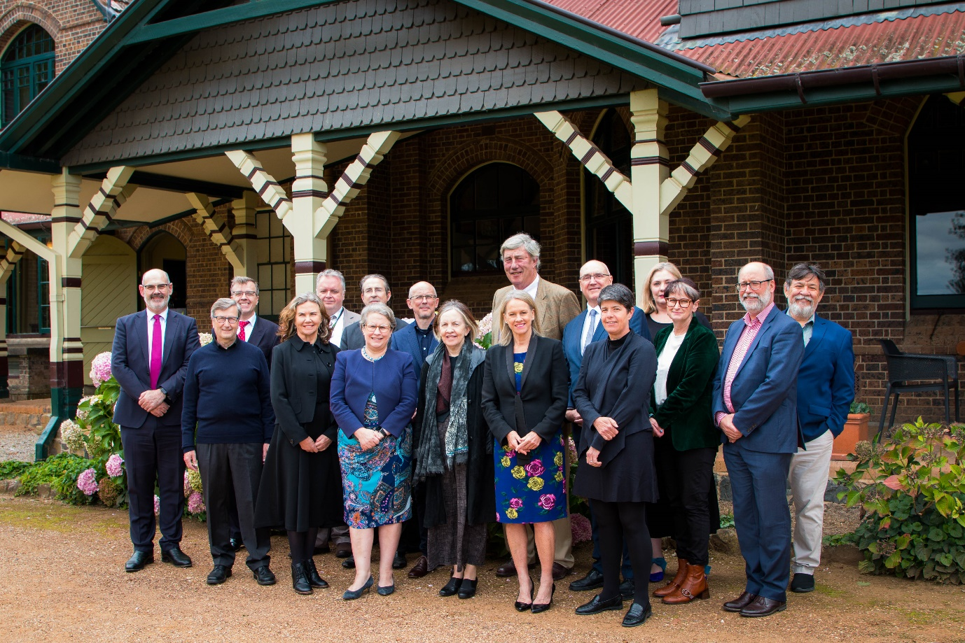  
University of New England leadership including Chancellor James Harris, and leadership of several regional universities with Accord Panel members*