


Job-ready Graduates
  - Preliminary paper

Title

With the exception of the Commonwealth Coat of Arms, the Department’s logo, any material protected by a trade mark and where otherwise noted all material presented in this document is provided under a Creative Commons Attribution 3.0 Australia licence.
The details of the relevant licence conditions are available on the Creative Commons website (accessible using the links provided) as is the full legal code for the CC BY 3.0 AU licence.
The document must be attributed as the Job-ready Graduates: Preliminary Paper.

Contents
Overview 4
Before the Job-ready Graduates package 5
Job-ready Graduates package 6
Increasing the number of graduates in areas of expected employment growth and demand 6
Lifting Attainment for Students in Regional Australia 10
Strengthening Industry Engagement 11

Overview
The JRG package was announced on 19 June 2020. The majority of measures in the package commenced on 1 January 2021. The reforms were the first major change to higher education funding rates since 2005 when the Commonwealth Grant Scheme (CGS) was introduced. The reforms centred on a redesign of the CGS funding clusters and student contribution (SCA) bands, with a rebalance of Commonwealth and student contributions. It included reductions in student contributions for some (priority) fields and increases in student contributions in other fields.
The cluster redesign enabled other reforms to be implemented.
- To accommodate increasing numbers of students, significant growth funding was introduced based on campus locations, while indexation for all CGS grant amounts was linked to the Consumer Price Index (CPI), ensuring funding maintains value over time.
- The package also allocated funding for additional student places in national priority fields.
- Universities were given more freedom to enrol students at the course levels they deem most appropriate, through the introduction of a “funding envelope”.
- A new industry engagement fund – the National Priorities and Industry Linkage Fund or NPILF – was introduced to encourage more engagement with industry and to better-prepare students for work in priority areas.
- Demand driven funding was restored for First Nations students from regional areas studying non-medical bachelor programs at table A universities.
Transitional arrangements included a funding guarantee (which guaranteed both full payment of CGS payments irrespective of enrolments and the use of pre-COVID indexation parameters) and a transition fund loading. These arrangements operate over the first three years of implementation (2021 to 2023), to ensure universities have time to adjust their operations in line with the new funding system. Grandfathering arrangements were also introduced to ensure that students that commenced prior to the introduction of JRG were not disadvantaged while finishing their course.
In addition to these changes, the package also introduced a range of student protection measures, including a requirement that students pass at least 50 per cent of their course in the first year. A seven-year limit (plus an allowance for long courses and lifelong learning) on a student eligibility for Commonwealth support was also introduced to encourage students to complete their degrees and enter the workforce.
While the JRG package was announced during the initial response to the COVID-19 pandemic and was intended to contribute to Australia’s economic recovery, it was not specifically designed as a response to the pandemic. Its objectives, as outlined at its announcement were to:
- increase the number of graduates in areas of expected employment growth and demand;
- lift educational attainment for students in regional Australia; and
- strengthen university relationships with business to drive workforce participation and productivity.

Before the Job-ready Graduates package
The majority of changes introduced as part of the JRG package were adjustments to higher education funding arrangements that previously existed. The package therefore needs to be considered within the context of the system that existed prior to its introduction.
Between 2012 and 2017, Australian public universities were funded based on bachelor student demand for study. The Demand Driven Funding System was ceased in the 2017-18 Mid-Year Economic and Fiscal Outlook (MYEFO).
Effective from 1 January 2018, non-designated (domestic non-medical bachelor places, which had previously been demand-driven) CGS funding for universities remained at the 2017 level, throughout 2018 and 2019. This pause in funding growth was implemented by setting a Maximum Basic Grant Amount (MBGA) for non-designated courses in the 2018 funding agreements between universities and the Commonwealth. Growth in non-designated CGS funding resumed in 2020, subject to universities meeting performance targets – the Performance-based funding (PBF) scheme.
Prior to JRG, growth funding from 2020 onwards was to be set at the rate of projected population growth for 18-64 year-olds (1.36 per cent in 2020), while CGS cluster rates continued to be indexed by CPI. This would lead to fewer places being “fully funded” by the MBGA over time if CPI grew faster than population. However, universities continued to receive the full student contribution for every student enrolled in a CSP, and universities maintained the ability to enrol as many students in CSPs as they wished. This meant that only CGS funding, not student places, was capped. Most universities continued to grow enrolments over this period.
Due to concerns over the impact of the COVID-19 pandemic on the sector, the Higher Education Relief Package (the relief package) was announced in April 2020. The relief package implemented a funding guarantee, which guaranteed CGS funding for higher education providers, regardless of any fall in student enrolments. The introduction of this guarantee meant the PBF scheme that was meant to commence in 2020 was essentially paused as all universities were guaranteed their full CGS funding.
To provide universities with more flexibility in the courses they could offer, funding agreements were adjusted to allow universities to move funding that had previously been specified for designated (sub-bachelor, postgraduate and medical) courses to support non-designated (non-medical bachelor) courses. The relief package also introduced support for online short courses (including the new award category of undergraduate certificates).

Job-ready Graduates package

Increasing the number of graduates in areas of expected employment growth and demand

Redesigning CGS Clusters and student contributions
At the centre of the reforms was redesign of the CGS cluster rates and student contributions, with the system simplified from eight CGS clusters and three SCA bands, to four clusters and four bands. The revised funding rates were intended to promote student enrolment in areas of high future employment growth and focus the Commonwealth’s subsidy on priority fields.
Table 1: New and old CGS and student contributions (2022 dollars)
 |  | CGS |  | SCA
Cluster | Field | New CGS Rate | Old CGS Rate |  | New SCA Rate | Old SCA Rate
1 | Management and Commerce | $1,109 | $2,257 |  | $14,630 | $11,457
1 | Law and Economics | $1,109 | $2,257 |  | $14,630 | $11,457
1 | Humanities | $1,109 | $6,282 |  | $14,630 | $6,865
1 | Other Society and Culture | $1,109 | $11,114 |  | $14,630 | $6,865
1 | Communications | $1,109 | $13,668 |  | $14,630 | $6,865
1 | Human Movement | $1,109 | $11,114 |  | $14,630 | $6,865
1 | Mixed Fields, Food and Hospitality | $1,109 | $2,257 |  | $14,630 | $11,457
2 | Clinical Psychology | $13,369 | $13,668 |  | $3,985 | $6,865
2 | Education | $13,369 | $11,565 |  | $3,985 | $6,865
2 | English | $13,369 | $6,282 |  | $3,985 | $6,865
2 | Mathematics | $13,369 | $11,114 |  | $3,985 | $9,785
2 | Prof Pathway Psych, Soc Work | $13,369 | $11,114 |  | $8,021 | $6,865
2 | Creative Arts | $13,369 | $13,668 |  | $8,021 | $6,865
2 | Architecture and Building | $13,369 | $11,114 |  | $8,021 | $9,785
2 | IT | $13,369 | $11,114 |  | $8,021 | $9,785
2 | Other Health | $13,369 | $11,114 |  | $8,021 | $9,785
2 | Allied Health | $13,369 | $13,668 |  | $8,021 | $9,785
3 | Foreign Languages | $16,396 | $13,668 |  | $3,985 | $6,865
3 | Nursing | $16,396 | $15,261 |  | $3,985 | $6,865
3 | Engineering | $16,396 | $19,433 |  | $8,021 | $9,785
3 | Environmental Studies | $16,396 | $24,666 |  | $8,021 | $9,785
3 | Medical Science | $16,396 | $24,666 |  | $8,021 | $11,457
3 | Other Science | $16,396 | $19,433 |  | $8,021 | $9,785
4 | Agriculture | $27,243 | $24,666 |  | $3,985 | $9,785
4 | Pathology | $27,243 | $24,666 |  | $8,021 | $9,785
4 | Medical Studies | $27,243 | $24,666 |  | $11,401 | $11,457
4 | Veterinary Science | $27,243 | $24,666 |  | $11,401 | $11,457
4 | Dental Studies | $27,243 | $24,666 |  | $11,401 | $11,457

In addition, the package also sought to more closely align base funding levels with the average measured expenditure on delivering courses, as determined through the Transparency in Higher Education Expenditure data collection (see Figure 1).

Additional CSPs for national priorities
One of the core objectives of JRG was to increase the number of students entering courses of national priority. The package included 12,000 National Priority Places (a single cohort) and, initially 300 commencing Innovative Places (ongoing) to be allocated for priority fields through a competitive process with commencing cohort sizes growing over time.
To provide retraining options and upskilling opportunities during the labour market disruptions of the COVID-19 pandemic, funding was provided in the 2020-21 Budget for 50,000 short course places (25,000 EFTSL) spread across universities and non-university higher education providers (NUHEPs). The short courses program was extended in April 2021 by providing a further 5,000 Commonwealth supported short courses for NUHEPs. Unspent funding in 2021 was rolled over to 2022 as part of MYEFO 2021-22.

The Funding Envelope
To support universities to offer places at the sub-bachelor, bachelor and postgraduate coursework levels that are appropriate for their student cohorts and communities, the concept of a ‘funding envelope’ was continued through the implementation of a new MBGA for Higher Education Courses (a funding envelope or HEC MBGA). This provides universities with greater flexibility to choose their CSP composition, allowing them to offer any mix of courses, by field and course level. Medical places are excluded from these arrangements and continue to be allocated by the Government and funded through an MBGA for designated higher education courses.
In addition, the introduction of the funding envelope also reinstated CPI indexation of all MBGAs. As CGS cluster rates are also indexed by CPI each year, this ensures there is no reduction in the number of places that a university’s MBGA supports due to different indexation factors.

Transition funding
Transition Fund Loading (TFL) was introduced to support universities transition to the new funding arrangements from 2021 to 2023. It compensates for base funding (Commonwealth plus student contributions) and changes to the Higher Education Participation and Partnerships Program (HEPPP) by comparing the base funding a university would have received had JRG not been introduced to the base funding a university receives after the implementation of JRG (including the impact of grandfathering of students).

Figure 1: Student contributions, Commonwealth contributions, and expenditure on teaching and scholarship ($2022; 2020 cost data, 2020 student data)
Previous system | JRG reforms
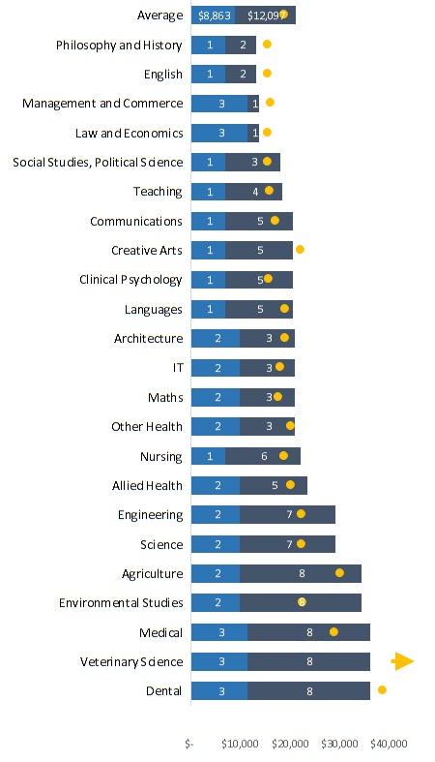 | 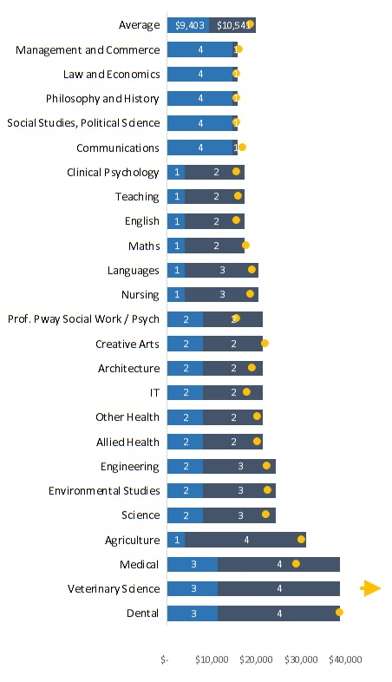

Funding Guarantees
To provide certainty to universities during the transition to the new arrangements and to support recovery from the pandemic, the JRG package guaranteed CGS funding to providers through the Higher Education Continuity Guarantee (HECG), implemented through the Other Grants Guidelines. This was similar to the 2020 CGS guarantee that provided certainty for universities during the pandemic (the Higher Education Relief Program). HECG applies from 2021 to 2023 and guarantees funding for universities at the level of their HEC MBGA, Designated MBGA, medical loading, Performance-based funding (PBF) and TFL (excluding short courses, national priority place and innovative place funding), regardless of the level of enrolments.
In addition, it was also guaranteed that university MBGAs (excluding funding associated with short courses, national priority places and innovative places) would be indexed using pre-COVID economic parameters. This policy was introduced to ensure the projected reduction in CPI caused by COVID would not negatively affect university funding.
A CGS funding floor (enacted in HESA section 30-27) was also introduced to limit any possible reduction to universities’ HEC MBGAs, such that they cannot be less than the HEC MBGA of the year prior in years after 2024. Prior to 2024, and to allow for the progressive reduction of university MBGAs through the transition phase of the JRG, a universities’ HEC MBGA cannot be less than an amount set out in the CGS Guidelines.
Note that due to the implementation of the HECG, the PBF introduced at the time of the 2017 funding freeze is effectively inoperable through 2023 due to the interaction with the HECG. Some commentators have also noted the potential interaction of the PBF with the funding floor, should universities not receive their full PBF amount.

Student Protection
To encourage universities to properly assess students’ abilities to study and reduce the risk of students amassing significant HELP debts for study they are unable to complete, several student protection measures were introduced:
- only provide access to Commonwealth assistance to people assessed as being ‘genuine students’
- ensure students have been assessed as academically suitable for their course
- require students to maintain a reasonable (50 per cent) completion rate whilst accessing Commonwealth assistance (a requirement introduced for students at non-universities higher education providers since 2018) for a course, allowing for Commonwealth assistance to continue for students who change course or who have been significantly affected by circumstances out of their control
- place a limit on the amount of concurrent study that a student can enrol in
- protect students from being pursued for study debts if the debt has resulted from their provider not being compliant with legislation
- extend the Government’s ability to audit providers for compliance to all providers, and
- support providers to operate utilising best practice marketing and enrolment practices.
All of the above changes commenced on 1 January 2021, except for the requirement that students maintain a reasonable completion rate, which commenced on 1 January 2022.

Student Learning Entitlement
Introduced as an amendment during the passage of the reforms through Parliament, the Student Learning Entitlement (SLE) provides students enrolled in a CSP with 7 EFTSL of subsidised study. Students can also accrue Additional and Lifelong SLE that increases the EFTSL they can undertake in a CSP.
Commencing from 1 January 2022, the SLE was intended to encourage students to complete their degrees and enter the workforce.

HELP Loan Changes:
The JRG package provided for a reduction in the FEE-HELP loan fee for undergraduate students from 25 per cent to 20 per cent from 1 July 2021. An extension of the FEE-HELP loan fee exemption that was instituted in the previous Budget for COVID relief provided that no loan fee was incurred until after 1 January 2022. Also, a provision was added for students who use HECS-HELP, whereby they can make upfront payments towards their tuition fees to reduce their overall loan by 10 per cent.

Lifting Attainment for Students in Regional Australia

Additional Places Growth Funding
To support growth of universities in regional areas and metropolitan areas with high population growth, universities are provided with additional funding determined by distribution of their student cohort across campuses and regionality. The campus type delineations and funding growth rates are regional (3.5%), high-growth metropolitan (2.5%) and low-growth metropolitan (1.0%).
The distinction between high-growth and low-growth metropolitan campuses is determined using population projections from the Australian Institute of Health and Welfare, and the most recent Australian Statistical and Geography Standard (ASGS) to determine campus regionality. Any campus located in a metropolitan Statistical Area 4 (SA4) that has a higher-than-average population growth is classified as a high-growth metropolitan campus. A campus is considered regional if the SA4 it is located within is classified as regional under the ASGS.
Growth rates are applied to the bachelor component of universities’ HEC MBGAs (formerly the non-designated MBGA). Growth is tapered in, so that funding for commencing cohorts grow at the relevant rates, with full growth rates applying from 2024.

Indigenous, Regional, and Low SES Attainment Fund (IRLSAF)
Prior to the JRG package, there were several programs designed to help support students from under-represented cohorts. To simplify funding arrangements, several of these were merged under a single program, the Indigenous, Regional, and Low SES Attainment Fund (IRLSAF).
The IRLSAF combined the HEPPP, regional loading, enabling loading and relevant elements of the National Institutes Grant. Funding for these programs is being distributed according to existing policy guidelines until 2023, meaning initially the programs contained in IRLSAF continue to operate as they did before.
The exception to this is the HEPPP. Changes were made to HEPPP to expand eligibility beyond the previous low-socioeconomic focus to also include First Nations and regional students. The changes from the previous formula (100 per cent low-SES) to the new formula (45 per cent low-SES, 45 per cent regional and 10 per cent First Nations) phase in over three years.

Regional First Nations Demand Driven Funding
To help increase higher educational attainment rates for First Nations students located in regional and remote areas, the JRG package reinstated demand driven funding for First Nations students from regional or remote areas studying non-medical bachelor level courses at Table A universities.

Regional Education Commissioner
As part of the JRG reforms, and in response to the Napthine Review, on 6 December 2021, the Hon Fiona Nash was appointed as the inaugural Regional Education Commissioner (the Commissioner). The Commissioner oversees and coordinates efforts to reduce the disparity between metropolitan and regional students. In doing so, the Commissioner brings a national focus and direction to regional and remote education, working with stakeholders and governments to explore opportunities for people in rural, regional and remote Australia.

Relocation Equity Measures
To help ease barriers for relocating students, the JRG package introduced the Tertiary Access Payment (TAP). The TAP initially provided a one-off $5,000 payment for remote and outer regional school leavers commencing full-time study in higher education to put towards their additional cost of study and relocation. In late 2021 the TAP was expanded to also include inner regional students who receive a one-off $3,000 payment. In, addition, to further support relocated and other disadvantaged students with their costs of transportation, any student who is eligible for Youth Allowance or the Pensioner Education Supplement had their fare allowance increased.

Additional support for Regional University Centres
The package provided $21 million to expand and strengthen the Regional University Centre (RUC) program. This included funding for:
- establishing up to eight additional Centres to further support regional and remote students who remain in their local communities
- implementing a network and central support for all Centres
- an evaluation of the program to inform improvements to the program and RUC governance and operation
- undertaking a research project on Centre partnerships and how to best support them, particularly Centre-university partnerships
- a scoping study to inform the location and selection of future Centres

Enhancing research capacity of regional universities
Announced as part of the JRG package, the Regional Research Collaboration Program responds to Recommendation 6 of the Napthine Review. Funding is provided for research collaboration between regional universities, industry and other higher education providers and aims to improve regional research capacity by realising the challenges associated with undertaking research in regional areas.

Strengthening Industry Engagement

National Priorities and Industry Linkage Fund (NPILF)
The JRG package sought to strengthen the relationship between industry and the higher education sector through the establishment of the NPILF. The NPILF provides funding for Table A universities to create contemporary and ongoing partnerships with industry which foster collaboration across teaching and research. It focuses on three priorities, namely increasing work integrated learning opportunities (WIL) and approaches, increasing STEM-skilled graduates and their employment outcomes, and supporting partnerships between universities and industry.
Funding for the NPILF is allocated tri-annually via a tiered structure, based on student enrolment/load. A test/learning year for the NPILF model began in 2021, the pilot commencing in 2022, with an end date in 2024.

Work experience in industry
The JRG Bill amended HESA to allow CGS funding for certain Work Experience in Industry units, which had previously been ineligible for subsidy. This change is intended to provide more incentive for universities to offer students meaningful internship experiences as part of their courses.

Industry 4.0 Advanced Apprenticeship Pilot
The Advanced Apprenticeships (Industry 4.0) pilot targets small to medium sized businesses in key manufacturing industries. It aims to upskill, retrain, and reskill their employees to enhance their capabilities in the workplace and provides them with free and open access to advanced tools and facilities to improve their skills in Industry 4.0 technologies.
Students participating in Advanced Apprenticeship (Industry 4.0) pilots can enrol in a range of qualification types within an applied technology Industry 4.0 pathway, including Diplomas and Associate Degrees. The flexible pilot design accommodates less than full-time study loads to allow students to balance work and study where required.
There are currently six universities participating in the Advanced Apprenticeships (Industry 4.0) pilot, Swinburne University of Technology, University of Technology Sydney, University of Tasmania, RMIT University, the University of Western Australia and University of South Australia.

The Hon Dan Tehan MP, “Minister for Education Dan Tehan National Press Club address,” 19 June 2020. https://ministers.dese.gov.au/tehan/minister-education-dan-tehan-national-press-club-address

