


Submissions on priorities for the Australian Universities Accord
  - Prepared by Nous Group

Disclaimer:
Nous Group (Nous) has prepared this report for the benefit of the Department of Education (the Client).
The report should not be used or relied upon for any purpose other than as an expression of the conclusions and recommendations of Nous to the Client as to the matters within the scope of the report. Nous and its officers and employees expressly disclaim any liability to any person other than the Client who relies or purports to rely on the report for any other purpose.
Nous has prepared the report with care and diligence. The conclusions and recommendations given by Nous in the report are given in good faith and in the reasonable belief that they are correct and not misleading. The report has been prepared by Nous based on information provided by the Client and by other persons. Nous has relied on that information and has not independently verified or audited that information.
© Nous Group
The extracts quoted throughout this report were selected by Nous to highlight key themes raised across all submissions.

Contents
Executive summary 5
Number of submissions from each category 8
Top 5 subthemes referenced by each submitter group 9
Term of Reference 1: Meeting Australia’s knowledge and skills needs, now and in the future 15
Responsiveness to future skills needs 15
Lifelong learning 20
Industry engagement 23
Supply of graduates 25
International student work rights and migration 28
Student demand for higher education 30
Terms of Reference 2: Access and Opportunity 34
Improving access to higher education 34
Improving outcomes for equity cohorts 37
Diversity across higher education 40
Population-level attainment 42
Term of Reference 3: Investment and affordability 45
Funding for research 46
Funding for teaching and learning 49
Job-ready Graduates Package 52
Student fees and contributions 55
Student cost of living 57
Total Commonwealth investment in higher education 60
Infrastructure funding 62
Term of Reference 4: Governance, accountability and community 64
Regulatory and legislative frameworks 64
Purpose of the higher education sector 68
Accountability and reporting 72
Workforce and workplace relations 75
Institutional diversity 77
Institutional governance 81
Academic freedom 84
Term of Reference 5: The connection between the vocational education and training and higher education systems 86
Regulatory, funding and legislative arrangements 87
Pathways between sectors 91
Dual sector providers 94
Term of Reference 6: Quality and sustainability 96
International education 97
Student experience 101
Impacts of COVID-19 on the higher education sector 105
Term of Reference 7: Delivering new knowledge, innovation and capability 108
Research collaboration and industry linkages 109
National priorities for research 110
Research assessment and quality 112
Research commercialisation and translation 113
Research training 115
Research Workforce 117

Executive summary
The Australian Universities Accord (Universities Accord) provides an opportunity to review the entire higher education system with the intention of delivering lasting and transformative reform. To inform what the Universities Accord should prioritise the Department of Education (the department) requested submissions from the public. The department engaged Nous Group (Nous) to conduct a rapid analysis of these submissions and to communicate the key insights.
The department received 185 submissions on the priorities for the Universities Accord. In collaboration with the department, Nous identified 36 subthemes which categorised key ideas within each Term of Reference (see Table 1). Nous used a combination of thematic analysis to identify themes and priorities and matrix analysis to tease out relationships and links between variables and concepts. This process included a review of each submission, categorising sections within each submission against the relevant subthemes. A snapshot of the total references for each subtheme was then generated to demonstrate which ideas came up most commonly in the submissions (see Figure 1).
The Universities Accord received submissions from a broad range of interested organisations and individuals with suggestions for priorities for the review to address. The largest group of submissions was received from universities (33 submissions) and unaffiliated individuals (24). For a full breakdown of submissions please refer to Figure 2| Distribution of submissions by category.
The submissions received referenced a wide range of topics, identifying areas for improvement within the higher education sector and providing recommendations for the panel to consider. This report provides a summary of the key ideas captured in the submissions. Some of the common priorities referenced included:
- Improving access to the higher education system, particularly for underrepresented cohorts and identifying programs to improve student outcomes.
- Reviewing the current higher education funding model to ensure it supports the long-term success of teaching, learning and research, in line with national priorities.
- Investigating the regulatory arrangements which govern the higher education system
- Reviewing how the institutions within the higher education sector interact with each other, the Vocational Education and Training (VET) sector and industry to deliver the skills needs of the future.
The report below is divided into the Term of References with each subtheme called out as an individual topic. Each subtheme section identifies the top submitter categories and discusses the key ideas raised in the submissions.

Table 1| Terms of Reference and subthemes used in submission analysis
Term of Reference | Subtheme
1. Meeting Australia’s knowledge and skills needs, now and into the future | Industry engagement
 | International student work rights and migration
 | Lifelong learning
 | Responsiveness to future skills needs
 | Student demand for higher education
 | Supply of graduates
2. Access and opportunity | Diversity across higher education
2. Access and opportunity | Improving access to higher education
2. Access and opportunity | Improving outcomes for equity cohorts
2. Access and opportunity | Population-level attainment
3. Investment and affordability | Funding for research
3. Investment and affordability | Funding for teaching and learning
3. Investment and affordability | HELP loans
3. Investment and affordability | Infrastructure funding
3. Investment and affordability | Job-ready Graduates package
3. Investment and affordability | Student cost of living
3. Investment and affordability | Student fees and contribution amounts
3. Investment and affordability | Student protections
3. Investment and affordability | Commonwealth investment
4. Governance, accountability and community | Academic freedom
4. Governance, accountability and community | Accountability and reporting
4. Governance, accountability and community | Purpose of the higher education system
4. Governance, accountability and community | Institutional diversity
4. Governance, accountability and community | Institutional governance
4. Governance, accountability and community | Regulatory and legislative frameworks
4. Governance, accountability and community | Workforce and workplace relations settings
5. The connection between the vocational education and training and higher education systems | Dual sector providers
 | Regulatory, funding and legislative arrangements
 | Pathways between sectors
6. Quality and sustainability | Impacts of Covid-19 on the higher education sector
6. Quality and sustainability | International education
6. Quality and sustainability | Student experience
7. Delivering new knowledge, innovation and capability | National priorities for research
7. Delivering new knowledge, innovation and capability | Research assessment and quality
7. Delivering new knowledge, innovation and capability | Research collaboration and industry linkages
7. Delivering new knowledge, innovation and capability | Research commercialisation & translation
7. Delivering new knowledge, innovation and capability | Research training
7. Delivering new knowledge, innovation and capability | Research workforce

Figure 1| Distribution of submissions across Terms of Reference
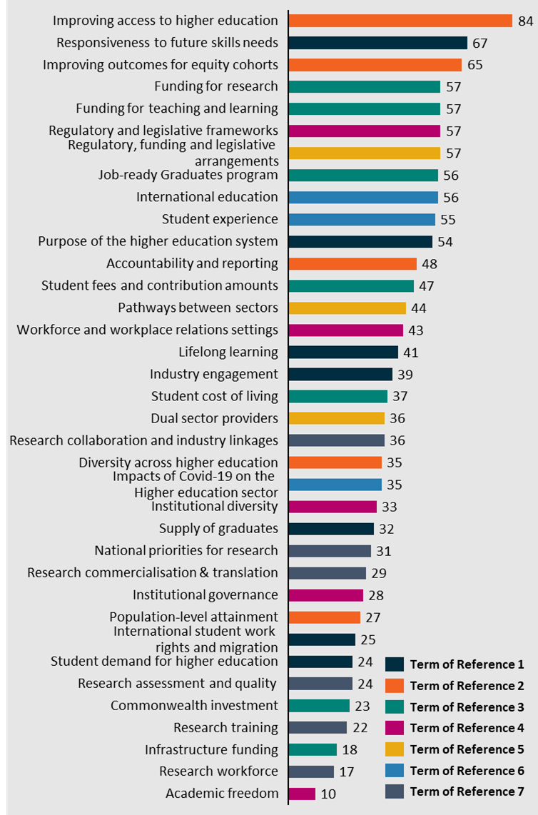

Number of submissions from each category
The 185 submissions have been broken down into the categories distributed below.
Figure 2| Distribution of submissions by category
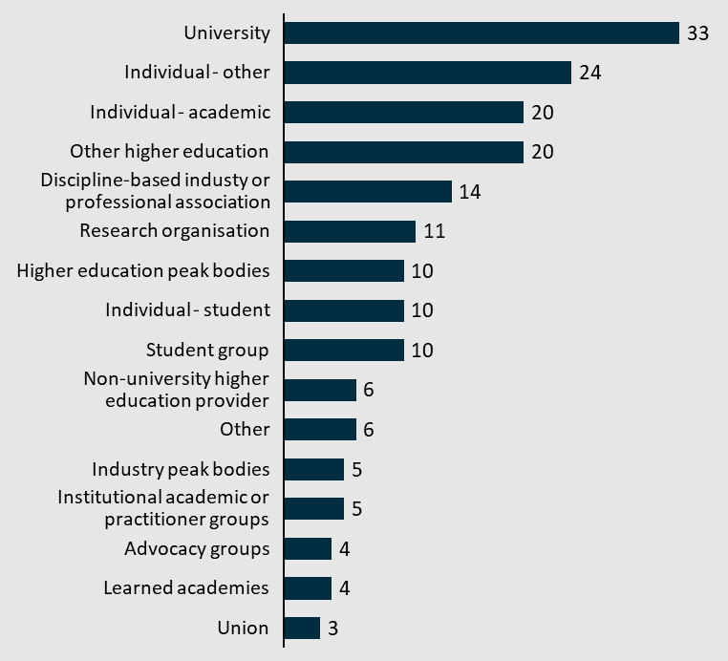

Top 5 subthemes referenced by each submitter group
Figure 3| Top 5 subthemes referenced by University (n=33)
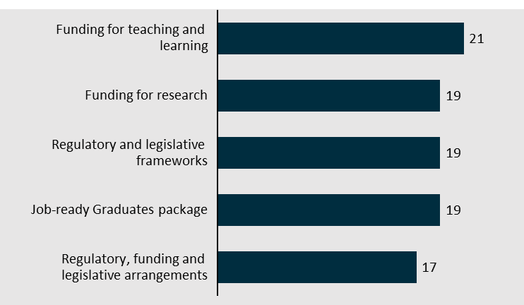
Figure 4| Top 5 subthemes referenced by Individual - other (n=24)
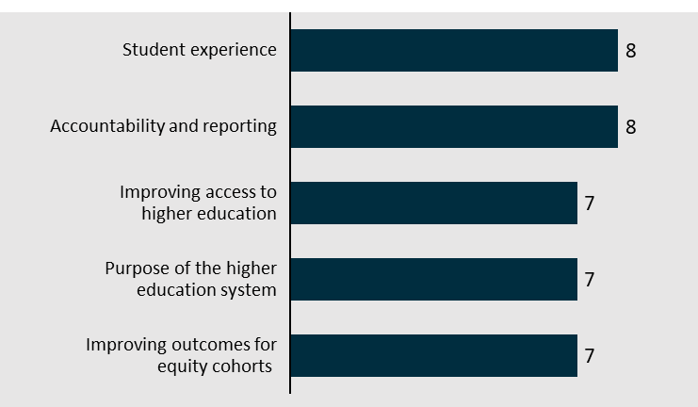
Figure 5| Top 5 subthemes referenced by Individual - academic (n=20)
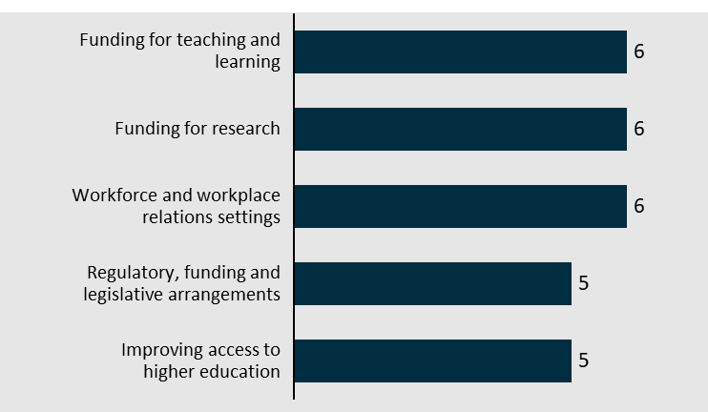
Figure 6| Top 5 subthemes referenced by Other higher education (n=20)
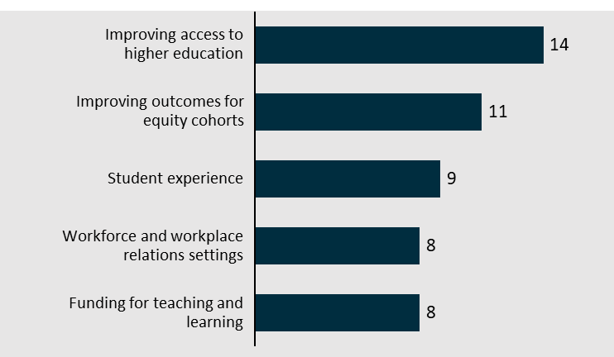
Figure 7| Top 5 subthemes referenced by Discipline-based industry or professional association (n=14)
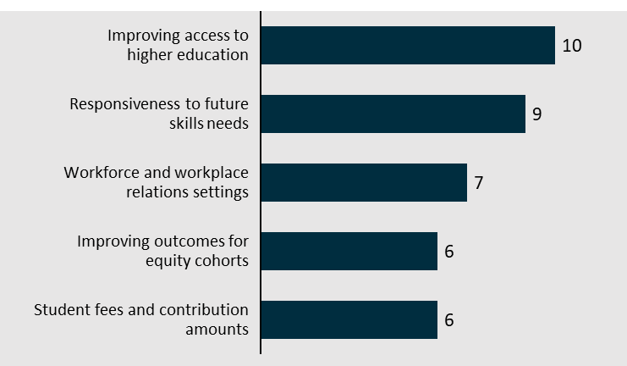
Figure 8| Top 5 subthemes referenced by Research organisations (n=11)
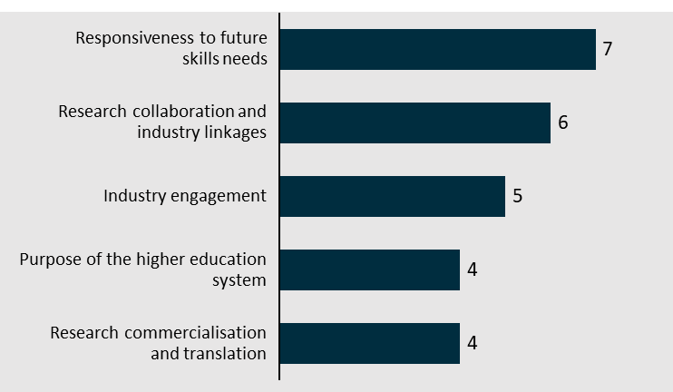
Figure 9| Top 5 subthemes referenced by Individual - student (n=10)
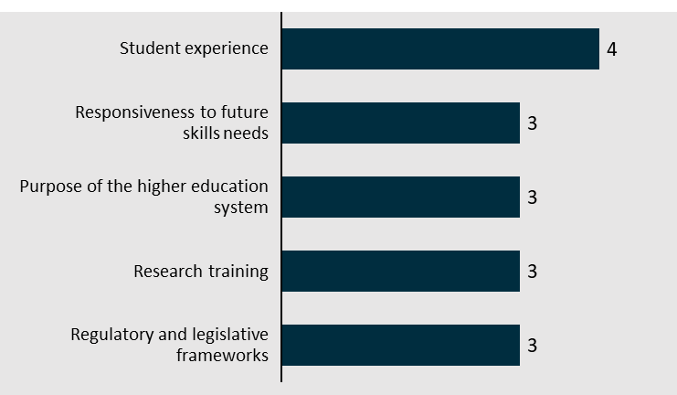
Figure 10| Top 5 subthemes referenced by Student group (n=10)
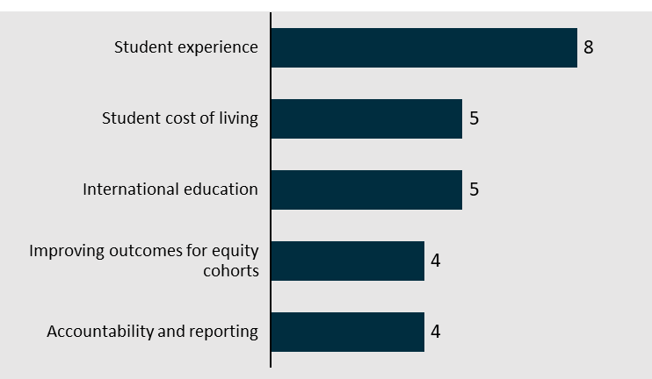
Figure 11| Top 5 subthemes referenced by Higher education peak bodies (n=10)
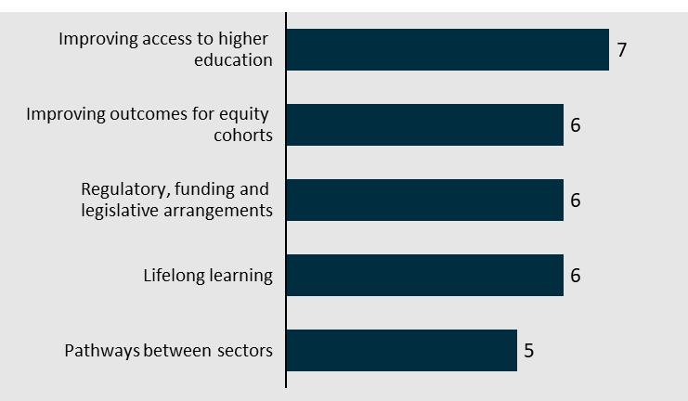
Figure 12| Top 5 subthemes referenced by Non-university higher education providers (n=6)
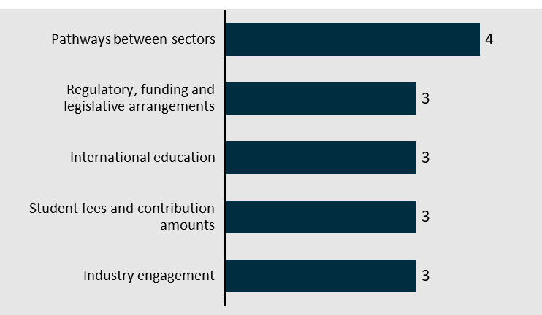
Figure 13|Top 5 subthemes referenced by Other groups (n=6)
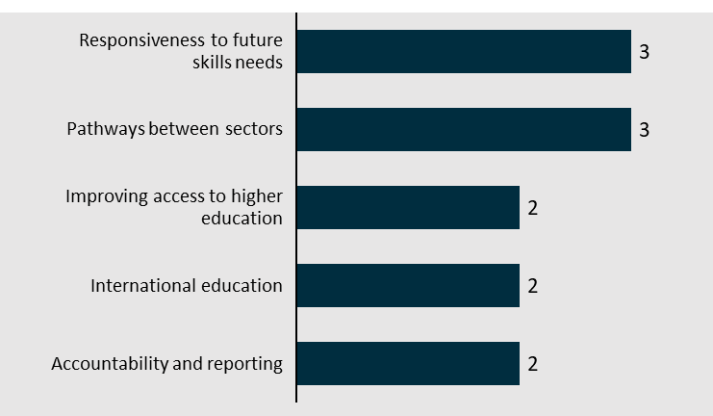
Figure 14| Top 5 subthemes referenced by Industry peak bodies (n=5)
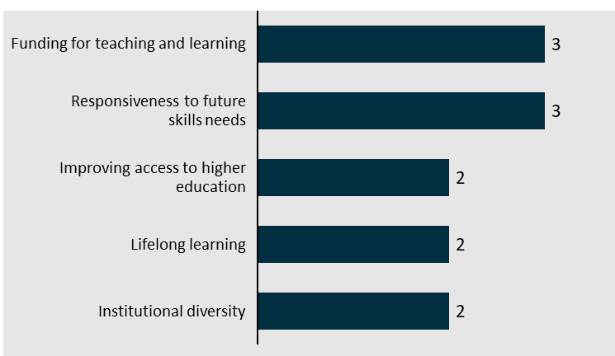
Figure 15| Top 5 subthemes referenced by Institutional academic or practitioner groups (n=5)
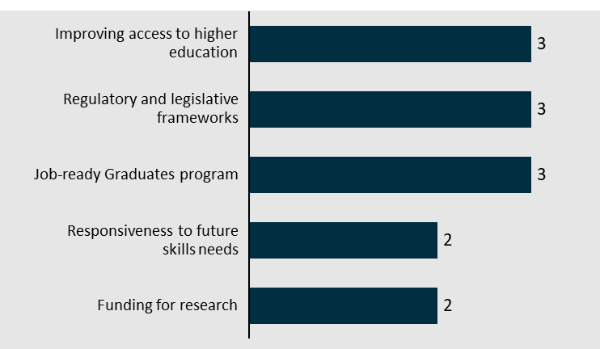
Figure 16| Top 5 subthemes referenced by Learned academies (n=4)
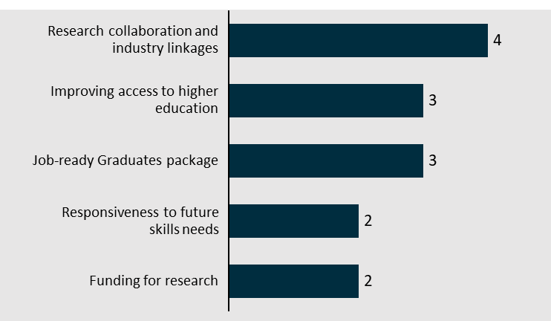
Figure 17| Top 5 subthemes referenced by Advocacy groups (n=3)
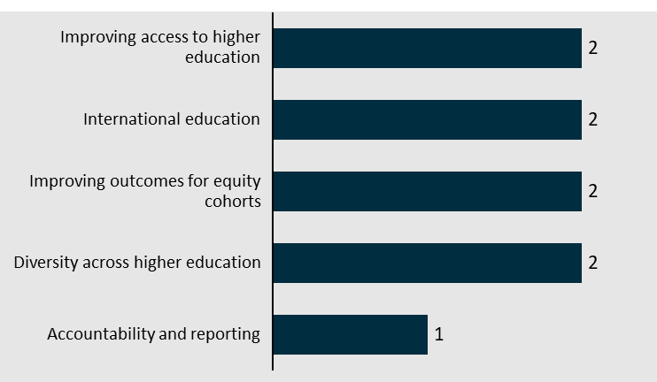

Figure 18| Top 5 subthemes referenced by Unions (n=3)
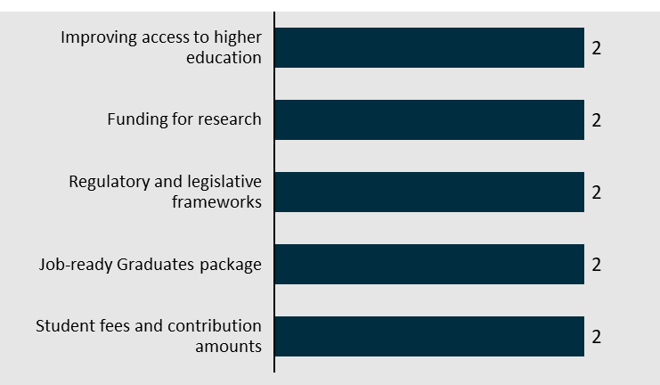

Term of Reference 1: Meeting Australia’s knowledge and skills needs, now and in the future
Enhance the delivery of quality education that meets the needs of students across all stages of lifelong learning and develops the skills needed now, and in the future.
This will include recommendations for new targets and reforms recognising that more than nine in ten new jobs will require post-school qualifications, and fifty per cent of new jobs are expected to require a bachelor’s degree or higher.
Submitters to Term of Reference 1 focussed their submissions on how the higher education system can be responsive in developing the skills of the future. This included discussions about supporting lifelong learning, engaging with industry to understand their needs, ensuring there is sufficient supply of graduates and workers and demand for the higher education system.
Figure 19| Distribution of submissions across Term of Reference 1 subthemes
1.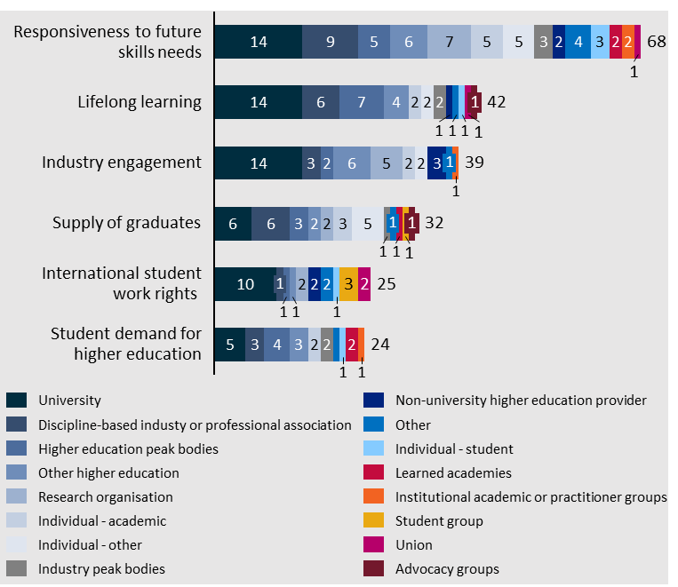

Responsiveness to future skills needs
Submissions addressing this subtheme addressed diverse future skills, current pedagogical frameworks and understandings of workforce needs.
‘Responsiveness to future skills needs’ was referenced in 37% of the submissions (68 total) made to the Universities Accord.
Figure 20| Distribution of submissions which reference subtheme 'Responsiveness to future skills needs'
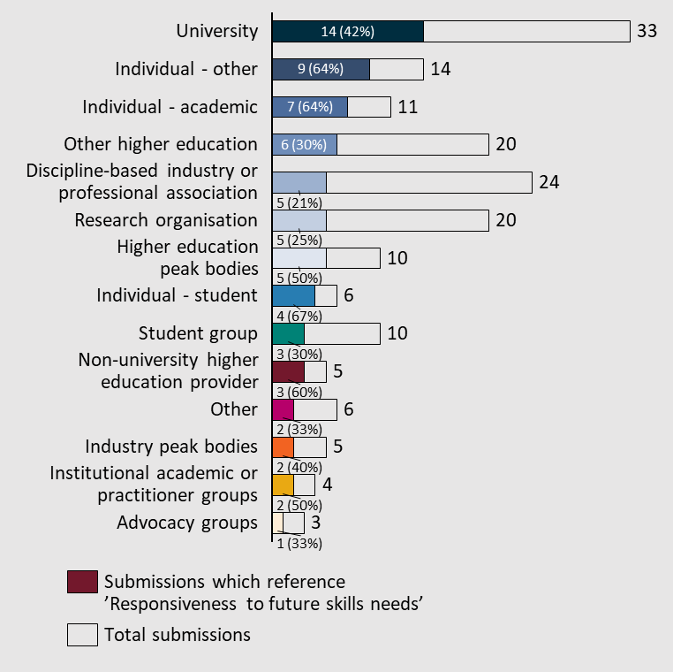

There are mixed views on the extent to which STEM and ‘hard’ skills are prioritised in higher education settings compared to arts and ‘soft’ skills
Views were mixed regarding the balance between emphasising STEM and the arts, equipping hard and soft skills respectively, across the sector. Some stakeholders felt there is too much funding, attention and resources for STEM – while others felt there is too little. Others avoided such a dichotomy by speaking generally about the importance of a particular set of (particularly ‘soft’) skills. Perspectives broadly reflected the interests and foci of submitters’ institutions.
“The growing demand for highly skilled workers across Australia is clear, particularly in STEM fields such as engineering, where there is a current and growing skills crisis... To develop Australia’s technology-powered, human-centred future, it is critical that we unlock the full potential of our future workforce.” – The Australian Academy of Technological Science and Engineering
“[An] area of pressing skills shortages… is for data and digital skills. Demand is outstripping the supply of skills in automation, AI, data analytics and cyber security. If Australia can better meet the demand for these skills, it opens up new opportunities, as data and digital skills are amongst the fast growing emerging skills, they are transferrable across a range of occupations and sectors and are core to solving some of our biggest problems.” – Chartered Accountants Australia and New Zealand
“… addressing the skills shortages in STEM alone may not yield the much sought-after productivity and growth outcomes. Skills derived from knowledge and practice in the social sciences and humanities are important for developing management, business, and soft skills.” – Anonymous
“Creative skills, requiring original thought and innovation, are particularly resistant and are likely to face relatively higher demand in the future.” – National Association for the Visual Arts (NAVA)
The University of Canberra also proposed a potential program to support students developing the soft skills required in the future.
“A similar scheme [to the NPILF program] could be explored whereby higher education qualifications can demonstrate that students acquire a minimum ‘soft-skills threshold’ such that they can solve complex problems, develop critical thinking and creativity.” – University of Canberra

Some submissions encouraged interdisciplinary and multidisciplinary teaching and research to better meet future skills needs
Referencing current and future challenges, a multidisciplinary, interdisciplinary and cohesive approach to knowledge acquisition and transmission, and skill development, was encouraged.
“Students graduate into a transdisciplinary world not a monodisciplinary one… Yet many universities and colleges still tend to have structures, curricula and assessment approaches that operate in isolation from each other and emphasise specific disciplinary knowledge, skills and boundaries.” – Emeritus Professor Geoff Scott
“Australia must adapt to a changing climate as well as to emerging green technologies, an escalating health imperative, geopolitical shifts, digitisation and an ‘explosion’ in artificial intelligence, and public demand for new forms of governance. If Australia is to respond effectively to these challenges, universities must play a central role. Therefore, we would propose that an overarching theme of the Review should be to establish the contribution of Australia’s universities not just to labour market outcomes but to the shaping of Australia’s future and especially to establishing a trajectory of sustainable economic prosperity for the nation.” – Macquarie University

Skills and knowledge to ensure sustainable development were emphasised in several submissions
In line with Australia’s decarbonisation agenda and net zero efforts, some submissions discussed the importance of education that can equip Australians with the skills and knowledge necessary to ensure a sustainable and prosperous future.
“Skilled professionals are also needed to enable organisations to respond to increasing stakeholder demand for sustainability-related disclosures, as well as the assurance of these disclosures. And accounting, audit and finance professionals have a significant role to play in supporting climate change mitigation and adaptation efforts… currently, there is an ongoing and critical shortage of these professionals in Australia, and also globally. Skilled migration may be able to provide an immediate solution to this shortage, particularly while domestic talent develops, acknowledging however that Australia will be competing with other jurisdictions for these skillsets.” – Chartered Accounts Australia and New Zealand
“I believe it is of the utmost importance that we support future climate researchers, as climate scientists (and indeed scientists generally) will have a critical role in shaping our transition into a zero-carbon future and in providing risk and hazard information (such as for climate disasters) that will greatly impact Australians.” – Anonymous
“Graduates also need to be equipped with the knowledge and skills to create positive social and environmental impact in the world, whether through waged employment or otherwise. Universities should be incentivised to foster these future-oriented graduate capabilities through their education programs.” – Dr. Giedre Kligyte
“There are gaps in the scope of, renewable energy science and engineering education available in Australia… I advocate that Australian universities should offer more renewable energy degrees and in particular that some degrees be offered completely online so that to expedite the transition experienced professionals are facilitated to study part time whilst continuing to work in their current job.” – Anonymous

Institutions operating in rural, regional and remote areas emphasised the important role local universities play in equipping local residents with skills for the future
Based on these submissions, universities are seen as critical centres of learning and research core to developing the skills and knowledge to drive positive outcomes in the regions.
“The regions are, with limited exceptions, dying and outer regions beyond the commuter belt are dying more quickly as small towns die and send populations to the nearest bigger town, e.g., Horsham. Then those towns slowly die. Most employment ends up being Government supporting inter-generational dependency. Regional, targeted skills and transition plans could go some way to addressing this.” – Federation University

“We feel there is a need for regional universities to provide a comprehensive range of course offerings, both at regional campuses and through online delivery (supported by local campuses), to assist with the development of a sustainable workforce pipeline now and into the future. Cairns, like other regions in Australia, is in the grip of massive professional skills shortages from Engineers and Architects to health professionals and accountants. Cairns is also on the cusp massive expansion in the maritime industry, with a pipeline of technical and professional skill requirements that cannot be met without an increase in local university graduates.” – Regional Development Australia Tropical North Inc.
“[We recommend] that the Accord recognises the vital role of regional universities in the equity agenda, in addressing skills shortages and for serving the communities in which they operate.”- University of Wollongong

Socioeconomic changes require students to be prepared for evolving workforce dynamics
Several submissions discussed workforce changes as they relate to skills needs and the need for university courses and training modules to adapt and prepare students accordingly. Changes in student demand for particular career paths, as well as heightened demand for data and technical skills, were prominent issues raised. Professional accreditation and commercial representative bodies shed further insight in light of these workforce changes.
“Other accounting and finance jobs are changing. CA ANZ research predicts nearly half (48 percent) will require reskilling. While titles may remain unchanged, expectations regarding tasks performed will not. For instance, higher emphasis on cognitive abilities and data skills have become a critical element of new and reshaped accounting roles. Indeed, to be more ‘future-proof’ both the accounting workforce and individuals need to augment their technical skills with the ability to be flexible, innovative, and adaptive to maintain resilience in the face of significant turbulence.” – Chartered Accountants Australia and New Zealand
“Previous expansions of medical school places without factoring community and medical workforce needs have led to an unsustainable medical workforce. There is now a bottleneck into vocational medical training places and intense competition into these training places between unaccredited service registrars due to the increased number of doctors in training within the Australian medical system. University medical schools receiving Commonwealth Supported Places (CSPs) funding must be accountable for delivering and addressing community and medical workforce needs.” – Australian Medical Association
“Of particular concern, only 15% of graduating medical students are interested in a career in General Practice. Modelling has suggested that by 2032, we will have a shortfall of over 10,000 GP’s.” – Australian Medical Students’ Association (AMSA)
“Workplace settings - consider how Australian universities can have workplace settings that provide staff with high quality, secure jobs and also enable universities to rapidly develop and deliver new content and innovations to respond to fluctuating industry and skills needs.” – University of Newcastle

Lifelong learning
Establishing the policy and funding measures to ensure that microcredentials can deliver social and educational outcomes for students across the spectrum of learning journeys was a common topic occurring under lifelong learning. This included discussion of provisions for mature-age students to have their lived-experience in industry formally recognised in future learning.
‘Lifelong learning’ was referenced in 23% of the submissions (41 total) made to the Universities Accord.
Figure 21| Distribution of submissions which reference subtheme 'Lifelong learning'
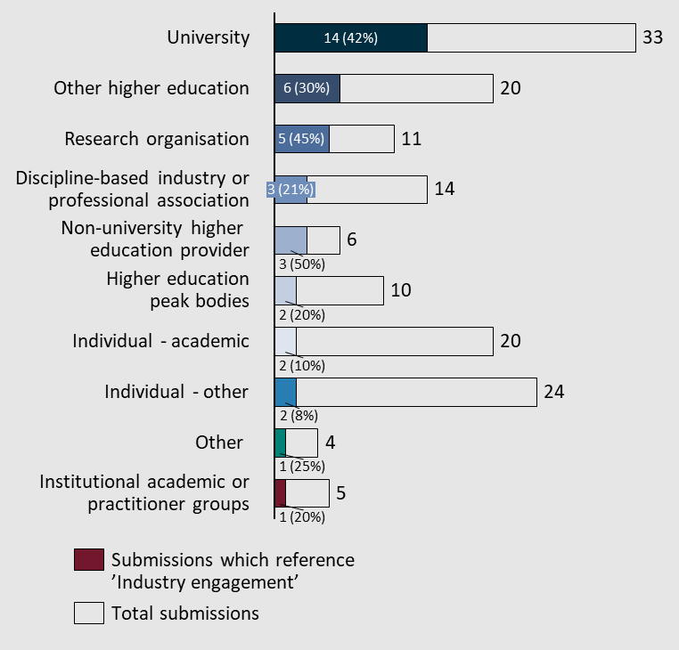

Use of lifelong learning qualifications necessitates a clear and accessible funding structure
Expanding existing government funding provisions, including Commonwealth Grants Scheme (CGS) and Higher Education Loan Program (HELP), to support the uptake of short courses and microcredentials were common recommendations to the review. This included ensuring that individuals who have reached their HELP loan limit will still be able to access further study in a financially responsible way.
“Consideration should be given to the role that government plays in [lifelong learning qualifications] funding, and ensuring they are widely and appropriate available to meet demand.” – UNSW Sydney
“… Applicability and linking of CGS and HECS to facilitate life-long learning for all Australians through our HE institutions – not only through registration in traditional AQF defined programs.” – University of South Australia
“Provide lifelong learning entitlements that learners can draw upon over their lifetimes to fund their continuous learning and credentialing approved with an expanded AQF.” – Chartered Accountants Australia & New Zealand
“If these courses are considered important pathways into Award courses, they should be funded on an ongoing basis and incorporated into the MBGA [Maximum Basic Grant Allowance].” – Curtin University

Establish policy frameworks which reflect trends in participation and enable re-engagement of learners throughout all stages of life
Current policy frameworks were noted as being prohibitive to the proliferation and uptake of lifelong learning across microcredentials and short courses. Submissions highlighted several systemic challenges, including:
- The need for recognising the lived experience of international and mature age students.
- An incohesive government approach that contributes to a provider-centric funding structure.
- Lack of a national lifelong learning strategy across and between education sectors.
- Non-existent harmonisation of credit across post-secondary schooling in the context of the AQF and the ability to ‘stack’ microcredentials.

Equitable access to lifelong learning
Several responders noted the importance of initiatives for lifelong learning in providing a conduit through which cohorts traditionally underserviced by formal education. The constraints implied by traditional degrees – cost and time – were recognised as less prominent in the space of short courses and microcredentials. However, submissions noted that any strategy which looks to promote the proliferation of lifelong learning across Australian society needs to ensure equitable access for vulnerable cohorts.
“In contrast, Australians with less previous education who are seeking (or forced) to transition from existing occupations or industry sectors toward areas of new employment demand are underserved, in some instances critically… This cohort is increasingly exposed to changing labour market demand yet experience the highest barriers to reskilling.” – RMIT
“Sub-degree programs, including microcredentials, and postgraduate education, all support knowledge and skills development and equality of opportunity, particularly for the 54% of university entrants who are not school leavers. In considering measures of success for the sector, we recommend the Panel take account of the opportunities and outcomes delivered through these programs.” – University of Melbourne
Cultural barriers, noted by the National Seniors Australia, need to be addressed in future policy action. Particularly, for policymakers to destigmatise and replicate the enshrinement of lifelong learning and adult education in policy as has been done by the European Commission.
“The absence of such objectives in Australia is perhaps the result of the weakness of lifelong learning policy in Australia, which is reflected in the low participation of vulnerable groups in tertiary education… While Australian universities generally welcome older students, the reality is many older Australians exclude themselves from higher education in later life because of cultural and other barriers. These ageist barriers need to be addressed.” – National Seniors Australia

Facilitate students’ assessment of the quality and relevance of short courses and microcredentials
The novelty of lifelong learning innovations such as microcredentials and short courses have given rise to myriad offerings which are not easily comparable. Submissions that encouraged the proliferation of lifelong learning initiatives caveated their support by mandating a clear and discernible way in which students can discriminate the outcomes implied by different offerings. This included calls for expanding and making more accessible the Microcredentials Marketplace. Submitters like the Independent Tertiary Education Council Australia (ITECA) strongly supported the establishment of a replacement and more inclusive approach which would provide guidance on all relevant offerings post-secondary school. Moreover, this approach, as highlighted by ITECA, would also provide more access to important information to mature-age students.
“…The Microcredentials Marketplace, is poorly focussed and currently being poorly deployed by the Australian Government… The development of this initiative should immediately cease in order for the Australian Government to develop a more considered pan-tertiary education approach.” – Independent Tertiary Education Council Australia (ITECA)
“If the Microcredentials Framework applies to [Vocational Education and Training] VET and reputable non-traditional providers, in addition to higher education providers, then the Marketplace has the potential to provide a nationally consistent platform that gives learners agency over their lifelong learning journeys.” – Chartered Accountants Australia & New Zealand
Responders also noted that any future education system that tries to leverage the advantages of short courses and microcredentials must make these offerings compatible with the existing education system. Credit for prior learning and lived experience needs to be built into policy arrangements to contribute to a more integrated and cohesive ecosystem.
“[meeting Australia’s skills needs] will require all segments of the ecosystem to come together to better recognise prior learning, and to co-create pathways for those looking to upskill, reskill or transition to other elements of the sector.” – Regional Universities Network

Industry engagement
Submissions consistently discussed how industry engagement is an effective mechanism for addressing the current and emerging skills needs as it acquaints students with the most recent innovations and trends across their chosen professions. They also noted that programs that see students participate in industry before entering the workforce gives them the opportunity to learn valuable and transferable soft skills – otherwise difficult to teach in a traditional degree. This was supplemented by views on student equity as targeted programs for people underrepresented in higher education represent a conduit into industry that can be used to facilitate better outcomes post-completion of studies.
‘Industry engagement’ was referenced in 21% of submissions (39 total) made to the Universities Accord.
Figure 22| Distribution of submissions which reference subtheme 'Industry engagement'
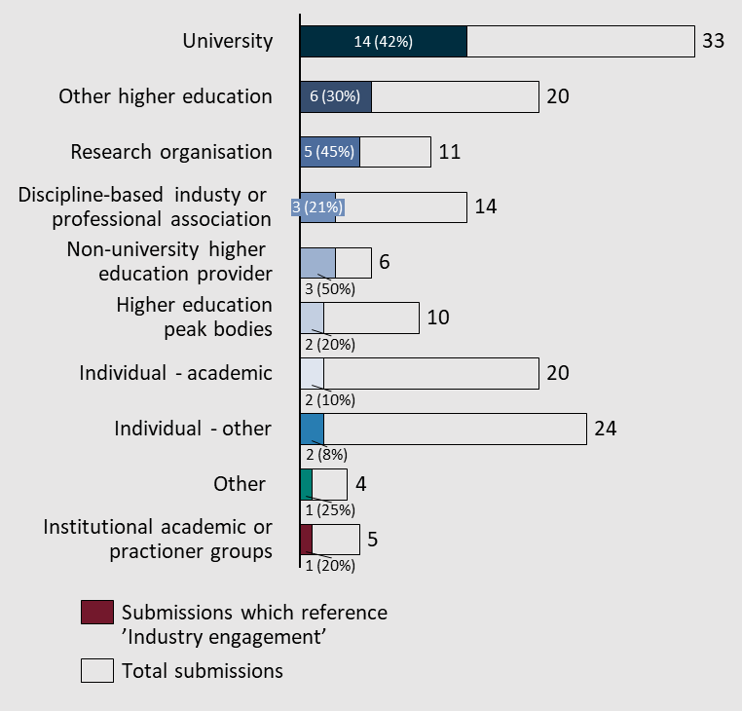

An effective policy tool to efficiently address current and emerging skills needs
Submissions under this subtheme stressed the importance of ensuring that funding for work-based placements and their availability is commensurate with policy enacted to stimulate the supply of graduates from a specific degree. This was particularly relevant for professions requiring clinical placements such as nursing.
“… the availability of clinical placements… has not risen in parallel with the demand to study Nursing. Universities such as ACU are not able to enrol additional students in Nursing courses without being able to guarantee that these students will be in a position to undertake clinical placements.” – Australian Catholic University
Other submissions, notably those by universities such as RMIT, University of New England, Federation University and the University of Western Australia, highlighted the instrumentality of work-based learning models and initiatives in improving student outcomes and addressing the country’s future labour needs. A tangible funding recommendation was to incentivise business uptake of students in work placements and programs as these initiatives represent an opportunity cost that smaller businesses may otherwise not be able to afford.
“Expand and fund nationally recognised work-based-learning qualifications to improve skills opportunities for people of working age and enhance systemic connections between universities, vocational education and industry.” – RMIT
“Resourcing is a major barrier to small businesses. The panel may wish to consider targeted interventions to support collaboration.” – Universities Australia
“Current settings do not encourage nor facilitate employers to accept students on placements (despite their need for graduates), imposes unfunded costs on students and institutions (and on industry), and drives unhealthy competition between institutions for placement places.” – University of New England

Industry must be involved in the education and training of its future workforce
Promoting co-design with the industry was cited as a necessary feature of future curricula to ensure that the knowledge, skills and training received by prospective employees is practical and relevant. Industry, as quoted by the Australian Centre for Career Education, “has the responsibility to participate in the development of its future workforce”. Universities were a key category of submitters for which this represented an important issue. In acknowledgement of the improved community and student outcomes, Federation University announced its novel ‘co-operative learning model’.
“Federation University is rolling out an Australia-first co-operative learning model that will see all our programs being co-designed, co-developed and co-delivered in partnership with regional employers from 2025.” – Federation University
“The cocreation of curricula better advances the impact of work-integrated learning which has long been cited as beneficial for students, universities and their industry, business and community partners.” – Engagement Australia
“Canada’s successful cooperative education model, where employers provide paid internship opportunities to students with government assistance in select areas, is a good example to consider.” – University of Western Australia
Some submissions also noted that work experience at the student level has positive externalities for communities. This ‘reciprocal relationship’, as quoted in the submission made by Engagement Australia, gives students the opportunity to apply the skills and learning they have acquired in their education while delivering outcomes for communities.
“Reciprocal relationships with the community sector have seen many examples of students delivering outcomes for communities as part of the curriculum offering, resulting in the strengthening of social and educational outcomes.” – Engagement Australia

Appropriate funding and policy measures must exist to ensure equitable work-based experiences for people underrepresented in higher education
A submission by the CSIRO commented on the capacity of work-based experience for First Nations Australians students to build greater participation across industry and more favourable study outcomes. These programs were described as conducive to better employability and building clear pathways for future First Nations Australians STEM leaders. In promoting equitable inclusion across industry engagement, funding provisions for reasonable adjustment for disabled students were cited as a concern for the Australian Disability Clearinghouse on Education and Training.
“A priority objective of the James Cook University (JCU)-CSIRO partnership… is to co-develop ways to build institutional and individual capacity to grow research and employment opportunities for Indigenous students. This involves working to strengthen access and participation pathways for future Indigenous STEM leaders.” – CSIRO

Supply of graduates
Submitters highlighted several industries and professions which were underserviced by the current supply of graduates. These submissions stressed the importance of using policy and funding mechanisms to direct prospective students into these streams of work. This includes making macroeconomic forecasts on workforce trends accessible to prospective students. Submissions also noted that Australia is marred by both oversupply and undersupply phenomena. Regional areas within the country are experiencing critical shortages of graduates across disciplines as opposed to urban regions experiencing tranches of the population that are overqualified for the careers that they ultimately pursue.
‘Supply of graduates’ was referenced in 13% of the submissions (24 total) made to the Universities Accord.

Figure 23| Distribution of submissions which reference subtheme 'Supply of graduates'
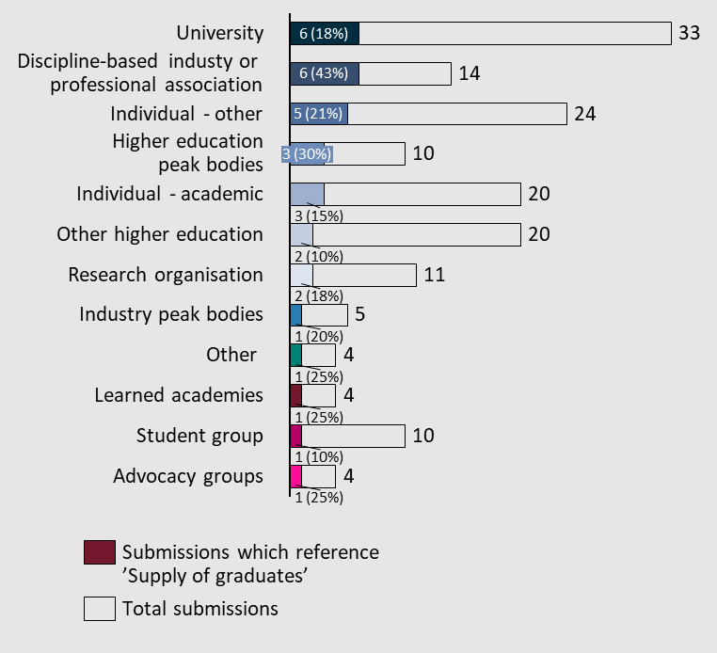

Targeted funding and support of professions critical to the Australian economy
Of the submissions that commented on critically undersupplied industries and professions across Australia, the following jobs were overwhelmingly the greatest concern to responders.
- Doctors - General practice
- Nursing
- Engineering
- Teaching
- Specific technology capabilities such as cybersecurity, AI and robotics.
One submission also highlighted the explosion of accounting services required by small businesses as a consequence of the pandemic. Given the interaction of this phenomenon with the declining local supply, it has created a “skills and labour shortage that is likely to persist in the absence of concerted action” (Chartered Accountants Australia & New Zealand).

Use macroeconomic forecasts and workforce projections to inform student choice
Workforce projections constituted an important topic for submitters who commented on the supply of graduates. They attributed them as an important source of information for students when choosing their desired career paths and the necessary education. They were cited as a concrete indicator of employment outcomes post-completion of studies. However, contention over who should carry this responsibility persisted. Submitters like the University of Melbourne placed the onus on universities to apply their own workforce modelling to identify industry trends and characteristics and present these to students for them to make a more informed career choice.
“Assess the most effective ways of providing employment projections and other labour market data to prospective students at the time of course discovery… Consider ways of translating future skills needs to influence current and future student behaviour and choices with regard to study.” – Victorian Tertiary Admissions Centre
“Australian students are not universally prepared to make sound pathway choices as career education is not mandated in Australia. Consequently, the flow-on effect in tertiary education is that they have no or low understanding of the workforce. Many graduates swap or leave tertiary courses because they are uncertain about their career choices. As a result, it takes them longer than necessary to enter their career and become productive citizens. It also results in marketplace employment gaps. This situation is worse for vulnerable cohorts who have less exposure to education and employment opportunities.” – The Australian Centre for Career Education

Some industries are experiencing a ‘qualification inflation’
In increasing participation in tertiary education across Australian society, some submissions noted that this had an inflationary impact on the types of qualifications required for places in industry.
“There is no doubt that increasing numbers of persons with a degree have resulted in degree holders ending up in jobs that previously did not require a degree.” – Mackenzie Research Institute
A submission by SkillsIQ highlighted that an additional consequence is ‘creeping credentials’ – a phenomenon where degrees are established as an entry requirement to jobs where in the past a certificate or diploma qualification was sufficient. The submission also reflected on the cultural attitudes towards alternative study post-secondary school, reporting that four in five parents preferred their children attend university as opposed to Vocational Education and Training (VET). In periods of a competitive labour market, employers were noted as choosing individuals with higher qualifications than needed.

Undersupply of key professions persists in regional economies
Submissions listed several realities currently experienced by regional communities across Australia:
- Younger generations of regional communities are unwilling to travel to cities and if they do, they are not inclined to return.
- Regional towns face difficulty in attracting and retaining skilled workers.
- The opportunity cost of education is too high and prospective students are instead choosing to enter the workforce immediately.
The interaction of these characteristics has resulted in regional communities being “hollow[ed] out” of talent and people qualified to provide critical services such as education and health (Federation University). Submissions call for implementation of retention strategies to ensure that vulnerable communities can sustain themselves.
“Explore incentives that are embedded into university courses to encourage graduates to work in regional communities post-university.” – Society for the Provision of Education in Rural Australia
“In the current employment climate Universities are not filling their student number caps because paid jobs in this time of workforce shortages can be more attractive than tertiary education.” – Taree University Campus

International student work rights and migration
While many submissions stressed the importance of international students in addressing Australia’s skills and labour shortages, this was caveated by the challenging experiences many face once inside the country. These challenges included inaccessible and inconsistent information over working rights and discrimination in the workforce. Many submitters also called for a simplified and less cost-prohibitive migration pathway for international students to elevate Australia’s competitive position as a provider of international education.
‘International student work rights and migration’ was referenced in 14% of the submissions (25 total) made to the Universities Accord.

Figure 24| Distribution of submissions which reference subtheme 'International student work rights and migration'
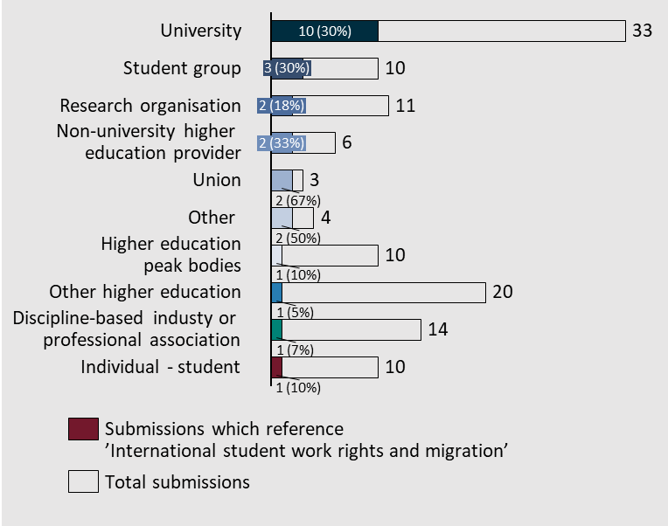

International students must be afforded greater protection and support in work environments
Systemic and cultural elements of Australian society were noted as contributing to a sometimes exploitative relationship between Australian employers and international students. Wage theft of international students was a key area of concern for universities, student groups and unions. Macquarie University supported this claim, stating that, based on the Migrant Worker Justice Initiative, “over a quarter (26%) of all submitters earned $12 or less per hour in their lowest paid job (approximately half the minimum wage for a casual employee)”. This reality for international students was reportedly a feature of formal work placements forming the requirements for successful completion of degrees such as medicine. Those who commented on these issues cited a lack of awareness of entitlements and working rights in Australia from international students.
“… international students are the second largest group of international visa holding workers, but one of the most vulnerable to labour trafficking.” – National Tertiary Education Union
“International Students are highly susceptible to exploitation due to a lack of knowledge of their employment rights in Australia, unscrupulous behaviour of employers and a fear of losing their visa if they speak up.” – United Workers Union
“… although making up a signiﬁcant portion of Australian medical graduates, International Students are signiﬁcantly disadvantaged in their placement experiences, and face discrimination in accessing work opportunities.” – Australian Medical Students’ Association

Systemic issues regarding visa and migration pathways are detrimental to the brand and reputation of Australian universities internationally
Most relevant submissions across universities, individuals, student groups and unions commented on the experience of obtaining visas for international students. In particular, the pathway between student visa and permanent residency is reportedly unestablished despite this being an important aspect when students are choosing countries for study. In the context of the post-pandemic environment, responders noted that more advantageous policies, regulations and incentives need to form part of the Australian response to regain lost market share.
“Australia’s visa system does not reflect contemporary best practice, making it unnecessarily difficult for students, researchers, and academics to choose Australia as a destination to learn and live.” – University of Notre Dame
“… there is no automatic pathway from a student visa to a permanent residency visa in Australia. However, demand is strong with 63,000 Temporary Graduate visas granted in 2020.” – Curtin Student Guild
“We accept more students as temporary migrants than we offer positions for permanent residency. Many international students I know only realise this tightening bottleneck after they enrol and arrive in Australia. To have the fourth largest export built on exploiting international students is not something we should be proud of.” – Errol Phuah

International students can help to relieve Australian labour shortages
A small number of submissions made note of how international students can help address Australian labour challenges by extending Commonwealth supported funding to disciplines for which there is long-term skills need. This included targeted funding and visa arrangements to incentivise greater uptake of these critically required skills. However, C5C group posited that international students have failed to meet Australia’s skills needs in the past.
“International students have failed to meet Australia’s knowledge and needs skills. Students need a qualification, the piece of paper, to obtain post study work visas and PR – there is no requirement that they actually enter the profession their studies prepared them for. This loophole has shown we still need accountants and IT professionals – this loophole needs to be closed – then, and only then will there be a stronger and more closely aligned connection between education and meeting our national interests for current and future requirements in knowledge and skills.” – C5C Group Pty Ltd

Student demand for higher education
Submissions stressed the importance of having an adequate number of institutions available to service the high projected volume of future demand. By 2050, this may include up to 75 universities based on a population of 36 million (Paul Wellings). Other submissions had their views predicated on government projections that nine out of ten jobs will require post-school qualifications and that, of the one million new jobs over the next five years, at least half will require at least a bachelor’s degree.
‘Student demand for higher education’ was referenced in 13% of the submissions (24 total) made to the Universities Accord.
Figure 25| Distribution of submissions which reference subtheme 'Student demand for higher education'
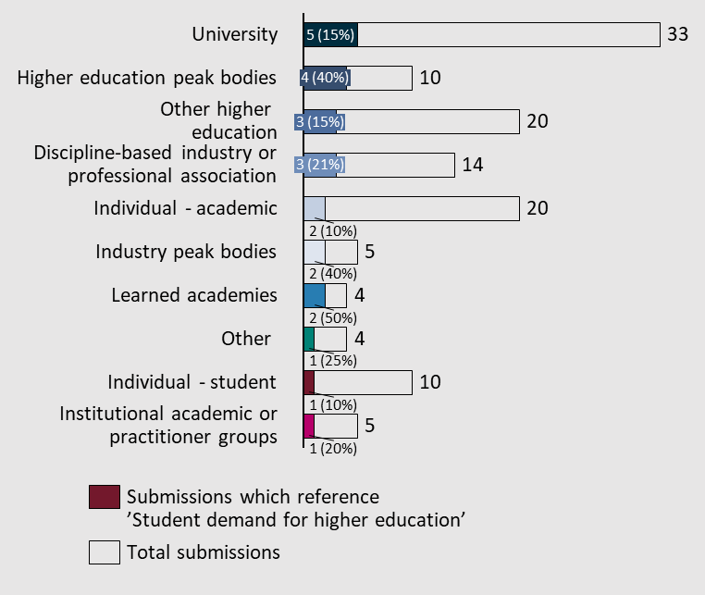

The dynamics of student demand across disciplines and industries
Submitters contributed information on demand dynamics across discrete disciplines. These areas were noted as being vulnerable to university department closure owing to unsustainable student enrolment numbers. Submissions noted that some of these departments, such as the earth sciences, represent a key discipline in tackling important national security issues such as climate change.
- Earth sciences departments across universities are being threatened with closure - Australian Academy of Science
- Enrolments in Management and Commerce degrees have been declining since 2016. – Chartered Accountants Australia & New Zealand
Submissions from Universities Australia and the University of Melbourne call for a more forward-looking approach to education to ensure the sector is well-prepared to tackle projected demand.
“Policy settings must support universities to meet student and labour market demand in the immediate term. However, it must also allow universities to respond effectively to changes in demand, including growth in the aggregate level of demand as well as changes in need for qualifications in particular disciplines or at particular levels of study.” – Universities Australia
“In considering future investment, the Panel must also consider what growth in the sector will be needed in coming years. System growth is currently static, with piecemeal measures delivering more student places into the sector on an occasional basis. We suggest the panel consider a longer-term strategic approach to growth in the sector, taking account of local and international demographic trends and national needs, which enables institutions to plan effectively.” – University of Melbourne

Understanding motivation for pursuing university education can facilitate outcomes more aligned with student expectations
A small number of submissions highlighted the importance of understanding what motivated students to pursue higher education. By understanding motivations, institutions and government are better positioned to deliver education outcomes for students. Although similar data in an Australian context was unavailable, one submission noted survey results which reported students from the United States as pursuing education for the purpose of starting their own businesses, indicating social innovation underpinned the inclinations of the latest cohorts of students.

Trends reflecting the growing importance of independent higher education
Submissions by independent education providers indicated that Australian students are increasingly choosing independent providers to meet their education needs. Independent Higher Education Australia cited this as evidence of the “increasing value” students are placing on independent higher education compared to public universities, with enrolments growth outpacing those in public universities across 2017-20.

Caps on student numbers in regional universities are directing prospective students away from their homes
Submitters noted the inequitable funding arrangements for teaching and learning currently facing institutions operating in regional areas. Students, unavailable to access places locally, are forced to migrate to regions with higher admissions caps.
“…Often there are simply no spaces left in regional universities due to local demand – students need to leave the regions and travel to cities to study. Once this occurs, it is challenging to entice students back to the regions. Consideration needs to be given to increase the higher education caps in regions and reduce the caps in metro centres.” – Regional Development Australia Tropical North
This forms part of a broader narrative formed by some submissions which stress the notion of universal access to education by those who demand it. A tangible and concrete policy measure suggested by the National Centre for Student Equity in Higher Education included the re-instatement of the demand-driven funding system.
“The supply of higher education places should match demand. An under-resourced higher education system that necessitates competition for undergraduate places is a significant barrier to equity.” – National Centre for Student Equity in Higher Education
However, some responders also noted necessary caution when implementing fully flexible arrangements for students and the implications this may have for courses that are not traditionally popular, but necessary for the growth of the economy.
“Market-driven business models adopted by universities are causing critical, but low demand, courses to be dropped. Many of these are the 'hard' sciences which traditionally have not attracted high numbers of students and are expensive to equip and deliver.” – Dr Kim Jessop

Terms of Reference 2: Access and Opportunity
Improve access to higher education, across teaching, learning and research.
This will include recommendations for new targets and reforms to support greater access and participation for students from underrepresented backgrounds (including First Nations Australians, those from low socio-economic backgrounds, people with disability, and regional and rural Australians).
Submissions received highlighted the continued importance of supporting underrepresented groups to access higher education and implementing programs to help them be successful. The submissions encouraged the review to investigate mechanisms to improve diversity in higher education and to continue the efforts started in the Bradley review.
This section has been structured differently as all submissions that referenced access and opportunity supported measures to expand access to higher education. The main variation in submissions was that many submitters made recommendations for how to improve the system. As such, this section outlines the recommendations made rather than the priorities to be addressed.
Figure 26| Distribution of submissions across Term of Reference 2 subthemes
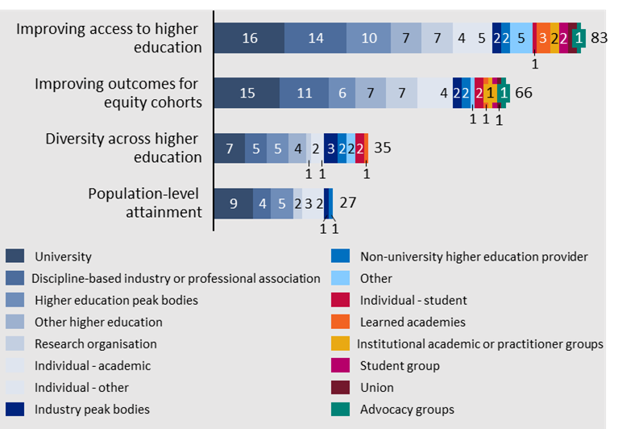

Improving access to higher education
Improving access to higher education was referenced in ~45% of submissions (83 total). Most of these submissions called for improved access for various underrepresented groups, including, students with disability, First Nations students, regional students, students from low income backgrounds and LGBTIQA+ students.
Figure 27| Distribution of submissions which reference subtheme 'Improving access to higher education'
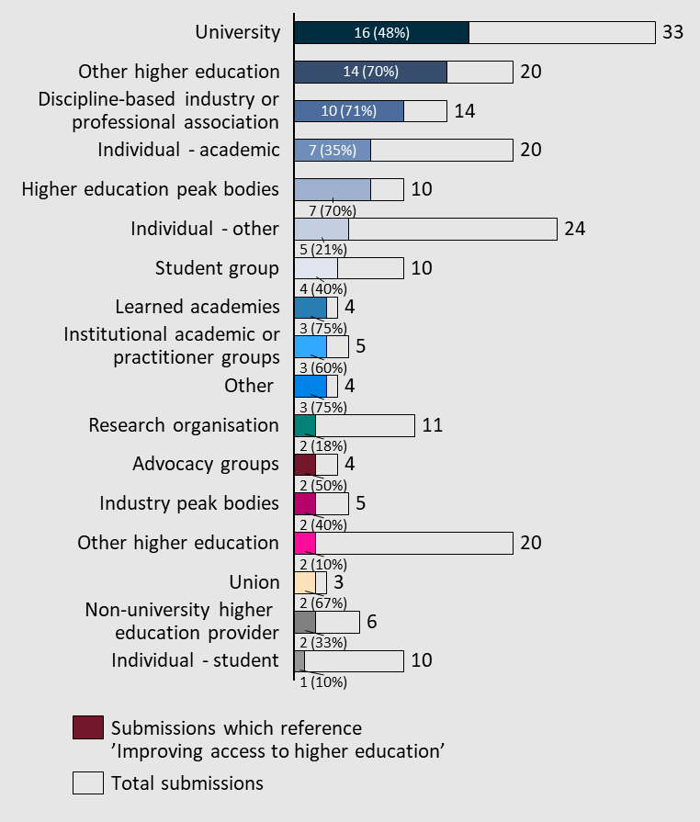
These submissions highlighted a number of potential ideas to improve accessibility, listed below.
Suggested mechanisms to support access
- Review, redesign and standardise pathways between vocational education and higher education. – Australian Council of Deans of Education, Country Universities Centre, Dr Gierdre Kligyte, Engaged Learning Solutions Pty Ltd, Equity Practitioners in Higher Education Australasia, University of Canberra, Victorian Tertiary Admissions Centre (VTAC)
- Consider guaranteeing CSPs for all equity students and institutions – Campus Model Regional University Centres, Independent Higher Education Australia, National Centre for Student Equity in Higher Education, University of Newcastle – Teachers and Teaching Research Centre
- Reintroduce participation targets for underrepresented groups – Chartered Accountants Australia and New Zealand, National Centre for Student Equity in Higher Education
- Reinstate Demand Driven Funding (DDF) for equity students – Country Universities Centre, Equity Practitioners in Higher Education Australasia
- Remove the 50% minimum pass rate requirements for students in CSPs –Australian Tertiary Education Network on Disability (ATEND), Curtin Student Guild, Edith Cowan University, National Association of Enabling Educators Australia, National Centre for Student Equity in Higher Education, National Union for Students, Professor Sally May Kift, Queensland University of Technology, Universities Australia, Western Sydney University
- Development of a national or (at minimum) state-based alternative assessment framework and university entry program – Equity Practitioners in Higher Education Australasia
- Consider equity across lifetime of learning such as postgraduate studies, microcredential and short courses. – Equity Practitioners in Higher Education Australasia
- Revisit the recommendations from the Review of Identified Equity Groups (Tomaszewski et al., 2018) and make enhancement to enable institutions to cater for invisible equity cohorts. – Equity Practitioners in Higher Education Australasia
- Legislate equity funding to provide medium to long-term commitment to institutions to enable the access, participation and success of students from targeted equity groups. – Equity Practitioners in Higher Education Australasia
- Provide an entitlement to a level of general education equivalent to the successful completion of school at a level which would make it possible to enter a degree program. – Mackenzie Research Institute
- Advise students of the supports they can receive – National Disability Coordination Officer Program
- Review financial incentives for taking on underrepresented groups of students – Paul Wellings
- Add first in family status to the national equity framework – University of Newcastle – Teachers and Teaching Research Centre
- Develop targeted early entry schemes and provide financial support for underrepresented students – University of Newcastle – Teachers and Teaching Research Centre
- Consider how enhanced funding flexibility can reduce financial barriers that restrict numbers from underrepresented cohorts – University of Tasmania.
Specific suggestions for students with a disability
- Promote VET options for student with a disability – National Disability Coordination Officer Program
- Higher education providers should regularly review their institutions and programs against ACOLA’s Good Practice Guide for disability responsiveness training – The Australian Academy of Technological Sciences and Engineering.
Specific suggestions for First Nations Australians students
- Expand Indigenous Tutorial Assistance Scheme funding – Campus Model Regional University Centres
- Increase access to social work scholarships – Anonymous
Specific suggestions for Regional Students
- Prioritise access and funding for Regional University Centres to support bridging programs for regional students – Campus Model Regional University Centres
- Invest in regional providers – Australian Council of Deans of Education, Capricorn Community Development Association, Queensland University of Technology

Improving outcomes for equity cohorts
Improving outcomes for equity cohorts was referenced in 36% of submissions (66 total) to the Universities Accord.
Figure 28| Distribution of submissions which reference subtheme 'Improving outcomes for equity cohorts'
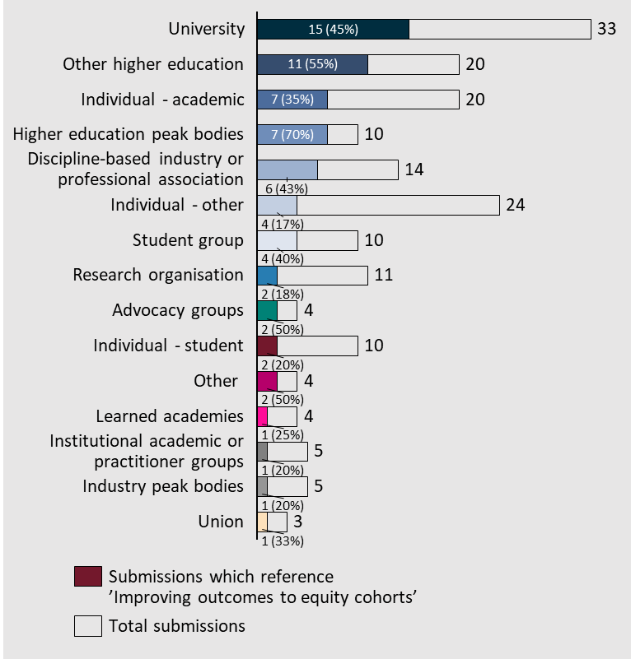
Many submissions highlighted the failure of previous policy setting to affect the desired improvement of outcomes for students from groups underrepresented in higher education. While equity targets were recognised as a step in the right direction, they fell short of concretely improving educational outcomes. Submissions called for the introduction of completion rates to complement participation targets. This could encourage institutions to invest more in supporting students in their studies and prevent failing grades which can have significant impact on student motivation, mental health and financial stability as they mount HELP debts. Moreover, this was supplemented by a call for definitions to be changed to reflect contemporary understanding of underrepresented groups and for reasonable adjustments to recognise the effects of intersectionality.
General recommendations
- Enshrine flexible assessment policies and practices – Australia Law Students’ Association, Equity Practitioners in Higher Education Australia
- Greater community outreach, engagement, and access – University of Newcastle, Queensland University of Technology, National Centre for Student Equity in Higher Education, Curtin University
- More funding support for accessing and participating in tertiary education including increased cultural sensitivity – Australian Medical Students’ Association, Universities Australia, University of Melbourne Student Union, Studiosity, Science & Technology Australia, Pauline Ford, NATSIHEC and NATSIPA, Dr. Annette Quayle, Australian Publishers’ Association, Australian Council of Deans of Education, Australian Catholic University, Ant Bagshaw
- Greater and more targeted support for LGBTQIA+ students – Pauline Ford
- Increased social and financial security during studies – Universities Australia, University of Melbourne, Mark Warburton
- Improving outcomes for students with mental illness – University of Melbourne Student Union, Pauline Ford
- Promote access to work-integrated learning by relieving time, location and financial constraints – Professor Sally May Kift, Australian Medical Students’ Association, National Union of Students, University of Melbourne, Regional Universities Network
- Improved employment outcomes and tailored career advice – The Group of Eight, Equity Practitioners in Higher Education Australia, Professor Sally May Kift, Anonymous, ATEND, Ant Bagshaw
- Establish new targets for equity cohort participation that are state-based and properly reflect reference rates in the general population – Edith Cowan University, ADCET, Equity Practitioners in Higher Education Australia, Curtin University
- National targets must be outcomes based and not just enrolments based – Curtin University, University of Newcastle, Queensland University of Technology, ADCET, Innovative Research Universities, Dr. Annette Quayle, Campus Model Regional University Centre
- Align equity student cohort definitions with contemporary views of the education disadvantage of individuals, replace ‘Martin indicators’ and address intersectionality – Campus Centres University, University of Southern Queensland, Queensland University of Technology, Edith Cowan University
- Reintroduce Demand Driven Funding for targeted equity groups and develop a targeted national employability program – ATEND
- Expanded independent higher education provider access to equity cohort support initiatives available to public providers – Independent Tertiary Education Council of Australia, Regional Universities Network
- Equity considerations should include cost of living and affordability for students – Innovative Research Universities, Mark Warburton
- Introduce a National Duty of Care to mandate student voice – National Union of Students
- Facilitate credit transfers between VET/TAFE and higher education – The Australian Centre for Career Education, Tom Worthington
- Remove measures that prohibit access to education such as the 50% pass rate or the seven-year entitlement to CSPs – Western Sydney University, Innovative Research Universities, Equity Practitioners in Higher Education Australia
- More accessible and affordable accommodation for equity cohorts – Mark Warburton
Specific suggestions for students with disability
- Mandatory learning modules for teaching staff – National Disability Coordination Office
- Development of a National Strategy for Students with Disability – ADCET, National Centre for Student Equity in Higher Education
- Whole-of-government response that considers interactions with higher education and other social and financial support systems – ADCET
- Impose a nationally consistent collection of data administrative criteria to the tertiary education sector to ensure that students – Equity Practitioners in Higher Education Australia
Specific recommendations for First Nations Australians students
- Alter the Indigenous Tutorial Assistance Scheme (ITAS) to allow Regional University Centres to access funding to support First Nations Australians students on Country – Country Universities Centre, Society for the Provision of Education in Rural Australia
- Take into consideration the cultural and geographical diversity (including metropolitan vs. regional) of First Nations Australians students during engagements – NATSIHEC and NATSIPA
- Connect students with First Nations Australians education centres – NATSIHEC and NATSIPA
- Promote a whole-of-university approach to funding arrangements; change funding facilities from completion- to needs-based – NATSIHEC and NATSIPA
- Courses must be redesigned using First Nations teaching and learning methodologies – The Australian Centre for Career Education
Specific recommendations for regional students
- Develop a low-population Regional University Centre that clusters across towns and incorporates VET/TAFE – Country Universities Centre
- Provide funding on a student and not EFTSL basis given higher proportion of part-time study at regional universities – Regional Universities Network
- Offer greater support for online courses and promote proliferation of courses in study areas identified as a priority for meeting regional skills demands – Taree Universities Campus, Campus Model Regional University Centre, Anonymous

Diversity across higher education
The overarching theme characterising diversity across higher education is the implication a diverse teaching cohort has on the participation of students from underrepresented backgrounds more broadly. Submissions highlighted that the most effective motivator for equity participation is having representation of all groups at the teaching level as it serves as a concrete illustration of the “visible career pathways” (Pauline Ford). Underrepresentation of First Nations Australians and students with disability were the greatest concern for submitters, with calls to increase the use of First Nations Australian knowledge in research.
Diversity across higher education was referenced in 19% of submissions (35 total) to the Universities Accord.
Figure 29| Distribution of submissions which reference subtheme 'Diversity across higher education’
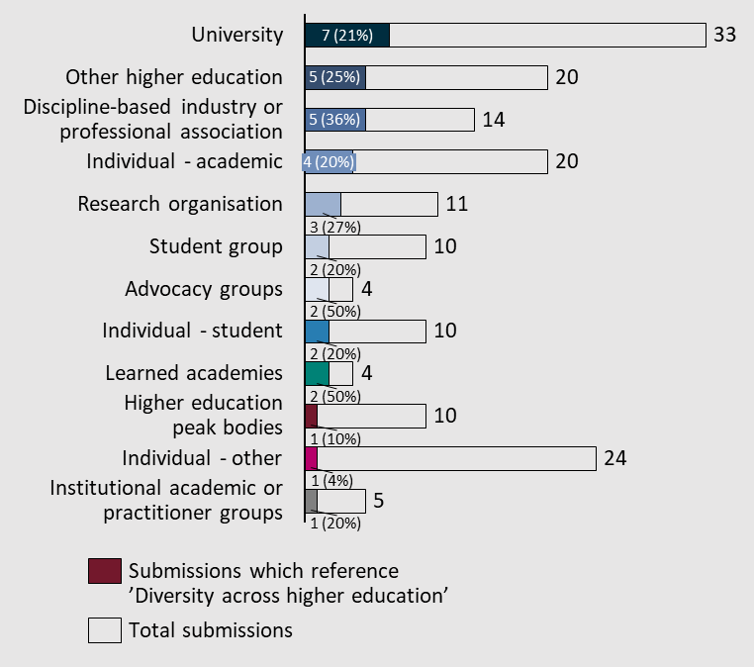

Promote the inclusion of First Nations Australians and address systemic barriers to educators with disabilities
First Nations Australians were identified by submitters as being disproportionately excluded from careers in higher education. Submitters on this issue highlighted that the Australian education sector faces a significant opportunity cost in excluding these communities from the country’s research apparatus.
“Making space for First Nations researchers in our knowledge institutions… if approached with genuine reciprocity, promises to prompt new angles for inquiry from the heart of all disciplines.” – Australian Academy of the Humanities
“[Indigenous] genuine inclusion in teaching and research broadens, deepens and improves what Australian universities do in a unique way on the world stage.” – National Association for the Visual Arts
People with disability were also highlighted as a group facing significant barriers to pursuing meaningful careers in higher education. Submitters criticised the lack of reporting requirements which are rooted in systemic and cultural challenges facing the disabled community. This is reportedly compounded by a lack of funding and reasonable adjustment for disabled staff in the workplace.
“There is currently limited data on people with disability in the Australia higher education workforce. This is due to concerns about the impact of disclosure, low disability confidence, a deficit approach to disability employment, and casualised or temporary employment.” – Australian Disability Clearinghouse on Education and Training
“… there has been a lack of recognition about the intersectionality between disability and other equity characteristics. – Australian Disability Clearinghouse on Education and Training
“Disabled students, as well as disabled staff, are reportedly receiving inadequate funding, attention, and due care with regards to the reasonable adjustments & accommodations which they require, with gaps in coordination and poor understanding of people with disability highlighted as thematic issues.” – Australian Law Students’ Association

Incorporate First Nations pedagogy into the way we conduct inquiry and disseminate knowledge
In addition to increasing participation of members of First Nations communities, a group of submissions called for the incorporation of First Nations ways of knowing, being and doing across Australian university course curricula. This was volunteered as a necessary way to concretely recognise the contribution of First Nations communities.
“The University encourages the Panel to consider ways to advance diversity and inclusion in research, encompassing Aboriginal leadership, gender, disciplines, and culture. There is considerable research to show that more diverse teams achieve superior innovation outcomes.” – University of South Australia
“The need to decolonise and promote First Nations knowledges, research, and leadership.” – Senator Mehreen Faruqi
“… re-examine the culture of the university, and the need to embed Aboriginal and Torres Strait Islander ways of being, knowing, and doing across the curriculum.” – Kaitlin Smalley

Population-level attainment
Population-level attainment was referenced in 15% of submissions (27 total) to the Universities Accord.
Figure 30| Distribution of submissions which reference subtheme 'Population level attainment'
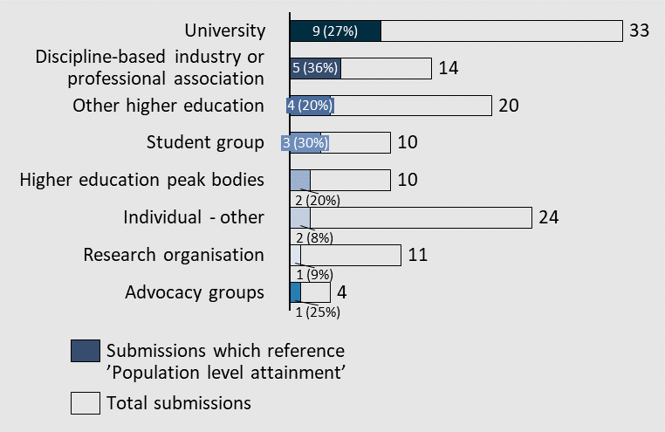
In submissions that discussed population-level attainment, significant concern was raised over the sometimes-exclusive categorisation of underrepresented groups across the student population resulting in lack of funding and acknowledgement of genuine needs. This was supplemented by views criticising the unintended consequences of the Job-ready Graduates package arrangements. Submissions cited implications for equity such as the perpetuation of a ‘class system’ in Australian society and increased barriers to completion for vulnerable students. Further, some submissions called out specific groups across particular industries and sectors as having experienced significant challenges in participating in education and, by extension, their careers.

Equity targets for the admission of students trigger perverse incentives for universities and do not meaningfully address equity participation in education
Of the submissions that considered population-level attainment, many noted that policies targeting the enrolment of traditionally marginalised groups gave rise to unmeaningful university initiatives. Significant investment was made by universities into recruiting students from underrepresented cohorts and satisfying enrolment quotas, but little consideration was given to supporting these groups throughout their studies. Submitters noted that, consequently, the most significant weakness of initiatives for widening participation were high attrition rates. For future policy initiatives, responders noted the necessity of including completion rates alongside enrolment rates to effect meaningful participation outcomes for students underrepresented in higher education.
“Introduce a National Student Equity Strategy, with national and institutional access and completion targets. With the Widening Participation focus on enrolment figures, the most significant weaknesses of the DDF were public universities’ subsequent high attrition rates...” – Australian Tertiary Education Network on Disability (ATEND)
“These targets must not only include access rates into higher education, but also sector completion rates to encourage universities to invest in significant supports to increase university completions as well as alternative exit pathways.” – Equity Practitioners in Higher Education Australia

National targets for improving student equity must be contextual and definitions need to be expanded
Several submissions from universities stressed the importance of setting contextual equity participation targets that were sensitive to the local institutions’ and communities’ characteristics such as demographics, socio-economic and historical factors that have contributed to poor outcomes.
“Institutional profiles are diverse and may require contextualised institutional approaches to meet [the needs] of their students. Whilst we understand the need to address inequities of student groups at a national level, there is also a need for contextualised institutional approaches informed by an institutions enrolment profile.” – Equity Practitioners in Higher Education Australia
The pursuit of categorisation was cited as being detrimental to cohorts who do not belong to one of the formal groups or belong to multiple groups. Submissions called for categorisation of cohorts underrepresented in higher education to be expanded.
“By being explicit, often invisible cohorts of students fall through the cracks, such as Pasifika, refugees and students in care.” – Equity Practitioners in Higher Education Australia

Sectors and industries with persistent disparity between student participation and the population-level
Several submissions highlighted specific industries with participation levels for students from underrepresented groups that were not commensurate with their proportion across the total population. These are summarised below.
- Medicine
- Women across medicine face difficulty entering specific specialties post medical school.
- First Nations students generally experience low retention and graduation rates.
- There is a lack of data on medical students with a disability. However, suggestions from overseas indicate a high likelihood of poor representation.
- Geoscience
- Women in earth sciences reportedly do not stay in the profession beyond 30-35 years of age resulting in senior cohorts and leaders being comprised of mostly males.
- All sectors and industries
- Statistics on disabled community’s participation is consistently lower. People with disability are reportedly less likely to go to university, more likely to rate their university experience as lower than peers and are more likely to drop out of university.
- In trying to rationalise this reality for students with disability, many submissions noted that Australians with disability are not familiar with the supports available to them, including reasonable adjustments upon commencement of their studies. Moreover, there are no formal requirements for teaching staff at universities to undergo disability awareness training, resulting in a teaching experience that may be insensitive to the unique requirements of individuals with disability.

Term of Reference 3: Investment and affordability
Explore funding and contribution arrangements that deliver equity, access, quality and longer-term investments to meet priorities in teaching, research, workforce and infrastructure. This will include a review of the Job-ready Graduates Package.
Submitters to Term of Reference 3 focussed their submissions on how the higher education funding model can be sustainable, fair and efficient. Three topics were clearly the highest priority in the submissions received: funding for research; funding for teaching and learning; and the Job-ready Graduates Package.
Figure 31| Distribution of submissions across Term of Reference 3 subthemes
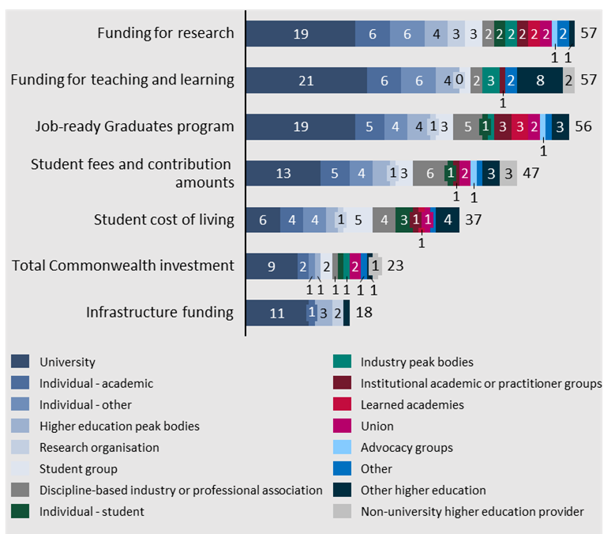

Funding for research
Ensuring adequate funding for research was one of the highest priorities across all submissions, being referenced in 31% of all submissions (57 total). The major considerations for research funding included meeting the full cost of research, funding models, regional research, and existing grant funding.
Figure 32| Distribution of submissions which reference subtheme 'Funding for research'
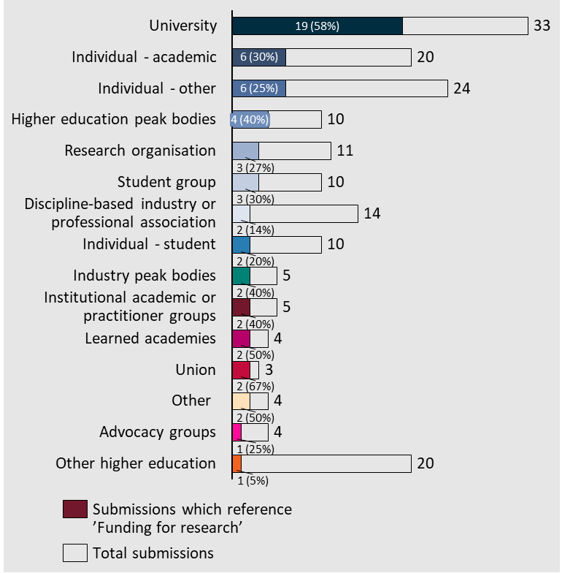

Research funding provided in the system does not cover the full costs, requiring universities to identify other funding sources
Twenty-three submissions outlined the challenge that current research funding does not capture the full range of costs for research. As a result, universities seek out other funding sources and use income from international student fees to subsidise research.
“Research funding from the government does not cover the full cost of research. This gap was estimated to be approximately $4.6 billion in 2018, which has been filled by funding from other sources, predominantly international education revenue. The gap has critical consequences on national research capability, putting at risk the scale and capacity of Australian research to serve the interests of the nation.” – Australian Academy of Science

An investigation into new research funding models was proposed
To tackle the challenge of research cross-subsidisation, multiple universities and higher education peak bodies have encouraged the panel to investigate new research funding models.
“Undertake a sector-wide analysis of government leverage of university funding into government grant programs and assess potential to consider advantages and disadvantages of an alternative approach. Consider making optional additional financial contributions to NCGP grants ineligible.” – Curtin University
“A balanced and predictable funding system is essential to retaining and developing Australia’s world-class research workforce and to providing the opportunities and career pathways that will keep our best and brightest here and attract researchers (including expat Australians) from around the world” – Universities Australia
As a part of this review, the Australian Network of Student Anthropologists recommends increased research funding for the humanities:
“Increase Humanities, Arts and Social Sciences (HASS) funding. The HASS disciplines are major contributors to the Australian economy, education sector, research and society. While HASS received 16% of the nation’s research income in 2012, the field produced 34% of the research outputs in the university sector. HASS contributed 44.2% of the total number of Units of Evaluation in the 2012 ERA [Excellence in Research for Australia] research assessment exercise, producing world-class research.” – Australian Network of Student Anthropologists

Additional funding to support research in the regions could support regional communities
Research conducted in regional centres can bring economic and social benefit which expands beyond the specific value of the research conducted, as outlined in the submissions below.
“It is crucial that regional universities receive sufficient funding to remain inclusive teaching and research universities, contributing to their community’s sustainability. Research underpins the capacity of rural and regional communities to learn, adapt, face future challenges and take advantage of the opportunities provided by the new knowledge acquired”– Capricorn Community Development Association
“Our universities are deeply engaged with local industry and community and therefore understand the current and emerging challenges and opportunities within our region. It is therefore imperative that regional universities retain their capacity to undertake research that is focused on local challenges and the needs of regional Australia. … Regional universities must continue to be ‘comprehensive’ rather than ‘specialist’”. – Regional Development Australia Tropical North Inc

The mechanisms for accessing research funding should be reviewed
More than ten submissions referenced the existing processes for bidding for grants. Specifically, the current distribution of grants between institutions and the burden placed on researchers to apply for grants. Currently many researchers are required to invest significant amounts of time applying for competitive grants for which there is a low probability of winning the funding. Some submissions suggested simplifying the competitive grants application process or delivering a higher proportion of funding through block programs to minimise this burden on researchers.
“Current funding structures inequitably exclude quality providers from gaining research funding highlight bias in Government funding policy which disincentivises capable providers from contributing to Australia’s productivity.” – Independent Higher Education Australia
“The distribution of Australian Research Council National Competitive Grant Program funding is even more distorted. In 2021, the Group of Eight received approximately two thirds of all administered funding, with RUN universities combined receiving just over one per cent. Similarly, the Group of Eight receives approximately two thirds of the nation’s research and development income. This distortion sustains inequities in opportunity for regional Australia.” – Regional Universities Network
“Australia’s funding mechanisms, primarily through the ARC and NHMRC, have high time costs during application and extremely low success rates (19.1% for all ARC grants in 2022; Australian Research Council) leading to high quality research not being funded and many researcher hours being wasted. It is critical to examine how Australian researchers can be best supported to produce a range of high-quality research at an international standard, and to align the outcomes of the Universities Accord with the concurrent review of the Australian Research Council (ARC).” – The Australian Academy of Technological Sciences and Engineering
Some universities suggested increasing the amount of block funding to minimise application times and to simplify funding.
“A better balance between block funding and competitive grants is needed. … Top researchers can spend 30-35% of their time on grant applications that have a very low success rate. Application for and administration of grants is a significant workload that could be better used elsewhere. Consideration should be given to a 2-stage grant application process similar to that of other countries (e.g., NZ’s Marsden Fund).”– University of Canberra

Funding for teaching and learning
Teaching and learning is a core responsibility of the higher education sector, ensuring these functions are appropriately funded to be successful and sustainable was referenced in ~31% of submissions (57 total).
The overarching goals of the funding system were communicated by the University of Melbourne.
“The funding of teaching and the setting of student contributions should also be predictable, and not subject to change year on year; to support continuity and efficiency in planning.” –University of Melbourne
Figure 33| Distribution of submissions which reference subtheme 'Funding for teaching and learning'
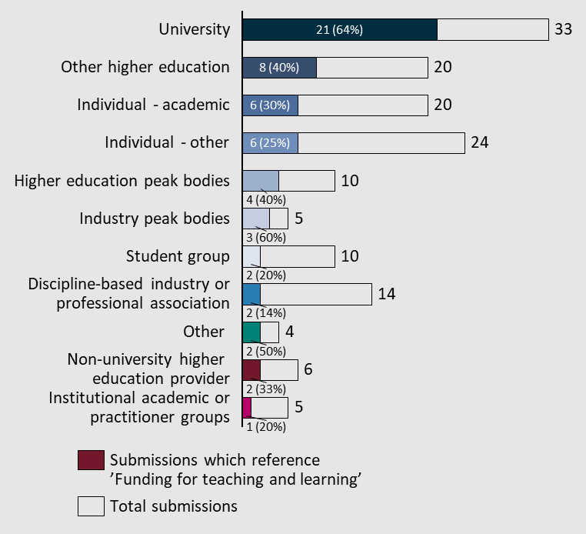

Flexible funding models were encouraged in some submissions
Funding models which are flexible were suggested in a few submissions to allow universities to manage their operations effectively. A more flexible set of funding agreements could allow universities to offer a broader range of study options, including increased online education offerings.
“We recommend the panel considers options for flexible agreements between government and universities to make funding available for different mixes of provision and activities in accordance with a university’s institutional mission and the needs of its local (and wider) community. … More work is needed on the range of different courses that universities offer and will offer in order to meet Australia’s skills needs, and which of these should be eligible for different forms of Commonwealth support (including direct grant funding and student loans).” – Universities Australia
“Funding must be sustainable and agile. This includes recognition of online education platforms must remain equal in funding to that of on-campus delivery, noting the need for universities to adapt to global forces to thrive.” – Swinburne University of Technology
A more flexible funding model could be advantageous over the performance-based funding scheme which was explicitly criticised in three submissions.
"Develop a Performance Based Funding model which rewards achievement rather than deducting funding for failing to achieve targets.” – Curtin University
“Increasing competition has not necessarily raised productivity or the quality of outcomes. Instead, participants have distorted the culture of universities in order to game the system set by performance-based funding models.” – Council of Australian Postgraduate Associations (CAPA)

Submissions called for a review of funding for teaching and learning in the regions
Many individual regional universities and the Regional Universities Network requested the Panel review the funding arrangements for regional education. The submissions outlined that there are higher costs for delivering high quality education in regional centres, due to higher costs per student.
“On top of this, the costs of educational delivery in regional areas, to regional students, are significantly higher (even when controlling for smaller subject size in the regions) than is supported through current regional loading allocations. Funding formulas based on sector average costs results in a maldistribution of public resources.” – James Cook University
“We echo the views of the Regional Universities Network (RUN) that the mechanism by which student funding is largely determined by equivalent full-time student load (EFTSL) places at a disadvantage those institutions unable to operate at scale, and particularly in the case of regional universities that support a notably diverse cohort of students who also tend to study clusters associated with lower student contributions.” – University of Southern Queensland

Funding for independent higher education providers creates a perceived disparity in student costs
The funding model for independent higher education providers was outlined as a priority for review by Independent Higher Education Australia, stating that the government should investigate options to support tertiary students who study in independent institutions.
“In the interests of competitive neutrality, creating sectoral efficiency and driving quality up, the Australian Government needs to urgently remove unfair taxes on tertiary students by permanently abolishing loan fee inequity that penalises independent sector students simply for choosing an independent sector provider. Instead, the Government might consider developing a universal, income contingent loan scheme with equitable settings for students regardless of student choice of provider. Previous economic modelling shows that a well-considered, universal income contingent loan scheme could earn nearly $1.2 billion to offset interest costs under the HELP lending program in net savings, and bring social benefit to the Australian Community.” – Independent Higher Education Australia

Job-ready Graduates Package
A review of the Job-ready Graduates Package was the sixth highest priority in the submissions, having been referenced in 30% of all submissions (56 total). Most submissions called for the package to be reviewed or revoked completely, however some of the strengths of the package were identified.
Figure 34| Distribution of submissions which reference subtheme 'Job-ready Graduates Package’
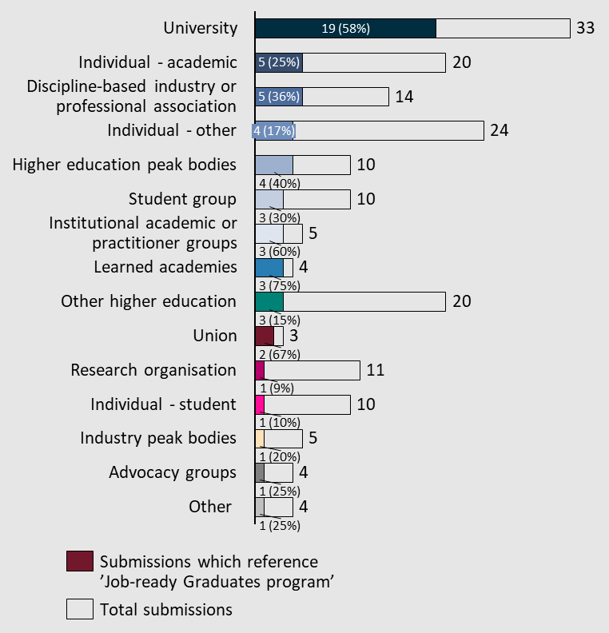

Using fees to influence student program selection was challenged
Five submissions noted that changes in fees have minimal impacts on the choice of discipline. This undermines one goal of the Job-ready Graduates Package, to steer more students into particular disciplines.
During the Job-ready Graduate Package consultation, ATSE noted that the use of fees as a market mechanism to alter students’ selected study areas was ineffective (Australian Academy of Technological Sciences and Engineering, 2020). – The Australian Academy of Technological Sciences and Engineering

The overall reduction in government funding is seen as problematic
A few submissions also identified that the Job-ready Graduates package had the impact of decreasing the government’s contribution to higher education and increasing student contributions. These submissions called for the review to consider these changes in funding distribution.
The policy effectively reduces the overall government contribution to degrees from 58% to 52%, with student contributions lifting from 42% to 48% to pay for more places without extra government funding and a 6% decline in overall student related income per Equivalent Full-Time Student Load (EFTSL). – Curtin Student Guild

Submitters encouraged consideration of the impact of the Job-ready Graduates package on particular disciplines
The majority of submissions which referenced the Job-ready Graduates package called for reform of the funding model which results in some disciplines having far higher funding rates than others. A sample of three submissions have been included which discuss the impact on Science, Humanities and Commerce degrees.
“[As a part of the Job-ready graduate program] The mathematical sciences in Australia, overall funding was reduced for students in a range of STEM subject areas. Cluster funding rates should be reviewed to ensure that declining funding per STEM student does not create a perverse incentive for universities to train fewer STEM students… the reduced funding means that these changes have the potential and incentive to lower the supply of STEM in universities in the long term.” – Australian Academy of Science
“[The Job-ready Graduates package] has been counter-productive in punishing students who choose area studies, history, culture, media. … disproportionately impacted women; made it far harder for students from low SES backgrounds, including in the regions, to aspire to and succeed at university in subjects of social, economic, cultural and community value; and incomprehensibly made the study of Indigenous culture and history more expensive than medicine.” – Australian Academy of the Humanities
“An outcome of the Job-ready Graduates Package review should be reduced student contributions and increased Commonwealth contributions to the cost of degrees in Management and Commerce degrees including Accounting.” – Chartered Accountants Australia and New Zealand

The pass rate requirements of the program were perceived as disadvantaging students from underrepresented backgrounds
The rule that students must pass 50 per cent of courses or lose their Commonwealth supported place was specifically referenced in 11 submissions to the Accord. Each submission encouraged the threshold to be reviewed or revoked, citing its impact on students from underrepresented backgrounds and the behaviours from students it incentivises. The impacts of the threshold were communicated in the submission from the Curtin University Student Guild:
“The completion rate requirement is flawed because:
- Equity groups will likely be most adversely impacted.
- It encourages students to swap courses to stay enrolled or move to part-time studies.
- It could lead to higher failure rates as part-time students are more likely to fail or leave university than their full-time counterparts.27
- The problem of non-participating enrolments can in part be attributed to concurrent enrolments at multiple universities which can be identified with improved government data sharing and the Universal Student Identifier (USI).
- There are different degrees and reasons why students fail and universities should have the discretion to look at individual circumstances instead of being forced to adopt a one size fits all approach.
- Increased administration on behalf of universities to identify and report on students who do not meet the 50% threshold.
- Need for increased support to assist students who are at risk or meet the criteria for low completion.
- It is expensive and resource heavy to ensure that university policy complies with the new legislation and universities may have modified processes around unsatisfactory academic progress and special consideration.
- Disengaged students are not protected from incurring debt.” – Curtin Student Guild

Some elements of the Job-ready Graduates package were encouraged to be continued
The Job-ready Graduates package was identified to have provided additional support to regional access to higher education.
“Maintain the elements of the Job Ready Graduates package that support regional access to higher education and consider how greater flexibility can be achieved within the Australian Qualifications Framework (AQF), that would enable higher education institutions greater agility in delivering the skills, education and training in areas of high skills need.” – University of Tasmania

Student fees and contributions
Student contributions are an important element of the higher education funding model contributing to teaching and learning costs. Student fees and contributions were raised in 16% of submissions (47 total).
Figure 35| Distribution of submissions which reference subtheme 'Student fees and contributions'
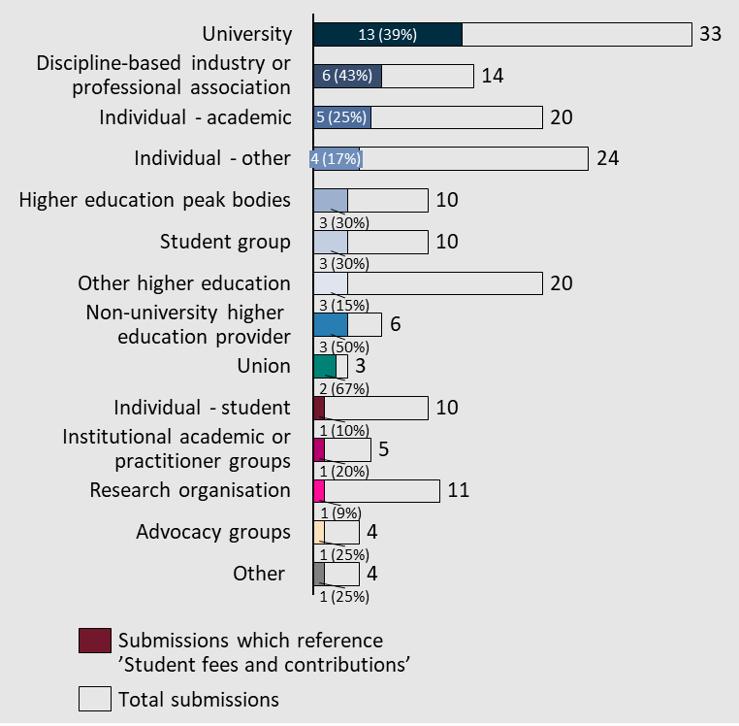

Stakeholders encouraged the Panel to review and identity the appropriate split between student and Commonwealth contributions
Multiple universities and one individual suggested a review of the allocation of the cost of higher education between students and the Commonwealth. These submissions encouraged the establishment of a funding system that could be in place for the long term.
“Undertake a considered and comprehensive analytical review within the Accord process to establish a fair, effective and sustainable basis for setting discipline funding levels including the split between Commonwealth and student share” – Queensland University of Technology
“RMIT believes that the university sector and Commonwealth must take the opportunity of developing a new Universities Accord to reframe the funding of university places and agree a consistently applied ‘fair price’ for student co-contribution. This should be put alongside a true-cost-of-delivery higher education supplement from the Commonwealth that reflects differences in learning and teaching provision across disciplines, pedagogies (i.e., reflective of work-based learning elements mentioned above) and potentially regional differences.” – RMIT University

Demand driven system for First Nations students
The NATSIHEC submission suggested the expansion of the current demand driven system for First Nations Australians from regional and remote areas to all First Nations Australians.
“NATSIHEC called on the government to open up the demand driven system to all Aboriginal and Torres Strait Islander students. This separation of our student cohort has a ripple on effect whereby each Indigenous student success team have to individually negotiate with their respective university regarding which students has a protected Commonwealth supported place (CSP) and which student does not” – NATSIHEC and NATSIPA

Expanding access to CSPs to other providers
Another suggestion raised in the submissions was to expand access to Commonwealth supported places to include TAFE courses and Independent Higher Education providers.
“Most TAFE higher education students are ineligible for Commonwealth Supported Place (CSP) funding. This inequitable exclusion means they have no option but to pay full fees even although a significant portion of students come from low socio‑economic and other disadvantaged backgrounds.” – TAFE Directors Australia (TDA)
“Independent sector students are the only Higher Education Loan Program (HELP) recipients required to loan 120 percent of their tuition costs to pursue their educational and career goals. This loan fee is not imposed on students attending public and private universities. IHEA views the FEE-HELP loan fee of 20 percent as a discriminatory fee on education and training for independent sector students. These are domestic students who are disadvantaged for choosing to study with an independent HE provider instead of at a university.” – Independent Higher Education Australia

Reinforcement of the benefit of HELP loans
Universities Australia and University of Canberra made a point in their submissions of reinforcing the value of HELP loans to support access to higher education.
“Higher Education Loan Program (HELP) is a cornerstone of Australia’s higher education system. HELP has enabled millions of Australians to gain access to higher education, and to realise the benefits that higher education brings. By enabling students to defer paying their fees until they are earning a reasonable income, HELP facilitates access to university for students regardless of their financial background. Anything that damaged HELP, or made it less effective or less fair would be detrimental to equity and accessibility in Australian higher education.” – Universities Australia

Repayment Threshold
The salary threshold at which graduates are required to begin repaying their HELP loans was identified as a growing challenge by five submissions.
“The HECS repayment threshold for 2022/23 is $48,361. In 2017-18 it was $55,874. Australians commence repayment of their HECS debt at an income threshold that is only 12.6% above the national annual minimum wage of $42,255. This is an unacceptable burden on students in an environment of escalating inflation, interest rate rises, reduction of funding for university education, increases in indexation of HECS debt, incremental wage growth and shouldering the tax burden of supporting older Australians. The coalescing of these factors exemplifies the regressive circumstances Australian students face when choosing to commit to tertiary education. Changes to HECS are often not based on economic theory or evidence-based analysis, but are driven by compromise to achieve specific political objectives.” – National Centre for Student Equity in Higher Education
“The repayment for loans should only commence once a person has income equivalent to the full-time medium income.” – Curtin Student Guild

Student cost of living
The cost of living for students can have significant flow on impacts on the higher education system, reduced enrolments, higher dropout rates and impacts on mental health which were all called out in submissions. Student cost of living was referenced in ~20% of submissions (37 total) and was a clear priority for the student groups (five submissions).
Figure 36| Distribution of submissions which reference subtheme ‘Student cost of living’
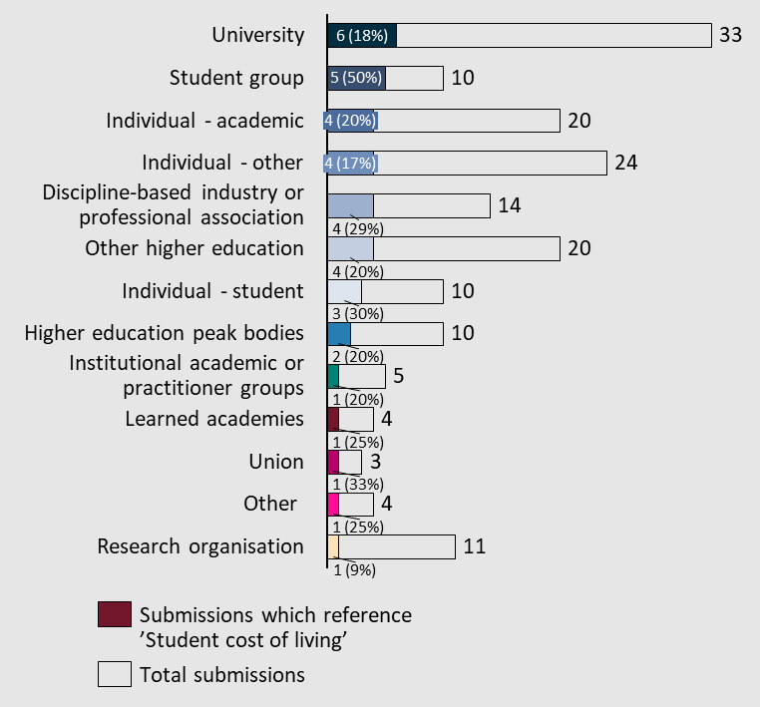

Loss of income while studying can be a large disincentive to engage in higher education
The immediate costs of being a student combined with the loss of income while studying can be a significant disincentive to pursue higher education. This challenge was referred to by the University of Sydney.
“There are no provisions to cover indirect study costs like textbooks and consumables, while the burden of covering basic living expenses such as housing, food, transport and utility costs continues to prevent too many students from accessing and succeeding in their tertiary studies.” – University of Sydney

Submissions advocate for a review of current study support initiatives
A review of the existing programs to support those pursuing higher education was identified as an area of focus for the review by ten submissions. The current system was described as difficult to navigate, overly restrictive preventing access for some students who need support and, in some cases, insufficient.
“The current study support initiatives, including Abstudy, Austudy, Youth Allowance and the Tertiary Access Payment Scheme are complex, resulting in gaps of students being eligible for such support. We would strongly advocate for a review of the financial study support available to students”. – Equity Practitioners in Higher Education Australasia

Cost of living pressures impact student outcomes
The cost of living for students can have an impact on their success. Financial pressures can manifest in different ways, impacting some students’ mental health and forcing some students to work additional hours, limiting their time to study.
“One of the key reasons students cite for dropping out is lack of money. Where a student cannot manage their living costs, or balance work and study, they are much more likely to drop out. This is a particular challenge for students from less traditional backgrounds – especially those who are mature age students. A more effective system for student income support could help address these problems.” – Universities Australia

Financial pressure during study placements
Student cost of living can be amplified during student placements. During these periods students often work full time hours unpaid which can impact their normal income sources. This challenge was described by the Curtin Student Guild and Taree Universities Campus.
“Many students are forced to work seven days across their placements, with paid work on weekends necessary to make ends meet. It is a paradoxical situation for students who have to obtain industry experience but at the same time need to work to support themselves through university. Only a small percentage of placements are paid.” – Curtin Student Guild
Cost of compulsory placements is a key stressor for students. Removing the need to relocate beyond the LGA, that is, prioritise placements to be local to their study location, and fund the costs of wages lost or childcare costs borne by the student whilst completing placement. – Taree Universities Campus
Note: Another common topic identified in relation to student cost of living was the PhD stipend. This topic is discussed at Term of Reference 7 under ‘Research training’

Total Commonwealth investment in higher education
Alongside discussions of funding for research, teaching and learning and the contributions of students were references about the total Commonwealth investment in higher education, referenced in 12% of submissions (23 total).
Figure 37| Distribution of submissions which reference subtheme ‘Total Commonwealth investment’
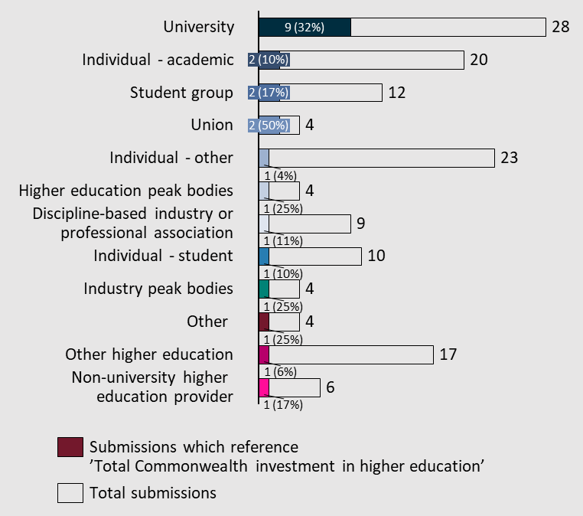

Establish long term funding arrangements
Multiple universities and university peak bodies requested the Panel to investigate the opportunities to establish long term funding certainty to support strategic and financial planning.
Long term funding and policy certainty— as a first priority the Accord must focus on giving universities certainty to inform longer term planning, policy and investment decisions. Often governments have offered short term funding initiatives to support growth in the sector which has resulted in universities bearing the long-term financial impost across areas such as systems and processes, staffing and new facilities and technologies. – The University of Notre Dame Australia
Within any changes to the existing funding models, ACU identifies an opportunity to simplify funding models.
ACU recommends the Panel focus on options to simplify university funding arrangements, including providing universities with longer-term, multi-year certainty over their funding arrangements. Such funding certainty is also likely to have benefits in terms of the budgetary confidence that will allow for the establishment more secure ongoing employment arrangements for university staff. – Australian Catholic University

Australia was compared to successful international examples when encouraging free higher education
Several submissions referenced free education in countries comparable to Australia, calling out or alluding to consideration of substantially increasing the Commonwealth’s total investment in the sector. In fact, six submissions encouraged the Panel to consider having the Commonwealth fully fund higher education and to wipe existing student debt.
“Many Australians holding officers of power now have benefited from free education. Why not return it for the new generation of Australians to benefit? After all, for every 50,000 extra graduates, an additional $1.8 billion of economic activity is generated annually (Universities Australia). Every graduate entering the workforce increases Australian GDP by $124450. For every 1000 new graduates entering the workforce, 120 new jobs are created for people without a degree. The wages of people without a degree are boosted by $655 a year when more graduates join the national workforce (Cadence Economics 2016). Indeed, if Germany, whose population is triple that of Australia, offers tuition-free higher education, why not Australia? Germany boasts the second-highest employment rate of recent graduates in Europe, standing at 91.3% (Trading Economics 2022). Why not Australia?” – Australian Network of Student Anthropologists and others
“In New Zealand the Government provides school leavers with one year of fee-free tertiary tuition. The Government plans to increase this to three years of free university education by 2024. Free tertiary education is available and successful in other countries including Germany, Denmark, Sweden and Norway.” – Curtin Student Guild
“The Australia Institute estimates that free undergraduate education for all Australian citizens and permanent residents would cost $3.1 billion per year. This cost could easily be covered if Australia reduced their subsidies of the fossil fuel industry by 30%, acknowledging that Australia’s future lies with a young, educated workforce, not with oil and gas”. – National Union of Students

Infrastructure funding
Infrastructure funding was referenced in 10% of submissions (18 total), with the majority (61%) from universities.
Figure 38| Distribution of submissions which reference subtheme ‘Infrastructure funding’
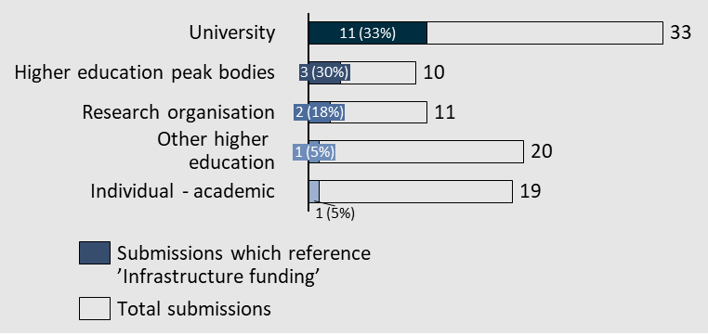

Greater coordination across government would support the sustainability of higher education infrastructure
Four submissions referenced a need for the review to investigate the options for greater coordination of funding across government, which can be drawn from a number of different state and Australian Government agencies.
“Infrastructure is an area that could also benefit from greater coordination across Government. There are no designated higher education infrastructure funding sources and there are significant legacy buildings that require maintenance or rationalisation. Also, the interaction between State and Federal Governments when prosecuting strategic education initiatives in relation to University property and infrastructure should be looked at.” – Geoscience Australia

Greater infrastructure funding is needed to keep Australian research competitive
A review of the total amount of funding on infrastructure was referenced in a few submissions. These submissions called for the total amount of spending to be increased to support the higher education sector in Australia to support the maintaining of facilities and research quality.
“To ensure that Australia’s higher education providers can meet the skilling and research needs of all Australians into the future, it is paramount that the Australian Universities Accord explores how to re-establish dedicated infrastructure funding, not only for new university infrastructure but also the maintaining and or upgrading of existing infrastructure.” – Regional Universities Network
“Australian universities spent $23.9 billion in capital expenditure over the period 2013 to 2018, which included $715 million in maintenance expenditure. During the same period Government investment in university capital grants fell by more than $1 billion. However, the cost of upgrading and maintaining our facilities to ensure students have access to high quality learning environments falls largely to individual institutions. ... Universities will require financial support from the Commonwealth to meet these infrastructure needs, both physical and digital.” – The University of Notre Dame Australia

Term of Reference 4: Governance, accountability and community
Enhance regulatory and workplace relations settings to support universities to meet their obligations to both staff and students.
Explore the contribution that higher education makes to the Australian community, national security, and sovereign capability.
Submitters cited concerns in what they perceive to be the changing role of higher education in Australian society, increasingly reflecting corporate interests that are undermining the sound governance, accountability and community engagement of diverse institutions. Nonetheless, many submissions highlighted strengths in regulatory and legislative frameworks and workforce considerations, as well as areas for improvement.
Figure 39| Distribution of submissions across Term of Reference 4 subthemes
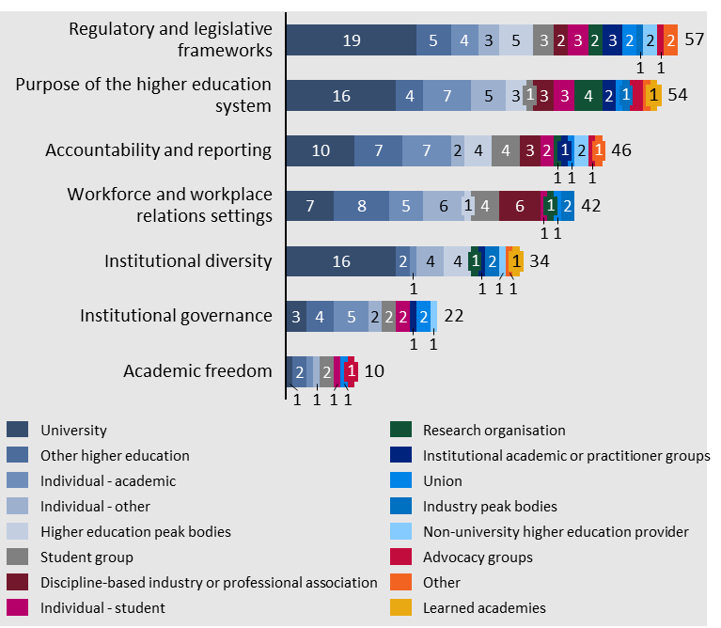

Regulatory and legislative frameworks
Regulatory and legislative frameworks were referenced in ~31% of submissions (57 total). This section is distinguished by three core considerations: funding, competition and enabling regulation.
Figure 40| Distribution of submissions which reference subtheme 'Regulatory and legislative frameworks'
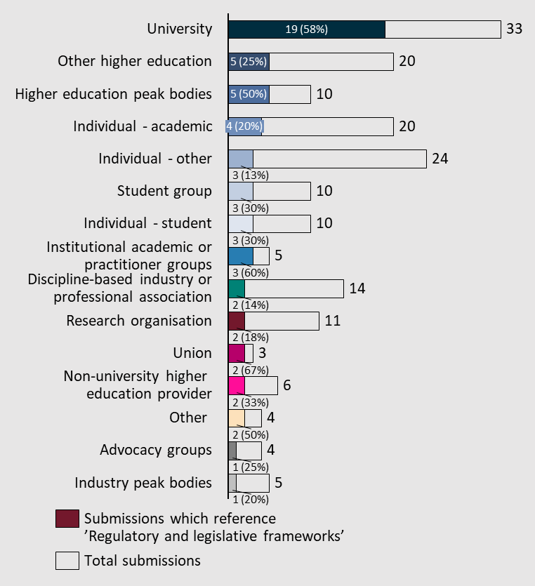

Submissions calling for regulatory reform and new or updated legislation addressed diverse issues
Many quotes throughout this paper make reference to regulatory and legislative frameworks the Australian Government and, to a lesser extent, state governments can reform to improve processes and outcomes across the higher education sector. These quotes have been ordered by their relevant subthemes, but this section includes some other quotes from submissions speaking for regulatory and legislative change or (re)consideration that span diverse issues.
The submissions suggested further investigation as a part of the review into the regulatory system that oversees microcredentials and the interactions between state and federal regulatory systems.
Microcredentials
The prominence of microcredentials in the higher education sector is relatively new, and as such, the regulatory framework that governs the sector has had less time to mature. The excerpts of submissions below outline the importance of advancing the microcredentials regulation environment.
“Make the Microcredentials Marketplace more widely available. If the Microcredentials Framework applies to VET and reputable non-traditional providers, in addition to higher education providers, then the Marketplace has the potential to provide a nationally consistent platform that gives learners agency over their lifelong learning journeys. They may follow pathways within higher education.” – Chartered Accountants Australia and New Zealand
“Define microcredentials as a national, atomic unit to genuinely enable lifelong learning, and flexible, stackable modes of learning. Australia is at risk of having seven or more models, and an unworkable national system. – University of Newcastle
“Inclusion of microcredentials within the AQF would provide clarity and coherence as well as assure the quality of these sub-unit credentials.” – University of Southern Queensland
Challenges for cross-jurisdictional institutions
The University of Notre Dame Australia encouraged the review to identify ways to streamline the regulation and reporting that governs the higher education sector. Specially referencing the overlapping regulation between States and Territories and the Australian Government.
“Universities, especially national institutions, such as Notre Dame, work in multi-jurisdictional environments and are required to apply considerable resources to the delivery of regulatory reporting throughout a range of government bodies at state and federal levels. At times there is tension between regulatory requirements for the different levels of government. There needs to be a cross jurisdictional review of the higher education regulatory framework to identify ways to streamline reporting processes and to create efficiencies that will result in a greater focus on the core business of learning, teaching and research.” – University of Notre Dame Australia

There is perceived overregulation and the need to reduce regulatory burden in the higher education sector
A small number of submissions, particularly from public universities, expressed their view that the higher education sector is overregulated – resulting in administrative inefficiencies and bureaucratic burden on staff and administrators.
“Ever increasing regulatory and other external burdens are taking up too much time and resources from our core mission of education, research and engagement. This is a complex issue and will require a longer time horizon to find solutions. We urge the panel to review this matter of the regulatory cost burden on the system.” – University of Western Australia
“It is not widely appreciated, but Australia’s public universities are arguably some of our most heavily regulated organisations. Currently, the University of Sydney must comply with the requirements of more than 200 separate pieces of Commonwealth and State legislation, as well as increasingly quasi-regulatory requirements as departments increasingly seek to administer programs through non-legislative guidelines, codes and contractual terms. ... However, achieving significant reform in these highly technical areas will require a dedicated commitment and leadership from the Federal Department of Education and the States.” – University of Sydney

There were mixed views about TEQSA, its role, and its performance
Some submissions described TEQSA and its establishment after the Bradley review positively. Others, however, cited perceptions of numerous shortcomings and issues with TEQSA that require the Panel’s attention. Specific suggestions for its improvement were provided across a considerable number of submissions.
“The establishment of TEQSA in 2011 following the Bradley Review has been very positive. The streamlining of regulation and the integration of quality standards has boosted the reputation of the sector.” – University Chancellors Council
“TEQSA, the supposed regulator for the sector, does not deal with individual complaints. Students are therefore thrust into general consumer processes such as state-based ombudsmans who are not up to the task of dealing with the horrific challenge of addressing SASH (sexual assault and sexual harassment) on campus. TEQSA was also put in charge of implementing recommendations from the 2017 Change the Course survey and it was starkly unqualified and unmotivated for the task. We saw very little difference in the 2021 National Student Safety Survey which is stark, considering this period included two years of lockdowns.” – National Union of Students
“This affords the opportunity to consider whether the TEQSA Act still serves the sector as well as it did when first drafted. The Act enforces a compliance-heavy burden both on TEQSA as the regulator, and providers. There is considerable scope to simplify regulation and allow TEQSA to adopt a more risk-based and data-driven approach. The Panel might also consider whether the TEQSA Act provides TEQSA with appropriate powers to pursue those who facilitate cheating.” – University of South Australia
“Strengthening the national leadership role of the Tertiary Education Quality and Standards Agency (TEQSA) through additional resourcing would serve to better insulate universities from threats to academic and research integrity.” – University of Southern Queensland
“The review should cover regulation and its economic impact. ASQA and TEQSA separation has a deleterious effect on the provision of timely and appropriate skills across the AQF. Training Packages are no longer fit for purpose either in themselves as they focus on competency, or as a pathway into non-competency based higher education provision. At a time when flexible pathways, micro-credentials for upskilling and hybrid learning is of growing importance, current regulatory arrangements can and do act as an impediment.” – Federation University
“TEQSA is behind the times – they cannot play catchup with trends in education and so reject applications that stifle innovation. Rejecting an application because the regulator cannot deal with it is a denial of natural justice… the regulator plays a significant role in stifling innovation in higher education.” – C5C Group Pty Ltd
“TEQSA as the university regulator must play a more future-facing role (e.g. through a mandate to fulfil this role and a legislated function) rather than dealing primarily with reaccreditation hurdles. University regulator should be about leading the future of the sector and not just governance based on past successes. Numerous examples of embedding innovation in governance exist across public sector organisations internationally.” – Dr. Giedre Kligyte

Purpose of the higher education sector
References to the contribution, purpose and value of the higher education system was referenced in ~30% of submissions (55 total). This subtheme included submissions that were more political, economic and philosophical in their content, and widely cross-referenced the Job-ready Graduates package.
Figure 41| Distribution of submissions which reference the subtheme ‘Purpose of the higher education sector’
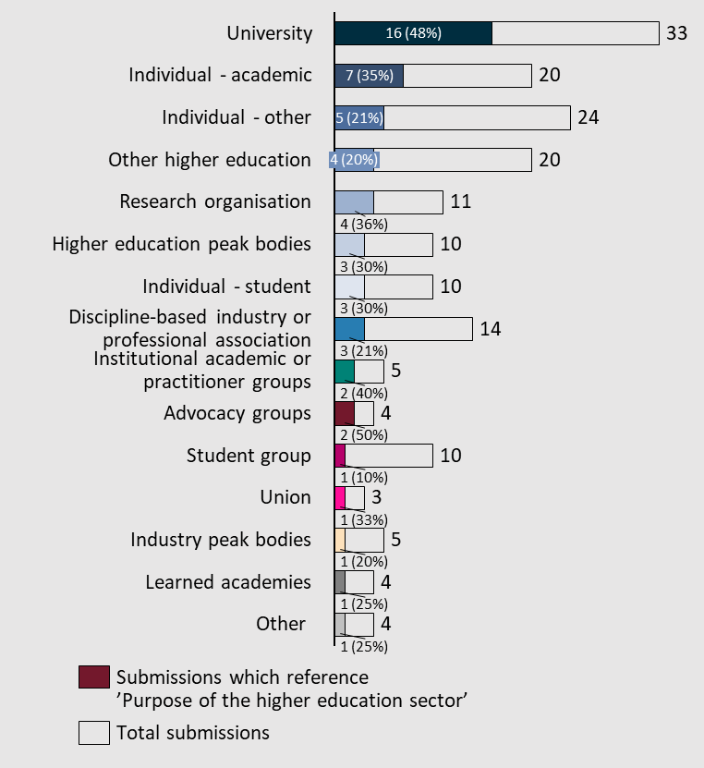

There are perceptions of a trend of neo-liberalisation and corporatisation among universities and other providers
Many submissions categorised to this subtheme either explicitly or implicitly described a changing role for universities, usually negatively expressed. Many submissions cited general, and sometimes specific, concerns about university policy changes that are characteristic of a trend of neo-liberalisation, corporatisation, and/or privatisation.
While the benefits of a strong international education sector were recognised, multiple submissions expressed that the revenue institutions received from international student fees has made their operations somewhat reliant on a constant stream of international students. Indeed, this revenue – according to a couple of submissions – is being used by universities to cross-subsidise research and training in lieu of adequate government funding. This was discussed in greater detail under ‘total Commonwealth investment in higher education’ under Term of Reference 3.
“In the current funding model for universities, it is forced to chase for ‘for profit’ International students to educate them in Australia, charge them a fortune for being educated and then in most cases this educated person leaves Australia and provides benefit to another country… it takes the focus of Australian Universities off providing a benefit for Australia and almost forces them to act for its own survival and benefit” – Martin Scanlon
“Our universities are some of the most important institutions in the country, yet as a consequence of decades of neoliberal policies their public-focussed mission has been reshaped. They are increasingly operating as corporations in an ‘international market’ and a ‘domestic market’ rather than ﬁrst and foremost being institutions of public good operating in a society.” – Senator Mehreen Faruqi
“The huge size, monochrome design and radical corporatisation of our universities, along with the science-driven research model and professional-training orientation (the instruction model), have tended in the Humanities to incentivise mediocre research while disincentivising first-class teaching. The Humanities sector needs seriously to address teaching quality: this is not even considered in the Review.” – Anonymous
“Our concern at this time is that the governance structures currently in place at many Australian Universities are governing universities towards a corporatised culture that is superseding the academic interest of the community and the public good. Numerous examples can be seen in recent media, including allegations of wage theft, the rising prevalence of workforce casualisation and the exploitation of international students as 'cash cows'.” – Council of Australian Postgraduate Associations (CAPA)

A perceived neglect of arts, social sciences and the humanities
Multiple submissions expressed concern that universities, often in line with the perceived trend of acting increasingly like private corporations motivated by profit, are neglecting more traditional foci on intellectual pursuit. This, they alluded and stated, was evidenced by the underfunding, and cutting of courses and resources for arts, humanities, and social science degrees. This was also expressed as a trend perpetuated by the Australian Government’s Job-ready Graduates package, which was controversial among humanities, arts and social sciences student and academic bodies alike. This is further discussed under ‘Job-ready Graduates Program’ in Term of Reference 3.
“CAPA is concerned with the current state of public universities in Australia as not-for-profit higher education providers created to serve the public good. We recognise the responsibility for higher education to form ethical and critical capacities in the population, specifically in the Humanities.” – Council of Australian Postgraduate Associations (CAPA)
“Too often in the Australian tertiary sector, arts degrees lose federal funding to allow for what are, misguidedly, determined to be more ‘job relevant’ degrees. Yet the arts and creative sectors are key contributors to the national economy and Australia’s rich cultural life… course cuts and studio closures are having a deleterious impact on both the number and quality of artists in Australia and may result in severe cultural deficit for Australia… we have not simply lost courses and facilities - we have been witnessing the erosion of vital sites of experimentation, creativity, critical thinking, collaboration and joy.” – National Association for the Visual Arts
“While the Job-ready Graduates Package has made learning a language at university cheaper, by making Arts courses more expensive it has divorced Asian Studies from the learning of Asian languages, putting in place disincentives to students who wish to acquire contextual knowledge on the history, society, culture, etc. of the country or countries whose language(s) they are studying.” – Asian Studies Association of Australia

Universities are seen as increasingly important in promoting innovation
Some submissions recognised the role universities are increasingly playing in promoting both a culture of innovation, as well as resultant technological outputs. Interestingly, this was described both negatively as a consequence of neo-liberalisation and corporatisation, but contrastingly also as a positive outcome, depending on the submission.
“We acknowledge the value of learning and research as essential for skills development, innovation and productivity growth. Universities have a key role in fostering the sense of discovery to find the new big ideas and to encourage the quest for knowledge… the jobs of the future will require ongoing adaptation and learning, and this will be best achieved by a university system which promotes this pattern of renewed learning.” – Business Council of Australia (BCA)
“The Union is advocating for a higher education sector that not only provides the graduates with the necessary skill sets for future productivity but one that is also positioned to support innovation and creativity in teaching and research. Higher education institutions should be seen as both assets and resources for their communities, providing expertise and infrastructure and supporting students with pathways and connections for life-long learning.” – National Tertiary Education Union

Accountability and reporting
Across all submissions, accountability and reporting was referenced in ~25% of submissions (46 total). Diverse views between and among groups of stakeholders were observed.
Figure 42| Distribution of submissions which reference subtheme 'Accountability and reporting'
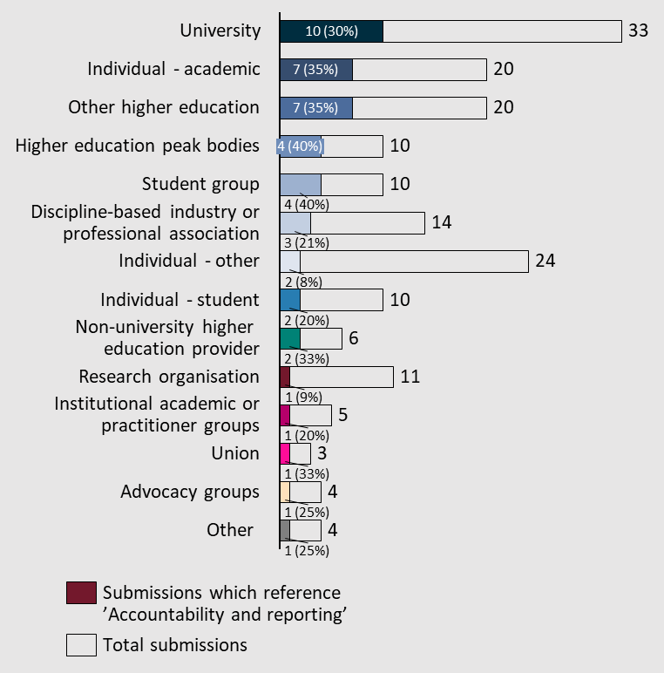

Some submissions highlighted perceived shortcomings in reporting, and holding accountable those responsible for, instances of inequality, harassment, and abuse
Submissions called for greater reporting and accountability requirements and regulations relating to addressing inequality across higher education settings. Submissions likewise cited a need to update the items of reporting in line with a heightened awareness of Environment, Society and Governance (ESG) initiatives. For example, one submission suggested mandatory university reporting for metrics as diverse as student retention and succession, percentage of casual staff, senior staff salaries (similar to publicly listed companies), gender pay gap statistics, gender equity among leadership positions, and greenhouse gas emissions and water use.
“The NTEU has also consistently advocated for the expansion of public reporting within the sector. This includes in relation to gender pay gaps, senior executive remuneration, the actual number of staff in insecure employment, the use of labour hire staff, and where public institutions have transgressed the provisions in industrial agreements.” – National Tertiary Education Union
Criticism of current regulators and bodies such as TEQSA in failing to adequately hold universities accountable for high rates of sexual harassment and abuse also featured across a small number of submissions particularly focused on heightening attention to relevant issues in higher education settings, especially across university campuses.
“Although TEQSA is the regulatory agency for higher education, it has demonstrated relative inaction with regards to the sexual violence experienced by disabled students and the lack of current disability action plans to address these issues: neither TEQSA nor the majority of universities have, as of July 2022, current Disability Action Plans.” – Australian Law Students’ Association, in conjunction with NUS and AMSA

There were calls for a review of university administrative frameworks for reporting
Several submissions highlighted a perceived need to review regulatory frameworks and bodies to ensure that the use of public funding is proportionate and justifiable. These sentiments were directed at public institutions.
“Undertake a comprehensive “red-tape review” designed to reduce the administrative costs to universities in meeting regulatory requirements. Better define the distinct roles and responsibilities of higher education providers and government agencies, including the information and services to students that might be better delivered by government agencies, rather than higher education providers.” – Edith Cowan University
“We believe the regulatory frameworks that oversee universities should be reviewed to ensure improved accountability oversight of universities for the use of public money and assets in line with government and community expectations around educational outcomes… universities currently fall between the cracks of state and federal audit offices. This means they are not subject to sufficient external scrutiny by auditor general’s and ensures public money is being spent efficiently, effectively, economically and in accordance with the law” – Dr. Annette Quayle
Other submissions focused less on the use of public funds in their calls for a review, but more on the need to reduce red tape and bureaucratic burden to ensure positive workplace settings and an environment that promotes innovation. Numerous submissions, including those from individual academics, described current reporting requirements as onerous and cumbersome, yet recognised their importance in ensuring the accountability of public funding.
“Autonomy comes with accountability to the taxpayers and students who sustain the sector. Our social licence is driven by our communities, our alumni, industry partners and local employers. An assessment of red tape and duplicative processes between Federal and State Governments would help to ensure administrative burden, particularly when enacting new legislation or policy instruments, is kept to a minimum.” – Federation University
“The most significant outcome from the Review and Accord process would be to reduce complexity in the existing system, and free up room and resources for universities to innovate for the future… the Accord provides an opportunity to put in place a modern framework that ensures accountability for public investment while also allowing for flexibility and for universities to focus on their mission. IRU universities have a clear mission in their establishing legislation to serve their communities.” – Innovative Research Universities

There is a perceived need for heightened accountability for administrators
A few submissions called for greater oversight for, and accountability of, university council members, vice chancellors, and other senior administrators. Some submissions alluded to concerns about the public accountability of Australian universities, or otherwise criticised what are perceived to be excessively high salaries of senior executives.
“As university councils and vice chancellors oversee significant public money and assets, they should be subject to oversight over their effectiveness and efficiency for those assets. State or federal performance audit of universities would provide meaningful insights into topics of relevance. We note that there are numerous issues that deserve increased external scrutiny. The recent case of universities underpaying their casual staff is one case in point.” – Dr. Annette Quayle
“All salaries of the executive officers of Australian public universities – including, but not limited to, vice chancellors – must be aligned with those of other leaders of public institutions and capped at twice a professorial salary. Furthermore, all salaries, remuneration and fringe benefits must be made fully public. The hiring process of all executive officers must be undertaken by committees that represent the university community (including academic staff, non-academic staff, students and alumni).” – Public Universities Australia

New challenges are increasingly being imposed by digital technologies
A small number of submissions expressed concern that the misuse of increasingly sophisticated digital platforms and applications, particularly those utilising artificial intelligence, are making cheating – both in student academic work as well as research proposals – more common and difficult to identify. Nevertheless, while interesting, this was not widely commented on.
“Contract cheating using AI is threatening the integrity and reputation of the Australian higher education sector.” – Curtin University

Workforce and workplace relations
Among submissions referencing workforce and workplace relations consideration, the most recurring issues were workforce casualisation and job (in)security, changing workforce needs, and industrial relations. This subtheme featured a larger number (12) and proportion (~29%) of individual submissions compared to others under the governance, accountability and community Term of Reference.
Across all submissions, workforce and workplace relations was referenced in ~23% of submissions (42 total).
Figure 43| Distribution of submissions which referenced subtheme 'Workforce and workplace relations'
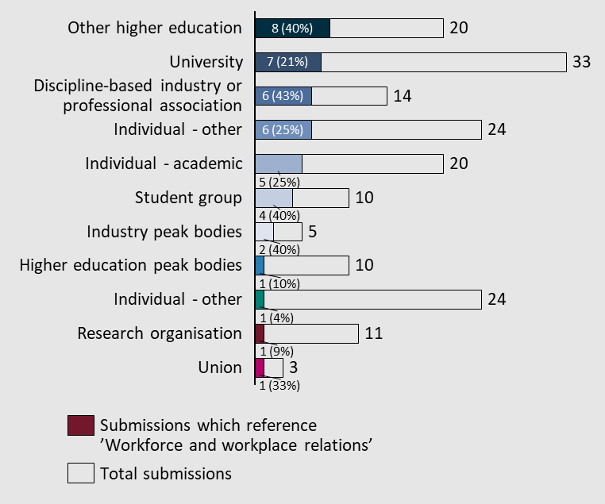

Diverse stakeholders expressed concern about the increasing casualisation, job insecurity and workload across the higher education sector, especially for academics
Most submissions categorised to the workforce and workplace relations subtheme related to concerns about job insecurity, staffing cuts due to organisational restructures, and role casualisation for employees in higher education settings, particularly public universities. Some submissions described the unintended consequences this has had on teaching and research quality (and, to a lesser extent, quantity). Some submissions included specific recommendations for the government to consider limiting the prevalence of such casualisation through regulatory and legislative frameworks. Calls were made for action to increase workload sustainability, ensure fair and equitable academic career progression, and limits to short-term and/or casual contracts. Concerns about casualisation were generally more pronounced for those representing, or expressing concern for, academics researching and teaching in the arts, humanities and social sciences.
“Another concern is that the increase in VC remuneration has occurred at the same time as significant staff reduction and workforce casualisation.” – Curtin Student Guild
“Meanwhile university staff have seen their wages stagnate, their workloads increase, and large amounts of experienced staff cut.” – Anonymous
“The[re is a] need for secure jobs with fair conditions and an end to rampant casualisation and wage theft at universities, and a transparent review of the salaries of VCs and senior management.” – Senator Mehreen Faruqi
“A vast majority of university staff in arts, craft and design faculties and schools across Australia endured months of job uncertainty and an unclear picture of their futures. For those ‘fortunate’ enough to keep their jobs, many of their roles have been restructured in ways that make their workloads unmanageable, and devalues what they do as teachers, researchers, and support staff… the casualisation of staff is rampant across the whole university sector including arts faculties. Two thirds of university workers are on limited term contracts or casual appointments. Teachers have no security in terms of knowing whether they will be employed for the upcoming semester.” – National Association for the Visual Arts
“Universities are also accountable to their staff. Sustainable workforce planning in higher education which contributes to a robust and high performing academic workforce is important. Excessive use of casualisation, and the devolution of responsibility for managing casual employment within institutions with consequent impacts for staff, is unacceptable. This problem has developed over time, and in part reflects financial drivers, linked to rapid growth in student numbers, which means there is no quick fix. Given that university workforce needs will vary significantly, as will finances, across institutions, it is also the case that a `one size fits all’ model or a heavy regulatory hand is unlikely to deliver the best outcomes, now or in the future.” – University of Melbourne
“Casualisation of the workforce: policy uncertainty and inadequate research funding helps drive casualisation of the university workforce, with negative consequences for staff and for the nation’s research and higher education capacity.” – Universities Australia
“Universities must provide secure, safe, non-exploitative employment, as well as tenured academic employment.” – Public Universities Australia
It is worth drawing particular attention to references made to staff workloads, which some submissions linked and attributed to staffing cuts and casualisation – while others discussed separately.
“The health and wellbeing of university staff across Australia are currently in dire straits, primarily due to work overload…[a] survey was completed by 165 UNE staff (approximately 12% of total UNE staff), with results indicating high levels of work overload, low staff morale, and concerning levels of reported adverse impacts on staff wellbeing.” – Liz Temple

A small number of suggestions were made for establishing and implementing enterprise agreements and relevant policies
A couple of submissions provided suggestions for improvements in higher education industrial relations, particularly with regards to enterprise agreements and university policies.
“To this end, in the short to medium term, single employer enterprise agreements should be encouraged within the higher education in preference to any form of multi-employer enterprise arrangements. Any pivot to multi-employer enterprise arrangements in the short to medium term will further amplify the disruptions currently being experienced by the sector as a result of Covid.” – Australian Higher Education Industrial Association
“When it to comes to workplace relations, [we] contend that individual institutions remain best placed to consult with their workforce and unions on appropriate pay and conditions and enshrine these into enterprise agreements and other policies as appropriate.” – Anonymous

Institutional diversity
Submissions that referred to institutional diversity mainly referenced issues differentiating private and public institutions, as well as the needs of regional and remote universities compared to their metropolitan and urban counterparts. Institutional diversity was referenced in ~18% of submissions (34 total).
Figure 44| Distribution of submissions which reference subtheme 'Institutional diversity'
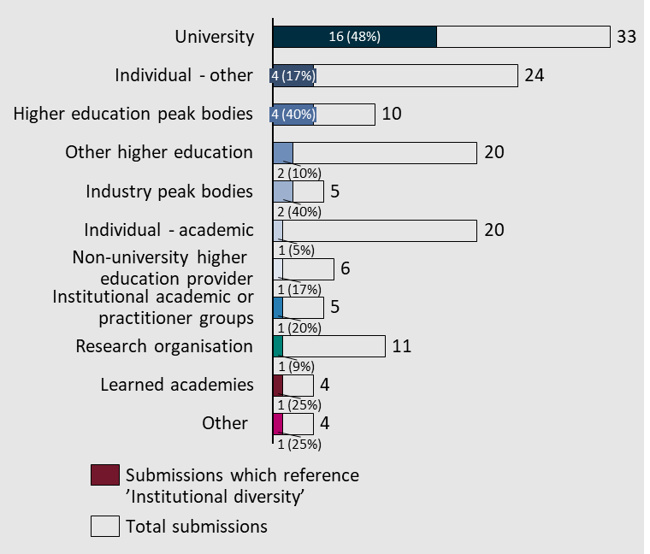

Private institutions emphasise their perceived need for institutional diversity
Submissions from private institutions, including universities, emphasised the role they play in the sector, and why it is important they are not overlooked. They expressed a perception that Australia’s public universities are, in their view, homogenous and sometimes lacking innovative thinking.
“Bond has provided an alternative to the largely homogenous public university system… the success of Bond University provides an instructive case study on how institutions with independent missions can provide alternative choices for students, and thus add strength to the system as a whole… the Australian university sector must deliver a quality educational experience that equips our students with the skills and attributes needed to succeed in an increasingly complex, digital and competitive global landscape. To achieve this, we need a system that supports institutions of different shapes, sizes, structures and missions, and policy settings that support institutional autonomy, innovation, and continuous improvement.” – Bond University
“Our oversized and homogeneous universities are not offering a truly diverse mix of learning opportunities for Australian undergraduates, regardless of their socio-economic backgrounds.” – Anonymous
“Good reform does not always correspond to a “one size fits all” approach— the higher education sector is diverse, including the size, shape and composition of each institution. The Accord must embrace the importance of a differentiated system that allows each university to meet the learning, teaching and research needs of their local community. Australian universities have embraced diversity and we need to ensure any future policy changes do not lead to a rise in uniformity across the sector.” – University of Notre Dame Australia
As noted in the July 2018 KPMG report “Reimagining Tertiary Education“ (authored by distinguished higher education experts - Professor Stephen Parker, Andrew Dempster and Mark Warburton), the Australian university sector lacks a level of diversification that is present in some of the other national higher education systems. Specifically, the authors note that “we see the paradox of sameness amongst our universities, despite ostensible differences. Most, but not all the people we spoke to believe that is the case and lamented it” (Parker et al. 2018, p11) – Top Education Group Ltd
“Private investment can deliver public good and cannot be excluded from considerations about investment and affordability in Australian Higher Education...” – Torrens Global Education

Public universities also encourage institutional diversity and differentiation while maintaining, or strengthening, consistent frameworks
The Academy of the Social Sciences in Australia recommended that regulatory frameworks and funding models for the higher education sector “ensure differentiation and value-add rather than impose a tendency to uniformity across Australian universities”. Universities Australia similarly suggested heightened “support for universities to develop and pursue diverse institutional missions” and calls for greater diversity of offerings in the sector. This sentiment was further supported by the individual submissions of public universities.
“A move toward longer-term funding and compact agreements between universities and the Commonwealth that reflect specialisation, anchor institution status and a focus on needs-based provision.” – RMIT University
“We recommend the panel consider whether the higher education system is sufficiently diverse in terms of offerings and institutional types and mission to support the needs of a range of learners from different backgrounds… more broadly, we recommend the panel note the diversity inherent in universities’ engagement in their communities, and particularly the benefits delivered through successful partnerships and collaborations. This will be important in ensuring partnerships are recognised and supported through funding and policy settings.” – University of Melbourne
“Australian universities have distinct missions. Models and programs must take into account this diversity and should provide equitable support.” – University of Canberra
“The need for a coherent national approach to industry accreditation of courses, so that accreditation ensures professional requirements are met but does overreach into institutions’ diverse operating models.” – University of New England
“Advancing a roadmap for the differentiation of higher education institutions in Australia over an agreed timeframe – allowing for the evolution of greater specialisation in the provision of offerings and higher quality outcomes for learners and partners.” – University of South Australia
“The Panel should support allowing different missions of universities to be shaped by institutional agreements with government and other stakeholders. UTS supports the need for recognising and enabling diversification, but this should be done by allowing diversity to flourish through the design of the system and funding drivers.” – University of Technology Sydney

Universities serving rural, regional and remote areas seek bespoke support distinct from those serving urban settings
Universities located primarily in rural and regional areas outlined a need for governments to consider their exigencies and requirements as, in some cases, distinct from other public universities. However, contrasting views mean developing balanced policies that serve the interests of different providers while managing stakeholder expectations may be difficult.
“Arrangements that we might need to put in place may be very different from a metropolitan-based institution and in keeping with the move away from a one-size-fits-all, we would also not want this imposed on us in the area of workplace relations… failure to ensure regional sustainability has resulted in and compounds the hollowing out of regions. It is a challenge to support replacement industries in dispersed regional towns with the appropriate skills and qualifications… there will be arguments to concentrate research funding where the impact can be greatest for finite dollars. If the objective is to create greater opportunities, to provide a system for the best ideas to flourish no matter where that pocket of excellence is, then creating an elite system that is only available in the major capital cities will not meet that objective.” – Federation University Australia
“The current system – both research and teaching – has been disproportionately rewarding institutions that operate at scale in densely populated urban markets. There is evidence of an emerging two-tier system of educational outcomes that has the potential to undermine the reputation of Australia’s higher education ecosystem... to ensure the sustainability of the Australian higher education ecosystem in meeting the skilling needs of Australia’s diverse future workforces, and to ensure that all Australian’s – regardless of their location or background – are able to pursue their desired study at the institution of their choice, RUN believes that it is vital the Australian Universities Accord examines the disproportionate challenges that entrenched diseconomies of scale present for regional universities and how the funding operate system can be sustainability set up to meet future student need.” – Regional Universities Network
“Additionally, a focus on regional, rural and remote access and success is crucial but care must be taken that interventions do not incentivise hyper-competition from metro universities to recruit students from thin regional markets.” – James Cook University

Institutional governance
Governance intersects with other subthemes such as regulatory and legislative frameworks, institutional diversity, accountability and reporting, and workforce and workplace relations (particularly concerning decision-making surrounding pay and casualisation). Most Australian universities are established by legislation in their respective state/territory parliament despite most of their public funding coming from the Commonwealth. Most submissions concerning institutional governance related to governance settings surrounding funding and support for student associations, the administration of university councils, and interjurisdictional discrepancies. Institutional governance was referenced in ~12% of submissions (22 total).
Figure 45| Distribution of submissions which reference subtheme 'Institutional governance'
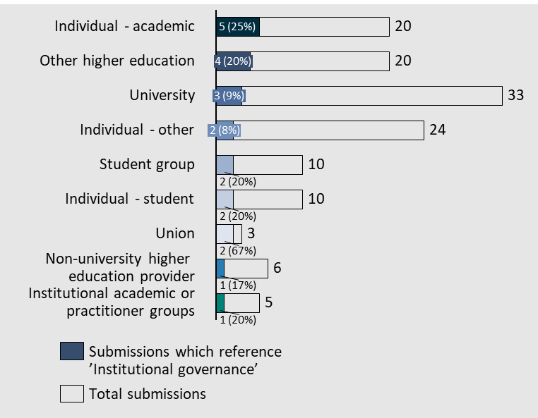

Student councils and bodies are perceived as underfunded and undervalued
Challenges concerning (under)funding, undervaluing and disempowerment of student councils and other representative bodies were mentioned in a few submissions, most notably but not exclusively from the student union.
“Crucially, this [Accord] provides perhaps a lone opportunity to put student services amenities fees up for discussion. Currently, student unions are funded by university management, who allocate some amount of revenue from the Student Services Amenities Fee (SSAF)to their respective student union(s). ... We need properly funded clubs and societies through a student union that has the [capacity] to do proper outreach to students. Involvement in clubs and societies is essential for online students to feel engaged and invested in their university or higher education provider.” – National Union of Students
“The more significant concern is postgraduate student associations challenges in this space. The needs of postgraduate students are significantly different to our undergraduate counterparts and still bear the scars from voluntary student unionism, with many of our postgraduate associations collapsing into a combined student organisation with undergraduates.” – Council of Australian Postgraduate Associations (CAPA)
“Student unions have been recognised for their contribution to improving the student experience and satisfaction at universities. The negative impacts of voluntary student unionism are still present in universities today… the student experience can be improved through dedicated government investment in democratic student organisations. These organisations have consistently been active in university policy, despite detrimental changes that have negatively impacted the student experience on campus.” – Curtin Student Guild

University councils were criticised as being un(der)representative and motivated by profit-driven and corporate interests
University councils were criticised as being un(der)representative and motivated by corporate interests. Some submissions alluded to university councils and governing bodies being more motivated by profit-driven interests than academic ones, exemplifying tensions between corporate and academic priorities across universities. Submissions called for a greater academic voice and representation in university governance.
“University democracy is eroding. More and more elected staff and students on university governing bodies have been replaced with corporate appointments. Funding for student services and student unionism is not suﬃcient and needs to be allocated democratically.” – Senator Mehreen Faruqi
“University 'senates' or 'councils' are currently comprised mostly of representatives from the community and or industry, and have few actual academic representatives. This fails to take advantage of the informed perspective of active and experienced academics in these important governance bodies. In these key governance assemblies, informed academic perspective is too readily overwhelmed by the uninformed. Similarly, current arrangements fail to make proper use of the corporate expertise of senates or councils, because there is insufficient contact between representatives of corporate and academic cultures, for academics to access the corporate expertise available.” – Public Universities Australia
“Ensure equal numbers of community, special interest groups and business as there are academics; run mandatory feedback and evaluation annually in every institution and publish the results publicly, with evidence of what the directors propose to do in response.” – Robbie Lloyd
“The AAUP believes that Academic Senates (Councils) in universities need to be restructured so that they are controlled by academic leaders from outside of the hierarchy and who are primarily accountable to the broader academic body and university community. As academic leaders, these academics need power to be able to influence the strategic direction of the university through the ability to initiate strategic proposals and critique those put forward by management. They need a say in how resources are to be allocated and into senior appointments to the university. Empowering Academic Senate in this way is important because it is considered by the Tertiary Education Quality Standards Agency (TEQSA, 2019) as the primary source of academic leadership in universities. AAUP suggests that TEQSA needs to do a risk assessment of the impacts on the effectiveness of universities.” – The Australian Association of University Professors (AAUP)

Interjurisdictional inconsistencies between governance mechanisms and structures mean the Commonwealth can play a greater role in ensuring consistency in standards
Submissions quoted below highlighted that governance mechanisms must be reviewed such that democratic processes and other consistencies across universities spanning diverse geographies are strengthened.
“The NTEU has consistently advocated for a reversal of the trend towards corporate sector style university governance and a move to the adoption of a more collegial model…. while most institutional governance structures are enacted via state government acts, there is still a role for the Federal Government to play in setting expectations around good governance structures (for example, as part of the Mission Based Compacts with each institution) … Simply having one or two elected positions on councils is insufficient to have any real impact.” – National Tertiary Education Union
“The powers of Councils/Senates to appoint their members is bedevilled by various anachronism and idiosyncrasies across jurisdictions. South Australian and New South Wales governments have made important moves to respectively eliminate and reduce State Government involvement in Council appointments, while not diminishing university-government interaction. These initiatives should be extended into a national reform whereby State Governments pull back from direct appointments but develop deep multi-faceted partnerships with their universities.” – University Chancellors Council

Academic freedom
References to academic freedom generally included concerns with current university policies and governance frameworks and provided calls to action to ensure greater accountability in relation to academic freedom.
This subtheme was referenced in ~6% of submissions (11 total). There were, however, some clear differences between groups.
Figure 46| Distribution of submissions which referenced subtheme 'Academic freedom'
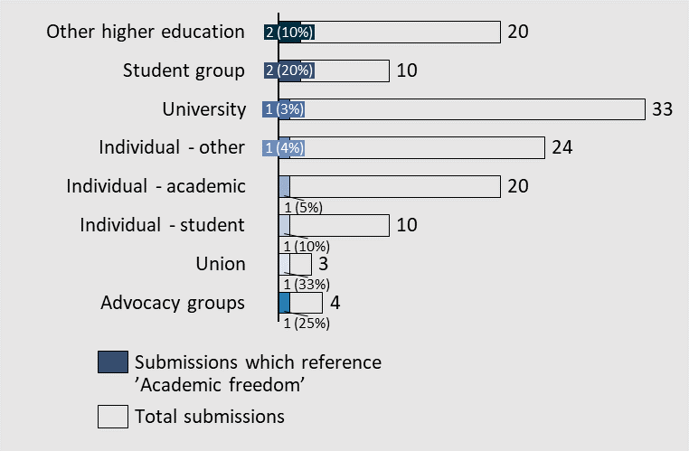

Concerns about the current state of academic freedom
Australia’s favourable conditions of academic freedom were mentioned as a point of attraction for international students. Notwithstanding, a small number of submissions cited explicit albeit general concerns that academic freedom is being undermined due to increasing corporate and political influences in higher education settings. They highlighted the important role ensuring academic freedom plays in promoting a positive culture across universities, and several submissions related academic freedom to the notion of autonomy in both teaching and research.
One submission described unspecified changes to the Australian Research Council (ARC) towards more applied research, particularly in STEM fields, as “interventionist” and undermining research independence. Multiple submissions cited concerns about university administrators increasingly suppressing academic freedom through micromanagement and excessive surveillance or otherwise by evoking fear and intimidation.
“Governments over time have not only increasingly become interventionist but have sought to undermine research independence through changes to the ARC and a shift towards applied research (specifically in STEM).” – National Tertiary Education Union
“PUA observes that many universities currently subjugate necessary academic freedom in favour of managerial methods that may be effective outside of universities, but that fail to properly support the academic enterprise.” – Public Universities Australia
“Research funding and academic freedom have also been steadily eroded with creeping political and corporate inﬂuence.” – Senator Mehreen Faruqi

The critical role of supports and provisions in ensuring academic freedom
Several submissions suggested particular safeguards and provisions to maintain, and improve, the condition of academic freedom in higher education settings, particularly universities. Submissions that related academic freedom to conceptions of autonomy and independence emphasised the importance of researchers feeling able to determine their own priorities. This relates to submissions that expressed concerns that current administrative arrangements and bureaucratic processes, such as the requirements for grant applications, are undermining the potential for innovative research in universities. Failure to adhere to the ‘academic enterprise’ was also mentioned as a concern.
“While some improvements have been made around academic freedom and intellectual inquiry in recent years, the NTEU maintains that it is only through the robust provisions in NTEU negotiated enterprise agreements that academic freedom protections for higher education workers have been upheld in this country. There are therefore opportunities for the legislation to be strengthened, extending protections to all workers who are engaged in scholarly practice, and signalling to university managements that academic freedom overrides corporate branding of institutions. We also support improved access and coverage of whistle-blower protections for higher education staff.” – National Tertiary Education Union
“From a democratic standpoint, it becomes vital to support scholars who think critically and freely, who do fundamental research, and who mentor students, and this must be protected in our universities. Academic freedom and adherence to academic values is a democratic imperative that must be insisted upon in opposition to the inappropriate imposition of corporate practices... we believe that academic freedom should be enshrined in the Acts of Parliament that govern universities, or at least incorporated into key university documents, in a manner that ensures application throughout the entirety of each university, and in all academic works.” – Public Universities Australia

Term of Reference 5: The connection between the vocational education and training and higher education systems
Explore possible opportunities to support greater engagement and alignment between the vocational education and training (VET) and higher education systems. In particular, the Panel will have regard to the experience of students in navigating these systems and ensuring a cohesive and connected tertiary education system.
Submissions called for greater integration and interoperability between both systems and identified challenges for dual-sector providers in meeting separate regulatory obligations. Some submissions also called for greater recognition of prior learning between higher and vocational education, while others emphasised the need for clearer and better integrated navigation pathways between secondary schools, TAFEs and universities.
Figure 47| Distribution of submissions across Term of Reference 5 subthemes
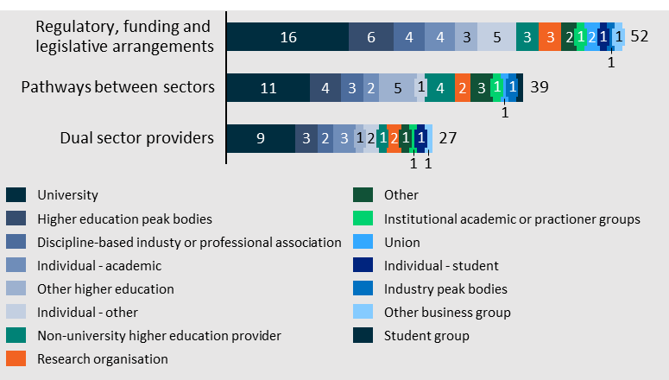

Regulatory, funding and legislative arrangements
References to regulatory, funding and legislative arrangements as they relate to the connection between the Vocational Education and Training (VET) and tertiary education systems were cited in ~29% of submissions (52 total).
Figure 48| Distribution of submissions which reference subtheme 'Regulatory, funding and legislative arrangements'
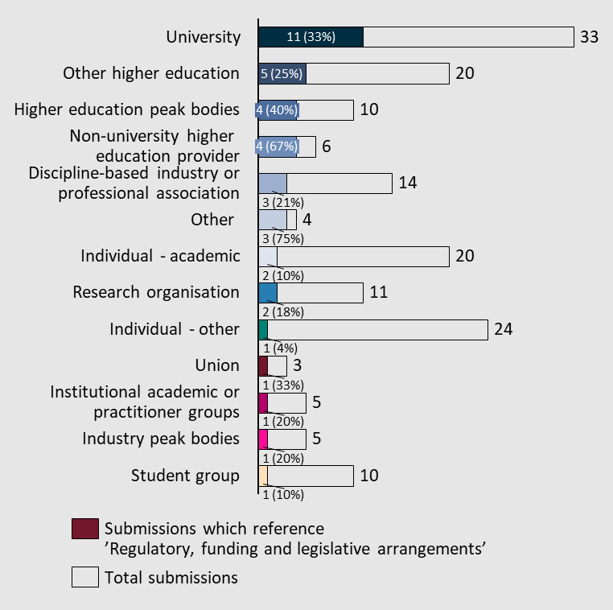
The key issues referenced are discussed in detail below.

Some stakeholders described the potential for greater integration and/or collaboration between universities and VET providers
References were also made across multiple submissions to the inherent possibility for more dual sector providers across the higher education sector, or otherwise greater collaboration between both industries. Submissions from a TAFE also described the economic and societal disadvantages of maintaining two rigidly distinct sectors with limited integration and collaboration.
“The committee should consider the potential to foster partnerships between public universities and TAFES to jointly develop contemporary qualifications, outside the bureaucratic strictures associated with competency-based training packages, for delivery primarily by TAFEs and where appropriate by universities.” – Mark Warburton
“VET providers can tap into university expertise to build quality training programs and the offerings needed to maintain a skilled and challenge-ready workforce.” – Science & Technology Australia
“There is an opportunity to enhance and align the partnerships between VET providers and the university sector that will serve to strengthen pathways to education for all Australians. Some universities are dual sector and others have good connections with VET providers, but there are inconsistences that need to be addressed.” – University Chancellors Council
“A strong and transparent connection between VET and higher education is imperative for Australia’s economic and social development. A united tertiary education sector will promote social inclusion and facilitate access to, and participation in, higher levels of learning by vulnerable members of the community (e.g., low socio-economic status). It will also contribute towards relieving the chronic workforce skills shortages currently experienced nationally across all industries. A VET and higher education link is essential however it is important to recognise that VET and higher education at a national policy level in Australia are not connected.” – SkillsIQ
“Use this opportunity to repair the Vocational Education and Training (VET) system. As one of Australia’s six dual-sector institutions, Swinburne supports policies that provide opportunities for articulation between the vocational and higher education sectors and the development of integrated programs that span the sectors. The post-compulsory education and training system must be able to respond to student and community needs, with the current fragmented policy, funding and regulatory settings providing barriers to pathways, innovation and participation.” – Swinburne University of Technology
“Facilitate interoperability and bidirectional transfer between VET and HE systems.” – Queensland University of Technology

The ongoing relevance of regulating both sectors is widely recognised and appreciated, particularly considering calls for greater integration
Amid suggestions for greater integration, there was a widespread and broad recognition of the important role regulation plays to ensure the quality and sustainability of higher education spanning both VET and tertiary qualifications. Nevertheless, the need for reform to reduce excessive or duplicative regulatory requirements was emphasised:
“IHEA acknowledges that regulation of both the higher education and VET sectors in Australia is necessary to protect the quality and reputation of our post-secondary education sector. However, where regulatory design and processes are excessive or duplicative, a risk to the efficiency, consistency and coherency of the regulatory model exists. For the education sector, these risks are felt directly by registered providers as direct objects of regulation but also indirectly by the broad range of actors and agents within the national education system including governments, the community, and students.” – Independent Higher Education Australia
“Greater flexibility and focus on mission would support more effective integration between universities and VET institutions, supporting clearer pathways for students. For example, IRU member universities would like greater flexibility to allocate Commonwealth-supported places to enabling and pathway programs, to build new partnerships and serve the needs of their communities. Universities would then report to government and the public on the effectiveness of those programs and on student outcomes.” – Innovative Research Universities
“There are a number of dual sector institutions (although there seems to be little integration of the vocational education and higher education components) and most universities are registered training organisations which can deliver vocational education and training certificates. Nevertheless, the different funding and regulatory arrangements have given Australia an incoherent tertiary education system.” – Mackenzie Research Institute
“Establishing strong connections between universities and VET means both cultural and regulatory change on both sides. Importantly, different approaches to teaching need to be reconciled and reforms needed to income-contingent loans for VET students.” – Macquarie University

Some submissions called for greater alignment between TAFEs, dual sector providers, and secondary schools
Federation University and Victoria University – both universities providing both higher and vocational education - explained why, in their view, policy changes affecting dual sector providers should not be considered independently from secondary schools. In addition, a small number of submissions suggested the Commonwealth to fully implement, and adapt, the Australian Qualifications Framework (AQF) in accordance with recommendations from the Noonan Review (2019), which proposed solutions for better integrating pathways between the secondary, vocational and tertiary/higher education systems.
“Federation University works closely with partner TAFEs to provide two-way pathways for students skilling and upskilling or changing careers in areas like Berwick and Gippsland where we do not have our own TAFE presence. Although the States are primarily responsible for public provision of vocational skills the settings between public TAFEs and dual-sector institutions are treated differently. The former has any losses underwritten by the State Government, unlike we who must cross-subsidise. There is an opportunity to assess funding arrangements more broadly as they apply to postsecondary education.” – Federation University
“We also cannot look at the tertiary sector in isolation from secondary schooling. There is a need for greater interoperability across all of the sectors, focused on measured outcomes. We believe that we need to be talking about learning continuum starting from the middle years of secondary schooling (Years 9-10). Put simply, a tri-sectoral, integrated university could be the model of the future.” – Victoria University
Other universities, institutions and individuals shared consistent messages:
“Establish clear and enduring co-funding arrangements for Commonwealth and state government funding of vocational education, to move Australia to a tertiary education sector with consistent goals for post-secondary education access, participation and achievement.” – Edith Cowan University
“There is clear connectivity (and appropriate credit transfer) between VET and higher education qualifications. This has been developed over decades of government and sectoral examination. If this is a university accord why should VET providers be excluded, particularly if the objective is better alignment between the two sectors?” – Paul Corcoran
“Incentivise higher education providers to collaborate with schools, VET, and local community organisations.” – Society for the Provision of Education in Rural Australia (SPERA)
One TAFE expressed dissatisfaction with their perceptions of inequitable funding between TAFEs and universities (including dual sector providers) perceived inequity amid funding disparities was highlighted as a major concern for the following TAFE:
“Universities are offering vocational education and Vocational Education and Training (VET) providers are offering higher education. Yet, students choosing to study higher education at TAFE do not receive the same funding support as do university students … VET providers offering higher education are generally excluded from CSP in accordance with the Higher Education Support Act 2003.” – TAFE Queensland

Pathways between sectors
Submissions referring to the student experience navigating the systems and pathways between the higher and vocational education sectors featured in ~22% of submissions (39 total).
Figure 49| Distribution of submissions which referenced subtheme 'Pathways between sectors'
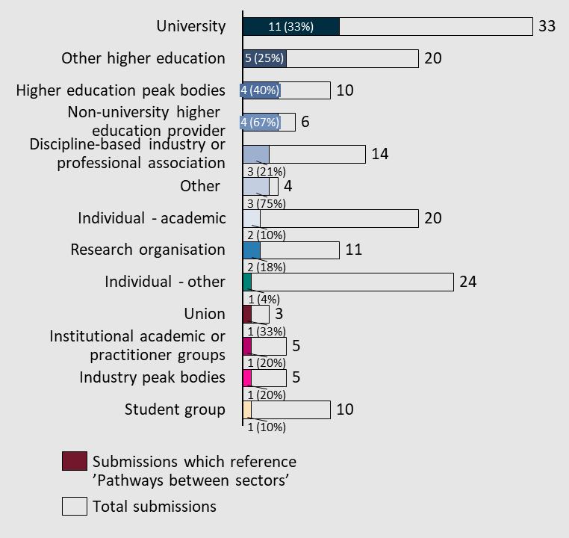
At present, the higher education and VET systems are distinct such that should a student complete a VET qualification like a Certificate IV or Diploma and proceed to undertake a bachelor’s degree, the responsibility to navigate the systems rests on the students. Submissions categorised to this subtheme included discussion of arrangements for students to receive credit or recognised prior learning and integrated qualifications or pathways. Moreover, the loans available to students differ between systems, causing challenges for students navigating between them.

Submissions argued for clearer pathways for students to navigate between VET and higher education
According to relevant submissions, changes in course offerings, including the increasing prevalence and diversity of micro-credentials on offer (discussed further in ‘lifelong learning’ under Term of Reference 1) as well as long-standing discrepancies between TAFEs and universities (or other VET compared to higher education providers) have resulted in unclear pathways for students.
“The BCA greatly welcomes the focus on the connectivity between higher education and VET in the Terms of Reference. It is crucial that we take this opportunity to create a genuinely joined up and interoperable post-secondary system that will be able to support Australian learners, businesses and industry, and build a culture of lifelong learning.” – Business Council of Australia (BCA)
“Pathways to and between tertiary education are not well understood and too inconsistently applied between TAFE’s and universities. Many regional areas have limited visibility to the various pathways into tertiary and vocational education.” – Campus model Regional University Centres
“The ongoing proliferation of post-secondary credentialled and non-credentialled learning possibilities have increased the challenges that students confront in confidently and effectively navigating, comparing, and enrolling in courses that are right for them… more effective articulation and course credit arrangements between higher education and VET is considered a priority issue for the Panel… Transparent and comparable information to help students identify and access courses that are right for them is considered a priority issue for the Panel.” – Open Universities Australia Pty Ltd
“Information is currently bifurcated, unhelpfully blurring investment and accountabilities across state-based vocational education and federally funded higher education – a distinction which is clearly important when considering transferability. This inevitably leads to confusion for prospective students who may be considering pathways.” – University of Southern Queensland
“Clearer pathways – the complexity of both sectors, including in how training packages and qualifications are developed and delivered makes it challenging to provide clear and seamless pathways between VET and higher education and vice versa. This should include the role of VET in schools. Improved outcomes in this area would go a long way to uplifting post-school training and education participation rates.” – Anonymous
“Identifying approaches to achieve better alignment, particularly from a student perspective, between VET and Higher Education must be a priority for both the government and the university sector. Ensuring seamless transition between the two systems, and providing the opportunity for genuine collaboration leading to new solutions for skills development, will lead to successful innovation in this area.” – University of Technology Sydney

Diverse stakeholders suggest and call for greater interoperability and recognition of qualifications across both sectors
Several submissions focused attention on the need for greater recognition of learning across both the vocational and higher education sectors. This is particularly in light of the experience for students navigating and receiving credit across systems.
“Current challenges for the VET student include [that] there are no systemic arrangements in place for credit for the first year of a degree for students with an AQF Level 5 Diploma. Credit transfers are not easily developed with universities, resulting in inadequate transfer information being available for the student pathway at time of enrolment. [There is also] lack of a formal collaboration of teaching teams across institutions to support the transition between the different styles of delivery and assessment inherent in different qualifications. While pathway options may be available, they may not be well known or utilised extensively.” – TAFE Directors Australia (TDA)
“A seamless, nationally consistent interface between VET and HE is critical. Individual system-based reforms to HE and VET must be replaced by an overarching policy framework for post-secondary education in Australia, thus the Accord process should consider a framework which preserves the distinctive roles of the higher education and VET systems while better connecting them, so that together they can help meet the future economic, social and demographic challenges facing Australia.” – Swinburne University of Technology
“Expand accredited qualifications with VET sector that allows students to mix and match their subjects across universities, vocational education and practical industry/community experience.” – Torrens Global Education
“The end result of this mindset for students has been an incredibly inaccessible system to transfer between the TAFE and university sectors, with limited recognition of qualifications and prior learning. Because qualifications frameworks were designed with this mindset, most students aren’t able to have all of their learning in one part of the sector recognised by the other and even where it is technically possible students don’t have the time, energy or money to make it happen.” – National Union of Students
Federation University asserted that changes in career preferences and trajectories necessitate greater attention to harmonising recognition frameworks:
“Funding and regulatory arrangements are different yet increasingly students will be choosing to take a vocational qualification to change careers having already attained a higher education qualification. Others will transition from or between the other as their life circumstances change. Making it clear that no one option is better than another is key to getting better connections between the systems, which really should be one post-secondary system. Both provide opportunities to be self-employed, to employ others or work across the country or overseas.” – Federation University

Dual sector providers
References to dual sector providers featured in ~19% of submissions (36 total).
Figure 50| Distribution of submissions which referenced subtheme 'Dual sector providers'
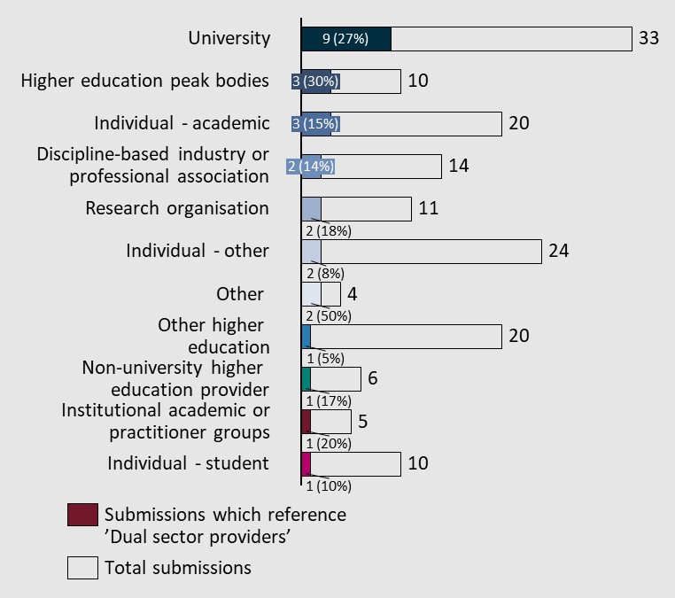
There are six dual sector universities in Australia, which must work with two different regulators due to offering both vocational and higher education courses.
Submissions mentioned an excessive regulatory burden and other structural barriers for dual sector providers
Institutions that offer both higher and vocational education, i.e., dual sector providers including Victoria University, RMIT, Central Queensland University, Federation University, Charles Darwin University and Swinburne University of Technology, face difficulties navigating what submissions described as regulatory burden and structural barriers due to needing to navigate multiple, distinct regulators. Yet, at the same time, universities providing VET courses were described as conducive to attracting diverse students, particularly those from underrepresented backgrounds, to higher education:
“Excessive regulatory duplication exists for dual and multi-sector HE institutions. The Government has long recognised the duplication and regulatory burden faced by providers co-regulated by different agencies. TEQSA even introduced a measure to reduce regulatory burden by working closer with ASQA for this very purpose. That said, little progress has been made to address the over-regulation of dual sector tertiary education providers meaningfully. IHEA proposes that the Higher Education Accord Reform prioritise reducing barriers and red tape that unfairly burden dual and multi-sector providers co-regulated by TEQSA, Australian Quality Skills Authority (ASQA), and in some instances, Professional Associations.” – Independent Higher Education Australia
“An examination of the experiences of dual sector universities would offer insights into some of the pressing regulatory and funding issues, and examples of innovative practice.” – Anonymous
“Dual sector universities recognise the ‘gift’ they have to offer qualifications across the AQF but are hampered by long term, entrenched historical and structural barriers. At present this limits choice, opportunity and ultimately potential.” – Victoria University

Term of Reference 6: Quality and sustainability
Examine the challenges faced by domestic and international students and staff due to the COVID-19 pandemic and the temporary and permanent impacts on the way the higher education sector works.
Support a competitive and resilient international education sector, reflecting the important role international students play in our society and economy, and Australia’s interest in deepening partnerships abroad.
Submissions highlighted both the positive changes, and difficult challenges, imposed on the higher education sector by COVID-19. Moreover, they cited an overreliance on international students among Australian universities, while highlighting opportunities for international students’ pathways to help address skills shortages. The mental health and safety of both students and staff were discussed, with specific concerns raised addressing the higher education sector at large.
Figure 51| Distribution of submissions across Term of Reference 6 subthemes
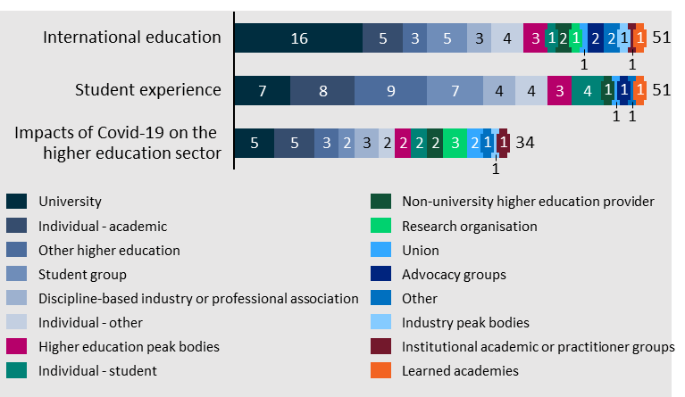

International education
This subtheme featured submissions also categorised to the other subthemes under Term of Reference 6, for example when they related to the impact of COVID-19 on the international student experience (relating to all three subthemes).
Nonetheless, 56 of submissions made references to international education – representing ~30% of submissions.
Figure 52| Distribution of submissions which referenced subtheme 'International education'
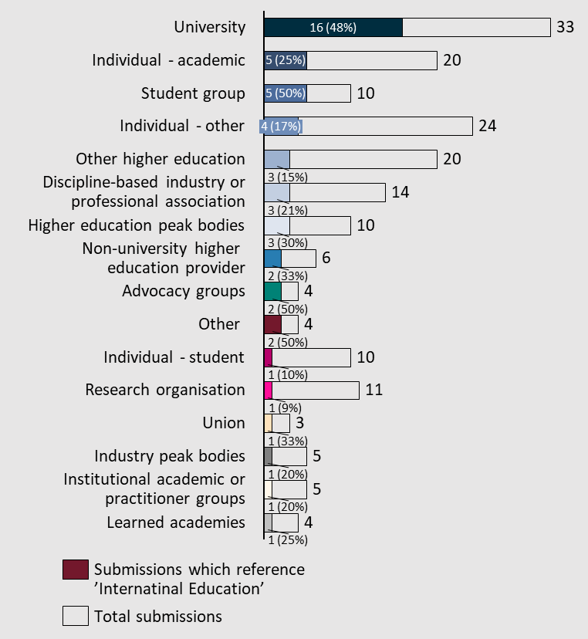

Submissions argued that COVID-19 accentuated an inherent vulnerability in relying on international student fees as a major source of revenue
Submissions of this nature urged that, universities should become less reliant on international student revenue, despite recognising the benefits the industry brings. They highlighted statistics and commentary to discuss how COVID-19 severely impacted international student numbers and experiences.
“COVID-19 and its impact on sovereign capability and supply chains – in relation to the higher education sector it quickly became apparent that the reliance of the domestic higher education sector on foreign fee income and foreign students meant that when these sources were diminished the ability of universities to continue research and other collaborative activities with industry and PFRAs was also diminished” – Australian Nuclear Science and Technology Organisation (ANSTO)
“Australian Universities welcome such a valuable pipeline of talent and are grateful for their significant contribution to our national research outputs, although, as with so many supply chain issues, COVID demonstrated the considerable risk and vulnerability of such a high proportion of international students.” – Australian Council of Deans of Science (ACDS)
“During 2020 and 2021, both Australia and New Zealand lost market share of international students to countries such as the US, the UK and Canada which had less restrictive borders during the COVID-19 pandemic. It is unlikely that international student numbers will return to pre-pandemic levels in the near future, reducing the pool of potential CA Program candidates until at least 2025.” – Chartered Accountants Australia and New Zealand
“However, the sudden shut down of international education as a result of the COVID-19 pandemic laid bare the extent to which the sector had become reliant on income from international students. The international sector contributed A$37.6 billion to the economy in the financial year before the pandemic; this was almost halved to $26.7 billion in 2020-21.” – National Tertiary Education Union
“The disruption to the international student arrivals due to the COVID-19 pandemic and associated travel bans highlighted the extent to which Australia’s higher education system is truly global, both in respect to staff and student mobility but also in terms of financial dependencies. The international student system has provided significant income to a wide range of institutions which has supported large-scale investment in teaching, research, and development endeavours. It also highlighted the market opportunity to provide online education into markets where this has been more difficult in the past.” – University of New England
“The COVID pandemic has shown how vulnerable Australian universities are to a drop in international student enrolments and the revenue they generate. The Accord Panel should consider whether current funding models are sustainable.” – University of South Australia

Submissions recognised the success and importance of Australia’s international education sector, and its potential to address skills needs
Several submissions, including those referencing this point generally, spoke of the importance of international collaboration and education on research output, university life, and the financial stability of higher education institutions.
“Over the last twenty years, Australia has developed one of the most internationalised university systems in the world, with high levels of international education and international research collaboration. This has improved quality and impact and delivered significant social, cultural and economic benefits to Australia and its partners, particularly in our region. The IRU is characterised by a diverse international student cohort and by successful offshore delivery of international education.” – Innovative Research Universities
“In the current funding model for universities, it is forced to chase for ‘for profit’ International students to educate them in Australia, charge them a fortune for being educated and then in most cases this educated person leaves Australia and provides benefit to another country.” – Martin Scanlon
“International student recruitment initiatives need to support all universities and facilitate student enrolment outside the major urban centres... Murdoch wishes to highlight the critical importance of strengthening the social licence for international students. They should be seen as valuable contributors to the social wellbeing of their institution as well as the broader community. In this way, there will be greater acceptance of those students seeking permanent migration as genuine members of the communities in which they live.” – Murdoch University
“Higher education is a global enterprise, and the success of the Australian sector rests in part on our capacity to recruit international students from a range of countries, and recruit and host the best academics from around the world. A whole-of-government approach is needed to ensure that efforts to increase student demand (particularly in underrepresented countries) and facilitate staff mobility are supported by the Australian government in country and not stymied by inflexible visa arrangements or outdated regulatory settings.” – University of Melbourne
“Australia’s visa system does not reflect contemporary best practice, making it unnecessarily difficult for students, researchers, and academics to choose Australia as a destination to learn and live. Visa reform will result in a system that lifts the ambition of Australia’s international education offerings by actively encouraging programs with joint degrees, allowing greater inbound and outbound student mobility.” – University of Notre Dame Australia
“The financial margin from international education is a significant contributor to university outcomes – including the enhancement of the student and campus experience, research support and infrastructure investments. Retaining Australia’s place in international education at the current scale will be necessary to continue the current high quality of these outcomes, unless there is a commitment from government to increase its funding to cover the financial margin. In the absence of direct government support, international education should be protected and supported as a key strategic policy element of Australia’s higher education sector.” – University of Technology Sydney
However, some submissions highlighted opportunities for the system to better leverage the skills of international students upon completion of their studies:
“The Accord presents an opportunity to think creatively about how education providers, governments, industry and local communities can work better together to address long-term skills needs – in both Australia and our region – across the health professions and many other critical fields that are facing similar challenges, including teaching, engineering and information technology. It presents an opportunity to critically assess the importance of international education in relation to ‘soft power’ and public diplomacy in the region, which was viewed as a feature of the original Colombo Plan.” – University of Sydney
“Work in partnership with the ‘Migration System for Australia’s Future’ review to ensure that the migration system complements the education and training systems to deliver the skills and workforce required both now and into the future.” – University of Tasmania
“The Panel is also asked to consider the proven soft-diplomacy, trade, cultural and wider benefits of international education. This is an incredibly competitive dimension of Australia’s higher education system and one that warrants a more sophisticated and nuanced addressing of, and progression from, current challenges related to cross-subsidisation, market concentration.” – Western Sydney University

A few submissions discussed vulnerabilities and disadvantages in the international student cohort regarding safety and experience
A small number of submissions expressed concerns about international student experience and safety, and recommended solutions.
“Although making up a signiﬁcant portion of Australian medical graduates, International Students are signiﬁcantly disadvantaged in their placement experiences, and face discrimination in accessing work opportunities.” – Australian Medical Students’ Association
“Our sector is generally kept afloat--not by federal funding but by cross-subsidies from lucrative international student enrolments. But many of those students receive less attention than is fair for their fees as a result, despite the importance of international students to Australia's workforce and future. However, the cross-subsidy does not go towards educating domestic students but research, because research activity is underfunded by government.” – Guy Redden
“Academic Pathways that academically prepare students from marginalised and disadvantaged cohorts of Australian society. To illustrate, Foundation Programs bridge post school learning gaps in numeracy and literacy, and English courses help students from diverse linguistic backgrounds to transition to HE courses predominantly delivered in English. This benefit also extends to international students who are critical to Australia's HE sector's success.” – Independent Higher Education Australia
“International students face particular challenges while living, studying and working in Australia. SUPRA has a large cohort of international students that access our services and many of their concerns are with predatory landlords, exploitative employers, and racism. These experiences have multiple causes, that are both structural (e.g., limits on the hours international students are allowed to work) as well as cultural (the attitudes of Australians to international students from, particularly, south-east and central Asia).” – Sydney University Postgraduate Representative Association (SUPRA)

Student experience
Submissions recognised the negative impacts on COVID-19 on student experiences, and highlighted concerns about a failure to adequately address and ensure student safety across higher education campuses. Multiple submissions stated that funding cuts and poor institutional governance more generally have resulted in negative impacts on student experiences.
Dual sector providers were referenced in ~28% of submissions (51 total).
Figure 53| Distribution of submissions which referenced subtheme 'Student experience'
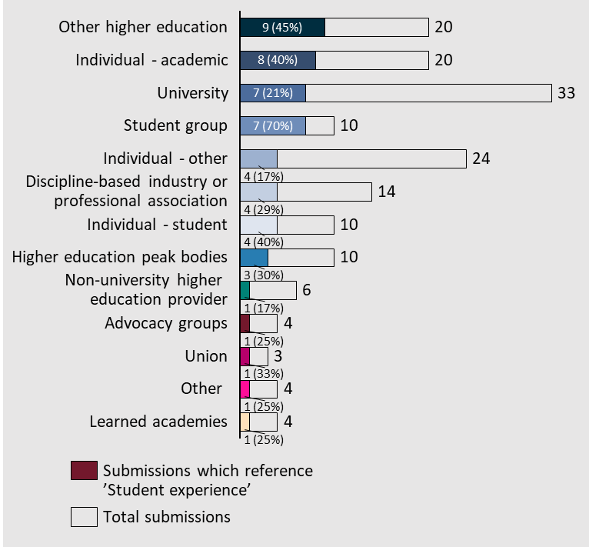

Sexual harassment and assault are seen as ongoing problems across higher education settings
A small number of submissions called out what they perceive to be the prevalence of sexual harassment and assault across higher education institutions, citing statistics to support this point. Women and those experiencing disability were specifically identified as more vulnerable to feeling, and being, unsafe due to sexual harassment, assault and violence.
“The release of the 2021 National Student Safety Survey (NSSS) in March 2022 demonstrated that the Australian university sector and TEQSA have failed to reduce campus sexual violence or achieve institutional accountability and transparency in the management and prevention of sexual assault and sexual harassment.” – Allison Henry
“The Disability Royal Commission enumerates in a 2021 report that people with disabilities are at 2.2 times the risk of sexual violence in comparison to people without disability, and also that young women with disability (18-29 years) are twice as likely to report experiencing sexual violence than young women without disability.” – Australian Law Students’ Association (ALSA) in conjunction with the National Union of Students (NUS) and Australian Medical Students’ Association (AMSA)
“There are many instances where universities heavily intervene in matters that may tarnish their image and reputation to the extent that individuals are silenced from speaking out and left unacknowledged. Some of the worst examples can be related to sexual harassment cases, where most internal investigations leave victims helpless and unsupported for speaking up. The most cynical critics would say universities will support the party they see the most benefits from supporting..” – Errol Phuah
“The National Students Safety Survey… [found] 1 in 6 students had experienced sexual harassment on campus. We saw evidence that 1 in 2 students did not know the reporting or support mechanisms available to them on campus. The survey detailed truly harrowing stories in the qualitative part of the report and proved our observation that during COVID, many students who had never been on campus were simply left behind.” – National Union of Students

Several submissions drew particular attention to the student experiences of those living with disability
Individuals living with disability require particular attention due to the unique challenges they face. A number of submissions called on the Panel to ensure consideration of this community in the Accord.
“Improved higher education teaching quality through better recognition and valuing of the role of educators can make a big difference to educational outcomes of people with disability. This would include the establishment of a professional accreditation framework for university educators, including minimum teaching qualification levels on par with VET educators and core learning units in inclusive pedagogies. By implementing Universal Design for Learning universities can ensure that inclusive curriculum design, development, and delivery fosters greater inclusion. UDL embraces learner variability, designs for it, and reduces barriers to learning, creating a greater sense of belonging.” – Australian Disability Clearinghouse on Education and Training

Ensuring flexibility in course delivery and study mode was emphasised as conducive to a positive learning experience for diverse cohorts
Rural and regional students were mentioned by multiple submissions as requiring flexibility in their course delivery and study mode. However, some submissions highlighted the importance of connecting online study with readily available learning supports.
“Further, universities must have in place clear and accessible flexible learning and part-time study options for all medical programs and courses. This includes the provision of flexibility in exam structure and less emphasis on high-stakes exams. Flexible learning arrangements and part-time study improve student wellbeing, reduces burnout, and supports students returning to study from caring or compassionate duties.” - Australian Medical Association
“Encouraging universities to actively promote and connect their regional ‘online’ students to a local RUC (where available) would further enhance success for these students and therefore completion to take up regional employment.” – Campus Model Regional University Centre
“Student placements are a significant barrier to completion of higher education in regional Australia. … Regional University Centres are well positioned to alleviate these challenges by facilitating local placements if students are permitted to do so by universities. By utilising local connections Regional University Centres can ensure student retention, success, and ultimately employment in the local workforce.” – Country Universities Centre
“Online students face isolation as a major barrier to their retention and success in higher education (Crawford, 2020). Developing communities of practice for students studying online from any university through existing infrastructure will be beneficial to student support and retention – especially in smaller remote communities.” - Society for the Provision of Education in Rural Australia (SPERA)
“There is now widespread recognition that online tertiary study in isolation from learning support is hard resulting in a high non-completion rate. The support provided by RUCs to regional students is, for many students, crucial for completion of their course of study.” – Taree Universities Campus

Concerns about mental health were also raised
A few submissions also made general and specific comments about mental health challenges for students, exacerbated by COVID-19, lockdowns, and socioeconomic challenges.
“Mental health has emerged as a key issue in the student population. This needs to be examined and greater support mechanisms need to be developed.” – Curtin University
“The emotional stress of upheaving one's life to start down a scary path of tertiary education cannot be overemphasised. These students often have complex needs and many have negative prior educational experiences plus a great deal of family and work responsibilities.” – Anonymous
“Once at university, fear of economic insecurity and lack of institutional cultural understanding and awareness create further barriers to completion.” – Julia Horne
“[There needs to be] a specific focus on the health and wellbeing of university staff and how it is adversely affected by work overload… to be clear, staff overload adversely impacts the quality of teaching, supervision and support provided to our students, the creativity, innovation and overall quality of the research we conduct, and the daily functioning of university administration and associated services provided for the betterment of the Australian public.” – Liz Temple
“Young people have the poorest mental health in Australia and they are particularly at risk if the have compounding factors like being lower-SES, queer or being a person of colour.” – Mitchell McBurnie
“Pay greater attention to monitoring and supporting student and staff mental health and wellbeing. … it is also noted that the HESF requires that adequate support for student mental health and wellbeing be provided (HESF Wellbeing and Safety: Standard 2.3.3). Australia is falling behind international best practice on student and staff mental health and wellbeing and this needs to be addressed.” – Professor Sally May Kift

There is a common view that greater support is required to ensure a positive experience for First Nations students and staff
Submissions from a range of institutions and individuals called on the Australian Government and individual universities to not overlook the bespoke support they can provide to First Nations Australians students and staff.
“Whether this is academics teaching about settlement of Australia with no context or reference to the Indigenous impact or intergenerational trauma impacts, or for migrants or international students being treated as stupid because of language challenges – there is a significant amount of work that is required in this space in order to ensure safe and respectful learning environments.” – Engaged Learning Solutions Pty Ltd
“We urge the panel to take a broad view of Indigenous matters and their place in the review. We would welcome the opportunity to discuss with the panel how universities are working to value Indigenous knowledge and values, and how this approach might inform policy development to drive the future of Australian higher education and research.” – Universities Australia
“Indigenous Knowledges can be best promoted and reflected in culturally-capable university teaching and research.” – Science & Technology Australia

Impacts of COVID-19 on the higher education sector
References to the impacts of the COVID-19 pandemic on the higher education sector featured in ~19% of submissions (35 total).
Figure 54| Distribution of submissions which referenced subtheme 'Impacts of COVID-19 on the higher education sector'
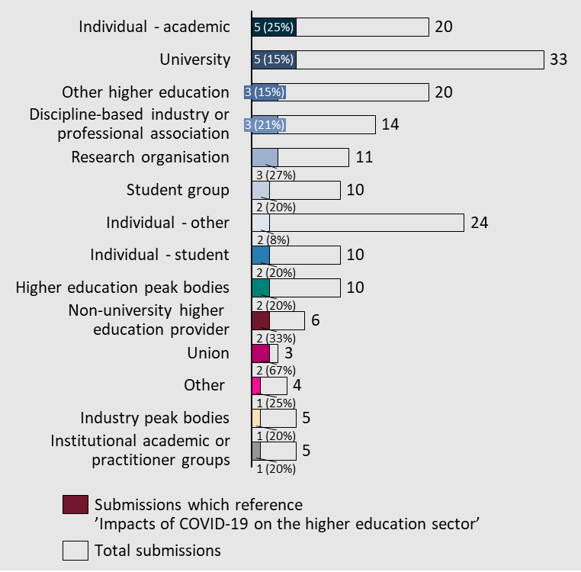
The impacts discussed in submissions were not limited to those relating to student experiences and the challenges of online learning, they also referred to sovereign capability, supply chains, workplace relations, staff adaptability, and innovation.

The pandemic propelled major positive changes to the use of technology in higher education, but stakeholders emphasised the importance of resuming in-person learning due to the shortcomings of online teaching
Submissions recognised both the benefits and shortcomings of the heightened dependence on digital technologies and online platforms as a result of COVID-19 and subsequent lockdowns across the country. Common benefits cited included greater adaptability and ability to propel the use of technology effectively, as well as reducing inequity for rural/regional students. In contrast, shortcomings included an overreliance on online education at the expense of resuming high quality in-person teaching. In addition, there were concerns about the difficulties some universities faced adapting to the new delivery format – and the consequent impact on student learning and university life.
“During covid, universities transitioned much of their education online and blended modes of learning. This increase in flexibility and quality of online education has benefitted regional, rural, and remote Australians providing access to expanded courses and learning opportunities. Coupled with a reinstatement of Demand Driven Funding and Regional University Centre led Widening participation activities, further normalising online learning will significantly increase access to higher education for regional people.” – Country Universities Centre
“Online learning, like recorded lectures, should be supplementary to in-person learning like in the pre-pandemic and not a complete substitute because we absorb information better in a stimulating environment.” – Errol Phuah
“Universities should offer options for both face-to-face and remote study consistent with NCSEHE recommendations for educational staff to transition to expanded hybrid/hyflex/blended learning approaches to retain accessibility and flexibility in learning opportunities. As a minimum, this should include work from home (‘WFH’) options for disabled students and disabled academics for whom WFH would constitute a reasonable accommodation.” – Australian Law Students’ Association (ALSA), in conjunction with the National Union of Students (NUS) and Australian Medical Students’ Association (AMSA)
“CAPA is concerned with the rise of online learning as a by-product of the COVID pandemic. In principle, we support flexible delivery initiatives in education, which will embrace the expansion of coursework awards to those who would otherwise find higher education inaccessible. While expressing general support for developing more flexible delivery modes, we are nevertheless concerned that the new initiative that has emerged is still incomparable (in terms of quality and engagement) to face-to-face learning.” – Council of Australian Postgraduate Associations (CAPA)

Several submissions highlighted the resilience and adaptability of staff, students and institutions across the higher education sector in responding to COVID-19
A few submissions discussed a silver lining of the COVID-19 pandemic in that it demonstrated, if not strengthened, the resilience of individuals working and studying across Australia’s higher education sector.
“Resilience is being ‘built into’ the Australian University model after the shock of COVID…” – David Reynolds
“Despite the significant toll experienced by the sector, many universities rose to the challenge and took up their role as part of society to respond to the collective crisis we all experienced. Universities redirected their infrastructure and resources to community needs, distributed food, became vaccination centres, produced COVID masks, undertook significant research in areas related to COVID and other emergencies being experienced and offered communities student resourced support – to name a few.” – Engagement Australia

Term of Reference 7: Delivering new knowledge, innovation and capability
Support a system of university research that delivers for Australia, securing the future of the Australian research pipeline, from basic and translational research to commercialisation. In doing so, the Accord will explore relevant initiatives and other opportunities and to further boost collaboration between universities and industry to drive greater commercial returns.
The review will synchronise with the ARC review and consider issues raised through that review and other areas of government that impact on the capacity of the higher education system to meet the nation’s current and future needs.
Submissions received reinforced the paradigm that research and developing new knowledge and capability is a fundamentally important to the higher education sector.
The submissions called for a research sector that had the funding, regulatory and incentive environment that encourages the sector to pursue actions in the interest of the long-term sustainability of the sector and in line with what is best for Australia.
Figure 55| Distribution of submissions across Term of Reference 7 subthemes
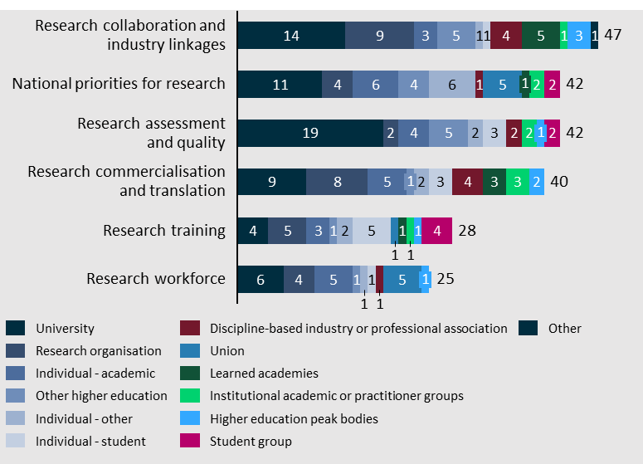

Research collaboration and industry linkages
Research collaboration and industry linkages was the identified subtheme as a priority for the Accord in Term of Reference 7, being refenced in 19.5% of submissions (36 total).
Figure 56| Distribution of submissions which referenced subtheme 'Research collaboration and industry linkages'
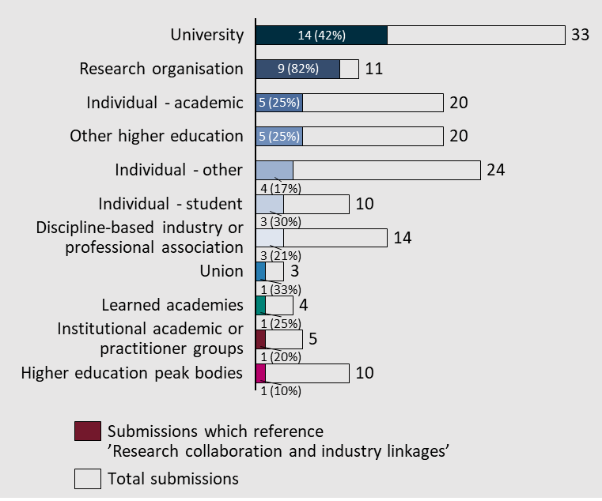
The importance of this subtheme was effectively described by Engagement Australia.
“University engagement with industry and community is critical to ensuring that research is impactful, relevant and translatable.” – Engagement Australia

Industry collaboration
Engagement and collaboration with industry was called out throughout the submissions, discussing multiple touch points with the higher education sector, including research, learning and skills. Encouraging industry collaboration is important to ensure that research is tailored for effective commercialisation. Research and commercialisation is a separate subtheme and is discussed below.
Two approaches to expanding research collaboration were referenced in the submissions. The first, proposed establishing and encouraging the colocation of industry and higher education research to establish connections and allow for the sharing of research infrastructure. The second, encouraged the placement of PhD students with industry organisations.

Community collaboration
Greater research engagement with communities was encouraged in a few submissions. It was argued that greater engagement can help achieve better outcomes for communities by:
- Providing underrepresented communities, a voice.
- Improving researcher understanding of specific community needs and understanding the impact of research on the community.
- Genuine partnerships can slow the ‘brain drain’ from regional areas by keeping researchers engaged in their communities.
“A more balanced approach to the translation and impact of university research would also include a focus on partnerships with the public and community sectors, and with local communities, that also lead to significant social, cultural, economic and health/wellbeing impacts.” - Innovative Research Universities

National priorities for research
A large number of submissions called out the importance of aligning funding, regulation and reporting to the national priorities for research, effectively defining these priorities is foundational for the research sector. ‘National priorities for research’ was referenced in 25% of submissions (47 total). There were however some clear differences between groups.
Figure 57| Distribution of submissions which referenced subtheme 'National priorities for research'
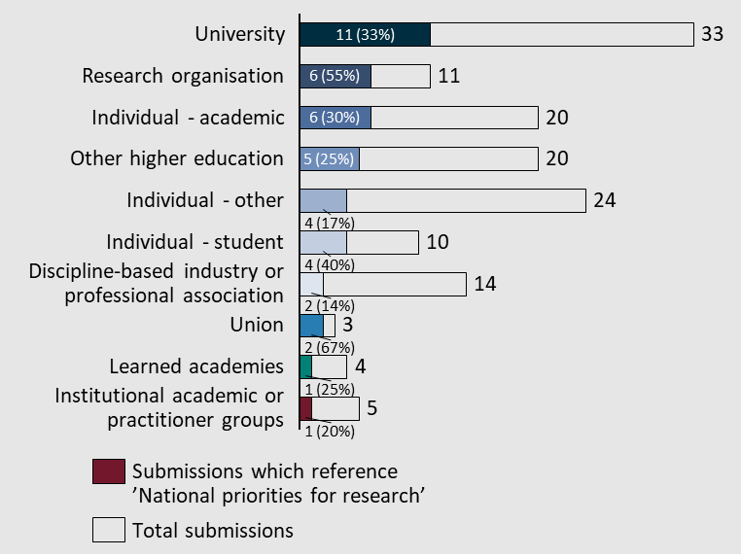

Balance between basic research, applied research and commercialisation
Some submissions identified the importance of finding the appropriate balance between basic and applied research. Defining the appropriate balance will guide the funding, regulatory and infrastructure decisions to support research.
“Boosting research translation (including commercialisation) to enable the widest possible benefit from university research is undoubtedly important, but so is supporting the basic research without which there would not be new ideas to translate.” – Universities Australia

The role of research in supporting Australia’s long-term priorities
Four submissions identified that research plays an important role in supporting Australia to pursue its long-term priorities. Identifying what these long-term priorities are was called out as a priority for the Accord. A few examples provided were:
- Supporting preparedness for pandemics
- Developing natural disaster resilience
- Innovating new technologies
- Understanding the nation’s economy
- Developing potential policy changes
- Understanding long term social change

Specific subject matter areas of focus
Five submissions referenced specific subject matter areas that they believe should be a priority for research that the University Accord should consider. These included, in no particular order:
- Cyber security
- Food/agriculture
- Manufacturing
- Space
- Data
- Climate change/Advancing technologies for the Net Zero goal
- Health
- Defence
- Productivity improvement

Research assessment and quality
Research assessment and quality, and measuring success and impact of research was referenced in ~22% of submissions (42 total).
Figure 58| Distribution of submissions which referenced subtheme 'Research assessment and quality'
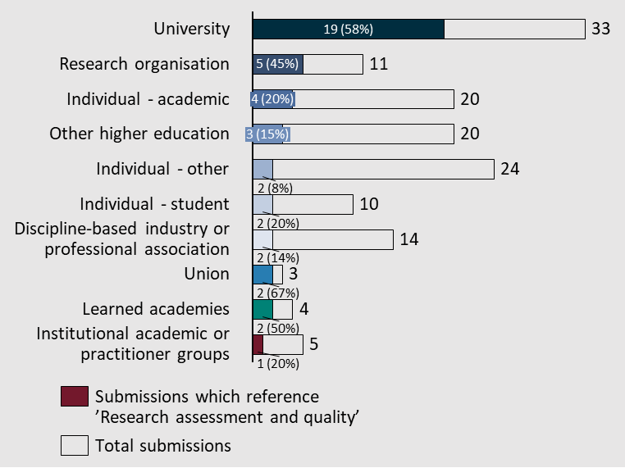
Some submissions outlined the role that research assessment plays in communicating what is valued in research with calls for the priorities to be communicated in what is assessed.
“Discontinue (Excellence) in Research for Australia (ERA) assessments and develop an efficient method of assessment of research quality in Commonwealth-funded research projects.” – Edith Cowan University

Research commercialisation and translation
Research commercialisation and translation was a common theme across the submissions, occurring in ~22% of submissions (40 total).
Figure 59| Distribution of submissions which reference subtheme 'Research commercialisation and translation’
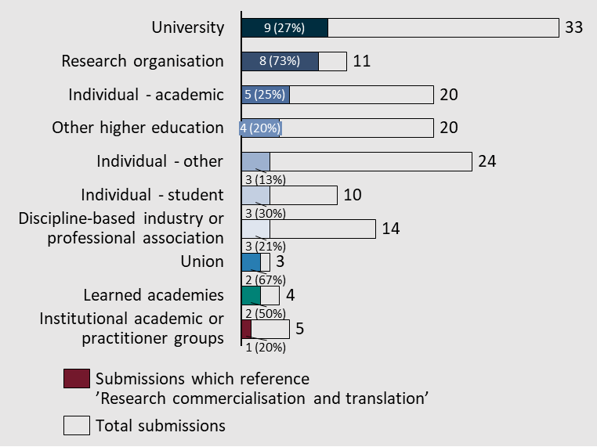
Perspectives on the importance of research commercialisation and translation varied across the submissions.

Commercialisation should be encouraged and incentivised
One perspective on commercialisation was that it should be encouraged and expanded as the final step in the research pipeline that allows for wider use of research innovations. The University Chancellors Council effectively outline the importance of research translation in its submission.
“If we want to make the most of the primary research we conduct, we need to address this funding disparity urgently and dedicate more to development. Too much of our intellectual property ends up overseas due to lack of funding in the development stage.” – University Chancellors Council

Economic, social and environmental returns from commercialisation could be encouraged on top of ‘commercial outcomes’
Some submissions challenged the framing of commercialisation and translation in the Terms of Reference, arguing that only calling out ‘commercial returns’ was too narrow for the Universities Accord. A broader definition of the returns to research was encouraged, to call out the public benefit of research. An example of the broader definition of benefits of research translation was communicated in the Cooperative Research Australia Submission.
“The Terms of Reference identify the importance in supporting a system of university research to ultimately drive greater commercial returns. While CRA commends such a vision, we also believe that the review would benefit from incorporating how translation and research can drive economic, social and environmental returns, as opposed to solely commercial outcomes.” - Cooperative Research Australia

Commercialisation and translation systems should be improved
There were calls for improving the current commercialisation and translation systems that are in place. This sentiment appeared in two main ways, the first was the general encouragement to investigate ways to improve the efficiency of research translation.
The second recommended a review of the role of government research agencies and universities in the sector and to consolidate the number of commercialisation programs. This was called out explicitly in the submission from the Queensland University of Technology.
“Consolidate and simplify the proliferation of research translation and commercialisation programs across government.” – Queensland University of Technology

Research training
Research training was referenced in ~15% of submissions (28 total) to the Universities Accord.
Figure 60| Distribution of submissions which reference subtheme 'Research training'
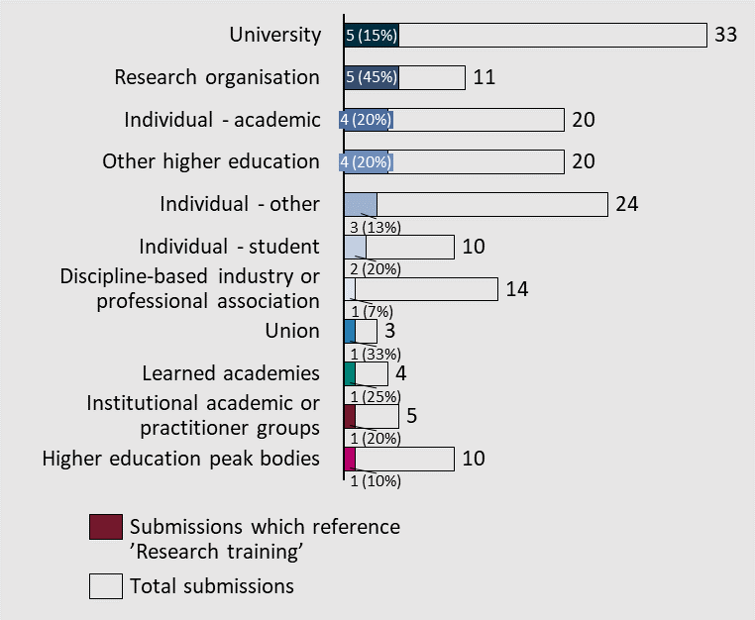
Two major ideas were identified in the submissions regarding the research training.

PhD student stipend causes significant cost of living pressures
Twelve submissions argued that the current PhD stipend is too low, disincentivising students to pursue research and often placing PhD students below the poverty line.
“a base PhD stipend is $29,500 for hours equal to or often longer than a full-time job, which is below the poverty line. PhD students on a stipend are restricted in how many extra hours they may work to keep their stipend, unable to bolster their income with additional employment.” – Australian Academy of Science
“we would like to highlight to the panel that our member’s role in higher education is being undermined, damaged, and hampered by a lack of supportive PhD stipends. Our region is already facing climate extremes which affect many facets of Australian society and our role in training, understanding, and researching the climate is of paramount importance to the future of Australia. However, our members are conducting their study in conditions that mean many live close to or below the poverty line with impacts on their own well-being as well as family and work. This fundamentally affects the Higher Education system’s ability to attract students, maintain quality education and deliver a Higher Education system fit for purpose.” – Career Researcher Committee, ARC Centre of Excellence for Climate Extremes
“HDR students are in a similar situation, with only an estimated 40% of PhD students receiving an RTP stipend scholarship with their letter of offer. The remaining students who do not receive a stipend often find employment at a university where they are easily exploited with wage theft and precarious work arrangements, affecting many students during the pandemic lockdowns where sessional jobs were the first to be cut. We are also deeply concerned that the minimum full-time stipend rate of $29,863 for 2023 will be below the poverty line ($31,786.04) for a single person…” – Council of Australian Postgraduate Associations (CAPA)

Preparing students for research
To ensure that Australian researchers are prepared for a career in research, a couple of submissions identified the importance of understanding current research capability and future skills needs of researchers. This review should investigate other methods of preparing students for research. An alternative approach was outlined by Macquarie University.
“A systematic mapping of university capability and capacity across Australia at least in areas of national priority would help fuel evidence-based decision within the university sector as well as assist in linking government and industry needs with the university sector.” - Geoscience Australia
“A new approach is also needed to developing PhD students as central players in the research ecosystem. Following ACOLA recommendations in 2016 which called for an alternative to the Honours year such as an HDR training Masters degree which would better prepare candidates to undertake research, an option to explore is the already successful MRes system operating at Macquarie. This would ensure that students are fully training before they begin their thesis work.” – Macquarie University

Research Workforce
The research workforce was referenced in ~13% of submissions (25 total) to the Universities Accord.
Figure 61| Distribution of submissions which reference subtheme 'Research workforce'
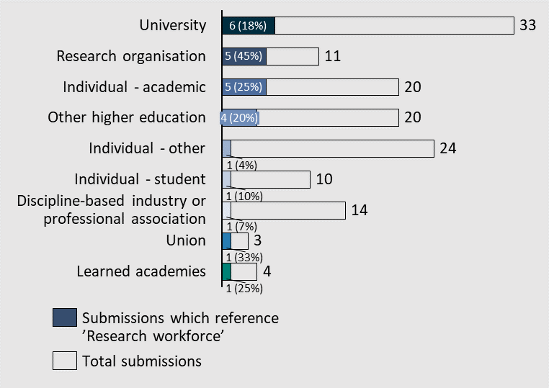
Two major ideas were called out in the submissions regarding the research workforce.

Casualisation of the research workforce
The most common concern raised was about the casualisation of the workforce and as a result the job security of researchers. This casualisation has impacts on both the individual workers, particularly minority groups. On top of the individual impact, the casualisation of the workforce can also pose a risk to the industry more broadly, these challenges were identified in the National Tertiary Education Union submission.
“The current system of high job insecurity works against the career progression and retention of early career, and women (especially in STEM) and researchers from minority and equity groups … the almost universal use of fixed term contract employment for research focused staff has also resulted in a ‘brain drain’, whereby researchers trained in Australian universities are abandoning both the sector and the country due to the lack of opportunities for secure employment and funding of research.” - National Tertiary Education Union

Researcher workload
Alongside the casualisation of the workforce, submissions also called out the workload of researchers in the industry and the reliance of postgraduate students to drive research.
“… staff overload adversely impacts the quality of teaching, supervision and support provided to our students, the creativity, innovation and overall quality of the research we conduct, and the daily functioning of university administration and associated services provided for the betterment of the Australian public.” – Liz Temple

