

# TPS Online Step-By-Step Instructions

How to use TPS Online to receive assistance from the   
Tuition Protection Service

The Tuition Protection Service (TPS) is an Australian Government initiative that supports international students on student visas and eligible domestic students when their education provider closes or stops offering their course. This situation is called a ‘**provider default**’.

If your education provider defaults, the TPS can help you to:

* find a course with another education provider to continue your studies, and
* receive a refund of your unspent tuition fees.

**TPS Online** is the system students use to request and receive assistance from the TPS. This document shows students how to use TPS Online.

Please check your emails regularly. You will receive email notifications from the TPS when further information is required from you and when you have tasks to complete in TPS Online.

For more information or support, please visit the [TPS website](http://www.tps.gov.au/)[1], or contact us by emailing [support@tps.gov.au](mailto:support@tps.gov.au) or calling [1300 131 798](tel://1300131798/).

TPS Online: Task Checklist

* Step 1: Log in to TPS Online 2
* Step 2: Change your password 3
* Step 3: Confirm your provider’s obligation to you 4
* Step 4: Provide proof of your identity 6
* Step 5: Review and update your contact details 8
* Step 6: Upload proof of payment 10
* Step 7: Apply for a refund 14

## Step 1: Log in to TPS Online

If you are eligible for TPS assistance, login details will be emailed to you.

1. To access TPS Online, visit the [TPS website](https://www.education.gov.au/tps)[2] and click **Access TPS Online**.

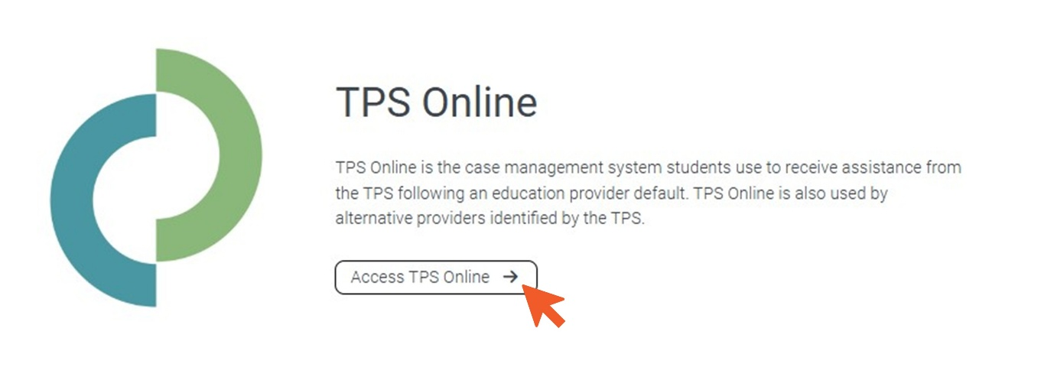

1. Log in on the left-hand side under ‘Student Login’. If you are logging in for the first time, use the username and password emailed to you.

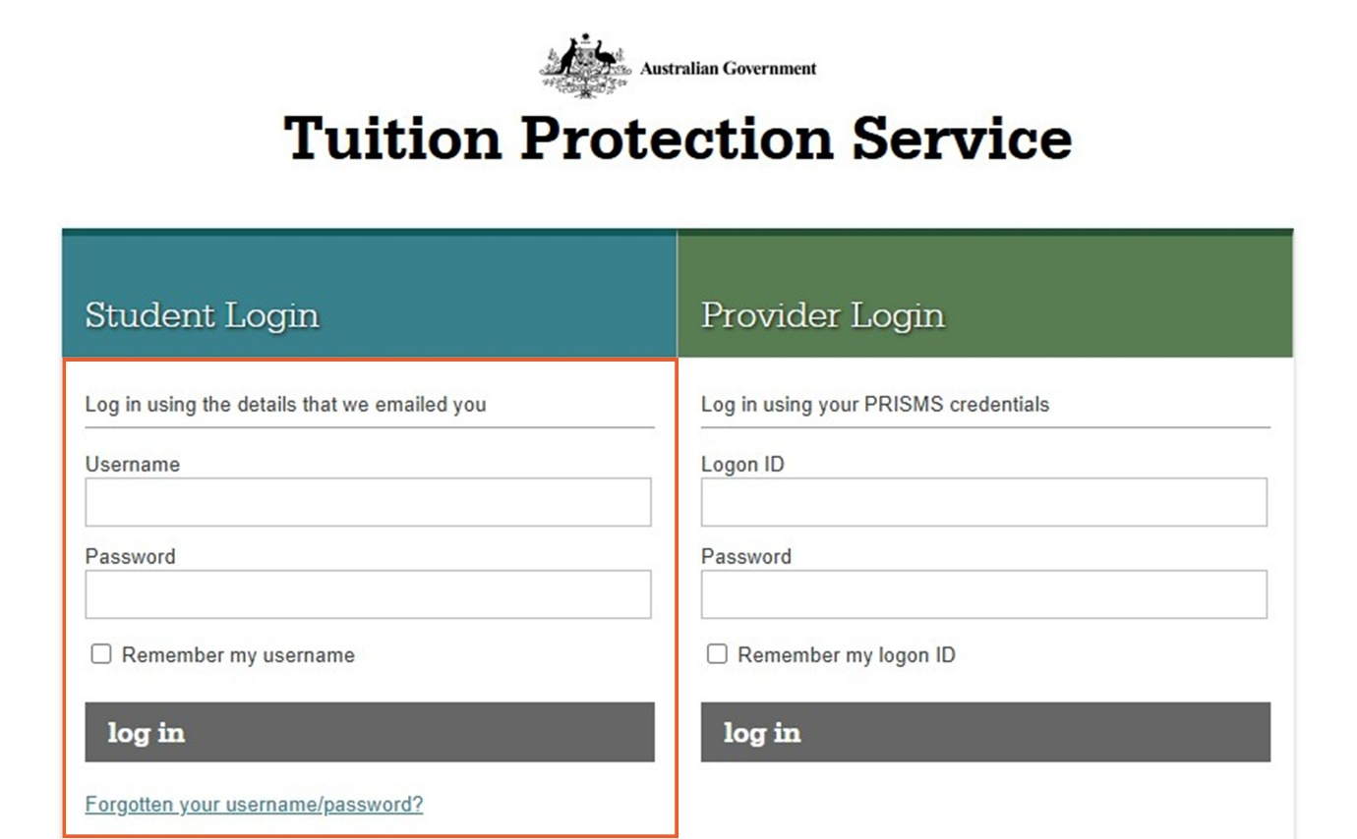

## Step 2: Change your password

When you log in for the first time, you will need to change your password.

1. Click **Change Password**.

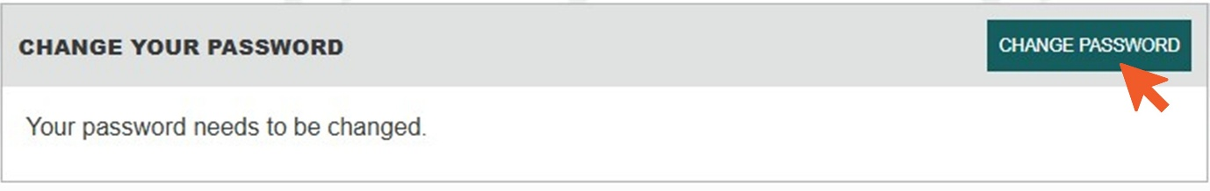

1. Enter your new password, choose a security question and answer, then click **save**.

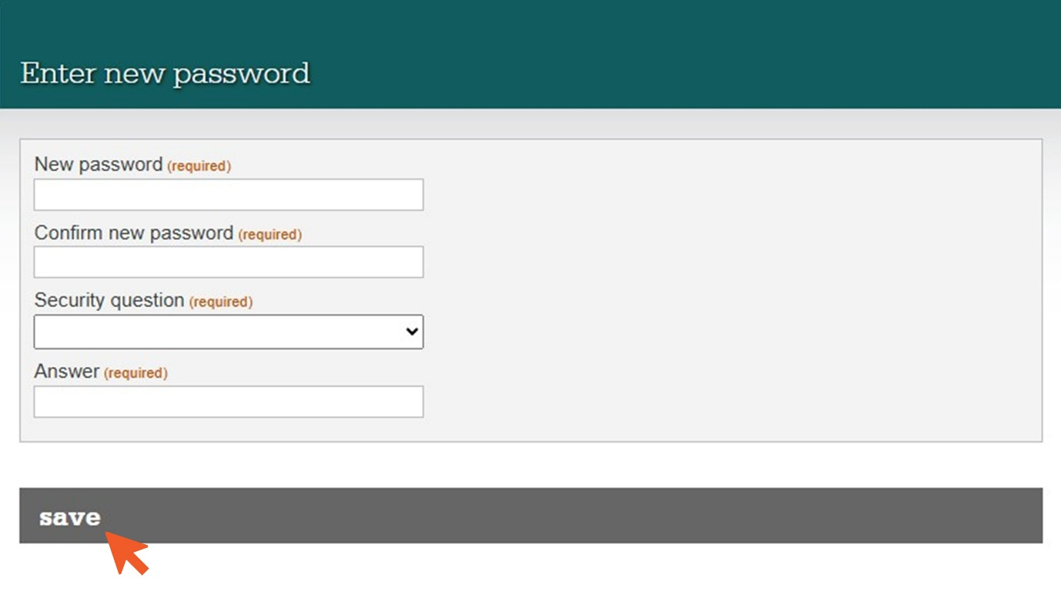

## Step 3: Confirm your provider’s obligation to you

The TPS needs to know whether your education provider owed you a refund of unspent tuition fees on the date of the default.

1. Click **Next** to begin this task.

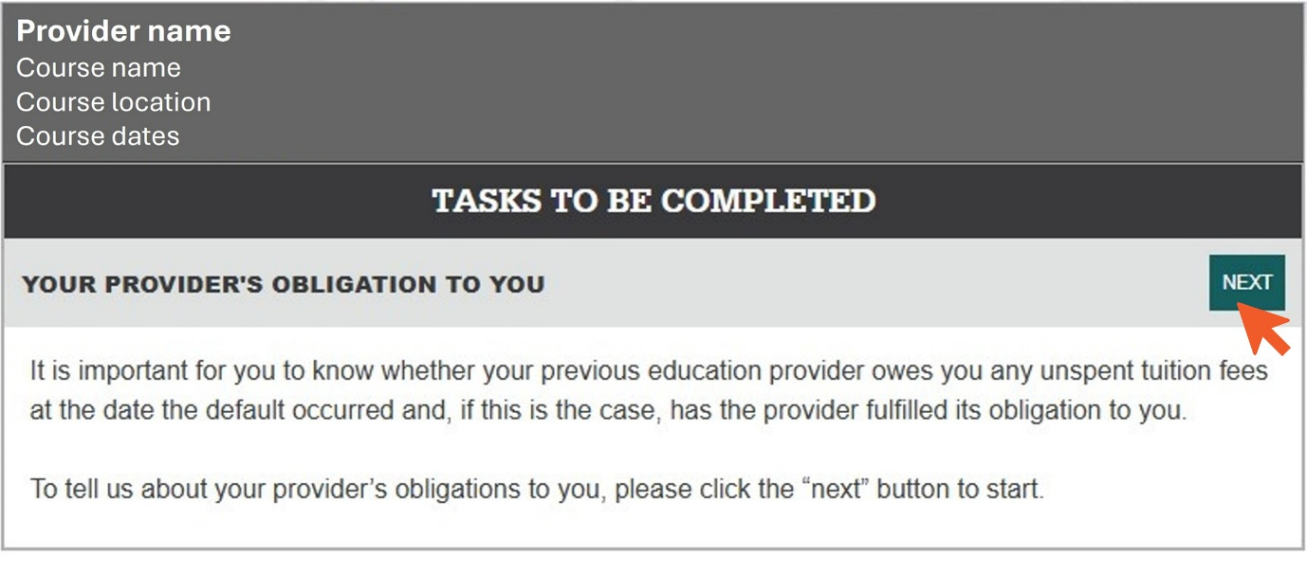

1. Indicate whether your provider owed you a refund of unspent tuition fees on the date of the default. To be eligible for TPS assistance, you **must** click **owed me unspent tuition fees**.

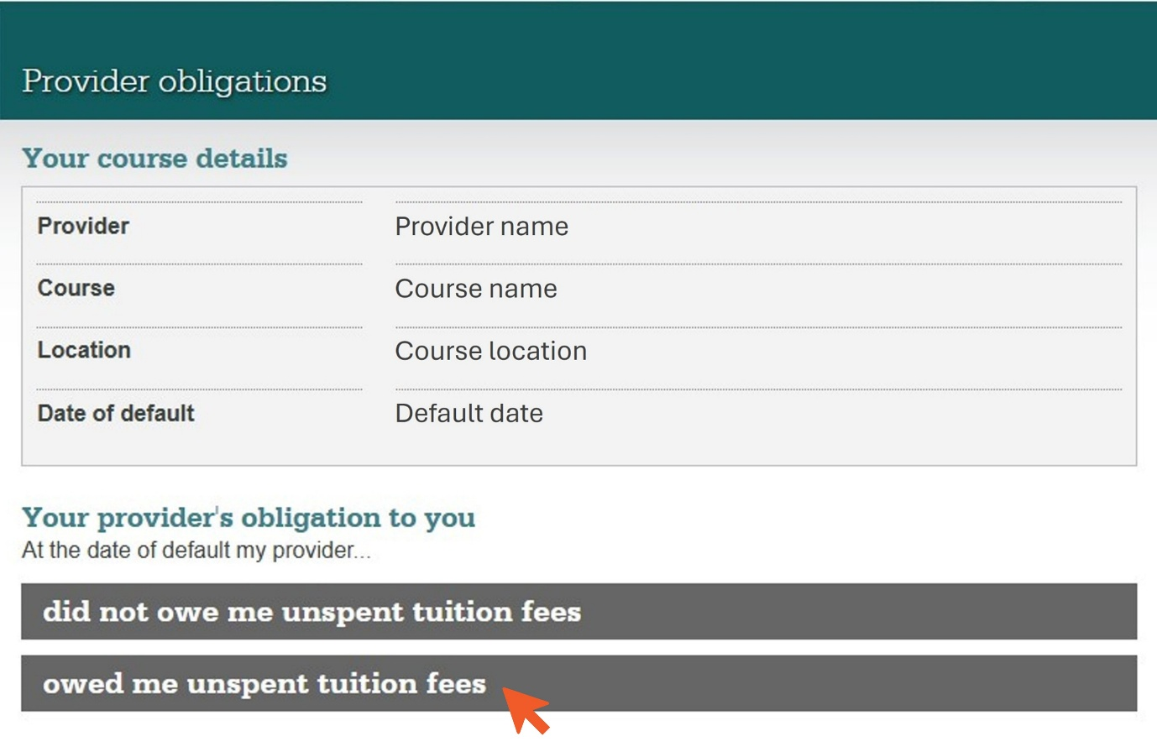

1. Confirm whether your provider met its obligations to you. We recommend selecting **My provider has not refunded any of my unspent tuition fees**. Click **save** to proceed.

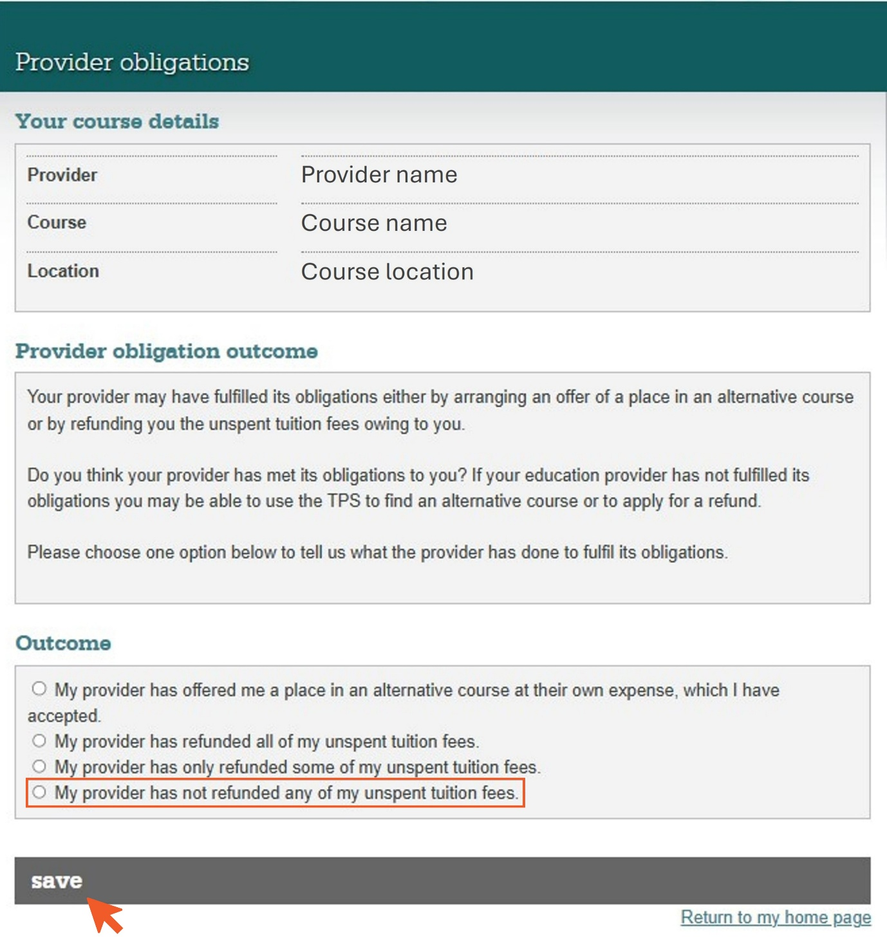

## Step 4: Provide proof of your identity

You must upload a photo of your passport in TPS Online as proof of your identity.

1. Click **Start** to begin this task.

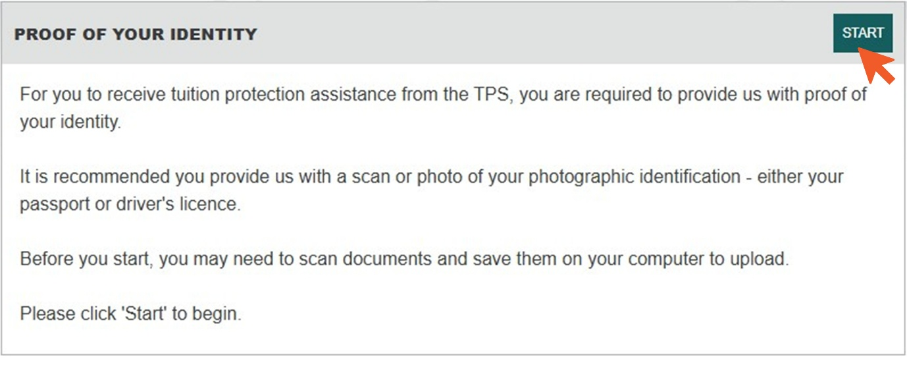

1. Take a photo of the identity page of your passport. Click **Browse**, select your photo file to upload it, then click **next**.

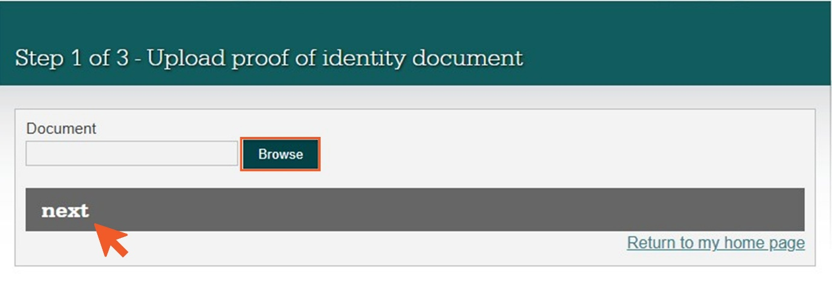

1. Check that your document is correct then click **next**.

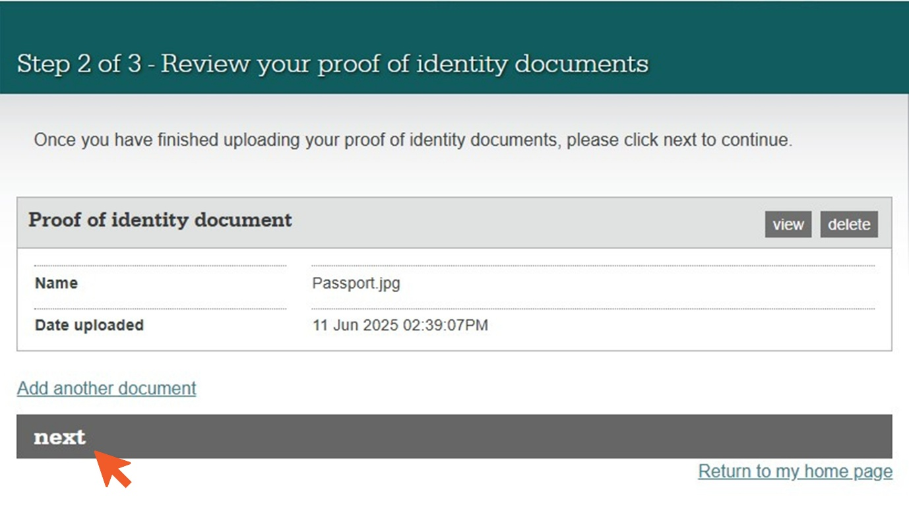

1. Tick the declaration boxes then click **submit**.

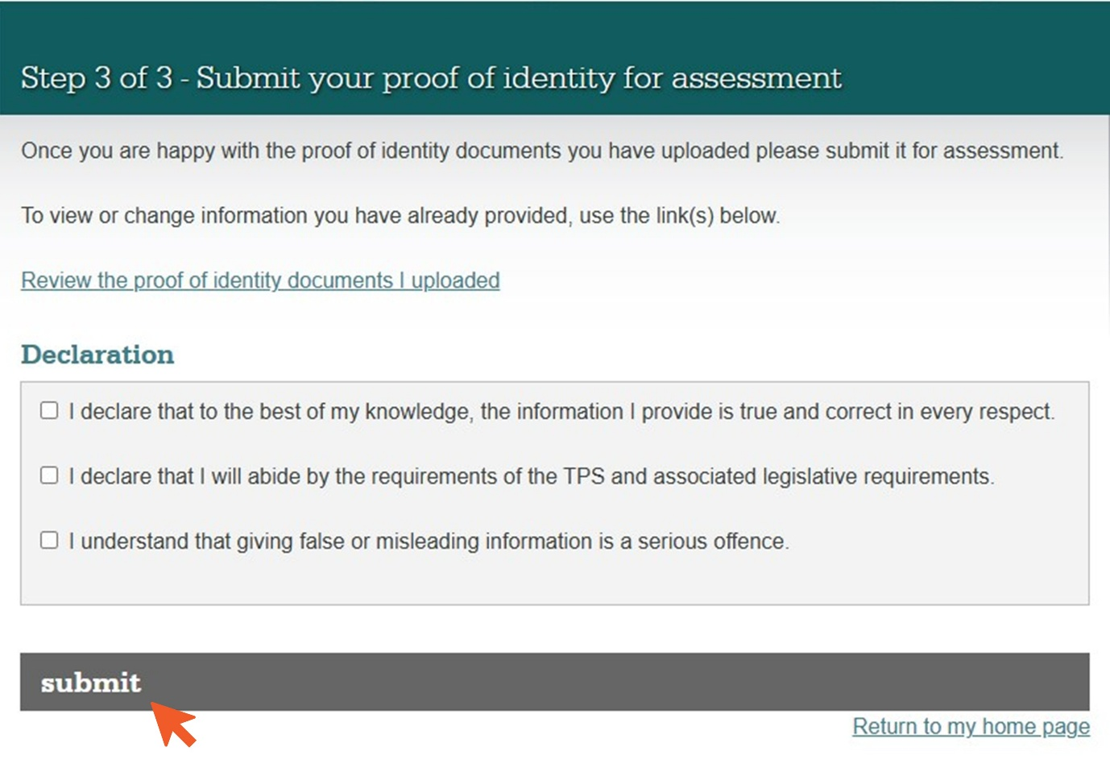

You will need to wait for the TPS to accept your proof of identity document before you can complete the next task.

## Step 5: Review and update your contact details

Your contact details are used to send you updates about your case. It is important that they are correct.

1. Click **Review** to check your contact details.

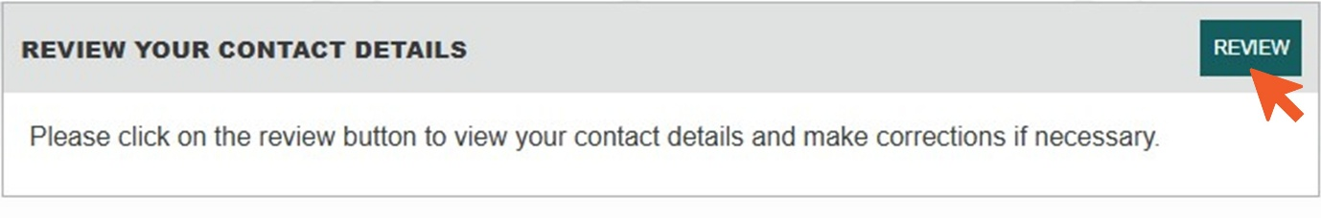

1. If your contact details are correct, click **yes, my contact details are correct**. To change your contact details, select **no, update my contact details**.

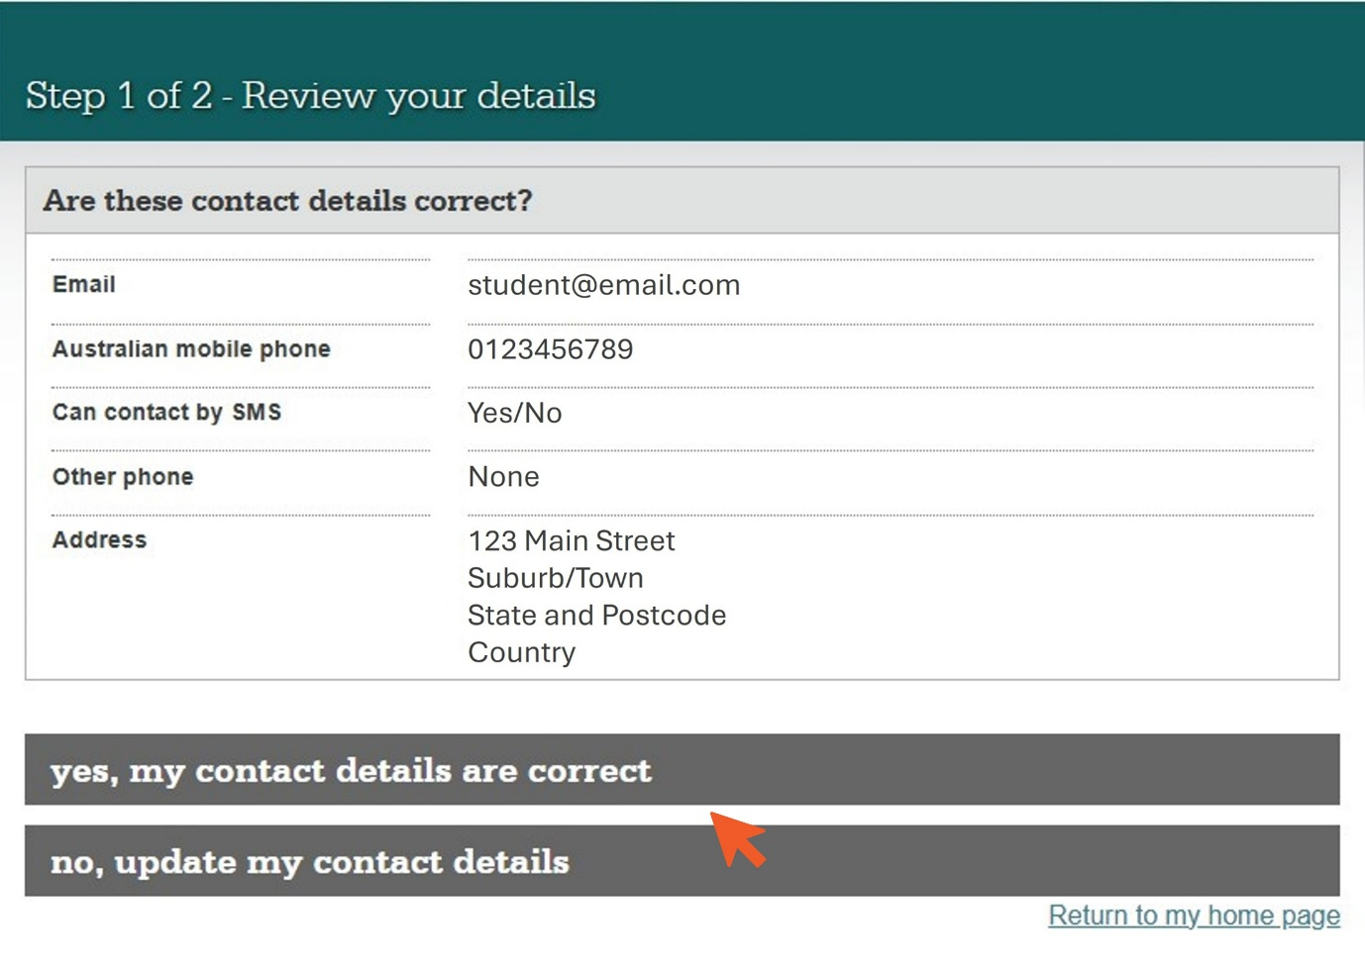

1. Review your personal details. If your personal details are correct, click **yes, my personal details are correct**. To change your personal details, select **no, update my personal details**.

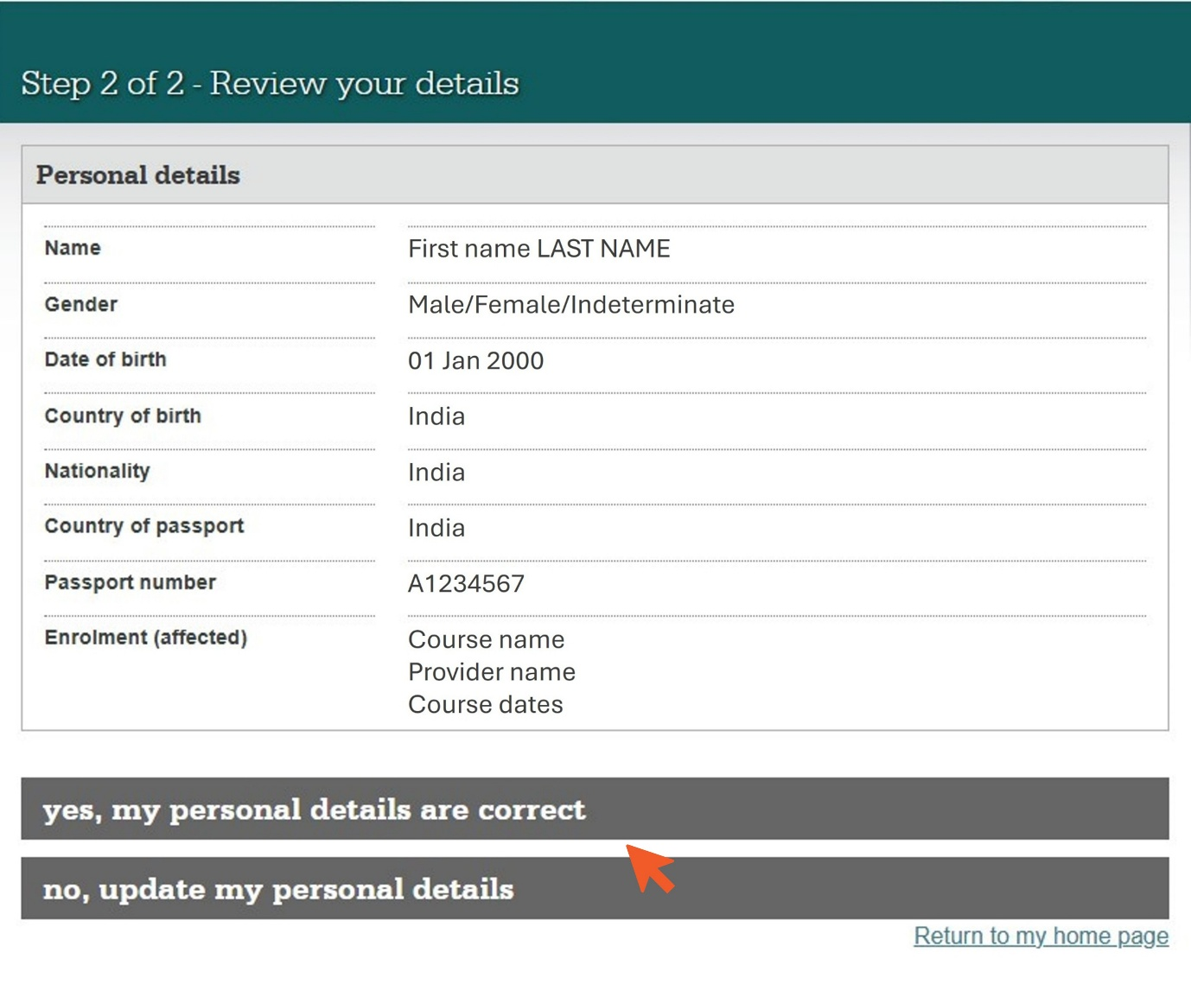

## Step 6: Upload proof of payment

If your education provider owes you a refund, you must submit proof of all payments made for your course.

1. Click **Start** to begin this task.

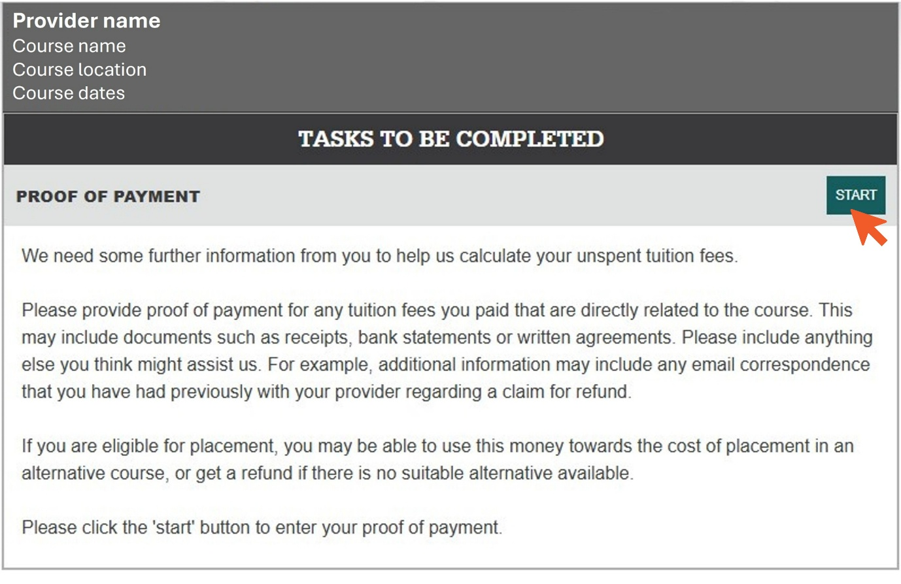

1. Review the payment information already in the system, then click **next**.

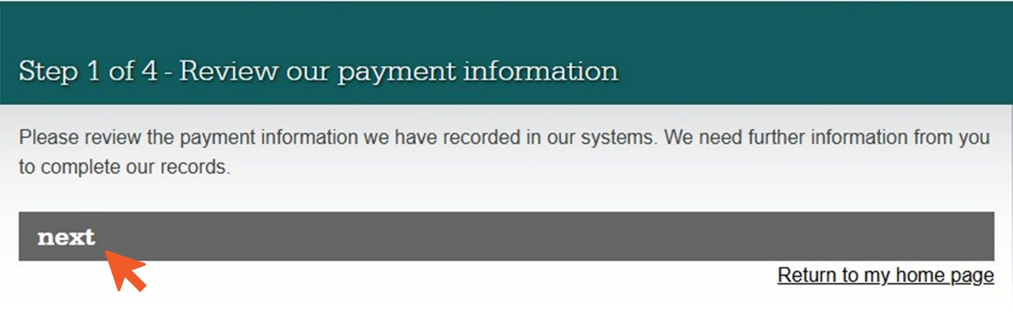

1. You can tell us about any payment details you think are incorrect in your student statement. You can also provide any information you think will help the TPS to calculate your refund amount. Once you have completed your statement, click **next**.

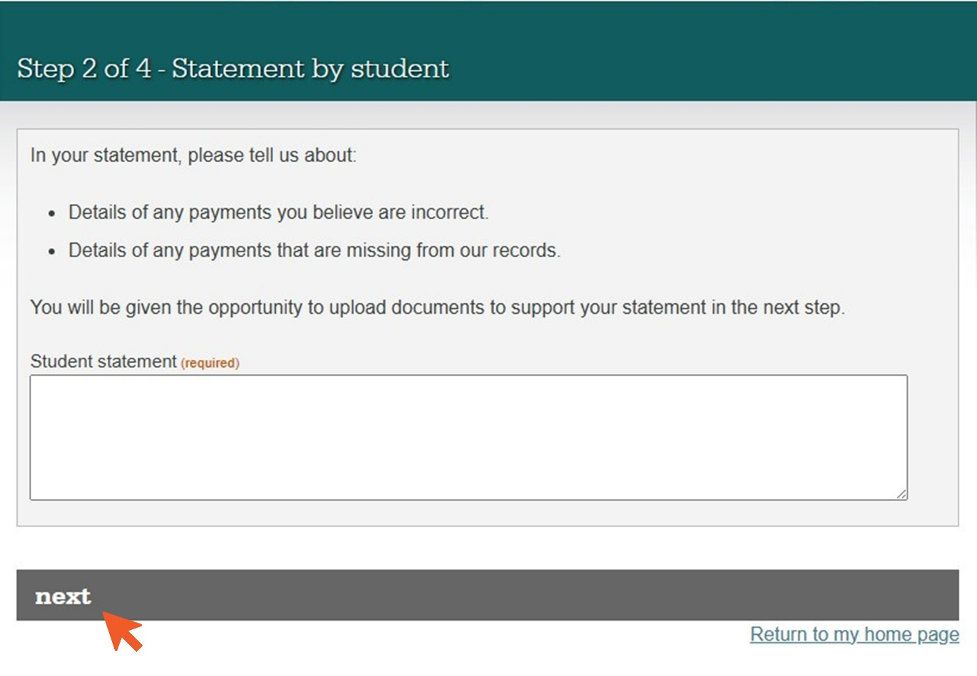

1. You **must** upload the following documents for the TPS to calculate your refund amount:

* **Visa Notification** from the Department of Home Affairs
  + signed **Letter of Offer** outlining **all** payments due to your education provider for your course
  + **bank statements** or **bank receipts** for **all** payments you made for your course.

**If you have an education agent**, you must also upload:

* + **bank statements** or **bank receipts** for **all** payments you made to your agent
  + **bank statements** or **bank receipts** for **all** payments your agent made to your education provider on your behalf
  + **agent commission statement**.

Click **Browse** and upload all required documents, then click **next**.

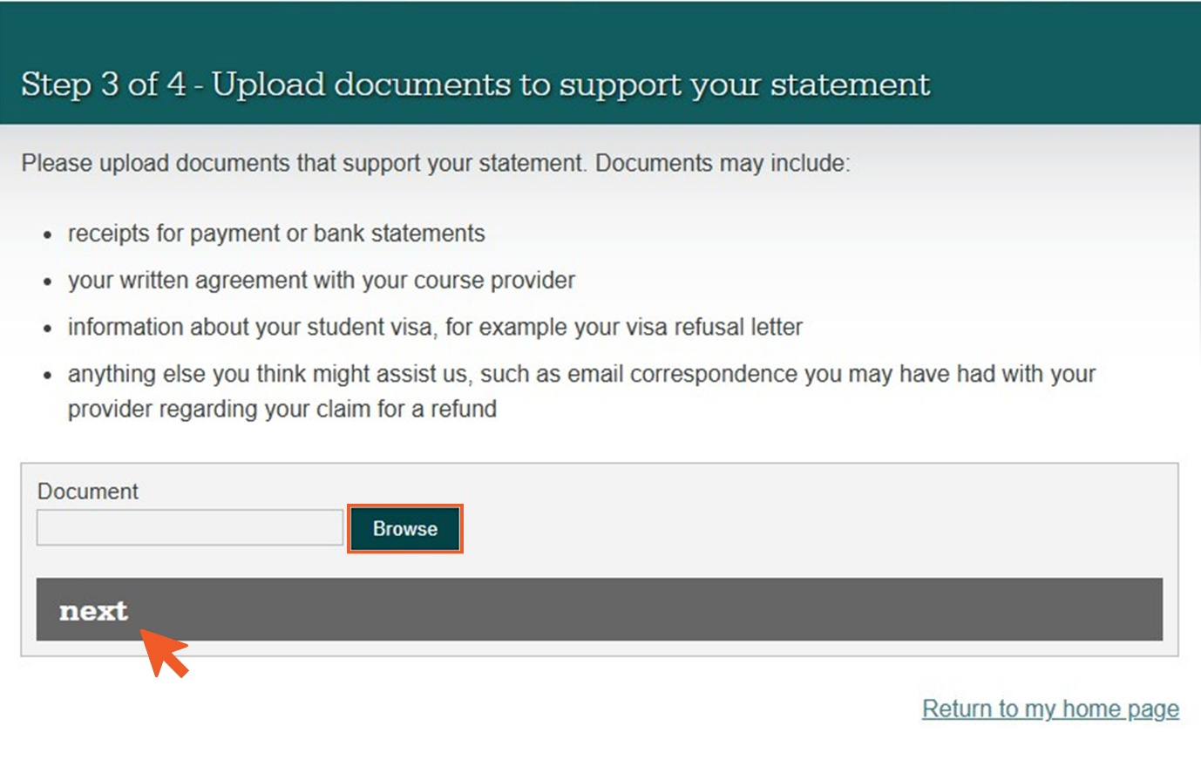

1. Check that your student statement is complete and that you have uploaded all required documents. To edit your student statement, click **Change my statement**. Click **Upload another document** if any documents are missing. If everything is correct, click **submit**.

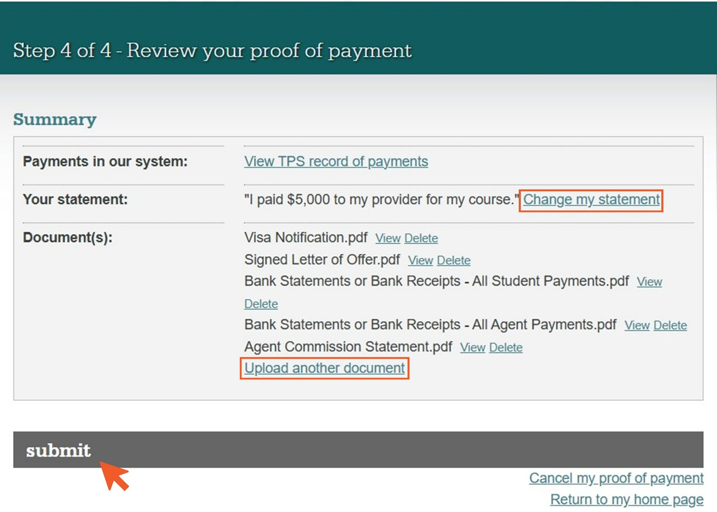

A Case Officer will review your documents and contact you if anything else is needed.

## Step 7: Apply for a refund

If the TPS confirms that you are owed a refund, you will need to provide the bank account details for the account you would like your refund to be paid to.

1. Click **Apply** to begin this task.

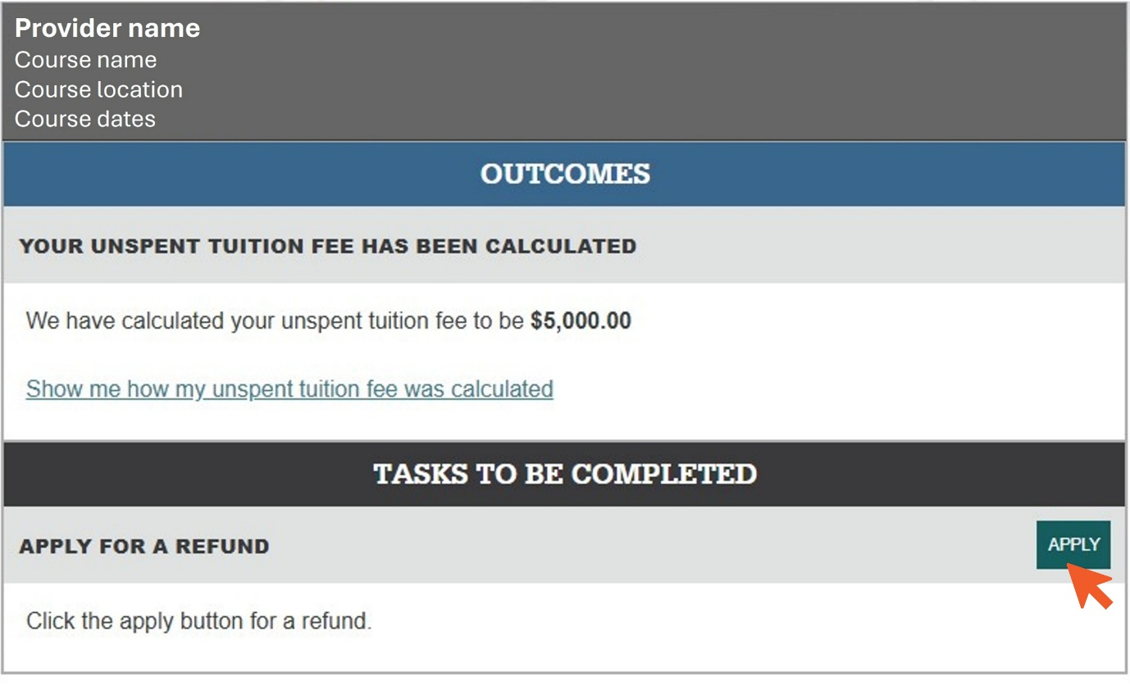

1. Enter your chosen bank account details. Check that they are correct, then click **submit application**.

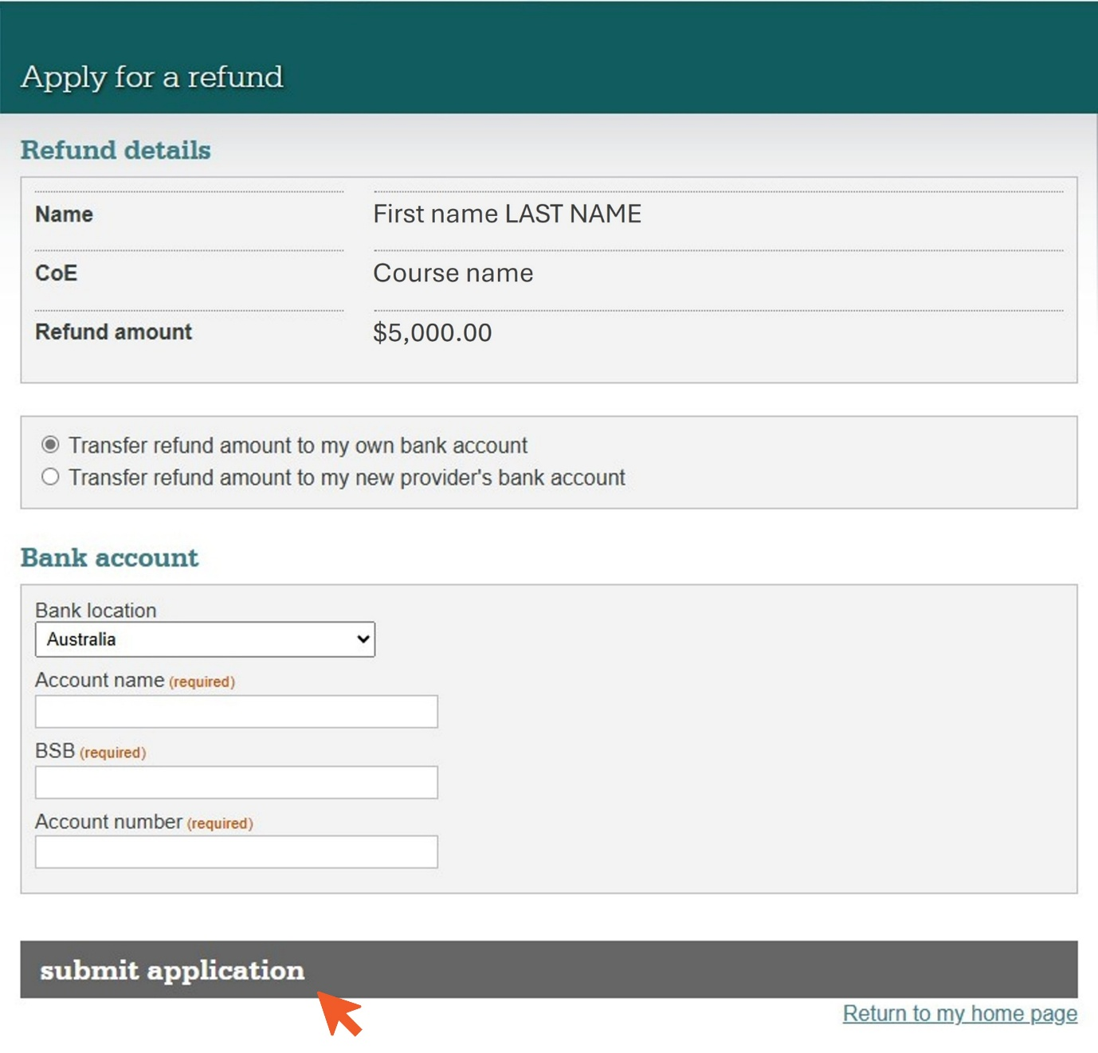

1. www.tps.gov.au
2. www.tps.gov.au