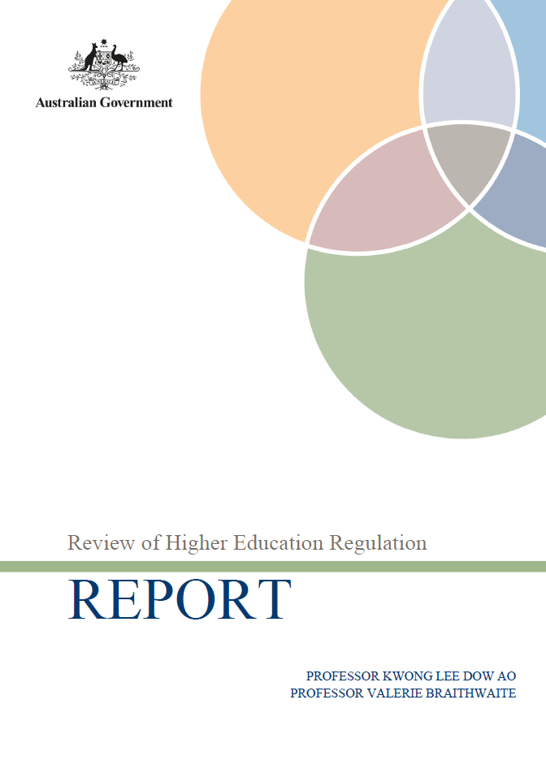

© Commonwealth of Australia, 2013
978-1-921916-93-9 (PDF)

This work is copyright. You may download, display, print and reproduce this material in
unaltered form only (retaining this notice) for your personal, non-commercial use or use
within your organisation. All other rights are reserved.

Disclaimer:

The material contained in this report has been developed by the Review of Higher Education Regulation. The views and opinions expressed in the materials do not necessarily
reflect the views of or have the endorsement of the Australian Government or of any
Minister, or indicate the Australian Government’s commitment to a particular course
of action.

The Australian Government and the Review of Higher Education Regulation accept no
responsibility for the accuracy or completeness of the contents and accept no liability in
respect of the material contained in the report. The Australian Government recommends
users exercise their own skill and care and carefully evaluate the accuracy, completeness,
and relevance of the report and where necessary obtain independent professional advice
appropriate to their own particular circumstances.

In addition, the Australian Government and the Review of the Australian Higher
Education, their members, employees, agents and officers accept no responsibility for
any loss or liability (including reasonable legal costs and expenses) or liability incurred
or suffered where such loss or liability was caused by the infringement of intellectual
property rights, including the moral rights, of any third person.
Senator the Hon Kim Carr
Minister for Higher Education
Parliament House
Canberra ACT 2600

2 August 2013

Dear Minister

In May this year, the Government asked us to conduct an independent review looking at ways to reduce the regulatory burden on higher education providers. We are pleased to present our Report.

Like those who spoke to us during the review, we have a vision for a high quality sector which strives for excellence and is competitive nationally and internationally. We believe such a system is best managed within a framework where providers themselves are predominantly responsible for maintaining and enhancing quality and supported in doing so. This will allow providers to spend more time focussing on their core business - providing quality higher education that will benefit our nation for generations to come.

The review’s consultation process was vital in shaping our positions as expressed in the report. We thoroughly enjoyed hearing views from a wide range of organisations including universities, private higher education providers and representative bodies within such a short timeframe. We were pleased to receive a range of interesting and thoughtful views from the sector and we thank all parties who contributed to the consultation process. In particular, we would like to thank TEQSA’s Chief Commissioner, Dr Carol Nicoll, who made herself and her team available to us for more than ten hours of discussions and questions. They also provided us with a wealth of documentation.

Among many important issues raised, two matters are clear to us. First, there is support for a national regulator. Secondly, and equally importantly, there is a need to strengthen the legislative framework within which TEQSA operates to provide a better guide as to the meaning of the principles of regulatory necessity, risk and proportionality across the sector and, as a consequence, TEQSA’s approach to regulation. This is the first step in changing a culture of top-down data collection in tertiary education that has become widespread and cost-insensitive.

We have put forward eleven recommendations covering our terms of reference that we believe will drive us closer towards the quality higher education we imagine.

We would also like to thank the Department for the support provided to us during the review and look forward to the sector’s and the Government’s engagement in taking forward these important issues.

Yours sincerely

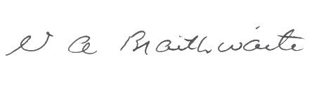
Professor Kwong Lee Dow AO Professor Valerie Braithwaite

Contents
Executive Summary 1
Introduction 3
Our approach to this review 3
1. The Australian Higher Education Context 5
1.1 Overview 5
1.2 Feeling the effects of reviews 9
1.3 The Australian tertiary regulatory architecture 12
2. Regulation in higher education 17
2.1 Broadening the lens for viewing regulation 17
2.2 Regulatory community 17
2.3 Multiple regulatory forces 18
2.4 The regulatory space of Australian higher education providers 18
2.5 The place of TEQSA in the regulatory community 22
2.6 Processes of regulation 23
2.7 Regulating as object 23
2.8 Regulating as partner 24
2.9 Smart Regulation and regulatory mixes 26
2.10 Principles to guide regulatory processes in higher education 26
3. Tertiary Education and Quality Standards Agency (TEQSA) 29
3.1 Setting up TEQSA 29
3.2 TEQSA’s powers and functions 30
3.3 Organisational Structure 32
3.4 Organisational practices 33
3.5 Assessing risk 34
3.6 Assuring quality 35
3.7 Legislative intersections with other activities 36
3.8 Improving regulatory relations 39
4. Next Generation Regulation in Higher Education: a discussion 41
4.1 Some fundamentals 41
4.2 Regulatory approach 42
4.3 A ‘one size fits all approach’ 43
4.4 Assessing risk 44
4.5 Constructive messages 46
4.6 Assuring quality 47
4.7 Cost of regulation 48
4.8 Relationships and governance 50
4.9 Other regulatory reporting 53
5. Recommendations 55
Appendices 61
Appendix A Terms of reference
Appendix B List of submissions and consultations
Appendix C Overviews of entities
Appendix D Quantification of the costs and effort of providers’ compliance
Appendix E The other subset of higher education providers
Appendix F TEQSA’s regulatory risk indicators
Appendix G APRA MoUs and letters of arrangement
Appendix H Chief Commissioner’s response to the Secretary, 18 June 2013

Executive Summary
Today, more Australians than ever, particularly those from lower socio-economic status backgrounds are participating in higher education. All the while, Australia continues to maintain its outstanding reputation for delivering quality education.

Our educational institutions, on the whole, comprise people at all levels committed to ensuring quality and striving for excellence for their students and in support of the Australian community and economy more generally. In an increasingly competitive and global education market, it is crucial that Australia continues to demonstrate and further develop the quality of its higher education sector. To ensure Australia’s ongoing competiveness, an effective regulator is a necessary and crucial component of the higher education regulatory architecture.

This review was established to address concerns raised by the sector about the effectiveness of Australia’s higher education regulatory framework. We have concluded that having one body responsible for compliance and monitoring such as the Tertiary Education Quality and Standards Agency (TEQSA) is crucial to maintaining the quality of Australia’s higher education sector. Moreover, we have found wide and continued support for the role of a national higher education regulator. However, TEQSA faces challenges which require action. Some of these challenges are a by-product of the higher education architecture and indeed the legislation underpinning regulation, while others are a result of TEQSA’s regulatory approach. To address these, a range of reforms are recommended that aim to improve both the broader regulatory architecture and the regulatory approach currently implemented by TEQSA.

The design of Australia’s regulatory architecture ensures that only quality providers are able to enter and remain in the system. Having a qualifications framework, higher education standards and a national regulator encompasses best practice principles of regulation. However, how they engage with each other will determine how well the ultimate aim of continuous quality improvement will eventuate.

TEQSA was established in an already crowded regulatory environment. The higher education regulatory community is multi-layered and diffused. Having placed TEQSA into this environment it appears that many legislative intersections do not support its mandate. TEQSA’s establishment has also identified that changes to other entities may be necessary to streamline the regulatory framework.

The regulatory principles of necessity, risk, and proportionality embedded in the TEQSA Act were included to ensure that the focus of TEQSA’s activities did not unnecessarily burden existing high quality providers. However, TEQSA’s legislation does not appear to be operating in the manner intended by Government or the sector. This is largely due to the lack of relationships in TEQSA’s governance and structure. Our recommendations therefore seek to build and improve relationships between the regulatory community.
Our recommendations are centred on what TEQSA should be delivering as a regulator in the current environment to build the future direction of Australia’s regulatory framework.
We believe that the aspects of quality assurance and best practice currently undertaken by TEQSA are better identified and delivered through other means already in place in the regulatory community.
There are many ways to make this happen. Therefore we recommend that to re-focus TEQSA’s effort and approach, its functions should be reduced so as to improve its timely delivery of its most important tasks – provider registration and course accreditation.
In a sector comprised of many self-accrediting institutions with high degrees of autonomy, the notion of ‘earned autonomy’ is an interesting one. We believe that the principles of regulatory necessity, risk and proportionality when applied in line with the Government’s intention, support a high degree of autonomy which supports the aspiration from the sector and government for light touch regulation across the sector.
We also considered to what extent the regulatory architecture was appropriately engaged and able to work together. It appears that often the legislative intersections are applied in isolation and underpin unnecessarily repetitive reporting requirements. The changing nature of tertiary education and the increasing number of multi-sector providers demands more effective and efficient application of regulatory requirements.
While work on aligning and restructuring legislative requirements should be commenced now, in the interim, the duplication of requirements could be compensated for by establishing transparent relationships between the respective entities. If responsibilities can be clarified and trust extended, then some activities could be reduced by one agency recognising the work of another. For this to happen, we need improved communication, consultation and collaboration. The Government must consider how these are implemented - whether through enforceable requirements or more informally. We recommend as an initial approach that non-statutory arrangements for advisory groups be enforced through clear and transparent memorandums of understanding.

Ultimately, our recommendations are to require wherever possible that consideration is actively given to aligning and streamlining regulatory activities and reporting. As the report identifies, the sector has been constantly at the behest of disruptions that steer the flow of events. And there are more to come. The respective reviews of standards, VET and higher education, have the capacity for further significant disruption and it is with these in mind, that we recommend that the Government align the work of individual entities to improve the efficiency of providers and ensure consistent protections for students.

This goal also applies to the Government and the work of its department/s. We acknowledge the initiatives already underway to reduce the reporting burden for providers. But these alone are not enough. The National Advisory Group for Higher Education Data and Information is a good start. To bring about the whole of architecture improvements required for the tertiary education sector, we recommend that greater impetus is given to further simplifying and, streamlining regulation towards one tertiary sector.

Introduction
On the 29th of May 2013, the Australian Government announced its action plan, Assuring quality while reducing regulatory burden. One of the elements of the plan is this review of higher education regulation.
Excellence in higher education is essential to Australia’s competitiveness in the Asian century. There is an international consensus that the reach, quality and performance of a nation’s higher education system are key determinants of its economic and social progress. Moreover an effective, high quality and streamlined regulatory approach is a fundamentally important component of a competitive higher education system.
It is imperative in the competitive global environment that Australia demonstrates the quality of its higher education learning outcomes. This is particularly important in a changing funding environment, moving from controlled allocation of places to one that is driven by student demand.
This review was established to examine concerns raised by the sector about regulation in higher education; specifically, the cost of regulatory compliance and reporting in meeting the Tertiary Education Quality and Standards Agency’s (TEQSA) requirements. Despite the best of intentions, it is quite telling that within eighteen months of establishment, TEQSA’s regulatory approach has caused concern to such an extent that this review has become necessary. There is clearly a mismatch between the sector’s expectations of the agency and their experiences of working with it. This could be attributed to many environmental and contextual factors; all of which may be underpinned by the founding legislation–its limitations and intersections, and interpretations of how it works with these.

Our approach to this review
We intend this report to first and foremost address the issues of perceptions of appropriate regulatory reach and the practical approaches which ensue. Australian higher education has always had forms of regulation, often related to its funding systems and therefore primarily administered by the Commonwealth. This is a role that has not been explicitly acknowledged as regulation. Regulation is defined in Part 2 as steering the flow of events. Funding bodies do this and as the funding evolves, so too do the regulatory and quality assurance mechanisms, especially the data requirements.
This leads us to note that it has very quickly become apparent that there is little differentiation in most minds and by most institutions between regulatory action and data requirements. Without a doubt, they are linked; taking on a particular approach to regulation will drive the extent of data collection and its use. But there are also practices of data collection that are entrenched as part of past policies and that do not have currency today. These many and specific data issues are already being addressed through the Government’s response to the Review of Reporting Requirements for Universities and other processes enacted by the Department of Industry, Innovation, Climate Change, Science, Research and Tertiary Education (‘the Department’). We therefore have focused this review on other aspects of the Terms of Reference (see Appendix A) that give us scope to comment on the effectiveness and efficiency of the regulatory measures that are in play in higher education.
The Review received some sixty submissions and undertook more than thirty interviews and roundtable discussions with key stakeholders (see Appendix B for details). The Action plan also requested immediate advice from TEQSA’s Chief Commissioner on what steps TEQSA could take now and would be taking in the future to reduce the regulatory burden on higher education providers. This advice from Dr Nicoll was provided in late June 2013. The Department was asked to consider suggestions for changes and the Department’s response was also provided to us.
With such a range of materials and scope for commentary and given the short timeframe to conduct this Review, a focus of our activities and information seeking is on TEQSA’s regulatory activities and approach. But it must be seen in its context. Consultations with more established regulatory bodies such as the Australian Prudential Regulatory Agency (APRA) confirmed what many of us see, that all new regulators have teething problems and their cultures can and do evolve. The strength of the sector’s reaction however, indicates that something more fundamental has gone awry and that there are important contexts that brings us to this point of an earlier than expected review.

Our report begins with a summary of the higher education environment and the activities that have set the stage for this Review. Like many complex systems, concerns for regulation are not only a response to the actions of TEQSA. What does get lost, not just for providers but we believe also for TEQSA, the Department and the other regulatory players, is the meaning and purpose of regulation. In Part 2 of the paper, we step back to discuss what it means to regulate, how approaches to regulation can differ and ideally how regulation would look for higher education.

Part 3 moves to discuss the establishment of TEQSA and its objectives and practices and to hear from TEQSA how it articulates its approach to regulation. Part 4 then describes what stakeholders have experienced and their concerns for how regulation in higher education is unfolding, particularly since TEQSA has commenced its operations. Our discussion in this Part works through the tensions and gaps between the better intentions of regulation, the principles of necessity, risk and proportionality and just how these are being put into practice.

Finally, in Part 5, we propose a number of recommendations with a particular eye to agreeing strategies for making improvements. It is easy to recommend apparently straightforward amendments to legislation which appear agreed by everyone. But this is worryingly simplistic, patching individual pieces of legislation can fix functional irritations, but will not necessarily change the way in which the legislation is being applied and why. If there is to be true regulatory improvement, then we need to agree the why and what before the how.

1. The Australian Higher Education Context

1.1 Overview
It is important to acknowledge the context in which this review has arisen. Higher education in Australia has changed dramatically over the last 30 years or so. It once comprised a small number of publicly-funded institutions. This is no longer the case. There are now more than forty self-accrediting higher education providers comprising a diversity of types; public, private and overseas universities and colleges of specialisation.
Australia also has approximately 130 non-self-accrediting higher education institutions. These institutions have been granted approval to operate and have had their courses accredited by State and Territory accreditation agencies. Non-self-accrediting higher education providers form a very diverse group of specialised, mainly private providers, although this group also includes institutes of technical and further education. These institutions range widely in size and disciplines offered. Some non-self-accrediting institutions are well established, having been operating for more than ten years and re-approved and re-accredited on multiple occasions. A smaller number are relatively new institutions which may be comparatively inexperienced at meeting quality assurance requirements.
Figure 1: Tertiary Education Provider Overview
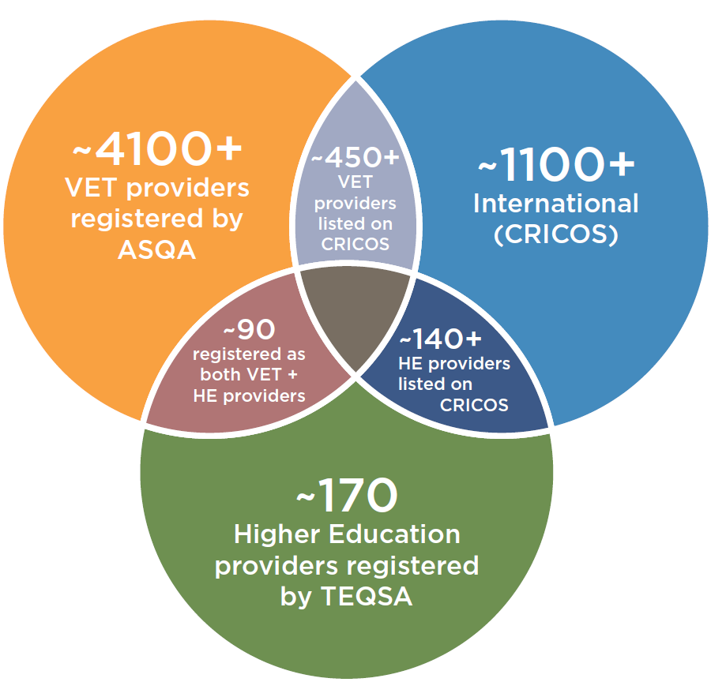
Today there are also a significant number of dual or multi sector providers which operate across two or more of the tertiary spheres including five dual-sector universities. The first of these – Victoria University, RMIT University and Swinburne University of Technology – were established in the early 1990s. Later came two regionally based dual-sector universities: University of Ballarat (1997) and Charles Darwin University (2004). Others may emerge in the future. As illustrated in Figure 1 above, approximately 50 per cent of higher education providers regulated by TEQSA are also regulated by the Australian Skills Quality Agency (ASQA) for their vocational education and training (VET) delivery. Moreover, the majority of higher education providers are also registered CRICOS providers.
Just as the make-up of the sector itself has changed, the policy, program and funding contexts too have changed and continue to change. If anything has been guaranteed for the higher education sector, it is change; the only thing differing is the speed at which it occurs. The list at Table 1 following is not meant to be comprehensive, but provides a flavour of a sector that is constantly responding to change. Many of which are also linked to forms of regulation. Australian tertiary education institutions are not alone in having to respond to what might appear to some as constant upheaval. The speed of change related to globalisation and technologies such as the internet, affect higher education all around the world. International alignment and benchmarking, previously unimaginable, are now commonplace. Education is now global, students and the labour force are multi-national, and people’s access to, and choices of, higher education providers and courses have exponentially multiplied.

Table 1: Timeline of significant changes in higher education sector
Year | Action
1988 | - Higher Education Funding Act 1988  - Employment, Education and Training Act 1988  - Abolition of Tertiary Education Commission and introduction of National Board for Education, Employment and Training (NBEET), including its advisory Higher Education Council and Australian Research Council
1989 | - Introduction of the Unified National System and conversion of Centres for Advanced Education to universities (“the Dawkins Reforms”)  - Introduction of the Higher Education Contribution Scheme (HECS)  - Direct Commonwealth funding of higher education providers conducted via individual negotiations between universities and the Department, monitored by the Higher Education Council
1990 | - Relative Funding Model ‘corrects’ misalignment of Commonwealth funding between universities by 1995, becoming basis for Triennial Funding Rounds
1991 | - Education Services for Overseas Students (Registration of Providers and Financial Regulation) Act 1991
1993 | - Commission for Quality Assurance in Higher Education established
1995 | - Australian Qualifications Framework established
1997 | - Education Services for Overseas Students (Registration Charges) Act 1997
1998 | - West Review (Learning for Life) recommended increased tuition fee flexibility and demand-driven funding. These recommendations not adopted by the Government  - Introduction of full-fee domestic student places
1999 | - Workplace Reform Program. Increased funding made available in return for institutional changes in workplace relations, management and administration
2000 | - Formal abolition of NBEET and its advisory Councils.  - Australian Universities Quality Agency (AUQA) commences
2001 | - Australian Research Council Act 2001; ARC becomes independent entity for the distribution of research grants  - Backing Australia’s Ability. Expansion of Government competitive research funding, established Centres of Excellence, increased targeted university places and introduction of the Postgraduate Education Loans Scheme (PELS)  - ESOS Assurance Fund commences operation – provides 3rd layer tuition assurance and protection to overseas students
2003 | - Higher Education at the Crossroads Review and introduction of the Higher Education Support Act 2003 (HESA)
2004 | - Transitional HESA arrangements  - Abolition of PELS and BOTPLS  - Introduction of the Student Learning Entitlement
2005 | - Commonwealth Grant Scheme established along with student entitlement to Commonwealth supported places – negotiations managed through funding agreements and Institutional Performance Portfolios  - FEE-HELP scheme commences – expansion of private provider market  - Changes to discipline funding clusters  - New funding arrangements introduced including workplace productivity and national governance protocols
2006 | - Introduction of Voluntary Student Unionism  - Review of the ESOS National Code  - The 2006 Senate Community Affairs Legislation Committee Inquiry into the National Health and Medical Research Council Amendment Bill 2006, oversaw the split of NHMRC from the Department of Health and Ageing (DOHA).
2007 | - Review of HESA – funding clusters adjusted from 2008  - National Code of Practice for registration Authorities and provides of Courses to Overseas Students
2008 | - Bradley Review of Australian Higher Education – recommends demand driven funding as well as a range of other changes  - VET FEE-HELP scheme commences – increasing intersections for providers between VET and higher education  - Changes to discipline funding clusters and student contributions  - AUQA Second Round audits begin  - The Cutler Review of Australian Innovation Venturous Australia (2008) provided recommendations to update and broaden the innovation policy agenda
2009 | - Phasing out of fee paying undergraduate places at public universities  - Changes to discipline funding clusters and student contributions and loadings  - Baird Review of the ESOS Act  - Innovation White Paper, Powering Ideas an Innovation Agenda for the 21st Century (2009): articulates a 10 year agenda for innovation policy (SRE, ERA, Super Science initiatives)
2010 | - Increases in undergraduate enrolments as over-enrolment funding increases to 10% in transition to demand drive funding  - Review of Funding for Postgraduate Places  - Changes to discipline funding clusters and student contributions and loadings  - Review of International Foundation Program Standards  - Introduction of triennial Mission-based Compacts
2011 | - ASQA commences activities  - Higher Education Base Funding Review undertaken  - Knight Review of the Student Visa Program  - Launch of MyUniversity website  - 1st phase of Government response to Baird Review. Overseas Students Ombudsman commences.  - TEQSA Act 2011
2012 | - TEQSA commences activities. First providers given re-registration  - Full demand driven funding system for undergraduate places (with caps introduced for sub-bachelor places)  - Tuition Protection Scheme introduced for international students  - Phillips KPA Review of Universities Reporting Requirements  - Review of Higher Education Access and Outcomes for Aboriginal and Torres Strait Islander People  - Abolition of Student Learning Entitlement  - Chief Scientist releases the National Research Investment Plan  - 2nd phase of the Government response to Baird Review. A new Tuition Protection Service commences  - Establishment of the National Advisory Group for Higher Education Data and Information
2013 | - Review of Higher Education Standards  - Review of National VET Standards  - TEQSA Risk Assessments first round completed  - TEQSA Third-Party Service Provision quality assessment survey  - A Plan for Australian Jobs released, including the introduction of Industry Innovation Precincts and work toward an Australian Innovation Statement  - McKeon Review of Health and Medical Research released  - Launch of MySkills website

The list also highlights that a key driver of change in the sector is the Commonwealth Government’s funding arrangements. Via its funding programs the Commonwealth has had a significant role in regulating or steering the flow of events in the sector. To deliver on its accountability requirements, the Government collects a large amount of data through its portfolio agencies. It also has long established relationships with the sector as a whole as well as with individual providers, the majority of which over the longer term have been the universities. The relationships with universities are even more distinctive given their roles as research bodies and seeking research funding.

These relationships have been built over time through the various funding negotiation and accountability mechanisms, such as the Commonwealth Grant Scheme funding agreements, Mission-based Compacts (Compacts) and Institutional Performance Portfolios (IPPs). Similarly, there is a wealth of data and information regarding the sector provided as a result of these funding activities. It is useful to note that these arrangements can be allocated to two broad types of activities, the first being forward looking assurances of strategic planning; and the second being backward looking accountabilities for delivery and outcomes. Both have an important role in regulating the sector particularly when they are linked through regular, on-going conversations and discussion.

1.2 Feeling the effects of reviews
Table 1 also provides a rather telling tale of reviews – the rate of which has intensified in the last decade. Broadly speaking the reviews are of two kinds. There are those that seek to renew a policy environment with a concomitant effect on government funding and its regulatory requirements. Then there are those responding to externalities such as crises in the international student market with more of a direct regulatory effect on providers, for example through more stringent entry standards and stronger oversight. Four reviews of particular note for our work are:
- Review of Australian Higher Education (Bradley Review);
- Stronger, simpler, smarter ESOS - Supporting international students: Review of the Education Services for Overseas Students (ESOS) Act 2000 (Baird Review);
- Strategic Review of the Student Visa Program 2011 Report (Knight Review); and
- Phillips KPA Review of Reporting Requirements for Universities (Reporting Review)

These reviews identified concerns for the sector’s regulatory framework, namely weaknesses in legislation, absence or duplication of activities, and/or gaps in coverage or understanding. It is also the enacting of recommendations arising from these reviews that is shaping the current regulatory environment, especially for TEQSA.
The Bradley Review
The Bradley Review found the established mechanisms for assuring quality in higher education were complex, fragmented and inefficient. Specifically:
- the quality assurance framework was too focused on inputs and processes and did not give sufficient weight to assuring and demonstrating outcomes and standards;
- different and overlapping frameworks regulated the quality and accreditation of higher education institutions;
- responsibility was divided between the Commonwealth and the states and territories, with different units of government responsible for various regulatory frameworks in each;
- arrangements for mutual recognition of providers and courses operating across state and territory boundaries were inefficient and did not operate effectively;
- within higher education the framework was applied unevenly so that not all providers were reaccredited on a regular basis; and,
- reliable comparative information to underpin student choice of courses and institutions was limited.

In making these comments the Bradley Review drew on the 2007 PhillipsKPA Inquiry into the desirability of a national higher education accreditation body. The Bradley Review found many congruencies between the issues raised in both processes, including:
- the time taken to have courses accredited (up to 18 months) and the implications for responding to market forces and the significant advantage this gives self-accrediting institutions;
- perceptions that accreditation processes involving university academics on course assessment panels are unfair where these academics are direct competitors;
- perceptions of inconsistent requirements between states and territories in terms of registration, accreditation and annual reporting. Conversely some universities queried whether some institutions or courses should be accredited in the first place expressing concerns about the quality of degrees offered;
- the need for stronger and more coherent quality assurance of higher education delivered offshore by institutions whose courses were accredited by the states and territories;
- the compliance cost and complexity of compliance for those operating in multiple jurisdictions with duplicate processes leading to inconsistency and inefficiency.’

The Bradley Review recommended major reforms to the higher education regulatory framework as ‘the risk of ignoring these deficiencies and concerns is considerable’. Key to their considerations was to:

preserve our national reputation for quality provision and to ensure we are prepared for a more competitive global higher education environment we must reshape the regulatory system. There is no longer any defensible argument for the fragmentation and variation in requirements which is apparent across jurisdictions and sectors.

The result was to be a framework for higher education accreditation, quality assurance and regulation including an independent national regulatory agency.

The Baird and Knight Reviews
In response to the significant growth in the number of overseas students studying in Australia, the changing composition of the international student body and emerging issues in the sector, the Australian Government commissioned the Baird Review to examine the operation of the Education Services for Overseas Students Act 2000 (ESOS) and its associated regulatory and legislative frameworks.
Submissions to the Baird Review considered the biggest problem with regulation to be the lack of consistent and rigorous enforcement of ESOS. There were complaints about the regularity, targeting and effectiveness of monitoring activities and enforcement action and complexity and duplication, particularly for providers in multiple jurisdictions and sectors.
The Final Report of the Baird Review included 19 recommendations and findings related to student welfare and information, ethical recruitment, effective enforcement, risk management, and tuition protection. As part of the Government’s response to the Review, the ESOS Act was amended to incorporate many of the Review’s recommendations, including implementing a regulatory risk framework intended to better target monitoring and compliance activities.

In December 2010 the Government commissioned the Hon Michael Knight AO to review the student visa framework. The review found declining enrolments in the international education sector were mainly due to increased global competition, changes to Australia’s migration settings and a rising Australian dollar.
The 41 recommendations made in the Final Report of the Knight Review in June 2011 proposed changes to the student migration program, introducing streamlined visa processing and improvements in visa integrity measures. Of these, not all related directly to the ESOS Act, although some did have a direct effect in relation to student data reporting. As a result of changes to the Migration Act 1958 which abolished automatic visa cancellation for breaches of student visas, consequential amendments were made to the ESOS Act and took effect in April 2013. The Government’s response to the Knight Review will see further changes to reporting requirements for providers. Other recommendations from the Baird and Knight reviews are still to be progressed, there is now potential from this Review to consider how that work should intersect with the broader regulatory framework.
Review of reporting requirements for universities
One of the effects of increased accountability, regulation and transparency has been increasing complaints about the breadth and duplication of data collections. This vocal message from the sector resulted in the Department commissioning PhillipsKPA to undertake a review of the time spent and recurring costs involved for universities in reporting numerous data sets. The Review of Reporting Requirements for Universities (RRR) was released on 4 April 2013.
The RRR focused on universities’ reporting requirements to the Department and analysed the time spent and recurring costs involved in meeting 18 its requirements. The RRR acknowledged that the regulatory burden faced by universities results largely from the requirements to comply with laws that apply to all incorporated entities engaged in the wide range of activities that universities undertake.
The review found that, in 2011 a ‘typical’ Australian university spent over 2000 days of staff time and between $800 000 and $900 000 in meeting the requirements. The estimated cost of reporting requirements ranged from the minimum of around $0.20 for every $1000 (0.02 per cent) up to $30 for every $1000 in funding (3 per cent). The review emphasised that to a substantial extent the data collection activity undertaken by institutions would be undertaken even if there were no requirement to report the information to the Department, as this data collection was essential for an institution’s own internal management and planning purposes. The review also identified that TEQSA’s requirements had contributed to a university’s reporting burden.
A key message from the reporting review is that data collections are compartmentalised for singular purposes and there is no overarching understanding or picture of what is being collected, why or even how. In a functional sense, everyone is meeting their accountability requirements, but the much harder relationships between programs, systems or agencies and their meanings are not being engaged.
Prior to commissioning the Review, the Department had already identified this as an issue. Consequently, the Government established the National Advisory Group for Higher Education Data and Information (NAGHEDI) which met for the first time in October 2012 and again in May 2013 (see Appendix C for details). It is intended to provide advice to Government on the development of a single National Higher Education Statistics Collection and other matters pertaining to the collection and dissemination of higher education data. While only in its infancy, there are many positives to be drawn from the Group, in particular, the breadth of its membership and transparency of its work to-date.

At NAGHEDI’s second meeting it recognised there was also a gap to be addressed in the intersections between higher education data and VET data activities. To some degree this was picked up in the report from the perspective of dual sector universities being at the behest of data requirements for both arms of delivery. Overlap between sectors comes to the fore through the ESOS and CRICOS requirements as these apply across non-sectoral courses such as Foundation and ELICOS. The notion of there being a ‘tertiary sector’ was raised by the Bradley Review and similarly affects the Knight and Baird Reviews – the world of education providers is not simply compartmentalised into divisions such as secondary, VET and higher education. From a provider’s perspective, the overlaps are increasing as providers deliver education in several sectors and this strongly influences the extent of their experience of engaging with regulation and regulatory agencies as noted in Figure 1.

Previously only five providers were enabled through their legislation to provide both higher education and VET. These days, dual sector providers are more commonly institutions initially established to deliver in one part of the market which then choose to extend their services to the other. Today, of the 40 universities, more than 20 are registered as registered training organisations (RTOs). Of the 61 TAFEs, more than 20 are offering higher education qualifications.

Many of the policy and program changes identified in Table 1 have driven the opening up of the higher education market to different types of providers and increasing competition for students. These changes are expected to drive increasing intersections with VET. There is also a significant set of changes occurring for the VET sector – introduction of a national regulator, review of standards, changes to funding arrangements and restructuring within the sector in response to jurisdictional changes to name a few. These developments all have their ensuing operational responses within and across parts of tertiary education. For these reasons, we are describing below the ‘tertiary’ regulatory architecture rather than the narrower higher education regulatory architecture (see Figure 2 below). The regulatory complications for providers and TEQSA need to be considered in the fuller context of their requirements.

1.3 The Australian tertiary regulatory architecture
The Bradley Review prescribed a framework for higher education accreditation, quality assurance and regulation with a single national regulatory body to regulate all types of tertiary education. The Bradley Review suggests that quality assurance would primarily be gained through the development of standards, i.e. the Higher Education Standards Framework, and ‘a transparent process for assuring the quality of learning outcomes across all providers of higher education’. The latter role is far more difficult to assign. Quality assurance has technical meaning in which it comprises ‘systematic measurement, comparison with a standard, monitoring processes and feedback loops’ to know how one fulfils the requirements for a service or product. In this definition, every part of the current regulatory architecture has a role in quality assurance, some more explicitly than others. It is also important to note that post-AUQA, it has become increasingly common for higher education providers to instigate their own quality assurance programs.

As described in Figure 2, the current architecture has a multitude of structures and agencies involved each with their reporting lines, decision-making arrangements and legislative authorities. These bodies and their activities comprise the key elements of the Australian tertiary regulatory architecture with which higher education providers are interacting (see Appendix C for overviews of their various functions). The tertiary regulatory architecture is compartmentalised, yet intersecting, formally and informally, and as a result undoubtedly difficult for stakeholders to understand and navigate easily.
The most explicit components of the regulatory architecture are the two regulatory agencies and the standards bodies. Their roles are clearly defined. For example, the TEQSA Act enables the establishment of the Higher Education Standards Panel (‘the Panel’). The Panel is responsible for creating the Higher Education Standards Framework (‘the Standards’) which creates benchmarks for entry to, and continuance in the higher education sector. As detailed in the Explanatory Memorandum:

The Higher Education Standards Framework will incorporate national quality standards and performance indicators. These will be central to ensuring that the entry gateway to the higher education sector is sufficiently high and provides a solid basis of performance from which all providers can build excellence and diversity.

In terms of governance, while established by the TEQSA Act, the Panel is independent of TEQSA and reports separately to the Minister. It should be noted that, as part of future factors for the sector and for TEQSA, the current Standards are being reviewed. The Standards are applied to providers by TEQSA as the regulator. The Panel can provide advice and make recommendations to TEQSA on the Standards Framework but TEQSA is not required to report to the Panel or to the Minister in its application of those standards.

Meanwhile for VET regulation, the NVETR Act similarly establishes the National Standards Framework. However, the equivalent VET regulator, ASQA, and its standards body, the National Standards and Skills Council (NSSC) have very different reporting lines. The NSSC commenced operations on 1 July 2011 as a committee of the Standing Council on Tertiary Education, Skills and Employment (SCOTESE) which reports to the Council of Australian Governments (COAG). The Council has powers ascribed to it through the NVETR Act but in itself is not beholden to the Act.

The current VET Standards are also being reviewed. The governance arrangements in this case will be different from those in higher education as the outcomes of the review will be delivered to the NSSC for its consideration, then agreed by Ministers, state, territory and Commonwealth, and handed to ASQA to apply to providers as the regulator. ASQA in its application of those standards is accountable to the NSSC.

In a further variant of statutory structures and governance arrangements, the fourth component of regulation in Figure 2 is the Australian Qualifications Framework (AQF) Council. Similar to the NSSC, the AQF Council is a non-legislated (non-statutory) body. It too reports to SCOTESE, but unlike the NSSC, it has no roles given to it in any of the activity prescribing Acts, e.g. HESA, NVETR, or TEQSA. The Council’s creation, the AQF, is applied in the two sets of standards and some eligibility of courses in HESA. The only structural shared link for the AQFC with any other part of the regulatory architecture is its reporting to SCOTESE.

Meanwhile, the Commonwealth’s role as a regulator has not been well articulated in the tertiary regulatory architecture. For example, through the Commonwealth’s funding programs delivered under HESA by a portfolio responsible to a Minister, the Commonwealth has acted as a default regulatory agency, especially for quality assurance. There are assumed or perceived regulatory and quality assurance processes applied by controlling access to funding, the various accountability measures, and by the very nature of its funding programs. This type of regulation related to quality assurance has been further reinforced by bodies such as the former Australian Learning and Teaching Council and programs now managed by the Office for Learning and Teaching. It similarly occurs by controlling access to research funding – with perceptions of recipient organisations being more quality assured than those not receiving such funding and by the Excellence in Research for Australia assessments carried out by the ARC. In the current regulatory architecture, the Commonwealth and its funding, especially through HESA, is what drives the majority of the strategic forward looking assurance activities and conversations such as the Compacts and the data collection which forms the accountability for delivering outcomes.

By international standards, this complexity in the Australian regulatory architecture is distinctive but not unusual. Other countries’ regulatory architectures distinguish between higher education and VET (however defined). They also tend to separate standards setting bodies from auditing or regulating bodies. For some countries, but not all, equivalent qualification frameworks are in legislation. The Australian tertiary regulatory architecture reflects the complexities of state, territory and Commonwealth relations and powers as well as the funding of courses. It is certainly not the only system which has these types of relationships.

The combination of Table 1 and Figure 2 underlines the fact that components of the tertiary education regulatory architecture have come into being at different points in time and within different contexts. If there is to be a single critical comment drawn from this, it is that components have been designed in isolation from each other. This is exemplified by the lack of required intersections in membership between councils and panels and consultation mechanisms. In having such a compartmentalised approach, any principles and purposes of effective regulation have been lost in the tertiary regulatory architecture space. We are not alone in identifying this problem. This is why the sector feels the weight of duplication. This is why the Department, the AQFC, the Standards Panel and almost every actor in the architecture is setting up a working group and/or selecting members to build cross-representational relationships and lines of communication that were not enacted through structure or legislation.
This type of a response, as we commented in the introduction, is a necessary part of the solution, but it is not sufficient as a long-term answer. There is a need to build a shared understanding of the purpose of regulation and to consider what effective regulation for higher education might look like in the broader sphere of tertiary education. There will be many steps along the way to re-designing components and streamlining responsibilities. Moreover, it would be naïve to assume that change to the components is a thing of the past and that the pace of change will slow down in the future. There are more changes ahead, most imminently those that will be ushered in by the newly established Australian Charities and Not-for-Profit Commission (ACNC) with a new set of reporting demands for significant numbers in the tertiary education sector. One approach for a review such as ours is to stand back from what is currently in place and propose new organisational charts with mergers and overarching bodies, trying to pre-empt the future as best we can. We are not taking this path. Our view is that the goal for the regulation of higher education must be to adopt not only a more coherent regulatory architecture but also one that is simpler and easier for providers to engage with constructively. This will only come about if changes are designed with the perspective of providers foremost in future deliberations.
This report seeks to provide a first step toward putting forward the provider perspective and laying out principles for designing the regulatory architecture so that it is more responsive to the different circumstances of different providers. In the next Part we detail the way in which we think a regulatory architecture should be developed in higher education. Then we move on to discuss the very different perspectives of those who are regulating, being regulated and observing regulation in action, a group that we will refer to as the regulatory community.
Figure 2: The Tertiary Regulatory Architecture
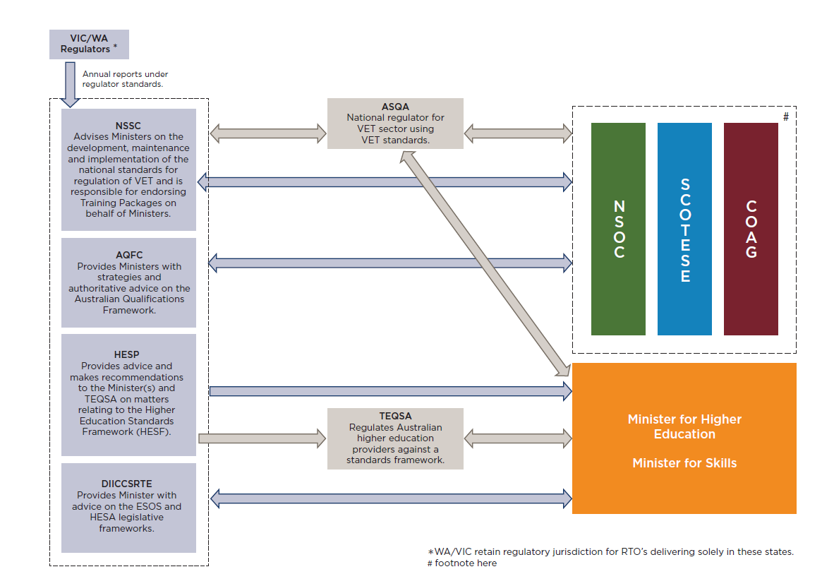
NSOC is comprised of Chief Executive Officers of the Commonwealth, State and Territory Government Departments responsible for tertiary education, skills and employment.
SCOTESE is comprised of Commonwealth, State and Territory Ministers with responsibility for tertiary education, skills and employment.
COAG is comprised of the Prime Minister, State and Territory Premiers and the Chief Ministers.

2. Regulation in higher education

2.1 Broadening the lens for viewing regulation
We earlier introduced the notion of regulation as that which steers the flow of events. This definition is in keeping with a world where governments steer rather than row and where professional accreditation bodies and students have as much sway over what is taught and how it is taught as higher education providers.
Common understandings of regulation do not accommodate these complexities and often fail to draw attention to how these other regulatory forces impact on the fortunes of the agency traditionally known as ‘the regulator.’ From our conversations with higher education providers, regulation is seen narrowly as the domain of TEQSA, ‘the regulator’, isolated from the other regulatory forces that are steering the flow of events in higher education. In this Part we want to move away from this image and from the expectation that a regulator’s task is to ensure that the regulated party (regulatee) is complying with the law through using its enforcement capability to coerce compliance.
Modern regulation involves much more than this. In many areas of regulation (health, safety, environment, nuclear power, transport, finances, food production and processing), it is not enough to have regulation that cracks down on ‘laggards’, it is equally important for the regulator to encourage as many as possible to be leaders moving ‘beyond compliance’, that is, to embark on a program of continuous improvement. Without this dual regulatory agenda, regulatory agencies can become prescriptive and oppressive, holding back developments that are in the public interest and that are being proactively encouraged through other regulatory forces. In the higher education domain, a large investment of resources in checking and proving that threshold standards are met can mean that there is little energy or appetite for new exciting initiatives that go beyond compliance, made worse by the fear that trying something out of the ordinary will risk the ire of the regulator. In our interviews we heard of such concerns that course developments were blocked by regulation. With these observations through our interviews, this Part detours into the world of regulation, bringing to life a more dynamic conception of regulation that can be applied to the higher education sector.

2.2 Regulatory community
It has never been reasonable to assume regulatees are isolated entities. Sub-cultural groups with their own norms, values, beliefs and processes have leaders who may on the one hand undermine regulatory authority, and on the other hand further its reach and influence. Those being regulated, through their alliances and networks, exert power in response to the efforts of a regulator to change their ways of doing things.
In the higher education sector, there are important regulatory players whose influence is publicly visible including peak bodies such as Universities Australia and the Australian Council for Private Education and Training (ACPET). Professional bodies like the Institute of Engineers also bring their own codes of conduct and learning expectations to the educational enterprise. Universities and higher education providers have their own norms, values and processes that together create a ‘scholarly culture’ with as much regulatory punch as any demands imposed from outside. These various regulatory forces in the community may aid or undermine the efforts of the regulator to steer the flow of events.
The lessons learnt from seeing regulation as occurring within a regulatory community are twofold. First, those being regulated are neither ‘black boxes’ nor passive objects of regulatory intervention. They can respond to regulation positively and/or negatively thereby strengthening or undermining the legitimacy and effectiveness of the regulator. Second, regulatees are not necessarily isolated entities at the receiving end of a regulator’s power. Regulatees marshall support and build social alliances that can paralyse a regulatory agency through marginalising it.

2.3 Multiple regulatory forces
The breadth and depth of regulatory influence has intensified. Organisations of all kinds – state, business, civil society and hybrids – have entered into the arena of regulation through developing sets of rules beyond or outside legislatures and courts to influence the flow of events.
As higher education has become a global industry and as competition for students and funding has become fierce, regulatory measures to assure quality and sell quality education to a status-conscious market have found a niche in higher education. Perhaps the most well-known and visible of these new private regulatory influences are the international league tables which assign universities a number that supposedly captures their overall academic excellence globally. Google scholar citations is another recent but prominent example that steers the flow of events in a very practical way through delivering promotions and research grants.
The demands made on higher education providers as a result of these different regulatory forces may overlap, complement or conflict. In many instances, higher education providers have a significant financial incentive to meet these demands, receiving acclaim and recognition for doing so. In an age of regulatory capitalism, TEQSA is but one player, and not always the most important player, in the higher education regulatory community.

2.4 The regulatory space of Australian higher education providers
Higher education providers, regardless of type, are all enmeshed in dense regulatory networks of stakeholders based on their enabling legislation, size and scope of activities and access to government funding. As observed in part one, Australian higher education comprises a range of providers including some forty plus universities and more than 150 other higher education providers. Under the Higher Education Support Act 2003, more than 120 of these institutions are eligible to receive funding from the Commonwealth by offering FEE-HELP loans to eligible fee paying students. The other subset of providers that are not receiving Commonwealth funding are not necessarily interacting with the same level of regulation and data collection. But as Figure 3 below shows, they will not be by any means an unregulated sub-set.
Figure 3: Regulatory forces for higher education providers
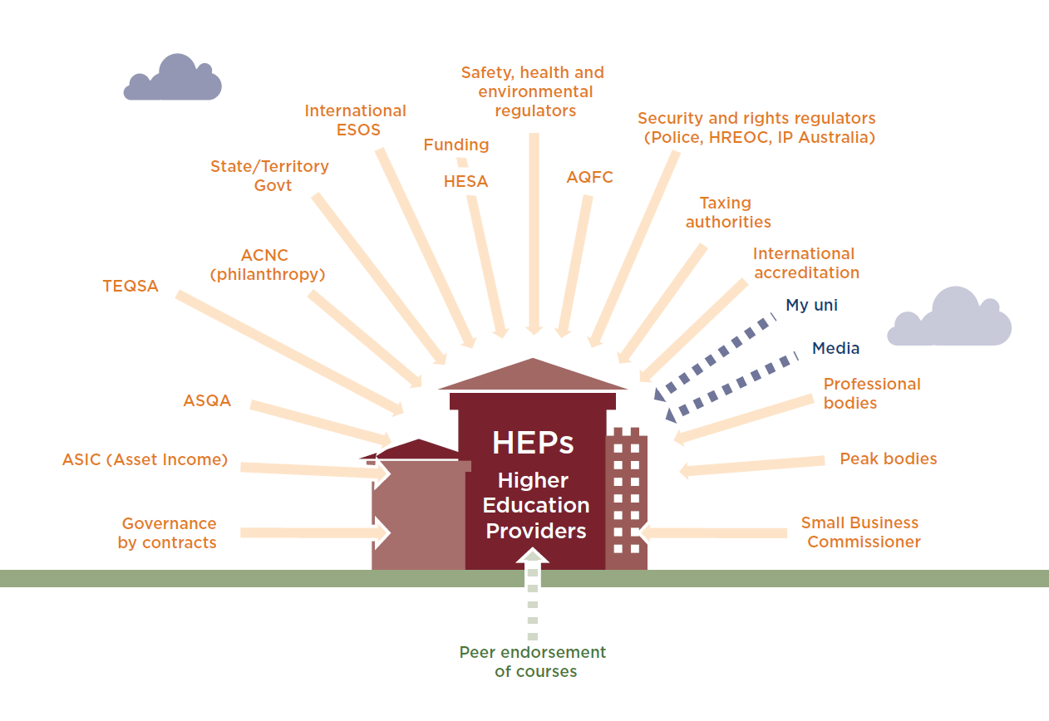
National and international market forces regulate higher education providers through steering their development in certain directions. Nationally, the demand driven system has changed the market system for recruiting students. The search for a bigger market has also seen partnerships created between providers for domestic and overseas campuses. The use of on-line teaching also creates opportunities for providers to increase market share without being hampered by physical or geographical constraints. Market forces may strengthen scholarly networks, enhance cooperation, and raise the standards of education across the sector. Or the business model that is required to make these ventures and collaborations a success may jeopardise quality and excellence. Capable management, sophisticated scenario planning and good business models are key to how these regulatory forces affect the sector.
Two points are worth making about the regulatory space of higher education providers that are not universities. In terms of teaching and learning, some will be enmeshed in looser regulatory networks than others. This means that the teaching and learning experiences of their students may be less open to critical scrutiny and there may be less opportunity for continuous improvement than for other better networked providers. In our interviews, higher education providers commented on the difficulty of getting universities to partner with them for benchmarking purposes.
Second, smaller providers are going to disproportionately feel the burden of regulatory demands from the education sector. Already shouldering many of the regulatory burdens experienced by small businesses, higher education providers struggle to find resources to meet the demands of TEQSA and ASQA. Doing so comes at a cost to teaching and learning and students in their fees (see Appendix D).
The density of regulation further increases when one compares the above with Figure 4 for universities. The regulatory space of Australian universities, like higher education providers, is created through a network of relationships based on shared culture, financial needs, market position, status acquisition and corporate governance. Just as some smaller providers are struggling with regulation as small businesses, universities are large and complex organisations that must meet a range of regulatory obligations that are borne by larger enterprises.
There are some distinctive additional complexities for universities that steer the flow of events. Australian public universities are generally established by state or territory legislation. The legislated peak governing body of a university is the university council with reporting obligations to government under which it has been established. The university council is responsible for the affairs, processes and property of the university. It ensures that staff, students and external stakeholders (including government) are familiar with its governance processes.
Academic culture is a powerful regulator of teaching, learning and research. Running through universities are systems of committees responsible for assuring quality in academic programs and processes. This system may be represented at a high level in the university by an academic board. Academic boards provide advice to councils and to the senior management of the university on the core business of teaching, learning, research and community outreach. Committees for teaching, learning and research committees that run through the universities and are themselves regulatory bodies, provide support for some activities, not for others. They are underpinned by a shared scholarly culture of norms and practices that transcend national boundaries and are institutionalised through disciplines and scholarly societies. Acceptance within this culture, along with individual academic success, depends on compliance with the standards of these disciplines that extend beyond the confines of the university. These forces may seem concordant. But tensions do emerge in the internal regulatory structure of universities. As academics become global citizens in their capacity as teachers and researchers, their affiliation to their academic community strengthens compared to their affiliation to their home institution. For many academic staff, vertical institutional regulatory ties within the university are at odds with the horizontal scholarly regulatory ties that define their identity and career success.
Figure 4: Regulatory forces for universities
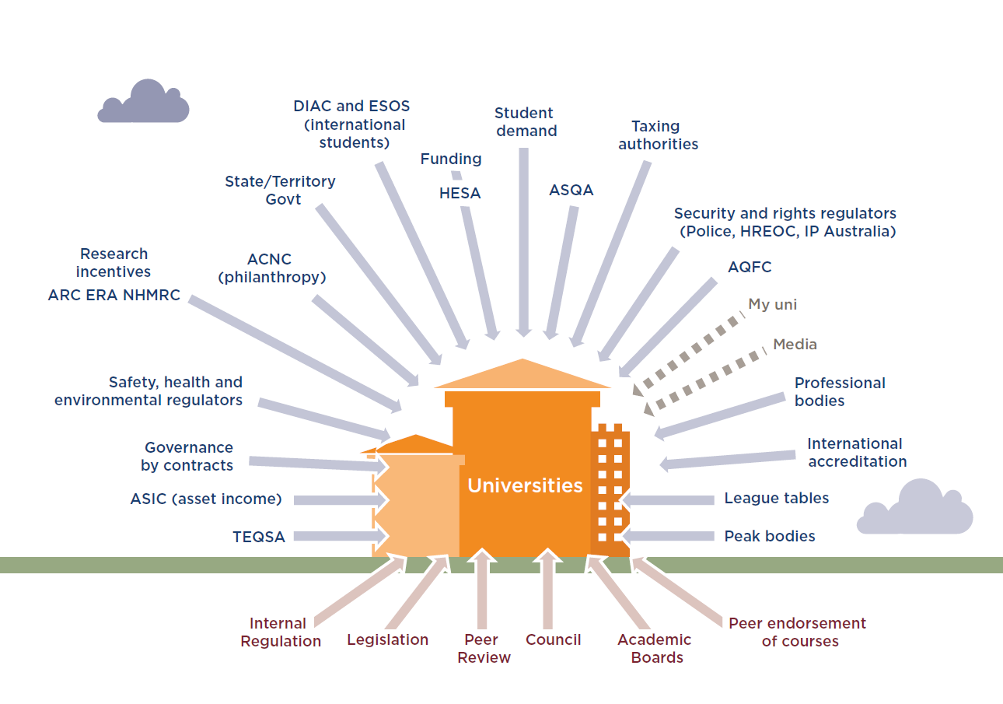
When comparing the regulatory networks enmeshing universities and other higher education providers the most significant difference lies in access to government funding, especially for research.
Government funding is of critical importance to universities and steers the flow of events. Government funding comes in a variety of forms and for a range of purposes. Universities receive grants for Commonwealth supported places, research and research training. In addition there are other grants awarded to universities for particular projects ranging from capital works to providing educational pathways for specific equity groups. The government can adjust its funding formulae to encourage different regulatory outcomes, for example, through rewarding universities for increased doctoral completions or higher levels of participation by students from low socio-economic status backgrounds. Sitting above the complex system of government funding arrangements is the strategic conversation among senior officers of the university and of government that occurs as part of the three-year Mission-based Compact process.
Research within universities provides further layers of regulation extending down to the activities of individual scholars. Funding for universities is not the sole responsibility of the university’s senior management. Individual academics also bear responsibility for raising money for both themselves and the university’s communal pot. Sources for individual fundraising efforts vary – government, non-government organisations and private industry within Australia and beyond. Some monies are competitively raised, other monies are not. Competitively won money attracts greater status than non-competitive funding. Government supports this norm through peer reviewed competitive fellowships and awards. This gives rise to another important quality lever in universities. Recruiting the best scholars with the greatest capacity to attract competitive funding cultivates high quality research environments and revitalises scholarly cultures. A high quality research environment feeds into league table rankings and enhances prospects of high disciplinary rankings on the government’s Excellence in Research for Australia (ERA) assessment system. Both league table rankings and ERA scores for disciplines affect prestige, which in turn affects success in recruiting students and attracting grants.
All higher education providers are highly attuned to the importance of reputational capital for attracting students and therefore develop effective internal regulatory mechanisms to ensure provision of quality higher education. Many higher education providers have well developed internal governance and quality assurance processes that are on par with those used in universities. This is particularly evident among large TAFEs and dual sector providers that offer professional accreditation awards like nursing and psychology. Higher education providers also have dedicated peak bodies for which quality assurance and continuous improvement are of central importance.
All of these regulatory interactions feed into providers’ deliberations on their strategic priorities and steer the flow of events.

2.5 The place of TEQSA in the regulatory community
Within this highly regulated environment, TEQSA has been established with responsibility for assuring the quality of students’ teaching and learning experience. In such a busy regulatory space, a question that might be asked is how TEQSA might be expected to add value to change the flow of events in the life of a higher education provider?
Prior to TEQSA’s establishment there was no single regulatory agency that had visibility across the entire range of higher education providers. Simply put, we do not know how many students are currently studying in higher education in Australia. As the national regulator, TEQSA will be able to draw together a fuller picture of higher education in Australia. information from these providers which would ensure that data about all higher education providers is available.
TEQSA was envisaged in its design, not as an agency that would compete with the other regulatory forces operating on higher education providers, but rather as a backstop. As noted in the TEQSA Bill’s Explanatory Memorandum, ‘TEQSA's focus will be on higher risk providers, allowing higher quality, lower risk providers to operate without unnecessary intrusion.’ TEQSA’s intervention into the life of higher education is to be defined by necessity, risk and proportionality. It is therefore reasonable to conclude that TEQSA would not be engaged with all higher education providers to the same degree. Rather it would regulate significant risks to students and to the reputation of the sector (risk-based) that were not being satisfactorily dealt with through other mechanisms (necessity). Where intervention was required, TEQSA would take into account the nature of the risk and the capacity of the higher education provider to deal with that risk (proportionality) and intervene accordingly. It would be reasonable to assume that if an institution had shown itself capable of dealing with a risk no intervention on the part of TEQSA would be necessary.
Having situated TEQSA in a regulatory community and outlined the nature of that community with complementary and competing regulatory forces, the next step is to address the processes by which efficient and effective regulation occurs in such an environment. Preference is given to those processes that we could see at work during our consultations and to those that we think may prove useful in the future for higher education regulation.

2.6 Processes of regulation
The purpose of Figures 3 and 4 has been to show that networks of regulation shape the activities of higher education providers and that these networks are likely to grow rather than decline in future years. The networks cut across institutions: academic, economic, government, professional, business and industry. Regulation works in various and uncertain ways across networks and within networks. The variety and uncertainty is unavoidable. Regulation by network means that it is very difficult for any one body to control outcomes. The result of the variety, uncertainty and uncontrollability can be confusion and frustration for both those being regulated and those with responsibility for regulating.
The various ways in which higher education providers are regulated through these networks will be described as processes of regulation. Processes describe how regulating is done, that is, the strategies and implementation pathways that increase the likelihood that events will be steered in one direction rather than another. We will use two broad categories in this report to differentiate regulatory processes. First are those processes that treat regulated entities as “objects” of regulation: The emphasis is on steering the flow of events through prescriptive requirements or through controlling options so that the desired outcome is most likely to occur. Compliance is uncomplicated in this type of regulation. The regulatee does what is required: no more, no less. Engagement is through obedience. Compliance can be sensibly thought about as a yes/no outcome response.
A second category of regulatory processes treats regulated entities as “partners” in regulation: The emphasis is on steering the flow of events through working with the regulated actor in a responsive way to achieve a shared outcome. The regulatee is expected to engage cognitively and emotionally with the task at hand and to contribute constructively to achieving shared objectives that are enshrined in legislation. Here compliance best describes a process of engagement which involves challenging and improving performance, not a yes/no outcome. Regulation as object and regulation as partner more often than not, co-exist. Regulatory wisdom lies in knowing which to engage when to steer the flow of events.

2.7 Regulating as object
The classic regulatory paradigm of command-and-control falls predominantly into this category. The regulator makes a demand and the regulatee complies with the command. When the command is simple and the authority of the regulator is accepted, command and control systems work well. Typically, the regulatee will say to the regulator, tell me what to do and I will do it. Command and control has an important role to play in higher education. If, for example, laboratories expose students to a preventable fire hazard, the laboratories will be closed until the problem is fixed. In this situation, it is likely to be clear what needs to be done to fix the problem. If the laboratories have been set up in such a way that students cannot safely run their experiments, however, command and control will be less useful. Someone needs to engage students and staff and find out why the problem exists and how it can be fixed.
Command and control breaks down as a regulatory process if the regulatee’s knowledge and cooperation is needed to solve the problem and if the regulator is not always there to direct the activities of the regulatee. The system also breaks down if the regulator does not have the respect and confidence of regulatees and gaming is more likely. Command and control suffers the additional disadvantage of being a very expensive method of regulation because it depends on the regulator being available to give instructions, monitor responses and judge the best response in the situation. As a result, other methods are often sought that are more cost-effective when the regulatory task is large and complex.
There have been a number of regulatory strategies that have become popular to reduce costs. One is architectural. For instance, if we want to book a ticket on the internet to an event we must complete all compulsory information fields; otherwise we won’t get our ticket. This is not to say that all the information that we provide to achieve the desired outcome is correct! Other regulatory strategies that treat regulatees as objects shift the work of regulation onto the regulatee. One of the most popular is the paper audit. Regulatees compile a portfolio of documents that address the issues of concern to the regulator and on that basis a decision of compliance or non-compliance is made. This mode of auditing by a regulator falls into the category of regulating as object. The regulatee does not have the opportunity to discuss what might be learned from the audit, how the audit might be better tailored to circumstance and what actions might be taken to correct problems that arise. From the consultations and submissions, many have experienced TEQSA in this way as we will hear in Part Four.

2.8 Regulating as partner
Regulating as partner recognises the expertise, knowledge and commitment of the party being regulated. The assumption behind regulating as partner is that those being regulated need to be motivated to work with the regulator to correct a problem or concern. The problem will not disappear simply because the regulator says someone should do something about it. When a course is unexpectedly terminated (e.g. through loss of professional accreditation), the provider is best equipped to rally students and staff toward a successful resolution of the problem. This is always going to be a far superior approach to the regulator dictating terms. Here the regulator’s task is to confirm “yes, this is unacceptable” and then to support all reasonable actions by the provider and staff to ensure that students’ teaching and learning experiences are not further compromised and are restored to the highest level possible.
When regulating as a partner, the regulator undertakes a process of getting to understand the organisation, management’s agenda and aspirations for the organisation, and where evidence permits, raising questions of how management might address impending risks. This requires considerable investment by the regulator in building relationships. Trust in the relationship centres on the fact that both the regulator and regulatee share the same objective (excellence in teaching, learning and research, for example). Both regulator and regulatee would understand, however, that the purpose of the regulatory encounter was to raise concerns about risks and obstructions to achieving the objectives and to work through problems to find a satisfactory solution. It is in this way that regulating through partnering pays dividends.
There are many areas where quality of performance matters, not just meeting a minimum requirement for classification as compliant, rather than non-compliant. Education is among them, from crèche to tertiary institutions. Having a teaching qualification might satisfy a minimum requirement of compliance. And certainly having qualified teachers will be better on average than having unqualified teachers. But a teaching qualification does not translate into high quality teaching. Realistically, high quality teaching can only be assessed in the classroom by those familiar with the teaching context. Judging quality in this case requires local knowledge and professional experience.
In situations such as these, regulators do not have to become overnight local experts. A regulator may add another layer to their partnering relationship. They may encourage the regulatee to welcome another party into the partnership. The regulatee may decide to introduce their own quality assurance program by engaging an approved third party such as a professional accrediting body to assess quality and assist the regulatee to lift its levels of performance. This third party can provide evidence to the regulator that quality in teaching and learning is being delivered by the provider. In our consultations, we found a great deal of evidence of higher education providers seeking external advice and feedback on their courses and teaching programs. Giving credit to organisations investing in improving the quality of the educational experience for their students is one way in which a regulator can strengthen its relationship with regulatees while reducing its need to be intrusive in the operations of the organisation.
One of the most paradoxical of findings to those who equate regulation with oppressive control is the finding that praise works, that is, recognition and appreciation of the things that a regulatee is doing well improves overall compliance and helps deliver continuous improvement. Praise within a partnering relationship works because the good opinion of the regulator matters to the regulatee, and vice versa. Mutual respect is essential under the regulating as partner model.
Sometimes assigning regulatory responsibility means that a key officer in the regulated organisation is given responsibility for ensuring that it meets the standards expected. This arrangement is currently under consideration for the VET sector as part of the review of VET Standards. An accountable education officer has responsibility for ensuring the licensed training organisation is delivering vet courses in line with the newly proposed standards This arrangement means that providers are essentially self-regulating, with the regulator having oversight over this arrangement. Meta-regulation of this kind uses resources efficiently and recognises the superior capacity of those in the organisation to ensure standards are met. Meta-regulation means regulated self-regulation. Another way of viewing this regulatory arrangement from the perspective of the regulator is enforced self-regulation.
Placing confidence in the regulatee or the accountable education officer or even a third party assessor does not mean that the regulator becomes powerless or is relinquishing responsibility for ensuring standards are being met. In such situations, regulators remain in a position where they can effectively steer the flow of events – if they believe it is necessary to do so. Enforced self-regulation signals an arrangement whereby an organisation will self-regulate and engage in partnering conversations with the regulator when necessary. If the regulatee proves to be unable to meet their responsibility to self-regulate, the regulator takes a more interventionist approach to ensure that compliance obligations are met. The responsive regulatory argument that underpins enforced self-regulation is two-fold. First, it is in the interests of the organisation to honour its regulatory obligations so that the organisation can preserve its autonomy and self-regulatory status. Second, the presence of the regulator in the background flags both the importance of compliance and the interventionist consequences of non-compliance: If the regulator is absent, it is easy for obligations to slip down the priority list of an organisation.

2.9 Smart Regulation and regulatory mixes
Smart regulation starts from the position that there is no one solution to a regulatory problem. Rather the regulator needs to simultaneously address the compliance problem from a number of different angles, the only condition being that the strategies used need to reinforce or complement each other, not undermine each other. Other principles employed to produce smart regulatory practice include preference for less interventionist measures, follow-through on threats of intervention, empowering third parties as surrogate regulators, maximising opportunities for win-win outcomes, and providing incentives for going beyond compliance.
Responsive regulation entails a particular kind of regulatory mix. Priority is given to education and persuasion over more intrusive regulatory measures that may be seen to have a deterrence or punishing edge to them. The central idea is to keep channels of communication open to increase the likelihood of cooperation with the regulator. Heavy-handed treatment is often unnecessary to elicit compliance, especially if the regulator has an arsenal of deterrence measures at its disposal. Moreover, when regulators rush into using deterrence measures, they can cut the line of cooperation, leaving in its wake resistance, disengagement and game playing.
The basic principle is that a general framework for regulatory intervention will be formed in deliberation with the regulated community to ensure that the use of sets of measures are appropriate and can be sequenced meaningfully so as to ratchet up pressure on a non-complier to comply. Most importantly, such actions by a regulator would be regarded as a “fair cop” by the community and not as the regulator over-reaching and acting in ways regarded as unreasonable and overly intrusive.
Responsive regulatory models work best when some basic conditions have been met. First, regulatees need to share the objectives of the regulator; there needs to be a shared understanding that what the regulator is asking for is legitimate and that the regulatee aspires to achieve this state of affairs. At a basic level, responsive regulation therefore must involve regulating as partner and not just regulating as object. That is not to say that strategies falling under the regulating as object umbrella do not have a place within responsive regulation. Ideally, those being regulated would agree to the use of regulating-as-object strategies in certain circumstances.
Discussions with TESQA staff revealed commitment to the model of an enforcement regulatory pyramid, but TEQSA approach has not engaged with the strengths-based regulatory pyramids in its dealings with the sector. Strengths-based regulatory pyramids acknowledge strengths and build on these strengths to raise standards and establish practices of continuous improvement. It is of note that much of this work is carried out by other parts of the sector. To date TEQSA has focused on what it sees as the more pressing work of enforcing regulatory compliance. That said there are indications that such evolution may be difficult for TEQSA from its current position. As we shall discuss in Part 3, a gap exists between how TEQSA sees its own operations and how it is experienced by those being regulated.

2.10 Principles to guide regulatory processes in higher education
This Part has sought to provide insight into how regulatory systems have evolved into complex networks. In these networks, actors are sometimes consciously regulating, sometimes not. Moreover, actors may be using a variety of processes, singly, in parallel or sequentially, steering the flow of events not necessarily in the same direction. The effectiveness of any particular regulatory intervention can be difficult to predict because it may be at cross-purposes with other regulatory activities. In such circumstances, controlling the regulatory space is often unrealistic. Partnering in regulation is the only viable course of action with a view to improving coordination across networks, building a shared understanding of what a dedicated regulatory agency might be expected to achieve and what regulatory processes it might use to meet these objectives.
With this in mind, the regulatory challenges in higher education are threefold. First, there is need to facilitate conversations and collaborations across networks and institutions to identify points of friction and knots of inaction that hold back higher education providers seeking to move forward in sensible ways. Second, there is need to develop a shared commitment to collectively mitigating risks that can jeopardise the quality of education and damage the sector’s reputation internationally. Third, there is need to have a shared understanding about the criteria for provider entry into the higher education field and for registration renewal, with full confidence in a regulator’s capacity to implement the criteria in a reasonable, fair and defensible way.
The following principles provide guidance for the regulatory processes that are necessary to meet these challenges:
Principle 1: Recognise the full range of institutions and actors who influence the way in which the regulatory community functions.
Principle 2: Tie regulation to problems that must be fixed and are recognised as such across the sector.
Principle 3: Charge the regulator with the task of winning legitimacy and support for its actions from the community.
Principle 4: Give the regulatory community opportunity to support the objectives of the regulator and the processes by which the regulator plans to achieve its objectives through including the community in discussions about objectives and processes.
Principle 5: Clarify roles and institute regular communication where regulatory load is shared to inform of progress, acknowledge and rectify failures, and catch issues that fall between the cracks.
Principle 6: Invest in negotiating with the community to build in-principle informed consent for regulatory measures as people come to a better understanding of what is expected of them, why the request is being made, and believe that through cooperating they are acting in the public interest.
Principle 7: Build and maintain relationships of trust and openness in the regulatory community. This involves understanding prevailing social norms, addressing pressure points openly, being interested in others’ points of view, guarding against actions that may be interpreted as excluding parts of the regulatory community, being conscientious about disseminating quality information, being honest in dealings with others and willing to work in partnership with third parties to achieve the desired outcomes.
Principle 8: Deliberate with the appointed regulator, third parties and regulated entities to understand when it is necessary for a regulator to intervene (necessity), what kind of intervention is proportionate to the problem (proportionality), what kinds of problems pose a threat to the sector (risk-based) and what impact various kinds of intervention will have on the sector (effectiveness).
Principle 9: Offer avenues for the expression of criticism and contestation. Compliance and support for regulatory measures is an on-going process and every effort should be made to facilitate dialogue and negotiation with the regulated community to reach a shared understanding of the best way forward.
Principle 10: Guard against “capture” through special measures to ensure transparency. Importantly, high-level boards of review should be established that routinely interrogate the integrity of the regulatory system and include as full members those who are most closely affected by regulatory failure, for example, students and their families, academic staff, and donors and funders to higher education institutions. A predominantly relational approach to regulation, which suits complex areas like higher education where networks are dense and knowledge highly specialised, risks capture. This is because regulators can become unwilling to adopt a critical stance toward those being regulated.
Principle 11: Adopt the policy of minimal intrusion on regulatees unless there is good reason to believe that there are threats to the quality of higher education. Assume people are trustworthy until proven otherwise. Respect the capacities and intent of regulatees to correct their own mistakes, help through best practice examples, link regulatees with third party advisers and consultants, and ensure that the regulatory community understands and is supportive of strategies that come into play when non-compliance persists.
With these principles in mind, we move now to examine TEQSA’s operations in more detail, its achievements, frustrations and future directions.

3. Tertiary Education and Quality Standards Agency (TEQSA)

In this part of the report, we detail the policy concerns and the governance arrangements that framed the setting up of TEQSA. We also detail the activities of TEQSA in its first 18 months of operation and the Commissioners views on how it intends to evolve in the future. Our intention is to present a view of regulatory responsibilities through a TEQSA lens that draws heavily on TEQSA’s documentation and from conversations with TEQSA’s staff and Commissioners. In the next part of the report we focus on how the actions of TEQSA have been interpreted and on its messaging to the regulatory community.

3.1 Setting up TEQSA
Following the Bradley Review, the Government announced a range of reforms designed to create more opportunities for Australians to access higher education. TEQSA was established in part to ensure that the anticipated growth in the sector resulting from opening up the controls on student places was underpinned by a robust quality assurance and regulatory framework. However, this anticipated growth has only partially come to fruition. The number of students participating in higher education has certainly increased. For example in 2013 there were around 149 000 more Government funded student places than there were in 2007. However the number of higher education providers has not increased significantly.

TEQSA’s establishment came following intense negotiations with the states, territories and the higher education sector, negotiations positions between a ‘regulator with teeth’ and a ‘light touch’ regulator. Our interviews with stakeholders and the submissions we received identified a range of different ambitions for the new agency. Universities anticipated that TEQSA would focus its regulatory attention on high risk providers and worst case scenarios, such as provider failure. Large cross-jurisdictional providers expected efficiency gains from combining eight separate regulatory approaches within a single national framework, whereas for smaller providers TEQSA would help create a more even playing field.

The sector’s experience with TEQSA’s regulatory approach is limited given the age of the agency. However differences have emerged between provider expectations and regulatory experience. These differences have created significant anxiety across the sector. In part the problem may be about coping with change. But also causing concern in the sector are legislative intersections that have filtered through to providers who are expected to tolerate resulting duplication and sort out inconsistencies. This Part of the report concludes with an analysis of these intersections to provide a base for future deliberation on how legislative requirements should be constructed in the future.

3.2 TEQSA’s powers and functions
The TEQSA website states that the agency is responsible for regulating and assuring the quality of Australia’s large, diverse and complex higher education sector. To do this, TEQSA has a range of powers and functions. TEQSA’s functions include provider registration, course accreditation, compliance assessments and quality assessments. The TEQSA Act also provides TEQSA with an extensive range of investigative and enforcement powers which enable it to impose a range of penalties including administrative sanctions, injunctions, civil penalties and criminal offences.
Internationally there is a perception that TEQSA sits at the one end of higher education regulation with its extensive powers to regulate and evaluate the performance of higher education providers. At the other end of this scale, countries such as Finland focus on quality enhancement processes and assess providers against individual institutional nominated criteria.
Upon assuming regulatory functions, TEQSA had the challenging task of creating and staffing an organisation whilst building policies and procedures to operationalise its new regulatory framework. TEQSA’s Chief Commissioner notes that the new regulatory framework required the development of innovative policy frameworks, supporting processes and the building of a sound evidence base. As such, TEQSA’s work plan reflected a staged approach to implementing standards-based, risk-based regulation of higher education. The first phase of regulation (2012-13) saw TEQSA staff design and implement the first registration and accreditation processes. In this phase TEQSA staff also designed and implemented the first full round of risk assessments of 170 providers.
In addition, as part of the transfer of regulatory functions, TEQSA inherited 65 matters from Government Accrediting Agencies, including applications for registration, renewal of registration, course accreditation and renewal of accreditation. These applications were prepared in accordance with regulatory requirements in place before the establishment of TEQSA. Staff however had to assess these applications against the TEQSA Act and the Threshold Standards. As a result, many applications were delayed and providers were often required to submit additional information in support of their applications. To date, all of these inherited cases have not been finalised. TEQSA statistics show that the majority of TEQSA’s work between January 2012 and May 2013, related to courses for overseas students (see Table 2 below).[1]
In implementing the first registration and accreditation processes, staff developed forms and guides that detailed the requirements of each of these processes (see Table 3 below). From Tables 2 and 3 it is also clear that a substantial part of TEQSA’s immediate work has been to deal with course registrations, especially for CRICOS.
Table 2: TEQSA’s workload as at 15 May 2013
Type of matter | Finished | In the works
New provider registration | 0 | 4
Renewal of registration | 0 | 34
New course accreditation | 22 | 158
Renewal of course accreditation | 2 | 154
Overseas student course items | 4590 (426 applications)* | 478
*many applications with multiple items, sometimes just a change of course name
The number and size of the forms and guides suggest that priority has been given to the creation of these documents. Moreover, staff have invested a significant amount of time and resources in this process. TEQSA Commissioners may need to consider the practical demands that the length of application forms and guides places on providers; recognising the impact may vary between providers, with smaller providers feeling the impact more significantly than larger providers.
Table 3: Application guides and forms developed by TEQSA
Core | Registration and renewal guides | Pages
1 | Guide to application for registration as a higher education provider | 50
1 | Guide to application for renewal of registration | 50
1 | Guide to application for change of provider category or registration as a university college | 99
1 | Guide to application for registration as overseas university, or overseas university of specialisation | 53
1 | Registration and renewal forms
1 | Application for registration as a higher education provider | 60
1 | Application for renewal of registration | 54
1 | Application for change of provider category or registration as a university college | 80
1 | Application for change of provider category to Australian university | 28
1 | Application for change of provider category to Australian university of specialisation | 28
1 | Application for registration as an overseas university | 50
1 | Application for registration as an overseas university of specialisation | 50
2 | Course accreditation guides
2 | Guide to application for accreditation of a higher education course of study (AQF Qualification) | 55
2 | Guide for renewal of accreditation for a course of study | 53
2 | Course accreditation forms
2 | Application for renewal of accreditation for a course of study | 48
2 | Application for accreditation of a higher education course of study (AQF Qualification) | 45
3 | CRICOS guides
3 | Guide to application for initial CRICOS registration | 22
3 | Guide to application for CRICOS re-registration | 18
3 | Guide to notifying, or requesting approval for, changes to CRICOS registration | 19
3 | Guide to adding a course of study on CRICOS (for providers with self-accrediting authority) | 13
3 | Guide to adding one or more courses of study on CRICOS (for providers without self-accrediting authority) | 14
3 | Guide to adding a Foundation Program on CRICOS | 21
3 | Guide to adding an English Language Intensive Course for Overseas Students (ELICOS) course of study on CRICOS | 20
3 | Guide to withdraw one or more courses of study from CRICOS, or cancel CRICOS registration | 17
3 | CRICOS forms
3 | Application for initial CRICOS registration | 22
3 | Application for CRICOS re-registration | 20
3 | Form for notifying, or requesting approval for, changes to CRICOS registration | 18
3 | Application to add a course of study on CRICOS (for providers with self-accrediting authority) | 7
3 | Application to add one or more courses of study on CRICOS (for providers without self-accrediting authority) | 16
3 | Application to add a Foundation Program on CRICOS | 22
3 | Application to add an English Language Intensive Course for Overseas Students (ELICOS) course of study on CRICOS | 20
3 | Application to withdraw one or more courses of study from CRICOS or cancel CRICOS registration | 15
4 | Self-accrediting authority
4 | Guide to application for Self-accrediting Authority | 36
4 | Application form for Self-Accrediting Authority | 33
 | Material change notifications
 | Guide to notifying TEQSA of Material Changes | 15
 | Template for notifying TEQSA of Material Changes | 11
 | Risk assessment
5 | Regulatory risk framework | 36
 | Data collection
 | Quick Tips Guide – instructions on how to access and use TEQSA Information Collection Document Library | 7
 | Provider Information Request information guide | 18
 | Reference document – definitions and scope of data collected by TEQSA | 85
 | Microsoft Excel data templates | 10 excel worksheets

3.3 Organisational Structure
TEQSA was established as an independent agency that is ‘not subject to direction from anyone in relation to the performance of its functions or the exercise of its powers’. The Minister can give direction to TEQSA if it is ‘considered necessary to protect the integrity of the higher education sector’. The Minister can also give direction to the Chief Executive Officer about the performance of his or her function. These directions are legislative instruments which much be tabled in Parliament and with which the Chief Commissioner must comply. In effect TEQSA is able to perform its regulatory functions and exercise its regulatory powers in an unfettered manner with only a slim possibility of being subject to Ministerial direction. The Commissioners understanding and application of ‘independence’ has contributed to TEQSA’s current regulatory approach, a topic that is discussed in detail in Part 4.

TEQSA comprises a Commission made up of a Chief Commissioner, two full-time and two part-time Commissioners. The Commission is supported by a Senior Management Team comprising the Chief Commissioner as Chief Executive Officer, three Executive Directors, the Chief Finance and Operating Officer and the Chief Lawyer. Sitting under the Commission are the:
- Regulation and Review Group
- Regulatory Risk and Information Group
- Legal Group
- Corporate Group
TEQSA’s Case Managers form part of the Regulation and Review Group. In our discussions with case managers we found them to be an extremely helpful and positive group; operating successfully within organisational and legislative constraints. This view was also reflected in a number of submissions and conversations.

As a publicly funded agency there is also a need to consider the extent to which TEQSA is delivering value for money. While an absolute assessment of this is beyond our review, a comparison with ASQA (its VET counterpart) reveals significant differences in the budgets and workloads of both agencies. For example, in 2013-14 TEQSA will regulate approximately 170 higher education providers with a staffing level of 99 (average), excluding the five Commissioners and a budget of $20 million. In contrast, in 2013-14 ASQA will regulate approximately 4000 registered training organisations with a staffing level of 211 (average), excluding 3 Commissioners and a budget of $38 million. By way of simple comparison, this means TEQSA has just over $117,000 for each provider it regulates on average, whereas ASQA has approximately $9,500 for each provider on average (see Appendix D).

3.4 Organisational practices
Information on the TEQSA website articulates that TEQSA’s regulatory approach is framed by the objects of the TEQSA Act, and in particular, the requirement to regulate higher education using a standards-based quality framework, and principles relating to regulatory necessity, risk and proportionality. In implementing this approach, there is a strong emphasis on access to complete and up-to-date information on key areas. To this end, an annual collection of information via the Provider Information Request (PIR) is undertaken. Providers are also required to submit annual financial statements and material change notifications to TEQSA.
A material change notification requires providers to notify TEQSA within 14 days, if an event occurs, or is likely to occur that ‘significantly affects the provider’s ability to meet the Threshold Standards.’ TEQSA has produced a 15 page guide on material change notification, which states that ‘it is the responsibility of each higher education provider to make an assessment about which events (or combination of events) constitute a material change, taking into account:
- the provider’s circumstances;
- the material impact on the provider’s higher education operations; and
- the provider’s ability to meet the Threshold Standards.’
From conversations with providers and through submissions, it is clear that the sector is struggling to interpret what constitutes a material change. Moreover, dual sector providers are experiencing duplication as they are required to report material changes on different forms to both TEQSA and ASQA. Providers who offer income contingent loans to students under the Government’s HELP schemes are also required to notify the Department as well. The Chief Commissioner has advised that TEQSA will communicate a narrowing of the circumstances in which it expects material change.
In discussions with the Commissioners, they identified that the TEQSA Act significantly restricts their capacity to delegate their powers and functions. Under the current delegations framework, decisions regarding initial accreditation, renewal of accreditation or conditions on accreditation can be delegated to individual Commissioners. And decisions about initial registration applications, renewals of registration and conditions on registration cannot be delegated at all and must be taken by the Commission.
In practice this means that each Commissioner spends one day a week reading material and a second day discussing the material with the Commission to arrive at a decision. This is not only a time consuming process, it also means that decisions do not have the right to internal review. Therefore the only review right available to providers that disagree with a decision is through the Administrative Appeals Tribunal. Broadening TEQSA’s capacity to delegate its powers under the Act would enable it to implement more efficient processes for decision making and would give the Commissioners more time to focus on competing priorities.

3.5 Assessing risk
Information is critical in TEQSA’s identification and assessment of risk. The Provider Information Request Background and Instructions notes that TEQSA seeks to use, wherever possible, robust information already available in the public domain or reported to other agencies or departments. To allow a wider disclosure of information to TEQSA and reduce any need for TEQSA itself to re-collect the same information, the Department amended the Higher Education Support Act 2003 in October 2012 to be able to share more granular levels of data. However as not all higher education providers currently report through existing Departmental collections, TEQSA undertakes an annual Provider Information Request (PIR).
To enable the creation of a ‘baseline’ of information on all providers TEQSA initiated the 2012 PIR. Prior to releasing the 2012 PIR, TEQSA consulted the sector and taking into account the feedback received, reduced the scope of the request. Using the information and data obtained from the 2012 PIR, TEQSA undertook initial risk assessments of all 170 providers using its Regulatory Risk Framework. The Regulatory Risk Framework comprises 46 quantitative and qualitative risk indicators and is used to derive a risk profile for each provider (see Appendix F). More than 20 of the risk indicators are identified as ‘major risks’. It is unclear how these were identified and why such an elaborate regulatory risk framework was necessary or how effective the framework has been.
TEQSA’s need to build a sound evidence-base at the outset generally assumed a ‘blank slate’; that all providers needed to be assessed from the same basis, with all of the data collected by the regulator. This approach also generated significant concerns about unnecessary data collection – acknowledging this has varied by type of provider. As the Chief Commissioner argues, for universities, the request required only six additional data items. However for other providers, the 2012 PIR contained a far greater number of items.

The Chief Commissioner has acknowledged that going forward, there is scope for a reconsideration of the checks and balances in the framework, and hence TEQSA’s practice of regulation. TEQSA has identified further action it can take to make the framework of regulation more efficient and effective. In 2014, TEQSA will introduce Low Risk and Limited Risk Re-Registration Tracks. ‘The Low Risk Re-Registration track will focus on a smaller number of specific standards and require a minimum evidence base. The Limited Risk Re-Registration Track will have the same requirements as the Low Risk Re-Registration Track plus an additional focus on specific risks and and/or concerns identified by TEQSA’. Similarly for course re-accreditation, TEQSA plans to introduce a streamlined re-accreditation track that focuses on a smaller number of specific Standards and a focused evidence base. The specific Standards will be advised by TEQSA and apply to all providers on this track’.
As noted previously and also raised by the Chief Commissioner, a large part of what TEQSA plans to take forward is subject to the outcome of the Standards review currently underway. Dramatic shifts to the Standards will require reconsideration of how re-registration and re-accreditation are assessed and what evidence is required to meet the Standards.

3.6 Assuring quality

Quality assessments focus on a particular area of interest or concern to TEQSA and can be conducted across the whole higher education sector, a sample of providers, or a single provider.

As part of its quality assurance functions, TEQSA can undertake quality assessments. The Quality Assessment: Third Party Arrangements Terms of Reference states the intent is to use quality assessments to identify, validate, and promote the adoption of good practice in meeting the requirements of the TEQSA Act, and in particular the Higher Education Standards Framework. On 5 April 2013, TEQSA released its first quality assessment on the area of third party arrangements. The survey comprising 47 pages and containing 136 questions was released to all providers, the day after the release of the PhillipsKPA Review of University Reporting Requirements.

The survey Terms of Reference state that TEQSA’s intention in conducting the survey is to examine three areas of third party arrangements and to provide guidance on good practice and areas for improvement in the establishment, management and operations of third party arrangements. The Third Party Arrangements update released in April 2013, notes that TEQSA intends to follow-up the information collected through targeted consultations with a smaller sample of providers that use third party arrangements for a variety of purposes. It had intended to carry out follow-up consultations in the second half of the year. To date these consultations have not occurred. The April update also identified that TEQSA would be able to share information and insights about good practice that may assist providers in the management of their own third party arrangements in its final report.

In discussions with TEQSA staff, they believed the methodology used in the quality assessment would be quicker and could help protect the sector from government concerns. The Commissioners now believe that this quality assessment has been the ‘biggest trigger for the greatest attacks on TEQSA’. The Commissioners highlighted that the survey could have been broader but they had chosen to narrow it by examining only three key third party arrangements. The survey resulted in antagonising the sector to such an extent that Chief Commissioner has since said that any further requirements in relation to the 2013 Quality Assessment will be voluntary.

TEQSA’s website notes that the second quality assessment on English language proficiency that was due to commence in May 2013, has been postponed until the second half of 2014.

Website information states that from time to time TEQSA will seek feedback from the sector and seek consult with its reference groups against many of its activities. To this end, TEQSA has developed an approach to consultation. However in the case of its quality assessment, as with the regulatory risk framework, TEQSA staff did not take adequate account of sector views and anticipate the level of resistance and negativity to the survey. TEQSA carries out its functions in a difficult environment with competing priorities; registration and accreditation demand timely processes, while quality assurance requires more strategic thoughtful preparation and engagement.

The functions described in Table 3 and above reflect three different types of legislative and organisational intersections for TEQSA. In the first of these TEQSA delivers its CRICOS activities on the basis of a completely separate Act, ESOS. Second, TEQSA delivers some activities alongside the activities of the Department and ASQA. Third TEQSA delivers its core regulatory activities of provider registration and course accreditation based around standards developed by another independent body, the Higher Education Standards Panel. To a great extent, TEQSA does not have control over how those other entities’ activities are prescribed. And for the large part, those activities and the partner relationships have been well established before the implementation. However Commissioners and staff do determine how they enact their approach to carrying out the tasks and engaging with the other parties.

3.7 Legislative intersections with other activities
Many providers conflate similarities across the functions and powers of the Acts as the regulators carrying out similar functions and collecting similar information. However, each Act does have its distinctive purpose and is relevant to specific populations of providers. The TEQSA Act applies to the entire higher education sector. The NVETR Act applies to only VET providers. Meanwhile HESA and ESOS have a mixed application as shown in Figure 5.
Figure 5: Overview of legislative reach
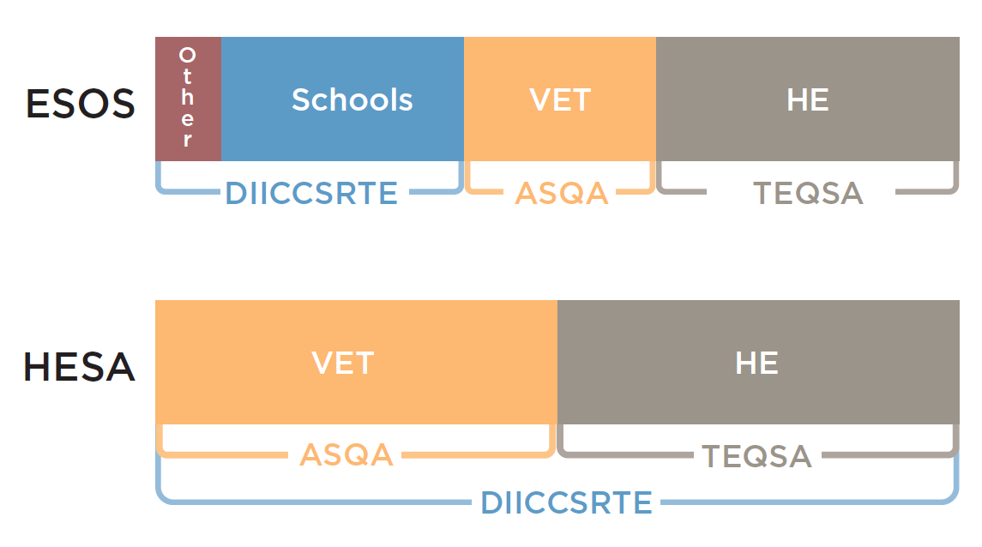

Intersections with the Education Services for Overseas Students Act
Approximately two-thirds of all higher education providers regulated by TEQSA also have to meet the requirements of the ESOS Act (see Figure 1). In effect, TEQSA is regulating the majority of higher education providers under two separate pieces of legislation. The parallel operation of the TEQSA and ESOS Acts creates complexity and regulatory burden for providers, as they are faced with two registration processes, two course approval processes and two sets of standards (the Threshold Standards and the National Code). Providers have identified duplication and administrative burden during the registration and re-registration process as similarities exist across the following standards:
- Fit and Proper Persons;
- Financial Viability;
- Grievances and Complaints;
- Student information on rights and obligations;
- Student support services; and
- Corporate governance.
This is further compounded by the different registration and accreditation periods provided under both Acts. Under the ESOS Act, registration and accreditation is for a period of between two to five years and can be extended for the same period. The TEQSA Act permits registration and accreditation for a period of up to seven years. Upon application, registration and accreditation can be renewed for the same period. In practice providers registered under both Acts are often subject to different registration cycles. This creates a situation where requests for information and data occur on an apparently constant basis.
As part of the review, in its response to the Department’s request for actions that could be taken to reduce the regulatory burden on higher education providers, the Chief Commissioner has also identified the duplication created by the TEQSA and ESOS Acts and the respective Standards and National Code. To address this, the Chief Commissioner suggests introducing a single set of higher education registration and course accreditation processes under the TEQSA Act. Without the benefit of detailed discussions on which parts of the ESOS/TEQSA Acts should be amended, any approach to fixing these issues must first be agreed to include consultation.

Intersections with the Australian Skills Quality Authority (ASQA)
Approximately 50 per cent of higher education providers regulated by TEQSA are also regulated by ASQA for their VET delivery (see Figure 1). It is this overlap which drives affected providers most to argue for a single regulator.
ASQA is responsible for registering providers delivering VET and accrediting VET courses. One of the core conditions of registration is compliance with the NVR Standards as required under the VET Quality Framework. Like the ESOS Act and National Code, duplication exists across a number of the NVR Standards and the Threshold Standards particularly in regards to:
- Governance structures;
- Material change notification requirements;
- Financial assessments;
- Grievance procedures
Under the NVETR Act, providers can be registered for a period of up to five years and apply for re-registration for the same period. Higher education providers delivering VET are therefore subject to another registration process and cycle, accreditation process and set of standards.
Recognising this burden for dual-sector providers, TEQSA and ASQA signed a memorandum of understanding (MoU) in December 2011 which included the goal of establishing a streamlined and coordinated ‘whole of provider’ approach to the regulation of multi-sector providers. To date this MoU appears to have had little practical impact for these providers.
The current VET Standards are also being reviewed. The governance arrangements in this case will be different from those in higher education as the outcomes of the review will be delivered to the NSSC for its consideration, then agreed by Ministers, state, territory and Commonwealth, and handed to ASQA to apply to providers as the regulator. ASQA in its application of those standards is accountable to the NSSC. As part of its review of the VET standards, the National Skills Standards Council (NSSC) commissioned a report on the potential for greater harmonisation of the relevant legislation to reduce the regulatory burden on the tertiary education sector. The report, by Dandolopartners, suggests there are specific areas where some of the ESOS requirements could be incorporated by the TEQSA and ASQA legislation (eg fit and proper person requirements) but did not recommend a wholesale incorporation of the ESOS Act into the TEQSA and NVETR Acts.

Intersections with the Higher Education Standards Panel
As noted in Part 1, the TEQSA Act creates the Higher Education Standards Panel (Panel) which in turn implements the Higher Education Standards Framework (Standards). When registering a provider or accrediting a course, TEQSA assesses and determines a provider’s compliance with the TEQSA Act and these Standards which have 102 components. The first four standards in the Framework are referred to collectively as the Threshold Standards. The Threshold Standards comprise the Provider Registration, Provider Category, Provider Course Accreditation and Qualification Standards.

The Qualification Standards are based on the Australian Qualifications Framework (AQF) and as such TEQSA is responsible for regulating a provider’s compliance with both the Threshold Standards and the AQF. The intersections between the TEQSA Act, the Standards and the AQF are creating uncertainty and confusion within the sector. From a provider’s perspective, it is required to interpret requirements created by two bodies independent of the regulator. The provider then has to present evidence to TEQSA to demonstrate its compliance with these requirements. The regulator then interprets and applies the Standards against the evidence presented.

While formally the TEQSA Act enables the Panel to provide advice to TEQSA on its Framework, there is no reciprocal requirement for TEQSA to provide advice to or engage with the Panel through any reporting or representative mechanisms.

Intersections with the Higher Education Support Act 2003
HESA is primarily a funding act which establishes a student’s entitlement to Commonwealth supported places and access to the various Higher Education Loan Program (HELP) schemes. However, the Act also serves to regulate its providers in terms of being eligible and accountable for Commonwealth funding and it also contains ‘quality and accountability’ requirements. Under HESA’s quality requirements, providers must operate, and continue to operate, at a level of quality that meets the Threshold Standards (within the meaning of the TEQSA Act).

In receiving funding related to student entitlements under HESA, higher education providers are required to deliver significant amounts of data – primarily related to students. This data is the accountability trail for delivering financial benefits to students. Higher education providers are also required to provide annual audited financial statements to the government. Under the TEQSA Act, providers are also required to submit annual audited financial statements. To address duplication, the Chief Commissioner has called for the implementation of a single government process for financial information collection and analysis that is tailored to the category of provider and thereby removes the current requirement on providers to supply this information to multiple agencies. This issue has been raised in more detail in the PhillipsKPA Report and will become more urgent as the ACNC rolls out its requirements. Other such aspects of HESA requirements have been replicated for TEQSA and ASQA, for example, fit and proper person assessments and notification of material changes, student grievance procedures. The Department’s response to the Chief Commissioners suggestion agrees that there is overlap, and suggests work should continue to proceed with TEQSA to reduce duplication.

3.8 Improving regulatory relations
As TEQSA settles into its role and there is greater understanding of what activities are being duplicated, TEQSA has also suggested that the Department should cease some of its processes to approve providers and instead rely directly on TEQSA’s registration, accreditation and compliance profile. Or, it may be possible for TEQSA to limit some of its processes on the basis of activities that the Department undertakes. A large part of the Department’s regulatory activities occur through relational partnering mechanisms, especially the Mission-based Compacts and funding agreement discussions (noting that these only take place currently with universities). For many institutions, these discussions are key opportunities to identify risks with a regulator, based on outcomes visible through data and forward looking strategic plans. It is equally the opportunity for the Department to hold the regulatee accountable and seek explanations for the past and assurances for the future.

There has been action taken to build coordination mechanisms with the vocational and higher education regulators. These actions have predominantly taken the form of the establishment of informal working groups to facilitate consistency in regulation, such as adhoc arrangements through meetings of the tertiary education standards setting agencies and the tertiary regulatory strategic meeting. However, these mechanisms have no statutory basis, are highly dependent on the goodwill of individuals and have no drivers for public processes to consult or inform.
TEQSA, as the last agency to be operational appears to bear the brunt of how the legislative intersections are being played out. However, the discontent emanating from the sector may also reflect the fact that TEQSA commenced in a relatively privileged place, compared to ASQA with its remit to supervise some 4000+ providers. Certainly the two agencies’ workloads differ enormously and ASQA cannot draw on the Department for information and data to the same extent as TEQSA. TEQSA regulates a sector that for the most part was already compliant, self-regulating, and monitored. It may well be that TEQSA’s blank slate approach as part of its ‘independent’ position has set-up an environment of regulatory over-reach. With no relationships structured into legislation, TEQSA has not put in place the avenues for advice and consultation between partnering regulatory bodies.
A relational approach to regulation is required to build relationships across the regulatory community. Throughout this review we have seen evidence of agencies working together in an attempt to reduce regulatory burden. More often these attempts have involved two actors in the regulatory community. We are yet to see a broad range of representatives from across the regulatory community working together in a coordinated, transparent way to enhance simplicity and minimise duplication.

4. Next Generation Regulation in Higher Education: a discussion

In this Part of the report, we describe how the sector has experienced the actions of TEQSA and what concerns providers have for the regulatory architecture as a result. As we saw in Part 3, TEQSA started with a diverse workload; getting courses accredited and registering providers while simultaneously approaching other more strategic functions like assessing risks and assuring quality. Recognising that some of these need to improve, TEQSA has outlined how it intends to evolve its processes. The discussion which follows may support and/or challenge what TEQSA has identified.

4.1 Some fundamentals
A key part of the original grounds for advocating a national regulator seems to us to have less strength and less urgency than appeared to the Bradley Review in 2008. That review anticipated a major increase in the proportion of young Australians enrolling in degree level education programs, and it anticipated an increase in the institutions that would provide those programs, particularly in the private sector. There has been a major increase in the number of students entering the higher education sector, though it is less certain that the rate of increase of recent years is likely to continue in say, the next five years. There has not however been an influx of new providers, and 94 per cent of higher education load remains within now well established universities. Nonetheless, a need for regulation in the sector remains.
Some submissions have called for abolishing TEQSA by merging it into one national tertiary regulator or morphing it into the Department. However, most stakeholders are of the opinion that we need a national regulator, which at a minimum carries out the functional tasks of maintaining a national register, registering providers and accrediting courses for those non self-accrediting providers.
It is a more open question as to whether TEQSA should continue to function both as a regulator and a quality assurance body, or whether, as statements emanating from TEQSA sometimes suggest, it should be primarily only a regulator, leaving quality assurance and quality improvement to develop elsewhere. And certainly its achievements to date with the third party arrangements survey which has attracted much criticism, or the anticipated English language assessment, would suggest that TEQSA should focus on its regulatory role. On this question both Universities Australia (UA) and the Group of Eight (Go8) argue that quality assurance should rest primarily within the institutions themselves. What is persuasive in that argument is the recognition that it is within institutions, and indeed within their component faculties, schools and departments that the commitment to enhance quality must take root and be sustained. It might be desirable for the government and its regulator to encourage and perhaps monitor that, but ultimate success will depend on individual staff and the culture of their disciplines, fields and professions and their institutions more than on a national regulator.
TEQSA should continue, subject to changes in its legislative base, particularly as it has been in existence for a short time only. While we also suggest major shifts in its orientation and significant curtailment in the way TEQSA operates in future by comparison with its first 18 months, it seems far too early to be contemplating restructures such as creating a single tertiary regulator with ASQA, or rolling its activities into the Department, or into a projected and not yet widely considered or supported universities' commission body. We did however give serious thought to these possibilities, given the depth and spread of unease with TEQSA’s activities that we judge to be felt across the sector.
The submissions and our discussions overwhelmingly identified an unnecessarily bureaucratic approach to TEQSA’s work – best exemplified by the earlier list of guides and forms in Table 3. Related to this approach was an underlying assumption that all institutions were equal in the sense that none were to be trusted. Even if the justification for this is procedural fairness, the message it sends to providers is demoralising, if not provocative. When we consider TEQSA’s primary work completed to date through the topics in Part 3, regulatory functions, assessing risk and assuring quality, we can see how far the regulatory experience has diverged from the ideal premised on the legislated regulatory principles.
Before addressing these issues in relation to TEQSA in more detail, a cautionary note relevant to the whole tertiary sector at all levels is warranted. The problems that have confronted TEQSA are not occurring in a cultural vacuum. They are part of a wider climate of unease in the higher education workforce that sees collegial, bottom-up quality assurance displaced by top-down managerialism and metrics of dubious validity. When the Chief Commissioner articulated that TEQSA’s approach was to challenge the orthodoxies of over 10 years of approaching quality assurance in a particular way, the current approach would appear to be the ultimate pinnacle of top down command and control data metrics management and as we will hear, not quite the wake-up call for all providers to reflect and act on the quality of the education experience and outcomes for students.

4.2 Regulatory approach
The second reading speech accompanying the Tertiary Education Quality and Standards Agency Bill 2011 states that:
TEQSA’s regulatory approach will be based on proportionality and risk. To support this approach, the Government has established a set of basic principles for regulation to which TEQSA must adhere in all of its functions. These principles are:
- the principle of regulatory necessity, which provides that TEQSA should not burden a provider any more than is necessary;
- the principle of reflecting risk, which provides that TEQSA should have regard to a provider’s history, including its history of compliance with state and federal laws relating to higher education; and
- the principle of proportionate regulation, which provides that TEQSA must exercise its powers in such a way that is proportionate to a provider’s non-compliance with the Bill and any risk of future non-compliance.

TEQSA will be required to tailor its regulatory actions in order to comply with these principles.
TEQSA will focus its activities on encouraging and supporting both new entrants to the system and higher risk providers, while ensuring that existing, higher quality, lower risk providers will not be unnecessarily burdened.
The terms of reference for this review asked us to consider if the notion of earned autonomy is warranted in Australia’s higher education sector. It is clear from a number of submissions and consultations, the majority believe that the notion of earned autonomy is implicit in TEQSA’s three regulatory principles. In fact as noted by Queensland University of Technology and La Trobe University, it is difficult to separate the difference between the principle of earned autonomy and TEQSA’s regulatory principles. We similarly believe that earned autonomy is legitimated through TEQSA’s regulatory principles. Therefore we believe it is not necessary to warrant a model of earned autonomy as we believe it is enshrined in the TEQSA Act.
The joint University of Melbourne and the Australian Catholic University submission, suggested earned autonomy automatically be granted to all universities. Therefore, universities would be responsible for auditing their own performance against the Threshold Standards and registering courses for ESOS. And TEQSA’s regulatory focus would be on ensuring new providers meet the national standards, with ongoing monitoring until new providers had well established self-accreditation processes to ensure quality. In our view, TEQSA’s regulatory framework should apply to all providers that carry out the same types of activities, irrespective of how the providers are categorised. However, this should not preclude the regulator taking a different regulatory approach to different types of providers. In this way, the notion of earned autonomy is available to all providers through the application of the principles but needs to be exercised by TEQSA in implementing its mission.
The Universities Australia submission suggested that a fourth basic principle be added to the TEQSA Act which would require the agency to consider economic efficiency when exercising its functions. At this stage we do not believe it would be useful to add an additional principle to the legislation. Rather than add another principle to the TEQSA Act, it may be more useful to examine TEQSA’s application of its regulatory principles and the impact this approach is having on the higher education sector. These issues are considered in detail below. We believe that if TEQSA’s regulatory principles are applied in accordance with their legislative intent, then economic efficiencies will result.

4.3 A ‘one size fits all approach’
Indeed, we recognise that many of these issues may be due to the fact that TEQSA is developing sophisticated regulatory capacity. However, the fact remains that TEQSA processes too often reflect a specified data capture and one-size-fits-all audit mentality rather than the regulatory principles of risk, proportion and necessity (RMIT).
Across the sector many have acknowledged that TEQSA is a young, developing regulator. However the majority of submissions and consultations expressed concern with TEQSA’s interpretation and application of its legislation. The dominant perception in the sector is that the TEQSA Act is not being interpreted in line with its basic principles of necessity, risk and proportionate regulation. In fact, many submissions have contended that the approach being adopted does not represent a reasonable interpretation of these legislative principles. Rather a ‘one size fits all’ approach is being applied across the higher education sector, irrespective of an institution’s characteristics, history or risk.
It is also clear to us that TEQSA is not applying its legislation in line with the Government’s original intent. The approach in train values data and documentation over dialogue. To address this, we believe TEQSA should seek less documentation and conduct more conversations and not necessarily just with its regulated providers. In the higher education sector, the mission-based compact process allows for open and frank discussion about a provider’s mission, strengths and challenges. We believe that such an approach should be incorporated into TEQSA’s regulatory approach and the reform of higher education regulation more broadly. In its submission, TAFE Directors Australia suggests TEQSA should require evidence-based responses from institutions in response to a core set of questions such as:
- How do you know that your students have consistently achieved the required level of professional competence?
- How do you know that your students have been engaged in a meaningful and quality learning experience?
- How do you know that industry/employers or licensing/registering bodies are satisfied with the skills of your graduating students?
- How do you know that your educational and operational systems reflect international practice?
- How do you know that your facilities, support services and learning and information resources accord with student expectations and curriculum requirements?
- How do you know that the rights and interests of your students are being respected and safeguarded?
- How do you know that your teaching staff have the educational skills and experience to contribute to the development of individual student capability?
We agree that there would be enormous value in TEQSA engaging the sector in dialogue over a core set of questions such as these. Information obtained from these strategic discussions could then be fed into, or form the basis of, TEQSA’s core regulatory activities including re-registration and could serve to link TEQSA’s activities in a constructive way to other regulatory bodies (including the Department and ASQA).

4.4 Assessing risk
A common concern identified as part of this review is the perception that TEQSA has taken a ‘blank slate’ approach to ensure it has access to complete and up-to-date information on key areas and has as a result, collected significant amounts of information to assess risk. Throughout consultations the validity and effectiveness of TEQSA’s regulatory risk framework was questioned by many providers. Specifically, concerns were raised by the number of risk indicators in the framework, the ability of the framework to identify ‘real risks’ and the implications for institutions once risks were identified by TEQSA’s framework.
The formula and analysis in relation to library expenditure per student takes no account of the large proportion of students offshore who access library and information resources from Melbourne but also via partner institutions. Subsequently, this was one of two sub-themes rated `high risk’, despite it not being afforded high weight in the institution’s own risk management framework. Misalignment of risk by the regulator creates more work, as it then drives institutional activity. (RMIT)
Both in interviews and in submissions, concerns were raised in the way 'red flags' were apparently arbitrarily used for some risk factors in preliminary profiles (see Appendix F for TEQSA’s regulatory risk framework). TEQSA shares its preliminary risk assessment with institutions for comment before delivering its final risk profile for the institution. TEQSA seriously evaluates comments received from institutions and on occasion reduces the level flagged. Yet, the final outcome appears to those who have drawn this to our attention, and also to us, to be fairly described as 'one size fits all'.
The ideal low-risk provider against which others are compared is an institution of large size with a wide range of programs, mainly Australian students taught on Australian campuses using traditional methods in facilities that require substantial ongoing capital expenditure. This has been put to us by many diverse institutions with different histories. In their view, TEQSA’s risk assessment is not sufficiently cognisant of institutions very different sizes, varied governance arrangements, fields of focus and geographical spread.
This generalisation could be illustrated by numerous examples ranging from small theological colleges through regional universities attempting to increase their reach and student numbers through various forms of distance education and online programs, to large comprehensive universities with off shore campuses and/or twinning arrangements with overseas providers described as 'third party providers'. To take the example of the International College of Management Sydney, a number of potential risk factors were identified in its preliminary TEQSA assessment including its high proportion of international students and its growth in student numbers. The College sees both as areas of pride and strength, certainly not risk factors given the nature and scale of its operation. The effect of such assessments could be quite detrimental:
These risk assessments are not trivial matters and an incorrect and misleading risk assessment through improper comparisons can have very serious commercial consequences for a small college. Publication of such data can directly affect student recruitment:
- by creating the impression that the institution is not stable;
- by allowing conclusions about quality to be drawn erroneously from such data even though quality was not measured and so influence both individual student choice and the opinion of foreign governments on the quality of our degrees.(International College of Management)
Advice from TEQSA indicates its risk framework is in the process of being reviewed and the Chief Commissioner states TEQSA ‘will reduce the number of risk indicators to focus on a core set of indicators.. A reduction in the number of risk indicators will be welcomed by the sector and we believe that the number of risk factors should be reduced significantly. Moreover we believe that a reconsideration of how TEQSA determines and identifies risk is also required.
The United Kingdom’s Quality Assurance Agency (QAA) and its supervisory regulator – the Higher Education Funding Council for England (HEFCE) have adopted a risk-based approach to regulation. However, the QAA/HEFCE’s approach to identifying risk is pragmatically far less scoped and detailed than TEQSA; with institutional track record providing the test for risk – rather than probabilities or formalized risk indicators. King notes that the key idea of risk-based regulation is not to control all risks, only the most important.
Today the majority of higher education providers have well developed internal mechanisms for identifying and managing risk. We believe it would be more effective for TEQSA to discuss with a provider its risk assessment framework. During this discussion TEQSA could identify concerns that it may have with the provider’s risk framework or seek clarification regarding the indicators used by the provider. Such an approach would reduce the amount of documents being sought from providers and prevent TEQSA’s framework from misaligning risk. Importantly, it would move TEQSA away from regulating the sector as an object to regulating the sector as a partner.
Another key component of assessing risks is the involvement of other regulatory agencies, in effect to work with the regulatory network rather than to assume control over everything within the one regulatory relationship. While not advocating for a single risk framework, it would be valuable to build a shared understanding of interpretations of risk factors. Currently, it is all too easy to imagine that TEQSA, ASQA, the Department and state and territory governments could all be assessing the same entity and come to different risk ratings.

4.5 Constructive messages
There is a tension between TEQSA’s stated regulatory approach and the regulatory experiences of providers. This can be attributed to inconsistent messaging around the interpretation of regulatory requirements. Numerous submissions identified problems with the requirement to notify TEQSA regarding a material change and the legislative timeframe associated with notification. TEQSA considers it has provided guides and forms for material change notifications that clarify what is required in order to minimise the effort involved for providers in preparing notifications. It is unclear how TEQSA reached this conclusion as numerous providers experienced difficulty and frustration interpreting the term material change. Many indicated they were unsure when what they should, or should not, notify TEQSA. This confusion was compounded when providers sought advice from TEQSA and were, as was relayed in many consultations, advised to come to their own conclusions on the matter using the TEQSA guide.
Providers also expressed concern as to the broad definitional scope taken in relation to material change in some areas. Currently, a material change has been interpreted by TEQSA as applying to the revision of key personnel who make decisions about the governance, management or direction of the academic and corporate operations of a higher education provider or exercise a notable degree of control or influence over the decision making about the governance, management or direction of the academic and corporate operations of a higher education provider. Therefore each time a staff member in one of the roles that falls within TEQSA’s definition changes, a provider must complete a new fit and proper person declaration and submit it to TEQSA. Numerous providers have expressed frustration at this requirement arguing that most institutions have robust recruitment and selection processes in place and that staff changes in these areas are unlikely to affect a provider’s ability to meet the Threshold Standards. Moreover most providers are unsure what TEQSA does with this information upon its receipt. Given the broad definition of a material change, the sector has also expressed concern with the requirement to report a material change within 14 days. In submissions, Deakin University and Holmesglen TAFE have suggested requiring notifications of material changes once a year in a provider’s annual report.
We understand that TEQSA is reluctant to give prescriptive advice to providers about what constitutes a material change. However clearly the current level of guidance is not meeting providers’ needs and is causing confusion and uncertainty. The Chief Commissioner has advised TEQSA will communicate a narrowing of the circumstances in which it expects material change. Again it is unclear how TEQSA has arrived at these narrower circumstances or if they are derived from consultation with, or feedback from the sector.

4.6 Assuring quality
‘TEQSA is a challenge to the status quo of higher education quality assurance in Australia [….] The establishment of a standards and risk based regulator in Australia with the dual responsibilities of regulation and quality assurance has been, and continued to be, a disruptive event in the higher education landscape.’
During consultations and via submissions the sector has expressed concern about TEQSA’s dual quality assurance and regulatory roles. In fact, we note that TEQSA itself changes the emphasis in the description of its role, referring to itself at times as a regulator and at other times as both a regulator and quality assurer. In its June 2013 Service Charter TEQSA describes itself as ‘Australia’s independent national regulator of the higher education sector’. However, on 3 June 2013, when recently asked at Senate Estimates if TEQSA was a quality assurance regime or regulatory regime, the Chief Commissioner responded ‘we are a regulator that has responsibility for regulation but also for quality assurance’.
In separating the two roles, the notion of quality assurance is being isolated from regulation rather than incorporated. The application of a standards framework provides quality assurance of a minimum setting; it is the idea of continuous improvement and the feedback loop that is then removed from quality assurance. Changing the emphasis has been interpreted by the sector as TEQSA ‘shifting its goalposts’ to suit the task at hand or as ‘muddying the waters’ in relation to its role. Although the sector’s experience of TEQSA is limited, we believe it is fair to conclude that it is viewed by the sector more as a regulator than a quality assurer. During consultations many providers questioned why an institution would seek quality assurance from TEQSA when most have robust internal processes to assure quality as required by the existing Standards. Others questioned what value TEQSA could add to an institution’s quality. As noted in Part 3, TEQSA released as its first quality assessment a survey on third party arrangements. The sector has been extremely critical of the approach adopted by TEQSA in this survey, with many contending the survey appears to be inconsistent with TEQSA’s legislative obligations of regulatory necessity, reflecting risk and proportionate regulation.
The recent TEQSA Quality Assessment on Third Party Arrangements survey is another example where it is difficult to understand how TEQSA will have the resources to reasonably analyse and use the information collected through the survey. It is also unclear why TEQSA chose to survey all providers. A stratified sampling approach based on risk, the academic profile of the institution and so on would have been more consistent with TEQSA’s over aching basic principles of regulation.
Added to this, the survey tool itself was ill-designed and repetitive leading to information redundancy. Some of the quantitative data sought was not defined in ways that is normally captured by institutions and some of the questions were ambiguous in their intent. With the efficacy of some of the data collected in question, there is doubt whether the survey will have any real impact on understanding the quality assurance risks to the sector posed by third party arrangements. (University of South Australia)
Other providers expressed concern at the lack of consultation in regards to the survey and emphasised a desire and need to draw on the sector’s expertise:
A more useful approach may have been to bring together sectoral experts to discuss the key drivers and risk elements in third party arrangements, and use that process to develop a shorter and better-targeted survey. Themed reviews such as this fall within TEQSA’s objects and may be ultimately helpful in helping TEQSA to identify systemic risks and issues. However, they should be appropriately implemented and resourced, and perhaps should not be initiated until TEQSA has developed capability and reached a more mature stage in its organisational development (RMIT).
We believe that perhaps now more than ever, institutions are often best placed and should be largely responsible for assuring the quality of their educational provision. Although TEQSA has only undertaken one quality assessment since its establishment, we are doubtful that the methodology employed in the survey will yield results that improve or enhance the quality of third party arrangements in the sector. Moreover, as TEQSA has indicated it will conduct one quality assessment a year; we question what can be achieved by the Agency in terms of the wide-ranging challenges of quality assurance. If there is a case to be made for the most effective form of quality assurance that leads to continuous improvement occurring at the site of delivery; it may be more effective to allow providers to manage their own quality assurance and for the government to reduce the functions and objects of TEQSA’s Act to require it to focus on its core regulatory activities of registering and accrediting providers.

4.7 Cost of regulation
Several submissions indicated that the additional costs imposed by the current approach to regulation may have had the effect of reducing the quality of teaching and learning in direct contradiction to the aims of the legislation. Many providers detailed the length of time, cost and effort involved in meeting regulatory requirements to TEQSA’s satisfaction (see Appendix D). While some acknowledged the benefit involved in completing regulatory tasks, the majority indicated that the additional costs imposed by the current approach to regulation were significantly impacting on their organisations, staff and students. Tabor Adelaide noted:
There is also no doubt that the work involved in preparing for reregistration/reaccreditation has refined management and quality systems such that there will be some ongoing benefit for both the institution and its students.
We have, however, found TEQSA processes extremely costly and burdensome…….The consequence has been significant staff fatigue and stress and reduction of availability of staff for students, teaching and learning and scholarship.
Multiple submissions commented on the amount of evidence required and the time taken to meet regulatory requirements and how using resources in this way impacted on their core business. The Australian Film, Television and Radio School (AFTRS) indicated it found the:
re-registration process onerous on its human and financial resources. AFTRS seconded three staff to focus on preparation of the School's application. Each of these positions was required to be back-filled by other staff in the organisation. The research, analysis, compilation and preparation of documents, as well as the writing of the application document itself, took six months. The process cost the School approximately $200,000.
AFTRS is not convinced that the generation of paperwork and a risk assessment not based in the core business arrangements and activities of an organisation, ensures quality and value for money.
A number of smaller private providers have convincingly demonstrated particular problems in dealing with regulatory requirements, simply due to their lack of resources. We spoke in detail to three member institutions of the Council of Private Higher Education (COPHE) as well as receiving submissions from a larger number of small providers in most states. Most have had long histories of involvements with state regulatory bodies and more recent involvements with AUQA audits. These providers indicated that TEQSA’s approach is quite different to their earlier experiences: information requests are not only more voluminous but often quite unclear, the assessment and decision making processes are not as clear as earlier methodologies involving peer review visits and discussions, the present timelines are described as 'unacceptable', delaying the introduction of new or modified courses, and costs are a major concern, including a perception that the regulator is 'double dipping' in the way costs increase for nested awards (where an associate degree forms part of a separate bachelor award, and a graduate diploma forms part of a masters course).
While these small providers acknowledge the benefits of a single national agency in preference to the variations in approaches they have experienced with multiple state providers, their summary assessments are:
Paradoxically, the agency set up to ensure quality is perceived by many COPHE members to be a major source of risk…

The experiences of our members drive them to conclude that TEQSA has little understanding beyond a public university model…

None of these issues are show stoppers but they destroy the credibility of TEQSA as a regulator. (roundtable discussion with COPHE providers)

In addition to the costs involved, providers expressed strong frustration at the amount of time taken to process applications. An applicant seeking initial registration described this experience as:
Our application for higher education registration designed professionally by respected Australian consultants in the area of higher education took over 18 months for TEQSA to process and required intervention from Senator Evans after six months to get TEQSA to even correspond with us. After eight months we were suddenly required to fill in totally new documentation and forms and undertake an extremely expensive and onerous KPMG financial audit. Once all this additional effort had been undertaken they then failed our application citing the need for even more policies and procedures. (Engineering Institute of Technology)
Similarly another applicant, described after unsuccessfully completing the accreditation process, that 'it would be extremely difficult for any new provider to become registered and accredited in Australia without a completely unreasonable level of backing to cover early development and establishment costs'. The provider asks rhetorically, when considering the areas deemed non-compliant: how is a start-up provider to demonstrate quality in operations before such operations have commenced, provide evidence of approval by an Academic Board before a complement of staff can establish such a body, provide samples of student course evaluations before there is a course and students, provide full documentation and processes to provide student feedback to students on assessment,...and so on. The provider concludes 'particularly galling are complaints about inadequate information or non-compliance that could have been addressed with a question at either of the two site visits. This includes information about hardware, software and student and staff facilities'.
For providers that have a long history of interaction with regulation, including AUQA auditing, TEQSA’s approach is generally poorly managed. For example, a college was repeatedly asked over 15 months to submit information without receiving response or feedback. Its experience ‘was unlike any other audit process where specific non-compliance was identified and addressed’ (VIT).
It is telling that the word audit appeared frequently with criticism in submissions. Audit as experienced by providers was generally not accompanied by advice or discussion of best practice, nor was it experienced generally as the regulator having sympathy for the different circumstances of a range of providers. Audit was experienced as command-and-control encounter in which most providers believed that they had to garner every shred of evidence to prove they were worthy of operating in the sector. To be fair to TEQSA, the environment in which it is operating is similarly demanding of a lot of information that is not always fit for purpose. Academics are critical of providers in the same terms. At all levels of sector administration there needs to be greater sensitivity to the high costs of red tape.
A main conclusion for this review is that concerns of over-regulation, unnecessary demands for information and an unwillingness to meet face-to-face and discuss rather than send long pieces of correspondence, do not come only from large established universities. It seems to us that it is the smaller less well-resourced providers that are hardest hit by TEQSA’s current regulatory approaches.

4.8 Relationships and governance
There is clearly support in the sector for a national regulator of higher education. However, a regulator that is highly respected by the sector is essential. The Chief Commissioner contends that TEQSA can ‘demonstrate a strong record of consulting with the sector’ and that it ‘consult(s) providers in the development of regulatory policies that affect them.’ A strong message coming from the sector is that TEQSA has not adequately consulted or built effective relationships with the sector. In effect we believe TEQSA has been regulating the sector as an object, not as a partner. As a result, there is a lack of trust in the Agency and its ability to carry out its functions.
There was a strong consensus from consultations and submissions that TEQSA needs to consult more and build stronger relationships across the regulatory community to ensure its regulatory activities are necessary and are not merely duplicating what is already occurring in the sector. It is worth noting that where TEQSA has built effective, trusting relationships through its case managers, providers were extremely pleased with the regulatory approach taken as evidenced by the University of Ballarat and others:
The University has also worked closely with TEQSA on the Notification of Material Change associated with the prospective transfer of the Monash University Gippsland Campus (Churchill). One aspect of this involves the transfer of some 70 Churchill Higher Education programs to the University. Rather than compel the University to develop individual cases for 70 separate CRICOS codes and approvals, TEQSA has facilitated a process by which all 70 programs will be treated in a single re-application procedure. This will expedite the transfer process considerably while reducing the University’s time and cost commitments that are needed elsewhere to facilitate transition arrangements.
Similarly, ANU notes:
When the recent third party providers survey was released, we identified significant overlap with our Application for Renewal of Registration. On raising this with our case manager, agreement was reached that an alternative submission would be possible.
Positive relations are emerging with the case managers and this is to be encouraged. For some providers, the distancing of TEQSA applied through the paper audit approach has meant a loss of local engagement.this shift in relationship building may indicate an increasing maturity or confidence from the Commissioners for the case managers to give advice and engage, but there still remains the question of how the Agency itself should engage. As explained in Part 3, TEQSA and its Commissioners enjoy a high level of independence and in some ways isolation from the other parts of the regulatory community. While the CEO answers to the Minister as a portfolio agency, it would require a serious threat to the integrity of the sector for the Minister to intervene by direction.
The fundamental question, as raised by the University of South Australia, is ‘what body monitors the activities of TEQSA? While it was not questioning TEQSA’s powers and independence to make decisions, it raises the issue of how the practices and effectiveness of TEQSA as a regulatory agency could be managed. Other submissions identified the absence of governance arrangements in TEQSA’s structure. To address this, Universities Australia suggests legislative amendments to the TEQSA Act that would require senior TEQSA officers responsible for external requests to:
consult with a higher education representative body (HERB) before undertaking new work or imposing new regulatory demands on the sector. The HERB should be able to provide rigorous advice on the impacts of planned activities and where possible encourage a consensus-based approach between TEQSA and the HERB on new regulatory requirements.
Others have questioned and compared the composition of TEQSA’s commission with other regulators.
The Agency is made up of a Chief Commissioner, two full-time commissioners and two part-time commissioners. While similar agencies and commissions have tended to combine academic, management and industry expertise, TEQSA has no commissioners with academic experience, and the Agency sees itself primarily as a regulator that will rely on the judgment of its commissioners when regulating institutions.
By contrast, the Australian Health Practitioner Regulation Agency, which was established shortly before TEQSA and with similar regulatory powers, has a structure consisting of several accreditation boards made up largely of professionals who can make peer review judgements about a program's capacity to meet quality and outcome standards.
There is strong support for some kind of an overarching governance arrangement to force a level of consultation that is not currently enacted. Whether this should be articulated through joining regulatory activities through a single piece of legislation or the amendment of existing Acts to create links to an advisory body or consultative council or some kind, it does not seem that the informal types of arrangements are working and whatever options are considered, they should be ‘legislated’ rather than just left up to agency officers to enact.
There are many possible models we could consider at this point. During our consultation, two in particular were referenced, the Australian Prudential Regulatory Agency Finance Council and the Australian Health Practitioner Regulation Agency. As we can see from the APRA model in Figure 6, it is not necessary to legislate a body to create consultative and advice seeking processes. A good example of individual entities coming together to share and draw on each other’s expertise is the Council of Financial Regulators. The existence of this Council represents a non-statutory arrangement to pull together four distinct agencies, each with their own governance requirements – APRA is an independent statutory body, the Treasury reports to its Minister, the Reserve Bank of Australia has two boards (the Reserve Bank Board and the Payments System Board), and ASIC is an independent body with a range of external boards and an External Advisory Committee.
Figure 6: Models of oversight
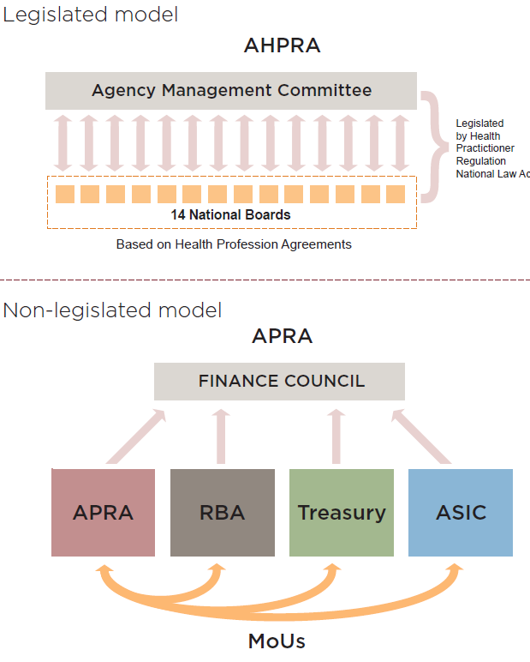
To support APRA in its role as the independent regulator, it has an MoU with each of the other entities, adapted to suit their respective needs (see Appendix G). Common characteristics of the MoUs include clear identification of roles and responsibilities, processes for communication and sharing information, and agreeing priorities for working together. While we understand attempts have been made to have MoUs with TEQSA and the Department, and that one was implemented between TEQSA and ASQA, there has been a lack of impetus and perhaps a lack of accountability to actually use the MoUs in any functional way. Similarly, we understand that meetings between regulators and the Department have not gained traction as a useful consultative forum.
Before moving to legislate a governing council or board, either in TEQSA’s Act or to create a new Act of some kind, it would be valuable to first strengthen existing mechanisms. It would seem fundamental to improving the status and roles of the informal bodies to acknowledge them and make them accountable to the sector. Transparency is key to this type of accountability. If no one knows about these entities and their meetings, there is little chance that they will ask what happened and what were the outcomes of discussions. Being held accountable by one’s external stakeholders is a powerful tool for engagement and consultation.
In summary, there are legislative impediments to an ideal and effective regulatory framework. However, the overwhelming constraints in the system that affect TEQSA are the lack of constructive partnering relationships. It is these relationships that would have enabled the sharing of expertise and advice and a more appropriate application of the principles of risk, proportionality and necessity. We imagine that if these principles had been thought through with others, many of the less than satisfactory and frustrating management practices would not have taken place.
Changing structural requirements like delegations and assigning TEQSA powers by moving ESOS requirements into its Act will address components of regulatory activity. Nonetheless, we believe it is more important to change the way in which people interact with and respond to the constraints that may always exist in the regulatory framework.

4.9 Other regulatory reporting
Our terms of reference included a call for other suggestions that the Department should consider to reduce regulatory burden. While we did not focus in particular on this in discussions, various ideas were raised in submissions. They ranged from merging research data collection into HEIMS, changing the duration of research grants to streamlining various HELP loan schemes and removing requirements for Commonwealth Assistance Notices.
As we identified in the report’s Introduction, regulation and reporting are inextricably interlinked. We are aware that the Department is working on a range of activities to reduce regulation and to identify even more actions it can take to streamline reporting without compromising its accountability and that of the Minister to Parliament.
It became even clearer to us however, that if these activities, like those of TEQSA, are not considered as a ‘whole’, in their entirety, there can be unforeseen consequences. This has been reinforced by the Review of the Reporting Requirements for Universities and the Government’s intention to establish a national higher education data collection. Having a single body take responsibility for such a collection has become even more relevant to us following our consultations. In fact, the very wide-ranging examples in the submissions add weight to an increasingly desperate appeal for action. The constant accumulation of regulating and reporting has seemingly reached a tipping point and the sector is in need of a clear signal that the Government is taking steps to reduce regulatory and reporting duplication. A national body to negotiate and manage the data and information requirements for the sector, and ideally more broadly beyond higher education, would be one of the most fundamentally important measures to reduce regulatory burden at every level. The establishment of NAGHEDI is a good first step in this direction. But there must be others. It seems to us that sufficient weight and repetition of messages about aligning legislative requirements, reducing duplication and working towards a minimum data set should be considered in response to every review and report to come. This especially needs to apply when considering the reviews of VET and higher education standards later this year.
We also acknowledge that the higher education sector is not alone in its regulatory concerns. More broadly, regulatory burden is also being addressed through other agencies such as the Productivity Commission, the Department of Finance and Deregulation and the Australian Government Information Management Office. In this context, it becomes even more important to have such a national body to engage with the breadth of activities.
We argue this not solely on a basis of value for money but for the future of the sector. What is also clear to us is that people are increasingly frustrated, albeit in difficult times, and the regulatory pendulum is at risk of swinging too far and doing damage. By wasting valuable time and effort of many talented people, the future of academia as a career for bright people is at risk. Without the passion and engagement of great teachers, scholars and researchers, the true quality of higher education will diminish.
We do not want to see an Australian regulatory framework that supports a bureaucratic wasteland of collectively safe mediocre education. We would much rather have regulators as assured supporters of productive and innovative higher education. There was great goodwill in the sector at the establishment of TEQSA and with this hope, we make the following recommendations.

5. Recommendations

We began this review in late May 2013. Along the way through our conversations and the many thoughtful submissions, we gave serious consideration to whether Australia continues to need TEQSA. Looking back, we are of the view that TEQSA’s establishment came at a time in which a different future was imagined. This future was based on assumptions that there would be many more new providers entering the higher education sector and that the market would be responding to quite different forces such as student choices and the international market. Notwithstanding the many changes taking place in higher education including new forms of delivery and structural responses such as those planned for Central Queensland University or the University of Canberra, we nevertheless see less regulatory risks emerging in higher education that would be managed centrally, particularly among established providers.

Throughout the review we have also been reminded of the ambitions that the Government and stakeholders had for TEQSA and have come to the following key conclusions: there is support for a national regulator. No one suggested returning to eight systems of provider registration for the non-self-accrediting sector. The consensus which we fully support is the unambiguous need for a national regulator.

The regulatory world that we imagine for the future is one in which providers are primarily self-regulating. The regulator in this world has clear goals to manage the entry of new providers to the market and checks in on any difficulties emerging for the sector as identified by the regulatory community. This would be a regulator that ensures new entrants to the sector understand and meet the requirements to be an Australian higher education provider based on clear standards. It is not a regulator that stifles innovation or limits niche providers in preference for larger institutions and universities. It is a regulator that is responsive to its sector.

We have concluded that TEQSA plays an important national and international role in asserting and maintaining the quality of Australia’s higher education system which needs to be retained. We note TEQSA itself in reflecting on its regulatory practice in recent times has signalled some changes in direction and we welcome these. Nevertheless, the question for us has evolved to how to shape TEQSA’s mandate in a way which ensures its resilience and relevance in higher education into the future.

Before we describe some of our suggestions for this, we would like to consider the ways in which principles of good regulation outlined in Part 2 should similarly apply to enacting any changes. In effect, our first recommendation is about how we would like the regulatory community, especially the Government, to implement changes to the regulatory framework:
- Plan to build awareness and understanding in what is happening as an outcome of this Review;
- Use existing entities or mechanisms to deliver and reduce duplication/overlap;
- Consult, and if in doubt, consult again, and in doing so, ensure the fullest range of providers and stakeholders are represented in consultations; and
- Transparency of actions means publishing timelines, papers and agenda, participants and roles, and reporting on progress.
We seek first and foremost to recommend that the regulatory community must be involved in identifying and agreeing which improvements will deliver the desired outcomes: constraining regulatory over-reach and reducing unnecessary duplication. The most important benefit is to build relationships between regulators and with providers. This will also support how regulatory requirements are interpreted and inform the application of the TEQSA Act’s principles of risk, necessity and proportionality.
Terms of Reference 1: Consider TEQSA’s approach to regulation including its legislative base and governance structures
This is where most of the sector’s concerns are being articulated and quite simply put where the nub of the problem lies. On this basis, we believe TEQSA’s role needs to be shaped differently, structurally and relationally. TEQSA has been established as a relatively large organisation almost as though it were the sole player in the higher education regulatory landscape and its governance arrangements reinforces this idea. In undertaking this work, we observed the department, the Standards Panel and to some extent, the AQFC are also partners in regulation. We believe there is a need to streamline these arrangements. Suggestions from submissions on how to address this ranged from different governance arrangements to absorbing TEQSA into the department, to creating a new structure that oversees TEQSA and its regulatory functions. However, we believe more simply, TEQSA should be smaller and be charged with fewer functions.
In line with a number of submissions, we believe that the aspects of quality assurance - best practice and continuous improvement - currently undertaken by TEQSA are better delivered through other means – especially those preferred by providers themselves such as the work of the Office for Learning and Teaching. If it agrees to refine TEQSA’s functions, the Government may wish to give thought to how it supports those best practice forums – sector and discipline-based.

We strongly believe the regulation of higher education providers needs to shift from regulating as an object to regulating as partners. TEQSA’s preference for paper audit rather than regulating as a partner through conversation objectifies providers in a command and control mode. We know it is possible to bring a better balance to the regulatory approach. The role of regulating as partners balanced with data has been in practice for several decades for the universities with government. Without these conversations, TEQSA is seen by the sector to be acting in isolation. We believe TEQSA needs to build on its working relationship with the sector, as it has recently flagged, and reposition its understanding of ‘independence’. Independence is valuable as a regulator to be free from interference in decision-making, but it should not be translated as a constraint to engage with others that have an understanding of the sector’s risks. Where relationships have worked well with the case managers, their potential roles in decision-making are constrained by the legislative architecture and this needs to be addressed.
There are many ways to make this happen. We are conscious that TEQSA Commissioners and staff believe they are bound by its legislation to carry out particular tasks, and in a particular way. Therefore we believe the best way to re-focus TEQSA’s effort and approach is to revise its objects, functions and ultimately, size.
Recommendations
- The Government should reduce TEQSA’s functions to focus on its core activities as a regulator; to reduce the number of Commissioners over time and revise their roles and responsibilities to allow greater decision making-responsibilities to be assigned to case managers or other TEQSA staff as appropriate;
- The Government should establish mechanisms for TEQSA to consult with stakeholders and receive sector advice; for example by creating an overarching advisory council with stakeholder representatives and subject experts. Such a council could also provide advice to the Minister on how TEQSA is progressing against its Strategic Plan;

Terms of Reference 2. Consider whether a model of ‘earned autonomy’ is warranted whereby providers with histories of excellence and track records of achievement would be largely exempt from some requirements.
We believe that the intention of the principles enshrined in the TEQSA Act in fact envisage a model of earned autonomy.
Most higher education institutions have a long history of achievements before TEQSA’s establishment. Within the legislative framework governing TEQSA, we believe it is possible and desirable to recognise autonomy of such institutions. The quality and relevance of the higher education standards and the AQF are critical to this autonomy.
Terms of Reference 3 Consider established principles of best practice regulation to assess whether TEQSA is equipped to apply its three regulatory principles of regulatory necessity, reflecting risk and proportionate regulation and to ensure quality and value for money to the Australian community.
We believe TEQSA is equipped by its legislation to apply the regulatory principles of risk, proportionality and necessity but the interpretation of how it applies these has not been clear in TEQSA carrying out its functions.
The key event which demonstrated to the sector TEQSA’s lack of application of the legislated principles has been the third party arrangements survey. To our minds, the approach to this survey contradicts the desired outcomes of quality and value. The information collected will neither ensure quality for the Australian community nor provide value for money in the effort required on behalf of providers. The survey has thus had the unintended consequence of reducing the sector’s confidence in TEQSA to undertake quality assessments.
A key to applying the regulatory principles would be to seek information and advice from the higher education regulatory community rather than taking a blank-slate approach and assuming one has to collect as much evidence as possible first to ascertain what might be the risks or what might be necessary or proportional. Providers themselves are best placed to identify risks to the sector. TEQSA would improve its delivery of value for money by focusing on its core activities as a regulator as recommended under the first Terms of Reference and prioritising its delivering of timely registrations and course accreditations.
Recommendations
- TEQSA should detail how the principles of risk, necessity and proportionality apply to different types of providers, for example, publicly funded institutions, for profit providers and/or not-for-profit. This could be effected through a set of legislative guidelines.
- TEQSA should identify how existing regulatory processes such as Mission-based Compacts, funding agreements and the Institutional Performance Portfolios could be used to streamline the re-registration processes for established providers;
- TEQSA should prioritise improved timeliness in delivering TEQSA’s key activities of initial provider registration and course accreditation. This could be effected through a Ministerial direction to the TEQSA CEO regarding allocation of resources.

Terms of Reference 4: Review the tertiary education system’s regulatory architecture to reduce red tape across the board; particularly taking into account the circumstances of dual sector institutions as well as the structure, basis and function of threshold standards set on advice from the Higher Education Standards Panel;
Australia’s regulatory architecture has intersecting components which, correctly engaged, should enable a dynamic and increasingly self-managed regulating environment. However, it has become clear to us through this review that the sector is experiencing, and anticipating difficulties with the regulatory architecture as currently framed due to a lack a clarity in roles and interpretation. Simply put, to ensure a coherent quality higher education sector, the Government has an Australian Qualifications Framework, it also has Higher Education Standards Framework and a national regulator.

At the edges, there are structural / intersecting difficulties in how existing responsibilities and reporting lines are, or are not, established in legislation. Most of these can be compensated for by having consistent, transparent and trustful relationships between the respective entities. Currently components of the regulatory community are building lines of communication by establishing a number of working groups. While these are only recent creations, their very need highlights that there is a problem in relationships and an inability to negotiate to find solutions.

In the ideal regulatory world, these sorts of issues can be addressed through collaborative consultations. It has become clear to us that such mechanisms are not in place. The informal arrangements are not working well and even if ideas are shared, there is no requirement to engage with them. As recommended for the second term of reference, the balance between what appears to be the regulator’s fear of ‘capture’ and therefore the need to maintain its independence, and resultant regulatory isolation needs to be addressed.

We believe that it is increasingly important for the Government to ensure that all current review activities, for the Standards and ESOS amendments, are considered as part of the whole regulatory system. At the time of establishing TEQSA, we believe limited consideration was given to how all the parts might come together, particularly those regulatory roles played by the department and how the AQF and Standards are created and enforced. Equally, implementation has thrown up issues which were not apparent at the time of designing the new regulator. It is important now to identify the role of each part of the regulatory system and how these should be aligned.

Recommendations
- The Government must reduce duplication across within the regulatory architecture by requiring specific consideration of how any matter in question, for example the ESOS National Code, aligns with its other regulatory components and partners. This could be enacted through structured MoU and letters of arrangements between TEQSA, the department and other regulatory bodies to cover such items as:
  - Financial viability assessments for providers approved under HESA;
  - Risk assessment priorities;
  - Consultation forums.
- The Government must align better the work of existing players, such as the Higher Education Standards Panel and the Australian Qualifications Framework Council and how they are structured to support a quality tertiary education system. Government also needs to address and manage concerns for the sector regarding the role of the AQF and the outcomes of the review of higher education standards in a way which usefully guides their implementation by higher education providers in support of a quality system.

Terms of Reference 5: Identify impediments and intersections that affect the functioning of the Higher Education Support Act 2003, the National Vocational Education and Training Regulator Act 2011, the Education Services for Overseas Students Act 2000 and the Tertiary Education Quality and Standards Agency Act 2011
If there was any topic that garnered the most complaints, it was duplication of effort in meeting the requirements of various Acts.
In the submissions and discussions, it was evident that there is high variability in agreeing the issues and an approach to reduce duplication across the four pieces of legislation. Transferring the functions of one Act into others may create more problems that it would fix and may not deliver the necessary policy and program intentions. We believe a shared understanding of where the ‘real’ difficulties lie should be built before commencing legislative amendments. It will be these collaborative efforts in partnership that will move us towards a single regulator.
Recommendations
- The Government must reduce duplication between the four Acts. This could be commenced by formalising, and extending the roles of information sharing / policy advisory groups, such as NAGHEDI, the tertiary education standards setting agencies and meetings of the regulators and the department. Any requirements related to the business nature of providers must be considered against the principle of ‘collect once, use multiple times’, such as:
  - Corporate governance; and
  - Financial reporting.

- The Government must identify and agree the alignment of activities between the Acts with ASQA and TEQSA that can be undertaken (i) without legislative change; and (ii) with legislative change, such as:
  - Improving information sharing provisions through identifying what data and information is available and how constraints are applied
  - Aligning the registration periods; penalty processing, nature and format of national registers and fee structures; and
  - Assigning responsibility for registering dual sector providers, fit and proper persons, and financial viability assessments.

Terms of Reference 6: Consider any additional opportunities for the Department of Industry, Innovation, Climate Change, Science, Research and Tertiary Education to take further measures to those already identified to reduce reporting and regulatory burden.
The Department and TEQSA are already responding to the recommendations of the PhillipsKPA report, Review of Universities Reporting Requirements. A key driver of duplication and reporting burden is the lack of an informed and coherent data collection and continued expansion of data and information collection without clear purpose and goals.
To address these issues, we, alongside so many others, recommend further actions to formalise the role of NAGHEDI and to give it impetus to drive the reporting changes identified in Phillips KPA Review of Reporting Requirements for Universities. At this time, we believe that NAGHEDI should have a central role as the body, possibly agency, for the National Higher Education Data Collection. It may not need a statutory basis yet, but we leave it open as an option for further consideration.
The Department’s responses to the Chief Commissioner’s suggestions for efficiencies as well as those already identified by the Department must also be actioned. The Department must address where its programs, like the HELP schemes, are part of the regulatory and reporting burden. These conversations with TEQSA and others as necessary need to commence as soon as possible and should be fed through consultative processes, possibly by NAGHEDI. Of all the recommendations, the following should be commenced immediately.
Recommendations
- The Government engage with TEQSA to agree where duplication, reporting or otherwise, can be addressed immediately; and

- The Government identify as soon as possible how NAGHEDI’s role can be formalised and strengthened with the aim of creating a single national higher education data collection agency; and include a role for NAGHEDI as the data clearinghouse / survey advisory body for TEQSA.

Appendices

Appendix A Terms of reference

Appendix B List of submissions and consultations

Appendix C Overviews of entities
C.1. Australian Qualifications Framework
C.2. Education Services for Overseas Students Act 2000
C.3. Higher Education Support Act 2003
C.4. Higher Education Standards Panel
C.5. National Advisory Group on Higher Education Data and Information
C.6. National Vocational Education and Training Regulator Act 2011
C.7. Tertiary Education Quality and Standards Agency Act 2011

Appendix D Quantification of the costs and effort of providers’ compliance

Appendix E The other subset of higher education providers

Appendix F TEQSA’s regulatory risk indicators

Appendix G APRA MoUs and letters of arrangement

Appendix H Chief Commissioner’s response to the Secretary, 18 June 2013

APPENDIX A

ASSURING QUALITY WHILE REDUCING THE HIGHER EDUCATION REGULATORY BURDEN
The Australian Government is unwavering in its commitment to enhancing higher education quality. Excellence in higher education is key to ensuring Australia’s knowledge and skills needs can be met in a more efficient and transparent way, enabling higher education providers to focus on what they do best —providing quality higher education. This will be achieved through good regulation, not just firm regulation.
In response to representations from the sector and evidence, such as the PhillipsKPA Report Review of Reporting Requirements for Universities, the Australian Government has proposed a Higher Education Red Tape Reduction Action Plan.
Terms of Reference
- Expert Review
Professor Kwong Lee Dow AO and Professor Valerie Braithwaite have been commissioned to conduct a review of regulation and red tape impacting the higher education sector, within the context of the Government and sector’s aspiration for Australia’s higher education system to demonstrate the highest quality . Specifically, their reference is to:
- undertake an independent process review of the approach to regulation by the Tertiary Education Quality and Standards Agency (TEQSA), including its legislative base and governance structures;
- consider established principles of best practice regulation to assess whether TEQSA is equipped to apply its three regulatory principles of regulatory necessity, reflecting risk and proportionate regulation and to ensure quality and value for money to the Australian community;
- consider whether a model of ‘earned autonomy’ whereby providers with histories of excellence and track records of achievement would be largely exempt from some requirements, is warranted;
- review the tertiary education system’s regulatory architecture to reduce red tape across the board; particularly taking into account the circumstances of dual sector institutions as well as the structure, basis and function of threshold standards set on advice from the Higher Education Standards Panel;
- identify impediments and intersections that affect the functioning of the Higher Education Support Act 2003, the National Vocational Education and Training Regulator Act 2011, the Education Services for Overseas Students Act 2000 and the Tertiary Education Quality and Standards Agency Act 2011; and
- consider any additional opportunities for the Department of Industry, Innovation, Climate Change, Science, Research and Tertiary Education to take further measures to those identified under (3) and (4) below.
Professor Lee Dow and Professor Braithwaite will also provide advice more broadly on the regulatory architecture in tertiary education and the increasing convergence of vocational and higher education in response to the needs of the economy in this Asian Century. Where appropriate, this may lead to future legislative change to give greater clarity to a risk-based regulatory approach.
The Department of Industry, Innovation, Climate Change, Science, Research and Tertiary Education will provide data and assistance to the expert panel as well as secretariat support. The review report will be submitted to the Ministers for Tertiary Education, Skills, Science and Research and Higher Education and Skills by the end of July 2013.
- Immediate advice from TEQSA
In the interim, the Secretary of the Department of Industry, innovation, Climate Change, Science, Research and Tertiary Education (DIICCSRTE) will write to the TEQSA Chief Commissioner and seek advice about any immediate actions that can be taken to ameliorate concerns in the sector about red tape against the principles of regulatory necessity, reflecting risk and proportionate regulation.
- Immediate action by DIICCSRTE
DIICCSRTE will take immediate action to reduce reporting burden in response to the recent PhillipsKPA report as follows:
- from this year, introduce a new process for universities to roll over unexpended research block grant (RBG) funds into the following year;
- scale back the Institutional Performance Portfolio (IPP) so it does not require a separate information collection and simply benchmarks data collected by existing means;
- merge equity reporting into a single report (from the current three reports); and
- examine whether efficiencies could be achieved by linking related fields in the two information systems: Higher Education Information Management System (HEIMS), Provider Registration and International Student Management System (PRISMS), which includes the Commonwealth Register of Institutions and Courses for Overseas Students (CRICOS).
- Further action by DIICCSRTE
DIICCSRTE will identify what action it can take to reduce regulatory burden and to take that action as soon as possible, including:
- developing a single national higher education statistics data collection under the aegis of the National Advisory Group on Higher Education Data and Information, established in 2012;
- rationalising the student contribution and fees reporting requirements, with immediate consideration of ceasing the 1 October unit of study publication requirements and follow-on administration of variations;
- streamlining the process for universities’ eligibility as low risk providers for VET FEE-HELP especially for tuition assurance requirements; and
- Investigating the potential to collect student contact data from provider systems for the purposes of tuition assurance (subject to legislative change).
APPENDIX B
SUBMISSIONS AND CONSULTATIONS
To maximise its reach, consultations utilised a range of approaches including face-to-face interviews and roundtable discussions, teleconferences and written submissions. Over 40 consultation meetings and teleconferences were conducted during June and July 2013, while over 60 written submissions were received over a similar period. As a result of these processes, the report benefited from input from universities and other higher education providers (including dual sector providers), peak entities, standards bodies, advisory bodies and individuals.
Lists of both organisations that made written submissions and attended consultation meetings are listed below.
Submissions
Organisation
Academy of Design
Alphacrucis College
Australian College of Theology
Australian Dental Council
Australian Film, Television and Radio School
Australian National University
Australian Qualifications Framework Council
Australian Technology Network of Universities
Blue Mountains International Hotel Management School
Bond University
Carnegie Mellon University
Chisholm Institute
Christian Heritage College
Council of Private Higher Education
Curtin University
David Dixon (individual)
David Woodhouse (individual)
Deakin University
Dr Benedict Sheehy (individual)
Edith Cowan University
Engineering Institute of Technology
Flinders University
Gavin Moodie (individual)
Group of Eight
Higher Education Standards Panel
Holmes Institute
Holmesglen Institute of TAFE
International College of Hotel Management
International College of Management
James Cook University
LaTrobe University
Macquarie University
Monash University
Murdoch University
National Skills Standards Council
Navitas
Northern Melbourne Institute of TAFE
Perth Bible College
Queensland University of Technology
Richard Braithwaite
RMIT
Stott's Colleges
Sydney College of Divinity
Tabor Adelaide
Tabor College Tasmania Inc
TAFE Directors Australia
The University of Sydney
Top Education Institute
Universities Australia
University of Ballarat
University of Canberra
University of Melbourne and Australian Catholic University
University of New England
University of Queensland
University of South Australia
University of Tasmania
University of the Sunshine Coast
University of Western Australia
University of Western Sydney
University of Wollongong
Victoria University
Victorian Institute of Technology Pty Ltd
Whitehouse Institute of Design Australia

Consultations
Organisation | Who was consulted
TEQSA (multiple consultations) | CEO and Chief Commissioner, Dr Carol Nicoll  Commissioner, Mr Ian Hawke  Commissioner, Ms Dorte Kristoffersen  Commissioner, Mr Eric Mayne,  Commissioner, Mr Michael Wells
Monash University | Vice-Chancellor and President, Professor Edward Byrne
Holmesglen Insitute of TAFE | Executive Director, Mary Faraone
Northern Melbourne Insitute of TAFE | CEO, Andrew Giddy
Australian Qualifications Framework Council | Chair, the Hon John Dawkins AO
Higher Education Standards Panel | Chair, Emeritus Professor Alan Robson AO
University of NSW | Vice-Chancellor and President, Professor Fred Hilmer AO
Australian Catholic University | Vice-Chancellor, Professor Greg Craven
University of Technology Sydney | Senior Deputy Vice-Chancellor and Senior Vice-President, Professor Peter Booth
Australian College of Theology | Dean and CEO, the Rev Dr Mark Harding  Professor David Barr, Chair of Board  Professor Ian Harper, Board
TAFE Directors Australia (TDA) and members (multiple consultations) | CEO TDA, Martin Riordan  Director TDA, Pam Caven  Polytechnic West  NSW TAFE Commission  Metropolitan South Institute of TAFE
ACPET members (multiple consultations) | CEO, Claire Field  JMC Academy, Whitehouse Institute of Design  Australian School of Management  QIBT (Navitas)  Study Group, Kaplan  Melbourne Institute of Technology (MIT)  Holmes Institute  Academy of Design  International College of Hotel Management  Australian Institute of Business
RMIT | Vice-Chancellor and President, Professor Margaret Gardiner AO  University Secretary and Vice-President, Dr Julie Wells
ANU | Deputy Vice-Chancellor, Marnie Hughes-Warrington
Queensland University of Technology | Vice-Chancellor, Professor Peter Coaldrake
University of Canberra | Vice-Chancellor and President, Professor Stephen Parker
COPHE Members (multiple consultations) | Former Chair, COPHE, Adrian McComb  Chair, COPHE and Principal, Tabor College Adelaide, Dr Don Owers AM  Wesley Institute Sydney  Universal Business School, GCA
James Cook University | Vice-Chancellor and President, Professor Sandra Harding
University of Queensland | Vice-Chancellor and President, Professor Peter Høj
Ballarat University | Vice-Chancellor, Professor David Battersby
University of New England | Vice-Chancellor, Professor Jim Barber
University of Tasmania | Vice-Chancellor, Professor Peter Rathjen
ASQA | Chief Commissioner, Chris Robinson
University of Melbourne | Associate Professor, Leesa Wheelahan
APRA | Chairman, John Laker
Edith Cowan University | Deputy Vice-Chancellor (Academic) and Vice-President, Professor Arshad Omari
Australian Dental Council | Director, Jasen Burgess
NSW Department of Education and Communities | Director of Higher Education, Andrew Rolfe
Universities Australia | Board
Other individuals | Professor Ian Chubb AC, Former Vice-Chancellor, ANU  Emeritus Professor Denise Bradley, Chair of Bradley Review of Higher Education

APPENDIX C.1
ENTITY: | Australian Qualifications Framework (AQF)
LEGISLATIVE BASIS: | Nil
DECISION-MAKING BODY: | AQF Council
GOVERNANCE ARRANGEMENTS: | Council Chair and members appointed by Standing Council on Tertiary Education, Skills and Employment (SCOTESE), and noted by the Standing Council on School Education and Early Childhood (SCSEEC)
SECTOR APPLICATION: | Senior secondary, VET, Higher Education
REGULATORY ARRANGEMENTS: | VET: ASQA, HE: TEQSA;
The Australian Qualifications Framework (AQF) is the national policy for regulated qualifications in Australian education and training. It incorporates the qualifications from each education and training sector into a single comprehensive national qualifications framework. The AQF was first introduced in 1995 to underpin the national system of qualifications in Australia encompassing higher education, vocational education and training and schools.

The AQF has been endorsed by all state, territory and Commonwealth Ministers with responsibility for education and training.

The AQF is managed by the AQF Council which manages maintaining and reviewing the AQF, overseeing and maintaining a register of institutions authorised to issue AQF qualifications, providing public information and advice to Ministers. The AQF Council comprises members appointed on the basis of expertise rather than on principle of representation. The Council has no status in law. It reports to the Standing Council on Tertiary Education, Skills and Employment (SCOTESE) as a committee to the Standing Council.

The accreditation of AQF qualifications, the authorisation of organisations to issue them and the ongoing quality assurance of qualifications and issuing organisations is legislated under Commonwealth legislation. Verification of AQF qualifications and the organisations authorised to issue them is through the AQF Register.

Intersections with other entities/legislation
Enforcement of the AQF applies through ASQA and TEQSA via references in the Higher Education Standards and the VET Standards.

The AQF is currently incorporated into legislation for the regulation of the higher education sector. The Standards are defined within a legislative instrument under the TEQSA Act. Currently, the Standards (specifically the Qualification Standards) require that all higher education awards that lead to AQF qualifications must meet the corresponding specifications in the AQF.

The AQF is incorporated in the national standards for the regulation of VET, and forms part of the VET Quality Framework under the NVETR Act 2011, which all providers registered by ASQA must comply with.

Under the Higher Education Support Act 2003, definitions of a higher education award reference the Australian Qualification Framework but are not limited to those meeting the AQF definitions. Eligible VET qualifications in HESA are defined as those referred to in the Australian Qualifications Framework.

APPENDIX C.2
ENTITY / ACT: | Education Services for Overseas Students Act 2000 (ESOS Act)
LEGISLATIVE BASIS: | Commonwealth Government, [likely heads of power: s51(I) – trade and commerce with other countries and among the States; s51(XIX) – naturalisation and aliens; s51(XX) – foreign corporations and trading or financial corporations formed within the limits of the Commonwealth; s51(XXVII) – immigration and emigration; s51(XXVII) immigration and emigration; s51(XXIX) – external affairs]
DECISION-MAKING POWER: | Minister for Higher Education
GOVERNANCE ARRANGEMENTS: | The Minister, Cabinet, Expenditure Review Committee in consultation with the Minister for Immigration, Multicultural Affairs and Citizenship
SECTOR APPLICATION: | Schools, VET, higher education, ELICOS, Foundation Studies and non-award programmes.
REGULATORY COMPLIANCE: | Department; TPS Director; TEQSA; ASQA; state & territory Designated Authorities
One of the main objectives of the ESOS Act is to set out the legal framework governing delivery of education and training services to overseas students studying in Australia on a student visa.

In addition to the ESOS Act, the ESOS legislative framework includes:
- Education Services for Overseas Students (ESOS) Regulations 2001
- National Code of Practice for Registration Authorities and Providers of Education and Training to Overseas Students 2007
- Legislative Instruments made under the ESOS Act.

The Government remains the primary decision maker for policy delivered through the ESOS framework. Application of the decision making powers in the ESOS Act are largely delegated to senior officers in the Department and those agencies that administer registration, compliance and enforcement powers under the Act. These agencies are TEQSA and ASQA and those agencies enact powers under the ESOS Act that have been delegated by either the Minister or by the Secretary of the Department.

The ESOS Act requires that a provider must have met certain requirements to be recommended for registration on the Commonwealth Register of Institutions and Courses for Overseas Students (CRICOS). Once registered, a provider is required to meet and sustain the Standards set out the in the National Code. The relevant regulatory bodies monitor compliance with the National Code and a registered provider may face penalties for breaches of the National Code or the requirements of the ESOS Act.

Intersections with other entities/legislation
Under the ESOS Act, ASQA is the designated authority and delegate for all Registered Training Organisations (RTOs), as per their definition in the NVETR Act registered on CRICOS in all States and Territories.

The Tertiary Education Quality and Standards Agency (Consequential Amendments and Transitional Provisions) Act 2011 amends the ESOS Act to provide that TEQSA and its staff undertake functions relating to provider registration and monitoring.

The Migration Legislation Amendment (Student Visas) Act 2012 amended the ESOS Act to abolish the automatic cancellation of student visas for unsatisfactory course attendance or course progress.

APPENDIX C.3
ENTITY / ACT: | Higher Education Support Act 2003 (HESA)
LEGISLATIVE BASIS: | Commonwealth Government, head of power is benefits to students
DECISION-MAKING POWER: | Minister for Higher Education; Minister for Skills
GOVERNANCE ARRANGEMENTS: | Minister, Cabinet, Expenditure Review Committee
SECTOR APPLICATION: | VET, higher education
REGULATORY COMPLIANCE: | Department
One of HESA’s main objects is to support students through providing benefits such as eligibility for Commonwealth supported places and the Higher Education Loan Program (HELP) schemes. These schemes include FEE-HELP, HECS-HELP, OS-HELP, SA-HELP and VET FEE-HELP. As such, the Act covers VET and higher education providers.

The primary decision maker in terms of policy delivered through HESA is the Government. Application of the decision making powers in the Act for the large part are delegated to senior officers in the Department which administers the Act, currently DIICCSRTE. This arrangement is established by the Administrative Arrangements Order (AAO) which assigns responsibilities for legislation to various portfolios and their respective ministers.

Data requirements for the programs delivered under HESA drive the Higher Education Information Management System (HEIMS). HEIMS was established to deliver student HELP debt information to the Australian Taxation Office (ATO). HESA provides the legislative basis/power to collect data through HEIMS. HESA also provides power to the Commissioner of Taxation to collect repayments of HELP debts.

Other key funding programs delivered under HESA include the following:
- Commonwealth Grant Scheme (associated with Commonwealth supported places)
- Commonwealth Scholarships
- Equity funding programs including: Higher Education Participation and Partnerships Scheme, Indigenous and Disability Support Programs
- Infrastructure funding programs
- Higher Education Superannuation Program
- Research funding including: Infrastructure Block Grants, Research Training Scheme, Joint Research Engagement, Sustainable Research Excellence, Collaborative Research Infrastructure Scheme, Commercialisation Training Scheme, Higher Education Research Promotion

Intersections with other entities/legislation
Under the quality requirements of HESA, section 19-15 requires that higher education providers must operate, and to continue to operate, at a level of quality that meets the Threshold Standards (within the meaning of the TEQSA Act); and that meets the requirements imposed by or under the TEQSA Act on the provider.

Similar requirements are placed on approved VET providers under HESA through the VET Guidelines, that they must meet the standards for the National Vet Regulator for registered training organisations, the Australian Qualification Framework for those referring states under the NVR Act; and for non-referring jurisdictions, the Australian Quality Training Framework.

Definitions of a higher education award reference the Australian Qualification Framework but are not limited to those meeting the AQF definitions. Eligible VET qualifications in HESA are defined as those referred to in the Australian Qualifications Framework.
APPENDIX C.4
ENTITY / ACT: | Higher Education Threshold Standards
LEGISLATIVE BASIS: | TEQSA Act 2011; the Higher Education Standards Framework (Threshold Standard) 2011 legislative instrument
DECISION-MAKING POWER: | Minister for Higher Education
GOVERNANCE ARRANGEMENTS: | Panel reports to Minister for Higher Education, funding allocated by TEQSA
SECTOR APPLICATION: | Higher education
REGULATORY COMPLIANCE: | TEQSA
The Higher Education Threshold Standards (the Standards) is managed and delivered by the Higher Education Standards Panel (the Panel). The Panel’s functions are to:
- Advise and make recommendations to the Commonwealth Minister(s) responsible for tertiary education and research on the Standards;
- Advise and make recommendations to TEQSA on matters relating to the Standards.

The primary decision maker in terms of policy delivered through the Framework is the Minister. The Minister is required to consult the Standing Council on Tertiary Education, Skills and Employment (SCOTESE) and TEQSA before making any changes to the standards.

All higher education providers in Australia are regulated by TEQSA and listed on the National Register of Higher Education Providers. Under sections 21 and 36 of the Tertiary Education Quality and Standards Agency Act 2011 (TEQSA Act) TEQSA can only register or renew a registration of a higher education provider if it is satisfied that the provider continues to meet the Standards.

The Standards are made by the Minister for Higher Education through a legislative instrument which has the force of law under the TEQSA Act.

The Higher Education Standards Panel (HESP) was established in January 2012 in accordance with the TEQSA Act, to provide independent advice on making and varying the standards for higher education. The TEQSA Act requires the Panel to commence a review of the current Threshold Standards within 12 months of its establishment, as it has done. The Panel expects to report to the Minister on revising the Standards in late 2013.

Intersections with other entities/legislation
Under the quality requirements of HESA, section 19-15 requires that higher education providers must operate, and to continue to operate, at a level of quality that meets the Standards (within the meaning of the TEQSA Act); and that meets the requirements imposed by or under the TEQSA Act on the provider.

The Standards are defined within a legislative instrument under the TEQSA Act. The Qualification Standards require that all higher education awards that lead to AQF qualifications must meet the corresponding specifications in the AQF. TEQSA uses the Provider Registration Standards as the basis of its Regulatory Risk Framework, and it uses all four sets of Standards for its re-registration and registration processes.

The 7 June 2013 SCOTESE communique noted the proposed collaboration between the National Skills Standards Council (NSSC) and the Panel to identify potential commonalities and opportunities to reduce regulatory burden.

APPENDIX C.5
ENTITY: | National Advisory Group on Higher Education Data and Information (NAGHEDI)
LEGISLATIVE BASIS: | Nil
DECISION-MAKING POWER: | Provision of advice to Minister for Higher Education
GOVERNANCE ARRANGEMENTS: | Chaired by Division Head, Higher Education
SECTOR APPLICATION: | Higher education
REGULATORY ARRANGEMENTS: | Responsible for developing a National Higher Education Statistics collection and acting as an advisory body to the Government.
The National Advisory Group on Higher Education Data and Information (NAGHEDI) was established in 2012 by the former Minister for Tertiary Education, Skills, Science and Research, Senator Chris Evans. The introduction of the student demand driven system, as well as the establishment of TEQSA and the development of the Excellence in Research Australia (ERA) for performance measurement has changed the higher education sector significantly, and hence has resulted in a greater need for access to data on performance of the system.

The Advisory Group is tasked with developing a National Higher Education Statistics Collection over the longer term, as well as advising Government on issues pertaining to higher education data collection and dissemination more broadly. The Terms of Reference for NAGHEDI state that the body’s advice will include:
- identification of the purposes and uses of data and the scope of the collection (data items and providers);
- establishment of priorities for the phased implementation of a National Higher Education Statistics Collection;
- establishment of preferred methods and location of collection and storage of data, that is, national data collection and repository arrangements;
- data governance and access issues, including privacy, and preferred mechanisms for access and dissemination by different stakeholders;
- resourcing and costs associated with the collection and dissemination of data ;
- coordination and interaction of existing data and information related initiatives, including MyUniversity; and
- the findings of the Review of Reporting Requirements for universities.

In formulating advice, the Advisory Group has reference to a set of principles, including data that is fit for purpose; privacy; consistency; auditability; transparency; timeliness; validity and reliability; and efficiency and cost effectiveness.

The Advisory Group membership includes representatives from DIICSRTE, the Department of Education, Employment and Workplace Relations, TEQSA, the Australian Research Council, Universities Australia, the Australian Council for Private Education and Training, the Council of Private Higher Education, the National Tertiary Education Union, the Council of Australian Postgraduate Associations and the National Union of Students.

It is anticipated that development of the National Higher Education Statistics Collection will be implemented in progressive fashion, with priorities for implementation to be conducted in consultation with the sector.

APPENDIX C.6
ENTITY / ACT: | National Vocational Education and Training Regulator Act 2011 (NVETR Act)
LEGISLATIVE BASIS: | Commonwealth Government, a referral of powers to the Commonwealth from most states (except Vic and WA), the exercise of the Commonwealth’s constitutional powers in the regulation of vocational education and training in the territories, the exercise of the Commonwealth’s constitutional powers (corporations, aliens, inter-jurisdictional trade) for the regulation of providers in Vic and WA
DECISION-MAKING POWER: | Minister for Skills and Training
GOVERNANCE ARRANGEMENTS: | Minister, Cabinet, Expenditure Review Committee, Standing Council on Tertiary Education, Skills and Employment
SECTOR APPLICATION: | VET, higher education providers (HEPs) when delivering VET courses
REGULATORY COMPLIANCE: | ASQA
The National Vocational Education and Training Regulator Act 2011 (NVETR Act) established a new approach to national regulation of the vocational education and training (VET) sector in Australia. The objects of the NVETR Act include providing for national consistency in the regulation of VET using a standards-based quality framework and risk assessments where appropriate; protecting and enhancing quality, flexibility and innovation in VET; providing a regulatory framework that encourages and promotes a VET system that is appropriate to meet Australia’s social and economic needs for a highly educated and skilled population; protecting students undertaking, or proposing to undertake, Australian VET by ensuring the provision of quality VET.

Part of the new approach saw the creation of a national regulator, the Australian Skills Quality Authority (ASQA), with responsibility for registering training organisations and accrediting courses. The NVETR Act establishes the Agency, which is led by a Chief Commissioner who is also the Chief Executive Officer and who is supported by two Commissioners.

ASQA’s core functions are to register an organisation as a National VET Regulator (NVR) registered training organisation (RTO), to accredit courses that may be offered and/or provided by RTOs, to carry out compliance audits of NVR RTOs and to promote, and encourage the continuous improvement of, an RTO’s capacity to provide a VET course or part of a VET course. ASQA undertakes its role by assessing relevant organisations against the conditions of registration in Part 2, Division 1, sections 21–30 of the NVETR Act.

Intersections with other legislation
One of the core conditions of registration is that relevant applicants and RTOs comply with the requirements set out in the VET Quality Framework, which aims to achieve greater national consistency in the way providers are registered and monitored and in how standards in the VET sector are enforced. The Act also provides for Standards for VET Accredited Courses. The Standards for VET Accredited Courses are a legislative instrument made under subsection 188(1) of the NVETR Act.

ASQA is a designated authority under the ESOS Act, meaning that it processes all applications from RTOs seeking registration on CRICOS, seeking a renewal of an existing registration, varying the scope of a course or a location of delivery and undertaking compliance monitoring and enforcement action against providers under the ESOS Act and the National Code. ASQA is the designated authority and delegate for all English Language Intensive Courses for Overseas Students (ELICOS) in all states and territories except where delivered in the capacity of a school, the capacity of a HEP, or under an entry arrangement with at least one HEP.

APPENDIX C.7
ENTITY / ACT: | Tertiary Education Quality and Standards Agency Act 2011 (TEQSA Act)
LEGISLATIVE BASIS: | Commonwealth Government. Head of power is Corporations Act 2001
DECISION-MAKING POWER: | Minister for Higher Education
GOVERNANCE ARRANGEMENTS: | Minister, Cabinet, Expenditure Review Committee
SECTOR APPLICATION: | Higher education, VET and international
REGULATORY COMPLIANCE: | TEQSA
The TEQSA Act established the Tertiary Education Quality and Standards Agency (TEQSA) as Australia’s independent national regulator for higher education. The main objects of the TEQSA Act are to provide for national consistency in the regulation of higher education using a standards-based quality framework and the principles of regulatory necessity, risk and proportionality.

TEQSA’s functions include registering higher education providers, accrediting courses of study and undertaking compliance and quality assessments. TEQSA registers and evaluates the performance of higher education providers against the Higher Education Standards Framework (Standards), which consists of Threshold and Non-Threshold Standards. The Threshold Standards comprise of Provider Registration Standards, Provider Category Standards, Provider Course Accreditation Standards and Qualification Standards. The Standards also make provision for the development of other Non-Threshold Standards including Teaching and Learning Standards, Research Standards and Information Standards. To date the Non-Threshold Standards have not been defined, nor are they regulated against.

The TEQSA Commission comprises of five Commissioners who are the Agency’s primary decision makers; the Chief Commissioner (who is also the Chief Executive Officer) two full-time and two part-time Commissioners.

Intersections with other entities/legislation

Under the Education Services for Overseas Students Act 2000 (ESOS Act), TEQSA is the designated and delegated authority for higher education providers, for providers of Foundation Programs and for providers of ELICOS courses of study in a pathway arrangement with a registered higher education provider. As such, TEQSA is required to approve those higher education providers, and providers of Foundation Programs and English Language Intensive Courses for Overseas Students (ELICOS) courses of study who wish to deliver courses on Commonwealth Register of Institutions and Courses for Overseas Students (CRICOS).

Higher education providers delivering vocational education and training are regulated under the National Vocational Education and Training Regulator Act 2011 by the Australian Skills Quality Agency (ASQA). In addition, higher education providers in receipt of funding related to student entitlements under the Higher Education Support Act 2003 (HESA) are regulated by the Commonwealth in terms of being eligible and accountable for Commonwealth funding. HESA requires providers to operate and continue to operate at a level of quality that meets the Threshold Standards (within the meaning of the TEQSA Act).

The Higher Education Standards Panel (HESP) is established by the TEQSA Act to provide independent advice to the Commonwealth Minister responsible for tertiary education and research and to advise and make recommendations to TEQSA on matters relating to the Standards. The HESP is currently reviewing the Standards. The Qualification Standards are based on the Australian Qualifications Framework (AQF). TEQSA is therefore responsible for regulating a provider’s compliance against both the Standards and the AQF.

APPENDIX D
QUANTIFICATION OF THE COSTS AND EFFORT OF PROVIDERS’ COMPLIANCE
Many submissions to the review provided data quantifying the costs and effort that providers apply to comply with TEQSA’s regulatory requirements. The Australian Council of Private Education and Training estimated that the cost of meeting regulatory requirements was between 7 and 10 per cent of turnover. The Holmes Institute quantified its costs of compliance over the past three years to be approximately $1.2 million, compared against revenue for higher education courses over the same period in the order of $90 million. Some submissions provided specific data on the amount of labour time involved with compliance processes. For example, the Blue Mountains International Hotel Management School, an organisation of 80 staff, noted that it devotes 5 full-time staff towards managing compliance costs in relation to questions, requests and surveys. Below are some comparisons of compliance costs between TEQSA and ASQA, and specific examples relating to specific regulatory activities providers must undertake.
Value for money comparisons between TEQSA and ASQA
TEQSA is a publicly funded agency, which implies that there is a Government responsibility to consider whether it is delivering value for money. A comparison with ASQA reveals significant differences in the budgets and workloads of both agencies.
For example, in 2013-14 TEQSA will regulate approximately 170 higher education providers with 99 staff (on average across the year), with 5 Commissioners and a budget of $20 million. In contrast, in 2013-14 ASQA will regulate approximately 4500 registered training organisations with 211 staff (on average across the year), including 3 Commissioners with a budget of $38 million.
This gives TEQSA a ratio of 0.582 staff per regulated provider, whereas the ratio for ASQA is only 0.047. TEQSA has a ratio of $117,647.06 of budget funding to regulate each provider (on average), while the ratio for ASQA is just $9,500 per provider.
Registration and accreditation
TEQSA’s core functions include registering higher education providers and accrediting higher education courses of study in accordance with the TEQSA Act. Under the requirements of the ESOS Act, TEQSA is also required to approve higher education providers and providers of Foundation Programs and ELICOS courses that want to deliver courses on CRICOS.
Concerns were identified by the sector in relation to all of these processes. While some providers indicated that the re-registration and re-accreditation processes were beneficial for the institution, multiple submissions commented on the amount of evidence, preparation and resources required to complete these processes. In relation to CRICOS, the University of Western Sydney considers that the ‘CRICOS course registration has become a more convoluted and lengthy process since TEQSA became the ESOS regulator’.
Holmesglen Institute of TAFE and the Holmes Institute provided submissions which detailed a range of costs and labour required for specific activities monitored by TEQSA. The data below from Holmesglen and the Holmes Institute provides examples of the effort providers apply in relation to re-registration and accreditation compliance:

Holmesglen Institute of TAFE re-registration processes
TEQSA Requirement | Support Staff | Experts | Managers | Leadership  team | Total work days | Estimated Cost for man hours | Total Estimated Cost
Re-registration | 2 x 8 mths -estimated | 6 months | 6 months | 2 months | 889 days | 200,000 | $278,000

Holmes Institute re-registration processes
Process | Fully Dedicated Effort | Direct Cost | Work Absorbed within normal workload | Opportunity cost of absorbed work | Audit Fee | Total Cost
Reregistration of Holmes as a HEP | 6 months effort by Director 90% | 90,000 | 10% support effort from Professor and | 6,500 | 20,000 | 136,500
Reregistration of Holmes as a HEP | Consultant | 15,000 | Selected faculty | 5,000 | 20,000 | 136,500
CRICOS Reregistration |  |  | 6 months effort General Manager 50% | 25,000 | 5,000 | 30,000

Further, Holmesglen Institute of TAFE and the Holmes Institute provided data on the effort and costs involved with complying with TEQSA’s course accreditation requirements, as found in the tables below:
Holmesglen Institute of TAFE accreditation processes
TEQSA Requirement | Support Staff | Experts | Managers | Leadership  team | Total work days | Estimated Cost for man hours | Total Estimated Cost
Accreditation | 12 months | 3 mths x 8 | 20 days | 15 days | 925 days | 160,000 | $237,256
Re-accreditation | 8 months | 6 months | 20 days | 15 days | 391 days | 68,000 | $146,000

Holmes Institute accreditation processes
Process | Fully Dedicated Effort | Direct Cost | Work Absorbed within normal workload | Opportunity cost of absorbed work | Audit Fee | Total Cost
Reaccreditation of MBA/Grad Dip | External Advisory Committee, Three meetings | $2,000 | 11 months of effort by Director 75% | 125,000 | 13,600 | 250,600

Other providers have provided their own data on registration and accreditation processes. For example, the Australian Film, Television and Radio School calculated the cost of its latest re-registration process to be $200,000, which involved six months of the organisation conducting research, analysis, preparation of documents and completing the application itself. As TEQSA required two copies of the documentation, this effort produced 36 folders, 1060 pieces of evidence and 12,986 pages. The International College of Hotel Management estimated that the re-accreditation process for its Bachelor of International Hotel Management involved more than 500 pages of data with just two students participating in the course.
Inherited matters
In comparing workloads, upon establishment both TEQSA and ASQA had the challenging task of creating and staffing an organisation whilst building their respective policies, procedures and organisational culture and identity. As part of the transfer of regulatory functions, both agencies also inherited matters (referring to applications for registration, renewal of registration, course accreditation and renewal of accreditation) from former state and territory regulators.
TEQSA inherited 65 matters from Government Accrediting Agencies. To date, TEQSA has completed 44 of these inherited cases and 21 remain active. TEQSA acknowledges that most of these 21 outstanding items are of the more substantial kind such as course accreditation, registration or renewal of registration for providers.
In contrast, ASQA inherited 1013 applications from state and territory regulators during its first year. At the time of inheritance, some of these applications were partially completed while others had not commenced processing. ASQA has since completed the processing of all of these applications.
Despite having inherited more than 15 times the number of regulatory matters than TEQSA, ASQA has managed to complete the processing of them all, whilst TEQSA is yet to complete processing of almost one-third of its matters.
It must be acknowledged that there are a number of factors which may be contributing to the differences in these figures. TEQSA and ASQA regulate different types of providers, which necessarily leads to different types of processes that must be completed. It is also possible that ASQA has more of an opportunity to benefit from economies of scale, or efficiencies resulting from the increased scope for streamlined processes when regulating a greater number of providers. However, the difference in figures between TEQSA and ASQA are so stark that they cannot be explained by these reasons alone; they clearly indicate an element of operational difference between the two organisations.
Material change
Both the Holmesglen Institute of TAFE and the Holmes Institute have provided data on the effort and costs involved with complying with TEQSA’s requirements in relation to material change, as found in the tables below:
Holmesglen Institute of TAFE material change processes
TEQSA Requirement | Support Staff | Experts | Managers | Leadership  team | Total work days | Estimated Cost for man hours | Total Estimated Cost
Material Change  (5 completed in 2013) | 1 -5 days | NA | 1 day | 2 hours | 30 days | 8,400 | $8,400

Holmes Institute material change processes
Process | Fully Dedicated Effort | Direct Cost | Work Absorbed within normal workload | Opportunity cost of absorbed work | Audit Fee | Total Cost
Material Change Dec 2012 Bachelor of Fashion and Business |  |  | 2 months of effort by Director 50% | 17,000 | 5,000 | 42,000
Material Change Dec 2012 Bachelor of Fashion and Business |  |  | BFB Course Convenor 100% and | 12,000 | 5,000 | 42,000
Material Change Dec 2012 Bachelor of Fashion and Business |  |  | General Manager 50% | 8,000 | 5,000 | 42,000

It appears that Holmesglen TAFE and Holmes Institute had differing experiences in relation to material change compliance. Holmesglen TAFE completed five material change notifications in 2013, which required thirty work days of effort for total estimated cost of $8,400. However, the Holmes Institute completed a material change process for the introduction of its Bachelor of Fashion and Business course. This required a considerable amount of effort from the General Manager, Director and Course Convenor for a total cost of $42,000. It is unworkable to have a regulatory approach that results in such a cost for merely notifying the regulator for a change to the processes of a business.
Quality assessment – third party assessment survey
Part of TEQSA’s role is to conduct targeted quality assessments of the entities it regulates. On its website, TEQSA has explained that it plans to conduct two quality assessments in 2013 – one on third party arrangements and one on English language proficiency. TEQSA has recently completed gathering information for its assessment on third party arrangements, but has now stated that it plans to delay its English language proficiency assessment until next year. On the other hand, ASQA has completed three ‘Strategic Industry Reviews’ (similar in nature to the TEQSA risk assessments) – an Aged and Community Care Strategic Review, a White Card Strategic Review and an Inappropriate Marketing and Other Practices Strategic Review. This suggests the possibility that ASQA may be more efficient at collecting information and reporting on the reviews it conducts than TEQSA.
A number of submissions provided details of the costs and labour required to complete the third party assessment survey. Holmesglen Institute of TAFE has provided data on the effort and costs involved with complying with TEQSA’s registration requirements, as found in the tables below:
Holmesglen Institute of TAFE risk assessment processes
TEQSA Requirement | Support Staff | Experts | Managers | Leadership  team | Total work days | Estimated Cost for man hours | Total Estimated Cost
3rd Party Quality Assurance survey | 5 days | NA | 5 days | 1 day | 11 days | 3,000 | $3,000

From the table, Holmesglen estimated that the completion of its third party quality assurance survey required an effort of 11 work days for an estimated cost of $3,000. This cost is too high for the completion of a quality assessment exercise.
Other providers related their own experiences in relation to the third party assessment survey. Monash University stated that the survey required over 110 central staff hours to complete. This figure does not include faculty staff that were involved in gathering the survey data. Further, the International College of Hotel Management (ICHM) stated that the third party assessment survey required 15 hours of labour to complete, and noted that it did not see how this information could be collated and analysed in a useful way. Members of ICHM also noted that third party arrangements were examined through the re-registration process, and therefore questioned why a separate survey on the issue was required.
APPENDIX E
HIGHER EDUCATION PROVIDERS NOT INTERSECTING WITH THE HIGHER EDUCATION SUPPORT ACT 2003
Of the 170+ higher education providers registered in Australia, the largest regulatory overlap occurs with HESA. Some 120+ providers are also approved under HESA to receive Commonwealth funding and/or offer HELP loans to their students. There is, however, some 40+ providers which do not receive Commonwealth assistance. The following list comprises those providers which are not subject to the data collection processes of the Department. They were identified by comparing the currently approved HESA providers list as at 30 June 2013 and the TEQSA National Register as at 22 July 2013.
Provider | Base | Courses offered
Academies Australia Polytechnic | Victoria | Bachelor of Tourism and Hospitality Management
Adelaide College of Ministries | South Australia | Associate Degree of Ministries  Bachelor of Ministries  Diploma of Ministries
Asia Pacific International College | New South Wales | Graduate Certificate in Business Management  Graduate Certificate in Project Management  Graduate Diploma of Business Management  Graduate Diploma of Project Management  Master of Business Administration  Master of Business Administration (Project and Program Management)  Master of Business and Project Management  Master of Business Management
Australian Institute of Business and Management (King’s Own Institute) | New South Wales | Bachelor of Business (Accounting)  Bachelor of Business (Management and Finance)  Diploma of Accounting  Diploma of Management  Graduate Certificate in Business  Master of Accounting (Accelerated)  Master of Accounting (Standard)  Master of Business Administration (Accelerated)  Master of Business Administration (Standard)  Master of Professional Accounting (Accelerated)  Master of Professional Accounting (Standard)
AIH Higher Education | New South Wales | Bachelor of Accounting  Bachelor of Business
Australian Institute of Management (QLD and NT) | Queensland | Graduate Certificate Professional Management  Graduate Diploma Management Innovation
Australian Institute of Management (Victoria and Tasmania) | Victoria | Graduate Certificate in Management  Graduate Diploma of Management
Cambridge International College Australia | Victoria | Bachelor of Business  Bachelor of Business (Accounting)  Bachelor of Business (Community Service Management)  Bachelor of Business (Management)  Bachelor of Business (Marketing)  Diploma of Business
Centre of Pavement Engineering Education | Victoria | Graduate Certificate in Pavement Technology  Master of Pavement Technology
Chartered Secretaries Australia | New South Wales | Graduate Diploma of Applied Corporate Governance
Colleges of Business and Technology WA (Curtin College) | Western Australia | Diploma of Arts and Creative Industries  Diploma of Built Environment  Diploma of Commerce  Diploma of Engineering  Diploma of Health Science  Diploma of Information Technology  Diploma of Physical Science
Commissioner of the Australian Federal Police (Australian Institute of Police Management) | New South Wales | Graduate Certificate in Applied Management (Policing and Emergency Services)  Graduate Diploma of Executive Leadership (Policing and Emergency Services)
Commonwealth of Australia – Australian Defence College | Australian Capital Territory | Graduate Certificate in Strategic Studies
Eastern Health | Victoria | Graduate Certificate in Alcohol and Other Drug Studies  Graduate Diploma in Alcohol and Other Drug Studies
Heriot-Watt University (Edinburgh Business School UK) | Edinburgh, Scotland | Not available
Institute of Emotionally Focused Therapy | New South Wales | Graduate Certificate in Emotionally Focused Counselling  Graduate Diploma of Emotionally Focused Therapy
International College of Management | New South Wales | Associate Degree of Business  Bachelor of Business Management  Bachelor of Events Management  Bachelor of Hospitality Management  Bachelor of International Tourism  Bachelor of Property Services  Bachelor of Retail Services Management  Bachelor of Sports Management  Diploma of Business Management  Diploma of Events Management  Diploma of Hospitality Management  Diploma of International Tourism  Diploma of Property Management  Diploma of Retail Management  Diploma of Sports Management  Graduate Certificate in Business  Master of International Business  Master of Management (Management and Organisations)  Master of Management (Sport Management)  Master of Management (Tourism and Hospitality)  Study Abroad 1-term  Study Abroad 2-term
International Institute of Business and Technology (Australia) | Western Australia | Diploma of Business Administration
Investment Banking Institute Business School | Victoria | Associate Degree of Finance  Bachelor of Investment Banking  Diploma of Commerce
Kollel Academy of Advanced Jewish Education | Victoria | Bachelor of Talmud/Bachelor of Rabbinic Thought
Mayfield Education Incorporated | Victoria | Graduate Certificate in Diabetes Education and Health Care
Montessori World Educational Institute (Australia) Incorporated | Western Australia | Diploma of Early Childhood and Primary Education (Montessori)  Graduate Diploma in Education
Newcastle International College (NIC) | New South Wales | Diploma of Business and Commerce  Diploma of Engineering  Diploma of Information Technology  Diploma of Media and Communication
OASES Community Learning Limited | Victoria | Graduate Certificate of Integrative and Transformative Studies  Graduate Diploma of Integrative and Transformative Studies  Master of Integrative and Transformative Studies
Relationships Australia (NSW) | New South Wales | Graduate Certificate in Clinical Supervision  Graduate Certificate in Mediation  Graduate Diploma of Couple and Family Therapy
S P Jain School of Global Management | New South Wales | Bachelor of Business Administration  Master of Business Administration (Executive)  Master of Business Administration (Global)  Master of Global Business
South Australia Management Institute | South Australia | Not available
Summer Institute of Linguistics Australia | Victoria | Diploma of Language Description and Development  Graduate Diploma of Language Description and Development
Swinburne College | Victoria | Diploma of Business
The College of Nursing | New South Wales | Graduate Certificate in Acute Care Nursing  Graduate Certificate in Aged Care Nursing  Graduate Certificate in Breast Cancer Nursing  Graduate Certificate in Child and Family Health Nursing  Graduate Certificate in Critical Care Nursing  Graduate Certificate in Leadership and Management  Graduate Certificate in Neonatal Nursing  Graduate Certificate in Paediatric Nursing Studies  Graduate Certificate in Peri-operative Nursing  Graduate Certificate in Stomal Therapy Nursing  Graduate Certificate in Nursing Practice  Graduate Certificate in Drug and Alcohol  Graduate Certificate in Musculoskeletal and Rheumatology Nursing
The Institute of Chartered Accountants in Australia | New South Wales | Graduate Diploma of Chartered Accounting
The Institute of Internal Auditors-Australia | New South Wales | Graduate Certificate in Internal Auditing
The Law Society of South Australia | South Australia | Graduate Diploma in Legal Practice
The New South Wales Institute of Psychiatry | New South Wales | Graduate Certificate in Mental Health (Adolescent)  Graduate Certificate in Mental Health (Adult)  Graduate Certificate in Mental Health (Child and Adolescent)  Graduate Certificate in Mental Health (General Practitioner)  Graduate Certificate in Mental Health (Older Person)  Graduate Certificate in Mental Health (Perinatal and Infant)  Graduate Diploma of Family Therapy  Graduate Diploma of Mental Health (Adult)  Graduate Diploma of Mental Health (Child and Adolescent)  Graduate Diploma (General Practitioner)  Graduate Diploma (Older Person)  Graduate Diploma (Perinatal and Infant)  Master of Family Therapy  Master of Mental Health (Adult)  Master of Mental Health (Child and Adolescent)  Master of Mental Health (General Practitioner)  Master of Mental Health (Older Person)  Master of Mental Health (Perinatal and Infant)  Master of Psychiatry
Vose College | Western Australia | Diploma of Management
Wentworth Institute of Higher Education | New South Wales | Bachelor of Interactive Media
Williams Business | New South Wales | Bachelor of Business
Worldview Centre for Intercultural Studies | Tasmania | Associate Degree in Cross-Cultural Ministry  Bachelor of Cross-Cultural Ministry  Diploma of Cross-Cultural Ministry  Graduate Certificate in Cross-Cultural Ministry  Graduate Diploma in Cross-Cultural Ministry

APPENDIX F
TEQSA’S REGULATORY RISK FRAMEWORK
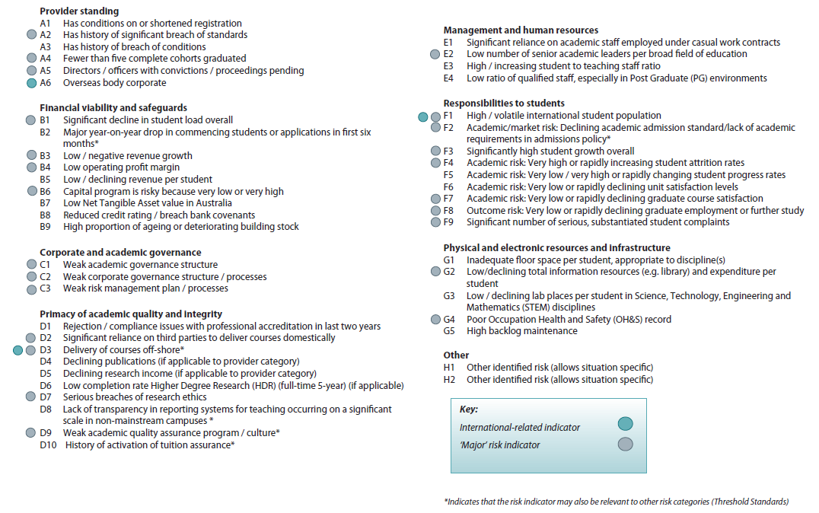
APPENDIX G
AUSTRALIAN PRUDENTIAL REGULATION AUTHORITY (APRA) LETTERS OF AGREEMENT AND MEMORANDA OF UNDERSTANDING
In 2008, a Memorandum of Understanding (MoU) between the members of the Council of Financial Regulators (CFR), which include the Australian Prudential Regulation Authority (APRA), the Reserve Bank of Australia (RBA), the Australian Securities and Investments Commission (ASIC) and the Department of Treasury was established. It sets out and delineates the objectives, principles and processes for dealing with stresses in the financial system. TEQSA could draft an MoU with other regulators such as ASQA, as well as the Department, to set out reducing regulation of the higher education sector and jointly reduce duplication of regulation generally. The key aspects of the MOU could include:
- clearly stated responsibilities for each body;
- objectives of what is to be managed and identification of the problem/risk;
- detailing the activities to reduce regulatory burden and duplication of reporting; and
- coordinating responses.

Some extracts from the CFR MoU provide examples of the above that could be replicated:

4. Principles that guide decisions and actions

- The response will be guided by the relevant statutory objectives of each member and the objectives referred to in this MOU.
- In considering the most appropriate means for resolving financial distress, the impacts on the broader economy will be taken into account.
- Any resolution option will also take into account short- and long-term benefits, costs and risks.
- Communication will be timely, coordinated and focused on the information needs of stakeholders.
- The response to financial distress will take into account cross-border implications where relevant, with a view to achieving a satisfactory outcome for all affected jurisdictions, subject to ensuring that the outcome meets the needs of the Australian financial system and depositors, policyholders and fund members in Australia. Trans-Tasman issues are particularly important in this context, given the integration between Australia and New Zealand in the financial area and relevant legislative mandates.
5.2 Assessment of financial stress and implementation of response options
- Where a Council member’s action could impact on the performance of responsibilities by another member or where the action may have implications for the overall response to the distress situation, the first member will ensure sufficient notice of the proposed action is provided.
  - Coordination of response
- The implementation of a response to resolve a distressed institution or broader financial system stress will be coordinated between the members of the Council, where more than one member has responsibility for responding to the situation.
- Where the Treasurer or the Government makes a decision on a response, the Treasury will inform the other Council members of that decision as early as possible. The members of the Council will work together to implement the Government’s decision.
- The Council members will keep the Treasurer and the Treasury informed on the progress of the implementation of a response to financial stress.

For the full MoU between members of the CFR (including APRA) on Financial Distress Management go to http://www.apra.gov.au/AboutAPRA/Documents/MOU-CoFR-Council-of-Financial-Regulators-on-Financial-Distress-Management.pdf

MOUs between partners

An MoU between APRA and the Department of Treasury defines the respective roles of the two organisations with respect to the regulation of the financial sector, and delineates them clearly. In relation to TEQSA, what may be most valuable would be to agree to establish ongoing relationships with its partners, similar to how APRA and Treasury have done so in their MoU:

7. The Treasury will advise the Treasurer in relation to ministerial responsibilities but, subject to any restrictions
imposed by Government, will consult with APRA in the development of its advice. The Treasury, consulting with
APRA, has responsibility for the development of laws relating to APRA (as for the Reserve Bank and ASIC). This
may include laws, legislative amendments and regulations proposed by APRA. Where agreed, policies, drafting
instructions and other materials may be developed by joint working parties involving Treasury and APRA staff.
8. APRA has responsibility for developing prudential standards (and informal policy guidelines) under its authority.
APRA will consult Treasury in the substantive development of its policies (whether through standards or
guidelines). In general, this consultation may take a form and timing equivalent to any industry or public
consultation, and in respect of many of these, it is expected that Treasury will often not wish to comment. However,
in areas of particular significance or sensitivity, prior consultation (or, if agreed, joint policy work) will be
undertaken. This will include any proposal to alter the coverage of the classes of entities regulated by APRA, major
changes to the approach to prudential regulation or which significantly change retirement income policy, and any
regulations substantively affecting entry to financial service markets or the class of activities permitted for regulated
financial entities.
9. An early priority for Treasury and APRA is the development of a co-ordinated policy in relation to the licensing
of financial institutions and the regulation of ownership and control of financial institutions. Since the administrative
responsibility for these is split between the Treasurer and APRA, and the Treasurer may delegate some of his
powers in relation to shareholdings to APRA, these policies should be fully harmonised as soon as possible.

For the full MOU between APRA and the Department of Treasury, go to http://www.apra.gov.au/AboutAPRA/Documents/MoU-Treasury.pdf

The letter of agreement between APRA and ASIC provides for APRA to act as ASIC’s agent in receiving written reports required to be lodged with ASIC under subsection 912D(1B) of the Corporations Act 2001. TEQSA could draft a similar letter of agreement with bodies such as ASQA to streamline reporting requirements. The letter of agreement between APRA and ASIC can be found below.
Appendix F
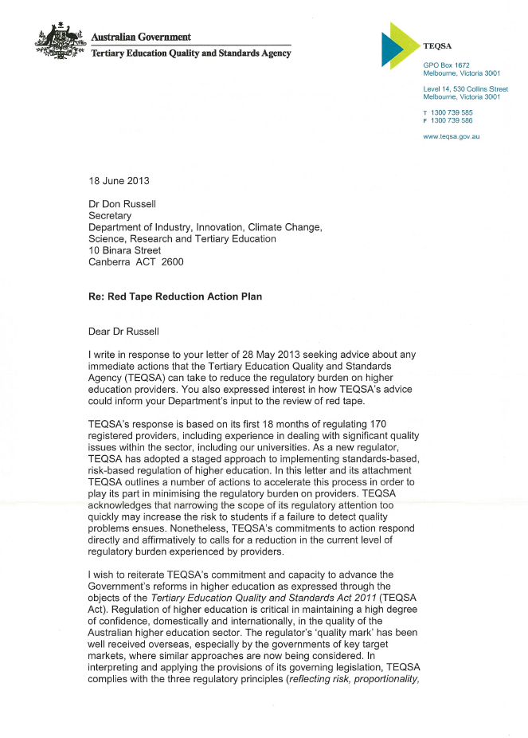
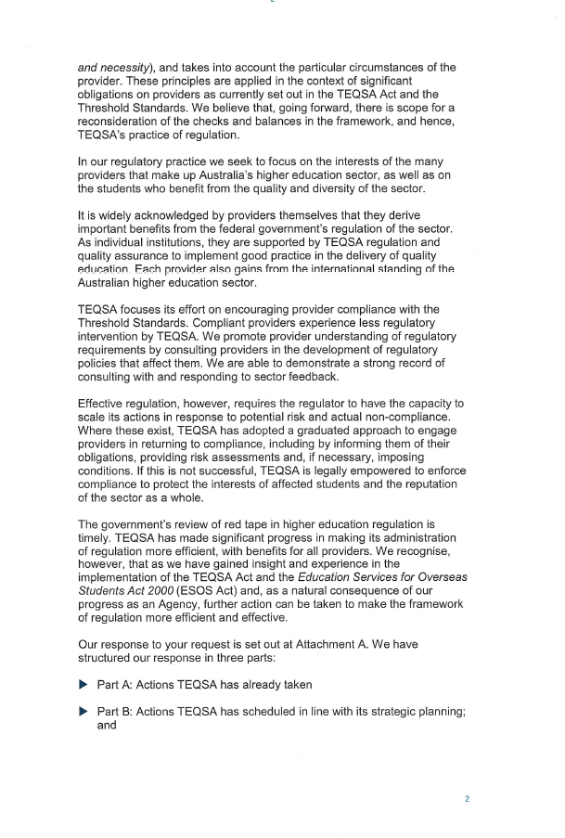
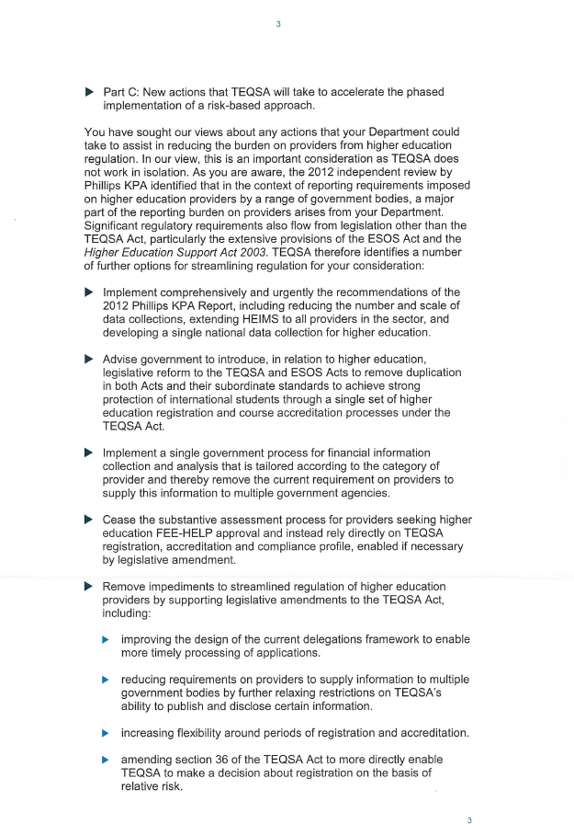
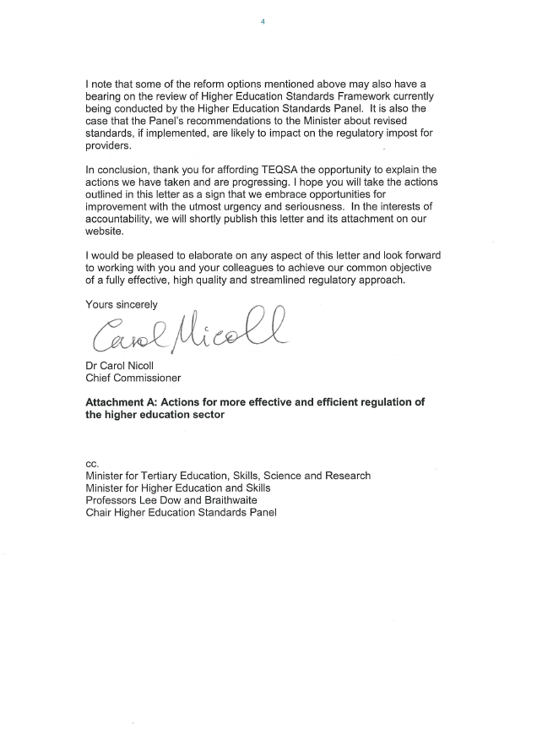
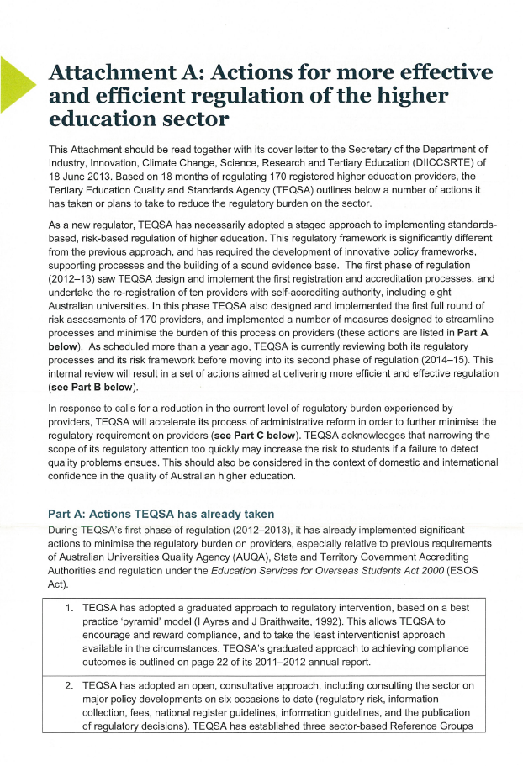
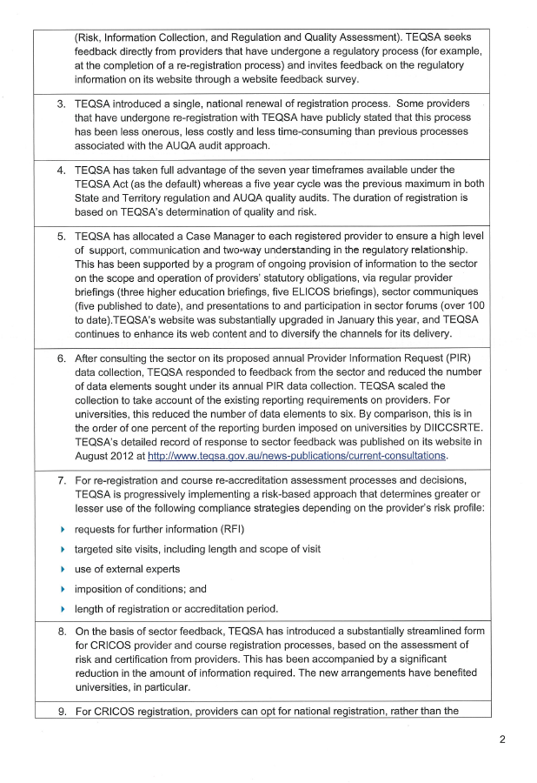
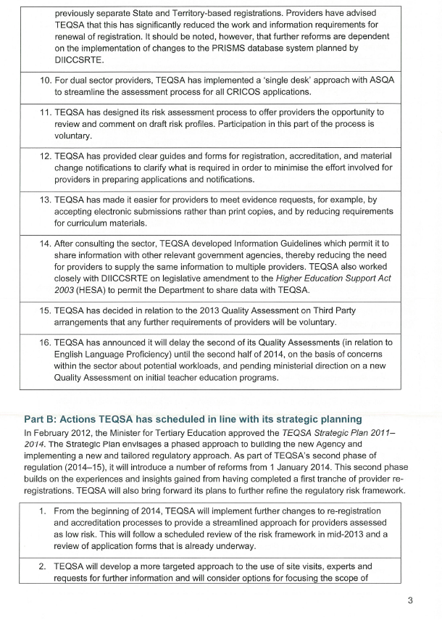
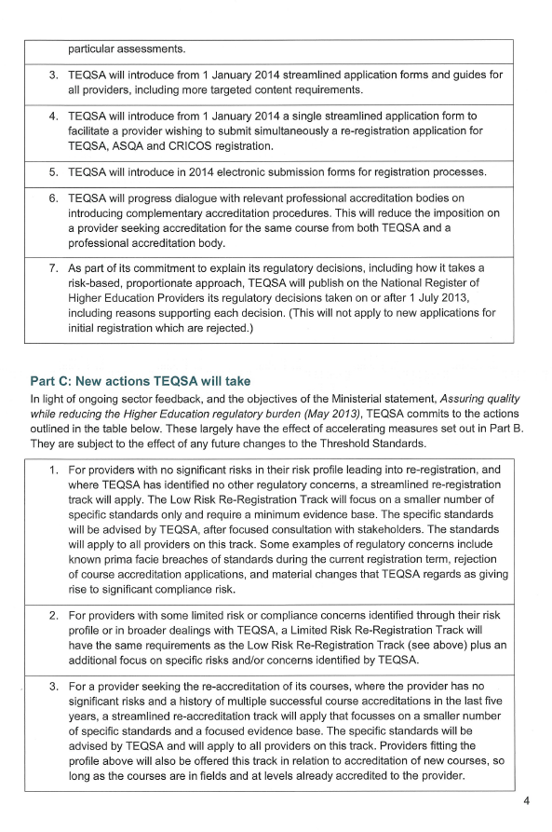
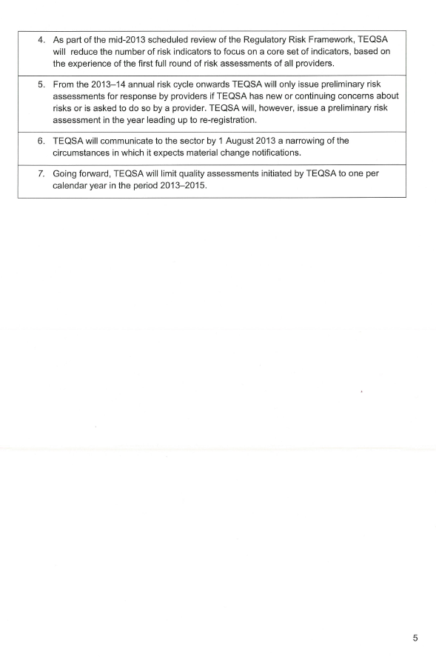

www.innovation.gov.au/HigherEducation/Policy/HEAssuringQuality/Pages/default.aspx
Parker, C. and Braithwaite, J. (2003) ‘Regulation’ in Cane P and Tushnet, M (Eds) The Oxford Handbook of Legal Studies, Oxford: Oxford University Press pp 119- 145.
Self-accrediting institutions are authorised to self-accredit each course of study that leads to a higher education award that if offers of confers. Accrediting a course means that institutions interpret the requirements of the Threshold Standards and judge whether these will be appropriately applied and met throughout the development, approval, delivery and discontinuance of a course of study. See http://www.teqsa.gov.au/for-providers/self-accrediting-authority for further information.
Mathews, M and Murphy, D (2010) Dual Sector University Cohesion, University of Ballarat page 13.
As at 6 March 2013
DEEWR 2008, Review of Australian Higher Education Final Report, p115 http://www.innovation.gov.au/HigherEducation/ResourcesAndPublications/ReviewOfAustralianHigherEducation/Pages/ReviewOfAustralianHigherEducationReport.aspx
Ibid, pp117-119
Ibid, p 119.
Many university officials acknowledged they would continue to collect similar information for their own cost management and benchmarking purposes.
NAGHEDI is committed to publishing the outcomes of its meetings and activities more generally, see www.innovation.gov.au/highereducation/HigherEducationStatistics/Pages/AdvisoryGroup.aspx .
Explain Foundation and ELICOS courses
https://en.wikipedia.org/wiki/Quality_assurance, http://www.eqavet.eu/qa/gns/glossary/q/quality-assurance.aspx
Interest in quality assurance in the sector has extended to sharing best practice through the ACPET Journal of Private Higher Education. Research publications in this journal play an important part in building a culture of quality assurance from the bottom-up.
http://www.austlii.edu.au/au/legis/cth/bill_em/teqasab2011476/memo_0.htm
The review is being undertaken by the Panel through a program of extensive consultation, with the final outcomes to be provided to the Minister for his approval as required by the current legislative arrangements.
See s168-1(b) of the TEQSA Act. We understand that TEQSA representatives observe Panel meetings.
http://www.nssc.natese.gov.au/
Noting that the current AQFC Chair, the Hon John Dawkins AM is also the chair of the NSSC but this is not a requirement of either position that they have both roles.
See for example, the European Union’s Standards and Guidelines for Quality Assurance Framework and the European Qualifications Framework and regulatory and quality assurance frameworks for New Zealand, the United Kingdom, Finland and Singapore.
Gunningham, N and Sinclair, D. (2002) Leaders and Laggards: Next-generation Environmental Regulation, Texas, Greenleaf Publishing.
Meidinger, E (1987) pointed out long ago that regulators and regulatees are part of a broader regulatory community with subcultures of both support and resistance to regulation. See Regulatory Culture: A Theoretical Outline’ Law and Policy; pp 355-86
Regulatory capitalism is the term used by Levi-Faur and Jordana to describe the explosion in regulatory activity outside government. See Levi-Faur, D. and Jordana, J. (2005), ‘The rise of regulatory capitalism: The global diffusion of a new order’, The ANNALS of the American Academy of Political and Social Sciences, 598: 1.
See Appendix E. Many of these providers have niche discipline offerings and would be interacting with a range of indexing/profession related bodies. By not receiving any Commonwealth funding they are subject to a different level of data reporting requirements from TEQSA as the data is not available from the Department.
A number of universities provided their submissions to the PhillipsKPA Review of Reporting Requirements for Universities which included extensive lists of such regulatory reporting requirements.
The focus on universities here is not to deny that other institutions, some of which are very longstanding education providers, grapple with similar complexities of governance and research. It is the very nature of being titled a university which has both brought about the additional complexities and which enforces them as requirements with which a university must engage.
With the exception being the Australian National University (ANU) established by Commonwealth legislation.
This is not to imply that other higher education providers do not undertake research, rather it is merely to highlight that government funding associated with research does not steer the flow of events for higher education providers in the same way it does for universities.
Originally, additional funding was tied to the Compact conversations. More recent Compact rounds have focused on an exchange of information about how the university’s mission and strategic priorities align with the Government’s key policy objectives on teaching quality, research excellence, access and engagement with business and industry. They have included discussion about voluntary key performance indicators in these areas.
This full understanding of the sector will assist providers to understand their niche and enable them to make comparative outcomes for their students.
http://www.austlii.edu.au/au/legis/cth/bill_em/teqasab2011476/memo_0.html
One incident mentioned in our consultations illustrated this situation well. A crane had collapsed on a university building site. The matter was handled by the university and by the state building authorities and Worksafe Australia. Building or student safety issues that are addressed through working with other agencies such as safety authorities and the police need not command TEQSA’s attention under the necessity principle.
N Gunningham and P Grabosky (1998) Smart Regulation: Designing Environmental Policy, Oxford University Press: Oxford
Denise Bradley described the set-up of TEQSA as based on the APRA experience, ‘it was to be a light touch regulator with ability to pursue providers in areas that required action – following the 80/20 rule’. Discussion held 24 June 2013.
The original recommendation was to extend a demand driven system to providers other than universities. This was based on earlier practice of allowing approved providers to apply for tranches of identified commonwealth supported places in nursing and education. One measure of growth in the sector is those providers applying to offer FEE-HELP. In the first three years of the scheme, provider numbers grew more than 300 per cent to 107 providers. The last five years saw only thirteen per cent growth.
Discussions with Greg Craven on 11 June, Denise Bradley and Peter Coaldrake on 24 June 2013 highlighted the range of these positions.
http://www.teqsa.gov.au/about
See section 134 of the TEQSA Act for a full list of TEQSA’s functions and powers
Massaro, V. (2013) ‘TEQSA and the holy grail of outcomes-based quality assessment’ in Simon Marginson (Ed)Tertiary Education Policy in Australia, Centre for the Study of Higher Education: University of Melbourne, pp 49 - 57. Massaro notes that 45 pages of the Act are devoted to TEQSA’s investigative and enforcement powers.
Ellen Hazelkorn (2013) ‘Has Higher Education Lost Control Over Quality?’ The Chronicle of Higher Education
Chief Commissioner’s response to Secretary, 18 June 2013, Attachment A (see Appendix H).
[1] http://www.theaustralian.com.au/higher-education/sympathy-for-the-regulator/story-e6frgcjx-1226642274065
Section 135 TEQSA Act
Section 136 TEQSA Act
Section 155(1)
TEQSA must prepare, for the Minister’s approval, a written strategic plan, for a 3-year period, that defines the principal objectives of TEQSA in performing its functions during that period and gives a broad outline of the strategies to be pursued by TEQSA to achieve those objectives. TEQSA must also prepare, for the Minister’s approval, an annual operational plan relating to the 12-month period beginning on 1 July in each year. In the operational plan TEQSA must set out any action it intends to take to support the principal objectives set out in the strategic plan as well as include appropriate performance indicators against which its performance can be assessed. An annual report on its operations during the year is also required for presentation to Parliament.
http://www.teqsa.gov.au/regulatory-approach
Provider Information Request Background and Instructions page 3
Section 29(1) of the TEQSA Act
Material change guide
ASQA similarly has a guide to material change notification.
Chief Commissioner’s response to Secretary, 18 June 2013
Section 200 TEQSA Act
Section 199(2)
Provider Information Request Background and Instructions page 1.
Higher Education Support Amendment (Maximum Payment Amounts and Other Measures) Bill 2012 Explanatory Memorandum
Provider Information Request Background and Instructions page 3-4.
Ibid
Official Committee Hansard Senate Economics Legislation Committee Monday 3 June 2013 page 62.
Chief Commissioner’s response to Secretary, 18 June 2013
Chief Commissioner’s response to Secretary, 18 June 2013
Chief Commissioner’s response to Secretary, 18 June 2013
http://www.teqsa.gov.au/for-providers/quality-assessments
Section 60 of the TEQSA Act states that TEQSA may review or examine any aspect of an entity’s operations to: (a) assess the level of quality of higher education provided by one or more registered higher education providers; or (b) assess whether there are any systemic issues relating to a particular course of study leading to a particular regulated higher education award; or (c) assess the level of quality of, or whether there are any systemic issues relating to, the courses of study that lead to one or more kinds of regulated higher education awards.
Third Party Arrangements Terms of Reference page 4.
January 2013 Quality Assessment: Third Party Arrangements Terms of Reference January 2013 pages 3 – 4.
Questions and Answers – third party arrangements updated 30 April 2012 page 4.
Questions and Answers – third party arrangements updated 30 April 2012 page 4.
Chief Commissioner’s response to Secretary, 18 June 2013
http://www.teqsa.gov.au/for-providers/quality-assessments
TEQSA’s approach to consultation can be found at http://www.teqsa.gov.au/news-publications/current-consultations
TEQSA is dependent on data collected by the Department through HEIMS. The Department sets the financial statement guidelines for universities which is the accepted format for their annual financial reports.
TEQSA also has responsibility for registration and compliance functions under the ESOS Act for higher education providers of Foundation Programs and ELICOS courses of study in a pathway arrangement with a higher education provider that want to deliver courses on the Commonwealth Register of Institutions and Courses for Overseas Students (CRICOS). In registering a provider for CRICOS, TEQSA assesses compliance with the ESOS Act and the National Code.
See subsections 9AC(1) and 9AC(4) of the ESOS Act.
See subsections 22(6) and 36(4) of the TEQSA Act.
Chief Commissioner’s response to Secretary, 18 June 2013.
See subsections 17(5) and 31(1) o the NVETR Act.
See VET Standards Harmonisation Report 17 April 2013
There are two different sets of requirements (i) universities have special purpose accounting standards set out each year by the Department in its annual financial statement guidelines for universities. These guidelines are agreed with the State and Territory Auditor Generals as the agreed format for financial statements. Other providers do not use these guidelines but may provide general purpose or special purpose audited financial statements in line with approved HELP provider guidelines.
Exceptions apply to Table A providers under the HESA Act, and The University of Notre Dame Australia. http://www.teqsa.gov.au/for-providers/provider-obligations/annual-financial-statements
Chief Commissioner’s response to Secretary, 18 June 2013.
Chief Commissioner’s response to Secretary, 18 June 2013 page 3
Tertiary education Standards Setting Agency comprises the AQFC Chair, HESP Chair and the NSSC Chair and the Associate-Secretary of the Department. The Tertiary Regulatory Strategic Meeting is comprised of Commissioners from TEQSA and ASQA and representatives from the Department including the Associate-Secretary. Both are fledgling working groups having only been established within the past year or so.
The creation of one national tertiary regulator was raised in a number of discussions. Discussions with the CEO of TAFE Directors Australia on 18 June 2013, identified the need to begin preparing for a shift to one tertiary regulator, particularly before the regulators diverge further .The Vice-Chancellor of the Queensland University of Technology suggested in discussions on 24 June 2013 it is too early to bring the regulators together, but some alignment would be useful to prepare for this.
Even Fred Hilmer, a strong critic of TEQSA acknowledges a need for a regulator see speech 25 July 2012 ‘Let’s Stop Pretending: A realistic vision for Australian Universities.
Chief Commissioner speech delivered to OECD
http://ministers.deewr.gov.au/evans/second-reading-speech-tertiary-education-quality-and-standards-agency-bill-2011
The necessity for TEQSA to focus on the real risks in order to be effective was raised in discussions with the University of Queensland Vice-Chancellor on 26 June 2013
The issue of red flags was raised in discussions with the Vice-Chancellor of James Cook University. Concern was expressed by the automatic red flags given to institutions with overseas operations.
Chief Commissioner’s response to Secretary, 18 June 2013
King R. 24 July 2013 Best of both worlds, The Australian. http://www.theaustralian.com.au/higher-education/opinion/best-of-both-worlds/story-e6frgcko-1226683954455
Correspondence received from the University of Adelaide on 9 July expressed frustration at the multiple and conflicting messages coming from TEQSA staff and hoped going forward for a more unified voice from TEQSA.
Chief Commissioner’s response to Secretary, 18 June 2013
Material change guide - TEQSA
Chief Commissioner’s response to Secretary, 18 June 2013
Dr Carol Nicoll (2012) ‘How can higher education maintain and improve quality?’ Speech delivered at IMHE General Conference Paris 17-19 September 2012.
See also submissions from Curtin University, Deakin University, Blue Mountains International Hotel Management School, Australian National University, Monash University, the University of Queensland, RMIT University, the Queensland University of Technology, Tabor Adelaide, Flinders University, University of Western Australia, Victoria University, Australian Technology Network, Universities Australia, International College of Hotel Management, Group of Eight and La Trobe.
Chief Commissioner’s response to Secretary, 18 June 2013
See submission from Perth Bible College
Cf. the comparison to ASQA’s reporting lines were raised in a number of discussions and submissions.
Massaro, V. (2013) ‘TEQSA and the holy grail of outcomes-based quality assessment’ in Simon Marginson (Ed) Tertiary Education Policy in Australia, Centre for the Study of Higher Education: University of Melbourne, pp 49 – 57.
The demotivating effects of the regulatory processes were raised in a number of submissions, cf Stott’s Colleges. Professor Hilmer also argues that the ‘skills and motivation of people creates excellence, not regulation’, discussion held 11 June 2013.
In discussions with a range of ACPET members on 18 and 25 June providers expressed concern that overly intrusive and excessive regulation will stifle the sector to such a degree that further homogenisation will be unavoidable.
Discussion with RMIT Vice-Chancellor and President, 3 July 2013.

