

# Task card - how to make changes to Additional Child Care Subsidy certificates and determinations in the Provider Entry Point

How to make changes to Additional Child Care Subsidy certificates and determinations in the Provider Entry Point

Overview 3

Cancelling ACCS 4

Step 1: Opening the Additional Child Care Subsidy menu 4

Step 2: Searching for the child 5

Step 3: Select the action 6

Step 4: Cancelling the ACCS 6

Step 5: Evidence Requirements 7

Step 6: Declaration 9

Step 7: Receipt 9

Notifying Support Agency 10

Step 1: Open the Additional Child Care Subsidy Menu 10

Step 2: Searching for the child 11

Step 3: Select the action 11

Step 4: Notify Support Agency 12

Step 5: Evidence Requirements 13

Step 6: Declaration 14

Step 7: Receipt 14

Uploading Documents 15

Step 1: Open the Additional Child Care Subsidy Menu 15

Step 2: Searching for the child 16

Step 3: Select the action 17

Step 4: Attach the Evidence 18

Step 6: Declaration 19

Step 7: Receipt 20

## Overview

The following task card will provide an overview of how to:

* cancel an Additional Child Care Subsidy (ACCS) (child wellbeing) certificate or determination
* notify a Support Agency
* upload a document

via the Provider Entry Point (PEP).

A description of the fields and important information is outlined above each image.

**Note:** Only certain special characters can be used in the PEP:

* full stop (.)
* comma (,)
* hyphen (-)
* slashes (/, \)
* apostrophe (‘).

All other special characters will cause an error in the system.

## Cancelling ACCS

### Replacement certificates, where incorrect dates were submitted initially

Providers should ensure they have selected the correct dates before submitting certificates. If an incorrect date is entered, follow these steps to enter the correct date:

1. Cancel the certificate that was given incorrectly, by following the below Steps
2. Give a new certificate from the intended start date until the day before the start date of the initial certificate that was cancelled. Refer to the “*How to Create a new Certificate in PEP*” Task card for instructions on how to complete this function.
3. Give a replacement certificate for the remaining weeks (from the start date entered for the certificate that was cancelled), noting that certificates can only be given for six weeks in total. Refer to the “*How to Create a new Certificate in PEP*” Task card for instructions on how to complete this function

Step 1: Opening the Additional Child Care Subsidy menu

After signing into the PEP (using your username and password you created for your PRODA account), select the ‘**More details’** button from the ‘**Additional Child Care Subsidy’** tile.

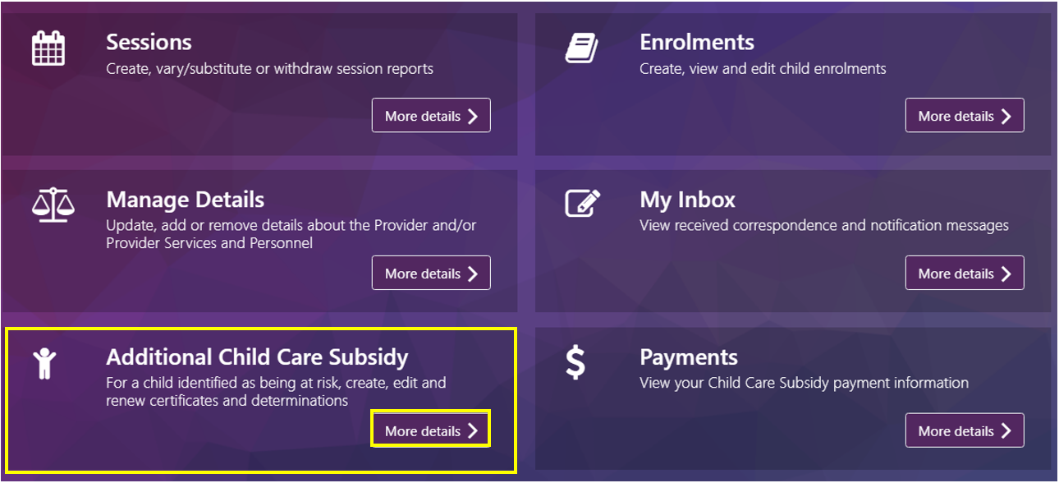

#### The Additional Child Care Subsidy screen

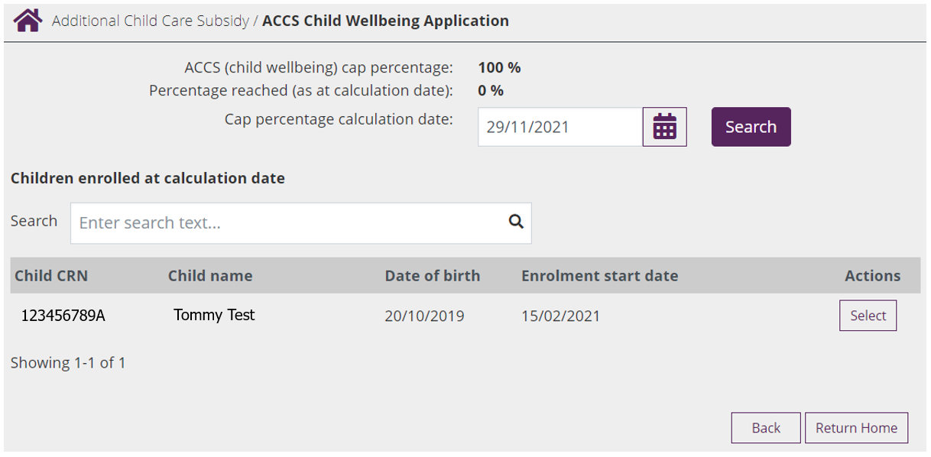This screen details any children identified as being “at risk” by the service within the last 12 months. If no certificates or determinations have been created, the message ‘No children have been identified as ‘at risk’ at this service in the last 12 months’ will appear.

* **ACCS (child wellbeing) cap percentage:** Previously this was 50%, now will show as 100% unless a lower percentage has been imposed on the service.
* **Percentage reached (as at calculation date):** This field is no longer in use, unless the service has a percentage cap less than 100%
* **Cap percentage calculation date:** View and calculate the ACCS cap for the service by inputting a calculation date. You can use the calendar icon to select the date.
* **Select:** At any time, you can view and calculate the ACCS cap for the service by inputting a calculation date. Use the calendar icon to select the date.
* **New Certificate or Determination:** Select this button to create a new certificate for a child.

Step 2: Searching for the child

In the PEP, search for the child you wish to cancel ACCS for by entering in the childs CRN and clicking on the magnifying glass: 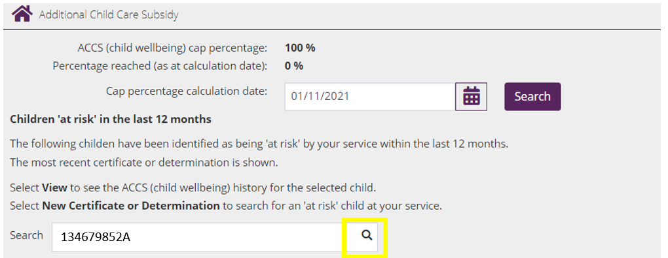

Step 3: Select the action

Once you have located the correct child, find the certificate or determination you wish to cancel and click on the “**Action**” button. Three menu items will be presented:

* Cancel ACCS
* Notify Support Agency
* Upload document

Select “**Cancel ACCS**”.

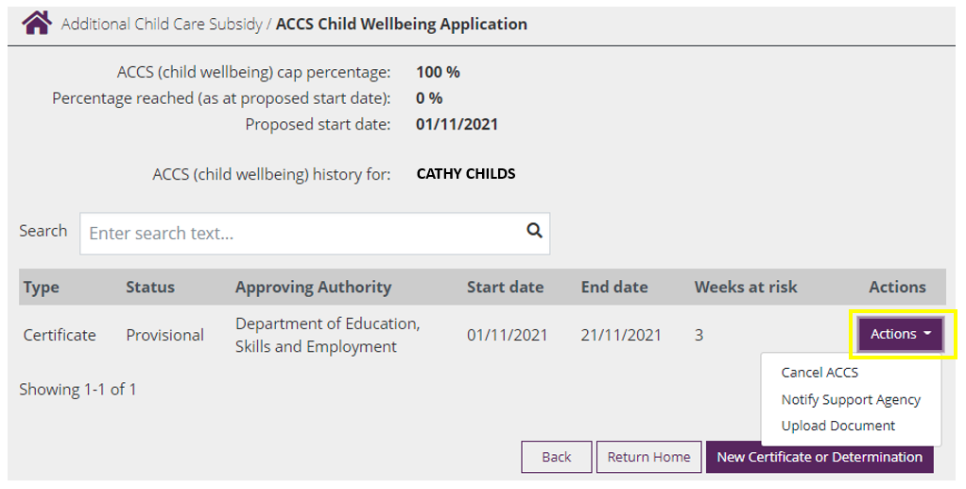

Step 4: Cancelling the ACCS

Once you have selected “Cancel ACCS” a warning message will display, advising you that if you cancel a certificate, or a determination it will be taken to have never been made and any ACCS (child wellbeing) payments will be raised as a debt and recovered.

Key in the following fields:

* **Date from which child is considered no longer at risk:** Enter the date the child is no longer considered at risk (the date must be a Sunday).
* **Do you hold evidence to support the view that the child is no longer at risk?** This is not mandatory,If you have evidence that you would like to attach, select ‘Yes’. Evidence can include a file note that describes new information that was given to you or explains if the certificate was given in error.
* **Next:** Select when ready to proceed.

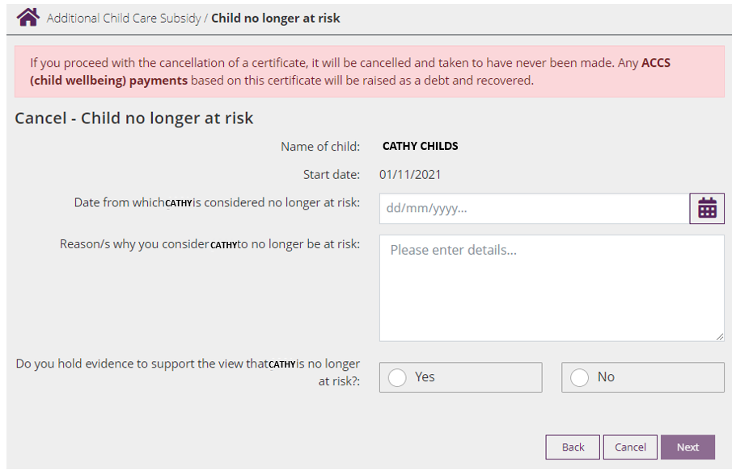

Step 5: Evidence Requirements

Providing evidence is optional, however this screen will display regardless. You are able to click ‘**next’** without attaching anything.

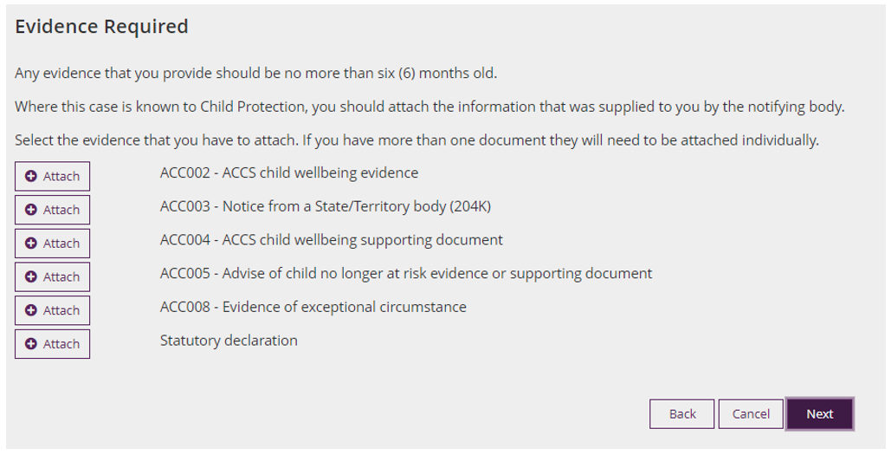

To add evidence, click on the  button next to the evidence you are wanting to include and click ‘**next’**. To select the documents to be uploaded, click on ‘**Choose a file’**

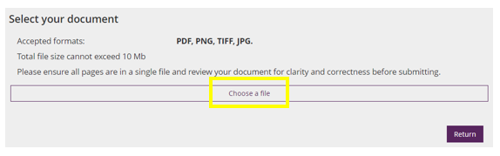

Navigate through your folders to find the file you’re wanting to attach. The file must be an accepted format (PDF, PNG, TIFF or JPG) and not exceed 10 MB.

Once you have located the evidence, click “**Open**”.

You will know the evidence is attached when you see a green tick next to the document name:

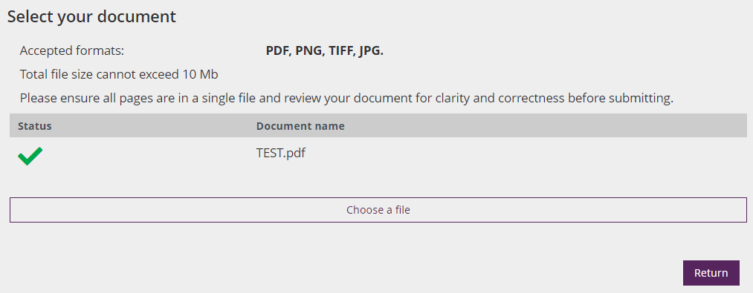

Select “**Return**”, which will take you back to the “Evidence Required” screen. From here you can “Delete” any evidence which was added incorrectly, or select “**Next**” to progress.

Step 6: Declaration

When the declaration is displayed, review for accuracy, before checking the checkbox and clicking “**Submit**”.

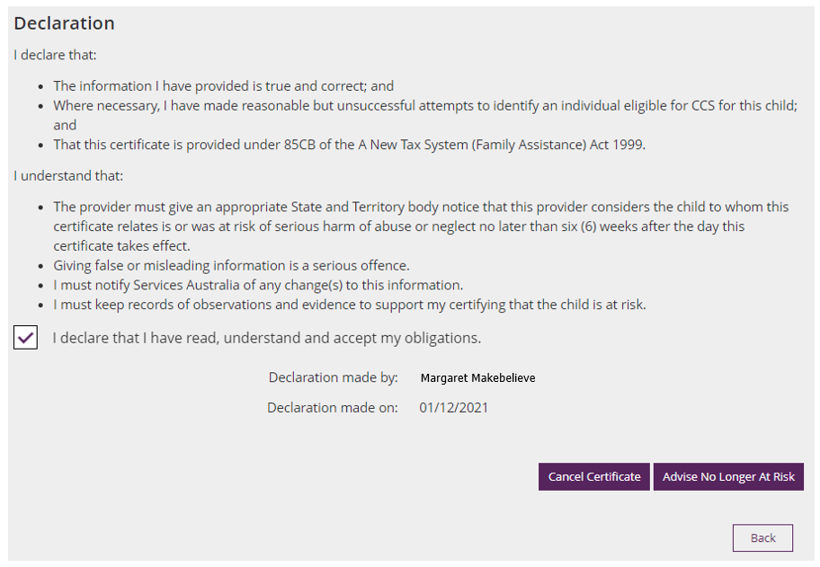

Step 7: Receipt

A receipt will display, notifying you of the cancellation you have submitted.

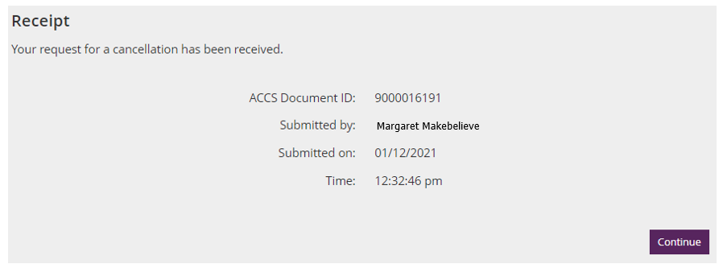

## Notifying Support Agency

Step 1: Open the Additional Child Care Subsidy Menu

After signing into the PEP (using your username and password you created for your PRODA account), select the ‘**More details’** button from the ‘**Additional Child Care Subsidy’** tile.



#### The Additional Child Care Subsidy screen

Details of any children identified as being “at risk” by your service within the last 12 months will display. If no certificates or determinations have been created, the message ‘No children have been identified as ‘at risk’ at this service in the last 12 months’ will appear instead.



* **ACCS (child wellbeing) cap percentage:** Previously this was 50%, now will show as 100% unless a lower percentage has been imposed on the service.
* **Percentage reached (as at calculation date):** This field is no longer in use, unless the service has a percentage cap less than 100%
* **Cap percentage calculation date:** View and calculate the ACCS cap for the service by inputting a calculation date. You can use the calendar icon to select the date.
* **Select:** At any time, you can view and calculate the ACCS cap for the service by inputting a calculation date. Use the calendar icon to select the date.
* **New Certificate or Determination:** Select this button to create a new certificate for a child.

Step 2: Searching for the child

In the PEP, search for the child you wish to notify the support agency for by entering in the childs CRN and clicking on the magnifying glass:



Step 3: Select the action

Once you have located the correct child, find the certificate or determination you wish to advise of the support agency for and click on the “**Action**” button. Three menu items will be presented:

* Cancel ACCS
* Notify Support Agency
* Upload document

Select “**Notify Support Agency**”.



Step 4: Notify Support Agency

Key in the following fields:

* **Name of the Support Agency:** Enter the name of the Support Agency
* **Type of body/class of organisation:** Use the drop down box to select the type of Agency
* **Date advised:** Enter the date you advised the agency (or that they advised the service)
* **Any additional details:** Phone number and name of the person.
* **Next:** Select when ready to proceed.

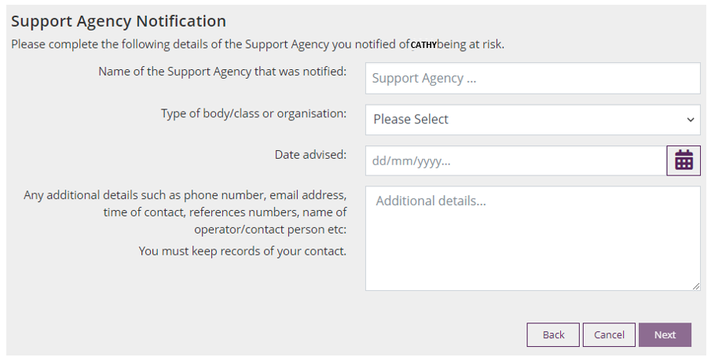

For more information, refer to the [Guide to ACCS (child wellbeing).](https://www.dese.gov.au/additional-child-care-subsidy/resources/guide-accs-child-wellbeing) You are able to include a record of your observations or a conversation with the family, or with a referring body.

Step 5: Evidence Requirements

Providing evidence is optional, however this screen will display regardless. You are able to click ‘**next’** without attaching anything.



To add evidence, click on the  button next to the evidence you are wanting to include and click ‘**next’**. To select the documents to be uploaded, click on ‘Choose a file’



Navigate through your folders to find the file you’re wanting to attach. The file must be an accepted format (PDF, PNG, TIFF or JPG) and not exceed 10 MB.

Once you have located the evidence, click “**Open**”.

You will know the evidence is attached when you see a green tick next to the document name:



Select “**Return**”, which will take you back to the “Evidence Required” screen. From here you can “Delete” any evidence which was added incorrectly, or select “**Next**” to progress.

Step 6: Declaration

When the declaration is displayed, review for accuracy, before checking the checkbox and clicking “**Submit**”.

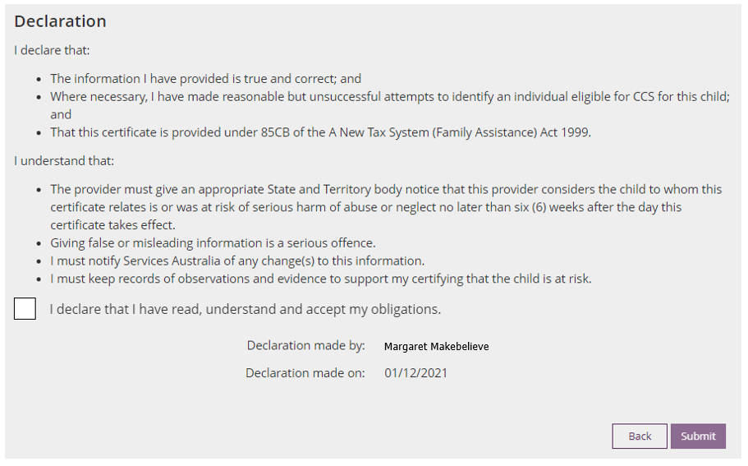

Step 7: Receipt

A receipt will display, notifying you of the details you have submitted.

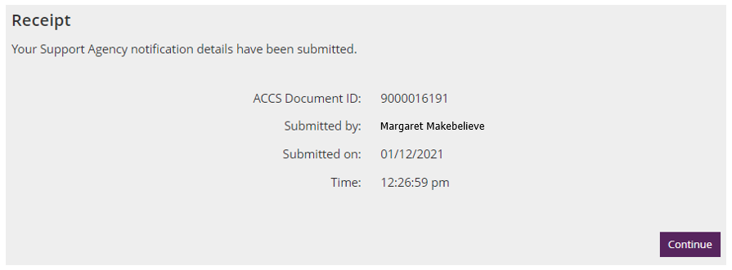

## Uploading Documents

Step 1: Open the Additional Child Care Subsidy Menu

After signing into the PEP (using your username and password you created for your PRODA account) , select the ‘More details’ button from the ‘Additional Child Care Subsidy’ tile.



#### The Additional Child Care Subsidy screen

Details of any children identified as being “at risk” by your service within the last 12 months will display. If no certificates or determinations have been created, the message ‘No children have been identified as ‘at risk’ at this service in the last 12 months’ will appear instead.



* **ACCS (child wellbeing) cap percentage:** Previously this was 50%, now will show as 100% unless a lower percentage has been imposed on the service
* **Percentage reached (as at calculation date):** This field is no longer is use, unless the service has a percentage cap less than 100%
* **Cap percentage calculation date:** View and calculate the ACCS cap for the service by inputting a calculation date. Use the calendar icon to select the date.
* **Select:** At any time, you can view and calculate the ACCS cap for the service by inputting a calculation date. Use the calendar icon to select the date.
* **New Certificate or Determination:** Select this button to create a new certificate for a child.

#### Important considerations

Details of any children identified as being “at risk” by your service within the last 12 months will display. If no certificates or determinations have been created, the message ‘No children have been identified as ‘at risk’ at this service in the last 12 months’ will appear instead.

Step 2: Searching for the child

In the PEP, search for the child you wish to upload documents for by entering in the childs CRN and clicking on the magnifying glass:



Step 3: Select the action

Once you have located the correct child, find the certificate or determination you wish to upload documents for and click on the “**Action**” button. Three menu items will be presented:

* Cancel ACCS
* Notify Support Agency
* Upload document

Select “**Upload Document**”.



Step 4: Attach the Evidence



*Note: When applying to backdate an ACCS (child wellbeing) determination* ***up to 13 weeks (ACC008)****, evidence* ***must*** *demonstrate the relevant exceptional circumstances in addition to the evidence required to show that a child is considered at risk. Refer to* [*the Guide to ACCS (child wellbeing)*](https://www.dese.gov.au/additional-child-care-subsidy/resources/guide-accs-child-wellbeing?utm_source=ECCC%20newsletter&utm_medium=email&utm_campaign=newsletter%20traffic) *on backdating in exceptional circumstances.*

To add evidence, click on the  button next to the evidence you are wanting to include and click ‘**next’**. To select the documents to be uploaded, click on ‘**Choose a file’**



Navigate through your folders to find the file you’re wanting to attach. The file must be an accepted format (PDF, PNG, TIFF or JPG) and not exceed 10 MB.

Once you have located the evidence, click “**Open**”.

You will know the evidence is attached when you see a green tick next to the document name:



Select “**Return**”, which will take you back to the “Evidence Required” screen. From here you can “Delete” any evidence which was added incorrectly, or select “**Next**” to progress.

Step 6: Declaration

When the declaration is displayed, review for accuracy, before checking the checkbox and clicking “**Submit**”.



Step 7: Receipt

A receipt will display, notifying you that you have uploaded evidence.

