


COUNCIL FOR INTERNATIONAL EDUCATION
  - 2021 Report to the Prime Minister

Council for international education membership

Ministerial Members
The Hon Alan Tudge MP, Minister for Education and Youth (Chair)
The Hon Alex Hawke MP, Minister for Immigration, Citizenship, Migrant Services and Multicultural Affairs
Senator the Hon Marise Payne, Minister for Foreign Affairs, Minister for Women
The Hon Melissa Price MP, Minister for Defence Industry, Minister for Science and Technology
The Hon Stuart Robert MP, Minister for Employment, Workforce, Skills, Small and Family Business
The Hon Angus Taylor MP, Minister for Industry, Energy and Emissions Reduction
The Hon Dan Tehan MP, Minister for Trade, Tourism and Investment

Expert Members
The Hon Phil Honeywood, CEO, International Education Association of Australia (Convener)
Mr Malcolm Baigent, Executive General Manager, University Partnerships Australasia, Navitas
Professor Helen Bartlett, Vice-Chancellor and President, University of the Sunshine Coast
Ms Janelle Chapman, Executive Director,
Executive Director, Australian Pacific Training Coalition
Mr Tomas Johnsson, CEO, Unilodge
Ms Karyn Kent, CEO, StudyAdelaide
Professor Linda Kristjanson AO
Ms Kathleen Newcombe, CEO, Sarina Russo Group of Companies
Mr Oscar Zi Shao Ong, National President, Council of International Students Australia
Mr Derek Scott, Principal and CEO, Haileybury
Professor Michael Wesley, Deputy Vice-Chancellor (International), The University of Melbourne

Table of Contents
Council for international education membership i
- Development and delivery of the Australian Strategy for International Education 2021–2030 1
Australian International Education in 2021 3
2.1 Sector health check 3
2.2 International student arrivals 6
2.3 International student welfare 6
2.4 Supporting international students –visa flexibility and post-study work rights 7
2.5 Provider registration fee relief and regulatory flexibility 7
2.6 The Innovation Fund 8
2.7 International outreach and marketing 9
2.8 Connecting Australian students, researchers and institutions to the world 9
2.9 Building university resilience to foreign interference 10
2.10 Achievements through multilateral and bilateral arrangements 10
- Next Steps 11

1

Development and delivery of the
Australian Strategy for International
Education 2021–2030

National Strategy 2025 and 2020 Interim Report
The Council for International Education (Council) was established in 2016 to oversee and drive the implementation of the National Strategy for International Education 2025 and Austrade’s Australian International Education 2025 (AIE2025) market development roadmap.
In 2020, the Expert Members recommended that a new ten-year Strategy be developed to provide a strategic vision beyond the immediate disruption of COVID-19 into a longer-term, more resilient and diverse future for Australian international education. At its 2020 meeting, the Council agreed that a new strategy was the priority for 2021. The Council agreed that Expert Members would lead stakeholder consultations, including seeking written responses to a consultation paper, to support the delivery of a new Australian Strategy for International Education.

Consultations on the new Strategy
Public consultation on the Strategy occurred between March and June 2021. In early 2021, Expert Members of the Council developed a Consultation Paper in collaboration with the Australian Government. The Consultation Paper outlined the proposed vision and goals for the Strategy, and immediate priorities for the sector over the next ten years.
On 31 March 2021, the Hon Alan Tudge MP, Minister for Education and Youth, called for public submissions in response to the Consultation Paper. The Department received a total of 124 written submissions. Of these submissions:
- 22 submissions (18 per cent) represented peak bodies
- 11 submission (9 per cent) represented State or Federal Government departments or agencies
- 52 submissions (42 per cent) represented education providers (public and private, school and post-school)
- 22 submissions (18 per cent) represented student service providers and industry stakeholders, and non-government study bodies
- 8 submissions (6 per cent) represented overseas education providers, agents and educators
- 9 submissions (7 per cent) represented members of the public, individual students.
Stakeholders’ views were also canvassed through nine public webinars, a series of policy consultation workshops, and meetings with peak international education bodies. Over 1,600 stakeholders participated in these webinars and workshops.

Sector priorities for the new Strategy
Several clear sector priorities emerged from these consultations:
- Ensuring students benefit from a world-class educational experience, regardless of location or mode of delivery.
- Ensuring the sector is sustainable and resilient to future market shocks,
- Strengthening the alignment between international education and Australia’s skills needs,
- Building community understanding and support for international education,
- Enhancing Australia’s capabilities and attractiveness for international research collaboration, and
- Leveraging international education to bolster Australia’s diplomatic relationships.
To achieve these priorities, several mechanisms were identified as central. In particular:
- Diversifying student cohorts, courses and modes of delivery,
- Ensuring visa settings, including post-study work rights, are attractive and competitive,
- Building a strong and unified national reputation for Australian international education and training,
- Supporting opportunities for work-integrated learning and industry integration, and
- Maintaining regulatory settings that encourage innovation while ensuring the quality and consistency of Australian international education.
This comprehensive consultation process formed the basis of Expert Member advice delivered to the Minister for Education and Youth in July 2021, which in turn provided the foundations for the Strategy’s development. The work of the Expert Members in leading these consultations was considered and thorough, yielding highly representative and constructive perspectives to guide the sector’s strategic direction for the coming decade.

Delivery of the Australian Strategy for International Education 2021–2030
The release of the Australian Strategy for International Education 2021–2030 (the Strategy) on 26 November 2021 marked a milestone for the Council for International Education and the international education sector. The Strategy will:
- Guide the recovery of the sector,
- Outline Australia’s approach to international education over the next ten years,
- Respond to emerging opportunities, including changes in student demands,
- Equip the sector to be resilient, sustainable and innovative, and
- Maintain Australia’s position as an effective and trusted partner in international education.
In partnership with industry, education and government stakeholders, the Council will turn its focus to ensuring the successful implementation of the Strategy over the coming decade. This will form the basis of future reports to the Prime Minister and will require active and ongoing engagement between the Government and the international education sector.
2

Australian
International
Education in 2021

2.1 Sector health check
The serious challenges facing Australia’s international education and training sector since border closures in February 2020 continued into 2021. The absence of international students was felt keenly in communities and on campuses around Australia. The sector, its allied industries and the social and economic networks that rely on international students, look forward to gradually welcoming international students back to Australia throughout 2022. With the support of Commonwealth, state and territory governments, the sector worked hard to maintain business and pedagogical continuity under unfamiliar circumstances. Together, government and industry continued to make substantial efforts to meet the full spectrum of student needs and expectations, both onshore and offshore.
According to preliminary figures from the Australian Bureau of Statistics, export income from international students studying in Australia in 2020–21 amounted to $27.6 billion. This indicated a 26 per cent decline on the equivalent figure of $37.3 billion for the 2019–20 financial year. Despite this fall in export revenue, international education and training remained Australia’s fourth largest export after iron ore, coal and natural gas in 2020–21.
In September 2021, there were 557,836 international students studying with Australian education providers, a drop of 17 per cent compared with the same period in 2020. As at 15 November 2021, there were a total of 257,995 student visa holders in Australia, with 150,697 outside of Australia, approximately 37 per cent of the total number of student visa holders. Despite continued reductions in student enrolments and revenue, 2021 still saw significant numbers of international students continue and commence Australian courses within and outside of Australia
557,836 international students were studying with Australian providers at September 2021. This was a drop of 17 percent from the number of students studying with Australian providers in September 2020.
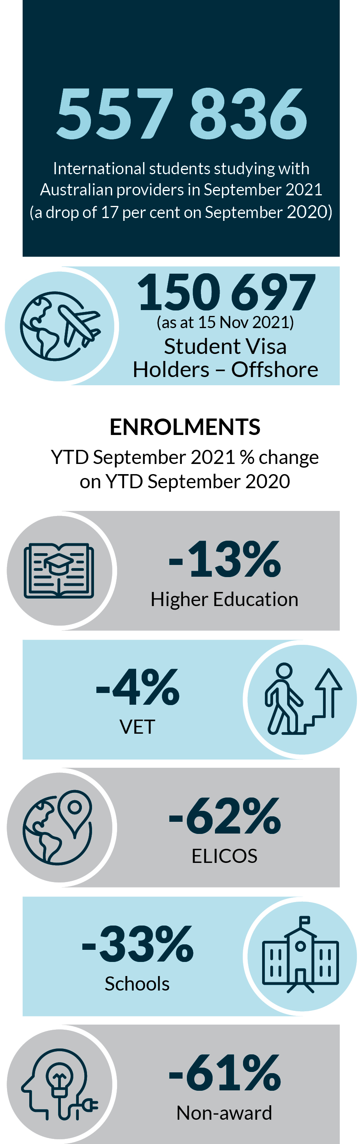
As at 15 November 2021 150,697 stud ent visa holders were studying offshore.
The percentage decrease in international student enrolments from year to date September 2021 to year to date September 2020 were:
- a decrease of 13 per cent in higher education,
- a decrease of 4 per cent in Vocational Education and Training
- a decrease of 62 per cent in English Language Intensive Courses for Overseas Students
- a decrease of 33 per cent in schools, and
- a 61 per cent in the non-award sector.
At the outset of the pandemic, Australia benefited from the fact that semesters commence early in the calendar year, which allowed most international students to arrive in Australia prior to the introduction of travel restrictions. As a result, the full effects of travel restrictions only began to emerge in the data for the 2021 calendar year, as compared to 2020.
While year-to-date enrolments dropped by 4 per cent between September 2019 and September 2020, enrolments dropped by around 13 per cent in this year’s data for the higher education sector.
Meanwhile, 2021 vocational education and training (VET) enrolments decreased 4 per cent on 2020 data. Although small compared to the decrease in higher education enrolments, this is a significant change on the equivalent figure for 2020, which showed an increase of 11 per cent, driven by onshore students continuing or transferring their studies from higher education to VET.
Facing a much more pronounced drop in short-term visa-holders, the English Language Intensive Courses for Overseas Students (ELICOS) sector saw a 62 per cent decline in enrolments, compared to a 27 per cent decline the previous year. In addition to the immediate challenges to the English language sector, this posed a potential downstream threat to other part of the international education landscape that benefit from student pipelines through ELICOS providers.
Australia also saw deeper drops than in the previous year in enrolments in schools (33 per cent) and in non award courses (61 per cent). As a significant portion of non-award students are on foundation programs with pathways onto further education in Australia, the decline in these enrolments is likely to have a significant impact on student pipelines well into the future.
Due in part to various forms of government support for the sector, including regulatory flexibility, the number of provider closures has slowed since the early days of the pandemic. In 2020–21, the Tuition Protection Service (TPS) tracked 6 international education provider closures, affecting approximately 822 students. This is a significant reduction on 2019–20, which had 20 international education provider closures, affecting approximately 4,736 students.

Australia’s re-establishment of visa processing in July 2020 saw an increase in visa applications and confirmations. While student visa applications rose over the second half of 2020, indicating some optimism regarding the reopening of borders, visa lodgements seemed to plateau in mid-2021.
Figure.1 Student vis applications
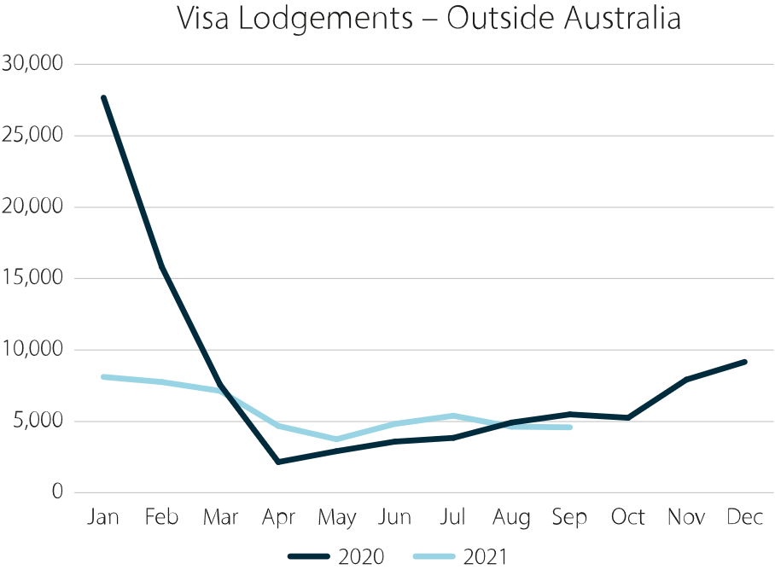
In comparison to both visa applications and enrolments, student commencements, or the number of new student enrolments in a discrete course of study, mostly kept in step with 2020 data, with the largest drops occurring between 2019 and 2020. ELICOS and non-award commencements are exceptions, with substantial further decreases between 2020 and 2021.
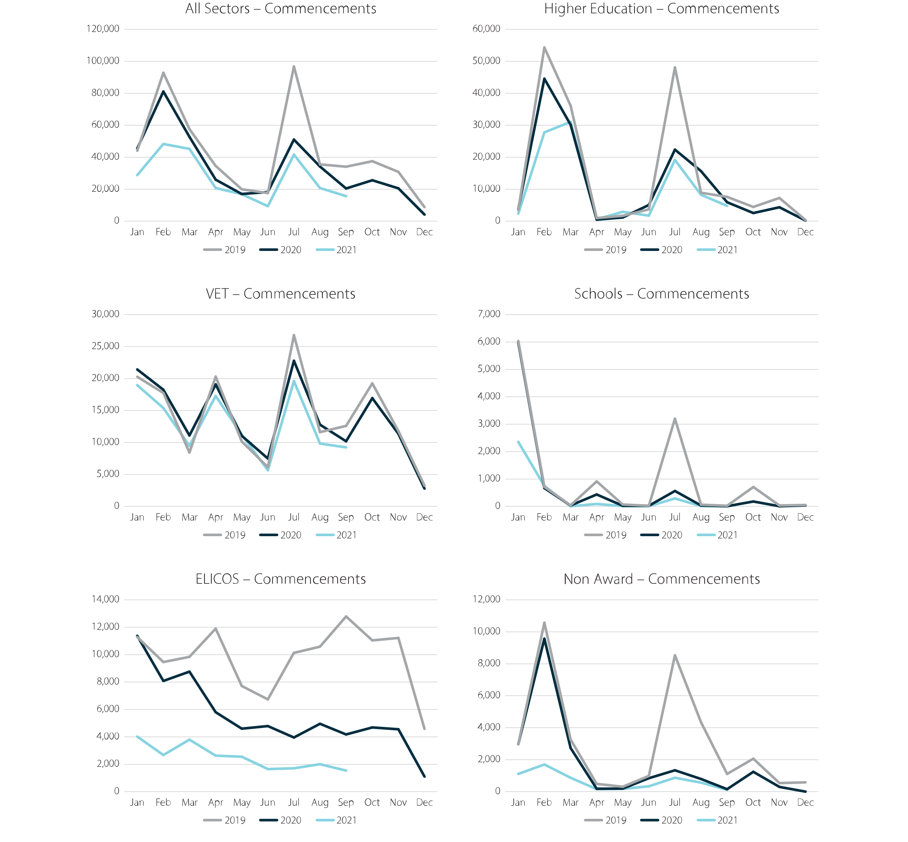
Figure 2: Sector commencement data as at 30 September 2021
Figure 2 includes 6 line charts showing sector commencement data as at 30 September 2021. Each chart shows monthly international student commencement data for 2019, 2020 and the first nine months of 2021.
The higher education Commencements chart shows decreases in higher education commencements for both 2020 and 2021. Key features include a sharp decline in semester 2 commencements for 2020 compared to the same time in 2019. and smaller semester 1 commencement figures in both 2020 and 2021, as compared to 2019.
The All Sectors Commencements chart shows decreases in overall international student commencements for both 2020 and 2021. Key features include sharp declines in commencements for semester 2 2020 and semester 1 in 2021.
The Vocational Education and Training Commencement chart shows only slight decreases in 2020 and 2021 data compared to 2019. In the sector the largest drop in international student commencements occurs in August and September in all years.
The Schools commencement chart shows a significant decreases in international student commencements in 2020 and 2021 compared to 2019. The sharpest drops in commencements occur in semester 2 in 2020 and semester 1 in 2021.
The ELICOS Commencement chart shows sharp decreases in international student commencements across 2020 and 2021 as compared to 2019. The largest year-on-year losses occur in the second half of 2020 and the first half of 2021.
The non-award commencements chart shows the sharpest declines in international student commencements occur in July to August 2020 and January to February 2021.rgest year-on-year losses occur in the second half of 2020 and the first half of 2021.
Across Australia’s international education and training sector, the impacts of the COVID-19 pandemic and border restrictions continued to be felt. The data shows that the worst of the pandemic has not yet passed for the sector, with student pipelines significantly disrupted. Moreover, disruptions have been uneven across different parts of the sector, with ELICOS and non-award providers hit particularly hard. Despite substantial ongoing challenges, there has been some cause for optimism, with significant numbers of students commencing study offshore, and a gradual return to onshore study anticipated in 2022.

2.2 International student arrivals
The return of international students to Australia continued to be a key focus for 2021.
On 6 August, National Cabinet agreed a National Plan to transition Australia’s National COVID -19 Response (National Plan), to provide a path for opening back up in a clear and safe way. The National Plan outlines measures for the safe return of international students (and other travellers) over four phases. This includes the expansion of commercial trials for limited entry of student visa holders under Phase A, capped entry of student visa holders under Phase B, and increases to this cap in Phases C and D of the plan. The National Plan is explicit that any returns to Australia will depend on health advice, the rollout of vaccines and other measures to suppress community transmission in Australia. However, the inclusion of international student cohorts in each Phase is a strong signal to students and the sector that the safe return of international students remains an important goal of the Australian Government.
The Australian Government also developed the Protocols and Preconditions for International Student Arrivals (the Protocols) in 2020, to outline health and education preconditions that states and territories must meet prior to returning international students through an International Student Arrival Plan.
In line with the National Plan and the Protocols, the Australian Government received plans from a number of states and territories over the course of 2021. Much of the work to implement these plans was ongoing throughout 2021, demonstrating a commitment across all states, territories and the Commonwealth to the safe return of international students.
In December 2021, the Australian Government took further steps to safely reopen to the world, with changes to international border arrangements in support of the education sector. Consistent with the National Plan to safely reopen Australia, fully vaccinated international students with a valid visa were prioritised for arrival to Australia without needing to apply for a travel exemption. Subject to ongoing public health requirements, the decision to begin returning international students will likely be seen in increased student arrivals across the 2022 academic year.

2.3 International student welfare
2021 was challenging for Australia’s international students, onshore and offshore. Studies have shown that international students were at an increased risk of experiencing poor mental health, with isolation from families and culture, language barriers, financial stress, and academic pressures among the key drivers. The 2020 International Student Experience Survey showed significant decreases on 2019 data in student satisfaction with learner engagement and learning resources, with drops of around 10% each. However, 71% of students were happy with the level of student support received, consistent with previous years. Furthermore, the overwhelming majority of international students were also satisfied with their personal safety, both on campus (97%) and off campus (90%).
The Australian Government continued to work with relevant industry and community stakeholders to support international student welfare, including improving information available to students to increase awareness of the support and services available. In 2021, the Australian Government engaged education providers, Study Hubs and community focused organisations, such as the Australian Human Rights Commission and Fair Work Ombudsman, to discuss activities that help build social cohesion, reduce areas of exploitation and increase wellbeing for students in their communities.
This work was complemented by financial supports available to international students. On 3 June 2021, the Prime Minister announced the launch of the Commonwealth COVID-19 Disaster Payment, a lump sum payment to help workers in Australia unable to earn income due to a COVID-19 state public health order involving a lockdown, hotspot or movement restrictions. Eligibility for disaster payments included visa holders over 17 years of age with the right to work in Australia, including international students, who live or work in an Australian Government declared COVID-19 hotspot.
International students studying in Australia, aged 16 years and over, were also included in Australia’s phased vaccine roadmap throughout 2021, with students able to register to receive a vaccine. The Australian Government actively promoted the uptake of vaccines by international students, through in-language communication and consultation with peak bodies, institutions and students. As part of vaccine outreach for culturally and linguistically diverse communities, the Australian Government, in collaboration with the Multicultural Youth Advocacy Network, held a dedicated Vaccine Roundtable for International Students in October 2021. This was an important opportunity to share information, address concerns and build understanding of the needs of the international student community.
Austrade successfully launched the Study Australia Employability Hub in August 2021. The Hub has been designed to recognise the importance of employability for international students, prospective, current and former students. The hub features a new suite of free micro-credentials covering work-readiness, entrepreneurship, academic preparation, and student and graduate information resources, including workplace rights and protections.

2.4 Supporting international students –visa flexibility and post-study work rights
To further support international students in 2021, the Australian Government implemented a suite of measures relating to visa flexibility. Student visa (subclass 500) holders were temporarily allowed to work above 40 hours per fortnight in industries impacted by COVID-19. Critical industries to benefit from these changes included agriculture, aged and disability care, health, tourism and hospitality, along with supermarket distributers and retailers. These arrangements helped to meet national workforce needs across Australia and allowed international students to support themselves while contributing to Australia’s COVID-19 response.
On 20 January 2021, the Temporary Graduate Visa (TGV) was also amended to provide greater opportunities for international students to study in regional Australia and support a more even distribution of the economic and social benefits of international education. TGV applications increased almost 13 per cent (amounting to over 87,000 applications) in the 2020–21 program year compared to 2019–20, demonstrating that the TGV remained the most utilised pathway for international students.

2.5 Provider registration fee relief and regulatory flexibility
The Australian Government continued to provide targeted support to education providers most affected by international border closures. In April 2021, the Government announced the $53.6 million 2021–22 Budget International Education Support package to give further assistance to Australian international education and training providers most affected by COVID-19 and border closures. These measures complemented the Higher Education Relief Package announced in April 2020 that committed $18 billion in funding for the higher education sector.

Regulatory fee relief
The package included $17.7 million to extend the pause on registration fees and charges from the Commonwealth Register of Institutions and Courses for Overseas Students (CRICOS), the Tertiary Education Quality and Standards Agency (TEQSA), and the Australian Skills Quality Authority (ASQA) until 31 December 2021. This followed an initial 18 months of regulatory fee relief worth $47.5 million, from 1 January 2020 to 30 June 2021, which was part of the Government’s Higher Education COVID-19 Relief Package in April 2020. From 1 January 2022, the Australian Government will also implement revised CRICOS charges, representing an overall reduction of approximately $7 million per year in the costs of registration previously incurred by Australia’s international education sector.

Regulatory flexibility
For the duration of 2021, the Australian Government continued to take a flexible regulatory approach that minimised administrative burden and enabled providers to focus on adapting to the impacts of COVID-19. Measures for regulatory flexibility included removing requirements for in-person attendance and full-time course delivery (Standard 11.1), removing limits for online delivery to international students and supporting students to study online either in Australia or offshore (Standard 8.18, 8.19 and 8.20 limit online delivery to no more than one third of units and at least one unit must be delivered face to face in each study period). Regulators continued to encourage providers to consider suspension and deferral requests from students relying on the “compassionate and compelling circumstances” set out in Standards 8.16 and 9.2 of the National Code.
Extending timeframes for meeting regulatory obligations - such as extending registration periods and postponing regulatory activities, enabled providers to place their registration ‘in hibernation’ where they have temporarily ceased operations. This will give providers a greater chance of success in 2022.
In response to COVID-19, international students were allowed to commence or continue their study fully online whether they were located in Australia or offshore. Education Services for Overseas Students (ESOS) regulators continued to work with providers to ensure that online delivery met high quality standards and international students received a quality education experience, regardless of their location. As part of this work, regulators issued guidance to providers and students on adapting to online delivery. Guidance was also provided to ensure informed consent of students underpinned the transition to online learning.

Supplementary courses
The Education Services for Overseas Students (Exempt Courses) Instrument 2021 came into effect on 29 June 2021. This instrument exempted some courses from the definition of course in the ESOS Act, meaning they could be offered to international students without being registered on the Commonwealth Register of Institutions and Courses for Overseas Students (CRICOS). This included courses that help international students participate in their communities or gain prerequisite industry qualifications for jobs in the hospitality, construction, retail and healthcare sectors such as first aid, barista, responsible services of alcohol, hygienic food preparation, infection control and white card courses.
These changes enabled providers to more easily enter the market to deliver a wider range of supplementary courses to overseas students and assisted Australian businesses to fill short term skill shortages to deliver critically important goods and services. The changes also aimed to reduce the regulatory burden for providers and enrich student experiences while in Australia.

2.6 The Innovation Fund
The 2021–22 Commonwealth Budget’s International Education Support package also assisted providers to refocus on the delivery of education to Australian students and to adjust their business models to expand online and offshore course offerings. This included the establishment of a $9.4 million Innovation Fund to provide one-off grant funding for eligible private higher education and English Language Intensive Courses for Overseas Students (ELICOS) providers to grow online and offshore education delivery in 2021–22. English Australia was appointed as the Program Administrator on 1 June 2021 and administers the Innovation Fund on behalf of the department.
The Fund supported 63 eligible private higher education and English language providers to develop new education products and expand their delivery to new markets online and offshore through grants of up to $150,000.

2.7 International outreach and marketing
Through international outreach and marketing, the Australian Government and the sector worked to ensure Australian providers were in the strongest possible position to recover from the effects of the pandemic. In May 2021, Austrade released a three-part Market Information Package (MIP) series on an Australian Nation Brand, including a provider resource. Nation Brand assets were made available first to federal, state and territory governments, with a tiered activity-based roll out.
Austrade’s #MyAustralia social media initiative was launched in June 2021 and built on a new collection of student stories published by Study Australia, showcasing positive student connections with the Australian community, peers and employers. Since going live in May 2021, #MyAustralia video and editorial content has attracted over 8 million impressions on Facebook and Weibo, resulted in over 340,000 engagements on Facebook, and reached over 77,490 people organically across Study Australia Facebook and Instagram channels.
A new global education campaign was launched in October 2021. The Shine with Australia campaign invited prospective international students to ‘discover their brilliant future self’ by studying with Australia. The campaign showcased inspiring alumni whose academic and professional journeys highlight the quality of an Australian education.
The Australian Government also added online courses, together with 12,000 new transnational (TNE) course options to the Study Australia Course Search tool. The tool now lists all available Study Australia options, including courses taught locally at a branch campus, partner provider campus, through an online study centre, or online from home – with the option for students to plan ahead to transfer to studies in Australia. The Study Australia Course Search tool is now the world’s most comprehensive resource of its kind.
Since its inception in mid-2020, the Course Search tool has attracted over 129,000 course detail searches by prospective students. As a result of these searches, the website facilitated over 48,000 click-throughs to provider websites to date. Over 29,000 enquiry emails were sent directly to education providers at no per-student recruitment cost to providers, as at October 2021.
The Study Australia Masterclass Live Series and Library project expanded in both reach and impact during 2021. The Masterclass Series engaged the global student and education community, encouraging them to start and/or retain a meaningful connection to Australia’s education sector. Masterclass recordings were made available through the Study Australia Masterclass Library at the Study Australia website. To date, there have been 1.3 million click throughs to the landing page.
In 2021, the Australian Government encouraged the development of innovative new products and services such as International Skills Training (IST) Courses. IST Courses are designed to enable skills development for trainers delivering VET courses offshore. In May 2021, the Minister for Employment, Workforce, Skills, Small and Family Business approved a new phase of implementation of the IST courses, to see the courses delivered globally and the development of new courses in key sectors of demand.

2.8 Connecting Australian students, researchers and institutions to the world
The disruption to New Colombo Plan (NCP) programs since March 2020 was mitigated by the delivery of online events, language training, alumni networking, professional development and wellbeing webinars. This included the creation and delivery of the new NCP Momentum seminar series, combining in-person and online knowledge exchange and networking opportunities across Australia. NCP Mobility projects, including study, language programs, practicums and internships also moved to virtual delivery. The response from the university sector to this initiative was positive - as at the end of September 2021, the Australian Government had approved over 290 NCP mobility projects for virtual delivery equating to over 7,500 virtual international student experiences. Through the 2021 NCP Scholarship and Mobility rounds, the Australian Government awarded a further 125 long-term immersive scholarships, and 8,058 mobility grants.
As part of the 2021–22 Budget, the Australian Government established a Global Science and Technology Diplomacy Fund (GSTDF). The GSTDF consolidates international science funding programs in the Industry portfolio, including elements of the Global Innovation Strategy, while retaining elements such as the Australia-China Science and Research Fund and the Australian-India Strategic Research Fund. $57.6 million was committed over four years from 2021–22, and $8.2 million per year ongoing.
The $93.7 million Destination Australia Program, announced in August 2019, continued to offer scholarships valued at $15,000 per student per year, to domestic and international students to study and live in regional Australia. Scholarships were made available for both VET and higher education students enrolled in qualifications from Certificate IV through to PhD for the duration of one to four years. Destination Australia Round Two awarded 257 scholarships to 17 tertiary education providers in 2021.

2.9 Building university resilience to foreign interference
International education and research collaboration fosters knowledge sharing with the best and brightest minds around the world, but it is now occurring in an increasingly complex and evolving world. Throughout 2021, Australia’s university sector remained at particular risk of interference, given its leading role in policy, research and scientific development. Foreign actors interfered, or attempted to interfere with the university sector, through threats and pressure on academics, financial coercion and attempts to steal sensitive material as part of cybersecurity attacks.
In October 2021, the University Foreign Interference Taskforce delivered the refreshed Guidelines to Counter Foreign Interference in the Australian University Sector (Guidelines) that are more specific and measurable and respond to evolving threat of foreign interference. Complementary guidance material, tools and case studies were updated and made available to help universities implement the Guidelines. The refreshed guidelines were jointly released by the Minister for Education and Youth and the Minister for Home Affairs in November.
The Guidelines help to better protect all Australian university staff and students from risks of foreign interference, by providing them with the principles and resources they need to address and proactively mitigate instances of foreign interference that may arise in their university work and research. The Guidelines acknowledge and complement other Australian Government initiatives to strengthen transparency and safeguard Australia’s international collaboration, including the Foreign Influence Transparency Scheme, the Foreign Arrangements Scheme, Defence Trade Controls Act and reforms to protect Australia’s critical infrastructure.

2.10 Achievements through multilateral and bilateral arrangements
Australia’s international education interests were pursued across a range of multilateral fora in 2021. Significant progress has been made towards Australia’s ratification of the UNESCO Global Convention on the Recognition of Qualifications concerning Higher Education 2019, which is anticipated to be completed in 2022. Under the separate UNESCO Asia-Pacific Regional Convention on the Recognition of Qualifications in Higher Education 2011 (Tokyo Convention), Australia led the development of the Statement on COVID-19 to encourage further international cooperation on the recognition of qualifications gained through online and blended learning. Australia also contributed to the development of the Asia-Pacific Network of National Information Centres online portal, a platform to share information between overseas decision makers engaging with education institutions and qualifications across the Asia-Pacific region. The Australian Government successfully worked through the Lisbon Recognition Convention for qualifications recognition to secure United Kingdom (UK) recognition of Australian 3-year degrees. The change in UK policy allows graduates of Australian 3-year bachelor’s degrees to be admitted to postgraduate study at UK universities.
Australia’s international education sector was also supported through bilateral partnerships across 2021. The Australian Government worked closely with the Indonesian Government around the conditions for the establishment and operation of foreign universities in Indonesia. This resulted in Monash University becoming the first foreign university to set up a campus in Indonesia, with the Jakarta campus commencing operations in October 2021. The Australian Government also took steps to elevate education, training and research partnerships with a range of countries including India, Brazil, Indonesia, Colombia, Japan, Malaysia, Thailand and Vietnam.

3

Next
Steps
In 2022, the work of the Council will shift toward implementation of the new Australian Strategy for International Education
2021–2030. Expert Members of the Council will progress this work over the course of the year and report on progress to a full Council meeting in late 2022. The Strategy’s progress over its first year will also be the subject of the 2022 Report to the Prime Minister.

ABS, International Trade in Goods and Services.
Department of Foreign Affairs and Trade, Key Economic Indicators Australia.
September YTD 2021 Data, Enrolled students were not necessarily in Australia at the time of reporting due to COVID-19 travel restrictions
Department of Education, Skills and Employment, September 2021 YTD Data.
Orygen. (2020) International students and their Mental Health and Physical Safety. Australia.
Quality Indicators for Learning and Technology. (2021) 2020 International Student Experience Survey. P5.

