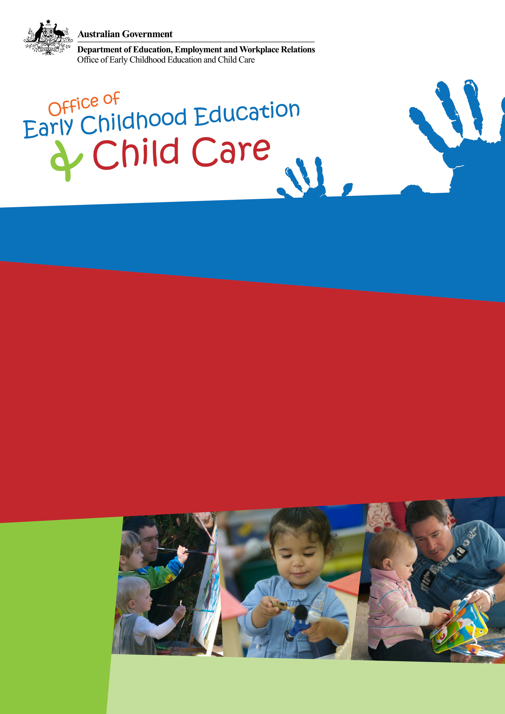
June quarter 2012
This publication provides information about child care across Australia for the June quarter 2012.

Key findings for the June quarter 2012:

- 986,280 children were in approved child care, an increase of 2.3 per cent since June quarter 2011.
- More than one in four children (27.5 per cent) aged 0 to 12 years attended child care.
- 700,600 families used approved child care of some kind, an increase of 1.4 per cent since the June quarter 2011.
- A record number of approved child care services (15,020) operated in Australia, an increase of 4.0 per cent since the June quarter 2011.
- The total estimated Child Care Benefit and Child Care Rebate entitlement was $1,023.6 million, an increase of 7.2 per cent since the June quarter 2011.

Child Care Update

Introduction
This report presents information on the numbers of children and families using approved child care, the costs of care and the numbers and types of child care services in Australia. It includes data from the Child Care Management System (CCMS) as well as information from the MyChild website.

Children

During the June quarter 2012, 986,280 children used approved child care in Australia, up by 2.3 per cent since the June quarter 2011. This represents 27.5 per cent of the 3,591,780 children aged 0–12 years in Australia.
Children attended various services providing approved child care, including long day care (59.5 per cent), outside school hours care (30.8 per cent), family day care and in-home care (12.0 per cent), and occasional care (0.7 per cent).

Table 1: Number of children using child care, June quarter 2011 to June quarter 2012
Service type | June 11 | Sept. 11 | Dec. 11 | Mar. 12 | June 12
Long day care | 585,000 | 607,510 | 611,440 | 598,450 | 587,100
Family day care and In-home care | 112,720 | 115,660 | 115,410 | 117,790 | 118,700
Occasional care | 7,580 | 7,660 | 7,300 | 6,130 | 6,510
Outside school hours care | 288,090 | 292,810 | 282,550 | 299,420 | 304,120
Total¹ | 963,870 | 992,520 | 987,590 | 976,230 | 986,280
Per cent of Australian population² | 26.1% | 27.6% | 27.5% | 27.2% | 27.5%
¹ As children may use more than one service type in any particular quarter and due to rounding, the sum of the component parts may not equal the Total. Totals for the September and December quarters 2011 and the March and June quarters 2012 include a very small number of children for whom other details are unknown.
² Number of children using child care as a per cent of all Australian children aged 0-12 years.
Source: Dept. Of Education, Employment and Workplace Relations (DEEWR) administrative data, ABS Cat no. 3201.0 Population by age and sex, Australian states and territories, June 2010, ABS Cat. no. 3101.0 Australian Demographic Statistics, June 2011, and ABS Cat no. 2001.0 Census 2011.

In the June quarter 2012, the largest proportion of children attending approved child care services was in New South Wales (32.1 per cent), followed by Queensland (24.7 per cent) and Victoria (23.3 per cent). In each of the states and territories, the largest number of children were in long day care (Table 2).

Table 2: Number of children using child care by service type and state or territory, June quarter 2012
Service type | NSW | Vic. | Qld | SA | WA | Tas. | NT | ACT | Australia
Long day care | 195,710 | 129,680 | 150,190 | 37,910 | 47,810 | 10,870 | 4,570 | 11,470 | 587,100
Family day care and In-home care | 38,140 | 34,750 | 24,060 | 7,720 | 7,370 | 5,240 | 460 | 1,160 | 118,700
Occasional care | 2,550 | 1,900 | 750 | 140 | 850 | 120 | 0 | 210 | 6,510
Outside school hours care | 89,160 | 69,440 | 75,820 | 31,290 | 20,350 | 7,060 | 3,320 | 7,870 | 304,120
Total approved care¹ | 316,510 | 229,990 | 243,640 | 74,320 | 73,210 | 21,850 | 8,220 | 20,320 | 986,280
¹ As children may use more than one service type in more than one state or territory in any particular quarter and due to rounding, the sum of the component parts may not equal the Total. Total for the June quarter 2012 includes a very small number of children for whom other details are unknown.
Source: DEEWR administrative data.

While most children who used child care used services located in major cities, over one in four (26.5 per cent) children used child care services located in regional and remote areas.

Table 3: Number of children using child care by region, June quarter 2012
Service type | Major Cities of Australia | Regional and Remote Australia
Long day care | 429,410 | 159,090
Family day care and In-home care | 74,350 | 43,900
Occasional care | 4,030 | 2,480
Outside school hours care | 239,370 | 65,490
Total¹ | 728,750 | 261,500
¹ As children may use more than one service type in more than one region in any particular quarter and due to rounding, the sum of the component parts may not equal the Total. Total for the June quarter 2012 includes a very small number of children for whom other details are unknown.
Source: DEEWR administrative data.

During the June quarter 2012, for all types of child care, the average time that a child spent in approved child care was 23.2 hours per week. This compares with children who used long day care who attended for an average of 27.2 hours per week.

Table 4: Average weekly hours¹ in child care, June quarter 2011 to June quarter 2012
Service type | June 11 | Sept. 11 | Dec. 11 | Mar. 12 | June 12
Long day care | 26.0 | 26.9 | 26.9 | 27.4 | 27.2
Family day care and In-home care | 21.0 | 21.7 | 22.4 | 23.6 | 23.6
Occasional care | 11.0 | 11.6 | 11.6 | 12.4 | 12.1
Outside school hours care | 10.2 | 11.7 | 11.1 | 12.1 | 10.7
Total² | 22.2 | 23.3 | 23.4 | 23.8 | 23.2
¹ Due to improved data collection arrangements, from the September quarter 2011, the methodology for calculating Average number of hours per week has changed. The new methodology has been applied to the previous quarters shown above for consistency. This has resulted in minor variations to the Average number of hours per week in child care that was previously reported. Data from the quarters above should not be compared to previously published data.
² Totals for the September and December quarters 2011 and the March and June quarters 2012 include a very small number of children for whom other details are unknown.
Source: DEEWR administrative data.

Families

During the June quarter 2012, there were 700,600 families using some form of approved child care for their children, an increase of 1.4 per cent since the June quarter 2011.

Table 5: Number of families using child care, June quarter 2011 to June quarter 2012
Service type | June 11 | Sept. 11 | Dec. 11 | Mar. 12 | June 12
Long day care | 476,050 | 489,410 | 490,910 | 479,530 | 479,830
Family day care and In-home care | 76,690 | 77,830 | 76,990 | 77,420 | 77,940
Occasional care | 6,260 | 6,280 | 5,930 | 5,030 | 5,370
Outside school hours care | 207,310 | 210,190 | 203,390 | 213,330 | 217,720
Total¹ | 691,060 | 704,030 | 700,110 | 689,790 | 700,600
¹ As families may use more than one service type in any particular quarter and due to rounding, the sum of the component parts may not equal the Total. Totals for the September and December quarters 2011 and the March and June quarters 2012 include a very small number of families for whom other details are unknown.
Source: DEEWR administrative data.

In the June quarter 2012, 232,100 families had children attending approved child care in New South Wales, followed by Queensland (169,100) and Victoria (160,120). Across Australia, more than two-thirds (68.5 per cent) of all families had children in long day care and around one-third of families had children in outside school hours care (31.1 per cent)(Table 6).

Table 6: Number of families using child care by service type and state or territory, June quarter 2012
Service type | NSW | Vic. | Qld | SA | WA | Tas. | NT | ACT | Australia
Long day care | 163,920 | 106,330 | 118,110 | 31,100 | 39,030 | 8,870 | 3,880 | 9,490 | 479,830
Family day care and In-home care | 27,330 | 19,660 | 16,120 | 4,920 | 5,160 | 3,600 | 370 | 910 | 77,940
Occasional care | 2,110 | 1,580 | 610 | 110 | 700 | 90 | 0 | 170 | 5,370
Outside school hours care | 64,650 | 50,500 | 53,060 | 21,900 | 14,500 | 5,000 | 2,430 | 5,800 | 217,720
Total approved care¹ | 232,100 | 160,120 | 169,100 | 51,190 | 54,020 | 15,240 | 5,880 | 14,490 | 700,600
¹ As families may use more than one service type in more than one state or territory in any particular quarter and due to rounding, the sum of the component parts may not equal the Total. Total for the June quarter 2012 includes a very small number of families for whom other details are unknown.
Source: DEEWR administrative data.

Services

During the June quarter 2012, there was a record number of 15,020 approved child care services operating in Australia, an increase of 4.0 per cent (579 services) since the June quarter 2011.
In the June quarter 2012, outside school hours care services accounted for 55.5 per cent of all services and long day care services accounted for 41.0 per cent of all services.

Table 7: Number of child care services by service type, June quarter 2011 to June quarter 2012
Service type | June 11 | Sept. 11 | Dec. 11 | Mar. 12 | June 12
Long day care | 6,053 | 6,071 | 6,123 | 6,133 | 6,156
Family day care and In-home care | 413 | 419 | 424 | 434 | 441
Occasional care | 84 | 82 | 82 | 80 | 80
Outside school hours care | 7,891 | 7,950 | 7,985 | 8,203 | 8,342
Total¹ | 14,441 | 14,523 | 14,614 | 14,851 | 15,020
¹ Totals for the September and December quarters 2011 and the March and June quarters 2012 include a very small number of services for which other details are unknown.
Source: DEEWR administrative data.

A mix of approved child care services are located in all states and territories. In the June quarter 2012, more than one third of services were located in New South Wales (34.2 per cent), with 22.6 per cent in Victoria and 21.6 per cent in Queensland.

Figure 1: Number of approved services by service type and state or territory, June quarter 2012

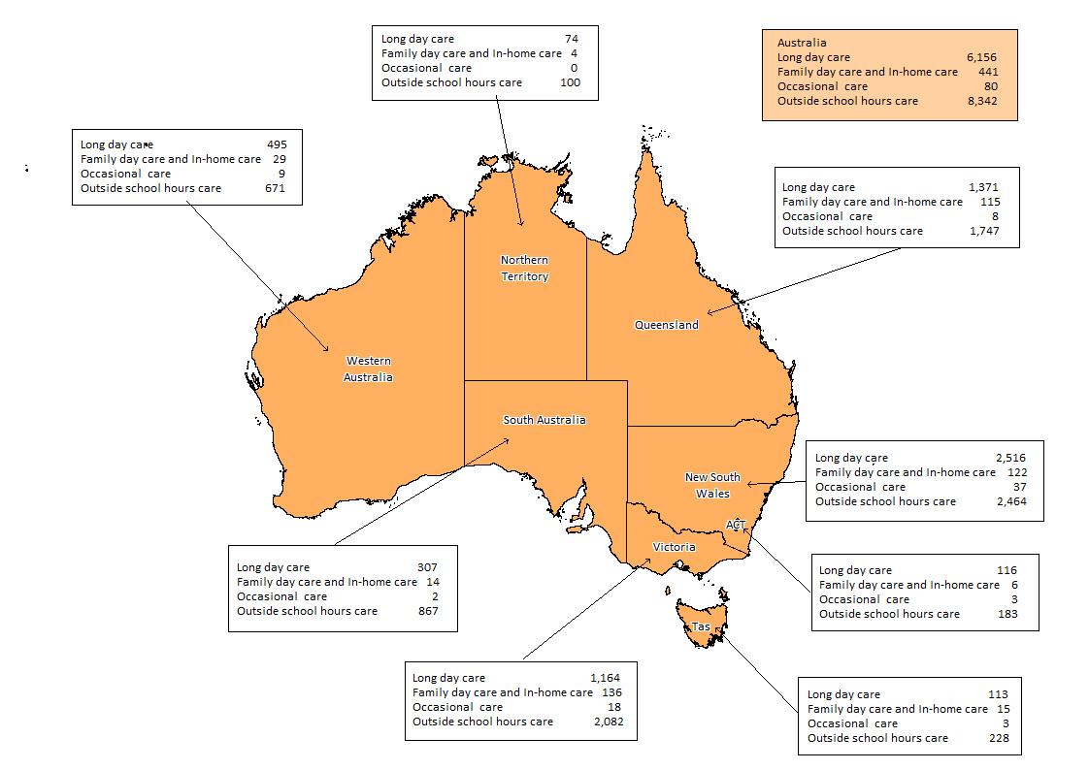
Source: DEEWR administrative data.

Costs of care

The Australian Government subsidises the cost of child care for eligible families through the Child Care Benefit and the Child Care Rebate to help parents with the cost of approved child care. From 1 July 2008, the Child Care Rebate increased from 30 per cent to 50 per cent of all approved out-of-pocket child care costs up to an annual cap of $7,500.

During the June quarter 2012, the total estimated expenditure on Child Care Benefit and Child Care Rebate was $1,023.6 million. Approximately three quarters (75.7 per cent) of this was paid on behalf of families using long day care services (Table 8).

Table 8: Total estimated Child Care Benefit and Child Care Rebate entitlements by service type, June quarter 2012
Service type | Child Care Benefit  (‘000) | Child Care Rebate  (‘000) | Total  (‘000)
Long day care | $381,621 | $393,036 | $774,656
Family day care and In-home care | $110,148 | $40,838 | $150,986
Occasional care | $1,434 | $1,626 | $3,061
Outside school hours care | $42,904 | $51,959 | $94,863
Total¹ | $536,109 | $487,461 | $1,023,569
¹ Total for the June quarter 2012 includes a very small number of families for whom other details are unknown.
Source: DEEWR administrative data – based on estimated entitlements.

Out-of-pocket costs to parents have fallen from 2004 to 2012 across the income spectrum. In 2004, the out-of-pocket cost, after Australian Government subsidies, for a family with one child in long day care and earning a gross income of $55,000 a year were 13.2 per cent of disposable income. In 2012, this proportion had declined to just 8.6 per cent. For families with a gross annual income of $115,000 the proportion of disposable income spent on child care declined from 11.4 per cent in 2004 to 8.6 per cent in 2012 (Figure 2).

Figure 2: Out-of-pocket costs as a proportion of disposable income in long day care by selected family income ranges, 2004 and 2012
Source: DEEWR administrative data.
Note: This graph depicts families with one child, using 50 hours of care per week, paying the average cost for long day care in a reference week in the March quarters of 2004 and 2012. Data for gross family income of $150,000 n/a for 2004.

Figure 3 presents the out-of-pocket costs (before and after Australian Government subsidies) for families with one child using long day care for 50 hours of care per week. Before subsidies, out-of-pocket costs varied from 39.7 per cent of weekly disposable income for families earning a gross income of $35,000 per year, to 15.4 per cent for families earning a gross income of $150,000 per year. After subsidies, out-of-pocket costs were significantly reduced to around 9.0 per cent of disposable income across all income ranges.

Figure 3: Out-of-pocket costs for one child in long day care before and after Australian Government subsidies, March quarter 2012
Source: DEEWR administrative data.

Technical Notes
General counting rules

Use of child care services is counted for each individual child using approved child care services. An instance of child care usage is defined as at least one child care attendance per child care service for the quarter irrespective of duration or frequency. For example, a single hour at an occasional care centre or 40 hours per week throughout the quarter at a long day care centre, are both counted as an instance of child care usage.
Children and families are recorded for each of the service types that they use during the quarter. Children and families using more than one service type during the quarter or financial year are counted only once within each applicable service type category and only once within the ‘Total’ category for the relevant time period. Note that as children and families may use more than one service type in any particular time frame the sum of the component parts may not equal the ‘Total’ category.
Changes in service type numbers need to be understood in the context of counting rules. Prior to the implementation of the Child Care Management System (CCMS) all services with an ‘active’ status were included regardless of attendance. This resulted in a small number of services being included in the data that did not actually have any children in attendance. Under CCMS a service is counted as ‘active’ only if it had at least one child attending at some time during the quarter, thus aligning the counting rules for children, families and services.

Data sources

Data included in this report comes from the following sources:
- From the September quarter 2011 the majority of data is extracted from the Child Care Data and Reporting System (CCDARS). CCDARS is a DEEWR based data storage system for data collected from approved child care services via the Child Care Management System.
- For data for previous quarters, the majority of data is extracted from the Centrelink Mainframe. Supplementary data is sourced from the FaHCSIA Online Funding Management System (FOFMS).

Revisions: Due to changes in the administrative system, data may be revised to ensure the most accurate, up-to-date figures are published.

Definitions

Approved care: Care provided by long day care, family day care, in-home care, outside school hours care and occasional care services approved by the Australian Government to receive Child Care Benefit on behalf of families.

Child Care Benefit (CCB): A payment made by the Australian Government to families to assist with the cost of child care.

Child Care Management System (CCMS): This is the electronic system used for the administration of CCB. Under CCMS, approved child care services submit attendance information to DEEWR over the internet. Data in this report are primarily sourced from CCMS.

Child Care Rebate (CCR): A payment made by the Australian Government to assist eligible working families with the out-of-pocket cost of child care. CCR is calculated based on the gap between the fees charged by the child care service and the CCB paid in respect of fee relief. Families who satisfy the work/training/study test requirements may be entitled to receive CCR for 50 per cent of all out-of-pocket costs up to an annual cap.

Family day care: A family day care scheme is a network of experienced caregivers who provide care and development activities for other peoples young children in the caregiver’s own home. Schemes are administered and supported by central coordination units.

In-home care: A form of approved child care in which experienced caregivers provide care for children in their own home.

Long day care: This is a centre-based form of child care service. Long day care services provide quality all day or part-time care for children of working families and the general community.

Occasional care: This is a care type mainly for non-school aged children. These services cater mainly for the needs of families who require short-term care for their children.

Outside school hours care: Services provide care for school aged children before and/or after school during the school term. Some services also provide care on 'pupil free' days. Vacation care is also included in this category. Vacation care services provide care for school children during the school holidays.

Region: Regions of Australia are classified according to the Australian Bureau of Statistics, Accessibility/Remoteness Index of Australia (ARIA) 2006. For more information on ARIA, please refer to ABS publications Australian Standard Geographical Classification (ASGC) 2006 (cat. no. 1216.0) and Information Paper: ABS Views on Remoteness 2001 (cat no. 1244.0).

Service: Child care services are approved by the Australian Government to receive CCB on behalf of families. Most long day care, family day care, before and after school hours care, vacation care services and some in-home care and occasional care services are approved child care services. Private operators, local councils, community organisations, employers or non-profit organisations may run these services. The total number of services refers to the number of services that were active during the June quarter 2012, that is, they had at least one record of child care attendance in the quarter.

_____________________________________________________________________________________________________
© Commonwealth of Australia, 2013
This work has been produced by the Department of Education, Employment and Workplace Relations (DEEWR) on behalf of the Australian Government. Apart from any use permitted under the Copyright Act 1968, no part of this publication may be reproduced by any process without written permission from DEEWR.
Cataloguing title: Child Care Update, June quarter 2012. ISBN: 978-0-642-78735-4

Comments and suggestions regarding this publication are welcomed and should be forwarded to DEEWR.
Published by DEEWR
ABN 87 007 967 311
Level 2, 17 Moore Street, Canberra ACT 2600
GPO Box 9880 Canberra ACT 2601, Australia
Web: DEEWR Email: childcare.data@deewr.gov.au

