


University Research
Commercialisation
  - ACTION PLAN

Copyright
ISBN 978-1-76114-007-5 [PDF]
ISBN 978-1-76114-004-4 [DOCX]
ISBN 978-1-76114-005-1 [Print]

With the exception of the Commonwealth Coat of Arms, the Department’s logo, any material protected by a trade mark and where otherwise noted all material presented in this document is provided under a Creative Commons Attribution 4.0 International (https://creativecommons.org/licenses/by/4.0/) licence.
The details of the relevant licence conditions are available on the Creative Commons website (accessible using the links provided) as is the full legal code for the CC BY 4.0 International (https://creativecommons.org/licenses/by/4.0/legalcode).
The document must be attributed as the University Research Commercialisation Action Plan.

Contents
Contents 3
Minister’s foreword 6
Acknowledgement of panel 7
Executive Summary 8
1 Increasing research commercialisation is critical for our national interest 13
2 Building Australia’s commercialisation future 30
3 Reform area: Put national priorities at the core of government funded research 39
4 Reform area: Accelerate commercialisation through two new priority-driven schemes 45
5 Reform area: rebalance the focus of existing research programs 57
6 Reform area: Build a bedrock of collaboration 76
7 Monitoring and evaluation of our success 83
8 Implementation and next steps 87
Appendix A: Consultation to develop the Action Plan 89
Appendix B: Glossary of terms 91

List of figures
Figure 1: National Manufacturing Priorities 9
Figure 2: Indicators on research, translation and commercialisation 15
Figure 3: Growth in R&D spending through time (index) 16
Figure 4: Higher education research expenditure ($b) 17
Figure 5: Total academic publications 17
Figure 6: R&D spending as a proportion of GDP, 2017 18
Figure 7: Business and higher education research expenditure by field of research, 2018 21
Figure 8: The ‘three P’s’ (Participation, Population and Productivity) of economic growth 23
Figure 9: Australian businesses by employment size range, 2018 26
Figure 10: Business enterprise researchers as a percentage of national total, 2018 28
Figure 11: Australian research workforce by sector 28
Figure 12: Imperatives for the Australian research ecosystem across sectors 31
Figure 13: R&D spending by sector and type (2018-2020) 32
Figure 14: Key success factors drawn from international experience 34
Figure 15: Australian Government competitive grant research allocation by subject area, 2016 41
Figure 16: Definitions of research commercialisation activities by methodology 46
Figure 17: Total research expenditure (all sources) by type (%, 2018) 47
Figure 18: Visual representation of Australia's Economic Accelerator 51
Figure 19: Visual representation of example projects in Australia's Economic Accelerator 52
Figure 20: Higher Education Expenditure on Research and Development (HERD) 58
Figure 21: International student numbers, 2002–2020 60
Figure 22: Source of university research spend, $m, 2018 61
Figure 23: Research programs mapped by prioritisation and stage-gating 62
Figure 24: Current RBG arrangement 64
Figure 25: Industry PhD and fellowship initiatives 78
Figure 26: Career pathways available under new industry PhD and fellowship initiatives 79
Figure 27: System-wide objectives and success factors 84
Figure 28: Developing program-specific key performance indicators 85

List of tables
Table 1: Gross expenditure on R&D by sector, 2010-11 – 2019-20 14
Table 2: Indicators of business collaborating on innovation with higher education institutions 19
Table 3: World Economic Forum’s ranking of countries on entrepreneurial risk and university–industry collaboration in R&D, 2019 19
Table 4: List of National Manufacturing Priorities Roadmap 10-year goals 40
Table 5: Key features and benefits of AEA 48
Table 6: University world ranking considerations and weightings 58
Table 7: IP-related constraints to successful commercialisation and collaboration 70
Table 8: Key elements of the HERC IP Framework 72

Minister’s foreword
In a rapidly changing, highly competitive global economy, Australia’s future prosperity lies in leveraging the excellence of our research sector. Australia has world-class universities and our researchers produce pioneering foundational research. Millions of people around the world rely on technologies and products that were made possible by Australian research breakthroughs. Too often, however, this research is not taken further down the pipeline towards production here in Australia and too often Australian universities and businesses are missing out on opportunities to commercialise Australian research in ways that benefit our economy and our society.
The Australian Government’s University Research Commercialisation Action Plan (Action Plan) lays out a comprehensive set of reforms to boost collaboration between universities and industry and drive commercial returns. This will be achieved through new ground-breaking initiatives, like the Trailblazer Universities Program and Australia’s Economic Accelerator, which will act as catalysts for change. It will also be driven by changes within the current research system to ensure that incentives and signals are all aligned to this end.
Research excellence does not happen in a vacuum; it requires a systemic, whole-of-government approach. The Government's Modern Manufacturing Strategy has set out clear priorities and leverages our strengths and resources to build new sources of growth. Medical products, food and beverage, recycling and clean energy, resources, technology and critical minerals processing, defence and space have been identified as 6 areas where Australia has significant comparative advantage and capacity to harness new opportunities. Aligning the Action Plan to these priorities means we can focus investment in sectors where Australia can build scale and have a real impact.
The Action Plan leverages the Government’s Digital Economic Strategy, which lays the foundation for Australia to be a leading digital economy by 2030; and the Action Plan for Critical Technologies, which is working to protect and promote critical technologies in Australia’s national interest. The Action Plan also builds on significant work to develop the 2021 National Research Infrastructure Roadmap, which sets out Australia’s research infrastructure capability and opportunities over the next 10 years.
This package of strategic reforms is informed by the excellent work of the University Research Commercialisation Expert Panel, led by Mr Jeff Connolly, Chairman and CEO, Siemens Australia. This panel represents a wealth of experience and expertise from the business, research and technology sectors. This group has been instrumental in providing advice informed by real world experience of what works and where critical change is needed. I extend my deep thanks to the members of the panel for their dedication and contribution to the future of Australia.
This Action Plan will ensure Australia’s universities play a bigger role in our economy, working hand in glove with Australian businesses to develop the next generation of great Australian products and companies.
The Hon Stuart Robert MP
Acting Minister for Education and Youth

Acknowledgement of panel
It has been a pleasure to chair the University Research Commercialisation Expert Panel ¬– a group of dedicated individuals, each of whom brings their own wealth of experience and expertise in the university, research, science translation and commercial arenas.
The panel was charged with the responsibility of providing advice to the Australian Government on how to improve the commercial returns from Australian research. Looking at the many examples of commercialisation success that have emerged from Australian university research, and the many institutions which have forged close ties with industry, it was clear to the panel that the question was how to accelerate that activity, build on the excellent foundation that already exists in our university sector and ensure that systemic opportunities are there for every researcher who wants to pursue a commercial opportunity.
It was very quickly apparent that a single program was not the solution to this issue and that a more strategic and systemic approach was required. The result is the broad-ranging reforms outlined in this Action Plan.
It was also very clear to us that the best outcomes for Australia’s economy and people will come from new approaches from government, within universities and from business and industry. This Action Plan commits the Australian Government to shifting the dial to place more emphasis on the translation and commercialisation of research. We know that many universities are well placed to respond to the signals and incentives that the initiatives in this Action Plan create; and trust that the system as a whole is ready to shift in this direction. This leaves business and industry. The reforms in this Action Plan will create a wealth of opportunities for business and industry to leverage our world-class research system and create genuine partnerships with universities and researchers. It is in their competitive interests to access those opportunities.
While every member of the panel brought the full weight of their experience to the challenge of advising Government on these matters, it was important that our advice reflected the full range of experience in the sector, was evidence based and drew on best practice globally. To this end, the panel was informed by a public submission process which received over 170 submissions, over 80 meetings and round table discussions, and 15 analytical studies commissioned across a range of topics. It was on this basis that we felt well positioned to make recommendations for the introduction of a series of complementary measures to improve the frequency of research commercialisation.
Mr Jeff Connolly
Chair
University Research Commercialisation Expert Panel

Executive Summary
The University Research Commercialisation Action Plan (Action Plan) will see our universities and businesses partner together to release the untapped potential of Australian research.
Research is critical to economic growth and productivity. Australia’s research system is world class, with 85 per cent of Australian research rated at or above world standard. Australian universities have established their reputation for research excellence and many institutions have placed a priority on engagement and translation.
Despite these efforts, while Australia produces world-leading foundational research, we currently underperform in achieving commercialisation outcomes. This limits the economic impact of our universities and shrinks the return on investment from publicly funded research. Too often, research that could be used to benefit our economy and communities is not taken through to innovations which can create new products and services, create jobs and lift productivity in businesses. In addition, most incentives for universities place greater emphasis on the number of research publications and citations over research outputs and commercialisation.
Local commercialisation success stories, as well as international examples, have demonstrated that prioritised investment and the right policy mechanisms produce strong results.
To capitalise on the potential of our research, the Action Plan will drive reforms in 4 key areas:
- Put national priorities at the core of Australian Government funded research
The goal of the Action Plan is for universities, industry and Government to partner on effective research through an aligned and prioritised investment across sectors. To achieve this the University Research Commercialisation reforms will focus research effort on the 6 National Manufacturing Priorities identified in the Modern Manufacturing Strategy. This will align research focus and industry demand and reduce fragmentation of research and development (R&D) activity across the country.
Figure 1: National Manufacturing Priorities
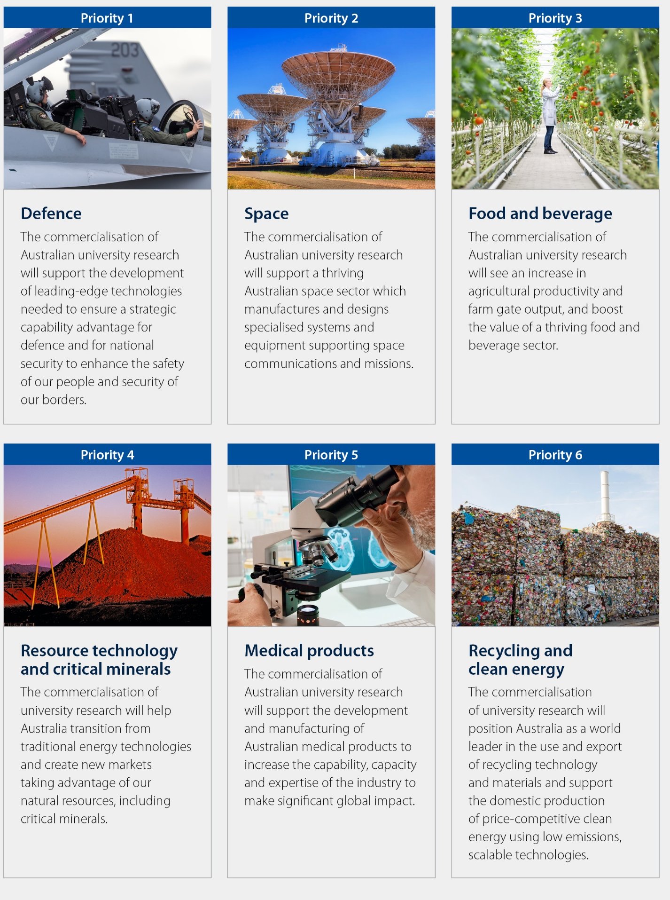

- Invest in 2 new priority-driven schemes to ramp up commercialisation activity.
Establishing Australia’s Economic Accelerator (AEA) and expand CSIRO’s Main Sequence Ventures
A new $1.6 billion stage-gated program dedicated to funding translation and commercialisation in national priority areas, combined with a $150 million expansion of the Commonwealth Scientific and Industrial Research Organisation (CSIRO) Main Sequence Ventures, will fundamentally disrupt the research funding system by introducing Australian Government funding that is stage-gated, fast fail and prioritised.
The new programs will bridge the ‘valley of death’ – where early-stage research is frequently not progressed to later stages of development because of the risk and uncertainty about commercial returns. Without government intervention, new innovations and technologies will continue to stall in the valley of death.
Projects which receive Stage 1 funding under this new model will only receive funding to take them to the next stage, where they will compete again, needing to prove project viability and commercial potential. Stage 3 of the AEA will be operated through CSIRO’s Main Sequence Ventures, which will be expanded to catalyse venture capital investment in Australian R&D for high-value opportunities to be taken to market. At each stage fewer projects will be funded as only successful projects will progress from proof of concept to proof of scale and on to full commercialisation.
Trailblazer Universities Program
The program will deliver an injection of $243.5 million to support select universities to boost prioritised R&D and drive commercialisation outcomes with industry partners. This includes $30 million for participating universities to partner with CSIRO and access specialist equipment, enabling researchers to prototype and test technologies at scale.
Through the Trailblazer Universities Program the Australian Government will provide additional capacity to focus on the problems that matter to the nation by driving research excellence and real-world impact behind Australia’s National Manufacturing Priorities.
To be eligible, universities will need to commit to institutional reforms that stimulate university–industry collaboration and commercialisation, including intellectual property (IP) arrangements that are attractive to industry and clear promotional pathways for academic researchers engaging in commercialisation activities.
- Reform existing university research funding to strengthen incentives for genuine collaboration with industry.
The current arrangements that support university research and commercialisation will be prioritised towards commercialisation activities. This will include:
- adjusting $2 billion in existing university research funding to better incentivise collaboration and commercialisation
- creating a new IP framework for universities that will include standardised terms, clauses and agreements for collaboration on IP licensing, options and assignment, which will drive greater collaboration by universities and greater uptake of world-class Australian research outputs by Australian industry by addressing critical IP issues.
- Build a bedrock of key people across the sector who are skilled in university–industry collaboration.
Industry-focused PhDs and fellowships
The Government will establish a new suite of industry PhD and research fellowship schemes that span the research career pathway and add 1,800 industry PhDs and over 800 industry fellows over 10 years. This $296 million investment aims to fundamentally reshape the workforce of Australia’s universities.
The industry PhD and research fellowship schemes will encourage mobility and collaboration between university researchers and industry, build capacity and understanding of research translation and provide recognised university career paths at all levels.
Australian Government investment
In total the Action Plan will see $2.276 billion of new Australian Government funding over 11 years.


1
Increasing research commercialisation is critical for our national interest

Increasing research commercialisation is critical for our national interest

Australia’s research system is world class
Australian universities continue to deliver on their reputation for research excellence. Australia is responsible for 2.7 per cent of the world’s scientific output, while being home to 0.34 per cent of the world’s population. Also, 85 per cent of Australian research is rated at or above world standard, and our research strength is demonstrated in numerous areas including technology, medicine and health sciences, and mathematical sciences where over 90 per cent of research is rated at or above world standard.
The 2018 Excellence in Research for Australia evaluation shows that Australian universities continue to improve, with more disciplines rated at world standard or higher across the discipline spectrum since the 2015 round, during a period where the volume of research output also increased.

Importance of universities in research landscape
The importance of universities in Australia’s research landscape continues to grow:
- Over 80,000 people are devoted to R&D, working across 41 research-active universities and one higher education provider.
- Of the $36 billion invested per year in R&D in Australia, universities undertake around one-third of the R&D activity.
- The higher education sector is the strongest contributor to overall growth in R&D in Australia. Business remains the largest overall contributor to total R&D spending, but its dominance is steadily declining.

Table 1: Gross expenditure on R&D by sector, 2010-11 – 2019-20
 | R&D spending $m  (current prices) |  | Average growth (2010-11 – 2019-20 | % of total spending
 | R&D spending $m | Average growth (2010-11 – 2019-20 | % of total spending |  | R&D spending $m
Business | 18,007 | 18,171 | 0.1 | 58 | 51
Government  (direct R&D activities) | 3,833 | 3,384 | -1.4 | 12 | 10
Higher education  (including government R&D grants) | 8,161 | 12,714 | 5.0 | 26 | 36
Private non-profit | 914 | 1,333 | 4.3 | 3 | 4
Total | 30,915 | 35,602 | 1.6 | 100 | 100

Commercial outcomes do not match Australia’s research performance

Across Australia’s universities there are many commercialisation success stories and institutions that have increasingly placed a priority on engagement and translation. However, while Australia performs well in knowledge creation, rightly earning its reputation for research excellence, at a system level this knowledge is not translated into new products or innovations often enough.
Another indicator that there is scope to translate more of Australia’s research into new products or innovations is that most of the innovation introduced by Australian businesses is new to the business only and reflects a low degree of novelty. According to Organisation for Economic Co-operation and Development (OECD) data, only 11 per cent of ‘product innovative’ firms in Australia introduced new-to-market innovations in 2016−17, placing us 25th among the OECD countries. This suggests that Australia is an incremental innovator and adopts innovations from elsewhere rather than creating them.
Industry–ဓဓဓuniversity collaboration is a key mechanism for the translation and commercialisation of research. Notwithstanding the high potential returns, metrics on the extent of collaboration indicate that Australia needs to improve its performance in industry−university collaboration if we want better commercial outcomes.
Figure 2 reports on key metrics in research, translation and commercial outcomes, showing how Australia’s performance is lagging behind leading nations such as the United States (US), Canada and the United Kingdom (UK).

Figure 2: Indicators on research, translation and commercialisation
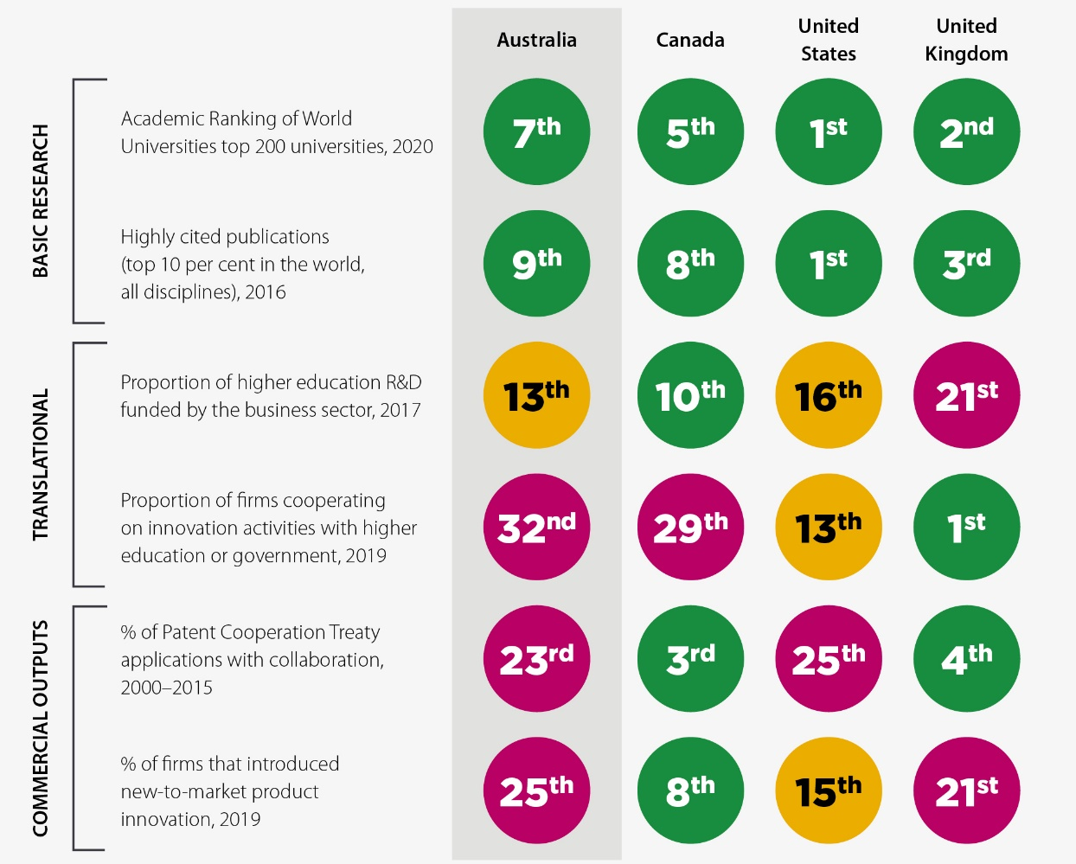
Industry continues to represent the largest share of total R&D spending in Australia, at $18.1 billion in 2019-20, followed by higher education ($12.7 billion), government ($3.4 billion) and the private and not-for-profit sectors ($1.3 billion). However, the dominance of the business sector in total R&D spending is declining, falling from 61 per cent in 2008−09 to 51 per cent in 2019−20, largely due to increased expenditure from the higher education sector and reduced mining R&D investment from 2014 (Figure 3).
Non-R&D innovation investment
Investment in non-R&D innovation is more widespread than investment in R&D innovation in Australia. For every Australian business that invests in R&D, more than 5 firms invest in innovation more broadly. Innovation beyond R&D plays a key role in many sectors.
Figure 3: Growth in R&D spending through time (index)
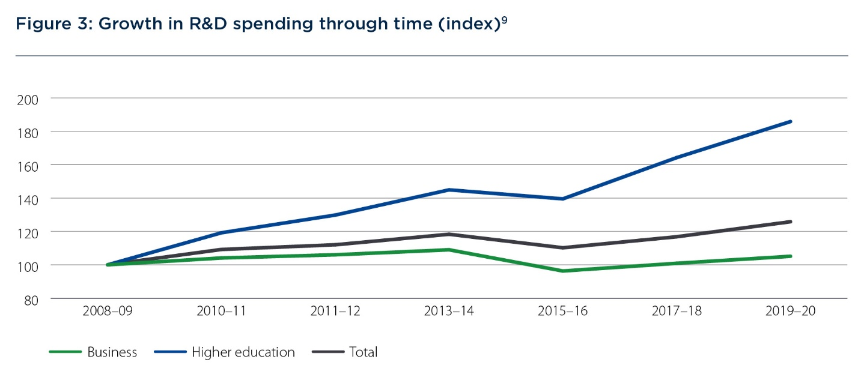
Figure 4: Higher education research expenditure ($b)
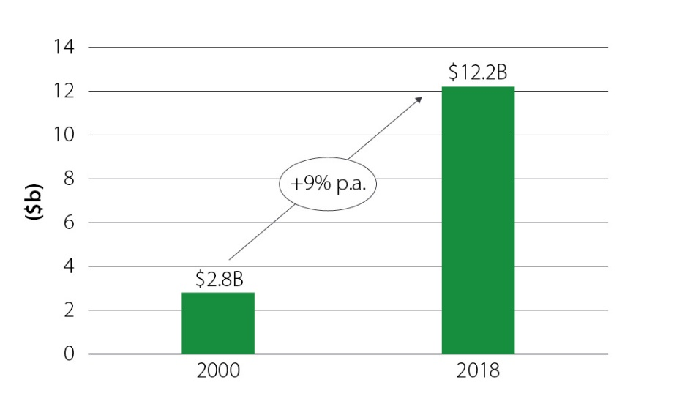
Figure 5: Total academic publications
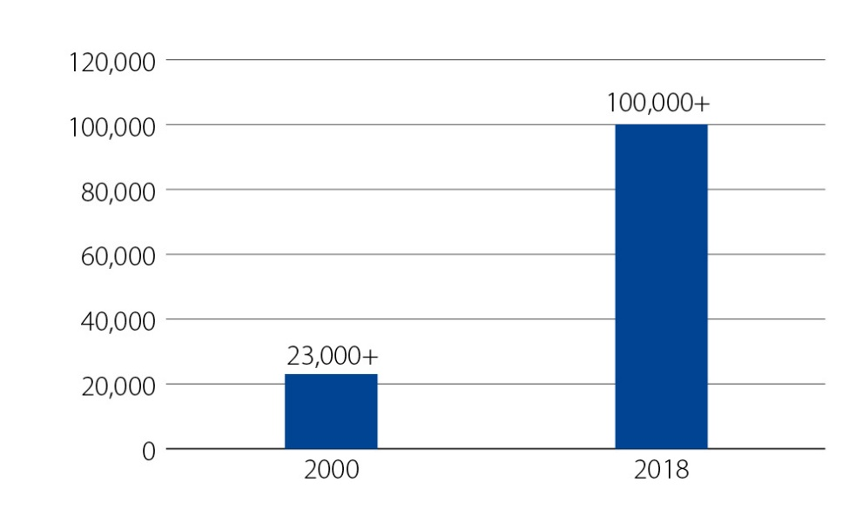
The Australian Innovation System Monitor points to Australia ranking last in the OECD for business collaboration on innovation with higher education or government institutions, noting ‘this reflects unfavourably on the ability of Australian businesses and research institutions to maximise the return on public investment in science and research’. Internal perceptions of university-industry collaborations within Australia are similarly low, ranking 40th on industry-university collaboration within the country in the World Economic Forum’s Global Competitive Index (Table 3).
There are signs, however, of a solid base to build on. A 2017 IP Australia report argued that patent data shows a different and more collaborative picture of Australia than the OECD data would indicate. An analysis of the proportion of Patent Cooperation Treaty (PCT) applications with university and industry co-applicants (for the period 2000-2015) places Australia 13th out of 35 countries, ahead of other OECD countries such as the US, the UK and Germany.

Barriers to industry investment in R&D and collaboration
R&D expenditure as a percentage of gross domestic product (GDP) in Australia fell from 2.2 per cent in 2008 to 1.8 per cent in 2017, sitting below the OECD 2017 average. Business expenditure on R&D is also low compared with other OECD countries - it is under 1 per cent of GDP, less than two-thirds of the OECD average of 1.67 per cent as a share of GDP. For comparison, businesses in Israel and South Korea invest over 3.5 per cent of GDP in innovation. The US and Germany invest just over 2 per cent of GDP.
Figure 6: R&D spending as a proportion of GDP, 2017
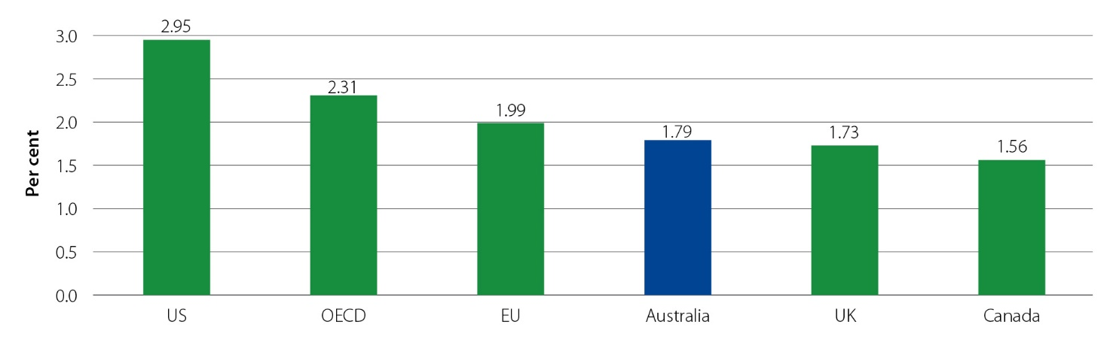

Table 2: Indicators of business collaborating on innovation with higher education institutions
 | Australia | OECD average
Innovation-active businesses collaborating with higher education or government institutions | 1.6 per cent of all product and/or process innovation-active business (2016-17) | 14.2 per cent
Higher education expenditure on R&D funded by businesses | 4.9 per cent of higher education expenditure on R&D financed by the business sector (2018) | 6.2 per cent
Innovation-active businesses that reported collaborating on innovation with Australian universities or other higher education institutions | 9.8 per cent (2018-19) | N/A
Table 3: World Economic Forum’s ranking of countries on entrepreneurial risk and university–industry collaboration in R&D, 2019
 | Attitudes towards entrepreneurial risk | Growth in innovative companies | University-industry collaboration in R&D
Australia | 36 | 28 | 40
Israel | 1 | 1 | 1
US | 2 | 2 | 4
UK | 10 | 19 | 11
Canada | 20 | 25 | 17

Misalignment between industry and university research

R&D values and culture across sectors
Differences in priorities, values and culture between sectors is one reason for the limited collaboration between industry and universities. Businesses report difficulties in engaging with universities, including cultural and skill set differences, barriers with IP, and regulation.
The differing priorities between universities and industry were highlighted throughout public submissions. Submissions indicated that value and culture mismatches exist between the 2 sectors, including universities’ focus on publications, the undervaluation of researchers by industry, lack of knowledge and capability of researchers to translate research, and differences in timeframes for research outcomes:
This ‘publish or perish’ mindset and model needs to be shifted to recognise the benefits that flow from applied and practical research and the role these can play in complementing more traditional approaches. To achieve this, there must be a fundamental culture change within Australian universities in relation to how academics are able to progress through their careers, for example, via applied research and the natural flow-on effect of improved and more effective research development.
- Cyber Security Cooperative Research Centre submission
Further, the fields in which research is undertaken varies between sectors. Higher education research is diversified, ensuring that effort and capacity is expended across all disciplines and fields of research. In contrast, business research expenditure is currently concentrated in specific disciplines with commercial potential, such as engineering, information technology and medical and health sciences (Error! Reference source not found. 7).
Figure 7: Business and higher education research expenditure by field of research, 2018
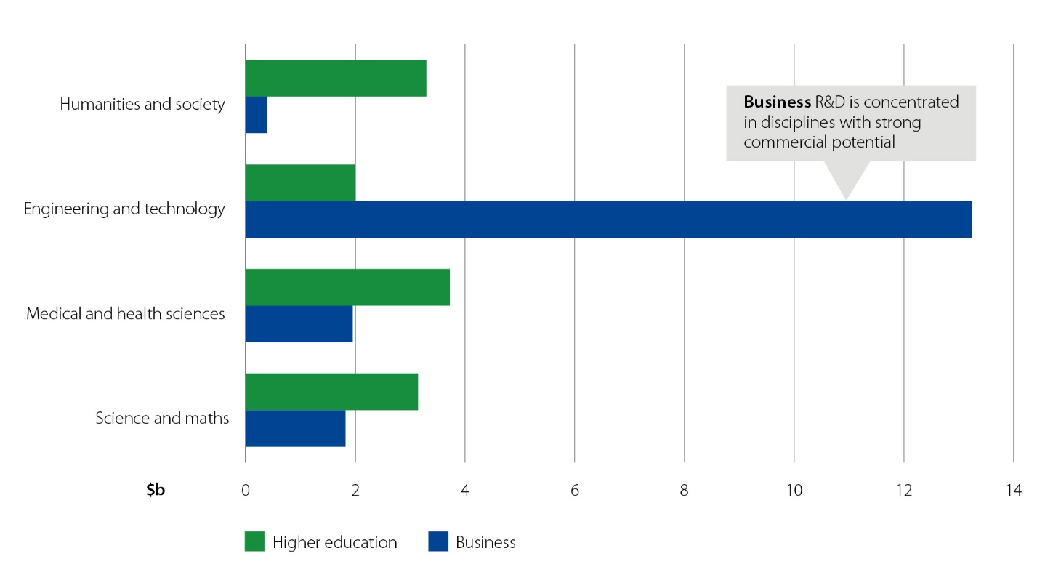
Another difference in priorities between universities and businesses relates to capturing the benefits of R&D. Industry and businesses tend to underinvest in R&D as they are unable to capture the benefits of their R&D exclusively. This is due to other firms also reaping the benefits of new technology which ‘spill over’ to the rest of the economy once released into industry.

Risk aversion in Australian business and higher education institutions
Risk and uncertainty in the costs, time and results of innovation are inherent in the nature of R&D activities. Australian business culture is fundamentally more risk averse than in countries that possess a stronger entrepreneurial culture. This risk aversion is a likely contributor to the lower rates of commercialisation and engagement activities in Australia.
Risk aversion in Australia
In Australia the share of adults prevented from starting a business by fear of failure (47.4 per cent in 2019) is above the OECD average (40.4 per cent) and countries such as Germany (29.7 per cent) and the US (35.1 per cent).
This aligns with the results from the World Economic Forum in which Australia ranked 36th on attitudes towards entrepreneurial risk.
Further to this, Australian businesses focus on innovation with a low degree of novelty. Compared with other countries, Australian firms rank poorly on the proportion of firms that have introduced new-to-market products in manufacturing and services (22nd and 14th out of 28 OECD countries, respectively). The new-to-business innovations undertaken by Australian businesses are often adaptations or modifications of other innovations and may require little or no R&D.

The case for reform
To support long-run economic growth as Australia recovers from COVID-19, Australia’s outstanding research outputs need to be better translated and commercialised so that Australian innovations can be utilised to create new jobs, companies and wealth.
With the resources investment boom easing, and our population ageing, Australia needs new sources of economic growth. Australia’s biggest growth opportunities will come from knowledge-intensive companies that develop new and better products for export. These companies have the potential to be profitable, internationally competitive and productive, and can make a substantial contribution to new jobs growth in Australia:
The creation and adoption of knowledge, ideas, products, processes and ways of doing business – in short innovation – are critical for maintaining Australia’s high standard of living, ensuring its ongoing international competitiveness, creating jobs and delivering future economic prosperity.
- Productivity Commission
The 2021 Intergenerational Report projects that, as has been the case over the past 40 years, productivity improvements will be the primary driver of growth in real GDP per person for the next 40 years (Figure 8).

Figure 8: The ‘three P’s’ (Participation, Population and Productivity) of economic growth
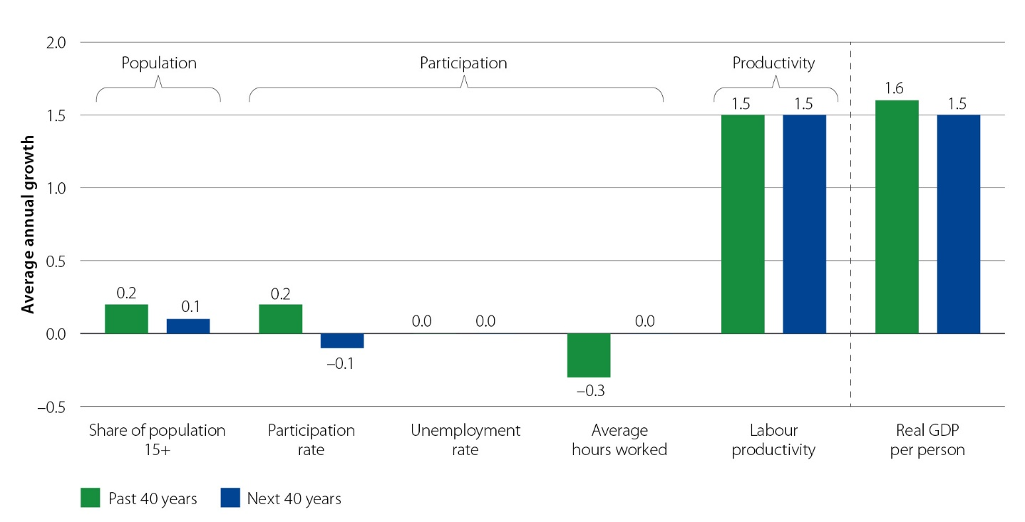
Notwithstanding the longer-term trends shown above, productivity growth in Australia has fallen considerably in recent years. Even excluding 2019-20 (and therefore the effects of COVID-19), the past decade of economic growth has been the slowest in 60 years on a per person basis. The slowdown in productivity growth in Australia is consistent with that experienced in most other advanced economies, suggesting that some global factors are contributing.
Productivity slowdown
While some argue that the global productivity slowdown is due to the reduction in innovation and technical progress, others argue that the productivity slowdown is due to the slow speed of technology diffusion from firms at the frontier of global productivity to laggard firms.
OECD analysis suggests that new technologies developed at the global frontier are spreading at an increasingly fast pace across countries, but spreading increasingly slowly to all firms within an economy. Technologies seem to be adopted by national frontier firms, and only diffuse to laggards once they are tested by the leaders and adapted to country-specific circumstances.
As in other countries, business dynamism has declined in Australia. Entry rates have fallen, and the share of economic activity done by young firms, which often drive innovation, has fallen. People have become less likely to switch jobs, with the lack of new firms appearing to be an important factor.
If further R&D collaboration is facilitated, a faster catch-up process will occur for laggard firms (firms in the bottom 40 per cent of productivity) very far from the national frontier, while firms close to this frontier keep pace with it.
Improvements in productivity come in many forms, but one of the key drivers is successful R&D. Research leads to the development of new technology and knowledge which, if commercialised and diffused through the broader economy, can raise returns on investment, lead to new industries being established and create jobs and economic growth. Translating research into new innovations and technological advances also benefits society in areas such as improved health care, more sustainable resource management and more liveable cities:
The use of research to stimulate better outcomes across business, government and not for profit services is essential for an effective research system. It is based in research productivity, the capability of university and researchers to pursue knowledge and its uses, directing resources and effort at new areas for development and responding to opportunities that emerge.
– Innovative Research Universities submission
Slower global growth will weigh on Australia’s productivity growth, but domestic policy can have significant impacts on productivity growth, incentivising and facilitating innovation and diffusion of technologies, removing barriers to resource reallocation and formation of trade linkages, and ultimately moving Australia closer to the global productivity frontier.
Over the last 10 years, spending on R&D by universities has grown rapidly, while industry investment in R&D has remained broadly constant. The imperative for industry to partner with the higher education sector and boost the commercialisation of its research has therefore never been greater:
As researchers and entrepreneurs move between sectors, so too do ideas and they gravitate to the best uses.
- University researcher submission

Return on collaboration
Industry-university collaboration is a key mechanism for the translation and commercialisation of research. Cross-sector collaboration has been modelled as resulting in $10.6 billion in revenue for businesses, representing a return on investment of $4.50 for every dollar invested in collaborative research with a university. Such a return on investment adds $26.5 billion to the Australian economy and supports 38,500 full-time jobs.
The development of new technology and knowledge can also improve production processes, reduce costs or create better or innovative new products for export. As Industry Innovation and Science Australia notes:
“Australia is part of a global innovation race, and we need to step up our pace to avoid being left behind other countries.”
- Industry Innovation and Science Australia
The Australian Government will invest $11.8 billion in R&D in 2021−22, with $3.7 billion of this investment going to the higher education sector. This investment, combined with the efforts of Australia’s 42 universities, has resulted in excellent research output in Australia. However, current efforts to pursue the commercial application of that research and to ensure that Australian business and industry are at the forefront of emerging technologies are not sufficient. More can be done to commercialise our research outputs and to establish genuine partnerships between universities and industry. The Australian Government is committed to working with universities and Australian businesses to rebalance this focus to create more benefit for the nation.
To leverage the investment that universities and Australian businesses make, the Australian Government is also aligning the research commercialisation with other key Government initiatives to ensure a whole-of-government approach. Key cross-government strategies that underpin this Action Plan include the Modern Manufacturing Strategy, which will allow our research excellence to be focused on areas of strength, and the Action Plan for Critical Technologies, which is working to protect and promote critical technologies in Australia’s national interest.

Australia’s business landscape
There is a need to ensure that the impact of innovation is spread across Australian businesses (at all levels), and that Australia has the workforce to support the research undertaken and the resulting commercialisation.
The Australian business landscape is dominated by small and medium enterprises (SMEs). As of 30 June 2021, 97 per cent of Australian businesses had fewer than 20 workers – 59 per cent with no employees and 39 per cent with 1 to 20 (Figure 9). The dominance of smaller firms presents its own challenge, as smaller firms tend to have diminished capacity for innovation due to a lack of financing and shortage of skilled labour. Most businesses with fewer than 200 employees spend less than $25,000 per year on innovation. Currently, a small proportion of large businesses are responsible for a large proportion of Australia’s industry–university collaboration effort, with most business R&D investment coming from large firms in a small range of sectors. The pattern of innovation in small businesses differs from that in large businesses. Smaller firms invest more of their limited innovation budgets in non-R&D than big firms do. About 5 times as many small businesses invest in non-R&D innovation as invest in R&D.
Figure 9: Australian businesses by employment size range, 2018
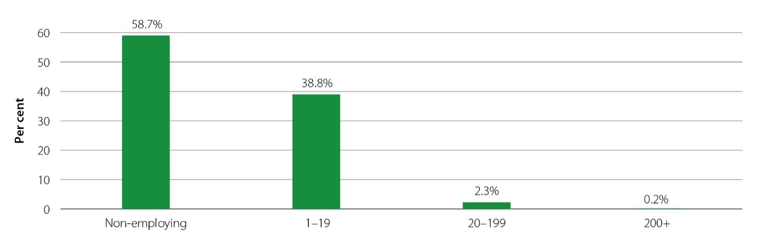
Innovative activity
A 2019 report released by the Australian Small Business and Family Enterprise Ombudsman reported that 63 per cent of large businesses are involved in innovative activity compared with 50 per cent of small businesses. Small business innovation activities are also on a downward trajectory, falling from 80 per cent in 2014.
It is often noted that, just as many universities lack the skills to engage with business, businesses often lack the skills and resources needed to collaborate with public sector research organisations. This is particularly an issue for SMEs which do not have the capacity to deploy the same resources to R&D and collaboration as larger firms. This was highlighted in submissions indicating that SMEs lack access to funding, equipment, and resources to undertake research and remain competitive. Public submissions also pointed to the complexities associated with negotiating collaboration agreements, where the use of IP is often a point of difficulty and the subject of protracted negotiation. Timing considerations are also particularly acute for SMEs, which often need R&D outcomes within a shorter timeframe than the university sector is accustomed to.
The CSIRO’s study SME Enablers and Barriers to Research found that, although science, technology, and collaborative innovation are key enablers for SME growth, there are significant barriers to collaboration. This includes limited funding, expectations and timing; bureaucratic processes within universities; concerns about IP; uncertainty about the value and risk of involvement; and differing motivations for collaboration.
SMEs need to allocate their limited resources carefully to ensure they support activities that have clear outcomes and benefits. Working with universities and research institutes is not usually considered by SMEs to be core to their business, and therefore it needs to be low risk.
Evidence shows these collaborations can be difficult to establish, and that SMEs have a lack of confidence in the ability of universities to understand their day-to-day problems and how to solve them. Collaboration can also be cost prohibitive, particularly when SMEs are expected to fund initiatives.
In spite of these challenges, collaborating SMEs were significantly more likely to introduce new innovations, especially in service and product development. These collaborations are important in providing a competitive edge and also enabling collaborating SMEs to better cope with uncertainty and change, like the disruption caused by COVID-19.

Geographical challenges
A unique challenge for Australian industry−university collaboration emerges from the geographical distance between businesses and universities. Research organisations are often situated in large metropolitan hubs, which makes engagement difficult for businesses that are spread across Australia. Businesses are more likely to collaborate on R&D if they are in proximal distance to other entities for collaboration.

Low proportion of researchers in industry and low researcher mobility
Another challenge for research commercialisation in the Australian landscape is the relatively low proportion of researchers in industry. Only 40 per cent of Australia’s researchers work in private industry − well below the OECD average and roughly half that of South Korea (Figure 10). On the plus side, despite slowing in recent years, there has been strong overall growth in the research workforce since 2006 (Figure 11).
The low number of researchers within businesses and the low mobility between industry and the university sector creates a capability asymmetry between the 2 sectors and reduces the ability for businesses to introduce innovations.
Figure 10: Business enterprise researchers as a percentage of national total, 2018
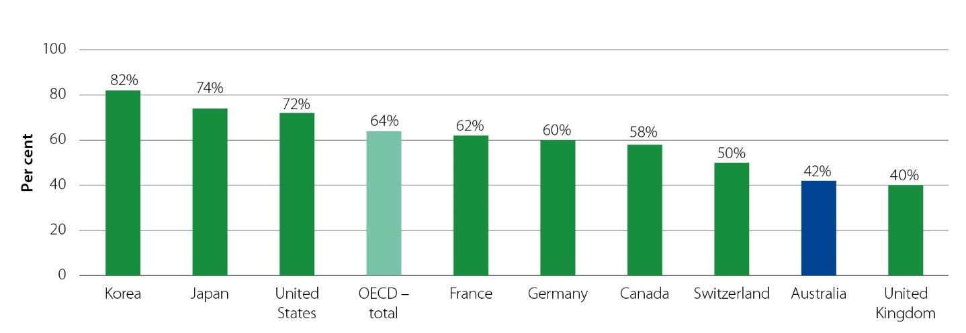

Figure 11: Australian research workforce by sector
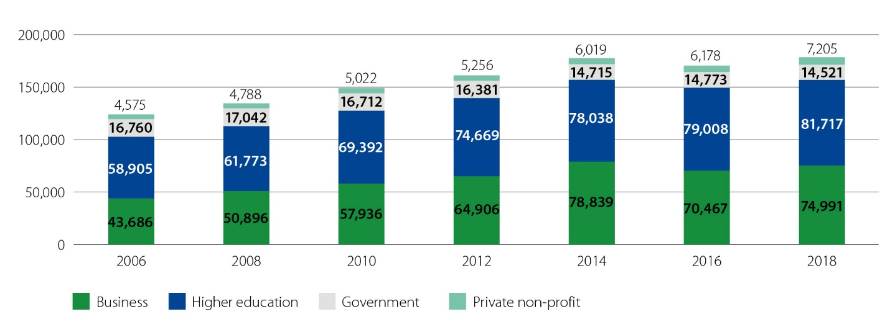

2
Building Australia’s commercialisation future

Building Australia’s commercialisation future

Shifting the dial to leverage research excellence to benefit all Australians
There are significant gains to be made for Australia from a strategic, targeted shift in focus, activity and attitude. The Government is focused on preserving those elements of the system which result in research excellence, while increasing the focus on commercialisation and impact. Shifting the dial on research commercialisation is about ensuring that appropriate resources and talent are dedicated to leveraging research excellence for the benefit of all Australians.
The research commercialisation ecosystem has many players with different priorities and practices and multiple interrelated incentives. The Government is aware that to ‘shift the dial’ it will be essential to consider the complex research ecosystem and institute a range of reforms that collectively create the right conditions to result in greater collaboration and commercialisation of university research in Australia.
Figure 12: Imperatives for the Australian research ecosystem across sectors
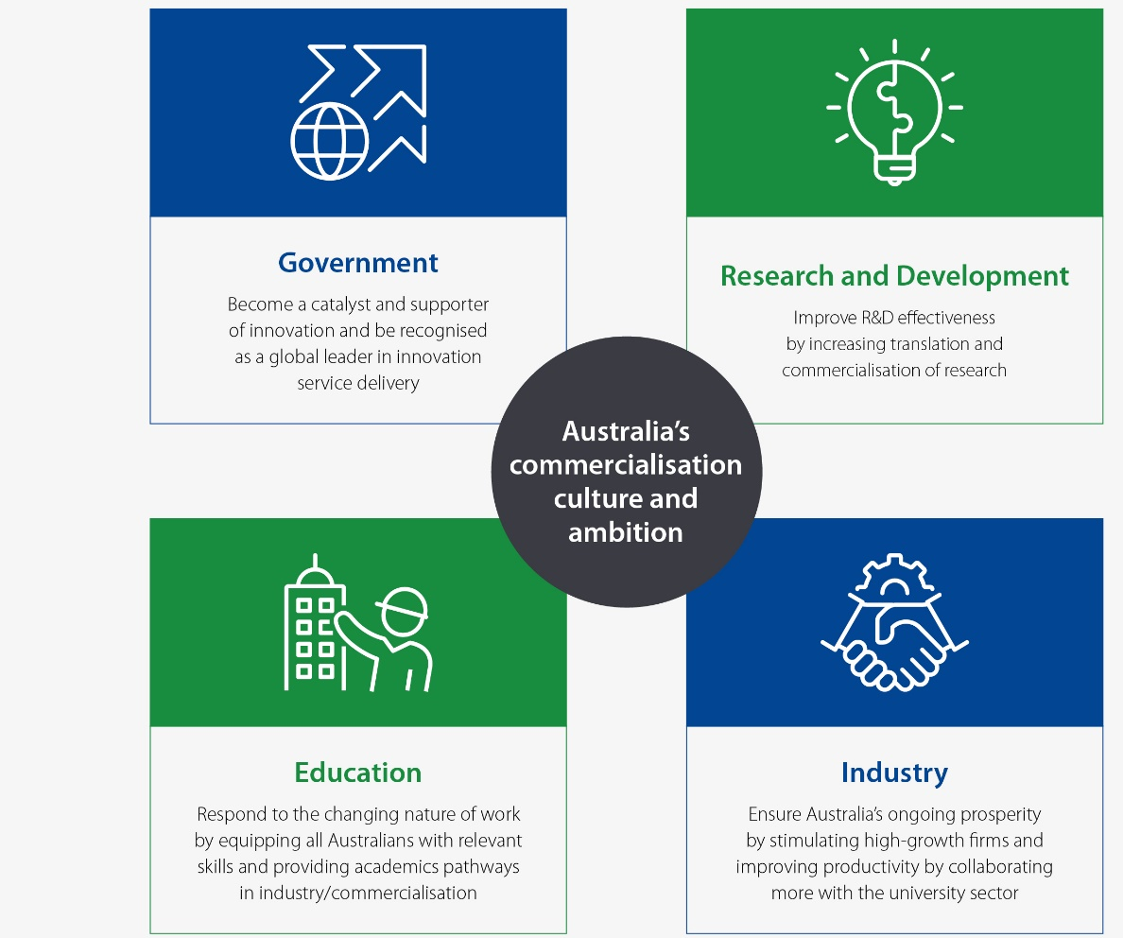

Universities need to have an internal focus on pursuing opportunities to collaborate with industry and commercialise research. This internal shift in university priorities must be reflected in changes to IP management and internal recruitment, promotion and recognition practices for researchers within academia.
Researchers within academia will respond to the new funding opportunities and incentive structures created within institutions to view industry engagement and translation and commercialisation activities as attractive and rewarding career opportunities. This will drive skill development within the sector. The ability to identify commercial potential, understand industry operating models and imperatives, and use ‘boardroom-ready’ communication will provide a competitive advantage.
Research in areas of national importance and economic potential will be prioritised, stimulating commercial ventures in these areas. The changed culture and practices within institutions will increase business appetite for collaboration and stimulate demand for collaboration and commercialisation partnerships.
The increased translation and commercialisation activity will drive economic growth, improving production processes, reducing costs and creating better or innovative new products for export. This will drive productivity gains in the wider economy. Australian taxpayers invest significant amounts in the work of Australian scientists. We make this investment on the premise that the work of our researchers contributes to global knowledge and will benefit our nation, through greater knowledge, prosperity, innovation, economic activity and environmental and social understanding. This is why we invest in science.
- Dr Cathy Foley, Australia’s Chief Scientist

Ensuring the research pipeline is supported
An important consideration is the need to maintain a solid base of investment in basic research, also called fundamental or blue-sky research. The OECD’s Frascati Manual, which outlines the methodology for collecting statistics about R&D, defines basic research as ‘experimental or theoretical work undertaken primarily to acquire new knowledge of the underlying foundations of phenomena and observable facts, without any particular application or use in view’.

Within the Australian context, universities undertake most of the basic research (90 per cent of pure basic research). Business investment in R&D is very much skewed towards the later stages of research.
Figure 13: R&D spending by sector and type (2018-2020)
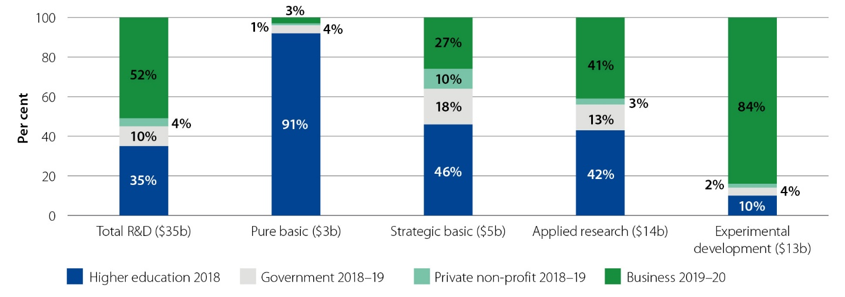
Many submissions strongly advocated for foundational research to be protected to ensure the commercialisation pathway is continually fed with high-quality research inputs arising from discovery. The Business Council of Australia demonstrated this broad view:
We must not let our basic research funding be supplanted by a renewed focus on commercialisation, but where additional resources are available for applied research: the more the better. A focus on research translation can drive further discovery, creating a virtuous cycle between applied and basic science.
- Business Council of Australia submission

Lessons from international experience
Strong feedback through public consultation processes, advice from the University Research Commercialisation Expert Panel and analysis of successful international programs has emphasised key success factors which contribute to commercialisation outcomes (Appendix A outlines the consultation process).
International programs range greatly in their methods and can provide an insight into how Australia can successfully drive innovation. Key programs considered include mission-driven research programs such as the US Small Business Innovation Research and Small Business Technology Transfer programs, Moonshot in Japan and the UK’s Catapult network of 9 innovation hubs; commercialisation funds such as the PreSeed Accelerator Fund in New Zealand; and research institutions such as the Fraunhofer research network in Germany.
There is no single commercialisation exemplar in Australia or internationally but, rather, common success factors (outlined in Figure 14) which have informed the development of this Action Plan.
Figure 14: Key success factors drawn from international experience
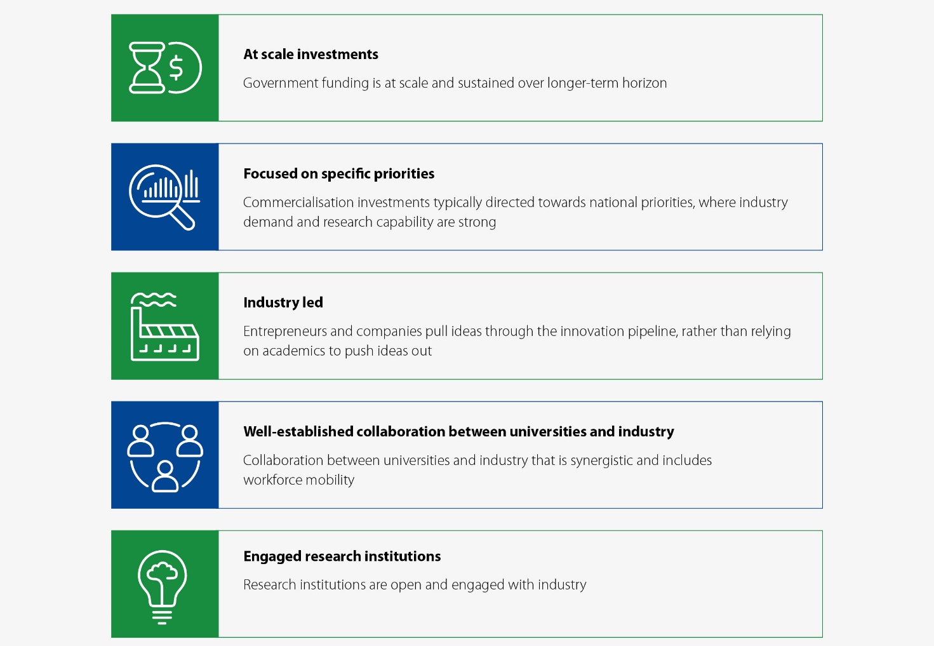

Small Business Innovation Research (US)
The Small Business Innovation Research (SBIR) program is a long-standing, mission-driven research program designed to fund SMEs to solve critical challenges and commercialise the research outcomes. Participating government agencies contribute funding to the program and in turn can set missions and award funding. A 2017 review found 45 per cent to 60 per cent of participants successfully commercialise through the program.
The SBIR program is stage-gated with 3 phases and funding for phases 1 and 2. Phase 1 applications for concept development are for 6 months to 1 year. Phase 2 applications for prototype development are for up to 2 years. Phase 3 is a step towards commercialisation: there is no SBIR funding; however, an agency may set an agreement for products, services or R&D with a Phase 1 or 2 awardee.
The mission of the SBIR program is to support scientific excellence and technological innovation through the investment of federal research funds in critical US priorities to build a strong national economy. The program’s goals are to:
- stimulate technological innovation
- meet federal research and development needs
- foster and encourage participation in innovation and entrepreneurship by women and socially/economically disadvantaged individuals
- increase private sector commercialisation of innovation derived from federal research and development funding.

Moonshot Research and Development Program (Japan)
The Moonshot Research and Development Program was created to promote high-risk, high-impact R&D to achieve ambitious Moonshot goals and solve issues facing future society. The intention is to build a portfolio of missions to promote R&D challenges without fear of failure. The portfolio will be reviewed by stage-gates and actively encourage utilisation of the R&D results.

Moonshot is a very new mission-driven program from Japan built on strong lessons and structures tested by its predecessor, the ImPACT program. It is highly inclusive of expert opinion and takes a collaborative approach to setting of missions through a symposium event. It encourages high-risk/high-reward projects as they are entirely government funded for the first 10 years.
The Moonshot goals are:
- Realisation of a society in which human beings can be free from limitations of body, brain, space, and time by 2050.
- Realisation of ultra-early disease prediction and intervention by 2050.
- Realisation of AI robots that autonomously learn, adapt to their environment, evolve in intelligence and act alongside human beings, by 2050.
- Realisation of sustainable resource circulation to recover the global environment by 2050.
- Creation of the industry that enables sustainable global food supply by exploiting unused biological resources by 2050.
- Realisation of a fault-tolerant universal quantum computer that will revolutionise economy, industry, and security by 2050.
- Realisation of sustainable care systems to overcome major diseases by 2040, for enjoying one’s life with relief and release from health concerns until 100 years old.

The Catapult Network (UK)
A ‘Catapult’ is a single innovation hub oriented to a specific industry mission or purpose. There are 9 Catapults in the network focused on different outcomes and each with an approach based on their specialisation, with a plan to add more by 2030.
The purpose of the Catapult Network is to bridge the gap between public and private organisations engaged in technology transfer from universities and other research organisations. Catapults are non-profit and funded by Innovate UK (a government program) to translate research to industrial and commercial impact.
The Catapult Network brings together 9 leading technology and innovation centres spanning over 40 locations across the UK. Each Catapult hub is themed around a priority ‘mission’ area of the economy that the UK Government wishes to stimulate. The mission areas are:
- Cell and Gene Therapy
- Connected Places
- Compound Semiconductor Applications
- Digital
- Energy Systems
- High Value Manufacturing
- Medicines Discovery
- Offshore Renewable Energy
- Satellite Applications.

Reform agenda
The reform package will deliver reforms in the 4 key areas below.
Put national priorities at the core of government-funded research
- Focus research effort on the 6 National Manufacturing Priorities identified in the Modern Manufacturing Strategy to align university research focus and industry demand and reduce fragmentation of R&D activity.

Accelerate commercialisation through 2 new priority-driven schemes
- Invest $1.6 billion over 11 years to establish Australia’s Economic Accelerator – a new stage-gated program dedicated to funding translation and commercialisation in priority areas.
- Expand CSIRO’s Main Sequence Ventures with an additional $150 million to take opportunities arising from Australia’s Economic Accelerator and make venture capital investments in companies linked to Australian R&D, continuing the channel for high-value opportunities to be taken to market.
- Commit $243.5 million over 5 years to support Trailblazer Universities to drive commercialisation wins (including IP, industrial relations and skills practices) by encouraging and incentivising universities which are early adopters with capabilities in priority areas.

Rebalance the focus of existing research programs
- Adjust $2 billion in existing university research funding to better incentivise commercialisation.
- Develop a new IP framework for universities that will include standardised terms, clauses and agreements for collaboration on IP licensing, options and assignment to drive greater collaboration by universities, and greater uptake of world-class Australian research outputs by Australian industry by addressing critical IP issues.
- Encourage universities to align researcher remuneration and promotion to research commercialisation outcomes.

Build a bedrock of collaboration
- Establish a suite of Industry PhD and research fellowship schemes that span the research career pathway and add 1,800 Industry PhDs and over 800 industry fellows over 10 years. This $296 million investment over 4 years will fundamentally challenge promotion and reward structures in Australia’s universities and encourage mobility and collaboration.


3
Reform area: Put national priorities at the core of government-funded research

Reform area: Put national priorities at the core of government funded research
Ambition | Our reform strategy
Australian Government investment in research is prioritised to focus effort and provide a catalyst for new commercial activity.​  Industry and universities have a common focus and there are incentives to participate in collaborative R&D.​ | Focus research effort on the 6 National Manufacturing Priorities identified in the Modern Manufacturing Strategy to align university research focus and industry demand and reduce fragmentation of R&D activity.

Lessons learned international demonstrate that a priority-driven approach:
- ensures funding will reach the scale required to accelerate commercialisation in key areas
- sends a strong signal to business that will generate higher private investment in R&D
- focuses research effort in areas with the greatest potential for economic impact.
As AlphaBeta found in its recent report on mission-driven research programs:
Governments may take a broader and longer-term view of priorities, they may be able to marshal more resources and expertise to determine priorities (e.g. by establishing panels of experts and industry), and because governments can be more prepared and willing to fund earlier and riskier ventures.
  - AlphaBeta
There are many international examples of governments setting national priorities for research investment (for example, Moonshot in Japan and Catapult in the UK) and examples where that concerted effort has led to significant step-change (for example, the US Small Business Innovation Research and Small Business Technology Transfer programs). The consultation paper submissions were overwhelmingly supportive of a priority-driven research model.
Focusing research effort in priority areas presents an opportunity to drive focus and collaboration in areas of activity critical to economic growth and sovereign capability. Linking commercialisation reforms to priority areas is important, as it will focus effort and ensure a connection between the supply of quality research and the demand from business for ideas and products to commercialise.
The global market is a competitive one and Australia will not win every race, but we can play smarter by targeting areas where we have a competitive edge.
- Business Council of Australia submission
The 6 National Manufacturing Priorities identified in the Modern Manufacturing Strategy are areas of established strength or emerging priority and have the potential for growth and to deliver long-term transformational outcomes for the Australian economy. Building world-leading R&D capability in the 6 priority areas will provide a catalyst for new commercial activity and ensure Australian industry is at the forefront of innovation in these areas.
The priority areas are:
- Defence
- Space
- Food and beverage
- Resources technology and critical minerals processing
- Medical products
- Recycling and clean energy
Table 4: List of National Manufacturing Priorities Roadmap 10-year goals
Priority | National Manufacturing Priorities Roadmap 10-year goal
Defence | More Australian businesses are contributing to local and international defence supply chains, while more Australian innovation and IP is contributing to products supplied to the Australian Defence Force and other markets.
Space | Greater end-to-end local manufacturer expertise, including designing, testing and launching products from Australia such as small satellites to low and medium earth orbits.
Food and beverage | Food and beverage manufacturing value has doubled, cementing Australia’s reputation as ‘world-best’ supplier and manufacturer of premium, safe and authentic food.
Resources technology and critical minerals processing | Australia seen as a regional hub for resources technology and critical minerals processing, with significant R&D advancements, retention in intellectual capital for SMEs and significant volume and value of exports.
Medical products | Australia has an international reputation for world-class medical products manufactured in medical precincts, with significant levels of end-to-end collaboration.
Recycling and clean energy | Growth in Australian R&D, design, production, sales and services will cement our position as a leading manufacturer of solutions to help Australia and the world transition to more sustainable energy and material systems.

While the National Health and Medical Research Council and Medical Research Future Fund have focused efforts on health and medical related fields, outside of health the Australian Government’s investment in research is fragmented (demonstrated in Figure ). Without funding at scale, it is difficult for an R&D pipeline to emerge and for business and industry to have the confidence to invest.
Figure 15: Australian Government competitive grant research allocation by subject area, 2016
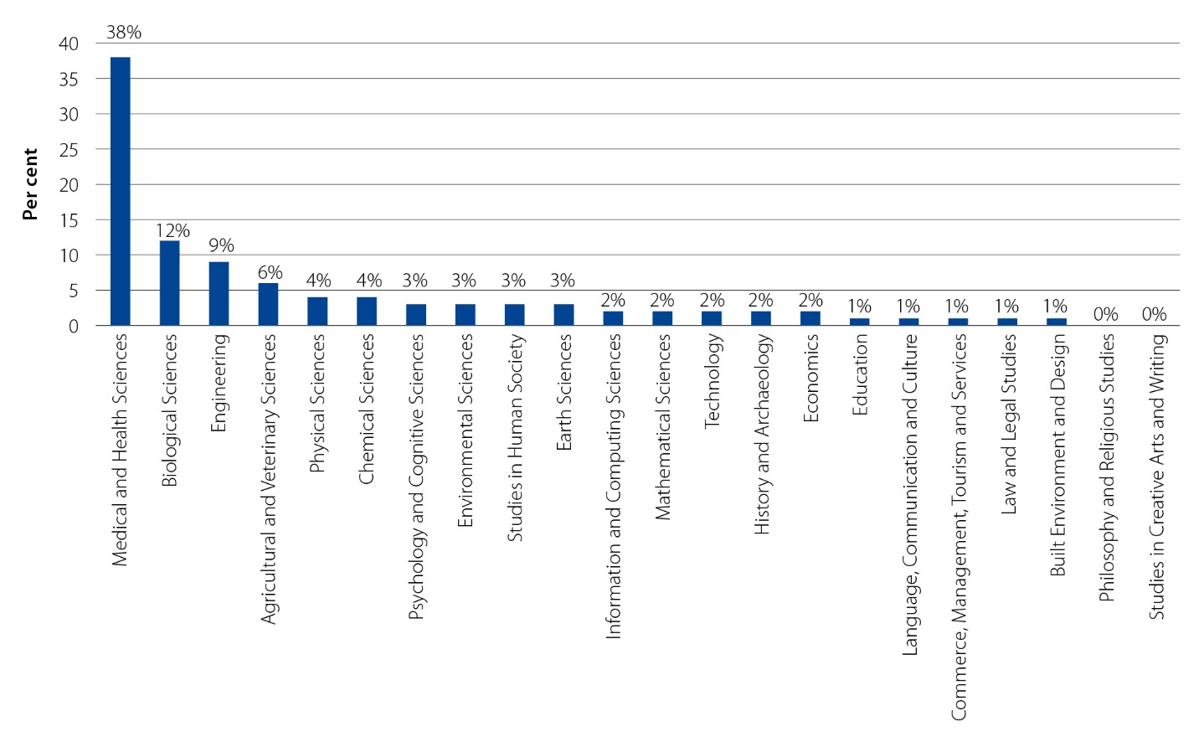
Initiatives such as the Government’s Low Emissions Technology Statement and Action Plan for Critical Technologies are paving the way for broader engagement with the National Manufacturing Priorities and recognise the vital role that universities can play in supporting core areas where Australia has competitive advantage.
Aligning the research commercialisation agenda towards the National Manufacturing Priorities, chiefly through the Trailblazer Universities Program and the AEA, will provide much-needed focus on these priorities and ensure the Government is fostering university and business collaboration. This complements the Government’s $1.3 billion Modern Manufacturing Initiative, which is providing co-funding for large manufacturing projects that have broad sectoral benefits across the priorities.
The Government will identify further opportunities to improve alignment to these priorities across the science, research, and innovation system, to ensure all possible levers to drive the National Manufacturing Priorities are engaged, including for critical enabling technologies. This includes changes to the Australian Research Council’s Linkage Program and the National Collaborative Research Infrastructure Strategy to strengthen alignment with the National Manufacturing Priorities outlined later in this Action Plan.
Implementation
- The success of aligning the research commercialisation agenda towards the National Manufacturing Priorities will be reviewed every 5 years and an annual report will outline progress in achieving research commercialisation.

Case Study
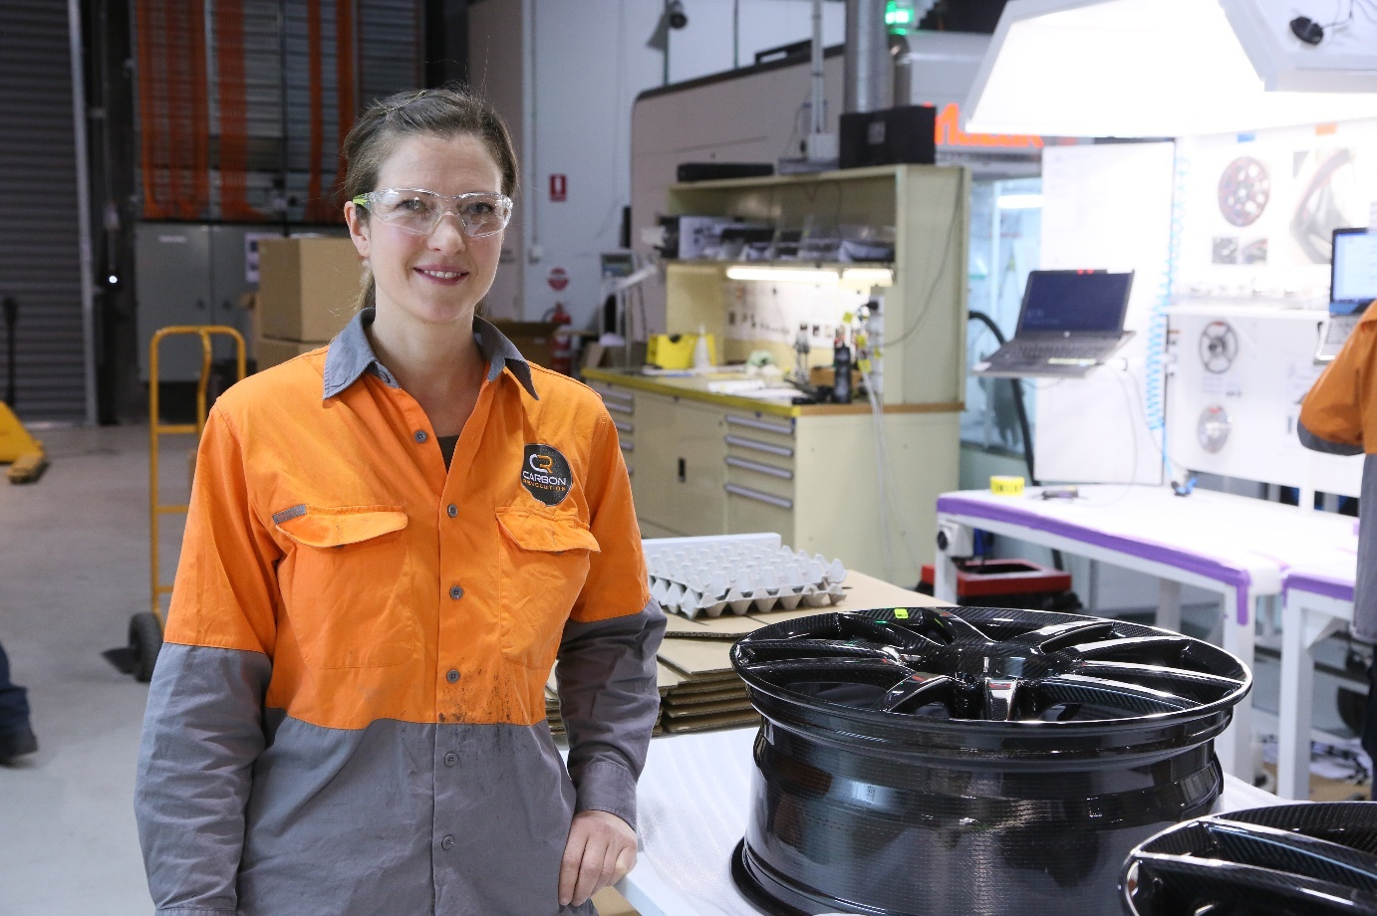
Photo: Supplied by Deakin University.
Deakin University at the heart of carbon fibre and composites manufacturing
The Deakin University campus at Waurn Ponds in Geelong is home to a growing carbon fibre and composites manufacturing precinct. The precinct includes manufacturing operations for several companies that supply to a wide range of markets, including automotive, industrial, sporting goods, medical and defence.
Within the precinct is a purpose-built research facility, Carbon Nexus, which is designed to accommodate the needs of manufacturing organisations to deliver cost-effective carbon fibre-related projects.
Through these facilities and partnerships, Deakin University is facilitating the development of market-ready innovations using the world’s first university-based carbon fibre line in a research environment.
‘It is truly the nexus of industry, research and teaching for the global carbon fibre community.’
In 2018 Carbon Revolution entered a $15 million R&D partnership with Deakin University. This partnership included access to testing facilities, IP and researcher knowledge on the transformation of carbon fibre production.
Carbon Revolution began its initial public offer on the ASX in 2019 with a market cap of around $300 million. Deakin remains a significant shareholder in Carbon Revolution, which continues to employ hundreds of staff on the Deakin Waurn Ponds campus.

Case study
Monash University manufacturing the future of 3D printing

Monash University has used its world-leading expertise in advanced manufacturing to build one of the strongest capabilities in laser-based additive manufacturing processes (3D printing) in the world through the Monash Centre for Additive Manufacturing (MCAM).

Through the MCAM, a company called Amaero Engineering was established to develop and commercialise products based on research by the Monash team. Since 2013, Amaero has grown to become a global player in 3D printing services - in particular, for the aviation and defence sectors.

Amaero International launched on the ASX in December 2019, raising a total $14 million, including a heavily subscribed internal public offering, with market value of nearly $35 million growing to approximately $75 million in the subsequent 10 months.

Specialising in additive manufacture of metallic components, Amaero started with a focus on the aerospace sector, manufacturing large-format complex metal components in Melbourne, Adelaide and California. The company works with the world’s leading aerospace and defence companies (including 6 of the world’s top 10 defence contractors). Partners include Boeing, Airbus, Raytheon, Northrup Grumman, BAE Systems, Safran, Thales Group and Virgin Australia. Amaero has now expanded to provide 3D manufacturing services, machines and specialist alloys to a global customer base across multiple industry sectors.


4
Reform area: accelerate commercialisation through two new priority-driven schemes

Reform area: Accelerate commercialisation through two new priority-driven schemes
Ambition | Our reform strategy
The research funding system supports research progressing through to commercial outcomes.  Research with commercial potential is utilised and not ‘left on the shelf’. | Invest $1.6 billion to establish Australia’s Economic Accelerator – a new stage-gated program dedicated to funding translation and commercialisation in priority areas.  Expand CSIRO’s Main Sequence Ventures with an additional $150 million as the final stage of Australia’s Economic Accelerator to invest venture capital in spin-outs, start-ups and SMEs with strong links to Australian R&D to continue the channel for high-value opportunities to be taken to market.  Commit $243.5 million to support Trailblazer Universities to drive commercialisation wins (including IP, industrial relations and skills practices) by encouraging and incentivising universities which are early adopters with capabilities in priority areas.

Bridge the ‘valley of death’
Promising early-stage university research is frequently not progressed to later stages of development. Businesses cannot justify investment in these projects given the relative risk of investing during the early stages of development; and current funding programs for universities are directed towards discovery. This results in a gap in funding for this development work and consequently a gap in taking promising opportunities to commercial readiness.
The Technology Readiness Level (TRL) scale is a globally accepted framework used to assess the maturity level of a specific technology, from basic principles through to actual systems proven in operation. While recognising that not all development cycles are the same, the TRL scale provides a conceptualisation of a pathway or pipeline from basic research to commercialisation.
There are many classifications and methodologies for defining different stages of R&D activities. Figure 16 provides an indication of how the commercialisation value chain and the Australian Bureau of Statistics methodology, both methodologies for defining research, relate to the TRL scale.

Figure 16: Definitions of research commercialisation activities by methodology
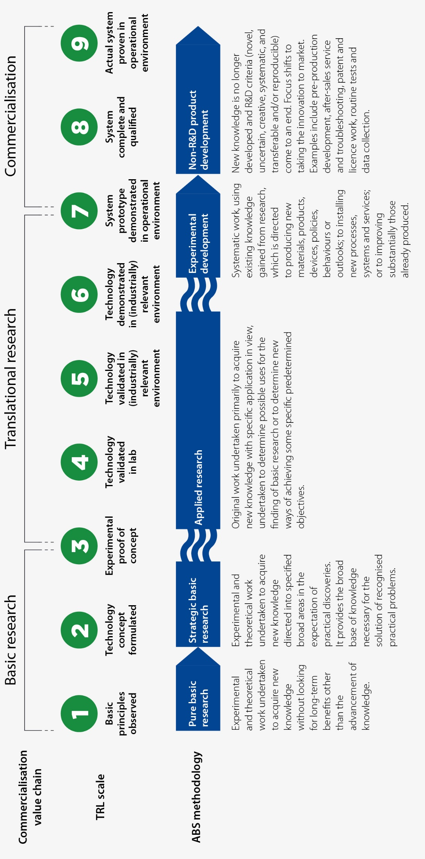

‘Valley of death’
The financial risk of investing in research commercialisation during the early stages of the TRL scale means it is often not attractive or justifiable for business and industry to bear the risk at that stage, particularly as costs escalate when moving from proof-of-concept to proof-of-scale (TRLs 3−7), known as the ‘valley of death’.
In making investment decisions, businesses make a risk calculation that takes into account that research in the early stages of the TRL will require significant additional investment to be able to make an assessment of the market readiness of the technology, and the commercial investment and commercial return risk associated with entry to market. With a number of technical and commercial factors determining the stage at which commercial funding can be supported for new technology opportunities, currently there is a well-recognised gap in funding for early-stage technologies.
The Australian Government invests across the full TRL scale. There is, however, a significant weighting of Government funding towards the early stages of TRL (1−3). This weighting is even more pronounced if programs targeting specific fields of research, and therefore not available for broader commercialisation opportunities, are quarantined − for example, the Medical Research Future Fund.
This focus on early-stage research is apparent when comparing total research expenditure internationally. Compared with other countries with a strong track record in translation and commercialisation, Australia invests relatively little in experimental research (Figure 17).
Figure 17: Total research expenditure (all sources) by type (%, 2018)
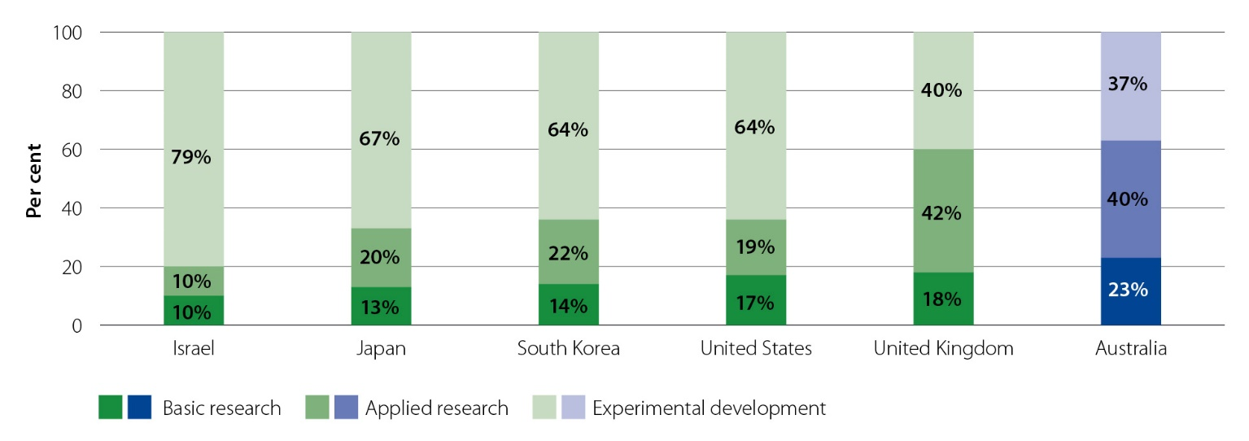
There is a well-recognised ‘valley of death’ which needs to be crossed if Australian industry is to adopt new technologies.
  - Australian National University submission
Early-stage research in many cases has a risk profile that makes it unattractive for business to invest in. A stage-gated investment program would help to de-risk promising projects that would otherwise fail to secure the capital they need to progress.
  - University of Melbourne submission
The current Australian Government research funding model is heavily focused on research in the early stages of the TRL. There is a gap in funding between TRLs 3 and 7.
There is a clear role for the Australian Government to de-risk investment through the TRL 3−7 part of the commercialisation pipeline. Without government intervention new innovations and technologies will continue to stall in the ‘valley of death’ (TRLs 3−7).
A funding mechanism to de-risk projects and incentivise timely, targeted investments in research translation will enable the rapid maturation of projects to both bridge this gap and make research outcomes more visible to industry.
The risks involved in the development and commercialisation of very early-stage scientific research are often too high for businesses to justify funding and the government does need to investigate ways in which to address this gap, including provision of funding for high-risk research.
  - The Australian Industry Group submission
The establishment of Australia’s Economic Accelerator and the expansion of CSIRO’s Main Sequence Ventures together create a unique research commercialisation pathway that builds on international exemplars like the US’s Small Business Innovation Research program.

Launch Australia’s Economic Accelerator
The Australian Government is establishing Australia’s Economic Accelerator (AEA) to bridge the ‘valley of death’ and accelerate reform in the higher education sector for translation and commercialisation research capacity by establishing a stage-gated funding program to invest in research aligned with the 6 National Manufacturing Priorities.
The AEA will drive commercial research outcomes in universities through a fundamentally new approach to research funding.
Table 5: Key features and benefits of AEA
Key feature | Benefits
Stage-gated funding | The AEA is a fast-fail model designed to attract projects at a proof-of-concept or proof-of-scale level of commercial readiness that have high commercialisation potential.  Projects will progress through the program, based on continued success and achievement of milestones. To incentivise ongoing excellence, the quantum of AEA funding increases as projects mature towards at-scale commercialisation.  The expanded Main Sequence Ventures Fund provides a high-value opportunity for projects that successfully progress through the AEA. Alternatively, outcomes from the AEA can be picked up by businesses who can take them forward or by other sources of venture capital investment (including through other schemes such as the Clean Energy Finance Corporation).
Priority-driven | AEA funding will be directed at National Manufacturing Priorities in areas of high commercial opportunity and research strength.  This ensures funding is at the scale required to shift the dial in commercialisation outcomes, sends a clear signal to business which will lift private R&D investment, and provides a whole-of-government targeted R&D pipeline.  For the first time, under these priorities universities will be directly challenged to respond to research opportunities that are specific, measurable, focused on industry needs and driven by explicit national goals.  It will drive a culture change within the higher education sector, through a focus on translation and outcomes rather than the dominant model of ‘publish or perish’.
Industry engagement required at every stage | The AEA design will require industry engagement from Stage 1 (e.g. in-kind support and embedding industry expertise in higher education institutions or vice versa), ramping up to formal partnership and co-investment (e.g. securing 50 per cent of the project cost) to access funding for Stage 2.  International experience shows that business engagement and partnership is critical to commercialisation success.
Expert governance | Stages 1 and 2 of the AEA will be governed by an expert commercialisation board, supported by expert Priority Managers. The AEA Board will consist of up to 8 members, who will possess experience and knowledge in research and its commercialisation, and represent government, industry business and research sectors.  Priority Managers will represent each of the National Manufacturing Priority areas and be highly qualified, experienced and motivated business and technology specialists.  The AEA Board will oversee the Priority Managers and advise the Minister for Education on the commercialisation of research through a Research Commercialisation Strategy which is to be developed every 5 years from 2022-23.  It is anticipated that the AEA Board will be appointed and Priority Managers engaged by mid-2022. Together, the AEA Board and Priority Managers will, among other things:  - assess the commercial potential of project proposals  - work with successful applicants to agree progress and success indicators and to foster and formalise connections with industry partners  - provide coaching support to researchers who might benefit from an improved understanding of the commercial environment.  Main Sequence Ventures Stage 3 activities will draw on established expert governance mechanisms in place for existing funds management.
By building a research strategy around the National Manufacturing Priorities, the AEA can catalyse public and private investment, encourage multidisciplinary responses to areas of national need and provide long-term certainty around government funding and priorities:
A stage-gated model in addition to a long-term commitment from Government for a Purpose-driven Research Scheme would provide certainty and confidence for academia and industry alike.
  - University of Wollongong submission
It is anticipated that the passage of legislation to establish the AEA program will occur in the first half of 2022. AEA guidelines will be available and applications will be open from mid-2022.
Case study
Q-CTRL

Q-CTRL is a cloud-based software for quantum computers and sensors, and includes aerospace and defence applications. Q-CTRL was spun out from the University of Sydney in 2017 and the founder was a chief investigator of the ARC Centre for Excellence for Engineering Quantum Systems.

Main Sequence Ventures funded the company at start-up with a ‘Seed’ stage investment and in 2019 the company conducted a ‘Series A’ capital round to raise US$15 million, led by Square Peg and in which Main Sequence Ventures participated. Investors include Un-Q-Tel, Sequoia Capital and Horizons Ventures. Q-CTRL has collaborations with the University of Sydney, the Australian National University and the Department of Defence.

Figure 18: Visual representation of Australia's Economic Accelerator
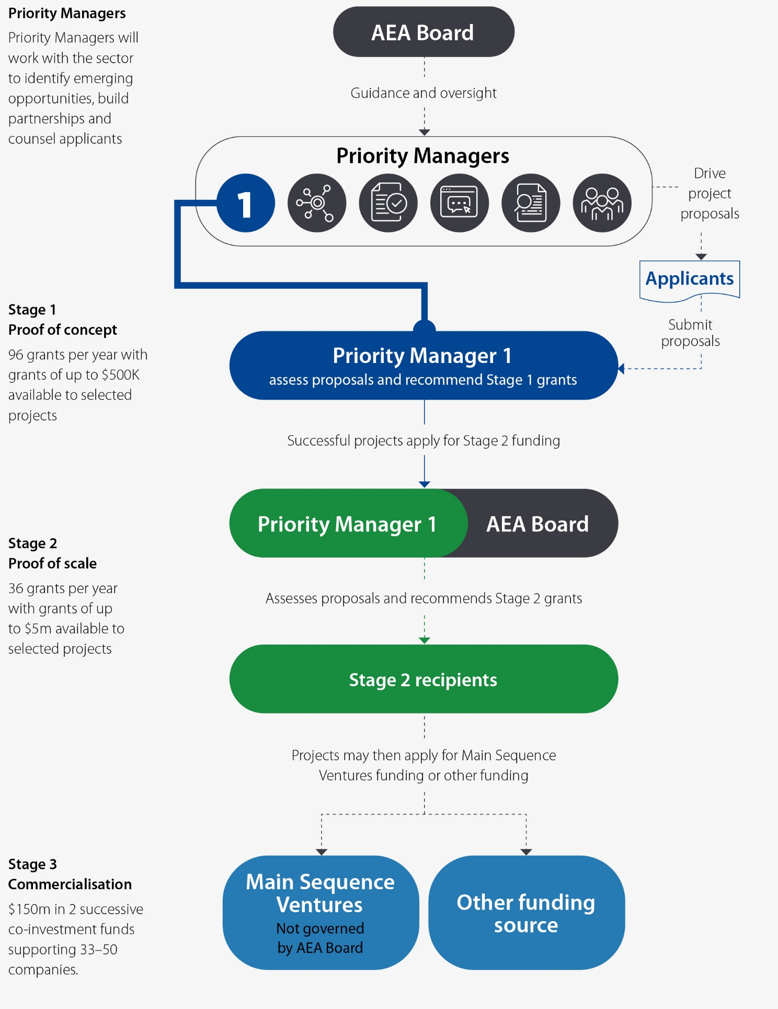
Figure 19: Visual representation of example projects in Australia's Economic Accelerator
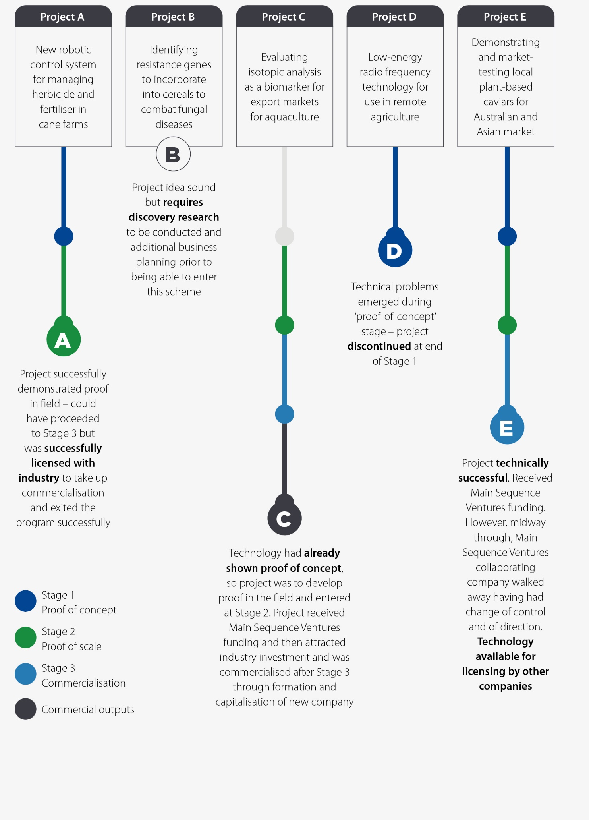

Expand Main Sequence Ventures to catalyse venture capital investment
Evidence from international research commercialisation schemes demonstrates that government investment is key at early stages, and investment by industry will only occur at later stages where returns on investment appear likely.
The CSIRO Innovation Fund, known as Main Sequence Ventures, was established to invest in early-stage opportunities from the research sector to increase translation into Australian industry. The Main Sequence Ventures Fund makes equity investments in high-value but early-stage opportunities and makes these investments on a fully commercial basis. Investee companies are often pre-revenue but have highly motivated founder teams that can drive company growth and address the global market. Main Sequence Ventures has conducted 2 successful capital raises and attracted $400 million of capital from the market based on cornerstone funding from CSIRO and Government of $100 million.
Main Sequence Ventures investments
By December 2021 Main Sequence Ventures has invested in 39 companies:
- The first 27 of these companies have created over 850 deep technology jobs at this early stage of company growth.
All investee companies are connected to the research sector. Of the 39 companies, 22 have research relationships with 16 universities and 20 have relationships with CSIRO.
To act as Stage 3 of the AEA, CSIRO’s Main Sequence Ventures will be expanded with a $150 million Government equity injection which is expected to result in a $300 million to $500 million Main Sequence Third Fund. It will catalyse venture capital investment in Australian public sector R&D and continue the channel for high-value opportunities from universities to be taken to market. The Main Sequence Ventures Fund will be one source of venture capital investment for commercial opportunities which arise from the university research commercialisation initiatives and in particular the AEA.
Case study
Need for government investment to establish and support a commercialisation pipeline (Cochlear Australia)
Cochlear Australia is a company that generates over $1 billion in annual revenue, employs more than 4,000 people and invests around $185 million in further R&D.
Cochlear is a great Australian success story. Its success is often attributed to the brilliant research and researchers behind the implantable device which has provided hearing to over 450,000 people worldwide.
Seldom explored, however, is the vitality of federal government funding to enable the program’s survival. In 1976, the Australian Government established the concept of a public interest grant, with the objective of improving national competitiveness by encouraging projects which could lead to new products, new processes, and new organisations.
In 1979, a $400,000 initial grant to undertake a global market survey and development cost plan for the Bionic Ear Project was awarded to the company Telectronics/Nucleus for their experience in commercialising implantable medical devices.
A total of 4 rounds of government funding took place between 1979 and 1985 totalling $4.7 million. It resulted in a licensing agreement being signed between Nucleus, the University of Melbourne and the Australian Government, providing for the latter 2 to have a joint share of royalties at a rate of 5 per cent of sales on the first 12,000 units and 2 per cent thereafter. The Nucleus Group was sold to Pacific Dunlop in 1988 and Cochlear was spun off via an initial public offering in 1995. In the end, Cochlear became the 1 in 10 survivor from the Nucleus stable of businesses, highlighting the often disjointed pathway of taking an invention to commercialisation. The R&D investment provided through the federal grant program was a necessary condition of the Cochlear success story.

Encourage early adopter ‘Trailblazer Universities’
Australia already has several universities that have shown commitment to commercialisation outcomes and the capability to deliver them. Many of these institutions are on the threshold of instituting internally driven reforms to implement IP and industrial relations arrangements which put translation, commercialisation and real-world engagement and impact on an equal platform with publications and citations.
An investment in these ‘Trailblazer Universities’ will provide a fast start to research commercialisation reform in each priority area − encouraging and incentivising universities that are early adopters of IP, industrial relations and skills practices that lift commercialisation outcomes and create cultural change in the sector. From 1 July 2022, selected Trailblazer Universities will have flexibility and agility to drive reforms including to adopt the Higher Education Research Commercialisation IP Framework, implement profit-sharing arrangements to ensure industry academics benefit, and bolster their chosen priority with industry-focused micro-credentials. The Trailblazer Universities will quickly create lighthouses that demonstrate to the sector and the country the benefits of an increased focus on commercialisation.
Case study
University of Technology Sydney at the cutting edge of mineral technologies
Within the University of Technology Sydney (UTS) is an advanced technology development unit, Rapido. UTS Rapido works with industry partners to leverage the expertise within the university and commercialise UTS research.
UTS Rapido has partnered with the Innovative Manufacturing CRC and Downer Mineral Technology to explore the use of 3D printed technologies for precision-engineered mineral separation and mining equipment.
The research team is also investigating additional development scope around Internet of Things (IoT) connectivity that will deliver Industry 4.0 milestone outcomes.
UTS Rapido replaced traditional manufacturing of gravity spiral separators (GSS) with a large-scale bespoke 3D printer. As part of the project, Rapido embedded IoT sensors to enable remote monitoring and automation of GSS. This increased design flexibility can reduce costs, improving health and reducing environmental impact during production.
There is a significant commercial benefit in the ability to print on site and in real time, which will ultimately deliver savings in both time and money.
The CEO of industry partner Innovative Manufacturing CRC believes that applying these technologies will revolutionise not only the manufacturing process of mineral separation equipment but also the associated supply chain operations, especially when the equipment is fitted with IoT sensors.
Mineral separation equipment is often operated in a remote and hostile environment. Deploying gravity spirals fitted with IoT sensors will offer Mineral Technologies a clear picture of the product performance.

5
Reform area: rebalance the focus on existing research programs

Reform area: rebalance the focus of existing research programs
Ambition | Our reform strategy
Australian Government programs create incentives for universities to prioritise collaboration and commercialisation. | Adjust $2 billion in existing university research funding to better incentivise commercialisation.
Arrangements within universities value a researcher’s commercialisation outcomes alongside publications and grant success.  Researchers are incentivised to spend time engaging with industry on translation and commercialisation activities. | Encourage universities to align researcher remuneration and promotion to research commercialisation outcomes.
Intellectual property (IP) arrangements allow businesses and universities to readily collaborate. | Support greater collaboration between businesses and universities, and greater uptake of world-class Australian research outputs by Australian industry, by addressing critical IP issues.  Develop a new IP framework for universities that will include standardised terms, clauses and agreements for collaboration on IP licensing, options and assignment.  Require use of the IP framework in a limited set of publicly funded research grants.

Current incentives for universities are not focused on collaboration or commercialisation
The generation of new knowledge is a core mission for universities. For most, this mission requires a focus on revenue generation and reputation.
The Australian Government provides one source of revenue for universities. An investment of $11.8 billion into R&D has been budgeted for 2021-22, and $3.7 billion of this investment will go to the higher education sector. (Note that 2020-21 data were affected by a one-off Research Block Grant of $1 billion to universities as a COVID-19 response measure.)
In addition, over the past 15 years, Australian universities have drawn on a steadily increasing volume of their own funds in order to drive scale and success in research (Figure 20):
Australia’s universities have significantly funded this outstanding performance by directing increased industry income and other general revenue, excluding Commonwealth research funding, to the overall cost of research.
- Western Sydney University submission
Figure 20: Higher Education Expenditure on Research and Development (HERD)
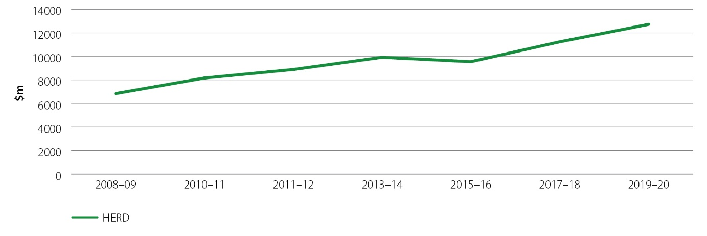
For some institutions, revenue from international undergraduate students has become a significant part of their business model:
While universities increasingly invest in research that has social and economic impact, they have weak incentives to commercialise research which has commercial potential. Revenue from international students is influenced by global rankings, which in turn are linked with publication output. Universities have strong incentives to increase their publication impact, but not their commercialisation outcomes.
- Murdoch University submission
An institution’s ability to generate income from international students is tied to reputation. A university’s reputation is also strongly linked to its research performance and publications. Many submissions argued that the focus on publications and citations in global rankings and the need to be competitive in the international student market drives universities to focus on publications, not commercialisation. The methodologies for 4 of the major university rankings systems are outlined in Table 6, with clear weight being given to the publications and citations criteria.
Table 6: University world ranking considerations and weightings
 | Times Higher Education | QS world rankings | Center for World University Rankings | Shanghai Ranking
Criteria | Weighting (%)
Research
Publications | 6 | × | 30 | 20
Citations | 30 | 20 | 10 | 40
Other | 24 | ×
Academic | 25.5 | 40 | 25 | 10
Employer reputation or employment | × | 10 | 25 | ×
Faculty/student ratio | 4.5 | 20 | × | ×
International students and faculty | 5 | 10 | × | ×
Industry income | 2.5 | × | × | ×
Quality of faculty | × | × | 10 | 20
Other | 2.5 | × | × | 10

Growth of the international student market
International education (across all levels of the education system) is one of Australia’s largest exports, earning $40.3 billion and supporting around 250,000 Australian jobs in 2019.

There has been exceptionally strong growth in universities’ international student numbers and revenue. Student numbers roughly doubled in the 10 years to 2019 (pre-COVID-19) (Figure 21), and in the 5 years from 2014 to 2019 universities’ international student revenue more than doubled, growing by 75 per cent in real terms.

Australian universities have been innovative and agile in this market, leveraging their strengths and effectively marketing themselves to become a destination of choice for the growing number of mobile tertiary students.
Figure 21: International student numbers, 2002–2020
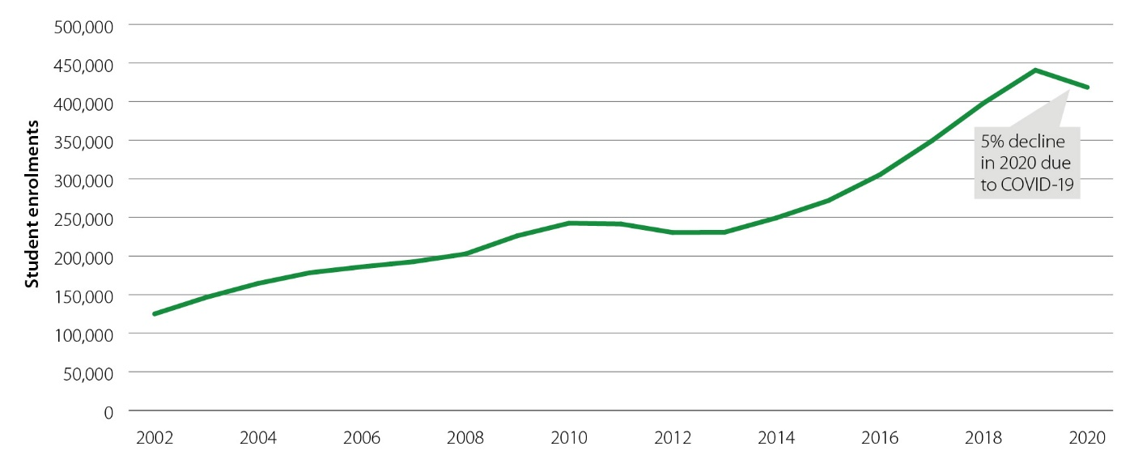
This focus on publications and citations is further reinforced by a number of funding programs which are preferential to peer-reviewed publications, citations and success at securing government R&D grants ahead of commercial outcomes and impact.
The university sector has been responsive to the incentives created by changes to research funding formulas and eligibility requirements in the past. Changes to Research Block Grant formulas to increase the emphasis on funding received for research from industry and other non-government sources (Category 3 income) saw an increase in income from this category of about 40 per cent, from $1.2 billion in 2016 to $1.6 billion in 2020.
The Australian Government will reform existing university research programs to increase the proportion of funding directed towards the 6 National Manufacturing Priorities and tilt the focus of research activity further across the TRL scale, towards translation and commercialisation.
Reforms to the core funding for university research and the grants process managed by the Australian Research Council (ARC) will boost incentives for university–industry collaboration and drive a new focus on the national interest.

Commonwealth funding source
- In 2018, $3.6 billion of the $12.2 billion the higher education (university) sector spent on R&D came from Commonwealth funding sources.
- Around a quarter of overall university research spending is directly tied to 3 funding programs:
  - the Australian Research Council (ARC)
  - Research Block Grants (RBG)
  - National Collaborative Research Infrastructure Strategy (NCRIS).
Figure 22: Source of university research spend, $m, 2018
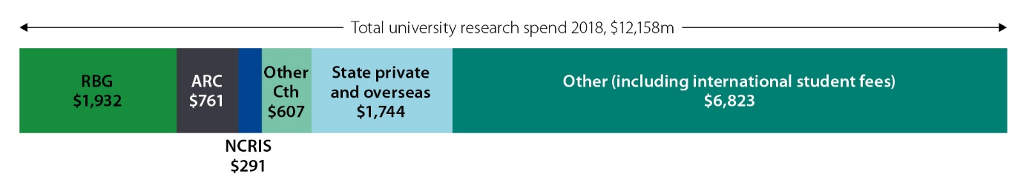

Principles for reform of existing research spend

Prioritising research in the national interest
In contrast to R&D undertaken by the private sector, university research tends to be more broad ranging, with effort distributed across all fields. This provides an opportunity to direct more of the Australian Government’s investment to priority-driven research, and thereby drive innovation in areas of national importance. As Figure 23 Figure 23: Research programs mapped by prioritisation and stage-gatingindicates, the majority of competitive research grants outside the medical and health areas are not currently prioritised. Focusing a proportion of this investment in priority areas, while protecting the quality and integrity of the research system, gives the greatest potential for economic impact from this investment.
Internationally countries such as the US, Canada, the UK, and Japan have targeted research programs, and this approach was endorsed through public submissions.
Figure 23: Research programs mapped by prioritisation and stage-gating
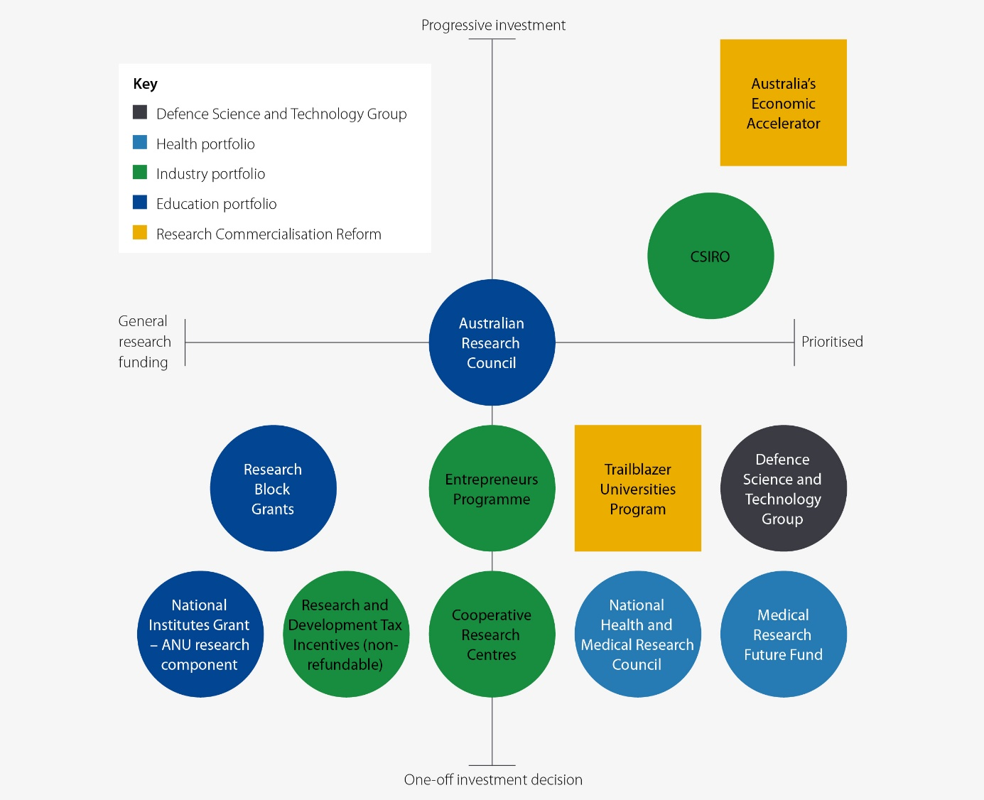

Balancing ‘blue sky’ discovery research with a greater emphasis on translation and impact
Basic research is an essential part of the knowledge spectrum on which commercialised or translated products and outputs depend.

Investment in basic research
At 0.4 per cent of GDP, the volume of basic research in Australia is relatively higher than in New Zealand (0.33) and the UK (0.32), and around the same as Japan (0.41) but well below leading countries such as in South Korea (0.7). Around two-thirds of all basic research in Australia is conducted by universities.
Reforms to existing research investment will continue to fund core aspects of the Commonwealth’s investment in blue sky research – a focus on quality, an appetite for higher risk and more speculative research, and a longer time horizon for expected returns.
At the same time, within that framework, there is scope to drive a greater share of research funding to the translational phases of the TRL scale to support research with more direct applicability to economic and social challenges that Australia is facing.

Rebalancing the focus on priorities through existing programs

Strengthen Australian Research Council arrangements in the national interest
The ARC’s purpose is to grow knowledge and innovation for the benefit of the Australian community through funding the highest quality research, assessing the quality, engagement and impact of research and providing advice on research matters. The ARC has delivered sustained investment in high-quality research since its establishment in 2001. Building on this foundation, the reform of these arrangements will evolve the funding of research in Australia to ensure research quality and impact is better aligned to Australia’s national interest.
The ARC administers the National Competitive Grants Program, which represents a significant component of Australia’s investment in R&D. The National Competitive Grants Program comprises:
- the Discovery program, supporting fundamental research for the development of new ideas
- the Linkage program, supporting collaboration in R&D between the key stakeholder groups.
The ARC is also responsible for assessing the quality of research through the Excellence in Research for Australia (ERA) assessment, and the impact of research through the Engagement and Impact (EI) assessment.
The Australian Government has strengthened the role of the ARC to have a broader focus on national outcomes. Through its Letter of Expectation, the ARC has a clear mandate to focus on driving the research contribution of universities to areas of national interest and to achieve improved economic and social outcomes.
The Letter of Expectation asks the ARC to undertake action to enable a greater role for industry, policy, and community leaders. This will be done by reforming the governance of the ARC, refocusing the management of its grant processes, and making changes to its research quality and impact assessments.
New standards will be applied by the ARC in relation to the grants that it administers in several key areas:
- alignment of at least 70 per cent of ARC Linkage Project grants to National Manufacturing Priority areas, combined with a regular review of the priorities to be applied to Linkage Project grants
- application of a strong national interest test and assessment process to all research grants, to ensure greater economic and social impact from Australia’s world-class research
- an enhanced and expanded role for the College of Experts, with a broadened College to include industry representation.

The ERA and EI frameworks will also be reformed to support a more efficient and more robust assessment of the quality and impact of research. The implementation of actions stemming from the ERA review will be fast tracked to ensure the assessments of the quality of Australian research remains robust and efficient. Robust quantitative metrics that are more explicitly focused on the impact of research will be developed for the next EI assessment round.

Reform Research Block Grants to create the right incentives
Research Block Grant (RBG) funding supports higher education provider (HEP) R&D capacity through the Research Support Program (RSP), which supports the systemic and indirect costs of university research; and the Research Training Program (RTP), which provides funding to HEPs to offer scholarships to higher degree by research (HDR) students.
Funding is allocated based on the relative performance of HEPs, grouped into research income from competitive and engagement sources. For the RTP the number of students completing HDR courses also factors into funding allocations. This funding model rewards universities for securing R&D grants and engaging with industry, international providers, and other organisations.
At present, the value of a government research grant is higher to the university sector than the value of a collaborative research partnership with industry, with $1 in government R&D grants effectively earning 31 cents in RBG funding compared with $1 in industry R&D funding earning 26 cents in RBG funding.
There is scope to adjust the RBG funding formulas to strengthen incentives for greater university–industry collaboration. With a fixed pool of funding through the RBG, an increase to the amount of RBG funding awarded to universities for engaging with industry would result in a smaller proportion being allocated based on securing government R&D grants. The Government will consult with the sector on refinements to the RBG formula to support incentives for industry engagement.
Figure 24: Current RBG arrangement
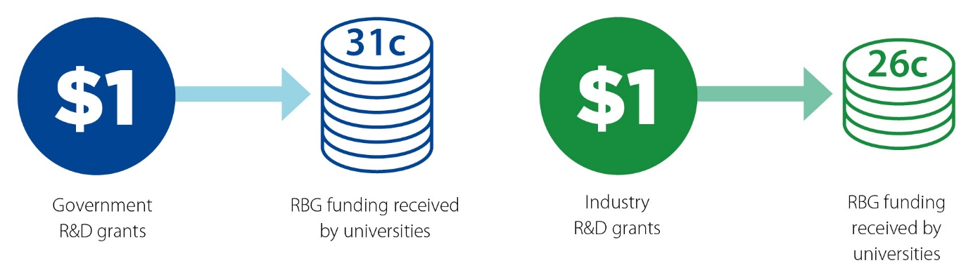

National Research Infrastructure supports modern manufacturing and enables research translation
National Research Infrastructure (NRI) is leading-edge equipment, services and advice that supports Australian researchers and innovators at all stages of the innovation pipeline. Australian Government investment in NRI fills critical gaps in the research infrastructure landscape, driving researchers to deliver world-class research outcomes and build national sovereignty and capability.
NRI provides the tools and environment for researchers and industry professionals to work together on practical solutions to shared problems, fostering innovation and research translation. Highly qualified staff provide expert advice to government, industry and researchers on practical and commercial applications of research.
There are many NRI capabilities that enable and directly support the Government’s National Manufacturing Priority areas and assist the Australian manufacturing sector to be globally competitive. For example, in relation to space, the Terrestrial Ecosystem Research Network and AuScope have significant capabilities in the development and deployment of satellites. Accelerator facilities such as the Heavy Ion Accelerator and the Australian Centre for Neutron Science can be used in the design and development of advanced materials required to manufacture space products, while testing and validation services can be provided by facilities such as Microscopy Australia and the National Imaging Facility.
National Research Infrastructure
Supporting national capability across all research domains and all stages of the innovation pipeline, the existing NRI:
- has a return on investment of $1.40 for every $1.00 of Government NCRIS spending
- is used by 51,482 Australian researchers and 9,552 international researchers
- was cited as supporting 95 patents and 8,985 publications
- supports over 1,500 jobs, with 4 out of 10 managerial and technical positions held by women
- provides critical or operational services to enable Australian Government policies and program delivery (76 per cent of current NCRIS projects report doing this).
The Australian Government develops an NRI roadmap every 5 years to set the policy direction for its investment. In keeping with international roadmap trends, the 2021 NRI roadmap has identified a set of key research challenges to assess NRI needs and to assess future impact. These challenges are aligned with the Modern Manufacturing Priorities, gearing NRI and researchers to help advance Australian manufacturing. For example, NRI facilities can provide advanced manufacturing capabilities, testing and quality assurance frameworks to support industry ventures. Proposed NRI will also fill current sector gaps in research translation and commercialisation which normally fall outside the remit of university research.
The NRI roadmap also identifies barriers that currently limit effective engagement and research translation between NRI and industry, and highlights opportunities to address this. Examples include standardised and centralised IP activities, NRI-embedded staff dedicated to industry engagement, grants for NRI-led research–industry partnerships, and data management frameworks that facilitate industry engagement:
Building the soft and hard research infrastructure for discovery and translation are key elements of the translation and commercialization ecosystem.
- Dr Andre Costa, Director, Teletraffic Research Centre, University of Melbourne submission
Case Study
University of Newcastle’s sustainable energy partnership

The University of Newcastle has successfully made printed solar cells, moving from basic research towards the goal of creating an advanced manufacturing facility. Created by University of Newcastle physicist Professor Paul Dastoor, organic printed solar cells are electronic inks printed onto thin plastic sheets using conventional printers.

The commercialisation of this revolutionary technology has been developed over the past 20 years through research, development and industrialisation funding, including ARC grants, support through the Australian National Fabrication Facility (an NCRIS facility) and the Synchrotron, AusIndustry and CSIRO grants, and numerous commercial contracts with industry.

The team at Newcastle is one of the first in the world to undertake a commercial-scale pilot of printed solar, and one of Australia's only research groups capable of manufacturing printed solar in-house.

The University of Newcastle partnered with global logistics company CHEP, a Brambles subsidiary, in 2018 to install a 200-square-metre rooftop array of printed solar in just one day.

The President of CHEP Asia-Pacific said the partnership highlighted how private enterprise and science can, and need to, unite to solve these global problems:

‘The drivers for working with Professor Dastoor’s team were twofold – the chance to steward this emerging renewable energy technology to implementation and the opportunity to make our circular ‘share and reuse’ business model even more sustainable.’

‘This partnership creates an important test ground where this technology can demonstrate its impact.’

Creating the right incentives for university researchers
The research system needs researchers and commercialisation professionals who have the skills and knowledge to engage with industry and commercialise promising discoveries. This capability will take time to develop.
A fundamental requirement for their success is for these skills to be valued and rewarded within a research career. Engaging with industry and translation and commercialisation activities take time. Under current industrial relations arrangements there is little career incentive for university researchers to pursue commercialisation opportunities given the focus on publications and citations in competitive grant assessments and in internal promotion decisions in many institutions. While this is a long-standing approach within universities, it can act as a deterrent for researchers who have the inclination to invest in developing these skills and pursing commercialisation outcomes:
Currently the reward system inside universities is not set up for commercialisation or collaboration with business. Researchers focus on academic publications as the primary output of their research since they are not incentivised to consider commercial application. Universities also look to publications as the metrics for academic promotions and university rankings. The research itself is rarely in a form that can be commercialised by business since researchers lack the level of business exposure required to understand the commercial considerations that go into making such decisions.
- Australian Chamber of Commerce and Industry submission
Case Study
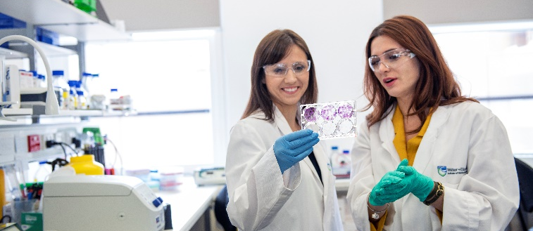
Photo: Supplied by WEHI.
How WEHI creates incentives that drive commercialisation success
Established in 1915, the Walter and Eliza Hall Institute of Medical Research (WEHI) is Australia’s oldest medical research institute and leading medical innovation centre, with over 1,200 staff and students.
To ensure the ongoing impact of their research, WEHI’s Business Development Office frequently provides skill development opportunities to its research and professional staff, including internships and programs to upskill its employees in areas of technology transfer, business development, commercialisation, and entrepreneurship. Commercialisation outcomes are included in staff evaluation and promotion criteria.
Additionally, payments from commercialisation of research are distributed to people who contribute to that commercialisation, including those who have published a paper in the relevant scientific area, are listed on a relevant patent, have contributed to commercial negotiations and/or have contributed to clinical translation.
These practices recognise and reward those whose efforts lead to successful commercial outcomes. Importantly, they also cultivate an environment which enables WEHI to support 90 laboratories committed to basic and translational research, and enable discoveries that have benefited over 30 million patients around the world.
Broadening and making visible a variety of pathways within a research career, including diverse employment opportunities, will be an important part of ensuring a sustainable research workforce pipeline.
Many submissions also noted the value of intersectoral mobility. Flexibility in academic career paths, with the ability to move between academia and industry, should be encouraged and supported. Compared with other countries, such as South Korea, Germany, the US and Canada, Australia has lower rates of academics moving to industry (per 1,000 researchers) and industry researchers moving to academia (per 1,000 researchers). The skills and experience developed across sectors should also be seen as an asset and rewarded under industrial relations arrangements within universities.
To address this, as part of the reform package, universities will be encouraged to align researcher remuneration and promotion to research commercialisation ​outcomes through:​​
- introducing new mandatory reporting in Compacts​ to improve transparency​
- eligibility requirements for participation in the new, commercialisation-focused programs AEA and Trailblazer Universities.
This approach supports the new suite of Industry PhD and research fellowship schemes that span the research career pathway outlined later in this report:
Given there are currently few career incentives for University researchers to specialise and focus their time on research translation and industry engagement, it is not surprising that few university researchers have a deep grasp of what is required to work effectively with industry and to deliver practical real-world solutions that truly add value.
- University of Adelaide submission
Case Study
The start-up superstar and connector of commercialisation
Universities are complex organisations − even to those who work inside them. So it is little wonder that industry partners often struggle to navigate the intricate network of institutes, centres, disciplines, and legal and IP offices inside most universities.
If industry partners cannot find their way to the right researchers, then the engine of commercialisation of potentially world-leading work stalls before it even pulls out of the driveway.
There is a need for visionary individual researchers who understand the commercialisation process, can draw together multidisciplinary teams to meet the challenges businesses want to address, and can navigate the often-Byzantine bureaucracies of universities.
Enter Professor Sharath Sriram − a connector of commercialisation who has brought more than $6 million in commercial partnerships into his university, RMIT, over the past 4 years.
Leading-edge work from his teams has included smart bedding products for aged-care support, a wearable for continuous molecular monitoring, and miniature biosensors for monitoring respiratory illnesses.
Professor Sriram, who is also the Policy Chair of Science & Technology Australia, has achieved this incredible success by working closely with industry, learning deeply about commercialisation processes, and by becoming a central and single point of contact for businesses looking into the university system for solutions to challenges.
His team now consists of 47 staff, including scientists and engineers, and they work closely with teams from the business and design schools at the university.
To his industry partners, Professor Sriram is a one-stop shop to access Australia’s world-leading research and expertise. To his university, he is a start-up superstar, generating income, building industry links and collaboration, and helping to transform a culture of bench-to-bookshelf publishing to bench-to-boardroom scientific commercialisation.
Incredibly, his commercialisation expertise is almost entirely self-taught.
‘Industry doesn’t know what’s going on in universities, and nor should we expect them to know’, he said.
‘I started by tackling the cultural challenge of moving our work from bench-to-bookshelf to bench-to-media. By talking about what we are doing publicly, and explaining what taxpayers’ money is paying for, we were able to attract industry attention and investment.’
‘So much of what we do with industry is about working in that middle space between the commercial imperatives of business, and the deep knowledge and deeper bureaucracies of universities and government funding schemes.’
‘I see our work with business as a partnership built on mutual respect for our drivers. We talk to them about their market, and then design things for a specific market need. We also act as a screen and filter so they don’t have to navigate university structures.’
Creating more connectors of commercialisation like Professor Sriram will build a pathway to turn more research into products, services and jobs. But to do it will require giving a small group of researchers the skills, support and training they need.
‘A key to this is tackling the incentive structure within universities and grant systems’, Professor Sriram said. ‘Give researchers the confidence and safety net to be bold and push the limits, and count time spent working with industry as an equally important reporting metric as time spent on publications.’
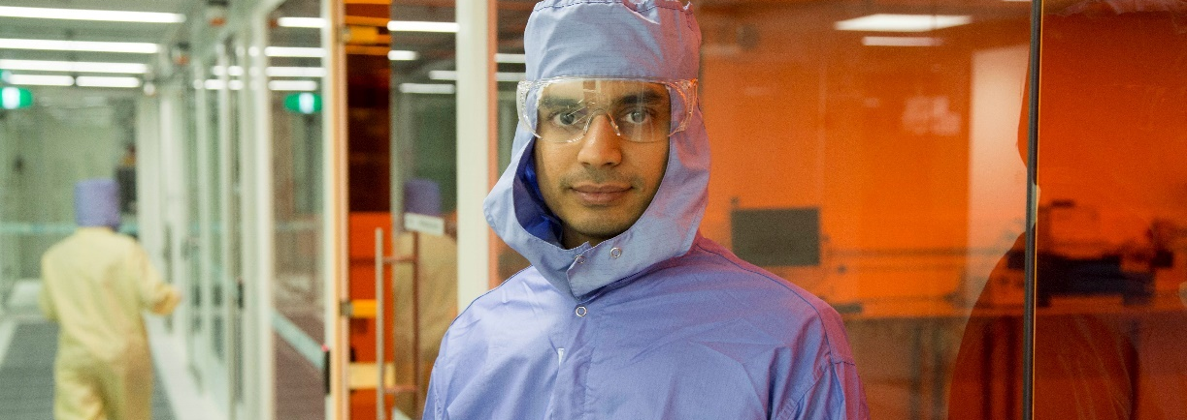Photo: Professor Sharath Sriram, supplied by Science & Technology Australia.

Remove barriers to commercialisation caused by intellectual property management
IP links universities, industry, and investors as an important asset and a shared commercial interest realised from public investment in university research:
When incentivising participation for multiple stakeholders […] the motivation for the parties is very different. […] Businesses are looking for competitive edge, expansion of business, revenue, and intellectual property. Universities are looking for scientific publications, PhD completions, intellectual property, and research income. Investors are looking for return on investment, maybe through intellectual property.
The only common ground is intellectual property – so managing the generation of, access to, and return from intellectual property will go a long way to motivating participation.
- Future Industries Institute submission
IP management is central to successful university research commercialisation. Barriers to negotiation on IP include lack of money, time and expertise on both sides and lack of understanding of each other's needs and objectives. This translates into difficulties in research commercialisation and lost opportunity for all Australians:
Industry faces a time burden in having to deal with each university differently and forming agreements across universities in alliances and collaborative efforts is very difficult. Australia needs to move to a common model for university focused commercialisation for all universities to adopt. These efficiencies in policy are needed to give industry and private investors confidence to access Australian university research capabilities.
- University of Queensland submission
Around the world, governments and university groups have prepared standard processes and agreements to assist negotiations that involve IP. International standardised agreements for university knowledge transfer include the UK's Lambert IP Toolkit and Knowledge Transfer Ireland’s Model Agreements.
Table 7: IP-related constraints to successful commercialisation and collaboration
Constraint | Description
IP rights and access | IP rights issues include background IP not being clearly defined and secured and a tendency of parties to want IP ownership. In addition, the ability to access and secure rights for improvements in IP and the ability of IP access in ongoing research and commercial projects are common constraints.
IP valuation and royalties | Agreeing on a fair value requires the parties to negotiate terms based on their respective contributions and expectations. This means committing to a commercial sharing agreement (e.g. royalties on milestones and sales) can be difficult – particularly when the IP needs significant further development or the commercial pathway is exploratory in nature.
Confidentiality before publication | If not appropriately managed, publication requirements of a university can conflict with confidentiality requirements of businesses in securing IP rights. There are specific challenges for PhD students working on projects under deeds of confidentiality.
Contractual confidentiality obligations | Conversations about confidentiality must be at an early stage of project design to establish if the project will fit with university and business policies on publication of research results. This is critical if research outputs need to be held as trade secrets or by government for security considerations.
Warranties and liabilities | What each party considers reasonable in terms of warranties about performance of IP that they should provide, and what warranties they expect in return, can vary. Who carries liability, scope of indemnity and capping liability, and whether a party is able to cover the agreed indemnity, are additional concerns.
Cost | Significant costs to both universities and businesses can be incurred for lawyers and patent attorneys. This can be a deal breaker for SMEs. There are also opportunity costs of diverting staff, loss of timeliness, principal researcher funding drying up, and strategic costs (one party 'swearing off' the other for future collaboration).
Timeliness | Significant problems arise when negotiations are drawn out and cycle times are not specified or adhered to. There are also long lead times in complex research projects, particularly in basic or discovery research projects.
Materiality | Efforts to arrive at a comprehensive contract can be seen as time-wasting and harm trust between parties. Parties can differ in their basis for making decisions on materiality, from a risk management based approach with contingency planning to a worst-case scenario approach.
Research performance incentives | Measuring research success by academic journal publication, which is required for researcher and university rankings and grant funding, is widely perceived as a constraint on commercialisation activity. Despite this, many businesses welcome academic publication as a measure of leading-edge research.
Communication | There are difficulties due to a lack of effective communication channels and procedures (nominated personnel, timeliness, frequency of contact and establishing relationships for potential licensing or collaboration). This compounds the other constraints.
Asymmetry between parties | A common perception is that some universities are in a poor bargaining position. Businesses can also feel out of their depth in navigating the system and finding people with relevant knowledge.

As part of the efforts to begin addressing these barriers to collaboration and commercialisation, the Australian Government has developed a Higher Education Research Commercialisation IP Framework (HERC IP Framework) for IP management and negotiation in university-led research commercialisation. The Government has worked with experts in research commercialisation and IP law, including IP managers, university researchers, university technology transfer offices, large and small businesses, start-ups, investors and government to develop the framework with an open consultation process.
The HERC IP Framework establishes a foundation for collaboration between universities and industry partners, and helps to bring partners to the negotiating table, shifting the cultural dial towards easier negotiation and commercialisation. The framework provides standardised IP licensing and contractual agreements as well as education and guidance materials to establish a common and clear starting point to negotiations. The HERC IP Framework will initially be applied for a limited set of publicly funded research grants and programs with future expansion to be considered over time.
By introducing clarity, confidence and a common reference point into the system, the framework will help build engagement and trust between collaborating parties.
Table 8: Key elements of the HERC IP Framework
Key elements of the HERC IP Framework
Standardisation to facilitate commercialisation process quality, efficiency and effectiveness | The HERC IP Framework will help guide partners towards the efficient and effective management of the IP commercialisation process. Specifically, standardisation:  cuts complexity and transaction times/costs  provides an easier entry point for negotiations − this is particularly important for SMEs, individual researchers and start-ups  promotes best practice.
Provide consistency across institutions | The HERC IP Framework will provide a consistent and coherent starting point in commercialisation practice for university researchers, businesses, and Australian Government agencies involved in commercialising publicly funded research.
Provide educational materials for reference | The HERC IP Framework will include educational guidance materials setting out IP processes during commercialisation activities. This will provide a basis for assurance that parties take the necessary steps for successful commercialisation together, regardless of experience.
Deliver strategic, economic and social benefits | Standardising processes reduces transaction costs and risks, increases transparency and accountability, and improves organisational performance in terms of quality, service and customer satisfaction.  Improved commercialisation performance will deliver economic and social benefits through the more effective commercialisation of publicly funded research.

Patent Box
To further support the Australian Government’s collaboration and commercialisation efforts, a ‘patent box’ tax incentive will be introduced from 1 July 2022. This will allow eligible companies to pay a lower tax rate on income generated through the commercialisation of patented technology in the medical and biotechnology sectors.

The aim of the Government’s policy is to encourage companies to base their medical and biotechnology R&D operations, and commercialise innovation, in Australia and to retain associated patent profits in Australia.

Case Study
FutureFeed
FutureFeed is commercialising a natural livestock feed additive (also known as FutureFeed®) based on the seaweed Asparagopsis. FutureFeed® arose out of work done by James Cook University (JCU) in collaboration with CSIRO (Dr Rob Kinley and his team at CSIRO’s site in Townsville, Queensland) in collaboration with Meat & Livestock Australia (MLA).
The IP, co-owned by CSIRO, MLA and JCU, has produced 2 patent families, an Australian trademark registration and a domain name. Further work and R&D will continue on new formulations and delivery applications of the seaweed.
The feed additive has been shown in trials to reduce methane emissions in cattle by more than 80 per cent and improve the feed efficiency and productivity of the animal. The feed additive may also provide opportunities for farmers to access other income streams through carbon markets and/or the ability to apply a premium via niche beef or dairy markets. These global benefits are substantial as just 10 per cent adoption of the feed additive is equivalent to removing 50 million cars from the road.
In August 2020 investor agreements in FutureFeed were signed with CSIRO, AGP Sustainable Real Assets-Sparklabs Cultiv8 Joint Venture, GrainCorp, Harvest Road and Woolworths in a transaction valued at $13 million. The company hopes to get commercial quantities of the feed additive to market within 2 years and be fully operational within 5 years.
FutureFeed® natural livestock feed supplement is good for animals, good for climate change and great for business.

6
Reform area: Build a bedrock of collaboration

Reform area: Build a bedrock of collaboration
Ambition | Our reform strategy
The academic research career pathway is driven by both publication track record and engagement with industry and commercial success.  Academic researchers who seek a research commercialisation focused career are recognised and rewarded. | Establish a suite of Industry PhD and research fellowship schemes that span the research career pathway and add 1,800 Industry PhDs and over 800 industry fellows over 10 years. This $296 million investment will fundamentally challenge promotion and reward structures in Australia’s universities and encourage mobility and collaboration.

Building workforce capability within universities
A broad skill set is needed to commercialise research, including identifying commercial opportunities, engaging with business and industry partners, communicating with investors and managing intellectual property. These skills and activities are not a natural extension from undertaking basic research.
A number of submissions suggested that while it is important to develop the commercialisation capability of some researchers within academia, not every researcher or academic needs to become a practitioner. It is not essential or desirable for every researcher to develop this skill set. Submissions pointed to models of knowledge brokerage or baton passing along the commercialisation pipeline as a preferred approach.
Throughout the consultation process the culture and skill gap within universities placing a constraint on collaboration and commercialisation was a recurring theme. Many academics and university researchers lack the experience and skills to collaborate effectively with business. Different nomenclature, operating models, pace of decision-making and risk appetite between universities and business and industry all create challenges. It is unrealistic to expect researchers to develop this capability without focused effort, investment and support. Without researchers with the skills and knowledge to engage with industry and commercialise research, there will always be lost opportunities.
“To achieve better research translation for impact universities need to find new ways to execute and commercialise the ideas they create. Academics typically do not have the interest or capability to commercialise their ideas. Universities need to find new capability to do the translation in partnership.”
- Cameron Turner, Australian researcher submission
The research system needs researchers and commercialisation professionals who have the skills and knowledge to engage with industry and commercialise promising discoveries. The capability will take time to develop within the research system.
In the same way many university researchers lack the skills and experience to engage with business and industry, many of those in business also have a skill gap in their capacity to engage with universities and take advantage of the opportunities presented by research and innovation. For industry, the complexity of university structures and protocols can make finding a point of entry and navigating the system a challenge. Some universities have attempted to overcome this by establishing technology transfer offices to act as the link between industry and researchers.
A fundamental requirement for increasing the entrepreneurship and commercialisation skills within academia is for these skills to be valued and rewarded within a research career. Engaging with industry and translation and commercialisation activities take time. Under current arrangements there is little career incentive for university researchers to pursue commercialisation given the focus on publications and citations in competitive grant assessments and in internal promotion decisions in many institutions. While this is a long-standing approach within universities, it can act as a deterrent for researchers who have the inclination to invest in developing these skills and pursuing commercialisation outcomes.
Broadening and making visible a variety of pathways within a research career, including diverse employment opportunities, will be an important part of ensuring a sustainable research workforce pipeline as well as building R&D capability within industry.
Many submissions also noted the value of intersectoral mobility. Flexibility in academic career paths, with the ability to move between academia and industry, should be encouraged and supported. Compared to other countries, such as South Korea, Germany, the United States and Canada, Australia has lower rates of academics moving to industry and industry researchers moving to academia. The skills and experience developed across sectors should be rewarded and seen as an asset.
“WEHI has a number of industry fellowships where an industry partner funds a postdoctoral fellow based at WEHI or a postdoctoral fellow joins an industry partner on secondment for a fixed period of time. These have had a number of benefits including cross-pollination of ideas, exposing postdoctoral researchers to later stages of drug development, skills development, increasing capabilities within WEHI, access to emerging industry technologies as well as providing future career opportunities for early career researchers.”
- Walter and Eliza Hall Institute of Medical Research submission
The Australian Government will establish a suite of Industry PhD and research fellowship schemes that span the research career pathway and deliver a tripling of the number of Industry PhDs by adding 1,800 industry PhDs and over 800 industry fellows over 10 years. The selection process for the Industry PhDs and fellowships will be conducted on a competitive basis, with preference given to applications aligned with the National Manufacturing Priorities.
Commencing from July 2022, the new Industry PhDs and research fellowships will create a clear and structured research career pathway in innovation and commercialisation focused research and fundamentally challenge existing funding and reward structures in Australian universities. This will embed researchers in industry settings, enhancing research commercialisation and translation skills and building research careers in industry.
These initiatives will allow researchers to gain knowledge on how research is undertaken in an industry setting, ensuring that the needs of industry clients are better understood and provided for in the university research sector. Support will be provided across all stages of the research career pathway, ensuring translation and commercialisation activities are leveraged across the research workforce.
Figure 25: Industry PhD and fellowship initiatives
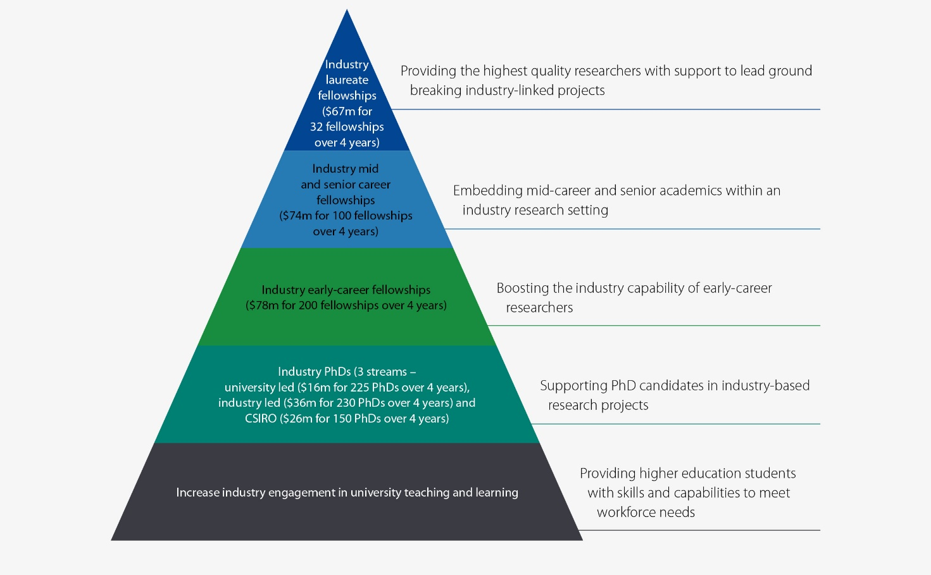

Figure 26: Career pathways available under new industry PhD and fellowship initiatives

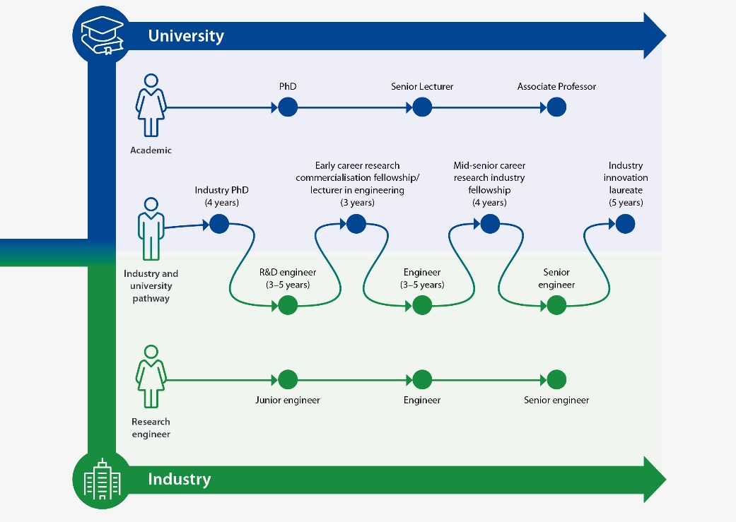
Case Study
A trailblazing ‘bench-to-boardroom scientist’
Few researchers in Australia have had more success at taking world-leading university research and working with industry to develop solutions than Professor Mark Hutchinson.
As Director of the ARC Centre of Excellence for Nanoscale Biophotonics at the University of Adelaide and President-elect of Science & Technology Australia, he’s a leader who personifies the shift from what he calls a ‘bench-to-bookshelf scientist’ into a ’bench-to-boardroom scientist‘.
Under Hutchinson’s visionary leadership over the past 7 years, his centre has generated 15 spin-outs and start-ups, and 30 flourishing industry partnerships. This includes developing probes that are used in brain surgery - but are also used commercially in the meat and livestock industry to grade meat quality for sale and export.
His ‘silo-busting’ approach urges engineers, physicists, chemists and biologists to communicate with, and work across, disciplines to build new products and techniques using light at the cellular level.
The secret is getting the right mix of industry partners, entrepreneurs, and scientists in the room from the start to solve the problems that businesses want solved.
‘We have industry with us from day one when the idea is founded,’ he says.
’Having the industry with us from the start of the journey means they have an opportunity to say “that’s a good innovation, but have you ever thought about doing this particular part of the work?”. This requires a trusted relationship and a common language in place before a project can start.’
‘We’ve had exactly those moments occur in our laboratory. As a consequence, we’ve got, for example, probes used in brain surgery today where the same technology is working in abattoirs to analyse meat quality.’
‘Getting that kind of outcome means, for example, getting neurosurgeons in the room at the same time as a representative from the meat and livestock industry. But it’s those moments of convergence that are needed to create those “ah-ha” moments for innovation.’
‘This journey is not for everyone and doesn’t need to be explored by every scientist. There is a need to create skilled scientists and professionals with these unique capabilities who can champion the translation efforts that will translate into hundreds of billion-dollar companies that have their origins in Australian blue-sky science.’
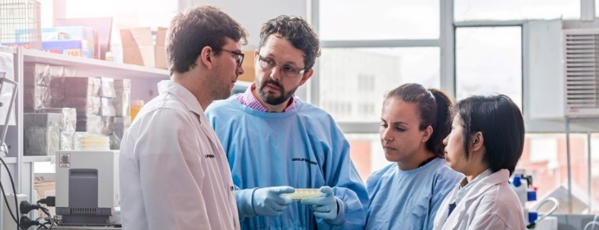
Photo: Professor Mark Hutchinson and team, supplied by Science & Technology Australia.

Case Study
University of Southern Queensland and John Deere develop precision spray technology
A successful collaboration between the University of Southern Queensland (USQ) and John Deere has led to the development of precision herbicide spray technology, See & Spray™ Select, that will reduce costs and minimise environmental impact.
USQ provided the experimental technology underlying See & Spray Select, which uses cameras to detect green plants and automatically trigger an application of herbicide. John Deere further developed and tested the technology across farms in the United States, Canada, and Australia, before launching globally.
The initial experimental work to develop the vision-based plant detection technology was funded through a combination of industry research projects from Sugar Research Australia, Cotton Research and Development Corporation, Hort Innovation, and USQ.
Professor Craig Baillie, USQ Centre for Agricultural Engineering Director, said the technology is an excellent example of Australian research and innovation having global application, and will enable Australian farmers to be at the forefront of transformative AgTech.
The collaboration between John Deere and USQ has led to the development of industry-leading innovation in Australia that has potential to deliver positive and impactful changes for farmers globally.

7
Monitoring and evaluation of our success

Monitoring and evaluation of our success
Regular monitoring and evaluation are key to the success of this Action Plan. The Australian Government is committed to a long-term strategy to shift the dial on research commercialisation. This will not happen overnight. Regular monitoring and evaluation of the research commercialisation ecosystem and the initiatives outlined in the Action Plan will provide the information that will give the Government, universities, industry and investors the opportunity to adjust investments and activities. This will allow the strategy to be responsive to emerging conditions in the national and global context.
The expert commercialisation board which will be established to oversee the AEA, along with the Priority Managers reporting to the board, will be a key part of the monitoring system, providing reports to Government on the success of achieving research commercialisation and progress of the research commercialisation agenda towards the National Manufacturing Priorities.
In addition to this, the Government has committed resources to evaluate the individual initiatives to ensure that they are targeting and achieving the outcomes which will have the most impact on the research commercialisation ecosystem.
A necessary first step in this regard will be the development of a set of key performance indicators (KPIs), at both system-wide and program-specific levels, which can be used to monitor the extent to which the program is having the desired effect.

Development of key performance indicators
System-wide KPIs were identified through overarching objectives – improved collaboration, improved commercialisation and improved innovation. These broader objectives were further broken down into defined success factors, against which specific indicators can be identified.
A breakdown of the 3 system-wide objectives into success factors is presented in Figure 27.
Underneath the broader objective of improved collaboration are 2 distinct success factors – first, more academics and businesspeople working together (‘human collaboration’); and second, ‘physical collaboration’ in businesses’ and universities’ research agendas. These 2 success factors can essentially be thought of as being 2 sides of the same coin; both make up the broader objective of collaboration and both are co-dependent on one another. Hence, a set of KPIs that did not separately track human collaboration and physical collaboration would risk failing to identify specific challenges to one which, if left unaddressed, might ultimately bring about a failure of both.
The development and use of program-specific KPIs ensure that the intended outcomes of each new commercialisation initiative are achieved. KPIs were developed against 3 key success factors – namely interest, effectiveness and impact. A breakdown of program-specific KPIs is provided in Figure 28.

Figure 27: System-wide objectives and success factors
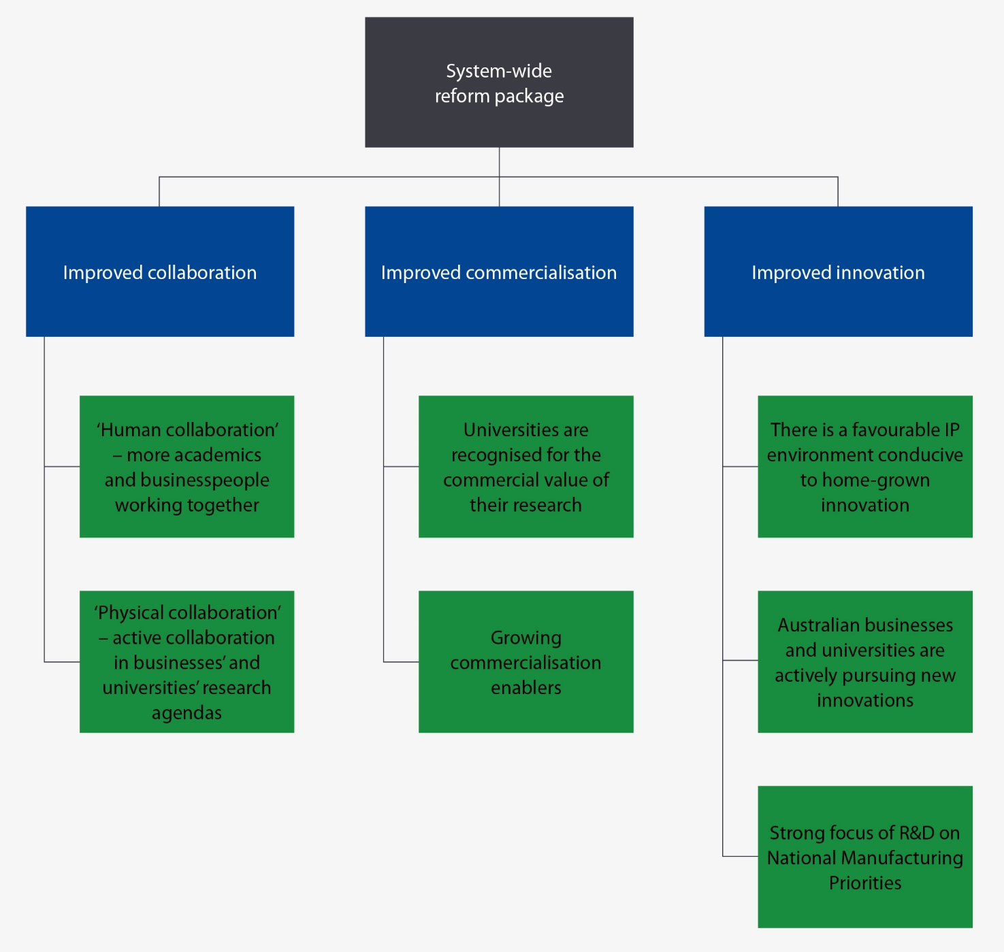

Figure 28: Developing program-specific key performance indicators
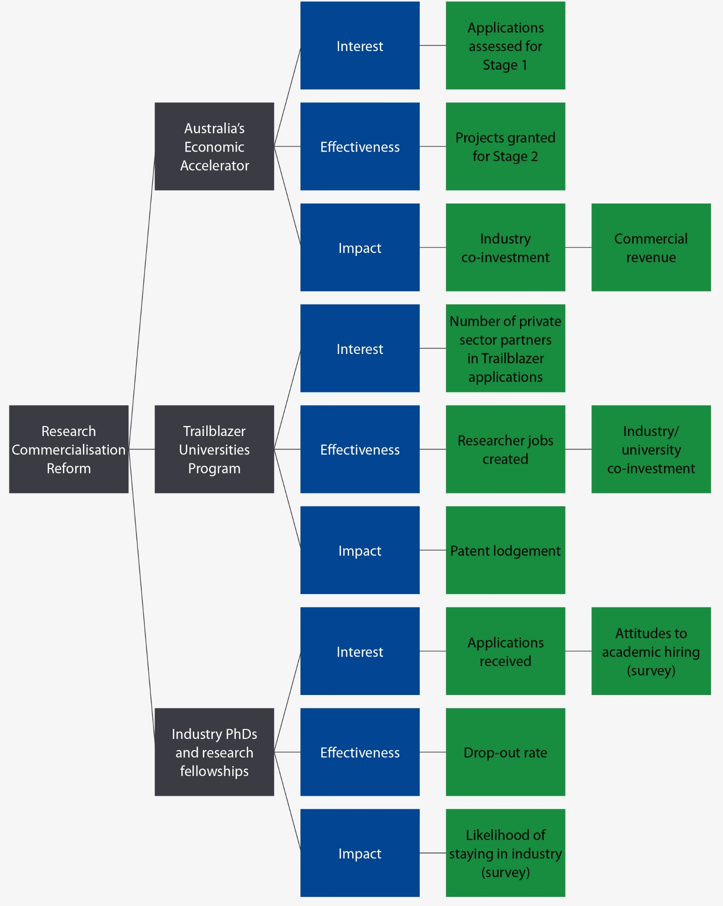

8
Implementation and next steps

Implementation and next steps
The Action Plan sets out a clear long-term vision to shift the dial on research commercialisation and leverage the benefits of Australia’s world-class university research system. To deliver on the ambitions for this agenda, implementation started in 2021 and will continue throughout 2022. The Australian Government has already made significant progress in implementing this Action Plan as outlined below.
In developing this Action Plan, the Government has worked closely with industry and the university sector. Throughout implementation the Government will continue to do so, drawing on expertise to ensure all initiatives are rolled out effectively. A key focus during implementation will be on governance and reporting to ensure that appropriate expertise and oversight is in place.

Australia’s Economic Accelerator
- Passage of legislation: first half of 2022
- Appointment of AEA board: mid-2022
- Engagement of Priority Managers: mid-2022
- Guidelines and applications available: mid-2022

Main Sequence Ventures (expansion)
- First capital injection to CSIRO: June 2022
- Vehicle build and Innovation Industry and Science approvals: first half of 2022
- Communication program to make sector and market aware: second half of 2022
- Private sector capital raising: second half of 2022 (through to 2025)
- Investment activity commences: mid to late 2022 (through to 2027)

Trailblazer Universities Program
- Expressions of interest open (first of 2-stage application process): 24 November 2021
- Expressions of interest close: 17 January 2022
- Shortlisted applicants expected to be announced: late January 2022
- Business case submissions close (second stage application process): 15 March 2022
- Funding provided: from July 2022

Industry-focused PhDs and fellowships and IP reform
- Guidelines released: mid-2022
- Program commences: 1 July 2022
The Australian Government is committed to expediting the roll-out of the initiatives in this package to ensure they are in place as soon as possible and can begin to accelerate commercialisation activities in the sector. While the Government works through the administrative processes to establish these new initiatives, universities and businesses do not need to wait. The economic imperatives for our nation are clear and the Government’s commitment to focusing on the National Manufacturing Priorities and our intention to reward collaboration are embedded in the future of research funding. The Government is ready to partner with universities and industry to pursue this agenda. Universities and businesses which choose to lead the charge in this direction, rather than wait to play catch-up, will be best placed to see the returns from this agenda.

Appendix A: Consultation to develop the Action Plan

Consultation has informed this vision and reform

In November 2020, the Australian Government established a University Research Commercialisation Expert Panel, bringing together experts from business and industry, universities and the research sector. The panel holds significant breadth and depth of expertise in research commercialisation (Table A1 outlines panel membership).
The government has undertaken extensive consultation across the research sector and industry and sought out best practice, both within the Australian context and internationally, to develop this reform package. Research and analysis have been commissioned to provide further insight into research commercialisation in Australia, as well as informing potential avenues for reform and national priorities.
Further to this, a public submission process was established in February 2021. Over 170 submissions were received from individual researchers, universities, research institutions and business and industry.
Figure A1. Evidence informing the development of the Action Plan
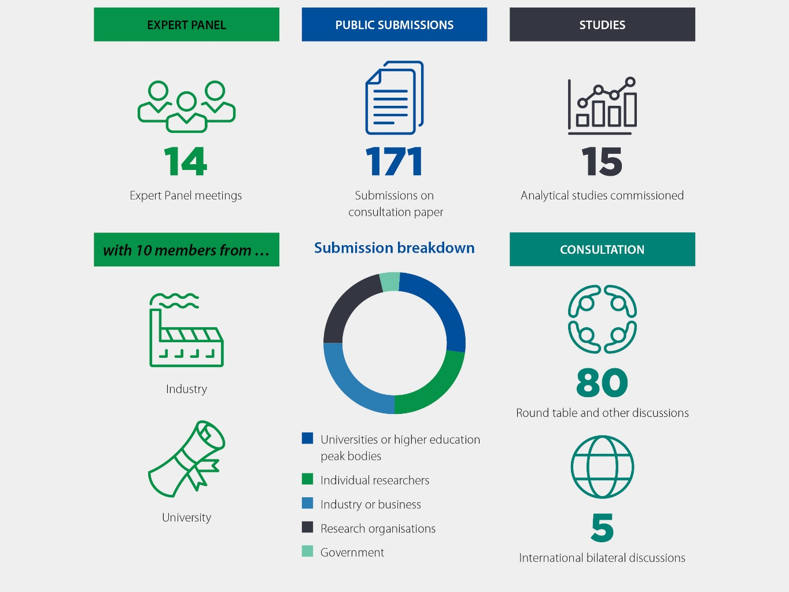
Table A1. University Research Commercialisation Expert Panel membership
Position | Appointee | Title
Chair | Mr Jeff Connolly | Chairman and CEO, Siemens Australia
Member | Ms Shemara Wikramanayake | Managing Director and Chief Executive Officer, Macquarie Group
Member | Professor Paul Wellings CBE | Emeritus Professor, University of Wollongong
Member | Ms Laura Tyler | Chief Technical Officer, BHP
Member | Professor Deborah Terry AO | Vice-Chancellor, University of Queensland
Member | Mr Andrew Stevens | Chair of Industry Innovation and Science Australia
Member | Professor Michelle Simmons AO | Director of the Centre of Excellence for Quantum Computation and Communication Technology
Member | Mr Dig Howitt | CEO and President, Cochlear
Member | Dr Catherine Foley AO PSM | Australia’s Chief Scientist
Member | Dr Alan Finkel AO | Special Adviser to the Australian Government on Low Emissions Technology

Appendix B: Glossary of terms
ABS | Australian Bureau of Statistics
AEA | Australia’s Economic Accelerator
ARC | Australian Research Council
ARENA | Australian Renewable Energy Agency
CEO | Chief Executive Officer
CSIRO | Commonwealth Scientific and Industrial Research Organisation
DESE | Department of Education, Skills and Employment
DISER | Department of Industry, Science, Energy and Resources
EI | Engagement and Impact
ERA | Excellence in Research for Australia
GDP | Gross domestic product
HDR | Higher degree by research
HEPs | Higher education providers
HERC | Higher Education Research Commercialisation
IP | Intellectual property
IISA | Industry Innovation and Science Australia
NCRIS | National Collaborative Research Infrastructure Strategy
NRI | National Research Infrastructure
OECD | Organisation for Economic Co-operation and Development
PCT | Patent Cooperation Treaty
R&D | Research and development
RBG | Research Block Grants
RSP | Research Support Program
RTP | Research Training Program
SMEs | Small and medium enterprises
TRL | Technology Readiness Level
WEF | World Economic Forum
WEHI | Walter and Eliza Hall Institute of Medical Research

Industry Innovation and Science Australia (IISA), Driving effective government investment in innovation, science and research, IISA, Commonwealth of Australia, 2021.
Australian Research Council (ARC), State of Australian University Research 2018-19: ERA National Report, ARC, Australian Government, 2019, accessed 2021.
ARC, State of Australian University Research 2018-19: ERA National Report.
Australian Bureau of Statistics (ABS) (May 2020), Research and Experimental Development, Higher Education Organisations, Australia, ABS website, accessed 2021.
ABS (August 2021), Research and Experimental Development, Businesses, Australia, ABS Website, accessed 2021. Gross expenditure on R&D (GERD) represents the total direct spending on R&D by the business, government, higher education and private non-profit sectors, irrespective of the source of those funds – e.g. government grants provided to a university are considered as research spending by the higher education sector.
OECD, Business innovation statistics and indicators, OECD website, accessed 2021.
Shanghai Ranking, 2020 Academic Ranking of World Universities, Shanghai Ranking website, n.d, accessed 2021; OECD, OECD Science and Technology Indicators, OECD 2021, accessed 2021; IP Australia, University-Industry Collaboration and Patents, IP Australia, Australian Government, 2017, accessed 2021.
AlphaBeta, Australian business investment in innovation: levels, trends, and drivers, Department of Industry, Science, Energy and Resources (DISER), 2020, accessed 2021.
ABS (various years), Research and Experimental Development, Businesses, Australia, ABS website, accessed 2021.
DISER, Innovation Systems Monitor, DISER, Australian Government, 2021, accessed 2021.
World Economic Forum (WEF), Global Competitiveness Report 2019, WEF website, 2019, accessed 2021.
IP Australia, Australian Intellectual Property Report 2017, IP Australia, Australian Government, 2017, accessed 2021.
AlphaBeta, Australian business investment in innovation: levels, trends, and drivers.
OECD, OECD Science and Technology Indicators.
DISER, Innovation Systems Monitor.
WEF, Global Competitiveness Report 2019.
IISA, Performance review of the Australian innovation, science and research system 2016, DISER, 2017, accessed 2021.
ABS, Research and Experimental Development, Businesses, Australia, 2017-18; ABS, Research and Experimental Development, Higher Education organisations, Australia, 2018.
DISER, Research and Development Tax Incentive, DISER website, November 2021, accessed 2021.
OECD, Frascati Manual 2015: Guidelines for Collecting and Reporting Data on Research and Experimental Development, The Measurement of Scientific, Technological and Innovation Activities, OECD, 2015, accessed 2021.
DISER, Innovation Systems Monitor.
WEF, Global Competitiveness Report 2019.
IISA, Performance review of the Australian innovation, science and research system 2016.
Productivity Commission, Shifting the Dial: 5 Year Productivity Review, Report No. 84, Productivity Commission, Australian Government, 2017, accessed 2021.
The Treasury, 2021 Intergenerational Report, The Treasury website, Australian Government, 2021, accessed 2022.
Productivity Commission, PC Productivity Insights: Recent Developments, Productivity Commission website, Australian Government, 2021, accessed 2021.
RJ Gordon, ‘Is U.S. economic growth over? Faltering innovation confronts the six headwinds’, NBER Working Paper, No. 18315, 2012.
Andrews et al., ‘Frontier firms, technology diffusion and public policy: micro evidence from OECD countries’, OECD Productivity Working Paper No. 2, OECD, 2015, accessed 2021.
Andrews Et Al., ‘Frontier firms, technology diffusion and public policy: micro evidence from OECD’, OECD Producivity Working Papers, No. 2, accessed 2021.
ABS, Research and Experimental Development, Businesses, Australia, 2019-20, ABS website, accessed 2021.
Universities Australia, Clever collaborations: the strong business case for partnering with universities, Universities Australia, 2020, accessed 2021.
DISER, Science, Research and Innovation (SRI) Budget Tables, DISER website, 2021, accessed 2021.
Deloitte, Innovation in Small and Medium Enterprises, Deloitte, 2017, accessed 2021.
AlphaBeta, Australian business investment in innovation: levels, trends, and drivers.
AlphaBeta, Australian business investment in innovation: levels, trends, and drivers.
ABS, Counts of Australian businesses, including Entries and Exits, 2018, ABS website, accessed 2021.
Australian Small Business and Family Enterprise Ombudsman (ASBFEO), Small business counts: small business in the Australian economy, ASBFEO, Australian Government, 2019, accessed 2021.
Verreynne et al., Enablers and barriers to industry-research collaboration: A small and medium sized enterprise perspective, CSIRO, Australian Government, 2021, accessed 2021.
IISA, Performance review of the Australian innovation, science and research system 2016.
ABS, Research and Experimental Development, Australia, 2018, (Businesses, Higher Education, Government and Private Non-Profit Organisations, 2018), ABS website, accessed 2021; OECD, OECD Science and Technology Indicators, accessed 2020.
ABS, Research and Experimental Development, Businesses, Australia, 2019, ABS website, accessed 2020.
DISER, Australia 2030: Prosperity through innovation, DISER website, Australian Government, 2017, accessed 2021.
OECD, Frascati Manual 2015: Guidelines for collecting and reporting data on research and experimental development.
ABS, Research and Experimental Development, Businesses, Australia, 2019-20, ABS website, accessed 2021; ABS, Research and Experimental Development, Higher Education Organisations, Australia, 2018, ABS website, accessed 2021; ABS, Research and Experimental Development, Government and Private Non-Profit Organisations, Australia, 2018-19, ABS website, accessed 2021. NB different data points refer to different years and hence the displayed totals are indicative only.
AlphaBeta, Mission-Driven Research Programs: A global comparison, report to the Department of Education, Skills and Employment (DESE), AlphaBeta, 2021.
ARC, State of Australian university research 2018-19: ERA national report, 2019, accessed 2021.
National Aeronautics and Space Administration (NASA), Technology Readiness Level, NASA website, 2021, accessed 2021.
ABS, Research and Experimental Development, Businesses, Australia, 2019-20. Other data from OECD.Stat. Figures in nominal, national currency terms.
DISER, Science, Research and Innovation (SRI) Budget Tables.
ABS, Higher Education Research and Experimental Development, Higher Education Organisations, Australia, 2018.
DESE, Commonwealth Provider Registration and International Student Management System (PRISMS) [data set].
DESE, Higher Education Research Data Collection [data set], DESE website, 2020, accessed 2021.
DESE, Higher Education Research Data Collection.
DESE, NRI Census 2017-18 Report Snapshot, DESE website, 2020, accessed 2021.
L Dayton, 2020, ‘A top-down reinvention’, Nature Vol 581(54).
IISA, Performance review of the Australian innovation, science and research system 2016.
L Dayton, 2020, ‘A top-down reinvention’, Nature, Vol 581(54).
Deere & Company, John Deere and USQ collaboration delivers new era in spraying technology, 11 March 2021, accessed 2022.

