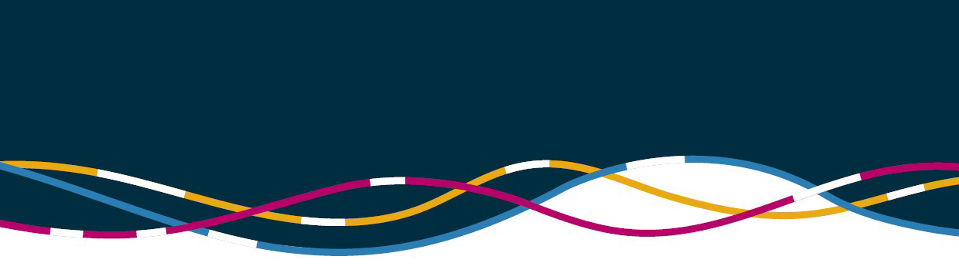


Australian Strategy for International Education 2021-2030

On 26 November 2021 the Australian Government released the Australian Strategy for International Education 2021-2030 and announced key initiatives supporting its implementation. As borders reopen to welcome international students back into Australia, the new Strategy aims to rebuild the sector more sustainably and create new opportunities for growth.

Why is the strategy being launched now?

COVID-19 significantly affected Australia’s international education sector in 2020 and continues to present challenges. Australian institutions have faced a decline in enrolments and onshore student numbers that may continue for some years.

The pandemic is not the only reason for a new Strategy. Innovations in education delivery, changing bilateral relationships with key partner countries and risks to the sector’s sustainability were already transforming the way international education was delivered. The effects of COVID-19 have accelerated many of these challenges and highlighted the need to embrace new ways of engaging with students locally and overseas for Australia to remain globally competitive.

As the sector recovers, it is important that the sector is more sustainable, can create new opportunities for growth and enhances the experience of domestic and international students. As the international education landscape continues to evolve, the strategy will position the sector to be responsive across four priorities and strengthen Australia’s position as a world leader in international education.

What is the key focus of the strategy?
The strategy identifies four priorities for the next decade in the Australian international education sector:
- Diversification
- Alignment with Australia’s workforce and skills needs
- Students at the centre
- Growth and competitiveness

