International Education Agent Performance Reports

Performance reports break down enrolment and visa outcomes for overseas students recruited through a particular education agency. These outcomes include whether a student went on to:
- successfully complete their enrolment
- have their visa application refused or their visa grant cancelled
- transfer to another provider
- notify early cessation of their studies
- have their studies terminated for non-payment of fees or disciplinary reasons
- be reported for unsatisfactory course progress or course attendance
- defer or suspend their studies
Education providers can only see reports for their own students recruited through education agencies. Providers will not see information about students from other providers. Report data is based on an education agent being recorded against a student’s Confirmation of Enrolment (CoE) by the provider. When analysing the reports, providers should also note that education agents cannot directly control student and visa outcomes.

Agency Performance by CoE completion rate
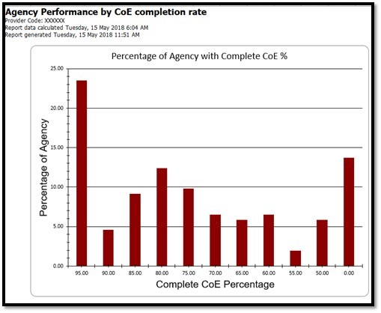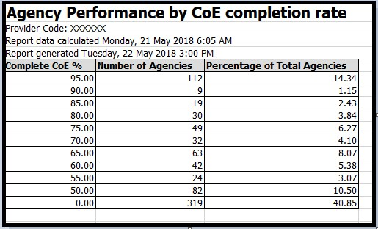
Agency Performance by Institution Detail
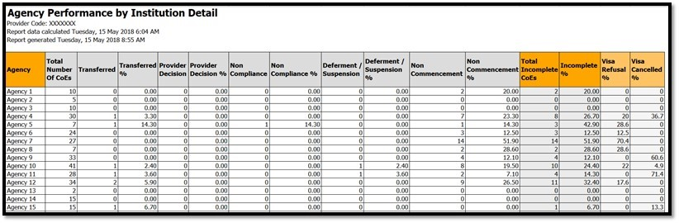
Agency Performance by Institution Summary
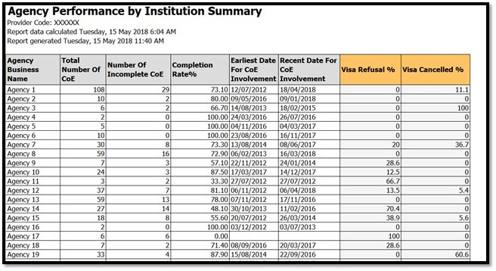
Agent Performance by CoE completion rate
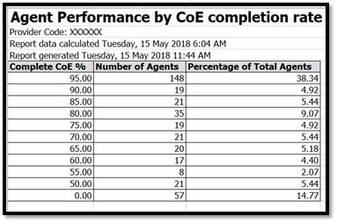
Agent Performance by CoE completion rate raw data

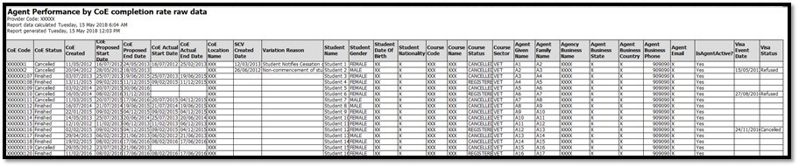
Agent Performance by Institution Summary

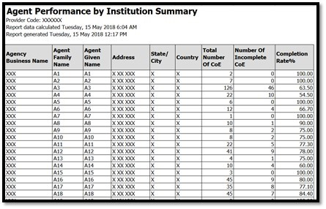
Institution Reliance by Agency
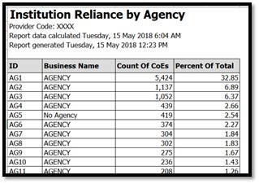
Agency Incompletion Rate
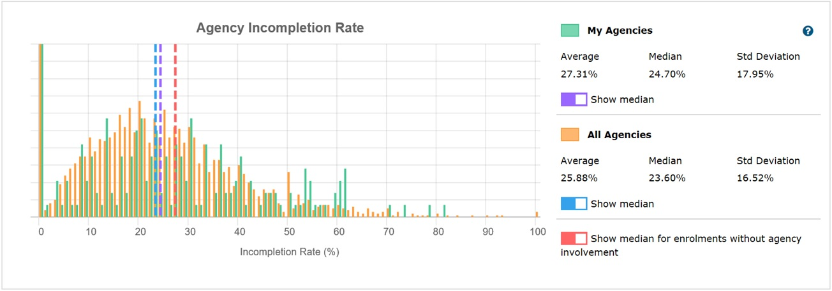

Agency Visa Refusal Rate

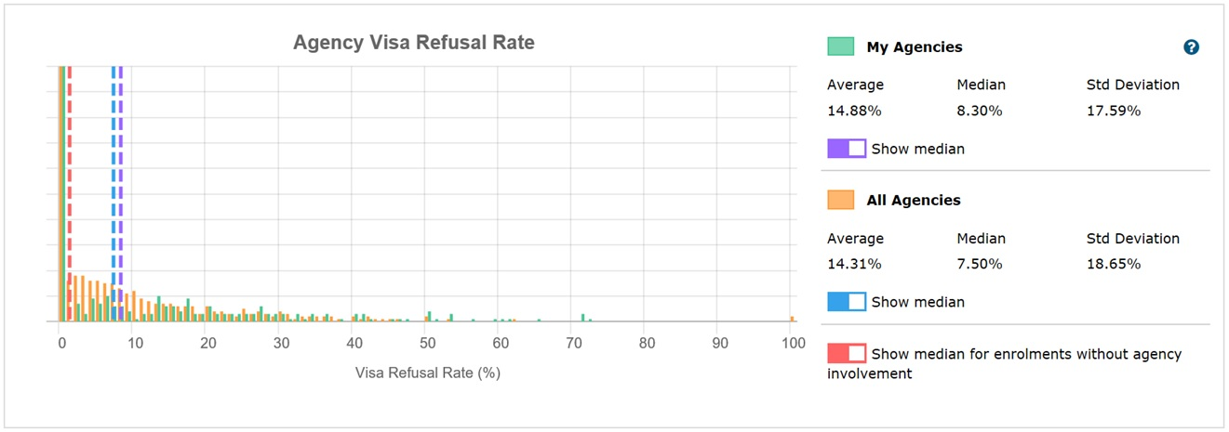
Comparison Summary Report
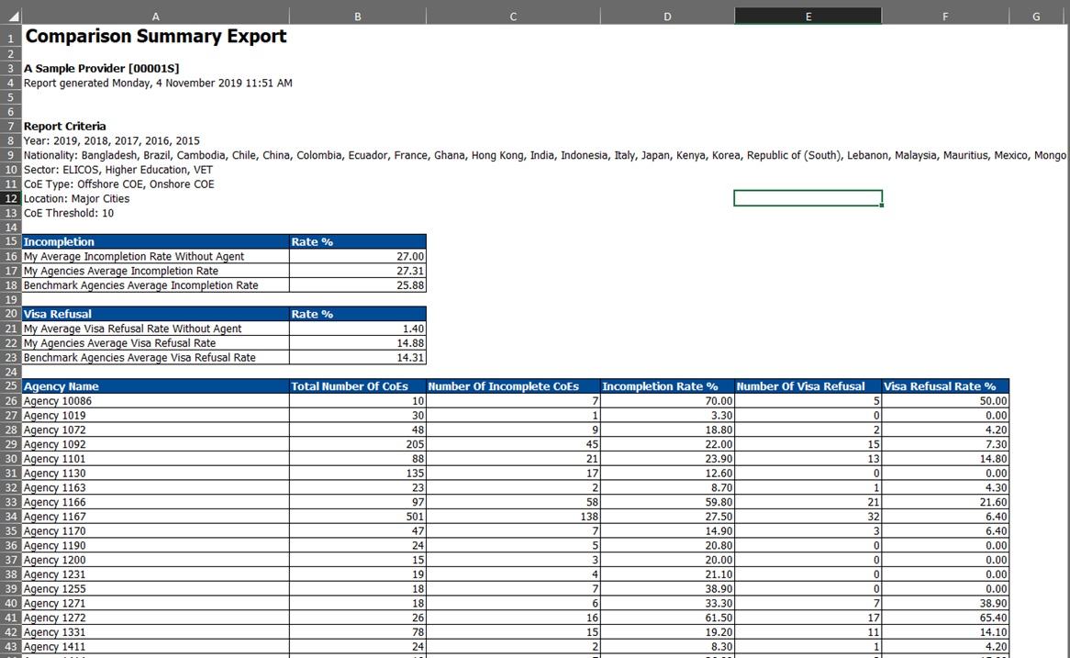

Incompletion Rate vs Visa Refusal Rate
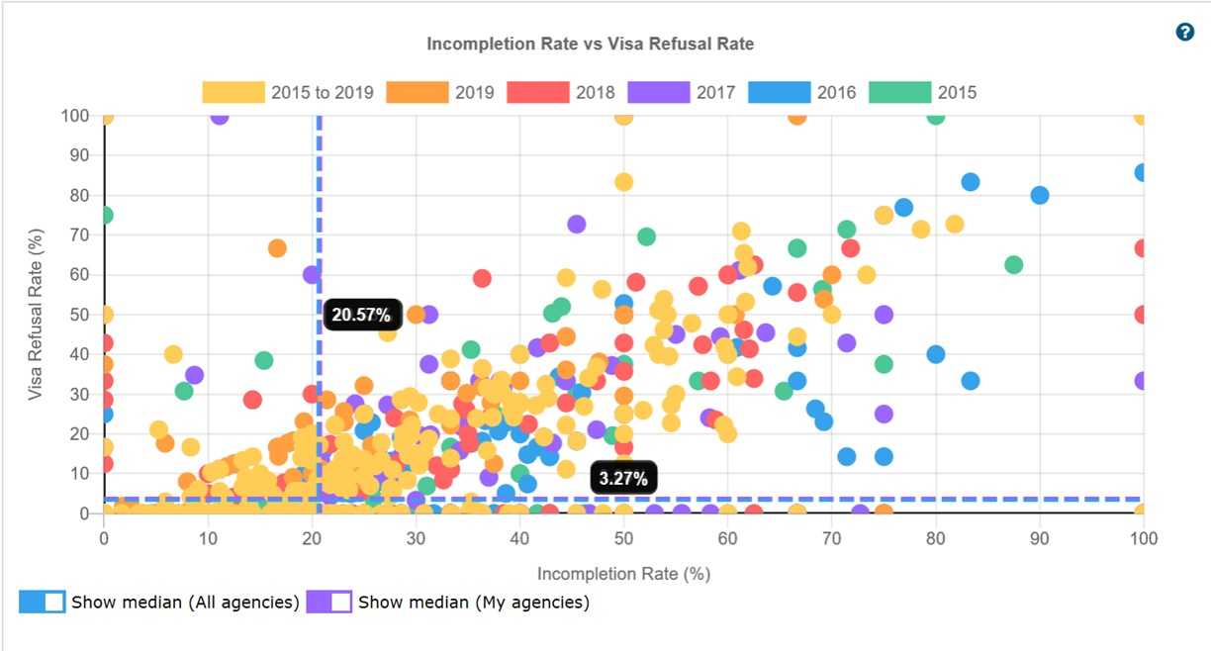

Agency selection on Incompletion Rate vs Visa Refusal Rate Incompletion Rate vs Visa Refusal Rate

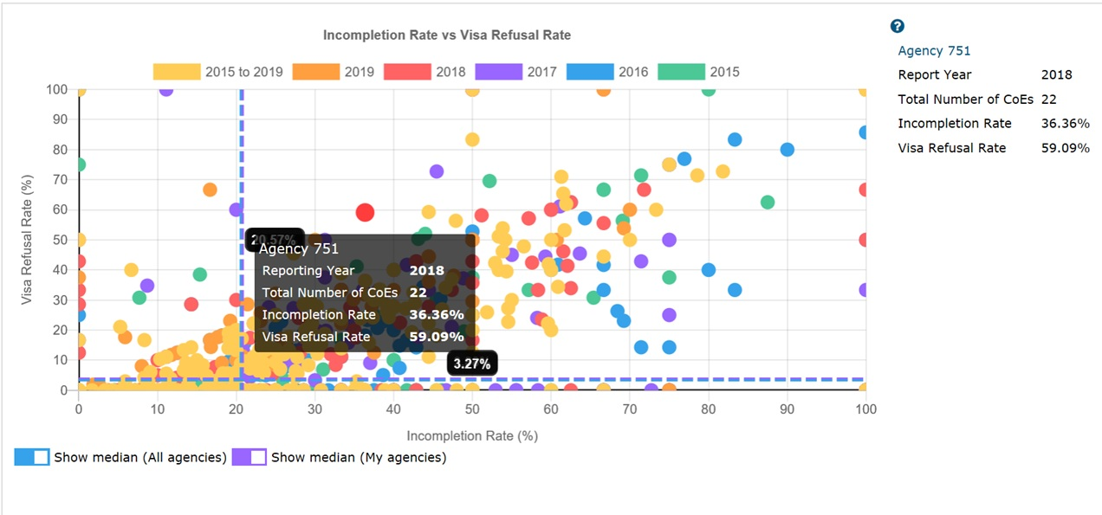

Agency / Agent Details

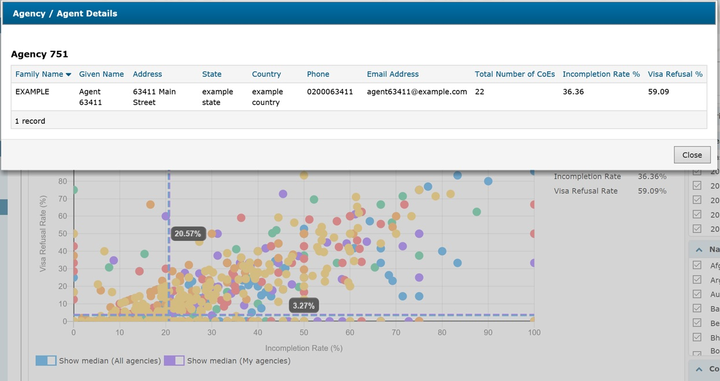
Detail Tab Export
