
UANP Review: Final Review Report
COAG Education Council
October 2020 (updated from March 2020)
Nous 20 YEARS OF INFLUENCE

Disclaimer:
Nous Group (Nous) has prepared this report for the benefit of the Australian Government Department of Education, Skills and Employment (the Client).
The report should not be used or relied upon for any purpose other than as an expression of the conclusions and recommendations of Nous to the Client as to the matters within the scope of the report. Nous and its officers and employees expressly disclaim any liability to any person other than the Client who relies or purports to rely on the report for any other purpose.
Nous has prepared the report with care and diligence. The conclusions and recommendations given by Nous in the report are given in good faith and in the reasonable belief that they are correct and not misleading. The report has been prepared by Nous based on information provided by the Client and by other persons. Nous has relied on that information and has not independently verified or audited that information.
© Nous Group

Contents
UANP Review: Key points 1
Executive summary 2
1 Background and context to the Review 17
1.1 Australian governments commissioned the Review to inform future directions for governments’ funding for preschool 17
1.2 The UANP expresses Australian governments’ shared commitment to lifting participation in quality preschool 17
1.3 UANP policy objectives and funding arrangements have evolved since the first UANP in 2008 18
1.4 The UANP has been implemented in conjunction with several related arrangements and initiatives 22
1.5 The Review’s approach is guided by its Terms of Reference and the available data 23
2 The UANP is delivered in a variety of contexts across Australia 24
2.1 Preschool sits within a broader education and care system 24
2.2 The UANP establishes a national preschool system with the flexibility to accommodate diverse service settings 25
2.3 States and Territories decide how preschool is funded and delivered based on local context 26
2.4 Universal access has been successfully implemented through a variety of funding and delivery approaches 27
2.5 Preschool provision and UANP implementation varies across Australia 31
3 There has been significant progress in achieving the UANP’s objectives, outcomes and outputs 48
3.1 The UANP has met ambitious targets for access to, and participation in, preschool 48
3.2 Participation of Indigenous children and vulnerable/disadvantaged children has improved 50
3.3 The UANP has contributed to an uplift in quality, though more work remains to be done 55
3.4 The UANP has increased the availability of free and low-fee preschool, though indirect costs can pose a barrier for some 59
3.5 Most parents can access a preschool provider that meets their needs, but funding may not align with their preferences 60
4 There are opportunities to improve UANP indicators, targets and measurement 64
4.1 The UANP’s performance framework has served it well, but there is room for improvement 64
4.2 The UANP’s quality, enrolment and attendance measures raise several challenges 66
4.3 There is a threshold issue about whether benchmarks are set at the appropriate levels 71
4.4 States and Territories are concerned that data limitations are compromising their own planning and funding decisions 71
5 Funding arrangements have been effective and efficient, but may no longer be fit-for-purpose 73
5.1 Efficient and effective arrangements provide sufficient resources while creating the right incentives for governments 73
5.2 UANP funding has been effective in achieving the agreed outcomes, with some room for improvement 74
5.3 UANP funding arrangements are efficient, but longer-term arrangements would enable better planning 78
6 Considerations for future preschool policy settings 83
6.1 Governments should build on the UANP’s success to drive further reform 83
6.2 The next phase of a national approach should redouble efforts to target children most in need 89
6.3 Future arrangements need to drive improvements in performance indicators, reporting and data sharing 97
6.4 Governments should strive to remove distortions in the preschool ‘ecosystem’ that impede progress 103
Appendix A Review Terms of Reference 106
Appendix B Acronyms 110
Appendix C Glossary 113
Appendix D UANP performance framework 114
Appendix E Evolution of the UANP and its predecessor agreements 115
Appendix F Figure 1 sources and notes 117
Appendix G The Review’s calculation of funding estimates 119
Appendix H Consultation participants 124

UANP Review: Key points
Nous was engaged on behalf of the COAG Education Council to conduct an independent review of the Universal Access National Partnership (UANP). Funding under this agreement expires at the end of 2020. The Review was overseen by officials from all governments and informed by extensive sector consultation.
The UANP is considered a major success across the sector. As intended, it has precipitated a significant increase in participation in quality preschool (kindergarten) by children in the year before full-time school (YBFS): more children are enrolled, and the proportion enrolled for the target of 600 hours has increased from 12 per cent in 2008 to 96 per cent in 2018. This reflects growth in service capacity and in community awareness of the importance of preschool (which remains voluntary in Australia).
Despite significant gains, some children are still missing out. Indigenous children and vulnerable and disadvantaged children are overrepresented in this group. Reported barriers to participation include transport costs, a lack of wraparound care, and factors related to the child’s home environment. It is not possible to infer from out-of-pocket costs the degree of preschool affordability, but the availability of targeted fee relief in all jurisdictions, high levels of enrolment and stakeholder feedback suggest that provider fees are not prohibitive for most families seeking access.
The UANP has established a national system, while preserving State and Territory autonomy to meet local needs. The mix of services – centre-based day care (CBDC), standalone and school-based preschools – and the allocation of funding between them, differs significantly across jurisdictions. This reflects local circumstances, historic infrastructure investment and different pathways to achieving universal access.
Preschool delivered by some CBDC providers attracts two streams of Australian Government funding – the Child Care Subsidy (CCS) and the UANP. While the CCS may indirectly subsidise preschool provision by contributing to some overhead costs, the Review finds that there does not appear to be a substantive overlap as the two funding streams serve different and distinct purposes. Not all jurisdictions share the Review’s views on this issue.
Australian Government funding and national coordination should continue. There is strong evidence that quality preschool improves educational and other developmental outcomes. A decrease in funding would reduce preschool participation and could adversely affect workforce participation.
Governments should enter into a new five-year National Partnership from 2021 to 2025, and transition to a National Agreement from 2026 onwards. A minority of funding under the new National Partnership should be performance-based. The uncertainty associated with short-term agreements and performance-based payments has compromised the ability to plan and invest for the long term.
Funding flexibility should be retained; but variation in State and Territory investment warrants further consideration. Although data is not directly comparable, jurisdictions with a higher prevalence of CBDC enrolments appear to invest less in YBFS preschool. It is not possible with current data to verify whether this is because they operate more efficiently, face lower costs, rely more heavily on other funding sources, or achieve relatively poorer outcomes. Governments should consider how to achieve more equitable levels of investment going forward. This work starts with improving funding transparency, including with respect to jurisdictions’ investment in preschool-related initiatives, and understanding varying cost drivers.
Over the next five years, governments should resolve outstanding issues and prepare for more enduring funding arrangements from 2026. Key priorities include lifting attendance and quality, developing robust measures of attendance and child development outcomes, modelling the efficient cost of preschool provision in different settings and contexts, and addressing looming workforce shortages.

Executive summary
The Universal Access National Partnership (UANP or the Agreement) reflects a national commitment to ensure that all Australian children in the year before full-time school (YBFS) can benefit from affordable, quality preschool. Under federal arrangements, States and Territories are responsible for the provision of preschool. The UANP enables the Australian Government to contribute funding towards meeting the costs of delivering at least 600 hours of preschool for all children, regardless of location, personal circumstances, or the delivery model. The Agreement also provides a performance framework for assessing progress and serves as the basis for implementation plans outlining agreed approaches within each State and Territory to pursuing UANP objectives and outcomes.
With the current UANP due to expire at the end of 2020, Education Ministers commissioned this Review to provide comprehensive, evidence-based advice on the extent to which the Agreement’s objectives are being met and what future funding and policy arrangements could be put in place to maintain and build upon the benefits already achieved. Nous Group (Nous) was engaged to conduct the Review.
Note to the reader: ‘Preschool’ refers to structured, play-based early childhood education delivered by a qualified early childhood teacher (ECT), in accordance with the Early Years Learning Framework and the National Quality Standard, to children in the YBFS. Preschool attendance is not compulsory. States and Territories, local government, not-for-profit organisations and/or private operators deliver preschool programs in a variety of settings, including school-based programs (government and non-government), standalone facilities and in centre-based day care (CBDC). The terms used for these programs vary across the country; for simplicity we use the term ‘preschool’ throughout this report.

The Review finds that Australian governments, through the UANP, have largely achieved the goal of providing universal access to 600 hours of quality, affordable preschool in the YBFS. A previous review of the UANP (conducted in 2014) found that the investment to that point had had a clear and positive impact. It noted that the capacity of the system to deliver the 600 hours had increased, and community expectations about preschool participation had begun to change. This Review, which covers the period 2014 to 2019, finds that further significant progress has been made – not only in terms of the UANP’s performance indicators, but also with respect to improving national data and building workforce capability.
The 600 hours per year requirement is accepted as a minimum and parental expectations have adjusted to this new norm. This is a significant policy achievement and a testament to highly effective intergovernmental cooperation.
Australian Government funding provided under the UANP during the period covered by this Review increased from $368 million in 2014-15 to $426 million in 2017-18. Meanwhile, States and Territories continued to invest in the achievement and maintenance of outcomes. State and Territory spending on preschool in the YBFS grew from $922 million in 2014-15 to $1.1 billion in 2017-18.
The evidentiary basis for these investments is strong. Quality preschool makes a significant, long-term difference to educational and other developmental outcomes. While all children benefit, increasing participation among those who are Indigenous or experiencing vulnerability or disadvantage is shown to deliver a relatively greater return (as long as quality standards are met). There are benefits to government, too: a recent economic analysis showed that the UANP contributes to increased workforce participation and tax revenues, and reduces pressure on education, health and justice budgets.
Successive governments at all levels have therefore re-affirmed their support for public funding of preschool. This commitment was reflected in COAG’s agreement, in December 2018, to the Early Learning Reform Principles, which are intended to guide national efforts to support and enhance children's learning from birth to five years of age, as well as their transition to full-time school.
Figure 1 | Highlights of the UANP’s impact since 2013
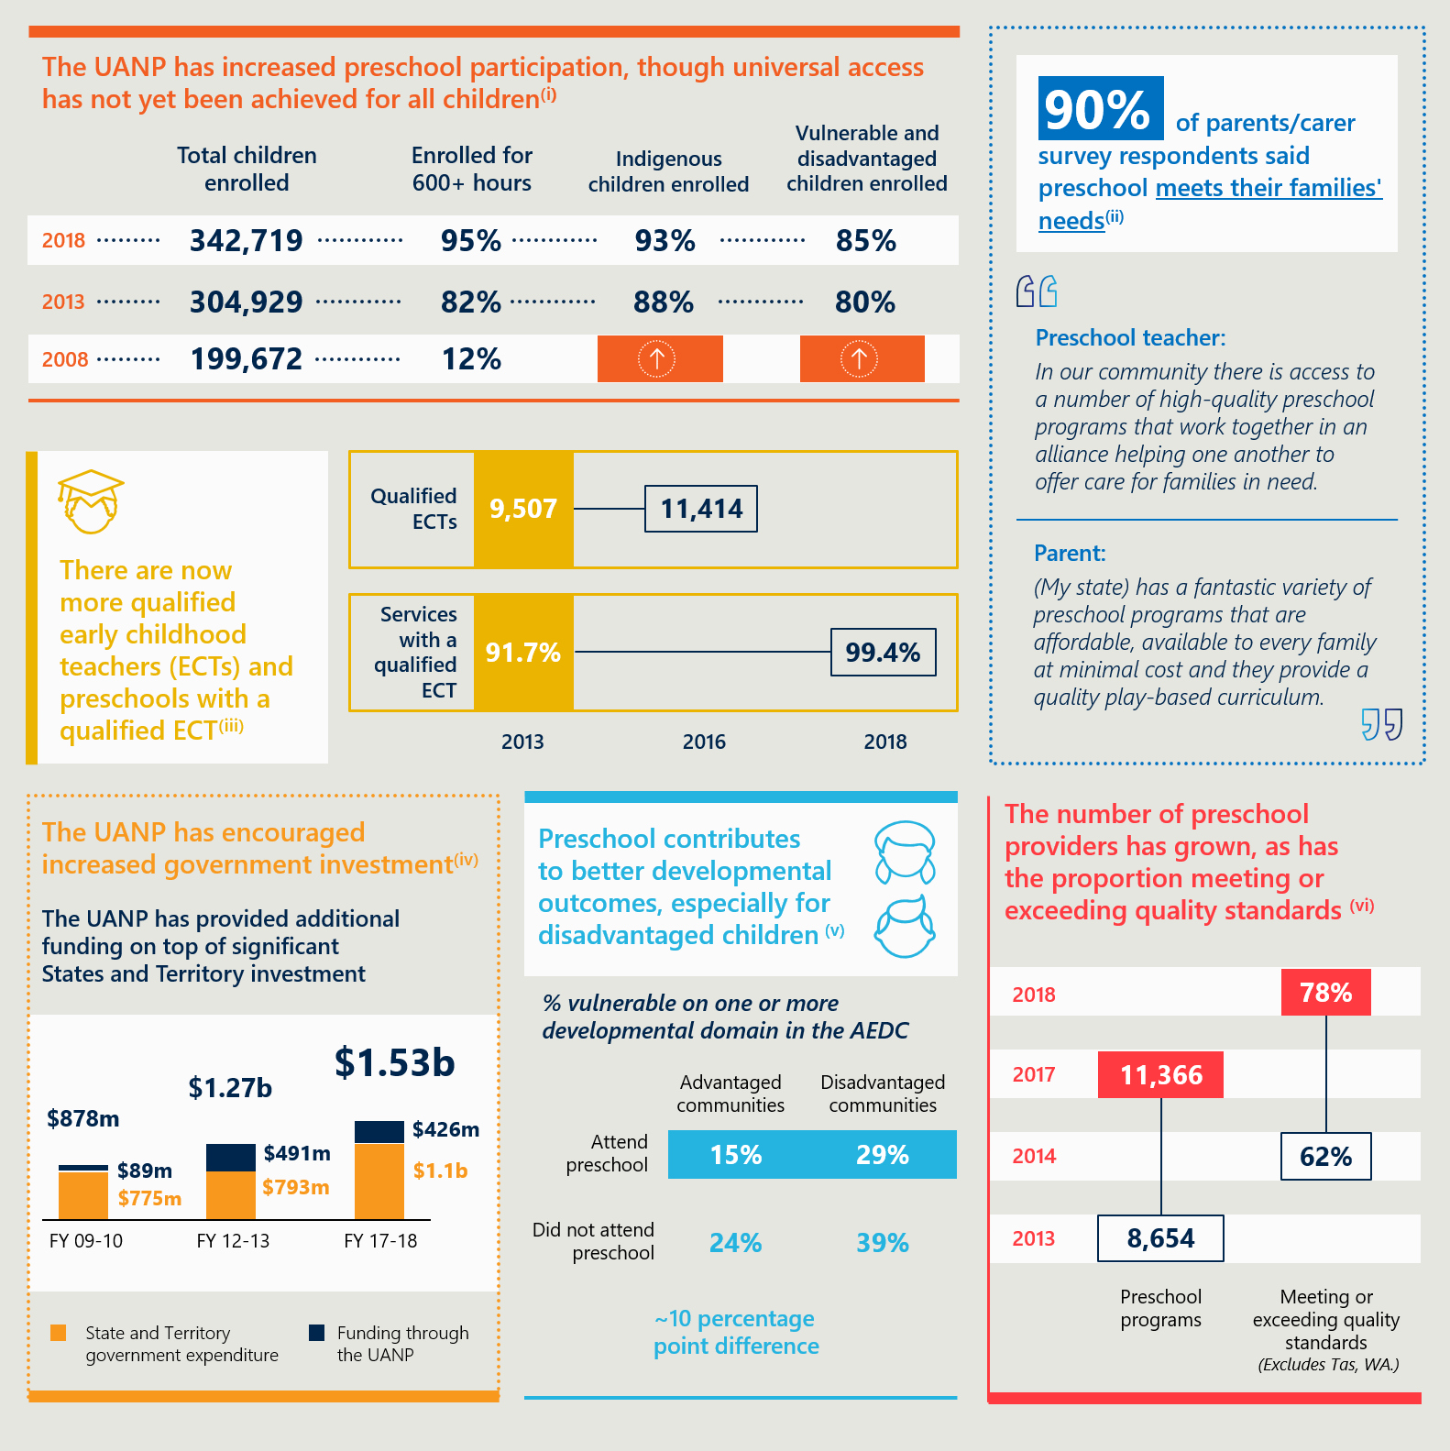

The Review’s Terms of Reference and methodology
The Review’s Terms of Reference (ToR) (see Appendix A) call for findings on:
- The extent to which the UANP policy objectives, outcomes and outputs have been achieved (addressed in Chapter 3 of this report).
- The appropriateness of the funding instrument, including the performance indicators, benchmarks and targets and the methodologies and data used to measure them (see Chapter 4).
- The efficiency, effectiveness and equity of current UANP funding arrangements (see Chapter 5).
- How the preschool system currently operates across jurisdictions and settings, including contextual factors and how collective investment supports the delivery of quality early childhood education programs for children in the YBFS (see Chapter 2).
- Future policy settings for children in the YBFS (see Chapter 6).
The Review commenced in August 2019 and involved extensive engagement with all jurisdictions and key sector representatives nationally and in each state and territory. Information was also provided through 55 written submissions and 1120 responses to an online survey. In addition, Nous studied UANP-related documentation, conducted desktop research, and analysed public and government-supplied data.
Non-renewal or a reduction of the Australian Government’s preschool contributions would have significant consequences, including for access and quality
The key message to emerge from our analysis and engagement is that while progress has been significant, there is a need to maintain investment. A reduction in funding would adversely affect preschool provision and participation, as well as workforce participation. There would be serious consequences for children, parents, the sector and its workforce, and other government programs.
The potential short- and long-term consequences of a withdrawal or significant diminution in Australian Government preschool funding are outlined in Figure 2.
Figure 2 | Potential consequences of the Australian Government not renewing preschool funding
The actual impact would depend on the extent to which States and Territories increase funding to meet the shortfall and, subsequently, the effect of any reduction in public funding on preschool participation. There would also likely be consequences associated with a decline in national leadership and cooperation.
The Review has not modelled the impact of any specific change to Australian Government funding. Some States and Territories suggested that, if funding ceased, they would revert to pre-UANP levels of provision. While fiscal constraints and competing priorities may prevent some States and Territories from significantly increasing their investment, the UANP has normalised preschool participation and governments would likely face public pressure to maintain universal access.
The Review’s overarching finding is that funding should continue under a new 5-year National Partnership, transitioning ultimately to a National Agreement
Notwithstanding strong momentum towards improving the reach and impact of preschool in the YBFS, further reform is required to deliver technical improvements in data capture and measurement, as well as advancements in engagement with more vulnerable and disadvantaged cohorts.
This has implications for the form and content of any future agreement. National policy coordination should continue to be underpinned by national funding arrangements. Funding uncertainty has reportedly hampered innovation and should be addressed through more enduring funding agreements and a smaller proportion of performance-based funding.
In this context, there is a strong case for a future National Agreement, linked to a Specific Purpose Payment and/or possibly a legislative mechanism. While a National Partnership is most practicable in the short term, governments should commit now to move towards a National Agreement. This commitment would provide a mandate for the necessary preparatory work and clearly signal ongoing investment.
The Review finds that the immediate successor agreement to the current UANP (i.e. from 2021) should be a National Partnership of five years’ duration. This would allow development of outcome measures that are appropriate to a more enduring, subsequent National Agreement – measures that would ensure effective transparency and accountability. It would also enable work to be done to model the efficient cost of delivering preschool in different service settings and jurisdictional contexts, and to develop a methodology to compare State and Territory investment in YBFS preschool. This would provide a much stronger foundation for designing future funding models.
As with the current UANP, the Review finds that a successor National Partnership should include performance-based funding. However, in recognition of achievements to date and current momentum around YBFS preschool, and to address concerns about funding uncertainty, a relatively larger portion of the funding (more than half) should be provided to support ongoing provision of the full 600 hours. While there would be an expectation of ongoing service improvement, in line with requirements under a National Partnership, the Review does not find a compelling reason for this component of the funding to be conditional on the achievement of specific targets. For the balance of the funding, consistent with jurisdictional flexibility in implementing the UANP, there should be scope to negotiate targeted areas of reform that would be subject to performance-based payment.
Successor funding agreements must continue to navigate a series of contested issues
In terms of other areas of reform focus for governments, key issues to tackle include improving the measure of attendance and striving for higher rates particularly among Indigenous children and those experiencing vulnerability and disadvantage. Workforce supply (on which work has already begun) also warrants ongoing attention.
The Review notes that the interaction between UANP and CCS funding is contentious, fuelled by a recommendation of the Productivity Commission that States and Territories be required to direct UANP funding to the service nominated by the family, regardless of setting, with child care subsidies to be reduced by an equivalent amount. The underpinning argument is that, by subsidising child care for children in the YBFS, the Australian Government is already underwriting preschool provision in those settings. The Review has not found clear evidence to support (or indeed definitively refute) the contention that the dual sources of funding (UANP and CCS) overlap at the service level. We would note, however, that each is used for a distinct and separate purpose and this is reflected in State/Territory requirements on providers on how the UANP funds will be used.
There is a related question of ‘funding equity’ between jurisdictions – defined both in terms of whether certain States and Territories are meeting an appropriate share of costs of preschool and whether others are ‘missing out’ on a funding source because there is much more limited use of CBDC-based preschool. On this, the Review finds that there are clear indications of an alignment between relatively low levels of investment in those jurisdictions that rely more heavily on CBDC-based preschool compared with those where school-based and standalone preschool provision is more dominant.
That said, the lack of information about the costs of delivering preschool in different settings and jurisdictional contexts, and the limited transparency on actual State and Territory expenditure, makes it difficult to interpret the reasons for relatively low level of investments where they occur. Moreover, as the system is founded on the principle of subsidiarity and jurisdictional flexibility to achieve the UANP objectives and outcomes in the most efficient, effective and appropriate way, it is not reasonable to expect uniformity in the balance of funding sources across all States and Territories. The Review nevertheless considers the degree of apparent variation among States and Territories warrants further consideration. To this end, it recommends that work be done to develop a fair comparable measurement of jurisdictional funding and an estimate of the efficient cost of delivering preschool in different contexts and service settings.
Issues such as these highlight the fact that, notwithstanding the strong coordination on policy and regulation, preschool as a system in Australia is not integrated. It is a manifestation of choices that reflect legacy policy decisions and systems, and community preferences for preschool. This diversity has been a strength, but it has also led to a degree of rigidity in that States and Territories are, in many ways, locked into their prevailing delivery models. The question is whether this is a problem. On the face of it, it is not, for the collective effort and investment has delivered, in a relatively short timeframe, impressive results in terms of delivering universal access to 600 hours of quality preschool in the YBFS. Most jurisdictions would argue, with good supporting evidence, that their systems are effective, and that they are accountable to their own constituents if that proves not to be the case. This is not to suggest, however, that these systems cannot evolve. Over time, it would be beneficial to continue to look at the strengths of other jurisdictions’ approaches and remain responsive and adaptive to the expressed needs of the communities being served.
Below we summarise findings by the relevant Term of Reference (ToR) in the order in which they are addressed in the body of the report.

ToR 1: Findings on the extent to which UANP policy objectives, outcomes and outputs have been achieved
The first predecessor to the UANP was introduced in 2008 and set an ambition to significantly increase preschool participation in the YBFS in terms of both the number of children enrolled and the minimum hours they would receive. Parallel work to progress a National Quality Agenda sought to lift quality for approved education and care services, including preschool.
The UANP has been renewed and extended several times. Early objectives centred on providing universal access to quality preschool. Over time as enrolments rose, greater focus was given to ensuring universal access to at least 600 hours per year, including by addressing system capacity and affordability, and improving participation particularly by vulnerable and disadvantaged cohorts and Indigenous children.
UANP funding has delivered a universal system of preschool at the minimum standard of hours (noting that before the UANP, many States and Territories were providing universal preschool for fewer hours) which has proved accessible to most children. The increase in participation witnessed over the past decade is remarkable, particularly given that preschool participation remains voluntary, and significant benefits have been realised for children and families. The Review affirms the value of the policy objectives and collective commitments of governments to this agenda, which includes maintaining flexibility to pursue reforms in a way that best suits local contexts and ensuring a continuing role for the Australian Government in policy leadership and funding.
Challenges remain that will require ongoing attention and investment. These include lifting attendance, including among Indigenous children and those who are experiencing vulnerability and disadvantage.

ToR 4: Findings on how the preschool system operates and how the UANP is implemented across different jurisdictions and settings
The abovementioned achievements would not have been possible without a concerted effort by all jurisdictions and timely responses by key stakeholders. There are strong evidence-based national frameworks underpinning the national system. These ensure broadly consistent learning experiences, even though preschool programs are delivered in a variety of different settings and by different organisations.
The dominant delivery model in some States and Territories is school-based preschool, supporting smooth integration with and seamless transition to full-time schooling. Others have a more mixed market with a greater reliance on standalone services which, like school-based preschools, can interact with related care services, and CBDC preschools which enable a seamless integration with child care.
Jurisdictions’ implementation of the UANP and its predecessor agreements necessarily varied according to the pre-existing market conditions – that is, the relative availability, maturity and quality of preschool (as variously defined locally) in 2008. Some States and Territories were already offering 11 or 12 hours of preschool a week, for example. But even where universal preschool was offered (typically in school settings), no jurisdictions provided 600 hours a year.
Similarly, while CBDC was well-established in many parts of the country, the availability of structured preschool programs in such settings for children in the YBFS was limited, and their quality was inconsistent. The UANP, alongside the introduction of National Quality Framework (NQF) for education and care services (including preschool) brought all States and Territories up to the same minimum standard in terms of universal access, hours and quality.
In addition to the prevailing market conditions and legacy factors, implementation of the UANP in different States and Territories has been heavily influenced by local geography and demography, as well as community preferences. Provision in regional and remote areas has been particularly problematic given the difficulties in achieving efficient scale and attracting and retaining qualified workers. Such issues can be compounded by barriers to participation such as a lack of suitable transport or cultural competency.
The Review finds that the increase in participation in preschool among target cohorts, and the extension of services offering 600 hours or more into remote areas, has been significant. Yet there is more work to be done here. This involves reaching children and parents earlier through other tailored programs, services and collaborative learning opportunities. It also involves continuing attention to improving service quality.

ToR 2: Findings on the performance indicators, benchmarks, data and associated methodologies
Significant progress has been made to develop preschool data collections and improve measurement of performance, but some issues remain.
The Review finds that a more reliable, accurate and nationally comparable measure of attendance needs to be developed, preferably one that allows governments and providers to collectively understand the reasons for attendance gaps, reflects the context of a voluntary system, and is tied to quality delivery by a qualified ECT. The current methodology and data for measuring attendance produce misleading results, as the UANP relies on reports of the proportion of attendance in preschool programs delivered by a teacher for at least one hour during a single reference week in August, which is subject to seasonal illness and access issues. Attendance targets are agreed as part of each jurisdictions’ Implementation Plan; however, the UANP references a long-term aspiration for 90 per cent of enrolled children to attend the full 600 hours per year (that is, a 100 per cent attendance rate). This represents a higher attendance rate than in the compulsory full-time school systems. While attendance targets are not tied to funding, it is nevertheless used as a performance indicator.
The Review finds also that consideration should be given to developing an appropriate set of outcome measures, noting that they might need to be tailored to each jurisdiction’s priorities and context. A stronger focus on longer-term child outcomes (in addition to enrolment and attendance) would further galvanise resources and effort to maximise the benefits of universal access. At present, the only available national outcome measure is the Australian Early Development Census, which provides a population-level view on educational and child development outcomes. This is a valuable reference but does not provide a child-level view of the impact of YBFS preschool and is only collected every three years, which would hinder timely monitoring.
A high proportion (70 per cent) of Australian Government payments under the UANP are tied to performance against enrolment targets, which has been an issue in terms of the uncertainty it introduces. This is partly mitigated by tiered performance payments: the Tier 1 performance benchmark for full payment is set at 95 per cent, but States and Territories receive a partial payment where they maintain achievement from the previous year. Jurisdictions argue, nevertheless, that the uncertainty about whether and when full payment will be received has a dampening effect on innovation and on the willingness of Treasuries to commit resources long-term.
The Review finds that performance-based funding appears to have been useful in the past to trigger new reform effort and investment by States and Territories. However, there is a weaker argument for providing a financial incentive to deliver universal access when markets are well-established and there is strong policy momentum in all jurisdictions.
To be clear: the Review sees a continuing role for performance payments in any new agreement, with any reward component sensibly focused on new reforms related to both extending provision to those harder-to-reach cohorts and communities, and lifting the quality of the related preschool programs. But it finds that the performance component should comprise a minority of the Australian Government’s payments.

ToR 3: Findings on the efficiency and effectiveness of funding arrangements
The Review was tasked with examining the efficiency and effectiveness of the funding arrangements underpinning the UANP, with specific regard to: the adequacy and equity of Australian Government funding; the appropriateness of the methodology for allocating funding, and the terms on which funding is provided (including with respect to performance-based payments, transparency and accountability, and funding certainty); and the National Partnership mechanism.
Having regard to the Intergovernmental Agreement on Federal Financial Relations (IGAFFR) and feedback from governments on the implementation of the UANP, the Review considers that effective and efficient funding arrangements are those that have the features set out in Figure 3. Findings on each of these considerations is discussed briefly in turn. Implications for future policy settings are discussed under ToR5.
It is important to note here the different uses of the term ‘equity’ in the UANP context. The Review sees equity as a consideration within the criteria for effectiveness, with the focus being on the outcomes for children. Equity is also viewed in terms of the equitable distribution of funding by the Australian Government to States and Territories, currently done on a per capita basis. Relevant to this consideration is whether there is a ‘double subsidy’ associated with the provision of both UANP funding and the CCS to CBDC providers that also deliver preschool (as discussed above). The Review considers these issues in the context of both effectiveness (is there sufficient funding being provided to achieve the outcomes?) and efficiency (are there duplicated funding streams?).
A further related question concerns ‘funding equity’ among the jurisdictions. This was touched on above and is discussed further here in terms of the extent to which the UANP promotes appropriate levels of investment.
Figure 3 | How the Review defines effectiveness and efficiency in the context of funding

Effectiveness: the UANP funding arrangement has been effective in achieving the agreed outcomes, with some room for improvement
Sufficiency of funding: Preschool provision remains a State and Territory responsibility. The Australian Government makes a discretionary contribution ($449.5 million in 2020) via the UANP; it does not purport to meet a specific proportion of the cost of achieving universal access. The adequacy of Australian Government funding must therefore be considered in the context of whether it supports sufficient collective investment, including by establishing incentives for States and Territories. The achievement of the agreed outcomes is evidence that governments’ collective investment has been sufficient. As intended, the UANP has precipitated universal access to 600 hours of quality, affordable preschool in the YBFS. On this basis, the Review deems the Australian Government contribution to have been adequate.
Incentivises and mobilises collective effort towards the achievement of agreed outcomes: The UANP performance framework is designed to create incentives for States and Territories to deliver universal access. There is no specific funding obligation on jurisdictions, so States and Territories benefit from implementing reforms efficiently. Some governments argue that the interaction between CCS and the UANP enables some States and Territories to meet UANP targets with minimal co-investment. Jurisdictions with a higher prevalence of preschool enrolments in CBDC, it is argued, are under less pressure to co-invest in children in the YBFS. (It should be noted that they may invest reasonably heavily in related programs.) Conversely, States and Territories that have historically supported preschool provision in schools or standalone preschool services tend to commit relatively more of their own funding to YBFS preschool (and may also support related programs).
The Review finds that, based on the information available to us (and acknowledging that contributions can be counted differently and are not always comparable), there appears to be significant variation in State and Territory funding for preschool. This may indicate that the UANP funding arrangements have failed to fully mobilise potential co-investment in all cases. However, it is not possible to determine whether the apparent relatively low level of funding by some State and Territory governments is attributable to favourable cost drivers; efficiencies in program and service delivery; the leveraging of alternative sources of funding; and/or differing outcomes.
Supports delivery of services that meet community needs: Australian Government funding under the UANP is offered on the same terms to all States and Territories. It is allocated on the basis of a per-child amount ($1,292 for 2020) for projected enrolments. The Review finds that the ability to use UANP funding in ways that suits the local context has ensured that investment largely aligns with need. However, the lack of funding certainty associated with short-term agreements has been a constraint on realising potential gains.
UANP funding distribution by the Australian Government does not consider the cost of achieving the agreed outcomes in each jurisdiction. Structural cost drivers, including those related to geography and demography, are not taken into account. The Review does not see these necessarily as an impediment to effectiveness given that the outcomes have broadly been achieved. Moreover, we would note there are other mechanisms (the Grants Commission process) designed to compensate for those cost differentials, albeit there is a lag involved and some jurisdictions argue that the additional costs are not fully offset.
Some States and Territories call for a ‘needs-based’ funding formula. This may be something to explore once the efficient cost of preschool has been modelled. Quantifying the impact of different child and service characteristics on the cost of preschool provision would be a necessary first step in aligning funding with need. There may also be grounds for future targeted investments to support children who have been harder to engage, in part due to some of those geographic or demographic characteristics, but the Review sees such investment as being reform-driven rather than cost-driven.
Promotes equitable outcomes for all children: The Review finds that some children face significant barriers to participating in 600 hours of preschool in the YBFS. This includes some children who are not captured by the target cohorts in the UANP. Barriers are typically not related to fees, as States and Territories provide free or subsidised services for those who are in financial need. Barriers may be logistical, meaning transport is an issue, or there might be language barriers or barriers associated with meeting additional needs. Quality, as well as access, can be inequitable. Services operating in regional and remote locations are more likely to find it difficult to attract and retain experienced ECTs which may negatively impact on quality outcomes for children.

Efficiency: UANP funding is used efficiently, but would benefit from greater certainty to inform planning decisions
Leverages existing assets: The Review finds that the capacity for States and Territories to leverage existing services (whether schooling or CBDC) does not render current arrangements inefficient. Relying on CBDC providers to deliver preschool programs may be an efficient response in some jurisdictions. Similarly, leveraging school infrastructure, particularly in thin markets, may represent an efficient way to extend preschool to as many children as possible. Moreover, the UANP was expressly designed to allow each State and Territory to decide how funding is deployed within their respective jurisdictions. This principle could not be applied if the policy decisions of States and Territories were to influence the amount of Australian Government funding available to them under the agreement.
Promotes delivery at low cost to families: The Review finds that some downward pressure on price (where fees are charged) appears to have been maintained through the availability of options for most parents in most situations. While some markets are more diverse than others, parents (other than those in small and remote communities) typically can choose between more than one provider, if not more than one service type. For-profit providers must compete against large not-for-profit providers, with anecdotal evidence suggesting there is some internal cross-subsidisation among preschool providers across their networks. (For example, we were told that fee-charging school providers sometimes cross-subsidise those in more marginally viable areas.) Such examples suggest there is little or no exploitation of the funding arrangements for unreasonable levels of commercial benefit. The UANP supports this efficient use of funding by promoting flexible delivery that allows for a range of models and provider types to be present in each jurisdiction’s market. The Review sees this as a strength.
Minimises administrative burden to providers: The Review finds that the reporting burden on providers related to compliance with UANP and associated requirements does not appear to be a significant point of contention.
Ensures certainty for long-term planning: The UANP has been renewed or extended six times, with the more recent extensions being of a short duration. The Review finds that the short-term nature of the UANP has had a debilitating effect on the sector. It has led to cautious decision-making about investment in programs and in staff and has compromised the ability to plan effectively. This means, for example, good staff cannot be retained, due to an inability to promise them longer term employment, which in turn leads to higher turnover and associated administrative inefficiencies.
Avoids duplication or overlap of funding sources: The Review does not support the claim that some preschool enrolments benefit from a ‘double subsidy’ at a service level. Although CCS and UANP funding can accrue to the same preschool-aged child in CBDC there is insufficient data to support the contention of a significant overlap. Resolving this would require access to detailed financial records held by the providers. What is clear to the Review is that the two funding streams have different policy intents and appear to serve distinct purposes.
While it is reasonable to speculate that there would be some costs of delivering child care that indirectly support preschool provision, CBDC providers and sector representatives assert that funding provided under the UANP is exclusively applied to the delivery of preschool – typically to engage a qualified ECT and preschool-specific resources. Moreover, several States and Territories explicitly prohibit cross-subsidisation of child care as a condition of funding.
Some jurisdictions do not share the Review’s views on this issue.

ToR 5: Findings to inform future policy settings
The foregoing analysis informs the Review’s findings with respect to potential future policy priorities and agreement structures to replace the current UANP. It highlights key components of what might form a reform agenda for the period 2021 to 2025, and the period from 2026 and beyond.
The first period (2021-25) assumes the introduction of a new successor National Partnership to the current UANP. This agreement would be of, we suggest, five years duration in order to provide greater funding certainty, address a range of important data and measurement issues, and explore both the development of an ‘efficient cost’ model for preschool and a methodology for consistently measuring State and Territory investment. There is also a need to address workforce supply issues (on which work has already begun) and, as noted above, pursue targeted reforms directed at those cohorts not fully accessing preschool at the appropriate level of quality or for enough hours.
Conceptually, the Review sees this five-year window as the period for resolving a range of outstanding issues while laying the foundation for a more enduring set of funding arrangements from 2026 onwards that would be underpinned by a National Agreement and/or possibly legislation.
Figure 4 below summarises how governments’ focus has shifted since the establishment of the first predecessor to the UANP, and how the agenda might evolve. It highlights key components of what might form a reform agenda for the period 2021 to 2025, and the period from 2026 and beyond.
The first period (2021-25) assumes the introduction of a new successor National Partnership to the current UANP. This agreement would be of, we suggest, five years duration in order to provide greater funding certainty, address a range of important data and measurement issues, and explore both the development of an ‘efficient cost’ model for preschool and a methodology for consistently measuring State and Territory investment. There is also a need to address workforce supply issues (on which work has already begun) and, as noted above, pursue targeted reforms directed at those cohorts not fully accessing preschool at the appropriate level of quality or for enough hours.
Conceptually, the Review sees this five-year window as the period for resolving a range of outstanding issues while laying the foundation for a more enduring set of funding arrangements from 2026 onwards that would be underpinned by a National Agreement and/or possibly legislation.
Figure 4 | The evolution of governments’ areas of focus, and potential future priorities
The main rationale for moving to a National Agreement in the period from 2026 is to ensure continuing funding for what is now a set of national service delivery arrangements. While there will be ongoing need for service delivery improvement and the pursuit of nationally-agreed outcomes, the system will have matured to the extent that a time-limited National Partnership would no longer be appropriate. The Review notes that – assuming the necessary preparatory work on improved outcomes, quality and attendance measures is done; that efficient costs have been modelled; and there is an agreed approach to counting State and Territory investment – a new funding allocation formula could be introduced from this point forward. Such an outcome should resolve the residual issues about funding equity and create the conditions for an even more cost-effective system to deliver the outcomes expressed in the UANP and in the Early Learning Reform Principles as they relate to YBFS preschool.

List of key findings
The Review makes 36 key findings, which are listed in Table 1 against each of the Review’s Terms of Reference (rather than where they are positioned in the report). Key findings relating to ToR 1 to 4 relate to the UANP’s current operation and impact, while key findings under ToR 5 consider the continuing role for the Australian Government, the form of any successor agreements and its key elements (including the performance framework and measures) and broader policy directions.
The Review believes that while most of the key findings under ToR 5 would be better pursued in successor arrangements to the UANP, several could be progressed by governments individually or collectively under broadly agreed policy directions and in line with the Early Learning Reform Principles.
Reflecting the diversity of preschool delivery models and policy approaches across Australia, Tasmania and Western Australia do not share some of the views put forward by the Review, particularly Key Findings 9, 10 and 24. While the Review respects these concerns, we remain satisfied that our views derive from the best available qualitative and quantitative data and application of conceptual logic. The fundamental challenge is improving the evidence base, and the Review has made several key findings on this.
 | Table 1 | The Review's key findings
Number | Key finding | Report chapter
 | ToR 1: The extent to which the UANP policy objectives, outcomes and outputs have been achieved
1 | The UANP has, since 2014, continued to build on the foundation of predecessor agreements to improve participation in affordable, quality preschool for children in the YBFS. This is a significant national accomplishment. | 3
2 | Success under the UANP reflects the continuing effort and commitment of all jurisdictions and the preschool sector. There is strong momentum to build on achievements to date. | 3
3 | While the objectives of the UANP have broadly been realised, participation by target cohorts is not yet at the desired levels. | 3
4 | The UANP has contributed to an uplift in preschool quality, though more work remains. Workforce challenges present a particular risk to the ongoing provision of universal access at the appropriate levels of quality. | 3
 | ToR 2: The appropriateness of the UANP funding instrument
5 | The UANP’s performance indicators are relevant, if lacking any outcome measures. | 4
6 | The current approach to attendance data collection and measurement is problematic and the UANP’s reported levels of attendance are unreliable. | 4
7 | Major strides have been made to develop preschool data collections and improve measurement of performance, but there are a range of issues yet to be resolved. | 4
 | ToR 3: The efficiency, effectiveness and equity of current UANP funding arrangements
8 | UANP funding arrangements have been effective in achieving the agreed outcomes, with some room for improvement. | 5
9 | The Review does not support the claim that some preschool enrolments benefit from a ‘double subsidy’ at a service level. While child care subsidies and UANP funding can accrue to the same preschool-aged child in CBDC, these two funding streams have different policy intents. | 5
10 | The Review does not accept that jurisdictions that attract relatively high amounts of CCS are ‘double dipping’. Funding flexibility contributes to the efficiency of current arrangements and is an accepted feature of the UANP. The apparent variation in the relative amount of State and Territory investment warrants further analysis, however. | 5
 | ToR 4: The context in which the UANP operates
11 | A key strength of the UANP has been the flexibility it provides for States and Territories to direct funding in a way that best meets local conditions and priorities, while still ensuring that its terms are being met. Such flexibility involves a trade-off between national consistency in service and funding models. | 2
12 | The Australian Government’s funding contribution delivered via the UANP contributes to State and Territory preschool investment, which is significant, if uneven. | 2
 | ToR 5: Future policy settings for children in the YBFS
13 | The collective achievement of governments in delivering universal access to quality preschool in the YBFS has been significant, and the return on this investment is starting to become apparent in children’s further developmental and educational progress. | 6
14 | The Early Learning Reform Principles should be a guiding light for future preschool policy developments and a key reference for prioritising future reforms and funding commitments. | 6
15 | To build on progress, meet the needs of parents and communities, and avoid risks to universal access and quality, governments should maintain their commitment to funding universal preschool in the YBFS. | 6
16 | Any reduction in Australian Government funding for YBFS preschool would trigger immediate and longer-term consequences. If changes were to be considered, the impacts, including on fees and the CCS, should be modelled. | 6
17 | The next phase of universal access to quality YBFS preschool represents a significant new era of development, to follow the previous phases of establishment and development. In general States and Territories need to continue to design their own sectors and systems for preschool provision but also to actively share experiences and each consider how their systems might improve for children and families. This should continue to be facilitated through national policy coordination with leadership by the Australian Government. | 6
18 | Efforts must continue to improve participation by all children. Successor arrangements to the UANP should include reforms that extend beyond access and availability of services to focus on facilitating attendance and improving program quality where needed. Governments should continue to focus particularly on Indigenous children and children experiencing vulnerability and disadvantage, as these target cohorts have lower enrolment rates and much to gain from quality preschool. | 6
19 | Governments should increase focus on: children living in rural and remote areas; those with disabilities and developmental delay; and those from culturally and linguistically diverse backgrounds. This might be expressed through jurisdictional-specific reform commitments, noting that care must be taken in setting targets until robust measures are in place. | 6
20 | Governments should develop better understanding of quality drivers in the range of YBFS preschool services and develop specific strategies to lift quality in geographic, sectoral or socio-economic environments where it is, on average, more likely to lag. | 6
21 | Governments should agree in-principle to move towards a National Agreement pertaining to preschool in the YBFS, potentially underpinned by legislation. The commitment should be for a new set of arrangements to be in effect from 2026 at the latest. | 6
22 | A National Partnership is the most practicable form of agreement to replace the current UANP in the short term. A new National Partnership agreement should be of five years’ duration in order to work through a range of proposed reform priorities and lay the foundation for new, more enduring funding arrangements from 2026. | 6
23 | To further promote innovation that is associated with higher levels of funding certainty, and in recognition of the clearly stated commitments by all governments to the early childhood education agenda, funding that is contingent on performance should constitute a minority of the Australian Government contribution under successor agreements to the UANP. | 6
24 | All States and Territories make significant investments in preschool, but some jurisdictions make relatively larger investments. Governments should explore ways to incentivise greater levels of co-investment from 2021, and incorporate measures into bilateral implementation plans that promote more equitable levels of State and Territory funding contributions to preschool, recognising the different service settings in each jurisdiction. These measures should be informed by a more detailed understanding of efficient and effective delivery. | 6
25 | Governments should consider the development of a model that would indicate the efficient cost of preschool delivery in different settings and jurisdictional contexts. This will be a complex exercise requiring dedicated resources. | 6
26 | Governments should develop an agreed approach to counting relevant jurisdictional contributions to YBFS preschool to inform future comparative analysis. This should take effect in time to inform the negotiation of a National Agreement (or similar enduring funding agreement) to take effect from 2026. | 6
27 | The current funding allocation methodology based on four and five year old enrolments figures is not fit-for-purpose. Future arrangements should consider an allocation methodology that uses an improved measure of enrolment, initially through the use of the state-specific YBFS measure. | 6
28 | Negotiations towards any successor agreements introduced from 2021 should consider a more accurate methodology for measuring enrolment rates for preschool in the YBFS. | 6
29 | Current measures of attendance are not suitable for performance reporting or funding decisions. Governments should invest in accurately and reliably measuring and reporting a nationally consistent measure of preschool attendance. | 6
30 | The UANP’s current attendance target is unrealistically high. Successor agreements introduced from 2021 should include a more realistic target that is tied at the child-level to actual delivery by an ECT, accounts for the reasons for absences and recognise the non-compulsory nature of preschool programs. | 6
31 | Negotiations towards any enduring funding agreement from 2026 onwards should consider the value and feasibility of child-focused outcomes measures. These negotiations should also consider whether AEDC results should be included as a performance indicator, though this should not be tied to funding. | 6
32 | Governments should explore a more broadly defined measure of vulnerability and disadvantage as an alternative to SEIFA IRSD. This might be enabled through development of a nationally agreed framework of indicators, which can then be used for jurisdictional-level analysis to inform policy and negotiated arrangements with the Australian Government on YBFS preschool reform funding. | 6
33 | To ensure a tight focus on continued quality improvement, governments should consider re-inclusion in successor National Partnership agreement (from 2021) of a measure that more accurately indicates the number of hours of preschool delivery each child receives from a qualified ECT. Governments should also directly reference NQF ratings and State and Territory data in any new agreement to enable a more explicit linkage between, and analysis of, preschool outcomes and quality of provision. | 6
34 | States and Territories should be encouraged to support evidence-based learning programs for three year olds in diverse forms. Such programs could be counted as relevant co-investment (along with other relevant initiatives) where they directly contribute to the achievement of UANP objectives, including improving participation of underrepresented cohorts in YBFS preschool. | 6
35 | Addressing the workforce challenges affecting preschool in the YBFS should be considered in the context of any agreed national approach to the ECEC workforce. | 6
36 | Governments should ensure that any new agreement continues to reflect a strong alignment with emerging national policy positions on early years development and school education, to promote a more integrated sector with seamless transitions for children. | 6

Background and context to the Review
This chapter provides background on the UANP and context for the Review.

Australian governments commissioned the Review to inform future directions for governments’ funding for preschool
In its 2019–20 Budget, the Australian Government committed to a one-year extension of the UANP for the 2020 calendar year, with a review clause. The Council of Australian Governments (COAG) Education Council agreed to undertake this review to inform future directions for governments’ funding for preschool.
Nous was engaged by the Australian Government Department of Education on behalf of the COAG Education Council to conduct an independent review of the UANP guided by the Terms of Reference provided at Appendix A and discussed in Chapter 1.5. Education officials from the Australian Government and States and Territories jointly oversaw the Review.

The UANP expresses Australian governments’ shared commitment to lifting participation in quality preschool
The UANP is an intergovernmental agreement between the States, Territories and the Australian Government. It aims to ensure children have access to at least 600 hours of affordable, quality preschool in the year before full-time school (YBFS). Under the UANP, the Australian Government contributes funding ($449.5 million for the 2020 calendar year) allocated to each State and Territory on the basis of a per-child amount ($1,292 for 2020) for projected enrolments to contribute to States’ and Territories’ own contributions to support delivery of preschool programs.
In entering into the UANP, all Australian governments recognised their mutual interest in improving outcomes for young children and the need to work together to achieve those outcomes through increased provision and participation in preschool. More recently, governments’ shared commitment is reflected in the Early Learning Reform Principles, agreed by First Ministers in December 2018, which set out the key features that should underpin future federal arrangements to improve outcomes for children and their families. The related design principles are set out in Figure 5 below.
Figure 5 | Early Learning Reform Principles – Design principles
All jurisdictions are committed to cooperation and shared responsibility for early learning. | All jurisdictions maintain flexibility to deliver services in a way that adapts to local circumstances, encourages innovation, and supports choice for families. | National arrangements for early childhood are cohesive, effective and efficient; funding is sustainable and transparent; and services are high quality, accessible, equitable and inclusive. | Reforms are evidence-based, child and family-centred, and complement existing arrangements. | Roles and responsibilities are clear, and jurisdictions are accountable under agreed and measurable evaluation frameworks, which are supported by accessible, meaningful and reliable data.

The Early Learning Reform Principles are included in the ToR for this review, providing a framework for considering evidence-based findings to inform future policy settings for children in the YBFS.

UANP policy objectives and funding arrangements have evolved since the first UANP in 2008
Prior to 2008, mainstream preschool provision was exclusively a State and Territory responsibility; there was no nationally articulated policy and limited comparable data. In November 2008, COAG agreed to the National Partnership Agreement on Early Childhood Education (NP ECE). This was a major initiative, signalling a collective commitment to early childhood development and the beginning of a nationally consistent approach to preschool. It was accompanied by landmark reforms to develop the curriculum, workforce and standards to ensure quality education and care in the early years from birth to full-time school entry.
“…by making a strong commitment to education in the year before school, the National Partnership emphasised the importance of early education for Australian governments, the ECEC sector and families. This placed early education and care firmly on the policy agenda and led to change in practice within service providers and in state and territory government policy.” (Social Policy Research Centre UNSW submission)
The principal aim of the agreement was to introduce access to 15 hours per week for 40 weeks a year of quality early childhood education in the YBFS. In 2013 this commitment was amended to 600 hours per year to provide greater flexibility in service provision.

The strategic context in which the UANP has been delivered has changed considerably over the past five years (and even more so since 2008)
Key changes include:
- growth in demand for early childhood education and care. The proportion of 0 to 4 year olds in formal care rose from 34 per cent to 42 per cent between 2008 and 2017, partly driven by increasing women’s workforce participation, which has risen from 58 per cent in 2006 to 61.1 per cent in 2019.
- the implementation of various State and Territory initiatives and programs to improve preschool participation, equity and quality (see State and Territory profiles in Chapter 2.5 for examples).
- the full introduction of the National Law and Regulations including the NQF and National Quality Standard (NQS) to inform preschool program quality.
- the June 2018 expiry of the National Partnership Agreement on the National Quality Agenda for Early Childhood Education and Care (NP NQA), with the Australian Government funding the Australian Children’s Education and Care Quality Authority (ACECQA) and States and Territories remaining responsible for regulation of the sector in their jurisdiction.
- the introduction of the new Child Care Subsidy in 2018 and other Australian Government child care funding arrangements, following the 2014 Productivity Commission Inquiry on Childcare and Early Childhood Learning.
- a move nationally to a model of ‘sector-blind, needs-based funding’ in school education.
- the improvement of data collection and reporting, including via the Australian Early Development Census (AEDC), providing a wealth of information about children’s development and wellbeing as they start full-time schooling across Australia.
- periodic interest in revisiting the roles and responsibilities in the federation, with preschool often cited as an example of the complex interface between Australian Government’s role as the major funder of child care and State and Territory responsibility for education.
- evolution in the purpose and use of National Partnership agreements, with different views emerging on how agreements should be structured and leveraged for national reform and improved service delivery.

The UANP has been renewed or extended six times, with each extension having a duration of two years or less. The current UANP is in place to end of 2020 calendar year, with final performance assessment and payment to be undertaken in early 2021. Four policy elements have remained constant:
- A core aim to improve access to, and participation in, 600 hours of quality preschool (delivered by a qualified early childhood teacher who meets the NQF requirements) in the year before full-time school.
- An emphasis on improving the participation of Indigenous children (including those living in remote communities) as well as vulnerable and disadvantaged children.
- A focus on ensuring that cost is not a barrier to participation in preschool.
- A commitment to improved data collection and sharing.
From 2015 onwards, each agreement has also included a commitment to ensure preschool is supported regardless of the setting.
The Australian Government’s funding contributes to significant State and Territory investments in preschool and related programs, thereby increasing total government investment in universal access. The Australian Government contribution under the original UANP agreement was $970 million over five years (with the annual spend increasing to $450 million by 2012-13), including $3 million per year for data development and evaluation. The evolution of the UANP and its predecessor agreements are summarised in Appendix E, while the features common to them all are summarised below.

The UANP and its predecessor agreements share seven key structural features
- The agreement defines the shared objectives of all jurisdictions.
- The agreement articulates the respective roles and responsibilities of the Australian Government and the States and Territories.
- State and Territory governments exercise discretion about how UANP funding is deployed within their respective jurisdictions.
- State and Territory governments determine the sum and purpose of State or Territory funding to support preschool provision. This is consistent with the Intergovernmental Agreement on Federal Financial Relations, which favours flexibility in service delivery, and with the Early Learning Reform Principles.
- The agreement sets out the total estimated disbursements to each State and Territory from the Australian Government.
- The agreement stipulates the terms under which funding will be provided.
- The agreement provides the basis for more detailed bilateral implementation plans. In the 2013-14 agreement and onwards, the UANP and its predecessor agreements have also included a proportion of funding attached to performance to drive reform.

The UANP is founded on strong evidence about the benefits of quality preschool
The collective investment by all governments under the UANP reflects a consensus that preschool improves children’s development and learning, and their school transitions. This consensus is based in research indicating that:
- Most of a child’s brain development occurs during their first five years, forming the foundation for lifelong learning.
- The development of children’s cognitive, social, emotional and physical skills as a result of attending a quality preschool program lay the foundation for both short-term and life-long benefits.
- Preschool sets up children’s readiness for success at full-time school, improves learning throughout primary school, and is associated with higher secondary school retention rates.,,
On the latter point, the Australian Government’s Review to Achieve Educational Excellence in Australian Schools (Gonski Review), for example, found that quality early childhood education builds the foundation for future learning and is an equitable and cost-effective way to narrow the gap between advantaged and disadvantaged students.
While all children can benefit from a quality preschool program, authoritative reviews suggest that developmentally vulnerable children have the most to gain. Of note is the Lifting Our Game report, which concluded on the basis of a review of published research, that the developmental benefits of preschool are especially marked for Indigenous children and children experiencing vulnerability and disadvantage. In addition, several jurisdictions note that preschool participation enables the early identification and remediation of vulnerabilities experienced by children and their families. These target cohorts are generally less likely to participate in preschool, however, and so are given especial focus under the UANP.
Benefits are seen not only at the individual level. A recent analysis of the UANP found that every dollar invested produces a $2 return to the economy. Australian governments benefit from their spending on preschool through increased workforce participation, consumption and tax revenue. Considerable savings are also realised in health, education and justice budgets.
While there is no clear evidence about the optimal amount of preschool that children should receive each week, a threshold of 15 hours per week (600 hours per year) in the year before full-time school was agreed based on a number of studies into the minimum amount for children to gain educational, social and developmental benefits. At the time the first NP ECE was introduced, most States and Territories were offering around 12 hours per week, so this was a substantial shift. Despite this set minimum, there is evidence an earlier start or longer hours is beneficial, provided the expanded services do not diminish in quality. Internationally, most developed countries are offering closer to 20 and 30 hour per week.
The UANP and its predecessor agreements are founded on the principle of ‘universality’. This reflects a strong evidence-based policy position by governments here and internationally that any initiatives to promote preschool participation should be provide equal opportunities for all children to participate. Doing allows systems to:
- capture children not formally identified as being at risk who would likely benefit
- avoid the risk of stigma being attached to preschool participation
- promote preschool as a normal preparatory phase to ease transition to full-time schooling
- achieve genuine systemic improvement
- provide a platform on which complementary targeted initiatives could be built.
This is consistent with governments’ approach to other parts of the education system, which offer universal access to primary and secondary school and tertiary education.

The UANP has been implemented in conjunction with several related arrangements and initiatives
The Australian Government’s funding contribution via the UANP contributes to States’ and Territories’ own contributions to support delivery of preschool programs and has made possible both the expansion of the number of hours of preschool available and an increase in participation. State and Territory contributions that pre-dated the UANP have continued, taking on different forms in different places and supporting services to align to local contexts and community needs.
States and Territories have also individually implemented initiatives that directly and indirectly contribute to the realisation of universal preschool access. Information about some of these initiatives are outlined in Chapter 2.5.
Nationally, around a year after the NP ECE was agreed, COAG signed the NP NQA, which was subsequently extended until June 2018. This provided the mechanism by which all jurisdictions agreed on the NQS for preschool services. It also gave rise to a new national body, ACECQA, that assists governments in administering the NQF, including by monitoring and promoting the consistent application of the Education and Care Services National Law across all jurisdictions.
Over the last decade, governments have jointly pursued specific objectives related to Indigenous early childhood development including through a commitment to the Closing the Gap targets for early childhood education (which reference the UANP’s Performance Indicator 2 for the enrolment of Indigenous children). Governments have also collaborated on measures to develop the early childhood workforce.

The Review’s approach is guided by its Terms of Reference and the available data
The last review of UANP arrangements occurred in 2014. The ToR for this Review (see Appendix A) build on the previous review and focus on the sector since that time. To deliver the Review, Nous broke down these ToR into more specific lines of enquiry, with its overarching question being “what value is being derived from the UANP and how should this, as well as governments’ experiences of the agreement to date, inform decisions about future funding of preschool nationally in Australia?”.
The Review is not a review of child care, child care subsidies or schooling, though it considers how the UANP funding intersects with related funding (including child care subsidies and school funding) in the delivery of preschool. Neither is it a review of the specific funding and delivery arrangements in States and Territories including how States and Territories have selected to deliver the UANP, although it considers how the collective investment of governments supports delivery of quality preschool.
The Review builds on previous analysis and reviews including the 2014 independent review of the UANP.

A range of data sources and methods informed the Review
The Review has used a mixed-methods approach to develop its findings, comprising:
- Consultations with officials from all jurisdictions and key sector stakeholders, including parent and carer representatives, peak bodies, major providers, non-government schools bodies, unions and preschool experts. 0 details this.
- A public consultation process through submissions (mail and email) and an online survey. Nous received 55 submissions and 1120 survey responses. The public consultation process was informed by a Discussion Paper, a website created for the Review, and two information webinars. The submissions where the authors granted the Review permission to publish are published on the Review website.
- Quantitative analysis of publicly available data and supplementary data provided by all State and Territory governments and the Australian Government in response to a series of data requests made by the Review.
- A desktop review of background documents in the public domain and those provided by State and Territory governments and the Australian Government and other stakeholders.
The Review team expresses its thanks to the individuals and organisations that attended consultations, responded to the survey and prepared submissions (some of which we have quoted in this report, though we did not have space to quote all). We greatly appreciate the time and expertise of everyone who contributed.
The Review would also like to place on record that it has been impressed by the expertise and commitment of officials who have worked effectively with the sector on achievement of UANP outcomes. Their input has been invaluable.

The UANP is delivered in a variety of contexts across Australia
The context in which the UANP operates is an important factor in understanding what the agreement has achieved and for informing future directions. To provide a framework for addressing Term of Reference 4, this chapter describes the diversity and complexity of preschool provision across Australia, including the approach that each jurisdiction has taken to implementing universal access.

Preschool sits within a broader education and care system
Preschool sits at the nexus between early childhood education and care and full-time schooling. Preschool therefore plays a pivotal role in supporting transitions from one to the other (see Figure 6).
Figure 6 | Connections between YBFS preschool and other elements of the education and care system

The UANP establishes a national preschool system with the flexibility to accommodate diverse service settings
The UANP establishes a national system by stipulating a set of minimum standards for preschool programs across all jurisdictions. The agreement requires children in the YBFS to have access to 600 hours of structured, play-based early childhood education delivered by a qualified ECT in accordance with the Early Years Learning Framework and the NQF. There are some challenges in observing the consistent implementation of these standards across jurisdictions; for example, the YBFS denotes a different age cohort in each jurisdiction. Chapter 3 explores these issues further.
The UANP requires States and Territories to provide services in a way that meets the needs of families and communities and ensures that cost is not a barrier to participation. It does not otherwise prescribe how preschool programs should be delivered or how participation should be supported. Preschool programs are not exclusive to particular settings, provider types or funding sources.
The UANP explicitly applies to preschool programs delivered in a diversity of settings, including: CBDC services, standalone preschools and preschools that are part of schools. There is variation within each of these settings related to, for example, ownership structure and profit status. The national data collection (discussed in detail in Chapter 4) defines four provider types, which are referenced throughout this Review:
- Government preschool (includes preschool programs in government schools, as well as standalone preschools delivered by state, territory or local governments)
- Non-government preschool (includes standalone community or private preschools and non-government schools delivering a preschool program)
- Preschool programs within government centre-based day care services
- Preschool programs within non-government centre-based day services (these may be for-profit).
Figure 7 illustrates the main preschool delivery types and proportions of children enrolled in each in 2018.
Figure 7 | Main preschool delivery types and proportions of children enrolled in each in 2018,
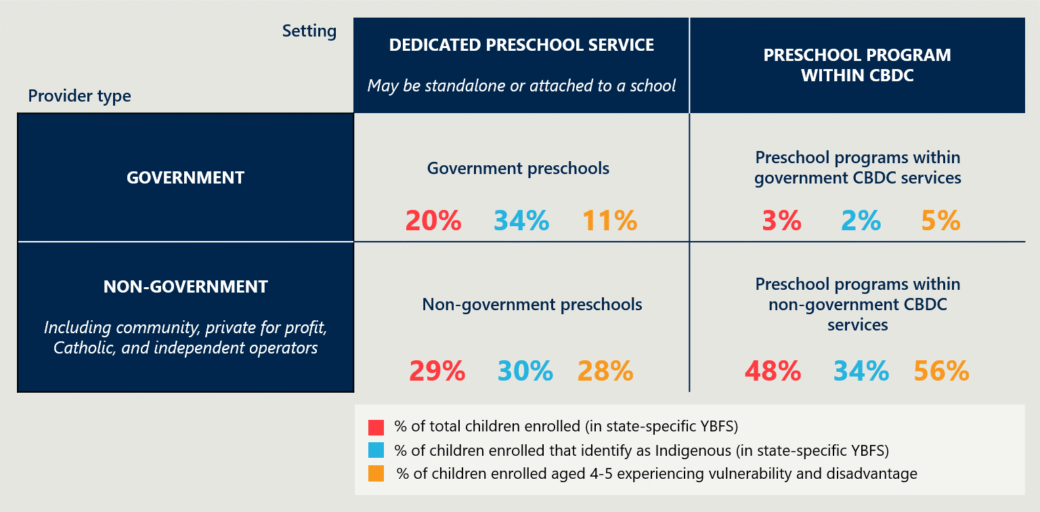

States and Territories decide how preschool is funded and delivered based on local context
States and Territories independently decide how to pursue the objectives of the UANP, as well as how much of their own funding to commit. This enables States and Territories to respond to the preferences and needs of their constituency and implement universal access in a way that is cognisant of the local early childhood education and care sector.
The service delivery context of each jurisdiction can vary in terms of:
- The needs and capacities of children and families – including the extent of developmental vulnerability, the level of socio-economic disadvantage, and the size of the Indigenous population.
- Prevailing family and community preferences – which shape demand for different service types.
- Legacy infrastructure, systems and policies – including the starting age for full-time school, the nature and prevalence of preschool provision, and the industrial arrangements relevant to the early childhood education and care sector.
- The geographic profile – including for example the degree of remoteness.
- The number and density of families and service providers.
These factors also affect the cost of delivering preschool. Figure 8 shows the proportion of children enrolled in preschool in each state and territory who are Indigenous or experiencing vulnerability and disadvantage, as well as degrees of remoteness in each jurisdiction.
Figure 8 | Percentage of each jurisdiction’s preschool enrolments reported as Indigenous or Vulnerable and Disadvantaged, and degrees of remoteness,

Universal access has been successfully implemented through a variety of funding and delivery approaches
States and Territories have adopted diverse approaches to meeting their commitments under the UANP. The mix of service types and the allocation of funding between them differs significantly across jurisdictions. Different arrangements are summarised below and outlined in detail in the following State and Territory profiles (Chapter 2.5).

States and Territories have adopted different approaches to preschool funding and delivery
Several States and Territories provide an entitlement to free preschool in a government service (often integrated with the government school system). Some also subsidise preschool programs delivered by eligible non-government providers, including in some instances CBDC providers. A small number of jurisdictions rely on non-government providers to deliver most preschool programs, only offering government preschool in thin markets. The delivery profile of each jurisdiction is represented in Figure 9, which needs to be viewed in the context of the different service profiles, legacy systems and policy decisions taken within each jurisdiction. The Review wishes to offer a further caveat, that care should be taken in drawing inferences from these cross-jurisdictional comparisons absent a more detailed understanding of the actual and efficient cost of delivery in different settings and jurisdictions.
In the Northern Territory, Tasmania and Western Australia, preschool is highly integrated with school. In these states, children in the YBFS are entitled to free preschool in a government school and can access subsidised programs through non-government schools. The ACT similarly provides free preschool in services that operate in conjunction with government schools; however, a relatively high proportion of families in the ACT choose preschool in non-government CBDC. Parents in these states and territories tend to view preschool as the first year of school.
South Australia similarly delivers preschool in standalone and school-based government services, as well as providing subsidies to non-government standalone preschools. Standalone government services cater for most preschool enrolments in the state, while enrolments in CBDC are also common.
Victoria provides a per capita grant to eligible preschool enrolments in all settings. Preschool is primarily delivered in non-government standalone services (often managed by parent or community organisations) and non-government CBDC. Local governments play a significant role in the delivery of preschool.
In NSW and Queensland, direct government preschool provision is relatively low, and mostly confined to communities where non-government services are not viable. A significant majority of enrolments are in CBDC. Both States subsidise preschool in eligible non-government CBDC and non-government standalone services (many of which are managed by parent or community organisations).
By way of further context, the Review finds that States and Territories and the Australian Government provide targeted funding to engage and support Indigenous children and children experiencing disadvantage and vulnerability, as well as children with additional needs. Several States and Territories also direct additional funding to regional and remote services to reflect the challenges they encounter in recruiting and retaining qualified ECTs and their higher cost structures. These initiatives typically take the form of loadings on per capita subsidies, specialist services, or complementary programs.
“Achieving the objectives of the NP UAECE has required major sector transformation, significant investment in infrastructure, and attracting and upskilling of the early childhood workforce.” (Victorian Government submission)
Children enrolled in standalone or school-based preschool services often attend CBDC on alternate days or after hours. In the national data collection, this enrolment pattern is recorded as children attending ‘more than one service type’. However, the Review finds that parents tend not to conceptualise this arrangement as providing two separate preschool programs. Instead, parents reported to the Review that their child attends preschool in a standalone or school-based service and then receives wraparound care in CBDC. The purpose of the CBDC enrolment is to enable the parents to manage other commitments, including longer work hours.
The Review notes that the interaction between the CCS and different preschool and child care delivery arrangements means in some services parents can access CCS for child care services that ‘wrap around’ preschool hours, while in others CCS is not available. Some providers and jurisdictions are working with the Australian Government to explore options that would improve access to CCS for preschool ‘wrap around’ child care.
Figure 9 | Proportion of children in the state-specific YBFS enrolled by main provider type in 2018
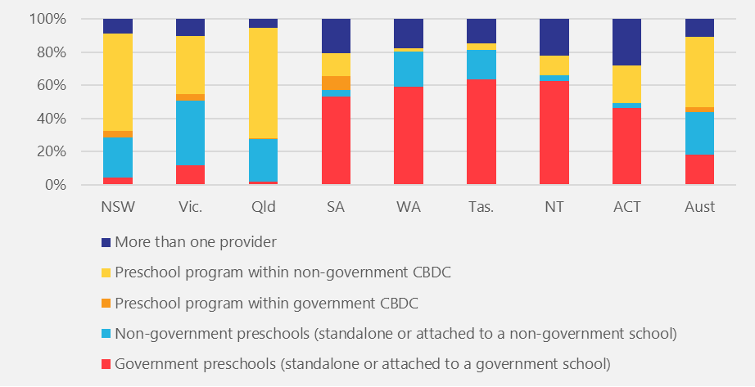
Enrolments by service type | NSW | Vic. | Qld | SA | WA | Tas. | NT | ACT | Aust.
More than one provider | 9% | 10% | 5% | 20% | 18% | 15% | 22% | 28% | 11%
Preschool program within non-government CBDC | 59% | 36% | 67% | 14% | 2% | 4% | 12% | 23% | 42%
Preschool program within government CBDC | 4% | 4% | 0% | 8% | 0% | 0% | 0% | 0% | 3%
Non-government preschools (standalone or attached to a non-government school) | 24% | 39% | 26% | 4% | 21% | 18% | 3% | 3% | 26%
Government preschools (standalone or attached to a government school) | 4% | 12% | 2% | 53% | 59% | 63% | 63% | 46% | 18%

Survey data supplied by Family Day Care Australia, a peak body representing the sector, indicates that some family day care providers believe they are offering a UANP-standard preschool service. None are receiving UANP funding for this purpose. While the survey sample size was very small and it is questionable whether the programs are of a comparable quality, governments should be mindful of this potential expansion of preschool provision. It would be appropriate to monitor any changes in the preschool sector and the impact of any additional sectors delivering quality preschool programs, including in terms of potential funding implications.

Preschool providers access a range of funding sources
Funding for preschool comprises parental contributions (out of pocket costs), Australian Government funding under the UANP, and State and Territory contributions which are determined at a jurisdictional level. Levels of State and Territory investment vary, but most provide the majority of public funding for preschool in their respective jurisdictions.
Some categories of preschool providers have access to alternative streams of public funding. The Australian Government Child Care Subsidy (CCS) and the Child Care Safety Net is provided to CBDC services, including those who offer preschool, to reduce the cost of child care for families. The Review does not accept the position put forward by some stakeholders that preschool programs delivered by these services benefit from a ‘double subsidy’, as the two funding streams are for distinct purposes. The interaction between CCS and funding provided under the UANP is considered further in Chapter 5.3.

The Australian Government helps families meet the cost of child care through the Child Care Subsidy (CCS) and the Child Care Safety Net
- The CCS (a proportion of the actual fee charged, up to relevant percentage of the hourly rate cap) is based on combined family income.
- The CCS is subject to an activity test. The number of hours of subsidised child care that a family is entitled to depends on the hours of activity (work, training, study, volunteering or other recognised activity) that parents undertake. This reflects the fact that the primary purpose of the CCS is to facilitate workforce participation.
- Certain families with preschool-aged children can be exempt from the activity test, meaning that the preschool-aged child, in such circumstances, can attend up to 36 hours of subsidised approved child care per fortnight.
- Services must be delivered by an approved provider.
- The Child Care Safety Net comprises several programs (Additional Child Care Subsidy, Inclusion Support Program and Community Child Care Fund) designed to assist families and communities that require additional support
School-based preschools in some states and territories also arguably benefit (albeit indirectly) from school funding. Under the National School Reform Agreement, the bilateral agreements between the Australian Government and each State and Territory sets outs what agreed costs can be counted towards the jurisdiction’s contribution to school funding. National school funding calculations exclude preschool children, however, so while there is an opportunity for preschool providers to leverage school resources (systems, personnel and infrastructure), the funding streams are more easily distinguishable. Two states and territories, the Northern Territory and Western Australia, count a proportion of their preschool funding towards their government schools funding contribution. However, this represents a fractional amount as it is just one of several costs that can be counted within an overall cap of 4 per cent of the total value of school funding.
The funding profile of each jurisdiction differs, as illustrated in Figure 10. It is important to note that this funding analysis draws on State and Territory expenditure reported to the Productivity Commission which is not directly comparable across jurisdictions.
Figure 10 | Estimated contribution of funding to preschool programs for 600 hours for children in state-specific YBFS across jurisdictions,
Source | NSW | Vic | Qld | SA | WA | Tas | NT | ACT | Aust
Category 1: State / Territory funding (total recurrent expenditure - UANP contribution) | 25% | 41% | 21% | 69% | 80% | 75% | 81% | 53% | 42%
Category 2: Australian Government contribution under the UANP | 15% | 16% | 19% | 13% | 12% | 16% | 12% | 16% | 15%
Category 3: Australian Government investment through child care subsidies (for 600 hours) | 25% | 17% | 31% | 8% | 1% | 2% | 3% | 10% | 18%
Category 4: Estimated parental contributions (out of pocket costs) (for 600 hours) | 35% | 27% | 29% | 9% | 7% | 7% | 4% | 21% | 25%
It nevertheless highlights the general observation that different service types, fees charged by providers, and the amount of funding provided by the State or Territory is highly variable. Further, higher rates of CCS flow to jurisdictions with a higher prevalence of preschool enrolments in CBDC and parents appear to incur higher out of pocket costs in these jurisdictions. Conversely, States and Territories that support preschool provision in schools or standalone preschool services attract less CCS funding (because preschool-aged children spend less time in CBDC) and tend to commit higher levels of funding. This issue is discussed further in Chapter 5.2.
The implications of the variations in funding composition is considered further in Chapters 5 and 6.
KEY FINDING 11
A key strength of the UANP has been the flexibility it provides for States and Territories to direct funding in a way that best meets local conditions and priorities, while still ensuring that its terms are being met. Such flexibility involves a trade-off between national consistency in service and funding models.

KEY FINDING 12
The Australian Government’s funding contribution delivered via the UANP contributes to State and Territory preschool investment, which is significant, if uneven.

Preschool provision and UANP implementation varies across Australia
The following section presents a snapshot of preschool provision for each State and Territory.

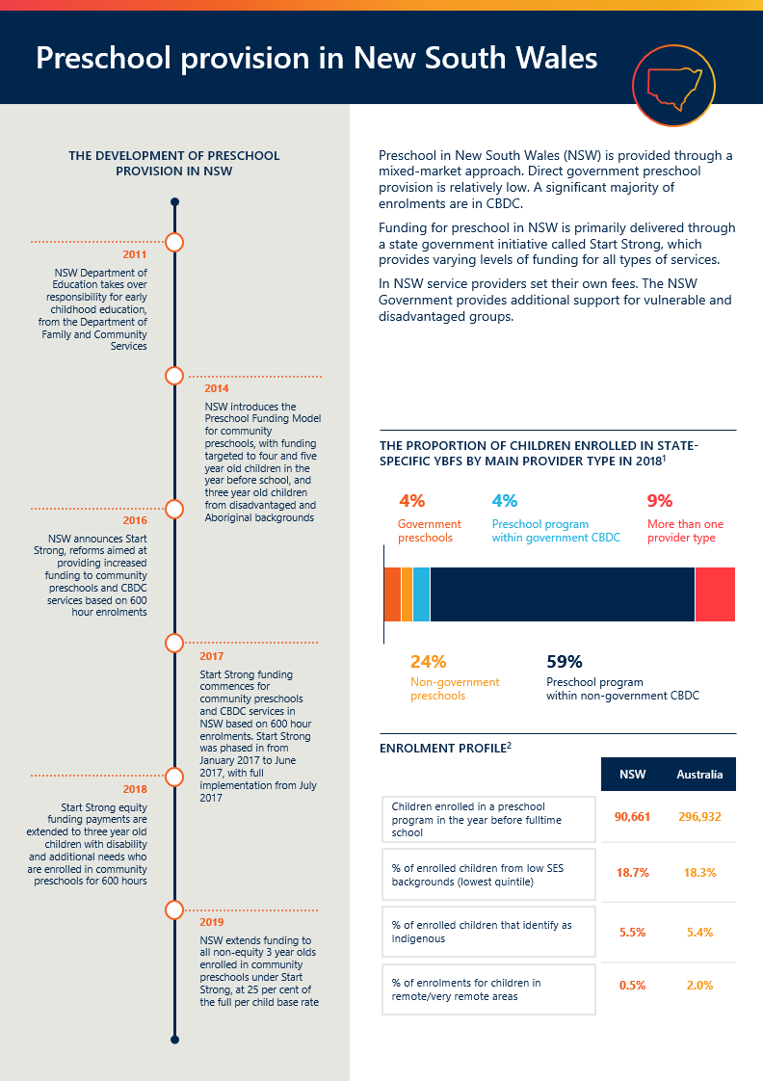
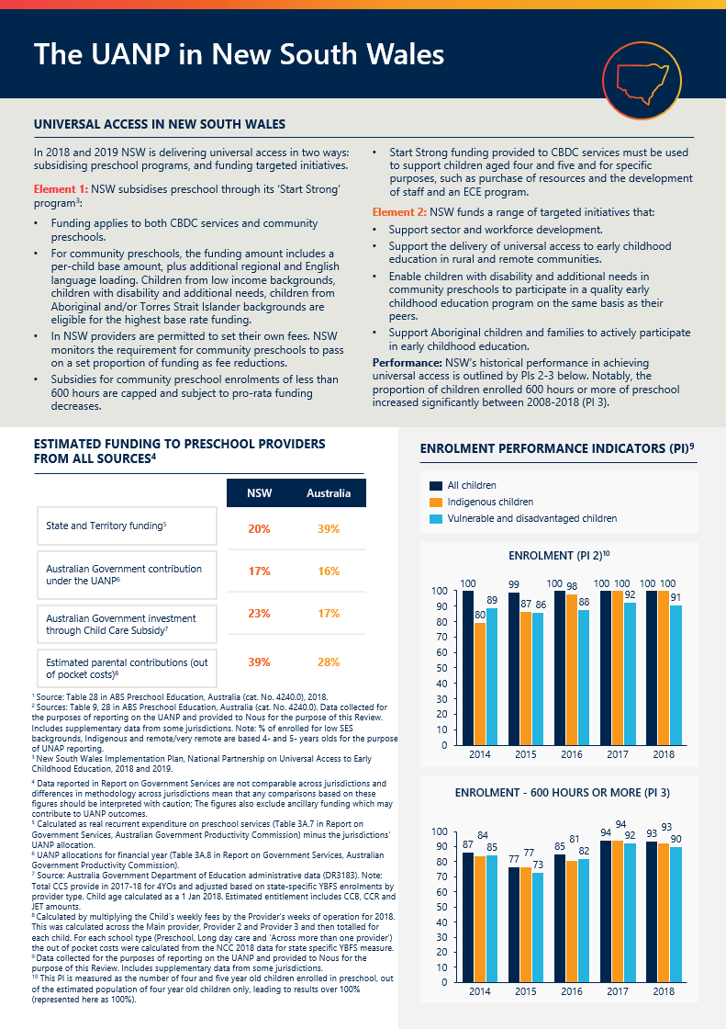

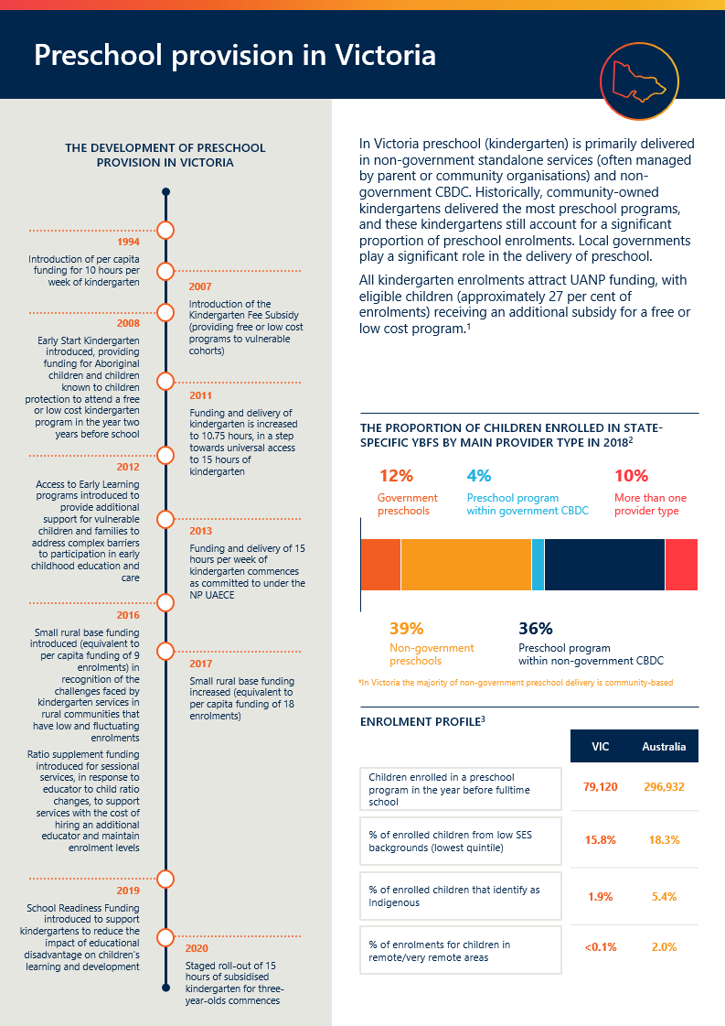
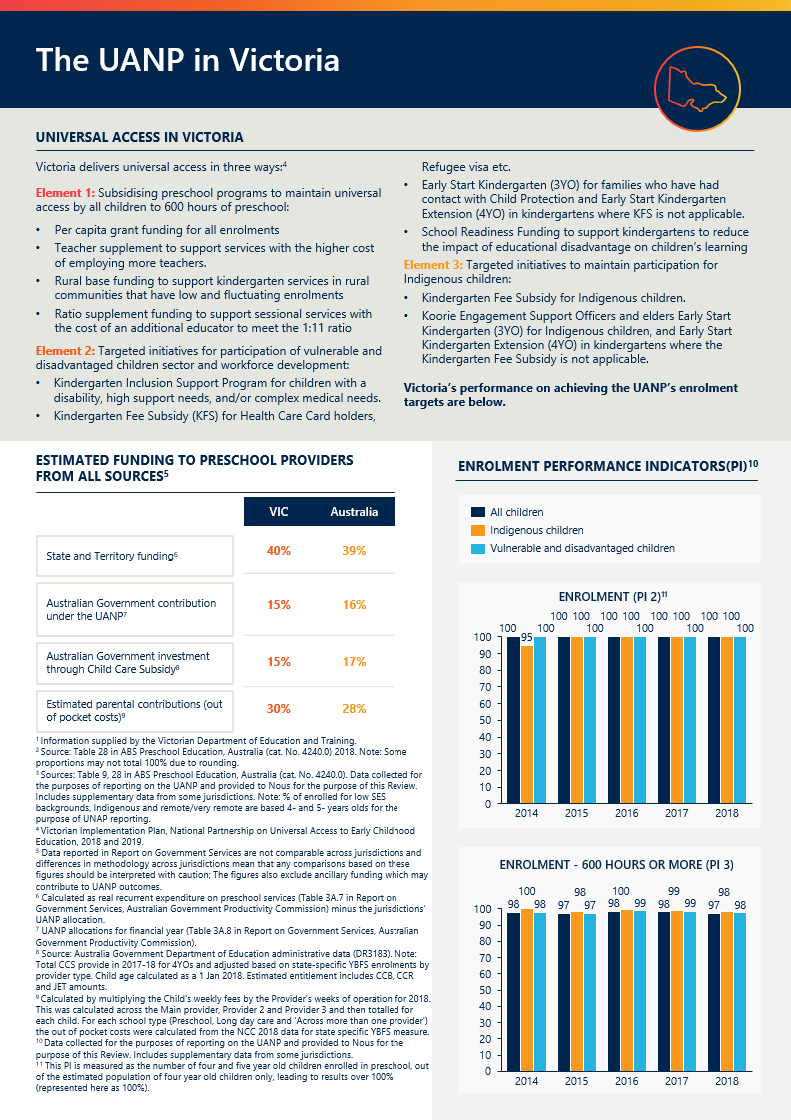
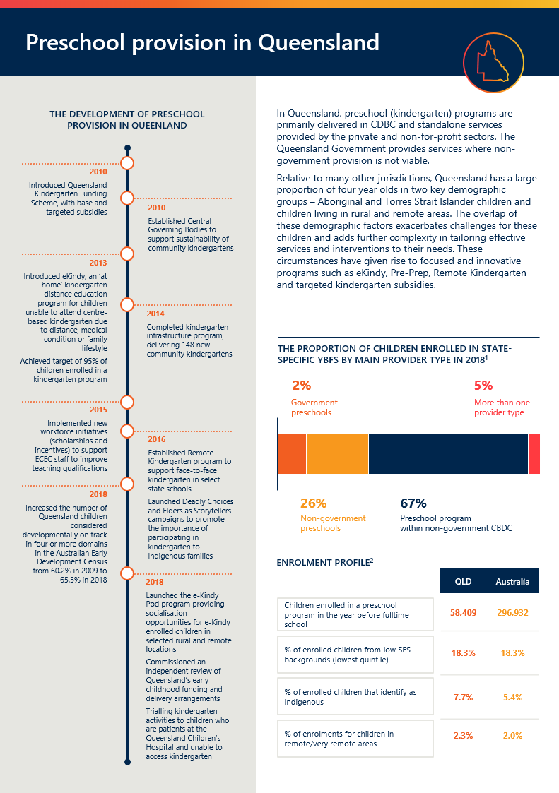

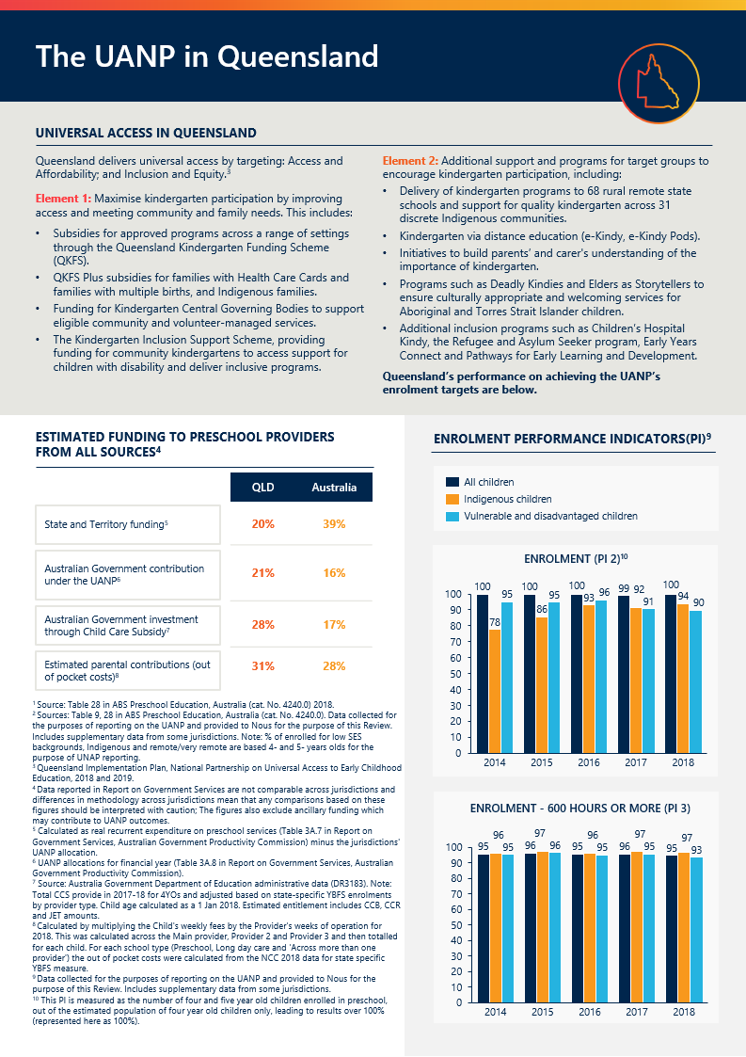
for ki
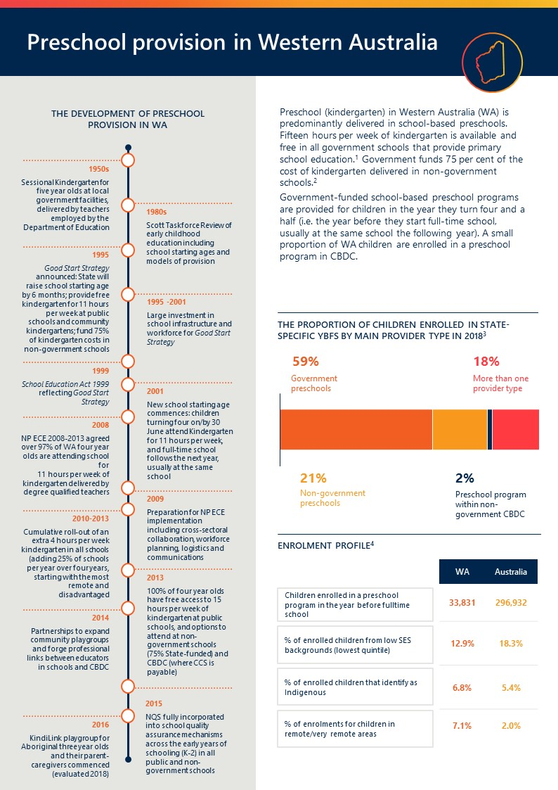

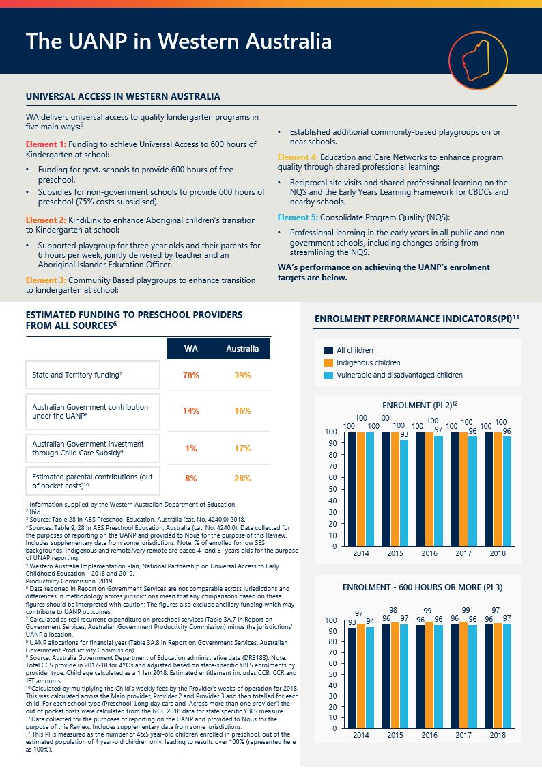
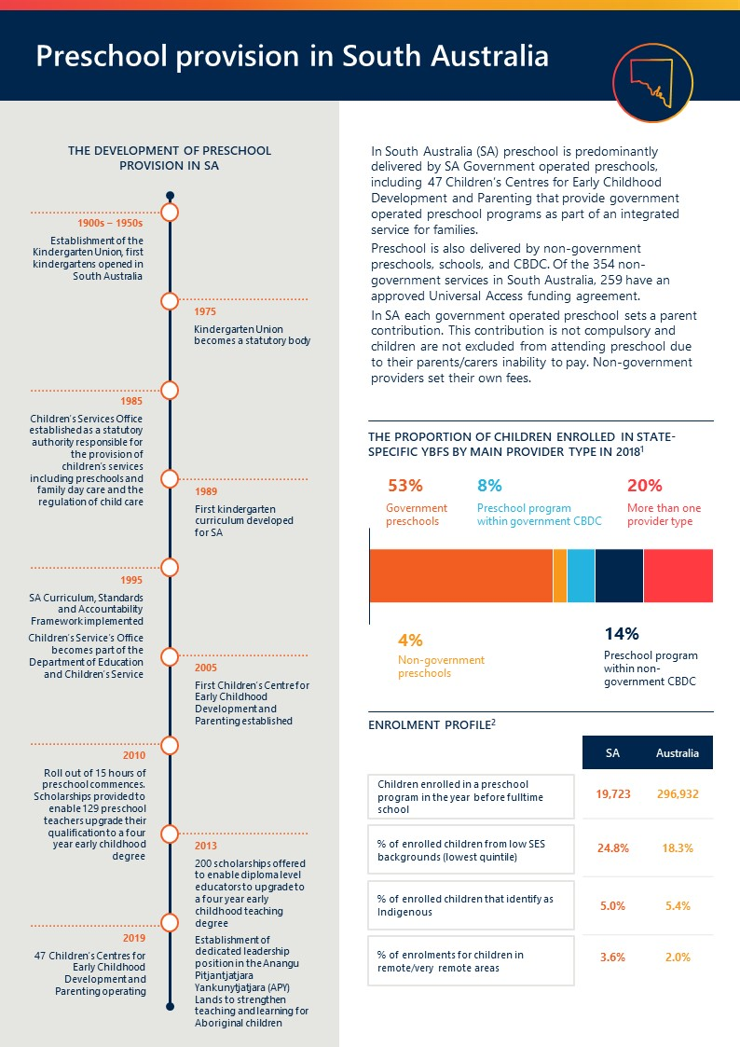
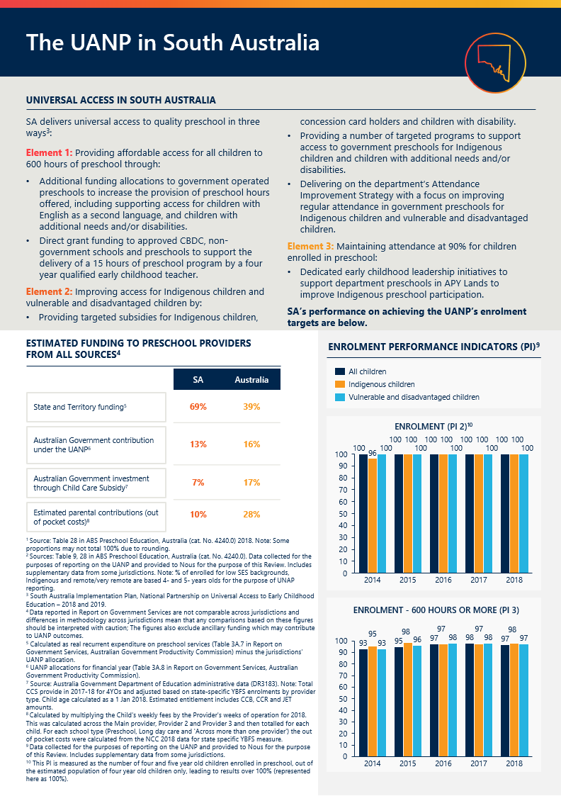

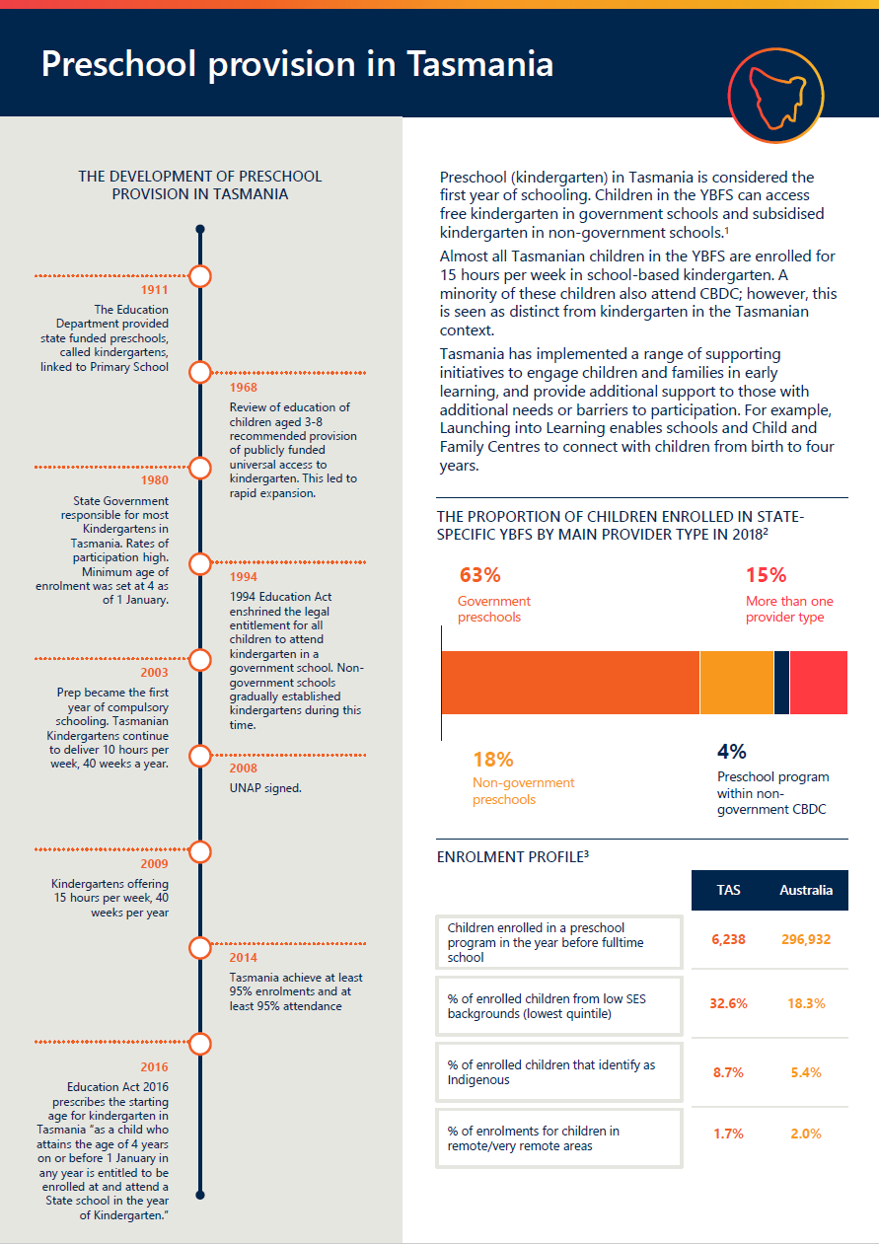

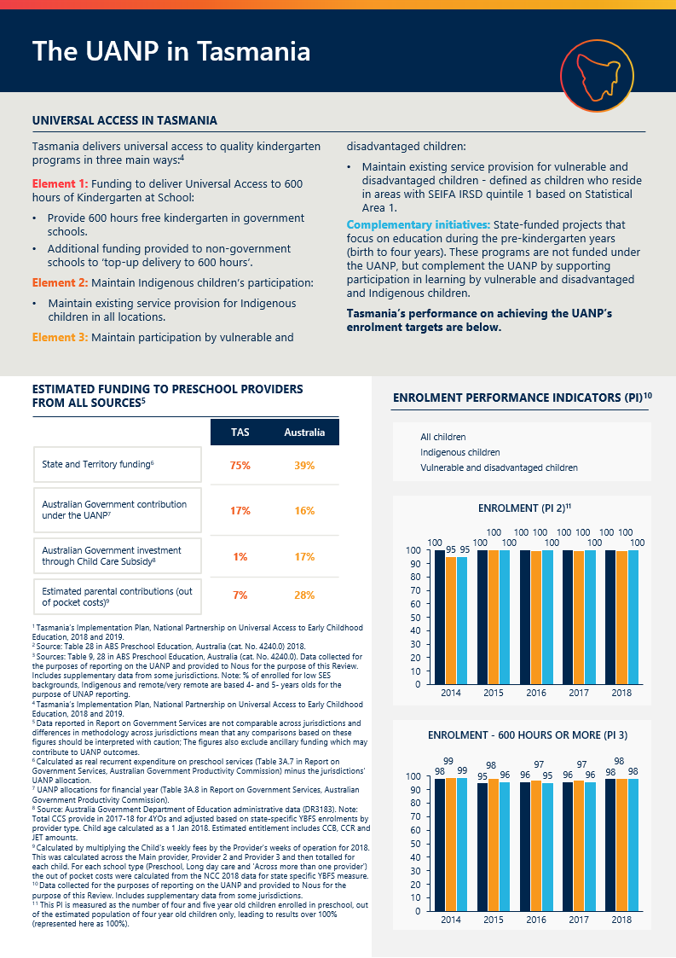

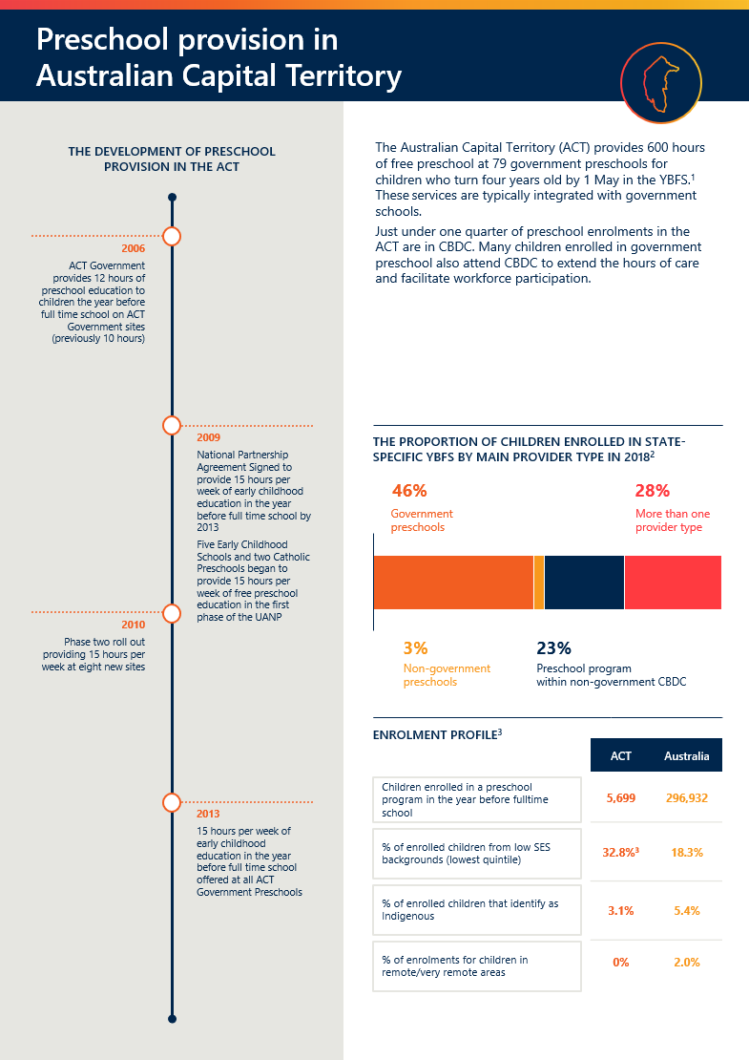

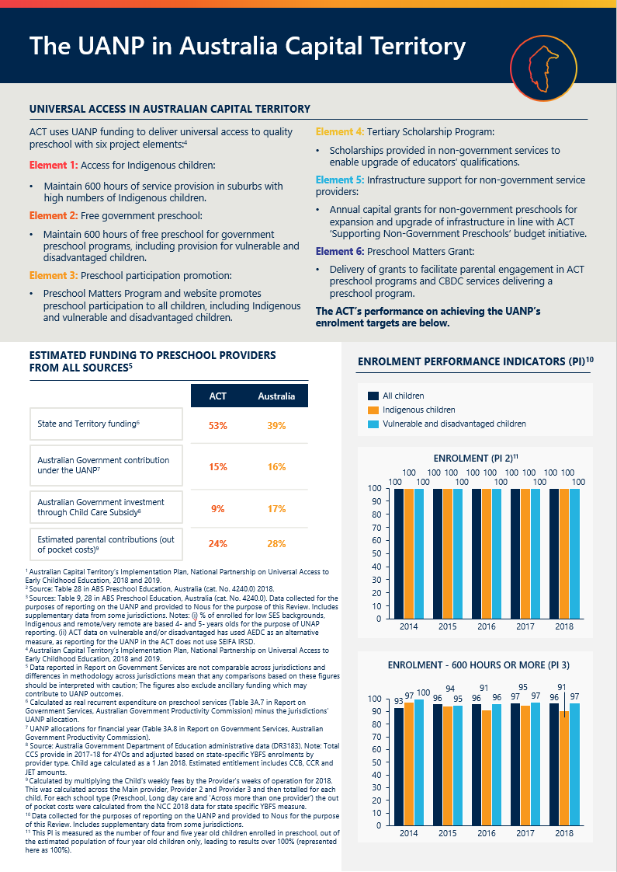

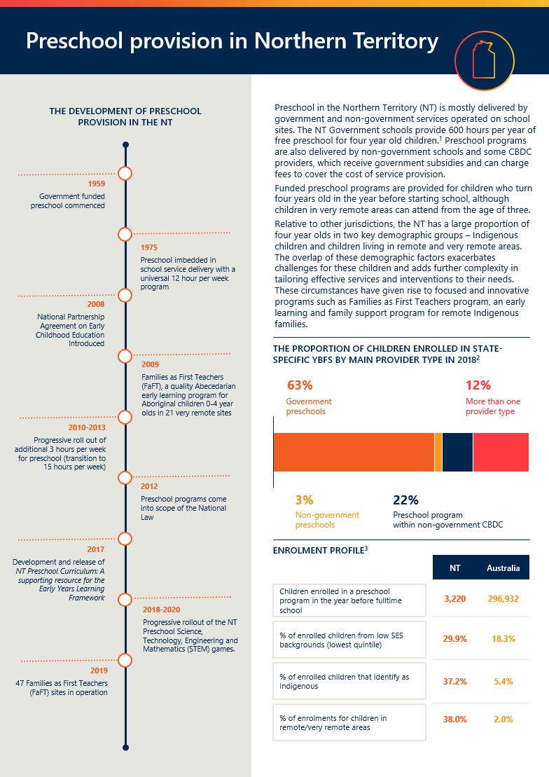

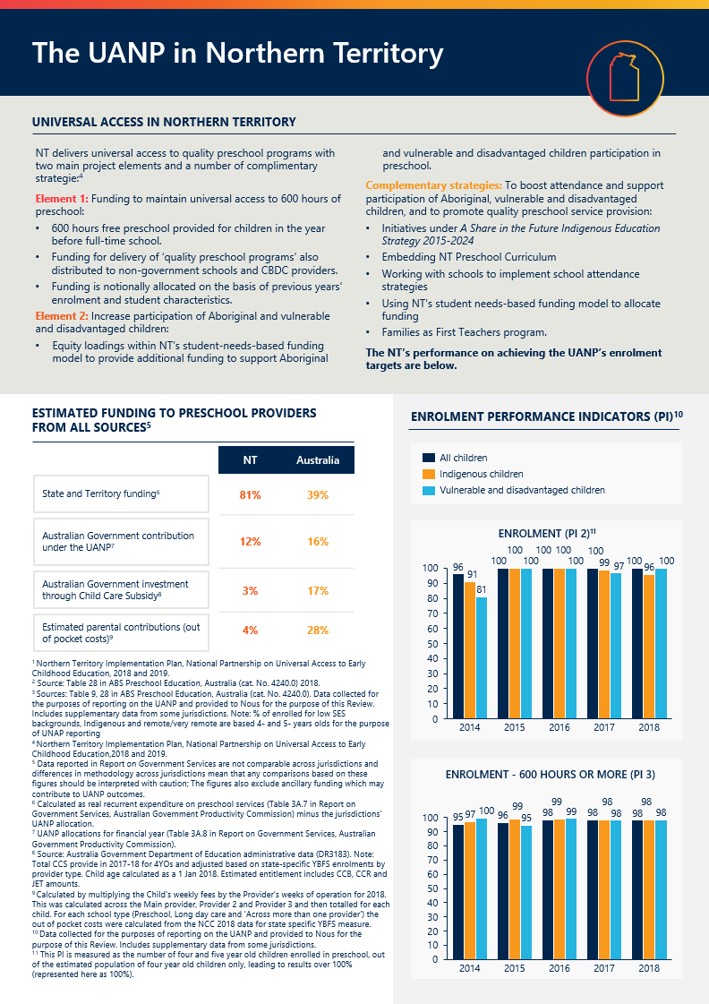

There has been significant progress in achieving the UANP’s objectives, outcomes and outputs
The UANP—both the funding provided by the Australian Government and the agreement as an expression of a national policy development process—has had a significant impact on the provision of and participation in affordable, quality preschool. It is considered a major success across the sector. To achieve the targets set in the UANP, jurisdictions have invested significantly to increase the number of services, the workforce and to change community attitudes.
To address Term of Reference 1, this chapter considers the extent to which:
- the UANP has improved access to, and participation in, preschool delivered by a qualified ECT for 600 hours in the YBFS (for all children and for target cohorts)
- the UANP has increased the quality of preschool provision
- the UANP has supported preschool across all settings
- preschool programs meet the needs of children, parents and communities, including whether cost is a barrier.

The UANP has met ambitious targets for access to, and participation in, preschool
The UANP defines outcomes, outputs, performance indicators and targets. Achievement of the objectives and outcomes in the Agreement are primarily informed with reference to the performance indicators and Benchmarks/Targets (see Appendix D for full extract).
The performance indicators, their related benchmarks and measurement under the UANP are provided in table below.
Table 2 | Performance indicators, benchmarks and measurement under the UANP
Number | Performance indicator | Target | Measurement
1 | Teacher qualification | 95% | Taken as met since 2014 NQF
2 | Enrolment in preschool—all children; Indigenous children; vulnerable and disadvantaged children | 95% | Number of 4 & 5 YO enrolled (from cohort) / 4YO ERP (from cohort)
3 | Enrolment in 600 hours of preschool—all children; Indigenous children; vulnerable and disadvantaged children | 95% | Number of 4&5 YO enrolled in 600 hours (from cohort) / Number of 4 & 5 YO enrolled (from cohort)
4 | Attendance in 600 hours | 90% (in IPs) | Number of children attending 600 hours / Number of 4 & 5 YO enrolled (from cohort)

This chapter adopts the methodology for reporting enrolment and attendance figures that is agreed by all governments in the UANP’s performance framework (see Appendix D). This method counts the number of four and five old years enrolled as a proxy for YBFS, with the enrolment rates measured over the estimated population of four year olds (leading to results over 100 per cent). It should be noted that the National Collection has introduced a state-specific YBFS indicator that overcomes many of these challenges and creates different results to some reported in this chapter. The limitations of the UANP’s methodology, and the new state-specific YBFS approach, are discussed in detail in Chapter 4.

States and Territories have consistently met the 95 per cent enrolment benchmark
Significant progress has been made since the first UANP was agreed in 2008 when an estimated 77 per cent of children in the year before full-time school were enrolled. National Collection data has been used as a proxy to report on access to quality programs. Since 2015, all States and Territories have consistently met the top benchmark of achieving 95 per cent or above for the proportion of children enrolled in a quality preschool program in the YBFS.

Enrolment in 600 hours a year grew from 12 per cent in 2008 to over 95 per cent in 2018
The UANP’s third performance indicator focuses on program availability and considers the proportion of children, enrolled in the YBFS school in preschool program(s) available for 600 hours per year.
The proportion of children enrolled in a quality preschool program for 600 hours a year has steadily grown from 12 per cent in 2008 to over 95 per cent in 2018. Figure 11 highlights the consistent results across States and Territories, particularly since 2017 in the proportion of enrolments of 600 hours in preschool programs for four and five year old children using the UANP Performance Indicator 3 methodology.
Figure 11 | Proportion of children enrolled in preschool programs for 600 hours (PI3.1),
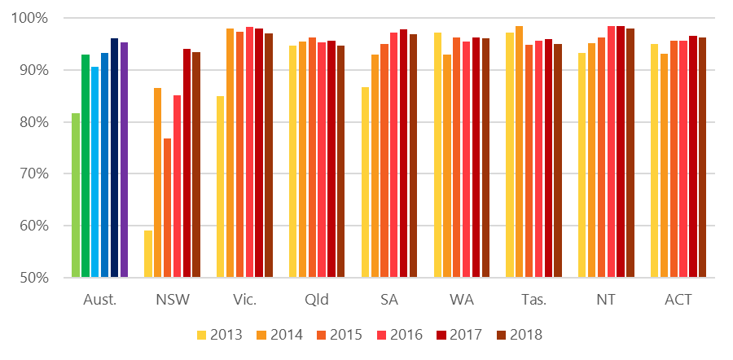
Year | Aust. | NSW | Vic. | Qld | SA | WA | Tas. | NT | ACT
2013 | 82% | 59% | 85% | 95% | 87% | 97% | 97% | 93% | 95%
2014 | 93% | 87% | 98% | 95% | 93% | 93% | 98% | 95% | 93%
2015 | 91% | 77% | 97% | 96% | 95% | 96% | 95% | 96% | 96%
2016 | 93% | 85% | 98% | 95% | 97% | 96% | 96% | 98% | 96%
2017 | 96% | 94% | 98% | 96% | 98% | 96% | 96% | 98% | 97%
2018 | 95% | 93% | 97% | 95% | 97% | 96% | 95% | 98% | 96%

KEY FINDING 1
The UANP has, since 2014, continued to build on the foundation of predecessor agreements to improve participation in affordable, quality preschool for children in the YBFS. This is a significant national accomplishment.

KEY FINDING 2
Success under the UANP reflects the continuing effort and commitment of all jurisdictions and the preschool sector. There is strong momentum to build on achievements to date.

Participation of Indigenous children and vulnerable/disadvantaged children has improved
The UANP reports on the access to quality program and program availability for two target cohorts: Indigenous children and vulnerable and disadvantaged children.
The UANP also notes two further target populations, rural/remote children and remote Indigenous children, but these groups do not have associated performance indicators.

Enrolment of Indigenous children has been largely been maintained or improved
The UANP includes a specific indicator to assess access to, and availability of, quality programs for Indigenous children. The review finds that all states and territories have significantly improved performance or maintained enrolment of Indigenous children, with a steady increase in the proportion of Indigenous children enrolled and attending preschool programs of 600 hours.
Figure 12 | Proportion of Indigenous children enrolled in preschool programs for 600 hours (PI3.2),
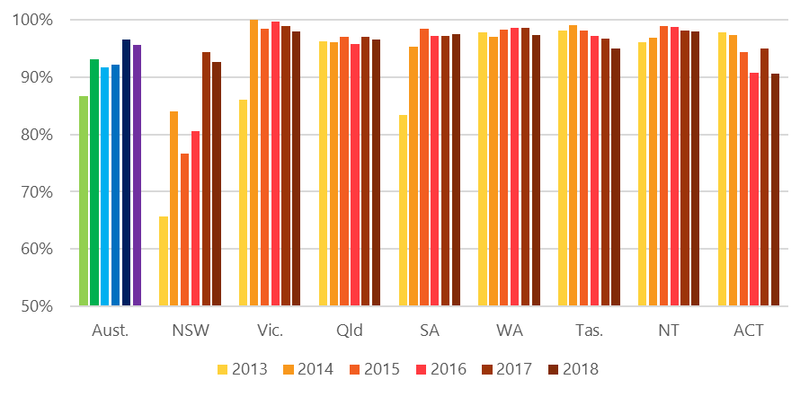
Year | Aust. | NSW | Vic. | Qld | SA | WA | Tas. | ACT | NT
2013 | 87% | 66% | 86% | 96% | 83% | 98% | 98% | 98% | 96%
96%2014 | 93% | 84% | 100% | 96% | 95% | 97% | 99% | 97% | 97%
2015 | 92% | 77% | 98% | 97% | 98% | 98% | 98% | 94% | 99%
2016 | 92% | 81% | 100% | 96% | 97% | 99% | 97% | 91% | 99%
2017 | 97% | 94% | 99% | 97% | 97% | 99% | 97% | 95% | 98%
2018 | 96% | 93% | 98% | 97% | 98% | 97% | 95% | 91% | 98%

As noted above, the UANP also includes a specific focus on access for Indigenous children in remote communities, but there is no corresponding performance indicator. Data from the National Collection suggests that Indigenous children enrolled 15 hours or more has risen from 95 per cent in 2015 to 98.5 per cent in 2018.

Considerable improvements have been made in all jurisdictions for vulnerable and disadvantaged children
The UANP has a specific focus on vulnerable and disadvantaged children, but there is currently no nationally agreed definition of ‘vulnerable and disadvantaged’ children under the UANP. The performance indicator specifications of the UANP classify ‘Vulnerable and disadvantaged children’ according to those residing in disadvantaged areas based on Socio-Economic Indexes for Areas (SEIFA) Index of Relative Socio-economic Disadvantage (IRSD). However, States and Territories may use different measures in their individual Implementation Plans as agreed bilaterally with the Australian Government. (The issues with the current measure are discussed in Chapter 4.3.)
SEIFA IRSD is a product developed by the ABS that ranks areas in Australia according to relative socio-economic disadvantage. The index is based on information from the five-yearly national Census and is a general socio-economic index that summarises a range of information about the economic and social conditions of people and households within an area.
Noting the limitations associated with robustly identifying vulnerable and disadvantaged children, and therefore measuring their access to quality programs at a national level, the Review finds that there have been considerable improvements made in all jurisdictions to improve access for vulnerable and disadvantaged children. Figure 13 highlights the progressive increase in the proportion of enrolments of 600 hours in preschool programs for vulnerable and disadvantaged children using the UANP performance indicator methodology.
Figure 13 | Proportion of vulnerable and disadvantaged children enrolled in preschool programs for 600 hours (PI3.3),
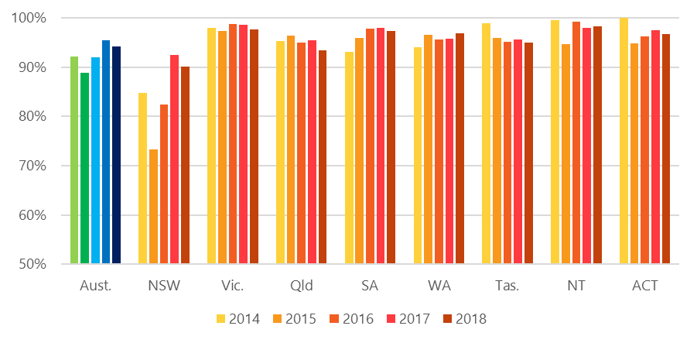
Year | Aust. | NSW | Vic. | Qld | SA | WA | Tas. | NT | ACT
2014 | 92% | 85% | 98% | 95% | 93% | 94% | 99% | 100% | 100%
2015 | 89% | 73% | 97% | 96% | 96% | 97% | 96% | 95% | 95%
2016 | 92% | 82% | 99% | 95% | 98% | 96% | 95% | 99% | 96%
2017 | 95% | 92% | 99% | 95% | 98% | 96% | 96% | 98% | 97%
2018 | 94% | 90% | 98% | 93% | 97% | 97% | 95% | 98% | 97%

Rural and remote participation is a known challenge
Participation by children in rural and remote areas is a known challenge, owing to thin markets for both preschool services and early childhood workers. Governments and providers have noted the significant contribution the UANP has made in addressing this challenge. Alongside the provision of direct funding, the UANP appears to have made it easier to communicate the importance of quality preschool in the YBFS to many remote communities.
An analysis of enrolments at the Statistical Area 2 (SA2) level using the UANP measurement for PI2.1
shows that a substantial proportion of enrolments in many rural and remote areas in approaching the 95 per cent target. However, there is still work to do to meet the universal 95 per cent enrolment benchmark.
Figure 14 | Proportion of children enrolled in preschool programs by geography (PI2.1) ,

Despite a lack of robust data, preschool attendance has been maintained
The UANP’s fourth performance indicator is focused on attendance. Accurately measuring preschool attendance has been an ongoing issue. Currently, for the purposes of the National Collection, a child is considered to be attending a preschool program if they are present for at least one hour during a single reference week. (See Figure 15, which shows that attendance rates for at least 1 hour across all jurisdictions has remained at 96 per cent for all children enrolled in Government preschools since 2015.)
While there is useful and accurate attendance data available for government preschools, data for CDBC attendance only covers billable hours, not actual attendance, meaning that the figures overall are, at best, illustrative. Importantly in this context, it should be noted that, under the alternative state-specific measures of enrolment and attendance provided by the which calculates the number of children enrolled in the state-specific year before school, nearly 1 in 10 eligible children are still not enrolled in preschool, and national data indicates that 25 per cent of children are not attending regularly for the full 15 hours. (This is discussed in detail in Chapter 4.2). This highlights the case for further improvements for in attendance across the board.
The issues concerning a lack of reliable attendance data are discussed further in Chapter 4.2 and Chapter 4.3).
Figure 15 | Attendance rates for children enrolled in Government preschool
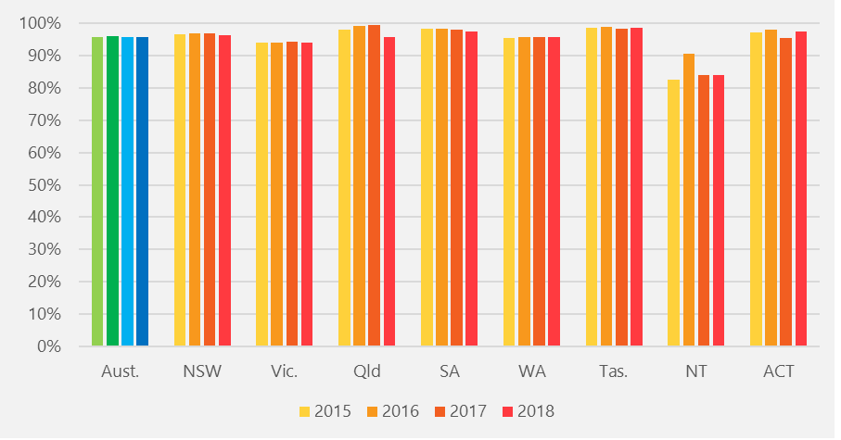
Year | Aust. | NSW | Vic. | Qld | SA | WA | Tas. | NT | ACT
2015 | 96% | 96% | 94% | 96% | 97% | 96% | 99% | 84% | 98%
2016 | 96% | 97% | 94% | 100% | 98% | 96% | 98% | 84% | 96%
2017 | 96% | 97% | 94% | 99% | 98% | 96% | 99% | 91% | 98%
2018 | 96% | 97% | 94% | 98% | 99% | 96% | 99% | 83% | 97%

Notwithstanding concerns about the accuracy of attendance data across all preschool providers, the Review accepts that the UANP has supported increases and maintenance of preschool attendance as per the set performance indicators and data sources in the UANP. The Review is further persuaded by the lift in enrolment across all provider types (particularly for 600 hours or more), which is correlated with attendance, as well as the apparent growing normalisation of preschool attendance among parents and communities.
KEY FINDING 3
While the objectives of the UANP have broadly been realised, participation by target cohorts is not yet at the desired levels.

The UANP has contributed to an uplift in quality, though more work remains to be done
Compelling evidence from a variety of sources shows that to make a positive difference in the educational and longer-term outcomes for children, preschool programs must meet minimum quality standards. This makes the reference to ‘quality’ in the UANP and the Review’s Terms of Reference crucial.
All four performance indicators in the current UANP refer to quality and implicitly recognise its importance, with Performance Indicator 1 having this as its central focus. The UANP’s objectives and its associated Performance Indicator 1 use the level of qualifications held by the ECT who delivers preschool programs as the UANP’s proxy measure of quality. This is for good reason, as workforce is a crucial contributor to quality. A comprehensive literature review on determinants of quality in early childhood education and care finds that, overall, the most influential factors affecting quality, across age groups and service settings, are the education, qualifications and training of the workforce, with higher educator qualifications associated with better child outcomes.
Since 2014, Performance Indicator 1 has been taken as achieved in the context of changes to the NQF requiring services to have access to a qualified ECT (see Chapter 4 for discussion of definitional issues). Further discussion about this quality measure is appears in Chapter 4.3.

The UANP has contributed to an uplift in quality
The Review finds that governments’ joint commitment to funding universal access to preschool has contributed to raising the quality of preschool. In 2013, 62 per cent of preschool providers met or exceeded quality standards, rising to 78 per cent in 2018. Reporting under the UANP shows that in 2013, 91.7 per cent of services had a qualified ECT, whereas in 2018, nearly all services (99.4 per cent) did.
Any consideration of the contribution of the UANP in driving quality must have regard to the accompanying complementary role of the NQF, other policy instruments like funding agreements and guidelines, and related investments by States and Territories and the Australian Government. That latter includes the NP NQA, which expired in June 2018. The introduction of the NQF was the main trigger for increasing the qualification thresholds for preschool delivery.
While the Review did not have the necessary data to isolate specific causal factors, it is reasonable to conclude that the UANP funding, which we find has been used to fund ECT salaries and workforce initiatives, has contributed to this this improvement. UANP funding has helped providers meet the higher salaries of more qualified staff and allowed services to backfill positions when staff need to be released for professional development. This includes giving diploma- or certificate-level employees time off to upgrade their qualifications.
Quotes from preschool providers, gathered through the UANP Review survey
“The fact that this funding is tied to an outcome of being delivered by a qualified early childhood educator is the key to the increase in quality since its inception.”
“It would be impossible to retain a good ECT without the (UANP) funding.“
“(The current preschool funding arrangements) provides ability to offer Bachelor Qualified Early childhood teachers above award wages in recognition of their qualification and impact on the quality of teaching and learning. Above awards also supports retention of ECTs in the prior to school sector.”

The children who are most likely to benefit from quality preschool are less likely to experience it
Quality needs to improve in many parts of the sector, including for children experiencing vulnerability and disadvantage and for those living in rural and remote areas. ACECQA NQF quality ratings data shows that children experiencing vulnerability and disadvantage are more likely to participate in a lower quality ECEC programs, since services in the least advantaged areas are usually of a lower quality than those in Australia’s most advantaged areas, as illustrated in Figure 16 (it is important to note that this data is for early childhood education and care services, not just preschools, and it is not collected for Tasmanian and Western Australian preschools). Since there are adverse consequences to children of providing preschool that does not meet quality standards, this is a particular concern.
Figure 16 | Overall quality ratings for NQF approved preschools/CBDC by SEIFA quintile,
SEIFA Quintile | Working towards NQS | Meeting NQS | Exceeding NQS
5 (most advantaged) | 14% | 39% | 47%
4 | 14% | 45% | 41%
3 | 16% | 47% | 37%
2 | 17% | 46% | 36%
1 (least advantaged) | 19% | 47% | 33%

“Access to preschool is of little use to children if the quality of the educational program is lacking. Australia should also be actively encouraging innovation in programs and practices, to achieve better outcomes for children and for governments.” (Early Childhood Australia submission)
“UANP measurement and reporting on quality is limited, despite the fact that quality is fundamental to achieving policy objectives.” (Mitchell Institute submission)
“Access to high quality services in Australia is not equal. There is an opportunity divide between wealthy and poor communities, cities and remote towns, and children who are from different cultural backgrounds.” (Early Learning Association Australia submission)

Workforce challenges present a risk to the ongoing provision of universal access
Two issues regarding the ongoing provision of qualified ECTs may challenge jurisdictions to continue to support universal access:

The preschool sector is experiencing challenges in recruiting and retaining qualified ECTs
Stakeholders across the preschool sector—including providers—report that a shortage of qualified ECTs is looming. Employers report difficulties in recruiting and retaining suitable staff, especially in rural and remote areas. The number of people working as ECTs is expected to grow very strongly from 40,800 in 2018 to 49,800 by 2023, and there are likely to be around 29,000 job openings over 5 years. However, there is concern that supply will not meet this demand particularly as, from 2020, the NQF requires CBDC services and preschools to have a second ECT available when 60 or more children are in attendance.
The consequence is a greater risk of preschool programs being delivered by staff other than qualified ECTs. (Note that this is not a risk in school-based settings.) ACECQA snapshot data shows NQF staffing waivers apply to 4.9 per cent of services overall (although they are mostly temporary). NQF staffing waivers enable preschool programs to continue to operate, notwithstanding the implications for quality. Waivers are more prevalent in remote and very remote locations (14.6 and 9.1 per cent of services respectively compared to 4.6 per cent in major cities), and in CBDC services (8.6 per cent) compared to standalone and school-based preschools (2.2 per cent). While snapshot data does not distinguish ECT and general staffing requirements, more detailed ACECQA data shows that in 2018-19 more than 1000 CBDC services sought waivers, and over 95 per cent of these applications related to ECTs.
Such issues raise questions about equitable access to quality preschool for all children. While waivers enable services to continue to operate in remote communities and other locations facing workforce constraints, it is important to understand and address any variance in quality among services. This suggests a need for additional measures of quality that take local circumstances and constraints into account, rather than rely entirely on satisfaction of NQF requirements.

ECTs experience diverse pay and conditions in different preschool settings
A two-tiered system of ECT compensation exists in Australia. Some ECTs enjoy pay, leave and condition parity with school teachers in some states and settings, while ECTs in many CBDCs are being paid close to minimum award wages with 4 weeks of annual leave. Many ECTs who are qualified and registered to teach children 0-8 or 0-12 in preschool and full-time school settings are likely to prefer to teach in school settings due to the better pay and conditions. The Review heard from many CBDC providers that expressed the financial challenges of providing ECTs with comparable pay and conditions to school-based or government run preschools and difficulties in recruitment and retention.
Such differences in employment conditions manifest in different status and cultures, creating unhelpful divisions in the sector. This is a problem not just within the ECT profession, but between fully qualified preschool teachers and other child educators.
Some States and Territories offer initiatives to both encourage people to enter the profession and upgrade their qualifications, and ensure that preschool services are able to recruit and retain qualified ECTs.
“ECTs working in early learning settings pay a penalty, earning significantly less than their peers in the school system.” (Early Childhood Australia submission)
“A shortage of qualified early childhood teachers is looming. Employers are reporting experiencing particular difficulty getting quality teacher applicants in regional areas, particularly in the child care sector, which continue to lose teachers to schools.” (Goodstart Early Learning submission)
KEY FINDING 4
The UANP has contributed to an uplift in preschool quality, though more work remains. Workforce challenges present a particular risk to the ongoing provision of universal access at the appropriate levels of quality.

The UANP has increased the availability of free and low-fee preschool, though indirect costs can pose a barrier for some
The UANP objective is to make preschool available at a cost that does not present a barrier to participation. Figures from the National Collection show that out-of-pocket costs for preschool range from zero to over $6 per hour. Between 2015 and 2018 average real out-of-pocket costs rose 11.7 per cent (from $4.33 per hour to $4.84 per hour). This is illustrated in Figure 17.
Figure 17 | Out of pocket costs over time by provider type (2017-2018 dollars)
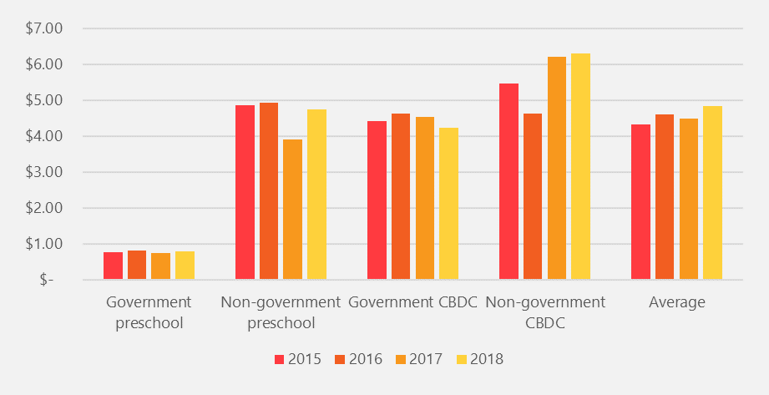
It is not possible to infer from out-of-pocket costs whether preschool is affordable for families. However, the Review is satisfied that out-of-pockets are not prohibitive for most families. This conclusion reflects the high levels of enrolment presented earlier in this chapter, feedback from stakeholders, and the availability of targeted fee relief in all jurisdictions.
Many States and Territories provide free preschool in government services, and all offer free or low-cost preschool to eligible families. Eligibility may be based on child and family characteristics (such as whether the family holds certain Australian Government concession cards) or service characteristics (such as the SEIFA band of the service). Children enrolled in CBDC may be eligible for the Additional Child Care Subsidy (in addition to the CCS).
The Review heard, however, that the cost of participation can be a barrier for some children. Governments, providers and parents commonly cited non-fee costs, including the cost of transport, as barriers to participation. This was especially evident in regional areas.
“Families of children in remote and regional areas have additional impediments in their children’s regular attendance, such as transport and distance.” (Flinders University submission)

Most parents can access a preschool provider that meets their needs, but funding may not align with their preferences

Parents and communities have diverse needs
The UANP is designed to support the implementation of preschool programs which meet the needs of parents and communities. The needs of parents and communities are not uniform. Parents’ needs differ between families, and over time as families’ circumstances change (for example, as one or more sibling progresses to full-time school). The Review heard that, in addition to the availability and quality of preschool programs, parents value a combination of factors, which primarily relate to the:
- location of the provider (particularly in terms of its proximity to wraparound services or other drop-off sites, including the parent’s place of work)
- out-of-pocket costs (discussed above)
- hours of operation
- integration of the preschool program with other services
- process of enrolling
- rapport between the parent and the ECT involved in the program.
Some children and families have specific or additional needs. For example, to meet the needs of Indigenous children, preschool programs must be culturally safe and relevant, CALD children may require tailored support to meaningfully participate in preschool, and children with a disability may require specialist teaching resources or equipment.

The variety of preschool providers in each jurisdiction, and the availability of specialist services, ensures that most parents can access a suitable preschool program
Given the diversity of parents’ needs, and the propensity for needs to change as families grow, the ability to choose from multiple service types is beneficial. Preschool is available in a variety of settings in all jurisdictions, and all States and Territories offer tailored programs and services for families and communities with specific or additional needs (though the design and eligibility criteria vary). The Review heard from many preschool providers that parents and community representatives have a strong voice in decision making, particularly in relation to program hours. This is often formally embedded in the governance arrangements or service standards adopted by the provider.

The fragmentation of the early childhood education and care sector prevents some parents from accessing the preschool program that best meets their needs
Providers and parents outlined a number of areas where preschool provision could better meet the needs of families and communities. The most prominent area for improvement relates to the integration of services for preschool-aged children. Around 11 per cent of all preschool children attend multiple preschool providers and many more rely on formal or informal child care to supplement preschool hours.
Some parents of children enrolled in a standalone preschool service (operating for 2.5 or 3 days per week) reported difficulty accessing wraparound care, or found it challenging to manage the transition between different providers. These concerns persist despite significant effort from providers and governments to promote seamless service provision. Strategies that have been implemented include, for example, the co-location of preschool and child care, or the agreement by one provider to safely transport children to another.
In some instances, funding and regulatory arrangements can prevent the practical integration of services for preschool-aged children.
For example, services that primarily provide preschool are not eligible for CCS. (This reflects the intent of CCS to assist families with child care costs.) Further, out of school hours care (OSHC) services must primarily provide care to children who attend full-time school. The Review understands that certain allowances have been made so that preschool children can attend OSHC services on-site or in a nearby location (with transport or escort services provided). However, in some cases, standalone preschools want to provide partial-day care themselves to avoid a situation where parents choose a full-day of child care (without a preschool program) in preference to a half-day of preschool, due to the lack of wraparound, childcare arrangements. The contention is that the children of these parents are not accessing the full 15 hours per week, but would if the half-day preschool could offer CCS eligible child care. A more general point is made in this and similar contexts: parents are being inconvenienced in their ability to access the preschool programs that best align with their child’s need. While this is not a universal issue, with some government preschools having well-developed co-location arrangements with CBDC providers, it is of concern in at least two jurisdictions.
The problem is that they cannot apply to be an OSHC provider, given the requirement that most children in those services are expected to be of school age. Neither can they apply to be CBDC services because they would normally operate during the school year (not for the requisite 48-week minimum) and the child care component would not be the primary service.
The Review finds that, in such cases, a market response is preferable to a regulatory change that might trigger unintended consequences. (For example, preschools could change their rosters, enter into partnerships with OSHC or CBDC providers, or adopt a different business model whereby they establish an ancillary business that offers child care services to a broader group of children over a longer period.) However, such a market response may be challenging in some cases, especially in thin markets (including in rural and remote areas). Further, the current policy settings have been in place for some time now and the market has not responded accordingly. The next-best option, therefore, is to seek a regulatory change from the Australian Government to allow standalone preschools to register as childcare providers for the purposes of providing wraparound care in specified situations. This is an option best pursued bilaterally in the first instance, given the unique circumstances of each jurisdiction.
Some CBDC providers noted the difference in the out-of-pocket costs associated with preschool programs in CBDC and in other settings can influence parents’ decisions. The share of public funding available to different preschool provider types (standalone, school-based and CBDC) varies by jurisdiction (see Chapter 2.4). This contributes to a wide contrast in the expenses associated with different preschool programs. Nationally, 94 per cent of parents using CBDC incur out-of-pocket costs, while over 80 per cent of government school-based preschools are free from compulsory fees. This is illustrated in Figure 18.
Figure 18 | Hourly fees vary by service delivery type
Hourly fees | Government preschool | Non-government preschool | Preschool program within government CBDC | Preschool programs within non-government CBDC | All
$0 | 82% | 21% | 26% | 5% | 22%
$1-$4 | 16% | 52% | 54% | 58% | 51%
$5-$9 | 2% | 24% | 16% | 27% | 21%
$10-$14 | 0% | 2% | 3% | 7% | 4%
$15-$19 | 0% | 1% | 1% | 2% | 1%
$20+ | 0% | 0% | 0% | 1% | 0%

There are opportunities to improve UANP indicators, targets and measurement
The UANP performance framework defines the outcomes, outputs, performance indicators and targets that governments have agreed to pursue (see Appendix D). Performance monitoring and measurement performs multiple purposes including to inform policy system management, to measure progress, and to distribute funding from the Australian Government to States and Territories.
To address Term of Reference 2, this chapter analyses the appropriateness of the performance framework, with reference to whether:
- the performance framework adopts the right indicators
- the measurement of performance is sound, including whether it is based on robust data
- the benchmarks/targets are set at an appropriate level
- the use of the current performance framework and whether its benchmarks/ targets are appropriate to make performance-based payments.
‘Appropriateness’ here is considered a function of how well the performance framework stimulates action, focuses investment where it will have the most impact, and provides accountability.

The UANP’s performance framework has served it well, but there is room for improvement
The UANP’s performance framework has four performance indicators:
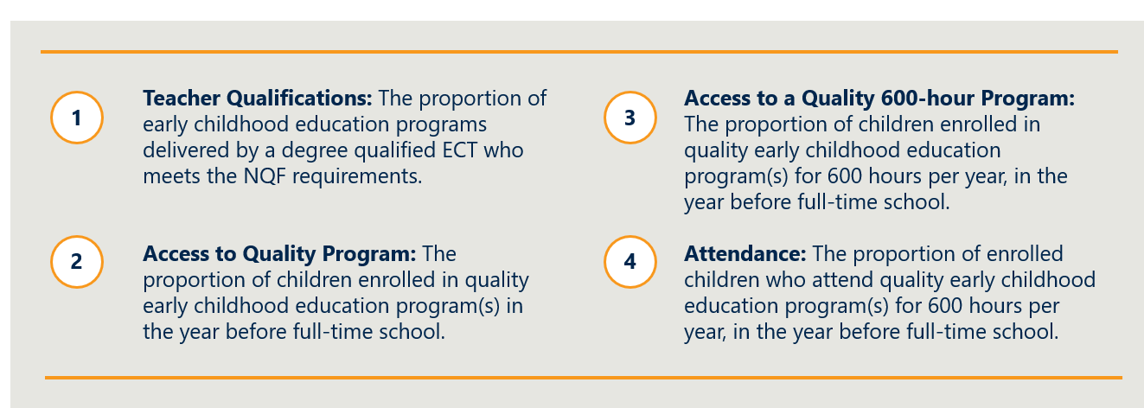
This section considers whether these PIs are the right ones.

The UANP’s objectives are interpreted and measured in terms of inputs and outputs, not outcomes
The UANP’s performance framework measures inputs to, and outputs from, the preschool sector. It does this in terms of the changes in preschool provision and participation that can be measured contemporaneously with the funding provided.
These are distinct from the UANP’s higher-level objectives, which relate to children’s early learning, socialisation and development. For this reason, the UANP’s performance framework centres on PIs that clearly show the within-year operation of the UANP in terms of the:
- proportion of eligible children participating in preschool, both in terms of enrolment and attendance
- extent to which the available preschool programs are considered to meet the UANP’s quality requirements.
Both sets of indicators are discussed below.

Performance Indicator 1 is focused on delivery by a qualified ECT
The UANP’s emphasis on the need for quality programs is well supported by published research. Given the weight of the evidence base, it is reasonable to regard participation in quality preschool as a leading indicator for improved educational outcomes.
The notion of quality incorporates ‘the interactions between children and their caregivers, their environment and other children’, as well as the structural factors that facilitate these interactions. The NQS encompasses a range of benchmarks spanning several dimensions of quality. Importantly, quality does not denote a specific service type.
For the purposes of the UANP performance framework, quality is assessed by reference to delivery by qualified ECT, through Performance Indicator 1. This is consistent with the generally accepted view that workforce is the key determinant of preschool program quality.

Performance Indicators 2, 3 and 4 cover enrolment and attendance
The focus on enrolment and attendance in the UANP’s performance indicators has been appropriate. The two enrolment indicators—enrolment rates, and enrolment rates in programs for 600 hours in the YBFS—provide information about children’s access to preschool programs in the first place, and the increase in hours available. While there are issues with the attendance performance indicator (discussed below and the reason why funding is not linked with this measure), attendance rates are highly appropriate to measure to assess not just access, but regular participation.
The National Early Childhood Education and Care Collection (the National Collection) is the source of data used to assess enrolment and attendance performance under the UANP.
The National Collection provides an annual ‘snapshot’ of preschool participation and delivery across the country and is published as the Australian Bureau of Statistics’ (ABS) Preschool Education, Australia publication. The National Collection is compiled from administrative data from the Australian Government, and State and Territory Governments collected annually and collated by the ABS. The collection period for all jurisdictions relates to a reference week in early August, and generally covers information on children’s enrolment and attendance in preschool, broken down by, inter alia, jurisdiction, delivery setting, socio-economic disadvantage, Indigenous status and geo-location.
Data is collected and validated by each jurisdiction prior to submission to the ABS. The timeframe for this varies, but generally takes around 2 to 3 months. The ABS then collates the dataset, verifies data with jurisdictions, and prepares the collection for publication. The first publication of a year’s preschool data occurs in February the following year, with summary data tables released (which relate to the UANP performance indicator measures). Following this, the full publication is made available in March.

While the National Collection provides the best source of national preschool data, there are some limitations in its use. For example, up to the start of 2019, CBDCs were not required to report actual attendance data, so hours enrolled was used as a proxy for that indicator. For assessing UANP performance, States and Territories can supplement National Collection data with additional information. Many jurisdictions do provide such data, for example, the ACT uses information from the AEDC for calculating performance in relation to enrolment by vulnerable and disadvantaged children, and the NT provides additional data relating to children’s participation in Families as First Teachers for inclusion. The outcome of this process results in a final performance assessment for each State and Territory against Performance Indicators 2 and 3 (for which payments are tied, including in relation to target cohorts) and Performance Indicator 4 relating to attendance.
The measurement of Performance Indicator 4 (attendance) is highly problematic. Due to differences in the reliability of attendance data across provider-types and jurisdictions, the UANP measures the Attendance performance indicator as the proportion of attendance in preschool programs for at least 1 hour in the reference week as agreed to by jurisdictions. This definition is essentially an enrolment proxy, designed to eliminate any enrolments of children who do not attend at all, and fails to capture the intent of the UANP to ensure that children participate regularly to gain the benefits that come from preschool. Noting the limitations of this measure, and recognising that preschool is not compulsory, progress against this indicator is reported but not tied to payments.

There is a lack of outcomes measures
The UANP and related investments have contributed to positive outcomes and have largely maintained the initial gains in preschool enrolment and attendance across Australia. While this is important, it is only part of the picture. A lack of outcome-focused measures limits the ability to demonstrate a child’s genuine development and progress. There is no longitudinal measure at the individual level or measures for engagement that provide insight into the extent to which preschool is having an impact (and why). In Chapter 6.4, we further discuss the need to address this.
KEY FINDING 5
The UANP’s performance indicators are relevant, if lacking any outcome measures.

The UANP’s quality, enrolment and attendance measures raise several challenges
The introduction of the UANP in 2008, and complementary major reforms of the preschool sector in the broader early childhood education and care sector (including preschool) have driven national improvements in data collection, measurement and reporting. National data is important to build a consistent picture of progress that jurisdiction-level data cannot provide due to inconsistent methods and approaches and the Australian Government has committed funding to data development as part of the UANP.
This section focuses whether the measurement of performance is sound, including whether it is based on robust data.

Measurement of the UANP’s teacher qualification performance indicator has resulted in inconsistency between service types
Performance Indicator 1 uses the level of qualifications held by the preschool educator as a proxy measure of quality, measuring the proportion of preschool programs delivered by a degree qualified ECT. Since 1 January 2014, changes to the NQF resulted in a requirement that all CBDC and preschool services providing care must have access to an ECT. Consequently, for the purpose of the UANP, Performance Indicator 1 is taken as achieved on the basis that the NQF requires services to have access to an ECT. This assumes that:
- the NQF requirement of access to a qualified ECT is equivalent to the UANP objective of the program being delivered by a qualified ECT; and
- all providers of a preschool program are compliant with the NQF requirement.
There is a clear definitional difference between the program being ‘delivered by’ a qualified ECT and the NQF’s requirements for ‘centre-based services educating and caring for children preschool age and under’ (i.e. including CBDCs and preschools) to ‘engage or have access to’ an ECT based on the number and age of children at the service. For example, under the NQF, services with fewer than 25 children need only have access to a qualified ECT for 20 per cent of the time the service is operating, and this can include access through an information communication technology solution. Further, under the current UANP data specifications, all program hours delivered by a qualified ECT and in accordance with the National Quality Standard are counted as quality preschool. For the program hours to be counted, it is only necessary for an ECT to be present at the service for one hour or more per week, and this requirement can be satisfied through a waiver.
In terms of data available to measure this indicator, while the National Collection retains an indicator relating to ‘delivered by an ECT’, the data quality is limited. Most notably, the CCS administrative data does not fully capture the extent to which a preschool program is actually delivered by a qualified teacher.
This means that UANP-funded preschool programs are not necessarily being delivered by a qualified ECT. Not all jurisdictions verify direct delivery by a qualified ECT. This masks a potential shortcoming of current provision, and this is unlikely to be addressed unless more stringent requirements are introduced to ensure that all program hours are planned and delivered by degree-qualified teachers.
Finally, the UANP only measures the quality of instructional inputs, notably the qualifications of the professionals delivering the preschool programs, but quality must also consider the quality of the setting, including whether the facilities are safe and conducive to an enriching experience and that the staff ratios are appropriate.

Enrolment is seen as an important indicator of progress, but enrolment calculations for the UANP are flawed
It is widely accepted that enrolment is an important measure in assessing the progress of universal access. Enrolment measures under the UANP covers two related but separate concepts:
- Measuring whether parents are willing and able to enrol children in preschool (enrolment rate).
- Measuring the intensity of that enrolment (proportion of enrolled children who are enrolled for 600 hours or more).
The UANP also examines specific target cohorts, Indigenous children and children who are vulnerable and/or disadvantaged. Unfortunately, the fundamental approach to enrolment calculations using the PIs is flawed.

Differences in school starting ages have led to a flawed approach to enrolment calculations
The UANP enrolment measure uses the proxy of the number of four and five year olds enrolled in preschool, divided by the estimated population of four year olds, to provide an enrolment rate. This creates two substantive issues:
- It overstates the total number of children enrolled in preschool due to the potential for children to be counted as enrolled in YBFS in multiple years, which is sometimes referred to as the ‘repeaters’ issue.
- It overstates the proportion of children enrolled for the purposes of PI2, sometimes referred to as the ‘numerator-denominator’ issue, due to the use of four and five year old enrolment counts in the numerator, but only four year old population estimates in the denominator. The cohort difference in the numerator and denominator for this measure leads to results over 100 per cent.
The ABS has attempted to address these issues by creating state-specific YBFS estimates, which has been used in recent years by the Productivity Commission for its annual Report on Government Services. These estimates use each state and territory’s preschool and school starting ages to define the cohort of children in the ‘YBFS’. For most jurisdictions, children born over a single year are included. However, for NSW and Victoria—given the flexibility in school starting age—the 12 months is slightly broader to account for the rates at which the youngest children proceed from preschool to school (see table below). This means that some actual enrolments are not counted.
Table 3 details the approach taken to develop the state-specific YBFS methodology.
Table 3 | State-specific YBFS age cohorts based on months and years of birth
State or Territory | Age cohorts by month and year of birth
NSW | All children born 2 July 2012 - 31 December 2013 and adjusted counts for children born in the interval 1 January 2014 - 31 July 2014 (56% of children born in the latter period are counted as SS-YBFS)
Vic | All children born 2 July 2012 - 31 December 2013 and adjusted counts for children born in January 2014 (74%), February 2014 (63%), March 2014 (52%), April 2014 (41%)
Qld, WA, NT | All children born 1 July 2013 – 30 June 2014
SA and ACT | All children born 1 May 2013 – 30 April 2014
Tas | All children born 1 January 2013 – 31 December 2013
The count of enrolments using four and five year olds is compared against the state-specific YBFS methodology for 2018 in Table 4. It shows that the current approach estimates total enrolment counts 15 per cent higher than using state-specific YBFS. This inflated enrolment count varies considerably across jurisdictions.

Table 4 | Count of enrolments, PI2 measure compared to ABS state-specific YBFS methodology
Year | Aust. | NSW | Vic. | Qld | SA | WA | Tas. | NT | ACT
Four and five year old enrolments | 342,464 | 104,695 | 95,454 | 66,276 | 22,333 | 35,018 | 7,912 | 3,543 | 7,241
State- specific YBFS enrolments | 296,932 | 90,661 | 79,120 | 58,409 | 19,723 | 33,831 | 6,238 | 3,220 | 5,699
Difference (as a %) | -15% | -15% | -21% | -13% | -13% | -4% | -27% | -10% | -27%
The proportion of enrolments using the Performance Indicator 2 method is compared against a state-specific YBFS methodology in Table 5. It shows that Performance Indicator 2 records participation rates at 12 and 14 percentage points higher, with similarly significant variations across the jurisdictions.
Table 5 | Proportion of enrolments, PI2 measure compared to ABS state-specific YBFS methodology,
Method | 2016 | 2017 | 2018
PI2 method | 107.2% | 103.6% | 107.7%
ABS state specific YBFS method | 95% | 92% | 93%
Over-estimate of the PI2 method | +11.8% | +11.5% | +14.4%

As noted earlier, under the alternative ABS methodology, nearly 10 per cent of eligible children are not enrolled in preschool, and national data indicates that 25 per cent of children are not attending regularly for the full 15 hours
While these estimates are the most accurate available, there is still a reasonable margin for error and therefore room for improvement as a measure of preschool enrolment rates in the YBFS. For example, the population data used in the denominator for the measure—whether using the UANP methodology or the state-specific YBFS methodology—has inherent limitations because of its use of projections, and becomes less reliable over the five-year national Census cycle.

The current approach to attendance data collection and measurement is highly problematic
There are two critical drawbacks with the current approach to attendance data collection, measurement and reporting:
- Attendance measures under the UANP fail to reflect the intent of the UANP.
- The reliance on a single annual measurement period also does not adequately reflect how preschool is delivered and operated.

Attendance measures under the UANP fail to reflect the intent of the UANP
Prior to 2015, children were taken to be attending a program if they attended for at least one hour in the reference week. In the 2015 agreement, the wording of the measure changed slightly, and the calculation methodology was altered to count children attending for the full 15 hours in the reference week. While this is the methodology recorded in the agreement the ‘one hour’ data continues to be used for the measure of attendance. This is a limited view of participation at a definitional level and does not capture the variation in hours of attendance for children in a service, or whether continual attendance is observed among children over a longer period. It also does not capture the reasons for any absences.
There have been considerable efforts to collect and report more reliable and accurate attendance data. Many jurisdictions collect reliable attendance data from government preschool providers, and these efforts will continue to inform better attendance measurement. Until the end of 2018, data on attendance in CBDC was based on session hours, so did not accurately reflect hours actually attended (where children were only present for part of a session). Since 14 January 2019, following introduction of the new child care system in July 2018, CBDC services have been required to report ‘in’ and ‘out’ times for children whose families are accessing CCS payments. Data the Australian Government collects from CBDC providers is typically shared with States and Territories through the National Collection, which is published in February of the following year. States and Territories can make arrangements to access the data more frequently, and a number have done or are doing so. Subject to legislative restrictions, there would be potential to expand earlier access to CBDC data collected under the new system through a national arrangement involving all States and Territories.

The reliance on a single annual measurement period also does not adequately reflect how preschool is delivered and operated
The National Collection collects data through combination of data collections from different jurisdictions where the results are extrapolated (to 600 hours) from either a single reference week or fortnight in August. The reliance on a single annual measurement period does not adequately reflect how preschool is delivered and operated within each state and territory, leading to unreliable attendance data.
Although collection of attendance patterns across a week is an improvement on the limited attendance data available prior to the National Collection, it does not provide detailed information about regular attendance across the year, the reasons for absences, and is an insufficient method. Further, the timing of the census in August may also understate attendance.
- In specific jurisdictions (notably Northern Territory and Tasmania) there are demonstrable challenges in that the census is conducted during predictably lower attendance weeks.
- Public and religious holidays and alternative programming during the reference week also have an impact on the accuracy of the measure.
- Similarly, preschool-aged children are prone to illness.
In addition to consistently predictable lower attendance (for which adjustments could be made) there are problems with unexpected or atypical large-scale absences during the reference week. The effect may be particularly pronounced for smaller cohorts, such as vulnerable and disadvantaged children and Indigenous children. Given the focus within the UANP on these groups, distortions in measures are of particular concern to several governments.
Moreover, the current measure does not effectively capture reasons for non-attendance, which is important to understand in terms of developing potential policy responses. For example, school attendance reporting includes a range of information including explained and unexplained absences.
KEY FINDING 6
The current approach to attendance data collection and measurement is problematic and the UANP’s reported levels of attendance are unreliable.

There is a threshold issue about whether benchmarks are set at the appropriate levels
This section considers whether the UANP’s benchmarks/targets are set at an appropriate level.

Targets focused on enrolment, particularly for 600 hours, have driven significant progress
The significant progress to reach and maintain 95 per cent-plus enrolment rates and widespread enrolment in 600 hours or more of preschool has been fundamental to the success of the UANP. The Review heard evidence that this target changed the perception of parents, service providers and governments. The Review also recognises the need to continue the focused effort to lift participation by children experiencing vulnerability and disadvantage, and Indigenous children, and that a range of other cohorts may need more focused attention.

A 90 per cent target for attendance is unrealistically high and poorly measured
The aspiration for 90 per cent of children enrolled in preschool to attend the full 600 hours is unrealistically high in a non-compulsory, and not universally-free system. Stakeholders in government and in the sector compared the attendance rate in preschool to that in school. In the schools sector, attendance rates averages 91.9 per cent attendance nationally in a compulsory setting. The attendance figure for schooling also considers explainable absences.

States and Territories are concerned that data limitations are compromising their own planning and funding decisions
This section considers whether the use of the current performance framework and its benchmarks/ targets are appropriate to inform decision making and to make performance-based payments.

Delays in data and reporting limits States and Territories ability to effectively use funding
States and Territories do not get access to performance data from the previous year, including CBDC figures, until the February ABS release. This means there is a lag such that children in the collection have already started school and following year’s cohort is already attending preschool.
When considered alongside the fact that around 70 per cent of UANP funding is held in arrears, jurisdictions become risk-averse, for they cannot be fully confident of receiving the balance of the amount. The point was made strongly by several jurisdictions that there is a reluctance to innovate or to provide longer-term commitments in complementary program areas in such situations of funding uncertainty.

Deficiencies in the collection and use of data heighten concerns of their usefulness for the purpose of performance-based payments
Performance-related funding is a defining feature of National Partnerships, but data concerns limit the appropriateness of fixed targets that do not make sufficient allowance for margins of error. Jurisdictions do provide supplementary data that can lead to adjustments, thereby addressing (at least in part) data limitations, however the use of tiered targets tied to funding will continue to be a point of contention.
A key issue for smaller jurisdictions is that small fluctuations can radically shift the percentage value of the performance indicator. This is particularly acute in relation to the target cohorts of Indigenous, vulnerable and disadvantaged children.
Changes to metrics have been considered by governments across the life of the UANP and there has been significant progress to identify more robust measures. However, the adoption of new metrics has been limited due to the direct impact on funding and because a new agreement has not been negotiated in years – it has been the same agreement, with same limitations, extended each time for short periods. This has not focused any reform effort or driven any new reform. The risk is that policy insight is compromised as jurisdictions continue with sub-optimal data.

Jurisdictions and the sector seek and would benefit from improved data sharing
Governments, preschool providers, sector representatives and researchers have told the Review that there are opportunities to share more data held by different stakeholders, in a more timely and transparent way:
- The Australian Government seeks more timely and granular data on preschool delivered outside of CBDC, to give it further transparency on its UANP investment.
- States and Territories want enhanced access to the CBDC data held by the Australian Government to give them the information they need to perform their system manager role. The introduction of the Child Care Subsidy system and its associated monitoring mechanisms provides an opportunity to accurately collect and share data, as appropriate, between governments and the sector and to do so in a timelier way.
- Preschool providers also seek more contemporary and granular data on preschool and other early childhood education and care settings to enable them to improve service provision and invest.
- Sector representatives and researchers believe that more collaborative data sharing will enable research and innovation.
Governments, preschool providers, sector representatives and researchers would also benefit from improvements to the agreement on sharing of data. Since the National Collection is comprised of data owned by all jurisdictions, it is jointly owned, and any linkage projects and the use of linked data requires lengthy processes of getting agreement from all jurisdictions. This restricts all governments’ ability to use available data effectively to inform policy in a timely way.
“More detailed data would support a greater understanding of who accesses early learning, of what quality, and at what level.” (Community Early Learning Australia (CELA), NSW Mobile Children’s Association (MCSA), Early Start University of Wollongong submission)
The Review notes that these issues are not unique to preschool data or the National Collection.
KEY FINDING 7
Major strides have been made to develop preschool data collections and improve measurement of performance, but there are a range of issues yet to be resolved.

Funding arrangements have been effective and efficient, but may no longer be fit-for-purpose
This chapter addresses Term of Reference 3. It assesses the efficiency and effectiveness of the funding relationship between the Australian Government and States and Territories under the UANP, with specific regard to:
- the adequacy and equity of the Australian Government contribution under the UANP
- the appropriateness of the methodology for allocating funding between States and Territories
- the appropriateness of the terms on which funding is provided (including with respect to the performance-based payment framework, transparency and accountability, and funding certainty)
- the National Partnership mechanism.
The evolution of UANP funding arrangements is canvassed in Appendix E. Findings regarding future funding arrangements are discussed in Chapter 6.2, in the context of Term of Reference 5.

Efficient and effective arrangements provide sufficient resources while creating the right incentives for governments
The Review considers that efficient and effective funding arrangements are those that have the features set out in Figure 19. These features are consistent with the Intergovernmental Agreement on Federal Financial Relations (IGAFFR), which aims to improve the efficiency and effectiveness of services by reducing Australian Government prescription, clarifying governments’ roles, and enhancing public accountability for the delivery of outcomes. The features also reflect feedback from governments about the implementation of the UANP and the Review’s view that equity is an essential component of effectiveness – that is, funding arrangements are effective where they achieve equitable outcomes for children.
Figure 19 | The Review’s definition of effectiveness and efficiency in the context of assessing UANP funding

UANP funding has been effective in achieving the agreed outcomes, with some room for improvement

Funding arrangements have provided sufficient resources to achieve agreed outcomes
Sufficiency is a key component of effective funding arrangements. Governments must collectively provide enough resources for the agreed outcomes to be realised.
Under Australia’s federal arrangements, preschool provision is a State and Territory responsibility. The Australian Government makes a contribution via the UANP to contribute to State and Territory funding. The Australian Government contribution under the first predecessor to the UANP was not based on the estimated cost of achieving target outcomes; rather, it was a discretionary funding commitment to support the realisation of universal access. Funding offered under subsequent agreements has been relatively stable (see Figure 20).
Until 2018 (incorporating the 2016-17 agreement), the Australian Government contribution was based on the funding available under the previous agreement (indexed at CPI). In the current UANP, this contribution is calculated on the basis of projected enrolments, with each enrolment attracting the per-child amount available under previous agreements (indexed at CPI).
Figure 20 | Real Australian Government funding to State and Territory governments under the UANP ($000),
Financial year | NSW | Vic | Qld | WA | SA | Tas | ACT | NT | Total
2009-10 | $24.715 | $17,756 | $27,124 | $8,922 | $6,067 | $1,784 | $1,071 | $1,784 | $89,224
2010-11 | $29,888 | $21,472 | $32,801 | $10,790 | $7,337 | $2,158 | $1,295 | $2,158 | $107,898
2011-12 | $88,748 | $63,757 | $97,398 | $32,039 | $21,786 | $6,408 | $3,845 | $6,408 | $320,388
2012-13 | $151,922 | $120,425 | $107,214 | $52,384 | $33,988 | $11,440 | $7,788 | $6,530 | $491,692
2013-14 | $137,576 | $102,519 | $88,987 | $45,908 | $28,575 | $10,506 | $6,748 | $5,359 | $426,178
2014-15 | $118,764 | $88,787 | $77,407 | $40,079 | $24,705 | $8,124 | $5,947 | $4,593 | $368,406
2015-16 | $133,134 | $100,440 | $87,743 | $46,058 | $27,664 | $8,869 | $6,989 | $5,077 | $415,974
2016-17 | $135,069 | $102,554 | $88,281 | $47,063 | $27,807 | $8,656 | $7,215 | $5,157 | $421,801
2017-18 | $132,233 | $108,204 | $88,622 | $46,987 | $28,044 | $8,892 | $7,797 | $5,065 | $425,844

Since the Australian Government’s funding is supplementary and does not purport to meet a specific proportion of the cost of achieving the agreed outcomes, its adequacy must be considered in the context of whether it supports sufficient collective investment, including by establishing incentives for States and Territories.
The Review finds that achievement of the agreed outcomes is evidence that governments’ collective investment has been sufficient. As intended, the UANP has precipitated universal access to 600 hours of quality, affordable preschool in the YBFS for children in all jurisdictions. On this basis, the Review deems the Australian Government contribution to have been adequate.

The UANP has mobilised significant effort, but variation in State and Territory funding warrants further consideration
The UANP aims to create incentives for States and Territories to deliver universal access through the offer of reward payments. There is currently no co-investment obligation. States and Territories therefore benefit from implementing reforms efficiently.
As discussed in Chapter 2.4, there is significant variation in State and Territory funding for preschool in the YBFS. Jurisdictions with a higher prevalence of enrolments in CBDC appear to invest less. Conversely, States and Territories that favour preschool provision in schools or standalone services appear to commit more of their own funding (as depicted in Figure 10). This raises questions about whether funding is equitable at the jurisdictional level (as opposed to the service or child level).
On the information available, it is not possible to determine whether the relatively low level of funding provided by some States and Territories is attributable to: efficiencies in program and service delivery; favourable cost drivers; the leveraging of alternative sources of funding; or differing outcomes. A further challenge is that reported State and Territory expenditure is not directly comparable across jurisdictions, and may not capture all initiatives that contribute to meeting the UANP’s objectives.
Such considerations underline the challenges in developing a definitive view on: a) the extent to which funding contributions are ranging as widely as appears; b) the drivers of such variations; and c) the implications for funding efficiency and effectiveness.
The Review considers State and Territory flexibility in implementing universal access to be imperative, and notes that this is consistent with jurisdictions leveraging alternative sources of funding. (These issues are discussed further in the context of efficiency, below.) The Review also accepts the need to better understand and address apparent unevenness in State and Territory contributions and what this may indicate in terms of potential underinvestment by some and/or inefficient expenditure by others. Opportunities to do so are canvassed in Chapter 6.
“There are several reasons for the variation in achieving the UANP objectives, including the historical development and current composition of the early childhood education and care sector in each State and Territory. Financial investment in preschool is also a critical factor. State and territory expenditure on preschool services responds to the unique circumstances in each jurisdiction, but it also shapes outcomes for children. Expenditure on preschool services (per child enrolled) varies widely.” (Early Childhood Australia submission)

States and Territories have flexibility to align services to community needs, but uncertainty dampens investment and curbs innovation
Under the UANP, States and Territories decide how funding should be deployed. Each State and Territory has responsibility for the development of an Implementation Plan which sets out a strategy for delivering on the specified outcomes within their respective jurisdiction. The Review finds that the flexibility afforded to States and Territories under the UANP has enabled funding to be responsive to community need.
The Review finds, however, that a constraint on continuous improvement of services has been the lack of funding certainty associated with performance payments, the reliance on short term agreements (discussed in Chapter 5.3 below), and, in some instances, the timing of payments (which can be made several months after the service delivery period).
Australian Government funding under the UANP is contingent on States and Territories meeting certain obligations. Currently, 30 per cent of the funding available to each State and Territory under the UANP is paid when the Australian Government agrees to the Implementation Plan. The remaining 70 per cent is contingent on the achievement of performance targets (see Table 6 ). These are payments in arrears based on jurisdictions’ achievement of performance targets.
Performance funding is evenly split between six performance indicators related to ‘Access to Quality Program’ (PI2) and ‘Access to a Quality 600-hour Program’ (PI3). (‘Teacher qualifications’ (PI1) and ‘Attendance’ (PI4) are not linked to performance payments.)
The UANP adopts a tiered performance payment structure (see Table 7), which reduces the impact of uncertainty by limiting the amount of funding that is forfeited when performance falls below the target. There is a minimum requirement for jurisdictions to maintain performance (allowing for a decline of 3 percentage points to account for data volatility) to receive funding. To receive the full amount of performance funding, States and Territories must meet the Tier 1 performance benchmark for each performance indicator (95 per cent).
Table 6 | Performance indicators linked to payments
2 | Access to Quality Program
2.1 | Proportion of children enrolled in quality ECE program(s) in the YBFS
2.2 | Proportion of Indigenous children enrolled in quality ECE program(s) in the YBFS
2.3 | Proportion of vulnerable and disadvantaged children enrolled in quality ECE program(s) in the YBFS
3 | Access to a Quality 600-hour Program
3.1 | The proportion of children enrolled in quality ECE program(s) for 600 hours per year, in the YBFS.
3.2 | The proportion of Indigenous children enrolled in quality ECE program(s) for 600 hours per year, in the YBFS.
3.3 | The proportion of vulnerable and disadvantaged children enrolled in quality ECE program(s) for 600 hours per year, in the YBFS.
Table 7 | Performance requirements for funding
 | % performance funding available |  | % calendar year funding available
Payment tiers | Total % if all results within tier | Total % per Performance Indicator  (Total divided by six- as per UANP) | Total % if all results within tier | Total % per Performance Indicator  (Total divided by six - as per UANP)
Tier 1 (>95%) | 100% | 16.67% | 70% | 11.7%
Tier 2 (90-95%) | 90% | 15.00% | 63% | 10.5%
Tier 3 (improve by 3% or more) | 70% | 11.67% | 49% | 8.2%
Tier 4 (maintain achievement*) | 50% | 8.33% | 35% | 5.8%
* includes a margin that allows a 3 per cent drop below previous year’s performance
The Review finds that there is strong policy momentum, well-entrenched systems and mature markets in all jurisdictions which minimise the need to incentivise major reform effort through performance-based funding. The focus in the past five years has switched, appropriately, from achieving outcomes to sustaining them, albeit with further work to be done to improve attendance. While there remains a case for rewarding targeted reform, the bulk of UANP funding is being used for ongoing service delivery, which suggests that a larger proportion of the payments should not be tied to performance targets. These issues are discussed further in Chapter 6.

The methodology for allocating funding between States and Territories has proved to be effective
UANP funding does not take account of the cost of achieving the agreed outcomes in each jurisdiction—for example, structural cost drivers related to geography and demography. The Australian Government contribution was initially allocated with a view to assisting jurisdictions that were further behind and faced greater challenges in delivering universal access. This changed in the final year of the first agreement, when funding allocations were based on each jurisdiction’s share of the ERP of four year olds. As noted above, this methodology remained in place until 2018. Funding is now allocated on the basis of projected enrolments. Each enrolment attracts the per child amount distributed under previous agreements, indexed at CPI. Table 8 sets out the current methodology in more detail.
Table 8 | Current methodology for allocating funding between States and Territories
Funding available to each jurisdiction | = per child amount x projected enrolment
Per child amount | = per child amount allocated in the previous year, indexed at CPI
Projected enrolment | = actual enrolments (which includes some five year old children), multiplied by a growth factor based on the change in the ERP of four year olds (inferred from the historical birth rate)

The Review does not see the allocation of funding on a per-enrolment basis as an impediment to effectiveness, given the outcomes that have been achieved. (Moreover, we note that fiscal equalisation through general revenue assistance is intended to compensate for different geographic and demographic cost drivers.)
This is not to say, however, that grounds do not exist for future targeted investments by governments directed towards children and communities who have been harder to engage. (And in this context, we acknowledge that further progress with respect to children with more complex barriers, or who reside in more remote communities that are difficult to resource, will require more intensive effort that may produce more incremental results.)
Further work could usefully be done to quantify the impact of different child and service characteristics on the cost of provision and model the efficient cost of delivering preschool in different jurisdictional contexts. The Review finds that examining this would be of significant value (see discussion of Key Finding 25 in Chapter 6).

Funding arrangements may not promote equitable outcomes for all children
The Review finds that some children face significant barriers to realising the benefits of 600 hours of preschool in the YBFS. This includes some children who are not captured by the target cohorts in the UANP. As discussed in Chapter 3.4, barriers are typically unrelated to fees. Access to services of a suitable quality also can be inequitable. For example, preschool programs in some locations and service categories are more likely to need waivers from NQF workforce requirements (as discussed in Chapter 3.3).
The Review notes that efforts to enhance equity at the child-level do not necessarily require a departure from State and Territory policy autonomy and funding flexibility. Funding can be aligned with cost (or need) at a jurisdictional level, with a view to States and Territories distributing funding on this basis. This approach reflects the position that States and Territories are best placed to ensure equitable outcomes within their respective jurisdictions.
KEY FINDING 8
UANP funding arrangements have been effective in achieving the agreed outcomes, with some room for improvement.

UANP funding arrangements are efficient, but longer-term arrangements would enable better planning

Leveraging existing assets to provide preschool can be efficient
The Review finds that the capacity for States and Territories to leverage existing services does not render current arrangements inefficient. Relying on CBDC providers to deliver preschool programs may be efficient in some jurisdictions. Similarly, leveraging school infrastructure, particularly in thin markets or communities with high proportions of children experiencing vulnerability and disadvantage, may represent an efficient way to achieve universal preschool provision.
Moreover, the UANP was expressly designed to allow each State and Territory to decide how funding is deployed within their respective jurisdictions. This principle could not be applied if the policy decisions of States and Territories were to influence the amount of Australian Government funding available to them under the Agreement.

Current funding arrangements promote a degree of competition which, in turn, can promote efficiency
The Review did not measure the effect of UANP funding on preschool fees. However, the ability of most families to choose between multiple preschool providers suggests that fees would be to some extent constrained by competition between providers. We therefore believe that such downward fee pressure is likely to be maintained through the availability of options for most parents in most situations. While certain markets are more diverse than others, parents often can choose between more than one provider. For-profit providers must compete against not-for-profit providers, with anecdotal evidence suggesting there is some internal cross-subsidisation from other child care supports to preschool rooms. We were told, too, that fee-charging preschool providers similarly cross-subsidise those in more marginally viable areas. While some providers will still seek to compete on quality or access to different school pathways, the Review did not perceive there to be much opportunity for providers to exploit preschool funding for unreasonable commercial gain.

The administrative burden to providers associated with current funding arrangements is not excessive
The Review finds that the reporting burden on providers related to compliance with UANP and associated requirements is not a point of contention. No stakeholders raised this as an issue. We did hear during consultations that some CBDC providers have chosen not to seek State or Territory funding for preschool because of the administrative overhead, but this appears to be a very small minority.
From a government perspective, there is an issue with the administrative load of having short-term renewal of funding arrangements. The UANP has been renewed or extended six times, with the more recent extensions being of a short duration. (The most recent extension to the UANP covers the 2020 calendar year.) Each renegotiation of a new agreement imposes a significant cost in time and effort.

Current funding arrangements do not provide certainty to facilitate long-term planning
The Review finds that the short-term nature of the UANP has adversely affected the efficiency of funding arrangements in that it has led to cautious decision-making about investment in programs and in staff and has compromised the ability to plan effectively. This means, for example, that good staff cannot be retained, due to an inability to promise them longer term employment, which in turn leads to higher turnover and associated administrative inefficiencies (in addition to affecting the quality of provision).
“Australia needs to build and strengthen its early childhood education system for the long term. However, UANP agreements since 2013 have been short term, creating uncertainty for parents and their children, as well as for the sector, and for State and Territory governments.” (Australian Council of Social Service submission)

UANP distribution appears to avoid duplication of funding sources at the service level
As noted in Chapter 2.4, approved CBDC providers receive funding (in the form of fee relief for parents) through the CCS and the Child Care Safety net. Many CBDC providers also receive UANP funding (via the State or Territory Government). Some stakeholders argue that this arrangement equates to the Australian Government providing a higher level of funding for preschool enrolments delivered in CBDC. The Review does not support this claim on the basis that these two funding streams serve different policy purposes.
Although child care subsidies and UANP funding can accrue to the same preschool-aged child in CBDC, these two funding streams have different policy intents. The dominant purpose of child care subsidies is to facilitate workforce participation; however, the role of child care providers in supporting early development is also recognised, notably through the preschool exemption to the CCS activity test. In contrast, while preschool necessarily involves an element of care, the main purpose of UANP funding is to support delivery of preschool programs for children in the YBFS.
It is difficult to establish conclusively the degree of potential overlap in funding without access to detailed financial records.
CBDC providers and sector representatives assert that funding provided under the UANP is exclusively applied to the delivery of preschool – typically to engage a qualified ECT and acquire preschool-specific resources. (Consistent with this position, several States and Territories expressly prohibit cross-subsidisation of child care as a condition of CBDC providers receiving UANP funding.) Conversely, CCS may indirectly subsidise preschool provision by contributing to the cost of resources (for example, facilities) that are used in the delivery of both preschool and child care. A similar argument could be made in relation to school-based preschools leveraging schools funding; however, unlike CCS, Australian Government schools funding is not allocated to children enrolled in preschool. (Interactions between the UANP and schools funding are considered in Chapter 2.4).
Ideally, the Review would be able to access better data to examine what happens in practice, and would be able to compare the contribution of different funding streams to the efficient cost of delivery. But even so, the question remains whether any attempt to remove the purported ‘double subsidy’ would create perverse outcomes (including possibly fee rises, deterioration of quality, withdrawal of services).

Different levels of State and Territory funding are not necessarily inefficient, but warrant further attention
The interaction between child care subsidies and the UANP also has implications for the demands on State and Territory funding to support preschool provision. From the Australian Government’s point of view, funding arrangements that allow or encourage some States or Territories to invest less, relative to others, and potentially shift costs to the Australian Government, are undesirable from both an equity and an efficiency perspective.
This issue was raised in the 2014 Productivity Commission Inquiry into Child Care and Early Childhood Learning. The Productivity Commission characterised provision of UANP funding to CBDC that also attract child care subsidies as double dipping on Commonwealth assistance and recommended that the Australian Government require States and Territories to direct payments for universal access to the service nominated by the family, regardless of setting. Under the proposed arrangement, child care subsidies would then be reduced by an equivalent amount.
It is true that the amount of CCS funding that flows to each jurisdiction is, in part, a function of State and Territory funding and policy decisions. However, this is allowed under the UANP, which has a strong emphasis on subsidiarity and transparency to drive effort and investment. From the Review’s perspective, preserving the responsiveness of preschool delivery to jurisdictional context is preferable to a model that prioritises jurisdictional-level ‘equity’ in terms of relative total (CCS and UANP) Australian Government contributions to children in the YBFS.
Claims of ‘double dipping’ arguably distract from the bigger (albeit related) questions of a) whether there is underinvestment by States and Territories, and b) what this implies for the efficient and equitable distribution of UANP funding among jurisdictions to support achievement of the agreed objectives. Using currently available data, it is not possible to conclude whether relatively low investment in some jurisdictions can be attributed to:
- higher levels of efficiency
- lower costs of delivery (for example, owing to geographic or demographic factors)
- a higher proportion of costs being met by Australian Government or private funding sources, or
- variation in the outcomes being achieved (such that jurisdictions spending more are delivering outcomes that exceed those measured for the purpose of the UANP).
This implies a need for a better understanding of: preschool delivery costs; State and Territory spending; and outcomes for children. These issues are considered further in Chapter 6.2.

The Review’s response to concerns about funding equity between children, services and jurisdictions
Stakeholders made four claims about the equity of current funding arrangements to the Review:
- Preschool delivered by some CBDC providers attracts two streams of Australian Government funding (CCS and the UANP). This is sometimes characterised as a ‘double subsidy’.
- As a result of this interaction between CCS and the UANP, the Australian Government meets a higher share of preschool costs in jurisdictions that rely more heavily on CBDC providers to deliver preschool.
- The actual cost of meeting UANP outcomes is higher in some States and Territories, and this is not reflected in how much Australian Government funding these jurisdictions receive.
- Individual children receive different amounts of public funding for preschool and, separately, the distribution of funding does not align with the cost of delivering preschool to different children.

Providers do not receive a ‘double subsidy’, but may leverage other services to deliver preschool
The UANP and CCS serve different purposes: CCS reduces the cost of child care primarily to facilitate workforce participation; the UANP is exclusively concerned with preschool in the YBFS.
The Review heard that UANP funding is not used to subsidise child care. However, CCS may indirectly subsidise preschool provision by contributing to the cost of resources that are used in the delivery of both preschool and child care.
A similar argument could be made in relation to school-based preschools leveraging schools funding; however, unlike CCS, Australian Government schools funding is not allocated to children enrolled in preschool. (Interactions between the UANP and schools funding are considered in Chapter 2.4).
Without greater transparency about delivery costs and the distribution of funding, the extent to which different funding streams (including CCS) contribute to meeting the cost of delivering preschool in different settings cannot be quantified.

State and Territory funding for preschool varies markedly
Using currently available data, it is not possible to verify whether jurisdictions that spend less are operating more efficiently, facing lower costs, relying more heavily on other sources of funding, or achieving poorer outcomes (which may nevertheless still satisfy the UANP performance framework). Similarly, it is difficult to determine whether funding for individual children is equitable.

Making changes to address concerns about funding equity is risky and involves policy trade-offs
Given the complex interactions between the UANP and other funding streams, engineering more equitable arrangements would need to be approached carefully. Changes to funding could severely disrupt the sector and may disproportionately affect particular children, services and communities. It may also have implications for the degree of autonomy that States and Territories exercise in deciding how to fund and deliver preschool. (Arrangements that create strong financial incentives to adopt a particular model could cause jurisdictions to depart from the service mix that is otherwise optimal.)

In the short-term, governments should focus on improving transparency
Modelling the efficient cost and improving the quality of expenditure and outcomes data would provide a stronger basis to scrutinise current funding arrangements and could underpin funding arrangements that align the allocation of funds with the cost of delivery. In addition, consideration could be given to incorporating measures that promote more equitable funding across States and Territories (e.g. setting expectations of a minimum level of investment, or to expanding CCS eligibility so that it can be used more broadly to subsidise child care that ‘wraps around’ preschool hours in jurisdictions with school-based and standalone preschool systems.
It is important to note that Tasmania and Western Australia do not accept the Review’s findings on these issues, including key findings 9 and 10 below. While the Review appreciates these concerns, we have formed our views using the best available evidence.

KEY FINDING 9
The Review does not support the claim that some preschool enrolments benefit from a ‘double subsidy’ at a service level. While child care subsidies and UANP funding can accrue to the same preschool-aged child in CBDC, these two funding streams have different policy intents.

KEY FINDING 10
The Review does not accept that jurisdictions that attract relatively high amounts of CCS are ‘double dipping’. Funding flexibility contributes to the efficiency of current arrangements and is an accepted feature of the UANP. The apparent variation in the relative amount of State and Territory investment warrants further analysis, however.

Considerations for future preschool policy settings
This chapter is focused on future policy and funding arrangements, addressing Term of Reference 5. It is informed by the Review’s findings discussed above, and makes a series of key findings which should, in our view, form the basis of future arrangements. This chapter covers:
- Considerations for future policy settings and any successor intergovernmental arrangements.
- Elements of the next stage of a national approach to maximising universal benefit from access to high quality preschool for Australian children in the YBFS.
- Future arrangements to drive improvements in data collection, measurement and reporting.
- Priorities to align developments in early childhood education with related policy reforms connected to early learning.
Some issues and priorities identified in this chapter will be best pursued in successor arrangements to the UANP. Some may be broader in scope, so better pursued in parallel to successor arrangements by Education Council or by individual jurisdictions.

Governments should build on the UANP’s success to drive further reform
As discussed in earlier sections of this report, the UANP clearly has been successful in delivering on its original intent and the envisaged outcomes have largely been achieved. This reflects the investment of State and Territory and Australian Government funding via the UANP and of the concerted effort of all jurisdictions to deploy these investments in an efficient, effective and flexible way.
The immediate benefits from universal access to 600 hours of quality preschool in the YBFS are becoming clear through a correlation with improved AEDC and NAPLAN outcomes. For example, researchers looking at data of over 4,000 Australian children involved in the Longitudinal Study of Australian Children found that there was a significant positive association between attendance at a quality preschool program and Year 3 NAPLAN results. Those who attended pre-school scored 18 to 20 points higher in Reading, Spelling and Numeracy and 13 points higher in writing (compared to children who did not). This represents the equivalent learning impact of one additional year of schooling. There have been numerous more recent state-based studies that show a similar correlation, although (due to the short passage of time) it is not clear the extent to which these improvements remain evident into the later secondary schooling years.
The intervention of quality preschool to improve education for children is therefore an effective way to overcome the inequities of socioeconomic and other forms of disadvantage, and thereby give children a stronger start in life.
Arguably the case for maximising participation in quality preschool is only strengthening as the demands on and expectations of today’s children to engage in lifelong learning grow. Without foundational literacy, numeracy and social skills, as well as the seeds of such traits as resilience, problem-solving abilities and curiosity, it will be more difficult for the adults of the near future to continually adapt to fast-paced changes in our economy.
Rather than risk backsliding, it is crucial not only to lock-in the returns that are starting to be realised from investment across the sector but to address outstanding issues to improve impact and transparency even further.
KEY FINDING 13
The collective achievement of governments in delivering universal access to quality preschool in the YBFS has been significant, and the return on this investment is starting to become apparent in children’s further developmental and educational progress.

The UANP has contributed to effective national policy coordination and this should continue under the Early Learning Reform Principles
The UANP is about much more than the delivery of funding; it is both an expression of, and vehicle for, policy coordination in line with national commitments. It has been the lynchpin for ensuring broad consistency across jurisdictions in policy approaches, including their connections to other relevant portfolio areas. The Review has no doubt that there is a continuing need for ongoing intergovernmental arrangements to ensure universal access to preschool. This includes the Australian Government’s continued policy leadership as well as its funding contribution.
A decade of implementing, renegotiating and monitoring outcomes from the agreement has produced learnings about the role of governments in supporting early childhood development and the interventions that work. Jurisdictions have been able to share best practice, jointly consider data and research, and collectively plan areas of focus for future effort. As a result, the policy frameworks for early childhood education have evolved and data collection and measurement has improved.
A key reference for the sector nationally is the Early Years Learning Framework, which was developed collaboratively to serve as a practical guide for designing and delivering quality early childhood education and care services. In December 2018, a further important milestone was reached with COAG’s agreement to the Early Learning Reform Principles. These recognised the “significant contribution that high-quality early learning makes to life-long educational achievement, productivity, wellbeing and success” and articulated a strong shared commitment by all governments to:
- The national early childhood quality and participation agendas
- The provision of high-quality early learning services across Australia
- Improvements to the availability and sharing of data, evidence and research.
They also acknowledge the value of maintaining diversity in the service provision and note the intersection between early learning with other portfolio areas, programs and supports.
The five principles and the outcomes to which they relate are reproduced below in Figure 21.
Figure 21 | Design principles and outcomes of COAG's Early Learning Reform Principles
The Review finds that the design principles of the Early Learning Reform Principles should, to the extent to which they relate specifically to preschool in the YBFS, be the prime reference for further policy development that, in turn, will inform future funding arrangements.
As noted throughout this report, there is need for continued reform to ensure all Australian children receive the full benefits of quality preschool in the YBFS. Such reforms should focus on the ongoing delivery of preschool during that critical year, with a focus on addressing remaining quality and accessibility gaps. The latter implies a need to promote strong connections to the complementary supports provided during the YBFS, and to the transitions and preparation that occurs beforehand. As noted earlier in Chapter 4 (and discussed in more detail below in Chapter 6.3), there is also ongoing work required to improve data collection, measurement and reporting. The Early Learning Reform Principles can usefully inform how such reforms are prioritised, designed and resourced.
KEY FINDING 14
The Early Learning Reform Principles should be a guiding light for future preschool policy developments and a key reference for prioritising future reforms and funding commitments.

Any reduction or removal of Australian Government UANP funding would result in negative consequences for children, families, the sector and other government programs
The Australian Government’s contribution and leadership has been essential to the achievement and maintenance of universal access. Its UANP participation has not just contributed to the costs of preschool delivery, but has:
- Driven additional preschool investments and reforms by States and Territories.
- Ensured a minimum level of consistency across Australia—increasing hours, coverage for all groups of children, and access in underserved locations—so that all children have the opportunity to benefit from preschool.
- Signalled the importance of early learning before school to families and communities through the influence of its national leadership.
Reducing or removing the Australian Government’s contribution would be a major step backwards for preschool access and quality, with both immediate and longer-term consequences. Universal access to at least 600 hours per year of preschool in the YBFS would be significantly compromised, with any reduction in, or discontinuation of, preschool funding leading to inconsistent and inequitable outcomes across Australia.
These and other impacts are outlined in Figure 22, which is based on feedback provided from a broad range of stakeholders. Note that the Review did not have an opportunity to quantify these impacts. We do, however, highlight examples of two of the potential consequences:
- Services may increase their fees to compensate for loss of UANP funding, or, if market pressures compel providers to limit fee increases, then quality will likely suffer. To adhere to the NQS, the challenges of attracting and retaining qualified staff to deliver the programs will increase. There will be fewer resources for learning materials in preschool rooms and fewer opportunities for special enriching activities.
- If standalone providers are forced to close or reduce hours, more parents would be driven into CBDC providers putting pressure on their capacity and on CSS funding from the Australian Government.
Figure 22 | The potential immediate and longer-term consequences of the Australian Government not renewing preschool funding
If Australian Government funding were to continue at a lower rate, many of the consequences of non-renewal would likely still apply. Given the range and seriousness of these risks, the Review finds that the impacts of any reduction in the current funding amounts—either a per-capita reduction or introduction of a new formula based on different provider types—should first be modelled. This impact assessment should include consideration of the flow-on effects to CCS uptake.
Further, should the Australian Government propose to reduce or distribute funding differently, it would need to stage any transition and monitor impact across States and Territories, sectors and regions so as to avoid and/or respond to unintended outcomes.
“A reduction or withdrawal of preschool funding in LDCs would inevitably see providers pass preschool costs onto families, which would erode any improvements in the affordability of child care achieved since the introduction of the Child Care Subsidy. This would increase cost barriers for families facing disadvantage and depress participation rates further among children who stand to benefit most from access to ECE. Still worse, providers may discontinue their preschool program to remain viable, resulting in a loss of choice for working families.” (Goodstart Early Learning submission)
It is also important to consider how State and Territory governments would respond to any reduction or non-renewal of Australian Government funding. The Australian Government contribution under the UANP forms a significant portion (estimated to be between approximately 12 and 19 per cent) of funding to YBFS preschool in each jurisdiction (see Figure 10 in Chapter 2.4). While we did not model the impact of a reduction in Australian Government UANP funding, the Review’s consultations with State and Territory officials and the broader sector representatives suggest that:
- State and Territory resources are already stretched, and the Australian Government’s participation in a national agreement helps to focus national effort where States might otherwise respond to competing priorities.
- If State and Territory governments increased their investments in universal access to meet any shortfall, this could result in reduced effort for complementary programs (e.g. the expansion of preschool for three year olds). Alternatively, the States that currently allocated UANP funding to CBDC providers could withdraw this support, leaving the Australian Government and parents to meet this shortfall through the CCS and fees, and negatively affecting access, quality, and the viability of providers.
- Without the UANP’s national commitment, States and Territories would determine their own policy directions, risking the unwinding of the nationally consistent approach that ensures all children have a minimum level of access to quality preschool.
Finally, it is important to note that any non-renewal or reduction of the Australian Government’s preschool contributions would run counter to the Early Learning Reform Principles agreed by COAG in December 2018. These principles commit all governments to shared responsibility for early learning.
KEY FINDING 15
To build on progress, meet the needs of parents and communities, and avoid risks to universal access and quality, governments should maintain their commitment to funding universal preschool in the YBFS.
KEY FINDING 16
Any reduction in Australian Government funding for YBFS preschool would trigger immediate and longer-term consequences. If changes were to be considered, the impacts, including on fees and the CCS, should be modelled.

The design of successor arrangements should reflect and build on learnings that derive from the diversity in YBFS preschool provision
In considering future arrangements, it is worth understanding how the broader economic and social policy context has changed in the past decade, as outlined in Chapter 1.3. Such developments should inform not only the content of any successor arrangements to the UANP, but also the mechanism by which any continued funding from the Australian Government should be designed.
On the question of the content of agreement, a key challenge is the need for governments to weigh up competing objectives or ‘public goods’. The most fundamental is the need to balance greater national consistency against jurisdictional diversity and the principle of subsidiarity, which respects the sovereignty of individual States and Territories and their direct electoral accountability to their citizens. While it may appear superficially attractive to promote a more consistent service delivery pattern across the country, the basis of the federal system is a broad acceptance that individual States and Territories make service delivery decisions in their own jurisdiction.
Thus, each jurisdiction has its own model for balancing a number of contemporary choice points in designing how it will implement the objectives of the UANP in its communities. Each must balance several tensions, including the following:
- facilitation of workforce participation alongside optimisation of developmental and educational outcomes
- alignment of preschool with compulsory schooling or alignment with integrated ECEC services
- wide parental choice versus the normalisation of a particular pathway
- provision of specialised supports as well as more general services
- full subsidisation of fewer provider types or partial subsidisation of more.
The Review’s general starting point is to respect jurisdictional sovereignty and the accountability each government has to its own citizens. For this reason, the Review does not proceed from a position of working out an ideal answer to each of the questions of balance above, and especially shies away from a one size fits all solution for the nation. The Review is also focused on the UANP’s national arrangements, rather than the specific funding and delivery arrangements in States and Territories.
The Review does not conclude that any jurisdiction has breached the UANP by developing and maintain models of delivery that differ significantly. That said, there are two points worth noting:
- In some jurisdictions, States and Territories do not provide UANP funding to child care centres to support integrated ECEC service models. The Review does not conclude this is a contravention of the UANP because there are other choices offered and, as explained, it puts a high premium on jurisdictional sovereignty. Notwithstanding this, the Review does observe that the different funding levels in different sectors may put practical restrictions on the ability for parents to choose between local providers, where such options exist.
- Partly because the UANP is built around the principle of subsidiarity, the effect has been effectively to lock in pre-existing arrangements in several jurisdictions, some of which face these dilemmas. The Review does not recommend reversing arrangements in different States and Territories. On the contrary: we support this diversity. However, over the course of the discussions recommended during the life of the next agreement, it would be useful for all jurisdictions to: consider if there are modifications they wish to make to legacy systems and ways of structuring preschool education in their State or Territory; to share experiences and strengths and weaknesses across their governments; and to consider whether it is worth some convergence on aspects which can be observed to hold potential benefits to children or families.
Figure 23 illustrates how governments’ focus has shifted since the establishment of the first predecessor to the UANP, and the potential priorities that emerge when considering the current state, agreed reform areas and specific issues raised across jurisdictions and the sector.
Figure 23 | The evolution of governments’ areas of focus since the UANP’s establishment, and potential future policy priorities
Key elements of the ‘next horizon’ for a successor agreement are explored below.
KEY FINDING 17
The next phase of universal access to quality YBFS preschool represents a significant new era of development, to follow the previous phases of establishment and development. In general States and Territories need to continue to design their own sectors and systems for preschool provision but also to actively share experiences and each consider how their systems might improve for children and families. This should continue to be facilitated through national policy coordination with leadership by the Australian Government.

The next phase of a national approach should redouble efforts to target children most in need
The Review has found that the objectives of the UANP have largely been met in terms of extending access to 600 hours of quality preschool in the YBFS, but that certain cohorts and communities are not being well-enough served and attendance remains an important area for ongoing attention. Here we discuss the implications of this for the design of future intergovernmental arrangements to succeed the current UANP.

Further reform is required to extend the benefits of quality, affordable preschool to all children
States and Territories have consistently met the 95 per cent enrolment benchmark, with enrolments in 600 hours a year growing from 12 per cent in 2008 to over 95 per cent in 2018, though the more accurate state-specific YBFS measure highlights that further work is required before this achievement can be confidently claimed. In particular, the UANP’s current target cohorts - Indigenous children and children experiencing vulnerability and disadvantage - continue to be among those less likely to participate in preschool, and it is important for any successor agreement to continue to target participation for these groups of children. It is important to note that while these groups of children are overrepresented, they do not account for eligible children not enrolled or not attending regularly. It is critical to understand the characteristics of other children that are not enrolled and attending and consider the policy significance of this. For example, children living in rural and remote areas are less likely to participate due to a range of factors that affect all types of service delivery into such communities.
It is widely acknowledged that lifting both participation and quality outcomes for more marginalised children and families is more challenging than with other children; there are good reasons why they have not yet fully realised the benefits of the national effort and investment in YBFS preschool. There are arguments for increasing participation in quality programs for three groups that are not currently included as target cohorts:
- Children living in rural and remote areas: the UANP references the need to ensure access to services in rural and remote locations, but this is not a specific metric included in the performance framework. This warrants heightened attention.
- Children with disabilities and developmental delay: while the Review has been unable to find detailed data, many sector and jurisdictional representatives believe that preschool participation by children with disabilities and/or children with developmental delay is relatively low. This would be consistent with findings by the Australian Institute of Families studies, among others. A focus on those with developmental delay is self-evident given one of the prime objectives of quality preschool is to improve school readiness. Measurement and performance monitoring of success against these objectives is also a priority.
- Children from culturally and linguistically diverse backgrounds: participation by eligible children from CALD backgrounds is also relatively low in many jurisdictions. In 2014, children not attending preschool were disproportionately from non-English speaking backgrounds (12.9% compared to 7.7% of children from English speaking backgrounds). Stakeholders and researchers alike have commented on the cultural barriers that can influence a parent’s decision not to enrol their child in preschool. Of particular concern is the extent to which children who have refugee and asylum seeker backgrounds might be missing out on the opportunity that quality preschool in the YBFS provides.
There is also indirect evidence that children in lower SEIFA areas are less likely to participate in a service that is exceeding the NQS. This evidence relates to CBDC settings in general but is very likely to be representative of integrated ECEC services (i.e. those offering preschool for the YBFS) as well.
The Review recognises that all governments have made investments to support improved services generally to these cohorts and regions, and that this has included supports to improve preschool participation. The objective would be to build on such initiatives where they have proven to be effective.
The Review acknowledges that there is currently limited national data on these proposed additional target categories of children, and further investment may be needed to produce a more robust and comparable data source. Accordingly, governments should proceed with caution in tying funding to performance measures. However, States and Territories are encouraged to consider these groups of children in the bilaterally-negotiated implementation plans that agree focus areas and rely on evaluations to indicate the returns on any additional investments.
KEY FINDING 18
Efforts must continue to improve participation by all children. Successor arrangements to the UANP should include reforms that extend beyond access and availability of services to focus on facilitating attendance and improving program quality where needed. Governments should continue to focus particularly on Indigenous children and children experiencing vulnerability and disadvantage, as these target cohorts have lower enrolment rates and much to gain from quality preschool.

KEY FINDING 19
Governments should increase focus on: children living in rural and remote areas; those with disabilities and developmental delay; and those from culturally and linguistically diverse backgrounds. This might be expressed through jurisdictional-specific reform commitments, noting that care must be taken in setting targets until robust measures are in place.

KEY FINDING 20
Governments should develop better understanding of quality drivers in the range of YBFS preschool services and develop specific strategies to lift quality in geographic, sectoral or socio-economic environments where it is, on average, more likely to lag.

A National Partnership is the best vehicle for promoting targeted reform for now
When the first National Partnership for YBFS preschool was agreed in 2008, the Agreement stated an intention to provide funding for universal access after 2012-13 through a National Agreement, rather than continue with a National Partnership. The question still arises as to whether a National Agreement would be the more appropriate successor to the current UANP.
A National Agreement is traditionally accompanied by Specific Purpose Payments to the States and Territories that are linked to a set of agreed outcomes in a major area of service delivery. A variation on this is to have the funding terms and commitments included in legislation (as is the case with schools funding).
The case for a National Agreement rather than a National Partnership centres on:
- A link to a funding mechanism that is designed to both deliver an ongoing funding stream and enable more flexible use of the funding within the relevant sector.
- The scope for the Agreement to have wider coverage and to auspice a number of separate, related National Partnership agreements.
- The connection to other larger service delivery systems for which funding is transferred on the basis of a commitment to shared outcomes rather than specific, output- or input- based performance targets.
Implicit in these arguments is that a National Agreement is more enduring and raises the status of early childhood education to a service area of similar stature to the vocational education and training sector, for example.
By comparison, the case for a National Partnership over a National Agreement centres on the:
- Provision of the funding directly tied to a reform, rather than potentially reallocated to broader outcome areas within a portfolio.
- Tendency to use National Partnerships of this kind (i.e. reform-oriented National Partnership as distinct from those that fund specified projects) to drive targeted effort and service delivery improvement, including through incorporation of performance-based triggers for funding.
- Opportunity to build in matching requirements or similar (noting that this could also be done via a legislative mechanism potentially, although this would be a much more involved process).
The Review finds that there is a sound argument for moving to a National Agreement but that it is not practical or appropriate to pursue this as an option in the short term. There are several reasons for this:
- There does not yet appear to be a full consensus at the national level to negotiate a National Agreement at this time, and such a consensus would be required to complete negotiations without risking further funding uncertainty.
- Considerable time would be required to develop and agree a National Agreement (even if there were unanimous commitment to one). Moreover, should it be accompanied by a legislative mechanism, there would be a complex and lengthy set of processes to follow to negotiate the text and secure passage through parliament.
- There remain key areas of targeted reform, alongside the ongoing service delivery, that arguably do lend themselves to a different (i.e. reward-based) payment structure.
- It is important for all jurisdictions to understand, in a quantifiable sense, what difference that funding under a National Agreement is making. Such outcome measures are not yet available for YBFS preschool.
- While the use of different funding instruments has evolved and continues to evolve, an agreement that focuses narrowly on one age cohort would seem out-of-kilter with the scale and scope of National Agreements past and present.

A successor agreement to the UANP should be of a much longer duration
The Review finds that the issue of funding uncertainty attached to the investment from the Australian Government is real and important. It not only affects the ability to plan; it stifles innovation and improvement as there is a reluctance to start something new when the necessary investment may be short-lived. Funding uncertainty relates in particular to the duration of the UANP.
Accordingly, the Review is sympathetic to arguments from stakeholders that any new National Partnership should guarantee funding for a minimum of four or five years.
The Review finds that longer-term arrangements could improve progress towards the UANP objectives by:
- enabling service providers to plan, innovate and retain staff
- reducing the risk for States and Territories in investing and undertaking long-term, more ambitious reforms
- making it easier for governments to pursue higher-level outcomes such as early learning and development and transition to school.
The case for five years rests on the need for more time to resolve data issues and improve outcome measures (discussed in Chapter 6.3 below). It also allows for the accumulation of one more year of data to inform trend analysis, while minimising the risks of a short-term extension.
The Review does not have a strong view on whether the next National Partnership agreement should be of four or five years’ duration but leans to the latter position, primarily because there is a range of proposed work to be done during that period – details of which are reflected in findings below.
That further work includes doing the groundwork to move towards a National Agreement, possibly with related legislation. In this context, the next National Partnership should be a bridge to a new funding mechanism that provides for more enduring funding of preschool in the YBFS.

Governments should commit now to move towards a National Agreement for preschool in the YBFS in the medium term
Notwithstanding the reasons cited for why it would not be appropriate to pursue a National Agreement in the immediate future, there are strong arguments for a National Agreement to come into force upon expiration of the next (ideally a five-year) National Partnership. These include the fact that, assuming the findings of this Review are acted upon, data and measurement would have improved and, most specifically, new outcome metrics would have been developed.
Reasons for committing to develop a National Agreement to succeed the next UANP are that:
- Work can commence sooner rather than later to develop the broad terms and consider whether the funding mechanism will be legislation-based. This process will likely take two or three years.
- An end can be put to speculation on this matter and the sector will enjoy the certainty that it strongly desires.
- It would be a powerful signal of governments’ enduring commitment to preschool in the YBFS, in line with the Early Learning Reform Principles.
The Review notes that a move to a National Agreement might generate an opportunity to consider an alternative funding model, including one more aligned to a ‘needs-based’ formula. This is discussed further below.
KEY FINDING 21
Governments should agree in-principle to move towards a National Agreement pertaining to preschool in the YBFS, potentially underpinned by legislation. The commitment should be for a new set of arrangements to be in effect from 2026 at the latest.

KEY FINDING 22
A National Partnership is the most practicable form of agreement to replace the current UANP in the short term. A new National Partnership agreement should be of five years’ duration in order to work through a range of proposed reform priorities and lay the foundation for new, more enduring funding arrangements from 2026.

To the extent there are performance-based terms in a new National Partnership, they should not put the majority of funding at risk
National Partnerships are intended to promote service delivery improvement as well as targeted reform. In tracing the arc of development of preschool in the YBFS, it is evident that the first phases involved a great deal of new policy initiatives, new programs and new governance arrangements to monitor the system and adapt accordingly. More recently, the focus has been on continuous improvement, accompanied by targeted reforms to improve attendance, including among the target cohorts. This shift in focus – from sector reform to service delivery improvement – has not been matched with a similar re-alignment of a reward-based component versus an ongoing ‘service delivery’ component.
Why is this important? The Review has noted that an aspect of funding uncertainty is the proportion of funding tied to performance (i.e. 70 per cent). This issue does not loom so large as the question of funding agreement duration, for there are tiered payment arrangements in place that avoid an ‘all-or-nothing’ outcome from the reward-based component. It is an issue for States and Territories, however, particularly when the data or measurement methodology related to a target is contested.
The concern is that, wherever funding is highly dependent on performance (which is subject to measurement challenges), it is difficult for State and Territories to support significant co-investment in reform for fear that the Australian Government contribution will not be forthcoming and the jurisdiction concerned will be left to carry all the risk. As discussed in Chapter 5, this is a deliberate tension; performance payments represent an incentive to mobilise systems to change, and this has proven a useful strategy in the past with respect to introducing universal access to preschool and driving other nationally-agreed reforms. However, as noted, the Review has not seen any evidence of any desire or intent to ease back on jurisdictionally-based reform efforts. The Early Learning Reform Principles make clear that early childhood education and care remain priorities, and this is reflected in State- and Territory-level policy pronouncements.
Such policy commitments, and the track record of co-investment to date, lead the Review to conclude that a future funding agreement does not need to be so heavily skewed toward performance-based payments. Removing some of the anxiety about meeting a target, which will inevitably be somewhat arbitrary and imperfect, should embolden even more innovative responses to tackling the remaining, more complex challenges associated with lifting participation by all eligible children and the quality of service provision. (This is particularly likely if the duration of the agreement is lengthened to four or five years.)
None of this is to argue that there should be any diminution in the scrutiny of the returns being realised from investment into preschool in the YBFS by all levels of government. On the contrary, the more tightly focused the reform element of a future intergovernmental agreement in this area becomes, the more granular the data collection needs to be (though care must be taken to ensure that targets are not so granular as to become hard-to-measure). Similarly, the more that investment into such reforms grows, the more rigorous governments need to be in evaluating impacts.
KEY FINDING 23
To further promote innovation that is associated with higher levels of funding certainty, and in recognition of the clearly stated commitments by all governments to the early childhood education agenda, funding that is contingent on performance should constitute a minority of the Australian Government contribution under a successor agreement to the UANP.

Longer term arrangements, to be developed over the life of the next agreement, should clarify the basis of levels of co-investment
As discussed in Chapter 2, a key strength of the UANP is that it has been a catalyst for additional investments by States and Territories and providers. However, the level of State and Territory contributions for preschool in the YBFS is inconsistent. An argument could be made that more limited spending in some jurisdictions is going further (i.e. is more efficient) or that greater contributions in other jurisdictions are reinforcing expensive models of provision, without proportionate gain. There is not the data to judge this or to establish whether the lower level state contributions are holding back (or missing opportunities to lift) quality of education or developmental outcomes.
Nevertheless, the variation points to relatively lower levels of investment by some. This is a particular concern for the Australian Government given its interest in an equitable allocation of resources among States and Territories, which is partly seen in terms of what is proportionate to the level of co-investment.
To re-state a point made earlier: the Review does not see a breach by any jurisdiction of the terms of the UANP. Nor, it should be stressed, is it critiquing the different delivery models used or making assumptions about deliberate choices to maintain relatively lower levels. On the contrary: the delivery models have evolved to be largely effective, and the commitment by all jurisdictions to the objectives of the UANP (and the Early Learning Reform Principles) is clear and unchallenged. It would be useful to understand better, however, the true extent of the apparent unevenness and whether investment by some is a problem in terms of outcomes.
The best way to build this improved understanding is to analyse the efficient cost of delivering the 600 hours of preschool by:
- regionality and rurality (taking account both of different cost structures and the presence of thin markets)
- settings for delivery (i.e. school-based, standalone and CBDC provision)
- demographic context (including the proportion of children who are Indigenous and/or who are experiencing vulnerability and disadvantage).
Modelling the efficient cost of preschool would be a challenging but useful exercise. It would enable more rigorous analysis of whether public investment in different jurisdictions is adequate (especially if coupled with better expenditure data and measurement of outcomes) and could provide the foundation for more efficient and effective future funding arrangements. For example, it would enable the distribution of funding (nationally and within each jurisdiction) to be more closely aligned with the efficient cost of delivery in different contexts. Importantly, the model would not necessitate or predispose governments to any particular funding arrangements.
We suggest that governments conduct this work from 2021 and 2025, prior to the proposed introduction of a National Agreement (see Key Findings 21 and 22). In addition to understanding the efficient cost, governments should agree what constitutes Australian Government and State and Territory investment in preschool in the YBFS. The Review finds that the following should be included in the count of State and Territory investment:
- Programs aimed at improving quality and/or attendance at YBFS preschool (including those directed at children before they reach preschool age).
- Targeted interventions to remove barriers to participation, including for children from different backgrounds or with different needs.
This is in addition to the direct contributions towards ongoing delivery of preschool in the YBFS. There will need to be consideration of other inclusions, such as capital investments, with the ultimate goal being to have a framework that enables different States and Territories to demonstrate how they are directing resources to reflect their respective priorities and issues to be addressed. For example, one jurisdiction might reasonably want to count expenditure on specific training initiatives for ECTs to work in low SEIFA or rural and remote services; another might legitimately argue for inclusion of transport provision aimed at improving access by disadvantaged children to services.
In the process of doing these two pieces of work – i.e. on modelling the efficient cost and agreeing what is counted as investment – the Review finds that governments should work to build clearer expectations of their relative contributions.
The Review considered, and rejected, the option of including a requirement for a minimum level of State and Territory investment in the next National Partnership agreement. Without further policy, measurement and costing work being done first, this could trigger a perverse incentive to invest at the level of the ‘floor’ rate or to use funding inefficiently. In the longer run, this and other options should be on the table. However, it is worth noting that any expectations about matching contributions in the future should not:
- steer any jurisdictions towards favouring one model of delivery over another
- trigger the introduction of any other form of input controls that prescribe how the co-investment will be directed
- create a ‘ceiling’ for State and Territory co-investment
- distract from ongoing effort to improve the value of existing investment in the interests of ratcheting up further funding in/for other, newer programs
- incentivise inefficient spending
- be introduced with the intent of producing absolute consistency.
Another option would be to intensify the rigour of reporting and evaluating co-investment by States and Territories, focusing not only on the quantum but also the cost-effectiveness of such funding. This would be intended to promote further cross-fertilisation of ideas (a lot of which, admittedly, goes on already) and potential opportunities for scaling the proven interventions.
KEY FINDING 24
All States and Territories make significant investments in preschool, but some jurisdictions make relatively larger investments. Governments should explore ways to incentivise greater levels of co-investment from 2021, and incorporate measures into bilateral implementation plans that promote more equitable levels of State and Territory funding contributions to preschool, recognising the different service settings in each jurisdiction. These measures should be informed by a more detailed understanding of efficient and effective delivery.
KEY FINDING 25
Governments should consider the development of a model that would indicate the efficient cost of preschool delivery in different settings and jurisdictional contexts. This will be a complex exercise requiring dedicated resources.
KEY FINDING 26
Governments should develop an agreed approach to counting relevant jurisdictional contributions to YBFS preschool to inform future comparative analysis. This should take effect in time to inform the negotiation of a National Agreement (or similar enduring funding agreement) to take effect from 2026.

Note that not at all jurisdictions agree with Key Finding 24.

The current allocation methodology based on four and five year old enrolments figures is not fit-for-purpose
As described in Chapter 5.2, the Review finds that consideration should be given to a more robust data source to project enrolment. In Chapter 4.2 we noted that the state-specific YBFS measure would yield a more accurate enrolment count and limit the scope for enrolments to attract more than one year of funding. A future agreement should consider the use of the state-specific YBFS method as an improved method for enrolment counts, in the near term, while potential further improvements are investigated. Any improved measure could then be incorporated into longer-term funding arrangements.
Further work could also be undertaken to refine the growth factor applied to enrolments. Some States and Territories are disadvantaged by the use of the historical birth rate for this purpose, given that this measure excludes some population determinants (for example, internal and overseas migration).
KEY FINDING 27
The current funding allocation methodology based on four and five year old enrolments figures is not fit-for-purpose. Future arrangements should consider an allocation methodology that uses an improved measure of enrolment, initially through the use of the state-specific YBFS measure.

Future arrangements need to drive improvements in performance indicators, reporting and data sharing
As per Key Finding 7, major strides have been made to develop preschool data collections and improve performance measurement, but there are a range of issues to yet resolve. To further improve the efficiency and effectiveness of national policy development and collective investment related to preschool in the YBFS, it is important to measure the things that matter and do so in a robust and consistent way. This report and others have referred to some protracted data issues, some of which are being worked through; others that have lost momentum; and others still that will require deeper consideration and extensive negotiation.
Most improvements would hinge on the opportunity to improve data linkage and data sharing among governments and between the sector and their funders and regulators. Chapter 4.4 outlined the benefits that jurisdictions and the sector would expect to derive from improved data sharing. The understanding of data linkage, data protection and data sharing is improving exponentially, as are the systems that underpin effective analysis. And data-sets themselves are getting better. The Review finds that any new agreement should seek to leverage these emergent capabilities to allow for the accurate data, improved monitoring, and more timely analysis.
The specific data issues on which the Review thinks it can provide a useful perspective are set out below. The benefit of such measures will need to be carefully evaluated against the cost and complexity implementing such findings, including at the service level.

A future agreement should move toward a more accurate methodology for measuring enrolment rates
Much of the funding arrangements and performance reporting in the UANP rely on enrolment rates. As covered in Chapter 4.2, the method for calculating enrolments is not fit-for-purpose. The introduction of state-specific YBFS estimates through the National Collection, which has been used in recent years by the Productivity Commission for their annual Report on Government Services (RoGS), shows that improved methods are currently available.
While the use of state-specific YBFS measurements are the most accurate available, the adoption of this measure in a future arrangement would still leave a reasonable margin for error, and there is room for improvement. The use of population data used in the denominator for either the UANP methodology or the state-specific YBFS methodology continues to have limitations because of its use of projections and becomes less reliable over the five-year national Census cycle. The methodology partly resolves concerns of ‘repeaters’, i.e. children counted as enrolled in preschool for more than one year. However, it does not resolve the issue of cross-border enrolments (which is of particular interest to the ACT, given the number of NSW-resident children enrolled in ACT services).
The Review finds that any future agreement should move toward a more accurate methodology for measuring enrolment rates for preschool in the YBFS noting that, ideally, this should align with other government measures—including those reported in ROGS and those used to track progress on Closing the Gap targets. This may require an iterative process. For example, in the short-term, governments might adopt the current state-specific YBFS methodology (or a version thereof), but in the long-term, develop a more nuanced measure that better takes into account details of when children transition into school and whether they have repeated their preschool ‘YBFS’ year.
KEY FINDING 28
Negotiations towards any successor agreements introduced from 2021 should consider a more accurate methodology for measuring enrolment rates for preschool in the YBFS.

Improving the measurement of attendance is a clear, accepted priority
The current attendance measure has a major limitation – namely, the fact that attendance is currently measured as ‘at least one hour in the reference period’. This provides a limited view on participation at a definitional level and is a binary measure that does not capture variation in hours of attendance or even the current policy intent of participation for 600 hours a year.
It is not surprising, therefore, that there is wide agreement of the need to develop a meaningful, reliable, accurate and nationally comparable measure of attendance – in particular to understand progress against Performance Indicator 4, which currently cannot be measured. The issues are not just about how best to measure attendance, but also at what frequency, and how to take account for the fact that preschool attendance is voluntary.
Specifically, the Review finds that improved attendance data collection should:
- Collect whole year child attendance data, beginning with more frequent observations to support the accuracy of this proposed level of greater detail. For example, the data could be collected four times per year, as opposed to being extrapolated from a single—and non-representative—reference week each August.
- Report participation data in a way that enables a breakdown of average hours per week.
- Leverage the improvements since January 2019 (with the introduction of the CCS system) to reporting of data in CBDC services based on actual attendance in a session of education and care. (This improved source of attendance data should also feed into the calculation of attended hours in future National Collections.)
- Collect the reasons for absences. A clear improvement would be to incorporate data on absences that includes categories of reasons for why children who have access to a preschool service might not participating. This data would allow jurisdictions to exclude ‘reasonable’ or ‘predictable’ absences (e.g. illnesses during the flu season) thereby providing more insight into the factors driving non-participation.
- Link attendance to delivery by a qualified ECT of the 600 hours of preschool (more on this in discussion of Key Finding 33 below).
A more valid measure of attendance would clearly enable richer analysis of overall impact and return on investment. Over the longer term, it would also enable a more detailed picture of those children who are attending just under the 600 hours, and those who attend for more, and compare any effects. This would provide evidence to determine whether 15 hours per week is in fact an appropriate minimum for all children.
Improved data could also provide a stronger evidence base around optimal levels of attendance that lead to better educational and well-being outcomes for children from participation in preschool, as well as confirm the understanding that actual delivery of the preschool program by a fully-qualified ECT makes a substantive difference to outcomes.

Any successor agreement should reconsider the UANP’s unrealistically high attendance target
The UANP references a goal of achieving an attendance rate of 100 per cent for 90 per cent of eligible children – a higher attendance rate than in the compulsory full-time school systems. This is unrealistically high in a non-compulsory and not universally-free system. While this goal is not tied to funding, it is nevertheless used as a performance indicator.
When a reliable, accurate and nationally comparable measure of attendance is established an alternative target might be negotiated. This target could include reference to international experience and evidence on the link between attendance and child outcomes.
“Attendance data should be used to identify enrolled children who are not regularly attending (preschool). The purpose of collecting this data should be to enable services to engage with families to establish why a child is not attending and provide extra support to remove barriers to participation that families may be experiencing and really boost participation…tracking of attendance data must not be linked to funding because, unlike school attendance, participation in a (preschool) is not compulsory and therefore cannot and should not be enforced by services.” (Queensland Catholic Education Commission)
KEY FINDING 29
Current measures of attendance are not suitable for performance reporting or funding decisions. Governments should invest in accurately and reliably measuring and reporting a nationally consistent measure of preschool attendance.
KEY FINDING 30
The UANP’s current attendance target is unrealistically high. Successor agreements introduced from 2021 should include a more realistic target that is tied at the child-level to actual delivery by an ECT, accounts for the reasons for absences and recognise the non-compulsory nature of preschool programs.

There is a strong case for improved outcome measures
The UANP’s headline targets have become less meaningful as the sector has matured and enrolments have risen and been sustained at above 95 per cent for the general population. Further, the outcome measures as they are expressed in the UANP are, in reality, input measures that do not get to the heart of the change that quality preschool is intended to produce.
The Review finds that stronger focus on longer-term child outcomes would further galvanise resources and effort to maximise the benefits of universal access, and that governments should collaborate to develop a more meaningful outcomes measurement. Tracking long-term outcomes measures is also a helpful way of testing whether performance measures are an effective proxy, such as whether there is a robust correlation between attendance and quality measures and child outcomes. A cross-section of stakeholders express support for stronger outcome measures.
The question then arises as to what measure could be used. The Review considered the suitability of existing datasets, including the AEDC and NAPLAN, but the challenges and limitations of these are too great. For example, the AEDC provides population-level data on children’s performance against five domains of development in their first year of full-time school. However, it neither provides a child-level view of the impact of YBFS preschool or isolates preschool as a specific cause of changed developmental outcomes. A key issue is that the AEDC is conducted triennially, and so does not enable timely feedback into the system. NAPLAN is problematic for a similar reason; there is a lag of four years before the experience of preschool in the YBFS and Year 3 results can be connected.
To be clear, these relationships to AEDC and NAPLAN are useful to draw, but they do no serve as effective or timely measures of the specific outcomes of YBFS preschool as an intervention.
“The data challenge is to move to the next level of analysis to build evidence on the relationship between participation in quality preschool and improved outcomes for children.” (Dr Russell Ayres, Dr Wendy Jarvie and Dr Trish Mercer submission)
The Review therefore finds that consideration should be given to developing an appropriate set of outcome measures that can be used to better understand the impact that universal access to quality preschool in the YBFS is having. These measures may need to vary according to the local context, but should be linked with enrolment and attendance data at the child level. These considerations should factor in the current challenges in agreeing data linkages (as described at Chapter 4.4).
The Review does not judge it appropriate to tie any new outcome measures to funding. As noted above, the basis for reward payment should be on areas of targeted reform to overcome the remaining barriers that have affected the ability of all children to enjoy the benefits of a quality preschool in the YBFS. The impact of reforms, in the first instance, need to be measured at a more granular level and more immediately after the interventions concerned, some of which may occur before the YBFS.
KEY FINDING 31
Negotiations towards any enduring funding agreement from 2026 onwards should consider the value and feasibility of child-focused outcomes measures. These negotiations should also consider whether AEDC results should be included as a performance indicator, though this should not be tied to funding.

A better way of measuring vulnerability and disadvantage would prove more valuable to policy-making and analysis
Chapter 4.3 highlighted some issues with the use of the SEIFA-IRSD index as a measure of vulnerability and disadvantage. There is a significant opportunity to address these deficiencies while also building a richer picture of the specific cohorts within that general category that warrant more detailed attention and intensive effort.
Jurisdictions had, under Education Council auspices, previously begun to produce a clearer definition of vulnerability and disadvantage. The Review understands that this lost momentum once concerns arose about the consequences of lower levels of UANP funding should a definitional change mean a finding that some States and Territories (at least) had failed to meet the relevant benchmark.
The Review sees the following as potential steps to making progress on this issue:
- Continue to use the existing measure of vulnerability and disadvantage for the purposes of funding for the next funding agreement. In an environment where funding is tied to performance, States and Territories are understandably cautious in agreeing to new measures if there is a risk that new methodologies lead to reductions in the funding they receive. To encourage governments to agree to a richer, more nuanced picture of vulnerability and disadvantage, the UANP’s post-2020 successor agreement could use the current measure while governments develop a better way of measuring vulnerability and disadvantage and negotiate longer-term changes to the UANP from 2026.
- Update understandings of the dimensions of vulnerability and disadvantage, broadly-defined. In the first instance, a nationally agreed understanding of which factors most contribute to vulnerability and disadvantage in children needs to be understood. In addition to reactivating the work already well-advanced by education officials, there is the opportunity also to draw on analysis completed by the AIHW. There are numerous markers for identifying different types of disadvantage. These could range from low income households, to children with a disability, to children of parents with low education levels and so on. As mentioned, some jurisdictions use health care card eligibility as an indicator of those needing additional support.
- Prioritise and overlay relevant indicators, and remove unreliable data sources. In distilling this long list into meaningful metrics for the purposes of the post-2026 agreement to the current UANP, the Review would encourage governments to look to the specific cohorts that have been identified as being at higher risk of not participating in YBFS preschool. These included those who live in remote communities, those with additional needs, and those with CALD backgrounds. A jurisdictional overlay at this point will allow for prioritisation and tailoring of the indicators to suit the local context. At the same time, access to appropriate data may more easily quantify and locate those households where there are multiple markers. To assist in prioritisation and tailoring to jurisdictional context, this step should allow officials to remove from the basket of potential indicators any that are difficult to obtain or measure regularly and consistently. This proposal would require a commitment for more collaborative work to share relevant data between jurisdictions.
- Develop a framework of markers and develop a jurisdiction-specific algorithm. With an agreed set of relevant indicators, it is then possible to develop a framework for measuring vulnerability and disadvantage. The next step is to develop an algorithm that can be applied across those data sources to identify individual families or, failing that, communities, where there is a prevalence of young children in households that have multiple indicators of disadvantage. (The algorithm would indicate yes/no whether the marker is present for a household or community and group those with a high number of ‘yes’ responses from those with lower levels.) The algorithm could be tailored to the jurisdictional context e.g. to reflect different priority sub-cohorts. Once the analysis is run, there is clearer, more detailed information on who to target for additional support and whether preschool interventions are making an impact over time.
This approach may not be possible to realise in full, but the Review offers it as a way to explore an alternative to a single index of vulnerability and disadvantage – one that allows a nationally consistent set of indicators to be maintained, but one that also allows jurisdictions to adapt to reflect their respective challenges and priorities.
KEY FINDING 32
Governments should explore a more broadly defined measure of vulnerability and disadvantage as an alternative to SEIFA IRSD. This might be enabled through development of a nationally agreed framework of indicators, which can then be used for jurisdictional-level analysis to inform policy and negotiated arrangements with the Australian Government on YBFS preschool reform funding.

A future agreement should feature a more rounded view of quality provision
A significant consideration in the design of any future performance framework is the quality of preschool that children receive. It is clear that the quality of preschool programs needs to improve in many parts of the sector, and especially for children experiencing vulnerability and disadvantage.
Notwithstanding the key role of regulation in supporting pursuit and achievement of quality among preschool providers, the UANP funding provides an important complementary lever for improvement. As discussed earlier, the Review finds that preschool program providers greatly value the opportunity to leverage UANP funding to employ qualified ECTs and to backfill the positions of those educators undertaking professional development. This is crucial given the strong correlation between the quality of interactions between staff and children, including with respect to teacher-directed learning – and children’s outcomes.
A limitation of the current UANP is that the Performance Indicator 1 does not capture the amount of time a qualified ECT is directly engaged with children, and the UANP agreement does not require an ECT to be present and actively delivering for the full 15 hours a week. Though several jurisdictions require this as a condition of receiving funding, it is nevertheless seemingly inadequate to have, as a performance indicator, something that does not speak to the substance or duration of those all-important interactions.
The predecessor agreements to the current UANP did have a stronger measure in this respect, but it was changed to complement the NQF, when that was introduced in 2014. Now that the NQF has been fully introduced, the Review believes that it is timely to aim for a more aspirational and meaningful measure to ensure that children benefit from direct interaction with a qualified ECT.
The Review finds that, as a first step, any post-2020 successor agreement should include in the performance framework a metric that captures the highest level of qualification held by educators who are responsible for the preschool room for a majority of the week. If possible, it would be helpful to identify where there are instances of ECTs teaching hours adding up to more than 100 per cent (as an indicator of an ECT who is spread thinly across a service) of teachers that are in front of children in the room. An alternative, if not necessarily easier method, would be to track the number of children in a preschool program with a qualified ECT delivering a specified number of hours (e.g. it could be 15 hours or less) each week.
Where administrative data captured in the National Collection does not support this, there is potential to leverage other mechanisms for data collection. For example, the Early Childhood Education and Care National Workforce Census—currently undertaken around every three years—captures information about ECT delivery to children and staffing qualifications. The last census was in 2016, but covered CBDC providers only. The last full census, that includes all preschool settings, was in 2013. The Review encourages governments to consider the feasibility of running another cross-setting census.
At a more strategic level, it would be ideal to measure preschool quality with regard to the experiences and outcomes of children. This implies a need to develop mechanisms to assess the impact of the ECTs pedagogy, or of the curriculum. While a laudable aim, it would be challenging and resource-intensive to do in a nationally consistent and meaningful way.
However, it would be relatively straightforward to link the National Collection dataset to the NQF’s quality ratings of preschool providers, and this would enable some useful comparison of the qualitative assessment of service quality with children’s outcomes (i.e. via the AEDC). There are four important limitations to this approach:
- NQF quality ratings are not available for preschool programs in Tasmania and Western Australia. However, State data could be separately linked to complete the picture.
- NQF quality ratings data includes all early education and care providers and does not delineate for YBFS preschool.
- Preschool programs are irregularly assessed, with some services only rated every five years.
- States and Territories are the authorities that issue the quality ratings, so there is a risk of moral hazard.
A subsequent question then arises as to whether an outcomes-focused measure of quality should be developed and referenced in a future agreement. The Review notes that any efforts to monitor and report on quality in this way would have a significant burden on regulators and providers. For that reason, the Review does not find this to be practicable.
KEY FINDING 33
To ensure a tight focus on continued quality improvement, governments should consider re-inclusion in successor National Partnership agreement (from 2021) of a measure that more accurately indicates the number of hours of preschool delivery each child receives from a qualified ECT. Governments should also directly reference NQF ratings and State and Territory data in any new agreement to enable a more explicit linkage between, and analysis of, preschool outcomes and quality of provision.

Governments should strive to remove distortions in the preschool ‘ecosystem’ that impede progress
The Review has noted the place of YBFS preschool at the nexus of a broader education and care system for young children. This system has service providers, as institutions, in the foreground. But there are other key players, including parent communities, allied services beyond the field of education and care, and the workforce.
This wider ‘ecosystem’ has effectively risen to the challenge of delivering universal access, despite the complexity, and despite the barriers that can arise. The Review is concerned, however, that the ecosystem must still deal with a range of internal barriers – some of which are legislated, some funding-related, and some cultural. It finds that future intergovernmental arrangements should recognise that for a system to become greater than the sum of its parts, integration and coordination is key.
This is often done very well at a local, regional or State/Territory level. But the downside of pride in diversity is a defensiveness of ‘specialness’, which can manifest in a desire for separateness. All those engaged in this area of early childhood education understand that the common goal is to provide rich play-based learning experiences in a safe and emotionally supportive environment, regardless of setting. Those experiences should be of a suitable frequency and duration to leave a deep and positive impact. And yet, some of the key themes that have come through this Review include issues of demarcation barriers and difficult transitions.
It would be naïve to aspire to a truly seamless system. However, there are three findings, discussed here, that the Review considers to be useful references in contemplating future policy priorities.

There is evidence to support more investment in programs that prepare children for YBFS preschool, including for three year olds
There is accumulating evidence about the value of extending preschool to three year olds, with the point often made that these programs support outcomes in four year old preschool. The value of a second year is most evident among children experiencing vulnerability and disadvantage. Several jurisdictions are investing in an earlier year of preschool, while others are actively collaborating on other models of evidence-based learning programs. In so doing they expect to see:
- educational and developmental benefits for all children
- additional benefits for developmentally disadvantaged children
- improved participation among hard to engage cohorts.
A great many submissions received advocated extension of the UANP’s coverage to this cohort. To support their argument, they cite moves by several of Australia’s peer countries (such as New Zealand and the United Kingdom) to provide universal access to preschool for three year olds. The Review concludes that there is value in supporting three year olds to access evidence-based learning programs to improve outcomes for all children, including target cohorts (as long as the service provision is of a suitable quality).
Inclusion of universal three year old learning programs in the next set of intergovernmental agreements is unlikely, however, without a higher degree of agreement. Moreover, as noted earlier in the discussion about the merits or otherwise of a National Agreement, it would extend the scope for the UANP, which has been targeted at the YBFS.
That said, where appropriate, State and Territory funding of such services could be counted as relevant co-investment where the services contribute to increasing the participation of underrepresented cohorts in preschool in the YBFS.
KEY FINDING 34
States and Territories should be encouraged to support evidence-based learning programs for three year olds in diverse forms. Such programs could be counted as relevant co-investment (along with other relevant initiatives) where they directly contribute to the achievement of UANP objectives, including improving the participation of underrepresented cohorts in YBFS preschool.

Initiatives to tackle workforce challenges are needed to ensure continued universal access
The challenges in attracting and retaining qualified ECTs emerged as a common issue among sector representatives and jurisdictions, as outlined in Chapter 3.3. None of this is to suggest that there should be any dilution of the qualification standards that have been put in place. The NQS is a robust evidence-based instrument by which to assess quality, and its positive impact is evident.
The issues raised do nevertheless call for a new national workforce strategy to address supply issues and promote mobility across the sector. The Review understands that work is underway to build a national approach for the ECEC workforce and that this will include consideration of a national workforce strategy or framework. As part of this process, ACECQA has undertaken an extensive evidence gathering process, which has included consultation with jurisdictions, large service providers and peak bodies. Any responses to the workforce challenges identified during the Review should be considered in the context of this work.
Subject to the scope and timeframes for the national approach, potential initiatives for consideration could include:
- Actively support development of a community of practice jointly committed to raising the status of early childhood education among the profession, current students and within the community.
- Promote placements in and secondments across the boundaries of different providers, including to support and cover for professional development opportunities.
- Work with higher education providers to ensure there is consistent messaging about the important role of ECTs across the sector and to explore the value for collaboration among larger providers and government for combined professional development and networking opportunities.
- Trialling initiatives to actively break down the real and perceived differences between preschool delivery in different settings.
KEY FINDING 35
Addressing the workforce challenges affecting preschool in the YBFS should be considered in the context of any agreed national approach to the ECEC workforce.

There are opportunities to strengthen the alignment of YBFS preschool with the broader 0-8 education and care agenda
The Early Learning Reform Principles provide a cohesive vision to inform future policy on preschool in the YBFS. The Alice Springs (Mparntwe) Education Declaration expresses the imperative of early childhood education and presage a reinvigorated approach to considering the importance of smooth transitions through the early years into full-time school and beyond. This reflects important recent contributions on the theme, including by David Gonski in his most recent review into school education. That report included the following finding (number 2):
“Early childhood education makes a significant contribution to school outcomes. The transition between preschool and school education should be seamless. Ongoing reforms that lay the foundations in the early years for future learning, and close the learning differential between advantaged and disadvantaged students, are essential to ensure all children have the best start in life.”

COAG has also agreed to consider a long-term plan for early childhood education in 2020, informed by the Review and the Early Learning Reform Principles.
These developments are timely for the development of a post-2020 successor agreement to the UANP – one that can improve funding certainty and reflect contemporary challenges and forward priorities.
KEY FINDING 36
Governments should ensure that any new agreement continues to reflect a strong alignment with emerging national policy positions on early years development and school education, to promote a more integrated sector with seamless transitions for children.
- Review Terms of Reference

Review of the National Partnership on Universal Access to Early Childhood Education

OBJECTIVE
The objectives of the review are to assess:
- the degree to which the agreed objectives, outcomes and outputs of the National Partnership on Universal Access to Early Childhood Education have been achieved since 2014;
- the broader benefits that have been achieved for the community and economy as a result of the National Partnership;
- the efficiency, effectiveness and equity of current funding, measurement and performance arrangements; and
- future arrangements to maintain and improve the benefits already achieved and the benefit of pursuing any new objectives, outcomes or outputs.
The Review will also provide evidence-based findings to inform consideration of future funding and policy settings.

SCOPE
The review will address the following:
- The extent to which the National Partnership policy objectives, outcomes and outputs have been achieved, including:
  - the achievement and maintenance of Universal Access across Australia;
  - the achievements in improving access to, and participation (enrolment and attendance) in quality early childhood education programs for 600 hours in the Year Before Full-time School (YBFS), delivered by a qualified early childhood teacher who meets the NQF requirements for all children, and in particular children in regional and remote areas, Indigenous children, and children experiencing vulnerability and disadvantage;
  - that programs are accessible, meet the needs of parents and communities, and that cost is not a barrier to preschool participation, particularly for vulnerable and disadvantaged children; and
  - that preschool programs are supported across all settings.
- The appropriateness of current Performance Indicators, benchmarks and targets and the methodologies and data used to measure them, including:
  - the methodologies for assessing performance, including teacher qualifications, overall enrolment, enrolment for 600 hours, and attendance in quality early childhood education programs in the YBFS; and
  - performance benchmarks and targets.
- The efficiency and effectiveness of current National Partnership funding arrangements, including:
  - the appropriateness of the current performance based payment framework, adequacy and equity of Australian Government funding and the timing of payments;
  - the National Partnership as a mechanism for payments for universal access;
  - the level of funding certainty and the intergovernmental arrangements supporting funding arrangements, including the impact of the number, length and type of intergovernmental agreements;
  - transparency and accountability arrangements in the agreement; and
  - the appropriateness of the methodology for allocating funding.
- To allow consideration of the achievements under the National Partnership, and to support the development of future focussed findings, provide an overview of how the preschool system currently operates across jurisdictions and settings, including contextual factors and how collective investment supports the delivery of quality early childhood education programs for children in the YBFS.
- Based on the consideration of the above issues and the Early Learning Reform Principles agreed by COAG in December 2018, make evidence-based findings to inform future policy settings for children in the YBFS, including:
  - how funding may contribute to the maintenance and improvement of outcomes, taking account of each jurisdiction’s context and the interaction of National Partnership funding with related funding streams, including Child Care Subsidy payments;
  - whether and what changes to arrangements would lead to improvements in outcomes for all children, particularly vulnerable and disadvantaged and Indigenous cohorts, including consideration of:
    - improved targets and measures of attendance;
    - the interaction of National Partnership funding with other streams across different levels of government, including National Partnership and Child Care Subsidy payments;
    - the benefits of any new investment in new programs or improving the quality of existing programs;
  - identification of changes required to Performance Indicators, benchmarks and targets, as well as the supporting methodologies and data, to support all jurisdictions’ capacity to measure objectives and outcomes.

GOVERNANCE
Governance arrangements for the review will be consistent with the Guide to Reviewing National Partnerships available online at: http://www.federalfinancialrelations.gov.au/content/guidelines/ShortGuide_review_2015.pdf. The Commonwealth Minister for Education is responsible for initiating and leading this review. States and Territories (the States) are responsible for participating in accordance with Clause 37 of the DRAFT National Partnership on Universal Access to Early Childhood Education extension for 2020. The review will include consultation between Commonwealth portfolio and central agencies, as well as between Commonwealth and State portfolio agencies. State portfolio agencies are responsible for advising their central agencies of their participation in the review and consulting with their central agencies during the course of the review. The review will report to COAG’s Education Council, through Australian Education Senior Officials Committee (AESOC) and AESOC’s Early Childhood Policy Group (ECPG). The ECPG has established a time-limited Working Group to oversee the review process.

TIMING
Subject to Education Council’s approval of these Terms of Reference, the review will aim to deliver interim findings to Education Council by the end of 2019 to inform Commonwealth and State government consideration of arrangements for preschool from 2021. The review will aim to provide a final report to Education Council, including findings, in the first half of 2020.

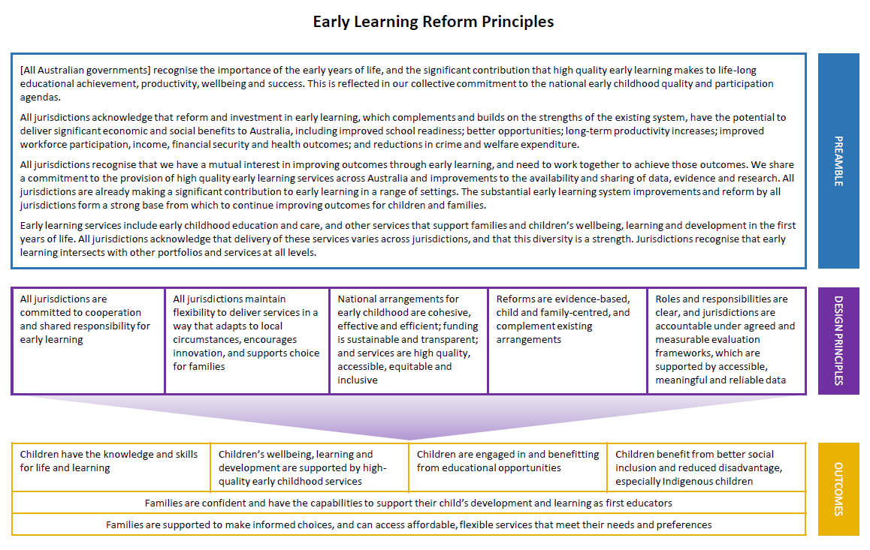

- Acronyms
Acronyms | Meaning
ABS | Australian Bureau of Statistics
ACECQA | Australian Children’s Education & Care Quality Authority
ACT | Australian Capital Territory
AEDC | Australian Early Development Census
AESOC | Australian Education Senior Officials Committee
AIHW | Australian Institute of Health and Welfare
CALD | Culturally and linguistically diverse
CBDC | Centre-based day care
CCS | Child Care Subsidy
COAG | Council of Australian Governments
CPI | Consumer Price Index
ECDSG | Early Childhood Data Sub Group
ECE | Early childhood education
ECT | Early childhood teacher
ECEC | Early childhood education and care
ECEC NMDS | Early Education and Care National Minimum Dataset
ECPG | Early Childhood Policy Group
ERP | Estimated residential population
ICSEA | Index of Community Socio-Educational Advantage
IGAFFR | Intergovernmental Agreement on Federal Financial Relations
IRSD | Index of Relative Socio-economic Disadvantage
LDC | Long day care
NAPLAN | National Assessment Plan – Literacy and Numeracy
NP | National Partnership
NPA | National Partnership Agreement
NPECE | National Partnership Agreement on Early Childhood Education
NQF | National Quality Framework
NQS | National Quality Standard
NSW | New South Wales
NT | Northern Territory
OSHC | Outside school hours care
PC | Productivity Commission
PI | Performance indicator
Qld | Queensland
RoGS | Report on Government Services
SA | South Australia
SA2 | Statistical Area Level 2
SA3 | Statistical Area Level 3
SEIFA | Socio-Economic Index for Areas
Tas | Tasmania
ToR | Term(s) of Reference
UA | Universal Access
UANP | National Partnership on Universal Access to Early Childhood Education
VET | Vocational Education and Training
Vic | Victoria
WA | Western Australia
YBFS | Year before full-time school

- Glossary
Term | Meaning
Early Years Learning Framework | The Early Years Learning Framework (EYLF) describes the principles, practices and outcomes that support and enhance young children's learning from birth to five years of age, as well as their transition to school. The framework is a key component of the National Quality Framework for early childhood education and care. The EYLF was developed by the Australian and State and Territory governments with input from the early childhood sector and early childhood academics.
Full-time school | The provision of full-time day primary or secondary education or the provision of primary or secondary distance education.
Indigenous | People who identify as Aboriginal and Torres Strait Islander.
National Assessment Plan – Literacy and Numeracy (NAPLAN) | An annual national assessment for students in Years 3, 5, 7 and 9. NAPLAN tests skills in literacy and numeracy that are developed over time through the school curriculum.
National Collection | The National Early Childhood Education and Care Collection published by the ABS in catalogue number 4240.0. Preschool Education, Australia, 2018 and previous versions.
Preschool program (also) ‘preschool’ | A structured, play-based early childhood education program delivered by a qualified early childhood teacher in accordance with the Early Years Learning Framework and the National Quality Framework.  States and Territories, local government, not-for-profit organisations and/or private operators deliver preschool programs in a variety of settings, including school-based programs (government and non-government), standalone facilities and in centre-based day care (CBDC).  The terms used for these programs vary across the country – they are referred to variously as preschool, kindergarten or Pre-Prep.
Universal access | Quality early childhood education programs for all children enrolled in the year before full-time school for 600 hours per year, delivered by a qualified early childhood teacher who meets NQF requirements, and with a focus on participation by Indigenous and vulnerable and disadvantaged children, regardless of the setting in which programs are delivered

- UANP performance framework
Table 9 lists the outcomes, outputs, performance indicators and performance benchmarks in the 2018-2019 National Partnership on Universal Access to Early Childhood Education.
Table 9 | The UANP Performance Framework
Outcomes | Outputs | Performance indicators | Performance benchmarks/ targets
Providing universal access to and improving participation of all children in affordable, quality early childhood education program(s), including that:  - i. vulnerable and disadvantaged children have access to, and participate in, an affordable, quality early childhood education program;  - ii. Indigenous children have access to, and participate in, an affordable, quality early childhood education program; and  - iii. all Indigenous four year olds in remote communities have access to early childhood education. | Implementing accessible, quality early childhood education programs which meet the needs of parents and communities at a cost which does not present a barrier to participation, particularly for vulnerable and disadvantaged children.  Delivering strategies and actions targeting the participation of vulnerable and disadvantaged children.  Delivering strategies and actions targeting the participation of Indigenous children, including in remote areas.  Supporting all children’s quality early childhood education participation, regardless of whether quality early childhood education programs are delivered through schools (non-government and government), standalone preschools or long day care centres. | 1. Teacher Qualifications  The proportion of early childhood education programs delivered by a degree qualified early childhood teacher who meets the NQF requirements. | 95 per cent
 |  | 2. Access to Quality Program  The proportion of children enrolled in quality early childhood education program(s) in the year before full-time school. | 2.1 95 per cent of children;  2.2 95 per cent of Indigenous  children; and  2.3 95 per cent of vulnerable and disadvantaged children.
 |  | 3. Access to a Quality 600-hour Program  The proportion of children enrolled in quality early childhood education program(s) for 600 hours per year, in the year before full-time school. | 3.1 95 per cent of children;  3.2 95 per cent of Indigenous children; and  3.3 95 per cent of vulnerable and disadvantaged children.
 |  | 4. Attendance  The proportion of enrolled children who attend quality early childhood education program(s) for 600 hours per year, in the year before full-time school. | Annual targets agreed in Implementation Plans taking into account a jurisdiction’s starting point and moving to 90 per cent over time.

- Evolution of the UANP and its predecessor agreements
While the focus of this Review is on the UANP’s operation since 2014, it is important to understand the full context of the agreement’s original goals and the cumulative contribution of subsequent agreements since 2009.
National Partnership Agreement | Service delivery period | Value | Policy and funding developments
Early Childhood Education | February 2009 to June 2013  (4.5 years) | $955m (+$15m for data development) | - For the first four years of the agreement, the allocation of funding between States and Territories reflected the different baselines and costs of each jurisdiction. The final year of funding was based on each jurisdiction’s share of the estimated residential population (ERP) of four year olds.
Universal Access to Early Childhood Education | July 2013 to December 2014  (1.5 years) | $655.6m (+$4.5m for data development) | - Funding allocation continues to be based on ERP of four year olds.  - 40 per cent of the funding available to each State and Territory is tied to performance; the remaining 60 per cent is paid on implementation plans and progress reporting. The performance indicators relevant to funding include: teacher qualifications, access to a quality program and access to a quality 600-hour program.  - The commitment changes from ‘15 hours a week, 40 weeks a year’ to ‘600 hours per year’.  - The program availability performance indicator changes to the proportion of children enrolled (previously the proportion of four year olds) who are enrolled in programs that are available for 600 hours per year.  - Teacher qualifications are aligned to the NQF (including service waivers).  - Governments agreed to conduct an independent review of the agreement to assess the degree to which the agreed objectives and outcomes and/or outputs have been achieved, and to inform decisions regarding the appropriate treatment following its expiry.
Universal Access to Early Childhood Education – 2015 | January 2015 to December 2015  (1 year) | $404.5m (+ $1.5m for data development) | - 70 per cent of the funding is tied to performance; the remaining 30 per cent is paid on agreement of implementation plans. The performance indicator relevant to funding include: teacher qualifications, access to a quality program and access to a quality 600-hour program. (i.e. attendance has no payment attached.)  - Strengthened reference to supporting all children’s participation, regardless of setting.  - Performance Indicator 3 (program availability) changes from children being enrolled in programs that are ‘available for 600 hours per year’ to children being enrolled for 600 hours per year.  - Performance Indicator 4 (attendance) changes from children attending programs that are ‘available for 600 hour per year’ to children attending for 600 hours per year.
Universal Access to Early Childhood Education – 2016 and 2017 | January 2016 to December 2017  (2 years) | $840m (+ $3m for data development) | - 70 per cent of the funding is tied to performance against the UANP benchmarks and targets, with the balance paid on implementation plans and progress reporting.  - The performance indicators relevant to funding included: access to a quality program and access to a quality 600-hour program (i.e. teacher qualifications and attendance have no payments attached).  - The payment structure is revised to introduce payments for lower levels of performance (i.e. 90 per cent performance payment, and separate payments for maintenance and improvement.) and each performance indicator assessed and paid separately.  - The performance indicator for teacher qualifications is taken to be achieved, given the NQF requirement that relevant services have access to an ECT.
Universal Access to Early Childhood Education – 2018 | January 2018 to December 2018 | $427.9m (+ $1.5m for data development) | - The allocation of funding between States and Territories changed to be based on projected growth of actual enrolments (rather than the ERP of four year olds).
Universal Access to Early Childhood Education – 2019 | January 2019 to December 2019 | $440.1m (+ $1.5m for data development)
Universal Access to Early Childhood Education – 2018 – 2020 | January 2020 to December 2020  (additional year) | $449.5m (+ $3.6m for data development, including this Review) | - Governments agreed to conduct this independent review of arrangements to inform future directions for governments’ funding for preschool.

- Figure 1 sources and notes
To reduce the length of the executive summary, this appendix lists the sources and notes for Figure 1 in the executive summary.

Sources
          - 2008 proportion of children enrolled for 600 hours or more: data from Bilateral Agreements under the National Partnership Agreement on Early Childhood Education, Council of Australian Governments, 2008.
2008 total children enrolled: data from Table 2.3 in Eighteen Month Review of the National Partnership Agreement on Early Childhood Education, The Allen Consulting Group, 2011.
2013 and 2018 data collected for the purposes of reporting on the UANP and provided to Nous for the purpose of this Review. Includes supplementary data from some jurisdictions. Indigenous/vulnerable and disadvantaged children in YBFS enrolment: 2013 data from Table 12, Table 19 in ABS Preschool Education, Australia (cat. No. 4240.0), 2012. 2018 data from Table 28, Table 30 in ABS Preschool Education, Australia (cat. No. 4240.0), 2018.
          - Quotes gathered through the UANP Review survey, conducted by Nous, 2019.
          - Qualified ECTs: 2013 data from Attachment table 3A.37 in Report on Government Services, Australian Government Productivity Commission, 2015. 2016 data from Attachment table 3A.46 in Report on Government Services, Australian Government Productivity Commission, 2017.
Services with a qualified ECTs: data collected for the purposes of reporting on the UANP and provided to Nous for the purpose of this Review. (Performance Indicator 1).
          - Funding through the UANP: attachment table 3A.8 in Report on Government Services, Australian Government Productivity Commission, 2019. State and Territory government expenditure: (FY 12-13 & FY 17-18) attachment table 3A.7 – preschool services total expenditure in Report on Government Services, Australian Government Productivity Commission, 2019, minus the UANP allocation. (FY 09-10) attachment table 3A.5 in Report on Government Services, Australian Government Productivity Commission, 2015, minus the UANP allocation
          - Research snapshot: Early childhood education and care and the transition to school, Australian Early Development Census (AEDC), 2014.
          - Preschool programs: attachment table 3A.11 in Report on Government Services, Australian Government Productivity Commission, 2019.
Meeting or exceeding quality standards: 3A.41 in Report on Government Services, Australian Government Productivity Commission, 2015. 3A.32 in Report on Government Services, Australian Government Productivity Commission, 2019.

Notes
- 2008 Total number of children enrolled: calculated by multiplying the proportion of children enrolled in ECE by population of children aged 4 in 2007-08 for each jurisdiction.
Percentages of Indigenous/vulnerable and disadvantaged children enrolled (i.e. Performance Indicator 2.2 and Performance Indicator 2.3) are reported using the YBFS method: number of children in subgroup in YBFS / ERP of four years old. In 2013, NT and Queensland distributed children with unknown 'SEIFA' proportionally across quintiles; SA moved from rolling intake to single year intake which impacted on data during collection week (smaller cohort included). In 2018, NT data included children from 2 Families as First Teachers centres; ACT uses AEDC data as alternative measure of vulnerability and disadvantage; Tasmania added a portion of the Not Stated to Indigenous enrolment numbers.
- Results extracted from the UANP Review survey of parents/carers (N=182).
- The number of qualified ECTs are defined as paid primary contact staff with a bachelor’s degree and above in early childhood education.
- The State and Territory government expenditure is the recurrent and net capital expenditures for preschool service delivery; in addition to this, S/T have made major significant capital investments and funded programs to promote preschool participation and early development outcomes. Capital expenditure data may fluctuate due to the timing of grants payments which are related to programs that are delivered across financial years. Time series financial data are adjusted to 2017-18 dollars using the GGFCE chain price deflator (2017-18 = 100). See table 36 in ABS Australian National Accounts: National Income, Expenditure and Product, June 2018 (Cat. no. 5206.0) Canberra for index value.
- The AEDC report uses 2009 data.
- ACECQA data as at 30 June for each reference year and are cumulative of services with a quality rating since ratings began in June 2012. Services with more than one quality rating are reported by their most recent quality rating. Data does not include Tasmania and Western Australia, who maintain a separate but similar quality standards assessment framework.
- The Review’s calculation of funding estimates
This note explains how the Review has estimated the contribution of different funding sources to preschool provision. These figures are used in Figure 10 of the report.
Government funding for preschool comprises State and Territory contributions that are determined at a jurisdictional level and Australian Government funding under the UANP. Some categories of preschool providers also have access to alternative streams of public funding, which are not for the express purpose of supporting preschool provision. Of most interest to the Review is the interaction with Australian Government child care subsidies (available for CBDC services but not standalone and school-based preschool services). In addition to this, parents and families contribute to the cost of preschool through payment of fees.
There are four funding sources for providers of preschool:
- Category 1: State and Territory funding
- Category 2: Australian Government contribution under the UANP
- Category 3: Australian Government child care subsidies (CCS and previous versions)
- Category 4: Out of pocket costs (i.e. after subsidies) incurred by parents.
No single data source encompasses all funding streams available to preschool providers. The Review therefore relied on multiple data sources, as follows:
- Category 1: Report of Government Services, Productivity Commission (ROGS)
- Category 2: ROGS
- Category 3: Administrative data, Australian Government Department of Education (Australian Government administrative data)
- Category 4: National Preschool Collection, Australian Bureau of Statistics (National Collection).
It is important to note that State and Territory expenditure reported to the Productivity Commission is not directly comparable across jurisdictions.

Composition of funding from all sources by jurisdiction
The Review estimated the composition of funding to providers of preschool in the YBFS in each jurisdiction. This information is presented and analysed in Chapter 2 and reproduced in the table below. There follows an explanation of how each figure in this table was arrived at.
Source (2018-19) | NSW | Vic | Qld | SA | WA | Tas | NT | ACT | Aust
Category 1: State / Territory funding (total recurrent expenditure - UANP contribution) ($’000s) | 212 482 | 314 009 | 96 223 | 151 161 | 306 887 | 42 720 | 32 710 | 30 196 | 1 186 389
Category 2: Australian Government contribution under the UANP ($’000s) | 124 932 | 120 888 | 88 024 | 28 204 | 46 328 | 9 267 | 4 795 | 9 106 | 431 543
Category 3: Australian Government investment through child care subsidies (for 600 hours) ($’000s) | 217 422 | 126 823 | 139 123 | 17 725 | 2666 | 921 | 1192 | 5404 | 512 298
Category 4: Estimated parental contributions (out of pocket costs) (for 600 hours) ($’000s) | 302 361 | 206 378 | 131 562 | 20 416 | 25 501 | 3 770 | 1 606 | 12 161 | 723 825

Figures were then reported as a proportion of total preschool funding from all sources.
Source | NSW | Vic | Qld | SA | WA | Tas | NT | ACT | Aust
Category 1: State / Territory funding (total recurrent expenditure - UANP contribution) | 25% | 41% | 21% | 69% | 80% | 75% | 81% | 53% | 42%
Category 2: Australian Government contribution under the UANP | 15% | 16% | 19% | 13% | 12% | 16% | 12% | 16% | 15%
Category 3: Australian Government investment through child care subsidies (for 600 hours) | 25% | 17% | 31% | 8% | 1% | 2% | 3% | 10% | 18%
Category 4: Estimated parental contributions (out of pocket costs) (for 600 hours) | 35% | 27% | 29% | 9% | 7% | 7% | 4% | 21% | 25%

Category 1: Estimating State and Territory funding
To arrive at the figures above for State and Territory contributions to preschool funding, the Review subtracted the Australian Government contribution under the UANP (reported in ROGS, Table 3A.8) from State and Territory real recurrent expenditure on preschool (reported in ROGS, Table 3A.7).
Source (2018-19) | NSW | Vic | Qld | SA | WA | Tas | NT | ACT | Aust
Category 1: State and Territory funding for preschool provision ($000) | 212 482 | 314 009 | 96 223 | 151 161 | 306 887 | 42 720 | 32 710 | 30 196 | 1 186 389
Source: Tables 3A.7 and 3A.8 Report of Government Services, Productivity Commission, 2020

Category 2: Estimating Australian Government funding under the UANP
The Review used ROGS (Table 3A.8) reporting of the Australian Government contribution under the UANP. The Australian Government contribution under the UANP represents the maximum available funding, and actual payments may be lower based on assessment against UANP performance measures.
Source (2018-19) | NSW | Vic | Qld | SA | WA | Tas | NT | ACT | Aust
Category 2: Australian Government funding to States and Territories under the UANP ($000) | 124 932 | 120 888 | 88 024 | 28 204 | 46 328 | 9 267 | 4 795 | 9 106 | 431 543
Source: Table 3A.8 Report of Government Services, Productivity Commission, 2020

Category 3: Estimating Australian Government child care subsidies
The Review used data held by the Australian Government Department of Education to estimate the contribution of child care subsidies to preschool provision in CBDC. An estimate for four year olds as at 1 January 2018 was used as a proxy for the number of children for enrolled in preschool programs in CBDC (and then adjusted, as per below).
Source (2018-19) | NSW | Vic | Qld | SA | WA | Tas | NT | ACT | Aust
Total Subsidy ($000) | 476 299 | 329 283 | 306 663 | 65 736 | 59 318 | 14 974 | 8 644 | 27 543 | 1288 460
Source: Australian Government Department of Education administrative data (DR3183), child age calculated as a 1 Jan 2019, estimated entitlement includes CCS and ACCS.

Adjustment to exclude additional child care hours
Children attending CBDC in the YBFS typically undertake a preschool program in conjunction with child care. For the purpose of estimating the contribution of child care subsidies to preschool provision, the Review assumed that the first 600 hours of CBDC constitutes the preschool component of the service. Additional hours were excluded from funding estimates.
The Review extrapolated the total value of subsidies provided (in relation to the first 600 hours of CBDC delivered to children within the specified age cohort) from the average hourly subsidy for CBDC in each jurisdiction.
Source (2018-19) | NSW | Vic | Qld | SA | WA | Tas | NT | ACT | Aust
Average subsidy per hour of CBDC  (total subsidy, divided by total charged hours) | $5.79 | $6.21 | $5.72 | $6.23 | $6.05 | $5.91 | $4.87 | $5.97 | $5.91
Average subsidy per child  (average subsidy per hour of CBDC, multiplied by 600) | $3,475 | $3,729 | $3,430 | $3,737 | $3,630 | $3,548 | $2,920 | $3,582 | $3,544
Total subsidy for 600 hours for four year olds ($’000)  (average subsidy per child, multiplied by the number of children receiving a subsidy) | 241 447 | 171 067 | 156 913 | 43 533 | 50 678 | 11 780 | 4 672 | 15 389 | 688 299

Adjustment to reflect state-specific YBFS enrolments
An estimate for four year olds as at 1 January 2018 was used as a proxy for the number of children for enrolled in preschool programs in CBDC for the child care subsidy administrative data set. This needed to be adjusted to align with the state-specific YBFS enrolment figures in the ABS National Preschool Collection. The Review adjusted the estimates based on the proportional difference between the two methods of measuring enrolment. This approach improves the original estimates while maintaining a nationally comparable approach.
Enrolments | NSW | Vic | Qld | SA | WA | Tas | NT | ACT | Aust
Number of 4 year olds captured in CCS Admin data set | 69,480 | 45,880 | 45,750 | 11,650 | 13,960 | 3,320 | 1,600 | 4,290 | 194,220
Number of children in CBDC (NCC ss-YBFS) | 58 734 | 32 187 | 39 685 | 4 546 | 698 | 246 | 396 | 1 410 | 137 898
Adjustment factor | 0.845 | 0.702 | 0.867 | 0.390 | 0.050 | 0.074 | 0.248 | 0.329 | 0.710
Source: Table 28, National Collection, Australian Bureau of Statistics, 2018; Australian Government Department of Education administrative data (DR3183), child age calculated as a 1 Jan 2019, estimated entitlement includes CCS and ACCS.
Using the adjustment factor, the Review estimated the contribution of child care subsidies to providers of preschool programs for children in the state-specific YBFS across jurisdictions.
Source (2018-19) | NSW | Vic | Qld | SA | WA | Tas | NT | ACT | Aust
Contribution of child care subsidies before adjustment ($’000) | 241447 | 171067 | 156913 | 43533 | 50678 | 11780 | 4672 | 15389 | 688299
Adjustment factor | 0.845 | 0.702 | 0.867 | 0.390 | 0.050 | 0.074 | 0.248 | 0.329 | 0.710
Category 3: Contribution of child care subsidies (after adjustment, $’000) | 217 422 | 126 823 | 139 123 | 17 725 | 2 666 | 921 | 1 192 | 5 404 | 512 298

Category 4: Estimating out of pocket costs
The National Collection reports out of pocket costs for preschool (that is, costs incurred by parents after the application of subsidies). The Review used 2018 data on out of pocket costs in the state-specific YBFS. Out of pocket costs were calculated by multiplying the child's weekly fees by the provider's weeks of operation. This was calculated by provider and then totalled for each child.
Provider type | NSW | Vic | Qld | SA | WA | Tas | NT | ACT | Aust
Preschool (standalone and school based) ($000) | 80 007 | 74 094 | 37 721 | 2 448 | 20 855 | 2 207 | - | 1 724 | 219 055
More than one provider ($000) Further explained below | 37 993 | 39 767 | 10 809 | 13 771 | 24 607 | 2 444 | 3 821 | 8 635 | 141 847
CBDC ($000) | 411 217 | 241 054 | 174 028 | 26 091 | 4, 08 | 1 900 | 2 836 | 17, 03 | 878 737
Source: National Collection microdata, ABS, 2018.

Adjustment to exclude additional child care hours from out of pocket costs for CBDC
The Review adjusted the out of pocket costs for CBDC based on the extent to which the average hours in CBDC exceeded 600 hours.
Source (2017-18) | NSW | Vic | Qld | SA | WA | Tas | NT | ACT | Aust
Average hours in CBDC | 1,183 | 1,155 | 1,173 | 906 | 702 | 763 | 1,110 | 1,075 | 1,123
Adjustment factor  (for 600 hours) | 0.507 | 0.520 | 0.512 | 0.662 | 0.854 | 0.787 | 0.541 | 0.558 | 0.534

The Review also adjusted the out of pocket costs for enrolments across more than one provider. Out of pocket costs across more than one provider type were calculated based on the cost of each provider type multiplied by the proportion of enrolments by single provider type.
Source (2017-18) | NSW | Vic | Qld | SA | WA | Tas | NT | ACT | Aust
Out of pocket costs for Standalone and school based preschool (no adjustment) ($’000s) | 80 007 | 74 094 | 37 721 | 2 448 | 20 855 | 2 207 | - | 1 724 | 219 055
Out of pocket costs for CBDC (after adjustment) ($’000s) | 208481 | 125231 | 89046 | 17279 | 3852 | 1495 | 1533 | 9543 | 469423
Out of pocket costs more than one provider (after adjustment) ($’000s) | 13,873 | 7,053 | 4,795 | 690 | 795 | 68 | 73 | 894 | 35,347
Category 4: Estimated parental contributions (out of pocket costs) ($’000s) | 302 361 | 206 378 | 131 562 | 20 416 | 25 501 | 3 770 | 1 606 | 12 161 | 723 825

- Consultation participants
The Review conducted consultations with officials from all jurisdictions and key sector stakeholders, including parent and carer representatives, peak bodies, major providers, non-government schools bodies, unions and preschool experts. This appendix lists the organisations Nous engaged.
ACT Aboriginal and Torres Strait Islander Education Advisory Group – Parent Member | ACT Chief Minister, Treasury and Economic Development Directorate
ACT Council of Parents & Citizens Associations | ACT Education Directorate
Anglicare (ACT, NSW South, NSW West) | Association for Children with a Disability
Association of Independent Schools of NSW | Association of Independent Schools, South Australia
Association of Independent Schools, Western Australia | Australian Childcare Alliance
Australian Childcare Alliance (New South Wales) | Australian Childcare Alliance (Queensland)
Australian Childcare Alliance (South Australia) | Australian Childcare Alliance (Tasmania)
Australian Childcare Alliance (Victoria) | Australian Children's Education & Care Quality Authority
Australian Community Children’s Services | Australian Council of State School Organisations
Australian Education Union (NT) | Australian Education Union (South Australia)
Australian Government Department of Education | Australian Government Department of Finance
Australian Government Department of the Prime Minister and Cabinet | Australian Government Department of the Treasury
Australian Government National Indigenous Australians Agency | Belconnen Community Service
Bestchance Child Family Care | Big Fat Smile
Camp Australia | Canterbury/Bankstown Council
Carewest | Catholic Education Melbourne
Catholic Education Northern Territory | Catholic Education South Australia
Catholic Education Tasmania | Catholic Education Western Australia
Charles Darwin University | Child and Family Centre New Norfolk
City of Greater Geelong | City of Kingston
City of Whittlesea | Community Based Directors Association of the ACT
Community Child Care Association | Community Connection Solutions Australia
Community Early Learning Australia | Community Kindergarten Association
Community Services #1 | Crèche and Kindergarten Association
David Gonski | Devonport Child Care Centres Inc
Early Childhood Australia | Early Childhood Australia
Early Childhood Australia (Northern Territory) | Early Childhood Australia (Queensland)
Early Childhood Australia (South Australia) | Early Childhood Australia (Tasmania)
Early Childhood Australia (Victoria) | Early Childhood Australia (Western Australia)
Early Childhood Educators of Tasmania | Early Childhood Intervention Australia Victoria and Tasmania
Early Childhood Management Service | Early Learning and Care Council of Australia
Early Learning and Childcare Council | Early Learning Association Australia
Early Learning Council of Australia | Early Start, University of Wollongong
Early Years in Education Society | Family Day Care Australia
Family Day Care Council Tasmania | Flinders University
Forbes Preschool and Kindergarten | G8 Education
Glenorchy City Council | Goodstart Early Learning
Gowrie Victoria | Independent Education Union
Independent Schools Queensland | Independent Schools Tasmania
Isolated Children’s Parents’ Association | Isolated Children’s Parents’ Association (QLD)
KU Children’s Services | Municipal Association of Victoria
Murdoch Children's Research Institute | National Association of Mobile Services for Rural and Remote Families and Children
National Catholic Education Commission | National Outside School Hours Services Alliance
New South Wales Department of Education | New South Wales Department of Premier and Cabinet
Nightcliff Early Learning | Northern Territory Department of Education
Northern Territory Department of the Chief Minister | Northern Territory Department of Treasury and Finance
Northside Community Service | NSW Local Government Education and Care Managers Group
NSW Treasury | Occasional Child Care Australia
Ocean View Child Care Centre | Only About Children
Orange City Council | Playgroup Victoria
Playgroup WA | Possums Playcentre
Professor Deborah Brennan | Queensland Catholic Education Commission
Queensland Council of Social Services | Queensland Department of Education
Queensland Department of the Premier and Cabinet | Queensland Lutheran Early Childhood Services
Queensland Teacher's Union | Queensland Treasury
SDN Children’s Services | Secretariat of National Aboriginal and Islander Child Care
Small Schools Association | South Australia Department of Education
South Australia Department of the Premier and Cabinet | South Australian Area Schools Leaders Association
State School Teachers Union of Western Australia | Tasmanian Department of Education
Tasmanian Department of Premier and Cabinet | Tasmanian Department of Treasury and Finance
Territory Childcare Group | The Front Project
The Gowrie (QLD) | Treasury Western Australia Department of
Try Australia | United Voice Queensland
Victoria Department of Premier and Cabinet | Victorian Aboriginal Education Association
Victorian Council of Social Service | Victorian Department of Education and Training
Victorian Department of Treasury and Finance | Western Australia Department of Communities
Western Australia Department of Education | Western Australia Department of the Premier and Cabinet
Woden Community Service | YWCA Canberra

The Australian Capital Territory (ACT), New South Wales (NSW) and the Northern Territory (NT) use the term preschool, and Queensland, Tasmania, Victoria and Western Australia (WA) use the term kindergarten. In South Australia (SA) both terms are used.
Review of the National Partnership Agreement on Universal Access to Early Childhood Education, Deloitte Access Economics, 2014.
Report on Government Services 2019, Productivity Commission.
A Smart Investment for a Smarter Australia: Economic analysis of universal early childhood education in the year before school in Australia, The Front Project, 2019.
Early Learning Reform Principles, Council of Australian Governments, 2018.
See Appendix F for sources and footnotes.
Australian Government Treasury Portfolio Budget statement, Australian Government Treasury, 2019, p. 17.
Early Learning Reform Principles, Council of Australian Governments, 2018.
Table: Labour Force Status of Selected Population Group in Labour Force Participation Across Australia, ABS Australian Social Trends (cat. No. 4102.0), 2008. Accessed November 2019.
ABS 2019, Labour Force statistics cited in Gender workplace statistics at a glance 2018-19, Australian Government Workplace Gender Equality Agency, 2019. Accessed November 2019.
See for example: D Warren, M O'Connor, D Smart, & B Edwards, A Critical Review of the Early Childhood Literature, Australian Institute of Family Studies, Melbourne, 2016.
P Winter, Engaging Families in the Early Childhood Development Story: Neuroscience and Early Childhood Development: Summary of Selected Literature and Key Messages for Parenting, Ministerial Council for Education & Early Childhood Development and Youth Affairs, Carlton South, 2010.
S Pascoe, & D Brennan, Lifting Our Game: Report of the Review to Achieve Excellence in Australian Schools Through Early Childhood Interventions, Melbourne, 2017.
Australian research drawing on the Longitudinal Study of Australian Children study of over 4000 Australian children, found that after controlling for socio-demographic characteristics, there was a significant positive association between attendance at preschool and year 3 NAPLAN results (Warren and Haisken-DeNew, 2013).
International longitudinal studies, such as the UK’s ‘Effective Pre-school, Primary and Secondary Education Project’, found that the preschool influence continued during secondary school. Those who attended high quality preschool had higher cognitive attainment and better social-behavioural development at age 14. By age 16, having attended a preschool program predicted better final exam results.
The OECD (2011) found that the Program for International Student Assessment (PISA) reading assessment results of 15-year-old students in most countries who had attended pre-primary or preschool for more than a year outperformed those who had not attended, even after accounting for their socioeconomic background.
Australian Government Department of Education and Training, Through Growth to Achievement: The Report of The Review to Achieve Educational Excellence in Australian Schools, 2018.
A review of the effects of early childhood education, Centre for Education Statistics and Evaluation of the NSW Department of Education, 2018.
S Pascoe, & D Brennan, Lifting Our Game: Report of the Review to Achieve Excellence in Australian Schools Through Early Childhood Interventions, Melbourne, 2017.
Inquiry Report: Childcare and Early Childhood Learning (No. 73), Australian Government Productivity Commission, 2014.
A Smart Investment for a Smarter Australia, The Front Project, 2019.
S Fox & M Geddes, Preschool – Two Years are Better Than One: Developing a Preschool Program for Australian 3 Year Olds – Evidence, Policy and Implementation, Mitchell Institute Policy Paper No. 03/2016, Mitchell Institute, Melbourne, 2016.
M O'Connell, S Fox, B Hinz, & H Cole, Quality Early Education for All, Mitchell Institute, Melbourne, 2016.
S Fox & M Geddes, Preschool – Two Years are Better Than One: Developing a Preschool Program for Australian 3 Year Olds – Evidence, Policy and Implementation, Mitchell Institute Policy Paper No. 03/2016, Mitchell Institute, Melbourne, 2016.
National Partnership Agreement on Indigenous Early Childhood Development, Council of Australian Governments 2008.
Early Years Workforce Strategy: The Early Childhood Education and Care Workforce Strategy for Australia 2012-2016, Standing Council on School Education and Early Childhood, Carlton South, 2012.
The Review also received 481 email submissions using standard wording from the Smart Start campaign.
Available at: https://www.uanpreview.nousgroup.com.au/
Source: ABS Preschool Education, Australia (cat. No. 4240.0), 2018.
Note: Children enrolled in more than one service type are assumed to be distributed across provider types in proportion to the main provider type for each jurisdiction.
Sources: Data collected for the purposes of reporting on the UANP and provided to Nous for the purpose of this Review. Includes supplementary data from some jurisdictions.
Notes: (i) Percentages relate to proportion of each jurisdiction’s preschool enrolment population, not national percentages. For example, in Victoria, 16 per cent of four and five year olds of children enrolled in preschool are assessed as in the lowest quintile (lowest 20 per cent) according to the ABS SEIFA IRSD and therefore considered as Vulnerable and/or Disadvantaged based on the reporting of the UANP. (ii) ACT data on vulnerable and/or disadvantaged and its equivalent data not available. ACT has used AEDC as an alternative measure, as reporting for the UANP in the ACT does not use SEIFA IRSD, according to which 33% of enrolled children aged 4-5 experience vulnerability and disadvantage.
Jurisdictions adopt different definitions of vulnerability and disadvantage. This is discussed further in Chapter 4.
This conclusion is based on analysis of Review survey responses and the Review’s discussions with parent representatives and other sector stakeholders.
Source: Table 28 in ABS Preschool Education, Australia (cat. No. 4240.0) 2018. Note: Some proportions may not total 100% due to rounding.
In a Family Day Care Australia survey of 68 members that was conducted in November and December 2019, 14.5 per cent of respondents said they currently offered a preschool program delivered by a degree qualified ECT, with none receiving UANP funding for this.
Comparisons using these figures should be made with caution, as the methodology for calculating funding is not uniform across jurisdictions. (The figures also exclude ancillary funding which may contribute to UANP outcomes).
Sources: ABS Preschool Education, Australia (cat. No. 4240.0). Attachment table 3A.7, 3A.8 in Report on Government Services, Australian Government Productivity Commission, 2020. Australian Government Department of Education administrative data (DR3183).
Notes: State and Territory expenditure: calculated as real recurrent expenditure on preschool services (Table 3A.7 in Report on Government Services, Australian Government Productivity Commission) minus the jurisdictions' UANP allocation. Australian Government contribution under the UANP: UANP allocations for financial year (Table 3A.8 in Report on Government Services, Australian Government Productivity Commission). Australian Government Child Care Subsidy investment: Total CCS and ACCS subsidy provided in 2018-19 for four year olds and adjusted based on state-specific YBFS enrolments by provider type. Child age calculated as of 1 January 2019. Estimated parental contributions (fees): Out of pocket costs were calculated by multiplying the child's weekly fees by the provider's weeks of operation for 2018. This was calculated across the providers and then totalled for each child. For each school type (Preschool, Long day care and 'Across more than one provider') the out of pocket costs were calculated from the NCC 2018 data for state specific YBFS measure.
Bilateral Agreements under the National Partnership Agreement on Early Childhood Education, Council of Australian Governments, 2008. Accessed October 2019.
Data collected for the purposes of reporting on the UANP and provided to Nous for the purpose of this Review. Includes supplementary data from some jurisdictions.
Source: Data collected for the purposes of reporting on the UANP and provided to Nous for the purpose of this Review. Includes supplementary data from some jurisdictions.
Notes: (i) Reporting on results are capped to 100 per cent, where data comparability issues between two different sources of data result in estimates greater than 100 per cent. (ii) In 2013, SA moved from rolling intake to single year intake which impacted on data during collection week (smaller cohort included). (iii) In 2014, NSW data experienced a change in methodology using CCMS data. (iv) In 2014 Vic. data excluded children receiving less than 15hrs of ECEP per week. (v) In 2014-2018, NT data included children from 2 Families as First Teachers (FaFT) centres. (vi) ) In 2014-2017, Vic. data used the correct counting of ‘Year Before Full-time School’ cohort.
Source: Data collected for the purposes of reporting on the UANP and provided to Nous for the purpose of this Review. Includes supplementary data from some jurisdictions.
Notes: (i) Reporting on results are capped to 100 per cent, where data comparability issues between two different sources of data result in estimates greater than 100 per cent. (ii) In 2014, SA data used the correct counting of ‘Year Before Full-time School’ cohort (iii) ) In 2014-2018, NT data included children from two Families as First Teacher (FaFT) centres. (iv) In 2014, NSW data experienced a change in methodology using CCMS data. (v) In 2014, Qld, SA, WA, Vic. data excluded children receiving less than 15hrs of ECEP per week. (vi) ) In 2014-2017, Vic. data used the correct counting of ‘Year Before Full-time School’ cohort. (vii) In 2018, Tas. data added a proportion of ‘Not Stated’ to Indigenous enrolment numbers, counted as enrolled for over 600 hours.(viii) Includes supplementary data from some jurisdictions.
Source: Data collected for the purposes of reporting on the UANP and provided to Nous for the purpose of this Review. Includes supplementary data from some jurisdictions.
Notes: (i) Reporting on results are capped to 100 per cent, where data comparability issues between two different sources of data result in estimates greater than 100 per cent. (ii) Due to data limitations, it has not been possible to report against the program availability for vulnerable and disadvantaged children Performance Indicator 3.3 for 2013. (iii) ) In 2014, Vic., Qld, SA, WA data excluded children receiving less than 15hrs of ECEP per week. (iv) In 2014, NSW data experienced a change in methodology using CCMS data. (v) In 2014-2017, Vic. used the correct counting of 'Year before full time Schooling' cohort. (vi) ) In 2014-2018, NT data included children from two Families as First Teachers (FaFT) centres. (vii) In 2014-2018, ACT data used alternative measures for Vulnerable and Disadvantaged (AEDC & ICSEA). (viii) In 2016, WA and Qld data apportioned SEIFA ‘not stated’ across quintiles.
Sources: ABS Preschool Education, Australia (cat. No. 4240.0), 2018, ABS Australian Demographic Statistics (cat. No. 3101.0) & ABS.Stat ERP by SA2 (ASGS 2016), Age and Sex, 2001 Onwards.
Notes: (i) Proportion for each SA2 is calculated as total enrolment / estimated four year olds population in 2018. Total enrolment: Retrieved from ABS Preschool Education, Australia (cat. No. 4240.0), 2018. Note data at SA2 level is not publicly available. Estimated four year olds population in 2018: Apply single age distribution among age groups in each state (i.e. proportion of four year olds amongst 0-4 age group population), calculated from ABS Australian Demographic Statistics (cat. No. 3101.0), to ABS.Stat ERP by SA2 (ASGS 2016) Age and Sex, 2001 onwards. (ii) Insufficient enrolments to access indicates that the number of enrolments in that area is too low to reliably report proportions. (iii) No enrolment data available indicates that data is suppressed by the ABS because of small numbers of four year olds.
Changes to CBDC data collection from January 2019 cover actual attendance, but this data was not available at the time of publication.
Calculated as the number of total children aged in their state-specific Year Before Full time Schooling (YBFS) attending 600 hours per year in 2018 (Table 28, ABS 4240.0 (2018)) divide by the Population estimates, children aged in their state-specific YBFS (Table 3A.4 ROGS 2020, using ABS4240.0 (2018))
Sources: ABS Preschool Education, Australia (cat. No. 4240.0), 2018 and previous years. Calculated as the number of four and five year old children attending at least one hour at a Government Preschool divided by the number of four and five year old children enrolled in Government Preschool.
L Harrison, S Goldfield, E Metcalfe, & T Moore, Early learning programs that promote children's developmental and educational outcomes, Australian Institute of Health and Welfare, Canberra, 2012.
S Pascoe, & D Brennan, Lifting Our Game: Report of the Review to Achieve Excellence in Australian Schools Through Early Childhood Interventions, Melbourne, Melbourne, 2017.
2013 data from Attachment table 3A.41 in Report on Government Services, Australian Government Productivity Commission, 2015. 2018 data from Attachment table 3A.32 in Report on Government Services, Australian Government Productivity Commission, 2019. ACECQA data as at 30 June for each reference year and are cumulative of services with a quality rating since ratings began in June 2012. Services with more than one quality rating are reported by their most recent quality rating. Data does not include WA and Tasmania, who maintain a separate but similar quality standards assessment framework.
Preschool Education, Australia – 4240 – 2018, Australian Bureau of Statistics.
K Sylva, E Melhuish, P Sammons, I Siraj-Blatchford & B Taggart, Effective provision of pre-school education (EPPE) project: Findings from the early primary years, 2004.
Source: ACECQA analysis of data at June 2019, provided to Nous for the purpose of this Review.
Notes: (i) ACECQA data as at 30 June 2019 and are cumulative of services with a quality rating since ratings began in June 2012. (ii) Services with more than one quality rating are reported by their most recent quality rating. (iii) 23 centre-based services offering preschool programs in Western Australia are included within this analysis or data. No services offering preschool programs in Tasmania are included in the ACECQA data. (iv) ‘Exceeding NQS’ combines services that have received an overall rating of ‘Exceeding NQS’ or ‘Excellent’. ‘Working towards NQS’ combines services that have received an overall rating of ‘Working towards NQS’ or ‘Significant improvement required’. (v) Some proportions may not total 100% due to rounding. (vi) Family Day Care services and services with an address that is unable to be tagged with a SEIFA classification are not included in the analysis. (vii) Analysis includes preschool, defined as defined as centre-based care offering preschool programs, and CBDC services, defined as centre-based care offering long day care programs, both of any age and with a waiver.
Occupation projections – five years to May 2023 from 2018 Employment projections – for the five years to May 2023, Department of Employment, Skills, Small and Family Business, Canberra, 2018. Last updated on 14 September 2018. Accessed November 2019.
ACECQA online snapshot, available at http://snapshots.acecqa.gov.au/Snapshot/waivers.html. Accessed February 2019.
ACECQA online snapshot, available at http://snapshots.acecqa.gov.au/Snapshot/waivers.html. Accessed February 2019.
P Weldon, Policy insights: The teacher workforce in Australia: Supply, demand and data issues, ACER, 2015. CBDC providers in multiple states and territories also made this claim to the Review.
Source: ABS Preschool Education, Australia (cat. No. 4240.0), 2018 and previous years.
Source: ABS Preschool Education, Australia (cat. No. 4240.0), 2018 and previous years.
Source: ABS Preschool Education, Australia (cat. No. 4240.0), 2018.
A New Tax System (Family Assistance) (Administration) Act 1999 (Cth) s 194D(vi).
Child Care Subsidy Minister’s Rules 2017 (Cth) s 45(3)(b).
Child Care Subsidy minimum operating periods - special circumstance requirements, Australian Government Department of Education, Skills and Employment. Available at: https://docs.education.gov.au/documents/child-care-subsidy-minimum-operating-periods-special-circumstance-requirements-fact-sheet
A New Tax System (Family Assistance) (Administration) Act 1999 (Cth) s 194D(vi).
Source: ABS Preschool Education, Australia (cat. No. 4240.0), 2018.
Source: ABS Preschool Education, Australia (cat. No. 4240.0), 2018.
L Harrison, S Goldfield, E Metcalfe, & T Moore, Early learning programs that promote children's developmental and educational outcomes, Australian Institute of Health and Welfare, Canberra, 2012.
D Warren, M O'Connor, D Smart, & B Edwards, A Critical Review of the Early Childhood Literature, Australian Institute of Family Studies, Melbourne, 2016.
See for example: S Pascoe, & D Brennan, Lifting Our Game: Report of the Review to Achieve Excellence in Australian Schools Through Early Childhood Interventions, Melbourne, Melbourne, 2017.
Some jurisdictions adopt a reference fortnight to take account of their preschool delivery models, with the data converted to a week for national comparison purposes.
While the NQF sets out service qualification requirements as agreed by all jurisdictions, it is worth noting that some jurisdictions go above and beyond the NQF standard in relation to their preschool programs and funding. For example, in some jurisdictions it is a requirement that preschool programs are actually delivered by a degree-qualified ECT.
Source: ABS Preschool Education, Australia, 2018, Appendix 4: State-specific year before full-time schooling.
Source: ABS Preschool Education, Australia (cat. No. 4240.0), 2018 and previous years.
Note: ABS YBFS method combines the general YBFS measure from 2013-2015 and state-specific YBFS measure from 2016 onwards.
Calculated as the number of total children aged in their state-specific Year Before Full time Schooling (YBFS) attending 600 hours per year in 2018 (Table 28, ABS 4240.0 (2018)) divide by the Population estimates, children aged in their state-specific YBFS (Table 3A.4 ROGS 2020, using ABS4240.0 (2018)).
Student attendance rate of Years 1-10 students in all schools in Australia, Australian Curriculum, Assessment and Reporting Authority. Accessed October 2019.
Part 3 in Intergovernmental Agreement on Federal Financial Relations, Council of Australian Governments, 2008.
Source: Attachment table 3A.8 in Report on Government Services, Australian Government Productivity Commission, 2019.
Notes: (i) Time series financial data are adjusted to 2017-18 dollars. (ii) Funding amounts in this table do not necessarily reflect final amounts received by states and territories.
Comparisons using these figures should be made with caution since the methodology for calculating expenditure is not uniform across states and territories.
Note: The ABS made changes in late 2016 to eliminate more duplicate counts from the National Collection. This means that transition from 2016 enrolment data (used for 2018 calculations) and 2017 enrolment data (used for 2019 calculations) has a material and variable impact on different jurisdictions.
Inquiry Report: Childcare and Early Childhood Learning (No. 73), Australian Government Productivity Commission, 2014, Recommendation 15.10.
O’Connell et al, Quality Early Education for All Fostering creative, entrepreneurial, resilient and capable learners, Mitchell Institute, Melbourne, 2016, p. 17.
D Warren & J.P. Haisken-DeNew, Early Bird Catches the Worm: The Causal Impact of Pre-school Participation and Teacher Qualifications on Year 3 NAPLAN Cognitive Tests, cited in a summary paper of the 2013 research jointly issued with the Victorian Government.
J Heckman, Invest in early childhood development: Reduce deficits, strengthen the economy, the Heckman Equation, 2012.
O’Connell et al, Quality Early Education for All Fostering creative, entrepreneurial, resilient and capable learners, Mitchell Institute, Melbourne, 2016, p. 29.
Preamble in Early Learning Reform Principles, Council of Australian Governments, 2018.
J Baxter & K Hand, Access to early childhood education in Australia, Australian Institute of Family Studies Research Report 24, 2013, pp 35-36.
M O’Connor, E O’Connor, S Gray & S Goldfeld, Trends in preschool attendance in Australia following major policy reform: Updated evidence six years following a commitment to universal access, Early Childhood Research Quarterly, Volume 51, 2nd Quarter 2020, pp 93-99.
See for example: Quality Matters in Early Childhood Education and Care: United Kingdom (England), OECD, 2012, p. 64. Barriers to Participation – the Experience of Disadvantaged Young Children, their Families and Professionals in Engaging with Early Childhood Services, Children and Families Research Centre, Macquarie University, Sydney, 2010.
There would be benefits and costs to these changes to data collection and reporting that should be quantified before a decision could be taken. This should consider what is already collected across jurisdictions and settings to identify best way forward and not add additional burden to the sector.
K Torii, S Fox & D Cloney, Quality is key in Early Childhood Education in Australia, Mitchell Institute Paper 01/2017, 2017.
Communiqué, Education Council, 28 June 2019.
D Gonski et al, Through Growth to Achievement Report of the Review to Achieve Educational Excellence in Australian Schools, 2018.
Nous will add the Early Learning Reform Principles to the document in mid-November 2019
Since 1 January 2014, changes to the NQF resulted in a requirement that all centre-based day care and preschool services providing care must have access to an early childhood teacher. Consequently, for the purpose of the UANP Agreement Performance Indicator 1 is taken as achieved.
A copy of the review can be found on the Education Council website at: http://www.educationcouncil.edu.au/site/DefaultSite/filesystem/documents/Reports%20and%20publications/EC%20Publications/NP_UAECE%20Review-220415.pdf

