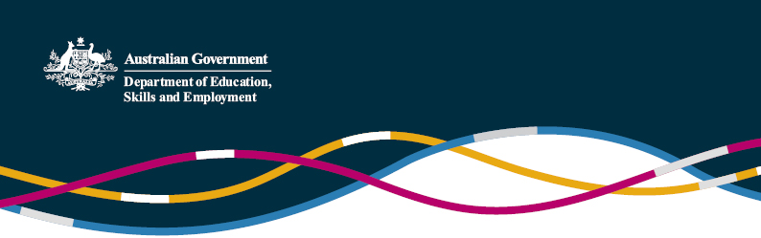

Updated advice from CSCSE -
  - Qualifications obtained partially and wholly online during COVID-19 to be verified
  - (Information as at 24 March 2021)

On 19 March 2021, the Chinese Service Center for Scholarly Exchange (CSCSE) published an announcement reiterating its flexible approach to verification of qualifications obtained online by students affected by COVID-19.
This is understood to be the first official follow up to CSCSE advice issued on 3 April 2020 clarifying that students who, due to COVID-19, were conducting some of their studies online and would not therefore meet the foreign qualification verification requirements, would nonetheless be able to have their foreign qualifications verified.
Noting many countries still have travel restrictions in place, students and education providers are understandably concerned to ensure that qualifications obtained wholly online at this time can also be verified. This latest announcement by CSCSE addresses this concern by clarifying these too can be verified under normal processes, provided the qualification meets the degree-granting conditions set by foreign higher education institutions.
The announcement also highlights, however, a concern of the CSCSE regarding perceived targeted recruitment of Chinese students into sub-par and/or fraudulent online courses that have emerged during the pandemic. The CSCSE urges Chinese students to stay vigilant as qualifications issued for these courses may not be verified by the CSCSE in accordance with the "Measures of Chinese Service Center for Scholarly Exchange on Foreign (Overseas) Academic Credential Evaluation".

An unofficial translation of the full text of the announcement is below.
Supplementary explanation on verification of foreign qualification for Chinese international students during the COVID-19 pandemic
(unofficial translation of 关于新冠肺炎疫情期间留学人员学历学位认证工作的补充说明)
Since the outbreak of the COVID-19 pandemic, the Chinese Service Center for Scholarly Exchange (CSCSE) has been paying close attention to the many negative impacts on the lifestyles and study conditions of Chinese students studying with foreign education providers as a result of the pandemic.
The CSCSE has actively addressed the concerns of Chinese international students through various forms and channels, and temporarily adjusted relevant policies for qualifications verification based on the status of the pandemic. This has minimised any adverse impact on the study plans of Chinese international students, safeguarded their vital interests and was generally welcomed by them.
However, it was noted recently that certain higher education institutions and intermediary agencies in some countries have used the pandemic as an excuse to launch a variety of online courses, have lowered admissions and graduation requirements, or shortened the length of study to aggressively recruit Chinese students, and claimed that these online courses can allow students to easily obtain foreign qualifications without going abroad for studies.
These actions are perceived as selling foreign qualifications in disguise, and have seriously infringed the interests of study abroad personnel. The CSCSE reminds those who intend to study abroad, that when receiving various admissions promotional materials, they must first: visit the official website of the institution to confirm whether the relevant online courses are formal courses offered by the institution; check whether the information in the promotional material is consistent with information on the institution’s official website; and determine if there appears to be any exaggeration or false advertising. Students should maintain a high degree of vigilance and avoid being deceived/having interests damaged, especially when entry requirements and the length of study advertised in the admissions guide are significantly lower/shorter than the general requirements of similar courses in the same country.
The CSCSE hereby reiterates that in order to fight the COVID-19 pandemic, we firmly put the safety and health of Chinese international students first. For Chinese international students who are forced to complete part or all of their courses online due to the impact of COVID-19, their degree qualification can be verified (recognised) under normal proceedings as long as it meets the degree-granting conditions set by foreign higher education institutions.
The CSCSE firmly opposes the practice that some foreign institutions and intermediary agencies have adopted using the pandemic as an excuse to abruptly launch a large number of online courses for profit-making purposes. In order to better protect the interests of Chinese international students and ensure the quality of overseas education, such foreign qualifications have always been considered outside the scope of the CSCSE’s verification remit as outlined in relevant guidelines in the "Measures of Chinese Service Center for Scholarly Exchange on Foreign (Overseas) Academic Credential Evaluation".
Notice is hereby given.
Chinese Service Center for Scholarly Exchange
19 March 2021
---------

For further enquiries, please contact the Education and Research Section of the Australian Embassy in Beijing.

People's Republic of China, Chinese Service Center for Scholarly Exchange , '关于新冠肺炎疫情期间留学人员学历学位认证工作的补充说明 ' (unofficial translation: Supplementary explanation on verification of foreign qualification for Chinese international students during the COVID-19 pandemic), 19 March 2021. http://www.cscse.edu.cn/web/xsy/411032/485662/index.html
People’s Republic of China, JSJ, ‘教育部留学服务中心国(境)外学历学位认证评估办法’ (unofficial translation: Measures of Chinese Service Center for Scholarly Exchange on Foreign (Overseas) Academic Credential Evaluation), 10 April 2018. http://jsj.moe.gov.cn/n2/1/1006/1114.shtml

