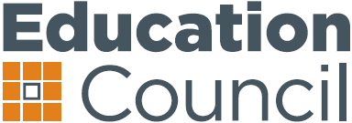
4 May 2018
Hilton Hotel, Adelaide

Communiqué
The Education Council convened in Adelaide today for a special-purpose meeting, at which Council received two presentations on key reports on school education reforms and early childhood interventions.

Ministers welcomed a presentation from David Gonski AC, who presented the findings of the recently completed report, Through Growth to Achievement: Review to Achieve Educational Excellence in Australian Schools. Ministers discussed the report. The report will be an important input into the forthcoming national schooling reform agreement.

Education Council was also pleased to receive a presentation from Susan Pascoe AM and Professor Deborah Brennan, authors of Lifting Our Game: Report of the Review to Achieve Educational Excellence in Australian Schools through Early Childhood Interventions. Council took the opportunity to consider this report and how this work can inform the development of reform principles – work which has recently been requested by the Council of Australian Governments.

Media queries: Greg Donaghue, Education Council Secretariat, 0423 748 320 or greg.donaghue@ec.edu.au

1

