Discussion Paper

##### About the Review

On 11 March 2021, the Hon Alan Tudge MP, Australian Government Minister for Education and Youth, delivered a speech which announced his intention to launch a review looking at the next evolution of reforms to initial teacher education (ITE). In his speech, Minister Tudge highlighted Australia's declining Programme for International Student Assessment (PISA) outcomes in both absolute terms and relative to other countries and identified quality teaching as one of the key areas of focus to return Australia to the top group of nations. Minister Tudge expressed that this review would build upon the significant reforms arising from the Teacher Education Ministerial Advisory Group (TEMAG) report.

The Quality Initial Teacher Education Review (the Review) was launched on 15 April, with the announcement of the Terms of Reference and an Expert Panel of Ms Lisa Paul AO PSM (Chair) (former Secretary of the Department of Education), Emeritus Professor Bill Louden AM (former Dean of Education and Deputy Vice Chancellor, University of Western Australia), Mr Malcolm Elliott (President, Australian Primary Principals Association) and Mr Derek Scott (Principal, Haileybury and 2019 Australian School Principal of the Year).

Every child, regardless of circumstance, has the right to a quality education to help them be the best they can be. This is the vision of the *Alice Springs (Mparntwe) Education Declaration*. Quality teaching, as the most important in-school influence on student learning, is fundamental to achieving this vision. As the COVID-19 pandemic has recently confirmed, teachers play a critical role in our society. We must ensure their expertise, experience and skill in the classroom, along with their dedication, resilience and passion for the profession, is supported by highly effective ITE.

## Provides information about how to make a submission. Public consultation is open now until 18 July. We are particularly interested in hearing from current Year 11 and 12 students, ITE students, teachers, and those thinking of making a career change to teaching.  To make a submission, go to the Review’s website: QITEreview.dese.gov.au. There is also a mailing list that can be joined. Responding to the Discussion Paper

The Expert Panel is interested to hear from a wide range of people, including current students and recent graduates of ITE, teachers, school leaders, teacher educators, and those considering pursuing a career as a teacher.

This Discussion Paper is intended to stimulate conversation and the sharing of ideas informed by evidence, expertise and experience.

While the Expert Panel strongly encourages feedback on the questions posed in this Discussion Paper, they also welcome your thoughts on what concerns you most – particularly if they are informed by your own experience as a teacher, pre-service teacher or other education stakeholder.

Submissions are not required to address each question in the Discussion Paper and the Expert Panel welcomes your contribution, no matter how short.

## ITE plays two central roles – selecting the future teacher workforce and preparing them for the classroom.

ITE has been through a period of significant reform over the last ten years. This has included a national framework based on the *Australian Professional Standards for Teachers* (Teacher Standards) and the *Accreditation of Initial Teacher Education Programs in Australia: Standards and Procedures* (Accreditation Standards), regulated by state and territory Teacher Regulatory Authorities (TRAs).

The 2014 TEMAG review recommended significant reforms, aiming to ensure that ITE programs were consistently of a high standard, producing graduates with the skills and knowledge to drive student outcomes.

2011

2012

2013

2014

2015

2016

2017

2018

2019

2020

2010

### Building on TEMAG

Recommendations of the TEMAG review have been progressively implemented since 2015. Several new elements to the ITE ecosystem have had a significant impact on the delivery of programs. It is through the professionalism and dedication of stakeholders across the sector that such significant changes have been implemented in such a short period of time.

Some aspects of these reforms are still being implemented and are maturing at different rates across the country. The *Through Growth to Achievement: Report of the Review to Achieve Educational Excellence in Australian Schools* (Excellence Review) warned that an ‘unrelenting focus on the rigour’ of the implementation of the TEMAG reforms was necessary if the goal of raising the quality of our initial teacher preparation was to be achieved (Australian Government 2018).

The Review is seeking to build on the significant reforms to date and consider whether further reforms are required to strengthen ITE in Australia.

#### TEMAG - Introduction to Teaching Performance Assessments

#### - The Literacy and Numeracy Test for Initial Teacher Education

#### - Introduction of non-academic selection criteria for applicants

#### - Quality assurance of ITE programs through strengthened accreditation processes

#### - Establishment of the Australian Teacher Workforce Data collection

It is critical that Australia continues to reflect on its approach to ITE and not simply rest on changes made following from TEMAG. Education has the power to transform lives and supports young people to realise their potential. Given the decline in Australia’s performance against international benchmarks, it is important that we have an ongoing commitment to ensuring our ITE system is selecting the right candidates and preparing them to be effective teachers.

### This collection of images provides a snapshot of ITE in Australia: 47 providers. More than 250 programs. Undergraduate 4 years full time. Postgraduate 2 years full time. Over $600 million in Commonwealth Funding. 87,000 enrolled students. At least 80 days of professional experience for undergraduates and at least 60 days for postgraduates. Shared responsibility

ITE is a shared responsibility between the Commonwealth, states and territories, ITE providers and the profession. This means an ongoing shared commitment is needed to make genuine, sustainable change.

This Discussion Paper explores the two key questions that form the scope of the Review: how best to attract and select high-quality candidates into ITE and how best to prepare them to become effective teachers.

# Part A. Attracting high-quality candidates into ITE matters

# Attracting high-quality candidates into ITE matters

Fifty per cent of the variance in students’ achievement comes from the students themselves (individual student characteristics) - there is a strong correlation between earlier and later achievement. Quality teaching, however, is the most significant in-school driver of student outcomes and school quality, accounting for up to 30 per cent of the variance. Teachers have a far greater impact than other factors such as the home (for example levels of expectation and encouragement), attributes of schools (such as finances, school size, class size) and peer effects (influence of peers on students) (Hattie 2003).

This image highlights the variations in student's achievement by main influences. 
50 percent of the variation in student achievement comes from themselves. 30 percent of the variance is from teachers, 5 to 10 percent home, 5 to 10 percent schools and 5 to 10 percent peer effects.


Source: Hattie 2003

ITE is a key part of attracting and developing high-quality teachers. As TEMAG found, high‑performing education systems screen ITE students against criteria they believe will make the best teachers, including academic capability, literacy and numeracy skills and personal characteristics. Competition is so strong in Singapore and Finland, for example, that only about one in ten students who apply to become teachers are accepted (Grattan Institute 2019).

### Trends in ITE Candidates

From 2009 to 2019, the number of students commencing an ITE course grew by four per cent. Over this same period, total commencements in all fields of study grew by 37 per cent. The number of students graduating from ITE declined five per cent, compared with a 40 per cent increase in completions across all fields of study from 2009 to 2019.

This diagram provides a snapshot of trends in ITE candidates in 2019.
There were 87,047 total enrolments in 2019. The share of postgraduate enrolments increased from 16 percent in 2009 to 22 percent in 2019. The share of part-time enrolments increased from 20 percent in 2009 to 25 percent in 2019. The share of students studying online (external and multi-mode) increased from 28 percent of enrolments in 2009 to 48 percent in 2019. The share of male enrolments increased from 24 percent in 2009 to 26 percent in 2019. The share of students aged 25 or more increased from 35 percent of enrolments in 2009 to 38 percent in 2019. 

There is also a pie chart that show ITE student commencements by basis of admission in 2019. 47 percent higher education. 27 percent secondary education. VET award 12 percent. Other 12 percent. Mature age 3 percent and professional qualification less than 1 percent


###### High-Performing School Leavers

Data from the Department of Education, Skills and Employment’s (DESE) Selected Higher Education Student Statistics shows that in 2019, 24 per cent of entrants to undergraduate ITE programs were admitted on the basis of their secondary education with an Australian Tertiary Admission Rank (ATAR). High-performing school leavers are usually considered to be those with an ATAR above 80. Of the 24 per cent of entrants admitted on the basis of their secondary education with an ATAR, 39 per cent of these had an ATAR above 80.

**Commencing students in undergraduate ITE courses admitted on the basis of their secondary education by ATAR band, 2019**

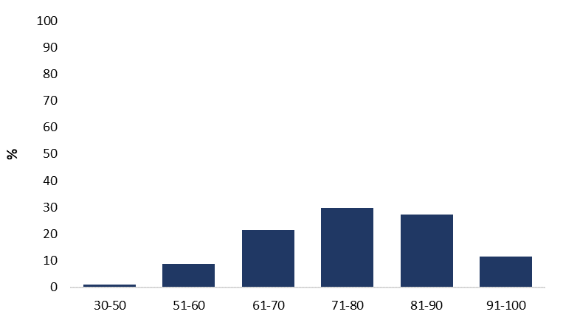

Source: Selected Higher Education Student Statistics, [www.dese.gov.au](https://sharedservicescentre.sharepoint.com/sites/DESE-ITEReviewSecretariat-TEAM/Shared Documents/General/Discussion Paper/www.dese.gov.au)

Notes: ATARs are not a category of admission on their own but are one selection criterion used by higher education providers. Not all ITE students have an ATAR recorded with their admission.

ITE bachelor students with a submitted ATAR above 80 are significantly more likely to complete an ITE course within six years of commencing their course.

**Six-year completion rates of commencing domestic ITE bachelor students by ATAR, 2005 and 2014**

Chart, bar chart.
Shows six-year completion rates by ATAR between 2005 and 2014. 

Source: Selected Higher Education Student Statistics, [www.dese.gov.au](http://www.dese.gov.au/)

Notes: Six-year completion rates refers to the proportion of students commencing an ITE course in a given year (e.g. 2014) who completed an ITE course six years later (e.g. by 2019) for [Table A and B providers](https://heimshelp.dese.gov.au/resources/providertype).

The proportion of ITE bachelor students completing an ITE course declined by 12 percentage points between 2005 to 2014 (63 per cent to 52 per cent respectively, rounded estimates), though completion rates for ITE students with an ATAR above 80 have remained stable over time.

The proportion of young high-achievers (students aged 20 and under with an ATAR of 80 or more) choosing teaching has declined by nearly a third from 2006 to 2019, with four per cent of these students studying in the field of education in 2019.

**Change in undergraduate degree choices among young high-achievers by field of study, 2006 to 2019**

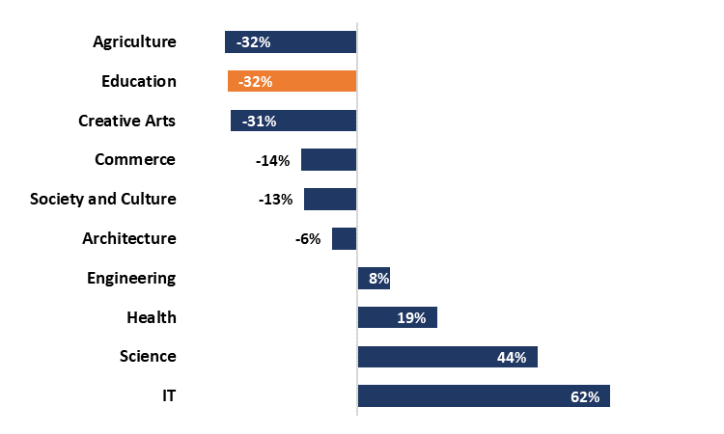

Source: Selected Higher Education Student Statistics, [www.dese.gov.au](http://www.dese.gov.au/)

Note: Share of domestic onshore commencing bachelor degree student enrolments aged 20 years and under, with an ATAR of 80 or more. Food, hospitality and personal services not reported.

A 2019 Grattan Institute survey on the career motivations of high achieving young Australians found that they perceived teaching to fall well short of the intellectual challenge and pay offered by their chosen career.

###### Mid-Career ProfessionalsShows the pathways to teaching, which includes two entry points: first time entry and university graduate. First time entry results in a four-year Bachelor Degree qualification. University graduate entry results in a two-year Master's Degree qualification. From the University graduate entry point there are two alternative pathways to teaching, including: employment based pathways like Teach For Australia or the High Achieving Teachers Program, or accelerated pathways which include Masters that can be completed in 1.3 - 1.5 years instead of two.

Diagram developed by the Quality Initial Teacher Education Review

Attracting more high-performing mid-career professionals into the teaching profession may assist with increasing teacher supply, particularly in certain areas.

The new national approach to the accreditation of ITE programs introduced in 2011 included the requirement that all postgraduate programs be two years in duration. This change, with phased implementation from 2013, has resulted in the removal of ITE Graduate Diploma programs, which were typically one year long.

The trend in postgraduate completions since 2014 has seen a greater decline in ITE completions relative to all fields (which have increased).

**Growth in domestic postgraduate coursework completions, 2009 = 100**

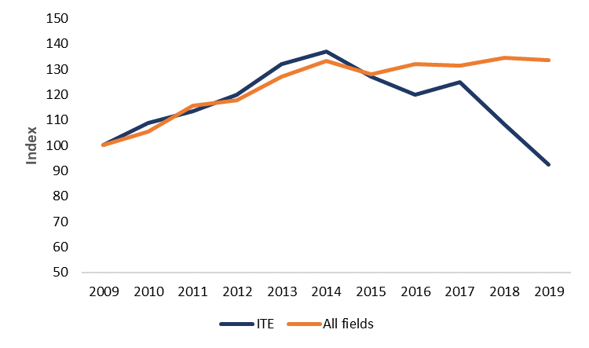

Source: Selected Higher Education Student Statistics, [www.dese.gov.au](http://www.dese.gov.au/)

Note: Base is the number of domestic postgraduate coursework completions in 2009. i.e.= 100. Index numbers in subsequent years show percentage growth in domestic postgraduate coursework completions since 2009.

In consultations undertaken by the Expert Panel to date, it has been suggested that the time taken to complete a postgraduate ITE program, and the loss of income while studying (particularly due to professional experience requirements) are significant barriers in attracting this cohort.

#### La Trobe University Nexus Program

#### The Nexus Program is funded through the Commonwealth’s High Achieving Teachers Program and aims to attract, select and prepare quality teachers to work in low socio-economic schools in Victoria.

#### While completing an accelerated Master of Teaching (Secondary) in 1.5 years at La Trobe University, Nexus participants are paid a small part-time salary to work as a teacher aide in a secondary school and are supported through mentoring and professional development.

#### In addition to standard entry requirements for the Master of Teaching (Secondary), candidates must submit a written statement and attend an interview. Preference is given to candidates who demonstrate a strong commitment to social justice and those from, or willing to teach in, hard to staff regional and rural locations.

#### For more information see the [La Trobe](http://www.Latrobe.edu.au/school-education/nexus-program) website.

Some higher education providers are actively trying to attract mid-career professionals using accelerated pathways, which allow graduate entry ITE students to complete their Masters in under one and a half years instead of two years. Governments are also targeting this group through employment-based pathways into teaching, including the Commonwealth’s High Achieving Teachers Program and the Victorian Government’s Accelerated Learning Programs and the New South Wales Government’s recently announced accelerated pathways for mid-career professionals.

#### Experience Counts

#### As part of a drive to address the United Kingdom’s teacher recruitment crisis, Now Teach focusses on making the mid-career transition to teaching easier.

#### The Now Teach programme supports trainee teachers throughout the two years it takes to become a fully qualified teacher. In the first year, trainee teachers gain their Qualified Teacher Status (QTS) as they complete their Initial Teacher Training (ITT). In the second year, Now Teach supports the transition from QTS to Newly Qualified Teacher, which operates as bridge between ITT and a teaching career.

#### Now Teach works with 58 training providers in 100 schools across the United Kingdom. Those in the program pay no fees. Funding comes from the Department for Education and philanthropic sources and the program is open to residents of the UK who meet the program’s requirements.

#### Most Now Teach teachers train in subjects with reported shortages. In 2020, they saw a 41 per cent increase in maths trainees, 75 per cent increase in science trainees, and 35 per cent increase in German, French and Spanish trainees.

#### Since its launch in 2017, Now Teach has recruited over 340 new teachers.

#### The program continues to grow. In 2020, they received over 900 applications – a 68 per cent increase on 2017.

#### Information is available on the [Now Teach](https://nowteach.org.uk) website.

###### Diverse Cohorts

Australian schools are some of the most diverse across the OECD (OECD 2019) and diverse entrants to ITE will over time help ensure the teaching workforce reflects the diversity of the student population.

In the United States, there is a growing body of literature that suggests student outcomes, including test scores and suspension rates, are affected by the demographic match between students and teachers (Figlio 2017).

**Proportion of ITE students relative to school students from diverse backgrounds, 2019**

This table shows the proportion of ITE students relative to school students from diverse backgrounds.
Aboriginal and Torres Strait Islander students represent 1% ITE and 6% school students.
Regional/remote represent 23% ITE and 28% school students. Low SES represents 19% ITE and 25% school students.


Source: Selected Higher Education Student Statistics, [www.dese.gov.au](http://www.dese.gov.au/), Report on Government Services (Productivity Commission, 2021)

Notes: Domestic ITE completions in ITE by select cohorts. RoGS data refers to full-time Aboriginal and Torres Strait Islander students, full-time equivalent regional/remote students and full and part-time low SES students who are in the bottom quartile of enrolled students in the Socio-Educational Advantage measure.

### Assessment of non-academic selection criteria

The TEMAG review recommended that higher education providers select the best candidates into teaching using sophisticated approaches that ensure ITE students possess the required academic skills and personal characteristics to become a successful teacher.

Key capabilities associated with successful teaching include:

* motivation to teach
* willingness to learn
* resilience
* self-efficacy
* conscientiousness
* organisational and planning skills
* strong interpersonal and communication skills (AITSL: Selection Guidelines)

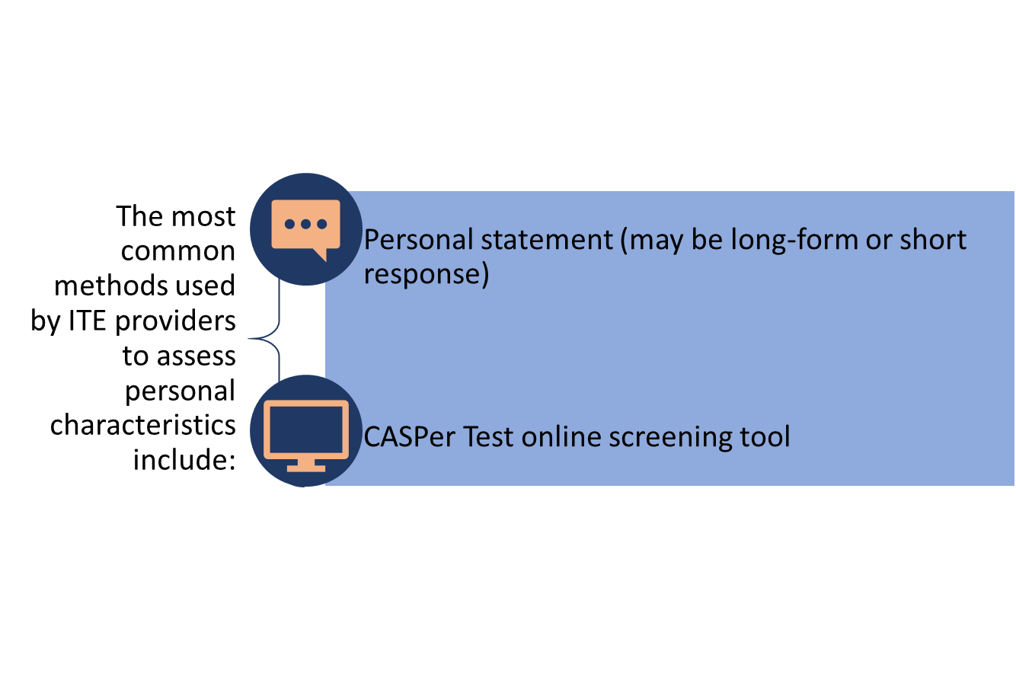The requirement to include assessment of non-academic characteristics has been in place since 2015. An international review conducted by the University of York found that both academic and non-academic selection methods have the potential to be predictors of future teacher success. While this may be the case, as there is no longitudinal research on the relationship between selection criteria and teacher effectiveness, the researchers reported that it is difficult to say what the true impact of selection criteria on teacher effectiveness is (Klassen and Kim 2018).

#### Teaching Capability Assessment Tool (TCAT)

#### TCAT is a research-based online assessment tool for pre-service teacher selection.

#### Candidates complete a series of user-friendly modules designed to assess ability (e.g. literacy, numeracy and spatial reasoning) and other competencies, characteristics and attributes such as previous experience, motivation to teach, communication style, ethics and cultural sensitivity.

#### TCAT is supported by research into the characteristics of effective teachers led by Professor Janet Clinton at the Melbourne Graduate School of Education. All Master of Teaching applicants at the University of Melbourne must use the TCAT when applying for their course.

#### Decorative heading that says 'Questions for Discussion'. For more information, see the [TCAT](https://tcat.edu.au/) website.

* What can be done to attract more high-achievers and career changers to the profession?
* What factors influence the higher education course selection of high-performing school students?
* What features of the current ITE system may prevent high-quality mid- to late-career professionals transitioning to teaching? Has the move to a two-year masters affected your decision to enter ITE?
* How could more high-quality candidates from diverse backgrounds be encouraged to consider a career in teaching?
* How could more Aboriginal and Torres Strait Islander peoples be encouraged and supported to choose a career in teaching?
* What evidence is there that the introduction of assessments of non-academic characteristics has had an impact on admission, progress, completion, and retention of ITE students?

# 2. ITE program completions and entry into a teaching career

### Trends in ITE completion rates

Six-year completion rates of commencing ITE bachelor students have declined by 12 percentage points over 2005 to 2014, relative to a decline of five percentage points across all fields of study.

**Six-year completion rates of commencing domestic bachelor students, 2005 to 2014**

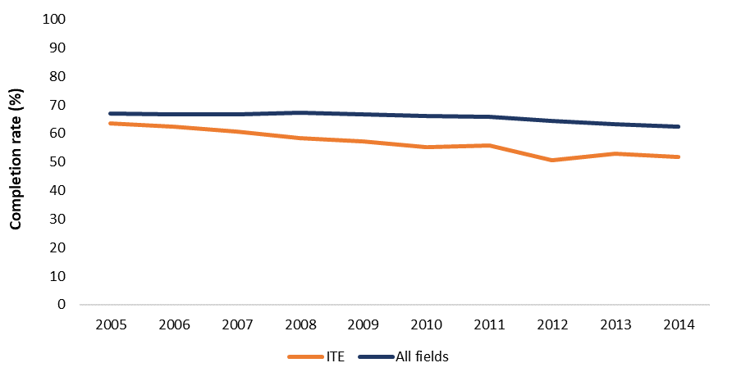

Source: Selected Higher Education Student Statistics, [www.dese.gov.au](http://www.dese.gov.au/)

Notes: Six-year completion rates refers to the proportion of students commencing a course in a given year (e.g. 2014) who completed a course six years later (e.g. by 2019). ‘ITE ’ refers to students commencing an ITE course that completed an ITE course. ‘All fields’ refers to students commencing and completing any course in any field of study. Results are for [Table A and B providers](https://heimshelp.dese.gov.au/resources/providertype).

Analysis of the proportion of students in a cohort who completed their ITE course within six years shows that the following groups of pre-service teachers were more or less likely to complete their program.

This image highlights the variations in student's achievement by main influences. 
50 percent of the variation in student achievement comes from themselves. 30 percent of the variance is from teachers, 5 to 10 percent home, 5 to 10 percent schools and 5 to 10 percent peer effects.


Source: AITSL, Initial Teacher Education: Data Report 2019.

Notes: Results based on six -year completion rates for ITE students who commenced in 2012. Completion rates for secondary education entrants with an ATAR of 30–50 are likely to fluctuate from year to year due to the small numbers of students in this cohort. Results for type or mode of attendance does not take into account if a student's attendance changed over the course of their program.

Data indicates that completion rates vary across higher education providers. As the figure below shows, completion rates range from 34 to 73 per cent.

**Six-year completion rates of commencing domestic ITE bachelor students by higher education provider, 2014** 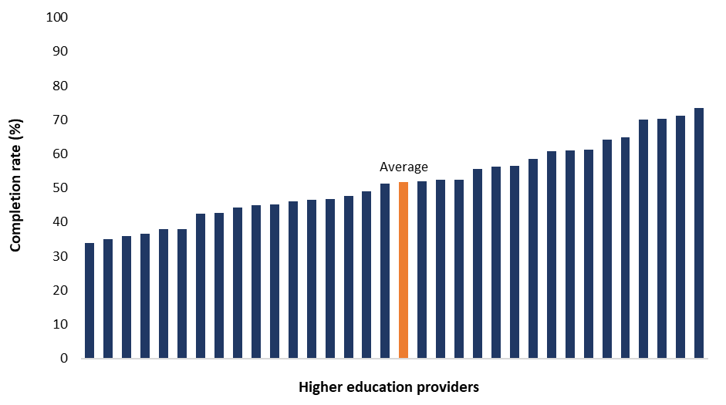Source: Selected Higher Education Student Statistics, [www.dese.gov.au](http://www.dese.gov.au/)

Notes: Every bar represents a HEP. Bars are sorted by the completion rates of undergraduates who commenced an ITE course in 2014 and completed an ITE course by 2019 for [Table A and B providers](https://heimshelp.dese.gov.au/resources/providertype).

First year attrition rates average 21 per cent and vary from 11 per cent to 45 per cent across higher education providers. ITE students who commenced in 2014 and dropped out of their course in their first year made up on average 48 per cent of the total number of ITE students who dropped out within six years.

**First year attrition rate of students commencing an ITE course by higher education provider, 2018**

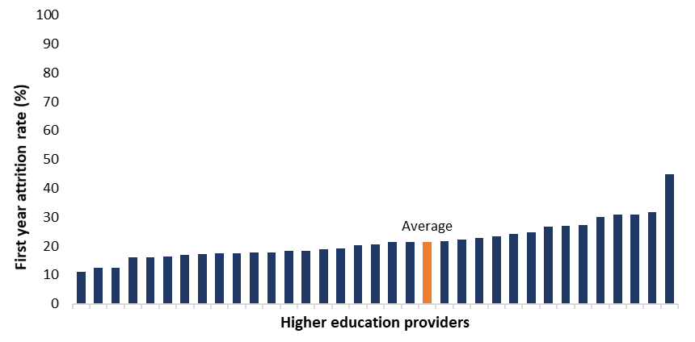Source: Selected Higher Education Student Statistics, [www.dese.gov.au](http://www.dese.gov.au/)

Notes: Every bar represents a HEP. Bars are sorted by the attrition rates of undergraduates who commenced an ITE course (in 2018) and were not enrolled in an ITE course in the following year (2019) for [Table A and B providers](https://heimshelp.dese.gov.au/resources/providertype).

Similar variation can be seen in the proportion of candidates meeting each component of the Literacy and Numeracy Test for Initial Education (LANTITE), from a low of 76 per cent to a high of 99 per cent in literacy and a low of 79 per cent to a high of 98 per cent in numeracy, respectively.

**First-time test candidates meeting the literacy and numeracy standards of the Literacy and Numeracy Test for Initial Teacher Education by higher education provider, 2020**

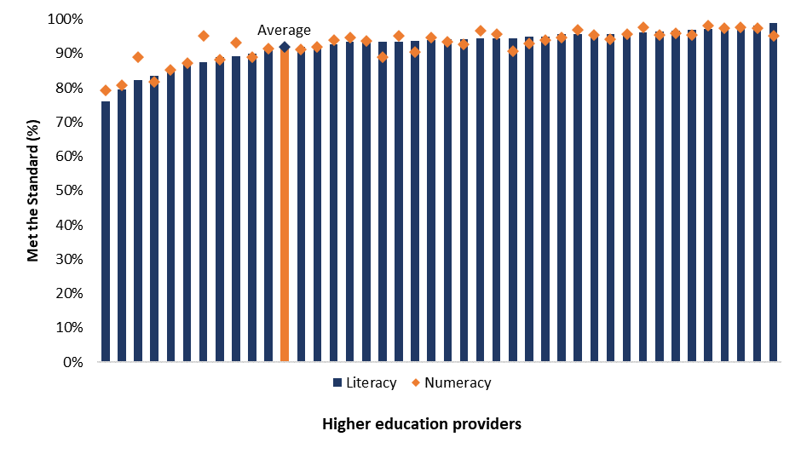Source: Australian Council for Education Research internal data.

Notes: The proportion of candidates meeting the literacy standard and numeracy standard refers to students who registered for the test for the first time in 2020 and who passed either on their first attempt or went on to pass in subsequent attempts in 2020. The test standard is literacy and numeracy achievement equivalent to the top 30 per cent of the Australian adult population. Every bar represents a HEP. HEPs with less than 20 students attempting LANTITE in 2020 have been excluded but are included in the national average. Bars are ranked by proportion of candidates meeting the literacy component of the test.



* Are low completion rates an issue? What is the impact? Can low completion rates be addressed?
* Is the degree of variability in completion rates between providers ideal? What could be done to address this?
* Should more be done to identify suitability for a career in teaching earlier in the degree or before entry to ITE? What might this look like?
* What are the main reasons ITE students leave an ITE course before completion?

# 3. Does the supply of teachers entering the workforce match areas of need?

### Supply and demand in the teacher workforce

Workforce planning in relation to teachers and school leaders requires collaboration between levels of government. The establishment of the Australian Teacher Workforce Data (ATWD) collection has been pivotal in the development of a national teacher workforce data set. It connects ITE data and teacher workforce data from around Australia for the first time.

However, there is no national model of teacher supply and demand. This means there is no direct relationship between the number of ITE places offered, and in what specialities, with the expected requirements of schools either in a jurisdiction or nationally. ITE providers may respond to student demand for places rather than the labour market demand for graduates in areas of shortages.

Reports of teacher shortages in regional, rural and remote schools, disadvantaged schools and certain subject areas such as STEM, languages and VET in schools are longstanding. Results from the 2019 Survey of Employer Recruitment Experiences (SERA), run by DESE does not show widespread shortages of teachers across Australia. However, many employers noted difficulty in attracting applicants to regional areas, and in recruiting specialist primary and secondary school teachers.

#### Incentives to attract and retain teachers

#### ‘Incentives – financial, accelerated promotion, rental and housing subsidies, guaranteed rights of return and extra professional development – are among those used to attract and retain teachers for rural schools. Incentives help to fill vacancies. They do not, however, ensure that ‘top teachers’ are appointed to schools where they are most needed’.

#### (Halsey 2017)

Data from the 2020 Graduate Outcomes Survey shows that 81 per cent of teacher education graduates are in full-time employment four months after completion of their course. This varies between a low of 58 per cent and a high of 99 per cent across higher education providers. Most teacher education graduates who are in full‑time employment are working full-time as a school teacher (83 per cent).

**Full-time employment rates of teacher education undergraduates by higher education provider, 2020**

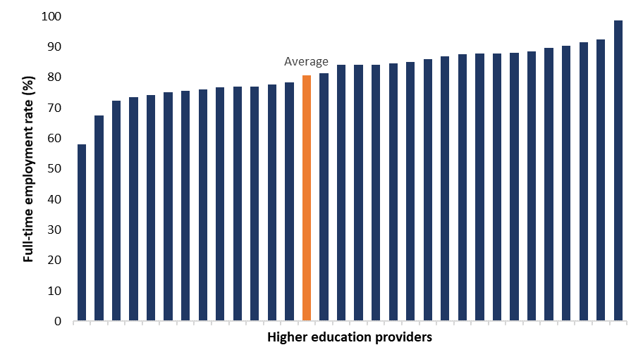Source: Graduate Outcomes Survey, [www.qilt.edu.au](http://www.qilt.edu.au), 2020. Notes: Full-time employment rates of students are measured approximately four months after completing their course and refers to full-time employment in any occupation.

###### Out-of-field teaching

Studies examining the Australian science and maths teaching workforce indicate the prevalence of teachers teaching maths or science out-of-field, referring to teachers teaching a subject that was not included in their ITE course or other professional qualification.

Data from the Teaching in Maths and Science Survey (TIMSS) shows nearly one in four (23 per cent) Year 8 students are being taught by maths teachers who had not majored in either maths or maths education, while nine per cent are taught by science teachers who had not majored in either science or science education (Thomson et al. 2021).

Data from the 2015 PISA show similar findings (Shah et al. 2020), where 21 per cent of maths teachers and six per cent of science teachers were teaching out-of-field at Year 10 level. Results also show that 17 per cent of STEM teachers are not teaching STEM subjects at a Year 10 level and are instead teaching non-STEM subjects. Teachers are more likely to be teaching out-of-field if they teach multiple subjects, are only qualified to teach one subject, work in government, small or regional/remote schools or are on temporary contracts. Graduate teachers are less likely to be teaching out-of-field.

#### Initiatives to stimulate supply in areas of shortage

#### At the Commonwealth level, recent initiatives to stimulate supply have focused on supporting employment-based pathways into teaching.

#### The High Achieving Teachers program currently supports two employment-based pathways into teaching for high achieving individuals – Teach For Australia and La Trobe’s Nexus program – committed to pursuing a career in the teaching profession. Participants are placed in teaching positions in secondary schools experiencing teacher workforce shortages and complete an accredited ITE program.

#### For more information, see the [Department of Education, Skills and Employment](http://www.dese.gov.au/teaching-and-school-leadership/alternative-pathways) website.

#### States and territories also have a range of incentives in place to attract teachers to specific subject or areas of need.

#### The NSW teach.MathsNOW Scholarship provides course contribution fee payments, paid part-time employment whilst studying and a guaranteed teaching position in a NSW public school following successful completion of studies.

#### See the [Teach NSW](http://www.teach.nsw.edu.au/getpaidtostudy/teach.mathsnow-scholarship) website for more information.

#### Western Australia’s [Country Teaching Program](https://www.education.wa.edu.au/teach-in-the-country) provides teachers with financial incentives of between $5000 and $13,730 a year depending on location and permanency at their school after two years’ continuous and satisfactory service.

The prevalence of out-of-field teaching indicates that the supply of teachers from ITE providers does not match demand. The Independent Review into Regional, Rural and Remote Education highlighted the complexities of staffing rural or remote schools, noting that the appointment of a teacher in non-metropolitan or larger regional centres often requires the teacher to relocate from their current residence.

Decorative heading that says 'Questions for Discussion'. 


* Have you experienced teacher shortages? Has it been in a particular subject area or region?
* Should something be done to match the supply of teachers from ITE providers with the demands of jurisdictions and sectors? What would this look like?
* Are there examples of incentives that have successfully worked to attract quality teachers in areas of shortage? How could these be rolled out more broadly?
* Why are STEM teachers not teaching STEM subjects? Is this an issue for other subject areas?

# Part B. Preparing ITE students to be effective teachers

# 4. Are graduate teachers ready for the classroom?

Top-performing education systems ensure that teachers are rigorously trained and equipped with the skills, confidence and knowledge to be highly effective from day one in the classroom.

The accreditation process for ITE programs in Australia is designed to produce graduates who meet the Graduate Teacher Standards.

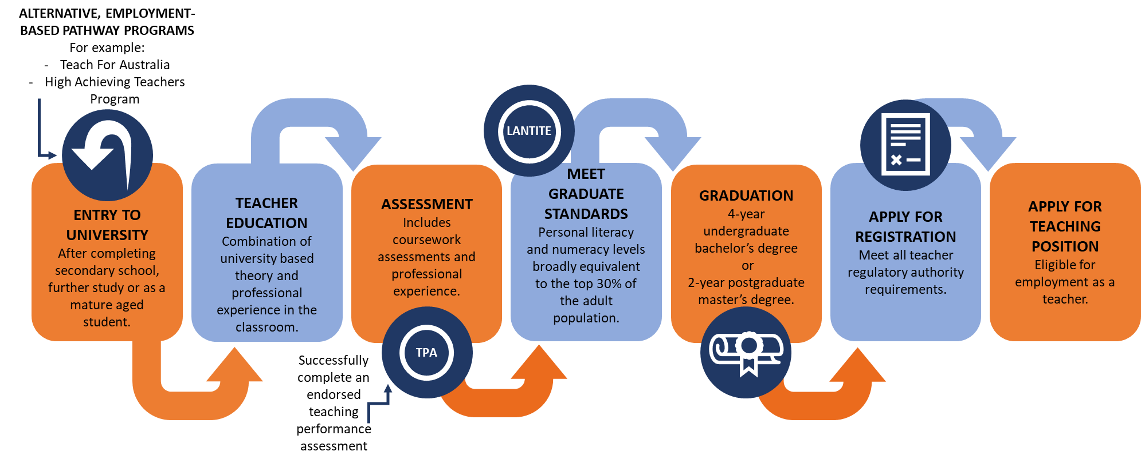

Diagram developed by the Quality Initial Teacher Education Review

### Teaching Performance Assessments (TPAs)

Provides information on TPAs. 

39 out of 47 ITE providers have an approved TPA. 18 providers are members of the Graduate Teacher Performance Assessment (GTPA) collective. 6 providers are implementing their own TPAs and 8 providers are yet to have an approved TPA. 12 providers are members of the Assessment for Graduate Teaching (AfGT) consortium. Of those without an approved TPA, 4 are developing individual TPAs and 4 are working together to develop a TPA. 4 providers are members of the Quality Teaching Performance Assessment consortium.  The introduction of TPAs represents a major shift in how pre-service teachers are prepared for the classroom. The introduction of TPAs followed TEMAG’s recommendation for the introduction of a robust assessment of graduates to ensure classroom readiness.

Source: Information provided by AITSL.

Notes: Information correct as of 31 May 2021. One provider is a member of both the GTPA collective and AfGT consortium and has been included in both member totals.

TPAs are used to assess the practical skills and knowledge of pre-service teachers against the Graduate Teacher Standards. ITE students collect evidence of practice to complete a TPA in their final year. Successfully completing a TPA is a requirement for graduation.

The Australian Institute for Teaching and School Leadership (AITSL) established an independent six member TPA expert advisory group (EAG) to consider and provide advice to the applicable TRA, on whether the TPA meets the requirements of the Accreditation Standards.

Preliminary feedback to the Expert Panel is that TPAs have made a significant positive contribution to the classroom readiness of teachers since introduction.

However, some six years later, eight ITE providers still do not yet have an endorsed TPA in place. A number of these providers have resubmitted their TPAs to the EAG on multiple occasions. In some cases, a TPA has been considered up to four times by the EAG. Students in these ITE courses may not be receiving the same quality of classroom preparation as others.

### Professional Experience

The Accreditation Standards require professional experience placements to be embedded in every ITE program. Opportunities for pre-service teachers to observe and participate purposefully in a school should be provided as early as practicable in a program.

The TEMAG review found that schools, school systems and ITE providers face challenges in ensuring that a sufficient number of professional experience placements of appropriate timing and length are available for all pre-service teachers.

Research conducted by the Australian Council of Deans of Education (ACDE) found that the quality of support for pre-service teachers during placements varies considerably (ACDE 2017).

#### Professional Experience

#### The range of professional experience days differs between teaching level and degree type.

#### For undergraduate programs, the minimum number of days for primary and secondary education is 80 days, while for early childhood it is 95.

#### This differs again with Master of Teaching, with a minimum requirement of 60 days with some programs offering up to 80 days of professional experience.

#### ACDE research found that professional experience days range from the minimum requirement up to 160 days in some programs.

### Evidence-based practice

Program Standard 4.2 of the Accreditation Standards set out the discipline-specific curriculum and pedagogical studies required in ITE programs. For primary programs, this includes at least one-eighth of a year equivalent full-time student load (EFTSL) for early reading instruction. The Program Standard requires early reading instruction to address evidence-based practice across the following elements: phonemic awareness, phonics, fluency, vocabulary, comprehension and oral language.

The Graduate Teacher Standards set out requirements for understanding and implementing effective teaching strategies. Research and workplace knowledge suggest these teaching strategies contribute to successful learning outcomes for students. The relevant focus areas at the graduate level include:

This diagram highlights some of the key focus areas in the Graduate Standard that relate to effective teaching strategies. Focus area 2.1 - Content and teaching strategies of the teaching area. Focus area 2.5 - Literacy and numeracy strategies. Focus area 2.6 - ICT. Focus area 3.2 - Plan, structure and sequence learning programs. Focus area 3.3 - use of teaching strategies.


Under the Accreditation Standards, ITE program development and design is required to take account of contemporary and emerging developments in education. However, what this means is not expanded upon. Nor do the Accreditation Standards reference long-standing evidence about learning from cognitive science and elsewhere.

The United Kingdom has taken a more direct approach to the content of ITE courses. The ITT Core Content Framework sets out both what ITE students should: “Learn that..” and “Learn how to..”. Course requirements are more explicit than those in the Australian Accreditation Standards for example, explicit instruction and systematic synthetic phonics are both referenced in the[**ITT Core Content Framework**](https://www.gov.uk/government/publications/initial-teacher-training-itt-core-content-framework).

### ITE course satisfaction

ITE students rate the quality of their educational experience positively, which is consistent with overall undergraduate student ratings. In 2020, higher education providers were forced to rapidly shift their teaching and learning arrangements online and the impact of the COVID-19 pandemic led to a decline in student ratings. Seventy-four per cent of teacher education students rated the quality of their entire educational experience positively in 2020, which ranged across higher education providers from a high of 86 per cent to a low of 46 per cent.

This table shows quality of the educational experience as rated by undergraduate students from 2014 to 2020. It shows that ITE students rate their experience positively.
Source: Student Experience Survey, [www.qilt.edu.au](http://www.qilt.edu.au) , 2014-2020  
Notes: Total refers to all undergraduate students.

**Quality of the entire educational experience, teacher education undergraduate students by higher education provider, % positive rating, 2020**

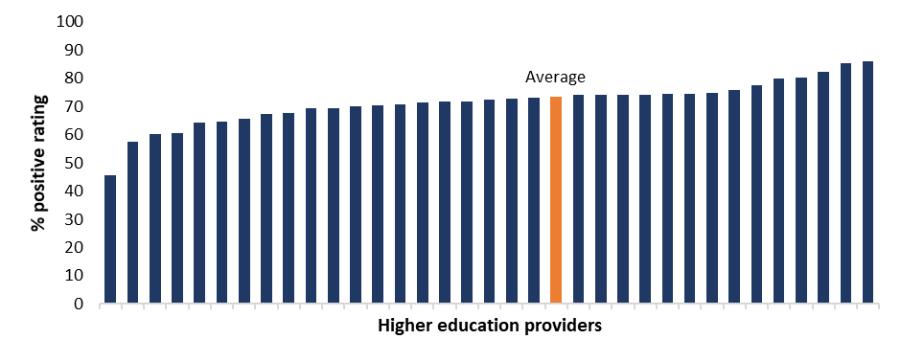Source: Student Experience Survey, [www.qilt.edu.au](http://www.qilt.edu.au), 2020.

Notes: Every bar represents a HEP. Bars are sorted from lowest to highest quality of educational experience in 2020.

Direct supervisors of recent higher education graduates report higher rates of satisfaction with education graduates than graduates overall.

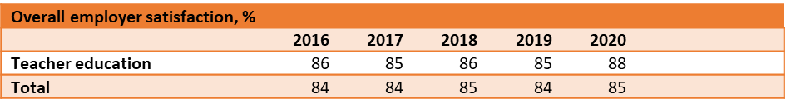  
Source: Employer Satisfaction Survey, [www.qilt.edu.au](http://www.qilt.edu.au) , 2016-2020Notes: Total refers to all undergraduate students.

In 2020, employers rated education graduates’ adaptive skills at 92 per cent, which was slightly higher than the rating of 90 per cent for all graduates. Conversely, slightly fewer employers were satisfied with education graduates’ foundation skills, collaborative skills and employability skills, compared to all graduates.

**Employer satisfaction by graduate attributes (%), 2020**

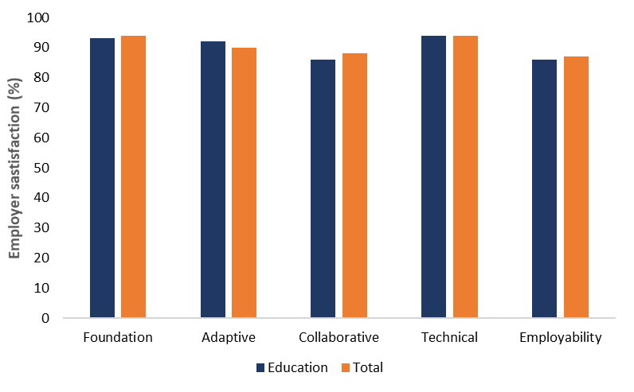Source: Employer Satisfaction Survey, [www.qilt.edu.au](http://www.qilt.edu.au) , 2016-2020

Notes: Total refers to all undergraduate students.

This diagram highlights findings on ITE graduate preparedness and effectiveness from the 2015 Studying the effectiveness of teacher education study. Graduate teachers reported being better prepared in pedagogy, professional ethics and engagement with ongoing professional learning. Graduate teachers reported being less prepared in classroom management, professional engagement with parents/carers and the community, assessment and the provision of feedback and reporting on student learning, and teaching culturally linguistically and socio-economically diverse learners. Graduate teachers reported being more effective as beginning teachers in professional ethics and engagement with ongoing professional learning, and less effective in teaching culturally, linguistically and socio-economically diverse learners, design and implementation of the curriculum, pedagogy and assessment and the provision of feedback and reporting on student learning.
The *Studying the effectiveness of teacher education* research (Mayer et al 2015) found that teacher education broadly gives graduate teachers the ‘tools’ to work with. Graduates, however, felt their preparation could have been enhanced by more time spent in schools, more time on strategies for teaching and less theory. Principals supported graduates in this assessment.

Source*:* Mayer et al.,(2015).



* Are the **[Australian Professional Standards for Teachers](https://www.aitsl.edu.au/teach/standards)** (Teacher Standards) fit for purpose in identifying the key skills and knowledge pre-service teachers need to be ready for the classroom? Do the Teacher Standards adequately reflect the role of teachers in supporting pre-service and graduate teachers? See: [**https://www.aitsl.edu.au/teach/standards**](https://www.aitsl.edu.au/teach/standards) for more information.
* Are ITE programs preparing graduates for teaching diverse student cohorts, including through cultural competency and inclusive education?
* What are the benefits and costs of the number of TPAs in operation?
* How could the TPA endorsement process be improved? Are the current arrangements leading to quality outcomes?
* Do the current professional experience arrangements support the preparation of ITE students for the classroom and school environment? How could these be improved?
* How can professional experience be delivered in a more efficient way for school systems and higher education providers?
* Do the current course accreditation arrangements support ITE students being taught evidence-based high-impact teaching strategies? How could this be improved?

# 5. The role of teachers and school leaders in supporting the next generation of teachers

### Role of school leaders and teachers in ITE programs

The Accreditation Standards require the development, design and delivery of programs to include the perspectives of stakeholders such as employers and practising teachers. The most tangible role for school leaders and teachers is participating in the professional experience undertaken by ITE students.

The Australian Government promotes quality teaching through supporting AITSL in implementing teacher certification at the highly accomplished and lead levels of the Teacher Standards.

#### Highly Accomplished and Lead Teachers (HALT)

#### As of 2020 there was a total of 840 certified HALT.

#### HALT make up less than one per cent of the teaching workforce (ABS 2020)

#### Some employers have specific salary levels for HALT, whereas others have additional allowances for teachers certified as HALT.

#### For example, in the Northern Territory as of October 2020: Highly Accomplished teachers received an annual allowance of $11,725 and Lead teachers received an annual allowance of $24,551.

HALT certification began in 2012. It is a voluntary, rigorous evaluation process that recognises skilled teachers and promotes collaboration between professionals. HALT certification is offered in ACT, NSW, NT, SA, Qld and to some extent in WA. In 2021, pilots have commenced in Tasmania in all sectors and in Melbourne Archdiocese Catholic Schools in Victoria. HALT are certified through a national process applied by the certifying authorities in each participating state/territory.

Under the current national arrangements, HALT have no specific role under the Accreditation Standards in supporting ITE students, including involvement in practical experience.

In considering any specific role that HALT might have in supporting the next generation of quality teachers, regard must be had to existing teacher workloads.

#### Teacher Workload – implications for ITE

#### In considering the role of teachers and school leaders in preparing new teachers, we need to be mindful of existing workloads.

#### A nationwide study into public and teachers’ perceptions of the teaching profession found that a majority of the teachers surveyed did not find their current workload manageable (Heffernan 2019).

#### 49.7 per cent of principals worked more than 56 hours a week in 2019. Over 97 per cent of principals worked over 40 hours a week during a school term (Riley 2019).

### The role of induction, mentoring and professional development

According to the 2018 TALIS survey, only 37 per cent of Graduate teachers (those with up to five years’ experience) report that they have a mentor. This is higher than the overall OECD average of 22 per cent.

## The best induction programs include practice-focused mentoring, leadership contact, participation in collaborative networks, targeted professional learning, observation and reflection on teaching, practical information and time allocation.

AITSL, *Graduate to Proficient: Australian guidelines*

*for teacher induction into the profession*

#### National Standards for Mentors

#### A key recommendation of the UK Government’s review of Initial Teacher Training (ITT), the *Carter Review of Initial Teacher Training* (2015), was to establish national standards for mentors.

#### The report noted that while mentoring is shown to be of critical importance for initial teaching training, mentoring across England was not as good as it should be, and the quality and training of mentors varied between institutions.

#### In 2016, the UK Government commissioned the Teaching Schools Council to develop standards for school-based ITT mentors.

#### The report recommended that all ITT providers adopt the mentor standards to help inform the selection, training and resourcing of mentors.

In the United Kingdom, the early career framework (ECF) is the evidence base that sets out what all early career teachers should learn to do in their first two years of teaching. From September 2021, the ECF reforms will fund targeted, high-quality professional development for new teachers across the first two years of their career as part of a structured induction program. This includes:

* Two years of training and high-quality development materials
* Funding for five per cent time away from the classroom for second-year teachers
* Dedicated funding to cover mentor’s time with mentee during their second year

The Singapore education model includes well-defined pathways available for a teacher to progress in their career. Singapore’s highly structured approach promotes a message that career progression is related to developing expertise – as a teacher, leader or specialist.

The Instructional Mentoring Programme (IMP) is an eight-day training program for Senior Teachers, Lead Teachers and School Staff Developers in Singapore to equip them with the tools required to be effective mentors. Focusing on mentoring conversations, the IMP helps mentors to understand the needs of their mentees and encourages collaboration, goal setting, effective feedback and building trust.

#### Teach For Australia (TFA)

#### Teach For Australia (TFA) provides employment-based pathways into teaching, allowing participants to earn a salary as they complete a Master of Teaching through the Australian Catholic University.

#### Successful applicants are employed as Associates and placed within one of the program’s partner schools.

#### Each new teacher hired as part of TFA’s Leadership Development Program is provided with a School Mentor who provides in-school support. School Mentors are experienced teachers who have gone through TFA’s Mentor Development Program. The Mentor Development Program is designed to build best-practice skills and knowledge in experienced teachers so that they can then support the development of new teachers in the early stages of their careers.

#### For more information, see the [Teach For Australia](https://teachforaustralia.org/about-us/) website.

As the *Australian Charter for the Professional Learning of Teachers and School Leaders* (the Charter) highlights, effective professional learning is a shared responsibility between all of levels of the education system, including teachers, school leaders, system leaders and policy makers.

In Australia, all jurisdictions specify the same minimum standard for hours spent on professional learning as a condition of continuing registration. However, different professional development or learning requirements apply depending on the type of registration a teacher holds. TRAs may also specify the kind of professional development required, for example, those targeting priority areas such as student mental health or Aboriginal and Torres Strait Islander education.

Some universities already offer accredited professional learning courses, while others provide short courses or upskilling in priority areas such as STEM, student wellbeing and Aboriginal and Torres Strait Islander education.

#### La Trobe University – The Science of Language and Reading Short Course

#### The online course covers the linguistic basis of early reading as this applies to word decoding and language comprehension.

#### The course includes initial reading instruction and support for struggling readers and frameworks for early identification and intervention.

#### More information about the Science of Language and Reading Short Course can be found on the [website](https://www.latrobe.edu.au/courses/short-courses/the-science-of-language-and-reading-an-introduction).

#### Professional and Continuing Education (PACE)

#### Monash University offers a number of professional development programs for educators and school leaders covering topics such as teaching and leadership, language and literacy, STEM and Numeracy.

#### The programs are offered online and range from short one seminar workshops through to week-long intensives, see more on the [Monash](https://www.monash.edu/education/professional-continuing-education) website.

* How can ITE providers best support teachers in their ongoing professional learning?
* Do the current HALT arrangements support the education ecosystem, particularly in relation to ensuring quality mentoring and supervision of ITE students?
* How could HALT support the development of ITE students and newly graduated teachers? What would this look like? What changes to current arrangements would be required to give effect to this?
* Should ITE providers continue to support the development of newly graduated teachers? What would this look like?
* How could teacher and school leader workloads be made more manageable to allow them to provide more support to pre-service and newly graduated teachers?

### Terms of Reference

**PART A - Attracting and selecting high-quality candidates into the teaching profession**

1. How can we further encourage high-performing and highly motivated school leavers to enter ITE and choose teaching as a career?
2. What changes to admissions and degree requirements, including recognition of prior experience, would better attract and support suitable mid- and late-career professionals from other fields transition into the profession and become quality teachers?
3. How can we increase ITE completion rates so that quality ITE students graduate and pursue careers as quality teachers?
4. What more can be done to address issues with workforce supply in some subject areas (particularly maths) and schools?
5. How can we attract a more diverse cohort into ITE so that teachers better mirror the diversity in school students and society?

**PART B – Preparing ITE students to be effective teachers**

1. What more can we do to ensure that ITE curriculum is evidence-based and all future teachers are equipped to implement evidence-based teaching practices?
2. What more can ITE providers and employers do to ensure ITE students are getting the practical experience they need before they start their teaching careers?
3. How can Teaching Performance Assessment arrangements be strengthened to ensure graduate teachers are well-prepared for the classroom?
4. How can leading teachers, principals and schools play a greater role in supporting the development of ITE students?
5. Can ITE providers play a stronger role in ongoing professional development and support of teachers?

## References

ACDE (Australian Council of Deans of Education) (2017) [*Professional experience in initial teacher education: A review of current practices in Australian ITE*](https://researchers.mq.edu.au/en/publications/professional-experience-in-initial-teacher-education-a-review-of-), Canberra.

Australian Government (2018) [*Through growth to achievement: The report of the review to achieve educational excellence in Australian schools*](https://www.dese.gov.au/quality-schools-package/resources/through-growth-achievement-report-review-achieve-educational-excellence-australian-schools)*,* Canberra.

AITSL (Australian Institute for Teaching and School Leadership) (2019) [*Initial teacher education: Data report 2019*](https://www.aitsl.edu.au/docs/default-source/research-evidence/ite-data-report/2019/aitsl-ite-data-report-2019.pdf), Melbourne.

Figlio, D (2017) [*The importance of a diverse teaching force*](https://www.brookings.edu/research/the-importance-of-a-diverse-teaching-force/)*,* The Brookings Institution, Washington, DC.

Grattan Institute (2019) [*Attracting high achievers to teaching*](https://grattan.edu.au/report/attracting-high-achievers-to-teaching/), Melbourne.

Halsey, J (2017) [*Independent Review into Regional Rural and Remote Education – Discussion Paper*](https://www.dese.gov.au/teaching-and-school-leadership/resources/discussion-paper-independent-review-regional-rural-and-remote-education), Canberra.

Hattie, J (2003) [*Teachers make a difference: What is the research evidence?*](https://research.acer.edu.au/cgi/viewcontent.cgi?article=1003&context=research_conference_2003) Paper presented at the Building Teacher Quality: What does the research tell us ACER Research Conference, Melbourne.

Heffernan, A (2019) [*Perceptions of Teachers and Teaching in Australia*](https://www.monash.edu/thank-your-teacher/docs/Perceptions-of-Teachers-and-Teaching-in-Australia-report-Nov-2019.pdf)*,* Monash University, Melbourne.

Klassen, R., and Kim, L. E (2018) ‘[*Selecting teachers and prospective teachers: A meta-analysis*](https://www.sciencedirect.com/science/article/pii/S1747938X18302173)’, *Educational Research Review*, 26: 32-51, University of York.

Mayer, D., Allard, A., Bates, R., Dixon, M., Doecke, B., Kline, J., Kostogriz, A., Moss, J., Rowan, L., Walker-Gibbs, B., White, S., & Hodder, P. (2015) [*Studying the effectiveness of teacher education: final report*](https://dro.deakin.edu.au/eserv/DU:30080802/walkergibbs-studyingthe-2015.pdf), Deakin University, Geelong.

OECD (2019), TALIS 2018 Results (Volume I): [*Teachers and School Leaders as Lifelong Learners*](https://www.oecd.org/education/talis-2018-results-volume-i-1d0bc92a-en.htm), TALIS, OECD Publishing, Paris.

Riley, P., See, S-M., Marsh, H., & Dicke, T. (2020) [*The Australian Principal Occupational Health, Safety and Wellbeing Survey: 2020 Data*](https://www.healthandwellbeing.org/reports/AU/2020_AU_Final_Report.pdf), Institute for Positive Psychology and Education, Australian Catholic University, Sydney.

Shah, C., Richardson, P., & Watt, H. (2020) [*Teaching ‘out of field’ in STEM subjects in Australia: Evidence from PISA 2015*](https://apo.org.au/node/303739), GLO Discussion Paper, No. 511, Global Labor Organization (GLO), Essen.

TEMAG (Teacher Education Ministerial Advisory Group) (2014) [*Action Now, Classroom Ready Teachers*](https://www.dese.gov.au/teaching-and-school-leadership/resources/action-now-classroom-ready-teachers-report-0), Canberra.

Thomson, S., Wernert, N., Buckley, S., Rodrigues, S., O'Grady, E., Schmid, M. (2021) [*TIMSS 2019 Australia. Volume II: School and classroom contexts for learning*](https://research.acer.edu.au/cgi/viewcontent.cgi?article=1003&context=timss_2019), Australian Council for Educational Research.