

2020 Guidelines
Important Note:
The 2020 Guidelines have been updated to incorporate special provisions in response to disruptions caused by the COVID-19 pandemic.
1. Evidence of adjustments is reduced from a minimum of 10 weeks to a minimum of six weeks in the 12 months preceding the reference date (refer C.2.1 of the Guidelines) for all students who are eligible for NCCD. However, schools are encouraged to collect 10 weeks of evidence where there is capacity to do so to ensure continuity of best practice.
2. Evidence requirements are revised for specific cohorts of students with disability only (refer C.4.1 of the Guidelines).
The special provisions apply to the 2020 NCCD collection only.

Note: The Guidelines are published annually and may be further updated during the year. If you are reading a printed version of these Guidelines, please check the online version of the Guidelines to ensure you are reading the latest version.

Change table
Key changes from 19 December 2019 edition | Section
Changes to approval authority and document dates | ‘Document particulars’ and ‘About the Guidelines’ sections (updated)
Reference to the Department of Education changed to Department of Education, Skills and Employment | Updated throughout
Evidence that an adjustment(s) has been provided for a minimum of six weeks | C.2.1 and related references (updated)
Revised evidence requirements for specific cohorts of students with disability | C.4.1 and related references (new)
Definition of ‘Specific student cohorts’ | Glossary (updated)

Contents
Change table 2
Document particulars 5
About the Guidelines 6
Purpose of the Guidelines 6
Status of the Guidelines 6
How to use the Guidelines 7
PART I – Introduction and overview 8
A. Introduction 8
A.1. Legislative framework 9
A.2. NCCD data and Australian Government school funding 9
A.3. NCCD data and national reporting 10
A.4. Further information 10
B. Overview of the NCCD 11
B.1. The Model 11
Figure 1 – The NCCD Model Diagram 12
B.2. How does the data get to the department? 13
Figure 2 – Transmission pathway for data collected under the NCCD 13
B.3. Privacy arrangements 14
B.3.1 Is consent required for a student’s information to be included in the NCCD? 14
B.3.2 Information to students, parents, guardians and carers 15
C. NCCD processes and support resources 16
C.1. Overview 16
C.2. Counting students in the collection 16
C.2.1 Evidence that an adjustment(s) has been provided for a minimum of six weeks 16
C.2.2 Full-time and part-time students 17
C.2.3 Students enrolled at more than one school or location 17
C.2.4 Newly enrolled students with disability 18
C.2.5 Schools that do not currently have students with disability enrolled 18
C.2.6 Overseas students with disability 18
C.2.7 Distance education students with disability 19
C.3. Determining the level of adjustment and category of disability 19
C.3.1 Level of adjustment 19
C.3.2 Category of disability 20
C.3.2.1 Students with multiple disabilities 20
C.3.3 School processes and policies 21
C.4. Supporting evidence 21
C.4.1 Special provisions for specific student cohorts 22
C.4.2 Consultation with the students, their associate and parents/guardians/carers 22
C.5. Professional learning on the NCCD Portal 23
C.6. Professional learning on the DDA and the Standards 23
C.7. Special school settings 24
C.7.1 Special schools that report by age group 25
C.8. How to prepare your school for the NCCD and related timelines 25
C.9. Quality assurance 26
C.9.1 Schools 26
C.9.2 Education authorities 26
C.9.3 The department 27
C.10. Advice for new non-government schools 27
C.11. Links to further information 27
PART II – Mandatory requirements 29
D. NCCD requirements 29
D.1. How schools may provide information to approved authorities 29
D.1.1 For government schools 29
D.1.2 For non-government schools of an approved system authority 29
D.1.3 For all other non-government schools 29
D.2. The way in which NCCD data must be provided to the department 30
D.2.1 Non-government schools data provision 30
D.2.2 Government schools data provision 30
D.3. Key dates for 2020 30
D.3.1 Reference date 30
D.3.2 Collection portal for data entry for non-government schools 30
D.4. Which students must be included in the NCCD? 31
D.5. What information must be provided on each student? 31
D.6. Census post-enumeration processes now apply to NCCD 33
D.6.1 Post-enumeration processes for non-government schools 33
D.6.2 Retaining NCCD student records 33
PART III – APPENDICES 35
APPENDIX 1. Contact lists for government, Catholic and Independent (school) sectors 35
APPENDIX 2. Levels of adjustment – descriptors, typical adjustments and student characteristics 36
APPENDIX 3. Broad categories of disability 38
APPENDIX 4. Glossary 39

Document particulars
Owner: Education Council
Content Last Updated: November 2019
Document status: Draft
Version: Version 5.0
Next Review Date: August–December 2020
Comments and enquiries:
Feedback or questions about these Guidelines can be sent to the Department of Education, Skills and Employment dedicated inbox: NCCDSupport@education.gov.au
Further information and links are on the Nationally Consistent Collection of Data on School Students with Disability (NCCD) Portal.
Approver: Schools Policy Group of the Education Council
Date of Approval: TBA
Note: These Guidelines comprise a flexible, dynamic and responsive working document that may be updated during the year. If you are reading a printed version of these Guidelines, please refer to the NCCD Portal where the online version may be accessed, to make sure you are reading the latest version.
ISBN: 978-1-74200-496-9
Copyright

With the exception of the Commonwealth Coat of Arms, and where otherwise noted, all material presented in this document is provided under a Creative Commons Attribution 4.0 licence.
The details of the relevant licence conditions are available on the Creative Commons website (accessible using the links provided) as is the full legal code for the CC BY 4.0.
The document must be attributed as being developed by the Commonwealth of Australia and by the following title: 2020 Guidelines for the Nationally Consistent Collection of Data on School Students with Disability.

About the Guidelines
These are the Nationally Consistent Collection of Data on School Students with Disability (NCCD) Guidelines for 2020 (the Guidelines).
The update to the Guidelines is approved by the Schools Policy Group on behalf of the Education Council, and the Australian Government Minister for Education (the Minister). This approval is required for the purposes set out in sections 4(1), 17A, 52(3A, 3B) and 58A of the Australian Education Regulation 2013 (the Regulation).
Note: In the Regulation, the Guidelines are referred to in sections 4(1) and 58A and subsection 52(3A) as the ‘Ministerial Council disability guidelines’.
The Guidelines specify:
- which students approved authorities for schools must report on in 2020 for the NCCD, for the purposes of section 58A of the Regulation
- the information that approved authorities for schools must provide to the national collection agency (the Australian Government Department of Education, Skills and Employment (the department) in 2020 in relation to those students, for the purposes of section 58A of the Regulation
the day by which that information must be provided to the department, for the purposes of subsection 52(3A) of the Regulation.
Note: References in these Guidelines to the NCCD should be read to mean the NCCD data submitted by schools in 2020.

Purpose of the Guidelines
The purpose of the Guidelines is to assist approved authorities and school teams to understand and complete the NCCD.

Status of the Guidelines
The Guidelines were developed through a collaborative, national process and are approved by the Ministerial Council for the year. They are the authoritative guide to the NCCD and form the basis of technical information and advice on the NCCD.
These Guidelines refer to or specify functions, responsibilities or roles placed on schools, or school officials (for example, school principals). For the avoidance of doubt, it is the responsibility of the approved authority of a school to ensure that all functions, roles and responsibilities imposed on, or in respect of, a party are performed appropriately in order for the authority to be able to meet its obligations under the Australian Education Act 2013 (the Act) and the Regulation.

How to use the Guidelines
The Guidelines comprise three parts:
Part I – Introduction and Overview
General information about the NCCD and an overview of the data collection model.
Part II – Mandatory requirements
Information about the mandatory requirements of the NCCD, including data that must be provided, timing of the collection, and other technical aspects of the data collection.
Part III – Appendices
- Contact lists for government, Catholic and Independent (school) sectors
- Levels of adjustment – descriptors, typical adjustments and student characteristics
- Broad categories of disability aligned to the definitions of disability in the Disability Discrimination Act 1992
- Glossary.

PART I – Introduction and overview
- Introduction
All schools and approved authorities for schools in Australia participate in the NCCD annually. The NCCD collects data about school students with disability across Australia in a consistent, reliable and systematic way. A student with disability is a student about whom information must be provided under these Guidelines (see section D.4 Which students must be included in the NCCD for 2020).
In practice, such students will be receiving reasonable adjustments from the school so that they are able to participate in education on the same basis as other students, as required by the Disability Standards for Education.
The data for the NCCD is submitted to the department as at the reference date of the first Friday in August. In 2020, the reference date is Friday, 7 August.
The collection of data for the NCCD is based on the professional judgement of teachers. Teachers determine the level of adjustments provided to students with disability to access and participate in education on the same basis as other students. A detailed description is at Appendix 2. Levels of adjustment.
Such adjustments help ensure schools meet their obligations under the:
- Disability Discrimination Act 1992 (the DDA)
Disability Standards for Education 2005 (the Standards).
Data collected through the NCCD is used:
to support evidence-based policy development and future planning related to school students with disability.
- to inform Australian Government recurrent funding for schools, specifically through the Commonwealth share of the Schooling Resource Standard and the annual student with disability loading, calculated under Part 3 of the Act.
Note: Further information about the Australian Government’s school funding arrangements is on the Quality Schools page on the department’s website.
for national reporting related to schools (such as the Report on Government Services and the Annual National Report on Schooling in Australia).

  - Legislative framework
Since December 2014, approved authorities for schools have been required to collect information about students with disability, and provide that information to the department for the purposes of the NCCD. This requirement is set out in subsections 52(1) and 52(3B), section 58A and section 17A of the Regulation.
The NCCD is designed to complement and reinforce the legislative requirements that apply to all Australian schools and education institutions under the:
- Disability Discrimination Act 1992
- Disability Standards for Education 2005.
The Standards plus guidance notes can be accessed through the department’s website on the Disability Standards for Education page
  - NCCD data and Australian Government school funding
The NCCD is used to calculate the student with disability loading in recurrent funding for schools provided by the Australian Government. This loading is based on the level of adjustment being provided to the student.
As such, it is very important for all schools and approved authorities for schools to ensure that the student information provided to the department is:
- accurate
- supported by evidence
- provided at the location (campus) level required by the department
quality assured prior to submission.
Failure to do so may result in:
the department being unable to calculate the student with disability loading for a school for a year
action to recover overpayments of disability loading funding, or
consideration of compliance action under the Act against an approved authority.
Further information about the NCCD and Australian Government school funding is available on the Quality Schools page on the department’s website.

  - NCCD data and national reporting
NCCD data is published in the:
- Report on Government Services, produced by the Productivity Commission
- National Report on Schooling in Australia, produced by the Australian Curriculum, Assessment and Reporting Authority (ACARA).
Data in these reports is aggregated to a high level (as in state/territory, national).
  - Further information
For further information about the NCCD refer to the NCCD Portal (the Portal) at: www.nccd.edu.au.
Note: While other resources and sector-specific support materials are also made available by state and territory education authorities and sectors, all schools should refer to the Portal to ensure consistency. The Portal contains the most current information relating to the NCCD model, including current Levels of Adjustment descriptors (see Appendix 2. Levels of adjustment).
Schools should direct questions about the Guidelines or about the NCCD to the relevant key contacts for government, Catholic and independent sectors listed on the Portal.

- Overview of the NCCD
  - The Model
The Model for the NCCD (the Model) applies across all educational settings and contexts, including mainstream schools and classes as well as special schools and special classes.
The Model has been designed:
- as a nationally consistent process for collecting data to build an evidence base that will provide teachers, schools and education authorities with information on school students receiving an adjustment due to disability and the level of adjustment that is being provided to them (support provided within Quality Differentiated Teaching Practice, Supplementary, Substantial or Extensive adjustment)
- to reinforce effective practice under the DDA and the Standards
to inform policy development and future planning to better equip schools and education authorities/sectors to support students with disability who have additional learning needs.
There are two fundamental aspects to the Model:
- the legislative requirements and professional responsibility placed on schools to provide reasonable adjustment under the DDA and the Standards
- the focus placed on the level of adjustment provided to the student based on their functional needs, in addition to the student’s category of disability.
Note: Under the Model, teachers and school staff use their professional, informed judgement, based on evidence, to determine the level of adjustment students with disability receive, in both the classroom and whole of school context, as well as the broad category of disability that relates to the adjustments (cognitive, physical, sensory or social/emotional).
School teams consider their student population to determine which students are being provided with adjustments to access education because of disability, consistent with definitions and obligations under the DDA and the Standards. The definition of disability used in the DDA is outlined in Appendix 4. Glossary.
The Model assists schools to make a decision about whether a student should be included in the NCCD (see flow diagram in Figure 1). If there is documented evidence at the school that the student has received an adjustment(s) to address the functional impact of a disability for a minimum of six weeks of school education (in the 12 months preceding the relevant reference date for the 2020 NCCD), the student should be included in the NCCD. (see section C.2 Counting students in the collection).
The Model involves a number of key decision points that guide a school team’s decision as to whether or not a student is to be counted in the NCCD (see section C.2. Counting students in the collection). Further information about the Model is available on the Portal.

Figure 1 – The NCCD Model Diagram
Throughout the school year, school teams use evidence, including discussions with parents, guardians and carers, to inform decisions about the adjustments that they make for students with disability. Go to a PDF version of the infographic at the NCCD Portal. A transcript is available.
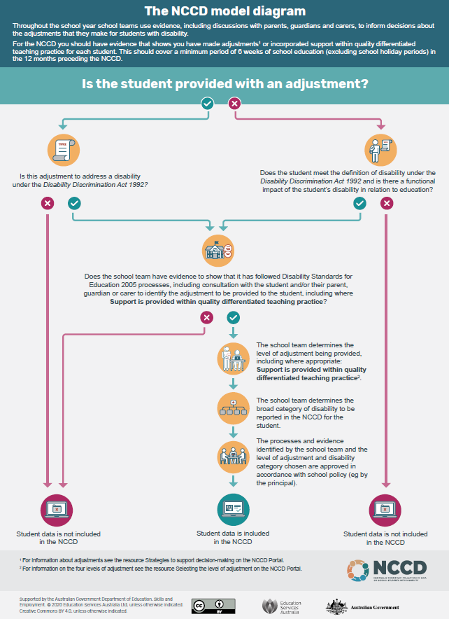
  - How does the data get to the department?
Each school location (campus) identifies the students to be counted in the NCCD and collects the required data for each student. Depending on the school’s operational situation, the data may pass through a central collection point (such as a state/territory education authority or another body such as a system office for non-government systemic schools), or may be passed directly to the department by the school.
Generally, government and non-government systemic schools will provide their data through their education authority or system office to the department, while independent schools will provide their data directly to the department. See Figure 2 below.
NCCD data submission for non-government schools will occur as part of the Non-Government Schools Census (see also section D.2. The way in which NCCD data must be provided to the department).

Figure 2 – Transmission pathway for data collected under the NCCD

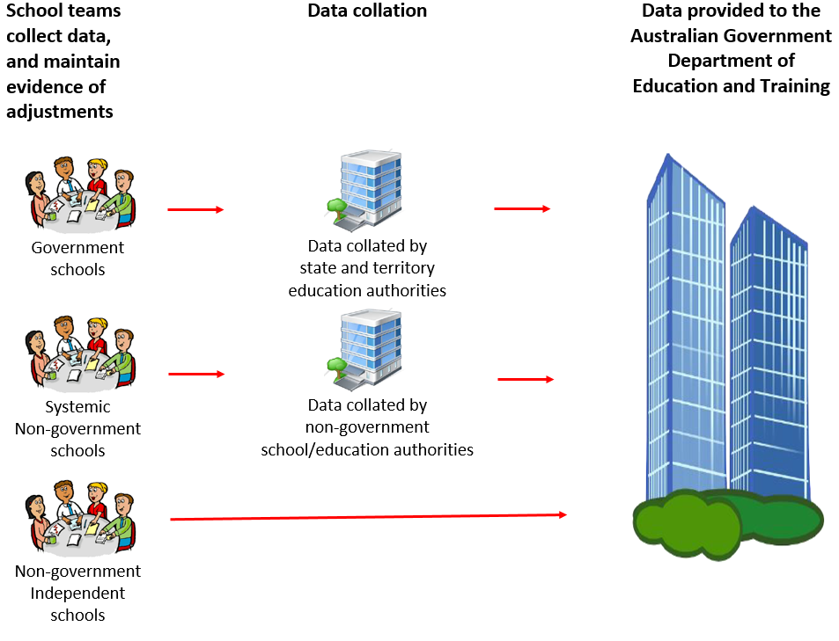
Data to be provided is outlined in Part 2 of the NCCD Guidelines for the collection year.

  - Privacy arrangements
The Australian Government, state and territory governments, and non-government school systems involved in the collection of student information for the NCCD, are committed to the protection of personal information, and comply with applicable privacy legislation and policies in their respective jurisdictions.
When student information is provided to the department for the purposes of the NCCD, that information must not explicitly identify any student, in accordance with subsection 58A(3) of the Regulation. For example, student names or student identifiers are not provided. Information provided to the department for the purposes of the NCCD should not identify or reasonably identify individual students.
In limited cases, a student may be reasonably identifiable from the information provided by an approved authority to comply with the NCCD requirements (for example, because of the small size of a particular school). To the extent this may occur, the disclosure of such student information to the department – by an approved authority for a school, approved authorities for non-government schools and approved system authorities – and the collection of that information by the department, are both required and authorised by law for the purposes of the Privacy Act 1988 (Privacy Act) and other applicable privacy-related legislation and policies.
In addition to the NCCD data collection process, the department undertakes assurance activities, including the annual Census Post-Enumeration process, to ensure that information provided for the purposes of the NCCD is complete and accurate. This is part of the department’s financial administrative responsibilities. Where this occurs, an authorised person may sight or collect and use personal information from approved authorities, and will handle any such information in accordance with the Privacy Act. The collection and use of personal information in such circumstances is authorised by law for the purposes of the Privacy Act (see sections 39 and 39A of the Regulation for the powers granted to authorised persons to require access to premises and/or records and information). See also D.6 Census post-enumeration processes now apply to NCCD.
Note: Information about how individuals can access and correct personal information held by the department, or about how to make a privacy complaint to the department, is on the department's webpage on its Privacy Policy.
      - B.3.1 Is consent required for a student’s information to be included in the NCCD?
Consent is not required for a student’s information to be collected for the purposes of the NCCD. This is because the collection is required and authorised by law (see paragraph 77(2)(f) of the Act and sections 52 and 58A of the Regulation which require the approved authority to provide the department with this information to maintain approval).
It is important to acknowledge that parents/guardians/students are not required under the Act or the Regulation to disclose information to their school for the purposes of the NCCD. However, whether parents/guardians/students choose to disclose such information to the school or not, an approved authority must still provide any relevant information it may hold (or have collected from other sources) to the department, in accordance with the legislative provisions cited above.
If a parent of (or person with responsibility for) a student objects to that student being included in the NCCD, and such objection is not able to be overcome through further engagement and discussion, this does not absolve the approved authority from including that student in the NCCD as required by law.
      - B.3.2 Information to students, parents, guardians and carers
Approved authorities and their schools must notify students and parents/guardians/carers to ensure that all involved in the NCCD are fully aware of the data collection. In particular, the notice provides information on its purpose, legislative basis, to whom NCCD data will be disclosed, and assurance activities that may be conducted by the department in relation to the NCCD data. This notification is consistent with Australian Privacy Principle 5 —notification of the collection of personal information of the Privacy Act.
Approved authorities and their schools should also ensure that students and parents/guardians/carers are made aware of the importance of the NCCD data collection for the calculation of Australian Government funding (that is, the student with disability loading) for the school.
Every effort should be made to inform parents/guardians/carers that a student has been included in the NCCD. Where this is not possible, the reasons should be documented (see C.4 Supporting evidence).
To assist schools with this communication, a public information notice is available on the department’s website.
Fact sheets and other resources for parents, guardians and carers are available on the Portal.
- NCCD processes and support resources
  - Overview
This section outlines the process involved in correctly counting students in the NCCD. It also provides information on the support available to assist school staff with this process.
  - Counting students in the collection
The NCCD counts each school student with disability who is required to be included at each school location (campus).
Each student must only be counted once at the school location. (See section D.5 What information must be provided on each student?).
In counting students, specific data about the school location and about each student must be provided in accordance with the Regulation. This information is required for the purpose of calculating school funding entitlements.
      - C.2.1 Evidence that an adjustment(s) has been provided for a minimum of six weeks
Students counted in the NCCD must have educational needs directly related to their disability and for which an adjustment(s) is made in order for the student to access and participate fully in schooling. Decision making for the NCCD relies on the judgement of teachers and evidence of adjustments for students to meet ongoing, long-term specific needs associated with disability that have a functional impact on their schooling.
Where a student is counted in the NCCD, the school must have documented evidence that the student has been provided with an adjustment(s) to address the functional impact of a disability for a minimum of six weeks of school education in the 12 months preceding the NCCD reference date. In 2020, the reference date for the NCCD is Friday, 7 August 2020 (see D.3.1 Reference date).
Note: The NCCD model requires evidence that a student has been provided with adjustments for a minimum of 10 weeks of school education in the 12 months preceding the NCCD reference date. Due to disruptions caused by COVID-19, this rule has been revised to a minimum of six weeks for the 2020 NCCD collection only. However, schools are encouraged to collect 10 weeks of evidence where there is capacity to do so to ensure continuity of best practice.
The adjustments do not need to take place each and every day over the six (or 10) weeks.
Where a student receives adjustments for any amount of time within a school week, that constitutes a ‘week’ for the purposes of the six (or 10) week rule. The amount of time an adjustment(s) is provided to the student may vary from infrequent or occasional (eg. for a specific class or activity) through to all day every day of the week (refer to the descriptors in Appendix 2. Levels of adjustment).
The provision of adjustments over the six (or 10) weeks may comprise weeks that are not consecutive and may be split across school terms. They may also include time when a student is participating in a school-based activity during school holidays (eg a camp, excursion) where the school is providing adjustments.
Where evidence maintained is not over consecutive weeks, schools must have cumulative evidence that supports the action taken during those periods, as reflected in their day-to-day planning and monitoring processes. (See also C.2.4 Newly enrolled students with disability).
Where the school does not have evidence of a student having received adjustment(s) for at least six weeks, that student must not be counted in the NCCD.
Approved authorities and their schools must ensure that schools have sufficient and adequate documented evidence of adjustment(s) having been provided over the minimum six weeks. The department carries out post-enumeration processes to verify the accuracy of data provided to the department by non-government schools for Australian Government school funding purposes, including NCCD data (see D.6 Census post-enumeration processes now apply to NCCD).
Note that, as discussed in B.3 Privacy Arrangements above, individual student records containing personal information may be collected and reviewed as part of the post-enumeration process, and viewed by the auditors, in accordance with the law.
See section C.4 Supporting evidence for more information.
      - C.2.2 Full-time and part-time students
The NCCD is used for multiple purposes. Schools/approved authorities are required to provide the number of full-time and part-time students with disability as a head count to support the different uses.
For the purpose of calculating school funding, when a student is not undertaking a full-time study load (that is, the student is studying part-time at the school), the school must report the fraction of the full-time study load that the student is undertaking (subsection 58A(2)(cb) of the Regulation). This is known as the full time equivalent (FTE). A fraction of the full-time study load must not exceed 1.0 FTE. (See also C.2.3 Students enrolled at more than one school and D.1.1 For government schools).
Where the functional impact of a student’s disability on his/her schooling results in the student attending school less than their enrolled status (e.g. enrolled full-time but attending less than full-time), the student is reported in the NCCD against their enrolled status, not against their attendance pattern. That is, the attendance pattern of a student has no relationship to whether the student is reported as full-time or part-time for the NCCD, as the NCCD is reported by enrolled status.
      - C.2.3 Students enrolled at more than one school or location
If a student is enrolled at more than one school (noting that enrolment arrangements vary across the country), each school/approved authority should report the fraction of the full-time study load that student is undertaking at that school. The combined reporting of the enrolment of this student must not exceed 1.0 FTE.

For example, a student attends School A for three days per week (0.6 FTE) and School B for two days per week (0.4 FTE).
Note: each school/approved authority may only count the student if that student has also been counted in each school’s census carried out for the purpose of the Australian Education Act 2013.
There may be circumstances where a student included in the NCCD is enrolled at a school and attends school predominantly at one of the school locations but attends a different location of that school for one or two terms of the school year.
Under Section 9B(3) of the Regulation an approved person may request consideration of an individual student for inclusion in the Census because of special circumstances that apply to that student (eg. if the student was not in attendance during the Census reference period due to their medical condition). The request must be submitted through the Special Circumstances Application.
In this circumstance, the student must be counted in the NCCD at the school location that the student is expected to attend on the NCCD reference date (7 August 2020). This is consistent with how students are counted in the Non-Government Schools Census. This ensures that the student is counted once, consistent with section C.2.2 and C.2.3.
      - C.2.4 Newly enrolled students with disability
Where a student has enrolled in the school at any time within the 12 months prior to the reference date, evidentiary requirements still apply.
Evidence of adjustment(s) from the student’s previous school can be included, provided it is within the 12 months prior to the reference date.
For example, evidence for a newly enrolled student with disability could include evidence of long-term adjustments from the student’s previous school together with evidence that similar adjustments are required, or being implemented, at the new school.
See section C.2.1 Evidence that an adjustment(s) has been provided for a minimum of six weeks.
See also section C.4.1 Special provisions for specific student cohorts.
      - C.2.5 Schools that do not currently have students with disability enrolled
Where the approved authority for the school location is satisfied that school location does not have any students enrolled who should be included in the NCCD, the school must respond to the NCCD with a ‘no students to report’.
      - C.2.6 Overseas students with disability
Overseas students with disability in non-government schools are counted in the NCCD provided they have been counted in the Non-Government Schools Census and meet NCCD requirements. Students with disability in government schools are counted in accordance with Section D.1.1 For government schools.
Schools/approved authorities must clearly identify where a student reported in the NCCD is an overseas student.
Note: All overseas students with disability are excluded from Australian Government recurrent funding calculations and related purposes.
See section 6 of the Act and section 6 of the Regulation for more information on what constitutes an overseas student (see also Appendix 4: Glossary).
      - C.2.7 Distance education students with disability
Eligible students with disability who receive a schooling service through schools of distance education or distance education centres must be included in the NCCD. The same evidentiary requirements apply for the inclusion of students receiving a distance education service as apply for all other students.
As is the case for all schools, where the evidence for the inclusion of the student in the NCCD includes a professional report(s) external to the school, the school at which the student is enrolled must retain a copy of this report(s).
Where the evidence for the inclusion of the student in the NCCD is generated by the school of distance education or the distance education centre, that information must also be retained by the school or approved authority to fulfil NCCD evidentiary requirements. Such evidence could include, for example, an Individual Learning Plan and the notes of consultation with parents/guardians/carers.
Non-government schools of distance education may be required to produce documented evidence as part of post-enumeration activities by the department (see also D.6 Census post-enumeration processes now apply to NCCD).
  - Determining the level of adjustment and category of disability
Once a school has determined that a student is eligible to be counted in the NCCD, the next steps are:
- Determining what level of adjustment is being provided to the student, that is, support provided within Quality Differentiated Teaching Practice, Supplementary, Substantial or Extensive adjustment. Appendix 2. Levels of adjustment contains definitions and further information about the levels of adjustment.
- Determining the broad category of disability influencing the adjustment (that is, physical, cognitive, sensory or social/emotional). Appendix 3. Broad categories of disability contains definitions and further information about these four categories.
- Recording (counting the student) and submitting the data to the collection via the agreed method (see section B.2 How does the data get to the department?).
      - C.3.1 Level of adjustment
The NCCD requires teachers to use their professional judgement, based on documented evidence, to determine the level of adjustment being provided to students with disability. This approach is based on the principle that teachers and school teams, in consultation with clinical experts and families, are the best judge of what adjustment a student needs to learn and participate in school education.
Students (except overseas students) identified in the NCCD as requiring a Supplementary, Substantial or Extensive level of adjustment will attract a funding loading, as set out in the Act, to support the relative costs of providing that adjustment.
Details on the range of evidence to support the inclusion of a student in the NCCD are available on the Portal. Decision-making should be aligned with the NCCD Data Collection Model webpage.
Where schools have difficulty deciding between the levels of adjustment, it is recommended they consider the frequency, intensity and range of adjustments or support being provided. It may also be helpful for the school to consult the relevant approved authority, education authority, system office or Association of Independent Schools.
To ensure compliance with the Act and Regulation, and for national consistency, it is important that teachers and school teams refer to the definitions and descriptors of the levels of adjustment. (See Appendix 2. Levels of adjustment and the Level of adjustment webpage on the Portal).
Approved authorities and schools must ensure they carefully consider which level of adjustment appropriately and reasonably applies to each student. The department actively monitors the data reported in the NCCD each year, including comparing student numbers and characteristics by level of adjustment reported across multiple years. Inaccurate reporting may result in compliance action being taken and/or overpayments being recovered.
Where a student has been provided different levels of adjustment for the minimum of six weeks in the 12 months preceding the reference date, a school must report the highest level of adjustment that the student has been provided. (See C.3.2.1 Students with multiple disabilities for advice about level of adjustment made for students.)
Note: The level of adjustment provided to students with disability to access and participate in education on the same basis as other students may change over time. The annual collection process reflects these changes.
      - C.3.2 Category of disability
The category of disability selected will be the area of disability that is the main driver or focus of the adjustments being provided for the student to support their learning. This category may change over time.

C.3.2.1 Students with multiple disabilities
If a student has multiple disabilities or does not readily fit within one category, the school team, using its professional judgement, should select the disability category that requires the greatest extent of adjustment to enable the student to access and participate in education.
      - C.3.3 School processes and policies
Before the submission of NCCD data to the department, the school processes followed under the NCCD, DDA and the Standards, and the evidence identified by the school team, should be approved by the appropriate person at the school location in accordance with school policy. This includes:
- approval by the school principal who is responsible for the accuracy of the data and verifying that there is evidence to support the inclusion of each student in the NCCD
- details of any moderation processes employed by the school to achieve consistency in decisions about students included in the NCCD (consistent with the national Moderation Resource for Schools on the Portal).
any other requirements of, or reviews by, the approved authority for the school, which is accountable for the approval of the submission to the department of NCCD data for the school location.
  - Supporting evidence
Where a student has been identified as eligible to be counted in the NCCD, there must be evidence at the school that the student has been provided with an adjustment(s) for a minimum six weeks over the 12 months preceding the reference date. (see Section C.2. Counting students in the collection).
The process of identifying evidence can occur at any time in the 12 months preceding the reference date for the NCCD (see Section D.3.1 Reference date). Schools are encouraged not to leave this process to the weeks immediately preceding the reference date, but to build it into their ongoing processes and structures for supporting students with disability throughout the year.
The evidence will reflect a wide range of practices in schools for meeting the educational needs of students with disability. Each school’s evidence will be contextual and reflect individual student needs and the school’s learning and support processes and practices. This includes evidence in four general areas:
- assessed individual needs of the student
- adjustments being provided to the student to address their assessed needs associated with disability – this includes support provided within quality differentiated practice
- ongoing monitoring and review of the adjustments
- consultation and collaboration with the student and/or parents, guardians or carers, or associates.
The evidence may include, but is not limited to, teacher judgements based on observation, specialist diagnoses reports, individualised/personalised learning planning, records of assessments, and records of discussions with parents/guardians and carers and (if appropriate) the student as part of the process for determining and providing adjustments.

For further examples of evidence, visit the following pages on the Portal:
- The Data Collection Model page
Resources page.
School principals are responsible for verifying that there is evidence at the school to support the inclusion of a student in the NCCD.
Schools, sectors and/or jurisdictions should develop protocols about how such evidence is recorded and stored.
Approved authorities for non-government schools should also see section D.6.1 Census post-enumeration processes for non-government schools apply to NCCD.
      - C.4.1 Special provisions for specific student cohorts
In response to the COVID-19 pandemic, many schools have had to adjust their operations in 2020, including providing support and educational adjustments to students with disability in a remote learning context. This may limit schools’ ability to collect the full range of supporting evidence for specific cohorts of students during periods of remote learning. These cohorts are:
- Foundation (Year 1 minus 1) year students;
- new enrolments. This may include:
  - students who commenced at the school in 2020;
  - students transitioning between levels of education, e.g. primary to secondary school, or moving campuses;
- students with newly diagnosed or newly imputed disability;
- students attending special assistance schools.
For the above cohorts, for the 2020 NCCD collection, schools will only be required to collect evidence of assessed student needs, adjustments provided and consultation and collaboration with the student and/or parents, guardians or carers, or associates (evidence areas (i), (ii) and (iv).
Ongoing monitoring and review of adjustments is best practice and should be conducted by schools. However, this evidentiary requirement will be waived for the above student cohorts for the 2020 collection only.

      - C.4.2 Consultation with the students, their associate and parents/guardians/carers
The Standards provide that, before the school makes an adjustment for a student, it must consult the student or an associate of the student to determine the type of adjustment(s) required.
Under the Standards, an associate of the student includes another person who is living with the student on a genuine domestic basis, a relative or a carer (see Appendix 4. Glossary).
For some students, it may be more appropriate to consult only with the student themselves or with an associate. In each case, this will be a matter for the school to determine depending on the students’ individual circumstances.
  - Professional learning on the NCCD Portal
A significant amount of professional learning material and guidance is available to help teachers and school teams work through the steps for completing the NCCD.
To access these support materials, visit the NCCD Portal.
IMPORTANT NOTE: It is important that all school staff who will have any level of involvement with the NCCD complete the professional learning on this website. The Standards apply to all school staff and it is essential that all staff are aware of their legal obligations to students with disability.
The Portal provides a freely available, comprehensive and authoritative source of information and professional learning resources relevant to the NCCD for teachers, school leaders, support staff, parents/guardians and carers.
The support materials on the Portal provide detailed guidance on:
- the data-collection process
- how to apply the NCCD Model (including by demonstrating application of the model through case-study examples)
- strategies to support school teams in planning and implementing the NCCD and in effective and consistent decision making
examples of appropriate evidence of personalised learning and support that could be used to support a student’s inclusion in the NCCD.
The content on the Portal supports a nationally consistent approach to reporting by school teams, and will further develop common understandings among school staff about the NCCD model, levels of adjustment and categories of disability.
Schools’ uptake and active use of the Portal and associated materials is central to a consistent and reliable NCCD.
  - Professional learning on the DDA and the Standards
The NCCD is designed to complement and reinforce the legislative requirements that apply to all Australian schools and education institutions under the:
- Disability Discrimination Act 1992
Disability Standards for Education 2005.

Before completing the NCCD, all school staff should undertake professional learning to develop or refresh their knowledge and understanding of the DDA and the Standards. E-learning modules on the DDA and the Standards are freely accessible on the Professional learning page on the Portal.
This knowledge and understanding will strengthen the day-to-day practice of school leaders and teachers and provide an important platform for further understanding the focus of the NCCD model and its application within the school context.
The Standards and accompanying guidance notes can be accessed through the department’s website on the Disability Standards for Education page.
Practical guides about the Standards for parents and the community can be accessed on the Portal.
  - Special school settings
The NCCD applies across all educational settings and contexts, including special schools, special assistance schools and special classes (collectively called special school settings).
Note: Section C.4.1 set out special provisions for evidence requirements that apply to special assistance schools in 2020.
Special school settings usually provide modified environments, including highly adjusted curriculum and specialised equipment required by some students. In some cases, these settings access or employ other professionals (such as specialist staff and paraprofessionals). There may also be specialist programs and interventions that are clearly focused or tailored to meet the educational support needs of students with similar education needs.
Consistent with the approach taken to all students included in the NCCD, decisions about the level of adjustment and broad category of disability must be made on an individual basis for students in special schools, special assistance schools and special classes.
While many special schools will have multiple students with similar disabilities who are likely to be identified as requiring ‘substantial’ or higher adjustments, each student must be assessed individually.
As for all educational settings, staff in special school settings are encouraged to access the Portal and use its support materials for consistency in decision making. They may also find it helpful to consult its Frequently Asked Questions webpage.
      - C.7.1 Special schools that report by age group
Where a special school reports its school census by age group rather than year of schooling (that is, its students are ungraded), the school must allocate its students counted in the NCCD to a primary or secondary level of education as follows:
- primary level of education for students aged 11 years or under
secondary level of education for students aged 12 year or over.
Note: this allocation is regardless of whether or not the students are undertaking a primary or secondary school curriculum.
  - How to prepare your school for the NCCD and related timelines
There are a number of steps schools can take to prepare for the NCCD. These steps are shown below with suggested timeframes:
- Ensure school staff:
  - understand their obligations to students with disability under the DDA and the Standards, including the need to consult with students, their associate and/or their parents/guardians/carers regarding adjustments
(Ongoing)
  - access induction/professional learning on the DDA and the Standards.
(Ongoing)
- Ensure school staff have appropriate evidence and documentation in support of the adjustments they are providing to meet the needs of individual students with disability. It is recommended that the school team refer to the Examples of evidence to support a student's inclusion in the NCCD on the Portal.
(Ongoing)
- Identify the members of your school team responsible for completing or contributing to the NCCD, which may include staff involved in moderation of decisions relating to adjustment(s) provided to students.
(Term 1)
Ensure all identified members of the school team understand the NCCD Guidelines and the steps involved to complete the NCCD through visiting the Portal.
(Terms 1 and 2)
Implement quality assurance processes such as moderation to help ensure consistency across the school in assessment of students for inclusion in the NCCD. It is recommended that the school team consult, using the NCCD Moderation Resource for Schools. (See also section C.9 Quality assurance.)
(Terms 1 and 2)
- Seek assistance from state or territory authority or sector representatives as needed. Your local education authority can also provide further information about the NCCD collection arrangements for your school. Contact details are listed in Appendix 1. Contact list for government, Catholic and independent sectors.
(Ongoing)
Note: If your school or school location is new, please review the information at section
C.10 Advice for new non-government schools.
  - Quality assurance
The quality and reliability of information gathered under the NCCD is critical. Nationally consistent, high-quality data means that schools, education authorities and governments can confidently use this evidence base to inform funding, policy development and planning at federal, state and local levels for students who are receiving adjustments because of disability. The NCCD also provides an opportunity for schools to evaluate their learning and support systems and processes and focus on quality teaching for all students.
      - C.9.1 Schools
Schools are strongly encouraged to perform internal moderation on their NCCD data. A resource to assist schools in undertaking within-school moderation for the NCCD is the
NCCD Moderation Resource for Schools.
School principals have a key role in NCCD quality assurance as the key decision makers for the NCCD data for their schools. Principals should assure themselves, prior to submission of their data to the collection, that the:
- students counted in the NCCD are those who should be counted
- students are counted in the correct combination of level of adjustment and category of disability
school has documented evidence to support the inclusion of a student in the NCCD.
Note: See also section D.6 Census post-enumeration census processes now apply to NCCD.
      - C.9.2 Education authorities
Education authorities also have a key role in the NCCD quality assurance process, when submitting data to the collection on behalf of their schools, as an approved authority. Education authorities quality assure the data with schools before submitting it to the collection. Activities associated with this assurance may include, but are not limited to:
- conducting moderation sessions with schools
- providing specialist staff assistance to schools when assessing students or reviewing students for inclusion in the NCCD
investigating data anomalies in pre- and post-census data.
      - C.9.3 The department
Additional NCCD quality assurance is undertaken by the department for those approved authorities for non-government schools submitting their data directly to the department.
  - Advice for new non-government schools
When a new school (that has been approved under the Act in respect of an approved authority) starts operating, the department:
- must receive advice from the approved authority that the new school has opened
- estimates the school’s annual entitlement for the year
- makes initial funding payments to the school according to that estimate, then
- calculates the school’s final annual entitlement using school census and NCCD data, making a corrective payment if required.
Until the school census and the NCCD collections occur in August, the actual entitlement of a school for the year cannot be established, so the department estimates the school’s funding using data on students attending the school when it opens. The initial data is provided to the department as part of the approved authority’s application for funding in the Statement of Enrolments section.
Since 2018, this Statement of Enrolments has been expanded to include an estimate of the number of students with disability against each level of adjustment in the NCCD.
It is recognised that new schools may not have sufficient information about their students to make a definitive assessment of which students to count and their respective levels of adjustment. It is optional, therefore, for a new school to provide such a count when it begins operation (see also C.2.4 Newly enrolled students with disability and C.4 Supporting evidence).
However, if a school wants to have the disability loading included in its initial estimate of entitlement and in its first payments during the year, it has the option to provide an estimate of what it believes the count of students is going to be for each of the levels of adjustment in the NCCD.
Assistance with determining an estimate may be available from state or territory education departments, Catholic Education Offices or Associations of Independent Schools. New schools are encouraged to contact the relevant body to see if it can provide advice.
Note: If a school’s initial estimate is too high, and is not supported by NCCD legislative and/or evidentiary requirements, there is the possibility of an overpayment which would need to be recovered from the school after it completes the actual data collection in August.
Section C.2.4 Newly enrolled students with disability provides additional information for new schools that have opened in 2020 and have students with disability enrolled at the school.
  - Links to further information
Below are links to further information, including links to frequently asked questions.
Frequently asked questions about the Australian Government Quality Schools initiative, including questions about Australian Government funding for students with disability, are on the department’s Quality Schools frequently asked questions page.
The Portal has frequently asked questions about the NCCD for parents/guardians, carers and students and schools.

General information about the NCCD to support schools and school principals is contained in the Notice for schools and school principals.

PART II – Mandatory requirements
- NCCD requirements
This section provides detailed information on the mandatory requirements of the NCCD for approved authorities of both government and non-government schools.
As discussed in Section C. NCCD processes and support resources, under section 17A, subsection 52(3A) and section 58A of the Regulation, approved authorities for both government and non-government schools must provide certain information.
The requirement on approved authorities to provide information in accordance with subsection 52(3A) and section 58A of the Regulation is a condition of Australian Government financial assistance for schools. It is therefore important for approved authorities, and their schools, to ensure that they fully comply with the requirements of the NCCD to ensure conditions of funding are met.
Under subsection 52(3A) of the Regulation, the required information specified in section 58A of the Regulation must be provided:
- to the department, or another person determined by the Minister (in 2020, it will be the department)
- by the day determined by the Minister
in the way determined by the Minister.
  - How schools may provide information to approved authorities
      - D.1.1 For government schools
The relevant state or territory authority may require their schools to provide information to that authority in a certain way and manner for the purposes of the NCCD. This is because the state or territory authority will provide all required information for the purposes of the NCCD to the department for government schools in their jurisdiction, in accordance with subsection 52(3A) and section 58A of the Regulation.
      - D.1.2 For non-government schools of an approved system authority
The NCCD collection for non-government schools is incorporated in the department’s Non-Government School Census.
The approved system authority for a group of non-government schools may require the schools to provide information to that authority in a certain way and manner for the purposes of the NCCD. This is because the approved system authority may be providing all required information for the purposes of the NCCD to the department for its non-government schools, in accordance with subsection 52(3A) and section 58A of the Regulation. Accordingly, non-government schools that belong to a system of schools should check with their approved system authority about NCCD data submission arrangements.
      - D.1.3 For all other non-government schools
All other non-government schools provide their data directly to the department.
  - The way in which NCCD data must be provided to the department
      - D.2.1 Non-government schools data provision
The department uses a technology solution called SchoolsHUB to collect the Non-Government Schools Census (including NCCD data).
SchoolsHUB includes a help section, including the ability to request support to complete the NCCD requirements.
Consistent with the submission of 2019 NCCD data, 2020 NCCD data will be collected as a subset of the 2020 Non Government Schools Census process. Prior to that collection (in August 2020), the department will provide submission instructions and requirements.
Note: The above applies for all non-government schools, regardless of whether they are an approved authority for a single school, or an approved authority for more than one school, including an approved system authority.
      - D.2.2 Government schools data provision
State and territory jurisdictions will provide their NCCD data as part of the Government Schools Data Submission to the Australian Government. The data specifications for the required NCCD data will be detailed in the Data Technical Specification for the 2020 Government Schools Data Submission.
  - Key dates for 2020
The Minister has determined, under paragraph 52(3A)(b) of the Regulation, that:
- approved authorities for non-government schools must provide the information required for the NCCD by Friday, 14 August 2020
approved authorities for government schools must provide the information required for the NCCD by Friday, 9 October 2020.
      - D.3.1 Reference date
All national data collections use a reference date. A reference date enables all data submitted to the collection to be as at a specific day in the calendar year.
The reference date for the NCCD in 2020 is Friday, 7 August 2020.
      - D.3.2 Collection portal for data entry for non-government schools
The collection portal for the NCCD will open to receive data on and from the reference date.
Data must be submitted to the NCCD by Friday, 14 August 2020 (for approved authorities for non-government schools).
Note: Data cannot be submitted prior to the reference date.
  - Which students must be included in the NCCD?
Under subsections 58A(1) and 58A(3A) of the Regulation, the NCCD information that approved authorities must give to the department, must be provided in relation to each student with disability at a school location (campus).
Under subsection 4(1) of the Regulation, a student with disability, for a year, means a student about whom information must be provided, as specified in the Guidelines for the year.
For 2020, information must be provided for a student (that is, the student must be counted in the NCCD) when all of the following requirements are met:
- the student has a disability (defined in Appendix 4. Glossary)
- the student has been counted in the school’s census for 2020
Note: overseas students with disability are counted in the NCCD provided they have been counted in the school census, but are excluded from Australian Government recurrent funding calculations and related purposes.
- the student has been provided with an adjustment(s) for a minimum of six weeks of school education – in the 12 months preceding the relevant reference date for the 2020 NCCD – to address the functional impact of a disability. The reference date for 2020 is Friday, 7 August 2020 (see section D.3. Key dates for 2020). The school must ensure that it has documented written evidence of such adjustment(s) having been provided.
Note: If a student is participating in a school-based activity during the school holidays (eg. camp, excursion) where the school is providing adjustments, then this time can be included in the six (or 10) weeks.
Students at a school who do not meet these requirements, must not be counted in the NCCD.
  - What information must be provided on each student?
An approved authority for a school must provide information about each student with disability at the school (subsection 58A(1) of the Regulation). Where a school has more than one location, the information must be provided for each location (subsection 58A(3A) of the Regulation).
This information cannot be aggregated across schools, or suppressed, because Australian Government school funding from 2018 is calculated, in both the government and
non-government sector, at the individual school.
Note: any aggregation or suppression of student information across schools may result in a reduction to the student with disability loading for the school, or such loading being unable to be calculated.

NCCD data must be submitted to the Australian Government for each school/campus by a combination of education level (primary/secondary) and year of schooling.

For the purposes of the Australian Government funding requirements, and in accordance with subsection 58A(3A) of the Regulation, data must be reported at a campus level. It is very important that student information provided to the department through the NCCD, for the purposes of school funding, is provided at the location campus level. That is, if a school has more than one location, the information required must be provided for each location of the school.

Any suppression of data cells by approved authorities for schools may result in the student with disability loading for those schools being unable to be calculated, or a reduction in that loading. It may also trigger compliance action under the Australian Education Act 2013.

Under subsections 58A(2), 58A(2A) and 58A(3A) of the Regulation, the information that must be provided for each student with disability at a school location, is the student’s:
- level of adjustment, that is, support provided within Quality Differentiated Teaching Practice (QDTP), Supplementary, Substantial, Extensive.
See Appendix 2. Levels of adjustment and Appendix 4. Glossary.
– paragraph 58A(2)(c) of the Regulation
- category of disability, that is, physical, cognitive, sensory or social-emotional.
See Appendix 3. Broad categories of disability and Appendix 4. Glossary.
– paragraph 58A(2)(b) of the Regulation
- year of schooling defined as Foundation (Year 1 minus 1) through to and including Year 6 for primary education, and Year 7 to Year 12 inclusive for secondary education. Ungraded students in special school settings are allocated to either primary or secondary according to their age (see C.7 Special School Settings). Note that in South Australia, some schools will report Year 7 in the primary education setting.
– paragraph 58A(2)(ca) of the Regulation
- fraction of the full-time study load if the student is not undertaking a full-time study load, known as full-time equivalent or FTE (see also section C.2.3 Students enrolled at more than one school).
– paragraph 58A(2)(cb) of the Regulation
- whether the student is an overseas student
– subsections 58A(1) and 58A(2A)of the Regulation
- any other information required by these Guidelines. For the purposes of paragraph 58A(2)(d) of the Regulation, the following information is also required:
  - the school location Australian Government Education ID (AGEID)
  - for government schools, the school location’s region (Metro, Non-Metro)
  - the number, as a head count, of students with disability by level of adjustment and category of disability assessed by school staff as meeting the requirements of the NCCD
– paragraph 58A(2)(d) of the Regulation

- any information specified in a legislative instrument made by the Minister
(Note: There are currently no information requirements for this subsection of the Regulation.)
– paragraph 58A(2)(e).
Note: Eligible overseas students are to be included in the NCCD for information purposes only. Such students are excluded for Australian Government recurrent funding calculation purposes under the operation of the Act.
This information required above cannot be aggregated across multiple schools or locations of a school.
Note: This information enables the department to calculate the student with disability loading for each government and non-government school and to report on students in Australian schools receiving an adjustment to access education because of a disability.
Note: NCCD data will be aggregated to the year of schooling when the data is being provided to the Australian Government.
  - Census post-enumeration processes now apply to NCCD
      - D.6.1 Post-enumeration processes for non-government schools
The department conducts an annual post-enumeration process to verify the accuracy of information provided by non-government schools that is used to calculate the school’s Australian Government funding entitlement. Post-enumeration activities are part of the department’s financial management responsibilities and conducted in accordance with the Act and Regulation.
NCCD data provided by schools and their approved authorities forms part of the set of data used to calculate a school’s Australian Government funding entitlement. NCCD data provided by a non-government school and its approved authority may be subject to post-enumeration activities by the department.
As part of this process, personal information may be collected and used by the department and/or subcontractors engaged as authorised persons under the Regulation. Please refer to B.3 Privacy arrangements for further detail on the handling of such information.
      - D.6.2 Retaining NCCD student records
The use of NCCD data to calculate a school’s Australian Government funding entitlement means that the school’s approved authority must ensure the associated records to support the information provided under the NCCD are kept for seven years, as required by section 37 of the Regulation.
It is also important to note that some forms of evidence may also fall under other jurisdictional record management requirements that necessitate their retention for periods longer than seven years. It is important to check with your jurisdiction records management.

Examples may include, but are not limited to, records relating to a student’s health and administration of medications, student counselling and psychology records, individual student reports for system-wide assessments and VET competencies. Compliance with these requirements is a matter for the relevant school and approved authority. Such records include written documentation to satisfy the evidentiary requirements for including a student in the NCCD (for example, individual learning/education plans, or similar, recorded for each relevant student). Approved authorities are required to ensure that evidentiary records are maintained at the approved authority or school level.
Note: If an approved authority chooses not to store those records directly (i.e. in its own possession), then it must ensure that it has arrangements in place for such records to be kept in some other manner (for example, securely at the school level) for the time required, and with full access available to the approved authority. The department may also require access to such records.
For some Catholic schools the approved authority is not the ‘head of entity’ and therefore consent is required if the records are to be held by the authority i.e. the authority is a third party.
Ultimately, each approved authority must ensure that it complies with section 37 of the Regulation; it cannot shift responsibility to another entity.
At a minimum, records should be kept for each student included in the NCCD demonstrating
1. that the student has a disability as defined in the DDA, which informs the category of disability specified in the NCCD;
2. that, at least, six weeks of adjustment have been provided (see Section C.2.1);
3. justification for the adjustment level chosen to be reported in the NCCD (i.e. support provided within Quality Differentiated Teaching Practice, Supplementary, Substantial, Extensive);
4. suitable quality assurance measures exist at each school of the approved authority, to ensure that the NCCD is accurate, meets the requirements of the Australian Government, and is submitted correctly.

Note: Records around year of schooling, overseas student status, part-time study load, etc., should already be kept by approved authorities for the Non-Government School Census purposes. In addition, records should also be kept on those students included in the Non-Government School Census to demonstrate that such students meet the threshold requirements for inclusion in the census.

PART III – APPENDICES

APPENDIX 1. Contact lists for government, Catholic and Independent (school) sectors

Key contacts for government, Catholic and Independent (school) sectors are located on the Portal.

APPENDIX 2. Levels of adjustment – descriptors, typical adjustments and student characteristics
The information below provides descriptors for each level of adjustment as well as examples of the types of adjustments that might be made at each level, and the students who may be being provided with an adjustment at each level.
This Appendix 2 sets out what ‘level of adjustment’ means for the purposes of subsection 36(6) of the Act, section 17A of the Regulation and subsection 58A(4) of the Regulation.
Details of typical adjustments and the typical students for each level of adjustment in the model, are provided as examples only. An assessment of the level of adjustment and category of disability should be made on an individual basis for all students included in the NCCD.
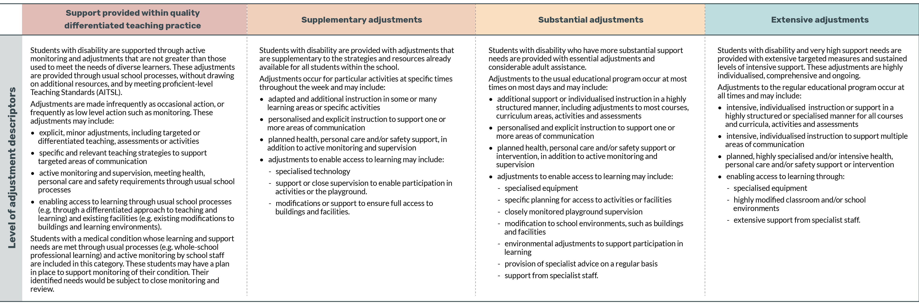
Go to an accessible version of the Selecting the level of adjustment table at the NCCD Portal.
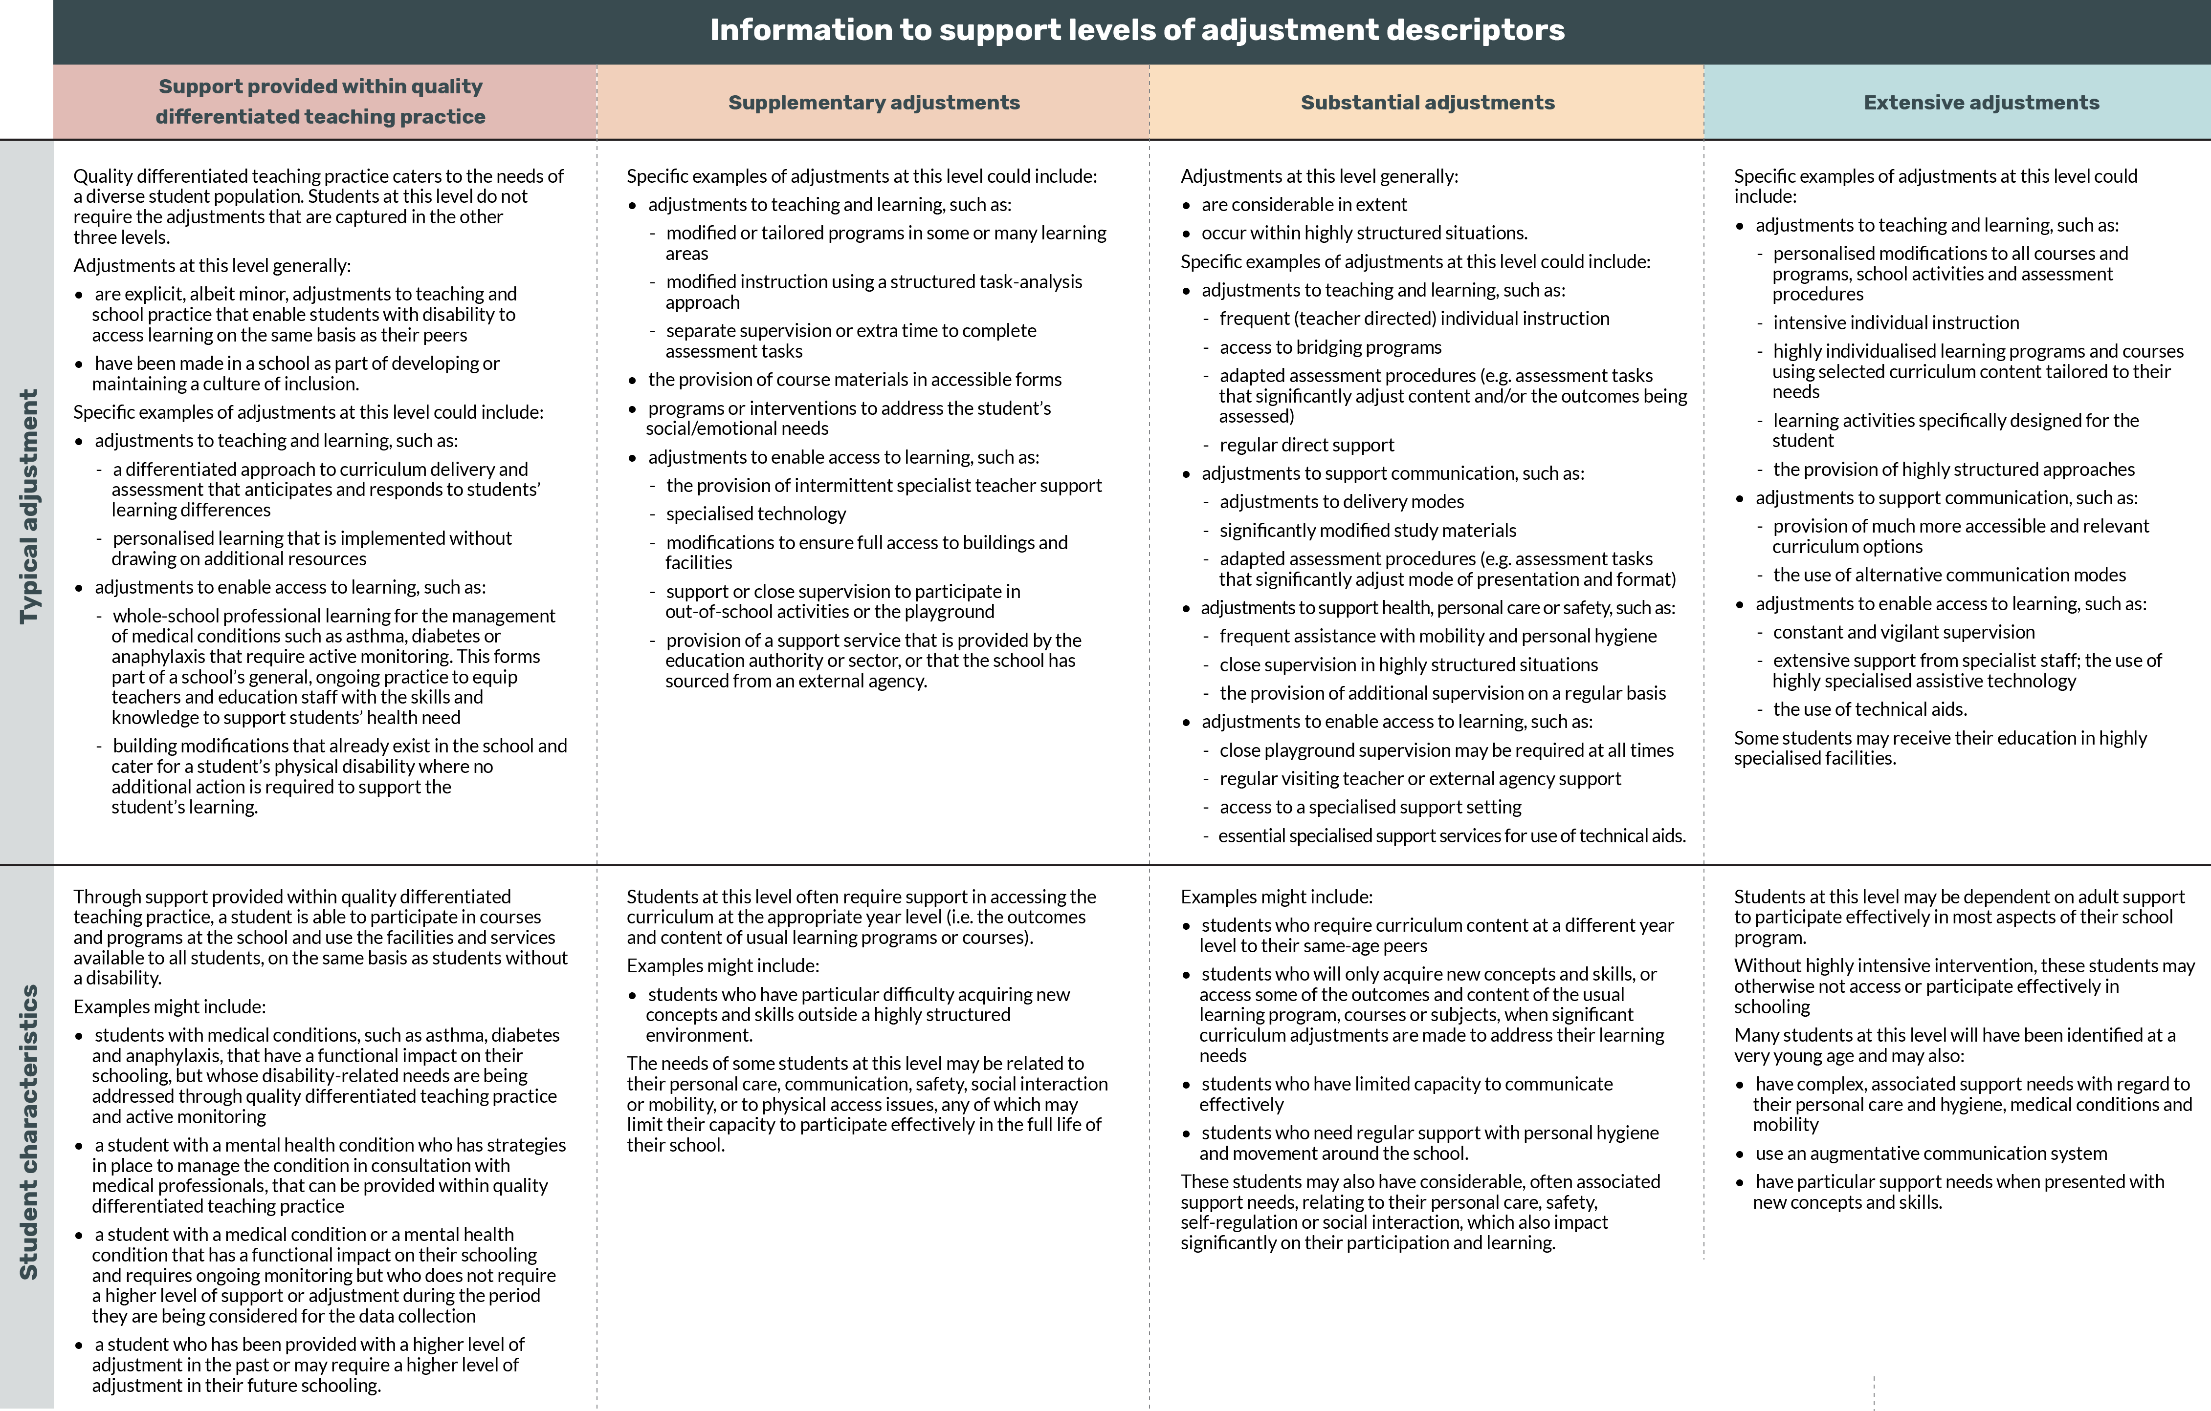

APPENDIX 3. Broad categories of disability
The table below outlines the DDA definition of disability, the Australian Human Rights Commission (AHRC) interpretation and how the broad disability categories that are used as part of the NCCD align with these two definitions. Appendix 3 is made for the purposes of the definition of ‘category of disability’ in subsection 58A(4) of the Regulation.
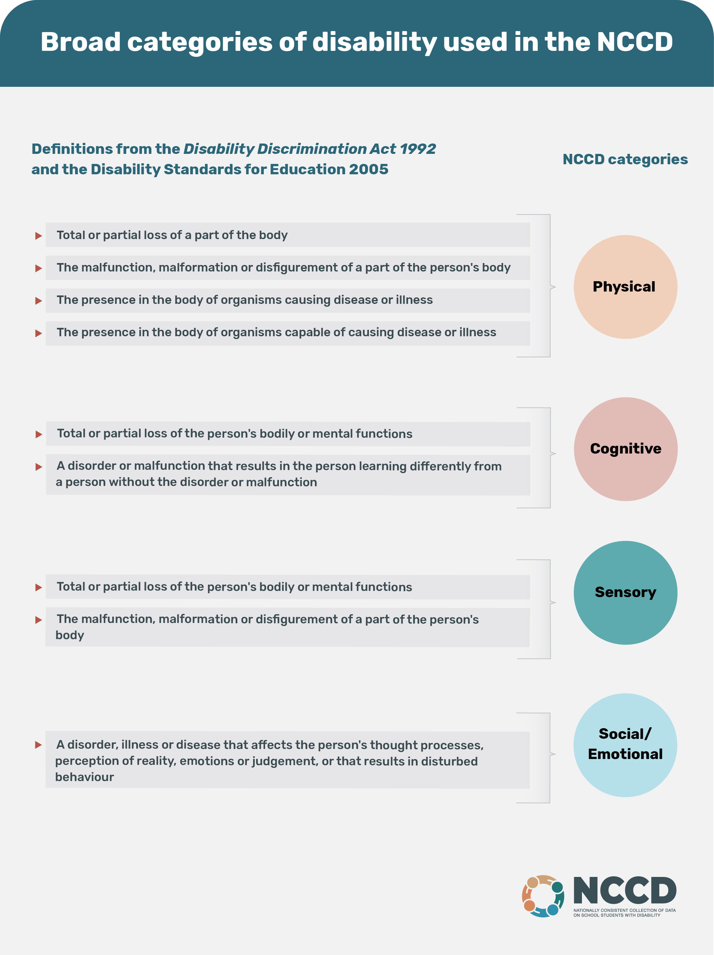

APPENDIX 4. Glossary
Explanation and further descriptions of some of these terms are contained in Appendix 2 and Appendix 3.
ABS means the Australian Bureau of Statistics.
ACARA means the Australian Curriculum, Assessment and Reporting Authority.
[the] Act means the Australian Education Act 2013 (Cth) and includes any regulation made
under the Act.
Adjustment has the same meaning as in section 3.3 of the Disability Standards for Education 2005. For the Standards, each of the following is an adjustment:
- a measure or action (or a group of measures or actions) taken by an education provider that has the effect of assisting a students with a disability:
  - in relation to an admission or enrolment – to apply for the admission or enrolment; and
  - in relation to a course or program – to participate in the course of program; and
  - in relation to facilities or services – to use the facilities or services;
on the same basis as a student without a disability, and includes an aid, a facility, or a service that the student requires because of his or her disability;
- an adjustment mentioned in subsection 7.2(4) of the Disability Standards for Education 2005;
- if a change is made to an adjustment mentioned in paragraph (a) or (b) – the adjustment as affected by the change.

AGEID means the Australian Government Education ID.
AHRC means the Australian Human Rights Commission.
Approved Authority means a body corporate or body politic approved by the Minister under section 73 of the Act to receive financial assistance from the Australian Government for one or more schools. For a government school located in a state or territory, the approved authority is the state or territory government. For a non-government school, the approved authority is the body corporate that is approved by the Minister for the school.
Approved System Authority means an approved authority that distributes financial assistance in accordance with subsection 78(5) of the Act. See subsection 78(6) of the Act, which states when an approved authority is an approved system authority.
Associate in relation to a person, includes:
- a spouse of the person
- another person who is living with the person on a genuine domestic basis
- a relative of the person
- a carer of the person
- another person who is in a business, sporting or recreational relationship with the person.
See section 1.4 Definitions of the Disability Standards for Education 2005.
Category of disability for the purposes of subsection 58A(4) of the Regulation and the NCCD, means any one of the following: physical, cognitive, sensory, and social/emotional. See Appendix 3. Broad categories of disability for details of each category of disability and how it correlates to the DDA and the AHRC interpretation of disability.
Census Day for a non-government school for a year is the day determined in writing by the Minister or their delegate under section 5 of the Regulation.
DDA means the Disability Discrimination Act 1992 (Cth).
[the] Department means the Australian Government Department of Education, Skills and Employment.
Disability is defined in section 4 of the Disability Discrimination Act 1992 as:
- total or partial loss of the person's bodily or mental functions; or
- total or partial loss of a part of the body; or
- the presence in the body of organisms causing disease or illness; or
- the presence in the body of organisms capable of causing disease or illness; or
- the malfunction, malformation or disfigurement of a part of the person's body; or
- a disorder or malfunction that results in the person learning differently from a person without the disorder or malfunction; or
- a disorder, illness or disease that affects a person's thought processes, perception of reality, emotions or judgement or that results in disturbed behaviour;
and includes a disability that:
- presently exists; or
- previously existed but no longer exists; or
- may exist in the future (including because of a genetic predisposition to that disability); or
- is imputed to a person.
To avoid doubt, a disability that is otherwise covered by this definition includes behaviour that is a symptom or manifestation of the disability.
[a] Distance education student is a student who:
1. resides in the State or Territory in which the school is located;
2. attends a school for which the State or Territory provides funding (other than financial assistance provided to the State or Territory for the school in accordance with the Act), for students enrolled at the school who receive distance education (however described) from the school;
3. is not approved as a home education student (however described) in accordance with the law of the State or Territory in which the person resides.
Distance education students can only be reported in the school census at schools which have been approved by the Australian Government for distance education.
Education authority means a state/territory government agency or another body as a system office for non-government systemic schools, either religious or independent.
Foundation has the same meaning as in the Australian Education Regulation 2013. It means the year of schooling immediately before year 1.
[a] Full time student is enrolled and participates in a level of education that constitutes primary or secondary education, undertakes a full time study load (as prescribed by the relevant State or Territory), and is included in the school’s Census Day enrolment. A full time student has an FTE of 1.0.
Functional impact of a student’s disability in relation to education. This includes the impact on communication, mobility, curriculum access, personal care and social participation. Other areas that might be considered for some students are safety, motor development, emotional wellbeing, sensory needs and transitions.
Functional needs of a student refer to the student’s educational and support needs across a range of domains which may include, but are not limited to:
- Key Learning Areas – this refers to changes required in curriculum and teaching practices to enable the student to achieve the learning outcomes described in syllabus documents;
- Communication – this refers to the student’s ability to receive and understand information being conveyed by others (receptive language) and to the student’s ability to convey a message to others (expressive language);
- Participation – this refers to the student’s ability to engage in successful interactions and participate effectively in the full school program (social competence) and to the management strategies required to ensure the student’s safety (safety and wellbeing);
- Personal care – this refers to essential hygiene routines which require intensive individual management to support participation (hygiene), eating/drinking/dietary needs which require individual management (eating and dietary), and the procedures specified in an individual health care plan which require specialised support (health care procedures);
- Movement – this refers to the student’s level of functional independence in mobility and positioning (mobility and positioning) and to the student’s ability to use the hand motor skills required to participate in learning activities (hand motor skills).
Guidelines refer to these Guidelines for the Nationally Consistent Collection of Data on School Students with Disability for the year (referred to as the Ministerial Council disability guidelines, for a year, in section 4(1) of the Regulation).
Level of adjustment for the purposes of subsection 58A(4) of the Regulation and the NCCD, means any one of the following: support provided within Quality Differentiated Teaching Practice, Supplementary, Substantial, and Extensive. See Appendix 2. Levels of adjustment for detailed descriptors, typical adjustments and typical student characteristics for each level of adjustment.
Level of education means primary education or secondary education (including their equivalents for special schools), as defined in sections 7 and 9 of the Regulation.
Minister means the Australian Government Minister for Education.
[the] Model means the Model for the Nationally Consistent Collection of Data on School Students with Disability, endorsed by education Ministers on 10 May 2013.
Moderation as it relates to the NCCD allows individuals within a school to collaborate, validate and learn from one another to regulate the assessment and data collection process. It is a key treatment in reducing variability in teacher professional judgement. Characteristics of NCCD moderation best practice include: use of external reference exemplars, strong leadership involvement (in school level moderation), cross school moderation and cross jurisdiction moderation. It is essential that teachers actively engage in quality-assurance activities with ongoing and direct reference to the levels of adjustment descriptors and the broad category of disability descriptors.
NCCD means the Nationally Consistent Collection of Data on School Students with Disability.
National Schools Statistics Collection (NSSC) refers to the dataset managed by the Australian Bureau of Statistics and reported in Schools, Australia 2019 (cat. no. 4221.0; www.abs.gov.au/ausstats/abs@.nsf/mf/4221.0). It is a joint undertaking of the various state and territory departments of education, the Australian Government Department of Education and the Education Council. The NSSC is the collection of data on students, schools, and staff involved in the provision or administration of primary and secondary education, in government and non-government schools, for all Australian states and territories.
On the same basis has the same meaning as in the Standards. It means that a student with a disability must have opportunities and choices that are comparable with those offered to students or prospective students (as applicable) without disability in relation to:
- admission or enrolment in an institution (this covers application for, or enrolment in, an institution, as well as treating a prospective student with disability on the same basis as a prospective student without disability where the provider makes decisions about admission or enrolment on the basis that reasonable adjustments will be provided in accordance with section 5.2 of the Standards)
- participation in courses or programs
use of facilities and services provided by an educational institution
as specified in section 2.2 of the Standards.
Overseas student has the same meaning as in the Australian Education Act 2013 and the Australian Education Regulation 2013, as amended.

Section 6 of the Act states that an overseas student is a person:
(a) to whom one or more of the following subparagraphs apply:
(i) the person holds a visa in force under the Migration Act 1958 that permits the person to travel to Australia for the purpose of undertaking a course provided by a body;
(ii) the person is included in such a visa in force under that Act;
(iii) the person is prescribed as an overseas student by regulations made for the purposes of this subparagraph; and
(b) who is not excluded from being an overseas student by regulations made for the purposes of this paragraph.
Section 6 of the Regulation specifies that for paragraph (b) of the definition of overseas student in section 6 of the Act, the following persons are excluded from being an overseas student:
(a) a dependant of a person who is receiving a sponsorship or a scholarship for the purpose of undertaking a course provided by an institution in Australia that:
(i) is a Table A provider or a Table B provider (within the meaning of the Higher Education Support Act 2003); and
(ii) is meeting the full cost of the education component of the course;
(b) a person who is undertaking a course of study provided by an institution or body in Australia under a Student Exchange Program registered by the relevant education authority in the State or Territory where the person is undertaking the Program;
(c) a person, or a dependant of a person, who is receiving a sponsorship or a scholarship from the Commonwealth for the purpose of undertaking a course provided by an institution or other body or person in Australia.
Part-time student is enrolled and participates in a level of education that constitutes primary or secondary education, and whose study load is less than the study load that a Full-time student undertakes at the school and is included in the school’s Census Day enrolment. Part-time students will have an FTE of less than 1.0.
Personal information has the same meaning as in the Privacy Act 1988. The Privacy Act defines personal information as: ‘. . . information or an opinion about an identified individual, or an individual who is reasonably identifiable:
(a) whether the information or opinion is true or not; and
(b) whether the information or opinion is recorded in a material form or not.'
Personalised learning and support requires attention to the unique needs of students of all abilities, acknowledging the different learning needs of each student. This is particularly relevant for students with disability and additional learning needs. It aims to fulfil the diverse capabilities of each student.
There are four elements in personalised learning and support:
- consultation and collaboration with the student and/or their parent or carer
- assessing and identifying the needs of the student
- providing reasonable adjustments to address the identified needs of the student
monitoring and reviewing the impact of adjustments.
Personalised learning and support may involve one or a combination of approaches in relation to curriculum, instruction and the environment. There is further information in
Planning for Personalised Learning and Support: A National Resource.
Reasonable adjustments has the same meaning as in section 3.4 of the Disability Standards for Education 2005. Among other things to be considered under the Standards, an adjustment is reasonable if it takes into account the needs of a student with disability and balances the interests of all parties affected.
Reference date means the date at which schools identify the student population to count for the purposes of NCCD. For the NCCD, this is the same date as the school census collected under the Australian Education Act 2013, that is, the first Friday in August.
[the] Regulation means the Australian Education Regulation 2013 (Cth).
School census means the national school census required under the Australian Education Act 2013. Data from this census is used to calculate school funding, to inform education policy and programs and for statistical reporting, including the National School Statistics Collection (NSSC).
School funding means Australian Government school funding.
School team means a team comprised of a range of staff in the school, or that support the school. The school learning support team may include teachers with specific experience or qualifications in disability studies, but this is not mandatory.
The school team provides a mechanism for the coordination of teaching and learning and embedding support for learning into the culture and practice of the school. It plays a role in supporting teachers in identifying and responding to the additional learning needs of students, in leading and supporting professional development for staff, and in supporting high expectations for every student, including those students who require adjustments to their learning. The school team supports collaborative partnerships between the school, parents/carers, other professionals and the wider school community.
The school team is responsible to the principal. In some regional, rural and remote schools that have a very small staff, the school team could consist of one person, the principal.
Special assistance school has the same meaning as in the Australian Education Act 2013. It means a school that:
(a) is, or is likely to be, recognised by the State or Territory Minister for the school as a special assistance school; and
(b) primarily caters for students with social, emotional or behavioural difficulties.
Special school has the same meaning as in the Australian Education Act 2013. It means a school that:
(a) is, or is likely to be, recognised by the State or Territory Minister for the school as a special school; and
(b) provides education under special programs, or special activities, designed specifically for students with disabilities.
Specific student cohorts refer to:
- Foundation (Year 1 minus 1) year students;
- new enrolments. This may include:
  - students who commenced at the school in 2020;
  - students transitioning between phases of schooling, e.g. primary to secondary school, or moving campuses;
- students with newly diagnosed or newly imputed disability;
- students attending special assistance schools.
The Standards means the Disability Standards for Education 2005.
The Statement of Enrolments provides enrolment figures from non-government schools for the calculation of entitlements under the Australian Education Act 2013.
Student with disability means a student about whom information must be provided, as specified in these Guidelines.
Student with disability loading, as defined in the Australian Education Act 2013 (section 6 and subsection 36(1)), means the funding loading provided for students with disability.

https://www.nccd.edu.au/tools/nccd-guidelines
https://www.nccd.edu.au
http://creativecommons.org/licenses/by/4.0
http://creativecommons.org/licenses/by/4.0/legalcode
On 22 May 2020, the Education Council agreed to delegate to the Schools Policy Group its authority to approve these Guidelines.
https://www.legislation.gov.au/Current/F2018C00920
https://www.legislation.gov.au/Details/C2018C00012
https://docs.education.gov.au/node/16354
https://www.legislation.gov.au/Current/C2018C00125
https://docs.education.gov.au/node/16354
https://www.education.gov.au/quality-schools-package
https://www.legislation.gov.au/Current/C2018C00125
https://docs.education.gov.au/node/16354
https://www.education.gov.au/disability-standards-education-2005
https://www.education.gov.au/quality-schools-package
https://www.pc.gov.au/research/ongoing/report-on-government-services
https://www.acara.edu.au/reporting/national-report-on-schooling-in-australia/national-report-on-schooling-in-australia-data-portal
The NCCD model requires evidence that a student has been provided with adjustments for a minimum of 10 weeks of school education in the 12 months preceding the NCCD reference date. Due to disruptions caused by COVID-19, this rule has been revised to a minimum of six weeks for the 2020 NCCD collection only. However, schools are encouraged to collect 10 weeks of evidence where there is capacity to do so to ensure continuity of best practice.
https://www.nccd.edu.au/sites/default/files/2019-01/nccd_model_diagram_0.pdf
https://www.nccd.edu.au/sites/default/files/2019-02/nccd_diagram_transcript_accessible.pdf
https://www.education.gov.au/privacy-policy
https://docs.education.gov.au/node/33415
http://www.education.gov.au/node/4209
https://www.nccd.edu.au/resources-and-tools/roles/parents-guardians-and-carers-14
https://www.nccd.edu.au/wider-support-materials/what-nccd-model-1?parent=/understanding-nccd&activity=/wider-support-materials/what-nccd-model-1&step=-1
https://www.nccd.edu.au/wider-support-materials/step-2-what-level-adjustment
https://www.nccd.edu.au/tools/moderation-resource-schools
https://www.nccd.edu.au/tools/data-collection-model
https://www.nccd.edu.au/resources-and-tools
https://www.nccd.edu.au
https://www.legislation.gov.au/Details/C2018C00125
https://docs.education.gov.au/node/16354
https://www.nccd.edu.au/resources-and-tools/professional-learning/format/e-learning-5
https://www.education.gov.au/disability-standards-education-2005
https://www.nccd.edu.au/wider-support-materials/disability-standards-education-practical-guide-individuals-families-and
https://www.nccd.edu.au
https://www.nccd.edu.au/faq
https://www.nccd.edu.au/tools/examples-evidence-support-students-inclusion-nccd
https://www.nccd.edu.au
https://www.nccd.edu.au/tools/moderation-resource-schools
https://www.nccd.edu.au/tools/moderation-resource-schools
https://www.education.gov.au/quality-schools-frequently-asked-questions
https://www.nccd.edu.au/faq
https://www.nccd.edu.au/tools/notice-schools-and-school-principals
https://www.nccd.edu.au/help-and-support/key-contacts
https://www.nccd.edu.au/sites/default/files/h5p/content/167/docs/endorsed_levels_of_adjustment.pdf
https://www.abs.gov.au/ausstats/abs@.nsf/mf/4221.0
https://www.legislation.gov.au/Details/C2013A00067
https://www.legislation.gov.au/Details/F2013L01476
https://docs.education.gov.au/documents/planning-personalised-learning-and-support-national-resource-0

